LEGONRUSH

Diaspora Halls
Appearance & Environment Correction Brief
Reference package for Claude Code | 15 October 2026
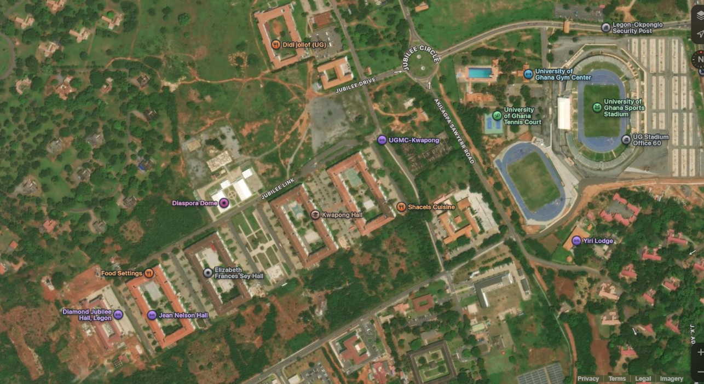
LOCATION CONTEXT
The current hall structures already exist in the game. The priority is to correct visual appearance, surfaces, landscaping and the relationship between each hall and its real surroundings—not to replace the existing campus layout wholesale.
Primary instruction: Use the real-life photos for architecture and the satellite screenshots for layout/environment. Preserve the existing building IDs and footprints unless verification proves a placement error. Do not make up hall-specific details that are not visible in a reference.

1. What Claude must correct
The hall massing/structure has already been created, but its façade treatment and surrounding environment do not yet look like the University of Ghana Diaspora Halls. Refine the existing objects and local scene using this brief and the attached reference gallery.
- Architecture: replace generic, flat, overly bright or overly simplified materials with the cream/white painted concrete, terracotta-red pitched roofing, dark-framed windows, recessed corridors/balconies and distinctive entrance cores seen in the photographs.
- Building identity: keep Elizabeth Frances Sey Hall, Jean Nelson Aka Hall, Alexander Adum Kwapong Hall and Dr. Hilla Limann Hall as distinct assets. Do not give all four halls the same entrance design, exact window map or façade decoration.
- Courtyards: reconstruct the actual inner courts, planted areas, walkways and sports courts visible for each footprint. Preserve the open U-shaped / perimeter-building character rather than filling the courtyards with generic blocks.
- Ground: distinguish vehicle roads, herringbone/interlocking paved forecourts, paved parking bays, concrete sidewalks, lawns, planted islands and exposed reddish soil. The source photos show broad hard-surfaced access/parking areas, not uninterrupted grass.
- Environment: place trees, palms, clipped shrubs, lawn and wooded bush edge to match the satellite / photos. Do not blanket every open area with identical trees or oversized low-poly canopies.
- Performance: use tiling materials, instanced vegetation, simple colliders and distance-based detail so the richer environment does not create excessive draw calls.

2. Evidence priority and confidence
- MAP-01 to MAP-05 (Apple Maps/satellite screenshots) are the primary sources for relative placement, footprint, adjoining roads, courtyard shape, parking areas, sports facilities and the surrounding vegetation boundary.
- REF-09 is a direct, readable photo reference for Elizabeth Sey Hall; the building sign is visible. REF-12 is a wider long-façade/forecourt reference whose filename identifies it as Jean Nelson. REF-11 appears to show a hall entrance with a central arch; verify the physical sign before using it as a specific hall template.
- Other photographs are architecture/environment references; do not assign them to a named hall solely because they look similar. Compare the entrance, roof, elevation and satellite footprint against the current asset before assigning hall-specific details.
- The Apple Maps page was supplied by the user at the URL below. In-app map/geography in the repository remains the authoritative source for implementation coordinates; the reference image is not a replacement for map data.
Apple Maps reference: Open the supplied satellite view

3. Hall identity and scope
The University of Ghana accommodation page lists Hilla Limann, Kwapong, Elizabeth Sey and Jean Nelson as UGEL halls. The satellite references also show adjacent landmarks such as Jubilee Hall / Diamond Jubilee Hall and Diaspora Dome. Keep those neighboring entities separate from the four named UGEL halls; do not merge their geometry or overwrite their labels.
Official University of Ghana accommodation page: ug.edu.gh/aad/accomodation
Additional campus reporting on Diaspora halls: Radio Univers: Diaspora Homecoming Festival

4. Shared façade specification

4.1 Roof and silhouette
- Use pitched hip/gable roof sections with a terracotta red/orange tile material. The aerial references show large continuous red/orange roof planes split across wings; preserve ridgelines, hips, valleys and eaves rather than using one smooth orange slab.
- Keep each hall’s real wing arrangement and approximate floor count as already represented. Make floor slabs, roof overhangs, window recesses and balcony rails cast readable shadows.
- Use subtle tile variation and roughness; avoid repetitive checker patterns, flat neon orange and exaggerated roof thickness.

4.2 Walls, windows and balconies
- Primary wall colour: warm white / pale cream painted concrete; use light grime/aging subtly near the base, joints and drainage edges rather than applying a uniform dirty overlay.
- Use dark charcoal/black or very dark grey aluminium window frames with tinted reflective glass. The glass may reflect blue from the sky, but should not turn the entire building into bright saturated blue windows.
- Model the repeated windows consistently with the floor rhythm, including smaller ventilation openings where visible. Use shallow recesses, sills and lintels to create depth.
- Where the reference shows external corridors/balconies, model actual recesses and slim cream/white guardrails, supported by columns/slabs. Do not simulate all balconies as a flat texture.
- Some photos show brick-red accent panels/columns and a darker grey plinth at ground level. Apply these only to the hall variants where references support them; do not paint every wing red brick.

4.3 Entrance features and signs
- Entrance cores are major identity features: some references show a projecting triangular/gabled portico with tall central glazing or an arched glazed volume. Keep the correct feature for each hall rather than copying the same arch everywhere.
- Keep entrance canopy, columns, stairs/ramps, landing, door group and signs aligned to the real entrance. Do not make the entrance over-sized or float its sign away from the façade.
- Use the correct hall name only when supported by the reference: “ELIZABETH FRANCES SEY HALL” is visible in REF-09; Jean Nelson naming is supported by the source filename of REF-12, but Claude should inspect the visible sign/asset metadata before final assignment. Avoid inventing signs for Kwapong or Hilla Limann.

5. Hall-specific visual work

5.1 Elizabeth Frances Sey Hall
- Use MAP-03 to verify the footprint and location; use REF-09 for the front/entrance treatment.
- Reproduce the pale façade, red-orange pitched roof, central entrance composition, tall dark glazing in the projecting upper entrance bay, supporting columns and the visible hall sign. Match the wings and repeated window grid to the existing model while adding façade depth.
- The front approach in REF-09 is hard-paved with brick/interlocking blocks; surround the entry with a broad paved arrival/parking apron, with small clipped shrubs/green beds close to the building. Do not substitute a large grass lawn directly in front of this entrance.
- Check the adjacent hall/courtyard in MAP-03 remains a distinct neighbouring structure with its own roof, walls and courtyard.

5.2 Jean Nelson Aka Hall
- Use MAP-03 and REF-12 to check the long frontage and entrance/parking arrangement. The reference photo shows a long multi-storey white façade with a continuous red-orange roof and a taller central entrance with arched glazing.
- Reproduce the extended façade rhythm, recessed open corridor/balcony bands and central entrance tower. Do not reduce the building to a plain slab with windows painted onto it.
- Model the broad vehicle forecourt/loop with separate parking rows and landscaped islands, not cars strewn on a green plane. Include curb geometry, walkable paving and small trees/palms in islands where supported by REF-12.
- Confirm exact hall assignment from the repository footprint and visible signs; keep its model entity independent from Elizabeth Sey Hall.

5.3 Alexander Adum Kwapong Hall
- Use MAP-02/MAP-04 to locate the U-shaped/perimeter footprint and inner court. Match the courtyard proportions and wings already built before changing materials.
- Use the shared architectural photo set for material and floor-rhythm guidance, but do not assume REF-09’s Elizabeth Sey entrance belongs to Kwapong. Keep Kwapong’s entrance and details consistent with the matching reference/model source.
- If an inner sport court is present in the map/photo references, preserve its exact place/shape and surface. Do not copy the same court into all hall courtyards.

5.4 Dr. Hilla Limann Hall
- Use MAP-02/MAP-04 to keep the hall separate from Kwapong Hall and preserve the actual orientation of both buildings and the road/parking between them.
- Use the multi-wing, cream/white residential architecture and roof references as material guidance only. Preserve any distinct façade, entrance or stair-core details visible in the matching source photo/model.
- Keep inner-courtyard sports/landscape features at the satellite-supported footprint. Do not invent additional buildings, courts or vehicle lanes to make the courtyard appear more symmetrical.

6. Ground and environment specification

6.1 Surface zoning: use different materials for different functions
Surface zone | Required treatment
Main campus road | Medium/dark grey asphalt with restrained aggregate texture and clear curb edge. Use road geometry/markings only where the satellite or in-game road layer supports them.
Parking / drop-off | Tan, brown-grey or concrete/interlocking paving, with organised stalls and kerb islands. Photos show parked cars and large paved forecourts; do not make these areas grass or an uninterrupted dark road.
Entrance forecourt and footpaths | Red-brown/tan interlocking pavers, commonly laid in herringbone/brick patterns. Vary orientation only where a real path layout changes; keep joins and borders neat.
Courtyard paths | Pale concrete or tan/red pavers that connect entrances and common areas. Follow the straight/orthogonal and branching routes in the aerial views; do not create decorative paths that cross planting beds.
Lawns / planting beds | Natural mid-green grass, slightly varied, with defined edges and curb/planter boundaries. Use lawn as islands and courtyard green areas, not as the default material for parking.
Bare earth / bush edge | Muted red-brown soil, low scrub and dense bush at the mapped periphery. Preserve visible clearings and tracks; do not turn every vacant parcel into manicured lawn.
Sports courts | Use the correct colored sport surface, lines, hoops or central feature only where visible in the corresponding photo/map. Maintain crisp boundaries between court, path, lawn and building.

6.2 Courtyard and planting
- Preserve each hall’s inner-courtyard layout as shown in satellite imagery: use the actual court(s), paved plazas, lawn panels, paths and planted pockets. The U-shaped building wings create enclosed spaces that should remain open and readable from above.
- Place trees and bushes in clusters matching the photographed landscaping. Use modest, realistic canopy scale. Shrubs may define walkways and building-front garden beds; avoid repeating identical green spheres at regular intervals.
- At the wider site edge, the satellite image shows a substantial wooded/bushy margin and irregular red-earth clearings. Represent this as a continuous dense bush edge made from instanced low-poly vegetation / clumps, with a limited number of hero trees. Do not scatter hundreds of independent high-poly trees.
- Keep vegetation clear of entrances, car lanes, parking stalls, signage, court markings and sightlines from ride cameras. Trees should not protrude through roofs, roads or pavements.
- For night-time visuals, add low-intensity warm-white lights around paths and entrances where light poles exist; do not use bright decorative lighting unsupported by references.

6.3 Vehicle parking and roadside layout
- Align paved parking and access roads to the aerial footprints. Parking is concentrated along some frontages and in lots adjacent to halls; keep individual vehicles within parking/road surfaces, not on grass or path areas.
- Use parking stall lines in rows where supported. Separate the circulation lane from parked vehicles; make driveways wide enough for a car to enter and leave without clipping curbs or building wings.
- Add raised curb islands and planted strips only where the map or photo shows them. Ensure the paved edge does not dissolve into the lawn through a green texture seam.
- Use existing gameplay road/path data as the primary route graph. Decorative paving must not become a driving route or block a walkable entrance.

7. Environment placement and geography safeguards
- Do not translate or rotate the halls just to make a pretty screenshot. Preserve current world coordinates, building IDs, footprint and orientation unless comparison to MAP-01–MAP-05 proves a real placement error.
- Use map screenshots for relative positioning and adjacency, not pixel-to-world coordinate guessing. Map screenshots may differ in zoom/rotation; use the repository’s canonical geography/scale conversion.
- Keep these entities distinct: Elizabeth Frances Sey Hall, Jean Nelson Aka Hall, Alexander Adum Kwapong Hall, Dr. Hilla Limann Hall, nearby Jubilee/Diamond Jubilee Hall, and Diaspora Dome.
- Check that building bases sit flush on terrain and don’t float, sink, intersect the road, or cover existing paths. Confirm roofs and trees do not clip each other.
- Preserve gameplay routes, entrance access, colliders, destinations, ride distances and progression IDs. When changing a curb or planter, validate collisions and rider clearance.

8. Claude Code workflow
- Inspect project instructions (CLAUDE.md / AGENTS.md), git status, existing hall IDs/assets/materials and location data. Do not immediately regenerate the campus scene.
- Create a hall reference ledger: current entity ID, hall name, current model files, satellite MAP-IDs, matching photo REF-IDs, visual gaps, confidence, and planned changes.
- Inspect each current model from front, side, rear and top-down views. Compare its façade/roof/courtyard to the relevant reference photos and map footprint.
- Keep existing footprints/coordinates by default. Apply visual changes to meshes/materials first; make only evidence-supported correction to ground surfaces, vegetation and environment props.
- Implement hall-specific variants so doors, arch/tower features, floor/window patterns and signage do not become a single generic copy across all halls.
- Build distinct surface layers and crisp boundaries for asphalt, interlocking pavers, concrete sidewalks, parking bays, lawns, planting beds, courts and bush/soil margins.
- Optimize trees and shrubs using instancing, shared materials, simplified colliders and LOD/culling. Avoid creating one high-detail draw call per shrub.
- Run typecheck, lint/tests available, and production build. Launch the game; inspect at ground level and from overhead with a rider camera and confirm the map context matches.
- Report files changed, IDs updated, whether any world position changed and why, visual improvements by hall, performance decisions, tests/build results and unresolved identity questions. Do not push/deploy without permission.

9. Ready-to-paste Claude Code instruction
Correct the appearance and immediate environment of the existing University of Ghana Diaspora Halls in LEGONRUSH. The hall structures/massing already exist; do not rebuild the campus or move the halls by default. Use MAP-01–MAP-05 in this brief for satellite-based layout/context and REF-01–REF-17 for architecture and environment. Keep Elizabeth Frances Sey Hall, Jean Nelson Aka Hall, Alexander Adum Kwapong Hall and Dr. Hilla Limann Hall as separate entities; also keep nearby Jubilee/Diamond Jubilee Hall and Diaspora Dome separate. Improve the existing models with accurate warm-white/pale cream wall materials, terracotta-red pitched tiled roofs, dark-framed tinted windows, real recess depth, open balcony/corridor bands and railings, proper entrance canopy/arched or gabled feature per the matching reference, and hall signage only where verified. Correct ground zoning: asphalt roads, red-brown/tan interlocking paver forecourts, paved parking with orderly stalls, concrete footpaths, bounded lawns, courtyard landscaping and sport surfaces where evidenced. Match courtyard and parking placement to satellite footprints; preserve the U-shaped inner courtyard arrangements. Rebuild the environment with clustered shrubs/trees and a dense but performance-efficient bush/woodland margin at the mapped site edge; use instancing/LOD rather than many heavy independent trees, and never let vegetation block doors, roads or court lines. Keep all current building IDs, world positions, road/path topology, entrances, destination points and collision geometry unless a clear evidence-backed mismatch is demonstrated. Inspect the current repo and geography data before editing, compare front/side/top views, run tests/typecheck/build, then summarize changed files, evidence used, tests and unresolved uncertainty. Do not push main or deploy.

10. Acceptance checklist
☐ Each of the four Diaspora hall assets remains individually named and recognizable.
☐ Terracotta roof geometry/texture and warm-white façades are closer to photographic evidence; windows, corridor recesses and entrance cores have visible depth.
☐ Courtyards match the map/photo footprints; sports courts are preserved only where present in evidence.
☐ Road, parking, footpath, paved entrance, lawn, court and bush/soil surfaces are visually distinct with crisp boundaries.
☐ Parking is aligned and orderly; no cars spawn in lawn/planter beds or clip building walls.
☐ Trees/shrubs follow reference density, use instancing/LOD and do not cover important architecture.
☐ No unintended movement of building IDs/positions, route breaks, lost destination triggers or new collision issues.
☐ Build succeeds and the changed area has been inspected from ground-level and overhead views.

11. References and uncertainty to preserve
The image gallery below includes all five supplied map screenshots and all 17 photographs supplied in the ZIP. Captions identify what is actually visible and note where a building-specific match is not certain. The map screenshots are partially labelled and are useful for relationships; use the current repository geographic source for exact world coordinates.
Map source supplied by user: Apple Maps hybrid view around 5.636849, -0.186364; link above.
Official identity list: University of Ghana Accommodation page currently lists Hilla Limann, Kwapong, Elizabeth Sey and Jean Nelson under UGEL halls. Nearby Jubilee Hall is visible in the user's satellite imagery and should remain a separate landmark.

Appendix A — Satellite map references
The maps are reproduced as supplied. Use the captions as location/context guidance, not as a substitute for canonical project coordinates.

MAP-01 | image(20261015-113349).png
Broad satellite overview: Diaspora Halls, Jubilee Link, the Diaspora Dome and the nearby sports complex.
Use to understand the wider context and the relative relationship among halls, roads, sports facilities, and wooded campus margins.

MAP-02 | Screenshot 2026-10-15 113503.png
Satellite overview around Kwapong Hall and adjacent halls.
Use to compare building footprints, surrounding paved spaces, parking areas, vegetation and road connections.
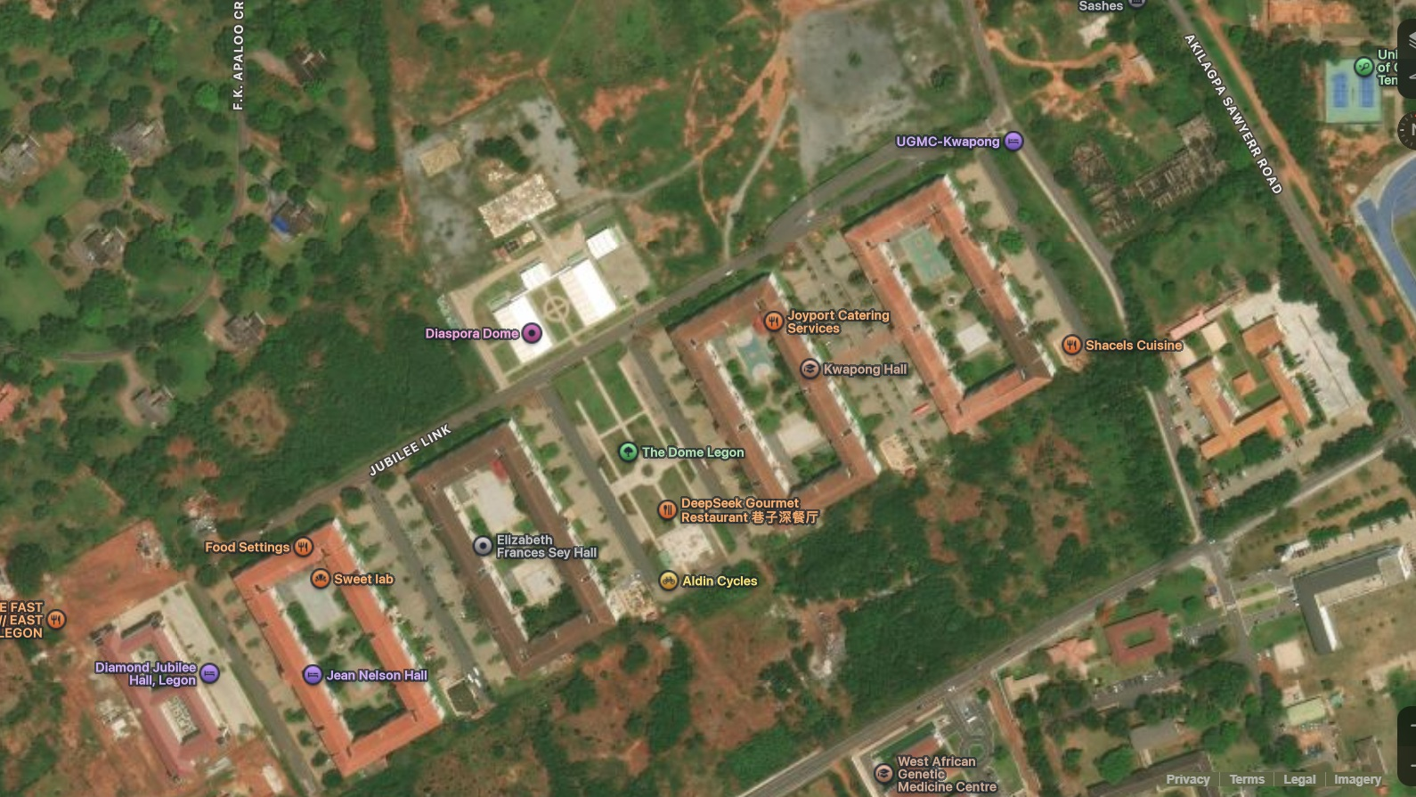

MAP-03 | Screenshot 2026-10-15 113437.png
Closer satellite view around Elizabeth Frances Sey Hall and Jean Nelson Hall.
Use to preserve the two separate hall footprints, their inner courtyards, the access street between them and the green/bushy margins.
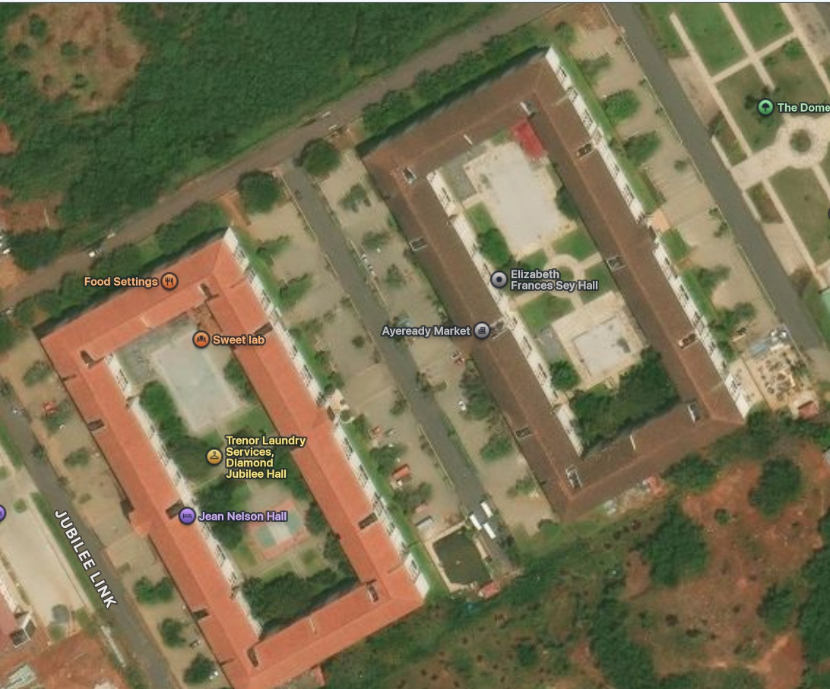

MAP-04 | Screenshot 2026-10-15 113425.png
Closer satellite view around Alexander Kwapong Hall and Dr. Hilla Limann Hall.
Use to retain the separate hall footprints, inner courts, Jubilee Link connection and open paved/landscaped spaces.
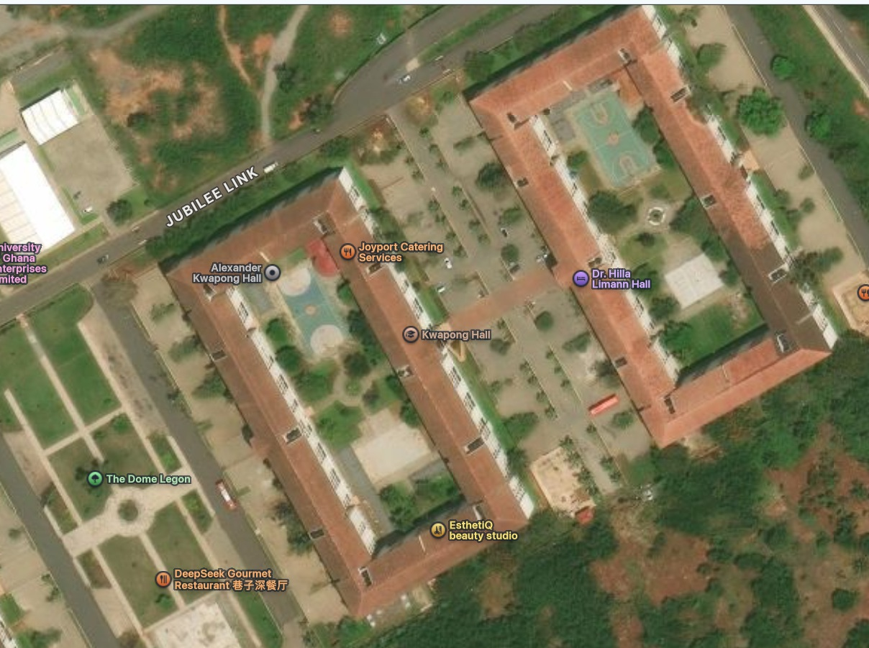

MAP-05 | Screenshot 2026-10-15 113331.png
Second broad satellite view of the same Diaspora Halls zone.
Cross-check the overall site relationship and avoid treating nearby buildings such as Jubilee Hall or Diaspora Dome as part of another hall.
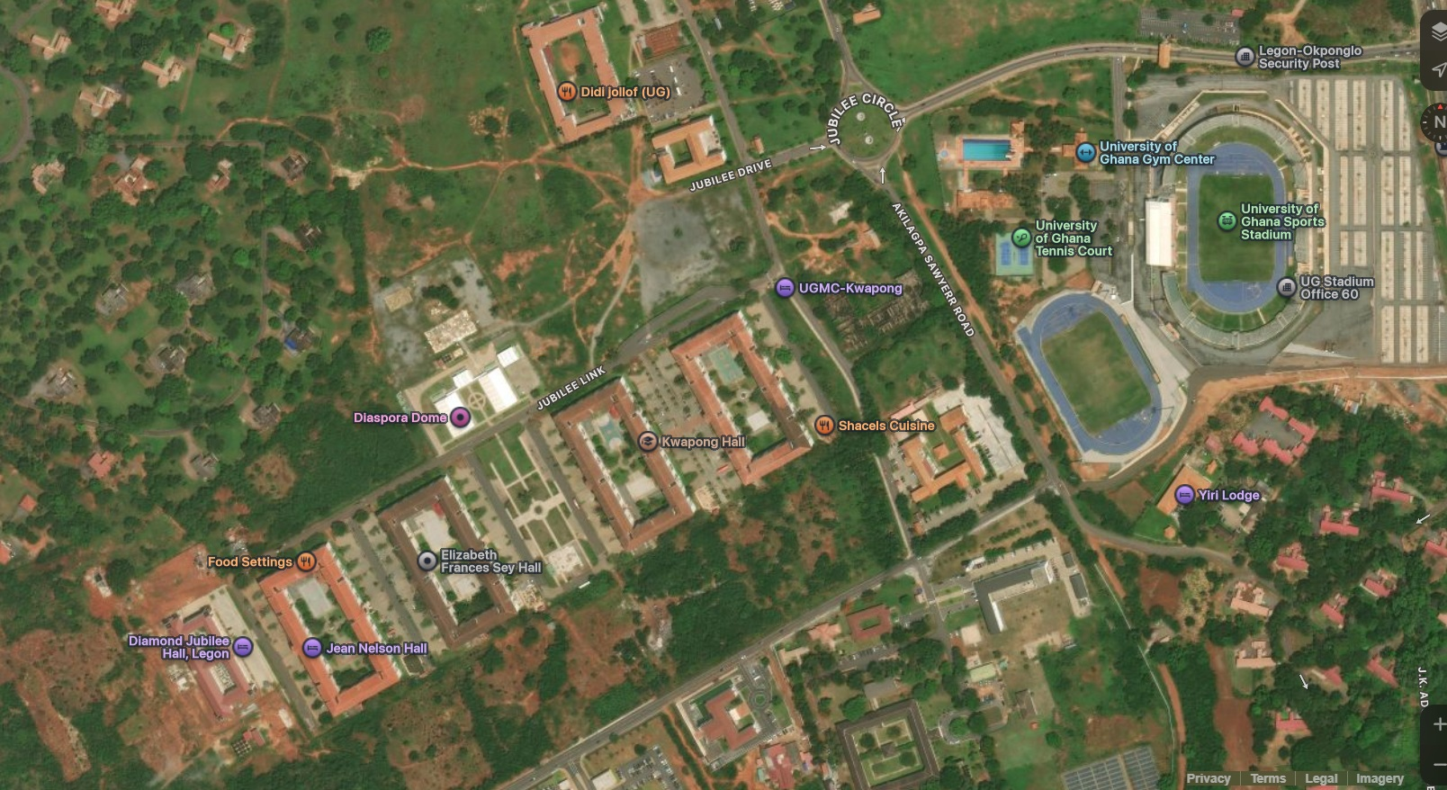

Appendix B — Real-life architecture and environment references
These images come from the ZIP supplied with the correction request. Reference IDs are used in the implementation prompt and detailed notes above.
REF-01 | images (15).jfif  Elevated view into a hall courtyard with multi-use sports courts and surrounding multi-storey wings.  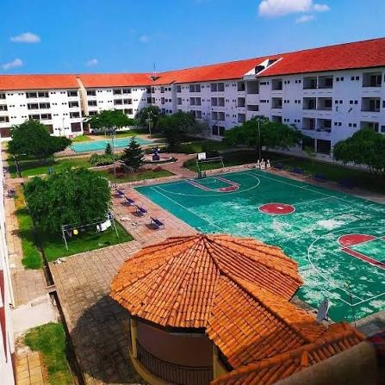  Use: Court surfacing/markings, building-to-court spacing, roof colour, courtyard planting and the way the wings enclose the courtyard. | REF-02 | images (16).jfif  Long frontal elevation with a sports court in the foreground.  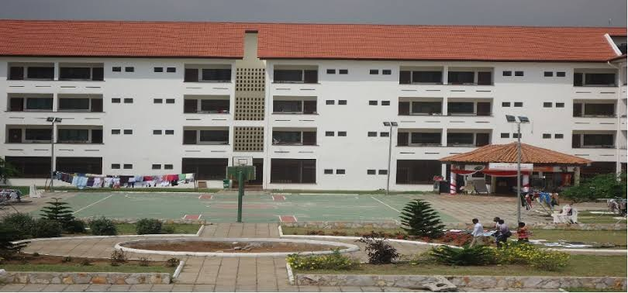  Use: Repeated façade rhythm, roof profile, floor count, dark window openings and court boundary.

REF-03 | images (17).jfif  Oblique exterior view of the long residential block and approach/forecourt.  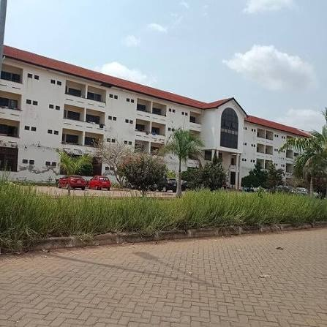  Use: Roofline, light exterior walls, balconies/windows, roadside planting and foreground surface zoning. | REF-04 | images (18).jfif  Night-time courtyard/path scene with a central circular landscape feature.  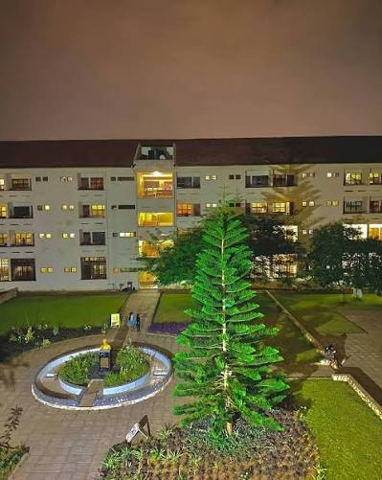  Use: Courtyard path geometry, lighting levels and planting composition; night reference only, not a coordinate source.

REF-05 | images (19).jfif  Top-down view of a hall perimeter and enclosed inner courtyard with sports courts.  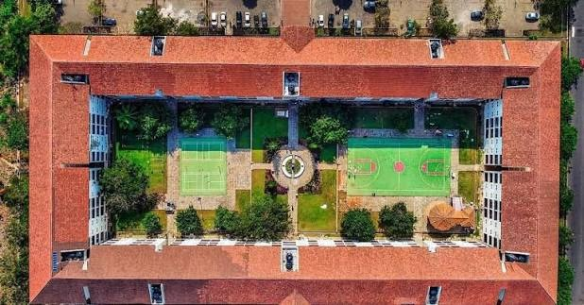  Use: U-shaped/rectangular courtyard massing, interior court positions, central paths and landscape islands. | REF-06 | images (20).jfif  Aerial view of two neighboring red-roof hall blocks and the connecting road.  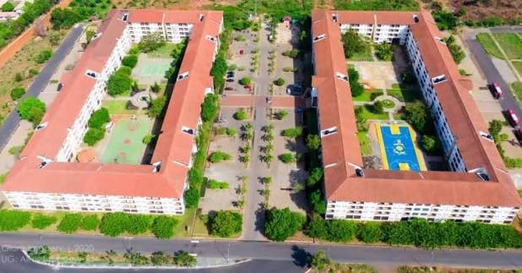  Use: Separate building footprints, how frontages meet the road, and scale of paved setbacks.

REF-07 | images (21).jfif  Oblique aerial of a cluster of residential blocks and recreation space.  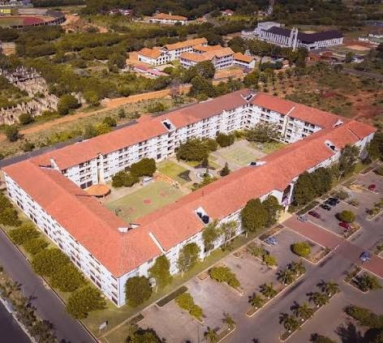  Use: Relative building heights and red/orange roofs, courts, lawns, driveway/parking and overall density. | REF-08 | images (22).jfif  Ground-level side view of an open corridor/balcony façade.  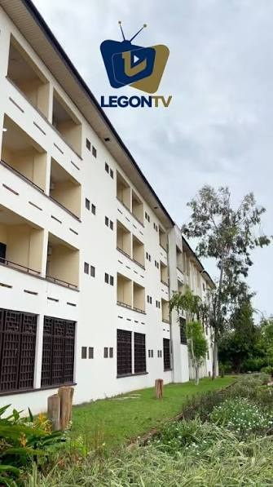  Use: Balcony recesses, guardrails, dark window frames, structural columns and shaded corridors.

REF-09 | images (23).jfif  Front entrance photo with the visible sign “Welcome to Elizabeth Sey Hall (Diaspora), University of Ghana”.  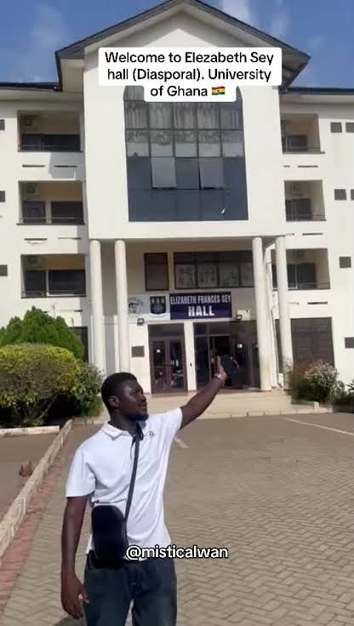  Use: Confirmed appearance reference for Elizabeth Frances Sey Hall: peaked entrance feature, tall central glazing, columns, signs and paved forecourt. | REF-10 | images (24).jfif  Wide aerial of the wider campus setting with repeated red-roof residential blocks.  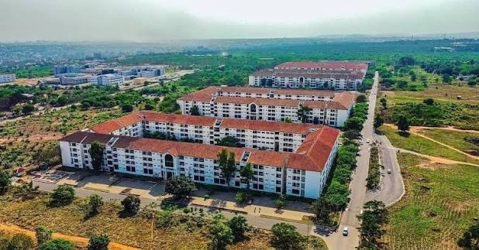  Use: Contextual reference for campus density, roads, vegetation and hall group scale; not a precise plan.

REF-11 | jean2.png  Frontal entrance reference with a high central arched glazed feature and paved vehicle approach.  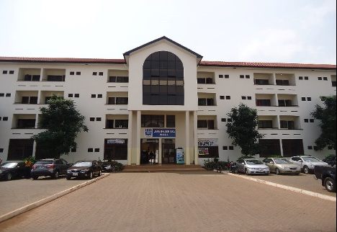  Use: Use as a hall entrance-style reference. Confirm the building identity in-repo/from the sign before applying its exact details to a named hall. | REF-12 | jeannelson.png  Long front elevation and parking/drop-off forecourt; image filename identifies it as Jean Nelson.  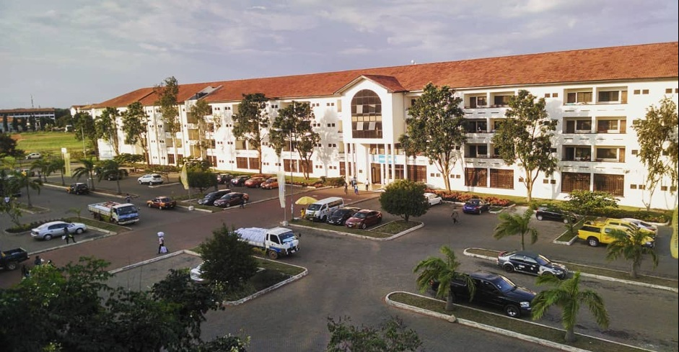  Use: Primary visual reference for Jean Nelson Hall’s extended frontage, central arched entrance, roof, landscape islands and car parking; verify match to the model.

REF-13 | L_height.webp  Oblique view of a tall white hall block, central arched glazing and parked cars.  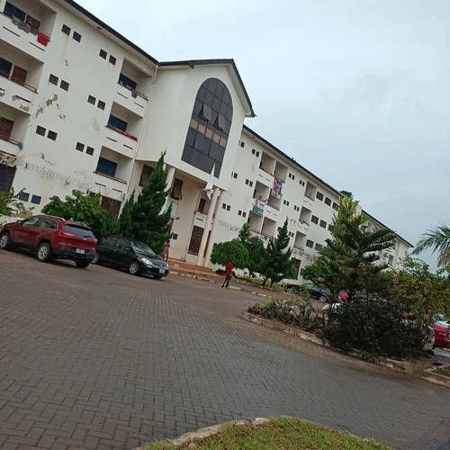  Use: Massing, window rhythm, balcony depth and material/shadow reference. Keep hall identity separate unless confirmed. | REF-14 | L_height (1).webp  Close-up of the entrance canopy, tall columns and central access.  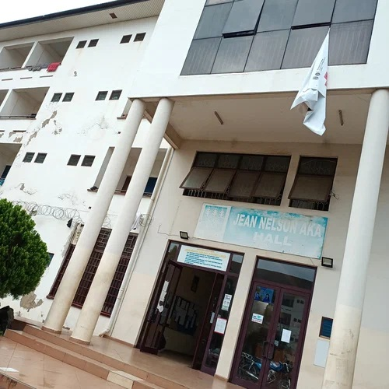  Use: Entrance proportions, column layout, covered arrival zone and glass/door treatment.

REF-15 | L_height (2).webp  Side façade with recessed balconies, ground-level openings and nearby parking.  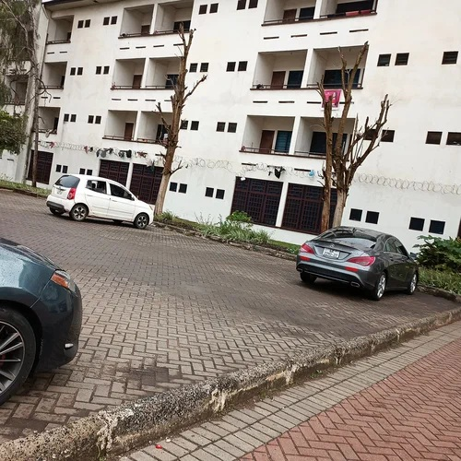  Use: Balcony/window recesses, ground-floor plinth, parking-to-building interface and local drainage/curb detail. | REF-16 | L_height (3).webp  Long façade viewed from the roadway, with repeated windows and reddish roof.  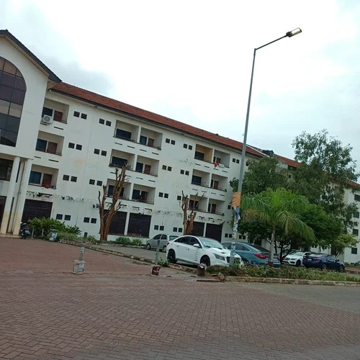  Use: Long elevation rhythm, visible storey count, roof/eaves, driveway edge and roadside lighting scale.

REF-17 | M_height.webp
Front approach with central arched entrance, palms/landscape and parking.
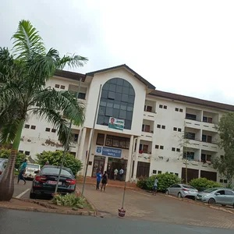
Use: Entrance hierarchy, planted forecourt, vehicle approach and front façade proportions.

