LEGONRUSH
CORRECTION FILE REVIEW
& IMPLEMENTATION BRIEF
Detailed build instructions with the complete 65-slide source-image appendix

Purpose
Translate the supplied CORRECTION FILE.pptx into actionable, evidence-linked instructions for Claude Code. This edition preserves every slide as a full-slide image in the appendix, then spells out implementation requirements by site and by element.

Source reviewed: CORRECTION FILE.pptx — 65 slides
Prepared 15 October 2026

1. How to use this brief
The slide deck is the primary source. The wording below describes visible evidence in its screenshots and converts the repeated comparison pairs into implementation tasks. When an exact name, coordinate, footprint, or facade relationship is not established by the deck, treat it as unresolved and verify it against the repository’s current canonical geography, the satellite views, or an official/ground-level reference. Do not fill the gap with a guess.
- The appendix reproduces every source slide (1–65) as a full-slide image. Images within a slide are preserved together as shown in the source deck; no slide has been intentionally omitted.
- The main sections provide detailed build instructions. Use the source slide numbers in each task to jump to supporting satellite screenshots, in-game views, and real-life photographs.
- Separate map corrections from appearance corrections. A correct facade does not prove that its building is in the right place, and a satellite footprint does not prove facade details.
- The deck contains a few slides that are section dividers or explicit markup rather than evidence. These are called out so they are not mistaken for building textures or geometry.

2. Correction register and work order
ID | Site / work package | Source slides | Priority | Required result
WP-01 | Night Market / Jubilee Drive commercial strip | Slides 1–20 | Critical | Match road and shop footprints; distinguish All Needs Supermarket, Euburger, CalBank, Prudential Bank and vendor stalls; correct signs, canopy, windows, street edge and kiosk placement.
WP-02 | Legon Basic School boundary | Slides 21–22 | High | Align fence to school perimeter and the existing hedge/walkway/fence photos; preserve all school gates and pedestrian access.
WP-03 | Republic Bank Legon Branch and neighbours | Slides 23–39 | Critical | Use satellite positioning plus multiple storefront/road views; model Republic Bank separately from UG Credit Union and neighbouring shops; fix sign, retaining wall, pavers and curb.
WP-04 | Ecobank Legon Main Branch | Slides 40–56 | Critical | Locate independently from Republic Bank; correct low-rise roof/facade/signage, entrance ramp, paving, parked-car space, hedge islands and road context.
WP-05 | Vikings Hostel | Slides 57–65 | High | Replace generic facade with evidence-based multi-wing hostel massing, balcony/corridor depth, windows, dark base and correct forecourt/paving.
WP-06 | Shared environment and geometry QA | Across all sections | Critical | Correct pavement/asphalt/grass boundaries, avoid overlapping roads and buildings, keep routes/access/collisions stable, optimize vegetation and validate from multiple views.

3. Mandatory repository and geography rules
- Before editing, read the repository instructions (CLAUDE.md, AGENTS.md, README), current git status and existing geography pipeline. Identify the existing IDs/records for the target buildings; do not create duplicates just to add a better-looking mesh.
- Use satellite/map screenshots to determine footprint and adjacency. Use real photographs to determine facade/massing. Use in-game images to diagnose the current model. These evidence types are not interchangeable.
- When moving a building is supported by evidence, update the authoritative record/data source, not only the render transform. Keep the facade transform, footprint, collision shape and destination-access point consistent.
- Keep each named building separate from adjacent businesses even when attached, sharing a wall, or close together. Signs are strong identification evidence; do not transfer a neighbour’s brand to the target facade.
- Preserve road/path topology, road widths, intersections, driveways, gates, entrances, destination access points, collision geometry, route IDs, challenge/race routes, ghosts, records and leaderboards unless a specific evidence-backed correction requires an update.
- Do not add trees, kiosks, parking bays, curbs, fences or signs just to make an image symmetrical. Match count/position as far as the visual evidence reasonably supports, and explicitly leave uncertain objects unresolved.
- Use low-cost repeated assets, instancing and level-of-detail where appropriate. Do not place hundreds of individual trees or high-poly shrubs in open forest areas; use a convincing dense bush/forest edge with efficient clustered vegetation when the scene only needs a background boundary.
- Run type check, unit/geography/route tests and production build. Open the game and inspect target sites from frontal, side, approach and top-down/map views. Do not push to main or deploy without explicit approval.

4. Shared ground, pavement and road specification
Apply these rules to all five work packages. The deck includes real streets and forecourts where pavement, asphalt and lawn sit side by side. They must read as distinct surfaces, not one generic grey/green plane.

4.1 Paved forecourts and sidewalks
- Use a repeated interlocking paving-block texture/mesh for pedestrian forecourts and many shop/bank approaches. The supplied ground reference shows rectangular pavers in a staggered/herringbone arrangement with varied taupe, brown and grey stones; the court/forecourt should not be plain sand or a flat uniformly grey slab.
- Show paver joints at a restrained scale; avoid oversized bricks, random cracks, noisy texture or strong directional patterns that fight the real paver layout.
- Sidewalks/paved aprons follow the building and street edge. They should not spread across a lawn unless the photo/map shows a path there. Use a visible curb or material boundary at grass, garden bed and asphalt transitions.
- Ramp, step, porch and wheelchair-access transitions must connect without a floating lip or impossible collision edge. Preserve existing drainage channels/gutters where evidenced.

4.2 Asphalt roads and junctions
- Use dark-to-medium asphalt for carriageways; reserve road markings for the actual main road where the source shows them. Do not turn internal pedestrian paving into asphalt or put lane markings on brick-paved forecourts.
- Keep road edges continuous across corners and junctions. Sidewalks and curbs should not abruptly vanish, cross the carriageway, or extend into the lawn. Keep driveway openings where cars enter the plot.
- Parking is a designed paved surface, separate from the lawn. Add parking bay lines and car positions only where supported by the photo/map layout; do not scatter cars on grass or place them across the pedestrian path.

4.3 Lawns, planting and trees
- Lawns should be contiguous, clearly separated from paved areas by curbs, planted borders or crisp material changes. Avoid weeds/tufts scattered across large pavement fields.
- Use shrubs and hedges as clipped landscape elements inside garden beds; avoid clipping hedges into the walkway or hiding entrance signs.
- Use a small number of well-placed trees where the photos show them. For the forest edge/background, dense bush or instanced clustered vegetation is preferred over many individual high-detail trees to reduce draw calls and gameplay lag.
- Streetlights and poles must be planted into the ground, scaled correctly, and placed outside the usable cycling/vehicle corridor unless the photo shows them on a narrow verge.

5. WP-01 — Night Market / Jubilee Drive commercial strip (slides 1–20)
Site identity caution
The deck combines an aerial map, game screenshots and real photos of several different businesses. Do not assume that every photo in this group is the same building. Establish the existing map footprint and match the sign/photo before applying a business identity.

5.1 Geographic layout and building separation
- Slide 1 is the location context. Preserve Jubilee Drive and the relative footprints on either side. Use the labels “All Needs Supermarket”, “Access Bank”, “Stanbic Bank”, “CalBank” and nearby vendors as visual map anchors, not as generic text to paste onto arbitrary facades.
- Inspect the corresponding master geography/map data and compare it with slide 1 before changing the position or rotation of any structure. Do not infer meter coordinates from the screenshot pixels; use the repository’s coordinate system and the source map alignment.
- Keep these identities distinct wherever map/photo evidence supports them: All Needs Supermarket Legon; Euburger food outlet; CalBank branch; Prudential Bank Ltd.; the low roadside retail/commercial block; individual small market/vendor stalls. If a footprint cannot be positively matched, leave its name generic until verified.
- In-game black title banners such as “SUPERMART (NIGHT MARKET)” and the route HUD are scene/UI labels, not physical building structures. Do not turn them into giant billboards floating above the real street unless the photo shows an actual roadside sign.

5.2 All Needs / supermarket frontage
- Current game representation (slides 2, 5 and related angles) is a long modern-looking, heavily glazed frontage with a wide green fascia and repeated yellow/red door/window panels. The real All Needs photo (slide 5) instead shows a long low commercial building with a pitched roof, continuous sheltered walkway/canopy, slim dark metal braces/posts, light wall panels, barred or framed openings, a signboard, and cars stopped/parked in front.
- Rebuild the facade as a low, continuous street-facing block. Match the roof slope and eaves, repeating support rhythm, shaded entry, opening sizes and modest material palette. Do not keep a floor-to-ceiling dark glass curtain wall if that is not in the real photo.
- Place the supermarket name only on the confirmed sign area. Ensure letters sit on the wall/sign plane and are readable from the road; do not stretch the word across several bays or turn it into oversized red extruded text unless that matches the real sign.
- Model the walkway and road-side paving as a continuous paved surface. Cars may use the road/parking edge, but should not cover the entrance or block the bicycle line.

5.3 Euburger and roadside low blocks
- The Euburger reference (slides 4 and 6) is identifiable by bright yellow upper signage panels with food/product photographs, grey/dark lower cladding, service windows and a low roof. Recreate it as its own small food retail frontage, not as the supermarket’s facade.
- The real low roadside commercial structure (slides 3, 9, and related street angles) has light walls, a red/dark pitched roof, a long covered edge supported by dark diagonal braces/posts, several modest openings and a paved sidewalk. Match this silhouette and repeated structural rhythm.
- Use separate wall meshes/material regions for roof, fascia, painted walls, dark base/lower panels, doors, window frames and braces. Avoid a single flat box with repeated generic windows.
- Check adjoining structures along the same road so their wall lines align with their true footprints; do not merge Euburger, the low block and the supermarket into a single building.

5.4 CalBank and Prudential Bank
- CalBank photos (slides 10–13) show a small low-rise branch: dark triangular louvred gable under a pitched roof, yellow fascia/band, white rectangular columns, white sign panel with the CalBank wordmark, recessed dark-glass entry, side windows and short steps. A trimmed hedge/planter sits near the front and the forecourt is paved.
- Prudential Bank photos (slides 14–15) show a different low-rise bank: light walls, red-brown roof, blue Prudential Bank sign over a recessed entrance and tiled steps/threshold. Do not use CalBank yellow branding on this facade.
- Use the street and satellite views to verify which bank belongs to which footprint. Keep signage, wall layout, drive entry and signposts associated with the correct parcel. Do not duplicate a single real sign into multiple locations.
- Use the real entrance locations for route/access placement. Preserve doorways and accessible movement; avoid props and signposts blocking the sidewalk or entrance apron.

5.5 Vendor stalls, kiosk correction and slide 16 removal note
- Slides 7–9 and 17–20 show roadside vendors, stall counters, small canopies/kiosks, parked cars, people and large existing trees. Use these photos to decide what belongs on the edge of the street and where pedestrian circulation is open.
- In slides where the game shows bright red/blue/green box kiosks, compare each kiosk against an actual stall in the corresponding photo. Match dimensions, roof/canopy colour, opening height, counter, orientation and spacing. Do not leave a generic unreferenced red box just because it is already in the scene.
- Slide 16 contains the explicit markup “REMOVE ALL WRONG STRUCTURES.” Implement it as: remove incorrect placeholder structures that fail to match an evidenced business or stall; keep verified real-world stalls/vendors. This reading avoids deleting legitimate businesses that are clearly present in the source photos.
- Keep vendor activity at the real commercial frontage/forecourt, not in the middle of cycling lanes or on lawns. NPCs must not obscure signs, entrances or curb geometry.

WP-01 acceptance checklist
- From a top-down view, all commercial footprints align to the slide 1 satellite context and current canonical geography.
- All Needs, Euburger, CalBank and Prudential Bank have distinct masses, signs and palettes; no business identity is transferred to a neighbour.
- The supermarket’s long glass/green-fascia look is revised to the supported low, roofed, braced frontage where the map/photo match confirms it.
- Vendor stalls are neither missing where clearly evidenced nor retained as unsupported colourful placeholder boxes.
- Road asphalt, sidewalk/pavers, building apron, parking and grass read as separate materials, and cycling/collision routes remain unobstructed.

6. WP-02 — Legon Basic School boundary (slides 21–22)

6.1 What the evidence shows
Slide 21 shows the school in aerial context with the instruction “FENCE THE LEGON BASIC SCHOOL.” Slide 22 shows real fence/edge images: metal fencing along a path, vegetation/hedge and trees near the boundary. The photographs are evidence for fence style and edge relationship; the aerial image is evidence for the overall boundary path.

6.2 Required implementation
- Use the aerial/canonical geography to determine the boundary segments; do not invent a rectangle if the school boundary follows existing paths, trees or building edges.
- Build a continuous perimeter fence only along confirmed segments. Use dark metal vertical bars/mesh panels, regularly spaced posts and grounded end points. Match the material and approximate height to the photo; place an appropriate low masonry/kerb base only where the reference shows one.
- Preserve school entrance gates, pedestrian entries and vehicle access breaks. Do not fence across the public footpath, driveway or entrance. Ensure the fence meets corners cleanly and does not float above terrain.
- Keep the trees/hedge behind or beside the fence as shown; avoid placing repeated tall trees along the path as a substitute for the fence.
- Update collision geometry for the fence while keeping access through gates valid. Ensure cycling/walking routes do not run through fence panels.

6.3 Acceptance checks
- Top-down fence position follows the verified school boundary.
- Ground-level view matches the reference fence rhythm and vegetation context.
- Every entrance/gate shown in the current map remains usable and correctly aligned.
- No floating panels, broken gaps, duplicated fence sections or fence collisions across paths.

7. WP-03 — Republic Bank Legon Branch and neighbouring buildings (slides 23–39)

7.1 Location and identities
- Slide 24 marks Republic Bank Legon Branch in a satellite view. Slides 38–39 provide wider aerial context. Use these to anchor the building and its neighbours, road frontage, signpost and surrounding open areas.
- The Republic Bank is a distinct low-rise branch. Slide 26 visibly identifies a nearby “UG CREDIT UNION BUILDING”; treat that as a separate adjacent facade/building. Other nearby retail units shown in slide 33 must retain their own identity and signage.
- Slides 28–30 show the bank’s freestanding blue roadside sign and its relationship to a low stone retaining wall and street. Slides 31–37 provide road, paving, garden, entrance and fence context.

7.2 Bank architecture
- Construct a low, mostly single-storey banking branch with light/cream walls, a red-brown/terracotta pitched roof, blue Republic Bank branding/signage, front door/glazing and appropriate window openings. Use actual roof pitch/eave line from the photo; avoid growing it into a multi-storey structure or generic glass box.
- Reproduce the main entrance and facade from the front/oblique images (slides 25, 27, 34 and 35). The entrance is recessed and framed by signage; shallow steps/threshold connect to the paved apron. Do not place the door at a different bay than the reference.
- Use the real signboard as a separate vertical structure at the road side. Match the blue panels and support/mounting, approximate height and setback from road. Do not create a second duplicate sign based on two photos of the same sign (slides 28 and 30).
- Use a modest amount of planted shrubs/hedging near the frontage. Keep plants inside beds/planters, not as green blobs sitting on the paving. Where the photo shows a stone wall/raised bank, preserve its height and position.

7.3 Pavement, road and context
- The foreground approaches show interlocking pavers and paved entry pads. Use the common ground specification in Section 4. Road asphalt and curb must be separate from the paved sidewalk/forecourt.
- Use slides 31–32 for the overall road profile, curb and tree pattern. Trees line/occupy selected verges; do not fill open areas with evenly spaced trees that are not visible in the references.
- Recreate access into the parking/forecourt while preserving real driveway gaps and car circulation. Parking spaces should lie on paved ground and not over the sidewalk, grass or bank steps.
- Use the metal fence shown in slide 37 only for the relevant boundary if location evidence matches. It is not a mandate to surround Republic Bank with a fence.

7.4 Acceptance checks
- Slide 24/38/39 aerial relationship agrees with the existing target footprint.
- Republic Bank and UG Credit Union remain separate named entities with separate facade materials and signage.
- Signboard, retaining wall, road, curb, entrance pavers and landscape beds occupy the correct side of the street.
- Model reads as the real low-rise branch from both road approach and front-on camera positions.

8. WP-04 — Ecobank Legon Main Branch (slides 40–56)

8.1 Location and facade
- Slide 40 is the satellite anchor for Ecobank Legon Main Branch. Verify its footprint independently; do not shift or reuse the Republic Bank location.
- The photographs show a compact low-rise branch with white/light walls, a red/brown tiled pitched roof, blue/teal sign band and blue-framed glass doors/windows. Several angles show attached wings; check whether each visible wing belongs to the branch or a neighbouring building before joining footprints.
- Build the roof as a pitched tiled roof with realistic overhang and eaves. Keep the scale horizontal/low-rise. Signage sits above/near the actual entry and should follow the angle of the facade, not float away from it.
- Model the entrance canopy/blue awning where shown, front steps and ramp/handrail where visible, and the glazed doors/windows with blue framing. Use one consistent brand palette across views.

8.2 Signage and site furniture
- Slide 42 shows a tall roadside blue/teal wayfinding sign with stacked panels. Match its general height, panel stack, post and road-side setback. Use only text actually legible in the source; do not invent extra directional panel names.
- Slides 44 and 51–56 show chairs/seating, entrance rails, signs, planted beds, hedge, curb and pavement. Put fixed site furniture in the forecourt/landscape zone, not in the drive path.
- If signs or furniture belong to the same branch, keep their IDs/position consistent between views rather than duplicate them to satisfy each photograph.

8.3 Ground, parking and landscaping
- Slides 43, 48–50 show parked cars in a paved forecourt/parking field, road/drive connection and a curved grass/planting island with curb. Parking must be visibly distinct from lawn and from the asphalt road.
- Use interlocking paving at pedestrian forecourts, a paved surface in marked parking areas and asphalt on the road. Make all boundaries explicit with curb/edging; do not blend a parking lot into lawn or run paver texture across the carriageway.
- Landscaping is controlled: clipped shrubs and small planted beds near the entrance; mature shade trees at selected locations; open lawn strips around the paved approach. Do not block building signs or windows.
- Use slide 54 to verify the side/rear relationship between roofed wings; do not merge the neighbouring white block into Ecobank unless the satellite and building seams establish it is one complex.

8.4 Acceptance checks
- Ecobank footprint agrees with slide 40 and is not confused with Republic Bank.
- Roof pitch, wall colour, blue/teal fascia, window/door arrangement, canopy, sign and entry ramp agree with multiple photos.
- Cars are on the paved parking surface; curb-island grass remains separated from parking and road.
- The facade and site read consistently from front, oblique and across-road views.

9. WP-05 — Vikings Hostel (slides 57–65)

9.1 Building massing and geometry
- The in-game model in slides 58, 60–62 is a broad multi-storey block with a prominent red strip/base; the real photos show a complex made of connected wings with visible depth, recesses and projecting balconies/corridors. Reconstruct the footprint and wing relationships from map data and the various real angles before detailing the facade.
- Preserve the correct footprint and orientation. Do not flatten the hostel into a single long office rectangle: the actual building has returns/corners, connected wings and recessed courtyard-like spaces visible in slides 59 and 64.
- Count floor/window/balcony rhythm only where photos support it. Avoid adding extra floors or changing proportions because of perspective distortion in a single photograph. Use several views as a set.

9.2 Facade specification
- Use white/off-white walls, repeated dark window/door openings, projecting/recessed balconies or open access corridors with rails, and darker grey base-level sections where shown. Red/brown brick or dark red surface accents appear on some elevations; apply them only to the segments visible in the photos.
- Balconies must have real depth and underside/shadow, not just a thin coloured line. Repeated openings should align vertically across floors. Add slab edges, recessed doors/windows and railings where supported.
- Use a roof/parapet/profile consistent with the references. Ground-level openings, access bays and recesses must match their facade segments rather than being covered by one flat wall.
- Night-time reference (slides 60–61) supports lighting placement and illumination only. Use selective warm/cool interior lights as visible; do not illuminate every window uniformly or let lighting replace daytime material accuracy.

9.3 Ground and surroundings
- The foreground is paved courtyard/driveway with clear building perimeter edges. The red strip visible in the current game must be checked against the photos: retain only where it corresponds to actual paving/base treatment; do not use a continuous red ribbon around unrelated facades.
- Keep vehicle access and parking on paved surfaces; preserve existing route/collision/access data. The photos show paved areas close to the walls, not a broad lawn covering the entrance approach.
- Vegetation and vehicles should remain subordinate and should not hide the balcony rhythm, entrance or building corner.

9.4 Acceptance checks
- Correct connected-wing massing and position match canonical geography.
- Balcony/corridor depth, window rhythm, floor bands, wall/base colours and facade recesses match multiple photos.
- Ground-level pavement meets the facade without floating edges; existing collision/access behavior still works.
- Day and night renders both look plausible without heavy light/geometry overuse.

10. Claude Code implementation sequence
- Inspect CLAUDE.md, AGENTS.md, README, current branch/status, geography source files, current landmark/building IDs and previous diffs. State which existing records correspond to each site before editing.
- Create a map-linked evidence ledger per building/feature: source slide(s), current record/ID, map anchor, facade source, position/orientation confidence, proposed change, and whether it is geography, facade, ground, signage, vegetation or collision/access.
- Fix authoritative placement/orientation/footprints only where the satellite image and canonical data support the adjustment. Keep all neighbouring footprints separate and do not infer coordinates from perspective photographs.
- Implement facade/massing with reusable meshes/materials: roof, wall segments, fascia, signboard, window/door openings, columns/braces, balconies, steps/ramps and base bands. Avoid texture-only fixes for architecture with real depth.
- Fix ground surfaces and transitions: asphalt, pavers, parking, lawns, planted beds, curbs, fence bases and drains. Audit every road/path intersection and driveway opening in the affected area.
- Reposition or remove incorrect props/placeholder kiosks after evidence check; retain every real business/stall/fence/site feature that the photos support.
- Update collision geometry and destination access in coordination with moved objects. Ensure route endpoints still reach the correct entrances and bicycles/cars do not collide with decorative props.
- Run type checks, relevant tests, geography/route tests and production build. Open each affected site in-game and inspect top-down, frontal, side, approach and (where relevant) night view.
- Report changed files and IDs, map/source evidence, which coordinate/footprint changes were made versus visual-only edits, test/build results, screenshots inspected, unresolved issues, and git branch/commit status. Do not push main or deploy.

11. Ambiguities that must not be guessed away
Open point | Required handling
Slide 16 — “REMOVE ALL WRONG STRUCTURES” | Treat it as removal of incorrect/unsupported placeholder structures after comparing to source photos. Do not delete a real vendor/shop visible in the real photos unless the owner explicitly intends that.
Shop identity in slides 2–10 | Several images compare game facades with All Needs/Euburger/CalBank/other commercial photos. Use signage and satellite footprints to map each reference to the actual building; do not assume all images depict one building.
Republic Bank neighbours | UG Credit Union and other nearby shops are explicitly separate visual identities. Never transfer Republic Bank branding or merge the facade without evidence.
Ecobank side/rear volumes | The source views include neighbouring roofed blocks. Verify seams and footprints before joining them into a single bank mesh.
Exact position/coordinates | The PowerPoint screenshots support relative location but do not, by themselves, provide reliable numeric coordinates. Use the repository’s current canonical coordinate reference; mark unresolved if no exact mapping can be proven.
Fence path at Legon Basic School | The aerial gives overall school context, while fence photos show local style. The exact boundary line and gate positions must be verified against current geography.

12. Definition of done
- All five work packages implemented or explicitly marked blocked by insufficient location evidence.
- All in-scope buildings have verified footprints/orientations and distinct IDs; none are accidentally merged with neighbouring businesses.
- Facades match the source photos from multiple angles, including roofline, floor/wall massing, window rhythm, openings, signage and entrance details.
- Pavement/asphalt/parking/lawn/planter/fence/curb distinctions are visually clear, with no abrupt surface dropouts or duplicated strips.
- No invented sign text or unsupported kiosks; all additions/removals are logged to source slide evidence.
- Routes, entrances, access points, collisions and route IDs remain valid; tests and production build pass.
- Claude provides before/after screenshots and the exact files/IDs changed; no deployment or main-branch push occurs without approval.

APPENDIX A — Complete source slide gallery (all 65 slides)
Every slide from CORRECTION FILE.pptx is reproduced below as a full-slide image so Claude can inspect the original photos, in-game screenshots, maps, slide headings and markup without losing the source layout. Caption notes summarize the correction relevance; consult the image itself for all included photos and exact visual details.

Source Slide 01 — Satellite location overview: Jubilee Drive commercial strip
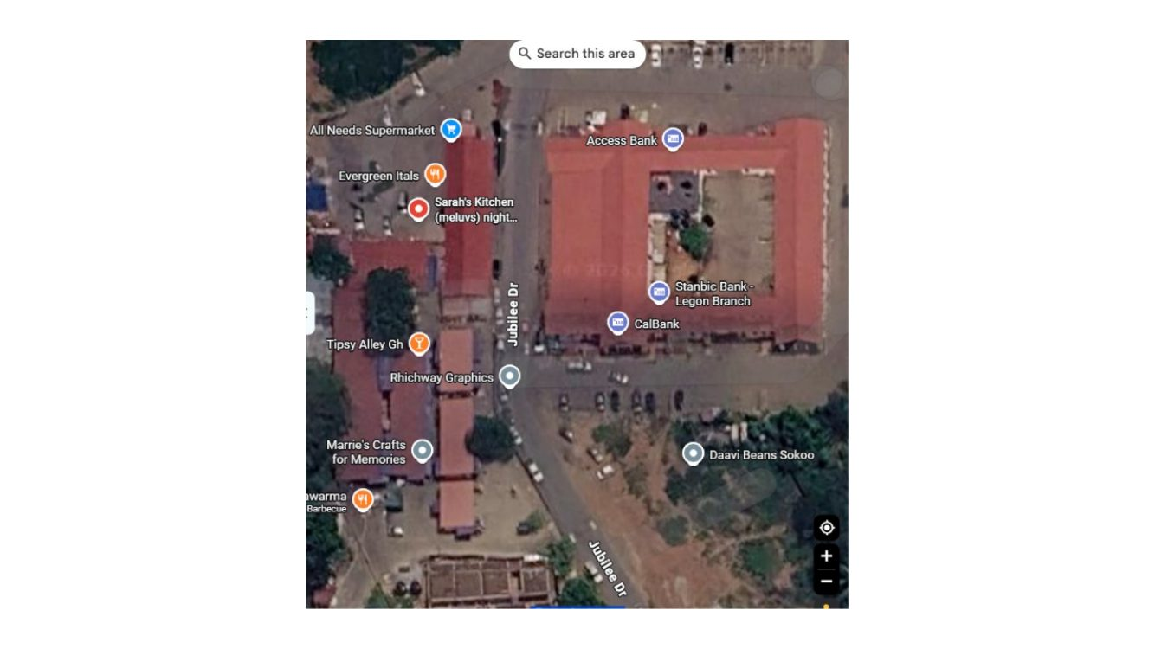
Evidence / correction note: Use as the main geographic anchor for the Night Market/Jubilee Drive work. Match the footprints, road alignment, adjacent retail blocks and bank labels; map labels are not building geometry.
Source: CORRECTION FILE.pptx, slide 1. Full slide retained; imagery and markup are not intentionally cropped.

Source Slide 02 — In-game supermarket frontage versus real low commercial block
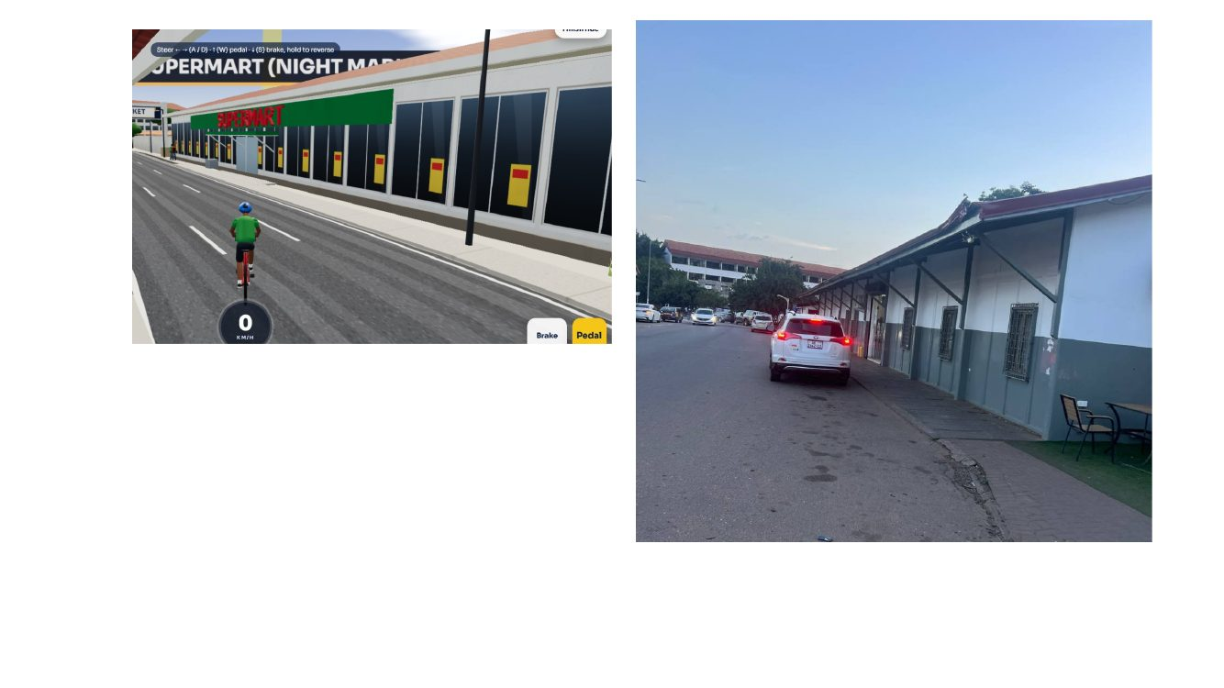
Evidence / correction note: The game shows a long glazed frontage, broad green fascia and repeated yellow/red panels. The real image shows a low, long building with a pitched/corrugated roof, shaded frontage and slender dark supports. Reconcile the building identity before assigning the facade.
Source: CORRECTION FILE.pptx, slide 2. Full slide retained; imagery and markup are not intentionally cropped.

Source Slide 03 — Roadside long block: facade and sidewalk reference
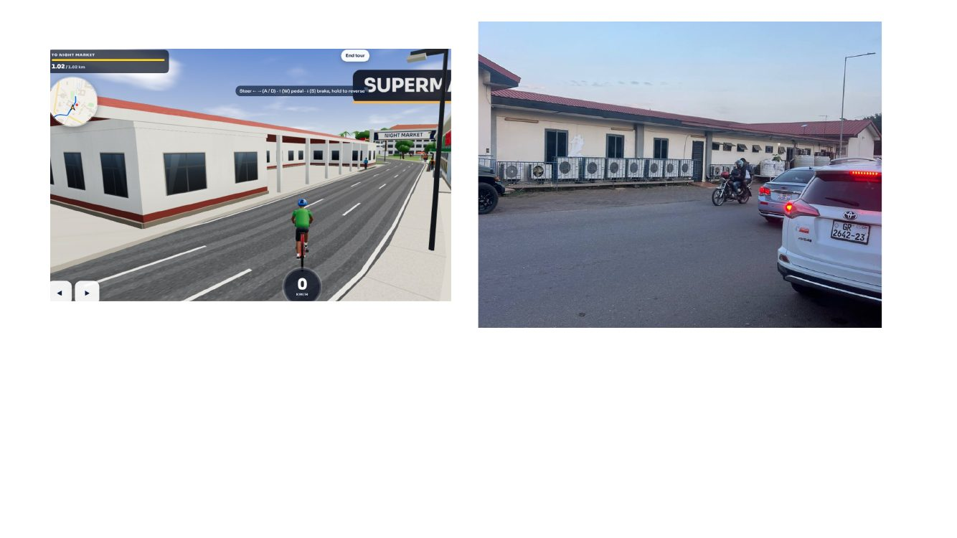
Evidence / correction note: Compare the one-storey white/grey structure, red roof edge, window rhythm, covered walkway and road-side paving. Do not replace this long low block with a glass retail box.
Source: CORRECTION FILE.pptx, slide 3. Full slide retained; imagery and markup are not intentionally cropped.

Source Slide 04 — Market shop / Euburger frontage context
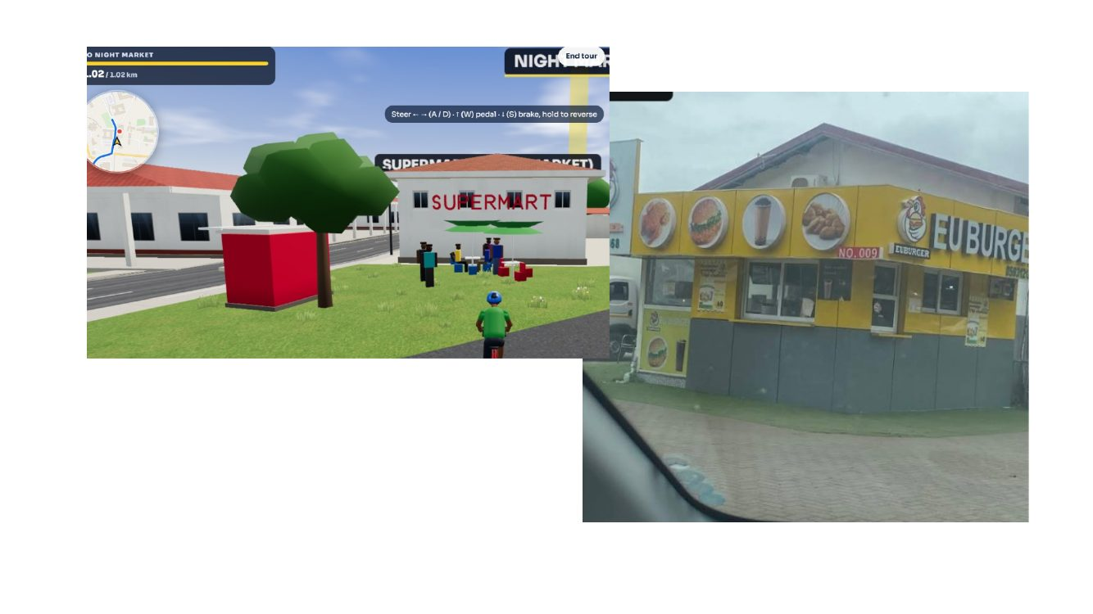
Evidence / correction note: The real Euburger frontage has yellow sign fascia, circular food photographs, dark lower panels and a low pitched roof. Keep it distinct from the long supermarket/commercial block and from generic market stalls.
Source: CORRECTION FILE.pptx, slide 4. Full slide retained; imagery and markup are not intentionally cropped.

Source Slide 05 — All Needs Supermarket reference
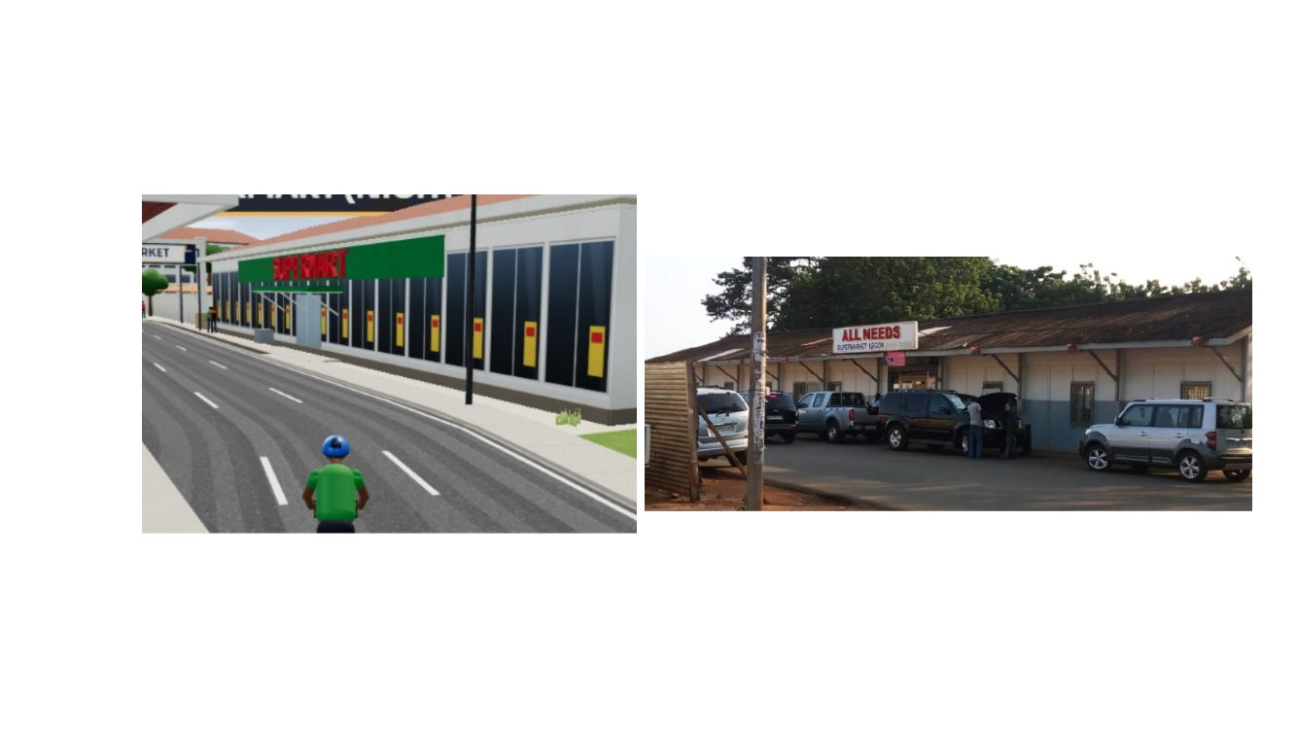
Evidence / correction note: The source photo has an “ALL NEEDS SUPERMARKET LEGON” sign over a long low building, a roofed canopy, dark bracing, barred openings and cars immediately in front. Use the signage/photo as identity evidence only where the mapped footprint matches.
Source: CORRECTION FILE.pptx, slide 5. Full slide retained; imagery and markup are not intentionally cropped.

Source Slide 06 — Euburger building, oblique reference
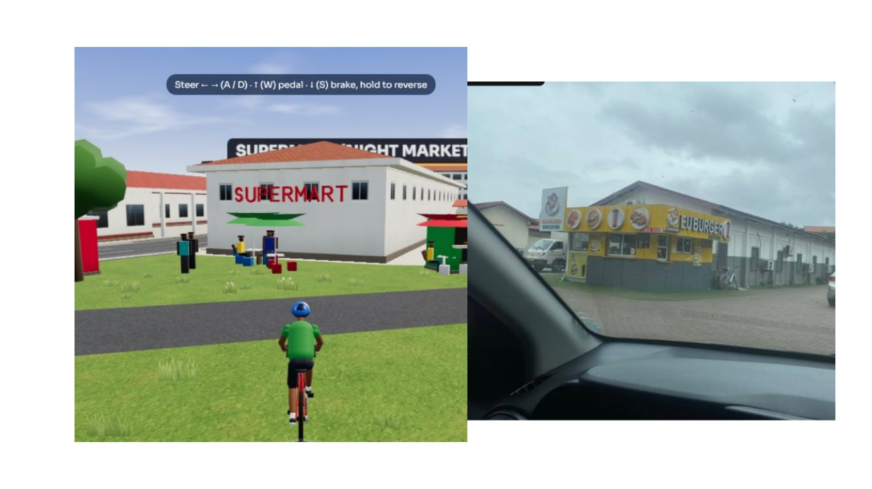
Evidence / correction note: Use the oblique photo to understand the yellow food-service fascia wrapping the corner, dark lower cladding, service windows and low roof. Keep the street/forecourt paved rather than turning the approach into lawn.
Source: CORRECTION FILE.pptx, slide 6. Full slide retained; imagery and markup are not intentionally cropped.

Source Slide 07 — Night Market kiosk zone versus real roadside retail
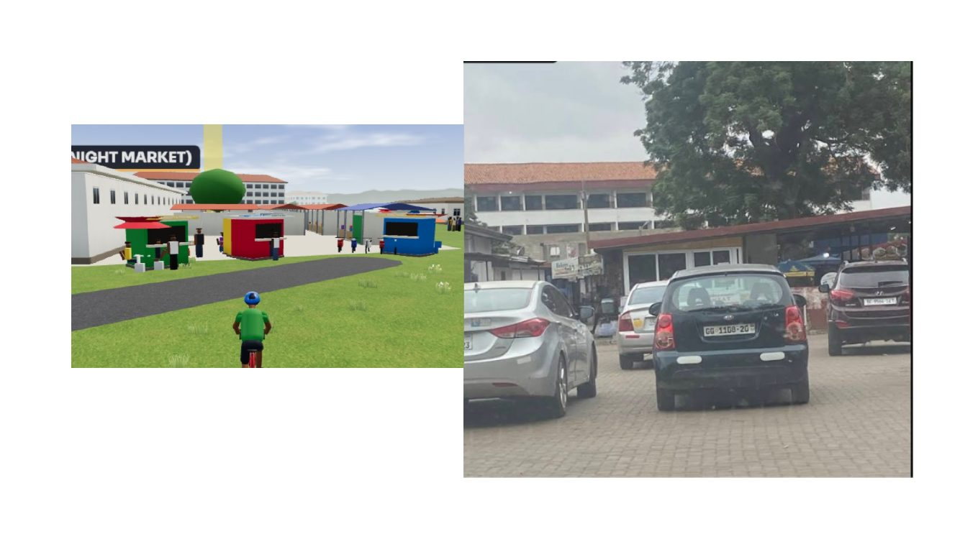
Evidence / correction note: The game kiosk and low-poly crowd must fit the real vendor/shop arrangement. Remove unsupported placeholder masses, but keep stalls supported by source photos and avoid placing them arbitrarily across lawns or routes.
Source: CORRECTION FILE.pptx, slide 7. Full slide retained; imagery and markup are not intentionally cropped.

Source Slide 08 — Vendor court and small kiosk arrangement
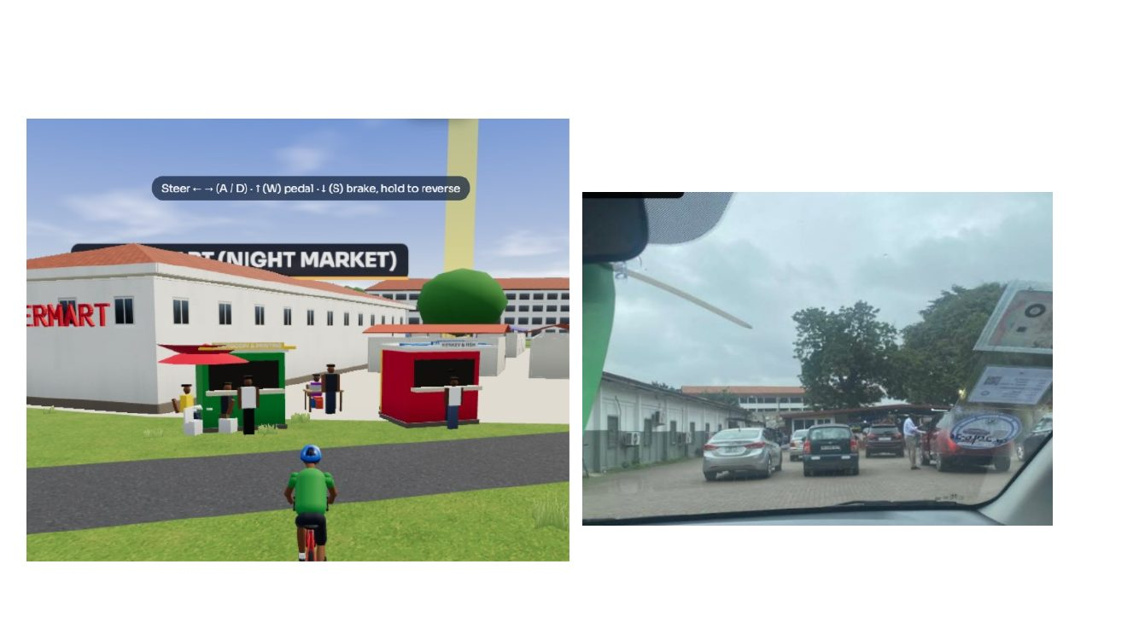
Evidence / correction note: Compare the game kiosks and people with the real roadside market view. Correct kiosk positions, size, canopy colours and spacing from the street/photo context; preserve pedestrian circulation.
Source: CORRECTION FILE.pptx, slide 8. Full slide retained; imagery and markup are not intentionally cropped.

Source Slide 09 — Side view of long low block / nighttime reference
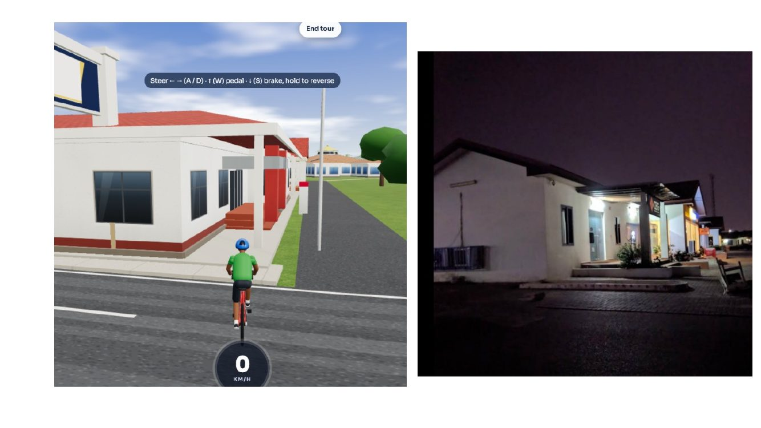
Evidence / correction note: The real night photo shows a low light-coloured building, dark roof/canopy, warm entrance lighting and a paved forecourt. Do not add tall glass frontage or an oversized in-world header sign.
Source: CORRECTION FILE.pptx, slide 9. Full slide retained; imagery and markup are not intentionally cropped.

Source Slide 10 — Nearby commercial strip and CalBank reference
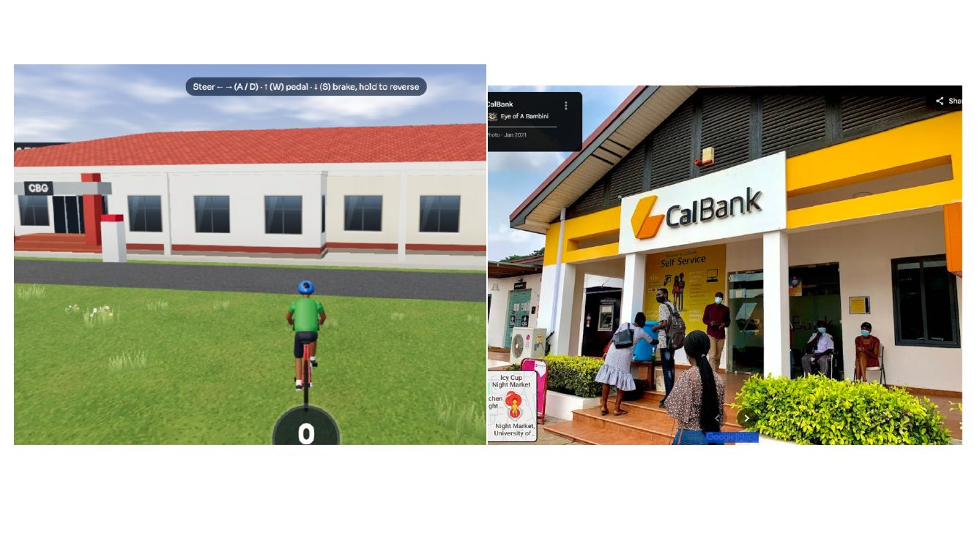
Evidence / correction note: The slide juxtaposes the game frontage and a real CalBank photo. Treat the CalBank image as a separate identity reference; do not assume the entire long game facade is the bank.
Source: CORRECTION FILE.pptx, slide 10. Full slide retained; imagery and markup are not intentionally cropped.

Source Slide 11 — CalBank front elevation
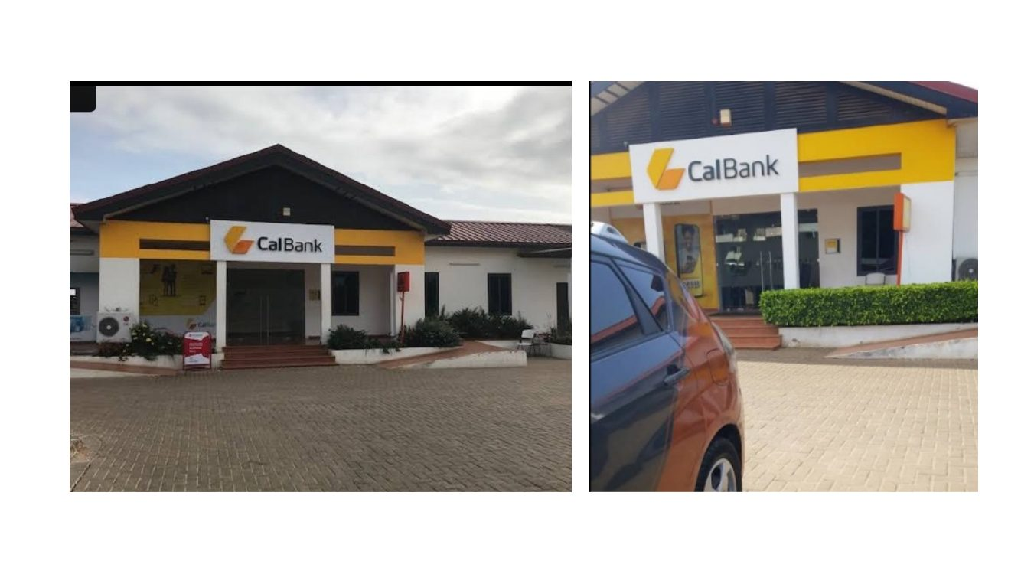
Evidence / correction note: CalBank has a small low-rise branch form with a prominent pitched roof, dark triangular louvred gable, yellow fascia, white columns and a centered entrance sign. Separate the bank from neighbouring units.
Source: CORRECTION FILE.pptx, slide 11. Full slide retained; imagery and markup are not intentionally cropped.

Source Slide 12 — CalBank sign and entry detail
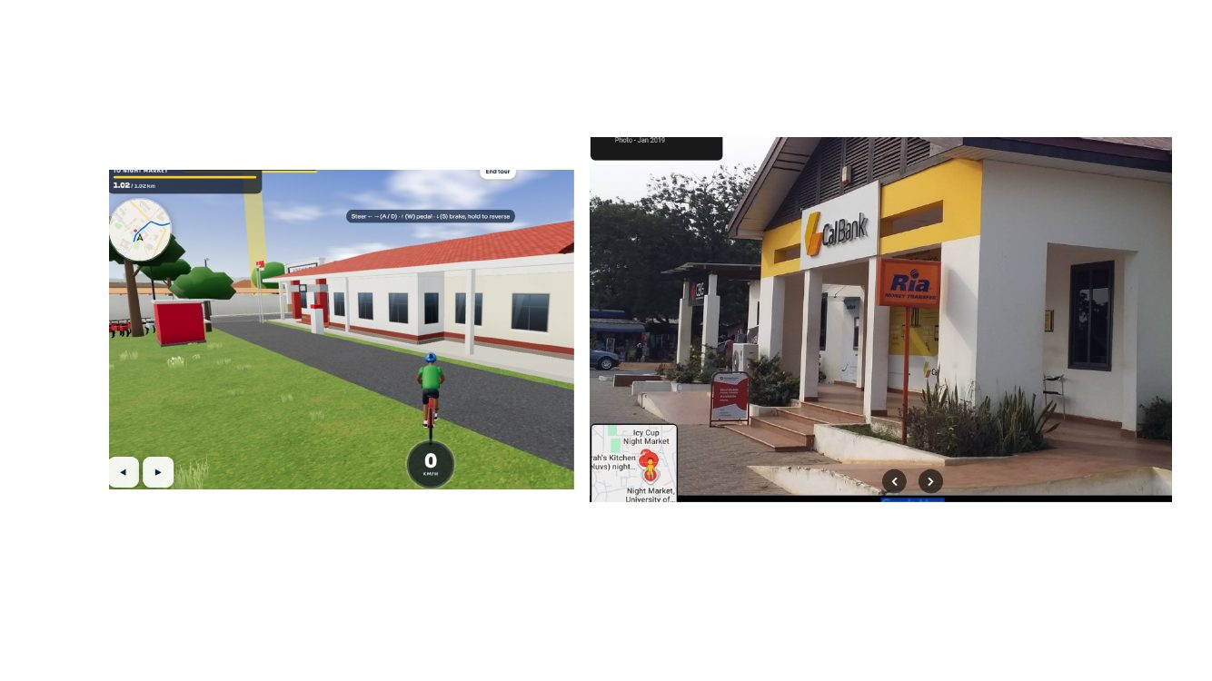
Evidence / correction note: Use the entrance sign, yellow brand band, white supports, dark glazing, steps and paved approach. Planting is a trimmed hedge/low planting bed, not random grass patches.
Source: CORRECTION FILE.pptx, slide 12. Full slide retained; imagery and markup are not intentionally cropped.

Source Slide 13 — CalBank frontal facade reference
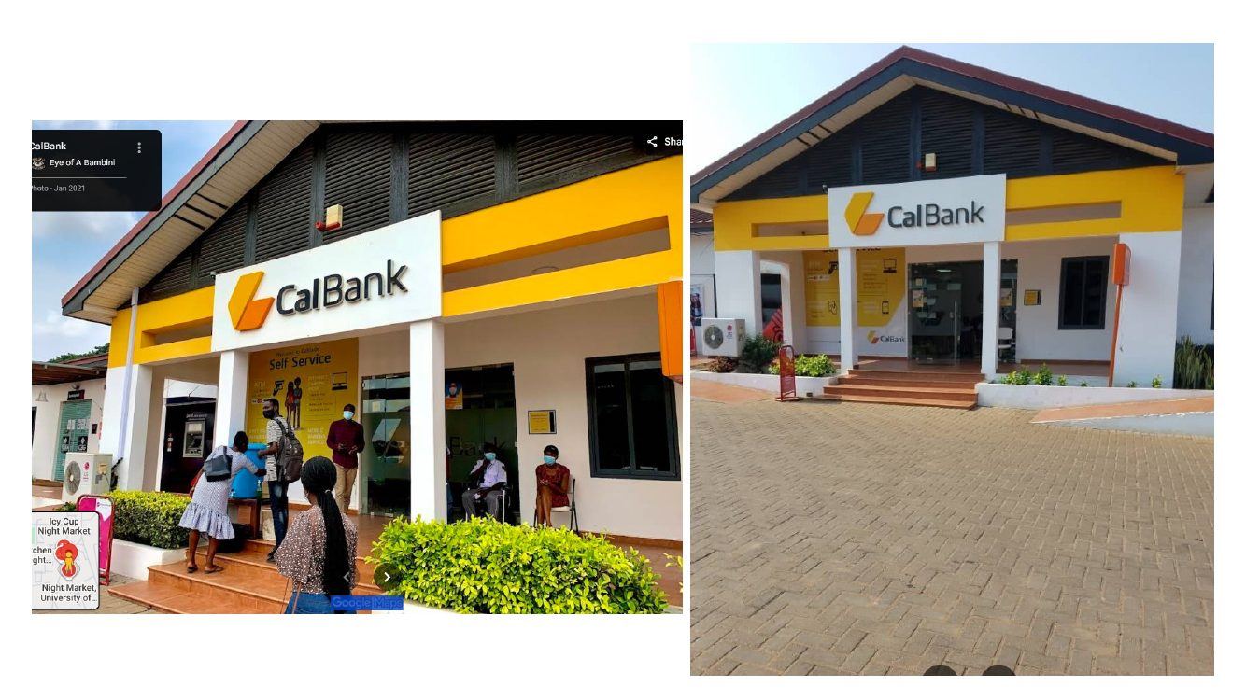
Evidence / correction note: This view confirms the pitched roof, deep black louvred gable, white CalBank sign panel, yellow band, recessed entry, side windows and short steps. Keep proportions low and horizontal.
Source: CORRECTION FILE.pptx, slide 13. Full slide retained; imagery and markup are not intentionally cropped.

Source Slide 14 — In-game low block and Prudential Bank reference
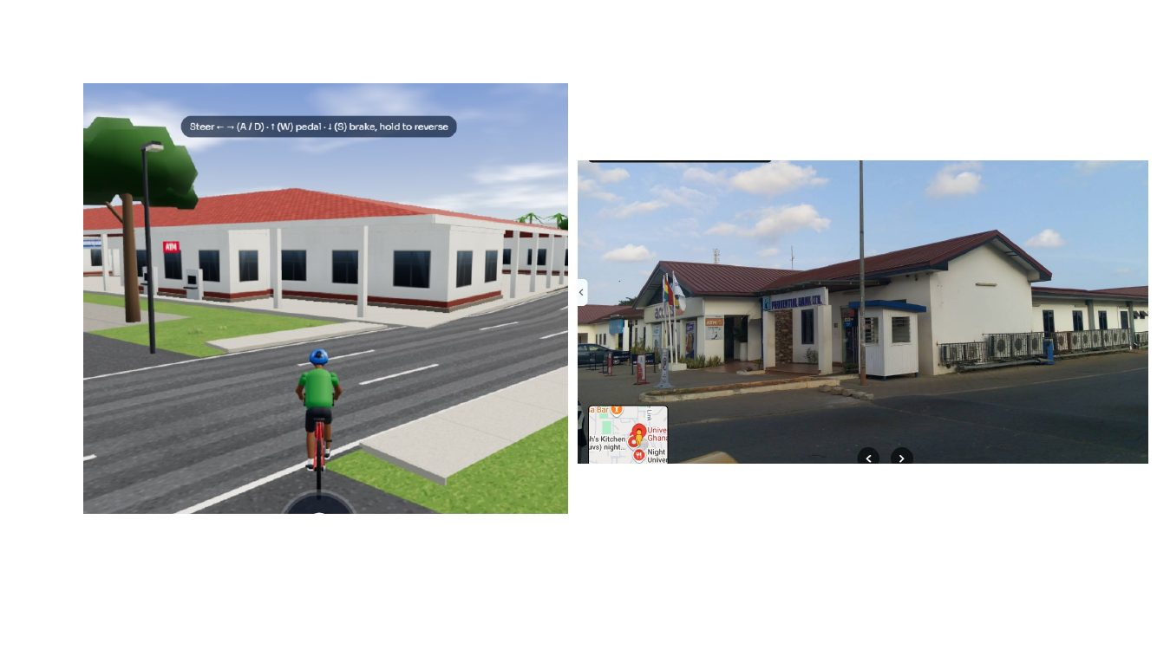
Evidence / correction note: The real Prudential Bank image shows a low branch with a red-brown roof, pale walls, blue bank sign and separate entrance volume. Verify mapped identity; do not transfer CalBank colours to Prudential Bank.
Source: CORRECTION FILE.pptx, slide 14. Full slide retained; imagery and markup are not intentionally cropped.

Source Slide 15 — Prudential Bank entrance and adjacent services
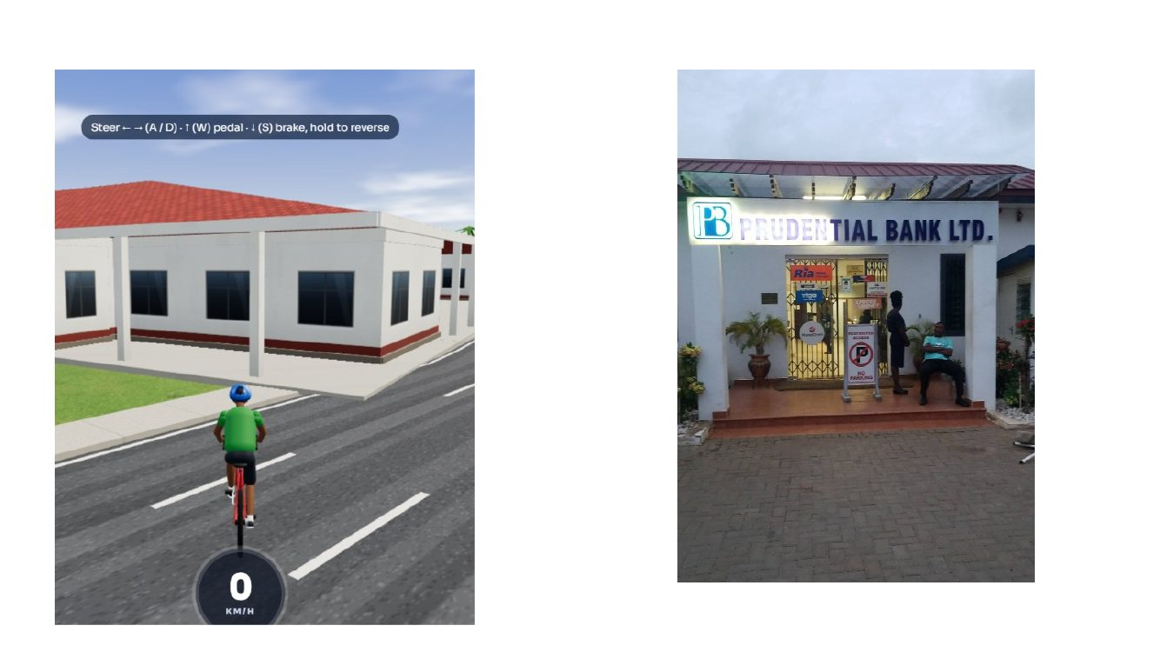
Evidence / correction note: Use the close reference for Prudential Bank signage, recessed door, tiled entrance/steps and pavement. Keep its footprint and neighbouring shop frontage separate.
Source: CORRECTION FILE.pptx, slide 15. Full slide retained; imagery and markup are not intentionally cropped.

Source Slide 16 — Explicit “REMOVE ALL WRONG STRUCTURES” markup
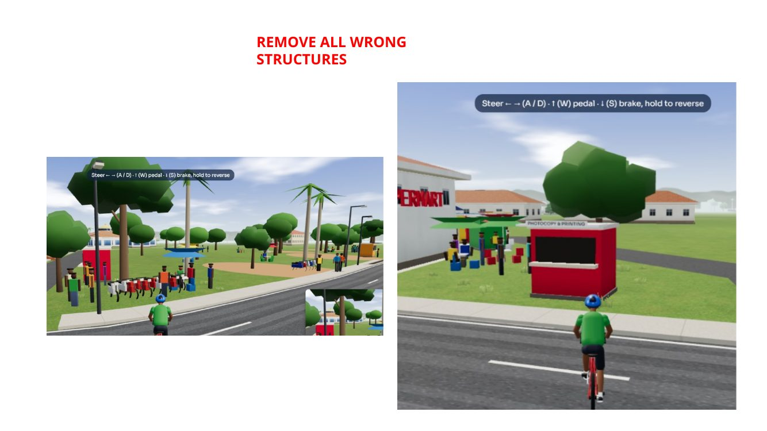
Evidence / correction note: This is a direct correction note. Remove unsubstantiated placeholder structures from the marked game scene after checking evidence; the phrase does not prove every real-world kiosk/stall should be deleted.
Source: CORRECTION FILE.pptx, slide 16. Full slide retained; imagery and markup are not intentionally cropped.

Source Slide 17 — Market vendors and small shopfronts
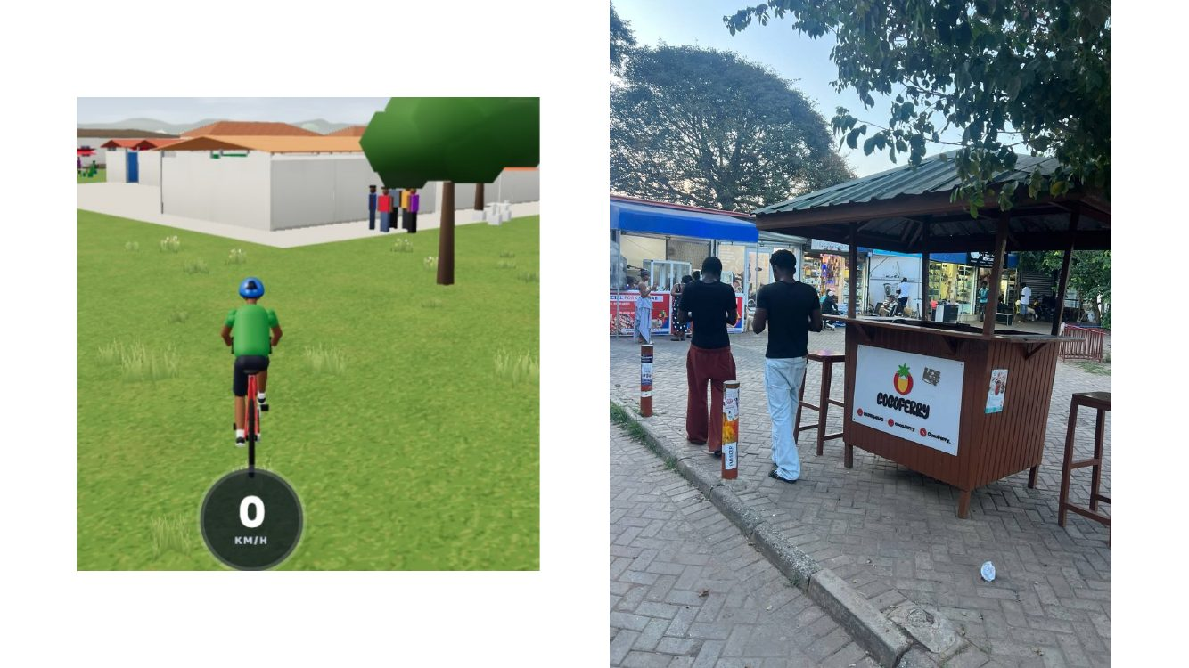
Evidence / correction note: Real photograph shows freestanding/roadside vendors beneath a tree beside a paved walkway. Use low stall counters, awnings and plausible spacing; do not populate every lawn with stalls.
Source: CORRECTION FILE.pptx, slide 17. Full slide retained; imagery and markup are not intentionally cropped.

Source Slide 18 — Roadside retail stalls versus in-game road
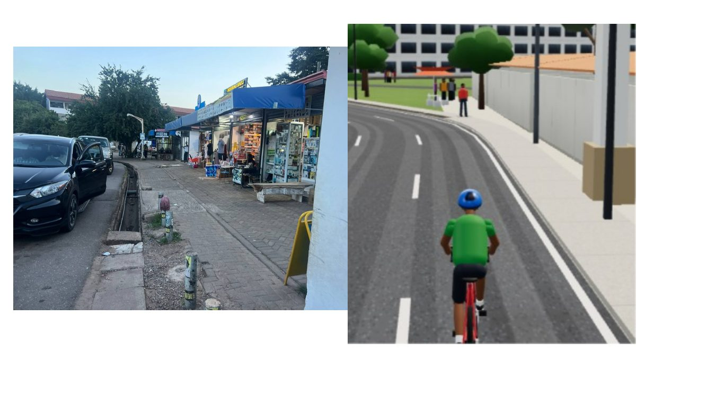
Evidence / correction note: Align road edge, sidewalk, vendor strip and adjacent parked cars with the photograph. Keep the carriageway clear and preserve real driveway/access breaks.
Source: CORRECTION FILE.pptx, slide 18. Full slide retained; imagery and markup are not intentionally cropped.

Source Slide 19 — Blue kiosk and vendor frontage
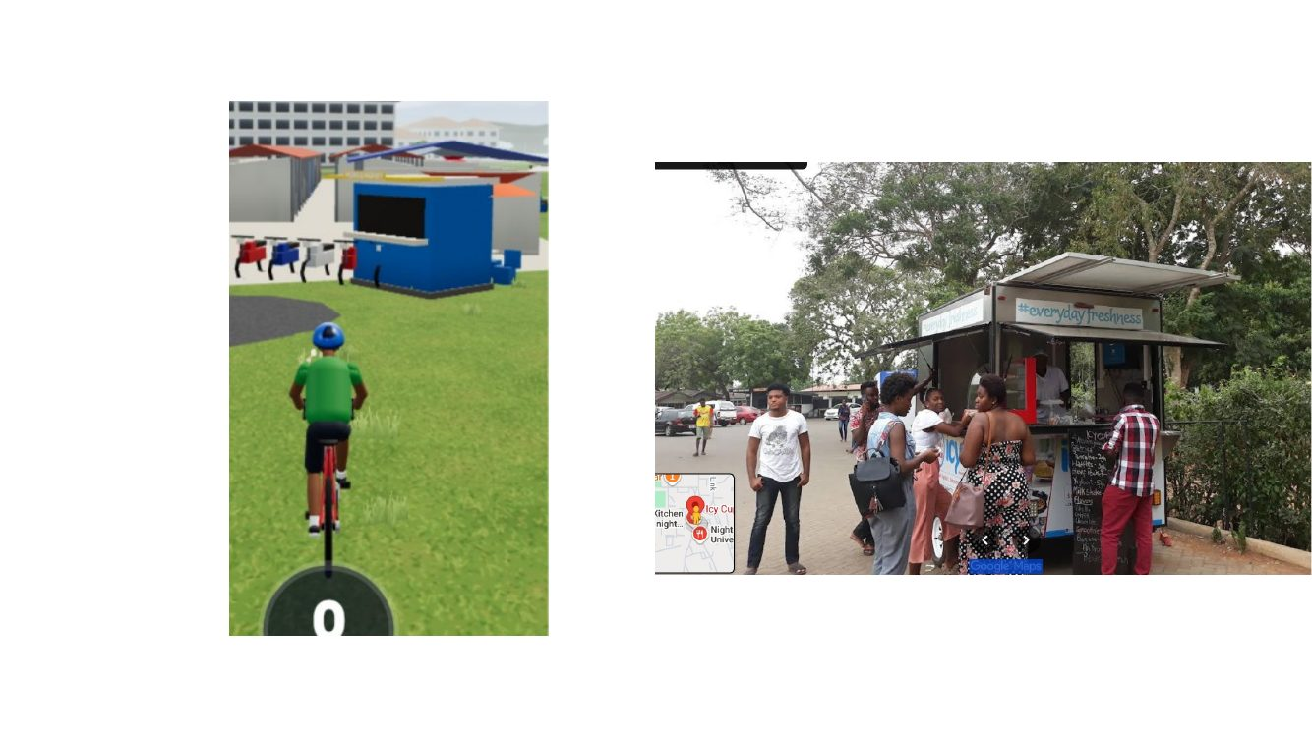
Evidence / correction note: The blue kiosk in-game needs evidence-based size, colour, roof and placement; compare the actual shopfront/vendor photo and use a clear pedestrian path.
Source: CORRECTION FILE.pptx, slide 19. Full slide retained; imagery and markup are not intentionally cropped.

Source Slide 20 — Street corridor, trees and road profile
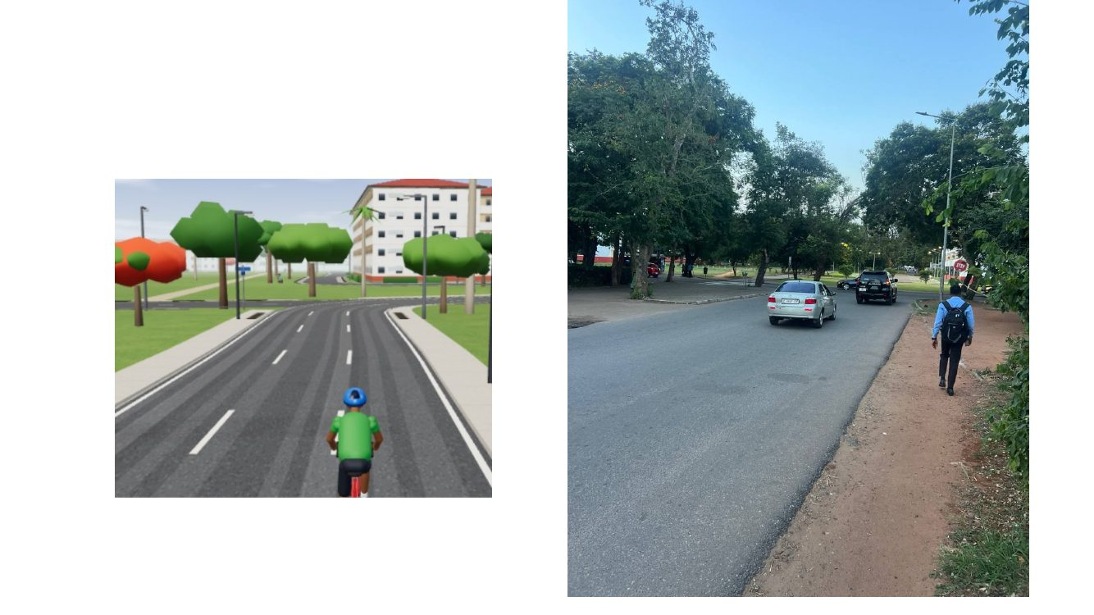
Evidence / correction note: Match the straight road, roadside path/verge, mature trees and roadside commercial frontage from the reference. Avoid excessive decorative trees or props that narrow the path.
Source: CORRECTION FILE.pptx, slide 20. Full slide retained; imagery and markup are not intentionally cropped.

Source Slide 21 — Legon Basic School aerial boundary
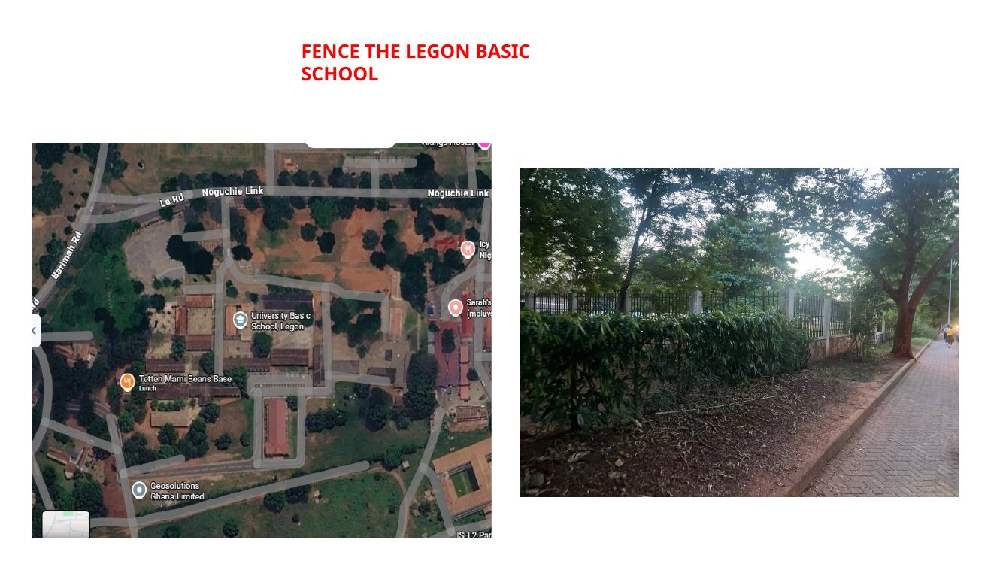
Evidence / correction note: The slide explicitly says “FENCE THE LEGON BASIC SCHOOL.” Use the aerial to identify the school perimeter and likely boundary lines; verify the exact fence path against current geography.
Source: CORRECTION FILE.pptx, slide 21. Full slide retained; imagery and markup are not intentionally cropped.

Source Slide 22 — Legon Basic School existing fence photographs
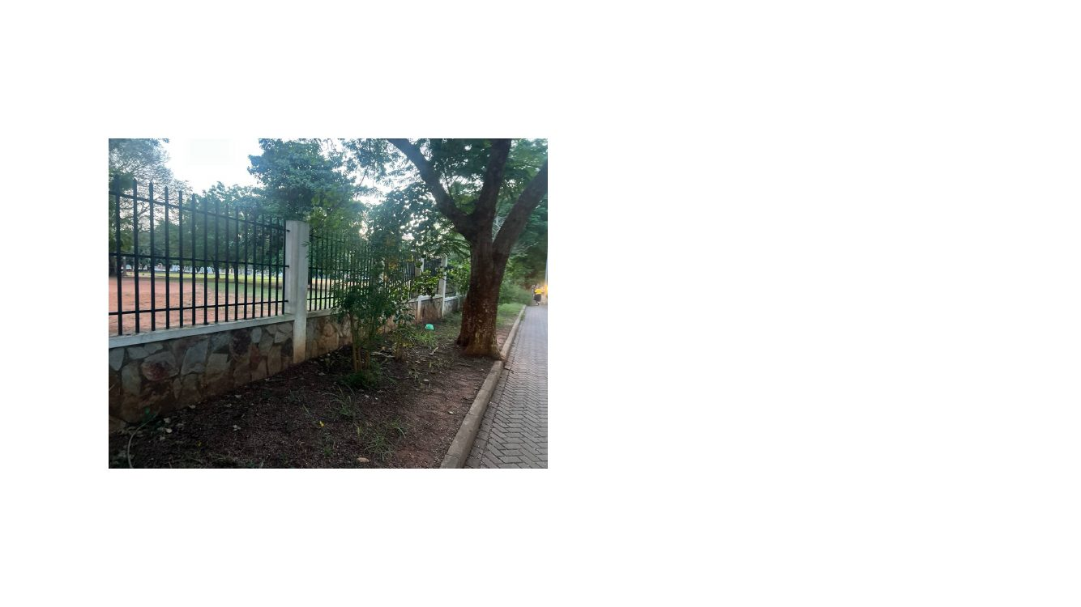
Evidence / correction note: Photos show an existing fence/hedge boundary beside a pedestrian path, trees and ground vegetation. Build a continuous but segmented fence where evidenced, preserving gates and school access.
Source: CORRECTION FILE.pptx, slide 22. Full slide retained; imagery and markup are not intentionally cropped.

Source Slide 23 — Republic Bank section divider

Evidence / correction note: Section label only. Use the following map and real photos, not this title slide, as evidence for geography and facade design.
Source: CORRECTION FILE.pptx, slide 23. Full slide retained; imagery and markup are not intentionally cropped.

Source Slide 24 — Republic Bank Legon Branch satellite location
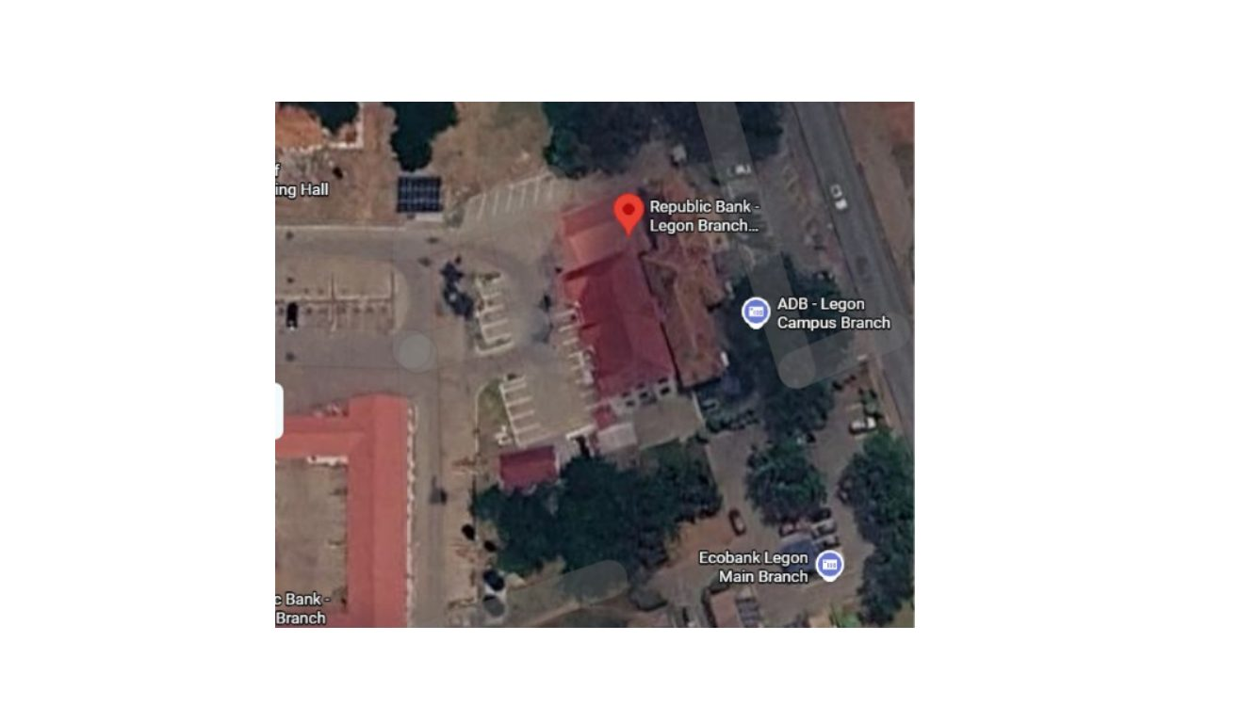
Evidence / correction note: Use this map as the primary location anchor for the bank and nearby Jubilee Drive buildings. Match its footprint and approach/road adjacency with existing geography; do not estimate coordinates from the screenshot alone.
Source: CORRECTION FILE.pptx, slide 24. Full slide retained; imagery and markup are not intentionally cropped.

Source Slide 25 — Republic Bank street-view front elevation
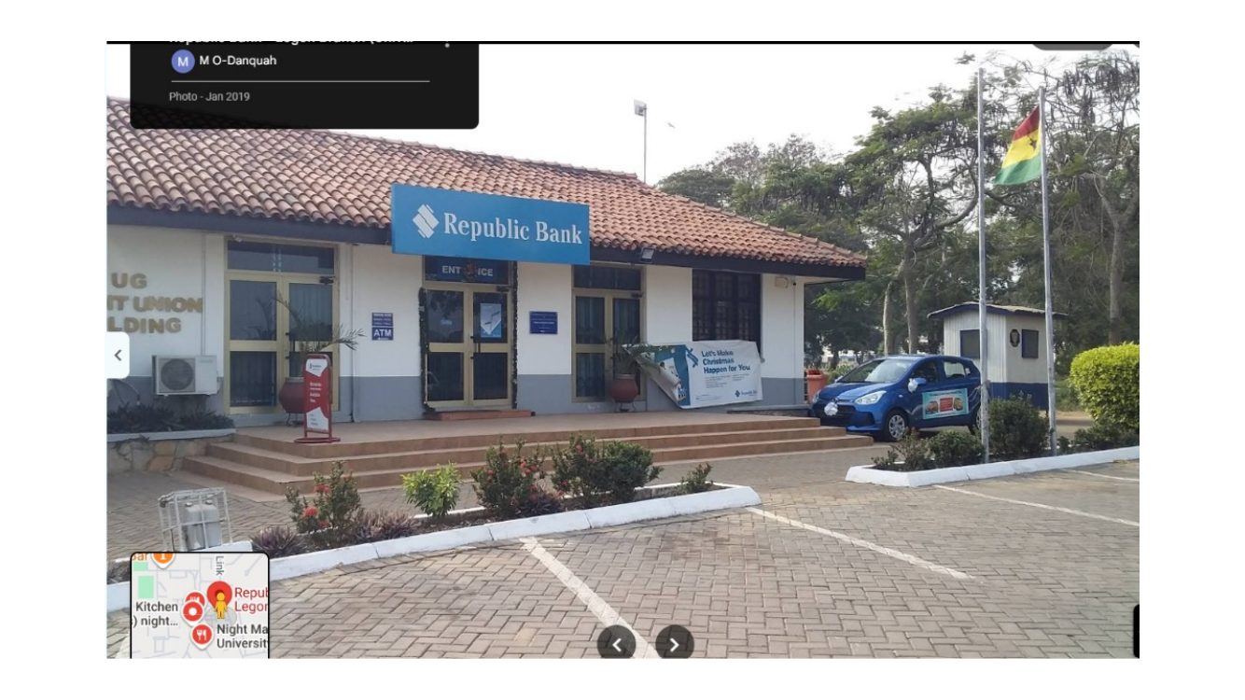
Evidence / correction note: A low-rise pale branch with tiled pitched roof, blue Republic Bank fascia/sign, front glazing/door and a paved entry zone. Restore the bank’s real horizontal proportions and entrance placement.
Source: CORRECTION FILE.pptx, slide 25. Full slide retained; imagery and markup are not intentionally cropped.

Source Slide 26 — Adjacent UG Credit Union Building
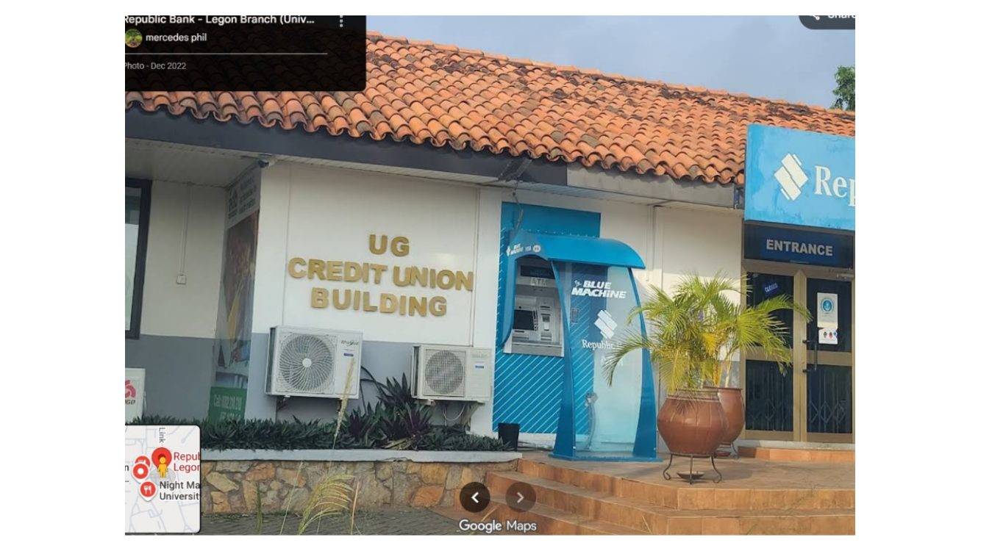
Evidence / correction note: This reference visibly names the “UG CREDIT UNION BUILDING” beside the bank. Keep it as a distinct neighbouring frontage/building; do not paint it as part of Republic Bank.
Source: CORRECTION FILE.pptx, slide 26. Full slide retained; imagery and markup are not intentionally cropped.

Source Slide 27 — Republic Bank facade, forecourt and pavers
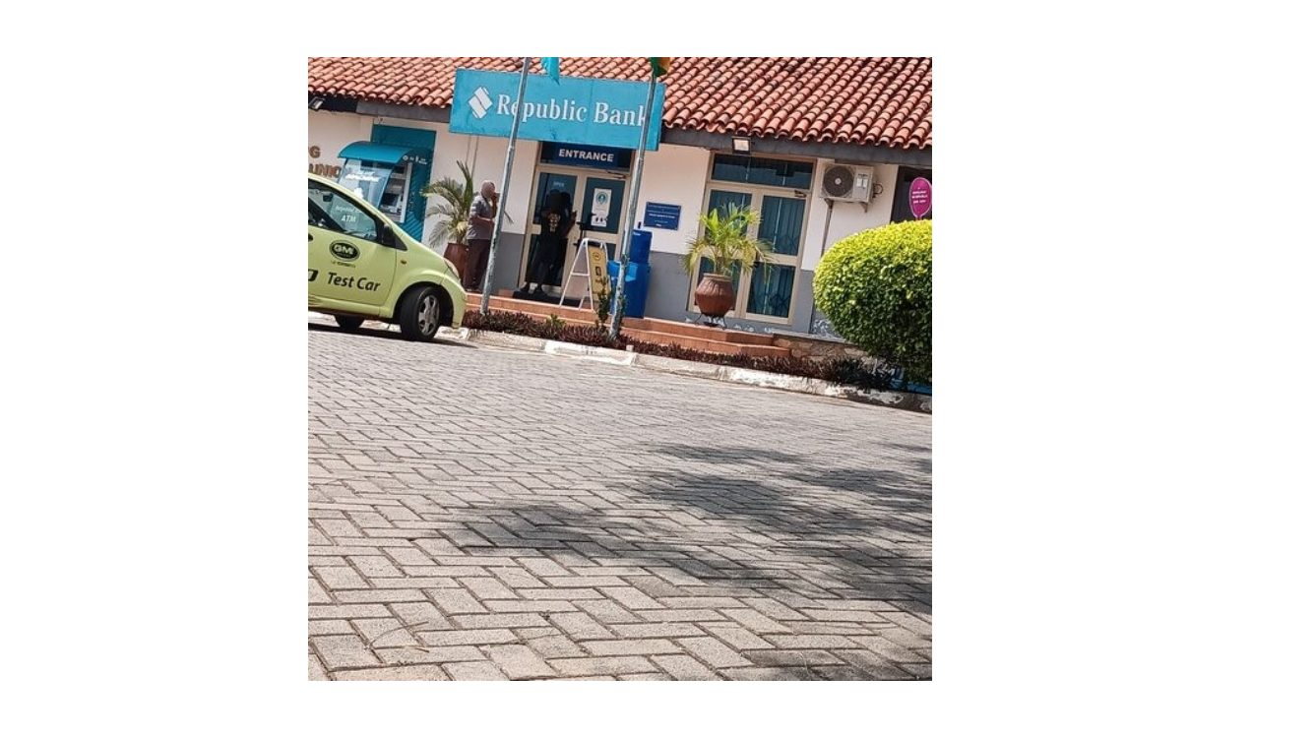
Evidence / correction note: The bank sits behind interlocking paving with shallow landscaping/planters and a defined entrance/steps. Recreate surface transitions and the scale of the small single-storey building.
Source: CORRECTION FILE.pptx, slide 27. Full slide retained; imagery and markup are not intentionally cropped.

Source Slide 28 — Republic Bank freestanding roadside sign
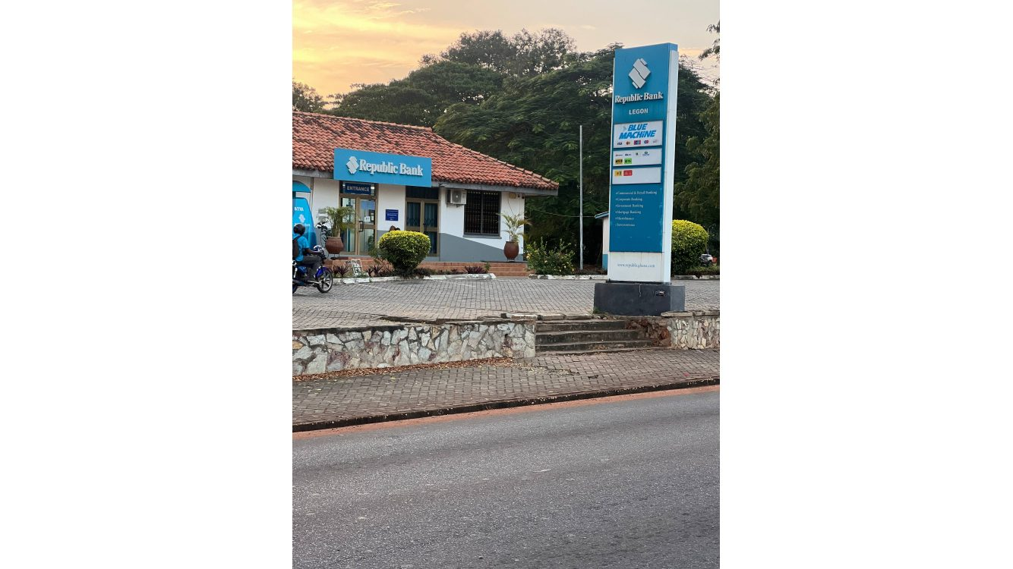
Evidence / correction note: Tall blue sign is set beside the road behind a low stone retaining wall. Maintain realistic height and setback, and do not put the sign on the road or across the sidewalk.
Source: CORRECTION FILE.pptx, slide 28. Full slide retained; imagery and markup are not intentionally cropped.

Source Slide 29 — Republic Bank across the road
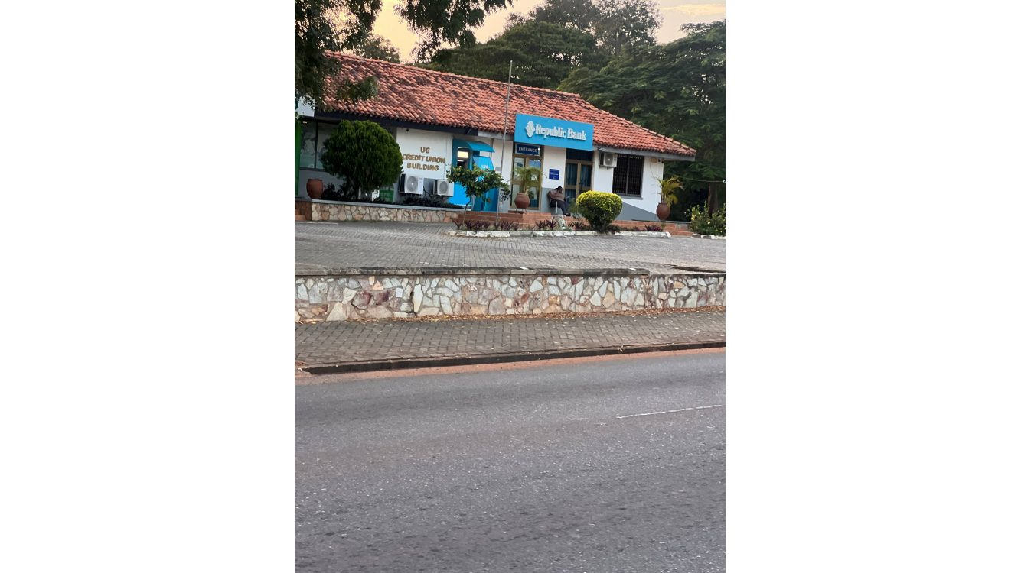
Evidence / correction note: The scene establishes relationship between bank, stone wall, hedges/trees and asphalt carriageway. Retain this context and road clearance.
Source: CORRECTION FILE.pptx, slide 29. Full slide retained; imagery and markup are not intentionally cropped.

Source Slide 30 — Republic Bank sign and frontage in a second angle
Evidence / correction note: Cross-check sign position and bank setback with slide 28; it is another angle on the same site, not a second bank sign to duplicate.
Source: CORRECTION FILE.pptx, slide 30. Full slide retained; imagery and markup are not intentionally cropped.

Source Slide 31 — Jubilee Drive edge/curb reference
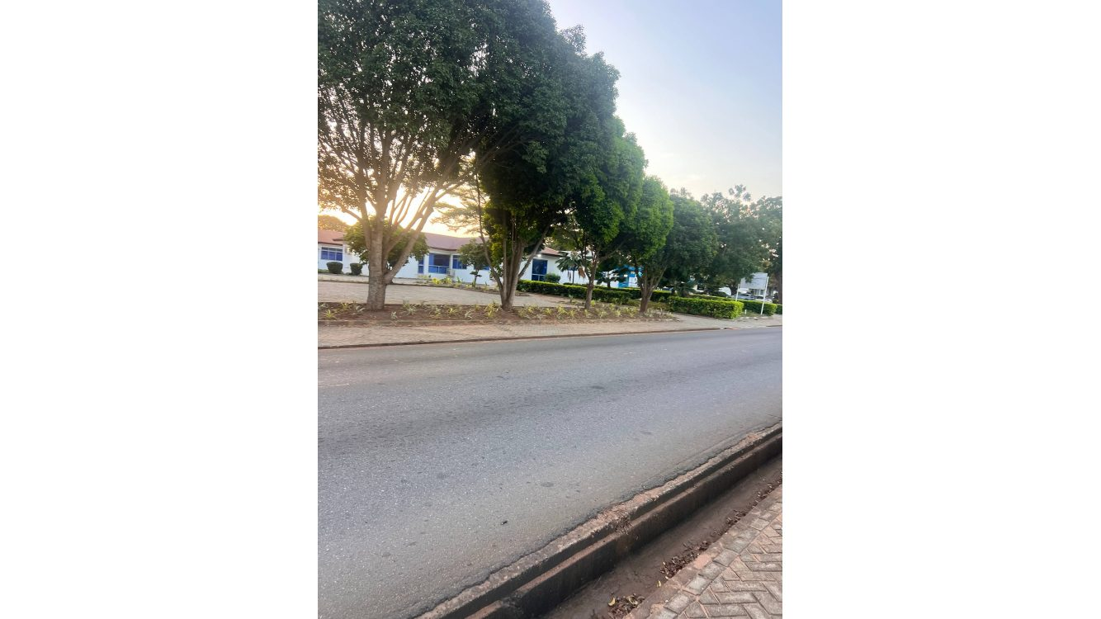
Evidence / correction note: Use this photo to set curb, road edge, sidewalk/verge, tree spacing and road width. Do not over-widen pavement or move the bank solely for a more attractive render.
Source: CORRECTION FILE.pptx, slide 31. Full slide retained; imagery and markup are not intentionally cropped.

Source Slide 32 — Panoramic road and green verge
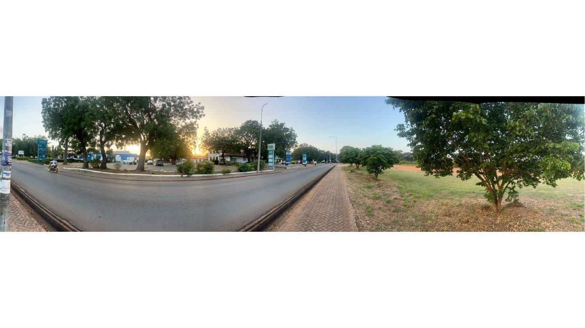
Evidence / correction note: Wide-angle context for the road line, verge, scattered trees and open ground opposite the retail units. Keep the tree pattern sparse/irregular as shown.
Source: CORRECTION FILE.pptx, slide 32. Full slide retained; imagery and markup are not intentionally cropped.

Source Slide 33 — Adjacent green-sign commercial unit
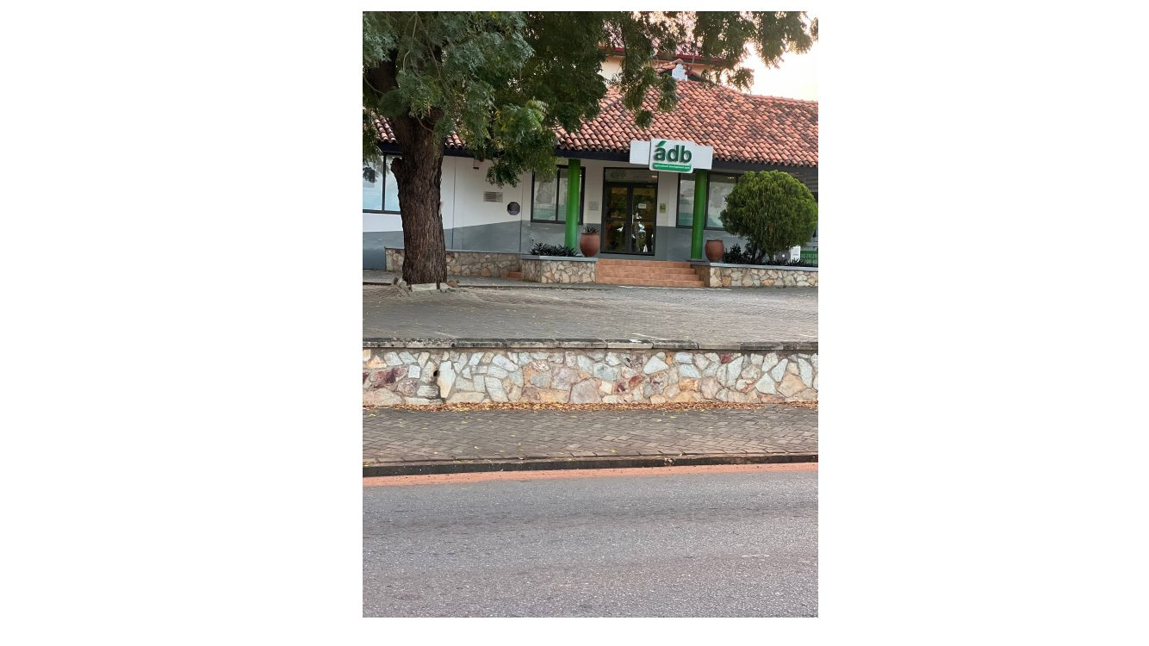
Evidence / correction note: This is a neighbouring shopfront near the bank rather than proven bank facade. Keep independent signage and facade identity.
Source: CORRECTION FILE.pptx, slide 33. Full slide retained; imagery and markup are not intentionally cropped.

Source Slide 34 — Republic Bank front from street view
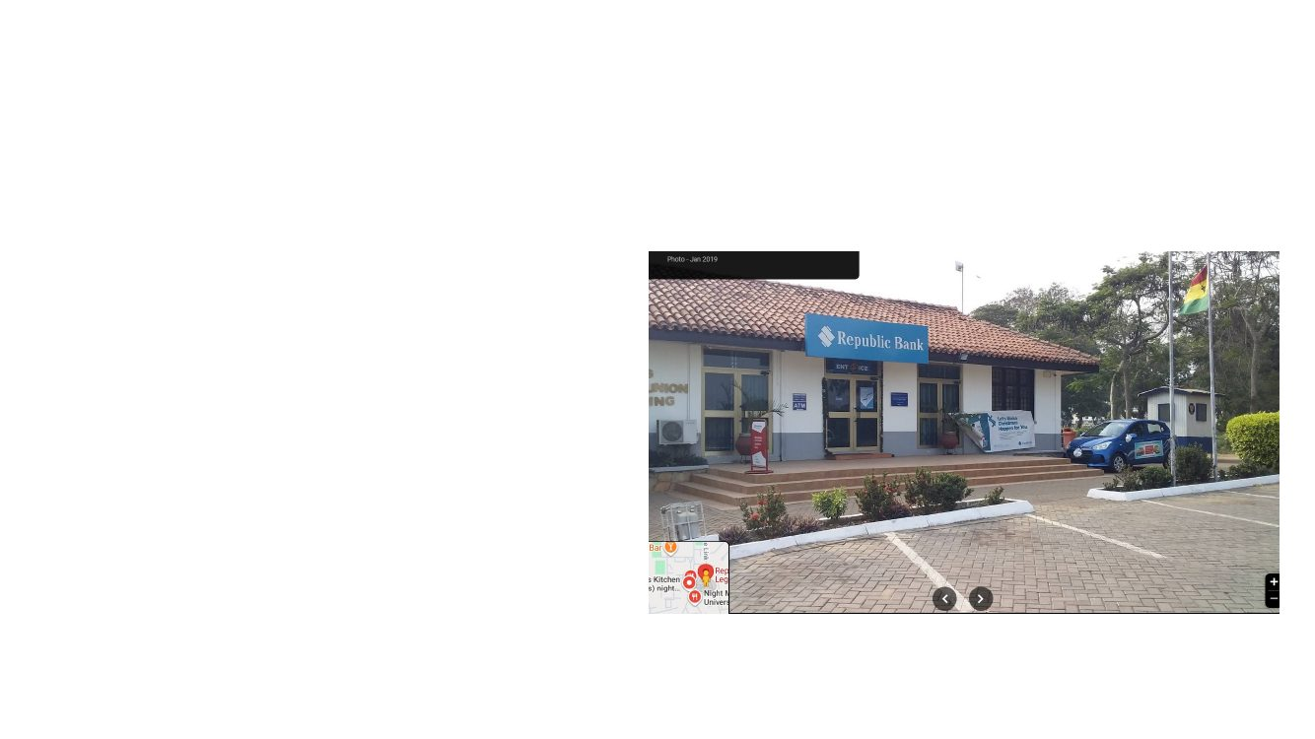
Evidence / correction note: Cross-reference this angle with slides 25 and 27 to settle entry orientation and facade/window arrangement.
Source: CORRECTION FILE.pptx, slide 34. Full slide retained; imagery and markup are not intentionally cropped.

Source Slide 35 — Bank entrance and landscaped forecourt
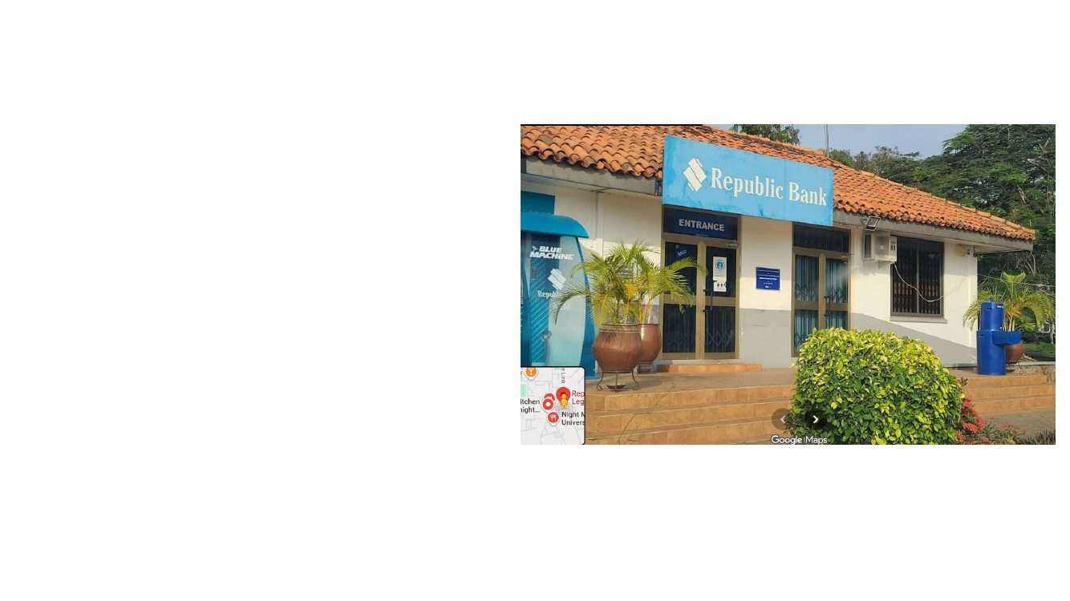
Evidence / correction note: Use the small entrance steps, front windows, blue branding, low shrub bed and broad paved pedestrian apron. Planting should remain within planters/bed outlines.
Source: CORRECTION FILE.pptx, slide 35. Full slide retained; imagery and markup are not intentionally cropped.

Source Slide 36 — Approach paving, curb and landscape islands
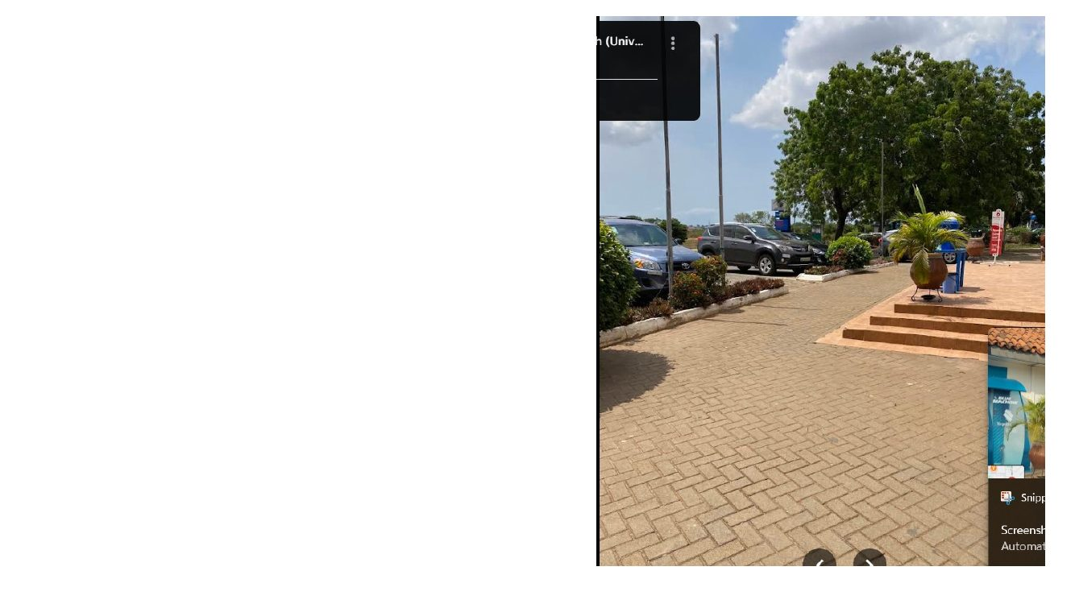
Evidence / correction note: Recreate pedestrian paving blocks, curb/raised planting edges and adjacent street furniture from this street-view angle. Preserve the walking route.
Source: CORRECTION FILE.pptx, slide 36. Full slide retained; imagery and markup are not intentionally cropped.

Source Slide 37 — Nearby metal boundary fence
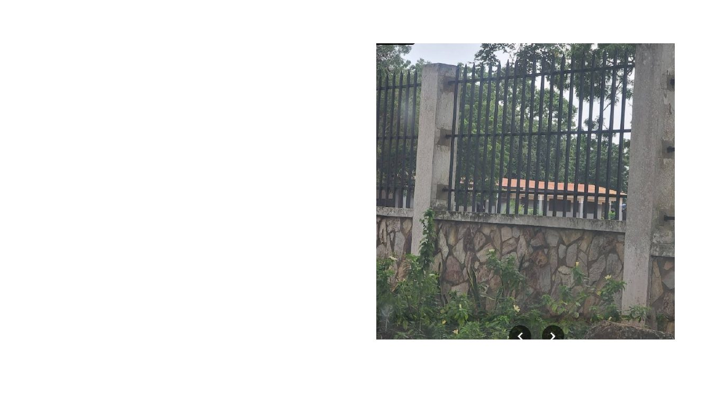
Evidence / correction note: This photograph shows vertical metal bars on a low stone wall near the bank area. Apply it only to the boundary segment supported by map/photo evidence, not automatically along all edges.
Source: CORRECTION FILE.pptx, slide 37. Full slide retained; imagery and markup are not intentionally cropped.

Source Slide 38 — Satellite overview of Republic Bank area
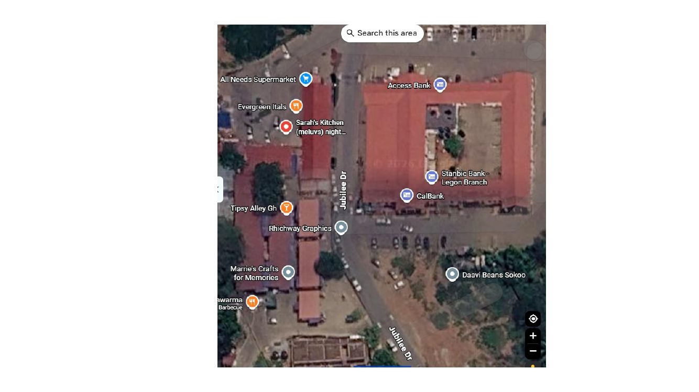
Evidence / correction note: The satellite confirms the bank area amid several retail footprints. Use this and slide 39 to align the building, adjoining shops, road and open areas before visual modelling.
Source: CORRECTION FILE.pptx, slide 38. Full slide retained; imagery and markup are not intentionally cropped.

Source Slide 39 — Wider aerial view with Jubilee Drive and neighbours
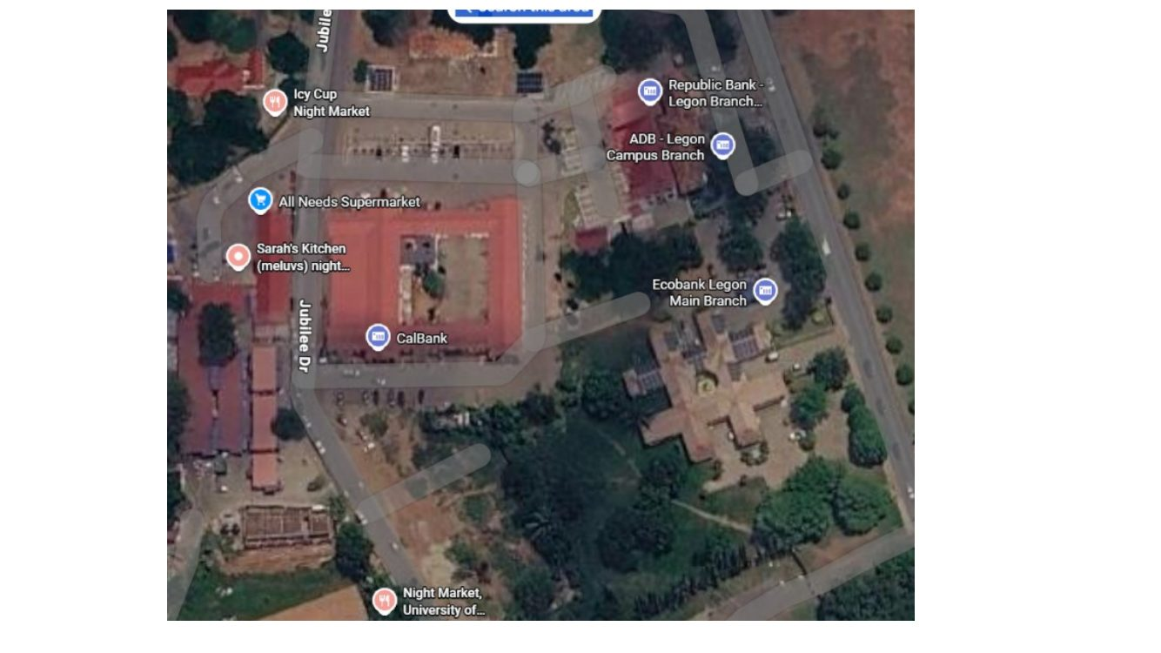
Evidence / correction note: Wider context helps distinguish Republic Bank from nearby banks and shops. Preserve the arrangement of footprints and street connections.
Source: CORRECTION FILE.pptx, slide 39. Full slide retained; imagery and markup are not intentionally cropped.

Source Slide 40 — Ecobank Legon Main Branch satellite anchor
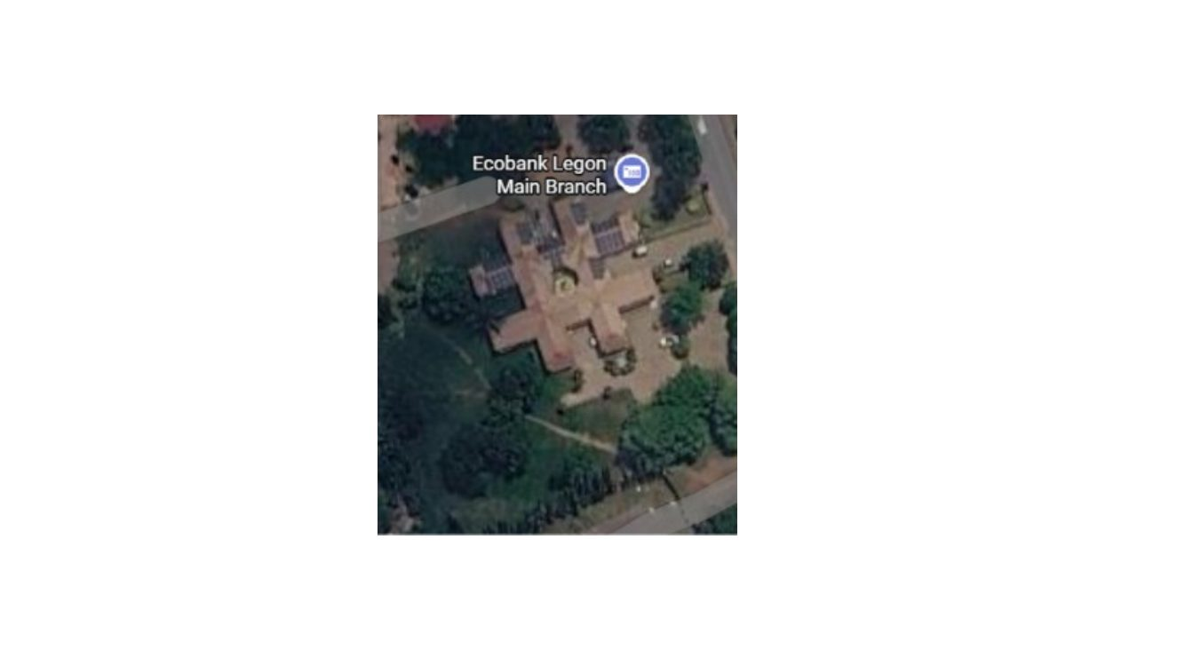
Evidence / correction note: This map/image starts the Ecobank package. Use it to locate the Ecobank site and orientation; do not borrow the Republic Bank footprint.
Source: CORRECTION FILE.pptx, slide 40. Full slide retained; imagery and markup are not intentionally cropped.

Source Slide 41 — Ecobank section divider

Evidence / correction note: Section label only; following slides provide map sign, building elevations and landscape details.
Source: CORRECTION FILE.pptx, slide 41. Full slide retained; imagery and markup are not intentionally cropped.

Source Slide 42 — Ecobank multi-panel roadside sign
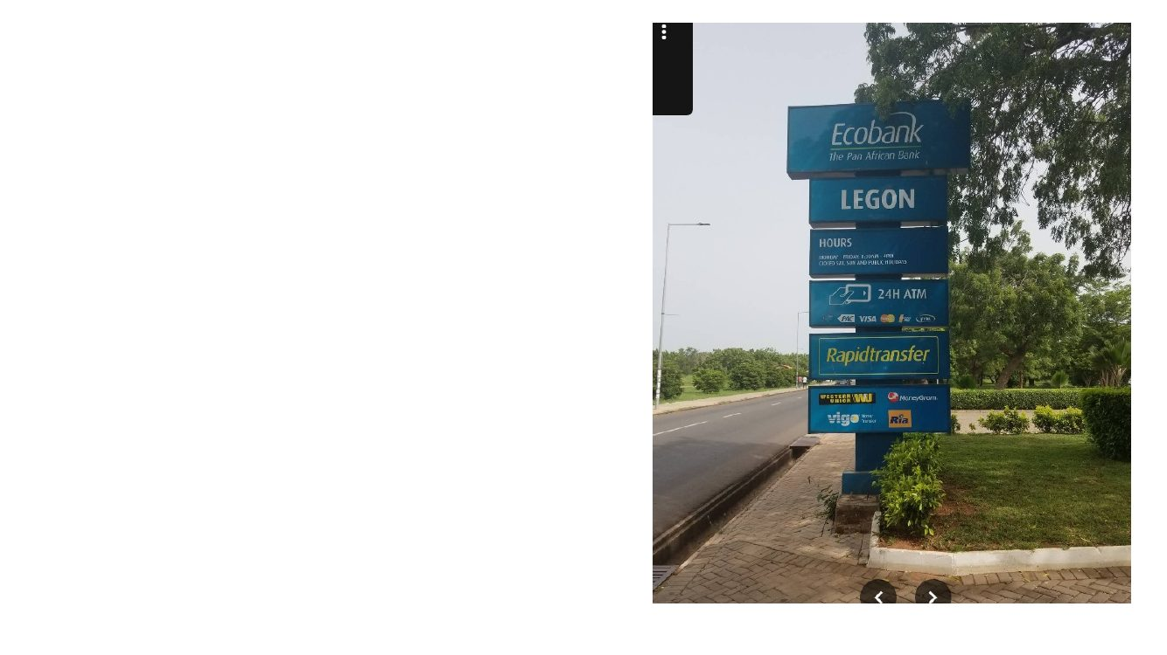
Evidence / correction note: A tall blue/teal wayfinding sign stands near the road and landscaping. Match overall height, panel stack, post and setback; text should be readable only if it can be grounded from source.
Source: CORRECTION FILE.pptx, slide 42. Full slide retained; imagery and markup are not intentionally cropped.

Source Slide 43 — Ecobank branch and parking reference
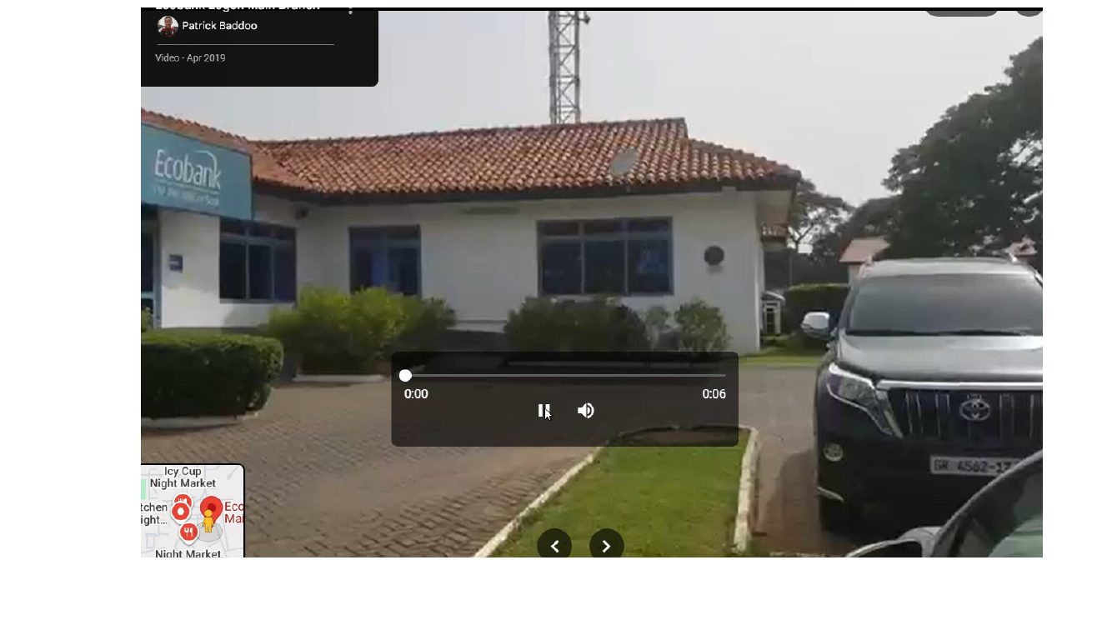
Evidence / correction note: The real branch is a single-storey low-rise building with white walls, red/brown tile roof, blue/teal fascia and glazing. Cars occupy a paved front parking area.
Source: CORRECTION FILE.pptx, slide 43. Full slide retained; imagery and markup are not intentionally cropped.

Source Slide 44 — Ecobank seating, lawn and entry context
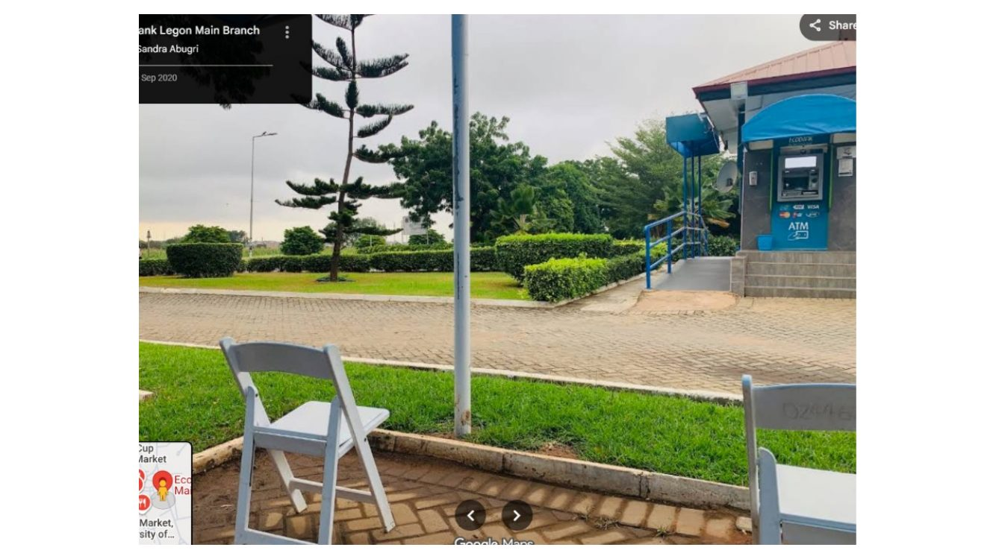
Evidence / correction note: Photo shows outdoor chairs at the edge of the paved forecourt, trimmed lawn, walkway, landscaping and branch entrance area. Do not place chairs in the driving lane.
Source: CORRECTION FILE.pptx, slide 44. Full slide retained; imagery and markup are not intentionally cropped.

Source Slide 45 — Ecobank side facade and paved surface
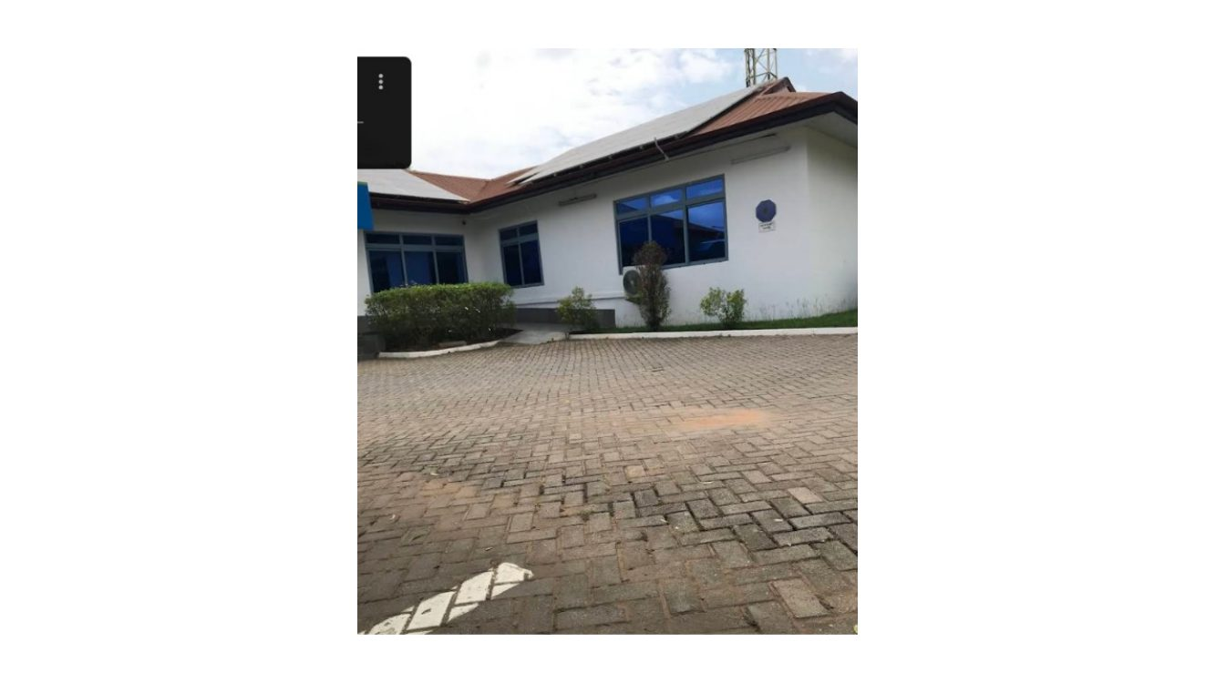
Evidence / correction note: Use the window rhythm, wall colour, roof profile, sidewalk pavers and asphalt/paver join. Keep the facade low and horizontal.
Source: CORRECTION FILE.pptx, slide 45. Full slide retained; imagery and markup are not intentionally cropped.

Source Slide 46 — Ecobank site from road across trees
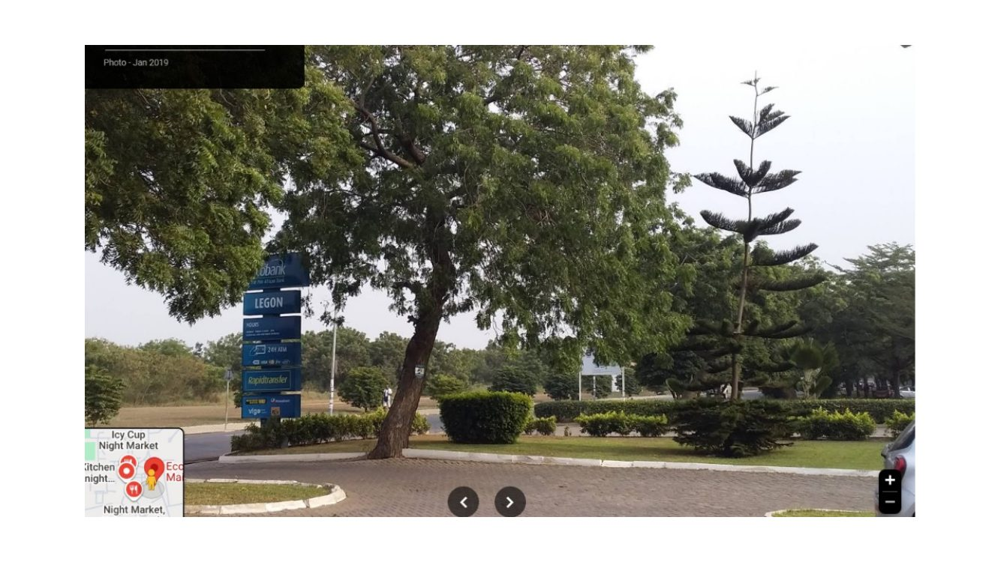
Evidence / correction note: This view establishes sign, mature trees and shrub/hedge positions relative to the branch and roadside. Use a small number of well-placed trees, not a dense decorative canopy over the entrance.
Source: CORRECTION FILE.pptx, slide 46. Full slide retained; imagery and markup are not intentionally cropped.

Source Slide 47 — Ecobank from across lawn and hedge
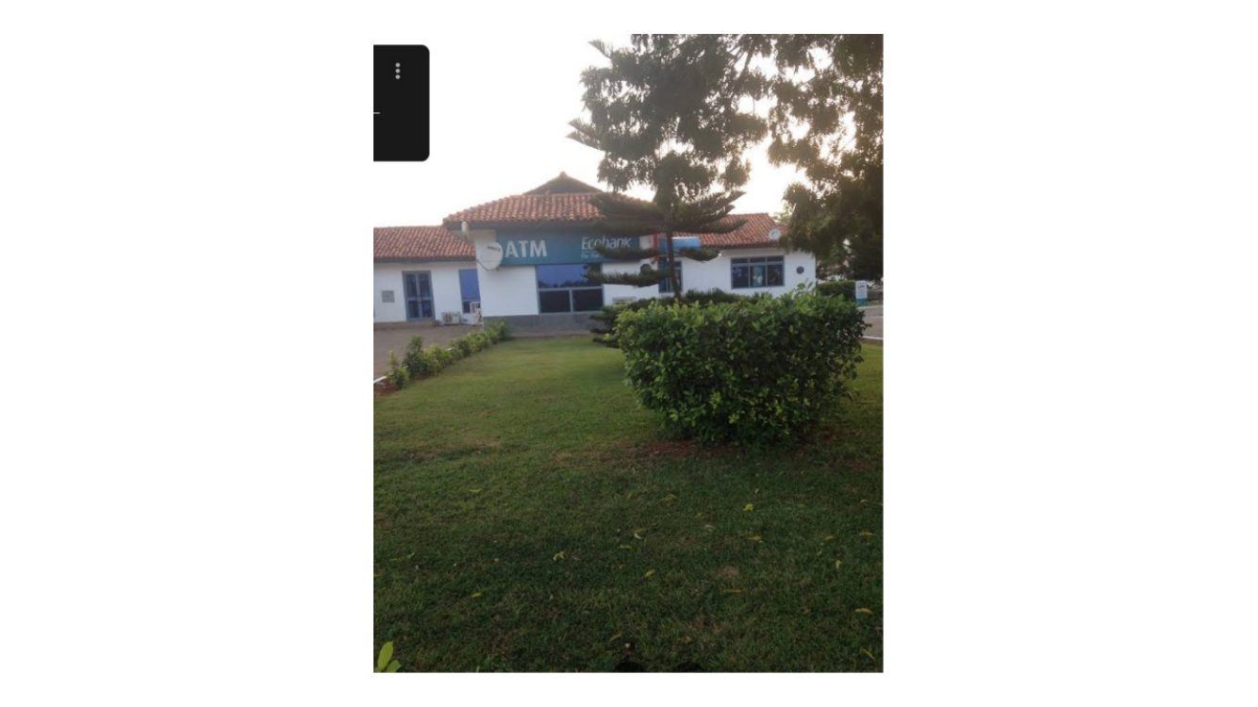
Evidence / correction note: Keep the grassy verge/landscape strip in front of the site, with shrubs as separate planted elements and the bank building set behind its forecourt.
Source: CORRECTION FILE.pptx, slide 47. Full slide retained; imagery and markup are not intentionally cropped.

Source Slide 48 — Ecobank road edge and parked cars
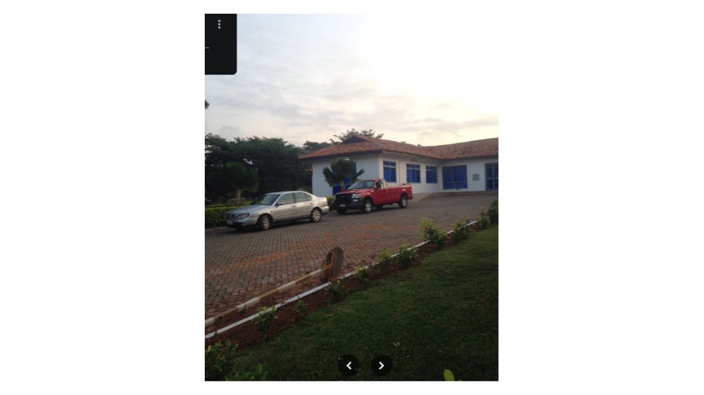
Evidence / correction note: Shows parking/driveway beside the building with cars, curb and lawn. Separate parking paving from grass with visible curb/edge geometry.
Source: CORRECTION FILE.pptx, slide 48. Full slide retained; imagery and markup are not intentionally cropped.

Source Slide 49 — Ecobank wide frontal context
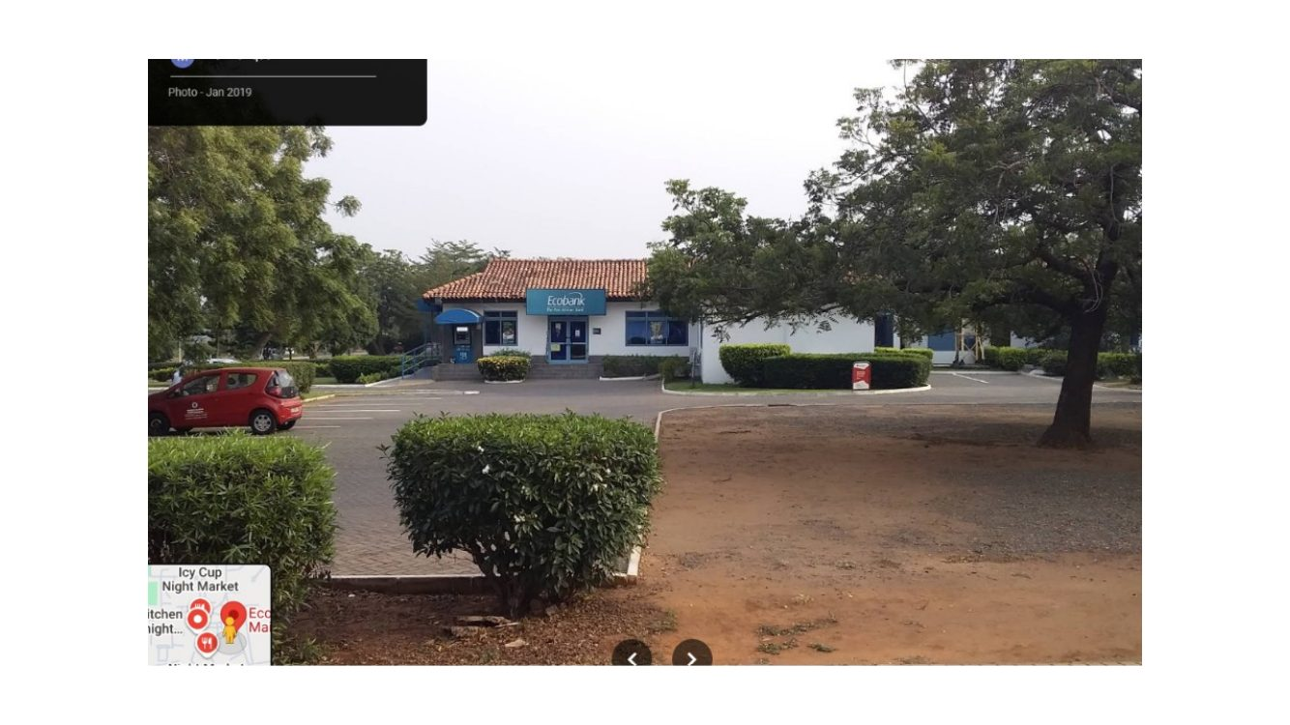
Evidence / correction note: The broad view shows branch, forecourt, trimmed shrubs and large shade trees. It is useful for overall orientation and scale.
Source: CORRECTION FILE.pptx, slide 49. Full slide retained; imagery and markup are not intentionally cropped.

Source Slide 50 — Ecobank paved car park and curved lawn island
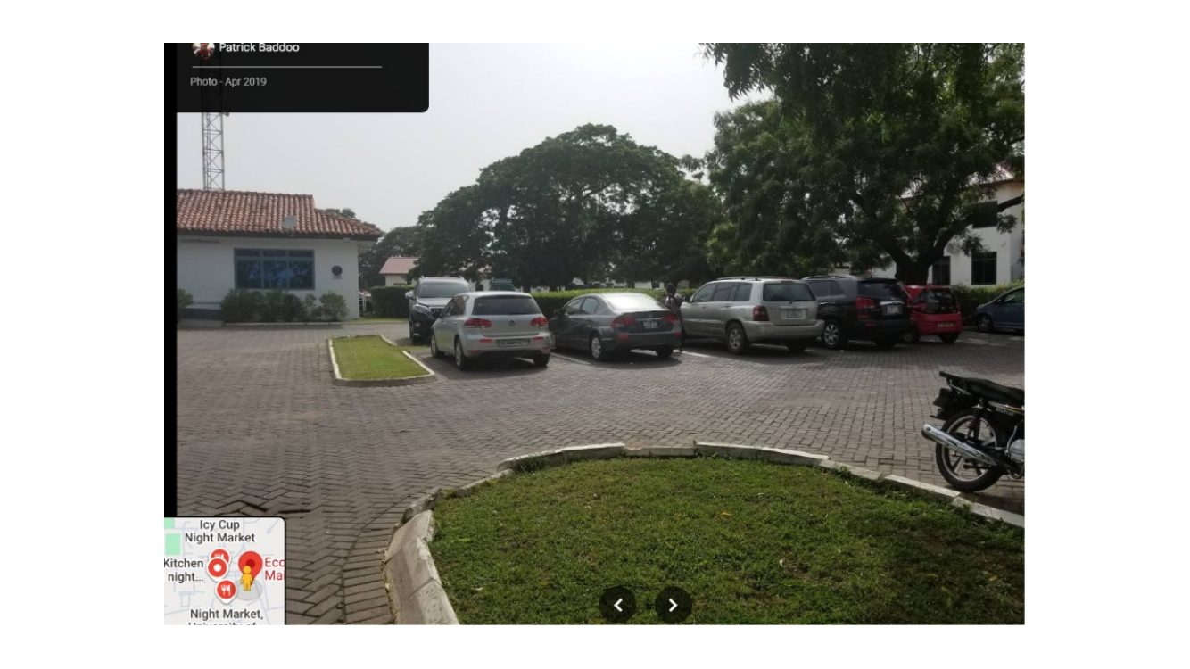
Evidence / correction note: Recreate the paved parking field and the curved island of grass with curb, including vehicle access. Do not render this entire forecourt as lawn or asphalt.
Source: CORRECTION FILE.pptx, slide 50. Full slide retained; imagery and markup are not intentionally cropped.

Source Slide 51 — Ecobank close angled entrance
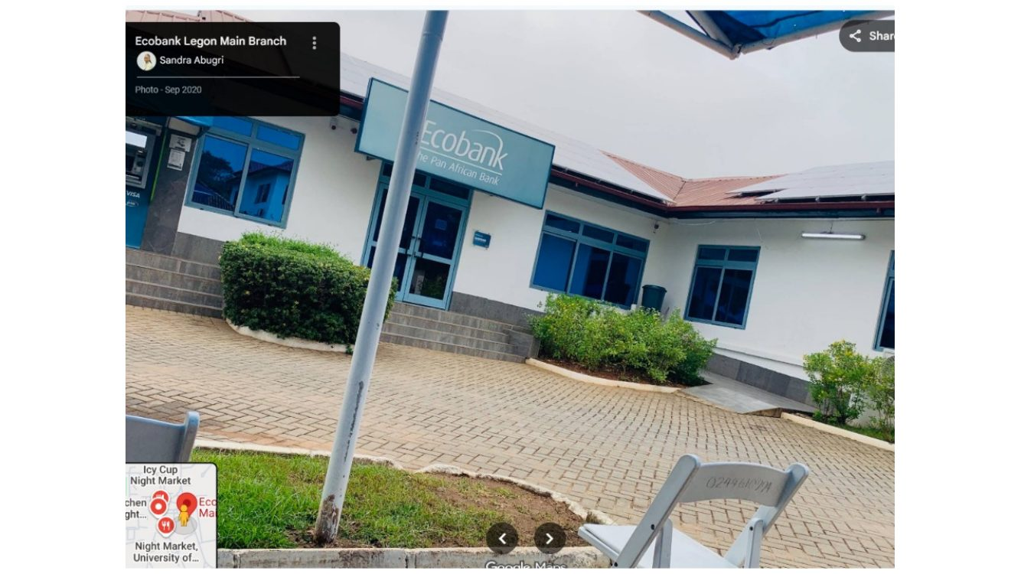
Evidence / correction note: Use the blue entrance canopy, blue/teal bank signs, glazing and ramp/steps to define the front door and facade detail.
Source: CORRECTION FILE.pptx, slide 51. Full slide retained; imagery and markup are not intentionally cropped.

Source Slide 52 — Ecobank entry from another angle
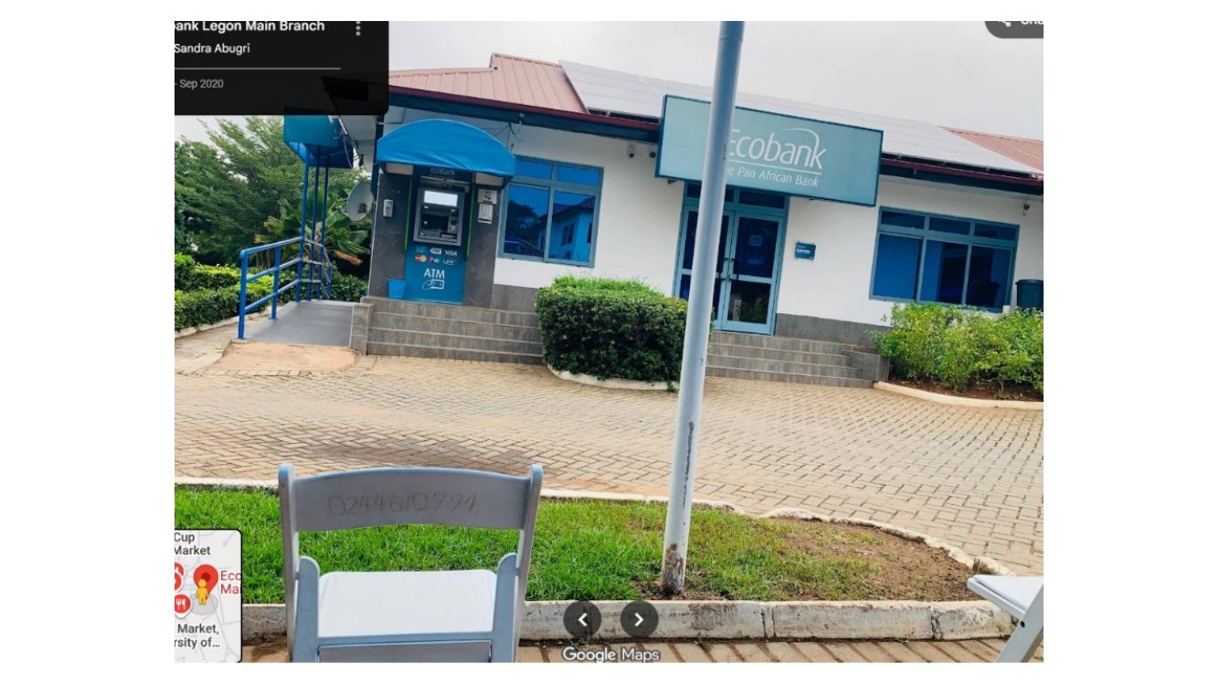
Evidence / correction note: Cross-check the entry canopy, access ramp/rail, concrete steps, paved apron and landscaping. This is additional evidence for the same entrance, not a second entrance to invent.
Source: CORRECTION FILE.pptx, slide 52. Full slide retained; imagery and markup are not intentionally cropped.

Source Slide 53 — Ecobank main entrance and frontage
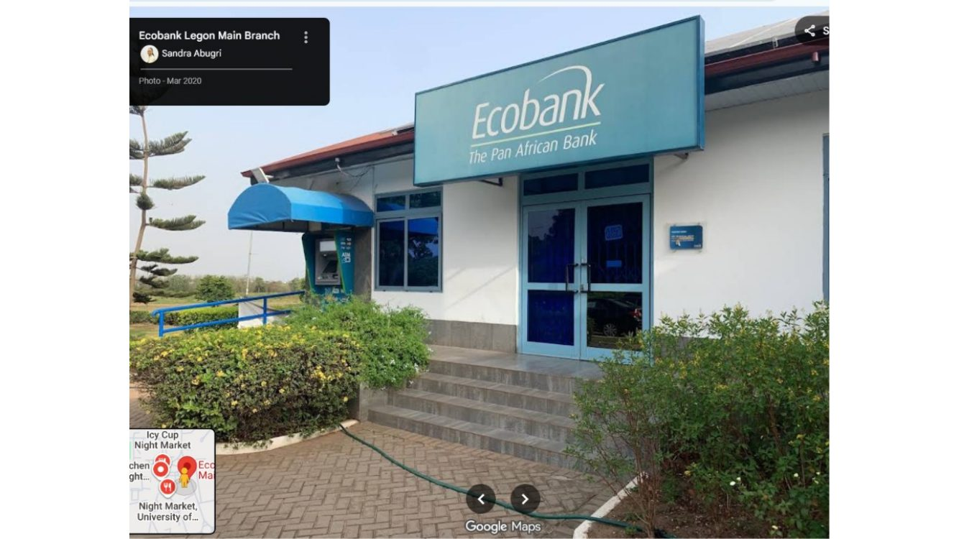
Evidence / correction note: Front sign placement, blue door/window frames, short steps/ramp and shrubs are visible. Keep the sign over/near the actual entrance zone.
Source: CORRECTION FILE.pptx, slide 53. Full slide retained; imagery and markup are not intentionally cropped.

Source Slide 54 — Ecobank side/rear and neighbouring roof volumes
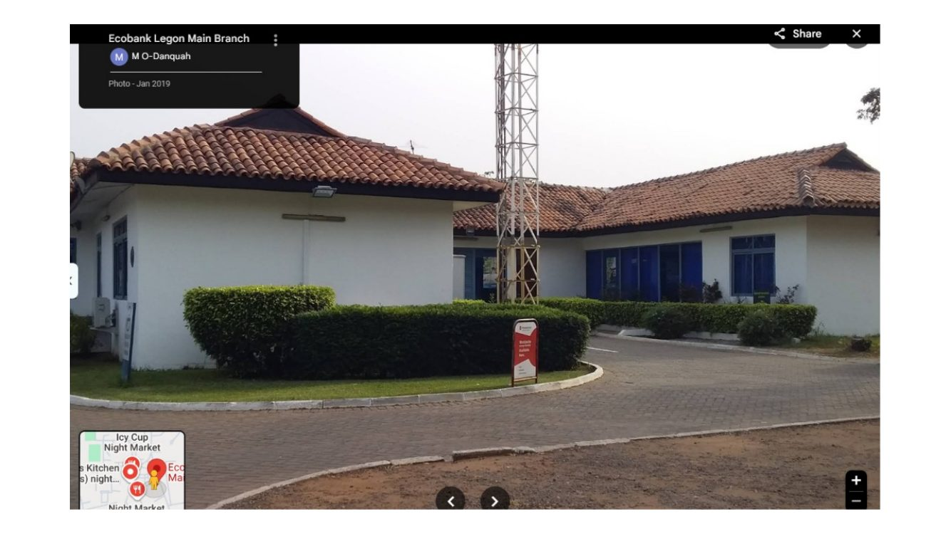
Evidence / correction note: Use the view to understand the low roofed wings and blue-framed openings. Confirm which volumes belong to the bank versus neighbouring structures before modelling them as one building.
Source: CORRECTION FILE.pptx, slide 54. Full slide retained; imagery and markup are not intentionally cropped.

Source Slide 55 — Ecobank site across road and mature trees
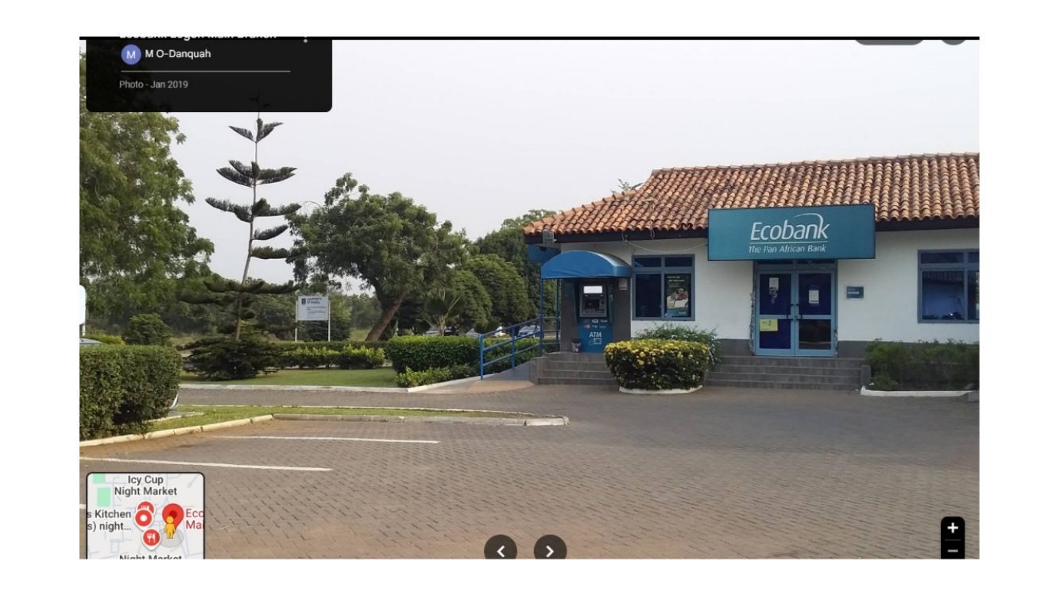
Evidence / correction note: Wide context for tree canopy, paved access, cars, site setback and branch frontage; avoid placing vegetation so it hides the entry.
Source: CORRECTION FILE.pptx, slide 55. Full slide retained; imagery and markup are not intentionally cropped.

Source Slide 56 — Ecobank ramp/approach and facade junction
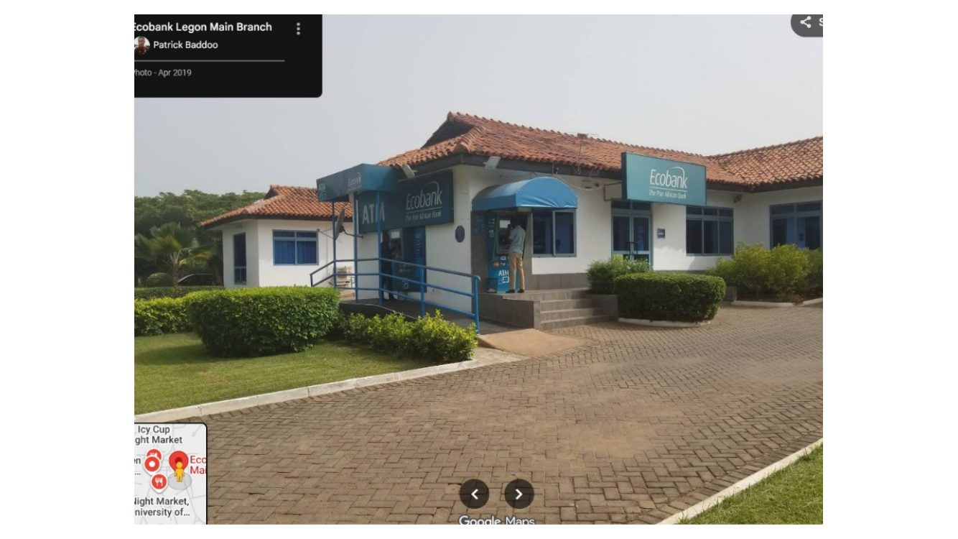
Evidence / correction note: Use the close oblique view for ramp/rail, step transitions, canopy, glazing, paving and junction between central entry and wing.
Source: CORRECTION FILE.pptx, slide 56. Full slide retained; imagery and markup are not intentionally cropped.

Source Slide 57 — Vikings Hostel section divider
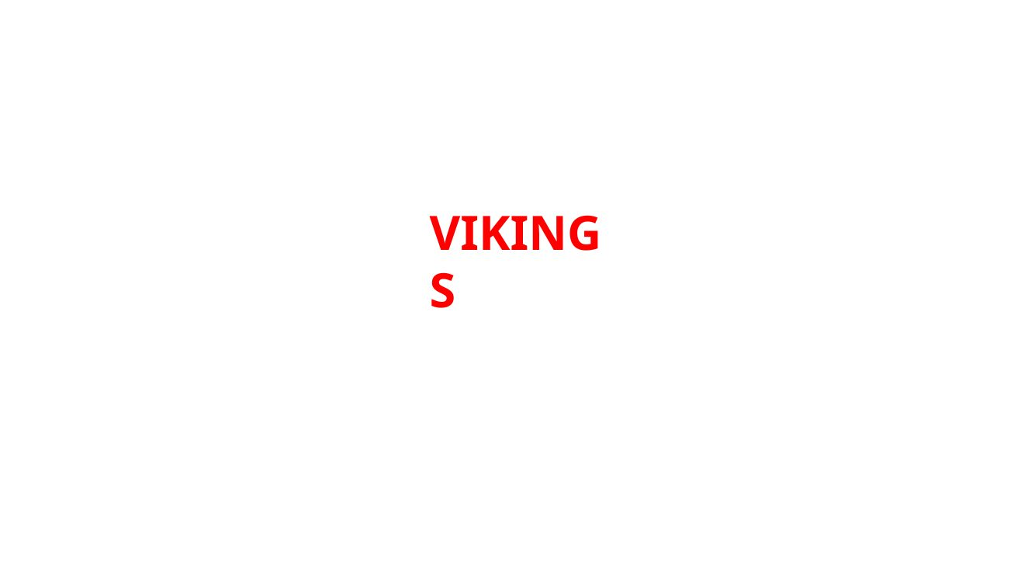
Evidence / correction note: Section label only; slides 58–65 form the visual evidence set for the hostel.
Source: CORRECTION FILE.pptx, slide 57. Full slide retained; imagery and markup are not intentionally cropped.

Source Slide 58 — In-game Vikings Hostel geometry versus real exterior
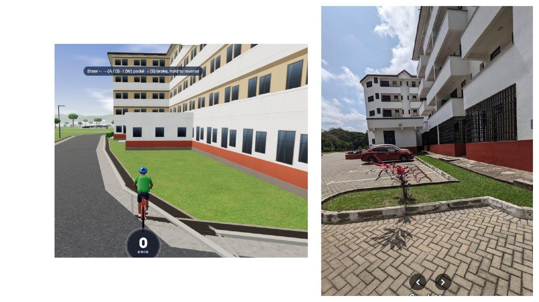
Evidence / correction note: Game shows the current broad building and red base strip; real photo shows multi-storey balcony/corridor faces and paved courtyard. Match the structure to the real footprint and elevations.
Source: CORRECTION FILE.pptx, slide 58. Full slide retained; imagery and markup are not intentionally cropped.

Source Slide 59 — Vikings Hostel front corner and ground-level context
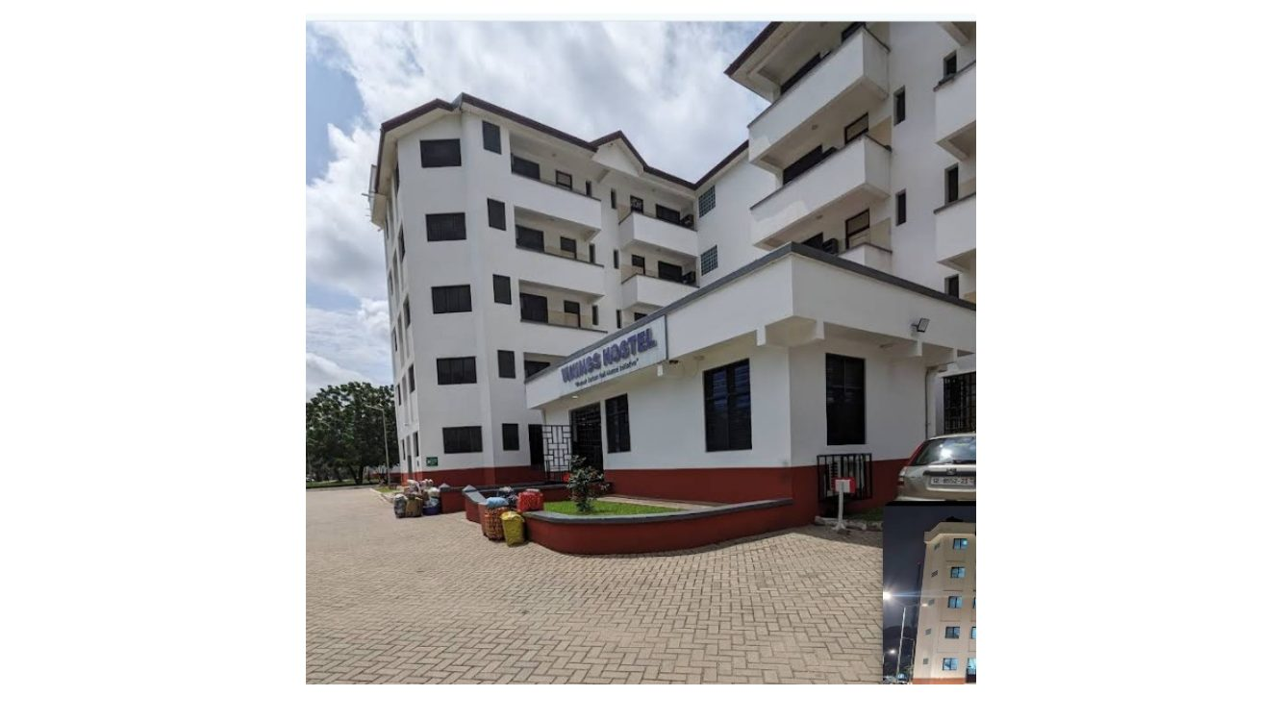
Evidence / correction note: Real reference shows white multi-storey wings, repeated dark windows/open balconies, a dark grey ground band and paved forecourt. Preserve the actual building’s connected-wing shape.
Source: CORRECTION FILE.pptx, slide 59. Full slide retained; imagery and markup are not intentionally cropped.

Source Slide 60 — Game frontage and nighttime hostel photo
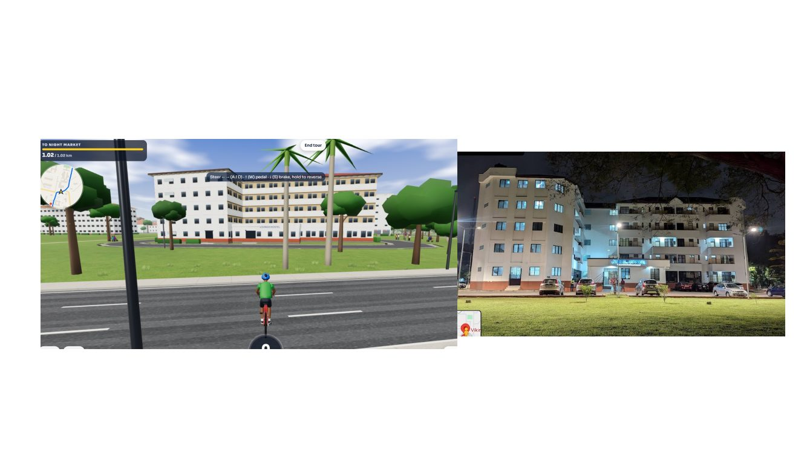
Evidence / correction note: Night photo shows façade lights, window/balcony pattern, multiple connected wings and the way the building reads after dark. Do not make every window uniformly emissive.
Source: CORRECTION FILE.pptx, slide 60. Full slide retained; imagery and markup are not intentionally cropped.

Source Slide 61 — Frontage alignment and nighttime facade
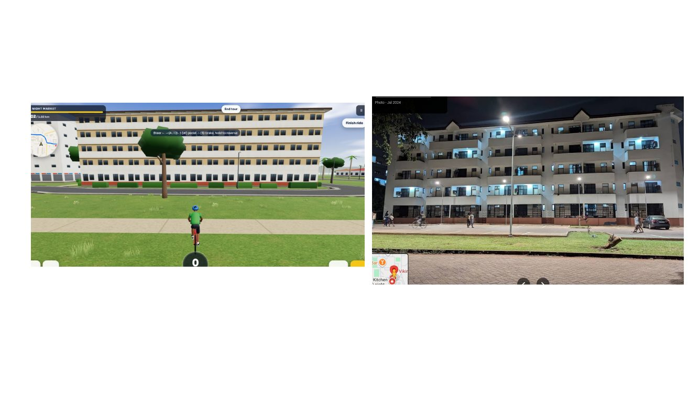
Evidence / correction note: Compare game building length/height and street offset to the night reference. Correct floor count and wing depth based on daytime photos too.
Source: CORRECTION FILE.pptx, slide 61. Full slide retained; imagery and markup are not intentionally cropped.

Source Slide 62 — Game view with real daytime hostel image
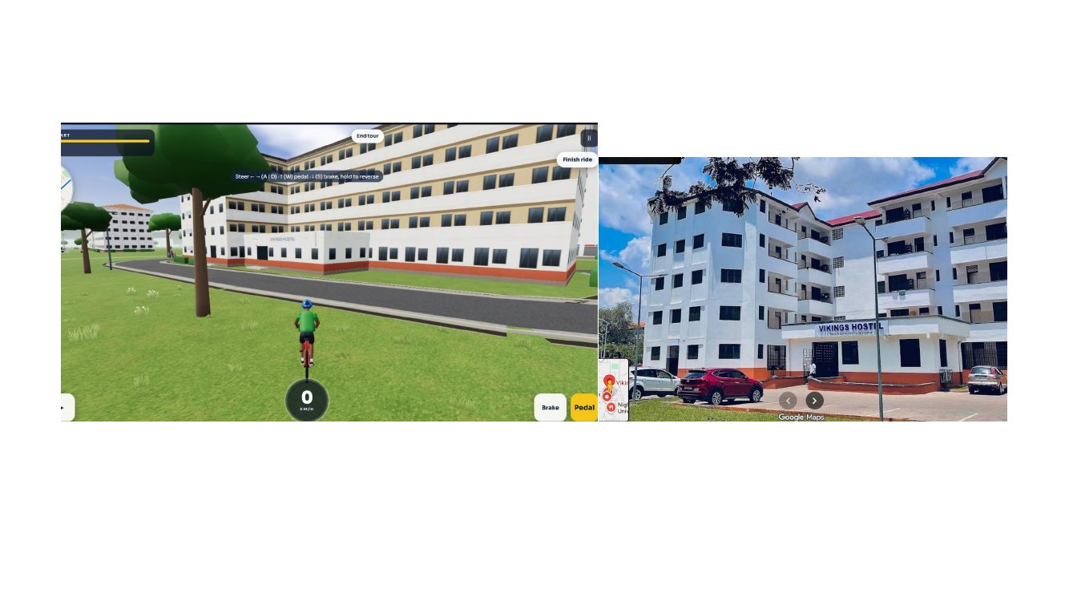
Evidence / correction note: Use daytime reference to tune white walls, dark window openings, projecting balconies, roofline and ground-floor recesses. Remove generic repetitive office windows if unsupported.
Source: CORRECTION FILE.pptx, slide 62. Full slide retained; imagery and markup are not intentionally cropped.

Source Slide 63 — Side/rear elevation with balconies
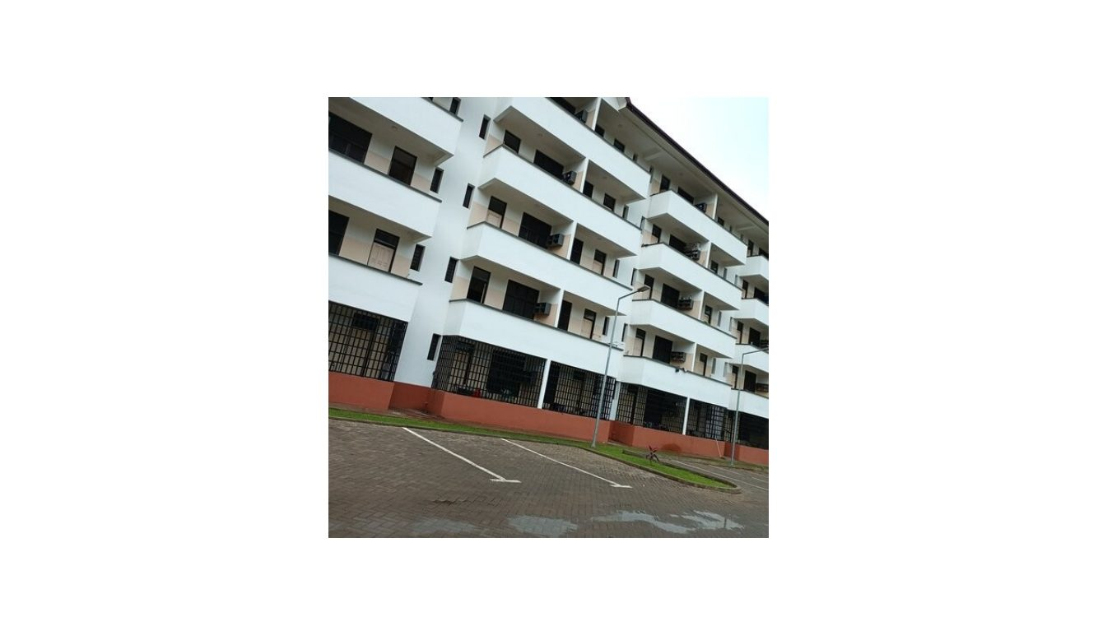
Evidence / correction note: Real side elevation shows stacked projecting/recessed balconies, railings, open corridors, dark openings, a red/dark base strip and paved surface. Recreate its depth rather than using a flat texture.
Source: CORRECTION FILE.pptx, slide 63. Full slide retained; imagery and markup are not intentionally cropped.

Source Slide 64 — Multi-angle collage of Vikings Hostel
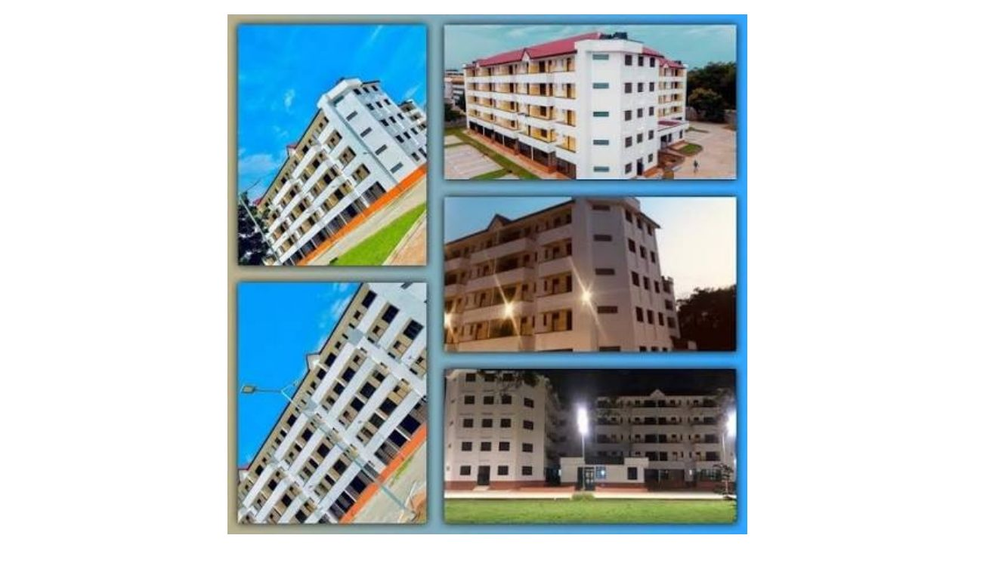
Evidence / correction note: Consolidated references: different elevations and night/day views. Use to validate building massing, facade rhythm, balcony depth, windows, roofline and lighting consistency.
Source: CORRECTION FILE.pptx, slide 64. Full slide retained; imagery and markup are not intentionally cropped.

Source Slide 65 — Vikings Hostel close facade/corner detail
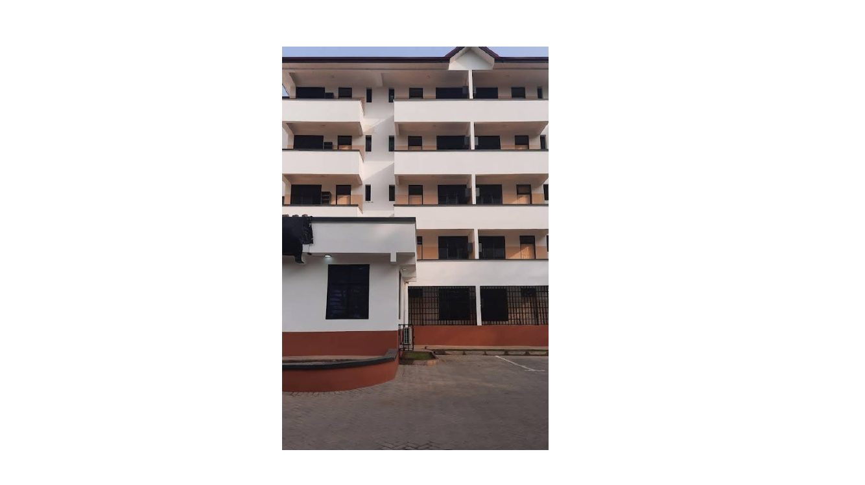
Evidence / correction note: Final close view reinforces stacked balcony openings, light walls, dark window/door recesses and the ground-level wall/paving transition.
Source: CORRECTION FILE.pptx, slide 65. Full slide retained; imagery and markup are not intentionally cropped.

