LEGONRUSH
IPS ROAD COMMERCIAL CORRIDOR
Standalone landmark and streetscape reconstruction brief
Scope: Nophil Heights · Prestige commercial block · Abednego F. O. Amartey Towers · connecting IPS Road frontage
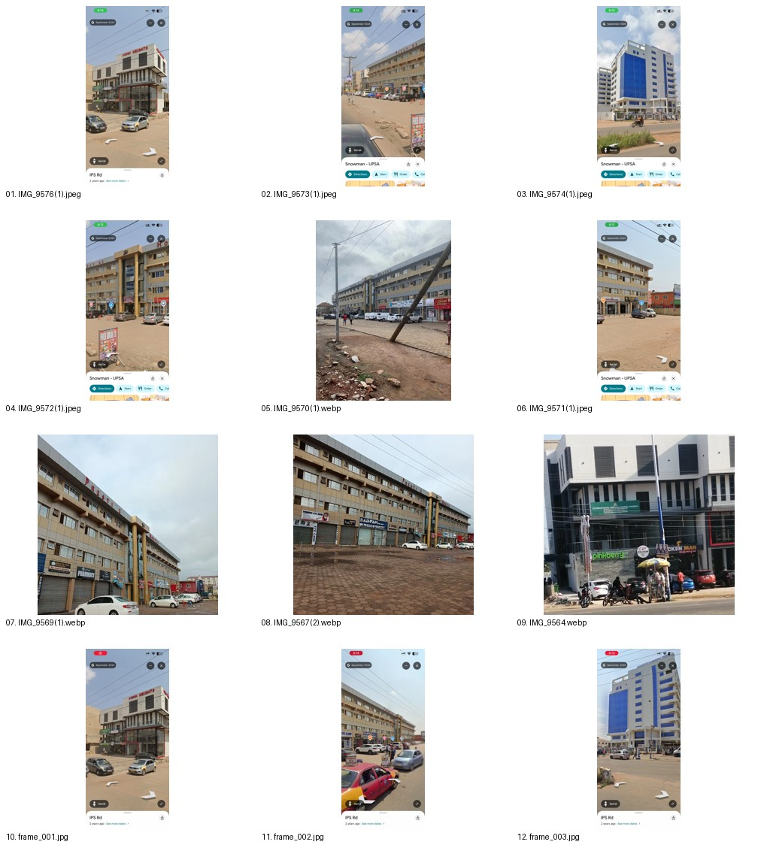

1. Scope and separation
This work package covers the IPS Road commercial corridor shown in the newly supplied street-level photographs and rotating video. It is intentionally separate from the earlier UPSA campus landmark pack. Do not merge the packages or change identities/locations of campus landmarks already documented.

2. Evidence hierarchy
- Supplied still photographs and the complete supplied rotating video are the primary visual evidence for facade details, visible sides, forecourts and roadside conditions.
- Existing repository master geography, road centerlines, building footprints and access/route registries are authoritative for placement and connectivity.
- External maps or public sources may corroborate location/name only; they must not override stronger project geometry or the user’s imagery.
- Where a dimension, rear facade, exact footprint or coordinate is not supported, mark it uncertain rather than inventing it.

3. Landmark specifications

Nophil Heights
Distinctive corner commercial building with projecting light upper volume, red raised lettering, black horizontal louvres, vertical window strips, metal balcony rails, ground-floor retail and a red-framed glazed corner shop. Recreate the corner silhouette and relationship between upper projection and lower shopfront.

Prestige commercial block
Long multi-storey beige/tan and grey tiled frontage with repeated windows, strong horizontal slab/awning ledges, red rooftop PRESTIGE lettering, central entrance bay with tall golden/yellow columns and reflective glazing, multiple shop bays and broad paved forecourt.

Abednego F. O. Amartey Towers
White multi-storey tower with large blue reflective curtain wall, vertical blue-glazed strips, repeated windows, projecting white slab edges, rooftop name, perimeter fencing/gates and roadside verge. Match visible silhouette and facade orientation to the supplied views.

IPS Road corridor
Continuous road frontage including asphalt/road surface, dusty shoulder, curbs and transitions, paved/herringbone forecourts, parking apron, utility poles and overhead wires. Keep the surface changes true to the references; do not pave over dirt shoulders or extend campus landscaping into commercial forecourts without evidence.

4. Video and image review
Review every image in reference_images/ and watch the complete 270_degree_corridor_reference_video.mp4 before implementation. Use video_keyframes/ for rapid orientation only; keyframes are not a substitute for the full recording. The contact sheet is an index, not the source of detail.

5. Geometry, materials and performance
- Establish each building’s location and footprint from authoritative repository geometry. Do not estimate coordinates or dimensions from perspective alone.
- Build each named building as a separate recognizable asset with distinct footprint, height, roofline, window rhythm, materials, signage and collision bounds.
- Use reusable/instanced facade modules where useful, while preserving distinctive shapes and proportions.
- Ensure road, curb, forecourt and terrain surfaces meet cleanly. Prevent z-fighting, grass/asphalt flicker, raised bars, floating surfaces, holes and collision seams.
- Utility poles and wires should follow the observed corridor and not create implausible obstructions across the playable path.
- Use cars and people sparingly as context; do not let dressing block the route or harm performance.
- Do not recreate phone UI, Google Maps controls, Street View arrows, watermarks or screenshot borders in the game world.

6. Preserve existing LEGONRUSH assets
Do not modify unrelated campus landmarks, the campus master boundary, road/path centerlines, route IDs, challenge/race geometry, access points, ghosts, leaderboards or collision systems. Do not remodel UGBS Graduate School, UPSA Hostel, Vice-Chancellor’s Ghana Office Complex, Central Administration, Joshua Alabi Library, KOKA Auditorium or other earlier UPSA landmarks in this task. Follow existing architecture and keep one source of truth for placement.

7. Implementation workflow
- Inspect repository status and identify the exact corridor using existing geometry.
- Review all supplied references; make an evidence table with feature, source image/video timestamp and confidence.
- Inspect current building/road rendering and footprint systems; reuse authoritative data and add only missing geometry.
- Implement three unique building assets and continuous road/forecourt/utility context.
- Run typecheck, geography/route tests, relevant unit tests and production build.
- Launch preview and inspect multiple viewpoints; test for scale, alignment, clipping, surface flicker, blocked routes, collisions and performance.
- Compare against the supplied references and correct only evidence-supported discrepancies.
- Report changed files, placement evidence, checks, unresolved uncertainties, branch/commit and whether anything was pushed or deployed.

8. Acceptance checklist
☐ Nophil Heights, Prestige and Abednego F. O. Amartey Towers are visually distinct and recognizable.
☐ Long-block versus tower proportions and each facade’s signature details are retained.
☐ Road, forecourts, curb/shoulder transitions, poles and overhead cables form a continuous corridor.
☐ No unrelated campus geography or established route geometry changes.
☐ No serious z-fighting, flicker, floating structures, ground gaps, route blockage or collision regression.
☐ Build/tests and visual inspection are reported honestly.
☐ No merge to main or production deployment without explicit user approval.

9. Ready-to-paste Claude Code prompt
Use the full prompt in the companion file CLAUDE_CODE_MASTER_PROMPT.md. It is the implementation authority for this work package and includes scope, evidence hierarchy, safeguards, workflow and acceptance criteria.

10. Reference catalogue

01 nophil heights front and corner
Nophil Heights: corner building with projecting upper white volume, red signage, black louvres, balcony railings and glazed retail frontage.

02 prestige commercial block long frontage
Prestige commercial block: long multi-storey beige and grey tiled frontage, repetitive windows, deep horizontal ledges, ground-floor shops and forecourt parking.

03 abednego amartey towers front
Abednego F. O. Amartey Towers: white high-rise, blue glazed curtain wall, vertical window stacks, rooftop name signage, perimeter fence and roadside verge.

04 prestige main entry and forecourt
Prestige frontage with emphasized central entry bay, tall golden columns, reflective glazing and broad paved forecourt.

05 prestige building wide oblique
Long oblique view of Prestige building and its ground-floor commercial units.

06 prestige long paved forecourt
Wide frontage and paved forecourt with shop bays, cars and road edge.

07 nophil ground floor retail and sidewalk
Nophil Heights retail frontage, signage, columns, shop glazing, pedestrians and vehicles.

08 roadside commercial context
Additional street-level commercial context and frontage alignment.

09 abednego towers secondary reference
Additional building reference image; verify exact viewpoint against other supplied photos before deriving geometry.
The rotating video and extracted representative keyframes are included in the pack. The exact video timestamps should be recorded by the implementer during review.

