LEGONRUSH — IPS Road Opposite UPSA
Separate landmark and streetscape reconstruction reference brief
Scope: Northill Heights • Prestige commercial/hostel frontage • Abednego F. O. Amartey Towers as the opposite-side visual reference • IPS Road street corridor
Prepared from user-supplied photographs and a 270° Google Street View screen recording dated in the supplied footage (September 2024). This document is separate from the UPSA campus-landmarks pack.

1. Critical scope and identity rules
- Treat this as a separate reconstruction area on/along IPS Road opposite UPSA. Do not merge these assets into the UPSA Main Entrance, Central Administration, Joshua Alabi Library, KOKA auditorium, Justice Aryeetey Building, or the UPSA Hostel/VC Complex pack.
- Northill Heights is the white/light building with a box-like projecting upper floor, large dark louvred panels, red rooftop letters, wraparound balcony railings, glazed ground-floor units and red-framed shopfront glazing.
- Prestige is the long tan/grey multi-storey commercial frontage with repeated windows, projecting slab/band details, red 'PRESTIGE' rooftop lettering, a columned/glazed entrance bay, and shops at ground level. The supplied images also show a sign reading 'HOSTEL' at the roofline in some views; preserve only the signage actually visible in the source imagery and do not infer the full official building name from that alone.
- Abednego F. O. Amartey Towers is a separate white high-rise with a large blue-glass façade and its own signage. It is across the road in the supplied street-view sequence and should be represented as a distinct landmark, not as part of Northill Heights or Prestige.
- Do not reproduce Google Maps UI, Street View arrows, phone status bar, location cards, watermarks or overlays as in-world objects. Use the footage only as visual/location evidence.

2. Visual specifications by asset

A. Northill Heights
- Overall massing: modern mid-rise commercial building; prominent upper box volume projects beyond the lower floors and wraps around the corner.
- Upper façade: off-white/light grey panels, regularly spaced dark rectangular louvred ventilation panels, small dark wall fixtures, red three-dimensional rooftop lettering on front and side.
- Middle level: narrow vertical window bays behind a continuous metal balcony railing; visible columns/supports and soffit.
- Ground floor: mixed retail units, dark glazing, one highly visible red-trimmed glazed corner unit, signage bands, stone/dark cladding at selected shopfronts.
- Foreground: broad hard-paved forecourt/parking apron, vehicles and motorcycles in references; do not bake parked cars into permanent geometry.

B. Prestige commercial/hostel frontage
- Long horizontal multi-storey block with tan/beige panel grid and grey horizontal bands/cap, repeated rectangular windows across several floors.
- Projecting horizontal sunshade/slab bands and repetitive window rhythm; some windows appear open or tilted outward in the Street View references.
- Ground-floor shops with individually different signs, shutters, doors and display windows; treat signs as replaceable details, not structural geometry.
- Distinctive entrance bay: tall ochre/gold columns, recessed dark glazing and a projecting upper canopy with a small emblem. Capture this as a local landmark on the frontage.
- Paved forecourt and parking in front, rougher earth/gravel shoulder at the edge, roadside utility poles and overhead wires.

C. Abednego F. O. Amartey Towers (opposite-side reference)
- Separate white multi-storey tower, strong vertical blue curtain-wall/glass panel on the main face, smaller blue windows on white elevations, projecting floor edges and visible rooftop name signage.
- The supplied photos show a perimeter wall/gate and a dusty verge/road edge. Model only what belongs in the target area and what repository geography supports.
- Use as a recognizable opposite-side landmark and scale reference; do not assume a precise footprint or distance from the photos alone.

D. IPS Road corridor and streetscape
- Asphalt carriageway with a broad, dusty earth shoulder and paved commercial forecourts on the building side.
- Overhead electricity/telecom lines span the view; utility poles are prominent vertical elements and should be placed from verified source geometry or carefully recorded reference positions.
- Street-facing frontage includes parked cars, motorcycles, pedestrians and retail activity. Use lightweight, performance-conscious props and avoid blocking playable paths or access points.
- Street View rotates through multiple bearings. Maintain a consistent continuous street alignment; do not model each screenshot as a separate disconnected scene.

3. Evidence and placement policy
- Primary visual evidence: the nine supplied still images plus the supplied 270° screen recording. The recording provides a sequential view of both sides of the road and should be reviewed frame-by-frame for frontage order, relative orientation, road edge and landmark transitions.
- Primary positional authority: existing LEGONRUSH repository geography and verified road/access data. Inspect existing GeoJSON/OSM/map data before editing; do not invent coordinates from perspective images.
- Use the aerial/map view already in the project and any available public map references to cross-check footprints. Record any uncertain building placement in a short uncertainty note rather than silently guessing.
- Photographs establish façade appearance but do not establish exact dimensions, height, setback, or legal property boundary. Approximate geometry should be proportioned from multiple views and validated in-game.
- Preserve all existing road/path geometry, route IDs, race/challenge routes, collision behavior, access points, ghosts, records and leaderboards. Avoid moving authoritative road nodes just to fit a building model.

4. Suggested reconstruction workflow
- Inspect the repository's current map/geography data and identify the IPS Road segment opposite UPSA. Establish which existing building footprints or placeholders correspond to Northill Heights, Prestige and Abednego Towers.
- Extract representative frames from the full 270° recording at regular intervals and note the visible left/right frontage, road direction, poles, entrances and transitions. The original recording must remain in the reference pack.
- Build or refine each building as a separate named asset with its own footprint, orientation, materials, façade details and signage. Use repeated façade modules for performance, but do not make the three buildings visually interchangeable.
- Reconstruct the ground plane, forecourts, shoulder, curbs/drainage transitions and utility poles only where supported by imagery and authoritative map geometry. Preserve legitimate driveways and shop access.
- Place low-cost traffic/people props sparingly. Ensure no cars, poles, walls or planters obstruct the cycling/routing corridor.
- Run type check, unit/geography/route tests and production build. Launch the game, ride the relevant road in both directions, and inspect the area from ground-level and elevated viewpoints.
- Report files changed, which source references informed each asset, unresolved uncertainty, checks run, and branch/commit status. Do not push to main or deploy without explicit approval.

5. Acceptance checklist
☐ Northill Heights has the projecting upper volume, dark louvres, red roof sign, balcony rail and red-trimmed glazed corner.
☐ Prestige remains a long continuous commercial block with tan/grey panel rhythm, horizontal projections, repeated windows, columned entrance bay and ground-floor retail.
☐ Abednego F. O. Amartey Towers is clearly distinct, white with a dominant blue-glass face.
☐ The frontage order and relative sides match the 270° recording; no guessed placement overrides the repository's authoritative geography.
☐ Road, shoulder, forecourts, poles and overhead wires feel continuous across the viewed segment; no floating or intersecting geometry.
☐ No unintended road/grass flicker, raised strips, broken sidewalks, new route changes, or performance regressions.
☐ Existing gameplay, route tests, collision and access points remain intact.
☐ No merge to main or production deployment without approval.

6. Ready-to-paste Claude Code master prompt
Work autonomously on a SEPARATE LEGONRUSH reconstruction task for the IPS Road commercial frontage opposite UPSA. Read this entire brief and inspect every supplied reference image plus the full 270° screen recording before changing code.
TARGET ASSETS
1) Northill Heights: off-white modern mid-rise with projecting box-like upper floor, dark louvred panels, red rooftop lettering, continuous balcony railing, vertical window bays, mixed retail ground floor and red-trimmed glazed corner unit.
2) Prestige commercial/hostel frontage: long tan/grey multi-storey block with repeated windows, horizontal projecting bands, red PRESTIGE roof lettering, a distinctive entrance bay with tall gold/ochre columns and recessed glazing, and ground-floor shops.
3) Abednego F. O. Amartey Towers: separate white multi-storey tower with a large blue-glass curtain-wall face and smaller blue windows.
4) IPS Road streetscape: road, dusty verge/shoulder, paved forecourts, utility poles and overhead wires as supported by the footage.
First inspect repository geography, building registry, source assets, rendering architecture, tests and recent history. Use authoritative existing road/path/building geometry for placement. Use the supplied video as sequential visual evidence; do not treat screenshots as exact coordinates. Do not model Google Maps UI or overlays. Do not merge these assets with the separate UPSA campus landmark pack. Do not invent coordinates or replace unrelated existing buildings.
Implement each target as a distinct, performance-conscious landmark. Preserve all existing road geometry, route IDs, race/challenge routes, collision, access points, ghosts, records and leaderboards. Do not alter campus topology to fit façades. Keep driveways and entrances usable. Avoid adding visual clutter or static cars that block playable routes.
After implementation, run the project's relevant type checks, tests, geography/route validations, production build and smoke test. Visually inspect the target corridor from multiple angles and both travel directions. Fix any clipping, z-fighting, floating objects, road/grass flicker, sidewalk gaps or collision obstruction caused by the changes. Do not claim success unless the checks actually pass.
Commit/push only to the current working branch if allowed by the project's workflow. Do not push to main, merge to main, or deploy to production without explicit user approval. Finish with a concise report of root findings, files changed, asset/source mapping, tests and results, unresolved uncertainty, and commit/branch/push status.

7. Reference catalogue

01 northill heights front
Northill Heights: oblique street-facing view showing the projecting upper floor, white/light façade, dark louvred panels, red rooftop lettering, balcony railings and ground-floor retail.
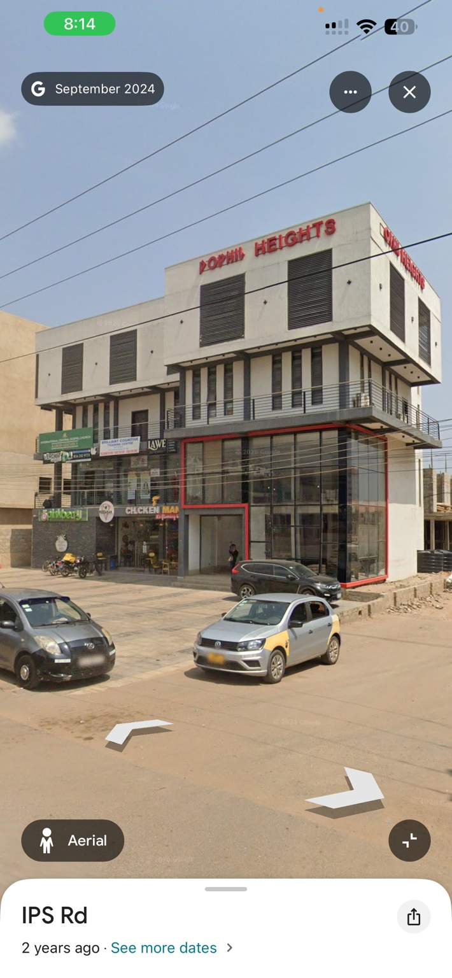

02 prestige commercial frontage
Prestige commercial block: long multi-storey tan-and-grey façade, repeated windows, projecting horizontal bands, ground-floor shops and paved forecourt.
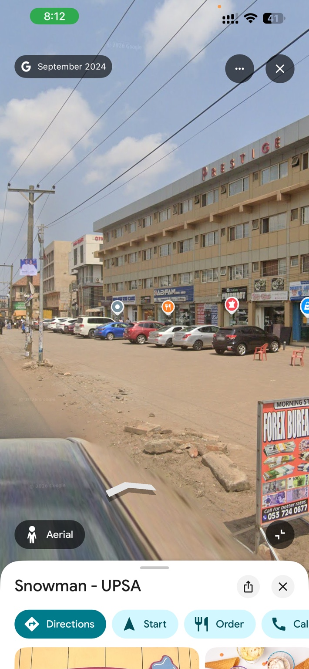

03 abednego towers street view
Abednego F. O. Amartey Towers: white tower with prominent blue-glass façade and visible tower signage across the road.
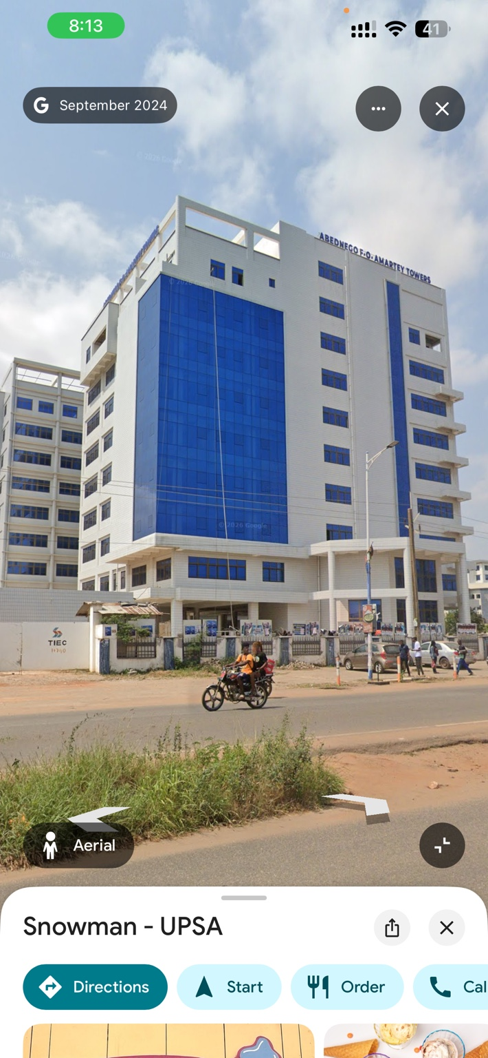

04 prestige corner entry
Prestige block corner entrance: tall columns, recessed dark glazing, branded upper canopy and ground-floor shopfronts.
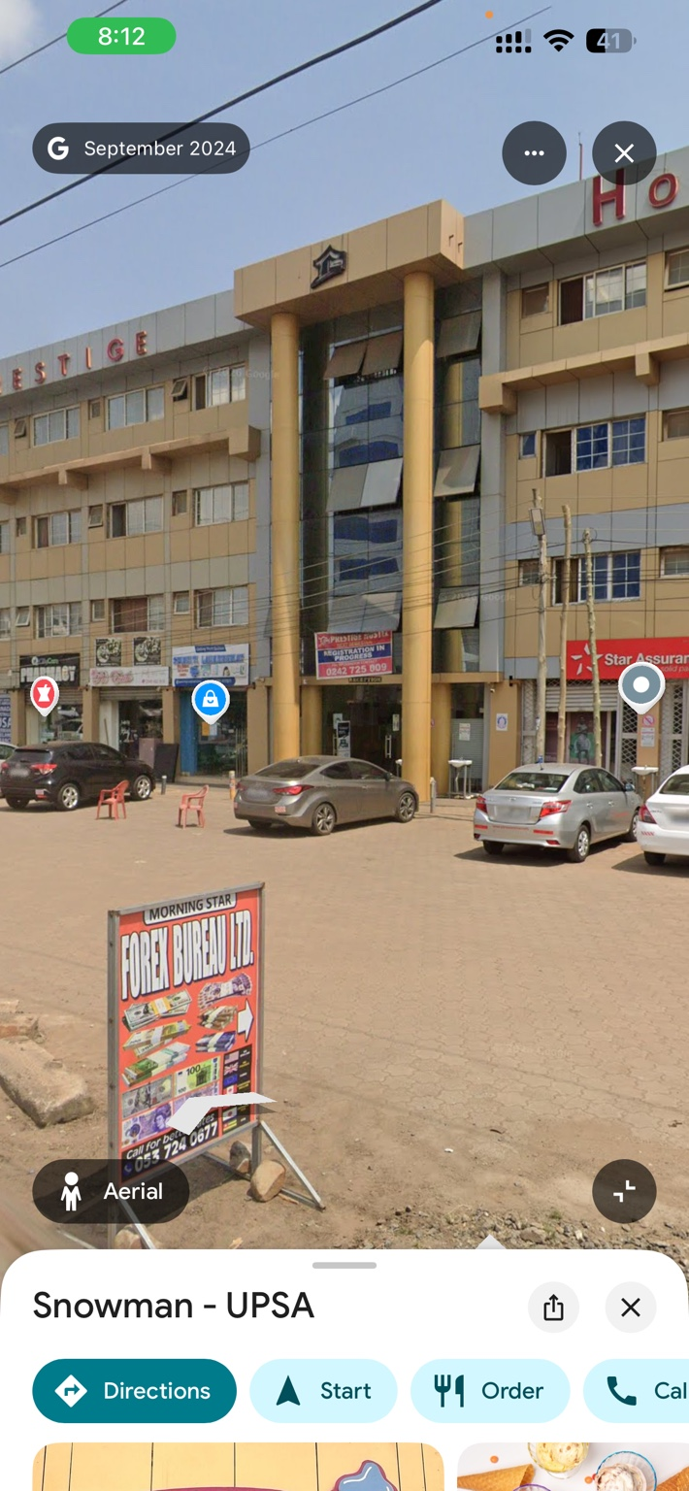

05 prestige hostel wide context
Wider street context for the long Prestige/Hostel frontage, sidewalk/forecourt, vehicles and rough roadside shoulder.

06 prestige side end
Side/end view of the long commercial frontage with a broad paved forecourt and adjacent lower-rise buildings.
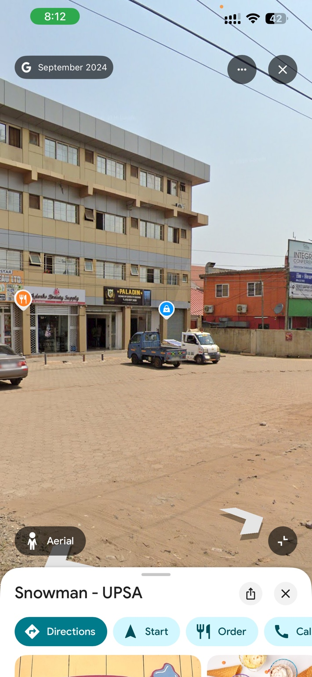

07 prestige oblique length
Oblique view showing the length and repeated façade rhythm of the Prestige building.

08 northill retail level
Northill Heights ground-floor retail frontage, pedestrian activity, vehicles and overhead utility wires.

09 ips road corridor
IPS Road corridor reference: roadway, roadside paving/earth shoulder, utility poles and overhead cables.

8. Recording
The full user-supplied 270° screen recording is included in the ZIP at reference_video/ips_road_270_degree_streetview.mp4. Review the full clip, not only the contact sheet. Street View interface overlays are evidence artifacts, not game assets.

