LEGONRUSH

UPSA HOSTEL-TO-CAMPUS
RECONSTRUCTION BRIEF
  - IPS Road approach • UPSA Main Gate • internal campus road • UPSA school / academic core
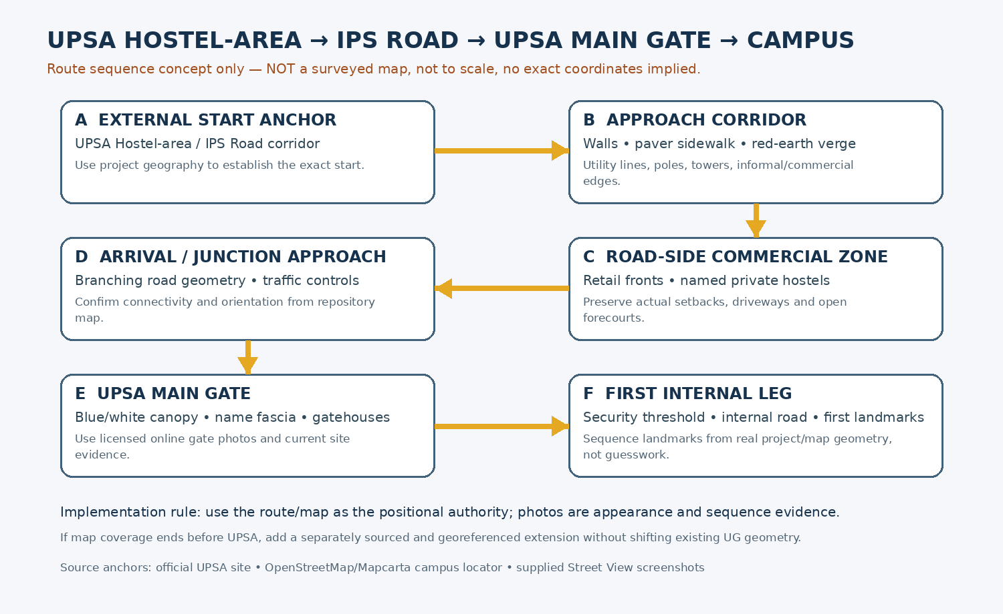
Prepared 12 October 2026 | Intended for Claude Code implementation
Core principle: geography first; photographs define appearance, not exact coordinates.

1. Brief and intended outcome
  - A continuous, place-faithful playable route from the UPSA Hostel-area approach, through UPSA Main Gate, and onward to the UPSA school / academic campus core.
Reconstruct the entire outside-to-inside journey beginning around the UPSA Hostel / IPS Road area shown in the user-supplied screenshots, following the actual mapped approach corridor and changing roadside frontages, reaching and passing through the University of Professional Studies, Accra (UPSA) Main Gate, and continuing along the real internal road network into the UPSA school / academic campus core. Internal landmarks are navigation anchors along the route, not an arbitrary stopping point.
The new screenshot set is strongest for the external approach and adjoining commercial frontage. It does not provide a complete photographic sequence after crossing the actual UPSA Main Gate. Online gate photos and campus overview images therefore supplement the user images, while the exact internal road/landmark order must be verified against the project map and available current sources.
Scope boundary
This is not a reconstruction of the whole UPSA campus. The required deliverable is one coherent, playable corridor through the main entrance and far enough inside to reach the first map-confirmed major campus landmarks. Keep later campus districts out of scope unless needed to make the route continuous.

2. What success looks like
- One continuous rideable route: hostel-area anchor → IPS Road corridor → roadside commercial/frontage sequence → true junctions and branches → UPSA Main Gate → security threshold → connected internal campus road → intermediate verified landmarks → UPSA school / academic campus core.
- The external approach feels like a real Accra urban edge: asphalt, sidewalk pavers, boundary walls, red-earth shoulders, open plots, trees, informal service/retail activity, signboards, electrical poles, bundled overhead wires, a transmission tower and changing setbacks where the photos show them.
- The Main Gate is recognisable from its blue-and-white gatehouse/canopy, fascia/signage, columns, access lanes, gate/barriers and road threshold; the latest geometry is anchored by the repository and not a 2021 photograph.
- Inside the gate, the road network and first landmarks have correct position and approach direction; terrain, paving, roads and building access connect without gaps or floating strips.
- Existing University of Ghana/Legon world, routes, ghosts, challenges, access IDs and unrelated landmarks remain unchanged. UPSA is added as a scoped extension only if required by current geography coverage.
- A production build succeeds and the implemented route is ridden and visually inspected in the browser from start to end.

3. Important identity and evidence rules
- UPSA Main Gate is the wide blue-and-white entrance canopy/gatehouse documented by the Wikimedia Commons gate photos and the official UPSA social reference. Do not substitute the white-and-blue arched gate from the Presbyterian Church Street View screenshot in the older corridor materials.
- “Prestige Hostel” and “Domil Heights” are names visible in the latest screenshots. Treat them as neighbouring frontage identities, not as the university Main Gate or the university-owned UPSA Hostel.
- Do not confuse UPSA Main Gate with University of Ghana’s Main Gate interchange/underpass. They are separate places and have different road topology.
- Google Street View navigation chevrons, “IPS Rd” road labels, screenshot UI, cars/people in particular frames, Google watermarks and screenshot crop boundaries must not be recreated as permanent world objects.
- Use the images for visible appearance and sequence clues. Use the project map/geographic data for coordinates, object positions, connectivity and collision route geometry. Treat official/web sources as identity/context references; some campus photographs are from 2019–2021 and should not be treated as current completion records.

4. Evidence hierarchy and uncertainty handling
Rank | Evidence source | How Claude should use it
1 — position | Current repository geography, OSM-derived campus features, access registries, routing and existing scene data. | Authoritative for alignment, positions, connectivity, IDs, route and collisions. Verify its coverage actually extends to UPSA.
2 — appearance | 15 user-supplied Street View screenshots (RW01–RW15). | Primary visual record of external approach, roadside conditions, named private hostels, shopfronts and open verges.
3 — gate identity | Wikimedia Commons Main Gate photos and official UPSA gate image reference. | Use to identify the entrance canopy, fascia, gatehouse, barriers and general appearance; not exact present-day geometry.
4 — campus context | UPSA official pages/reports and official aerial social posts. | Confirm campus facility names and broad context; old report plans and aerial perspectives do not prove today’s exact asset positions.
5 — current game | Existing LEGONRUSH current-game diagnostics (separate section). | Show current rendering/coverage for corrections; do not use the simplified game topology as real-world evidence.
6 — inference | Unseen internal road corners, hidden elevations, depth/footprints not shown by imagery. | Do not manufacture precision. Preserve anchored map data, make the minimum plausible continuation, and record remaining uncertainty in the completion report.

5. Route sequence to implement
  - The stage names describe the journey and reference groups, not surveyed distance/coordinates.
Follow the route shown in the project map from the selected hostel-area start through the connected IPS Road segments. Some uploaded viewpoints show nearby branches, large commercial forecourts and named private-hostel frontages; the actual continuity and left/right ordering must be resolved with geographic data, not only screenshot order.
FIGURE 1. Route sequence schematic — order-only, explicitly not to scale.
Stage | Location role | Required interpretation
P0 | Start anchor around UPSA Hostel area / IPS Road | Use the already existing destination/road anchor closest to the observed starting point. Confirm this is the same location as the route entry point; do not assume every high-rise in RW01 is the UPSA Hostel.
P1 | Long IPS Road corridor | Carry roadway, sidewalk/pavers, wall/vegetation, road markings, utility lines/poles and red-earth shoulders continuously. Keep variations by side and frontage.
P2 | Open shoulder / transmission corridor | Locate tower(s) and distribution structures using the map. Represent open land, tyre/service frontage and vegetation without obstructing the playable road.
P3 | Road branches and commercial frontage | Reconstruct road forks/side roads only as the map confirms them. Include shop rows, private hostel/hotel block frontages and forecourts shown in references.
P4 | Gate approach / final exterior zone | Connect roadside pedestrian paths/curbs/drains and vehicle approach lanes into the actual Main Gate threshold; retain turn radii and access.
P5 | UPSA Main Gate and control point | Model gatehouse blocks, connecting canopy/fascia, entry/exit lane arrangement, barriers/boom gates and security clearances from verified references and map alignment.
P6 | Immediate internal access road | Continue beyond the gate. Preserve the mapped road centerline and roadside edges; do not stop at the gate or add a fake road beyond the mapped internal path.
P7 | First major internal landmarks | Select the first landmark(s) encountered along the mapped route (for example Central Administration, Joshua Alabi Library, auditorium/academic blocks if truly first by geography). Verify with the repository map and official map context; do not pre-impose a name/order.

6. Reconstruction specifications — external approach

6.1 Carriageway and surface
Retain actual map alignment, width changes, slopes and branches. Use warm-to-neutral medium grey asphalt with modest noise, worn edges and subtle patch variation; lane markings must reflect the source frame and actual road topology. Avoid turning the local road into a wide generic highway. Handle branching/forecourt transitions as integrated geometry, not separate flat dark polygons.

6.2 Sidewalk and curb
The long tan/pale concrete interlocking paver sidewalk is especially visible on the left in RW02, RW03, RW05 and RW06. Use a credible block/paver pattern with a consistent top elevation, concrete kerb face and real gaps only for driveways/drain crossings. Avoid gaps, floating pavement and a forced sidewalk on the opposite side where images show earth instead.

6.3 Drainage / culverts
Represent roadside drains, open culverts, inlet/outlet mouths and drain covers only when supported by images/map/earlier user references. Keep openings visible where real; where pedestrian or vehicle access bridges a drain, create a surface crossing that does not bury the channel with random geometry.

6.4 Earth shoulders / ground
Use Ghanaian reddish-brown lateritic soil, dry grass, weeds, scattered shrubs and patchy bare ground on open plots. The edge between asphalt, kerb, pavers and earth is uneven/irregular in some frames; reproduce the pattern at a plausible scale but do not copy litter or transient debris wholesale.

6.5 Boundary walls / fences
Use low weathered concrete wall on the tree/green side where shown, long blue-painted panel wall where evidenced, and mixed property walls/gates. Vary length, height and finish by real frontage. Do not create a single wall across driveway openings or use one wall material throughout the whole route.

6.6 Buildings / businesses
The references show older unpainted concrete/commercial structures, multi-storey white and blue glazing buildings, retail blocks, paved commercial forecourts, and recognizable “Prestige Hostel” / “Domil Heights” signage. Model these only at actual mapped positions. Sign text is an identity clue, not permission to fabricate unverified exact branding or dimensions.

6.7 Transmission/distribution infrastructure
Distinguish the tall lattice high-voltage transmission tower from lower timber/concrete distribution poles and streetlights. Keep tower feet outside the road, model a clear base footprint, add cables with natural sag and correct directions, and keep wires from visibly slicing through the camera/player.

6.8 Roadside activity
Allow shopfront canopies, tire stacks, kiosk/vendor elements, parked vehicles and pedestrians as low-priority contextual assets where the references show them. Do not reproduce exact individual people/vehicles from Street View. Prefer reusable, varied props with collision disabled unless needed.

6.9 Junctions / forecourts
The open triangular or fork-like spaces in RW08/RW09 should be solved from actual road polygons/centerlines. Preserve side-road connections, turn paths and visibility. Wide retail parking forecourts in RW12–RW15 must remain private hardstand, not accidentally become a public road or block the cycling route.

6.10 Lighting / performance
Use sunlit daytime default. Correctly scale pole heads, billboard supports and building windows. Reuse materials/meshes; instance trees and poles where safe. Avoid unnecessary transparent shader layers and high-cost individual wire meshes.

7. UPSA Main Gate and continuous route to the UPSA school / academic core
The public web sources confirm the identity of UPSA and provide images of the named Main Gate, but the user’s 15 new Street View screenshots principally document the surrounding IPS Road/commercial approach. Treat the gate/campus interior as a separate reference group, not as a building implied by the approach screenshots.
ON-01 — Wikimedia Commons — Main Gate (UPSA).jpg
Open the photo to inspect gatehouse proportions, wide canopy/fascia, columns, entrance lane, barriers and threshold pavement. Image page attributes photographer Manson04 and CC BY-SA 4.0; photographed 22 May 2021.
ON-02 — Wikimedia Commons — Main Gate (UPSA) 1.jpg
Second angle; inspect entrance sign, canopy underside, side gatehouse windows, fence and approach road. Also dated 22 May 2021 and CC BY-SA 4.0.
ON-03 — Official UPSA gate image (2019 social post)
Official institutional reference for the gate appearance and name fascia. Open online; use for visual corroboration, not as a current survey.
ON-04 — Official UPSA campus aerial (2019)
Broad building/landscape composition reference. Confirm each candidate building against present map geometry.
ON-05 — Official UPSA aerial campus view (2023)
Wider campus silhouette/road and sports-facility context. Use only for orientation, not measurement.
Do not guess inside-campus ordering
The first internal landmark must be whatever the current route reaches first according to authoritative project/OSM/map geometry. UPSA describes the Joshua Alabi Library as a central campus landmark in older official material and describes Central Administration, lecture blocks, a clinic and other facilities, but these names alone do not establish which one is encountered first from this gate. Resolve the actual approach using coordinate/road connectivity and current building footprints.

7.1 Main Gate visual requirements
- A wide, flat/low-pitched roofed canopy connecting two side gatehouse blocks; pale walls with deep blue vertical/horizontal accents; large university-name fascia across the front. Use photo reference to reproduce proportions rather than eyeballing from user street scenes.
- Separate vehicle entry and exit where present, gate barriers, guard/security positions, pedestrian entrance or side gate only where visible/confirmed, lane islands and gate threshold pavement.
- Make the gate and building sit on the correct road centerline/orientation and at correct setback; align the canopy height with vehicle clearance and maintain playable collision/clearance.
- Model the rear elevation enough to support the camera entering campus; do not leave a paper-thin facade, a blocked invisible wall, or an unmodeled hard edge immediately behind the gate.
- Keep the gate photo dated 2021 as appearance guidance. The project’s current footprints/data and current official sources take precedence if there have been renovations or additions.

7.2 Internal road continuity and school-area endpoint rules
- Continue a proper internal approach road from the gate into campus. Retain its mapped direction, junctions, lane/drive edges, access branches and actual destination connection.
- Use official campus sources, mapped footprints and actual road connectivity to establish the order of buildings/landmarks after the gate and identify the appropriate endpoint in the UPSA school / academic campus core. Candidate facilities include Central Administration, Joshua Alabi Library, lecture/academic blocks, auditorium/students’ centre, clinic and others; their names alone do not prove route order. Do not stop at the first gate-side landmark if the academic area lies farther inside.
- Model verified intermediate landmarks and the endpoint buildings at their defensible footprints, not as generic rectangular fillers. Continue the road and playable route all the way to the mapped school / academic area. Use relevant officially published or openly licensed building photos where available, preserving attribution/license requirements.
- Avoid importing an obsolete historical site arrangement wholesale. Official reports from 2016, 2017 and 2024 describe various paving, walkways, library, gatehouse, police-station and construction work; these prove those facilities/work were documented at those times, not their exact current state.

8. Labeled user-supplied real-world image catalogue
  - All 15 images are preserved in the ZIP under reference_images/user_uploaded_streetview. The text below records only what is visible, with an implementation target for each.

RW01 — Hostel-area boundary, large residential block and red-earth verge
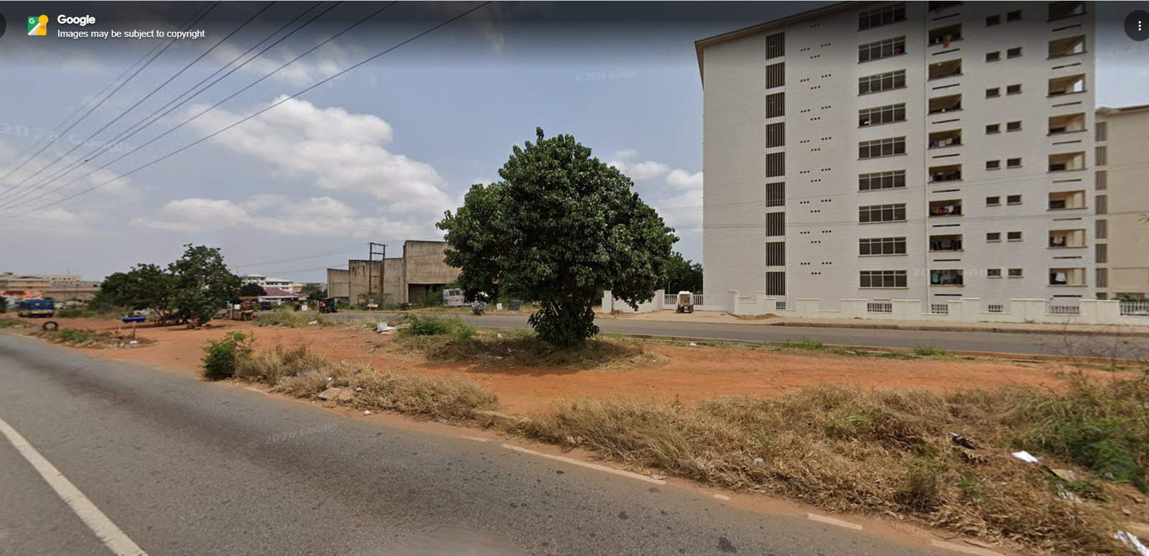
Source: User-supplied Google Street View screenshot, uploaded 12 October 2026. Google UI arrows, text overlays and watermarks are not game-world assets.
Observed: The frame shows a large cream multi-storey residential building at the right, mature shade tree near the centre, open reddish soil and dry grass between the camera and a road. Use it to establish the contrast between the built frontage and rough open verge. Do not assume every visible residential block is the UPSA-owned hostel; confirm building identities from signs and map data.
Implementation target: Model the block only as a context landmark if it falls on the route. Prioritise terrain patches, road shoulder, tree canopy and the change from asphalt to red earth.

RW02 — Long IPS Road perspective, left paver sidewalk and high utility lines
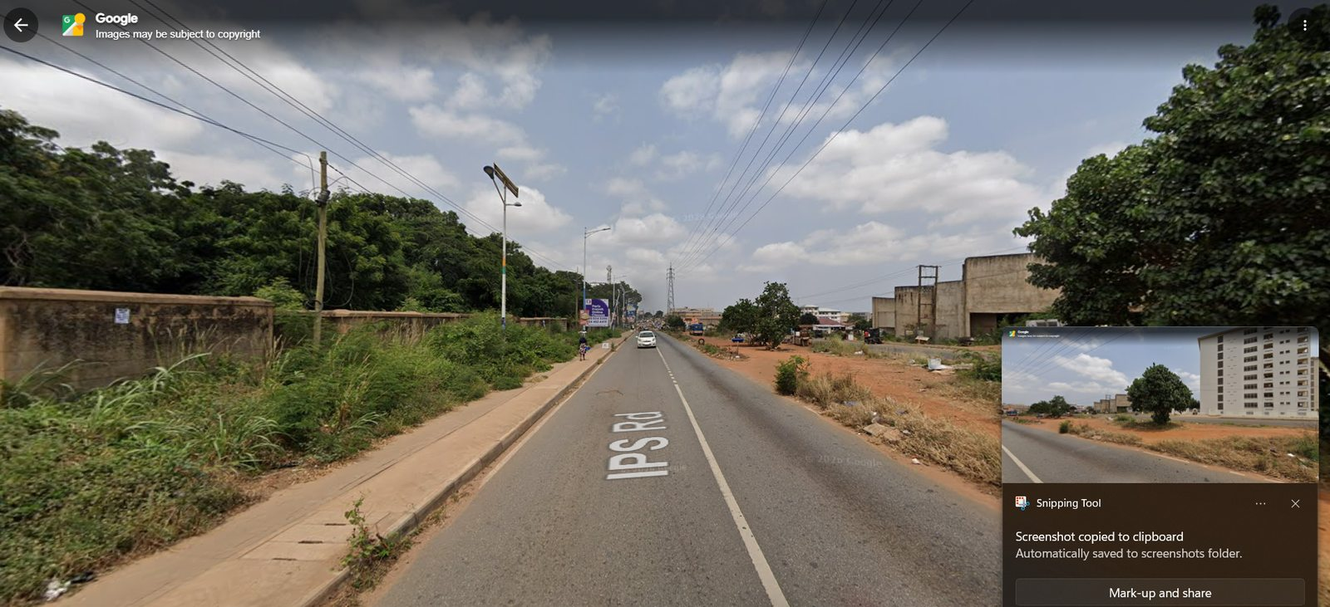
Source: User-supplied Google Street View screenshot, uploaded 12 October 2026. Google UI arrows, text overlays and watermarks are not game-world assets.
Observed: A long straight-to-distant view of IPS Road with a centre marking, raised tan paver sidewalk and wall/vegetation on the left, open dirt and older low-rise frontage to the right, and bundled overhead wires.
Implementation target: Create a continuous perspective, correctly placed left sidewalk and wall, repeated but irregular poles, cable bundles and right-side verge; preserve road centerline from map.

RW03 — Pedestrian on sidewalk; dense greenery and institutional frontage
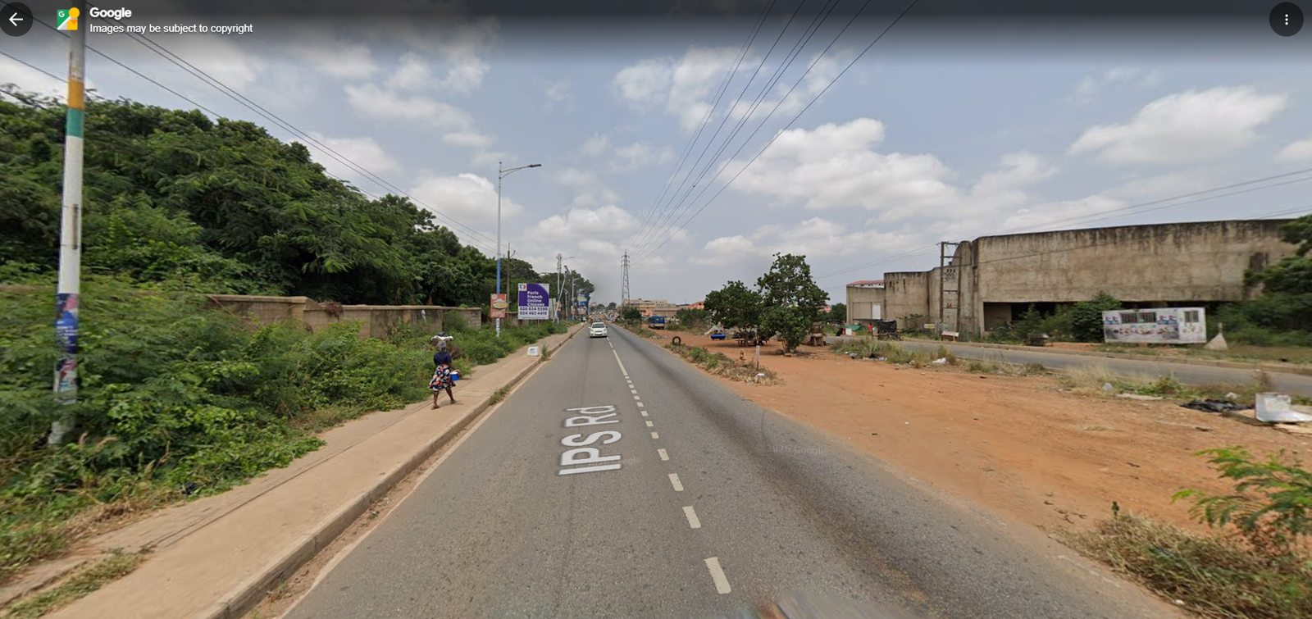
Source: User-supplied Google Street View screenshot, uploaded 12 October 2026. Google UI arrows, text overlays and watermarks are not game-world assets.
Observed: Road ahead with paver sidewalk, concrete boundary wall and thick vegetation on the left, pedestrian-scale street furniture, older concrete building and dusty shoulder on the right.
Implementation target: Add sidewalk slab/paver texture, kerb/edge, wall weathering and dense foliage on left; keep right-side frontage open and uneven, not mirrored.

RW04 — Broad dirt shoulder, shade tree and worn concrete commercial structure
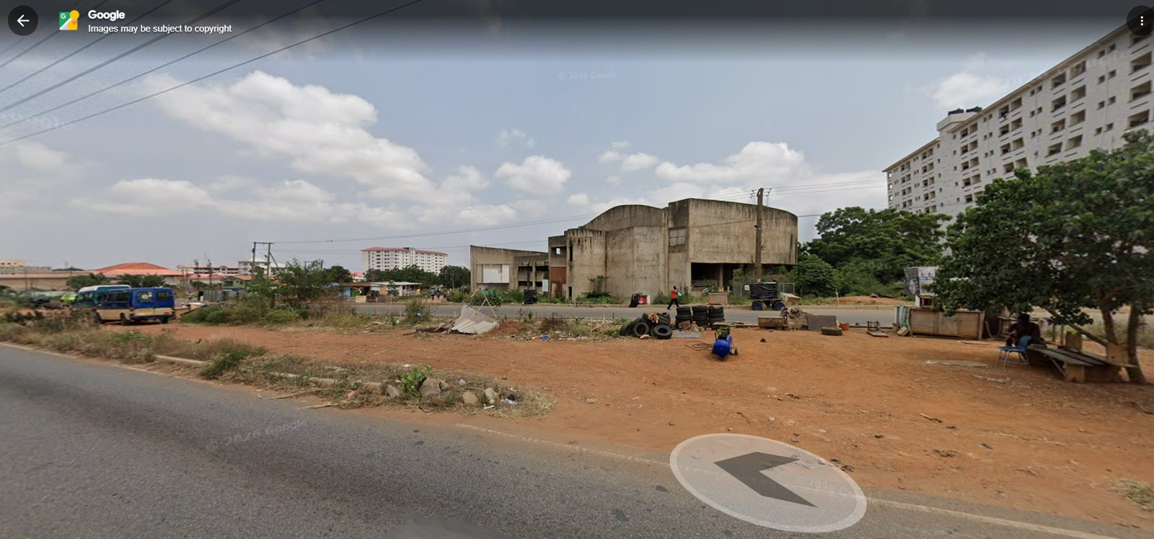
Source: User-supplied Google Street View screenshot, uploaded 12 October 2026. Google UI arrows, text overlays and watermarks are not game-world assets.
Observed: Oblique view across a wide red-earth/rough verge with a prominent tree, older concrete commercial or service building across a side road, small roadside work/parking activity and the taller residential mass behind.
Implementation target: Represent the open setback, older concrete frontage, tree, small ground objects only where appropriate. Do not overbuild the verge or turn it into a landscaped park.

RW05 — Wall-side pedestrian corridor with advertisement and lighting
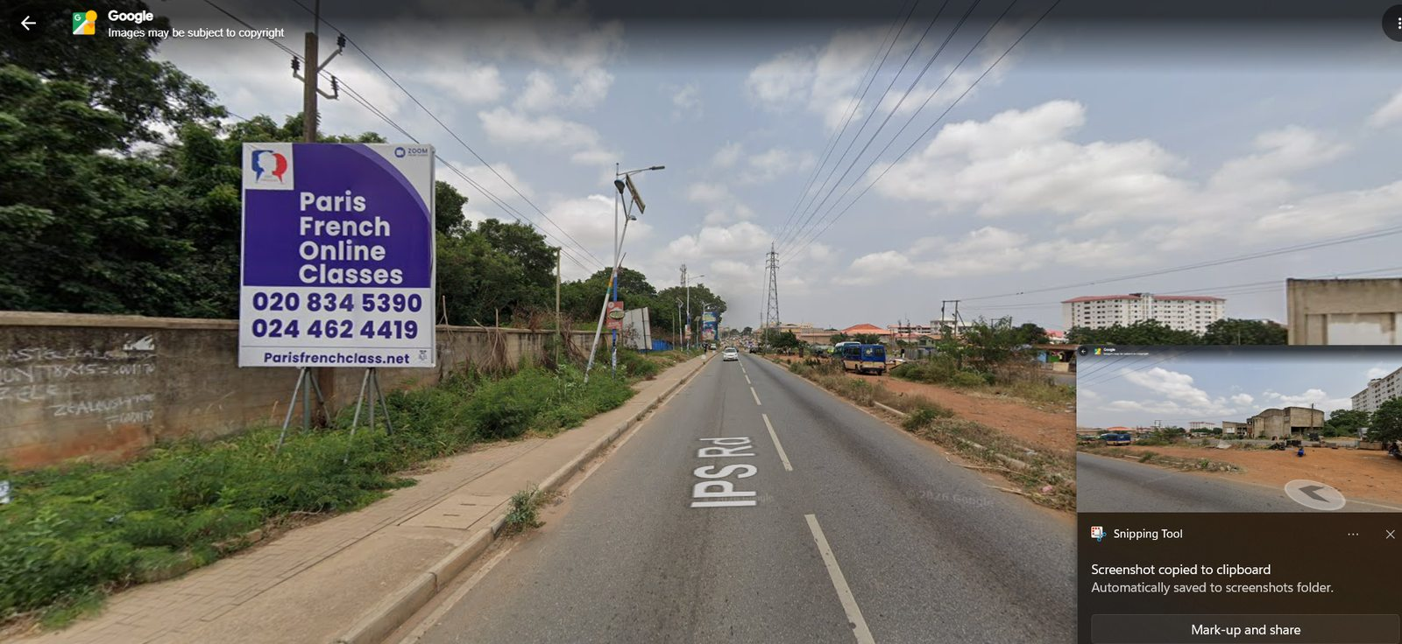
Source: User-supplied Google Street View screenshot, uploaded 12 October 2026. Google UI arrows, text overlays and watermarks are not game-world assets.
Observed: A long forward-facing road view with a raised paved footpath against a boundary wall and vegetation, billboard in the near foreground and recurring streetlights and cables diminishing into the distance.
Implementation target: Place the footpath and kerb continuous where observed. Billboard frames should stand clear of pedestrian route and road visibility; do not copy text from the Google UI.

RW06 — Blue wall, roadside earth and minibus along IPS Road
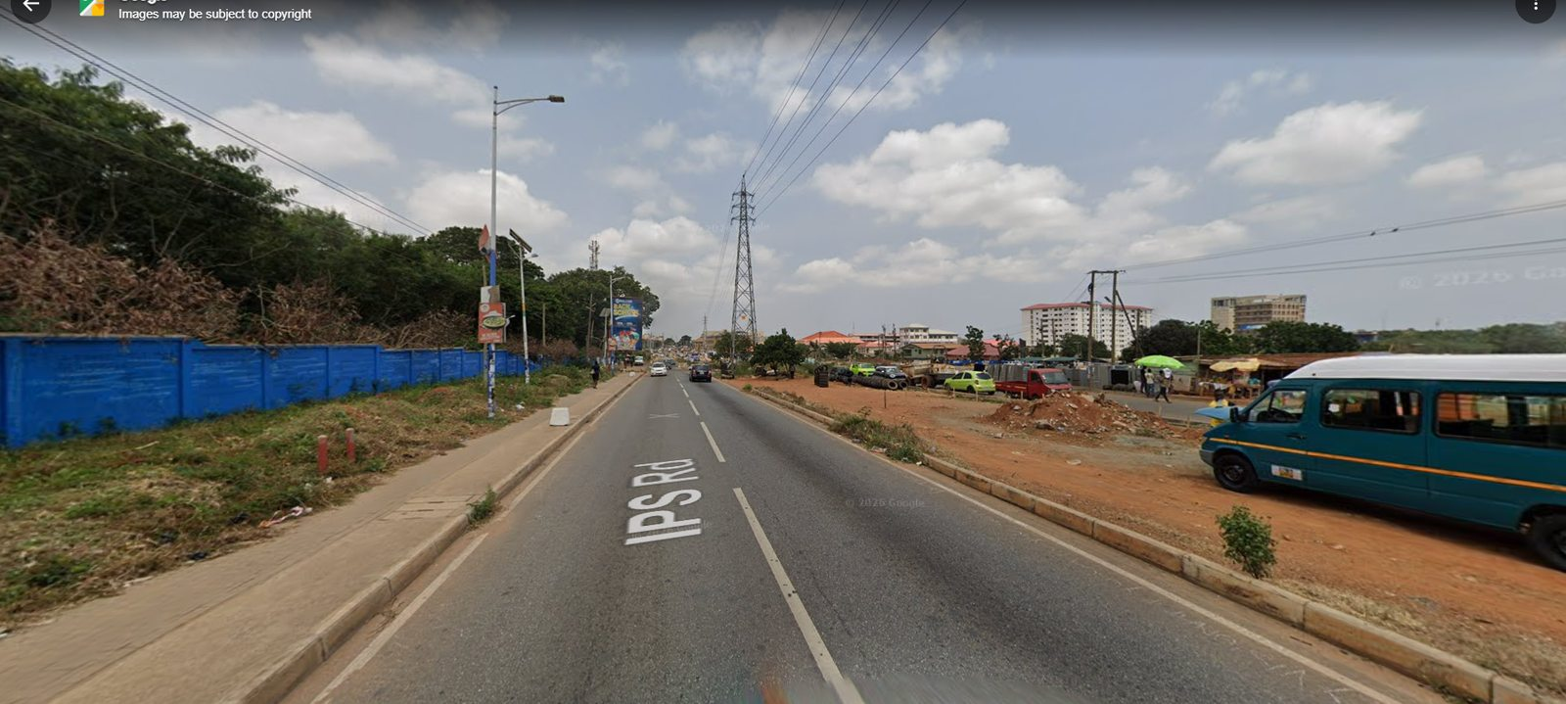
Source: User-supplied Google Street View screenshot, uploaded 12 October 2026. Google UI arrows, text overlays and watermarks are not game-world assets.
Observed: The view shows a long blue boundary wall on the left, paver sidewalk, asphalt carriageway, overhead wires, minibus, open red-earth frontage and a transmission tower farther along.
Implementation target: Recreate wall colour and rhythm only where map/frontage agrees; place tower according to map evidence, add dusty shoulder and keep real driveway interruptions.

RW07 — Transmission tower and tyre/service activity at open frontage
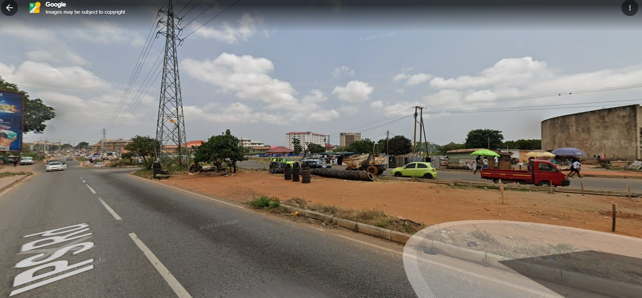
Source: User-supplied Google Street View screenshot, uploaded 12 October 2026. Google UI arrows, text overlays and watermarks are not game-world assets.
Observed: A large lattice power transmission tower rises beside roadside open land. A tyre/service business uses the red-earth strip with vehicles, tyres and small signs; the road and kerb continue past it.
Implementation target: Model tower as an independent high-detail silhouette with plausible base clearances; represent tyre stacks/service stalls as small roadside props only if the corridor point is geographically supported.

RW08 — Near transmission-tower base and road branching
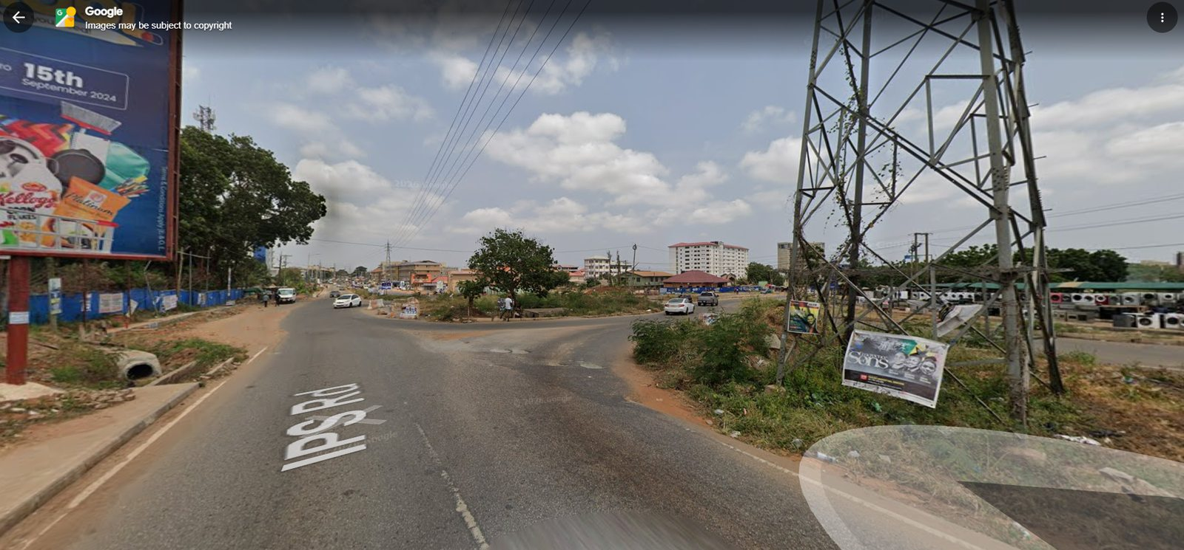
Source: User-supplied Google Street View screenshot, uploaded 12 October 2026. Google UI arrows, text overlays and watermarks are not game-world assets.
Observed: An oblique street view shows a large transmission tower in the foreground, broad roadside asphalt, a branching roadway or junction edge, billboards and open undeveloped ground.
Implementation target: Treat as a junction/branch cue; determine the true centerlines and traffic connections from authoritative geometry. Do not assume the transparent Street View navigation arrow marks a physical island.

RW09 — Road fork and informal planted/rough median
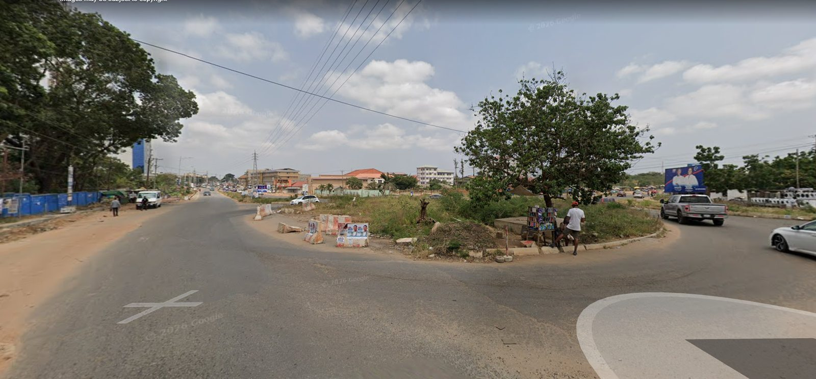
Source: User-supplied Google Street View screenshot, uploaded 12 October 2026. Google UI arrows, text overlays and watermarks are not game-world assets.
Observed: A fork/branching road is visible around a low open island or verge containing a tree and rough vegetation; temporary barriers and scattered small objects sit near pavement edges.
Implementation target: Render the branch geometry from the map layer, not from perspective alone. Preserve turning paths and driveability; avoid a roundabout unless the map or source proves one exists.

RW10 — Urban approach with tall white/blue building and open drainage cut
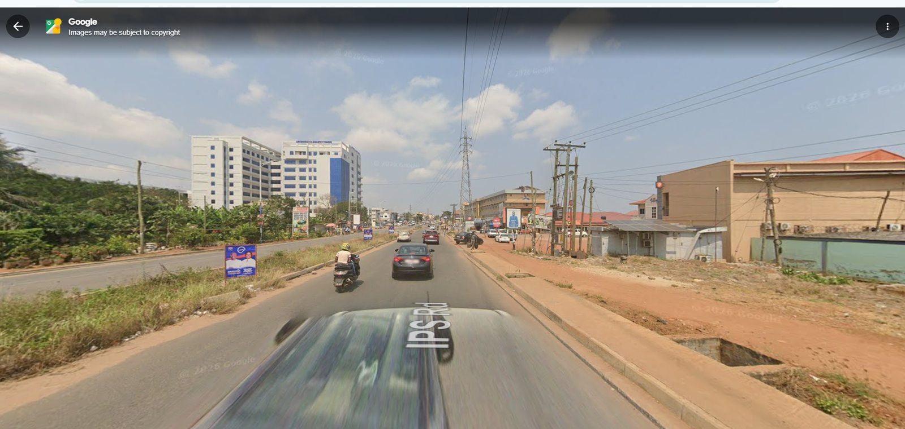
Source: User-supplied Google Street View screenshot, uploaded 12 October 2026. Google UI arrows, text overlays and watermarks are not game-world assets.
Observed: The approach shows a prominent white multi-storey block with blue glazing to the left, shops and low commercial buildings to the right, overhead wires and an open drain/cut at the road edge.
Implementation target: Use the tall building as a contextual landmark only if this location is on route. Reproduce visible curb/drain opening and preserve pedestrian/vehicle crossing logic.

RW11 — Approach road at large utility tower with mixed frontage
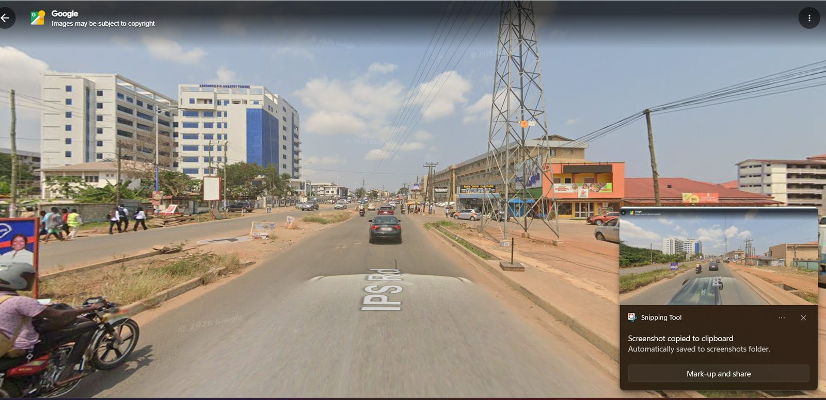
Source: User-supplied Google Street View screenshot, uploaded 12 October 2026. Google UI arrows, text overlays and watermarks are not game-world assets.
Observed: The Street View frame gives a forward view along IPS Road, tall tower, larger building to the left and low retail buildings, sidewalks, curbs, signs and cables along both sides.
Implementation target: Build a convincing skyline with tower-to-building scale; maintain road clear width and avoid wires intersecting the rider camera more than unavoidable.

RW12 — Paved commercial forecourt and shopfronts near IPS Road
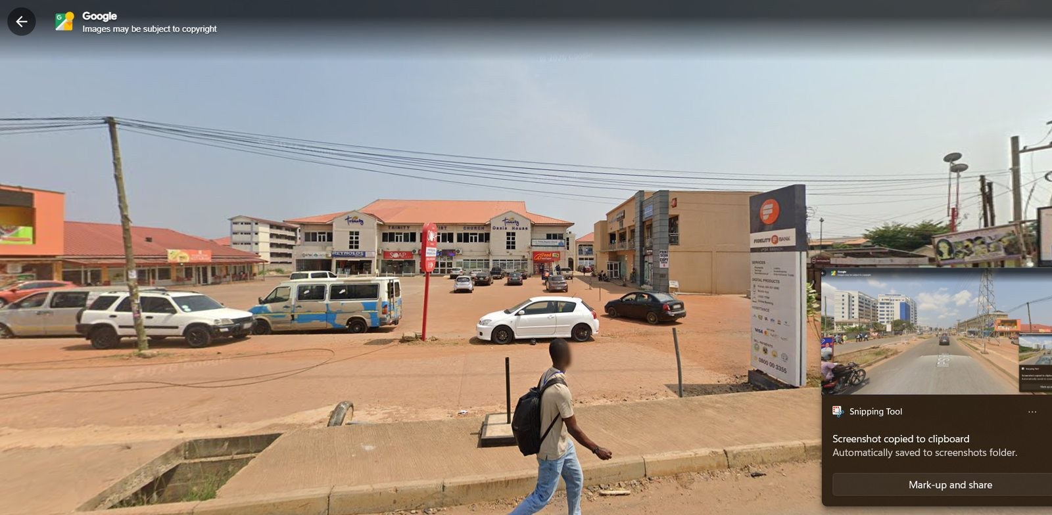
Source: User-supplied Google Street View screenshot, uploaded 12 October 2026. Google UI arrows, text overlays and watermarks are not game-world assets.
Observed: A broad hardstand/forecourt sits in front of a row of multi-storey commercial facades. A pedestrian crosses the sidewalk; cars/van use the paved area and a tall business-directory sign occupies the frontage.
Implementation target: Make the forecourt surface, curb cut and shopfront rhythm clear. Business directory/sign must be anchored on property side rather than the riding line.

RW13 — Commercial plaza, shops and tower corridor
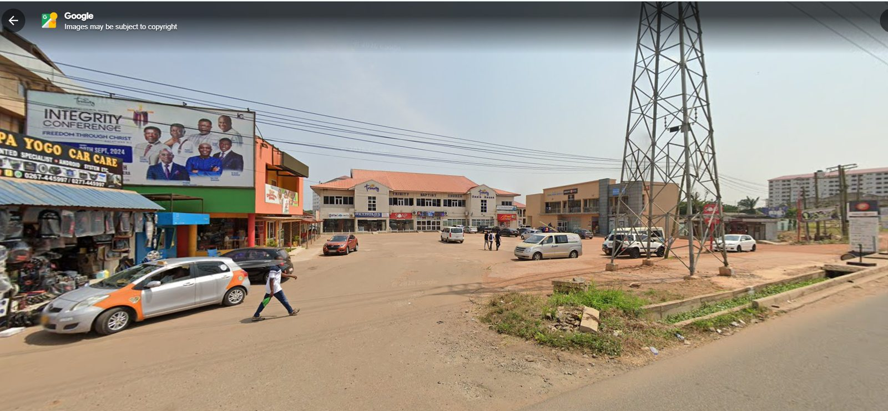
Source: User-supplied Google Street View screenshot, uploaded 12 October 2026. Google UI arrows, text overlays and watermarks are not game-world assets.
Observed: A closer view of retail facades and a wide parking apron, a large transmission tower, several billboards and irregular shoulder/road edges.
Implementation target: Use the tower as a visual orientation point, but derive its location from map data. Create varied shop facades and modest sign clutter without transcribing every advertisement.

RW14 — Prestige Hostel sign and broad paved forecourt
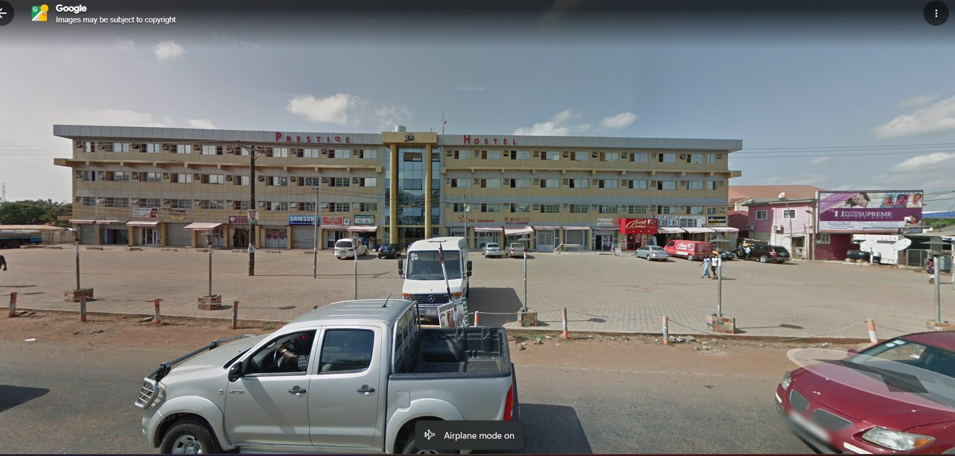
Source: User-supplied Google Street View screenshot, uploaded 12 October 2026. Google UI arrows, text overlays and watermarks are not game-world assets.
Observed: The building fascia reads “PRESTIGE HOSTEL”; this is a multi-storey, long horizontal frontage behind a large paved forecourt with boundary bollards/posts and vehicles. It appears to be a separate private hostel along the corridor, not proof of the UPSA Main Gate or campus hostel identity.
Implementation target: Preserve this as a distinct roadside property if included in route geometry; use the observed broad paved apron and repeated façade rhythm. Never relabel it as UPSA Main Gate, UGBS or the university hostel without evidence.

RW15 — Domil Heights frontage, side shops and street edge
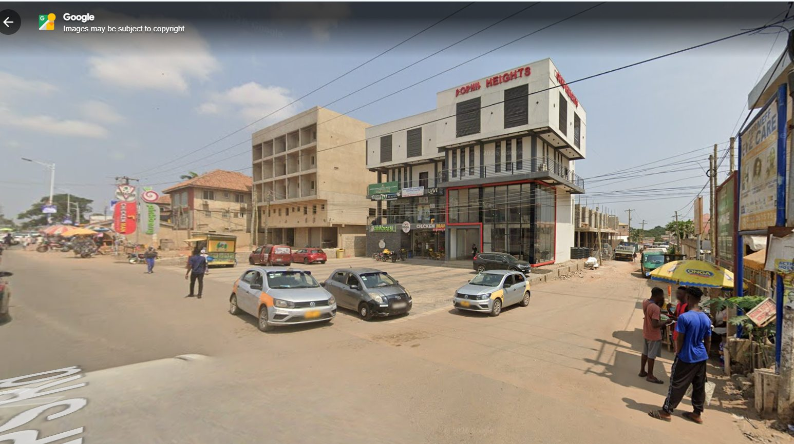
Source: User-supplied Google Street View screenshot, uploaded 12 October 2026. Google UI arrows, text overlays and watermarks are not game-world assets.
Observed: A corner view shows the “DOMIL HEIGHTS” name, a modern corner building with dark glazing/vertical accents, neighbouring shops, red/cream roofed retail buildings, vehicles and informal vendors.
Implementation target: Use the sign as an identity clue for this private commercial building; model only if its actual map position falls on this corridor. Include shopfront, driveway, pedestrian edge and overhead wire context.

9. Online map, institutional and image research
  - Source state checked 12 October 2026. Treat older photos/annual reports as dated references and verify present-day geometry.
Online imagery is provided as clickable source links. Current runtime/network constraints prevented downloading the externally hosted photographs into the local Word file, so the document does not pretend these images are embedded. The 15 user-supplied Street View images are embedded; use the links below to open the separate gate/campus images. Image-use terms vary by source.
S1 UPSA official homepage
Official institutional reference for campus identity and current navigation to official resources.
S2 UPSA official article: building names on campus (2017)
Confirms presence of Central Administration, lecture blocks, clinic and five-storey library complex; older article, so use as naming context not present-day completion status.
S3 UPSA official Student Services / campus info
Names the Central Administration Block and discusses the campus/hostel context and nearby institutions.
S4 UPSA Annual Report 2024
Documents a Model Police Station, pedestrian walkway/drains behind Amon Kotei Hostel, and campus construction projects; this is a dated report and may not reflect today’s exact completion state.
S5 UPSA 2016 Annual Report (historic gate/wayfinding context)
Describes pedestrian route to the pedestrian gate near bus stop, security shelter near the main entrance, grating over a drain and lay-by near security post. Treat as historical design notes only.
S6 Wikimedia Commons: Main Gate (UPSA).jpg
Openly licensed main-gate photograph by Manson04, dated 22 May 2021; page identifies CC BY-SA 4.0. Gate photo is appearance reference, not a current survey.
S7 Wikimedia Commons: Main Gate (UPSA) 1.jpg
Second angle of the main gate by Manson04, dated 22 May 2021; CC BY-SA 4.0. Shows signage, canopy, gatehouse, traffic barrier/approach.
S8 Wikimedia Commons UPSA image collection
Open photo list including Campus, Central Administration, Joshua Alabi Library, Auditorium and Justice Aryeetey Building references.
S9 OpenStreetMap campus object / Mapcarta UPSA page
OpenStreetMap-derived campus locator: approx. 5.66155 N, -0.16638 W. This is a campus-area anchor, not the exact gate coordinate or a complete surveyed path.
S10 OpenStreetMap direct map around UPSA
Use for orientation and to inspect mapped roads/buildings; confirm licensing and source attribution if data is imported.
S11 Google Maps: UPSA search link
Interactive map entry point. Street View imagery may be older/incomplete; compare multiple angles and map data.
S12 User-supplied Google photosphere
User-provided Street View/photosphere context link around the wider hostel/road environment.
S13 Official UPSA social post showing main entrance gate (2019)
Institutional image reference for the blue-and-white entrance arch, fascia and approach. Open link in browser; not used as survey geometry.
S14 Official UPSA social post showing aerial campus view (2019)
Aerial visual reference for building massing and campus landscape arrangement; image is historical, so verify against current map/build data.
S15 Official UPSA aerial campus view (2023)
A wider aerial view showing general campus density, sports/campus context; do not use perspective alone to set building coordinates.

9.1 What is confirmed online vs what remains to be verified
- UPSA is the destination campus, officially referred to as University of Professional Studies, Accra. Its official site publishes facility, student-service and institutional material (S1–S5).
- UPSA’s official building-naming article documents Central Administration, lecture blocks, clinic and a five-storey library complex; later official materials refer to Joshua Alabi Library and the Central Administration Block (S2, S3).
- Wikimedia Commons provides two Main Gate photos with file metadata and CC BY-SA 4.0 licensing, dated 22 May 2021 (S6, S7).
- An OpenStreetMap-derived campus point on Mapcarta is approximately 5.66155° N, -0.16638° W. That is the campus object/locator, not a surveyed gate location or a route origin (S9, S10).
- UPSA Annual Report 2024 describes a model police station and a walkway/drainage work behind Amon Kotei Hostel, and describes construction projects as of the report date (S4). These features should only enter this scoped reconstruction if geography and route sequence prove they are near the chosen first internal segment.

9.2 Uncertainties Claude must explicitly resolve or log
- Exact start coordinate within the external hostel-area corridor; determine from current repository/OSM geometry and the intended playable route.
- The exact point at which the route passes the large transmission tower and each visible commercial plaza; the 15 screenshots are perspective views, not a georeferenced survey.
- Exact current state and recent renovations of the gate, main internal road and first building faces; gate photos are from 2021 and aerial photos can be older.
- Exact internal route order and the suitable UPSA school / academic endpoint; determine using official campus information, map/building polygons and connected road geometry before modeling. Do not assume the first landmark is the endpoint.
- Precise dimensions, hidden back elevations, exact number of lanes/booths/barrier arms, pavement widths and cable heights. Do not claim these from perspective images.

10. Separate current-game correction section
  - Use the current game screenshot sheet only to identify gaps and rendering priorities; it is not a real-world base map.
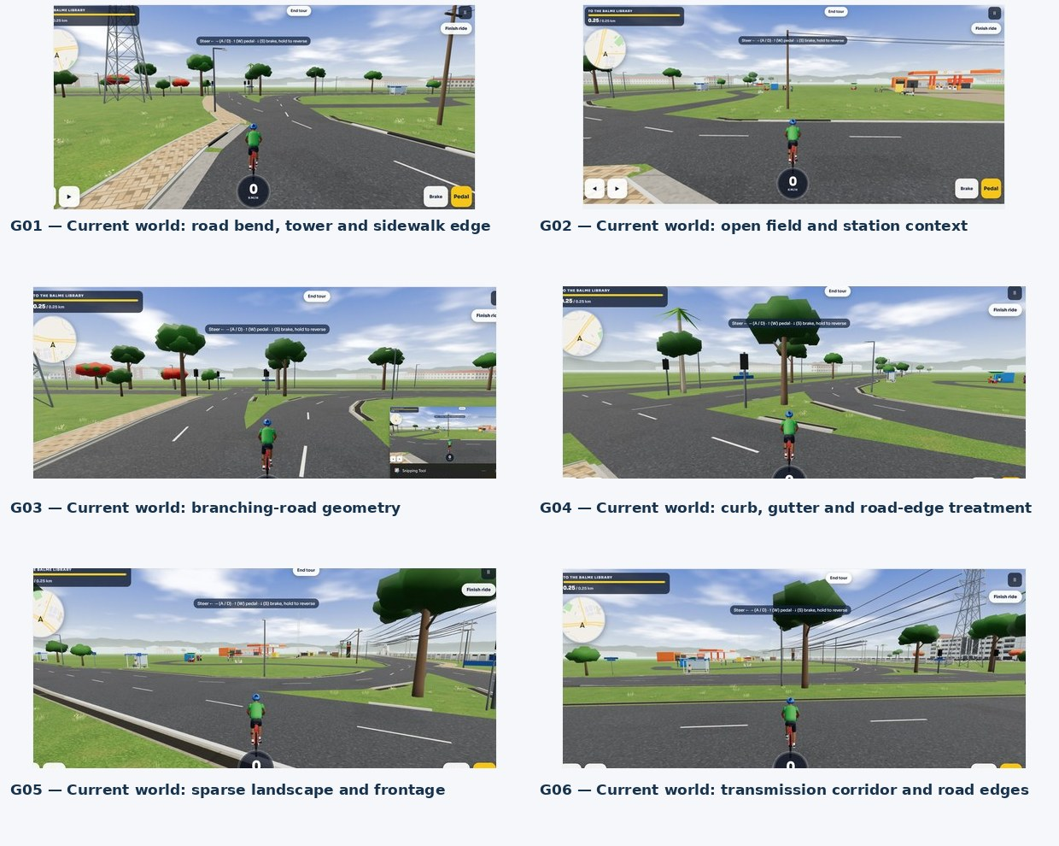
FIGURE 2. Current LEGONRUSH gameplay diagnostics supplied in earlier corridor/junction work (G01–G06). These views show existing stylized campus roads/terrain around a route labeled to Balme Library.
The current-game images show stylized asphalt, simple white lane markings, pale curb/sidewalk pieces, large grass areas, repeated low-poly trees, simple utility assets and a generic GOIL-like station/roadside world. These are useful for rendering diagnostics only; they are not evidence that the scene geometry is the real UPSA approach.

CG-01 — Coverage / identity
The current diagnostic views are dominated by a generic open green scene and a route UI that says “To the Balme Library.” They do not yet represent the detailed IPS Road approach sequence or prove a route to UPSA.
Correction target: Add the UPSA corridor as a properly georeferenced extension and create a new destination/path where needed; do not relabel or repurpose the Balme Library route.

CG-02 — Road topology
Visible roads branch through stylized triangular grass islands; it is not clear that this matches the outside IPS Road branches.
Correction target: Compare each real branch against map centerlines and access topology. Rebuild only the UPSA-specific road layer/meshes; retain existing branch endpoints and UG routes.

CG-03 — Ground / road edge
Road edges and pavement/kerb bands are highly stylized and can show discontinuous gutter/sidewalk pieces.
Correction target: Make asphalt, lane markings, kerb, drains, pavers and red-earth shoulder a continuous geometry system; test for z-fighting and raised strips.

CG-04 — Urban frontage
Large empty green lots, sparse trees and generic building silhouettes do not capture the dense mixture of walls, shrubs, shopfronts, private hostel blocks, paved forecourts and informal service activity in RW01–RW15.
Correction target: Populate only the route’s real mapped frontages using the catalogue; use varied low-rise/medium-rise blocks with correct setbacks and preserve open red-earth space where visible.

CG-05 — Utility infrastructure
The diagnostic sheet shows a tower and repeated power lines but simplified scale/context.
Correction target: Match tower class, base footprint, line direction, local distribution poles and streetlight spacing to reference and map; avoid unsafe player/camera intersections.

CG-06 — Main Gate / inner campus
No current-game view in the diagnostic sheet establishes a correctly reconstructed UPSA entrance-to-campus sequence.
Correction target: Create/verify the entrance canopy, gatehouse, barriers and threshold using online main-gate links; continue to the first map-confirmed internal landmark.

CG-07 — Performance
Current stylized scene suggests reused assets; keep reuse where it helps, but the site needs more contextual variation.
Correction target: Instance repeated trees/poles, reuse materials, avoid dozens of unique transparent cable shaders, and profile frame rate during a complete ride.

11. Repository inspection and safe implementation plan
- Inspect current Git branch/status and recent commits; check whether the UPSA corridor and gate already exist, whether their coordinates are within the current geography bounds, and which data/code path generates road and building geometry.
- Read the project’s geo/docs before editing, especially destination-access, entrance verification, building identity, map generation and any road/terrain bug reports. Inspect data/geography/legon-master.geojson, data/geography/legon-access.geojson, data/geography/registry/access.json, data/legon.osm, src/data/legon-map.json, source POIs/corrections and scripts/geography/* where present.
- Check coverage: the original world is centred on University of Ghana/Legon. If the authoritative geodata does not cover the full outside IPS Road-to-UPSA route, create a clearly scoped, sourced, georeferenced UPSA extension. Do not warp existing UG geometry to force the new campus into it.
- Create a provenance record for every new road/building/POI coordinate or manually inferred frontage. Cite OSM/official/user photo sources and tag confidence. Keep inferred backside geometry distinct from confirmed footprints.
- Model the complete road network first, then shoulders/sidewalks/curbs/drains, roadside property/building silhouettes, gate and threshold, then connected internal road and intermediate landmarks through to the school / academic core, followed by vegetation/signage/props. This preserves scale and makes visual QA manageable.
- Preserve stable IDs, existing route/challenge geometry, access points, collision behavior, ghosts and leaderboard-compatible routes. New UPSA paths/landmarks get new IDs and narrow scope; do not regenerate unrelated routes.
- Run geo generation if applicable and ensure committed/generated map data are in sync; run type checks, unit/geometry/route/access tests and production build.
- Open the deployed/local browser world and ride the full route, from the external start to inside the campus. Inspect both road edges, each branch, forecourts, cables, the tower, gate threshold and first landmark(s) from cyclist eye height plus an elevated overview.
- Capture before/after screenshots from repeatable viewpoints. Check road-ground flicker, raised bars, broken curbs/gutters, floating surfaces, road-to-driveway joins, collision blockers and frame rate.
- Review diff for unrelated campus changes and report uncertain facts. Do not push to main or deploy without explicit user approval.

12. Acceptance checklist
- □ Start point confirmed against route data; path connects from the hostel-area/IPS Road anchor to UPSA Main Gate and continues into campus.
- □ All branches/turns along external corridor follow mapped road geometry; no guessed roundabouts or invented junction arms.
- □ Sidewalks, pavers, kerbs, gutters, drain crossings and red-earth shoulders follow image evidence and real property entrances.
- □ Main Gate identity, canopy, fascia, gatehouses, barriers and access lanes read correctly from the approach and inside.
- □ The route continues beyond the gate through correctly ordered internal landmarks to the mapped UPSA school / academic core; endpoint justified by evidence, not assumed from names alone.
- □ Distinct local commercial frontage and visible named properties are not mislabeled as university buildings.
- □ Tower, distribution poles, overhead wires, streetlights, billboards and trees align with the corridor and do not obstruct playable space.
- □ No road/grass flicker, z-fighting, raised bars, missing sidewalk/gutters, floating meshes, black seams or excessive material overlap.
- □ No existing University of Ghana geometry, route/access IDs, race/challenge paths or gameplay features were changed unintentionally.
- □ Generated map assets are in sync; typecheck/tests/route+access tests/build pass.
- □ Browser inspection/ride completed continuously from external hostel-area start through UPSA Main Gate to the school / academic endpoint; before/after screenshots stored.
- □ Remaining uncertainty and provenance are reported; no push to main/deploy without approval.

13. Ready-to-paste Claude Code master prompt
  - Use the companion file CLAUDE_CODE_MASTER_PROMPT.txt if you want to paste the prompt without copying it from Word.
LEGONRUSH — MASTER PROMPT: EVIDENCE-FIRST RECONSTRUCTION FROM UPSA HOSTEL AREA THROUGH THE MAIN GATE TO THE UPSA SCHOOL / ACADEMIC CAMPUS CORE

ROLE AND OUTCOME
You are working in the existing LEGONRUSH repository. Reconstruct one continuous, geographically faithful, playable route that begins in the UPSA Hostel-area / IPS Road corridor shown in the supplied references, follows the real external approach, reaches and passes through the University of Professional Studies, Accra (UPSA) Main Gate, and continues along the actual internal campus road network to the UPSA school/academic campus area. The task must NOT stop at the gate or merely at the first landmark if the academic/school area lies farther inside. Intermediate landmarks should help establish the route, not become the arbitrary endpoint.

NON-NEGOTIABLE PHASE 0 — READ AND AUDIT ALL PROVIDED MATERIAL BEFORE MAKING DECISIONS
Do not edit source code, generate replacement geometry, choose a route, infer a building identity, or decide what to model until you have completed this evidence-intake phase.
1. INVENTORY THE MATERIALS FIRST
- Recursively inventory every file supplied in the current UPSA Hostel-to-Campus reference pack and every accessible, task-related UPSA / IPS Road / UPSA Junction / UPSA Hostel / VC Complex / UGBS reference pack already present in the working environment or explicitly attached to this task.
- Include Word/PDF briefs, README files, text prompts, source lists, CSV image registers, contact sheets, route/topology diagrams, raw user screenshots, game screenshots, online reference images and any map/geographic extracts.
- Produce an inventory table with path/name, file type, short role, and review status. Do not claim a file was reviewed if it was not opened/read.
- Keep unrelated branding, marketing or general UI assets out of the reconstruction evidence set unless a document explicitly ties them to this place. Record them as unrelated rather than silently mixing them into site evidence.
2. READ EVERY TASK-RELATED DOCUMENT IN FULL
- Read every relevant DOCX, PDF, TXT, Markdown, CSV and other text-based project document completely before implementation decisions.
- Extract and read the full instructions in the current brief, its source register, README_FIRST.md, ONLINE_SOURCES.md, and this master prompt; inspect the brief's embedded images, diagrams, tables, captions, notes and acceptance criteria too.
- Read the related previous road-focused, UPSA Junction, hostel / VC Complex and UGBS briefs that are available in the materials. Resolve their scope boundaries and preserve their corrections about building identity.
- Read the repository's CLAUDE.md / README, geographic documentation, migration/handover notes, relevant code comments and test expectations before modifying the project.
3. VIEW ALL ORIGINAL IMAGES, NOT JUST CONTACT SHEETS
- Open and visually inspect every original uploaded real-world image individually, including all 15 user Street View / road screenshots included in this pack and all task-related images in earlier reference packs that are accessible.
- Inspect all current-game screenshots separately. They describe the present implementation and defects; they are NOT authoritative real-world geography.
- Inspect each contact sheet and the conceptual route diagram, but never treat a contact sheet or schematic as a substitute for the original image.
- Match each source image to its register ID and description. Note what it proves, what it only suggests, the visible direction/viewpoint, and any limitations caused by screenshot overlays, perspective, cropping, Street View navigation arrows or dates.
- If any file is missing, unreadable, corrupt or inaccessible, record the exact item and the impact. Do not pretend to have reviewed it or fill its evidence gap by guessing.
4. CHECK THE ONLINE SOURCES
- Open the links supplied in ONLINE_SOURCES.md and verify the relevant parts where available.
- Search authoritative UPSA sources for the campus plan, Main Gate, academic/lecture blocks, Central Administration, library, auditorium / student facilities, roads, and campus names. Use official campus information for identity and terminology, not to infer a building's exact order on the route without map evidence.
- Check OpenStreetMap or another traceable geospatial reference for road connectivity, campus entries and building footprints. Record the source, access date, coordinate reference system where known, data limitations and confidence.
- Use the supplied Google Street View screenshots for the visible roadside appearance and sequence. They are dated/perspective views, not a survey. Treat online gate photos as appearance references only unless their positions and current state are independently verified.
- Add a source/provenance note for every geography or identity decision. Do not say an online image was downloaded or embedded if it is only linked.
5. CREATE AN EVIDENCE LEDGER BEFORE IMPLEMENTATION
Only after steps 1–4 are complete, write a concise project note (for example, docs/upsa-hostel-to-school/evidence-audit.md) with:
- The complete materials inventory and what was actually read/viewed.
- A source hierarchy and per-source reliability/confidence.
- A route sequence supported by map/road-network evidence.
- Confirmed features vs estimates vs unresolved facts.
- Conflicts between sources and the chosen resolution, with reasons.
- The current-game mismatch list and intended changes.
- A file/data impact plan showing what is likely to change and what must remain untouched.
Do not start implementation until this audit note exists. Work autonomously after the audit; do not ask for routine approvals. Ask the user only if a genuinely critical route/identity ambiguity remains after all provided materials and sensible online checks have been exhausted. If uncertainty is non-blocking, mark it explicitly and choose a conservative, reversible solution.

EVIDENCE HIERARCHY
Use sources for the aspects they are best qualified to support:
1. Existing repository's authoritative road/building geography, stable IDs, connectivity, CRS, route data and tests control placement, topology and existing gameplay compatibility.
2. User-supplied real-world Street View / field screenshots control the visible physical appearance and roadside sequence in their views.
3. Official UPSA sources control official names, building identity and campus terminology.
4. Traceable OSM / map data and openly licensed sources supplement road connectivity and geospatial context.
5. Current-game screenshots are diagnostics to compare against reality, not evidence of real-world layout.
6. Conceptual diagrams are orientation aids only; they are not surveyed maps and must never determine coordinates, scale or road geometry.
When sources conflict, explain the conflict in the evidence ledger and avoid silently replacing higher-confidence evidence with an assumption.

GEOGRAPHIC SCOPE — DO THE WHOLE ROUTE TO THE SCHOOL AREA
A. START: establish the actual route start from repository anchors and the uploaded images around the UPSA Hostel / IPS Road corridor. Do not confuse university-owned UPSA Hostel with nearby private properties whose signage includes “Prestige Hostel” or “Domil Heights.”
B. EXTERNAL APPROACH: reconstruct the connected road corridor from the hostel-area reference sequence toward UPSA Main Gate. Depending on the documented route, the context may include asphalt carriageway and lane markings; actual branches and junctions; paver sidewalks; kerbs; open gutters, culverts and driveway crossings; red lateritic shoulders; boundary walls and fences; mature trees and weeds; exposed plots; older concrete/frontage buildings; shops and commercial blocks; private hostel/hotel buildings; forecourts and parking; billboard structures; streetlights; distribution poles; overhead cables; and the lattice high-voltage transmission tower. Place each feature only where the evidence and map support it.
C. JUNCTIONS / CONNECTIONS: derive side-road and turning geometry from the geographic road network and the supplied multi-view images. Street View perspective, the viewing vehicle, labels and navigation arrows are not geometry. Do not invent a roundabout, straighten real bends, close a true side road, or create impossible/overlapping intersections to simplify the model.
D. UPSA MAIN GATE: accurately connect the external road to the correct UPSA Main Gate and threshold. Use the supplied/openly licensed gate images for the blue-and-white gatehouse/canopy, university name fascia, columns, gatehouse volumes, vehicle/pedestrian entry arrangement, barriers and approach paving. Verify current orientation, number and layout of openings and location against geographic evidence before placing them. Do NOT substitute the unrelated Presbyterian Church gate shown in some corridor references.
E. INSIDE UPSA: continue THROUGH the gate and along the real connected internal road. Reconstruct the internal-road connection, gates/guards/booths if verified, pavement transitions, footpaths, kerbs, drainage, boundary edges, landscaping and the first internal buildings/landmarks encountered in their correct order.
F. ENDPOINT — UPSA SCHOOL / ACADEMIC CAMPUS AREA: continue beyond the first gate-side landmark(s) to the actual campus school/academic area. Do not stop at the gate, in the entry apron, or at whichever landmark happens to be closest if the core academic area is further inside. Using official UPSA campus information together with mapped building footprints and actual road connectivity, identify the appropriate endpoint around the lecture/academic and/or main administration/library core that is reached by the genuine connected road. Include the major campus buildings and public-space edges that define this arrival area, but do not invent the sequence from building names alone. If sources support more than one academic cluster, select the one genuinely reached by the road being reconstructed and explain why in the evidence ledger. The final ride must visibly arrive at the UPSA school/academic area, not merely show a road disappearing into generic green space.

CRITICAL GEOGRAPHY RULE
The existing LEGONRUSH geography is strongly associated with University of Ghana / Legon. First verify whether its authoritative geographic data truly includes the IPS Road corridor, UPSA Main Gate and internal UPSA road/building network.
- If it does, use it without perturbing its stable geometry.
- If it does not, create a clearly separated, documented, provenance-tagged and georeferenced UPSA extension with its own namespaces/IDs, transform rules and tests. Do NOT shift, warp or relabel the University of Ghana/Legon map to force UPSA into it.
- Establish CRS and coordinate transformations explicitly. Never guess GPS coordinates, scale or metres-per-unit from perspective images.
- Never place a building by eyeballing a screenshot when a footprint/anchor can be sourced. Where no reliable anchor exists, preserve a known anchor or defer a precise claim; record the uncertainty.
- Keep the route graph connected and navigable from the external start through the gate to the academic endpoint. New IDs must be stable and unique.

VISUAL RECONSTRUCTION REQUIREMENTS
- Asphalt: plausible colour, aggregate/wear variation, carriageway width, camber/elevation, lane/edge markings and transitions grounded in the images.
- Roadside surfaces: tan/red/brown lateritic soil, hard shoulder, concrete edges, pavers, kerbs and visible drainage features; represent side-to-side differences rather than mirror-copying the same verge.
- Urban frontage: trees/canopies, walls, fences, building setbacks, commercial facades, sign supports and parking/forecourts at evidenced locations; maintain the recognisable roadside character around IPS Road.
- Utilities: accurately position transmission tower and poles, avoid implausible cable connections, and model overhead lines at suitable height/scale using efficient geometry. Do not turn distribution poles into high-voltage pylons or vice versa.
- UPSA gate and internal campus: correct identity, massing, paving, boundary transitions, circulation and academic-area context.
- Signage: use only persistent/identifying signs supported by references. Do not copy Google UI, watermarks, Street View arrows, screenshot browser chrome, transient adverts or temporary people/vehicles into permanent world assets. Keep temporary traffic as reusable game assets if appropriate.
- The visual style must integrate with the current LEGONRUSH renderer and player scale but must not substitute a generic green campus for the documented urban corridor and real academic campus.

CURRENT-GAME CORRECTION / DEFECT REVIEW
Compare the current game diagnostics against the real-world image set after the evidence audit. The screenshots may show generic low-poly green land, stylized roads/trees, simplified frontages, a Balme Library tour or other locations; do not mistake these for UPSA.
Investigate and fix relevant causes of:
- road/asphalt flicker against grass or terrain;
- long raised strips/bars across roads;
- missing or broken sidewalks and gutters;
- floating road/curb/wall meshes;
- z-fighting, terrain intersections, black seams and duplicate strips;
- disconnected road branches, implausible curb continuity or blocked driveways;
- misaligned markings, broken surface joins and unnecessary frame cost.
Fix the real source in geometry/data/mesh generation and validate in the browser. Do not hide problems with arbitrary height offsets, duplicated cosmetic geometry, or edits to unrelated parts of campus.

PRESERVE EXISTING GAME CONTENT
- Do not redesign the entire game.
- Preserve all unrelated University of Ghana / Legon geographic layers, roads, junctions, building footprints, destination/access IDs, landmark IDs, challenge/race routes, ghost recordings, leaderboard compatibility, collisions, player controls, UI features and unrelated campus content.
- Do not relabel a Balme Library route as UPSA, do not repurpose existing IDs, and do not change unrelated stable route geometry.
- Put UPSA-specific additions in separately named data/modules where necessary and update generators and tests coherently.
- Do not commit secrets, copy copyrighted source imagery into permanent game textures without appropriate rights, or claim a source is open-licensed without verification.

IMPLEMENTATION SEQUENCE — NO SKIPPING THE EVIDENCE GATE

PHASE 0. Inventory all task-related uploads and reference packs; read every relevant document; open every original image; review all source links; read repository geography instructions. No code edits.

PHASE 1. Create evidence-audit.md and a route table with start, junctions/branches, approach segments, landmarks, gate threshold, internal road anchors and the UPSA academic endpoint. For each, include provenance, confidence and evidence. No coordinates sourced solely from a perspective view.

PHASE 2. Inspect the live/current game and source files; document exact mismatches and establish repeatable viewpoints for before/after comparison.

PHASE 3. Implement the external road and true intersections with continuous road mesh, lane markings and height/elevation consistency.

PHASE 4. Add side-specific sidewalks, pavers, curbs, drainage, culverts, shoulders and transitions; preserve real driveway/gate openings.

PHASE 5. Add geographically grounded roadside context: vegetation, walls, shops/frontages, private hostel buildings, billboards/supports, streetlights, distribution poles, overhead cables and transmission tower.

PHASE 6. Implement the correct UPSA Main Gate, entry apron and road/pedestrian connections.

PHASE 7. Continue the route inside UPSA through the first mapped landmarks and farther into the academic/school campus core. Model key visible building masses and grounds only at verified/defensible footprints; do not stop at the first landmark if it is not the school-area endpoint.

PHASE 8. Synchronize derived/generated map data and update geospatial provenance/route tests.

PHASE 9. Run type checks, relevant unit/integration tests, geometry/intersection/access/route tests, map generation consistency checks and production build.

PHASE 10. Launch in a browser. Ride or inspect the full continuous route from the Hostel/IPS Road start through the correct gate and into UPSA's academic area. Inspect both sides of every road section, junction joins, gate clearance, road markings, sidewalks/drains, power infrastructure, surface intersections, collisions and performance. Capture before/after screenshots from repeatable angles; fix visible defects and repeat tests.

ACCEPTANCE CRITERIA
- Every task-related uploaded document/image has been inventoried and reviewed; inaccessible items and their impact are documented.
- The external corridor follows evidenced real-world road connectivity and distinctive roadside context.
- The road correctly reaches and passes through UPSA Main Gate.
- The road continues inside UPSA all the way to a mapped, explained endpoint in the school/academic campus area; it does not stop at the gate or a random first landmark.
- Building identities and order are sourced, not guessed from nearby signs or image perspective.
- All road/ground/sidewalk/curb/drain/driveway transitions are continuous and plausible, with no unexplained gaps, floating meshes, flicker, raised bars or blocked access.
- The UPSA additions use stable unique IDs and do not move/overwrite unrelated UG/Legon geometry or routes.
- Generated data is synchronized; all relevant tests and the production build pass.
- Browser inspection / full-route ride is completed and comparison screenshots are saved.
- Remaining uncertainty, evidence gaps and confidence are reported honestly.

FINAL REPORT REQUIRED
Report: materials inventory totals and any unreadable/missing files; documents and individual images reviewed; external sources actually checked; geographic coverage and CRS; route sequence and each key anchor; exact reason for choosing the UPSA academic endpoint; verified facts vs estimates; files/data/IDs created or changed; fixes for current-game defects; tests/build results; browser screenshots and full-route ride results; performance impact; unresolved uncertainty; Git status and commit hash if one was created.

GIT / DEPLOYMENT SAFETY
Work autonomously after completing the evidence audit. Do not push to main, merge into main, deploy to production, or trigger a live deployment without the user's explicit approval. Do not say work is deployed unless the deployment workflow confirms it.

FINAL PRIORITY
Read everything before deciding. Then reconstruct a geographically coherent, visually grounded, playable route from the UPSA Hostel / IPS Road area THROUGH UPSA Main Gate and ONWARD TO THE UPSA SCHOOL / ACADEMIC CAMPUS CORE. Preserve the existing LEGONRUSH world and clearly distinguish source evidence, verified geography and uncertain inference.

14. Use and handoff notes
The user-provided Google Street View screenshots are reproduced as supplied for reconstruction reference. Google UI, copyright notices, browser chrome and Street View navigation arrows are not world assets and must not be copied into the game.
Online photographs and maps are linked by source unless a file is explicitly included in the reference pack. Do not claim an online image was downloaded or embedded when only a source link is provided. Verify licensing and attribution before redistributing any derivative image or texture.
Handoff: extract the accompanying ZIP and give Claude Code the Word brief, CLAUDE_CODE_MASTER_PROMPT.txt, reference_images folder, REFERENCE_REGISTER.csv and ONLINE_SOURCES.md. The master prompt requires a complete inventory and review of all task-related supplied documents and each original image before any implementation decision. It extends the route beyond UPSA Main Gate to the UPSA school / academic campus core.
The reference register maps each RW code to the source screenshot filename and a short description. The route-sequence illustration is conceptual and not to scale; never use it as the source of coordinates, distances or geometry.

