LEGONRUSH

UPSA JUNCTION
COMPLETE 3D RECONSTRUCTION BRIEF
For Claude Code • Visual reference library • Geometry / topology / rendering / validation
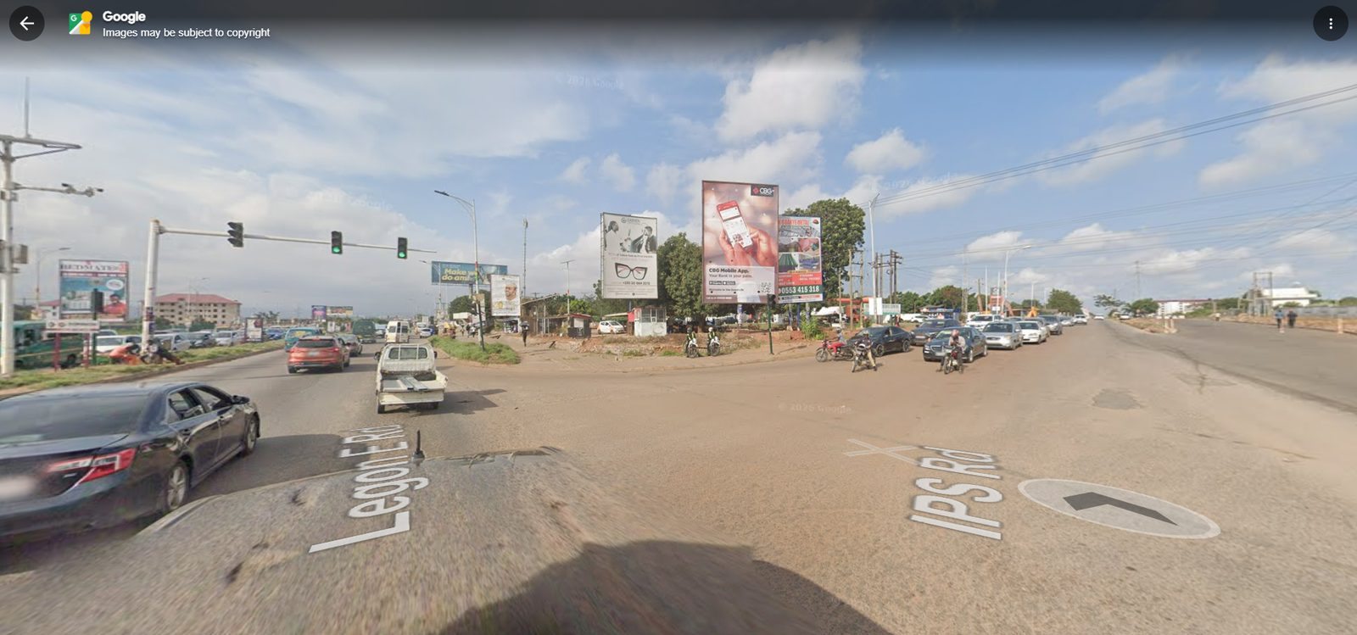
Scope: the signalised junction itself and its immediate corners—not the full road corridor and not the Main Gate underpass.
Prepared 12 October 2026 • 44 labelled visual references • Online source links included

Document roadmap
- 1. Brief introduction and reconstruction target
- 2. Critical interpretation: what junction this is—and what it is not
- 3. Evidence hierarchy, confidence levels and source limitations
- 4. Junction components and spatial sequence
- 5. Road topology, lane geometry and turning paths
- 6. Traffic signals, signs and billboards
- 7. GOIL station and commercial corner context
- 8. UGBS Graduate Building as a separate landmark
- 9. Pedestrian areas, kerbs, drainage and ground surfaces
- 10. Utility poles, wires, pylon and trees
- 11. Materials, lighting, rendering and performance
- 12. Existing game comparison and known risks
- 13. Implementation plan and acceptance checklist
- 14. Ready-to-paste Claude Code master prompt
- 15. Online reference sources and image-search links
- Appendix A. Labeled Street View screenshots (J01–J14)
- Appendix B. Original field photographs (F01–F18)
- Appendix C. UGBS identity references (B01–B06)
- Appendix D. Existing game diagnostics (G01–G06)
How to use the image IDs
The short IDs (J01, F01, B01, G01, etc.) are the stable reference keys used in the document, `reference_images/`, and `JUNCTION_REFERENCE_REGISTER.csv`. Claude should cross-reference those keys, not rely on long filenames.

1. Brief introduction and target outcome
Reconstruct the real UPSA Junction area in LEGONRUSH as a coherent, rideable and recognisable 3D environment. The project target is the broad signalised intersection where IPS Road meets the N4 / Legon-East Road corridor near the GOIL filling station and the University of Ghana Business School (UGBS) Graduate Building. The work includes the intersection itself, its immediate approach throats, traffic-signal poles and mast arms, roadside utility infrastructure, billboards and sign clusters, GOIL frontage, the UGBS landmark, adjacent verges, sidewalks, kerbs and corner ground treatment.
This is a location-specific reconstruction, not a global game redesign. Use authoritative project geography to determine road locations and connectivity. Use the supplied photographs for visible surface character, relative relationships and environmental details. Reuse and refine the existing LEGONRUSH system rather than building a disconnected demo scene.
Definition of success
A player can ride through and turn across the junction with the correct road connections and a recognisable real-world visual signature: broad asphalt field, traffic lights, turn paths, GOIL forecourt, UGBS landmark, tall billboards, tree canopy, rough reddish verges, sidewalk/paver runs and the dense electrical infrastructure visible in the photographs.

2. Critical interpretation: what this junction is—and is not
- The real-world screenshots show a broad, signalised, at-grade multi-leg intersection / crossing area with traffic-light poles and overhead signal arms. Use the existing map graph and images to recover the exact road arms and turning paths.
- Do not remodel the junction as a roundabout. The provided views do not show a central circular island controlling traffic; signal heads and wide turning movements are prominent.
- Do not add an overpass, flyover or underpass here. The Legon Main Gate underpass/bridge mentioned in previous work belongs to a different location.
- Do not place the GOIL station in the middle of the road or treat its driveway as a public road branch. Keep the forecourt as a separate site attached to the station frontage.
- UGBS Graduate Building is a separate landmark opposite GOIL, as confirmed by UGBS and University of Ghana sources [S1, S2]. Use its dedicated B01–B06 photos and existing project footprint.
- Google Street View road names, copyright overlays, direction arrows, vehicles, interface panels and screenshot artefacts are not 3D-world assets. Use the images to infer road relationships and the visible roadside content only.
Important limitation
Photographs are perspective views. They do not establish exact lane widths, exact signal coordinates, exact pole spacing, exact cardinal orientation or a surveyed footprint. The current project geography is the source of truth for those properties.

3. Evidence hierarchy and confidence
Priority | Evidence source | Use it for | Do not use it for
1 | Existing repository geography / OSM-derived project layers / access registry | Road centre-lines, junction connectivity, geometry anchors, feature IDs, destination access and orientation. | Do not overwrite validated geometry because a perspective screenshot appears different.
2 | User-uploaded Street View screenshots J01–J14 | Actual junction appearance, traffic-signal placement patterns, GOIL corner, billboard silhouette, trees, utilities, rough ground and visual adjacency. | Exact coordinates, accurate measurements or current traffic states.
3 | Original field photos F01–F18 | Road surface, pavers, sidewalks, station context, tower, UGBS visibility and shoulder details. | Hidden side/rear geometry not visible in those frames.
4 | Dedicated UGBS photos B01–B06 | UGBS building identity, facade massing and separate entrance-gate appearance. | Location of the gate without cross-checking map geometry.
5 | Game screenshots G01–G06 | Current project’s visual style and possible gaps in detail. | Real junction topology. Several carry a “to Balme Library” HUD and are only diagnostic.
6 | Official UGBS / University source pages and map links S1–S9 | Landmark identity and broad location; online map context. | Survey-level road design or exact spatial measurements.

4. Junction components and spatial sequence
Use the following as a semantic scene breakdown for inspection and code organisation. It is not a substitute for the repository’s actual road graph. Confirm exact orientation and relative side placement from authoritative project data before moving assets.
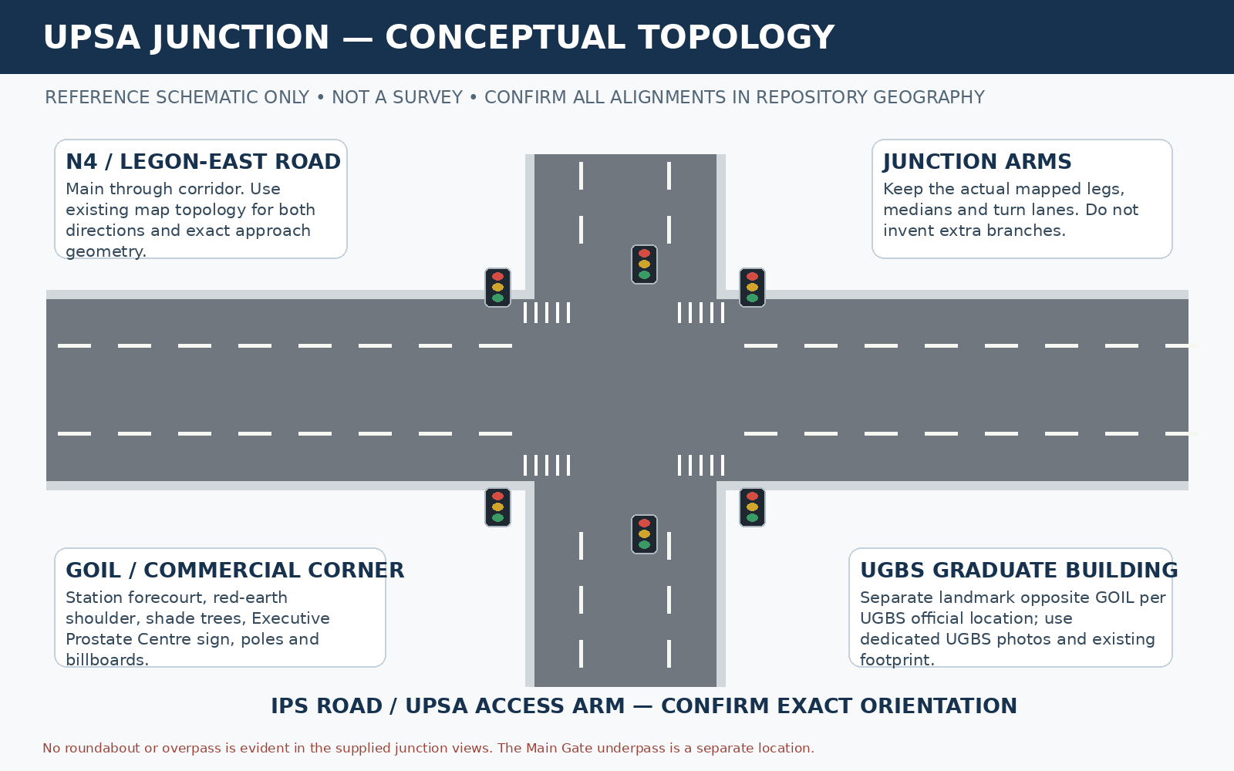
Figure 1. Conceptual four-arm schematic for communication only; exact arms, orientation and geometry must be verified in the repository map and are not implied by this illustration.
Zone ID | Component | Required representation / inspection task
Z0 | Central conflict area | Broad paved surface joining all mapped arms; correct road elevations, turning paths and markings; no centre roundabout island unless data proves otherwise.
Z1 | N4 / Legon-East Road approaches | Maintain through movement on the main corridor; preserve existing widths and medians; tie approach road meshes into the central junction without seams.
Z2 | IPS Road / UPSA access approach | Recognisable connection from the junction toward UPSA; use true direction and angle from project data rather than guessed camera orientation.
Z3 | GOIL station corner | Canopy, forecourt, pump island forms and station building context; separate driveway; surrounding tree, signage and informal parking context.
Z4 | UGBS Graduate Building context | Keep distinct white multi-storey building at its established opposite-GOIL position. Use B01–B06 for visual identity; preserve object identity/access.
Z5 | Signal system | Mast-arm signals and side poles oriented to the correct approach; consistent supports and realistic head scale; do not freeze arbitrary lamp state.
Z6 | Billboards / local signs | Large vertical and horizontal advertising boards, sign frames and local signboards; correct scale, offsets, road-side direction and collision/performance.
Z7 | Electrical infrastructure | Transmission pylon, distribution frames, utility poles, transformers and overhead cables as seen from multiple approach views.
Z8 | Pedestrian / verge edges | Pavers, concrete sidewalk segments, curbs, open drainage/culvert edges, red-earth shoulder, rough grass and driveway openings.
Z9 | Trees / informal frontage | Mature shade tree canopy, smaller planting, small covered structures or roadside parking where visible. Avoid cloning identical trees at even spacing.

5. Road topology, lane geometry and turning paths

5.1 Preserve the correct network
Start by extracting the exact connected road edges at the junction from the project map/graph. Do not hard-code a four-way intersection solely because one panorama looks like a cross. Keep every authoritative arm, node, approach and access relationship; if a source conflict appears, document it and use the validated repository anchor.
- Inspect `data/geography/legon-master.geojson`, `data/geography/legon-access.geojson`, `data/geography/registry/access.json`, `data/legon.osm`, `src/data/legon-map.json`, source POIs, corrections and `scripts/geography/*` where available.
- Inspect road/junction generation in the actual renderer and relevant modules. Trace each road centre-line to the generated surface, edge strips, curb/gutter geometry, terrain patches and junction patches.
- Preserve existing IDs, routes, challenge geometry, access points, collision rules and ghost/leaderboard compatibility. Avoid regenerating route geometry unless a real, documented correction demands it.

5.2 Intersection surface
- Build the central junction apron as a coherent surface that joins all mapped approach ribbons. Avoid separate rectangular slabs that create triangular grass gaps or abrupt straight cuts at curved roads.
- Use broad paved space appropriate to the photographs. Road widths and exact radii must come from map data and existing geometry—not the screenshot perspective or conceptual diagram.
- Align surface normals and elevation across the centre. The intersection must not flicker against terrain, overlap with a duplicated road patch or reveal seams from oblique camera angles.
- Maintain continuous, drivable turn paths. Check the riding path and vehicle-scale turning transitions as the cyclist enters from IPS Road and leaves along each valid connected arm.

5.3 Markings, medians and islands
- Use broken lane separators on approach segments where visible, and road-edge / stop / turn markings only when supported by the map, photos or existing data. Not every marking is readable in Street View; do not hallucinate a complex American-style marking layout.
- Inspect existing median, curb noses and channelised turn regions. Preserve verified islands, curb ends and raised edges. Do not add symmetry for its own sake.
- No central roundabout island. No flyover deck, retaining wall or tunnel mouth at this junction unless the repository’s actual local geography provides independent evidence.
- Keep markings coplanar with the final asphalt without floating, z-fighting or disappearing under a patch. Use the project’s existing supported technique for markings.

6. Traffic signals, sign structures and billboards

6.1 Traffic signals
The latest Street View screenshots show several traffic signal heads, some on overhead/mast-arm systems and others on side poles. Reconstruct the poles, brackets, horizontal arms and signal heads at realistic relative scale. Orient the faces so the signals address the correct approach lanes, as verified with the source geography and turn paths.
- Separate the signal geometry from road mesh geometry so it can be adjusted without altering lane topology.
- Keep mast-arm bases and pole footprints out of the playable carriageway unless the real support is placed there; check collision clearance around sidewalks and road shoulders.
- If the game has signal-state logic, bind the objects to it; do not bake one photographed red or green aspect permanently into the world.
- Create enough variation between signal installations to reflect the images, without adding an arbitrary forest of signal poles.

6.2 Billboards and roadside signs
A distinctive part of this site is the number and scale of roadside signs: tall portrait billboards, long horizontal billboard faces, skeletal empty frames, local business signboards and the Executive Prostate Centre sign near the GOIL-side tree/utility cluster. The exact adverts change; their size, support structure and spatial arrangement are the durable world features.
- Model a few distinct billboard supports with plausible steel frames and feet, plus textured faces. Keep their orientation legible from the appropriate approaching road.
- Do not copy the Street View interface, Google road-name overlays, arrow controls or watermark. Do not spend time reproducing exact ad copy unless it is a deliberate approved asset.
- Avoid billboards blocking signal faces, UGBS identity or the intended riding view. Ensure no billboard base or brace intersects the road or sidewalk incorrectly.

7. GOIL station and commercial corner context

7.1 GOIL station anchor
GOIL is a key visual anchor used by official UGBS location text, which describes the Graduate Building as opposite the GOIL filling station [S1, S2]. The user images show a red/orange and white canopy, forecourt, dispenser islands and a low station building. Use the existing station asset if one exists; improve its placement and scale only after confirming its geographic anchor.
- Keep a visible but realistic driveway opening between the forecourt and the road/frontage. Do not make the driveway look like a new public road leg.
- Use an orange/red canopy fascia with white supports and subdued station-building walls based on the photos. Keep pump islands simple but recognisable from junction views.
- The station should read as a property at a corner/roadside, with an asphalt or compacted forecourt and nearby tree/utility/advertising elements. Do not place it as a freestanding object floating in green lawn.

7.2 Nearby commercial sign/tree cluster
Several images show a mature tree canopy shading informal parking or roadside activity, utility pole/transformer frames, a sign reading “EXECUTIVE PROSTATE CENTRE”, scattered red earth, paving and nearby signboards. Represent the characteristic cluster and its footprint with a small number of differentiated props. Use generic but locally plausible shelters/parking forms where visible; do not freeze people or individual vehicle positions from one frame.
- Red-earth ground and patches of compacted gravel are important; do not replace the whole corner with flat grass.
- Use a large broad-canopy tropical shade tree with a natural irregular silhouette. Place secondary trees and shrubs according to photographs and existing geography, not a uniformly repeated planting grid.
- The signboard is an identity anchor in multiple views. Keep its sign structure, height and position readable from relevant approach views, but don’t invent the unseen site/building behind it.

8. UGBS Graduate Building: separate landmark
UGBS’s official programme page identifies the physical address as “University of Ghana Business School Graduate Building (UPSA Junction, Opposite Goil Filling Station)” [S1]; the University of Ghana event notice also says the building is on the Legon–Madina Highway, right-turning before PRESEC, opposite GOIL [S2]. These sources support the landmark relationship; they do not provide survey-level coordinates.
The supplied B01–B06 images show a white multi-storey building with repeated window bays and a prominent tall central dark-glazed vertical feature, a gabled/raised central roofline, forecourt parking and a separate entrance gate portal. Use them to retain the building’s identity. The junction brief is not authorisation to rebuild its whole architecture if the existing project model is already correct.
- Check the UGBS footprint, facing direction and entrance gate with the repository map. Do not determine the gate location solely from the perspective image.
- Preserve the unique facade with the central glazed vertical band; do not replace it with the cream UPSA Hostel facade or the white stepped VC Complex facade.
- Do not merge the UGBS forecourt gate, GOIL driveway, Executive Prostate Centre frontage, UPSA Hostel gate or VC Complex gate into one connected fictional compound.

9. Pedestrian space, kerbs, drainage and ground surfaces

9.1 Surface palette
Surface | Visual target | Implementation caution
Carriageway asphalt | Dark/medium grey with modest coarse texture; broad unpainted centre area where evidence suggests faded/limited markings. | Use one coherent material strategy. Avoid high-frequency noise, excessive gloss, road/terrain overlap and duplicated strips.
Concrete curb / drainage edge | Grey concrete with distinct top and side profile; curb line follows actual road arcs. | Keep curb heights consistent along a segment, transition smoothly at junction mouths and preserve driveway openings.
Brick/interlocking pavers | Warm sandy-brown paver blocks, visible joint pattern, clean alignment beside the road. | Pattern must be scaled to the cyclist/avatar. Avoid stretched UV texture and abrupt clipped ends at corners.
Red-earth / compacted verge | Warm orange-brown soil mixed with gravel, low grass and irregular edges. | Do not blanket all open corners with green terrain; preserve rough shoulders and exposed ground.
Grass / planting | Low grass tufts and natural shrubs, denser beneath/behind tree clusters and open lot boundaries. | Avoid grass blades intruding through asphalt, kerbs or pavers; use performant placement.
Wall / rock edge | White/grey painted masonry, occasional rough stone retaining edge and property walls where shown. | Do not force walls to run straight through access openings or misalign them with the mapped frontage.

9.2 Sidewalk and drainage continuity
- Use F03, F07, F12, F13, F16, F17, J13 and J14 to inspect pavers and pedestrian edges. The road edge and sidewalk width vary by location; represent only the segments evidenced or mapped.
- Preserve kerb and drain breaks at vehicle driveways and culverts. A curb should stop where a genuine property entry exists, rather than continue across the opening.
- Inspect low points, water-channel structures, utility covers and the round/circular feature in F07. Do not elevate or enlarge such objects unless corroborated by another view or map feature.
- Use one consistent height datum. No paver strip should float; no asphalt should run on top of a drain opening; no terrain should cover an exposed culvert where the image clearly shows it.

10. Power infrastructure, poles, wires and trees

10.1 Transmission and distribution
The junction photographs repeatedly show a tall lattice transmission tower and several dense power-line corridors. They also show lower distribution frames and transformer-like hardware near the commercial corner, plus streetlight poles and overhead signal supports. Those vertical silhouettes help identify the junction from a distance.
- Reuse the existing tower asset and geography if present. Place or adjust only after checking the current tower node/footprint against project data.
- Use multiple cable heights/parallel runs to approximate the dense overhead system without modelling every photographed cable at full detail. Prioritise silhouette, direction, sensible sag and clear separation from roads and trees.
- Avoid duplicate wires, intersecting cables, flickering z-fighting, wire geometry that crosses the camera uncomfortably, or unnecessarily expensive high-segment curves.
- Distribution structures should appear structurally distinct from the transmission pylon and traffic-light gantries.

10.2 Tree canopy and vegetation
- Use a few mature broad-canopy trees to produce the strong shade masses in J02, J07, J08, J12 and F01/F17. Tree placement must not obscure traffic signals or important landmark facades.
- Use variable canopy size, trunk thickness and spacing. Don't repeat a single low-poly tree every few metres in a perfect line.
- Preserve visible grass, scrub, red earth, exposed rock, pavers and open plots as mixed materials. The site is not a manicured campus lawn.

11. Materials, lighting, rendering and performance
- Integrate with existing LEGONRUSH world materials, lighting, scale and camera. Keep the game's established stylised 3D aesthetic while making the junction layout, urban clutter, signs and landmarks much more recognisable.
- Use bevel/normal and roughness details selectively; preserve road readability under diffuse daylight and shadows.
- Keep large billboard faces legible as volumes, but do not overstate their textures or reproduce all photo ads literally. Keep station and UGBS materials consistent with their references.
- Do not generate static exact cars and pedestrians copied from the photo; use existing traffic/NPC systems when supported. Static props should be the durable site features, not a snapshot of one traffic moment.
- Reuse meshes and materials. Avoid per-frame geometry regeneration, dense unnecessary instanced details, excessive shadows, very large textures or wire geometry with unreasonable segment counts.
- Investigate existing road/grass flicker, raised strips, missing curb/gutter bits, seams or terrain overlaps where they intersect the junction implementation. Fix root causes in the generating code/data rather than random offsets.

12. Existing game comparison and known risks
G01–G06 show the present game style and should be reviewed before editing, but at least some display “To the Balme Library” in the ride HUD and therefore are not a trusted layout of the real UPSA Junction. Compare what is useful (materials, player/camera scale, road/sidewalk implementation and assets) and disregard the current view as a source for the intersection’s exact shape.
Observed contrast | Action
Real views: broad signalised intersection, multiple traffic-signal groups and large paved turn area. | Make the actual mapped connected arms meet in a single clean at-grade junction; do not create a roundabout or Main Gate underpass.
Real views: GOIL station and sign/tree/utility cluster close to the road. | Anchor the station as a separate property and populate its edge with the visible large tree, Executive Prostate Centre sign, poles and billboard structures.
Real views: UGBS building appears across the road from GOIL. | Confirm its existing anchor and facade; keep the landmark distinctly identifiable in the relevant sightline.
Real views: dense cables, a lattice tower, overhead signals and tall billboard silhouettes. | Reconstruct utility and signal silhouettes with efficient, correctly placed geometry.
Existing-game samples: broad green open areas, simple road splits and sparse local clutter. | Replace generic open-scene impression at the actual junction with the evidence-supported local street-edge mix. Do not make all neighbouring landscape dense urban clutter.
Known bug risk: mesh strips, terrain overlap, road/grass flicker and missing drains. | Inspect current mesh generation and eliminate duplicate/coplanar surfaces and broken transitions.

13. Implementation plan and acceptance checklist

Phase A — inspect and establish baseline
- Inspect branch/working tree and avoid deleting unrelated changes.
- Locate the actual junction in the existing map/geography layers and record the connected road arms and feature IDs.
- Open current game view and capture repeatable screenshots from each approach.
- Inspect the road mesh, junction patch, terrain, curb/drain, signal and roadside prop generators.
- Map each reference image ID to its purpose using the CSV register.

Phase B — reconstruct the junction core
- Fix junction surface connectivity and elevation across all mapped approach arms.
- Preserve the signalised at-grade topology and turn paths; maintain real widths, medians and curbs from repository data.
- Restore road/marking/curb/gutter/sidewalk continuity and retain true access openings.
- Eliminate duplicated asphalt, raised strips, z-fighting and terrain gaps around the conflict area.

Phase C — add locally distinctive environment
- Place/orient signals and mast arms, billboard frames, road signs and curved-arm streetlights.
- Represent GOIL station forecourt in the correct corner relationship to the junction.
- Ensure UGBS identity and gate remain distinct, and preserve the opposite-GOIL relationship.
- Add the tree cluster, red-earth verges, small roadside structures, pavers, utility frames and overhead wires where visible and correctly located.

Phase D — visual/test gate
- Run type checks, unit/geometry tests, route/access/topology tests, production build and existing smoke tests.
- Open the game in a browser and ride through the junction from every mapped arm. Inspect turn-ins, turn-outs and all visible corner edges.
- Compare before/after images at repeatable viewpoints; check signal facing direction, station/UGBS relative positions, paver/kerb continuity, billboards and tower/wires.
- Check no props obstruct rideable lanes or access points; confirm there are no flicker bars, floating meshes, missing edges or severe frame-rate drops.
- Review the complete Git diff for unrelated campus/map/UI changes and report anything uncertain.

Definition of done
- ☐ The junction topology follows authoritative data and looks visibly signalised and at-grade, not like a roundabout or underpass.
- ☐ Every mapped arm joins cleanly; lane/turn paths remain rideable and route/access IDs remain compatible.
- ☐ GOIL, UGBS, traffic signals, tall billboards, tree/utility cluster and surface transitions create a recognisable UPSA Junction scene.
- ☐ Road, pavers, curbs, gutters, verges and property driveways connect cleanly without seams, gaps or fictitious blockages.
- ☐ All relevant checks pass, and a browser ride-through plus before/after visual review has been completed.
- ☐ No push to main or production deployment has occurred without explicit user approval.

14. Ready-to-paste Claude Code master prompt
Copy the prompt below into Claude Code after placing this DOCX and the extracted `reference_images/` folder within reach of the session. The plain-text version is also supplied as `CLAUDE_CODE_MASTER_PROMPT.txt`.

LEGONRUSH — Reconstruct UPSA Junction (the Junction Itself)
You are working in the existing LEGONRUSH repository. Implement a detailed, geographically faithful reconstruction of UPSA Junction at the meeting of IPS Road and the N4 / Legon-East Road corridor near GOIL and the UGBS Graduate Building. Focus on the junction’s topology, asphalt geometry, traffic-signal system, turning paths, edges, corner plots, GOIL forecourt context, UGBS landmark, roadside signage/billboards, sidewalks, drainage, utility poles, overhead wires and high-voltage transmission structures.
Read LEGONRUSH_UPSA_Junction_Reconstruction_Brief.docx completely and inspect all images in reference_images/. Also review the contact sheets and JUNCTION_REFERENCE_REGISTER.csv. The images are grouped by reference IDs:
- J01–J14: newest Google Street View screenshots around the real junction.
- F01–F18: earlier user-supplied road/junction photographs.
- B01–B06: dedicated UGBS Graduate Building and separate UGBS gate references.
- G01–G06: existing LEGONRUSH screenshots, diagnostic only. They are not reliable source geometry for the real junction; some show a ride to Balme Library.

Non-negotiable geographical interpretation
1. The supplied real-world images show a broad signalised, at-grade, multi-leg junction/intersection, with a large paved conflict area, multiple traffic-light poles/mast arms, turn movements, and approaches labelled IPS Road and Legon-East Road/Legon-Madina Highway. Do not change it into a roundabout just because that may be easier to model.
2. Do not add an overpass, tunnel or underpass at UPSA Junction. The Legon Main Gate underpass/bridge is a separate location in the broader project; do not transfer that feature here.
3. The GOIL filling station is a major corner landmark near the junction. Model its station forecourt and branded canopy context as a separate property. Do not place the entire station in the middle of the junction or make the station driveway a public-road branch.
4. UGBS Graduate Building is a separate landmark described by UGBS/University of Ghana as at UPSA Junction, opposite GOIL. Use the dedicated B01–B06 photos and authoritative existing UGBS footprint. Do not substitute UPSA Hostel or the Vice-Chancellor’s Office Complex for UGBS.
5. The Executive Prostate Centre sign, tall billboards, tree-covered roadside activity, electricity distribution frames, dense overhead cables and a nearby transmission tower are visible on the GOIL/commercial corner in several views. Use these as spatial anchors; exact positions must be confirmed against the repository map.
6. All diagrams in the brief are conceptual and not to scale. Do not derive exact coordinates, distances, widths, north orientation, lane counts or turning radii from a perspective photo or schematic.

Phase 1 — inspect and locate
- Inspect working tree, branch and recent commits first; do not discard local changes.
- Find the exact current junction and the render path for roads, junction patches, terrain, markings, sidewalks, curbs, islands/medians, traffic signals, signs, billboards and utility objects.
- Inspect the canonical geography sources where present: data/geography/legon-master.geojson, data/geography/legon-access.geojson, data/geography/registry/access.json, data/legon.osm, src/data/legon-map.json, POI sources, corrections and scripts/geography/*.
- Inspect src/game/landmarks.ts, Game.ts, campusmap.ts, world.ts, facades.ts and all relevant geometry code; use actual repository paths if names differ.
- Read relevant docs for junction topology, destination access, entrance verification and geography. Check git history for recent road/terrain fixes.
- Map each reference photo to the scene position it plausibly observes. Separate directly observed facts from inferred unseen edges.

Phase 2 — intersection geometry/topology
- Preserve existing authoritative road centerlines, graph nodes, junction connectivity, lane/route IDs, access IDs, race/challenge paths, ghosts/records and leaderboard compatibility.
- Use the source road graph/map as truth for how many arms exist, how they connect, and where medians/turn lanes sit. Photos help judge appearance, relative offsets and materials, not exact geospatial placement.
- Reconstruct the full intersection apron and the transitions between each approach. Avoid polygonal road meshes that leave triangular grass gaps, disconnected corners, straight-line joins at curves, road seams, or duplicated overlapping asphalt.
- Keep the junction wide and open as shown in the references, with turning-space that connects naturally to every mapped arm. Respect different road widths, shoulders and alignments; do not force symmetry.
- Use road markings from evidence: dashed lane separators on approaches where visible, stop/limit lines if supported by the references or authoritative road data, edge markings where present. Do not invent zebra crossings or directional arrows if there is no evidence; verify before adding.
- Preserve actual median/curb ends and traffic islands only where the project map or photos support them. Do not add a round centre island.
- Ensure road surfaces follow correct elevation and smoothly intersect the surrounding terrain. Keep all lane geometry drivable and collision-safe.

Phase 3 — signals and street furniture
- Reconstruct several traffic-signal groups shown from different viewing angles: overhead/mast-arm signal heads and side-mounted signal poles. Place and orient them according to mapped approaches and road directions.
- Create recognisable signal heads and mast/gantry supports, but do not freeze exact red/green indications from screenshots as permanent state unless game logic already supports traffic states.
- Add curved-arm streetlights, sign poles, tall billboard frames, smaller signboards and the large green / horizontal billboard silhouettes where the photos support them.
- Billboard placements matter more than reproducing the exact advertising copy. Use non-specific or project-approved texture artwork; do not copy Google overlays, road-name text rendered on the Street View image, UI controls, watermark or vehicles as scene assets.
- Add utility poles and transformer/distribution-frame structures on the GOIL-side corner, with overhead wires routed with appropriate height and sag. Keep wires visually readable and performant; avoid excessive geometry, camera shimmer and wire/mesh intersections.
- Model the tall lattice transmission pylon and power-line direction where supported by the photos and map. Do not move the existing tower if it is a geographically anchored landmark; check its footprint before changing it.

Phase 4 — corner landmarks and ground treatment
- GOIL: station canopy in red/orange/white brand colours, forecourt apron, dispenser islands and small station building forms only to the detail supported by current game assets and reference photos. Maintain a clear vehicle entry and exit. Do not insert a large generic station into open grass.
- UGBS Graduate Building: keep its existing correct footprint and unique white multi-storey massing. Use the separate UGBS facade/gate references if an appearance adjustment is necessary; avoid scope creep into full reconstruction unless the existing model is demonstrably wrong.
- GOIL-side commercial frontage: represent the shade trees, roadside sign location, informal parking / small shelter structures, red-earth apron, exposed gravel/soil and nearby sign clusters where documented. Use props as contextual geometry rather than copying the exact people or traffic snapshot.
- Opposite/frontage corners: keep open lots, small shrubs, grass patches, boundary walls, KAAF/other signs and the sidewalk/paver strips according to their observed location and existing geography. Don't replace red earth and compacted ground with continuous green grass.
- Keep public road edges separate from station and UGBS property areas. Driveways should enter the road through believable sloped aprons or kerb openings; do not bridge a real gutter with an opaque flat slab or close off existing access points.
- If pedestrian paving, gutters or culverts are present, ensure their endpoints align at corners and their openings remain open. Do not force the same curb/gutter treatment around every arm.

Phase 5 — visual style and performance
- Integrate with LEGONRUSH’s existing camera, player scale, materials, lighting, UI and world renderer. The new environment should look like the existing game, but much more location-specific at this junction.
- Address the contrast between the real scene (broad at-grade intersection, mixed asphalt/red-earth shoulder, sign/billboard density, GOIL and UGBS landmarks, roadside activity, large canopy trees, dense poles/wires) and the simplified game diagnostic screenshots (open green fields, minimal roadside detail, generic branches). These game screenshots are comparison only, not source geometry.
- Do not overpopulate the road with static vehicles or people. The real photos are snapshots; traffic and activity should remain dynamic or nonessential where existing systems support it.
- Eliminate road/grass flicker, raised strips, z-fighting, broken joins, gaps, floating meshes, curb height jumps and duplicate asphalt patches. Trace faults to the generating data/code; do not hide them with random offsets.
- Reuse materials and meshes where safe. Avoid per-frame mesh generation, massive numbers of tiny objects, oversized textures or expensive shadows that impair frame rate.

Phase 6 — validation
- Add/update focused tests only where appropriate; run type checks, route/access/topology tests, production build and available smoke tests.
- Open the built game in a browser and inspect the junction from all practical mapped approach directions and turn paths, including low rider camera, wider camera and side/oblique views.
- Inspect whether every branch connects correctly; whether signals face the appropriate approaches; whether medians, billboards and pylon positions make sense; whether GOIL access and UGBS remain correctly placed; and whether pavers/curbs/drainage connect without seams.
- Compare before/after screenshots from the same camera positions. Test ride-through instead of relying only on an editor or static screenshot.
- Check no geometry blocks the rideable lanes or intended pedestrian access, and no off-screen global changes were made.
- Re-run the checks after fixing any visual issues.

Scope control and delivery
- Scope: UPSA Junction itself and its immediate junction corners/approach tie-ins only. Do not reconstruct the entire IPS Road corridor, UPSA Hostel, VC Complex or unrelated campus.
- Preserve unrelated campus objects and all stable map/game IDs. Do not regenerate route geometry casually.
- Do not push to main or deploy to production without my explicit approval. If there is already an approved branch workflow, work within it and report current status.
- Deliver a summary of: root causes, files/data changed, junction topology changes (if any), visual improvements, tests/build results, browser inspection, before/after screenshots, remaining uncertainty, and git status/commit/remote status.
Work autonomously through investigation, implementation and verification. Do not stop for routine intermediate approval. Prioritise accurate real-world geometry and a cohesive, playable junction scene over cosmetic detail.

15. Online references and image research
Online research supports identity, broad location and context. It does not replace the project’s existing geography or establish surveyed junction measurements. The latest user uploads include Google Street View screenshots; the previous source packs provide additional junction field photos and dedicated UGBS facade photos.
S1 — University of Ghana Business School, MSc Business Analytics page
https://www.ugbs.ug.edu.gh/index.php/course/msc-business-analytics
Official UGBS page identifies the Graduate Building address as “UPSA Junction, Opposite Goil Filling Station”. Strong identity/location evidence for UGBS relative to GOIL.
S2 — University of Ghana — Inauguration of UGBS Multi-purpose Graduate Building
https://old1.ug.edu.gh/events/inauguration-ugbs-multi-purpose-graduate-building
Official University of Ghana event page says the building is on the Legon–Madina Highway, right-turning before PRESEC, opposite the GOIL filling station.
S3 — Waze directions to University of Ghana Business School, Madina
https://www.waze.com/af/live-map/directions/gh/greater-accra-region/madina/university-of-ghana-business-school?to=place.ChIJ_c98u32c3w8RidxBWmVfSdA
Online map/directions resource. Search result for its raster map tile explicitly labels N4–Legon-East Road, GOIL and IPS Road. Use as topology/orientation context; verify exact geometry in project geodata. The tile is linked, not embedded, because direct raster download was unavailable in this runtime.
S4 — Waze map tile shown in search results
https://www.waze.com/row-tiles/live/base/17/65471/63471/tile.png?highres=true
Direct live map tile referenced by S3. Use in a browser as a visual locator only; map tiles may change.
S5 — Mapcarta — GOIL map/place page
https://mapcarta.com/N3462088441
Third-party geographic context; identifies nearby UPSA Taxi Rank and UGBS Graduate Campus.
S6 — Goil Filling Station, UPSA Junction — nearby-place listing
https://gh.near-place.com/goil-filling-station-upsa-junction-n4-accra
Third-party listing gives an approximate GOIL locator (5.6603216, -0.1774666). This is only a rough reference point for opening mapping services, not a surveyed intersection coordinate. Confirm all coordinates with authoritative project data.
S7 — GOIL PLC — official service-station page
https://www.goil.com.gh/service-station/
Official GOIL station-network page; supports broad station identity/brand context, not exact branch geometry.
S8 — UGBS official homepage / campus tour
https://ugbs.ug.edu.gh/home
Official UGBS source with a Graduate School / campus-tour section. Use alongside the supplied dedicated facade images; do not assume homepage images depict the exact junction perspective.
S9 — Google Local photosphere supplied by the user
https://www.google.com/local/place/fid/0xfdf9c91e05dd553:0x44fa18abb0bf922c/photosphere?iu=https://streetviewpixels-pa.googleapis.com/v1/thumbnail?panoid%3D_fC_-YnWkh1Yd2VAnMR9xQ%26cb_client%3Dlu.gallery.gps%26w%3D160%26h%3D106%26yaw%3D18.997597%26pitch%3D0%26thumbfov%3D100&ik=CAISFl9mQ18tWW5Xa2gxWWQyVkFuTVI5eFE%3D
User-supplied 360-degree reference link for junction / hostel-area context. Open interactively during implementation to inspect directions and facade/road relationships.
S10 — Google Images — UPSA Junction / GOIL / IPS Road
https://www.google.com/search?tbm=isch&q=UPSA+Junction+Accra+GOIL+IPS+Road
External visual-discovery link. Image results may change; cross-check with user’s photos before use.
S11 — Google Images — UGBS Graduate Building opposite GOIL
https://www.google.com/search?tbm=isch&q=UGBS+Graduate+Building+UPSA+Junction+opposite+GOIL
External visual-discovery link for the neighbouring UGBS landmark; use its own building identity and the supplied photos.
S12 — Bing Images — GOIL UPSA Junction Accra
https://www.bing.com/images/search?q=GOIL+UPSA+Junction+Accra
Additional external image-search reference.
Web image availability note
The Waze map tile, current online maps, and the user-provided Google Local photosphere are linked in this document and in ONLINE_REFERENCES.md. The image service’s raster could not be downloaded directly in this runtime, so no remote image is falsely represented as an embedded original. The document embeds the full user-supplied Street View screenshots and field images as the primary visual references.
Useful live image-search links: Google Images — UPSA Junction / GOIL / IPS Road | Google Images — UGBS Graduate Building | Bing Images — GOIL UPSA Junction

Appendix A — Real junction screenshots (J01–J14)
These are the newest Street View screenshots uploaded for the junction itself. They provide multiple approach angles and overlapping views of the traffic-signal system, GOIL corner, billboards, road labels, utility corridor and UGBS context. Use the ID and caption to compare what each view actually proves.
J01 | New Google Street View screenshot  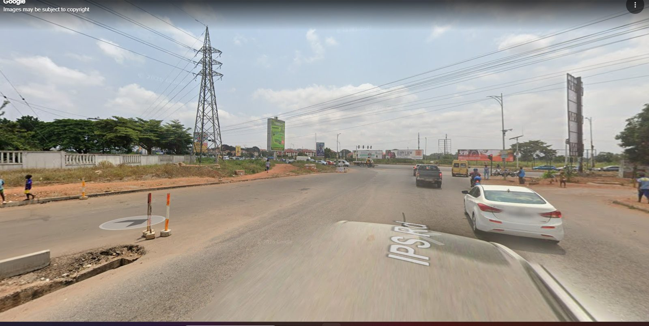  Wide view along the IPS Road approach into the junction. Shows broad asphalt, weak/partial lane definition, a high-voltage lattice tower, roadside verge, signalised intersection in the distance, billboards and traffic. Use for approach scale and the utility skyline; do not copy vehicles or map text overlays. | J02 | New Google Street View screenshot  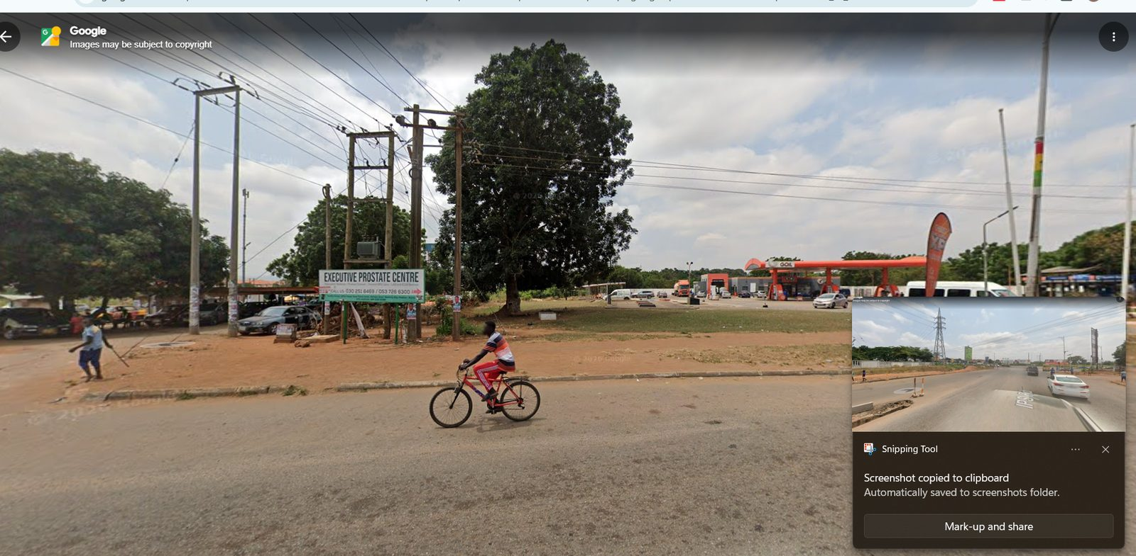  Side view across the road toward the GOIL-side frontage: large shade tree, utility structures, roadside sign, open red-earth forecourt, GOIL canopy in the background and a cyclist. Use for corner relationships and roadside activity, not the cyclist’s exact pose.
J03 | New Google Street View screenshot  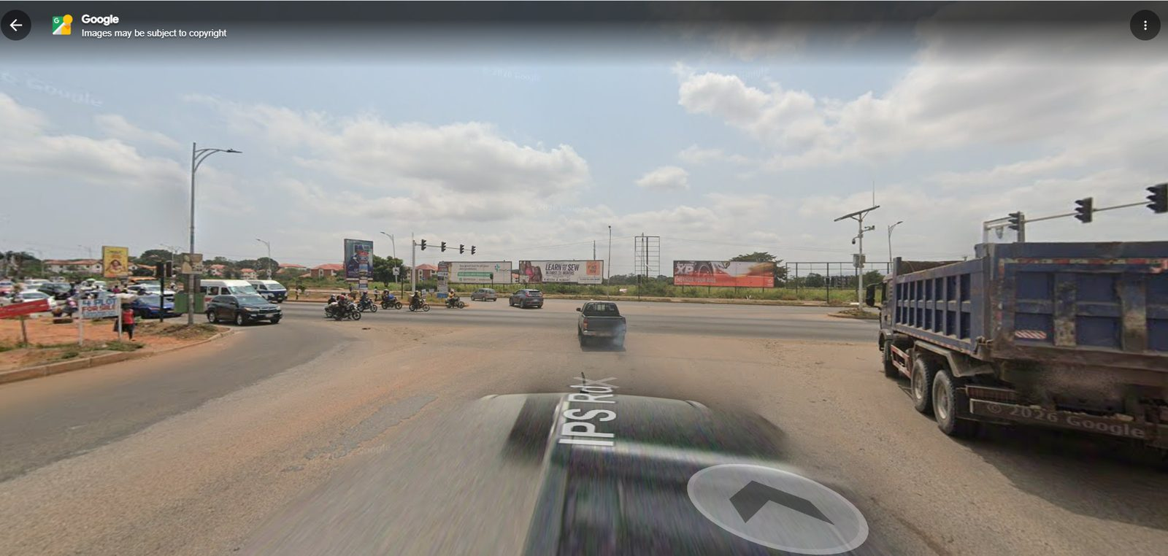  Forward view through the wide junction conflict area, with a truck to the right and several movement directions ahead. Use for the broad paved junction throat and turning-space scale. | J04 | New Google Street View screenshot  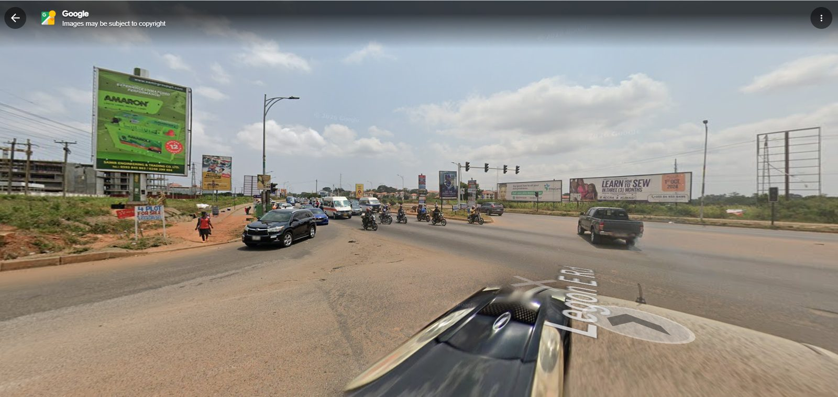  Oblique view toward the traffic-signal line and opposite roadside. Shows large vertical green billboard, signal heads, broad entry/exit asphalt, rough shoulders and transmission infrastructure.

Appendix A — Real junction screenshots (J01–J14) (continued)
J05 | New Google Street View screenshot  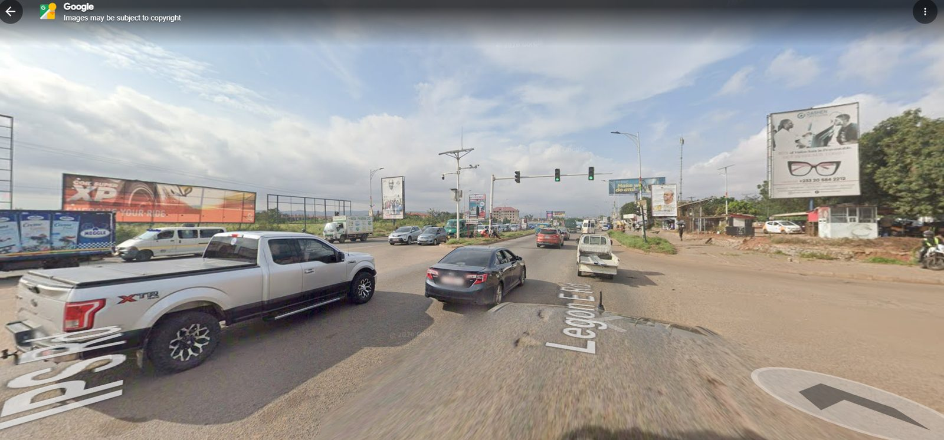  Another angle across the intersection with a pickup, traffic-light mast arms, billboards, roadside activity and the wide central paved area. Use to compare crossing directions and sightlines. | J06 | New Google Street View screenshot  Wide look across the junction toward multiple signal heads, billboards and the cross-road traffic stream. Use to understand the multi-leg at-grade junction form and turning movements.
J07 | New Google Street View screenshot  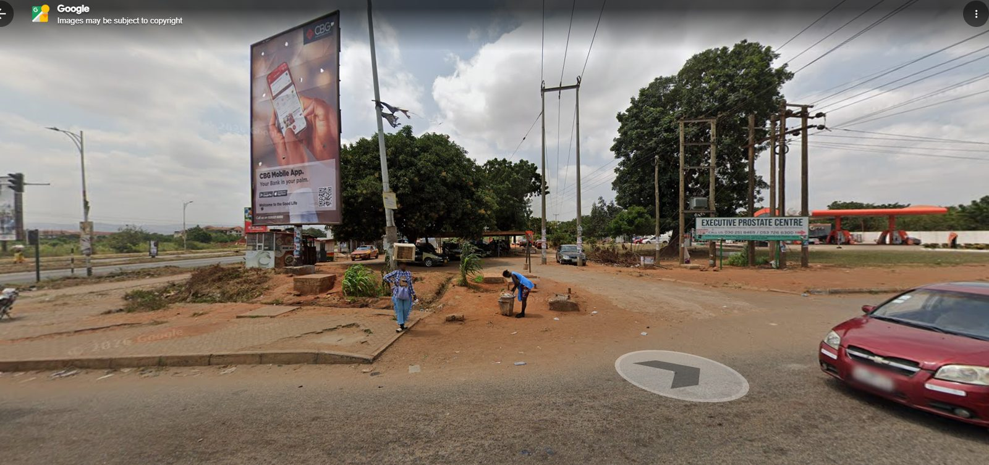  Corner scene with a large CBG billboard, tree canopy, utility pole frames, Executive Prostate Centre sign, red-earth ground and GOIL station visible across the background. Strong reference for the roadside commercial corner. | J08 | New Google Street View screenshot  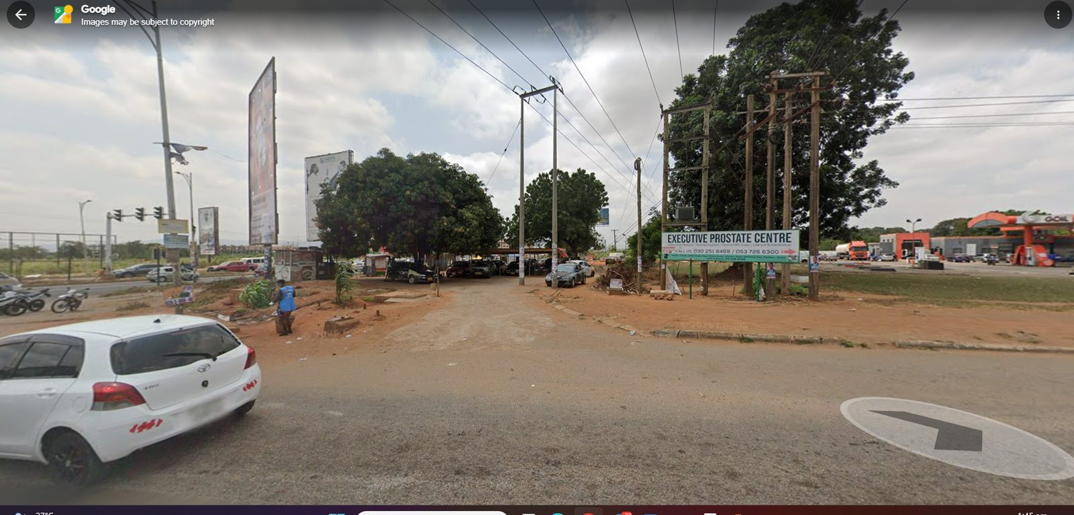  Opposite-angle view of the same general corner showing the white hatchback, signal infrastructure, frontage trees, signs, unpaved shoulder and GOIL canopy further back.

Appendix A — Real junction screenshots (J01–J14) (continued)
J09 | New Google Street View screenshot  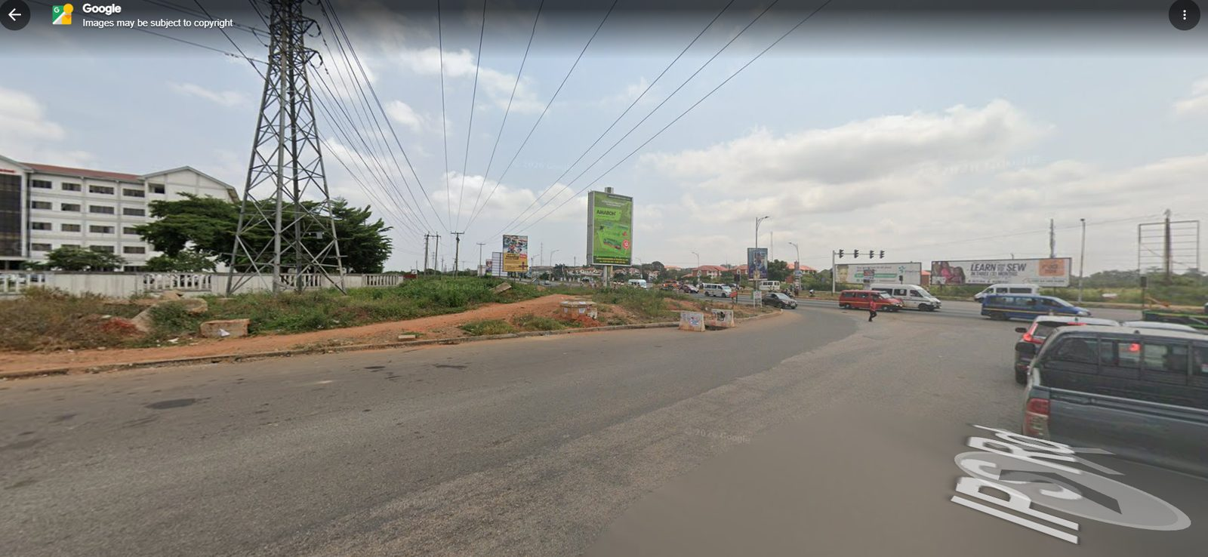  View across the junction corridor with the UGBS Graduate Building visible on the left side of the frame, transmission tower, billboards and open reddish verge. Use to relate the UGBS landmark to the junction, while verifying exact placement in map data. | J10 | New Google Street View screenshot  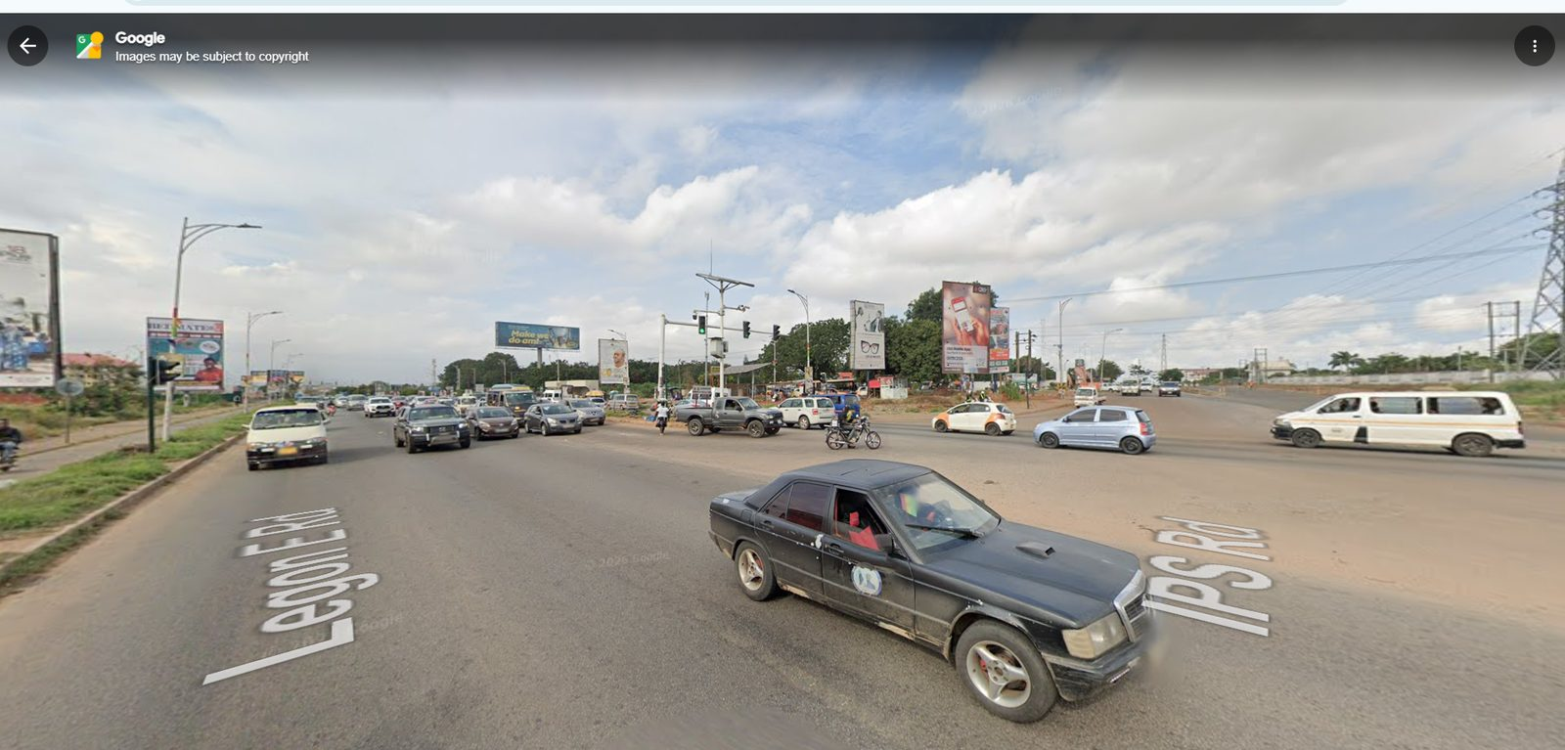  Broad intersection perspective with Google road labels showing Legon East Road and IPS Road. Useful for identifying the named road approaches and how the asphalt field opens into the junction. Map text itself is not a game asset.
J11 | New Google Street View screenshot  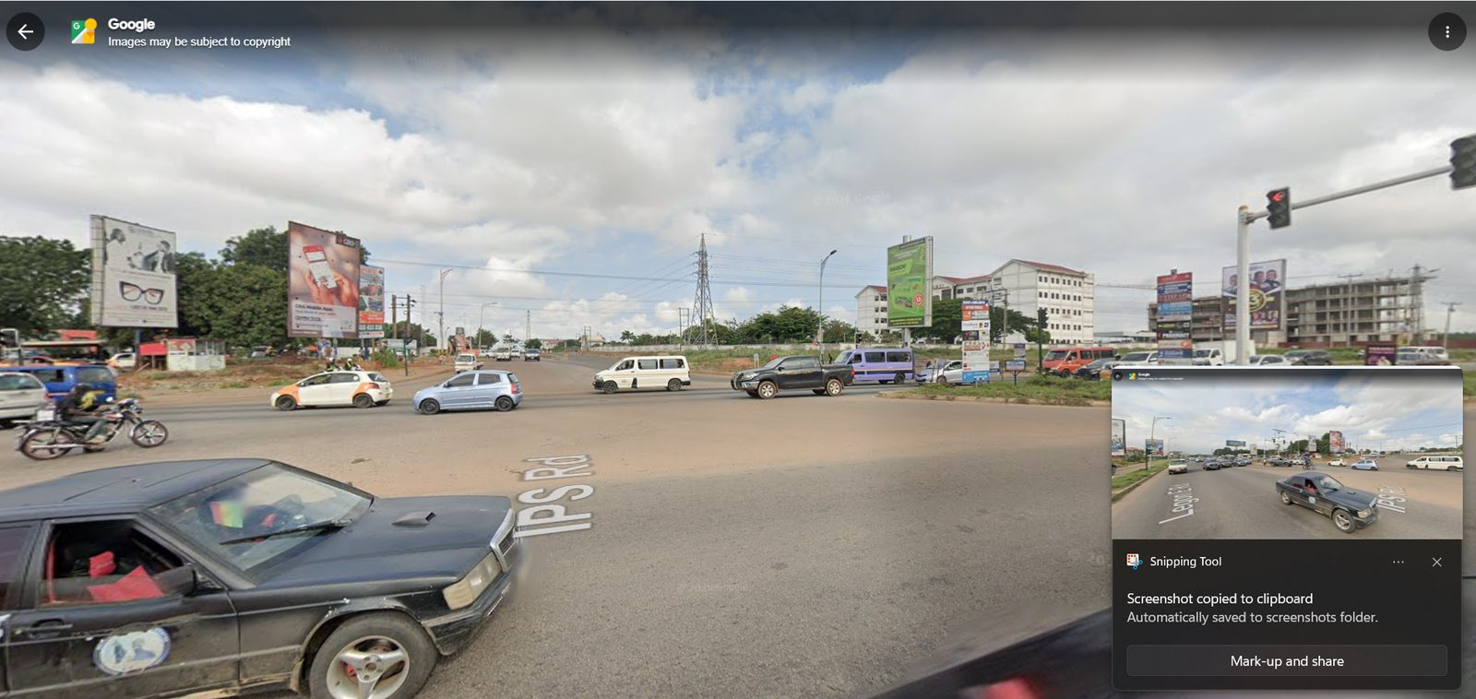  Wide view of the same signalised intersection from a slightly different angle. Shows vehicles crossing, repeated traffic signals, billboards and the two road-name overlays. Use as topology/context evidence, not a measured plan. | J12 | New Google Street View screenshot  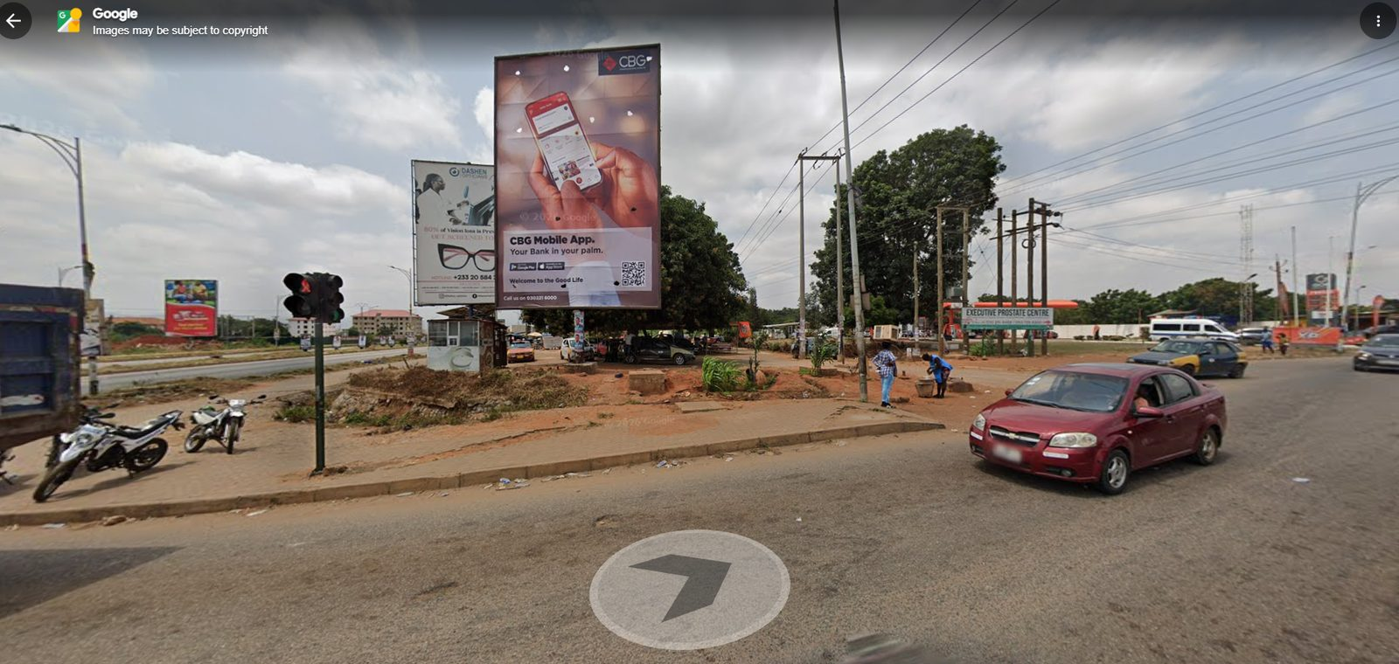  GOIL-side corner with a prominent CBG billboard, tree mass, utility distribution structures, roadside sign and red-earth apron joining the asphalt. Captures the less-formal edge conditions.

Appendix A — Real junction screenshots (J01–J14) (continued)
J13 | New Google Street View screenshot  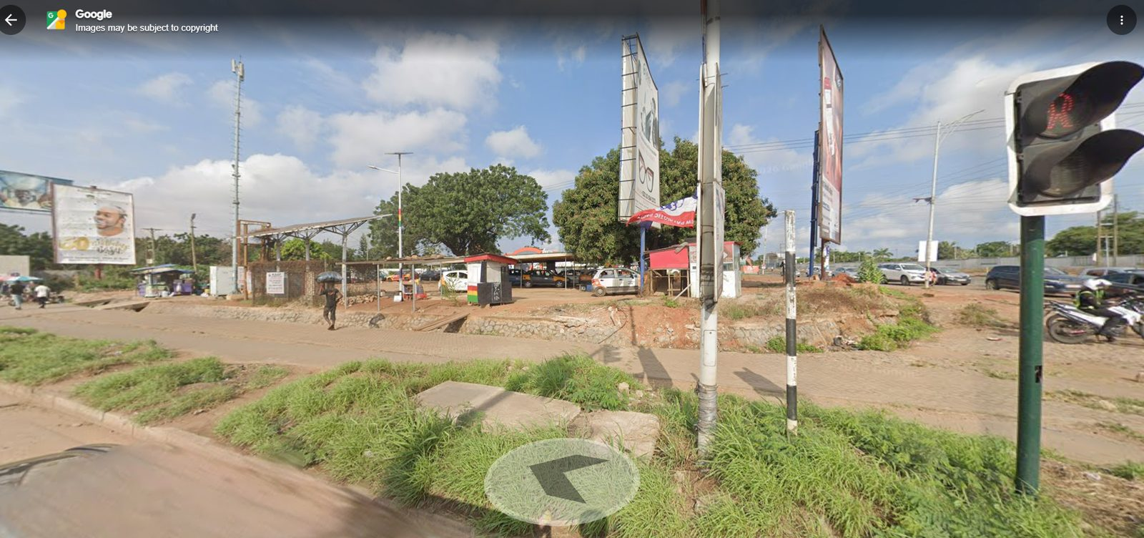  Side approach with traffic-signal pole at right, planted grass strip, sidewalk/paver path, low wall and covered commercial activity / GOIL context. Use for pedestrian-edge, drainage and frontage transitions. | J14 | New Google Street View screenshot  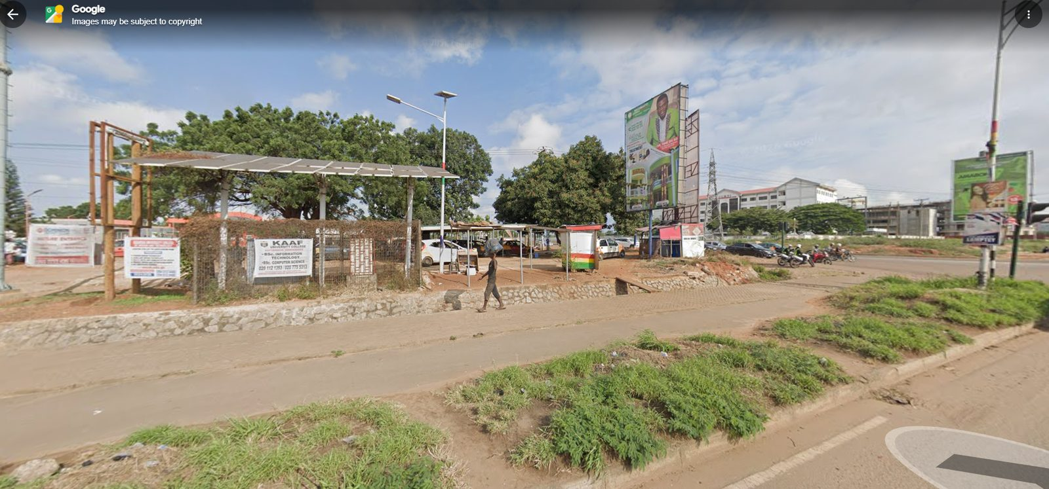  Roadside area with KAAF and other signs, a covered/open commercial structure, retaining stone edge, broad paver sidewalk, patches of grass and UGBS building visible across the road. Use for the junction’s human-scale frontage.

Appendix B — Original road and junction field photographs (F01–F18)
Earlier user-supplied photos provide closer views of the paver sidewalk, GOIL-side verge, tower, UGBS in the background, and road/pedestrian-edge treatments. They complement the wider Street View perspective but do not prove exact road geometry on their own.
F01 | Original junction field photograph  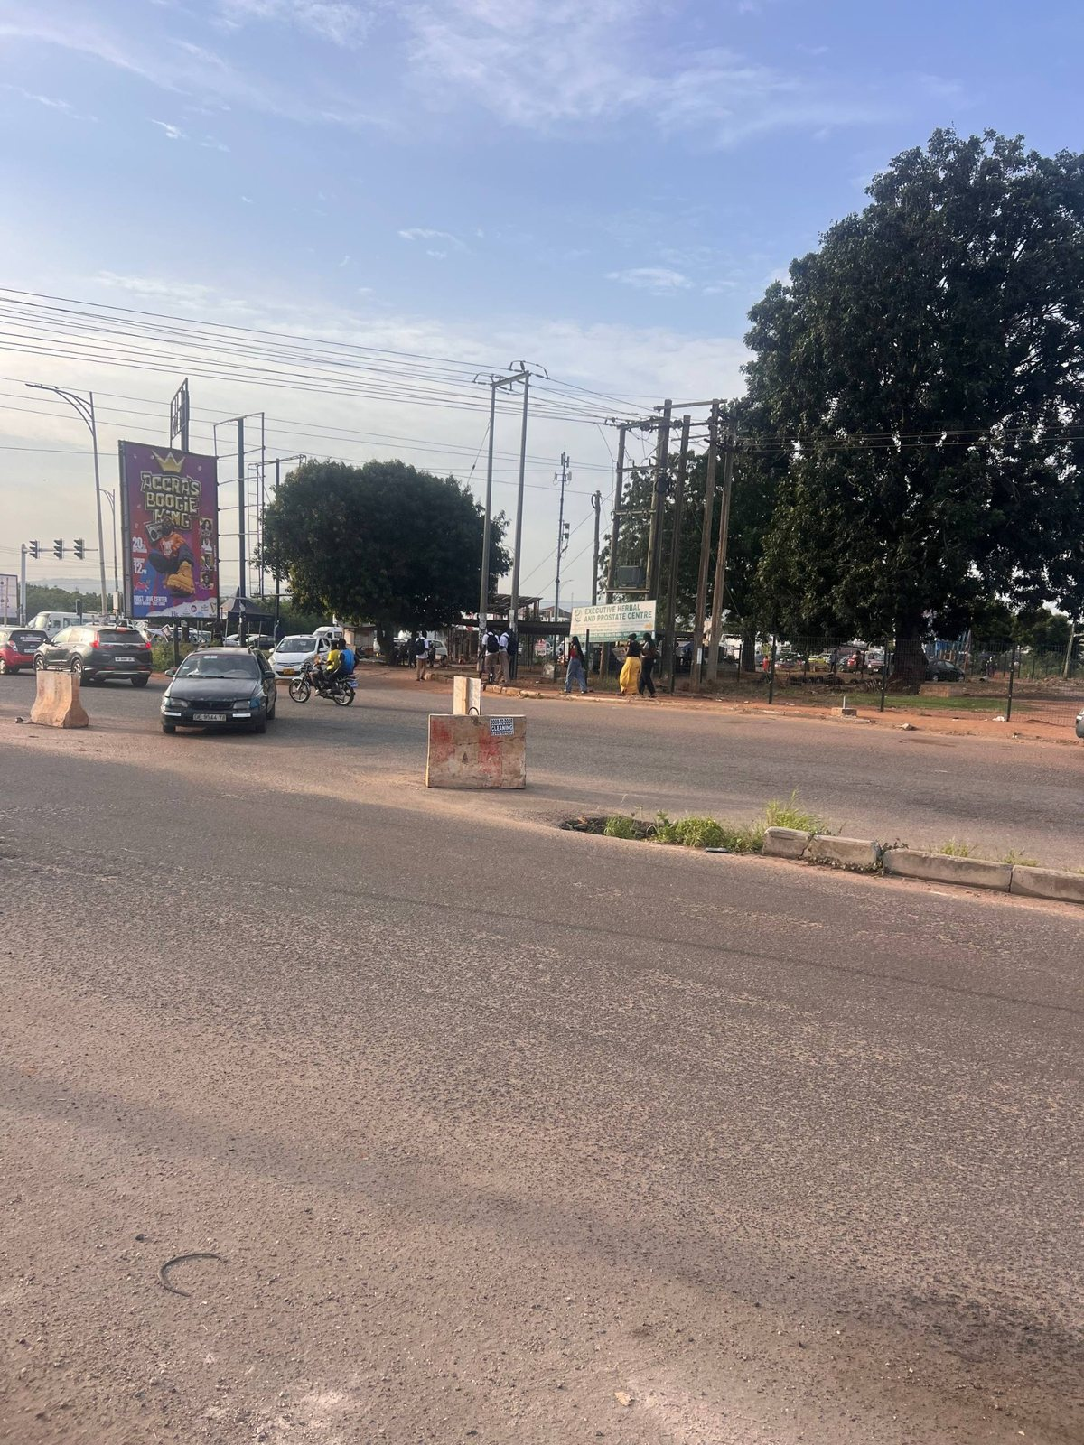  Long road view toward the junction with broad paved lanes, overhead cables and large tree mass at the roadside. | F02 | Original junction field photograph  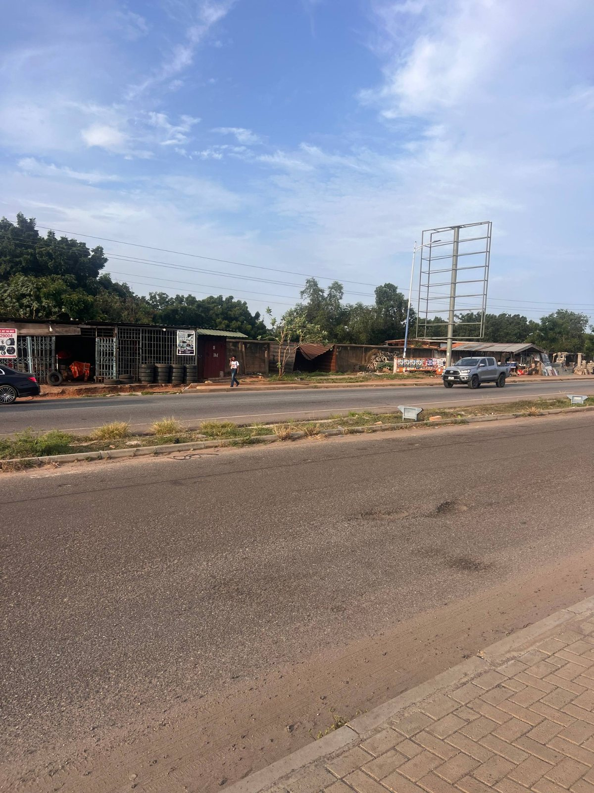  Opposite-direction look across the wide carriageway toward GOIL-side frontage and a tall transmission structure.
F03 | Original junction field photograph  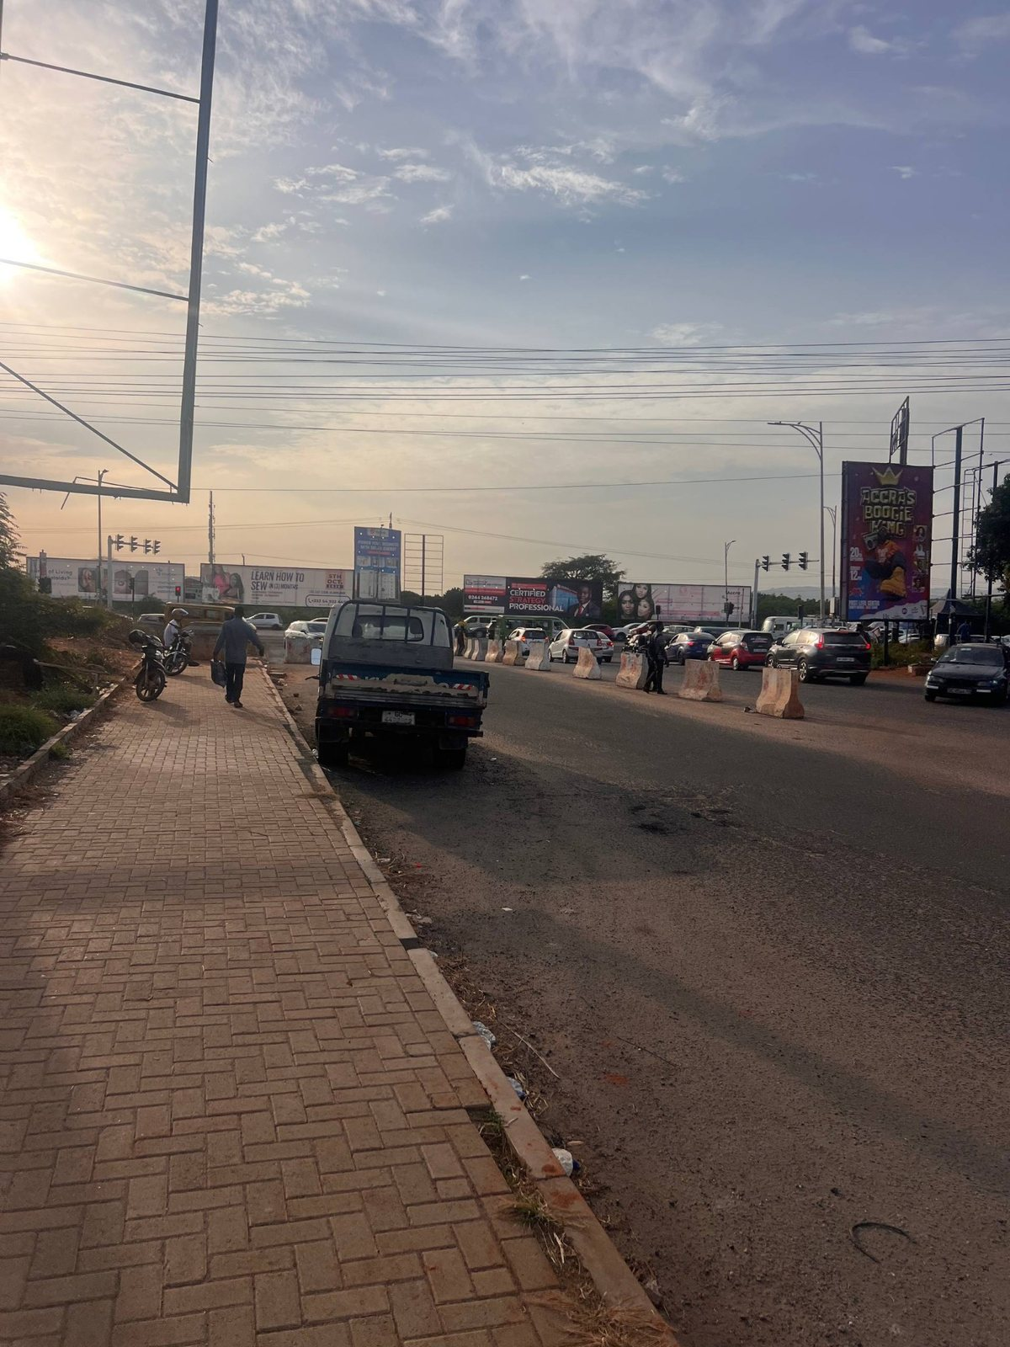  Close view of interlocking brick paving beside the road; useful for paver pattern, curb edge and pedestrian scale. | F04 | Original junction field photograph  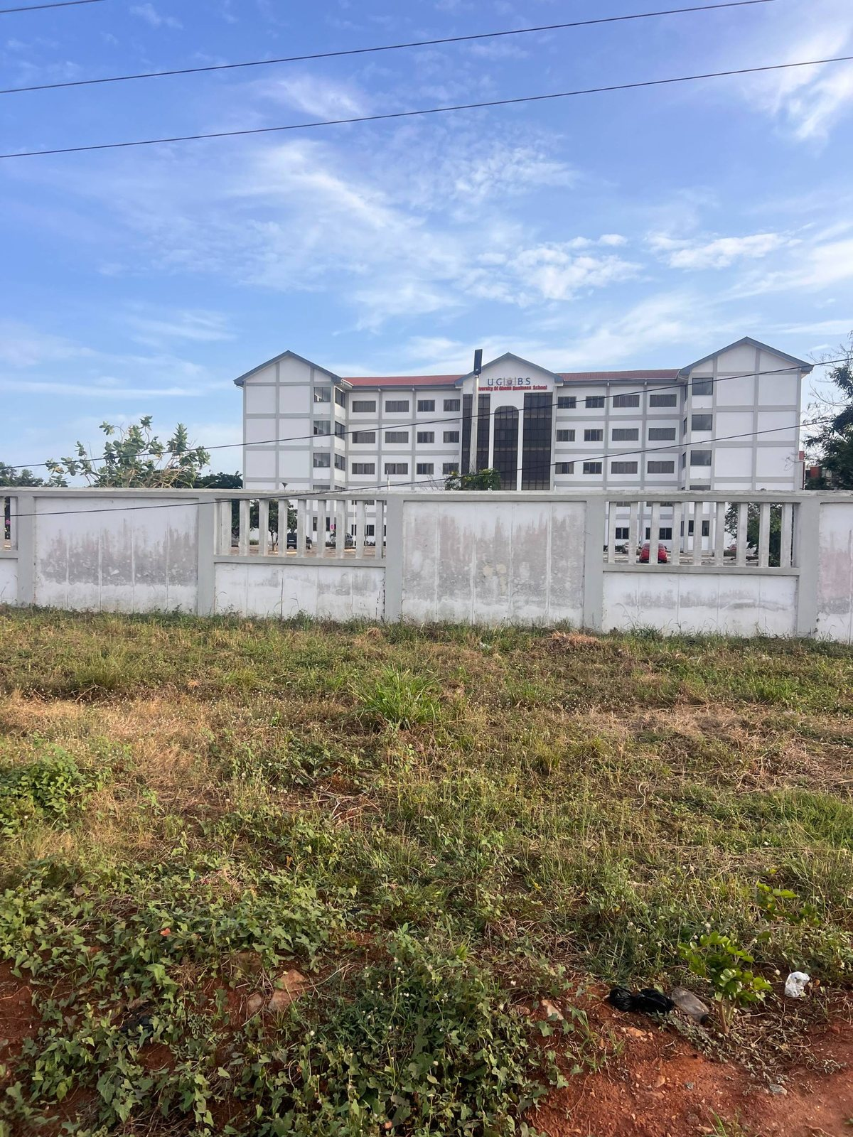  UGBS Graduate Building visible behind a roadside verge, with a high-voltage lattice tower and planted/rough open ground.

Appendix B — Original road and junction field photographs (F01–F18) (continued)
F05 | Original junction field photograph  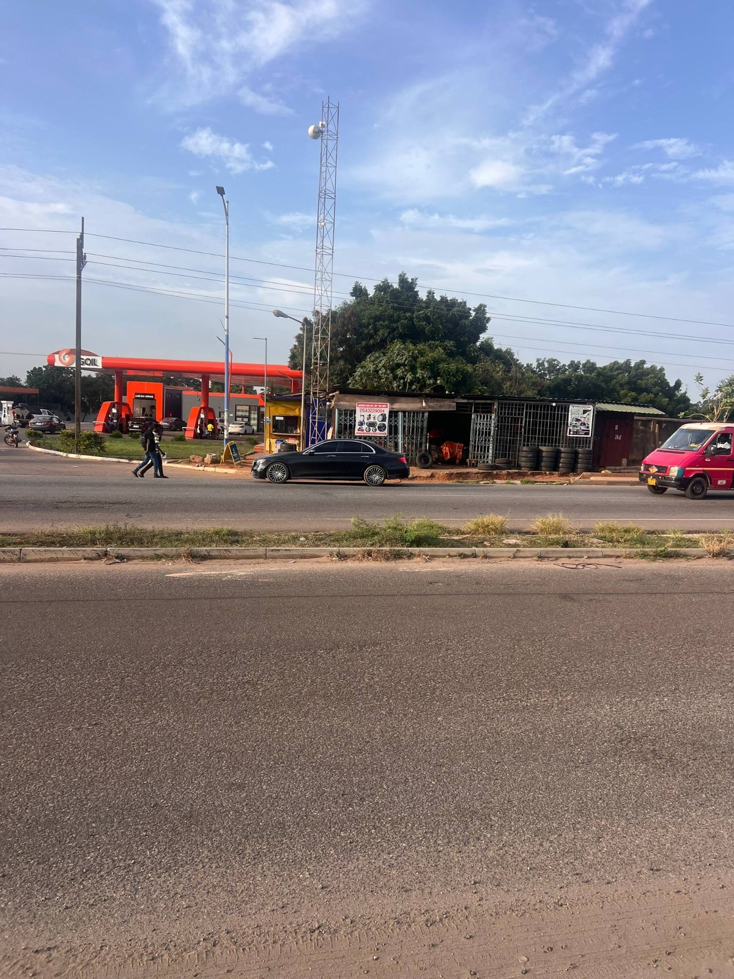  Across-road view with GOIL canopy and road frontage; use to position station context relative to the carriageway. | F06 | Original junction field photograph  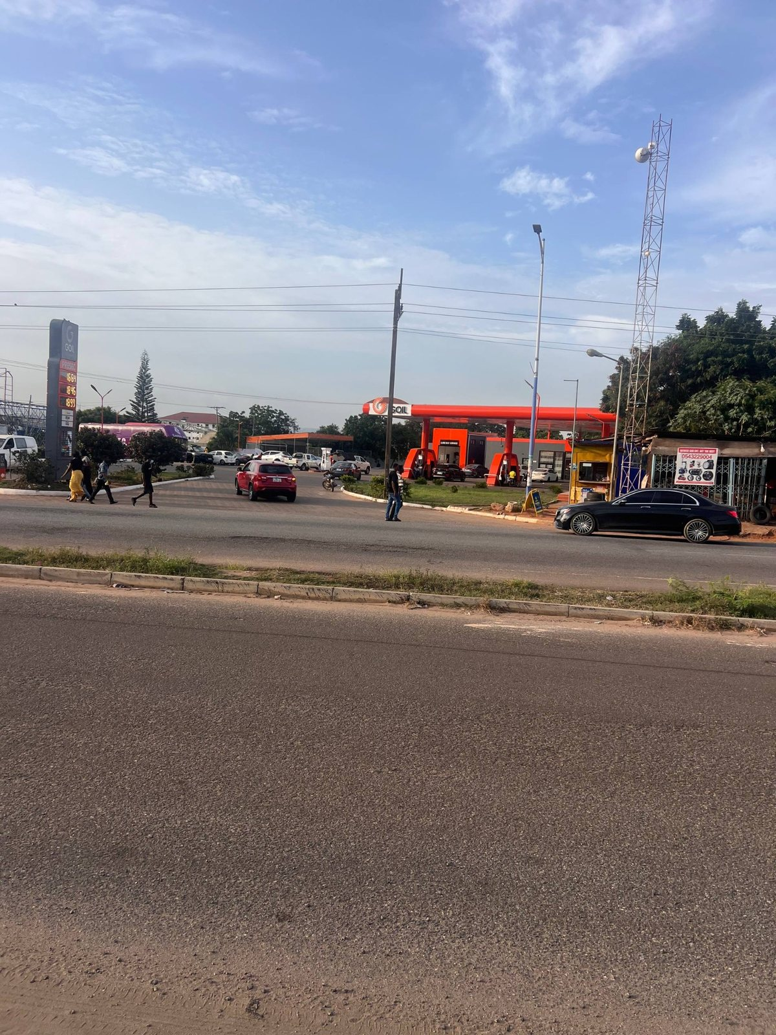  Road perspective across the corridor with station frontage and broad asphalt; helps compare approach views.
F07 | Original junction field photograph  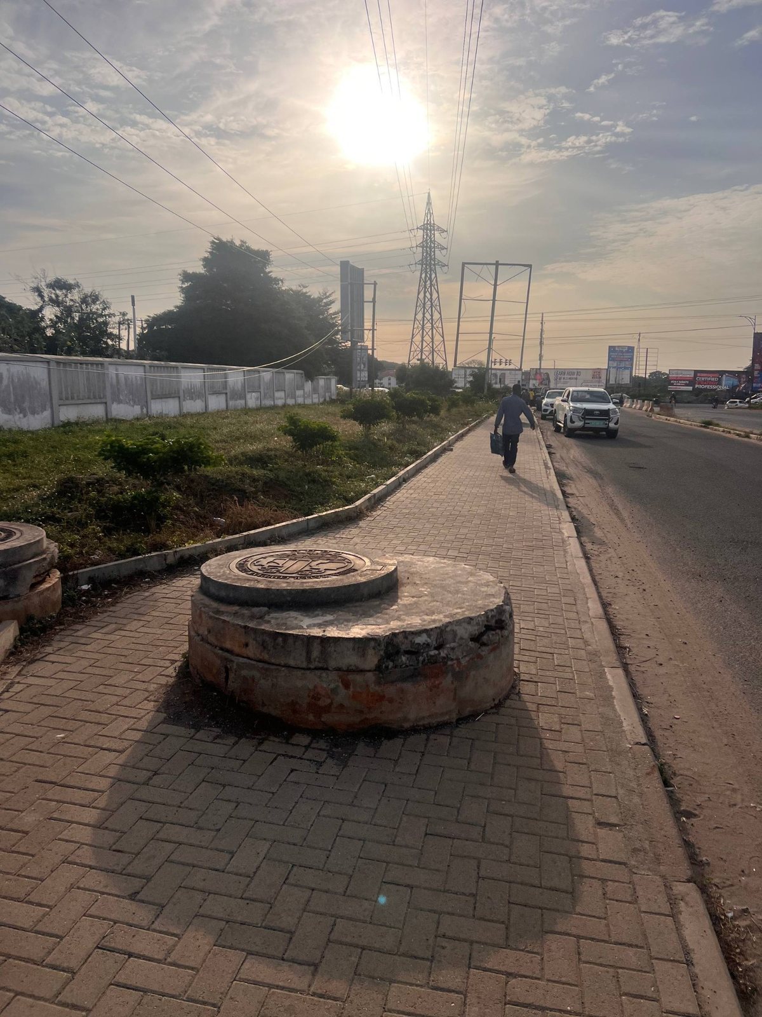  Approach sidewalk with a circular raised/utility feature in the paving; inspect whether it represents a real cover/island, do not copy without checking other angles. | F08 | Original junction field photograph  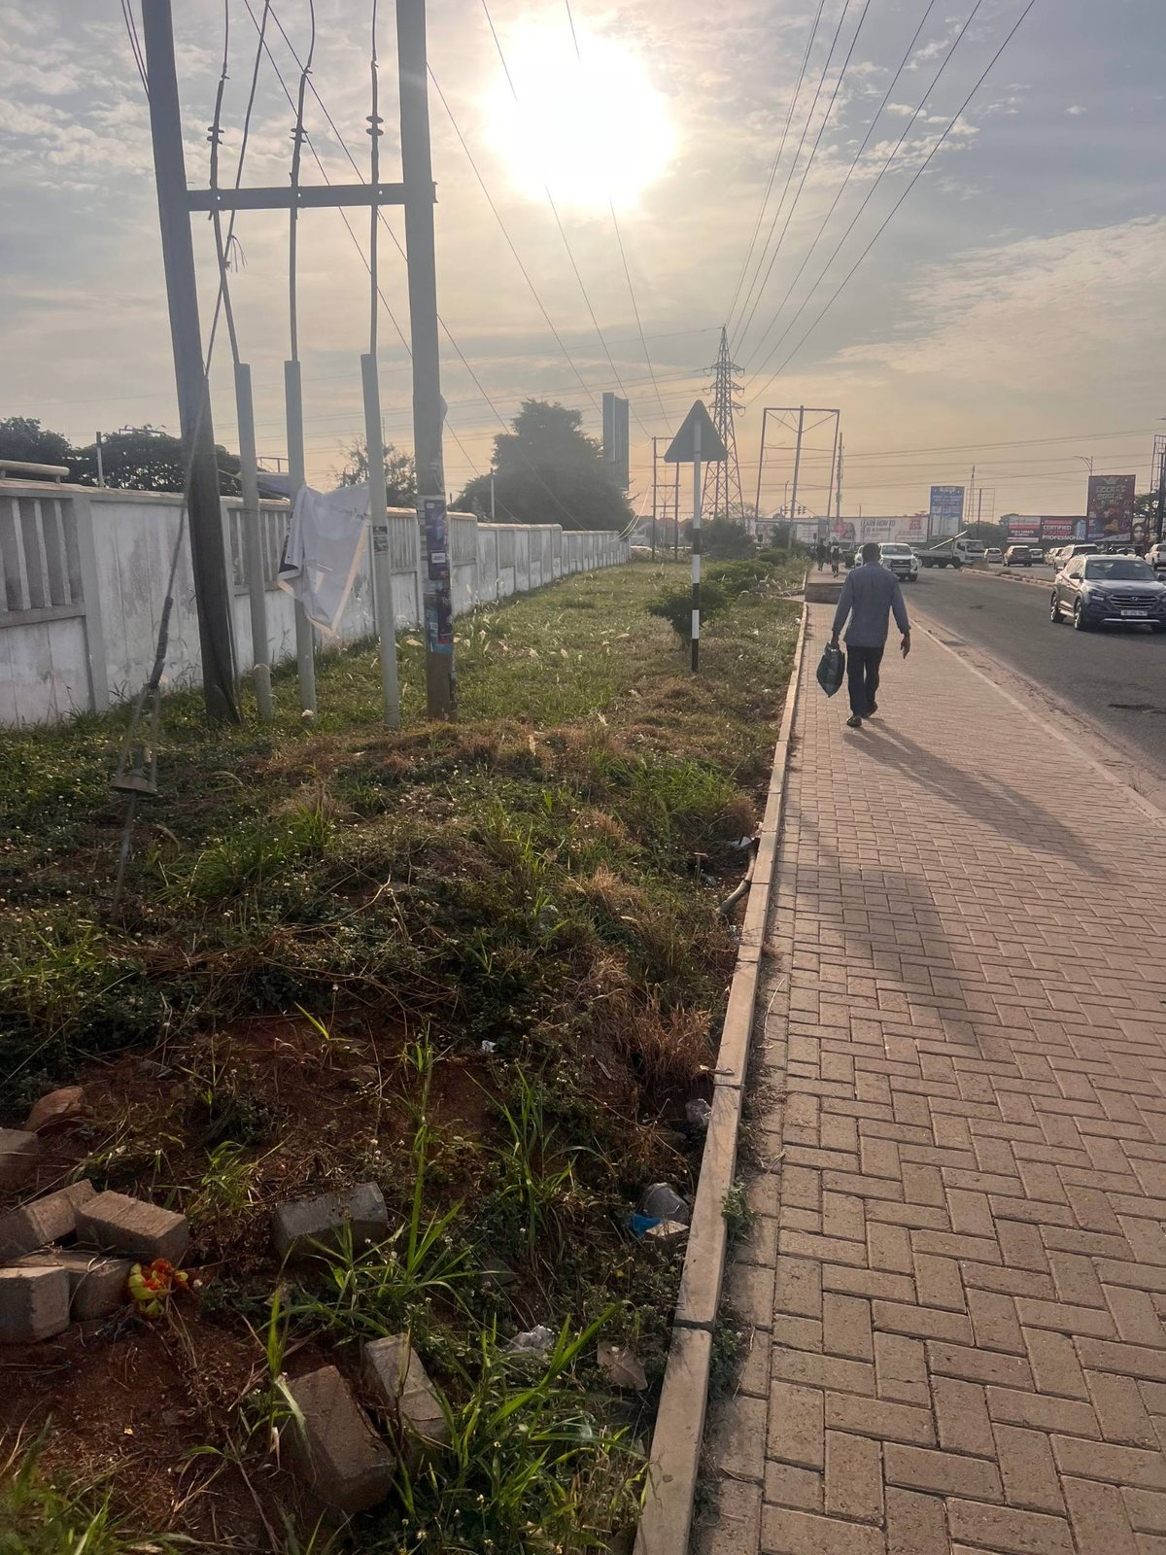  UPSA Junction / UGBS approach view with sidewalk, open verge and a tall infrastructure frame; use for near-side pedestrian edge and background landmark.

Appendix B — Original road and junction field photographs (F01–F18) (continued)
F09 | Original junction field photograph  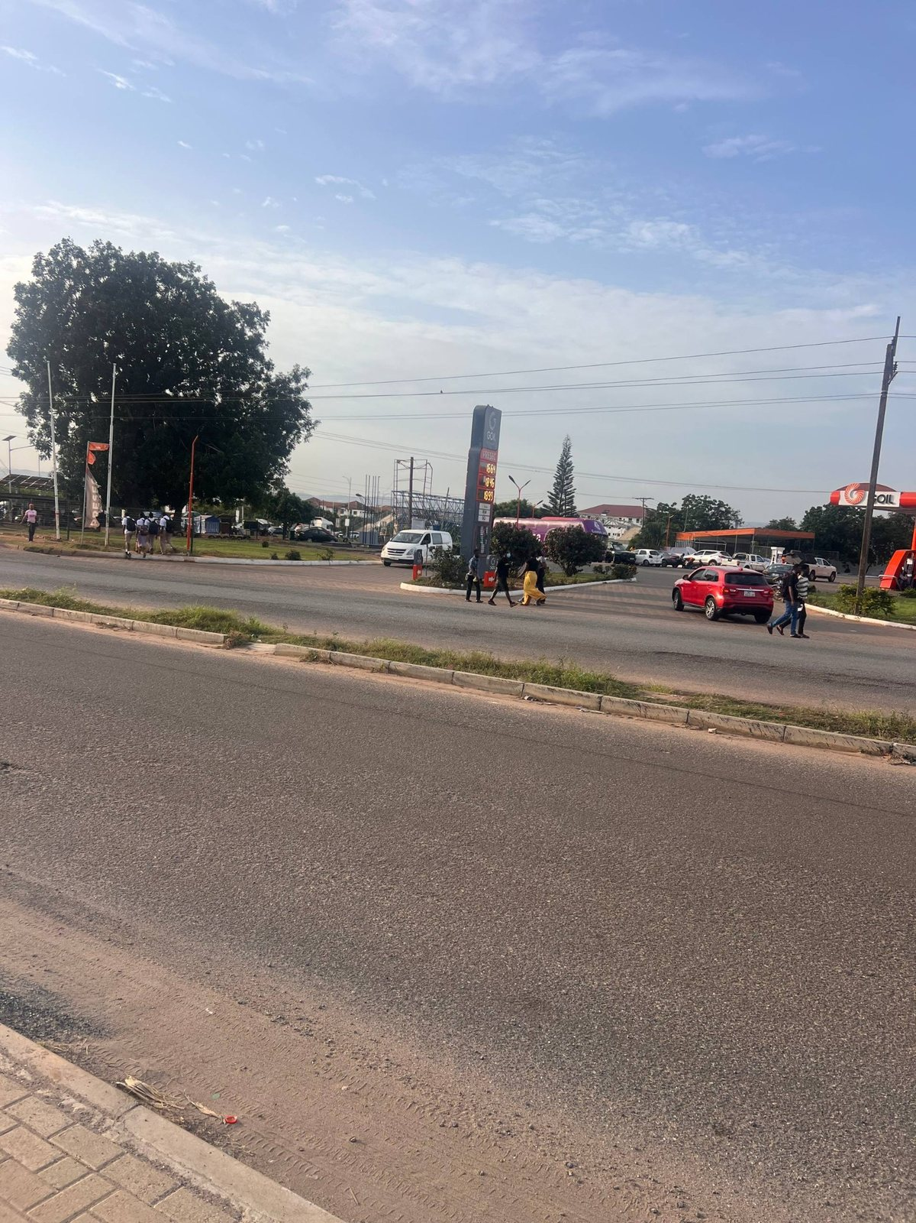  Road approach showing GOIL-side area and traffic along the highway. | F10 | Original junction field photograph  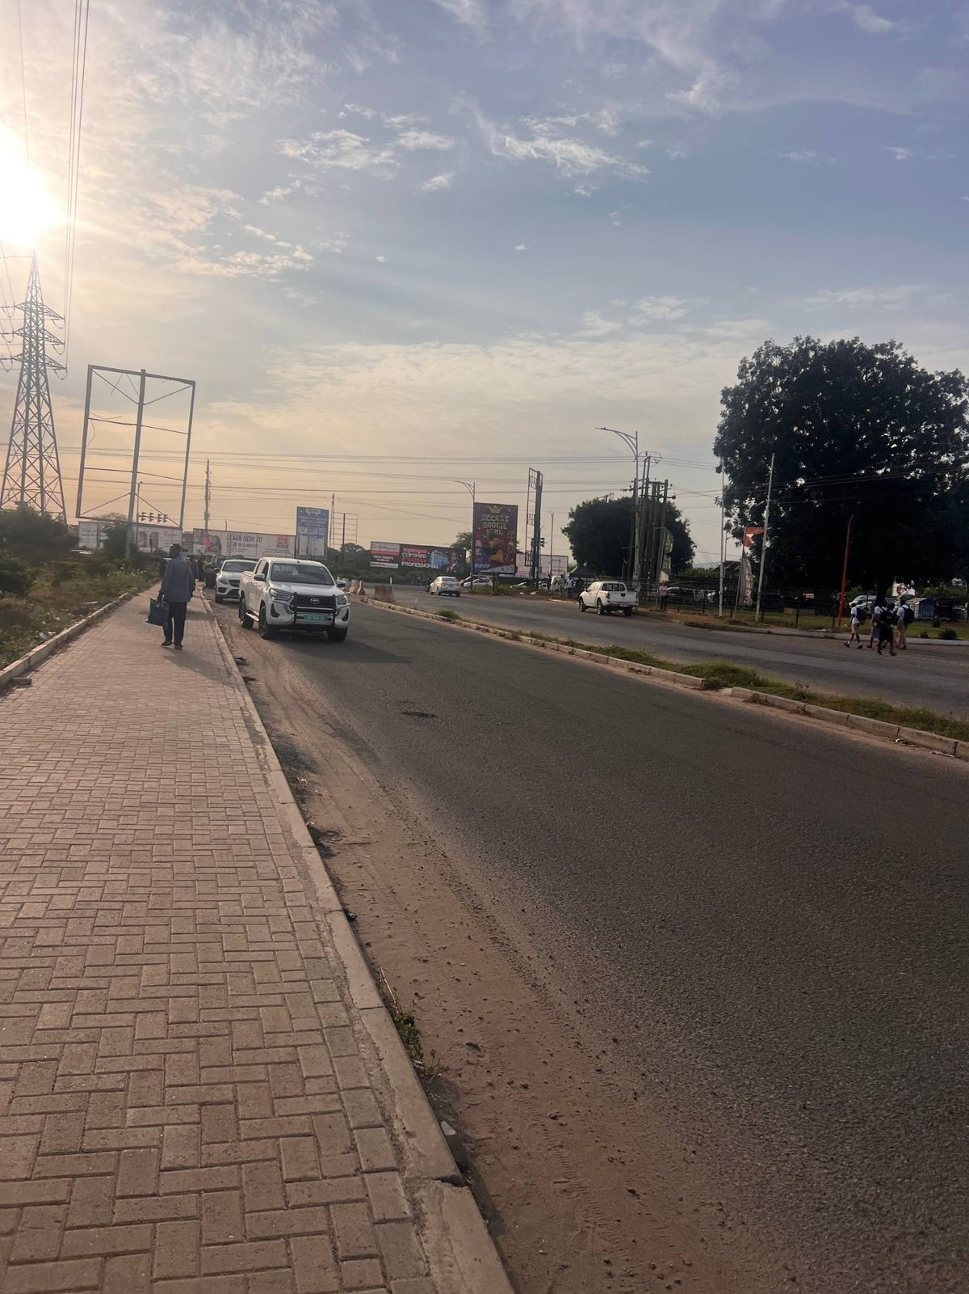  Road-side pavers, asphalt and distant junction direction; a useful long-perspective sidewalk reference.
F11 | Original junction field photograph  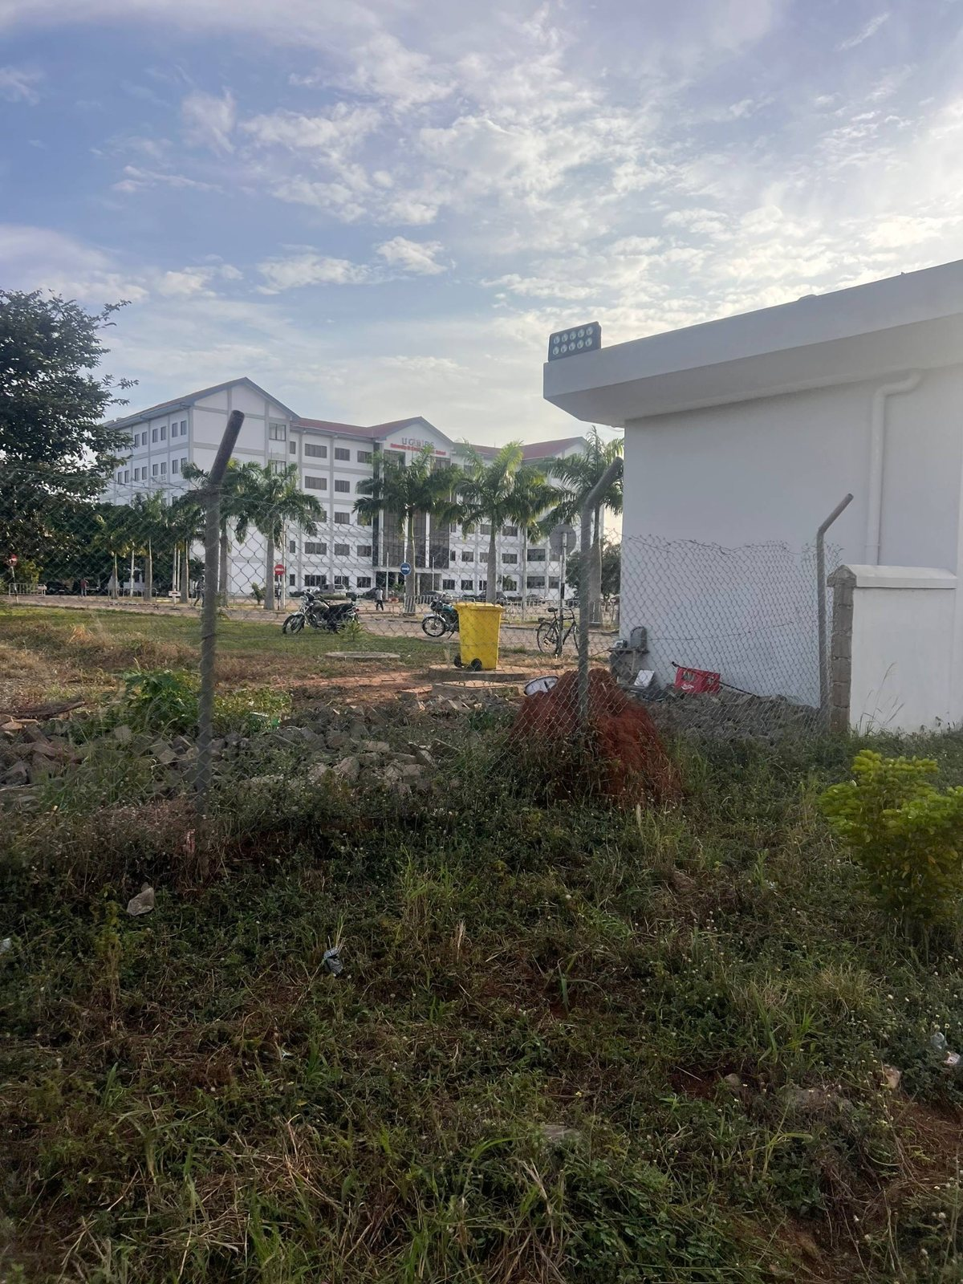  White property wall and vegetation beside the road with a larger building visible beyond; use for frontage boundary/landscape. | F12 | Original junction field photograph  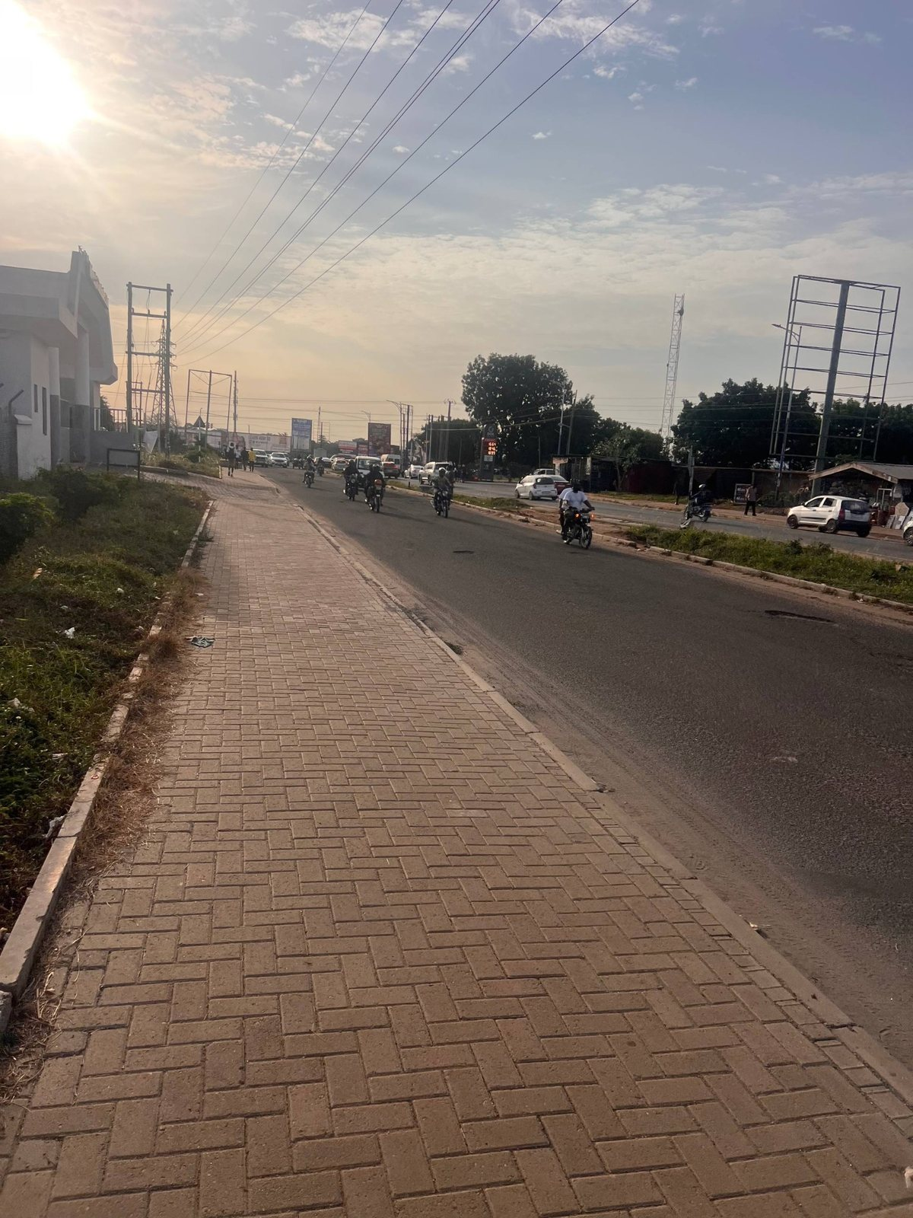  Continuous brick-paver path beside the carriageway; use for surface module, width changes and alignment to the curb.

Appendix B — Original road and junction field photographs (F01–F18) (continued)
F13 | Original junction field photograph  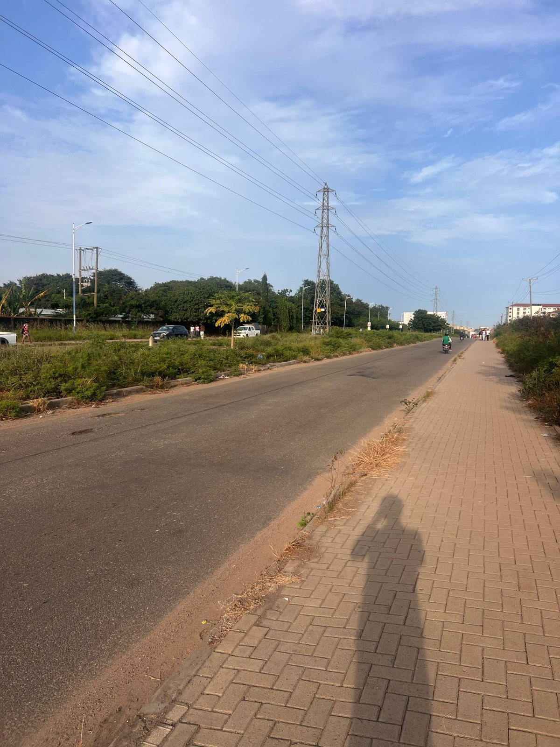  Long perspective along the paver sidewalk toward the junction, with open rough verge and overhead wires. | F14 | Original junction field photograph  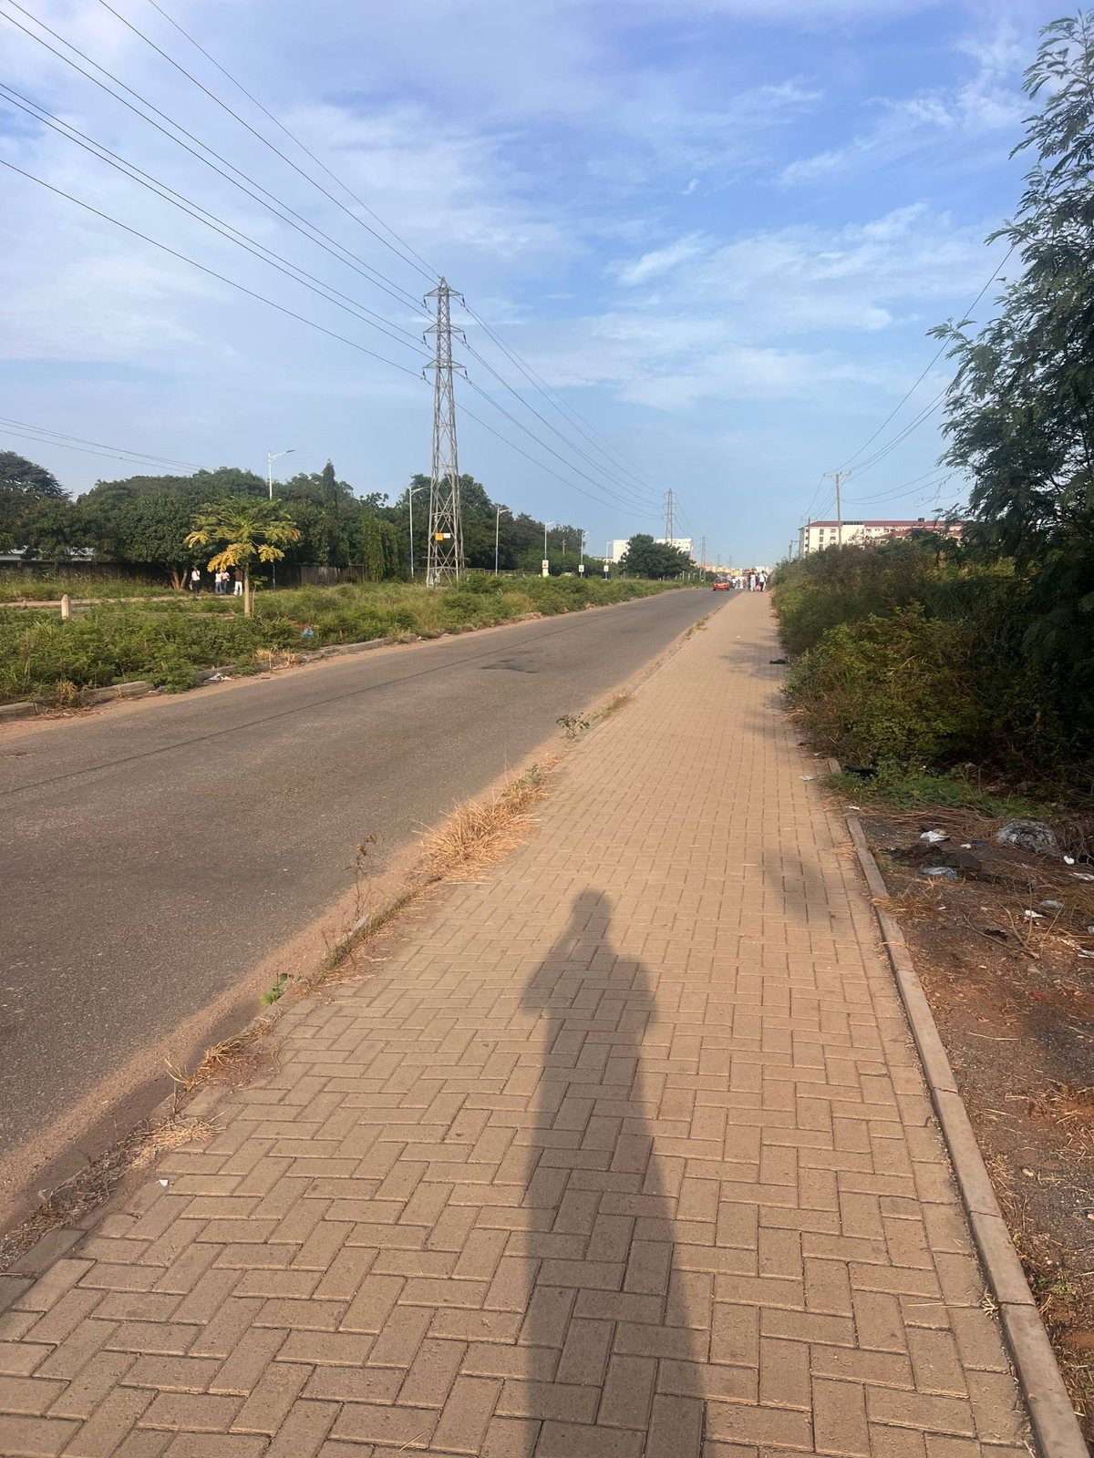  Another view of the sidewalk and roadway on the opposite side, useful for comparing verge treatment and curb continuity.
F15 | Original junction field photograph  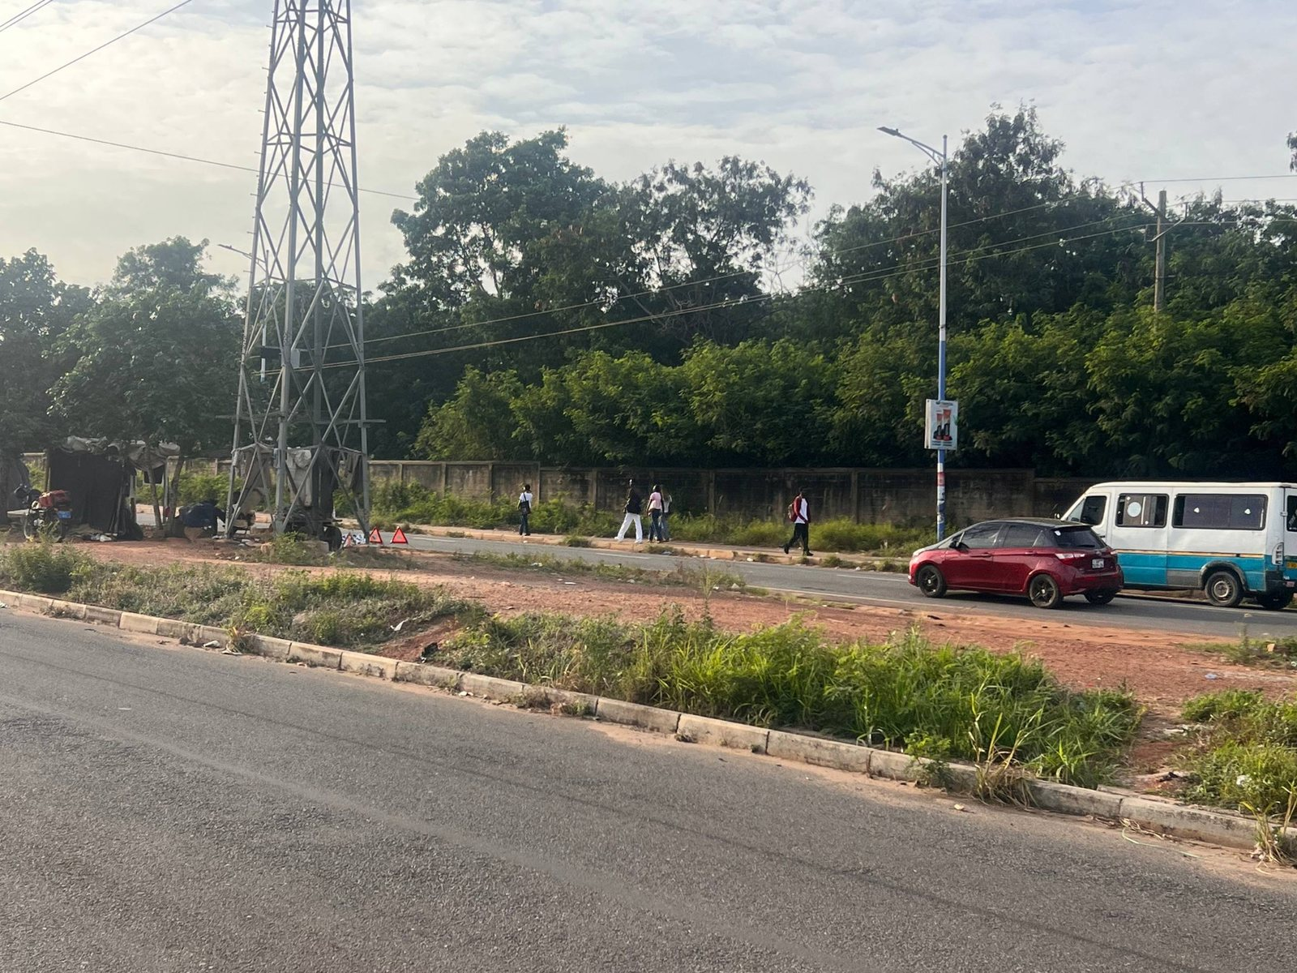  Junction-side planted/open area with tall transmission tower and roadside trees across the road. | F16 | Original junction field photograph  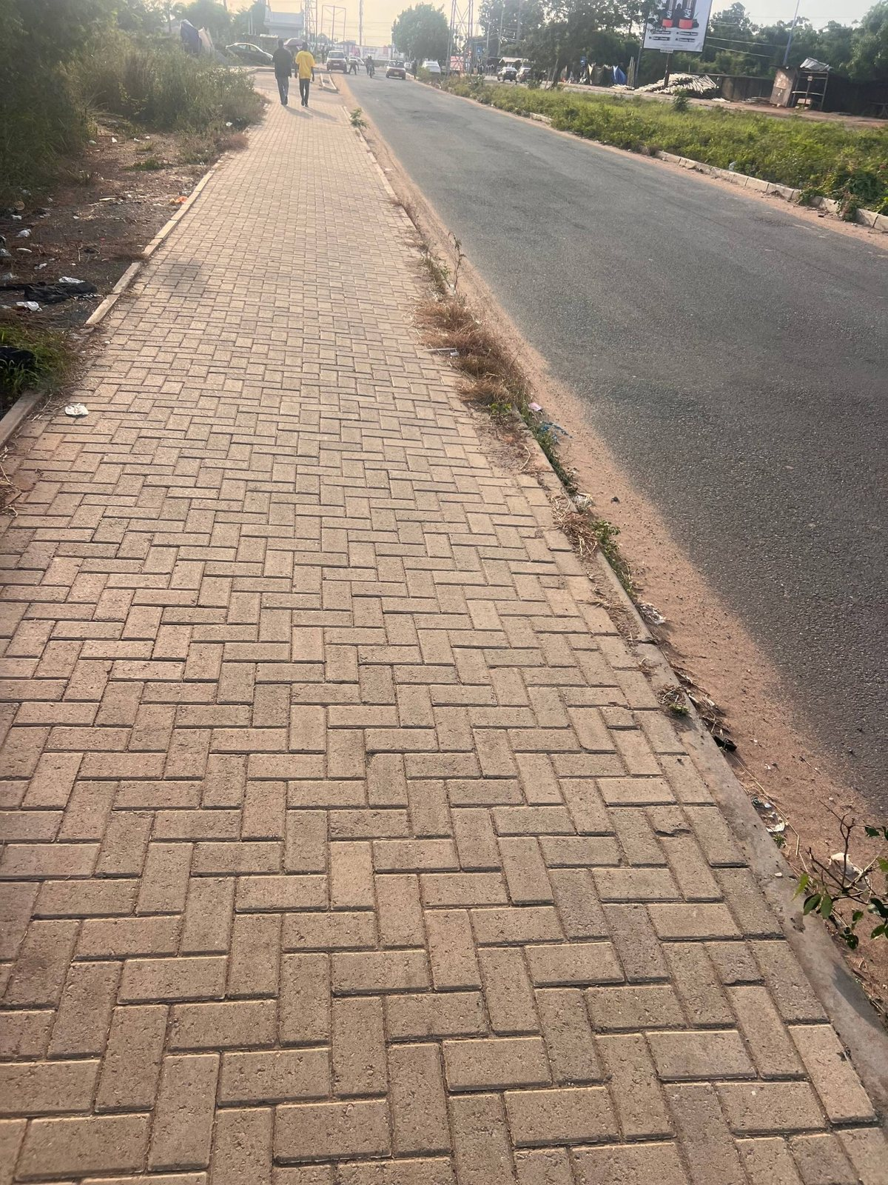  Close sidewalk paving and roadside shoulder with asphalt running alongside; check material and edge continuity.

Appendix B — Original road and junction field photographs (F01–F18) (continued)
F17 | Original junction field photograph  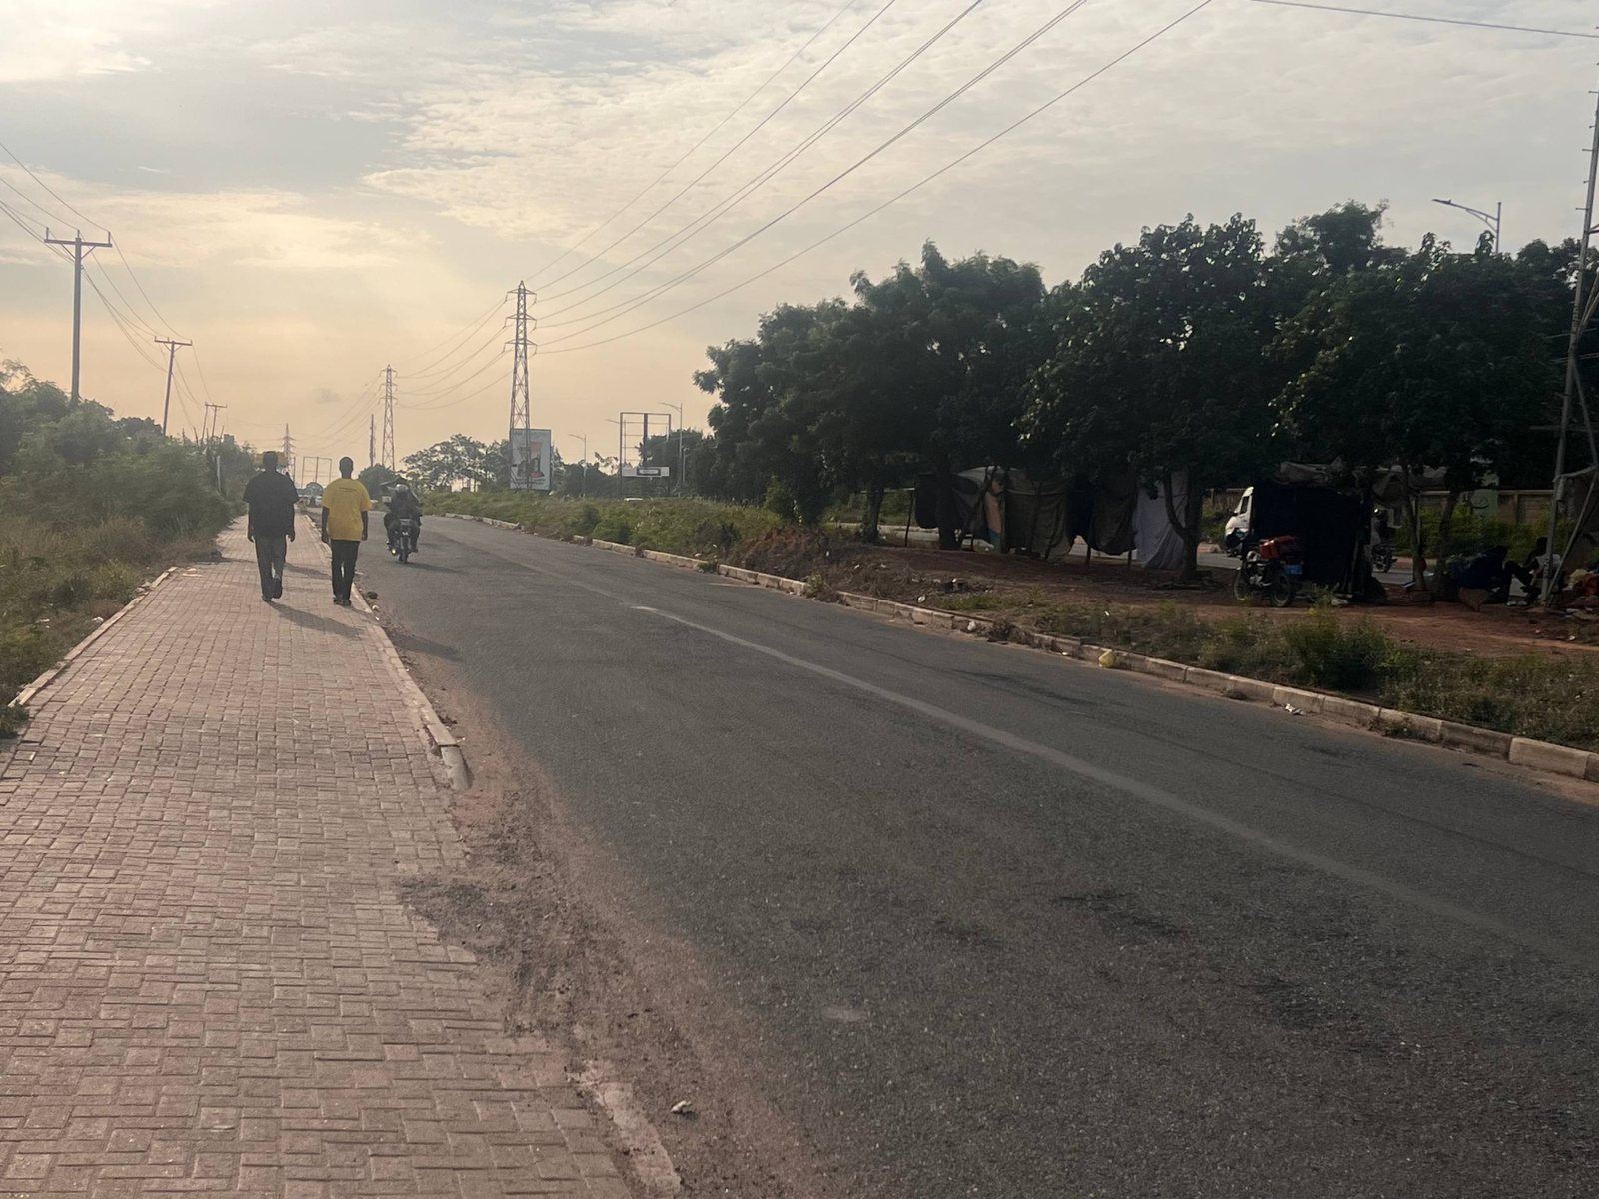  Broad pedestrian path beside the road with pedestrians and large shade trees; useful for the street character and scale. | F18 | Original junction field photograph  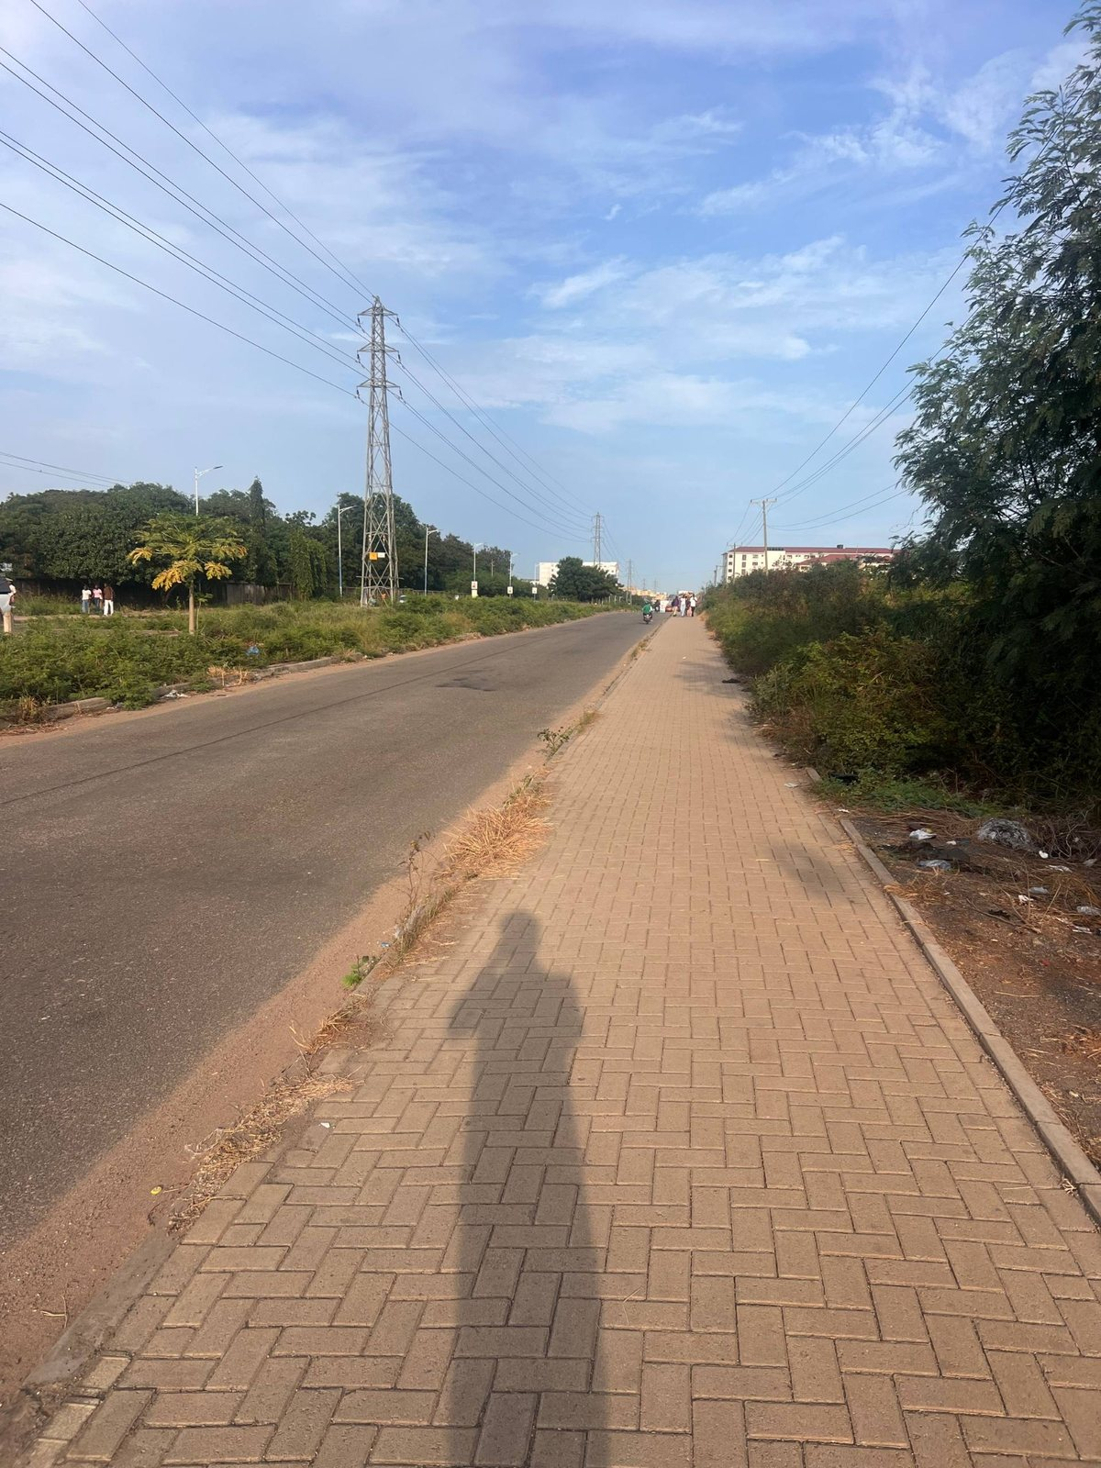  Wide GOIL-side station context across the road with open verge, utility lines and nearby roadside structures.

Appendix C — UGBS Graduate Building identity references (B01–B06)
These six photos are included to keep the UGBS landmark identifiable and distinct from GOIL, UPSA Hostel and the VC Complex. They are building/gate appearance references; use existing project geography to place the building and its gate.
B01 | Dedicated UGBS landmark photograph  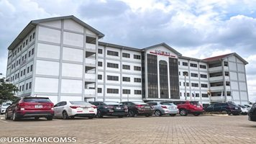  Wide oblique view of the UGBS Graduate Building: multi-storey white facade, symmetrical wings, central dark glazed vertical feature, forecourt and parked vehicles. | B02 | Dedicated UGBS landmark photograph  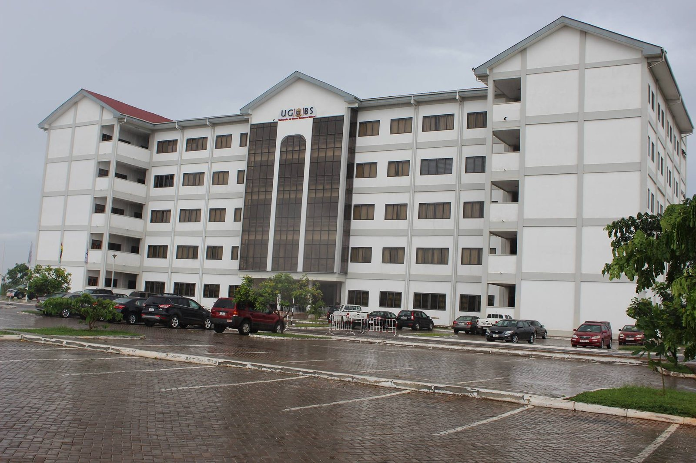  Alternate oblique view showing the repeated window grid, central glazed vertical feature, broad foreground forecourt and roof profile.
B03 | Dedicated UGBS landmark photograph  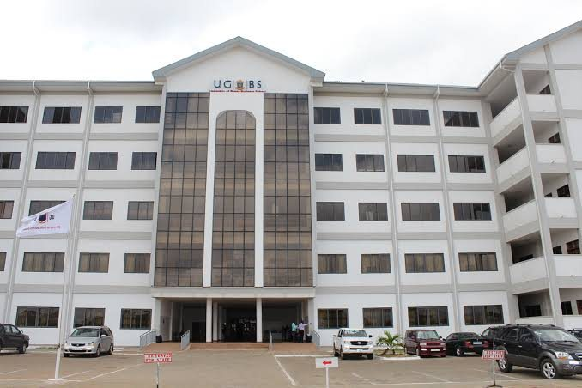  Frontal entrance elevation with central tall glazed feature, UGBS sign, repeated windows and paved approach. | B04 | Dedicated UGBS landmark photograph  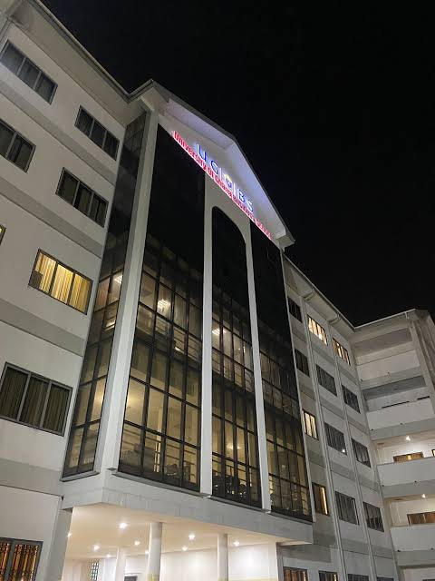  Night view of the main UGBS glazed entrance feature; use only for optional evening illumination, not daytime geometry.

Appendix C — UGBS Graduate Building identity references (B01–B06) (continued)
B05 | Dedicated UGBS landmark photograph  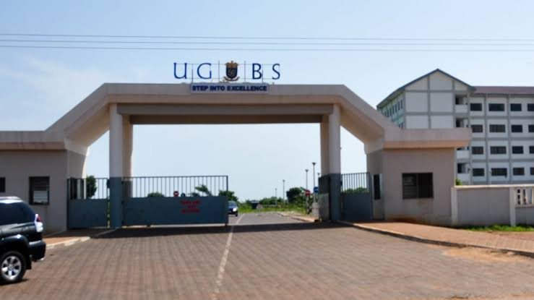  Separate UGBS entrance gate portal and gate approach. Treat the gate as a distinct access asset; place it using the authoritative geography, not by visual guess alone. | B06 | Dedicated UGBS landmark photograph  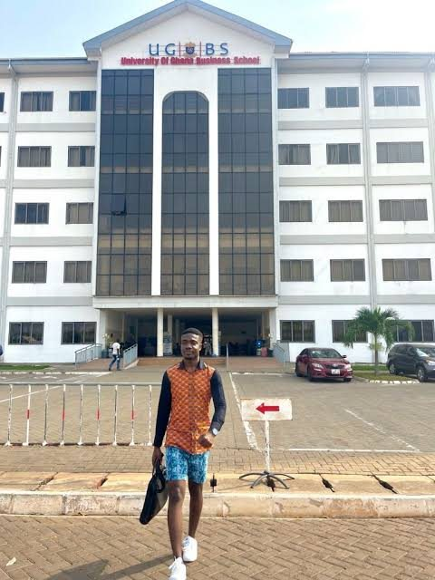  Daylight frontal view of the UGBS Graduate Building with its central glazed feature and signage; confirms the UGBS identity.

Appendix D — Current LEGONRUSH scene diagnostics (G01–G06)
These screenshots show existing LEGONRUSH rendering and nearby route context. Treat them as baseline images for visual QA only. Their HUD/landscape may refer to other nearby roads and is not the authority for the UPSA Junction layout.
G01 | Current game diagnostic  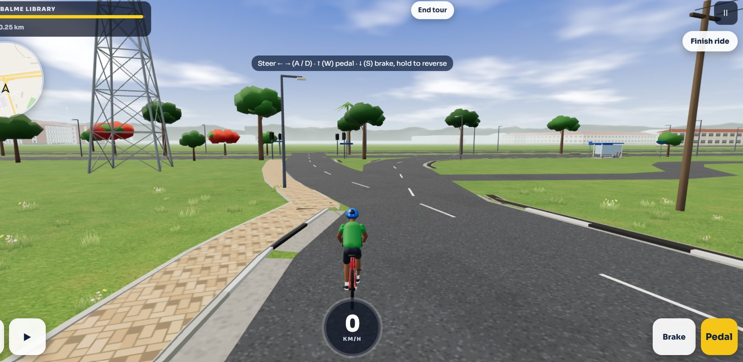  Current LEGONRUSH gameplay comparison view. Shows the existing low-poly road, sidewalk, tower, trees and road branching. Treat as a diagnostic game screenshot only; the HUD says the ride is to Balme Library, so it is not a trustworthy plan of the junction. | G02 | Current game diagnostic  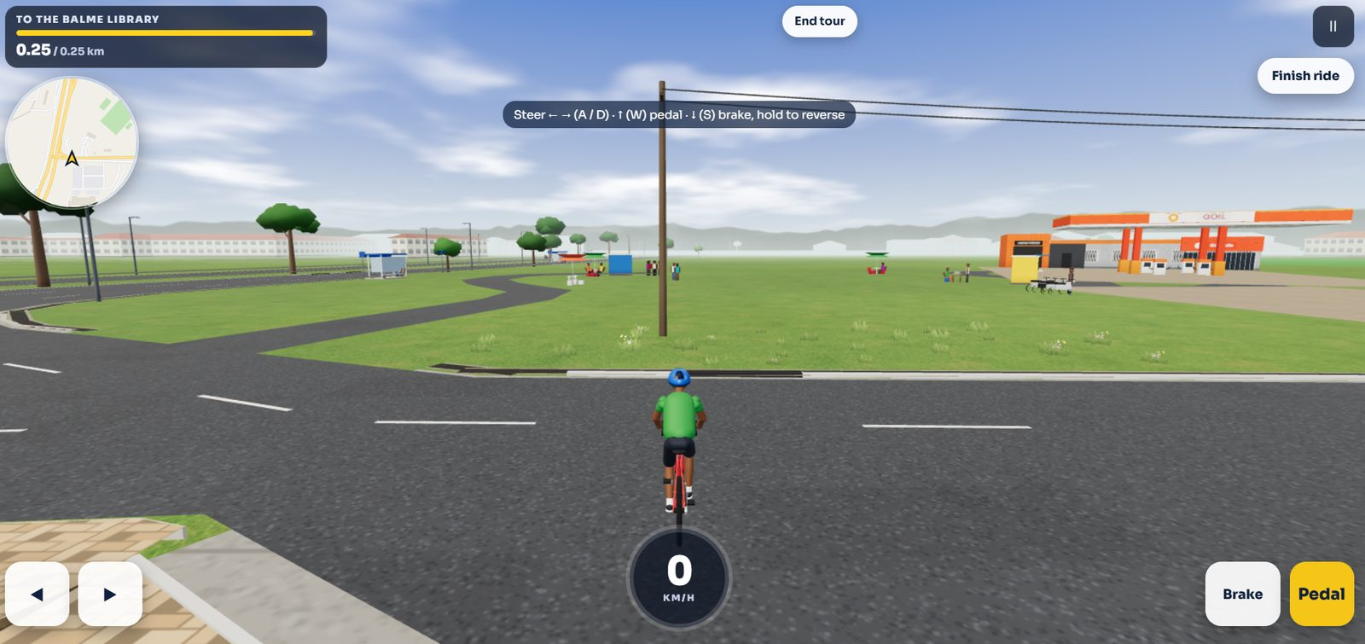  Current-game comparison with GOIL station rendered at a distance across large open green terrain, one road edge in foreground and sparse objects. Use to identify how the current overall style may need richer location-specific junction context; do not copy as real geometry.
G03 | Current game diagnostic  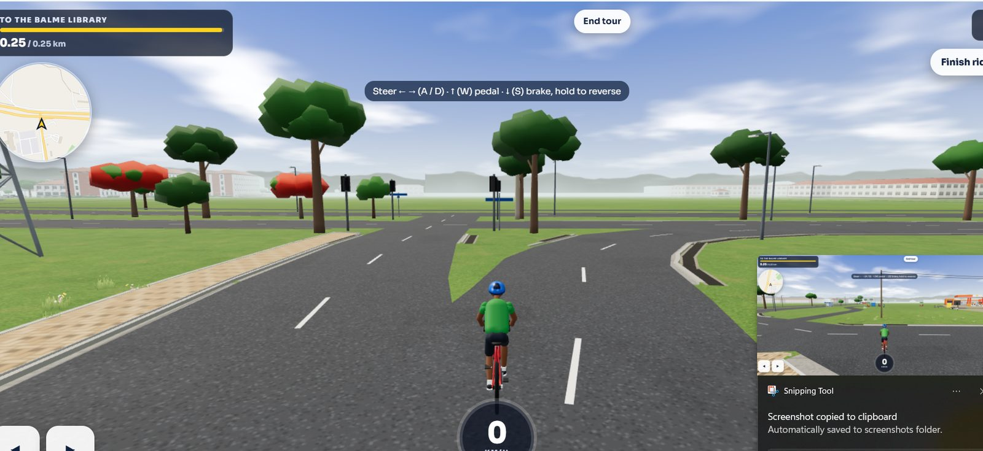  Current-game view of a branching road, simplified trees, utility assets and road markings. Diagnostic reference for present mesh style and transitions only. | G04 | Current game diagnostic  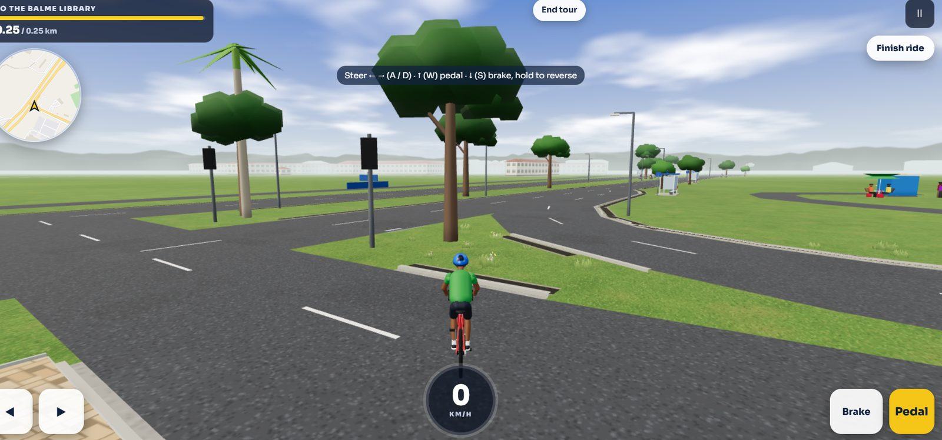  Current-game view of road edges, a large tree, utility poles and roadway split. Use for checking existing visual quality and geometry seams, not real-world object spacing.

Appendix D — Current LEGONRUSH scene diagnostics (G01–G06) (continued)
G05 | Current game diagnostic  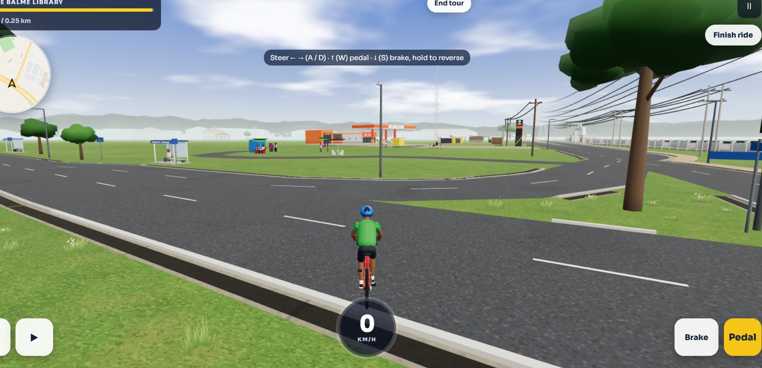  Current-game landscape view of several roads, open grass, trees and utility structures. Diagnostic only; do not infer UPSA Junction layout from this screenshot. | G06 | Current game diagnostic  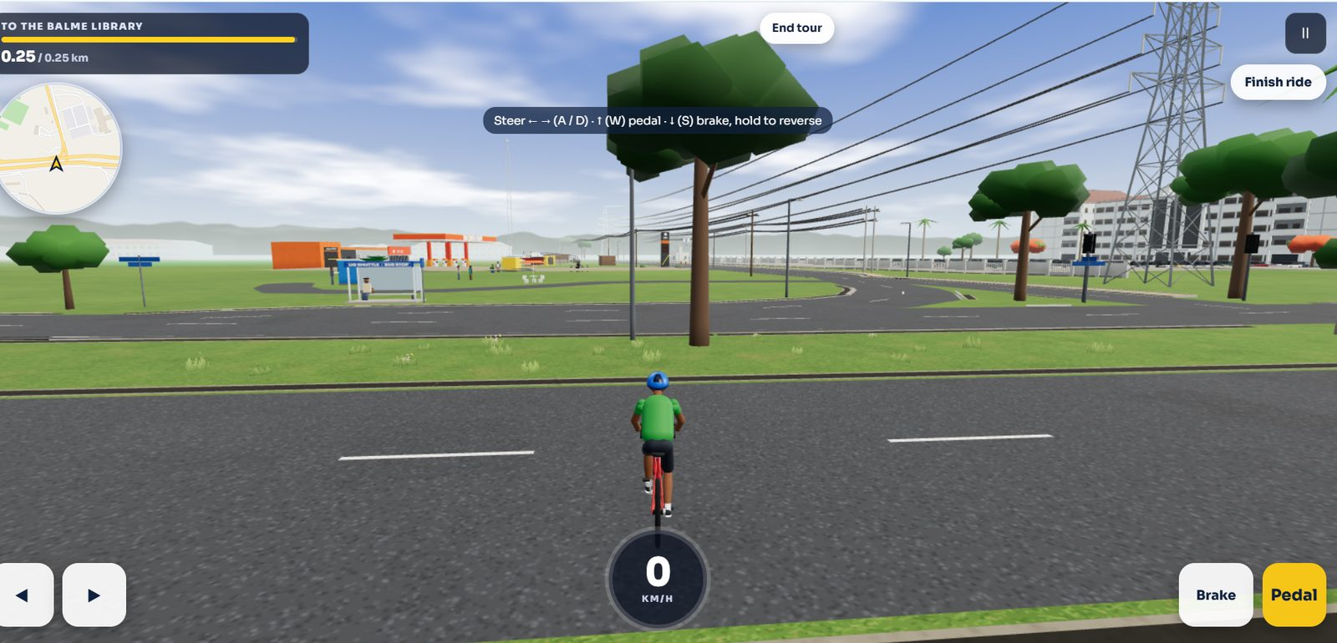  Current-game view with transmission-tower assets, roadside buildings and layered utility wires. Use to compare available assets with the denser real-world power corridor in the photographs.

Implementation handover checklist
- ☐ Word brief read fully and source references opened as needed.
- ☐ Claude Code can access `reference_images/` and `CLAUDE_CODE_MASTER_PROMPT.txt`.
- ☐ Road/graph topology verified against authoritative project data before mesh changes.
- ☐ GOIL and UGBS locations remain distinct and correctly anchored.
- ☐ Junction is not turned into a roundabout or an underpass.
- ☐ No unrelated road corridor, hostel, VC Complex or global campus reconstruction has slipped into the scope.
- ☐ Browser ride-through, tests, build and visual comparison completed.
- ☐ No `main` push / production deployment without approval.
End of brief.

