LEGONRUSH

UPSA JUNCTION TO
UPSA HOSTEL
ROAD CORRIDOR RECONSTRUCTION BRIEF
Road surface • sidewalks • drainage • verges • frontages • utilities • hostel approach
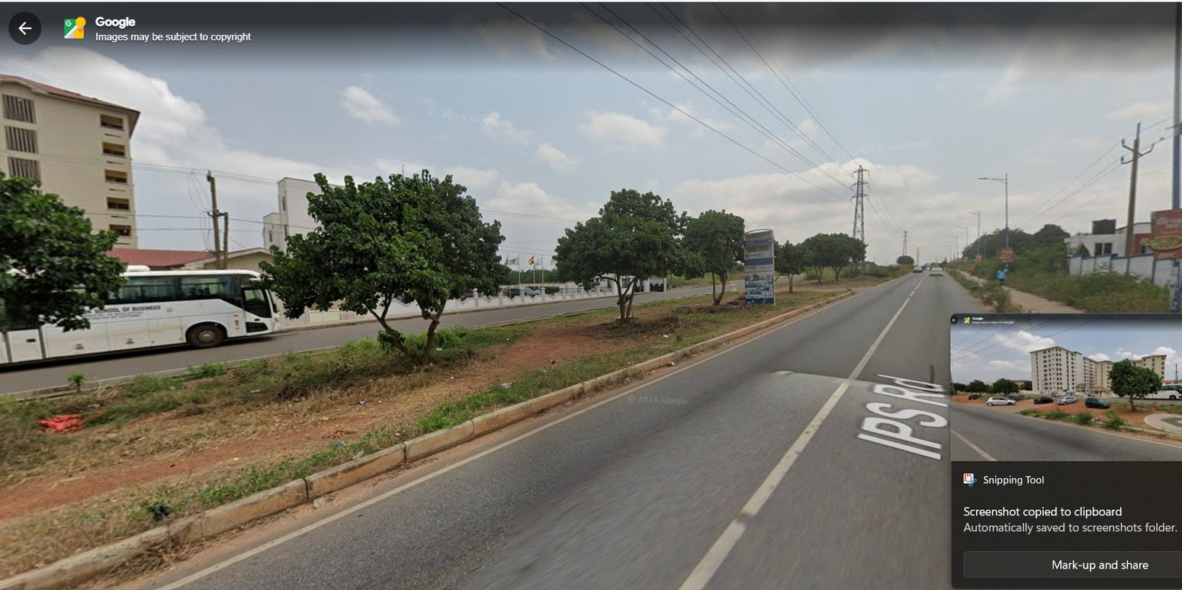
Scope boundary: GOIL / UPSA Junction → IPS Road corridor → UPSA Hostel frontage and access gate
CORE PURPOSE
Reconstruct the ROAD and its roadside environment along this one corridor. Treat GOIL, UGBS Graduate School, the VC Complex and UPSA Hostel as orientation landmarks and frontage context, not as separate building-redesign tasks.

Prepared for Claude Code | Based on user-supplied field photographs, Street View screenshots and current LEGONRUSH gameplay references | 12 October 2026

1. Brief introduction and intended outcome
Reconstruct the continuous IPS Road corridor that leads from the GOIL / UPSA Junction to the UPSA Hostel frontage and hostel access gate. This is a road-and-streetscape task: the main output is a believable, continuous, geographically faithful rideable road section, not a detailed redevelopment of every building beside it.
The corridor should read as one place from beginning to end. Road alignment, asphalt, lane/edge markings, kerbs, sidewalks/pavers, drains and culverts, red-earth shoulders, wall/fence changes, access openings, trees, utility poles, overhead lines, transmission towers and road-facing property edges must be composed in the correct geographic sequence.
THE SCOPE IN ONE SENTENCE
Make the road from the UPSA Junction to the UPSA Hostel feel real, continuous and correct; model only the road-facing building/frontage context necessary to support that experience.

1.1 Included
- Road centerline, horizontal curve, junction tie-in, elevation/profile, asphalt mesh, lane markings and edge markings.
- Road shoulders, red-earth patches, grass/weed transitions, block-paved sidewalks, curb returns, gutters, open drains, culverts and covers where evidenced.
- Boundary walls, metal fencing, institutional gates, driveway openings, sidewalk interruptions and frontage setback changes along the route.
- Roadside trees/shrubs, grass/open land, streetlights, utility poles, distribution wires, high-voltage towers and visible signs/billboards in the roadside corridor.
- The immediate road-facing approach to the hostel gate, including vehicle/pedestrian transitions and the correct position of the gate relative to the road.
- Diagnosis and repair of existing road/terrain artifacts: flicker, z-fighting, raised bars, disappearing sidewalk/gutters and broken mesh joins.

1.2 Explicitly out of scope
- A campus-wide rebuild or changes to unrelated zones of LEGONRUSH.
- Detailed interiors, courtyards, room layouts or full architectural redesigns for UPSA Hostel, the VC Complex or UGBS Graduate School.
- Changing stable road, route, landmark or destination-access IDs; rewriting race/challenge routes, ghost paths, records or leaderboard-linked geometry.
- Inventing precise widths, distances, coordinates, access openings or hidden building geometry from perspective photographs.

1.3 Distinct landmark identities
Landmark | Role in this task | Do not do this
GOIL / UPSA Junction | Start/orientation anchor; model only enough surrounding context to make the road entry believable. | Do not rebuild the whole station or derive road coordinates from a screenshot.
UGBS Graduate School | Separate existing landmark at the junction opposite GOIL; supports origin orientation. | Do not substitute the hostel or VC Complex model; do not redesign UGBS as part of this road task.
Vice-Chancellor’s Ghana Office Complex | Road-facing frontage/wayfinding landmark along the corridor. Preserve its correct location and existing identity. | Do not turn the task into a full office-building or compound redesign.
UPSA Hostel | Destination landmark; the main target is the road frontage and its access gate/approach. | Do not rebuild its interior courtyard or all hostel architecture; use the existing building as context unless a narrowly scoped road-facing correction is necessary.

2. Route definition and scene segmentation
Use the sequence below as an inspection plan, not a surveyed distance table. Before editing, trace the route through the repository’s authoritative geography and identify its exact start/end nodes, side-of-road orientation, access nodes and affected render segments. The photos confirm appearance and broad sequence; they do not establish precise coordinates or measured road widths.
Segment | Corridor stretch | Priority road work
C0 - Start | GOIL / UPSA Junction | Trace how IPS Road enters the junction; reconcile asphalt/markings, kerb returns, junction surfaces and sidewalk starts. Preserve connectivity.
C1 - Early approach | Initial straight approach and first roadside walls/paved footpath | Build continuous asphalt and readable markings; align curb and pavers; maintain actual wall, vegetation and utility setbacks.
C2 - Institutional edge | Boundary walls, gates, church/sports frontage and other institutional edges visible in the references | Match wall/fence runs, sign positions, footpath widths, driveways, culvert/open-drain locations and real openings; avoid a uniform repeated frontage.
C3 - Utility/open verge | Longer stretch with red earth/open ground, mature trees, distribution poles and transmission infrastructure | Blend asphalt to curb/shoulder/earth; place utility assets according to map context; preserve sightlines and playable clearance.
C4 - VC Complex frontage | Road-facing portion of the Vice-Chancellor’s Ghana Office Complex and access court | Treat the building and gate as landmarks; ensure road, sidewalk, curb cut and frontage do not clip or overlap the property mesh.
C5 - Hostel approach | Final road stretch, roadside planting/parking and hostel-visible approach | Maintain correct approach direction, perspective, sidewalk/earth transitions, curb cuts and the relation of the hostel footprint to the road.
C6 - Hostel access | UPSA Hostel main gate and road/pedestrian entry interface | End at the correct gate/approach. Preserve entrance opening, pedestrian/vehicle access, road collision and existing access ID.

POSITION RULE
If a photo appears to put a landmark on the left or right but the project map indicates otherwise, trust the authoritative geography. Record the mismatch and investigate; never shift a landmark just to match a perspective screenshot.

3. Evidence hierarchy and source interpretation
- 1. Repository geography and registries: authoritative for road centerlines, node connectivity, route/access IDs, footprints and positions.
- 2. User-supplied real photos: primary visual evidence for asphalt/kerbs/pavers, walls/fences, drains, vegetation, utility forms and building frontage appearance.
- 3. User-supplied Street View screenshots: support corridor sequence, broad setbacks and orientation. Strip out Google controls, road labels, icons, watermarks, UI overlays and screenshot borders from the simulated world.
- 4. Existing game screenshots: diagnostics of the current implementation only; they are not proof that current road geometry or buildings are correct.
- 5. Official online sources: corroborate landmark identity and broad location; they do not replace survey/map data or the photographs.
- 6. Any infographic, thumbnail, perspective guess or generic online photo: illustrative only, not a measurement source.

Reference-reading rules
- Use multiple views to understand one stretch; a wide Street View frame may compress distances and distort apparent road width.
- Use foreground pavement blocks and curb lines to infer material and edge construction, not absolute scale unless the repository provides a known dimension.
- Treat cars, pedestrians, shadows, temporary advertisements, vegetation growth and road works as time-specific context. Recreate only stable features and a believable level of activity.
- The user supplied a Google Local photosphere link for additional context; use it to inspect orientation if available, but do not copy its interface into the 3D scene.

4. Road and roadside construction specification

4.1 Carriageway and junction continuity
- Trace existing centerlines and the geometry leading out of the GOIL/UPSA Junction. Preserve curve, road width and connection unless a documented evidence-based correction is required.
- Keep a continuous asphalt surface with matching elevations at segment endpoints. Avoid wedge-like gaps, z-fighting, visible seams, sudden width changes and duplicate surface strips.
- Recreate the line markings actually supported by the references and the current geography: dashed/continuous center/edge markings only where appropriate. Do not add multilane markings from generic road templates.
- Road surfaces must be driveable with existing bicycle/vehicle movement and collision behavior; ensure the visual mesh and movement/collision road data agree.
- Junction geometry should blend across road branches with no raised rectangular patch or long thin bar crossing the riding line.

4.2 Sidewalks, pavers and curbs
- Use the photos showing rectangular/interlocking block pavers as the reference for the pedestrian surface. Keep paver direction, joint scale, edge alignment and visible color variation coherent along each applicable section.
- Where the footpath is concrete instead of block paving, use the evidence for that stretch; do not apply one paving material to the whole route.
- Maintain the visible curb profile, curb top and road-side seam. Road/sidewalk transitions must not flicker, float or disappear when viewed from a moving camera.
- Follow real discontinuities: sidewalks may stop or narrow at a driveway, gate or rough shoulder; otherwise do not allow unexplained missing chunks.
- Do not force left/right symmetry. Each road edge should follow its own wall, driveway, vegetation and drainage evidence.

4.3 Gutters, drains and culverts
- Use the driveway-and-drain references to identify open channels, culvert openings, covers and changes in channel profile.
- A curb/gutter may terminate at a real driveway or gate; return it correctly at the edges of that opening. Do not bridge the opening with a solid road strip or bury the drain in terrain.
- Keep the channel aligned with road/sidewalk elevation and give it enough visible contrast to read at ride speed without exaggerated depth.
- Inspect transitions where drain sections, sidewalk segments and curb segments are generated from different data sources. Fix root cause rather than patching over the seam.

4.4 Shoulder, red earth and natural ground
- Reproduce the changing frontage: pavers, rough concrete, red-earth shoulder, dry grass/weeds, shrubs, bare ground and mature-tree areas occur in different places.
- Avoid a uniform bright-green verge where the photos show red soil, dry grass or unmanaged vegetation.
- Blend the terrain into asphalt, curb and sidewalk with stable heights and no visible overlap. If surfaces meet, define which mesh owns the visible surface and eliminate coplanar duplicates.
- Where the real road edge has no formal curb, do not invent a raised curb as a universal feature.

4.5 Walls, fences, gates and driveway openings
- Track roadside boundary walls and fence runs using the views; wall height/color and fence style may change along the route.
- Keep real property gates, compound entries and driveway aprons open. Preserve navigation access; a wall must not cut across the road or block a known gate.
- Place wall posts, gate piers and fence bases so they meet the ground and footpath without clipping, floating or leaving unexplained holes.
- Do not copy the visually distinctive VC Complex zig-zag wall onto every institutional frontage. Use each photo for its own frontage.

4.6 Utilities, lighting and signs
- Represent the visible mix of streetlights, utility poles, distribution wiring, high-voltage lattice towers and overhead cable bundles where mapped/photo-supported.
- Tower locations and silhouettes should follow the wider corridor perspective; avoid placing a tower just because it appears in one screenshot unless that location makes geographic sense.
- Run wires between plausible attachment points with clean geometry and performance in mind. Avoid jittering, shimmering, camera-clipping lines and cables crossing the player’s intended path.
- Roadside advertisements/signboards may establish context; keep readable content restrained and avoid reproducing illegible or time-specific signage as fake precise branding.
- Use daytime base materials. Night references guide fixture/interior lighting only; they should not change road geometry or make the corridor permanently night-lit.

4.7 Trees, traffic and public realm
- Use irregular, natural spacing and varied canopy sizes based on references. Do not make a repetitive avenue if the road has gaps, open land or irregular roadside trees.
- Protect sightlines at driveways and the hostel gate. Keep vegetation out of the rideable carriageway and intended pedestrian path.
- Static cars and buses are secondary; do not copy the exact traffic snapshot. Prioritize stable landscape and road infrastructure.
- Match the lived-in Accra roadside quality shown by photos: maintained pavers beside patches of rough earth, walls and vegetation, poles/cables and open spaces.

5. Landmark frontage - context only
The following assets help Claude know where the road is. They are not independent reconstruction projects in this brief.

5.1 GOIL and UGBS at the start
At the GOIL / UPSA Junction, preserve current mapped station and UGBS footprints/identity. They exist to orient the corridor start and to check the route connection. Do not move, merge, rename or rebuild them unless the repository data and clear evidence show a specific error.

5.2 Vice-Chancellor’s Ghana Office Complex
The white office block and its boundary/gate may appear alongside the route. Use the road-facing photographs to check frontage alignment, driveway opening and the visual relationship to the road. Only change a roadside collision/clip, frontage anchor or immediate road-facing edge when demonstrably necessary; do not change the full building facade or compound as part of this work.

5.3 UPSA Hostel and endpoint gate
Use the cream multi-storey hostel image and gate photo to identify the final approach. The road task ends with a correct road-to-gate/sidewalk transition and a believable foreground/roadside environment. Do not rebuild dormitory floors, room windows, internal galleries or courtyard paths as a separate architectural task.
IDENTITY SAFEGUARD
UGBS Graduate School, the Vice-Chancellor’s Ghana Office Complex and UPSA Hostel are distinct places. Preserve their names, existing positions and IDs. Only the IPS Road corridor linking the junction area to the hostel is in scope.

6. Existing-game problems to investigate
Inspect every relevant road/terrain/sidewalk/gutter/junction generator and the last commits before editing. The aim is to correct confirmed root causes, not to layer new geometry over a broken implementation.
Symptom to test | Likely places to inspect | Acceptance condition
Asphalt flickers with grass/terrain | Coincident terrain and road faces; elevation offsets; draw order; overlapping mesh polygons. | No z-fighting/flicker at low and normal camera angles; road remains visually continuous.
Long raised bars/strips across asphalt | Duplicate curb/drain/junction patches; bad segment joins; incorrect Y/Z elevation or triangulation. | No unexplained raised bar crossing the riding line; documented real speed bumps/markings retained if present.
Sidewalk or pavers abruptly disappear | Segment list generation, clipping at chunk boundaries, wrong endpoints, terrain masking or material sections. | Pavers/sidewalk continue where the real corridor shows them; real driveway openings remain open.
Gutters/drains disappear or are covered | Drain profile generation, curb-return logic, driveway transition, terrain overlay and culvert masks. | Channels read continuously where present and terminate only at mapped/evidenced openings.
Road edges or markings jump at nodes | Height mismatch between segments, disconnected centerline nodes, duplicate marking meshes. | Smooth joins, aligned markings and consistent collision/visual geometry.
Performance drop during ride | Repeated mesh/material creation, excessive shadows/draw calls, rebuilding every frame. | Stable, playable corridor on a normal route ride; no major regression against baseline.

7. Repository workflow and change discipline
- Begin with git status, current branch, recent commits and the existing test/build commands. Save the baseline and identify any uncommitted user changes; do not overwrite them.
- Inspect the authoritative map, road centerline/access data and scripts that generate road/terrain/sidewalk/gutter meshes. Candidate assets include data/geography/legon-master.geojson, data/geography/legon-access.geojson, data/geography/registry/access.json, data/legon.osm, src/data/legon-map.json, source POI/correction files and scripts/geography/* where present.
- Read docs/LEGON_DESTINATION_ACCESS.md, docs/LEGON_ENTRANCE_VERIFICATION.md, docs/LEGON_BUILDINGS.md and relevant geography docs before touching access or frontages.
- Trace the exact route and mark the affected segment IDs/nodes. Determine which data owns placement and which code owns rendering. Review recent changes for regressions before editing.
- Use the smallest coherent patch. Reuse existing road/curb/sidewalk systems when they are correct; fix source inputs or mesh joins instead of adding duplicate cosmetic surfaces.
- Maintain stable IDs, route/access relationships, collision behavior and all unrelated world content. Do not regenerate races/challenges, ghost routes or leaderboards unless explicitly required and tested.
- Do not change Supabase schema/production data/secrets/settings or deploy. Do not push to main or deploy to production without explicit approval.
- Run tests/build/smoke checks, then open the browser game and ride the road from the junction to the hostel. Capture before/after screenshots at matching locations and inspect both sides of the road.

8. Definition of done / acceptance checklist
☐ The playable corridor begins at the correct GOIL / UPSA Junction and follows the mapped road to the UPSA Hostel approach/gate.
☐ The road reads as continuous through every segment: no floating/flickering asphalt, visible seams, random strips, geometry spikes or road/terrain overlap.
☐ Road markings follow the actual corridor; no invented lane system or inconsistent widths at joins.
☐ Paved sidewalks, curb and gutters remain continuous where present; real access openings, driveway aprons and drain openings are retained.
☐ Rough red-earth shoulders, open ground, grass, shrubs, walls, fences and mature trees vary according to the reference sequence rather than repeating uniformly.
☐ Streetlights, utility poles/cables and transmission towers sit in plausible, map-supported positions and do not block the rider or visual path.
☐ VC Complex, UGBS, GOIL and UPSA Hostel remain separate identifiable landmarks with original stable IDs and footprints.
☐ Roadside gate/frontage assets do not collide with road, sidewalk or access paths; the hostel endpoint can be reached as intended.
☐ No unrelated map, building, gameplay, UI, route, collision or destination-access changes are present in the final diff.
☐ Type check, road/access/route tests, production build and available smoke tests pass; browser ride inspection completed.
☐ Final report states root causes, files changed, tests/results, visual inspections, remaining uncertainty and git/commit/push status without overstating accuracy.

9. Reference index - how Claude should use the images
The 34 labeled images in Appendix A are embedded in this document and are also supplied as separate compressed files in the companion pack. Every image label maps to a filename in reference_images/. Source REF numbers preserve traceability to the uploaded source brief.
Image range | Role | Primary question it helps answer
R01-R04 | Junction/origin | Where does the target road leave the GOIL / UPSA Junction, and what are the road edge and frontage character?
R05-R19 | Corridor progression | How do asphalt, pavers, walls, open verges, trees and utility context continue or change along IPS Road?
R20-R26 | Roadside construction and approach | What do paver modules, drains, driveway openings, utility poles, towers and vegetation look like at close range?
R27-R30 | Landmark frontage/endpoint | How can the route be recognized beside the VC Complex and as it approaches the UPSA Hostel gate without rebuilding the buildings?
R31-R34 | Current game diagnostics | Which road/terrain/edge artifacts need root-cause investigation and before/after comparison?

10. Online references and geographic context
These sources were checked for public identity/location context on 12 October 2026. They are context references, not road surveys. The supplied user photographs and the repository geography take precedence for appearance and exact placement.
Vice Chancellors Ghana - Contact Us
Official source lists Vice Chancellors Ghana at No. 6 IPS Road, adjacent to UPSA Hostel. This supports its identity and relative context only.
https://vcg.edu.gh/contact/
UGBS Graduate Building - University of Ghana
Official University of Ghana event page describes the UGBS Graduate Building on the Legon-Madina Highway, opposite the GOIL filling station. This is an origin-area locator.
https://old1.ug.edu.gh/events/inauguration-ugbs-multi-purpose-graduate-building
UGBS programme flyer
UGBS flyer states that its Graduate Building is at UPSA Junction, opposite GOIL. Keep this building separate from UPSA Hostel.
Open source link
UPSA - hostel portal announcement
Official UPSA site confirms UPSA-hostel facilities/hostel portal context. It does not supply a measured road plan.
https://upsa.edu.gh/opening-of-hostel-portal-for-bookings-2024-2025-academic-year/
OpenStreetMap-derived UPSA Hostel locator
Mapcarta lists the UPSA Hostel feature at approximately 5.65901, -0.17178 (OSM node 4453017855). Use only as a cross-check; use the project’s authoritative geography for placement.
https://mapcarta.com/N4453017855
User-supplied Google Local photosphere
Additional visual context link provided by the user. If accessible, use it to compare road direction/approach; ignore the Google UI and do not derive surveyed measures from perspective.
Open source link

11. Ready-to-paste Claude Code master prompt
Copy the complete prompt below into Claude Code after placing this document and the companion reference_images/ folder in reach of the working session. It is intentionally explicit so the agent stays focused on the one road corridor.
LEGONRUSH - ROAD-FOCUSED IPS ROAD CORRIDOR RECONSTRUCTION
You are working in the LEGONRUSH repository. Your ONLY primary objective in this task is to accurately reconstruct and repair the road corridor from the GOIL / UPSA Junction to the UPSA Hostel frontage and main access gate. Read this full brief and inspect every relevant labeled image R01-R34 in this document and in reference_images/ before editing.
SCOPE: Focus on road geometry and the adjoining road-side band: asphalt/carriageway, mapped lane/edge markings, junction joins, shoulder/red earth, concrete and block-paved sidewalks, kerbs, gutters/drains/culverts, driveway and gate openings, roadside walls/fences, signs, utility poles/cables, high-voltage tower context, trees/grass/weeds, streetlights, and the road-facing frontage transitions ending at the hostel access. This is one continuous route, not a collection of isolated props.
IMPORTANT SCOPE LIMIT: Do NOT rebuild the whole UPSA Hostel, VC Complex, UGBS Graduate School or GOIL station. These are identity/position landmarks only. Use their existing correct project footprints and assets. The hostel frontage and road-approach images identify the endpoint; use the mapped access node for the exact gate position. UGBS is a different building at the junction opposite GOIL. Do not rename, merge, move or substitute these entities.
EVIDENCE ORDER:
1) Repository geography, road centerlines, node connectivity, footprints, stable IDs and access registries decide position and topology.
2) User-supplied real photos decide visible road-edge materials, paving, curb/drain details, wall/fence character, vegetation and local appearance.
3) Street View and the supplied photosphere support broad sequence/orientation only; strip out all Google UI, overlays, road labels, watermarks and screenshot framing from the game world.
4) Current game screenshots R31-R34 are diagnostic, not authoritative reality references.
5) Online official sources confirm public identity and broad context only; they are not surveys.
Do not invent precise widths, distances, coordinates or hidden geometry from perspective images. Where uncertain, preserve the authoritative project anchor and report the uncertainty.
ROUTE SEQUENCE TO VERIFY:
- C0: trace from GOIL / UPSA Junction onto IPS Road and preserve junction connectivity.
- C1: reconstruct the initial approach with continuous road surface, markings, curb/pavers where present, walls, vegetation and utility details.
- C2: follow the changing institutional frontage, fences/walls, signs, driveway openings and drains; do not create uniform frontage where photographs show different conditions.
- C3: reproduce the open/red-earth verge, roadside trees, poles/cables and transmission-tower context where geography supports them.
- C4: keep the VC Complex as a separate road-facing landmark; reconcile its frontage/driveway with the road without redesigning the entire building or compound.
- C5: continue the road toward the UPSA Hostel frontage, aligning the shoulder, sidewalks, parked-area/access transitions and surrounding vegetation with references.
- C6: end at the correctly mapped UPSA Hostel approach/main gate with the proper road and pedestrian transitions.
Confirm left/right and exact positions from project data before placing assets.
ROAD CONSTRUCTION REQUIREMENTS:
- Maintain the existing real road centerline and route connectivity; only change them if evidence clearly proves a location-specific correction is needed and document it.
- Keep asphalt, markings, mesh elevation, visual road and collision behavior coherent through all segment joins and junctions.
- Use appropriate asphalt, concrete, paver, painted wall, metal fence, red earth, gravel, grass and vegetation materials. Reproduce actual variation along the route; do not pave/curb the entire road uniformly.
- Continue pavers/sidewalk/curbs/gutters where the references show continuity. They may terminate only at real driveway/gate/open-drain transitions or actual changes in roadside construction. Preserve legitimate openings.
- Align drain/culvert geometry with terrain and driveways; never cover drain mouths with asphalt/terrain or fill them with a curb strip.
- Ensure walls, fences, poles, vegetation and signs never obstruct the rideable road or intended access path. Keep trees irregular and plausible, not mechanically spaced.
- Place towers and overhead cables only at project-supported positions. Avoid cable shimmer/camera clipping and unnecessary draw-call/per-frame costs.
- Treat temporary vehicles, traffic, pedestrians and advertisements as context, not fixed must-copy placements.
ROOT-CAUSE DEFECTS TO INVESTIGATE:
- Road/grass or road/terrain flicker and z-fighting.
- Raised bars/strips crossing asphalt; duplicate road/curb/gutter/junction patches.
- Missing or abruptly clipped sidewalks, pavers and gutters.
- Floating curbs, height jumps, road/terrain seams, inconsistent road width, duplicate or buried markings.
- Broken driveway transitions and misplaced gates/frontage collisions.
- Performance/frame-rate regressions while riding.
Trace each defect to the owning geography, geometry-generation code, material/depth settings or mesh joins before changing it. Avoid arbitrary offsets and new cosmetic overlays that hide the problem while damaging collision, access or road width.
REPOSITORY WORKFLOW:
1) Inspect git status, branch, recent commits and the baseline build/tests. Preserve existing uncommitted work.
2) Read the project's geography pipeline and relevant documentation, especially docs/LEGON_DESTINATION_ACCESS.md, docs/LEGON_ENTRANCE_VERIFICATION.md, docs/LEGON_BUILDINGS.md and relevant migration/geo docs.
3) Inspect relevant data where present: data/geography/legon-master.geojson, data/geography/legon-access.geojson, data/geography/registry/access.json, data/legon.osm, src/data/legon-map.json, geography correction/POI sources and scripts/geography/*. Trace the true owner of road placement and mesh rendering.
4) Map the selected route to affected stable road/node/access IDs. Record a small baseline of screenshots and current defects.
5) Make the smallest coherent, source-level fixes. Reuse existing mesh/material systems; do not perform a broad rewrite or recreate already-correct geometry over broken geometry.
6) Run existing type checks, road/access/route/collision tests, production build and smoke tests. Add narrowly scoped regression coverage if practical.
7) Open the game and ride/inspect the full route from the junction to the hostel gate. Check both road sides, driveways, drains, junction joins and multiple viewing angles. Compare before/after screenshots at matching positions.
8) Review git diff for unrelated changes. Do not change Supabase schema/production data/secrets/settings. Do not push to main or deploy to production without explicit approval.
DEFINITION OF DONE:
- A continuous, visually coherent, rideable road exists from the correct GOIL / UPSA Junction start to the correct UPSA Hostel approach/gate.
- Road markings, sidewalks/pavers, curbs, gutters/drains, red-earth shoulders, walls/fences, entrances, utilities and trees follow the evidence and mapped route.
- No unexplained flicker, raised bars, z-fighting, missing pavement, floating objects, mesh seams or broken transition in the tested corridor.
- GOIL, UGBS Graduate School, VC Complex and UPSA Hostel remain distinct entities and the existing building/route/access IDs are preserved.
- Tests/build/smoke and visual ride inspection have been completed; no unrelated campus changes are left in the diff.
FINAL RESPONSE REQUIRED:
Report (a) road segment IDs and source files inspected/changed, (b) confirmed root cause of each defect fixed, (c) road/sidewalk/drain/frontage changes, (d) type checks/tests/build/smoke results, (e) browser ride and screenshot comparison performed, (f) any location/width/sequence uncertainty left, (g) git branch/status and commit/push status. Do not claim exact survey accuracy where the sources do not support it.

Appendix A. Labeled road-corridor reference images
Use these photos to match the actual corridor appearance and to validate the route sequence. Original source-reference numbers are retained in the caption text; the R## labels are the short names used in the master prompt. These photos document road and roadside context. They do not provide a survey.
The companion pack includes a separate reference_images/ directory with matching R## filenames and ROAD_REFERENCE_CONTACT_SHEET.jpg. The image files are compressed for convenient handoff; the full-size originals remain in the source brief.
REFERENCE - 01 Route origin
R01 | GOIL / UPSA Junction - route origin
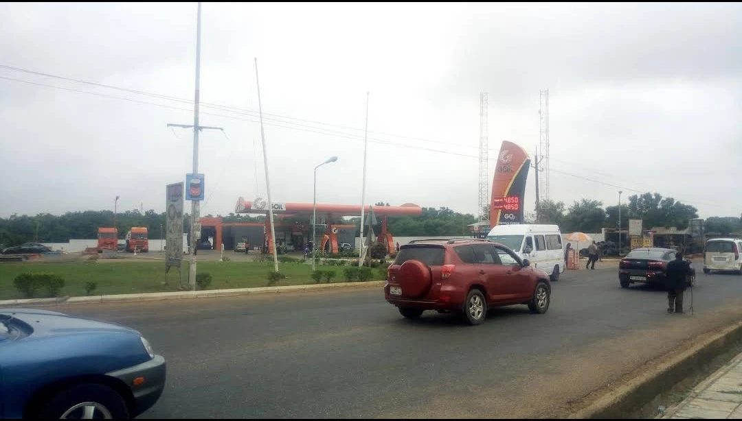
What it shows: Wide junction context showing GOIL station, traffic, road edge, and the transition into the approach corridor.
Implementation use: Use only to identify and orient the road starting point. Preserve actual junction centerlines and connectivity from project geography; do not copy image perspective as coordinates.
Source REF 20 | File: 01_goil_upsa_junction_context.jpg

REFERENCE - 01 Route origin
R02 | Junction approach - wide road context
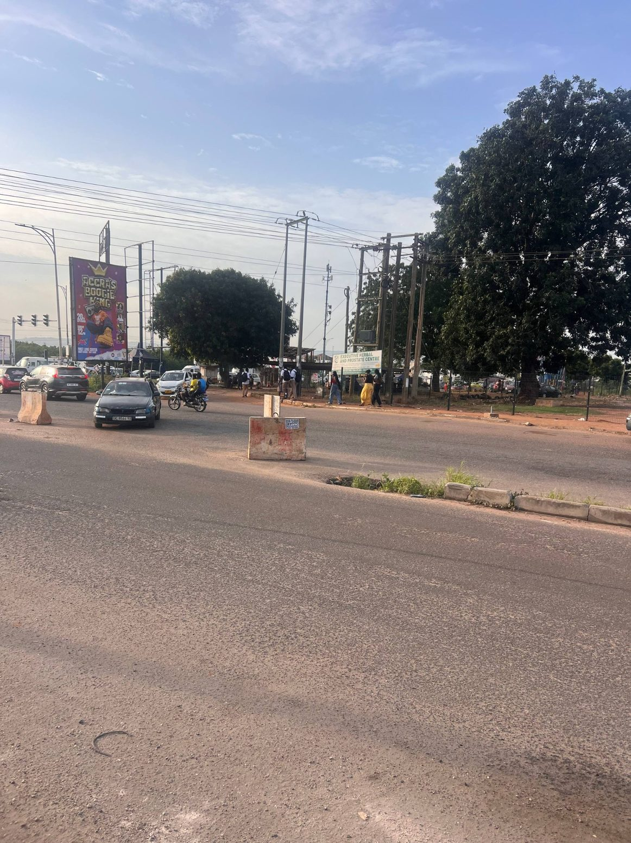
What it shows: User field photo of the major road near the GOIL/UPSA junction with traffic, utility elements, and roadside context.
Implementation use: Use for carriageway character, broad roadside density, and utility silhouette. The junction image does not prove exact lane widths.
Source REF 2 | File: 02_junction_field_view_01.jpg

REFERENCE - 01 Route origin
R03 | Junction edge and opposite frontage
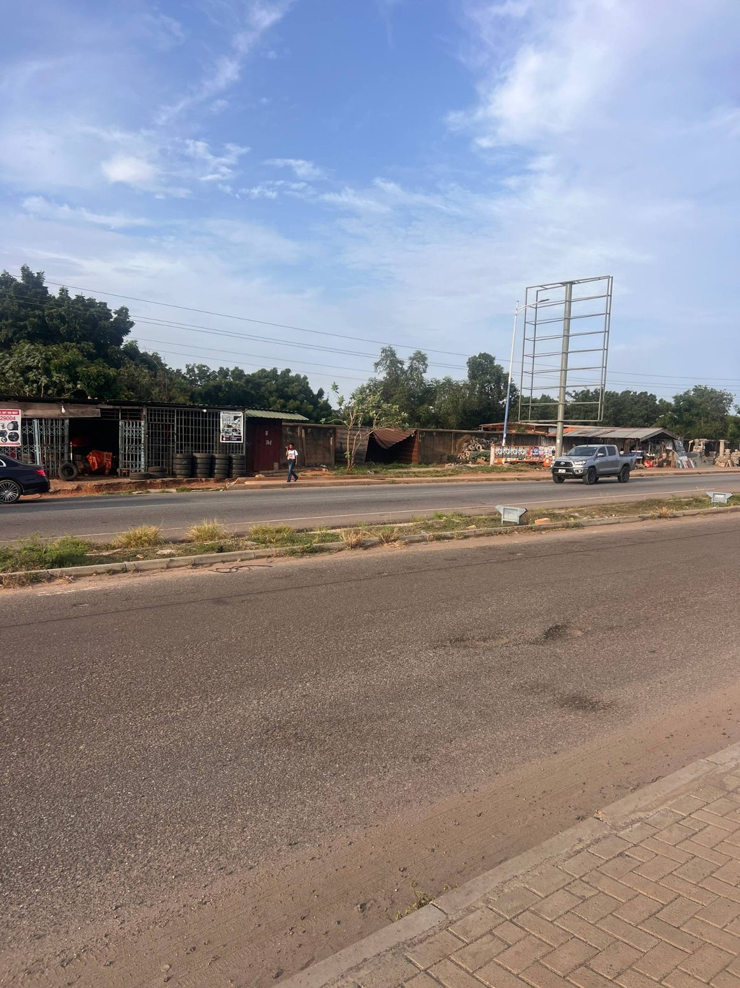
What it shows: User field photo of the junction area from another angle, showing asphalt, paved edge, road-side businesses/frontage, and roadside signs.
Implementation use: Use to compare the entry area and road-edge treatment. Do not place individual vehicles or temporary objects at the same fixed positions.
Source REF 3 | File: 03_junction_field_view_02.jpg

REFERENCE - 02 Carriageway and footpath
R04 | Paved verge near the junction
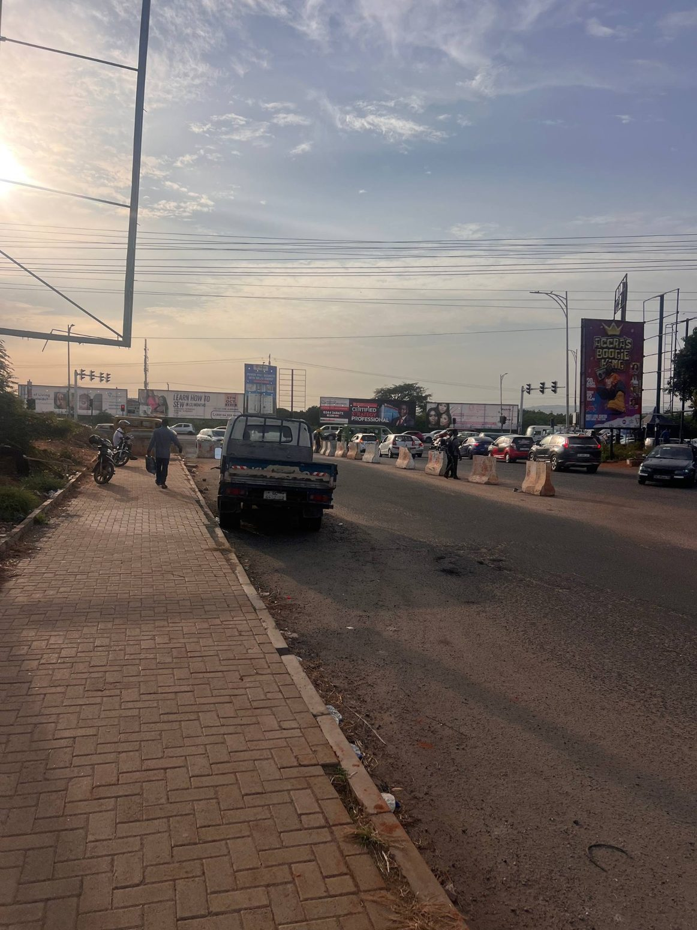
What it shows: User field photo looking along the road with a continuous block-paved pedestrian strip at the edge of the carriageway.
Implementation use: Use as a reference for paver rhythm, edge alignment, curb/road interface, and pedestrian-scale width; determine where this condition actually occurs from route geography.
Source REF 4 | File: 04_junction_field_view_03.jpg

REFERENCE PAIR - 02 Carriageway and footpath
R05 | Wall, sidewalk, vegetation and roadside edge  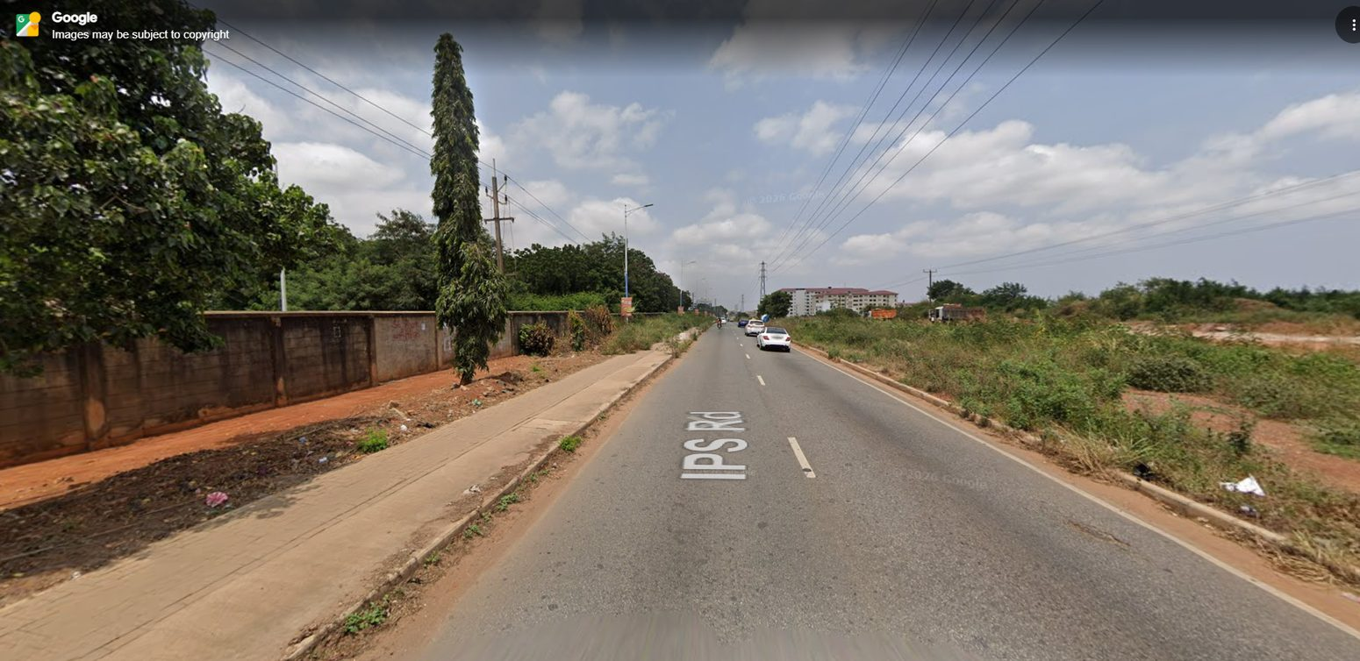  What it shows: Street View corridor perspective showing asphalt, concrete footpath, boundary wall, vegetation, overhead lines, and depth along IPS Road.  Implementation use: Primary reference for the continuous road corridor. Ignore Street View labels, watermarks, vehicle snapshot, and screen chrome.  Source REF 23 | File: 05_streetview_wall_sidewalk_corridor.jpg | R06 | Straight corridor with curb and overhead lines  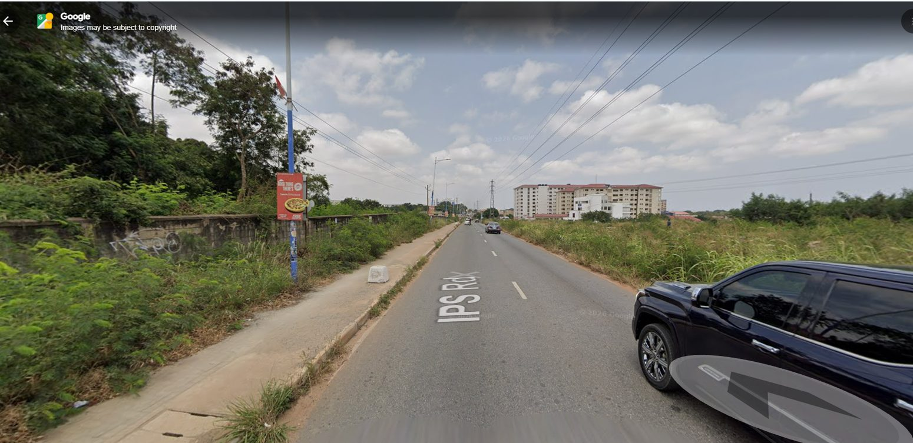  What it shows: Street View view along IPS Road with asphalt, a paved sidewalk, wall, trees, utility poles/cables, and long sightline.  Implementation use: Use for the repeated cross-section and road perspective. Do not infer exact road width or object coordinates from camera perspective.  Source REF 24 | File: 06_streetview_black_car_corridor.jpg

REFERENCE PAIR - 03 Frontage sequence
R07 | Open stretch and distant residential mass  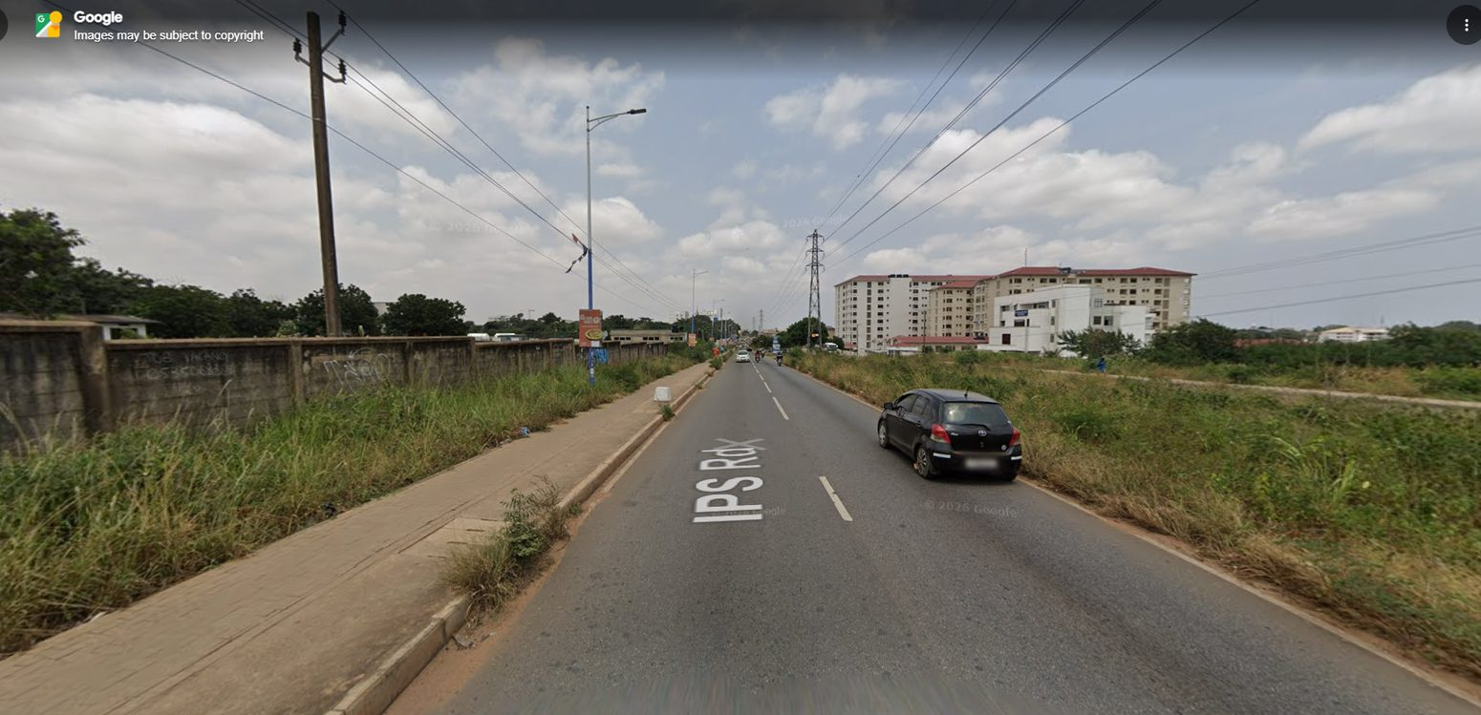  What it shows: Long view of the road with pedestrian edge, roadside setback, and distant multi-storey buildings.  Implementation use: Use for depth, background skyline, and the transition between developed frontage and open roadside land. The distant building is a locator, not a target for detailed redesign.  Source REF 25 | File: 07_open_road_distant_building.jpg | R08 | Institutional frontage and driveway opening  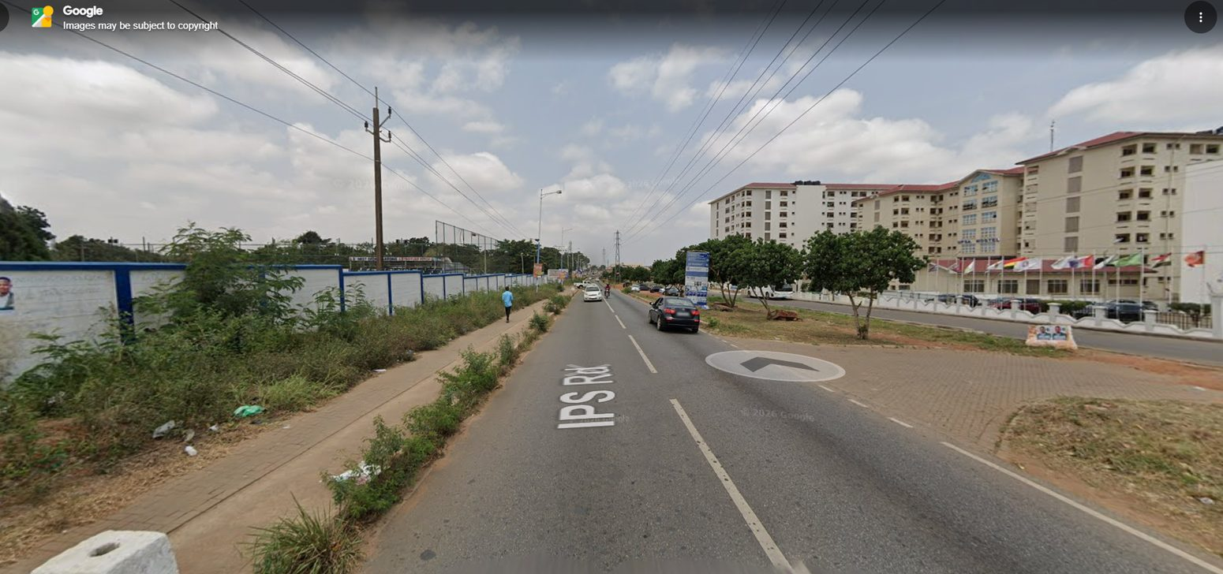  What it shows: Street View image of road, footpath, access opening, nearby institutional compound and opposite frontage.  Implementation use: Use to keep driveway curb cuts open and align paving/drain transitions with real access. Do not run a continuous curb through an actual driveway.  Source REF 26 | File: 08_driveway_institutional_frontage.jpg

REFERENCE PAIR - 03 Frontage sequence
R09 | Fence, sidewalk and changing setbacks  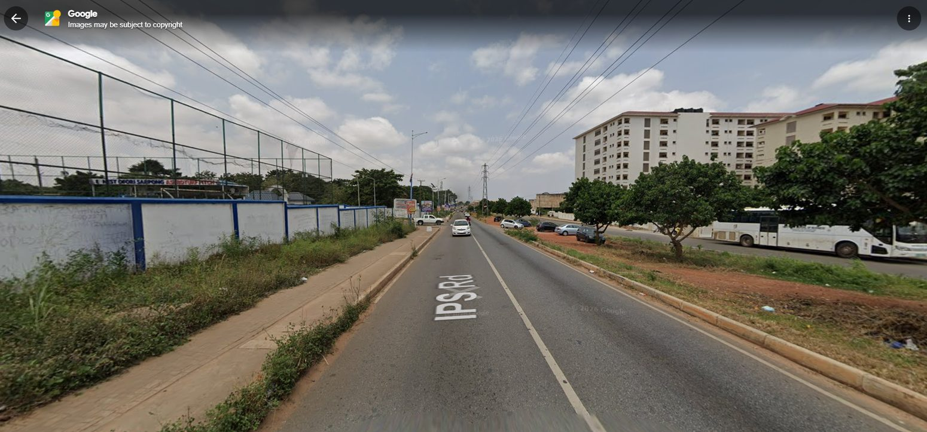  What it shows: Street View corridor with boundary wall/fence, sidewalk, vegetation/open land, utility infrastructure and roadway.  Implementation use: Use to model frontage changing along the route rather than a repeated, uniform wall or continuous planted strip.  Source REF 27 | File: 09_fence_sidewalk_open_land.jpg | R10 | Institutional frontage and roadside activity  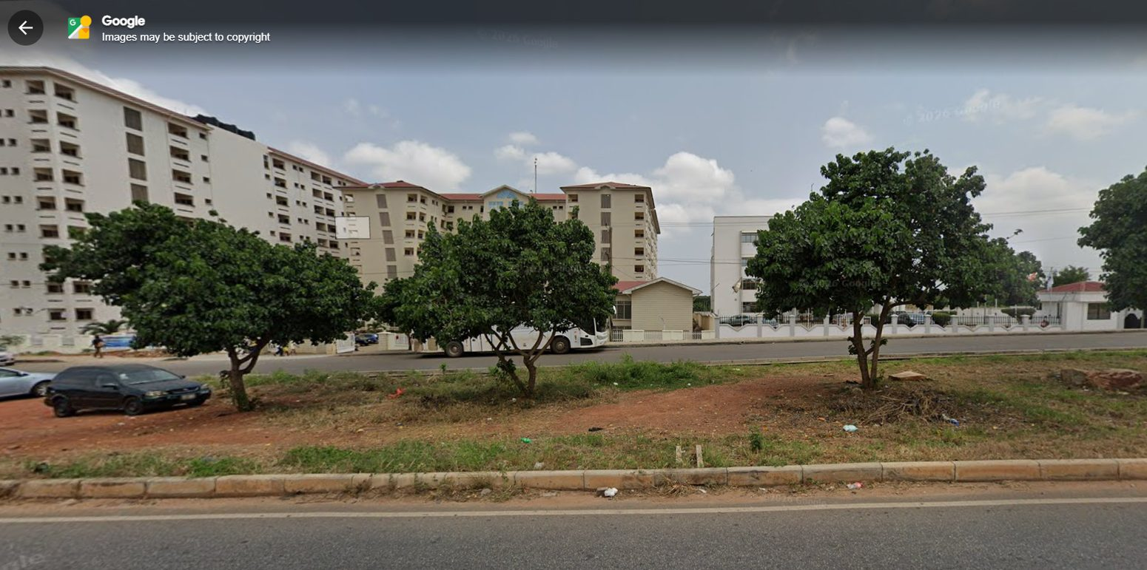  What it shows: Wide roadside view with institutional frontage, trees, parked/road vehicles, and the public road in foreground.  Implementation use: Use the fixed architecture and roadside planting only. Traffic and parked vehicles are transient composition cues, not required fixed placements.  Source REF 28 | File: 10_institutional_frontage_road_activity.jpg

REFERENCE PAIR - 03 Frontage sequence
R11 | Wider frontage with tree spacing  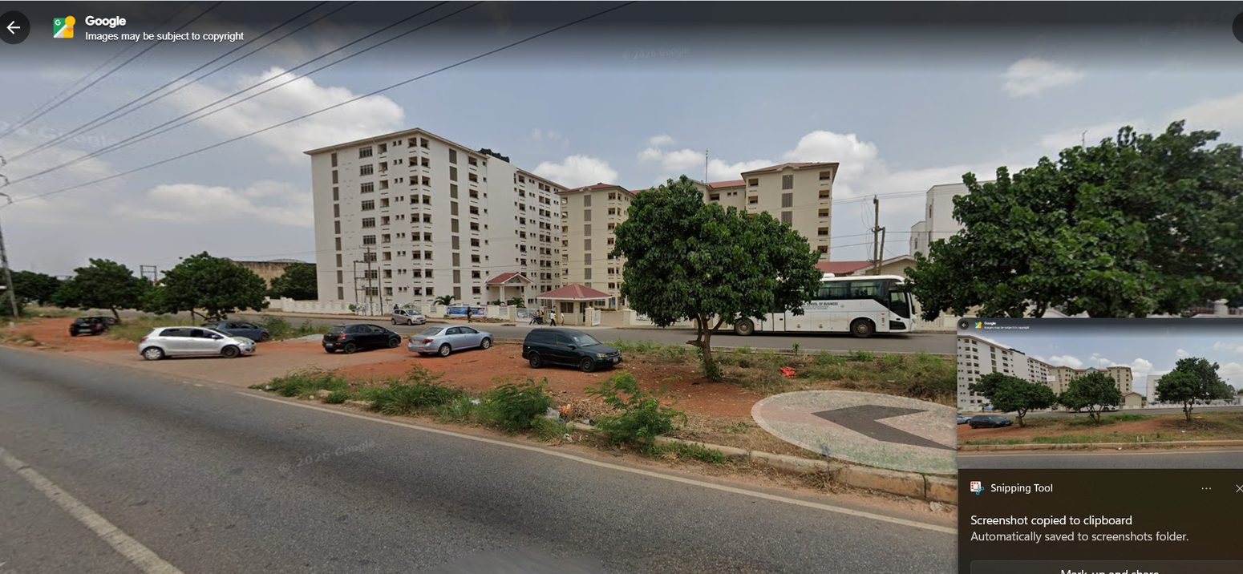  What it shows: Street View image showing roadside trees, open/setback area, building frontage, curb and road alignment.  Implementation use: Use to calibrate the relationship between road, verge, trees, parking and facade setback while preserving mapped building footprints.  Source REF 29 | File: 11_wider_frontage_and_trees.jpg | R12 | Approach toward the UPSA Hostel area  What it shows: Long perspective along IPS Road toward a built-up frontage, with utility poles/cables, sidewalk and the road edge visible.  Implementation use: Use as approach-direction evidence and to establish a continuous corridor through to the hostel area. Match order against the map, not solely this view.  Source REF 30 | File: 12_upsa_road_approach.jpg

REFERENCE - 02 Carriageway and footpath
R13 | Long block-paved pedestrian verge
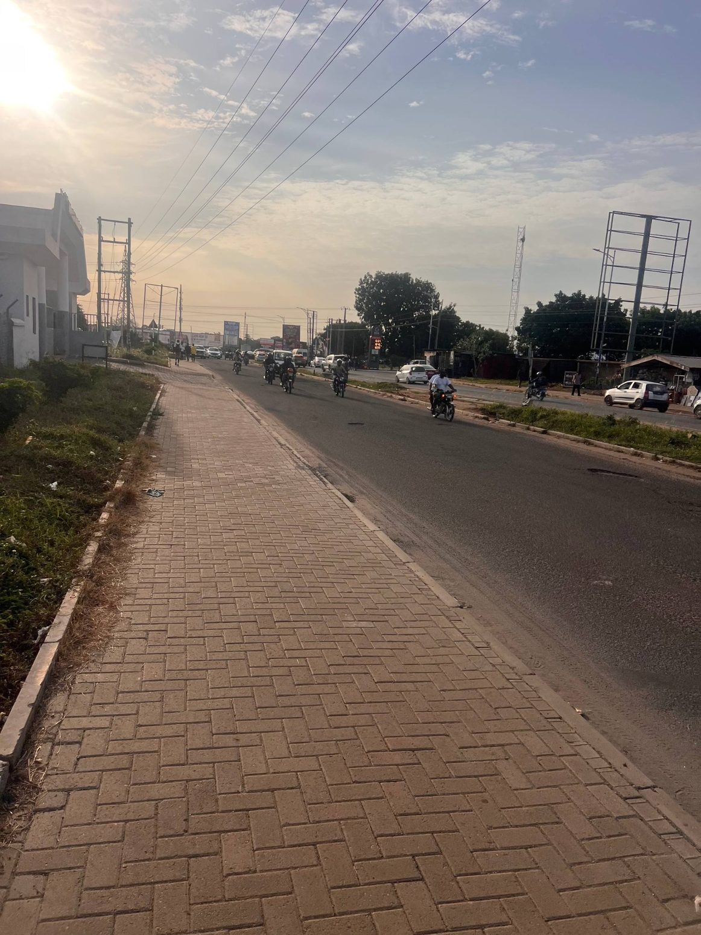
What it shows: User field photo of a long paved footpath alongside the asphalt carriageway; the paver surface has a repeated rectangular pattern.
Implementation use: Reproduce the paving pattern at an appropriate scale and keep its edge level with the curb/road transition. Avoid gaps or repeated texture stretching.
Source REF 13 | File: 13_field_photo_12_long_pavers.jpg

REFERENCE - 02 Carriageway and footpath
R14 | Pavers, kerb edge and asphalt
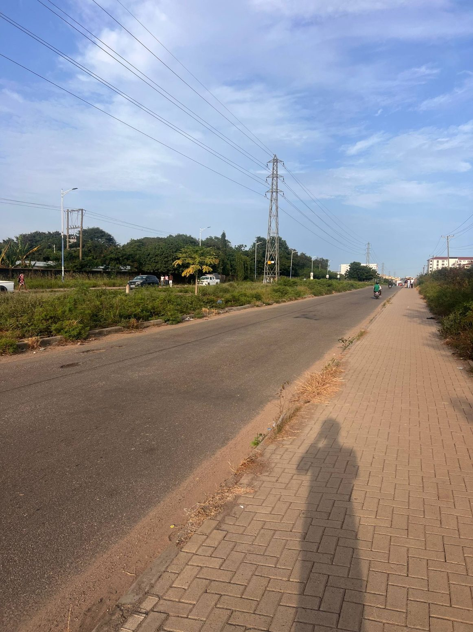
What it shows: User field photo showing the sidewalk paving continuing in the foreground alongside the road with an imperfect earth edge in places.
Implementation use: Use as direct material/edge evidence. Paver-to-earth transitions should follow what the road-side reference shows, not be forced into symmetry.
Source REF 14 | File: 14_field_photo_13_pavers_and_road.jpg

REFERENCE - 02 Carriageway and footpath
R15 | Continuous sidewalk and corridor distance
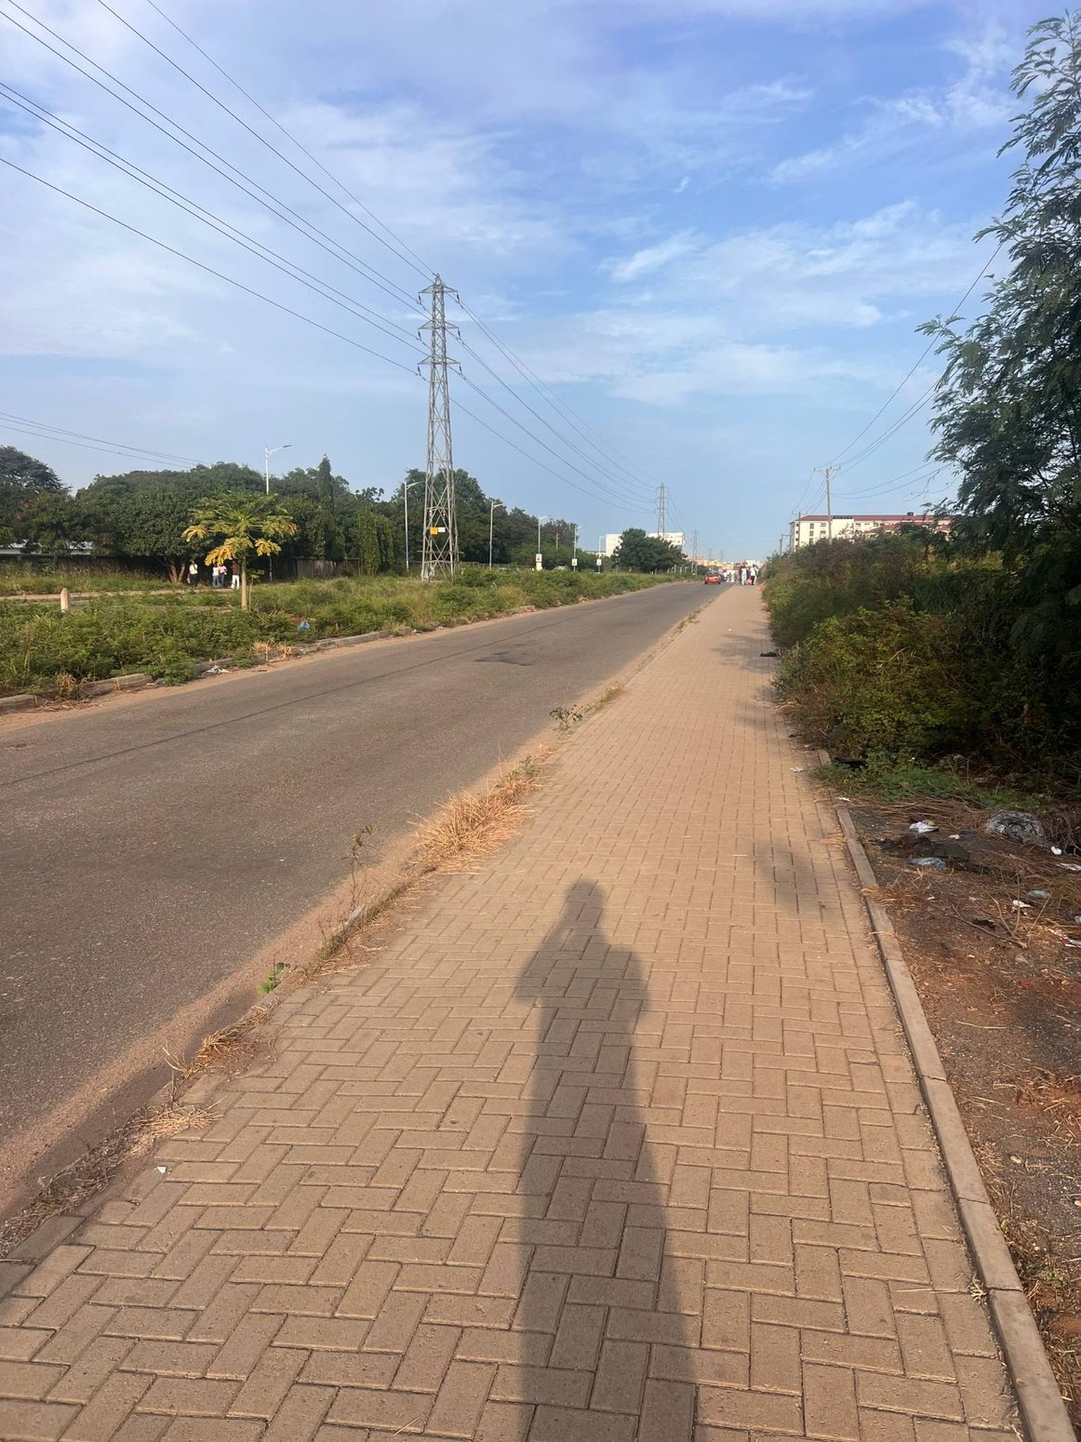
What it shows: User field photo down a long run of block paving, asphalt and a transmission tower in the distance.
Implementation use: Use for lengthwise continuity, paving orientation, and infrastructure scale. The photographer position is not a world-coordinate anchor.
Source REF 15 | File: 15_field_photo_14_continuous_walkway.jpg

REFERENCE - 05 Utilities and streetscape
R16 | High-voltage tower and opposite road edge
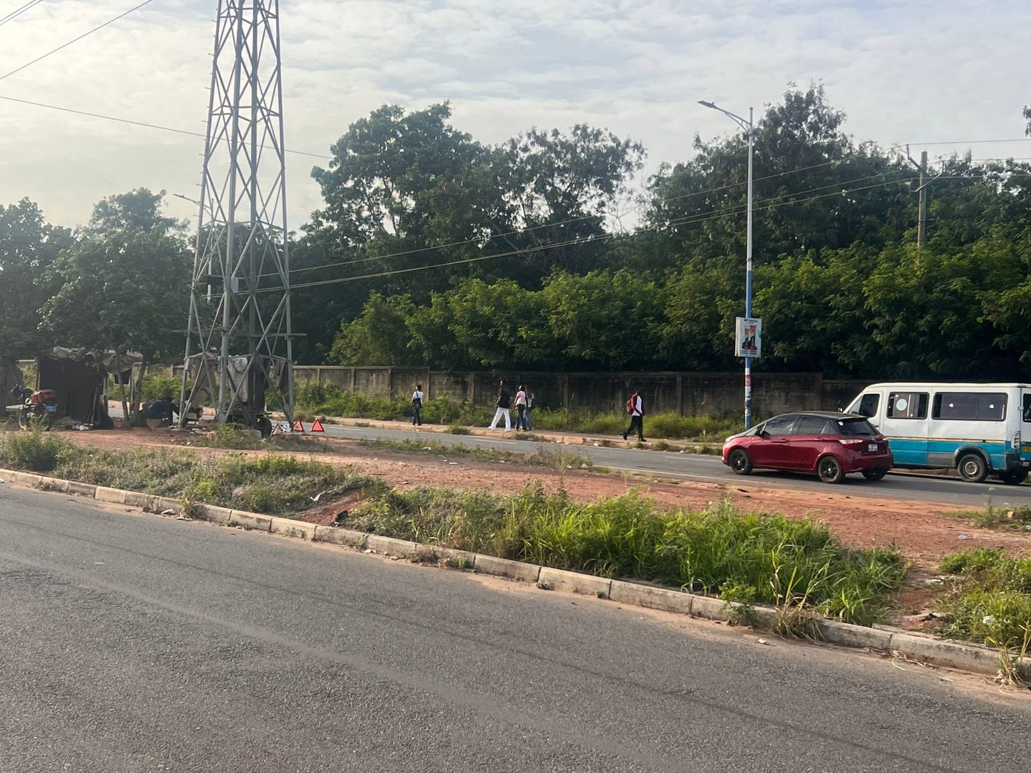
What it shows: User field photo of asphalt and a roadside verge with a lattice transmission tower, wall, trees and traffic on the farther side.
Implementation use: Include tower/cable silhouettes only at locations supported by existing project geography and these corridor views. Prevent cables from cluttering the riding camera.
Source REF 16 | File: 16_field_photo_15_transmission_tower.jpg

REFERENCE - 02 Carriageway and footpath
R17 | Sidewalk modules and road-edge wear
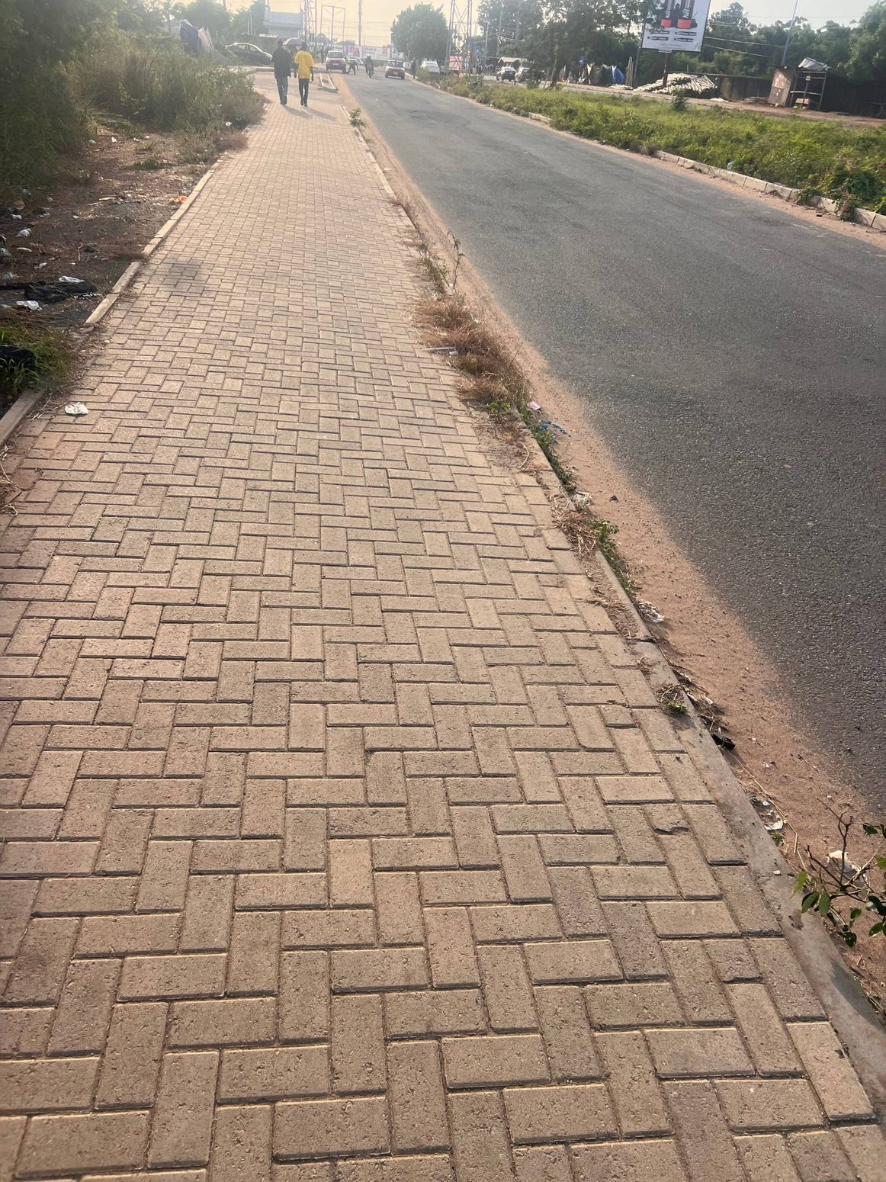
What it shows: User field photo looking across a paved pedestrian edge beside asphalt, emphasizing the modular block pattern and contact line.
Implementation use: Use for material roughness, small joints, alignment and road/sidewalk seam. Do not introduce raised strips or floating curb segments.
Source REF 17 | File: 17_field_photo_16_paved_edge.jpg

REFERENCE - 03 Frontage sequence
R18 | Road width, pedestrian activity and tree line
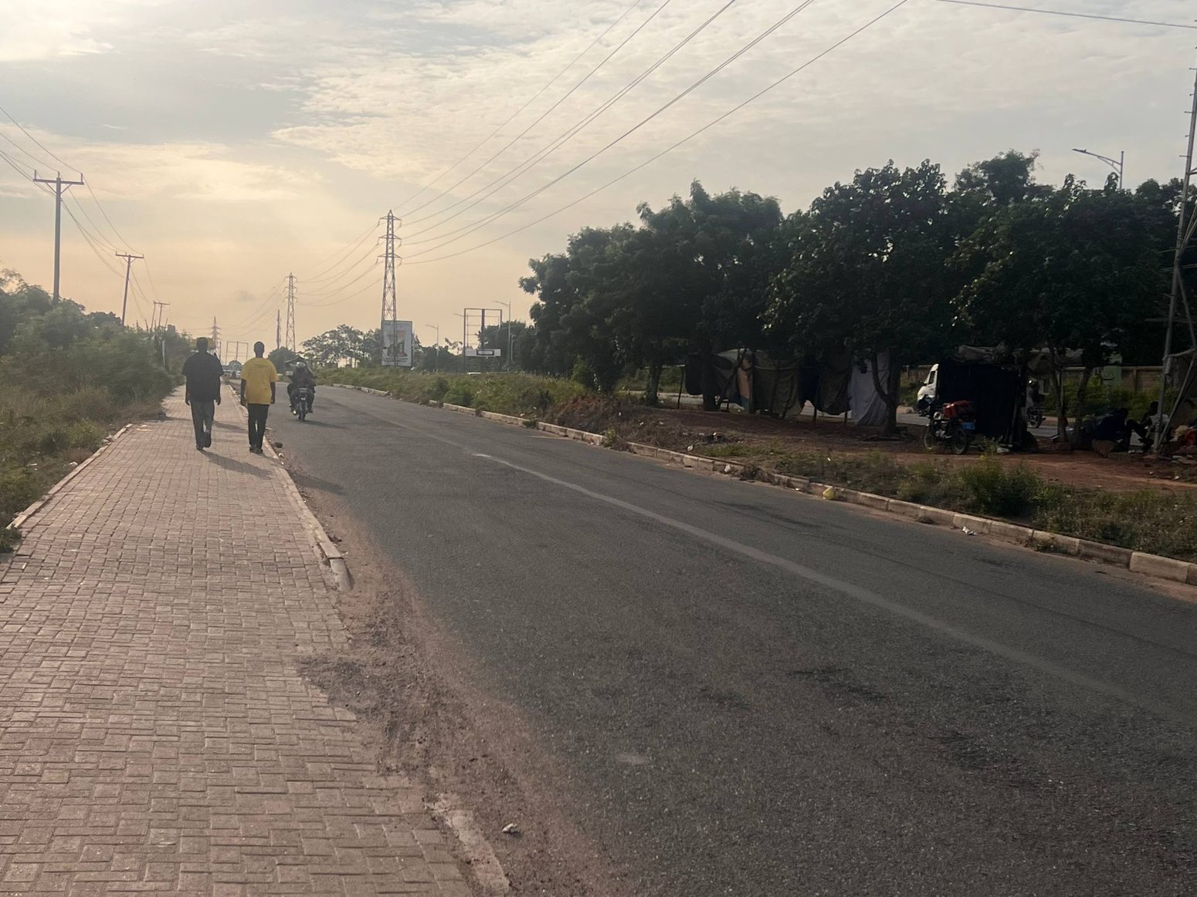
What it shows: User field photo of a broad roadway and paved pedestrian zone with trees and pedestrians visible in the distance.
Implementation use: Use for corridor scale and plausible pedestrian-side context. Do not add pedestrians as collision clutter in the riding line.
Source REF 18 | File: 18_field_photo_17_wide_carriageway.jpg

REFERENCE - 04 Hostel approach
R19 | Long approach sidewalk perspective
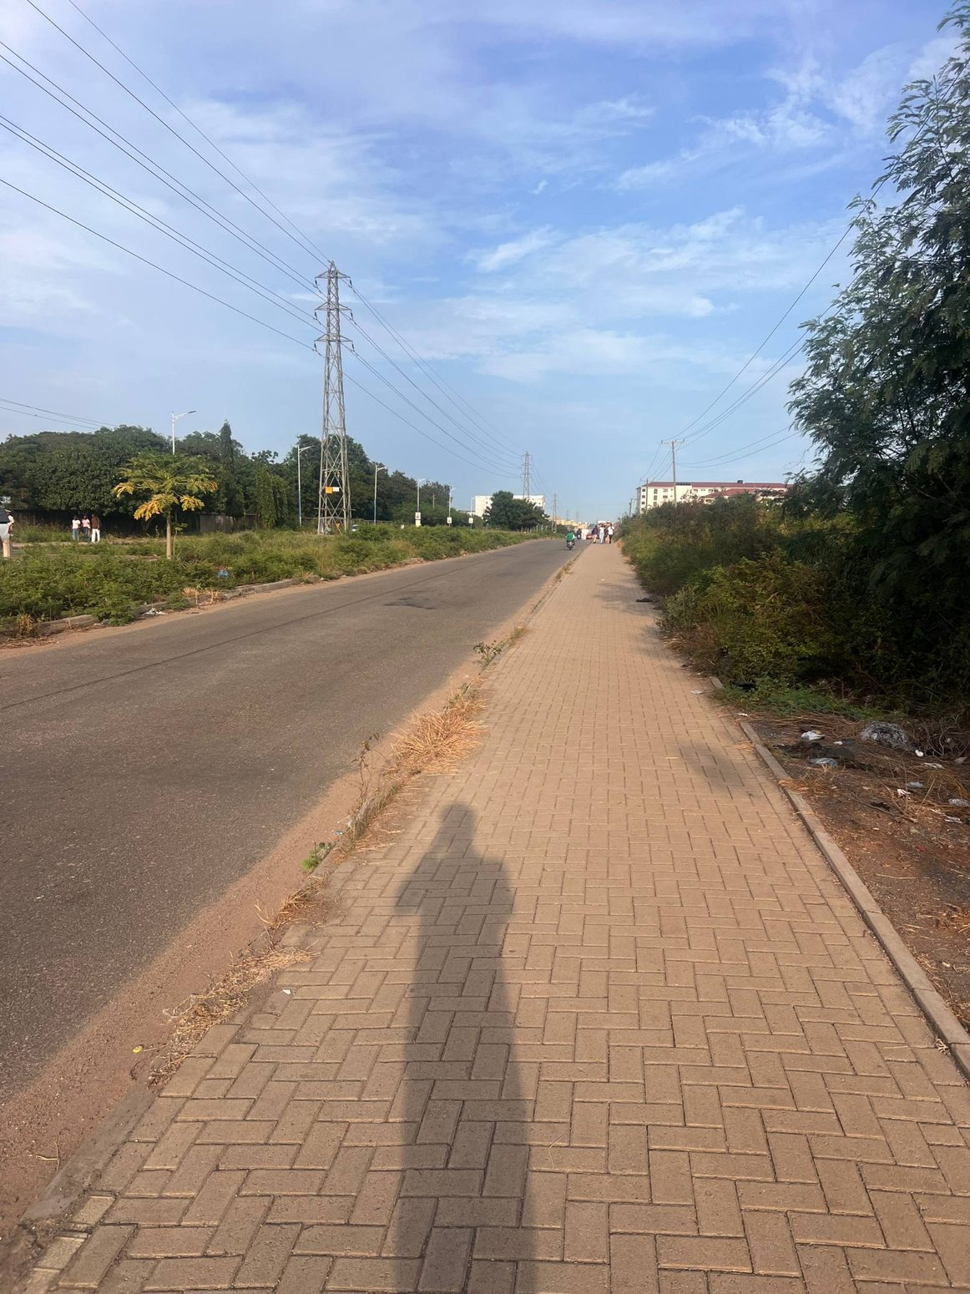
What it shows: User field photo looking down the paved footpath with road alongside and roadside vegetation/utility context.
Implementation use: Use to verify the pedestrian edge stays continuous along the applicable stretches and tapers only where the real access geometry changes.
Source REF 19 | File: 19_field_photo_18_long_sidewalk.jpg

REFERENCE - 02 Carriageway and footpath
R20 | IPS Road - wall, sidewalk and overhead services
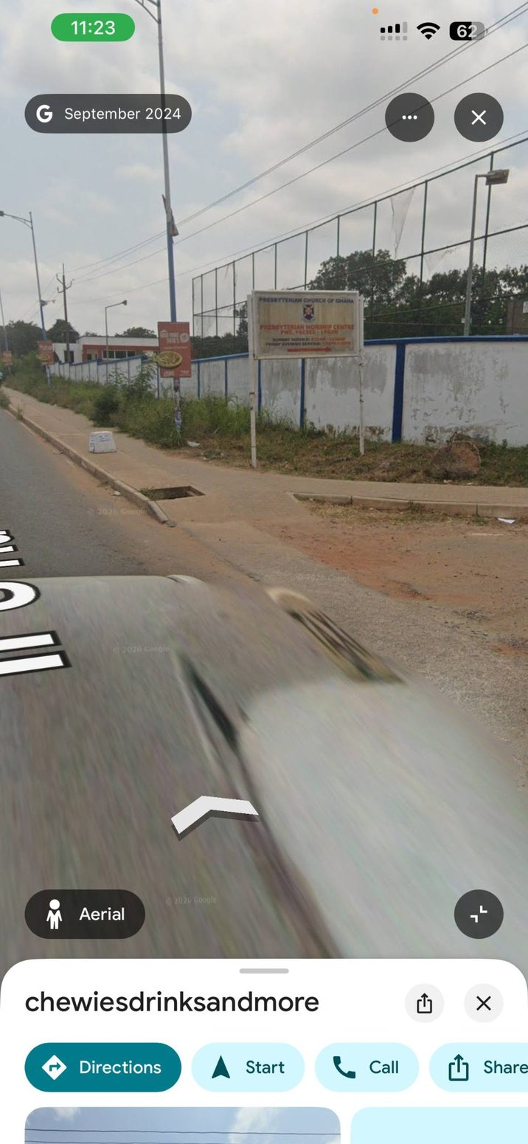
What it shows: User-supplied road-corridor image showing asphalt approach, block-paved pedestrian edge, boundary wall/green verge and overhead wires.
Implementation use: Use for the target corridor cross-section and roadside relationship. Keep poles/cables out of the driveable and pedestrian clear zones; use map data for placement.
Source image IMG-01 | File: 20_ips_road_wall_sidewalk_overhead.jpg

REFERENCE - 06 Roadside detail
R21 | Presbyterian frontage - arched gate and open drain
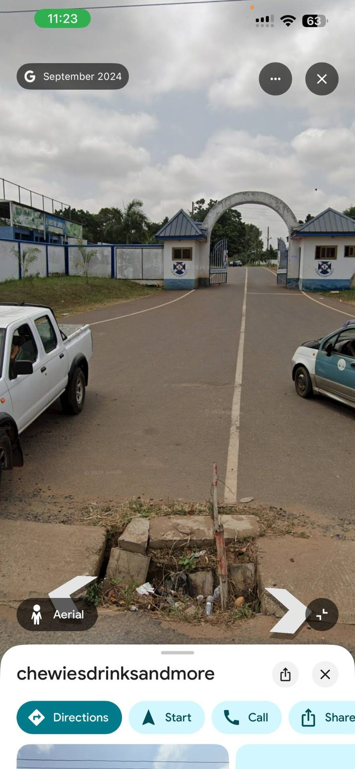
What it shows: User-supplied view of the Presbyterian compound entrance, gate structures, surrounding wall/fence and an open drainage crossing near the road.
Implementation use: Use as a road-side landmark and an access/drainage reference. Preserve the gate opening and drain/culvert geometry; do not model Google controls or screen UI.
Source image IMG-02 | File: 21_presbyterian_gate_drainage.jpg

REFERENCE PAIR - 03 Frontage sequence
R22 | IPS Road - straight approach perspective  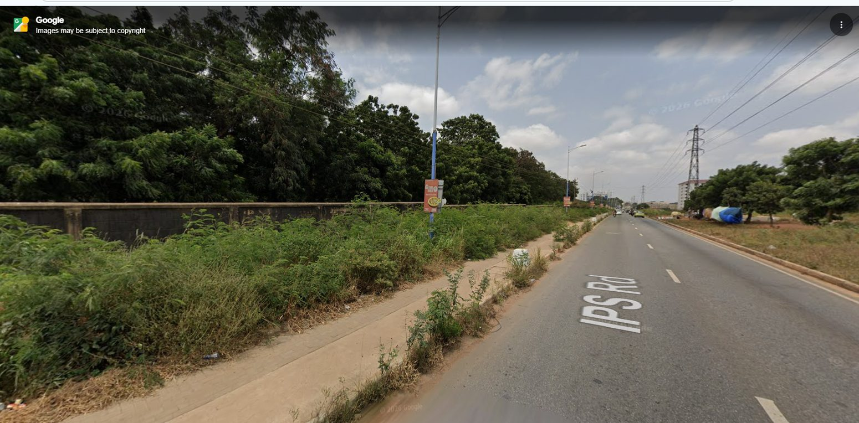  What it shows: Street View perspective down IPS Road with sidewalk, road marking, walls/trees and visible utility infrastructure.  Implementation use: Use to check visual continuity and the long approach. Confirm route order and side-of-road placement against the repository geography, not camera perspective.  Source image IMG-12 | File: 22_ips_road_straight_approach.jpg | R23 | IPS Road - pavers, kerb and utility poles  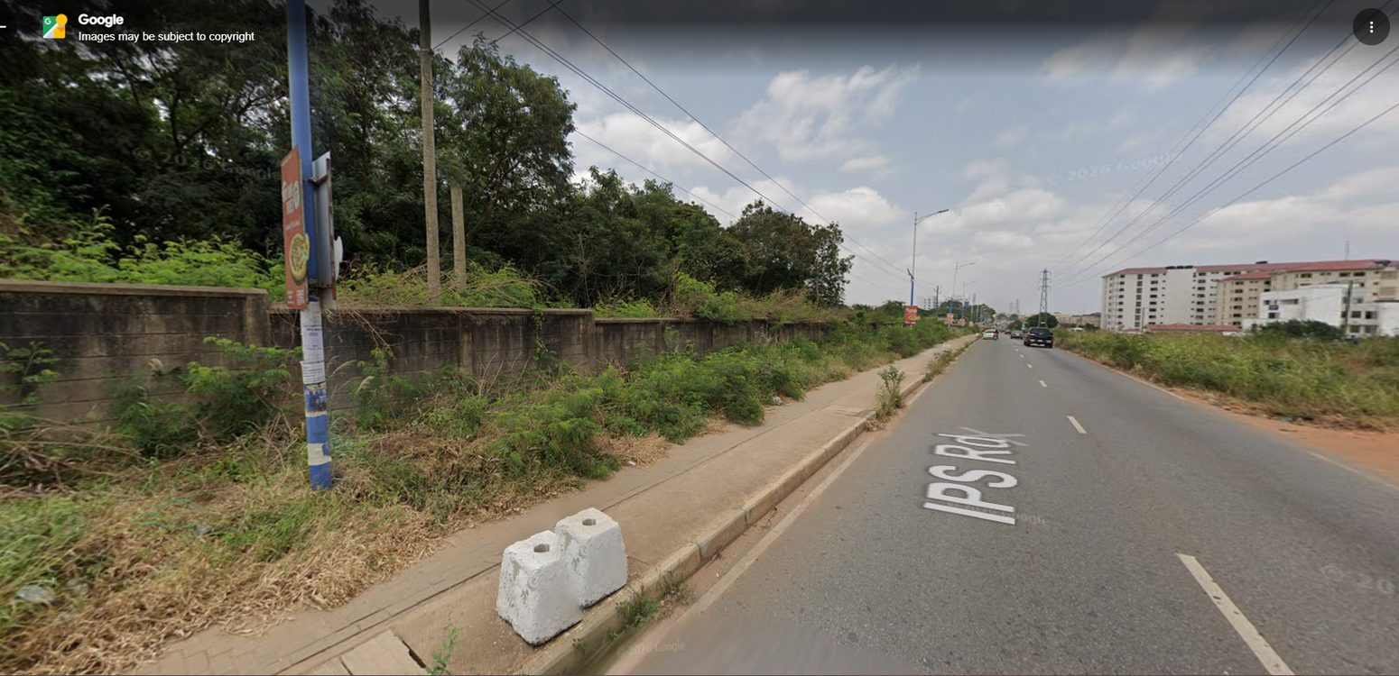  What it shows: Street View reference emphasizing the block-paved sidewalk, curb edge, utility poles and overhead cables alongside asphalt.  Implementation use: Use for the sidewalk/curb/utility relationship. Avoid sidewalk gaps, floating pavers, poles in the path and road-edge z-fighting.  Source image IMG-13 | File: 23_ips_road_pavers_kerb_utilities.jpg

REFERENCE PAIR - 04 Hostel approach
R24 | IPS Road - hostel and VC Complex frontage  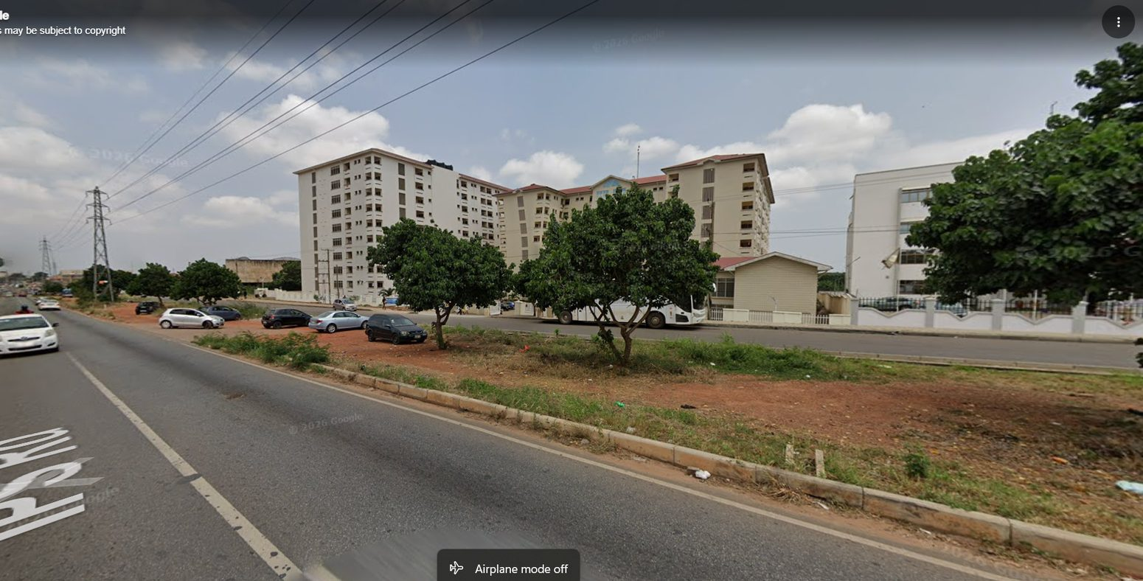  What it shows: Street View of the road opposite the UPSA Hostel and VC Complex frontage, with trees, red-earth shoulder, parked-area/setback and utility context.  Implementation use: Use as a frontage-sequence check only. Keep hostel and VC Complex distinct; do not rebuild their entire architecture in this road task.  Source image IMG-14 | File: 24_ips_road_hostel_vcg_frontage.jpg | R25 | IPS Road - institutional fence and wider corridor  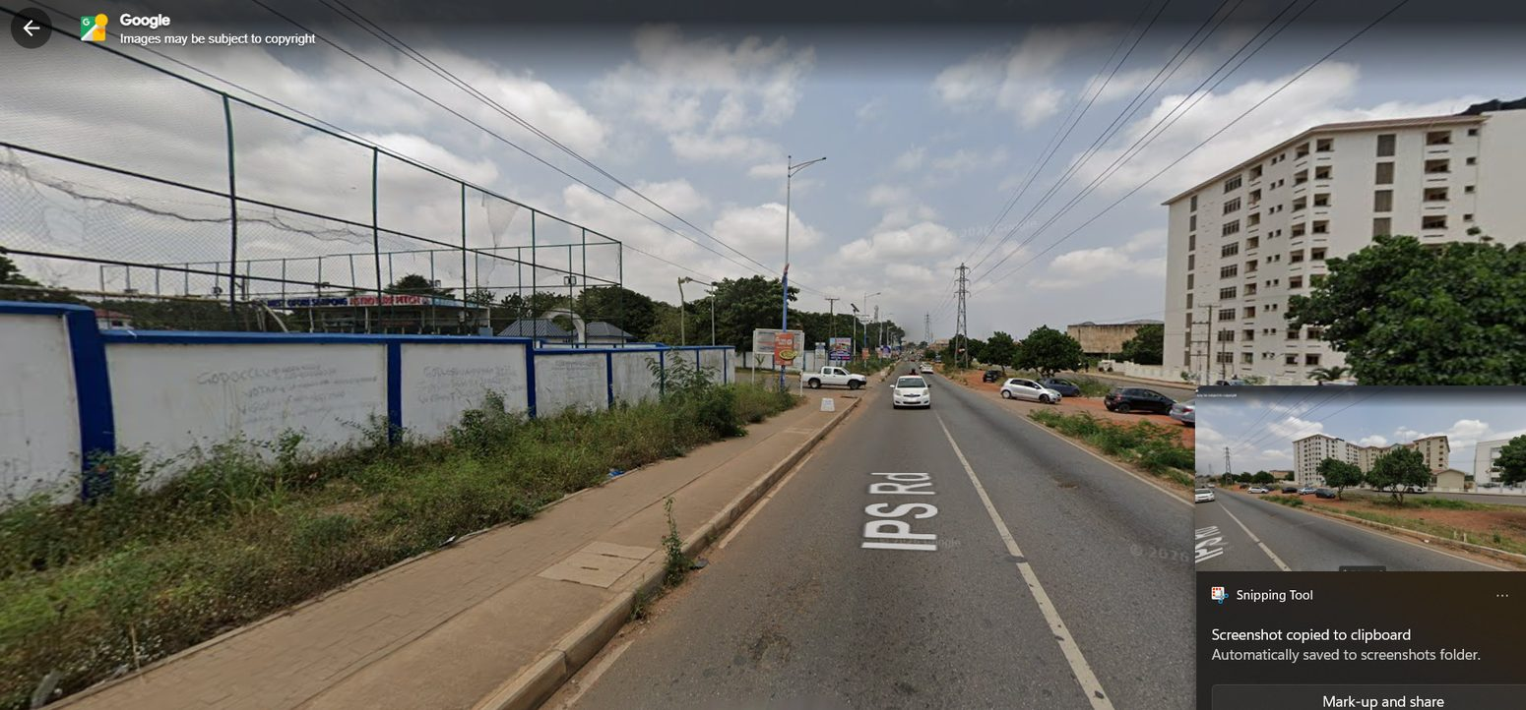  What it shows: Wide corridor view with a long institutional fence, sidewalk, road markings, roadside greenery, utility cables and a multi-storey building farther along.  Implementation use: Use to vary wall/fence and vegetation treatment across the route. Do not make every roadside section look identical.  Source image IMG-15 | File: 25_ips_road_institutional_fence_corridor.jpg

REFERENCE - 06 Roadside detail
R26 | Presbyterian approach - pavers, kerb returns and drainage
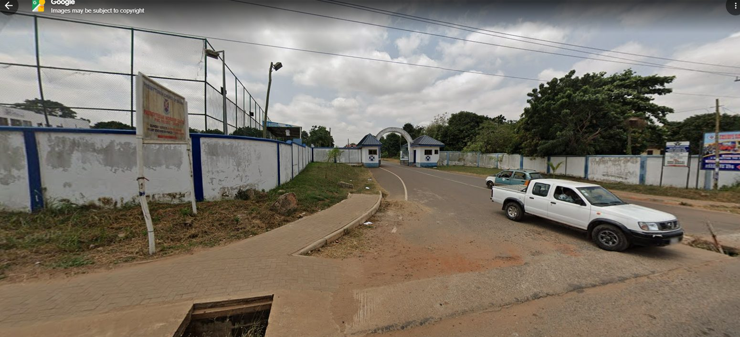
What it shows: User-supplied roadside approach showing the compound gate, paved footpath, rough road-edge ground and open drain/culvert transition.
Implementation use: Use to preserve real driveway/gate openings and visible drainage. Keep road mesh from covering the channel or creating a raised strip over it.
Source image IMG-16 | File: 26_presbyterian_approach_pavers_drain.jpg

REFERENCE - 07 Landmark context
R27 | VC Complex - frontage wall and road-side context
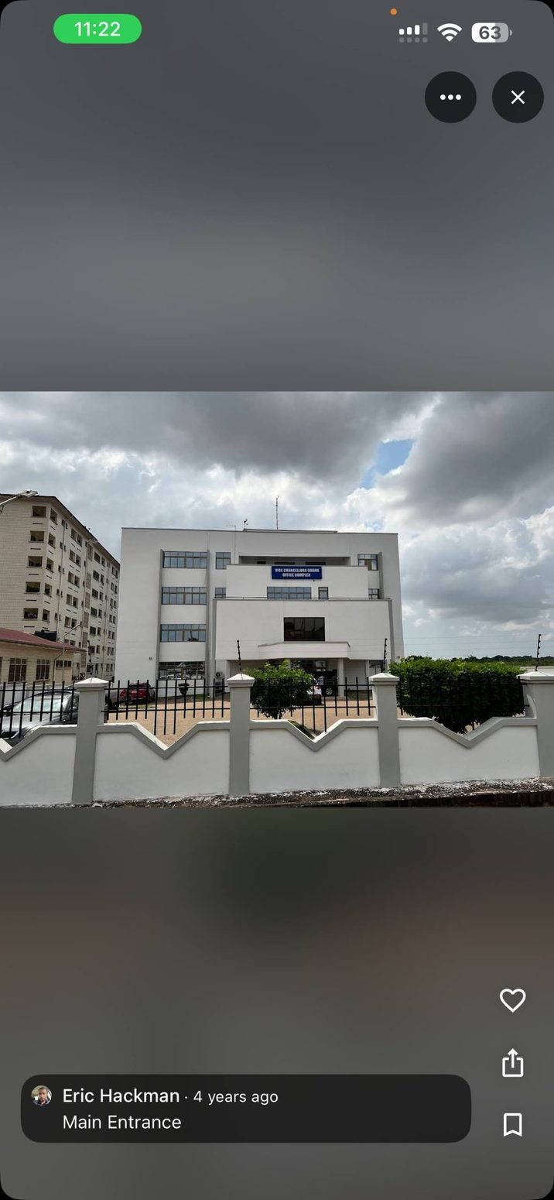
What it shows: User photograph of the VC Complex behind its white-and-grey perimeter wall and black metal fence, with the road-side edge in foreground.
Implementation use: Use only to identify the adjacent frontage and avoid clipping/overlap. Do not perform a full building or property redesign.
Source image IMG-05 | File: 27_vc_complex_frontage_wall_context.jpg

REFERENCE - 07 Landmark context
R28 | VC Complex - open gate and paved access
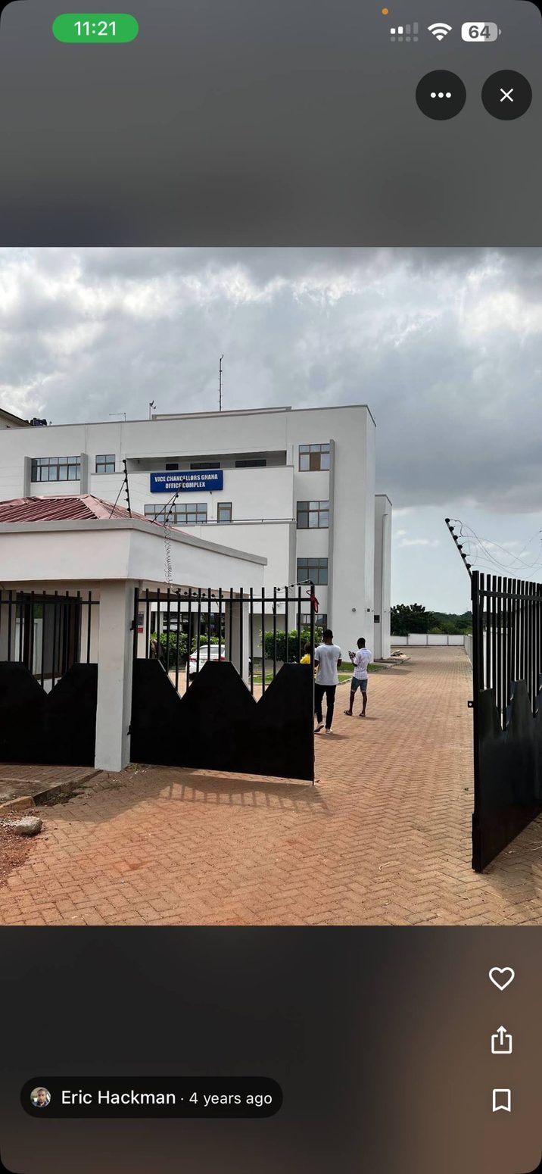
What it shows: User photograph showing the VC Complex gate/access and brick-paved approach/forecourt.
Implementation use: Use for the road-to-driveway interface and gate opening as frontage context. Keep the access aligned to existing geography and do not merge it with the UPSA Hostel gate.
Source image IMG-07 | File: 28_vc_complex_open_gate_paving_context.jpg

REFERENCE - 04 Hostel approach
R29 | UPSA Hostel - endpoint identity reference
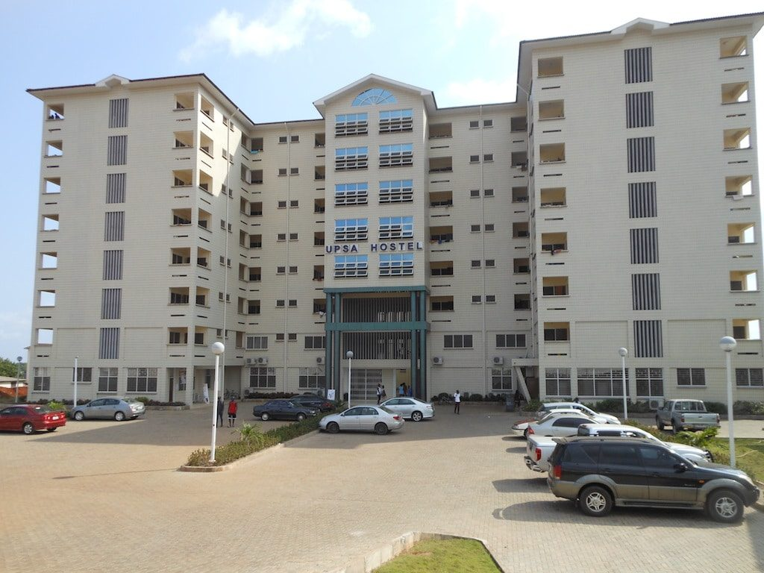
What it shows: Clean daytime photograph of the cream multi-storey UPSA Hostel, showing its central gable, repeated windows and entrance/forecourt.
Implementation use: Use to recognize the destination and set the final road approach against the correct building. Reconstruct only the road-facing edge and access required for the corridor task.
Source image HOSTEL_FRONT | File: 29_upsa_hostel_endpoint_front.jpg

REFERENCE - 04 Hostel approach
R30 | UPSA Hostel - frontage and forecourt in context
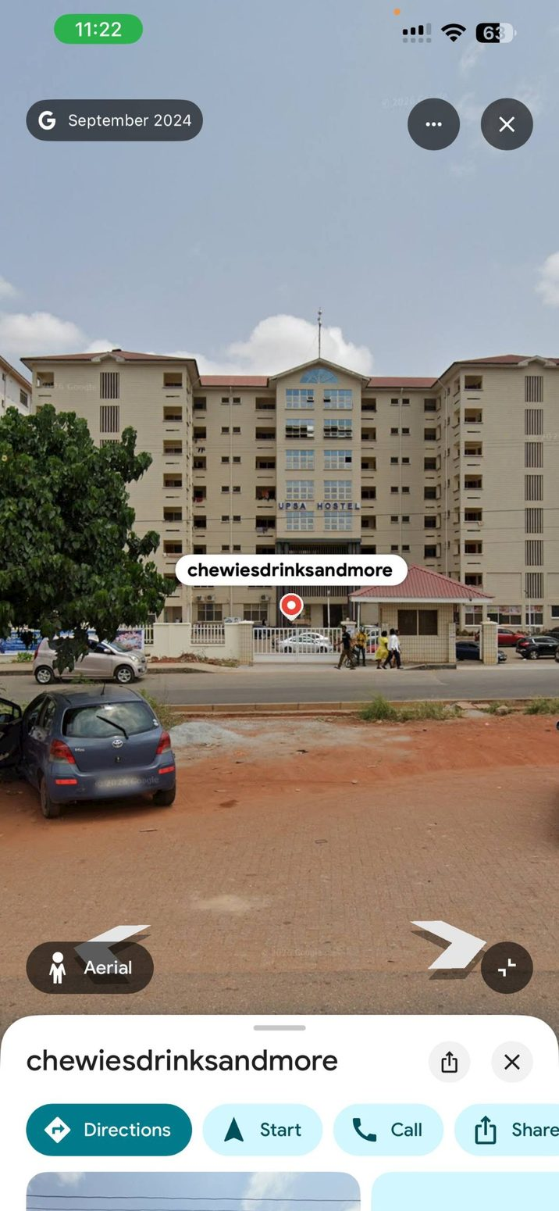
What it shows: User-supplied Street View image with the hostel frontage, repeated-storey facade, entrance zone and vehicles/roadside ground visible.
Implementation use: Use as a broad endpoint/frontage locator. Ignore screenshot UI/labels and transient vehicles; use the authoritative map for the actual gate and road connection.
Source image IMG-04 | File: 30_upsa_hostel_frontage_street_context.jpg

REFERENCE PAIR - 08 Existing game diagnostics
R31 | Current game - road edge diagnosis  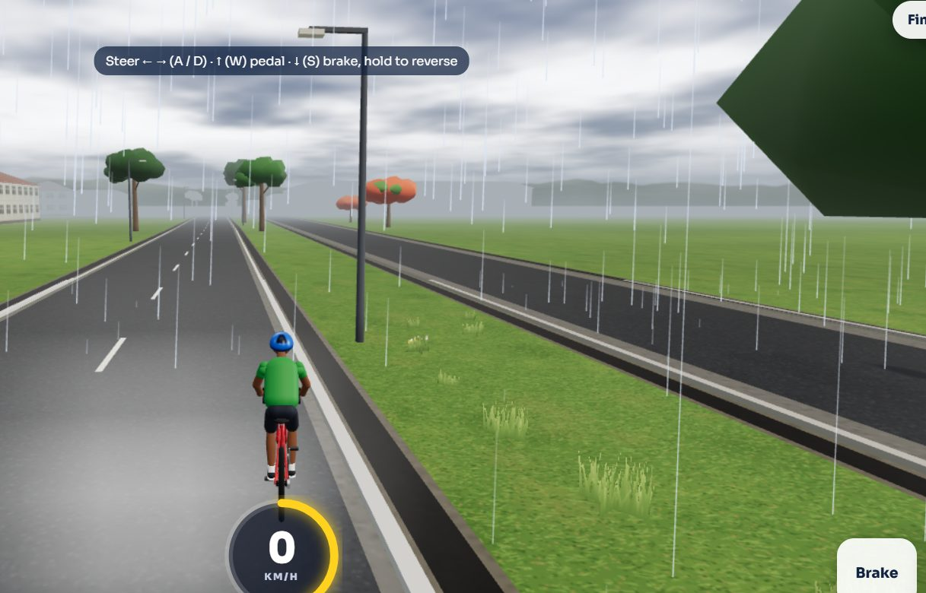  What it shows: Gameplay screenshot of the current road edge, curb/sidewalk alignment and adjacent terrain.  Implementation use: Diagnostic only. Compare against the real road references. Inspect edge height, overlapping surfaces, visual continuity and rider clearance before changing geometry.  Source REF 36 | File: 31_current_game_road_edge_diagnostic.jpg | R32 | Current game - roadside building comparison  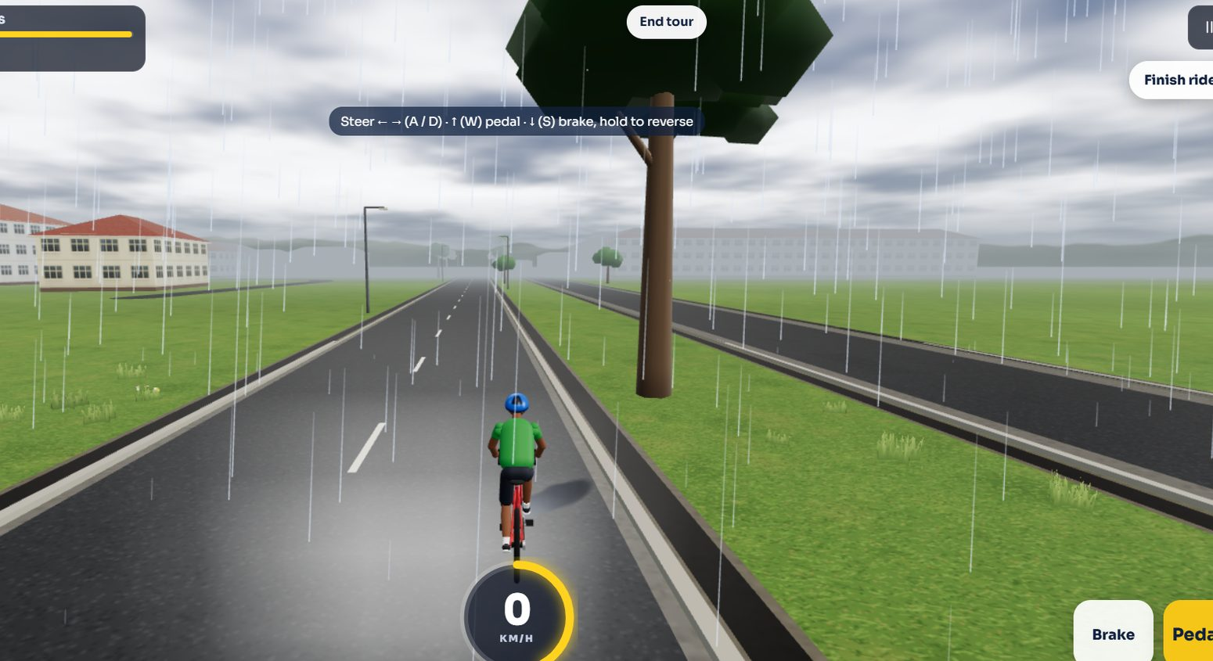  What it shows: Gameplay screenshot showing current road-side scenery and multi-storey building placement in a broad landscape.  Implementation use: Use to compare the simulated road-side context only. Do not assume the pictured campus blocks accurately represent the target frontage.  Source REF 37 | File: 32_current_game_roadside_building_diagnostic.jpg

REFERENCE PAIR - 08 Existing game diagnostics
R33 | Current game - wet road/material diagnostic  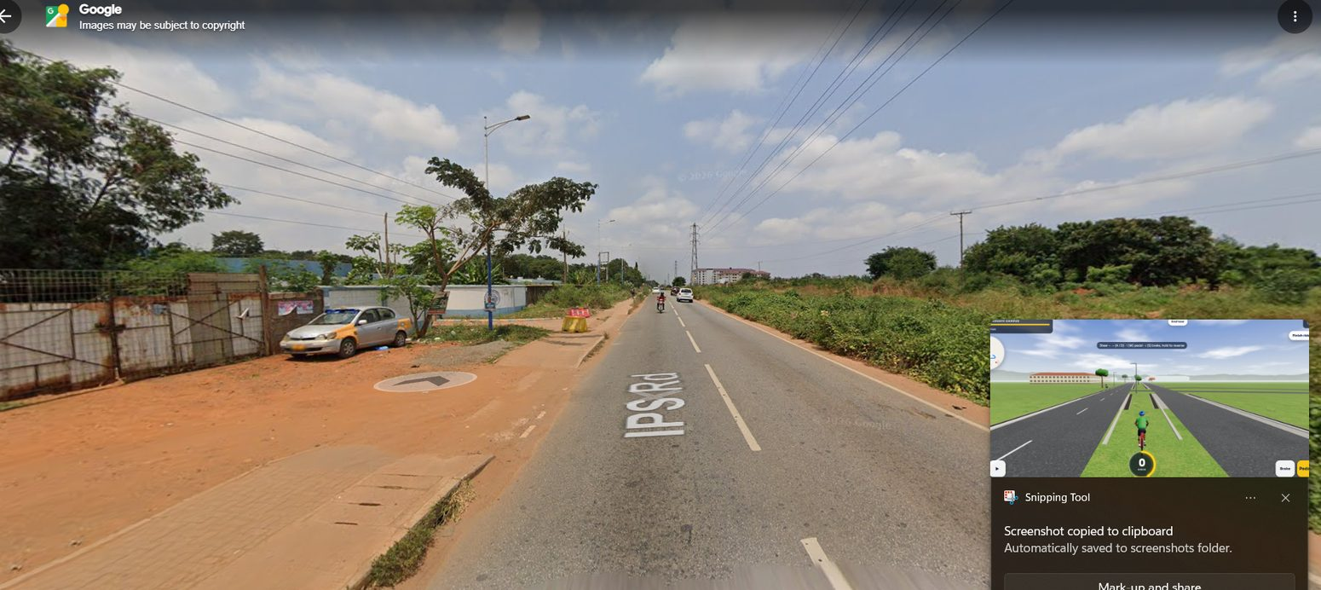  What it shows: Gameplay screenshot of the existing corridor in wet/rain presentation with reflective road materials.  Implementation use: Use to detect wet-weather material over-gloss, reflection artifacts and rendering bugs. Rain appearance does not define base road geometry.  Source REF 38 | File: 33_current_game_rain_material_diagnostic.jpg | R34 | Current game - road/terrain overlap diagnostic  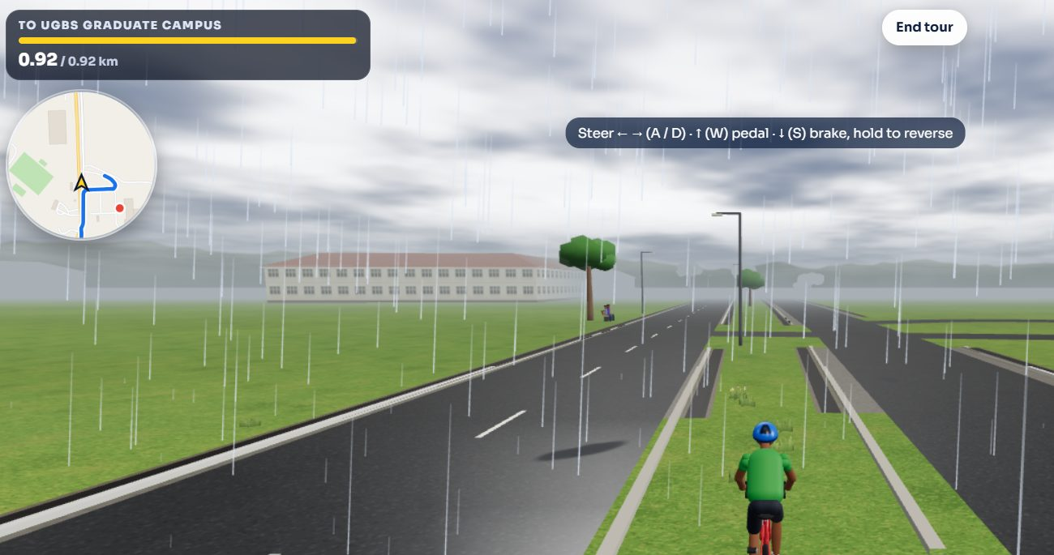  What it shows: Gameplay screenshot focused on the road surface and terrain intersection, useful for spotting flicker, raised bars and uneven edges.  Implementation use: Trace source meshes, elevation offsets, duplicate geometry and z-fighting. Fix the root cause rather than adding arbitrary offsets or overlapping cosmetic strips.  Source REF 39 | File: 34_current_game_road_terrain_diagnostic.jpg

