LEGONRUSH
UPSA LANDMARKS
UPDATED ENTRANCE, KOKA,
ADMINISTRATION, LIBRARY & TOWERS
Detailed 3D Reconstruction Brief for Claude Code
UPDATED ENTRANCE DESIGN • REAL-REFERENCE FIRST • GEOGRAPHY-PRESERVING
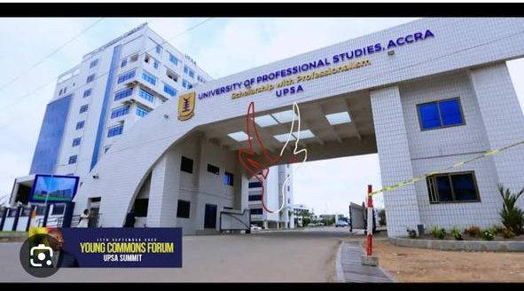 | 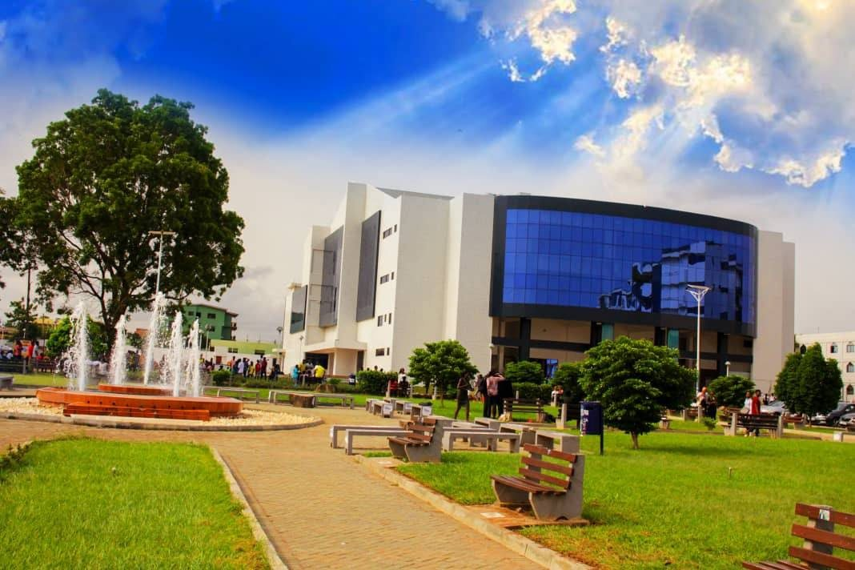
Scope: replace generic entrance/building placeholders only in the documented UPSA scene.
Prepared from 36 supplied image files, existing-game screenshots, aerial/map references, and linked official UPSA/Commons sources.

1. Executive direction
This phase corrects the updated UPSA Main Entrance and five named campus landmarks. The current entrance photos are the authority for the new gate design. In addition to Kofi Ohene-Konadu Auditorium (KOKA) and the adjacent Justice Aryeetey Building, the pack now documents the Opoku Ampomah Building / Central Administration Block, Joshua Alabi Library, and Abednego F. O. Amartey Twin Towers. Map geometry—not perspective photos—must determine exact placement and orientation.
CRITICAL DESIGN UPDATE — NEW GATE ONLY
Do not rebuild the older, simpler 2021 blue-and-white beam gate from Wikimedia images. Use the user-supplied newer cream/white square-tiled portal with the large sweeping curved/diagonal profile, deep covered passage and university fascia. Older web gate photos are historical context only.

Six distinct assets — not one blended campus model
- UPSA Main Entrance: the new tiled, curved portal, entry opening, fascia/signage, accessible pedestrian/ramp details, barriers/controls, and immediate ground transitions.
- Kofi Ohene-Konadu Auditorium (KOKA): broad curved blue-reflective glazed front, white tiled wings, recessed ground entrance and associated paved/fountain forecourt.
- Justice Aryeetey Building: separate white-and-blue multi-storey lecture block with repeated bands/windows, blue vertical façade strips, recessed corridors and a central arched/recessed bay.
- Opoku Ampomah Building / Central Administration Block: curved blue-glass upper facade, white/light lower wings and central administration sign band.
- Joshua Alabi Library: official name; separate multi-storey white/light library with blue window grid, symmetrical wings and a taller arched central entrance bay.
- Abednego F. O. Amartey Twin Towers: completed twin-tower multipurpose building with two linked/offset tall wings and blue-tinted windows.

Required outcome
Replace generic or mistaken assets rather than decorating them. The game should read correctly from an approach view, front/oblique gate views, auditorium forecourt, and the view with Justice Aryeetey to the right of the auditorium. Do not remodel unrelated UPSA blocks or the wider Legon world as part of this phase.

Evidence hierarchy
Priority | Evidence | How to use it
1 — Current gate | Newest user gate photos/video screenshots | Authoritative visual design for the updated portal.
2 — Current landmark photos | User-uploaded standalone KOKA/courtyard and adjacent-building photos | Primary geometry/material evidence for visible elevations and outdoor context.
3 — Official UPSA sources | Official article pages and photos | Confirm names: KOKA, Justice Aryeetey, Opoku Ampomah/Central Administration, Joshua Alabi Library and Abednego F. O. Amartey Twin Towers.
4 — Map/geography data | Existing repository map, footprints, route/access registry, OSM/site map | Authoritative source of positioning, orientation, access and topology.
5 — Older online gate images | 2021 Wikimedia Main Gate photos / older official social post | Historical only; do not override new gate design.
6 — Current game screens | Uploaded LEGONRUSH screenshots | Show defects/placeholders to replace, not real-world truth.

2. Confirmed facts, inference and open verification
UPSA sources establish that the 3,550-capacity auditorium was commissioned in May 2019 and named Kofi Ohene-Konadu Auditorium in 2021. An official UPSA feature says the Justice Aryeetey Building sits next to the auditorium and describes it as a six-storey lecture-block complex. The supplied photos visually match these identities. These facts support naming and separate asset identity; they do not give exact dimensions or geocoordinates.
Status | Finding | Implementation rule
CONFIRMED | Auditorium name: Kofi Ohene-Konadu Auditorium (KOKA); official source reports 3,550 capacity. | Use KOKA name; do not estimate its physical size from seating capacity.
CONFIRMED | Justice Aryeetey Building is described by UPSA as immediately next to the auditorium and a six-storey lecture block. | Treat as separate building. Verify which side corresponds to the user’s “right when facing auditorium” view against map/source imagery.
USER-REFERENCE AUTHORITY | Latest supplied gate views depict a different, newer design than the older 2021 gate photos. | Use the new tiled/curved gate, not the older blue-and-white lintel gate.
MAP-DEPENDENT | Exact building footprints, angle, setback, road edge, access path and gate lane geometry. | Resolve from current repo geography/building data, not perspective guesses.
INFERENCE | Unseen rear elevations, exact number of gate control units, small sign details obscured by capture overlays. | Use conservative matching geometry and document uncertainty.
NOT TO MODEL | Phone/browser chrome, Google image labels, TikTok buttons/comments, scribble arrows, browser overlay, screenshot watermarks. | These are capture UI, not physical world assets.

3. Site relationship and reconstruction sequence
Use the sequence below as a planning sequence, not as an asserted measured route. The map and repository geometry must establish the exact layout:
- Approach to the updated UPSA Main Entrance — use existing approach road centreline and portal/access anchor.
- Pass through the main entrance — keep the opening clear and connect ground, lane, ramps and pedestrian circulation cleanly.
- Campus-side arrival and circulation — align paths/roads to the actual existing map and avoid creating a fictitious connecting road.
- KOKA auditorium and forecourt — build curved façade, shaded entrance, paved gathering court, fountain/landscape and vehicular/pedestrian approach.
- Justice Aryeetey Building — separate adjacent block, correctly placed on the right in the user’s facing-auditorium view after geographic verification.

4. Current game vs real-world comparison
The comparisons below show the specific mismatch Claude must resolve. Screenshots are not camera-matched or surveyed; use them to identify missing/incorrect scene assets, then validate viewpoints in the live game. Additional reference pairs contrast each new real landmark with the current generic building cluster.

4.1 Updated entrance: new portal vs current game
REAL-WORLD REFERENCE | CURRENT LEGONRUSH
Gate reference screen with wide front / slightly oblique view | 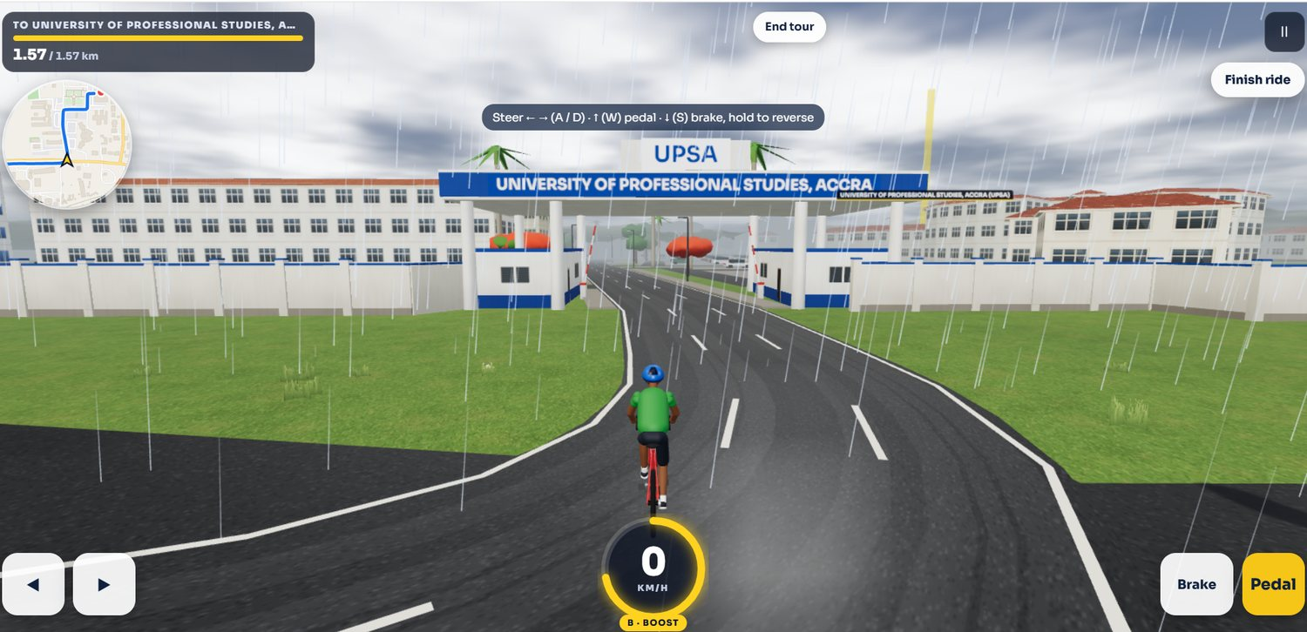  Current LEGONRUSH view approaching the oversized university sign/gate
Observed difference: The new real-world gate is a substantial tiled architectural portal with a sweeping curved/diagonal opening and a deep underside. The game currently appears to use an oversized sign/billboard spanning above the road and generic buildings behind it.
Implementation target: Replace the sign/placeholder gate with a correctly scaled portal mesh and signage fixed to the actual façade. Match curve, opening width/height, tiled grid, underside depth, supports, adjacent wall/building, and approach paving. Keep every physical object outside the rideable clearance envelope.

4.2 Gate oblique view: structure and side details
REAL-WORLD REFERENCE | CURRENT LEGONRUSH
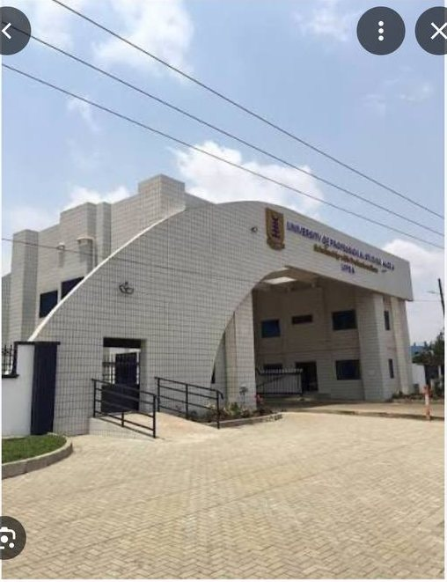  Gate reference screen showing the curved tiled portal and forecourt | 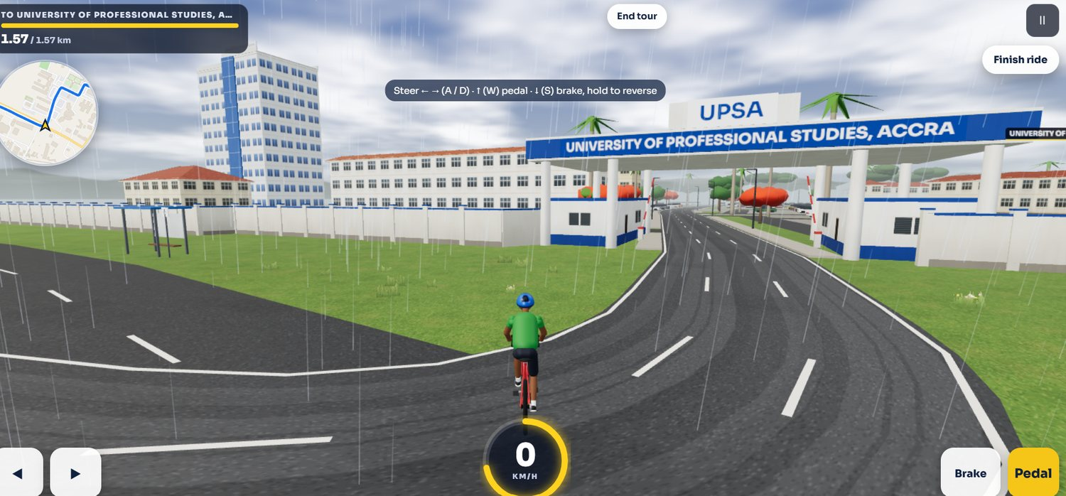  Current LEGONRUSH oblique view of the same generic entrance treatment
Observed difference: The oblique photo shows the tiled portal volume continuing into a large curved outer edge, plus access paving and a side pedestrian/ramp/rail treatment. The game view shows a banner and repeated blocks rather than this constructed portal.
Implementation target: Rebuild the side/oblique masses, parapet/edge profile, portal depth, tiled material and supported accessibility/rail details. Make the gate look correct from both approach directions; do not model it as a flat billboard or floating header.

4.3 KOKA auditorium frontage vs generic campus block
REAL-WORLD REFERENCE | CURRENT LEGONRUSH
Wide real-world KOKA facade, reflective blue glass, fountain court and landscape | 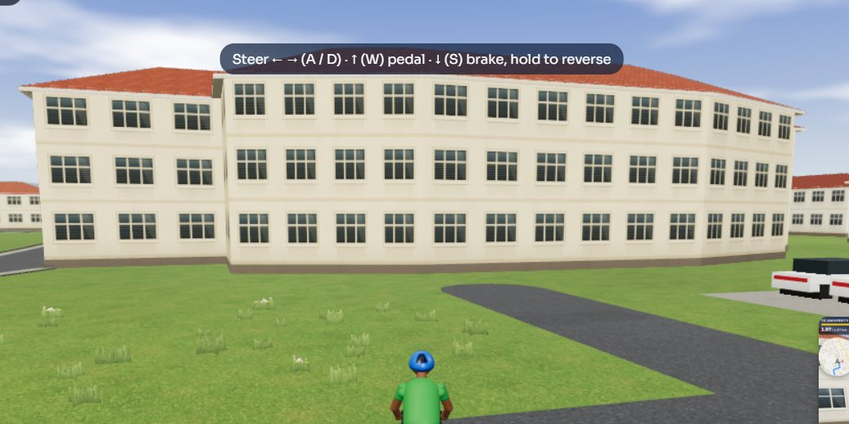  Current LEGONRUSH close view of repeated generic beige block
Observed difference: Real KOKA has a broad convex blue-glass curtain wall over a white tiled volume, shaded entry beneath and a paved fountain/plaza setting. Current gameplay shows a standard beige repetitive academic/dormitory block with red roof and no signature blue-glass curve.
Implementation target: Create a unique auditorium massing, blue panelized glass, solid white side volumes, recessed dark-column entrance, and the forecourt/paving/fountain landscape. Do not reuse the generic dormitory façade.

4.4 KOKA and Justice Aryeetey composition vs current repeated blocks
REAL-WORLD REFERENCE | CURRENT LEGONRUSH
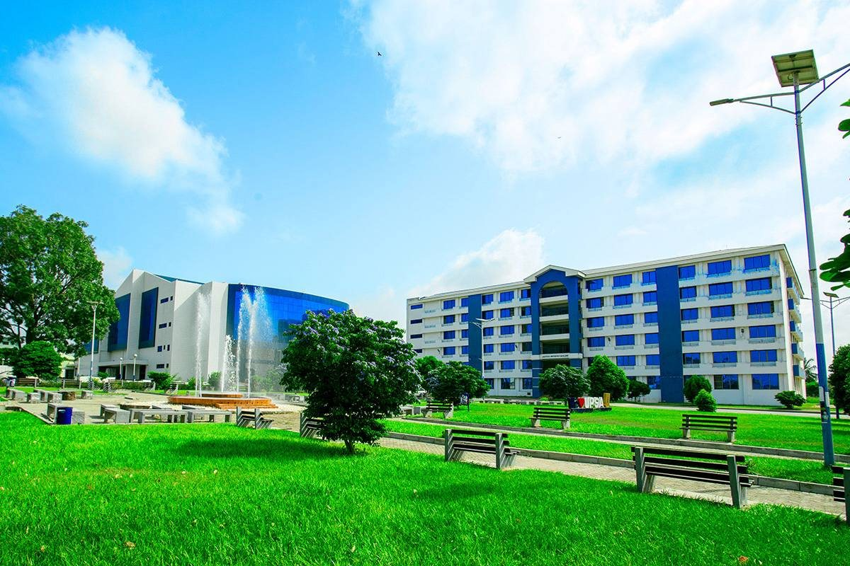  Wide site view: auditorium on the left, white-and-blue lecture block on the right | 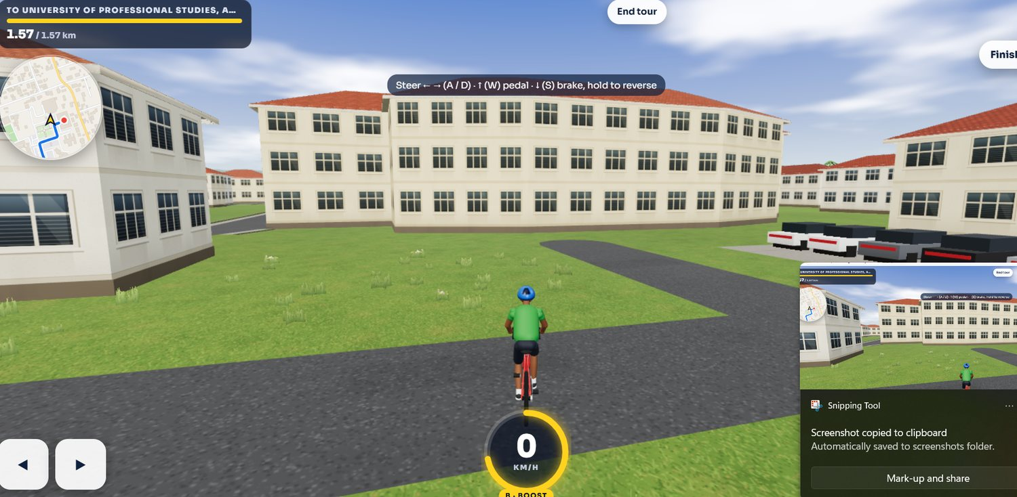  Current LEGONRUSH generic academic blocks in the target destination area
Observed difference: The supplied real view clearly shows two distinct forms: KOKA’s curved glass auditorium on the left and a white/blue multi-storey block on the right. The current game view repeats generic cream blocks and lacks these identities.
Implementation target: Build two independent meshes/material systems and preserve the real adjacency. Verify the right-hand block’s footprint and facing direction using the map. Use the site view to calibrate relative height, separation, paving and landscape—not to infer exact coordinates from perspective.

4.5 Justice Aryeetey Building identity vs existing game building
REAL-WORLD REFERENCE | CURRENT LEGONRUSH
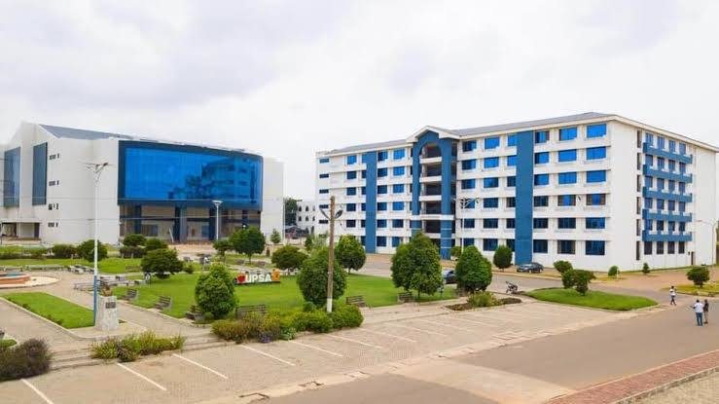  Real-world frontage/courtyard view of KOKA and adjacent white-blue block | 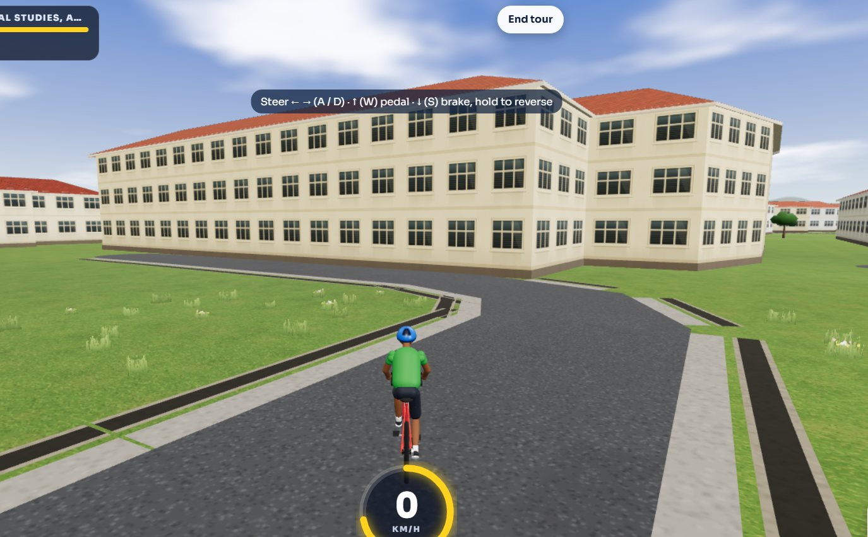  Current LEGONRUSH oblique generic blocks and roadway
Observed difference: The photo shows a separate white façade with strong blue vertical strips, regular horizontal floor bands/windows and a recessed central corridor/arched feature. The current scene’s plain block does not reproduce these cues.
Implementation target: Rebuild as a distinct six-storey-like lecture block based on the references and repository footprint. Create repeating but non-flat window bays, central blue panels and recessed corridor/entrance; do not give it KOKA’s curved curtain wall.

4.6 Court/site composition and misleading current signage
REAL-WORLD REFERENCE | CURRENT LEGONRUSH
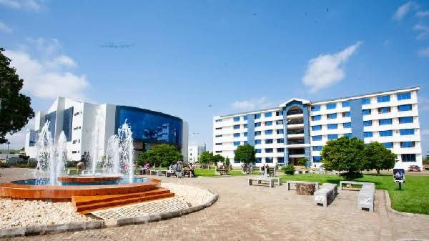  Wide court view showing KOKA, fountain, pavers and Justice Aryeetey Building | 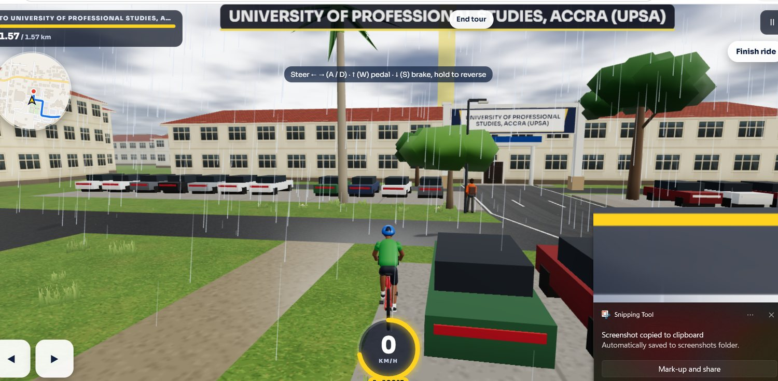  Current LEGONRUSH view with oversized sign, generic buildings and repeated vehicle placeholders
Observed difference: The real forecourt includes hardscape, fountain, benches, landscaped lawns and trees. The current game screenshot shows generic blocks, car placeholders and a large entrance banner that masks the wrong assets.
Implementation target: Place court, fountain, seating, landscaping and light poles around their evidence-backed positions. Remove oversized floating brand graphics and repeated vehicle placeholder rows where unsupported; preserve useful gameplay vehicles only where they belong.

4.7 Opoku Ampomah / Central Administration vs current game
REAL-WORLD REFERENCE | CURRENT LEGONRUSH
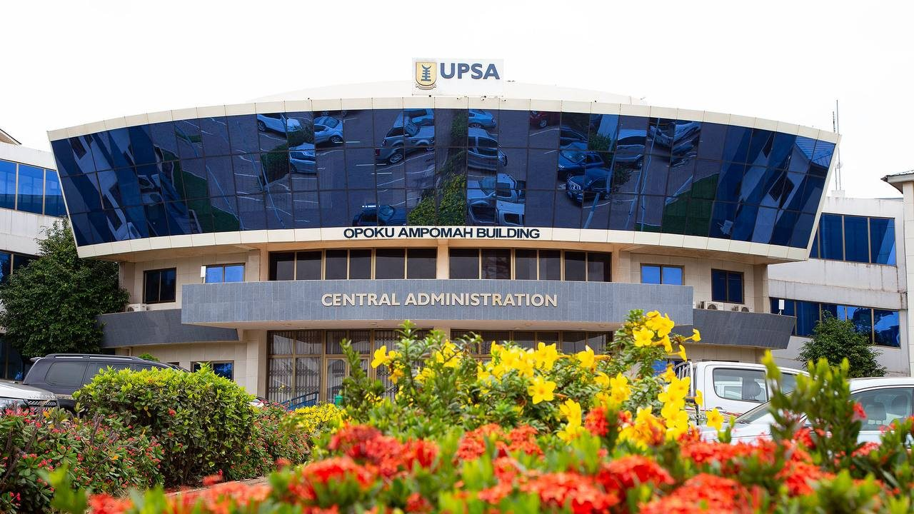  Clear frontal reference of the Opoku Ampomah Building / Central Administration Block: curved blue-glass upper frontage, UPSA name crest, CENTRAL ADMINISTRATION band, entry glazing and flowering foreground | 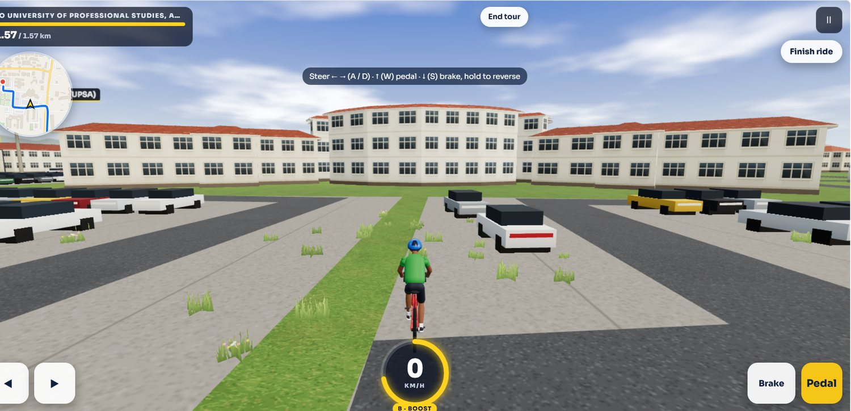  Current LEGONRUSH generic UPSA-area academic blocks and road/parking environment; target for replacing placeholders with site-specific landmark silhouettes
Observed difference: The real administration block has a large curved blue-glass band, visible panel reflections, a middle sign band reading CENTRAL ADMINISTRATION and OPOKU AMPOMAH BUILDING, lower entry glazing and landscaping. Current game views use generic blocks and repeated placeholders.
Implementation target: Create a dedicated Central Administration asset with the upper glass curvature, correct separate sign bands, tiled/light side masses, ground entrance and map-correct forecourt. Do not simply apply a blue material to a generic rectangle; verify location via the repository map.

4.8 Joshua Alabi Library vs generic academic blocks
REAL-WORLD REFERENCE | CURRENT LEGONRUSH
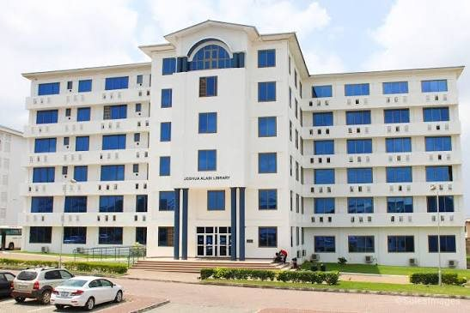  Joshua Alabi Library front elevation: white multi-storey block, central raised entrance bay, arched upper feature, blue-tinted windows and repeating horizontal floor bands | 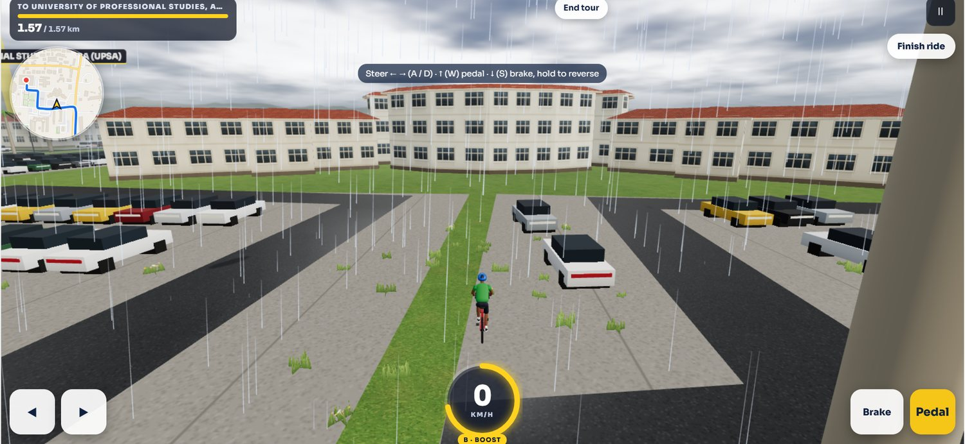  Second current-game view of the generic UPSA building cluster; compare against distinct admin, library and tower references
Observed difference: The reference library has long horizontal wings, regular white-and-blue floor/window rhythm, a taller central entry bay and an arched upper feature. Existing game screenshots lack this signature silhouette.
Implementation target: Create a separate Joshua Alabi Library mesh/asset using repeated floor bands and windows, central entrance projection and arch, with a correctly named destination. Never label it “Joshua Larbi”. Confirm its footprint from authoritative project geography and campus map evidence.

4.9 Abednego F. O. Amartey Twin Towers vs generic game buildings
REAL-WORLD REFERENCE | CURRENT LEGONRUSH
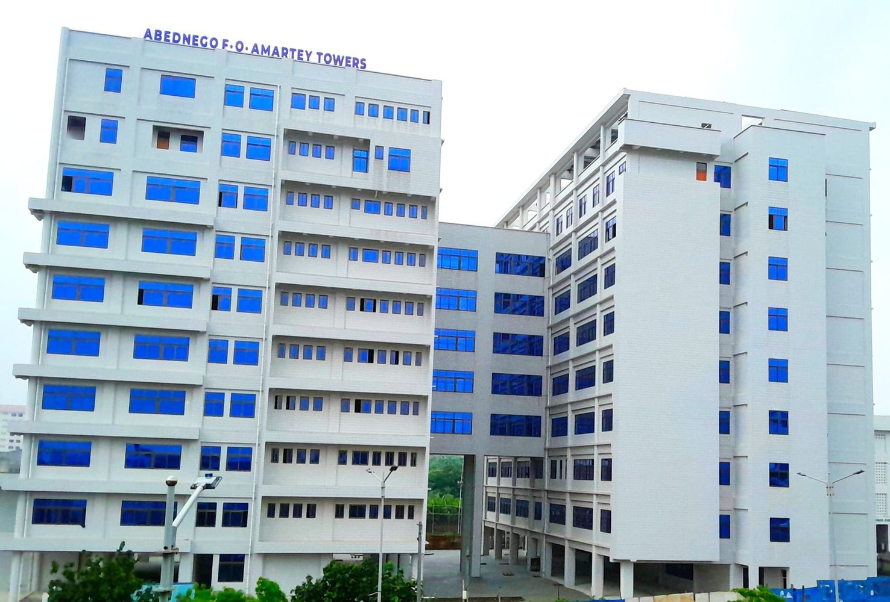  Abednego F. O. Amartey Twin Towers, broad view of the two connected multi-storey wings with pale cladding, strong blue windows and repeated slab bands | 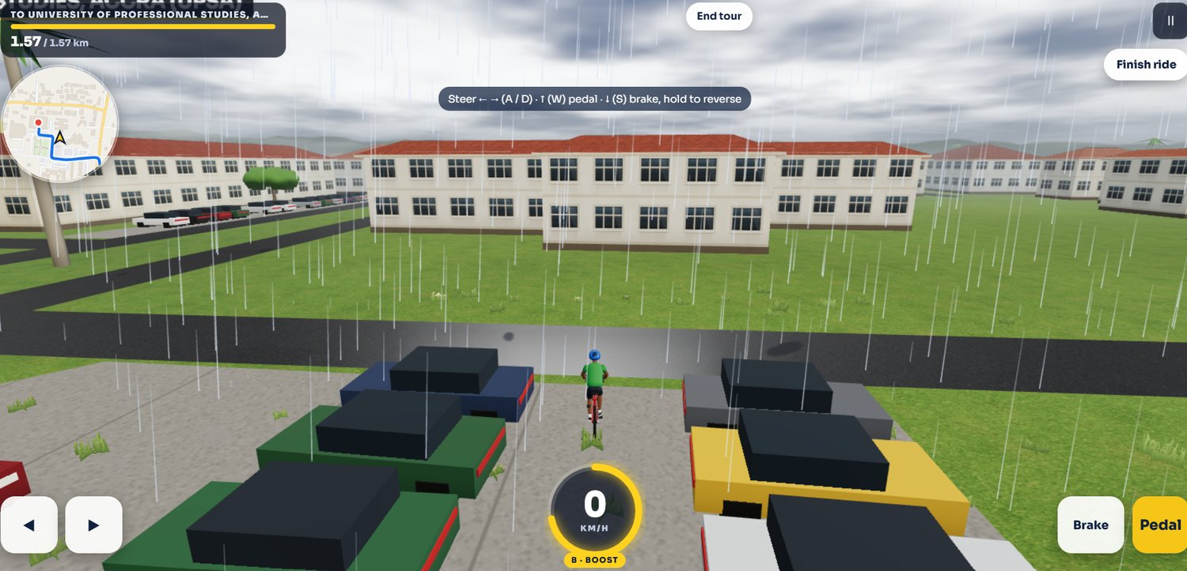  Current LEGONRUSH generic campus screenshot, including repeated building masses; use to target geometry/material mismatch, not for real-world positioning
Observed difference: The real completed towers are a pair of tall connected/offset masses, visibly taller than ordinary lecture blocks and clad in pale material with blue windows. Game screenshots show generic low repeated blocks.
Implementation target: Model a distinct twin-tower silhouette with separate wing volumes, connecting zone and repeated blue window bands; the official built-building photos outrank concept artwork. Preserve route clearance around the footprint.

4.10 Site layout check — map/aerial references
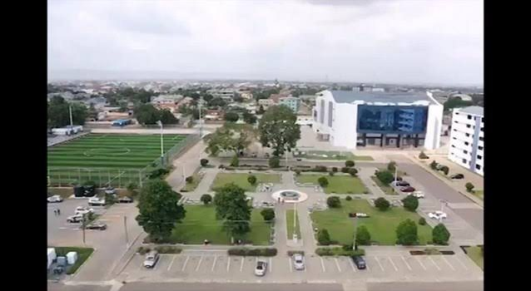
UPSA campus aerial overview. Use this only to understand broad relative arrangement of KOKA, plaza/fountain, roads and building clusters; not for precise measurements.
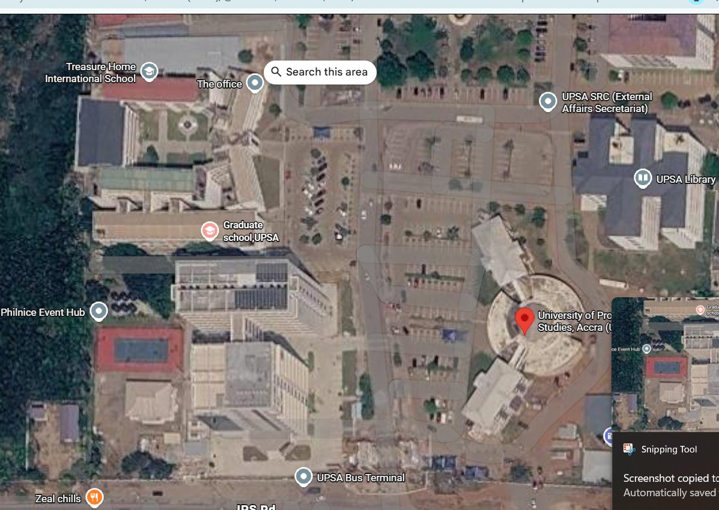
User-supplied satellite map screenshot. Labels include UPSA Library, UPSA SRC, Graduate School and bus terminal. Use as a cross-check for context; actual coordinates/footprints must be established from the repository geography and verified public map data.

5. Reference catalogue A — updated UPSA Main Entrance
Use these current user-supplied pictures as the visual authority for the redesigned gate. Since some were captured through Google Images/TikTok, interpret the photo portion only and ignore all interface overlays. Exact dimensions must come from site/map geometry or be labelled as estimates.

G-01 — Wide front/oblique gate photograph
What this reference proves: Shows the modern tiled portal with a large sweeping opening, top fascia, university wording and crest. Use for primary silhouette, proportions, branding position and vehicle clearance.

G-02 — Three-quarter external portal view
What this reference proves: Shows the curved side edge, tiled surface grid, deep covered entrance, approach apron and nearby access rail/ramp.

G-03 — Close-up tiled wall, logo and planting
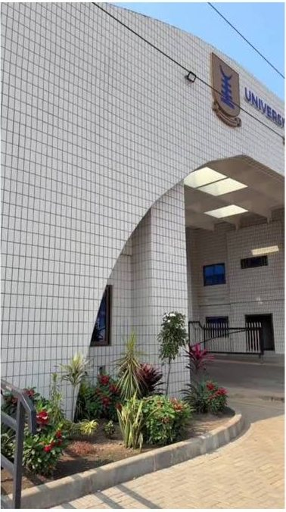
What this reference proves: Use for tile grid, logo/signage surface, blue/dark window panels, planter curb and pedestrian edge. Cropping/perspective means dimensions remain unknown.

G-04 — Gate side/facade video screenshot
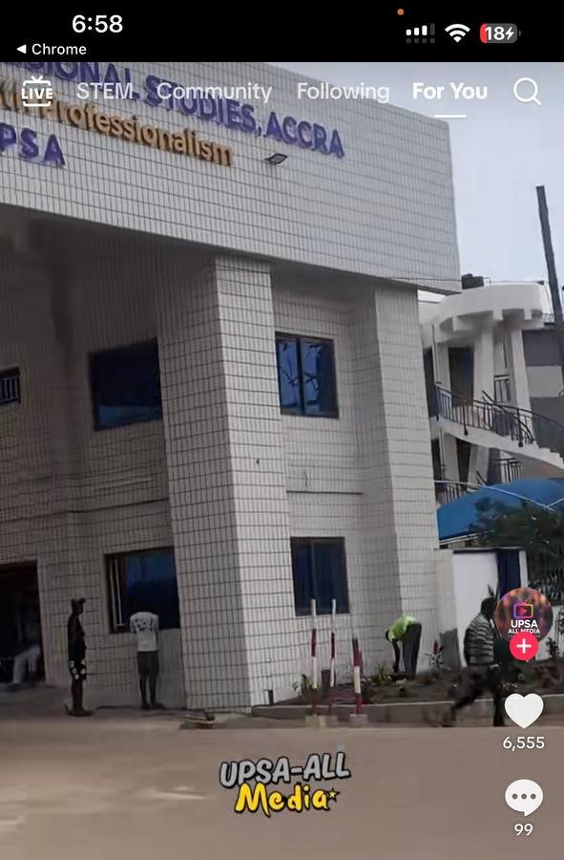
What this reference proves: Adds a side view of columns/openings, upper walkway/adjacent structure and ground-level access. Do not model people or phone overlays as fixed world objects.

Entrance geometry specification
- Portal silhouette: large architectural header/side mass with a continuous sweeping curved or diagonal outer profile; keep the opening void large and legible.
- Façade: small square cream/white tiles with visible grid joints. Use a modular tiling material or low-cost tiling texture aligned correctly to the surface; avoid huge featureless white polygons.
- Underside: deep roof/portal soffit with visible ceiling bays or recesses as supported by the photographs. The opening should feel tunnel-like but remain a gate, not a road overpass.
- Signage: university name, UPSA text and crest fixed to the fascia/wall with correct orientation and scale. Text should be legible, not random AI-generated lettering; use clean texture/vector or mesh text consistent with project conventions.
- Control/access details: verify lane count, barrier arm positions, security opening and pedestrian/ramp/rail details from images and map. If unclear, preserve open clearance and avoid invented gate machinery.
- Ground plane: connect approach road, vehicle apron, curb/paving, ramp/footpath and inner road without cracks, floating slabs or blocked entrances.
- Adjacent structures: the new-gate screenshot includes neighbouring massing on one side; use mapped building data to decide whether that mass is part of the gate complex or a separate building.
DO NOT DO THIS
Do not put a floating banner across the road and call it the new entrance. Do not reconstruct the older 2021 gate as the current gate. Do not use the image-search interface, arrows, TikTok logos or video comments as textures.

6. Reference catalogue B — Kofi Ohene-Konadu Auditorium (KOKA)
The auditorium is the signature low/medium-rise building with the curved blue-glass front. Official UPSA references identify it as Kofi Ohene-Konadu Auditorium, commissioned in May 2019 and formally named in 2021. Official sources report 3,550 capacity and mention a two-storey underground car park and support spaces; these are program facts, not a substitute for spatial measurements.
Wide real-world KOKA facade, reflective blue glass, fountain court and landscape | Wide court view showing KOKA, fountain, pavers and Justice Aryeetey Building

Architectural features to reproduce
- Primary volume: white/off-white tiled side masses with a broad convex or sweeping blue reflective glass curtain wall; panelize the glazing into a visible regular grid.
- Curvature: the front glazing bends across the façade; it is a signature silhouette. Make a true curved/swept surface or a segmented approximation with enough facets to avoid looking like a square billboard.
- Ground entrance: dark/shaded open portico under the glass, columns, glass doors/recesses and appropriate entrance stairs/approach where visible.
- Side elevation: white tiled solid walls with smaller dark windows/recesses; do not cover every face in blue glass.
- Name/sign: KOKA / Kofi Ohene-Konadu Auditorium only where supported by official or user images. Do not invent signage placements on unseen faces.
- Proportions: use existing map footprint and compare front, oblique and elevated photographs. Avoid scaling the auditorium to the dimensions of nearby teaching blocks.

Forecourt / public space
- Paved plaza made from interlocking/stone pavers or suitable textured paving consistent with the photographs.
- Circular/curved fountain basin with low raised reddish-brown/orange rim and jets in the frontal court, matching the imagery where the feature is visible.
- Benches, low planters, trimmed shrubs, grass panels and mature shade trees; place them around walkways and avoid blocking the facade or player route.
- Lamp posts and path intersections aligned to scene references and existing lighting conventions.
- Keep service/vehicle circulation and likely underground parking approach areas clear where mapped; do not invent a ramp if none is established by source geometry.

7. Reference catalogue C — Justice Aryeetey Building
The building immediately to the right of the auditorium when facing its front is identified as Justice Aryeetey Building based on the user’s composition photos and UPSA’s own description of a six-storey lecture block next to the auditorium. This identity is strongly supported; final side/position must still be verified against the map and building registry before placement.
REF J-01 — Supplied close view showing KOKA to the left and Justice Aryeetey Building at right.

Façade specification
- Six-storey-like horizontal rhythm, subject to the current visual references and footprint; rows of windows and slab/floor bands repeat consistently.
- White/light exterior walls with dark navy/blue vertical strips, especially around the prominent central circulation bay.
- Recessed open corridors/balconies and the vertical central void/atrium visible in the reference; avoid flattening every window flush with the wall.
- Central arch/cap feature over the vertical circulation bay and the main entrance beneath it, based on current supplied reference.
- Blue-tinted windows with small individual frames/panels. Use enough depth, mullions and shadows to distinguish windows from a flat blue texture.
- Paved frontage and restrained shrubs/trees; do not cover the ground-floor entrance or the edge between building and road/courtyard.
KEEP THE IDENTITIES SEPARATE
KOKA is the white mass with curved, broad blue glass. Justice Aryeetey is the adjacent multi-storey white-and-blue lecture block with repeated horizontal bands and a central recessed/arched bay. Do not duplicate one mesh for both, do not rotate them for symmetry, and do not substitute generic cream/red-roof classroom blocks.

8. Reference catalogue D — Opoku Ampomah Building / Central Administration Block
UPSA’s official building-names article associates Nana J. K. Opoku Ampomah with the Central Administration Block. The user-supplied clear frontal image carries both the wording “OPOKU AMPOMAH BUILDING” and “CENTRAL ADMINISTRATION”, so this is a single landmark with two sign bands, not two buildings.
REF A-01 — Clear front facade with curved reflective blue-glass band and both sign zones.
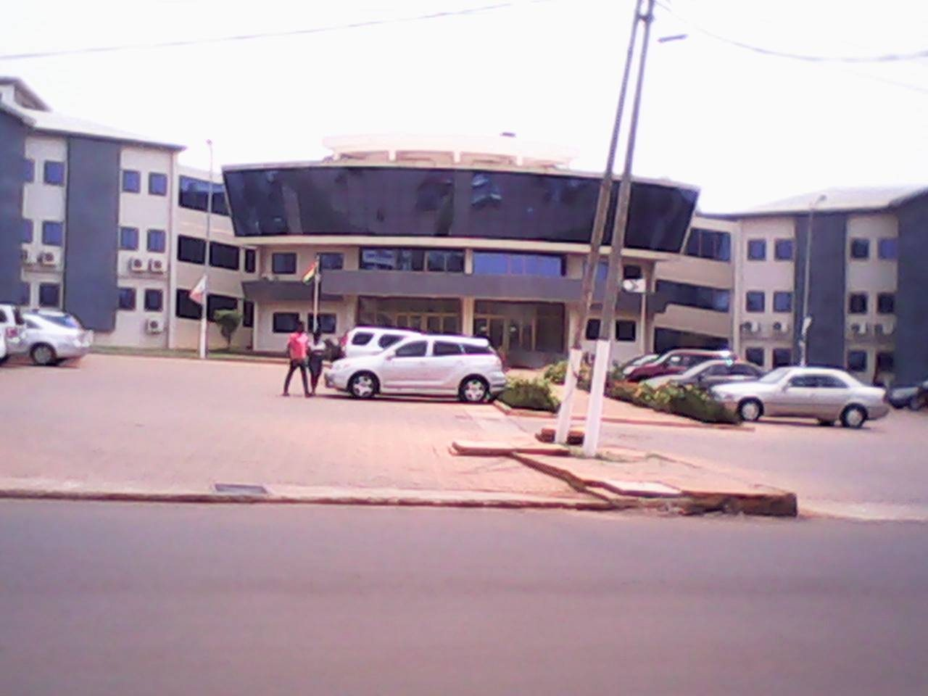
REF A-02 — Older oblique view showing building breadth, entry and forecourt.
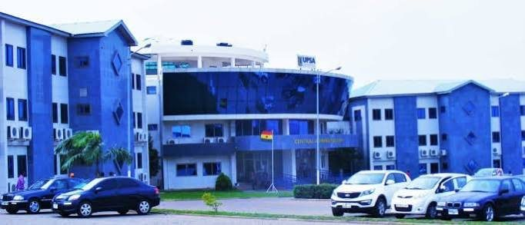
REF A-03 — Alternate wide view; colour cast is not authoritative.

Reconstruction specification
- Broad curved dark/cobalt-blue reflective upper glass band, broken into individual panels with mullions/reflections.
- White/light facade, distinct horizontal CENTRAL ADMINISTRATION band and upper OPOKU AMPOMAH BUILDING label where supported by the reference.
- Recessed central entrance glazing and ground-level support/columns; side wings have windows/accent panels and do not become a featureless box.
- Landscape and parking exist in the wider frontage; use the map and aerial references for placement, not the photograph’s parked cars or foreground flowers as fixed coordinates.
- Keep separate from KOKA despite both using curved blue glass. Their silhouettes, sign bands, wings and entrance proportions must stay distinct.

9. Reference catalogue E — Joshua Alabi Library
The correct official name is **Joshua Alabi Library** (also Joshua Alabi Library Complex), not Joshua Larbi. UPSA identifies Prof. Joshua Alabi with the Library Complex and describes the library as a six-storey facility on the east side of campus. The official facts establish its name and broad role; exact dimensions and position must still be derived from project geography and map evidence.
REF L-01 — Frontal view: raised central entrance bay, high central arch, regular window rhythm.
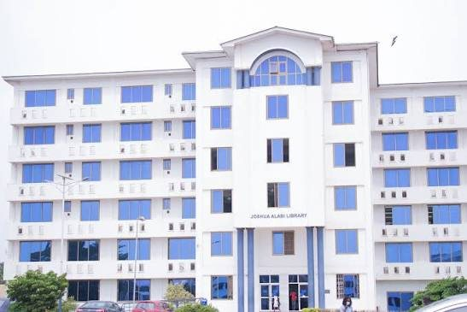
REF L-02 — Alternate front view: symmetrical wings, recessed entrance, blue window grouping.
REF SITE-01 — User-supplied satellite map labelled UPSA Library; use to cross-check campus context only, not as a surveyed building footprint.

Reconstruction specification
- Separate white/light multi-storey library block with two long horizontal wings and a taller central entrance tower.
- Central upper arched/capped feature with inset glazing; lower central entry recessed beneath the central bay.
- Repeat blue-tinted windows as individually framed rectangles with consistent spacing and floor bands; avoid flat pasted window textures.
- Use map-derived footprint and heading. Do not place the library based on a photo perspective or simply beside Central Administration because the screenshot sequence is ambiguous.
- Name and destination label must be “Joshua Alabi Library”.

10. Reference catalogue F — Abednego F. O. Amartey Twin Towers
UPSA’s official report confirms that the completed ten-storey multipurpose Twin Towers were commissioned on 18 December 2024 and named for Prof. Abednego F. O. Amartey. A user-supplied perspective/render is also included, but the completed-built photos and official report take precedence over concept-only details.
REF T-01 — Completed towers: broad view of two connected/offset multi-storey wings, blue windows and pale facade.
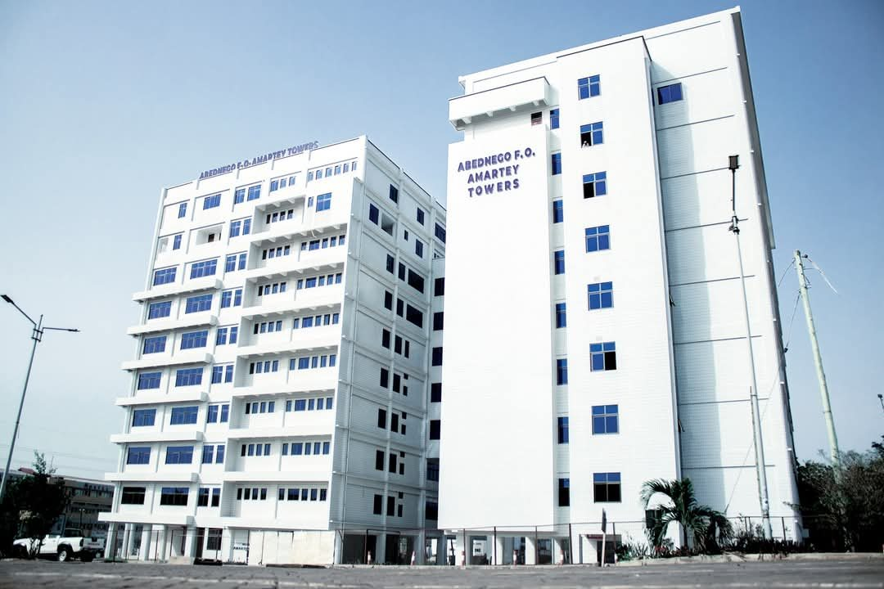
REF T-02 — Oblique completed-building view clarifying the twin-wing silhouette and connection.
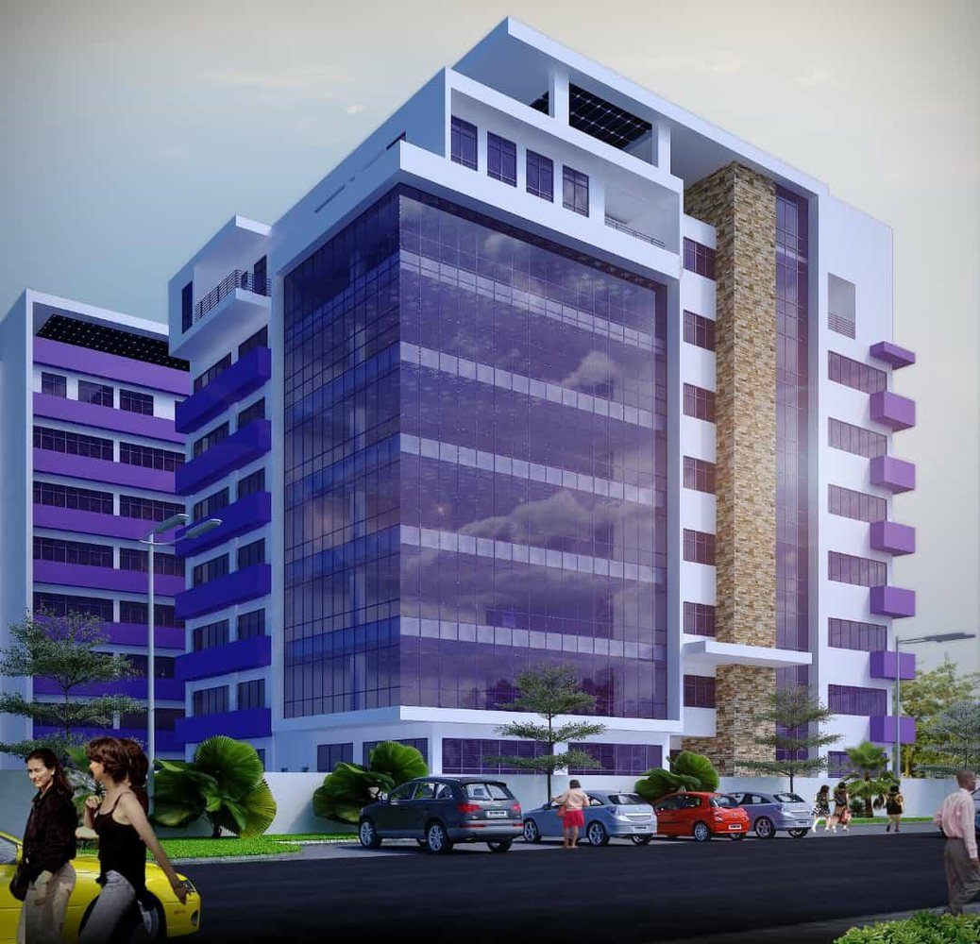
REF T-03 — Architectural visualization; concept/promo reference only, not definitive as-built evidence.
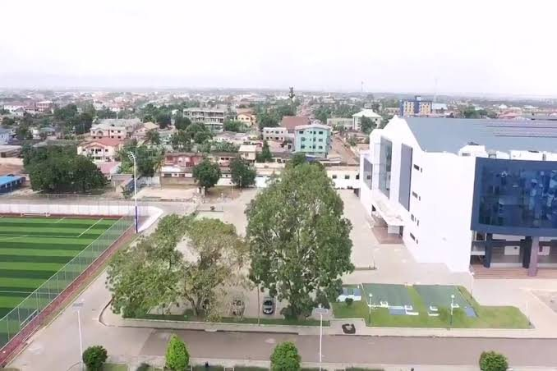
REF SITE-02 — Oblique aerial campus edge; broad orientation clue, not a surveyed plan.

Reconstruction specification
- Construct two distinct tall volumes with their own footprints/heights and a connecting or inset middle zone, following the as-built reference.
- Use pale cladding and strong blue-tinted window groups; repeat floor bands and window bays, but do not automatically mirror the two towers if the photos show different massing.
- Preserve ground-level access and any open/column-supported areas visible at the base; do not block existing routes.
- Do not copy the render’s stone-clad vertical spine or cantilever detail unless the built-building photographs confirm it.
- Use the official ten-storey description for a broad height constraint only; verify scale/floors from the photo and repository building data.

11. Complete image register — all supplied files
Every supplied image has been retained in `reference_images/original_uploads/` with its original filename, and an optimized display version is listed below. Some original files are search-result or game screenshots rather than clean photographs; use them for identity/site context or to identify current placeholders, but never model browser, Google, TikTok or Snipping Tool UI as campus geometry.

REF 01 — ENTRANCE
Gate reference screen with wide front / slightly oblique view
Original file: 01_photo_26_2026-10-12_19-10-18.jpg | Display file: 01_entrance_photo_26_2026-10-12_19-10-18.jpg

REF 02 — ENTRANCE
Gate reference screen showing the curved tiled portal and forecourt
Original file: 02_photo_25_2026-10-12_19-10-18.jpg | Display file: 02_entrance_photo_25_2026-10-12_19-10-18.jpg

REF 03 — ENTRANCE
Close-up of portal tiles, crest/signage, landscaping and ramp/rail
Original file: 03_photo_24_2026-10-12_19-10-18.jpg | Display file: 03_entrance_photo_24_2026-10-12_19-10-18.jpg

REF 04 — ENTRANCE
Video screenshot showing tiled gate elevation and adjacent elevated walkway/building
Original file: 04_photo_23_2026-10-12_19-10-18.jpg | Display file: 04_entrance_photo_23_2026-10-12_19-10-18.jpg

REF 05 — GAME
Current LEGONRUSH view approaching the oversized university sign/gate
Original file: 05_Screenshot 2026-10-12 185112.png | Display file: 05_game_Screenshot_2026-10-12_185112.jpg

REF 06 — GAME
Current LEGONRUSH oblique view of the same generic entrance treatment
Original file: 06_Screenshot 2026-10-12 185134.png | Display file: 06_game_Screenshot_2026-10-12_185134.jpg

REF 07 — SEARCH
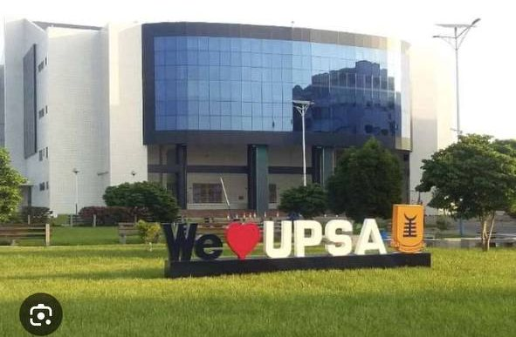
Search-result screen showing auditorium/glass facade and We Love UPSA context image
Original file: 07_photo_19_2026-10-12_19-10-18.jpg | Display file: 07_search_photo_19_2026-10-12_19-10-18.jpg

REF 08 — SEARCH
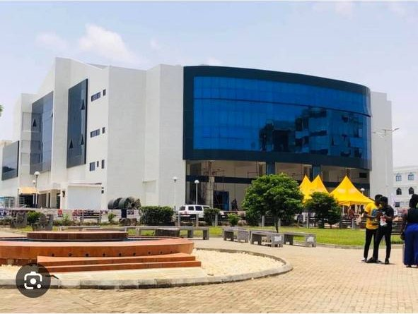
Search-result screen with UPSA official auditorium image and fountain/plaza
Original file: 08_photo_16_2026-10-12_19-10-18.jpg | Display file: 08_search_photo_16_2026-10-12_19-10-18.jpg

REF 09 — AUDITORIUM
Wide real-world KOKA facade, reflective blue glass, fountain court and landscape
Original file: 09_photo_15_2026-10-12_19-10-18.jpg | Display file: 09_auditorium_photo_15_2026-10-12_19-10-18.jpg

REF 10 — ADJACENT
Wide site view: auditorium on the left, white-and-blue lecture block on the right
Original file: 10_photo_14_2026-10-12_19-10-18.jpg | Display file: 10_adjacent_photo_14_2026-10-12_19-10-18.jpg

REF 11 — CONTEXT
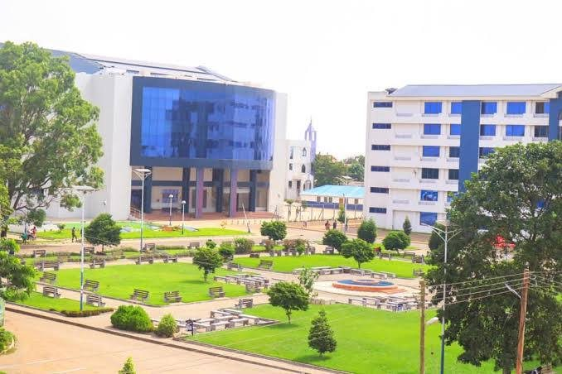
Elevated view of auditorium, adjacent block, landscaped central court and roads
Original file: 11_photo_13_2026-10-12_19-10-18.jpg | Display file: 11_context_photo_13_2026-10-12_19-10-18.jpg

REF 12 — CONTEXT
Wide court view showing KOKA, fountain, pavers and Justice Aryeetey Building
Original file: 12_photo_10_2026-10-12_19-10-18.jpg | Display file: 12_context_photo_10_2026-10-12_19-10-18.jpg

REF 13 — CONTEXT
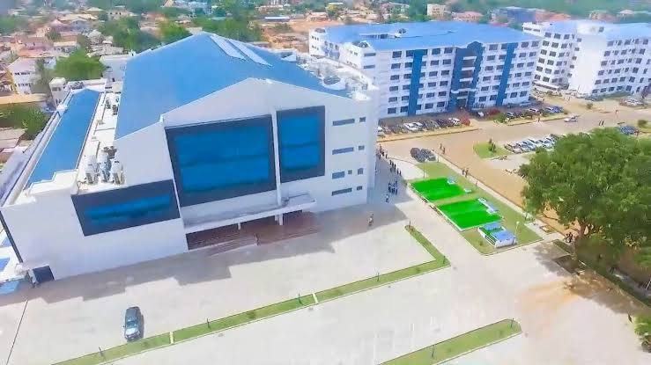
Aerial-style view of auditorium roof and internal campus paving
Original file: 13_photo_7_2026-10-12_19-10-18.jpg | Display file: 13_context_photo_7_2026-10-12_19-10-18.jpg

REF 14 — GAME
Current LEGONRUSH generic academic blocks in the target destination area
Original file: 14_Screenshot 2026-10-12 191747.png | Display file: 14_game_Screenshot_2026-10-12_191747.jpg

REF 15 — GAME
Current LEGONRUSH close view of repeated generic beige block
Original file: 15_Screenshot 2026-10-12 191753.png | Display file: 15_game_Screenshot_2026-10-12_191753.jpg

REF 16 — GAME
Current LEGONRUSH oblique generic blocks and roadway
Original file: 16_Screenshot 2026-10-12 191821.png | Display file: 16_game_Screenshot_2026-10-12_191821.jpg

REF 17 — ADJACENT
Alternate supplied copy of auditorium/adjacent-block vista; duplicate framing retained for provenance
Original file: 17_photo_14_2026-10-12_19-10-18(1).jpg | Display file: 17_adjacent_photo_14_2026-10-12_19-10-181.jpg

REF 18 — CONTEXT
Real-world frontage/courtyard view of KOKA and adjacent white-blue block
Original file: 18_photo_2_2026-10-12_19-10-18.jpg | Display file: 18_context_photo_2_2026-10-12_19-10-18.jpg

REF 19 — ADJACENT
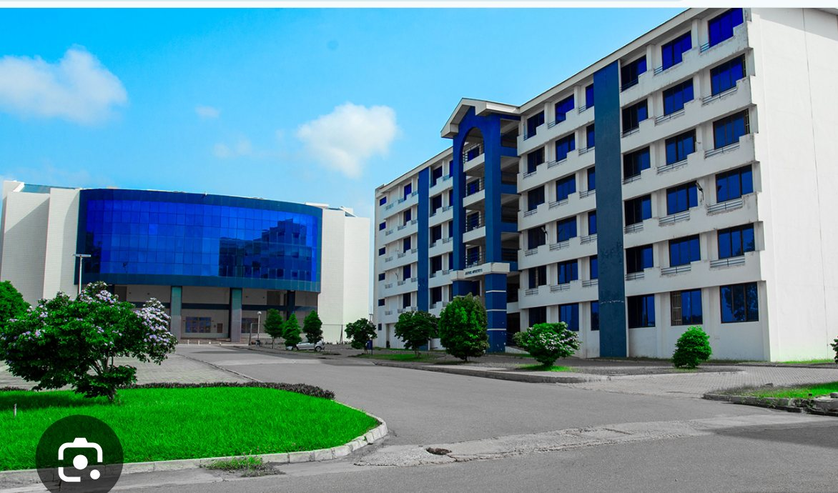
Close real-world view identifying the blue-and-white multi-storey building adjacent to auditorium
Original file: 19_image(20261012-192400).png | Display file: 19_adjacent_image20261012-192400.jpg

REF 20 — GAME
Current LEGONRUSH view with oversized sign, generic buildings and repeated vehicle placeholders
Original file: 20_image(20261012-192446).png | Display file: 20_game_image20261012-192446.jpg

REF 21 — ADMIN
Clear frontal reference of the Opoku Ampomah Building / Central Administration Block: curved blue-glass upper frontage, UPSA name crest, CENTRAL ADMINISTRATION band, entry glazing and flowering foreground
Original file: 21_photo_11_2026-10-12_19-10-18.jpg | Display file: 21_admin_photo_11_2026-10-12_19-10-18.jpg

REF 22 — ADMIN
Older oblique street-level reference of Central Administration: broad curved glass canopy, side wings, central entrance and paved parking forecourt; image quality is low so use only as secondary geometry evidence
Original file: 22_photo_12_2026-10-12_19-10-18.jpg | Display file: 22_admin_photo_12_2026-10-12_19-10-18.jpg

REF 23 — ADMIN
Alternate wider historic colour-cast view of the Central Administration Block and flanking wings; use to understand the broader building composition, not colour grading
Original file: 23_photo_5_2026-10-12_19-10-18.jpg | Display file: 23_admin_photo_5_2026-10-12_19-10-18.jpg

REF 24 — LIBRARY
Joshua Alabi Library front elevation: white multi-storey block, central raised entrance bay, arched upper feature, blue-tinted windows and repeating horizontal floor bands
Original file: 24_image(20261012-194001).png | Display file: 24_library_image20261012-194001.jpg

REF 25 — LIBRARY
Alternate frontal Joshua Alabi Library view, showing symmetrical wings, taller central bay, recessed entrance and blue window rhythm
Original file: 25_image(20261012-194217).png | Display file: 25_library_image20261012-194217.jpg

REF 26 — AERIAL
Elevated campus overview locating KOKA, court/fountain, roads, parking and surrounding buildings; broad positional reference only
Original file: 26_image(20261012-194438).png | Display file: 26_aerial_image20261012-194438.jpg

REF 27 — AERIAL
Oblique aerial of the UPSA campus edge and KOKA site, useful for relative orientation and approach roads but not a surveyed plan
Original file: 27_image(20261012-194453).png | Display file: 27_aerial_image20261012-194453.jpg

REF 28 — AERIAL
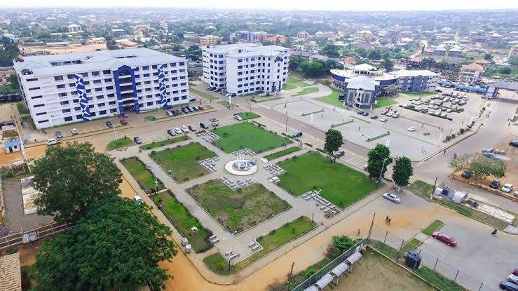
Aerial campus context view showing internal court, circulation and major building clusters; approximate visual map support only
Original file: 28_photo_8_2026-10-12_19-10-18.jpg | Display file: 28_aerial_photo_8_2026-10-12_19-10-18.jpg

REF 29 — TOWERS
Abednego F. O. Amartey Twin Towers, broad view of the two connected multi-storey wings with pale cladding, strong blue windows and repeated slab bands
Original file: 29_image(20261012-195246).png | Display file: 29_towers_image20261012-195246.jpg

REF 30 — TOWERS
Alternate oblique view of Abednego F. O. Amartey Twin Towers, showing the height, two-wing massing, central connecting zone and ground-level open/support structure
Original file: 30_image(20261012-195331).png | Display file: 30_towers_image20261012-195331.jpg

REF 31 — TOWER_RENDER
Architectural visualization associated with a twin-tower form; treat as concept/promo imagery only and compare against photos of the completed built towers before adopting details
Original file: 31_twin_tower1.jpeg | Display file: 31_tower_render_twin_tower1.jpg

REF 32 — MAP
User-supplied satellite map screenshot with UPSA Library, UPSA SRC, UPSA Bus Terminal and Graduate School labels; use for campus-level positional clues, not exact surveyed building footprints
Original file: 32_image(20261012-195741).png | Display file: 32_map_image20261012-195741.jpg

REF 33 — GAME
Current LEGONRUSH generic UPSA-area academic blocks and road/parking environment; target for replacing placeholders with site-specific landmark silhouettes
Original file: 33_Screenshot 2026-10-12 193657.png | Display file: 33_game_Screenshot_2026-10-12_193657.jpg

REF 34 — GAME
Second current-game view of the generic UPSA building cluster; compare against distinct admin, library and tower references
Original file: 34_Screenshot 2026-10-12 193726.png | Display file: 34_game_Screenshot_2026-10-12_193726.jpg

REF 35 — GAME
Current LEGONRUSH generic campus screenshot, including repeated building masses; use to target geometry/material mismatch, not for real-world positioning
Original file: 35_image(20261012-194345).png | Display file: 35_game_image20261012-194345.jpg

REF 36 — GAME
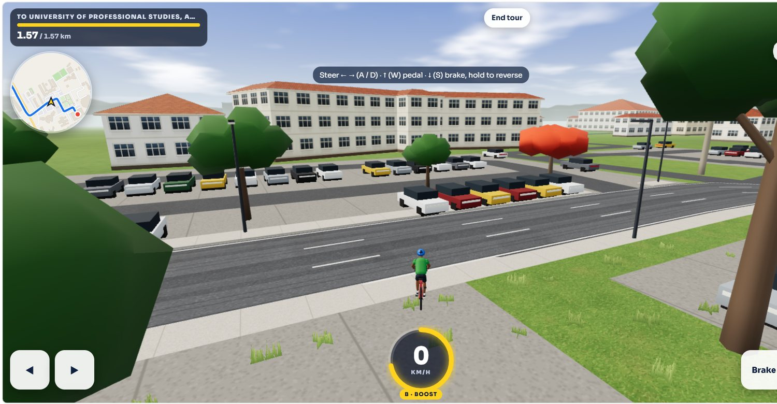
Current-game view of generic building massing and parking/circulation in the UPSA destination area
Original file: 36_image(20261012-195602).png | Display file: 36_game_image20261012-195602.jpg

12. Claude Code master prompt (full copy)
START HERE
Claude must complete the read-first gate before implementation. This is deliberately strict so that no geometry or building identity is guessed from a single screenshot.

LEGONRUSH — UPSA Landmark Reconstruction: Updated Main Entrance, KOKA Auditorium, Justice Aryeetey Building, Opoku Ampomah Central Administration, Joshua Alabi Library and Abednego F. O. Amartey Twin Towers

Mandatory read-first gate — do not edit before completing it
You are continuing the existing LEGONRUSH repository. This is a location-specific reconstruction phase, not a greenfield demo. Before deciding what to build or editing any code:
1. Inventory all files supplied in this task pack: read this prompt, read LEGONRUSH_UPSA_Entrance_Auditorium_Justice_Aryeetey_Reconstruction_Brief.docx, read ONLINE_SOURCE_REGISTER.csv, examine the contact sheet, and open every file inside reference_images/document_ready/ individually at full resolution. The reference_images/original_uploads/ folder preserves the original supplied captures; inspect any image whose detail might be lost in the optimized display copy.
2. Read the repository's own context and geography documents (including CLAUDE.md, README, geography authority docs, landmark/destination/entrance docs, recent handovers and active work notes). Read the relevant source files instead of inferring code structure from memory.
3. Inspect current main and working-branch status, recent commits, current geometry data, route/access IDs, building registry, renderer and existing gameplay screenshots. Do not overwrite other people's changes.
4. Open the running game or the available geography inspector and identify the exact campus area, gate access point, auditorium footprint and adjacent-building footprint using authoritative project map data. Compare the live scene with the real-world references from several views.
5. Produce a short evidence audit before implementation: (a) confirmed by current user images, (b) confirmed by UPSA/Commons sources, (c) inferred but needs map validation, (d) unknown. Record a planned feature-to-source mapping and verify the current gate identity before touching geometry.
Do not begin implementation until steps 1–5 are complete. If a file mentioned in the pack is missing, explicitly report it and continue by inspecting the files that are available; never invent its contents. Do not ask for routine approval during normal work.

Scope
Reconstruct six distinct landmark assets in the existing 3D UPSA destination area:
1. The updated UPSA Main Entrance shown in the newest uploaded photo/video screenshots.
2. The Kofi Ohene-Konadu Auditorium (KOKA) — the low/medium-rise white-tiled structure with a sweeping, curved reflective blue-glass front.
3. The white-and-blue multi-storey lecture block adjacent to KOKA, identified as the Justice Aryeetey Building; the user’s reference shows it to the right when facing the auditorium, but confirm the final side and footprint using map data.
4. The Opoku Ampomah Building / Central Administration Block, recognisable by its broad curved reflective blue-glass upper front, white/light cladding, signage band reading “CENTRAL ADMINISTRATION”, and broad entrance frontage.
5. The Joshua Alabi Library (official spelling; do not use “Joshua Larbi”), a distinct multi-storey white/light building with blue windows, a taller central entrance bay and an arched/capped upper feature.
6. The Abednego F. O. Amartey Twin Towers, a distinct completed twin-tower multipurpose complex with pale cladding, blue-tinted windows, repeated horizontal floor bands and connected/offset wings.
This phase replaces generic placeholder assets at these six specific landmarks and the immediately supporting outdoor spaces. It does not mean redesign all UPSA buildings, the wider campus, the IPS Road corridor, or unrelated Legon/UG roads.

Critical gate design correction
The newest user-supplied entrance images are the controlling design references. They show a large light cream/white square-tiled portal with a distinctive sweeping curved/diagonal outer profile, a deep covered opening, an elevated horizontal fascia carrying UPSA identity/lettering, a logo/crest, tiled side masses, dark blue/black openings/windows and paved approach areas. One view shows an access ramp/handrails and planting beds. Study all gate images together; do not copy a single perspective literally.
The newer gate design supersedes the 2021 Wikimedia Main Gate photographs. Treat those older photos only as historical context; do not reconstruct their simpler blue-and-white beam/gatehouse design. Also remove/replace the current game's oversized floating/bridge-like blue banner/sign and generic gate/wall treatment where it conflicts with the new portal. Do not simply add a new sign in front of the old model. Reconstruct the real portal's structure, massing, square tile grid, curved cutout/arch, supports, underside/ceiling, signage mounting, entry lanes, pedestrian access and associated ground transitions.
Exact current logo placement, text spelling, gate-panel details and measurements should be taken from the user's newest images and confirmed sources. Don't add invented translations, extra flags, invented entrance lanes or unrelated decorative elements.

KOKA auditorium reconstruction
UPSA's official pages identify the 3,550-capacity venue as Kofi Ohene-Konadu Auditorium, commissioned in May 2019 and named in 2021. Official descriptions mention the entrance foyer, multipurpose support spaces, four ancillary conference rooms and two-storey underground parking. Treat these capacity/program facts as source context, not dimensions to infer from photos.
Match the actual visible form in the supplied photos and official links:
- A substantial rectilinear white/light tiled building body with an unmistakable broad convex/sweeping curtain-wall zone of reflective dark/cobalt-blue glass at the front.
- Large, regular glass panel grid/mullions, blue reflections and a strong horizontal band separating the glass from the shaded lower-level entrance.
- Deep recessed/open ground-floor entry below the glass, supported by dark structural columns; preserve the visible doors, steps/approach and shadowed portico as supported by references.
- Solid white tiled side wings/volumes with small, more restrained windows and clean roof edges. Do not turn the whole building into a glass cube or a generic dormitory block.
- Auditorium signage where visible in the user's/official references; avoid garbled generated text. Prefer a clean text/sign mesh matching “KOFI OHENE-KONADU AUDITORIUM” only where the photo supports the sign.

Auditorium forecourt / landscape
Reconstruct the approach and outdoor public space supported by the images: large paved pedestrian court, pathways, circular/curved fountain feature in front of the auditorium, benches, small ornamental shrubs, lawns, mature trees, low planting beds, lamp posts and accessible circulation. Match the distinctive orange/brown raised fountain ring and water jets only to the extent clearly shown in the sources; use lightweight static geometry and an inexpensive water animation/particles if supported by current renderer. Don't make the courtyard uniformly grassy or replace its paving with a generic asphalt road.
If not modelling functional water, retain the fountain basin and nozzles as geometry and use a restrained effect. Prioritize the identifiable silhouette and the auditorium-to-court proportions over unnecessary high-polygon decoration.

Justice Aryeetey Building — the adjacent structure on the right
UPSA's official “manifest makeover” article says the Justice Aryeetey Building sits next to the auditorium and describes it as a six-storey lecture-block complex. User references show a separate white building with deep blue vertical façade strips, repeated horizontal floor/window bands, rows of blue-tinted rectangular windows, recessed open corridors/balconies around a central vertical bay, and a central arched/capped feature over the circulation bay. The façade identity is distinct from KOKA.
Required:
- Model a separate six-storey-like massing consistent with reference proportions and map footprint; do not attach it as a wing of the auditorium.
- Pale/white façade and slab bands, blue central vertical strips, repeated windows, inset balconies/corridors and its central recessed/arche­d feature as visible in the photos.
- Ground-level central entrance/circulation bay and paved frontage. Add small landscaping and paths only where reference/map evidence supports them.
- Do not copy the auditorium's curved blue glass façade onto this block. Do not replace it with the generic cream/red-roof residential blocks currently seen in the game screenshots.
- If exact rear elevations are not visible, keep the unseen side simple and consistent with the building footprint; mark inferred details in the implementation report.

Opoku Ampomah Building / Central Administration Block
UPSA’s official building-names page associates Nana J. K. Opoku Ampomah with the Central Administration Block. The user-supplied frontal photograph also visibly labels the facade “OPOKU AMPOMAH BUILDING” and “CENTRAL ADMINISTRATION”. Treat these as two labels for the same landmark, not two separate buildings.
Visual characteristics from the supplied references:
- A broad, curved/swept upper curtain-wall band with dark/cobalt-blue reflective glazing and a visible rectangular panel/mullion grid.
- Pale cream/off-white side and lower masses; the central administration sign band is a wide grey-blue slab/band across the middle of the front.
- A recessed glazed entry beneath the sign band, with columns/recessed portals and flanking lower wings.
- Side wings contain individual windows, white/light cladding and blue/dark vertical or accent elements; do not copy the KOKA facade exactly even though both have curved blue glass.
- Foreground landscaping includes flowering beds and shrubs in several references; use placement from actual site map/aerials and avoid obstructing the entry/parking.
- Use the clearer modern frontal reference for material and naming. The older low-resolution/colour-cast views are secondary evidence for overall massing only; do not reproduce their colour cast, compression, people or parked cars as permanent objects.
Build it as its own named object/asset with readable façade lettering. Preserve both sign zones where supported by reference. Do not place it in KOKA’s footprint merely because both have curved glass.

Joshua Alabi Library — official name
UPSA’s official sources use Joshua Alabi Library or Joshua Alabi Library Complex. Use this correct name in any game landmark label, asset filename, comments and documentation; do not use “Joshua Larbi”. UPSA describes it as a six-storey library on the east side of campus. These official descriptions establish the name and broad programme, not precise dimensions or coordinates.
Visual characteristics in the supplied images:
- A wide, near-symmetrical white/light multi-storey block with long horizontal wings.
- A taller central vertical entrance bay projecting above the wings, capped with a shallow arched feature and a smaller arched/glazed opening near the top.
- Repeated blue-tinted rectangular windows in consistent rows, with darker blue vertical accents flanking or outlining the central bay.
- A recessed, clearly legible ground-level main entrance below the central bay, with shallow stairs/landing and a modest paved forecourt.
- Small ground-level landscaping and a clean frontage. Do not add the prominent auditorium fountain here unless map/photo evidence shows it belongs to this exact location.
- Use repeated geometry/instancing for the windows and a consistent floor rhythm. Do not stretch the library into a flat generic classroom bar or copy the Justice Aryeetey central bay unchanged.
The reference screenshots include both a frontal view and an alternate front view. Compare both to model the central bay shape, window rhythm and wing symmetry. Use the satellite/aerial photos only to orient it relative to other buildings; use authoritative project geometry for footprint and exact placement.

Abednego F. O. Amartey Twin Towers
UPSA’s official report states that the completed ten-storey multipurpose Twin Towers were commissioned on 18 December 2024 and named after former Vice-Chancellor Prof. Abednego F. O. Amartey. The project description lists lecture halls, offices, meeting/reading rooms, commercial/residential functions, a moot court, rooftop dining and an open-air terrace. These programme notes do not provide exact facade dimensions.
Model the completed built structure using the supplied actual-building images as primary visual references:
- Two tall, connected/offset tower wings with a clear pair/twin silhouette rather than a single rectangular slab.
- Pale white/light cladding and strong blue-tinted glazing; repeated horizontal slab bands and grouped rectangular windows.
- Vary the two wings in depth and facade rhythm as shown in the photo instead of making mirrored identical extrusions if references differ.
- Include the central connecting/circulation mass and ground-level column/openage where visible; keep pedestrian/vehicle routes open around the base.
- Treat twin_tower1.jpeg as an architectural visualization/rendering, not proof of the as-built facade. The commissioned building photos and official 2024 article take priority where they disagree.
- Avoid inventing rooftop signs, extra height, balconies, stone panels or glass treatments beyond what the photos support. Use conservative hidden/rear details and note inference.
Do not confuse this completed pair of towers with the older buildings that it replaced, nor with the Joshua Alabi Library. It must remain a distinct landmark placed using the existing building/map registry and user’s satellite/aerial references.

Spatial placement and circulation
Use the existing authoritative UPSA/campus map geometry, current OSM/building data and registry/access files as the placement source. The photos are perspective views and cannot establish exact world coordinates, scale, heading or footprint by themselves. Establish the gate approach, through-gate road, forecourt, KOKA footprint, fountain/plaza, Justice Aryeetey Building, Central Administration Block, Joshua Alabi Library and Twin Towers relative positions before replacing placeholders. Use the user-supplied satellite/aerial references to understand context, then validate exact locations with the repository’s authoritative geography and building/access registries. Confirm all relationships using both map geometry and supplied photos; never assign footprints solely from perspective screenshots.
Keep the main entrance passable: no pillars, signage, barriers, trees, fountain, parked objects or UI markers may obstruct the designated player route. Preserve road centre-lines, junction connectivity, entrance/access IDs, collision rules, destination route geometry, ghosts and leaderboard compatibility. Do not join a separate secondary entrance near the auditorium to the main entrance without map evidence; official historic documents mention a second gate near KOKA, and it may be distinct.

Existing game vs real reference: fix the mismatch, not just the sign
Current gameplay screenshots show an oversized sign or banner spanning the route and generic repeated pale blocks/parking placeholders in the destination area, with model/landscape elements that do not match the real portal, curved-glass KOKA, fountain plaza, Justice Aryeetey Building, Central Administration Block, Joshua Alabi Library or Twin Towers. Use the side-by-side comparisons in the Word brief to replace the inaccurate asset shapes and set dressing rather than decorating the generic meshes.
Before implementing, locate the source assets/functions that generate the current gate sign, placeholders, repeated building cluster, paths and fountain/site landscaping. Reuse the current renderer and asset patterns where sensible, but create location-specific, reusable geometry/materials for these landmarks. Avoid duplicating world systems or adding a disconnected scene.

Visual and technical standards
- Match the existing LEGONRUSH scale, materials, lighting, camera and gameplay style, but raise landmark fidelity significantly.
- Clean mesh joins, non-overlapping surfaces, proper ground contact, no z-fighting, no floating paving, and no terrain clipping.
- Reflective blue glass should read as window-wall panels, not a flat unbroken blue billboard. Show subtle panel grid/mullions and enough reflectivity without causing excessive rendering cost.
- Use reusable geometry/materials, reasonable texture resolutions and instancing where appropriate. Avoid heavy high-frequency meshes/real-time reflections or unnecessary per-frame world generation.
- Make mobile start-up/performance a consideration: do not load large unused source screenshots as in-game assets; only use optimized generated models/materials in runtime.
- Respect source imagery. Uploaded Google/TikTok search/capture screens are evidence containers: do not recreate phone UI, TikTok overlays, browser chrome, arrows, comments, watermarks or search result cards in the game.
- Never use a search-result screenshot as a texture. Build structures using geometry and materials; use photo references for visual matching.

Mandatory acceptance checks
1. The updated gate silhouette matches the user's newest design (curved tiled portal, correct opening, fascia/logo and approach) and is visibly not the obsolete 2021 gate.
2. The player can ride through the gate opening and along its approach without collisions from decorative geometry.
3. KOKA is visually identifiable from the curved blue-glass front, white side masses, shaded entrance and courtyard/fountain context.
4. The separate Justice Aryeetey Building sits beside KOKA on the map-verified side, with white/blue repeated floor bands.
5. The Opoku Ampomah Building/Central Administration Block is recognizable by its broad curved blue-glass band and separate CENTRAL ADMINISTRATION sign band.
6. The Joshua Alabi Library has the correct official name, distinct central arched entrance bay, horizontal wings and repeated blue windows.
7. The Abednego F. O. Amartey Twin Towers read as two connected/offset tall wings and use the completed-building photo as authority over concept rendering.
8. Forecourt paving, fountain, benches, shrubs, trees, light poles, service/vehicle spaces and path intersections are coherent and do not block the route.
9. Current screenshots at the same camera positions clearly improve on the generic game scene. Inspect front, oblique, approach, side, and aerial/map views.
10. Test road/path connectivity, destination access and collision. No route geometry, stable IDs, ghosts, leaderboard references or unrelated Legon buildings were changed unexpectedly.
11. Run relevant test suite, route/geography tests, type-check and production build; browser smoke test the running game. Check mobile viewport and renderer performance if available.
12. Report exactly what was visually verified. Do not claim a real phone test if only desktop emulation was used.

Git/deployment boundaries
Work on the current feature/work branch. Inspect existing branch and working tree first. Do not discard unrelated edits. Commit/push only if the active project workflow permits it; do not merge to main or deploy production without explicit user approval.

Final report required
Report: materials reviewed; the evidence audit; files and assets changed; how the new gate replaced the previous one; KOKA changes; Justice Aryeetey, Opoku Ampomah/Central Administration, Joshua Alabi Library and Twin Towers changes; site/forecourt changes; any uncertain inferred details; test/build results; before/after screenshots or visual inspection viewpoints; performance/mobile notes; git branch/status/commit; and whether anything was pushed/deployed.

13. Online sources and attribution
Online research was used to confirm official names and high-level facility facts: KOKA and its programme, Justice Aryeetey adjacency, the Opoku Ampomah/Central Administration name, Joshua Alabi Library, and the completed Abednego F. O. Amartey Twin Towers. The exact current entrance shape and detailed facade appearance come primarily from the user’s supplied latest photos. The older online entrance photos are historical only.
S1 — UPSA — UPSA Outdoors New Auditorium.
https://upsa.edu.gh/upsa-outdoors-new-auditorium/
Official UPSA source: auditorium commissioned 8 May 2019; reported 3,550 capacity; four ancillary conference rooms; two-storey underground parking; entrance foyer and multipurpose spaces.
S2 — UPSA — UPSA unveils names for new auditorium and Astro Turf.
https://upsa.edu.gh/upsa-unveils-names-for-new-auditorium-and-astro-turf/
Official UPSA source: auditorium named Kofi Ohene-Konadu Auditorium; capacity reported as 3,550; naming announced in 2021.
S3 — UPSA — The manifest makeover of UPSA.
https://upsa.edu.gh/feature-the-manifest-makeover-of-upsa/
Official UPSA article states the Justice Aryeetey Building sits next to the auditorium and describes it as a six-storey lecture block complex; also describes auditorium forecourt and parking.
S4 — UPSA official image — auditorium forecourt.
https://upsa.edu.gh/wp-content/uploads/2021/04/outside-new-1.jpg
Direct official UPSA auditorium/plaza image source; if using in downstream toolchain, check current online rights/availability.
S5 — UPSA official image — KOKA tiled wall and blue-glass curtain facade.
https://upsa.edu.gh/wp-content/uploads/2021/08/IMG_8054-scaled.jpg
Direct official UPSA image source, identifiable auditorium facade detail.
S6 — Wikimedia Commons — Justice Aryeetey Building photo (2023).
https://commons.wikimedia.org/wiki/File:Justice_Aryeetey_Building_is_a_lecture_hall_at_the_University_of_Professional_Studies_(UPSA).jpg
Photo page states CC BY-SA 4.0; attribute creator Queen Murja10 and check the page for exact download/licence metadata before distributing adapted image.
S7 — Wikimedia Commons — Main Gate (UPSA), photo from 22 May 2021.
https://commons.wikimedia.org/wiki/File:Main_Gate_(UPSA).jpg
Historical/older entrance image only. NOT authoritative for the updated gate design shown in the user’s 2025/2026 reference screenshots.
S8 — Wikimedia Commons — Main Gate (UPSA) 1, photo from 22 May 2021.
https://commons.wikimedia.org/wiki/File:Main_Gate_(UPSA)_1.jpg
Historical/older entrance image only. NOT authoritative for the updated gate design shown in the user’s new references.
S9 — Official UPSA article — proposed/second campus gate near auditorium (2022 report).
https://upsa.edu.gh/docx/publications/annual-report-2022.pdf
Historical campus reference mentions a second entrance near Kofi Ohene-Konadu Auditorium; this is distinct from the main entrance reconstruction unless repository topology confirms the same gate.
S10 — UPSA location/campus site — official home.
https://upsa.edu.gh/
General official institution portal; use for cross-checking names and institutional details.
S11 — UPSA — UPSA Unveils Building Names And Busts on Campus.
https://upsa.edu.gh/upsa-unveils-building-names-and-busts-on-campus/
Official naming source: identifies Nana J. K. Opoku Ampomah with the Central Administration Block and Prof. Joshua Alabi with the Library Complex. Use official spelling Joshua Alabi Library; do not use “Joshua Larbi”.
S12 — UPSA — The manifest makeover of UPSA.
https://upsa.edu.gh/feature-the-manifest-makeover-of-upsa/
Official campus feature describes the six-storey Joshua Alabi Library as being on the east side of campus and discusses the campus evolution; use as naming and campus-context source, not exact coordinates.
S13 — UPSA — President Akufo-Addo commissions new UPSA Twin Towers.
https://upsa.edu.gh/president-akufo-addo-commissions-new-upsa-twin-towers/
Official UPSA source dated 19 Dec 2024: completed ten-storey multipurpose Twin Towers named after Prof. Abednego F. O. Amartey; provides use/program details but not measured dimensions.

14. Acceptance checklist and final report
- ☐ Updated gate: new cream/white tiled curved portal, deep opening and correctly anchored fascia; old 2021 gate not used as design authority.
- ☐ Auditorium: unique curved blue-glass face, white side masses, shaded ground entrance, believable KOKA signage and court context.
- ☐ Justice Aryeetey Building: separate white/blue lecture block, correctly map-positioned next to KOKA.
- ☐ Opoku Ampomah Building/Central Administration: curved blue-glass upper band and two correct sign bands.
- ☐ Joshua Alabi Library: correct official name and distinctive central arched entrance bay.
- ☐ Abednego F. O. Amartey Twin Towers: recognizable pair of completed ten-storey wings, distinct from library and lecture blocks.
- ☐ Forecourt, fountain, paved areas, planting, benches, lights and traffic/pedestrian clearances coherent and grounded.
- ☐ No floating/overlapping geometry, z-fighting, invisible gaps or gate obstruction.
- ☐ Authoritative existing route/access IDs and unrelated campus geographies preserved.
- ☐ Type-check, geography/route tests, build and live-browser visual inspection completed; responsive/mobile performance checked where possible.
- ☐ Report evidence review completed, files changed, tests, before/after views, uncertainties, git branch/commit and deployment status.
GIT / RELEASE SAFETY
Do not merge into main or deploy to production without explicit user approval. A passing build alone does not prove visual correctness.

