LEGONRUSH
LEGON–UPSA JUNCTION · GOIL · UGBS GRADUATE BUILDING
Field-reference dossier and implementation brief for accurate 3D world reconstruction
Prepared from 18 user-supplied field photographs plus web research and source links

1. Purpose and deliverable
This document organizes the field photographs by subject and viewing direction, records what can be observed directly, adds independently verifiable location references, and gives Claude Code a constrained implementation brief for recreating this specific Legon–UPSA Junction area in LEGONRUSH. The supplied photographs are the primary visual authority for the current appearance. Online sources help confirm place identity and context; they do not override the photos or the project's authoritative GIS.
Target scope: the approach roads and junction geometry visible in the photographs, brick-paver sidewalks and curbs, roadside planting and boundary walls, overhead electrical infrastructure, GOIL filling station and sign, nearby roadside shops/workshops, and the UGBS Graduate Building.

2. Confirmed location and context
The University of Ghana identifies the UGBS Graduate Building as being along the Legon–Madina Highway, on the right turn before PRESEC and opposite the GOIL Filling Station. The official UGBS programme page also labels the address as “UPSA Junction, Opposite Goil Filling Station.” These official references confirm the relationship between the building and station, but they do not provide exact site dimensions.
Approximate GOIL listing coordinate: 5.6603216, -0.1774666 (locator only; verify against the project's map data).

3. Visual organization of the 18 field photos
Photos are numbered in a stable sequence for discussion. Several are overlapping views of the same corridor; do not interpret each photo as a separate place. Use visible overlap (tower positions, wall runs, tree silhouettes, signs, curb lines and building façade) to align them into one mental/site model.

Field photo 01
Long road and brick-paver sidewalk; utility pylons and overhead power lines recede into the distance.
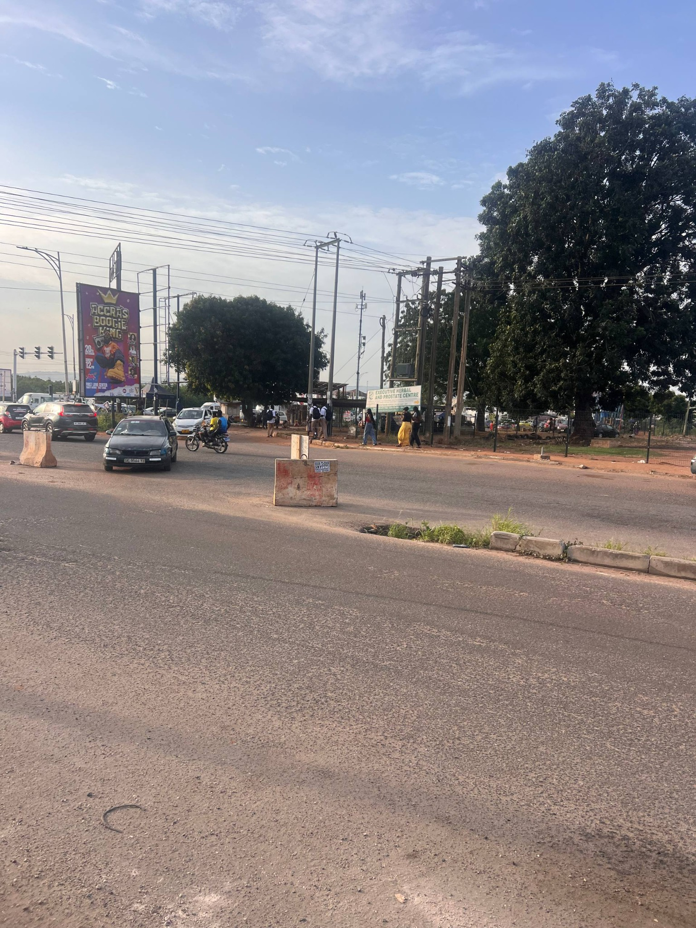

Field photo 02
Opposite-direction road view; paver sidewalk, roadside trees, informal roadside structures and overhead utilities.
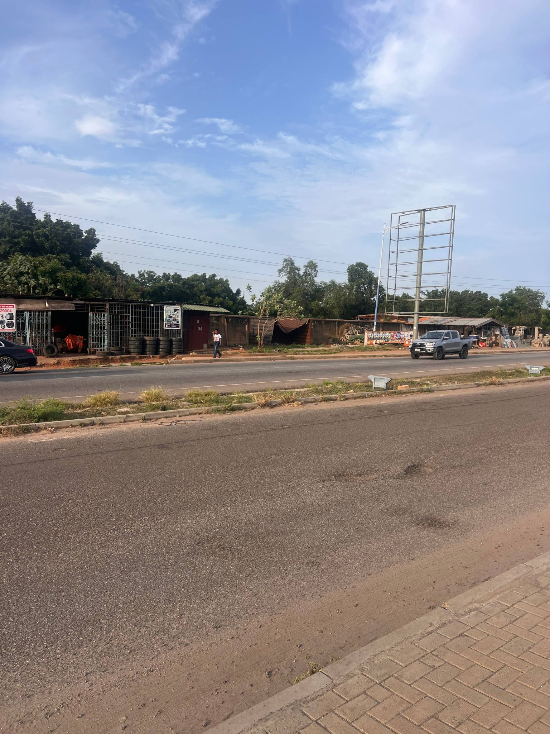

Field photo 03
Close view of interlocking pavers and the uneven dirt/asphalt transition along the carriageway.
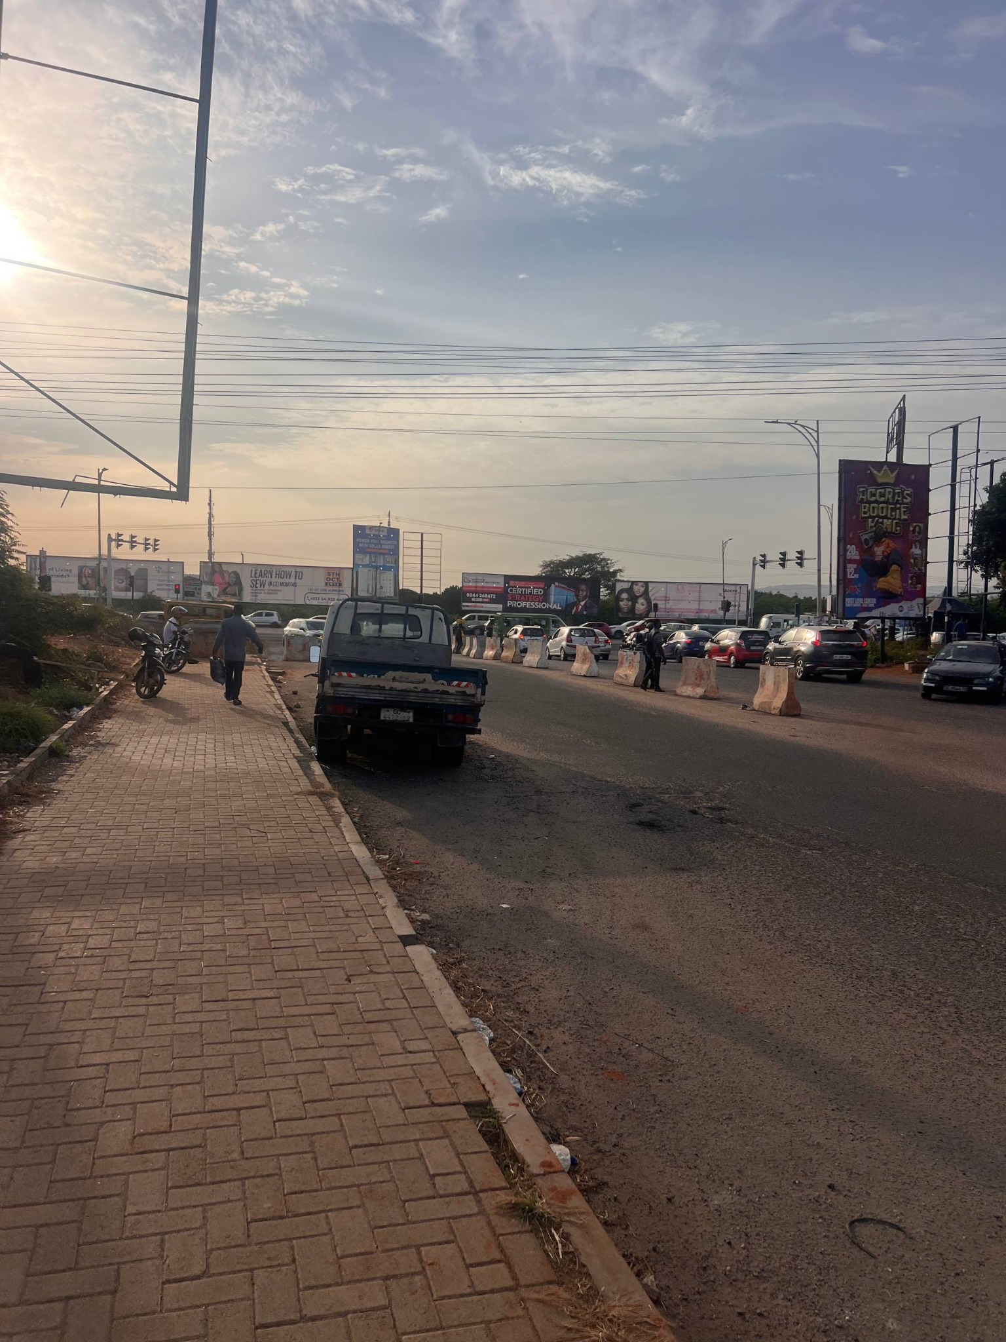

Field photo 04
Large lattice transmission tower, planted median/roadside strip, boundary wall, pedestrians and traffic.
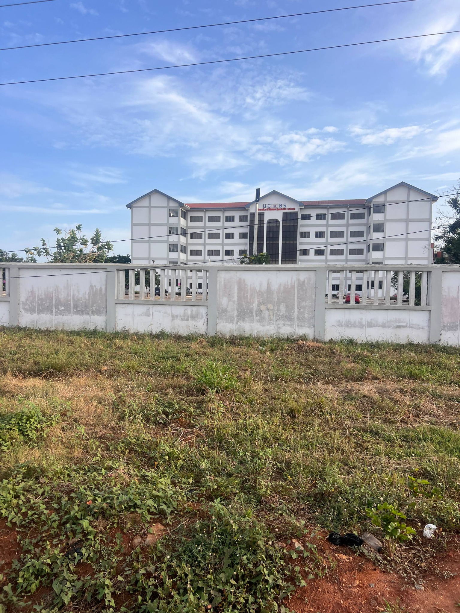

Field photo 05
Second view along the same straight corridor; sidewalk width, curb and roadside vegetation.
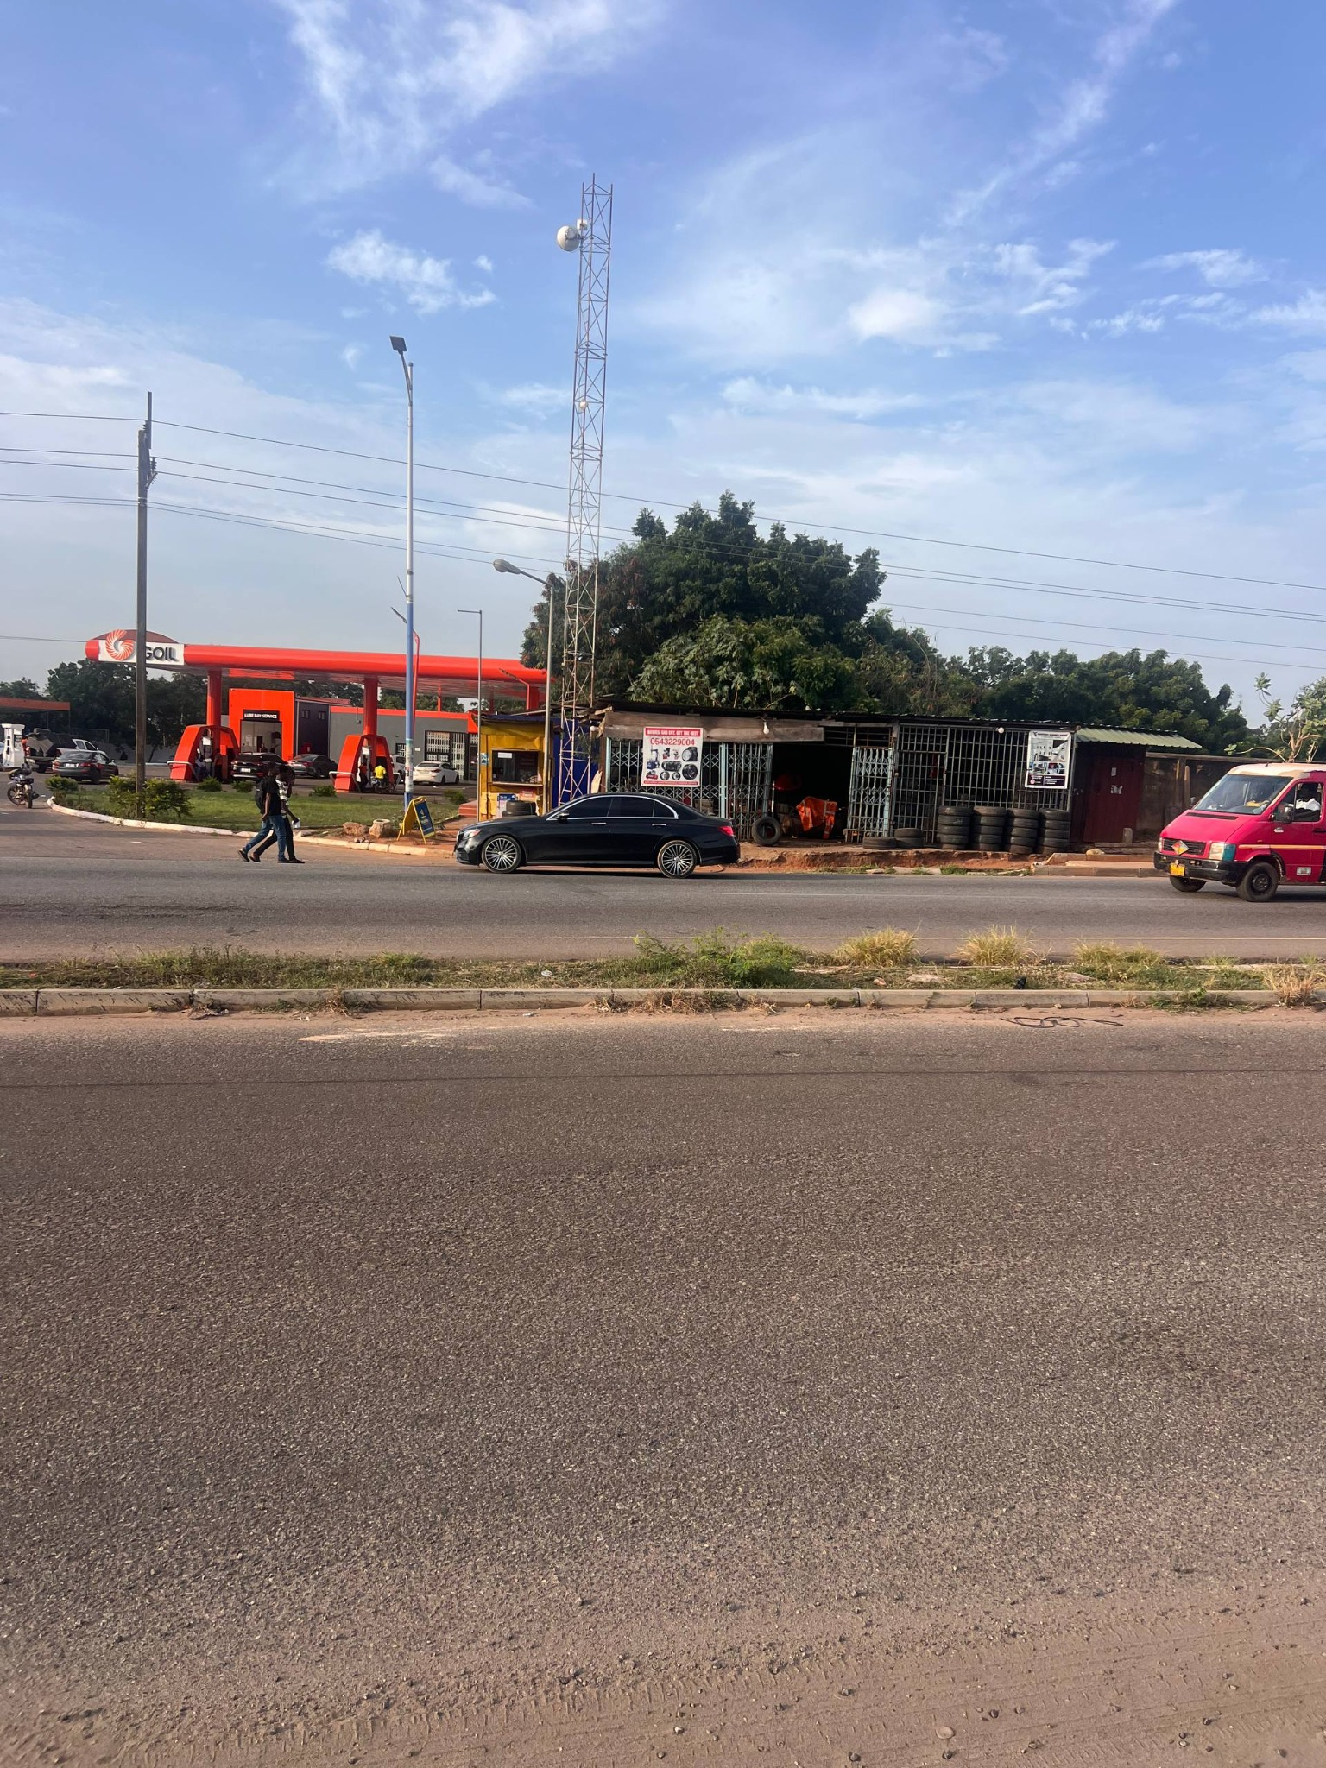

Field photo 06
Road perspective with the sidewalk in the foreground and transmission tower near the vanishing point.
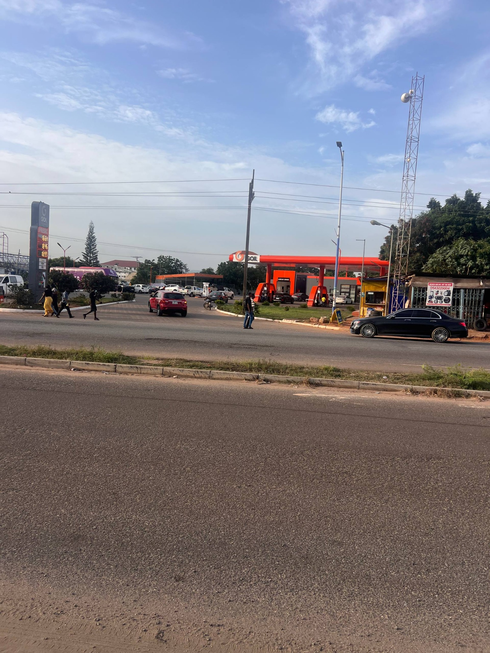

Field photo 07
Approach toward the junction with multiple vehicles, signage frames and traffic control visible ahead.
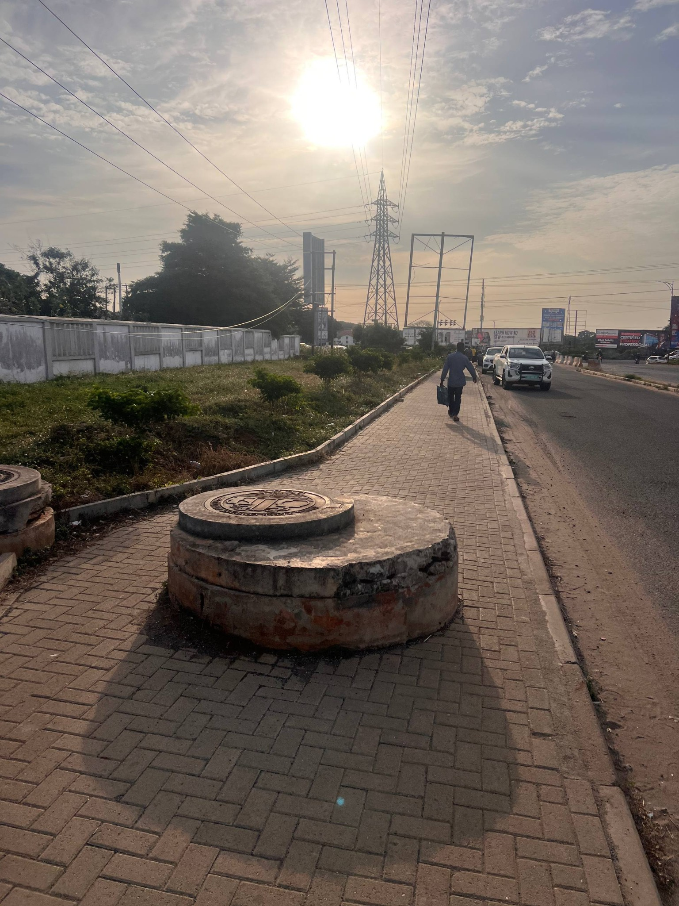

Field photo 08
UGBS Graduate Building seen behind a fence from an oblique angle; roadside landscape and foreground utility structure.
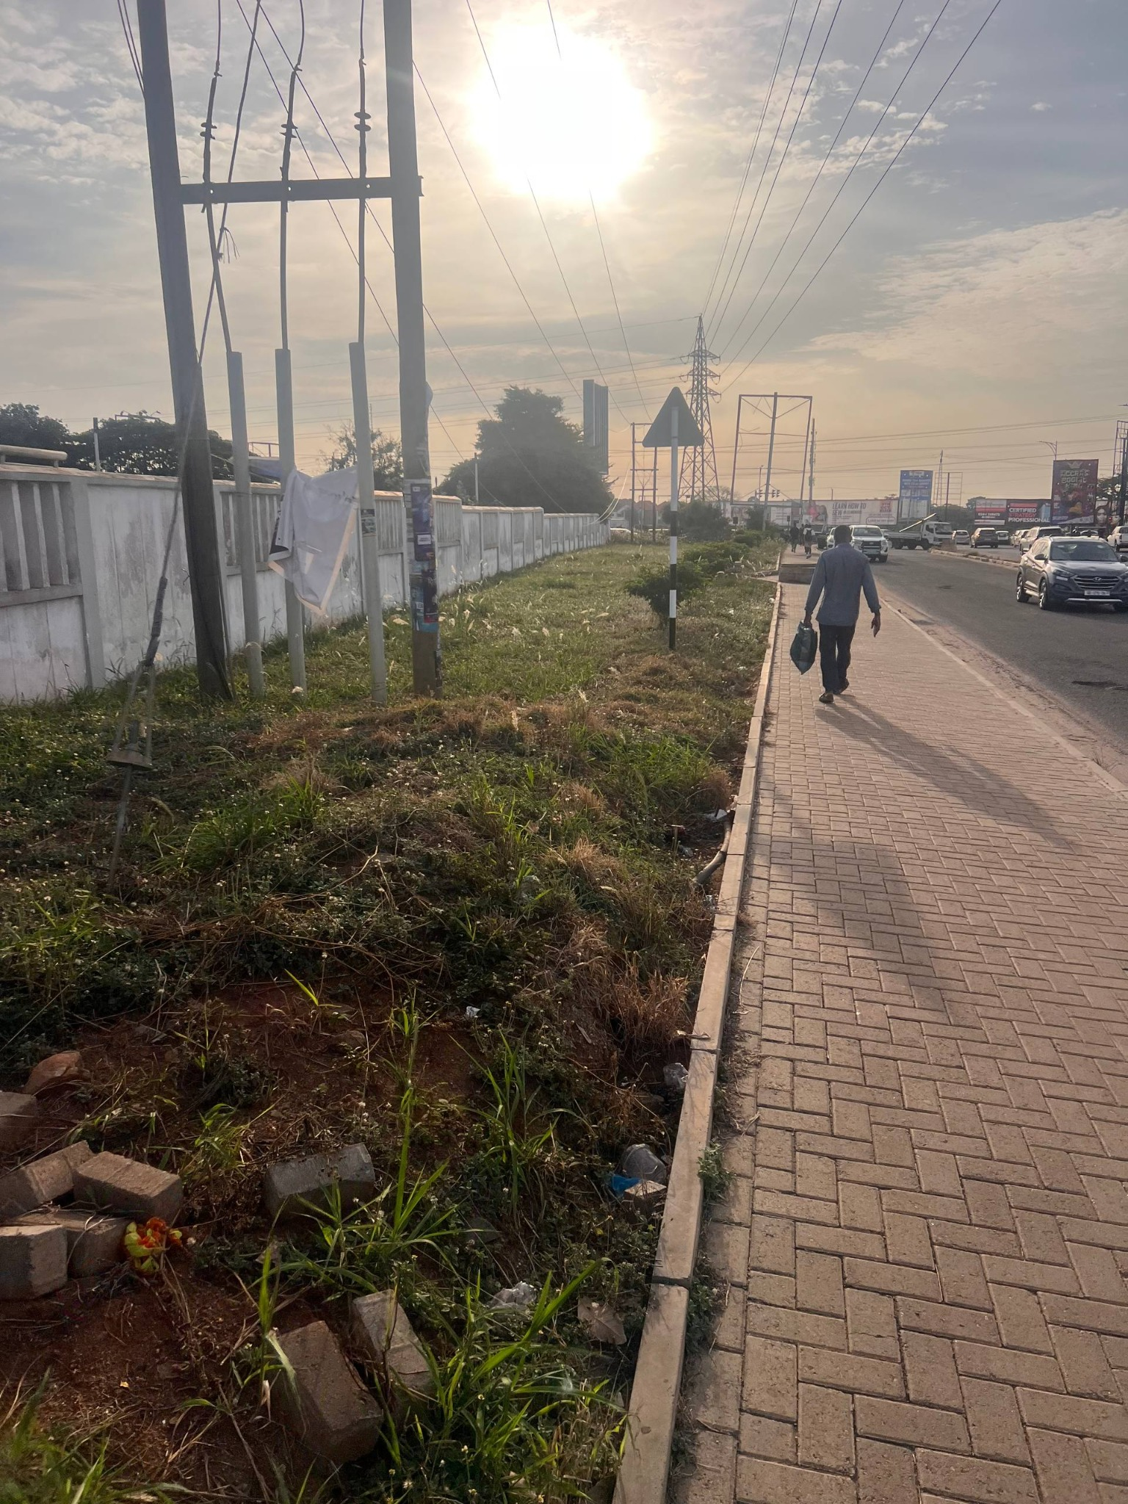

Field photo 09
Approach corridor with roadside wall, pedestrian paving, transmission infrastructure and distant junction activity.
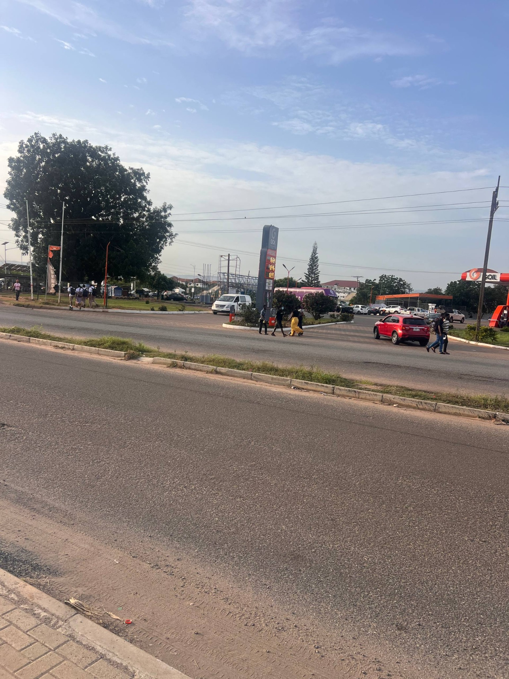

Field photo 10
GOIL station frontage from across the highway; branded canopy and tall price/sign pylon are visible.
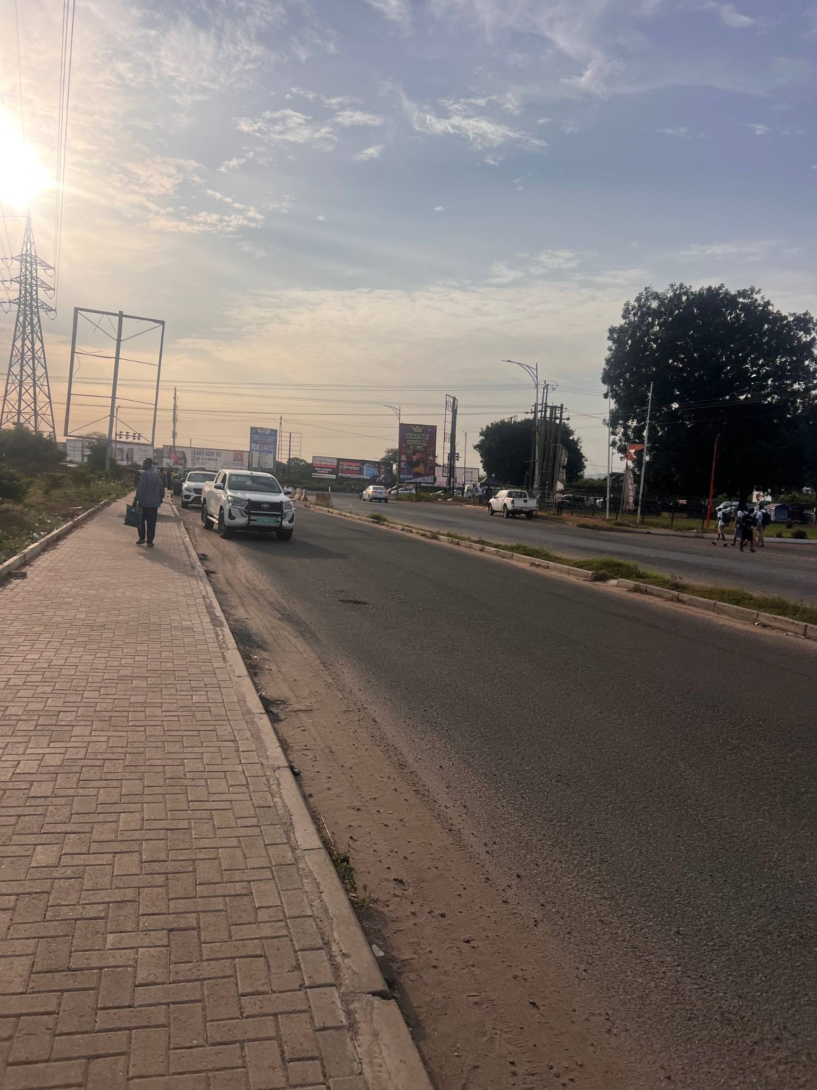

Field photo 11
GOIL forecourt and neighboring roadside workshops/shops; overhead wires and telecom tower provide skyline cues.
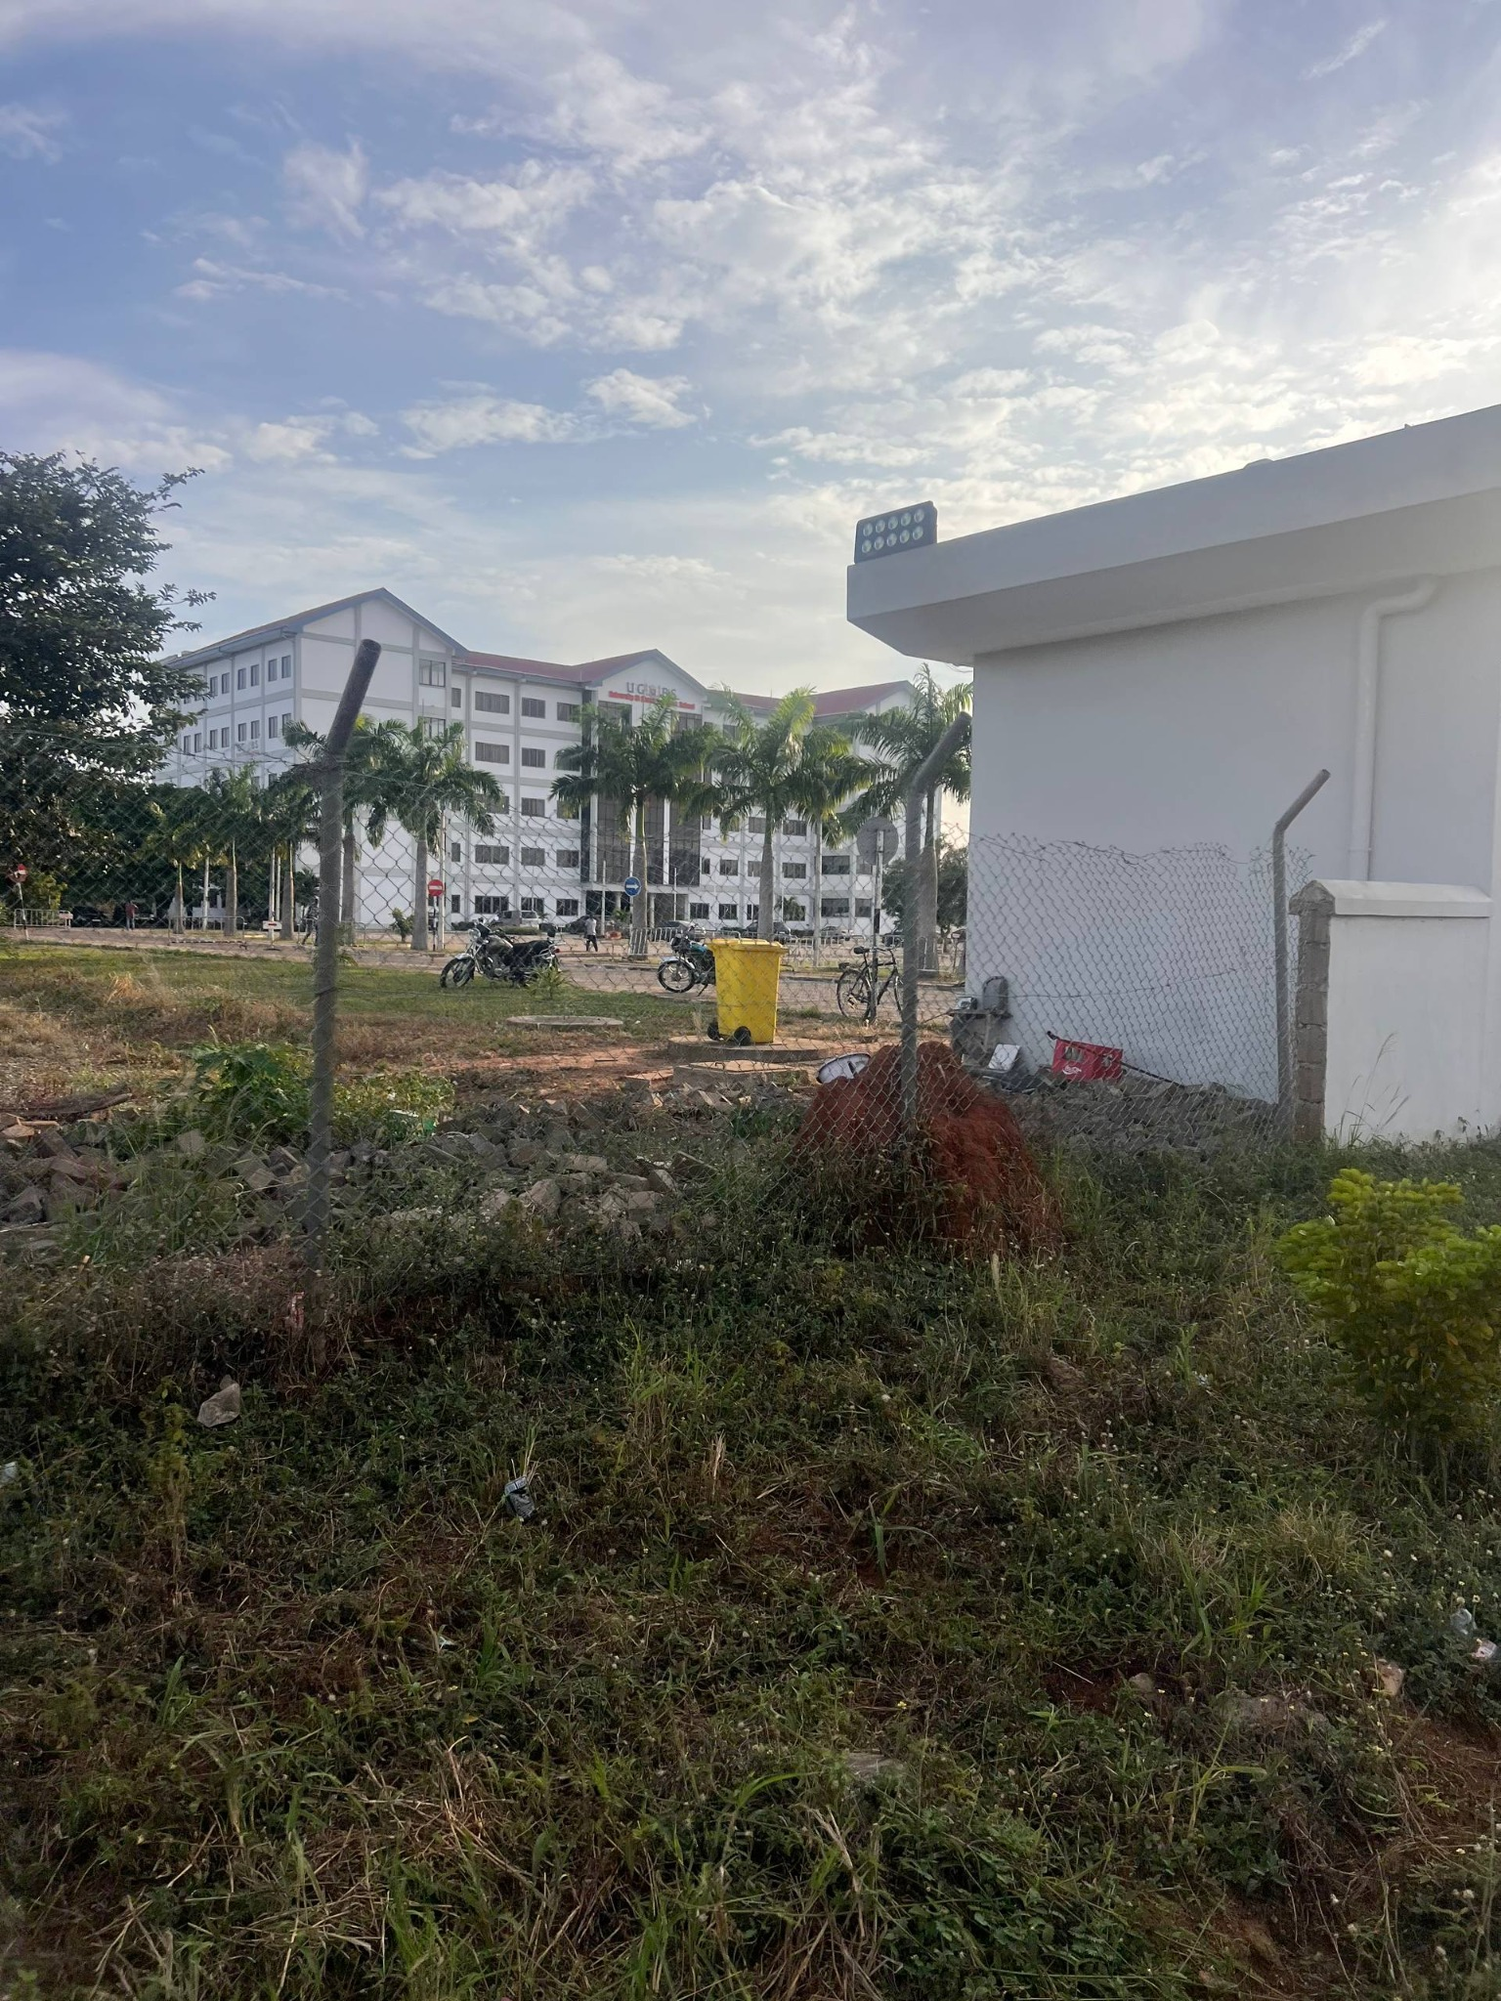

Field photo 12
UGBS Graduate Building front elevation behind its perimeter wall; symmetrical wings, red roof and dark central glazing.
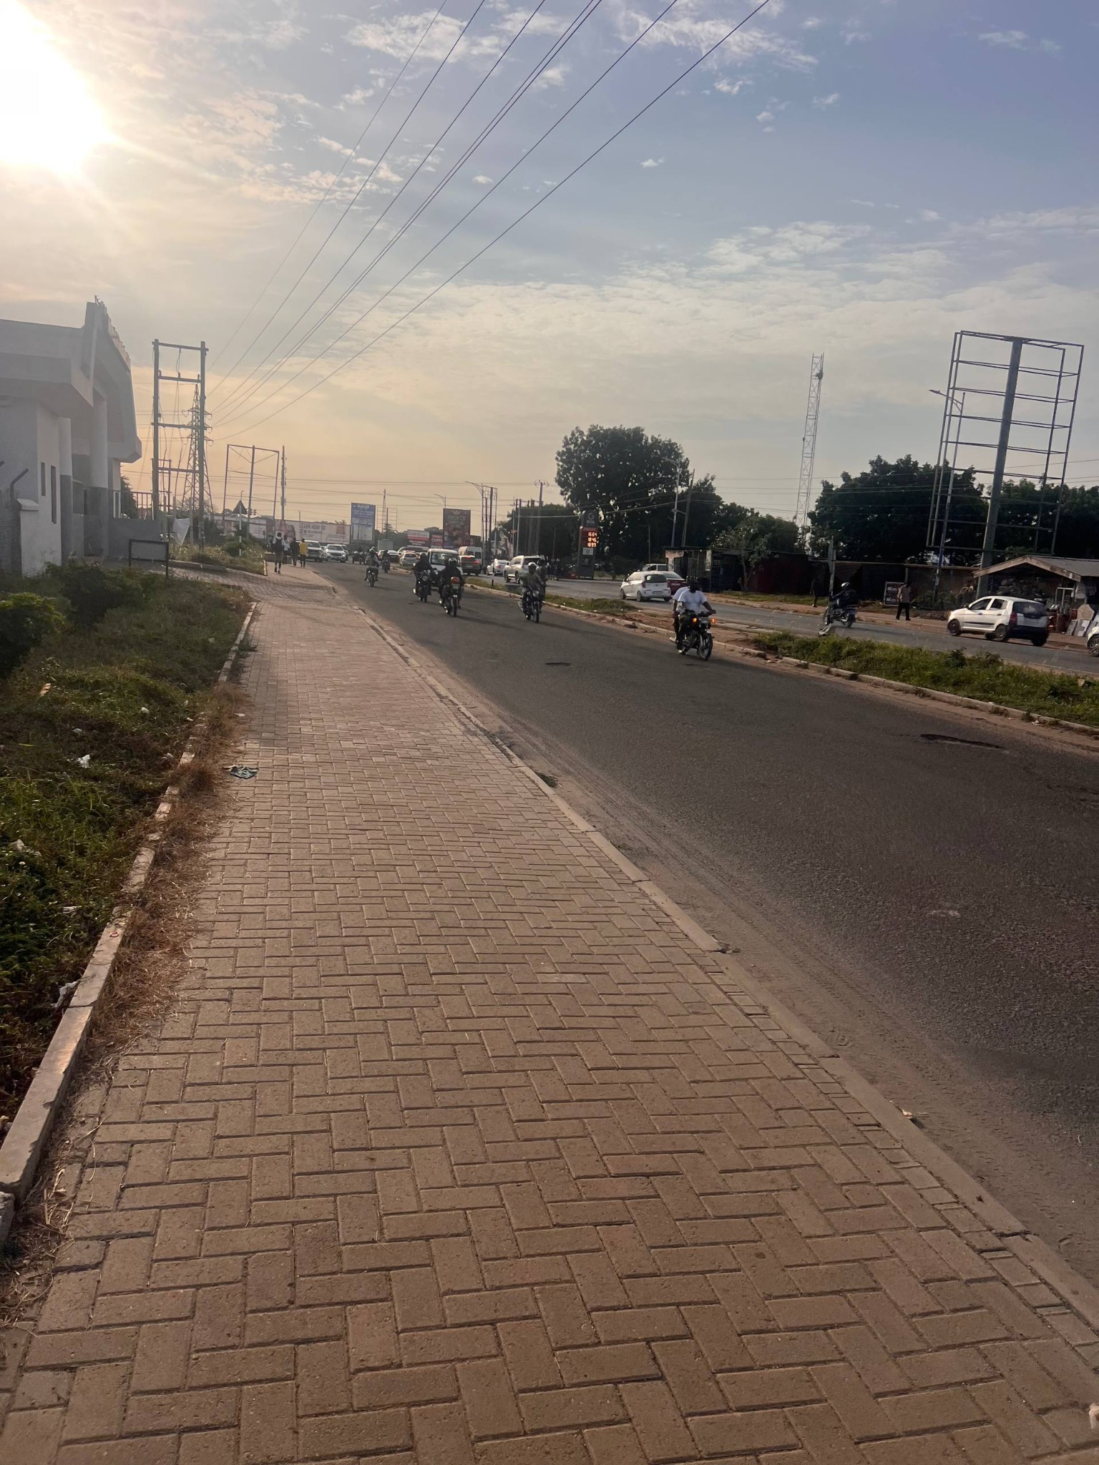

Field photo 13
Junction approach with pedestrian paving, vehicles, billboard/sign frames, traffic signals and concrete barriers.
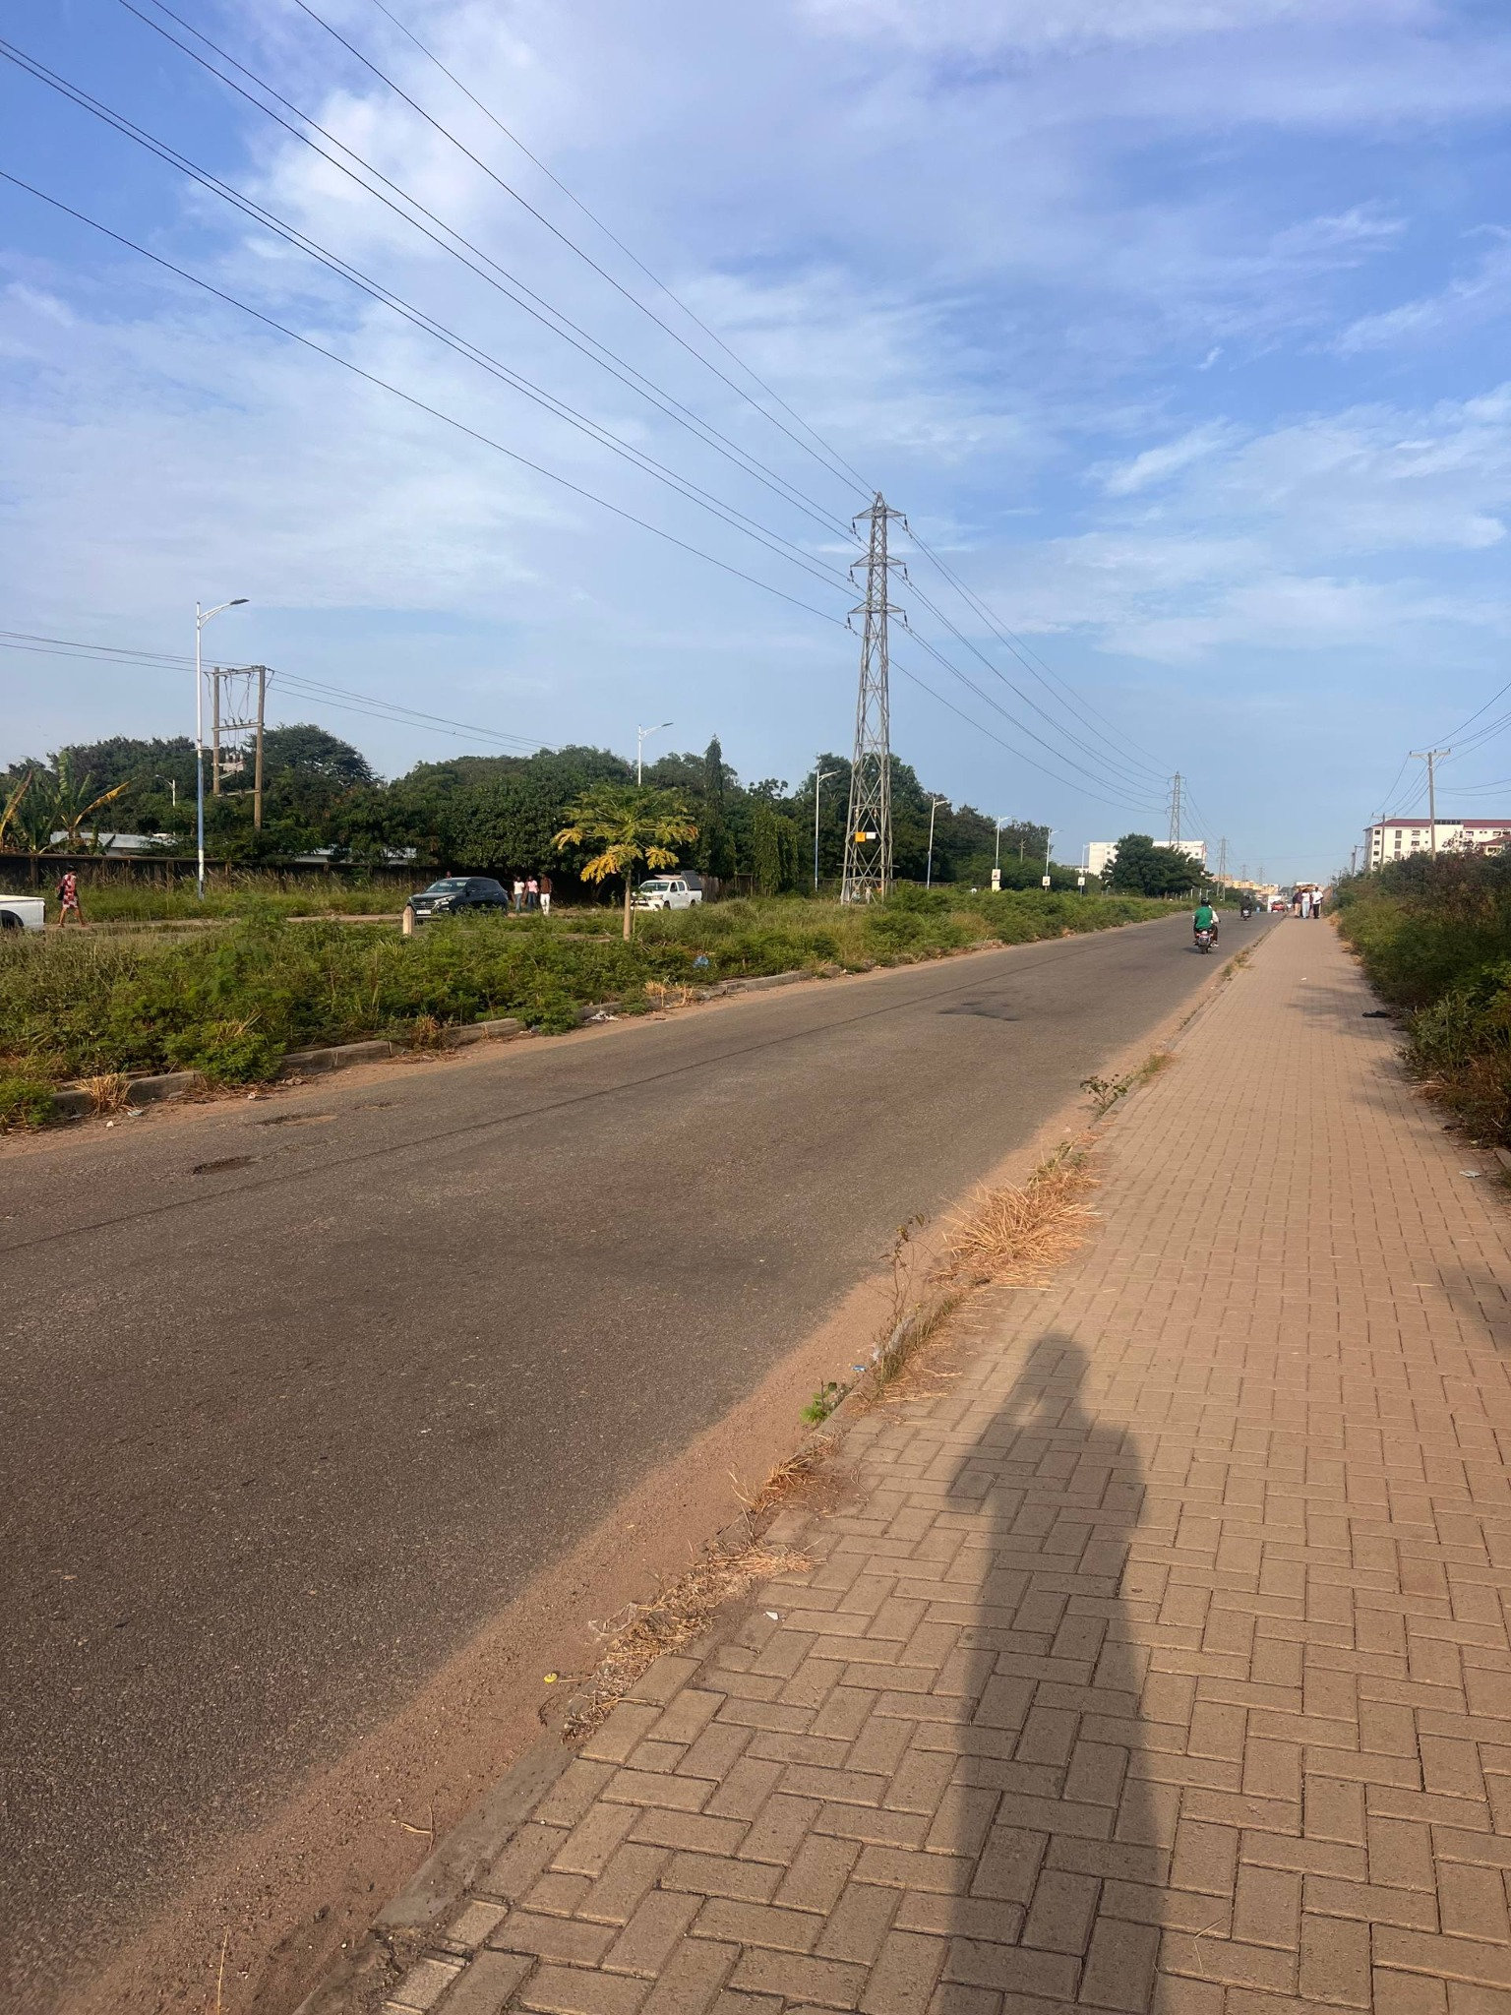

Field photo 14
Opposite side of the GOIL frontage and roadside shops; broad paved carriageway and planted median edge.
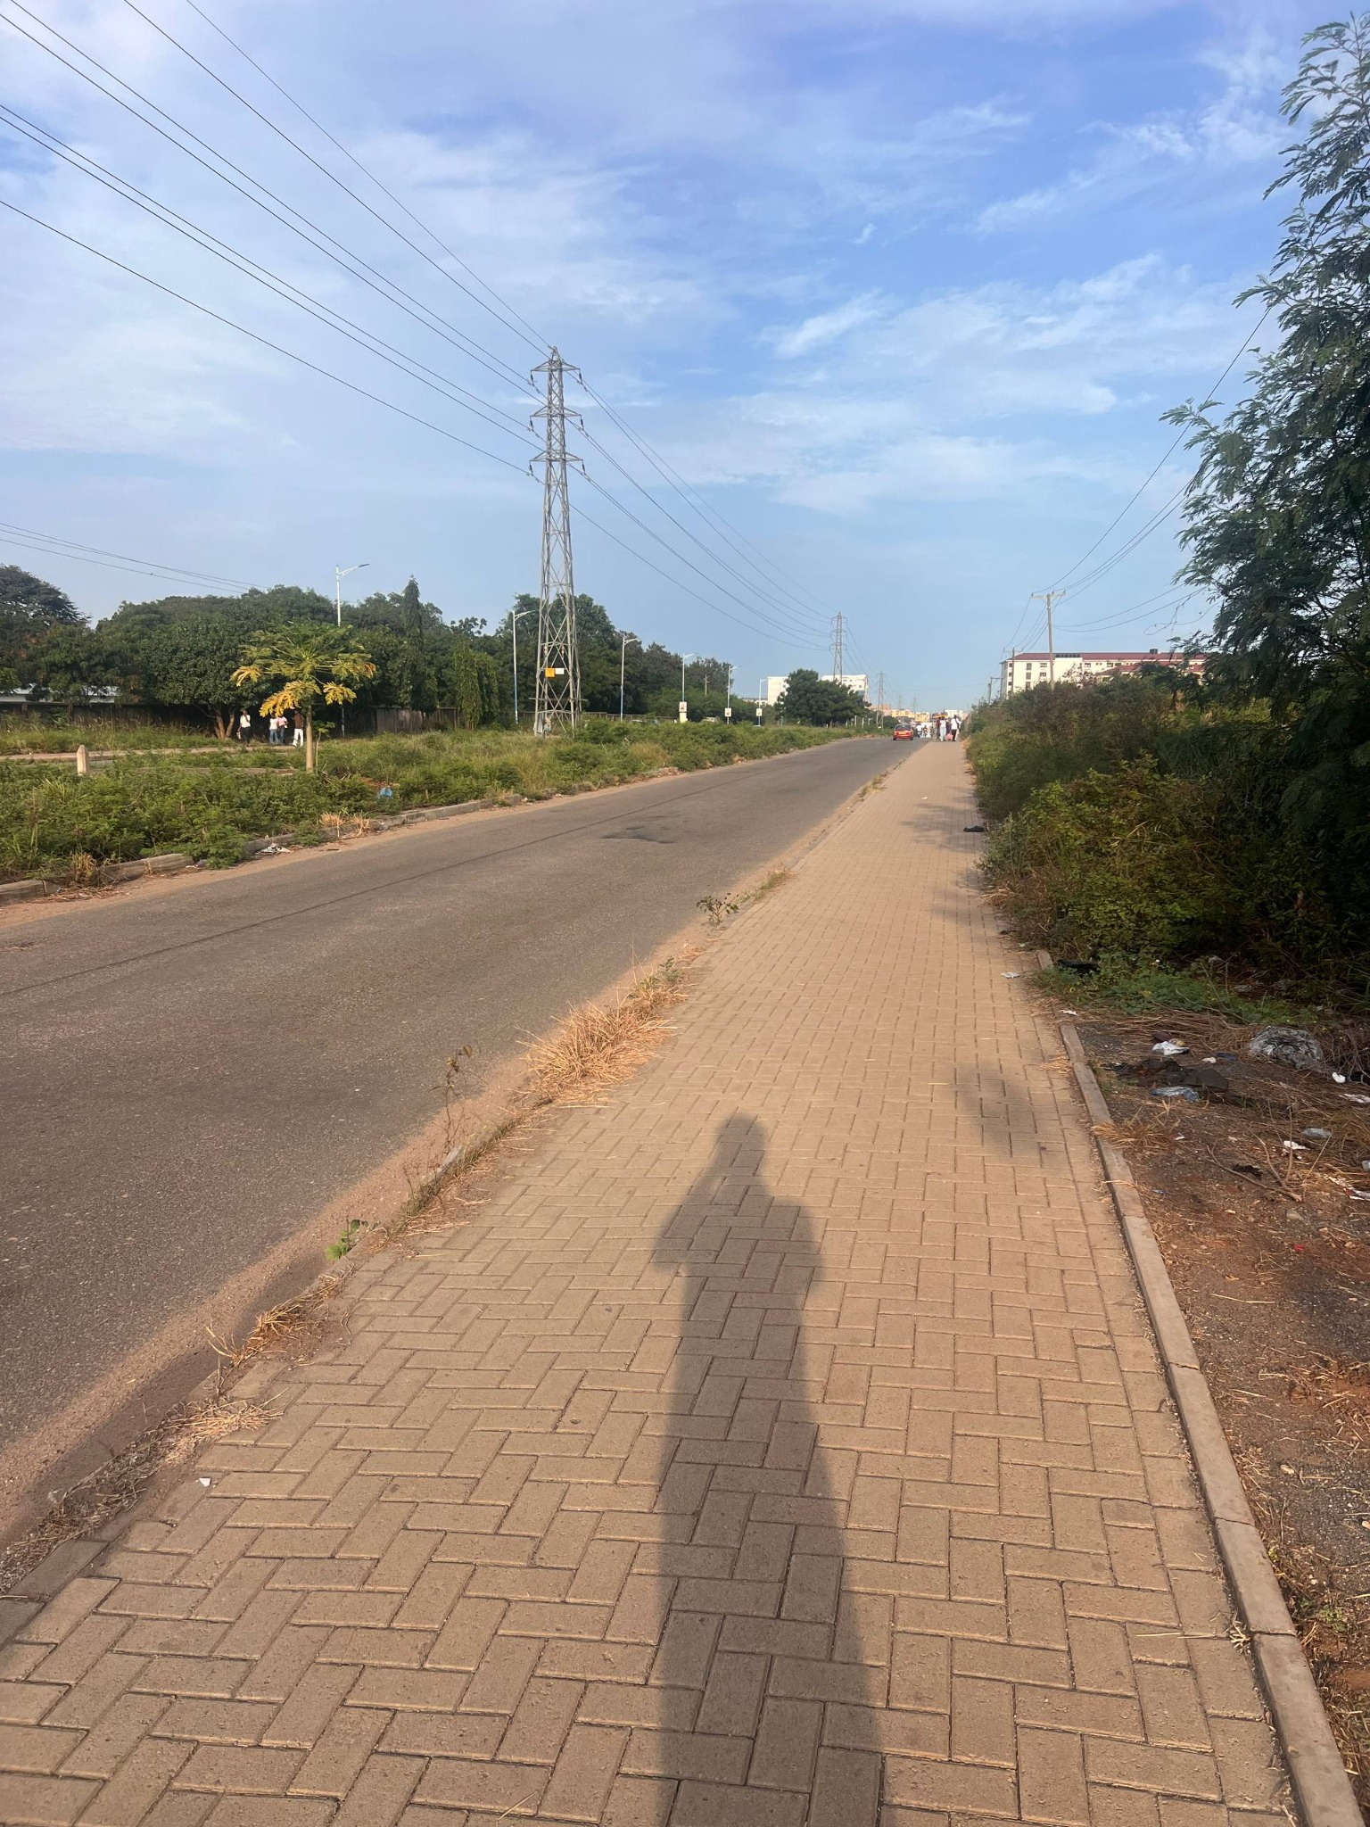

Field photo 15
Junction-side open area with a large mature tree, billboard, utility equipment and traffic approaching the intersection.
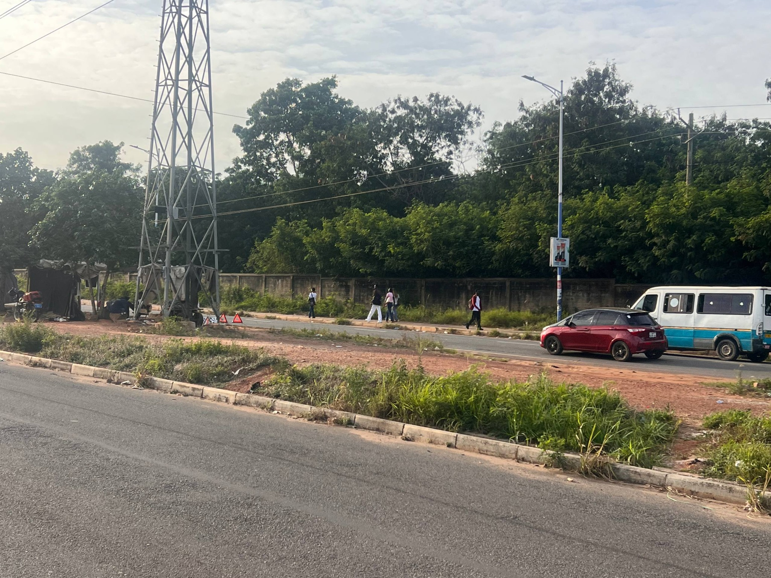

Field photo 16
GOIL canopy and tall sign from a different angle; forecourt access and road crossing activity.
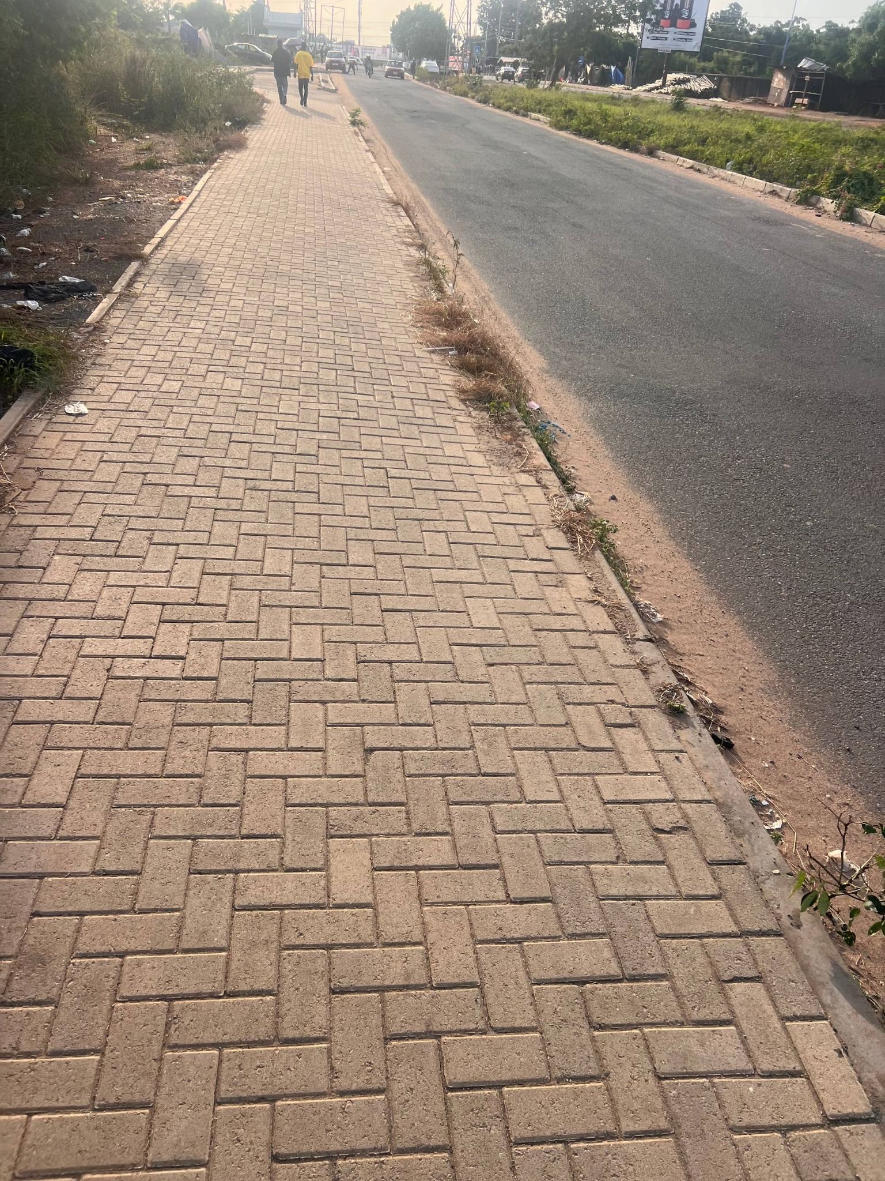

Field photo 17
Circular raised utility/manhole structure embedded in the sidewalk; useful detail for paving and street furniture.
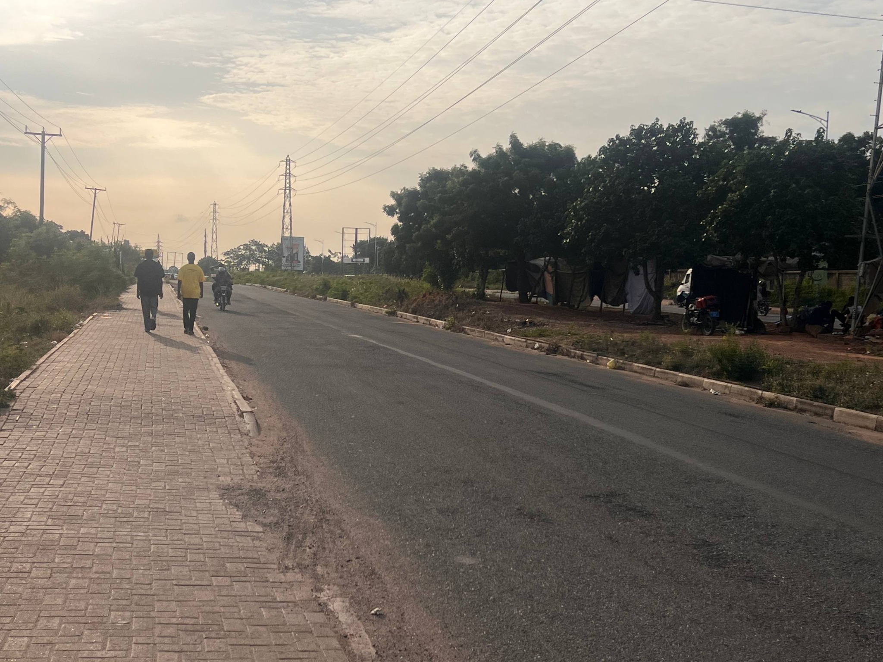

Field photo 18
Wide view of the GOIL station across the road with orange-red canopy, pylon sign, telecom tower and neighboring businesses.
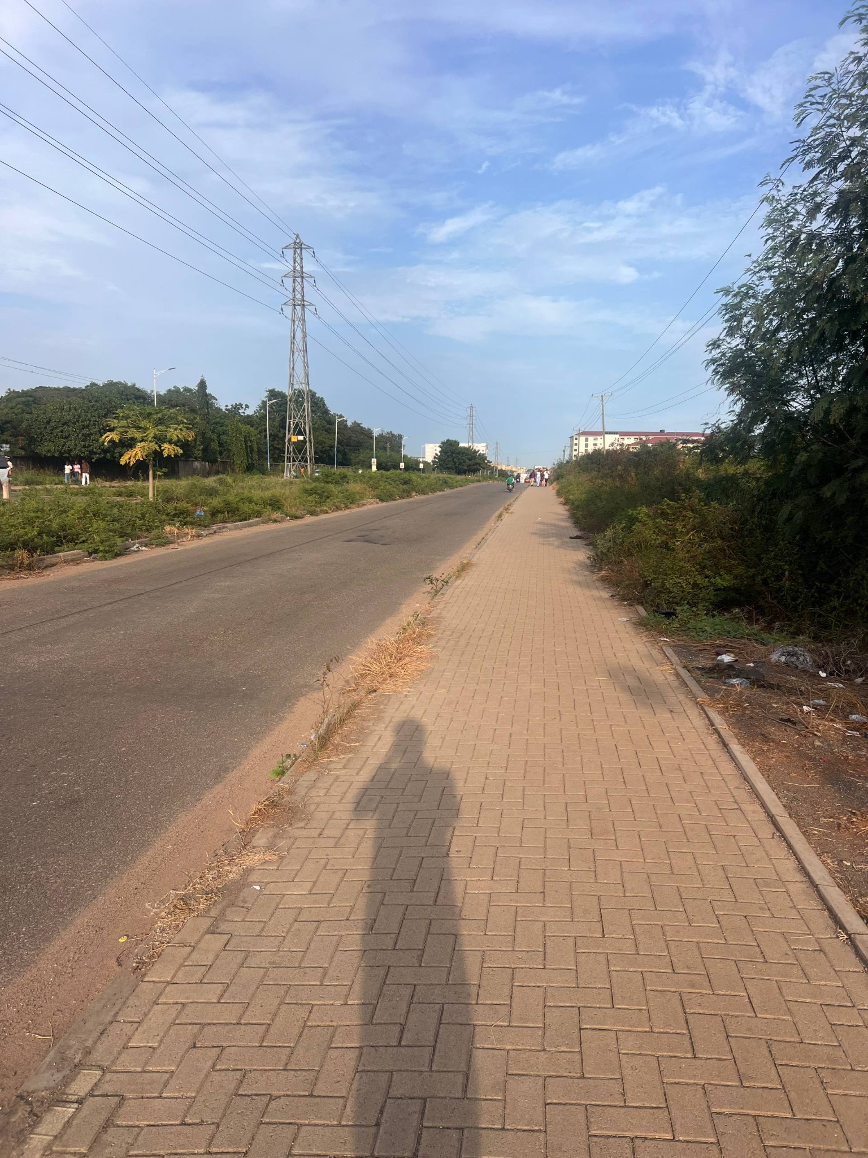

4. Site interpretation for the 3D reconstruction

4.1 Road corridor and junction
- Represent the main road as a broad, worn asphalt carriageway. The photos show subtle surface variation, patches and dusty shoulders rather than a pristine, uniformly dark surface.
- Preserve the real road alignment and branching from the repository's road graph. Do not redraw or simplify intersections by eye if authoritative OSM/project geometry exists.
- Roadside edges are not uniformly landscaped: some stretches have a curb, a narrow sandy strip, low weeds, scrub or a planted median; other edges transition directly from asphalt to dirt.
- At the junction approach, add the visible traffic-control context: signal heads, temporary concrete barriers where appropriate to the current state, sign frames/billboards, and vehicles/pedestrians only if those systems already exist or are separately in scope.
- Make the road, curb, pavers, drains and terrain meet continuously without z-fighting, floating strips, sudden sidewalk gaps or raised bars. Sidewalk edge elevation must remain consistent along each segment and through junction transitions.

4.2 Brick-paver sidewalks and curbs
- Sidewalk surface: warm dusty tan/brown interlocking rectangular pavers, laid in a repeating interlocking/herringbone-like pattern. Individual blocks and joints are visible, but do not over-scale the pattern.
- Sidewalks are relatively broad and continuous along the photographed corridor. Use consistent width within each continuous segment; adjust only where the photos or map support a change.
- Use a low concrete curb/edge restraint along the road and outer verge where visible. Edges are worn, dusty and irregular in places, not glossy or perfectly sharp.
- Include occasional weeds growing at the road-side seam and along the curb, plus dirt, dry grass and scattered small litter as restrained environmental details.
- One photograph shows a raised circular utility/manhole chamber sitting on the pavers. Treat it as a local obstruction/utility detail, not a repeating sidewalk feature; do not place it in a riding line unless accurate positioning is confirmed.

4.3 Electrical infrastructure and street lighting
- A prominent tall steel lattice transmission pylon stands close to the corridor and is a key skyline landmark. Additional pylons recede into the distance.
- Several parallel overhead power lines run longitudinally above the road and across the sky. The wires are visually important in the photographs; if full wire geometry is too expensive, prioritize the nearest lines and a believable receding rhythm.
- Smaller utility poles and streetlights appear at intervals. Their spacing and height should follow the photographic perspective; avoid randomly scattered poles.
- Keep electrical structures outside drivable road space and ensure collision/navigation systems do not treat thin overhead wires as obstacles.

4.4 Planting, boundary walls and roadside activity
- Vegetation is mixed and somewhat unmanaged: dense mature tree canopies, hedges/scrub, grass, weeds, and red-brown exposed soil.
- A long light-colored concrete boundary wall with regularly spaced posts/panels appears along one stretch opposite the station/building views.
- Near the junction are roadside businesses/workshops with simple low roofs, open fronts or security grilles, plus billboard/sign frames. These form the context between the formal station and the wider junction.
- Large mature trees are important landmarks, especially the broad canopy near the junction. Preserve their approximate placement relative to road edges, sign structures and opposite traffic lanes.
- Do not create dense decorative landscaping that hides the road edges or obscures the pylon, GOIL sign, station canopy or UGBS building.

4.5 GOIL filling station
- Primary visual identifier: a long, low, orange-red branded canopy with white GOIL fascia/logo, supported by regularly spaced columns. Match the proportions and orientation visible in field photos.
- Below the canopy, represent multiple pump islands, dispenser columns, vehicles and a small service/operations volume. Keep pump details legible at normal gameplay distance, not hyper-detailed.
- A tall, narrow freestanding GOIL sign/pylon stands near the road approach, with a dark blue/charcoal vertical body, GOIL branding at the top and stacked fuel-price panels below. Exact current prices are not required; avoid inventing readable prices.
- The station has a wide paved forecourt connecting to the highway. The entrance and exit should be broad enough for cars and align with the observed access points.
- Nearby elements include a small roadside kiosk/shop/workshop and a tall lattice telecom mast. Their exact ownership and boundaries are not confirmed; place them only where supported by photos/map context.
- Do not use a random GOIL branch as the exact model. Official GOIL galleries are useful for brand cues only; the user's photographs define this branch's layout.

4.6 UGBS Graduate Building
- The building is a multi-storey, largely symmetrical institutional block. The front elevation has repeated window bays across long wings, a central dark-glazed vertical entrance feature, and projecting end/gable-like roof forms.
- Exterior is predominantly white/light cream with pale structural framing and a muted red/brown pitched roof. The central entrance/glazing is darker and vertically emphasized.
- A light concrete perimeter wall with alternating solid panels and open vertical sections runs in front of the property in the user's views. The building is set back behind the boundary and landscaping.
- Use the official UGBS building/campus images for a second visual check, but use the supplied frontal photograph as the strongest source for façade rhythm and symmetry.
- Exact floor count, floor-to-floor heights, window dimensions and plot boundaries should be measured from map/building references where possible; if not, use proportional estimates and label them as estimates in code comments or the asset notes.

5. Evidence hierarchy and uncertainty
- Tier 1 — User's 18 photos: strongest source for current materials, visual appearance, adjacency, and the relative positions visible in the photographs.
- Tier 2 — Official University of Ghana / UGBS pages: authoritative for the building identity and the stated relationship “UPSA Junction, opposite GOIL.”
- Tier 3 — Location listings / Mapcarta / OSM: useful for geographic context and approximate coordinates; verify exact ways and junctions against repository data.
- Tier 4 — General GOIL gallery or historical GOIL photos: branding and station design only. They may show other branches and must not be treated as exact geometry for UPSA Junction.
- Unknowns that should not be fabricated: exact parcel boundary, current pump count if occluded, exact fuel-price digits, exact curb/sidewalk dimensions, exact sign wording, and unobserved back sides of buildings.

6. Recommended implementation workflow for Claude Code
- Read CLAUDE.md and docs/migration/ before editing. Identify the current road, terrain, sidewalk/curb, building, landmark and asset pipelines.
- Inspect the authoritative geography files and existing route/access tests first. Determine the precise target area from map coordinates and current game geography; do not hand-place the junction without aligning to that data.
- Create a small, explicit feature plan and locate the existing segment/mesh generators for road surfaces, sidewalks, curbs, terrain, roadside objects and building footprints.
- Align all 18 photos conceptually by landmarks. Use the GOIL station, UGBS building, tower, wall, major tree, billboard frames and curb/median lines as control features.
- Implement the road/junction and sidewalk continuity before adding decorative objects. Confirm no duplicate road strips, floating curb pieces, z-fighting or abrupt sidewalk endings.
- Build the GOIL site and sign as modular, lightweight assets. Use a simple canopy, columns, pump islands, forecourt, sign pylon and service block. Reuse the project's material and asset conventions.
- Build the UGBS Graduate Building façade with repeated window modules and a distinct central dark-glass entrance; align its footprint/orientation to the verified site geometry.
- Add major vegetation, boundary wall, pylons/poles, wires and roadside structures. Prioritize silhouette and spatial placement over tiny details.
- Run type checks, geography/route tests, production build and relevant smoke tests. Inspect the scene from the road approach, opposite carriageway, station entrance and UGBS-facing views.
- Report files changed, assumptions, tests, screenshot/preview evidence, and commit status. Do not change main branch or deploy without explicit approval.

7. Non-negotiable project safeguards
- Do not modify authoritative road/path centerlines, route IDs, race/challenge geometry, gate/access coordinates or landmark IDs merely to improve visuals.
- Preserve collision/navigation correctness. Roads remain rideable; sidewalks and curbs do not form unintended walls; station access must not cut across unrelated buildings.
- Do not replace the real junction with a generic roundabout or a simplified four-way crossroad unless the authoritative map confirms that geometry.
- Keep mesh elevations consistent. Asphalt, sidewalk pavers, curbs, gutter/drainage edges, terrain and station forecourt must be layered intentionally to avoid flicker.
- Keep performance in mind: reuse geometry/materials and instancing where possible for pavers, windows, poles, vegetation and repeated station components.
- Do not add fictional signage or logos. Keep any small text texture subtle if exact text cannot be read.

8. Copy/paste task prompt for Claude Code
Task: Reconstruct the real Legon–UPSA Junction area around the GOIL Filling Station and UGBS Graduate Building in LEGONRUSH, using this reference pack.
Start by reading CLAUDE.md and docs/migration/ plus the existing geography/building/road documentation. Inspect the current code and authoritative geographic datasets before editing. Treat the 18 numbered field photos in user_photos/ as the primary visual reference. Use the linked official University of Ghana/UGBS pages to confirm place identity and adjacency; use GOIL online galleries only for branding cues, not as exact UPSA station geometry.
Recreate the correct road/junction layout from authoritative map data, broad worn asphalt carriageways, tan interlocking-paver sidewalks, continuous low curbs, dusty shoulders, scrub/grass, long boundary wall, roadside workshops, billboards/sign frames, major mature tree, steel lattice electrical pylons and overhead wires. Model the GOIL station with its orange-red canopy, white GOIL fascia, columns, pump islands, broad forecourt and tall vertical price/sign pylon. Model the UGBS Graduate Building as a symmetrical multi-storey light-coloured institutional block with repeated window bays, red/brown roof and dark central vertical glazing, behind the visible concrete boundary wall.
Use evidence-based placement and proportions. Do not invent exact dimensions or unreadable sign text. Do not alter authoritative roads, route geometry, gate/access points, IDs or race/challenge routes. Fix continuity issues at asphalt/terrain/curb/sidewalk junctions and prevent z-fighting, floating strips, raised bars, gaps and clipping. Keep rideability, collisions and performance intact.
Work autonomously through investigation, implementation, tests and visual inspection without asking for intermediate approval. Run type checks, route/geography tests and production build; inspect the target area from multiple approach angles. Do not commit/push to main or deploy production without explicit approval. At completion, report root changes, files, assumptions, tests and preview evidence.

9. Online references and image-search links
- University of Ghana — Inauguration of UGBS Multi-purpose Graduate Building — Official University of Ghana source. Identifies the Graduate Building along the Legon–Madina Highway, right turn before PRESEC, opposite GOIL. https://old1.ug.edu.gh/events/inauguration-ugbs-multi-purpose-graduate-building
- University of Ghana Business School — MSc Business Analytics — Official UGBS programme page. Gives the Graduate Building address as UPSA Junction, opposite GOIL Filling Station. https://www.ugbs.ug.edu.gh/index.php/course/msc-business-analytics
- University of Ghana Business School — Campus Tour / Graduate School — Official UGBS site with a Graduate School campus-tour image. Useful for architectural cross-checking. https://www.ugbs.ug.edu.gh/home
- GOIL PLC — Official Photo Gallery — Official company gallery. Use for corporate branding and station design cues; gallery entries may be other branches, not the UPSA station. https://goil.com.gh/gallery/
- GOIL UPSA Junction — location listing — Local listing gives coordinates near 5.6603216, -0.1774666. Treat as a locator, not a survey-grade boundary. https://gh.near-place.com/goil-filling-station-upsa-junction-n4-accra
- GOIL station — Vymaps listing — Additional station location reference on N4, Accra. https://vymaps.com/GH/Goil-Filling-Station-60197/
- UGBS Graduate Campus — Mapcarta / OpenStreetMap — Map context and nearby road relationships. Cross-check geometry against the repository's authoritative map data. https://mapcarta.com/W797937346
- GOIL station photo — Wikimedia Commons (general reference, NOT confirmed to be this branch) — General GOIL station appearance reference; location is not confirmed as UPSA Junction. Check license/attribution before reuse. https://commons.wikimedia.org/wiki/File:GOIL_Tankstelle_Accra_2013_B003.jpg
- Google Images search — GOIL UPSA Junction — Image discovery page; open individual results and verify location/source/license. https://www.google.com/search?tbm=isch&q=GOIL+UPSA+Junction+Accra
- Google Images search — UGBS Graduate Building UPSA Junction — Image discovery page for the target building. https://www.google.com/search?tbm=isch&q=UGBS+Graduate+Building+UPSA+Junction+Accra
- Google Images search — Legon Madina Highway UPSA Junction — Image discovery page for road/junction context. https://www.google.com/search?tbm=isch&q=Legon+Madina+Highway+UPSA+Junction+Accra
- Bing Images search — GOIL UPSA Junction — Alternative image discovery page. https://www.bing.com/images/search?q=GOIL+UPSA+Junction+Accra

10. Suggested image-search targets
Search and visually verify individual images before using them as assets. The image-search pages are discovery aids, not permission to reuse.
- GOIL UPSA Junction Accra front canopy sign
- UGBS Graduate Building UPSA Junction frontal elevation
- Legon Madina Highway UPSA Junction traffic signals
- UPSA Junction GOIL Accra road median utility pylons
- University of Ghana Business School Graduate Campus exterior

11. Included files
This pack contains this Word document, the 18 original field photos copied into a numbered folder, and a README with source notes. If the online download succeeded, a separate general GOIL station reference image is also included; it is not confirmed as the UPSA branch.

