LEGONRUSH | SCHOOL OF ENGINEERING SCIENCES
Building placement, aircraft display, façade, forecourt, parking and rear landscape correction brief
GOAL FOR CLAUDE CODE
Correct the School of Engineering Sciences area in two linked passes: (1) verify and correct its location/orientation and its relationship to the forecourt, aircraft display, parking, adjoining roads and rear vegetation; (2) replace the inaccurate generic in-game building appearance and environment with a model based on the supplied real photos. Keep the campus geography and gameplay working.

What the supplied references establish
- The real building is identified by the entrance sign “SCHOOL OF ENGINEERING SCIENCES”. Its massing is a connected multi-wing complex, not just one plain rectangular slab.
- The front/entrance block has four visible storeys including the ground level, a red/brown hipped tiled roof, dark-framed rectangular windows, white/light cream walls and a projecting entrance canopy with a red/brown roof. The rear/side wings have repeated breeze-block ventilation screens, arched ventilation features and red-tiled roofs.
- The aircraft is a decommissioned Aermacchi MB-339. The University’s School of Engineering official report says it was handed over at the School’s forecourt. Use the forecourt as the correct general zone; exact aircraft footprint and facing direction still need to be matched to the satellite/user photos and current geography.
- The map screenshots place the School of Engineering Sciences site immediately west of Annie Jiagge Road. The official School page gives the access description as “off the Annie Jiagge Road after the School of Law”. This is an approach anchor, not a surveyed driveway path.
- The user specifically requests dense bush/forest just a few metres behind the building area. Represent this as a compact continuous vegetation mass or a small number of clustered bush meshes, not dozens/hundreds of individually modelled trees.

Evidence and confidence rules
- Use the satellite screenshots to identify the site footprint, connected wings, forecourt, nearby parking and roads. Use the photographs for architecture, aircraft appearance and ground materials. Use the game screenshot to diagnose the current model.
- The map POI coordinate found online is for the School-level map feature, not for the building centroid, entrance, or jet. Do not reuse it as a precise building or aircraft coordinate.
- Do not shift footprints from visual guesswork. Inspect the existing LEGONRUSH geography data, building/landmark IDs, access geometry and collisions first. If exact alignment cannot be proved, record the current ID and unresolved mapping issue.

1. Image comparison: current model vs real building
CURRENT IN-GAME CANDIDATE — generic block beside sports court | REAL-LIFE FRONT VIEW — School of Engineering Sciences  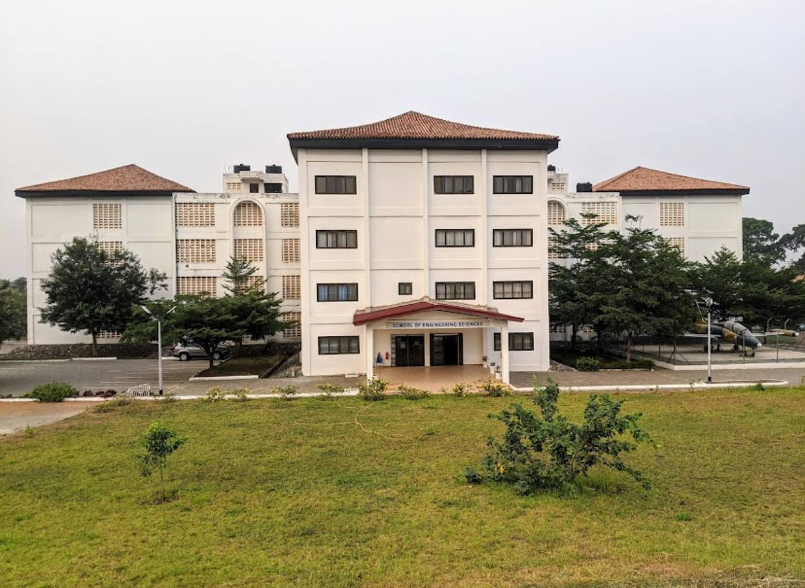

Primary visual mismatch to investigate: the current in-game candidate appears as a simple box with a repetitive blue-window grid and no clear red-tile roof, projecting entrance canopy, or connected rear/side wings. The real complex has a distinctive central entrance mass, multiple attached wings, pitched tiled roofs, and screened ventilation bays. Claude must verify that the in-game block is the actual SES footprint before modifying it; if the ID corresponds to another building, find the correct SES mesh/ID instead.
REAL-LIFE CLOSE VIEW — front/side and entrance roof  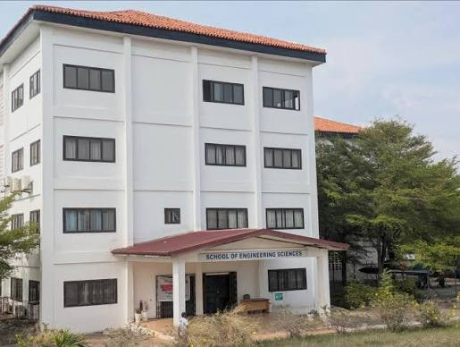 | REAL-LIFE AERIAL-ANGLE VIEW — roof geometry and connected wings  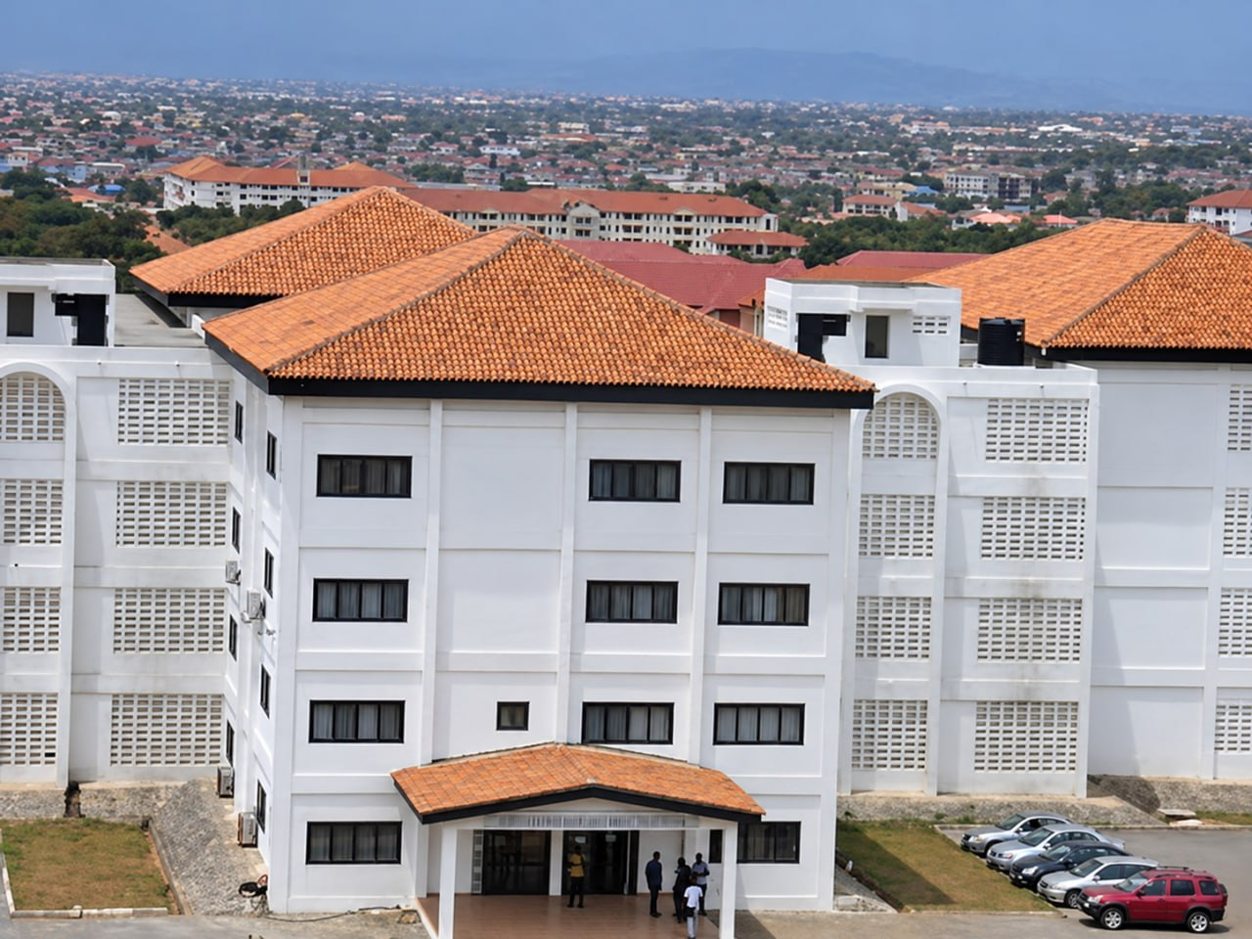

2. Architectural correction specification
- Overall massing: recreate a connected complex with a taller, central/front entrance block and two longer lower side/rear wings. Preserve the stepped/jointed roof plan visible from above; do not simplify it into one rectangular prism.
- Front block: about four visible levels in the reference, pale cream/white walls, visible vertical pilaster-like projections and horizontal floor bands. Use the photo to match relative proportions; treat storey count as visually observed, and verify any obscured levels before locking height.
- Roof: terracotta/red-brown tiled hipped roof over the main front block and lower wings, dark fascia/eaves. Use a pitched roof mesh with tile-coloured material, not a flat grey cap.
- Windows: dark charcoal/brown frames with blue/dark reflective glazing. Use correct group sizes and window spacing from the photos instead of the current uniform large bright-blue window grid. Add subtle sills/recesses and a small amount of reflected sky; avoid mirror-like overbright glass.
- Entrance: front-facing portico canopy projecting from the central entrance, red/brown sloped roof, light soffit, rectangular support columns, short steps/raised tiled landing and dark entrance doors. Put readable “SCHOOL OF ENGINEERING SCIENCES” signage above the doors; keep sign size physically plausible.
- Side/rear wings: rows of pale perforated concrete breeze-block screens/ventilation grilles grouped into rectangular panels, some tall arched screen features between wings, additional smaller dark-framed windows and visible AC units where present in the references.
- Materials: pale painted render / light off-white small tile or panel texture; slight grime near plinths and entrance; dark window frames; clay roof; light concrete/paving. Avoid heavy texture noise and avoid a shiny plastic appearance.

3. Correct geographic placement and site arrangement
SATELLITE DETAIL — School footprint, parking and access roads  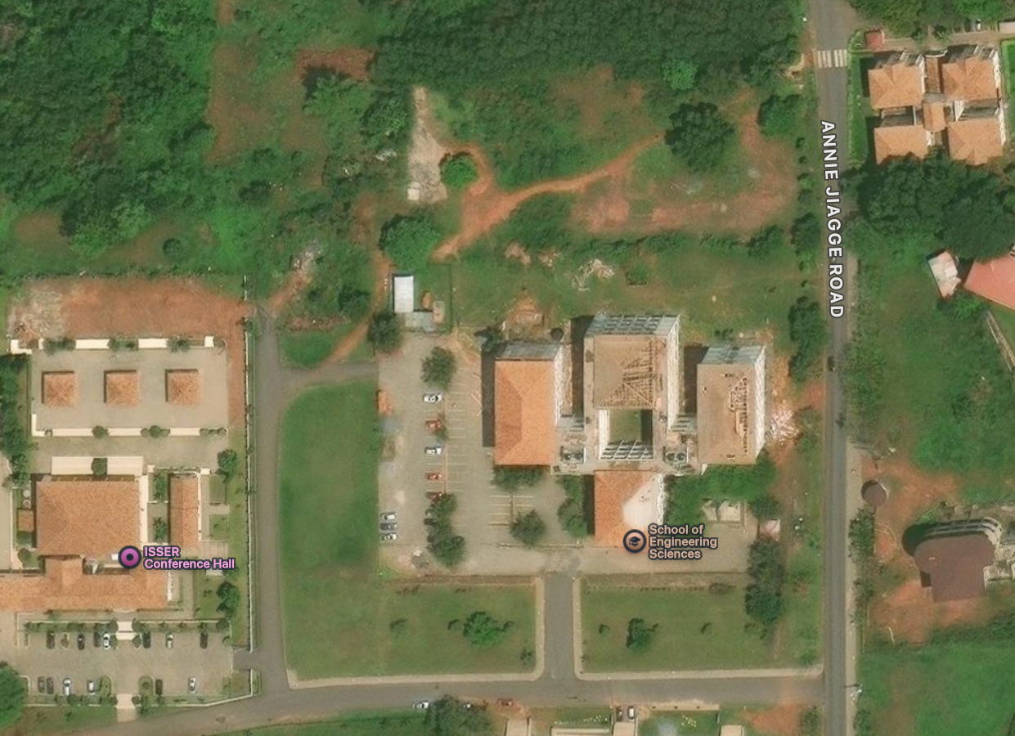 | WIDER SATELLITE CONTEXT — surrounding campus and forest edge  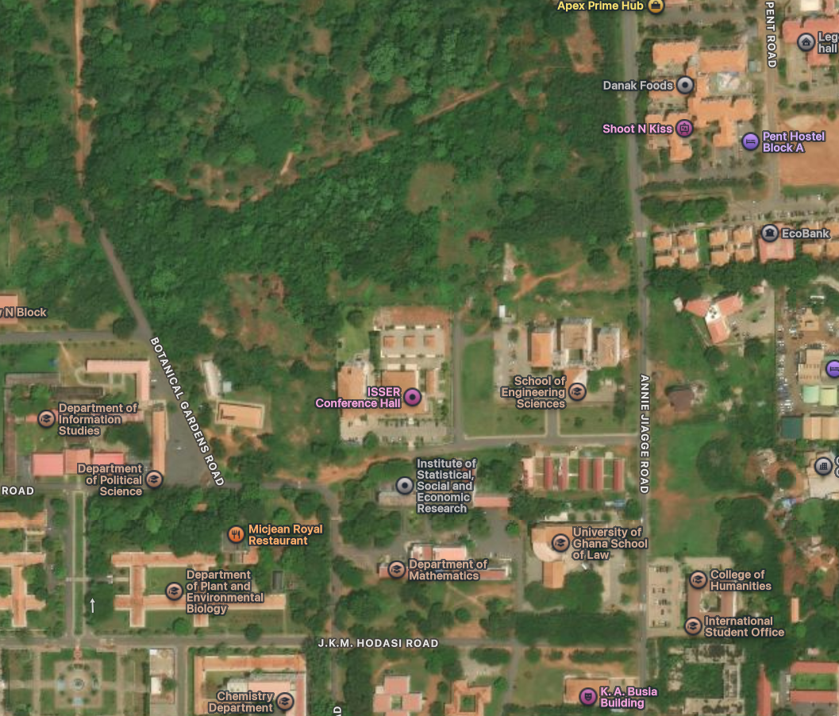

Orientation note: the satellite screenshots are north-up map views. They are the source for orientation and adjacency; perspective photos are not. In the detailed map, Annie Jiagge Road runs along the east/right side of the School site. The School complex, its open forecourt/parking and internal approach are west/left of that road. The western neighbouring compound is labeled ISSER Conference Hall. Use the existing canonical geometry to determine exact coordinates and the correct vehicle/pedestrian access connections.

Required map/site checks before moving anything
- Find the current SES building footprints and IDs in data/geography/legon-master.geojson, data/geography/legon-access.geojson, data/geography/registry/access.json, src/data/legon-map.json and the geography-generation scripts (actual current paths may differ).
- Compare the real roof arrangement in the aerial photo with the satellite footprints. Match the central/front block, attached wings, court/forecourt and parking, not only the school name label.
- Confirm that the correct frontage faces the approach/forecourt and that vehicle access joins the existing internal road. Do not route cars or the player through building footprints or closed yards.
- Place the aircraft display in the School forecourt as confirmed by the University notice. Match its location in the supplied real photos: fenced, on a hard paved/concrete display pad beside the building. The precise spot, orientation and stand spacing must come from map/photo matching and existing site geometry, not a guessed coordinate.
- Keep the jet inside its display compound, visible from the intended viewing/approach area, and outside driveable road/cycle collision space. Preserve a realistic perimeter fence/gate and sufficient setback around the aircraft.
- Do not snap the entire School to the School-level online point coordinate. The public POI has map-level accuracy only; use the existing exact footprint and imagery for structure-specific placement.

4. Aircraft display and forecourt
REAL-LIFE JET DISPLAY — front/side view and fenced concrete pad  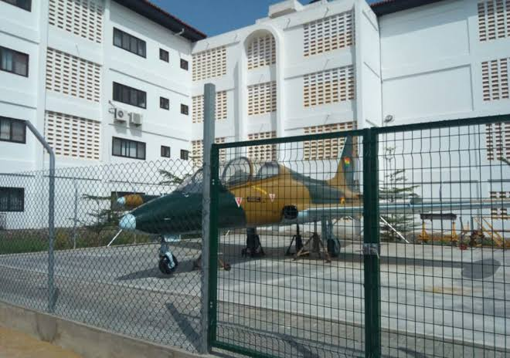 | REAL-LIFE JET DISPLAY — tail, wings, supports and fence  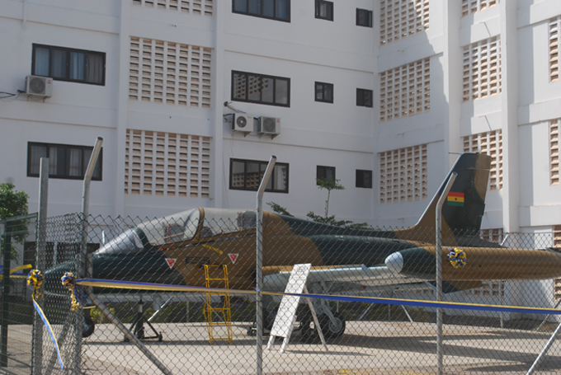

ENTRANCE VIEW — canopy, paved approach and people scale  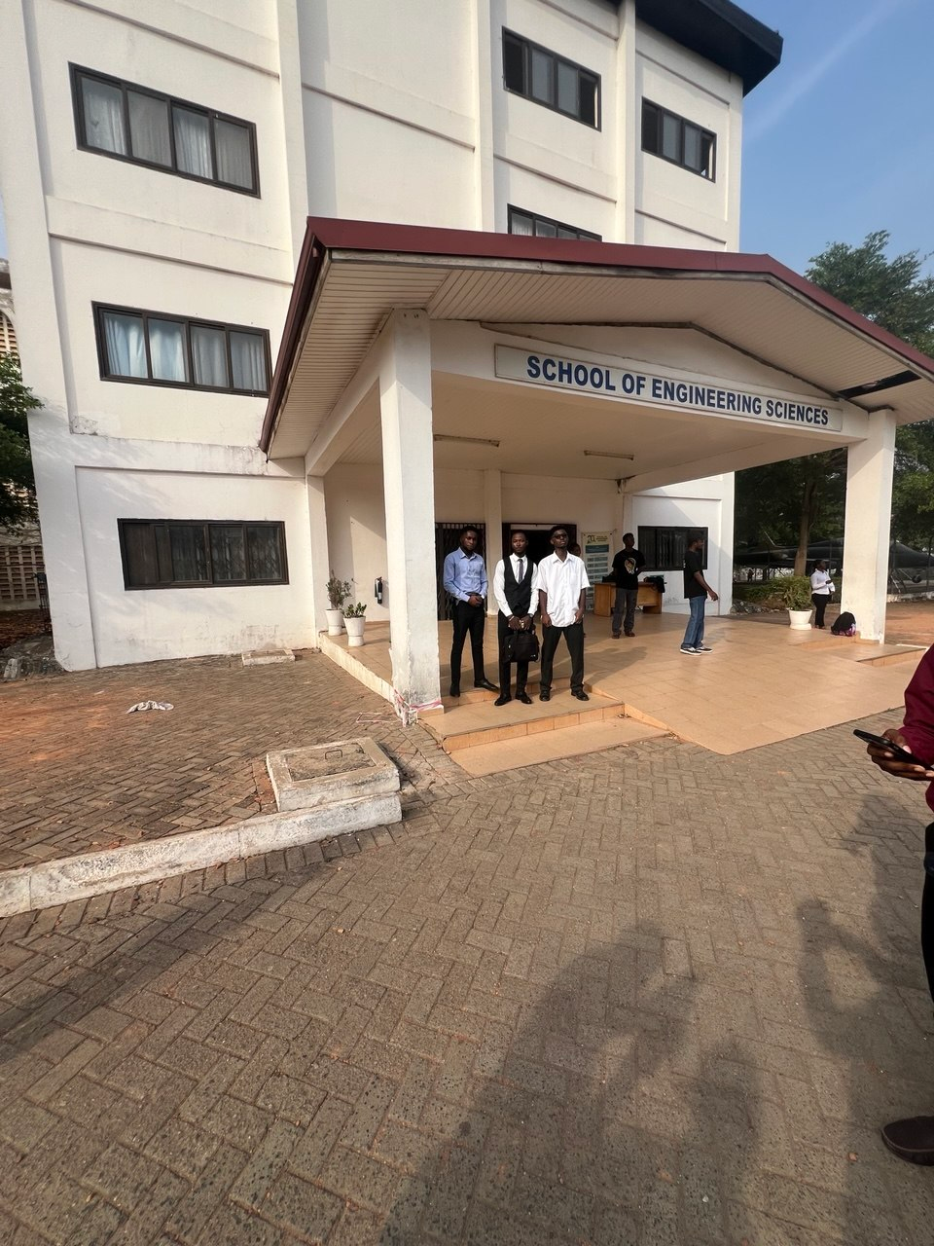 | ALTERNATE REAL-LIFE JET VIEW — orientation reference  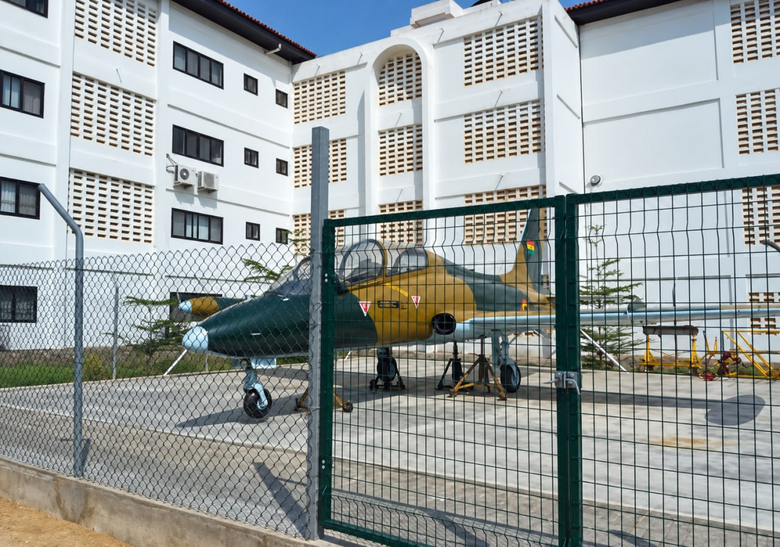

Jet identity and construction details
- Public source: the University of Ghana School of Engineering website identifies the donated aircraft as an Aermacchi MB-339; it is an instructional resource associated with aeronautics/space science education. The report says formal handover took place at the School forecourt.
- Model a compact decommissioned jet trainer with pointed nose, tandem cockpit canopy, swept low wings, rear tail assembly, undercarriage/wheels, subdued dark green/olive and tan/gold camouflage, and Ghana flag marking on the vertical tail where visible. It is a static display, not an active aircraft or runway vehicle.
- Use a light concrete display pad within a security fence. Fence posts, mesh panels, gate, hinges and base curb should have credible proportions. Do not make the fencing opaque or excessively thick; it should still let users see the aircraft.
- Match jet facing direction from the real photos and, where possible, the satellite/aerial context. Do not point it toward a road merely to make it visible. Verify wing/tail clearance to fence and building, and make sure supports and wheels contact the pad rather than float or sink.
- Avoid adding unnecessary decorative ground equipment. Only add stands, chocks, ladders, small maintenance stands or signage if the supplied references show them clearly and performance is acceptable.

5. Forecourt, car park, surfaces and rear environment

Front forecourt and parking
- Build the front approach as a coherent hard-surfaced forecourt connected to the correct internal road. The real photo shows paved/brick-pattern approach paving at the entrance; the aerial photo shows an open parking/arrival area with marked bays and parked cars.
- Use plausible car-parking stalls and align them to the site geometry. Cars should be parked in bays or along observed edges, at believable spacing and scale. Avoid floating vehicles, cars overlapping, rows blocking the entrance, or vehicles placed across pedestrian access. Keep a clear accessible path to the main doors.
- Use restrained low curb/kerb edges, planted margins and small shrubs around the paved apron where supported. Blend asphalt, brick pavers, concrete and soil carefully; avoid sharp material seams, floating patches, z-fighting, asphalt/grass flicker, or sidewalk/gutter segments that stop abruptly.
- Ensure the entrance steps and landing join the surrounding pavement at ground level. Add simple surface drainage only where visually appropriate; don’t create raised thin bars across paths or roads.

Backyard and vegetation performance
- The user’s intended environment is a dense wooded/bushy area only a few metres behind the School. Make that rear edge read as a nearby continuous bush/forest boundary, not an empty green plane and not an orchard of evenly spaced single trees.
- For performance, use a small number of clustered bush/shrub meshes and low-poly canopy masses to create a dense undergrowth line. A few silhouette trees can be used at the distant edge if essential, but avoid populating the whole back area with many separate high-detail trees.
- Use instancing or shared geometry/materials for repeated vegetation; prefer simple LODs, culling and a limited draw distance. Dense far-background foliage can use low-poly clusters/impostors or a shared canopy mass, with individual detail near the player only.
- Place the forest edge at the real/map-supported edge and keep the requested “few metres away” feeling, without putting vegetation through the walls, sidewalks, rear service access, or aircraft compound. Leave a narrow maintenance/service strip only if the imagery or canonical layout shows one.
- No excessive flower/grass clumps repeated across paving. Keep vegetation on soil/planting zones; remove grass tufts from the middle of road, parking bays, entrance pavers and jet pad.

Scene composition / environmental consistency
- Use the photos for daylight palette: natural pale walls, terracotta roofs, darker blue glazing, dusty red-brown soil, warm grey pavers and moderate green vegetation. Avoid oversaturated neon greens and every window being equally bright.
- Check approach views from the internal road, front door, side passage, jet fence and rear vegetation. A single front-on screenshot is not enough.

6. Suggested implementation sequence for Claude Code
- Audit the repository instructions, git status, current branch, building IDs, landmark definitions, canonical geography, access-point registry, and building/facade rendering code. Do not rewrite the pipeline.
- Create a small evidence ledger: SES complex ID(s); each footprint/wing; forecourt; parking area; aircraft display pad and fence; road/approach; rear bush boundary. For each record source image, current data path, confidence, and whether the proposed edit is geographic or visual.
- First fix placement and orientation only where map/photo evidence clearly supports a correction. Check the three-building/wing grouping against the satellite roof geometry. Keep IDs stable wherever possible.
- Next rebuild the 3D complex: attached wings, varied roof heights, hipped clay roofs, arched ventilation features, perforated screen blocks, properly spaced dark-framed windows, entrance canopy and sign.
- Position or refine the MB-339 display in the forecourt using source-grounded orientation and footprint. Make the jet pad, fence and gate part of the environment layer; ensure the aircraft has no unwanted driveable collision across the road.
- Build the surrounding ground layers: parking/arrival paving, stalls, cars, entrance paving and steps, curbs and sidewalks, rear service/ground edge, and a compact instanced bush-forest border.
- Run TypeScript checks, relevant geography/access/route/collision tests and production build. Inspect game screenshots at a minimum from front approach, front oblique, side passage, aircraft fence, top-down/map view and rear boundary.
- Report changed files, existing IDs retained, source evidence used, coordinate/rotation changes, façade/environment changes, test/build results, and remaining uncertainties. Do not push to main or deploy without permission.

Ready-to-paste Claude Code prompt
Correct the existing LEGONRUSH University of Ghana School of Engineering Sciences scene using the attached images and this brief. This is not a new-build task: inspect CLAUDE.md/AGENTS.md, git status, the current geography files, existing IDs, access registry, facade rendering and tests first. Use the official SES location/access description (off Annie Jiagge Road after the School of Law) and the University’s aircraft handover report (Aermacchi MB-339 displayed at the School forecourt) as geographic/context anchors. Use the supplied satellite screenshots for footprint, roads and adjacency; use real photographs for roof/facade/jet/paving details; use the current in-game screenshot to identify the model that needs correction. Verify that the in-game generic block corresponds to the SES footprint before editing it. Correct position/orientation only with evidence from canonical geography and satellite footprint matching; do not invent coordinates or move other structures. Rebuild the connected multi-wing white/light-cream complex with terracotta hipped roofs, dark-framed reflective windows, perforated ventilation-block panels and arched screen bays, central entrance canopy with red-brown sloped roof, steps/landing and readable SCHOOL OF ENGINEERING SCIENCES sign. Place/refine the static Aermacchi MB-339 at the forecourt in a fenced concrete display pad, matching the supplied photo orientation and proportions as closely as the evidence supports. Correct parking stalls/cars, pavers, concrete/asphalt, curbs, grass/soil transitions and entrance access. At the rear, represent the nearby forest as a compact dense bush line using shared/instanced low-poly clusters and LOD/culling, not many costly individual trees. Keep grass off hard paving and roads. Preserve canonical roads, paths, access points, building IDs, collision logic and route geometry except for specific evidence-backed fixes. Run checks/tests/build and visually inspect multiple viewpoints. Report all changed files, geography vs visual edits, tests, remaining uncertainties and git status. Do not push main or deploy.

Online references used
1. University of Ghana, School of Engineering - location/access: https://www.engineering.ug.edu.gh/admission
Supports: “Off the Annie Jiagge Road after the School of Law.”
2. University of Ghana, School of Engineering - donated aircraft report: https://engineering.ug.edu.gh/news/school-engineering-receives-donation-decommissioned-aircraft
Supports: Aermacchi MB-339 identity and forecourt handover location.
3. Mapcarta / OpenStreetMap School of Engineering Sciences feature: https://mapcarta.com/N9659871717
Use for regional context only; its displayed POI coordinate is not a surveyed building or jet placement.

