**Pagination**

1. **Task Detail:**

Use Django’s Built in pagination with search feature.

1. **Task Screenshots:**

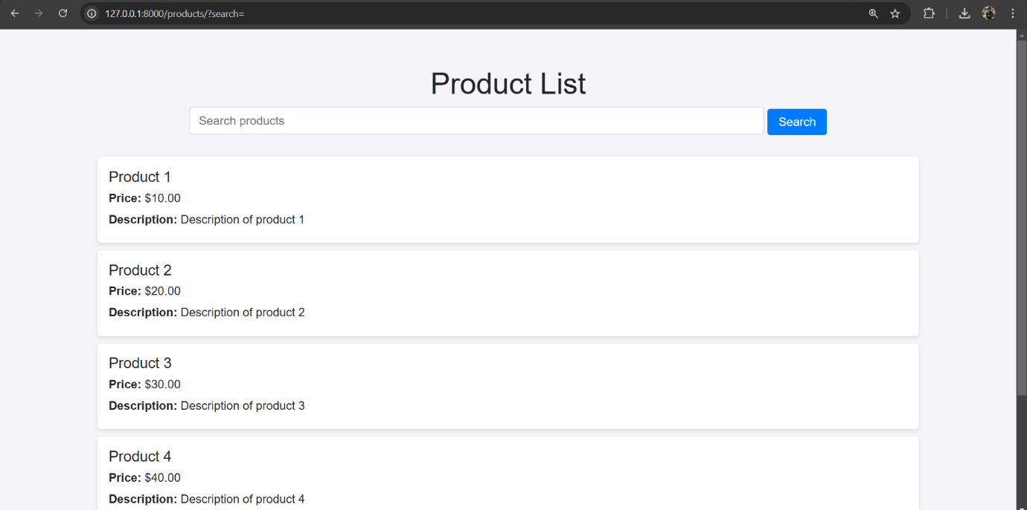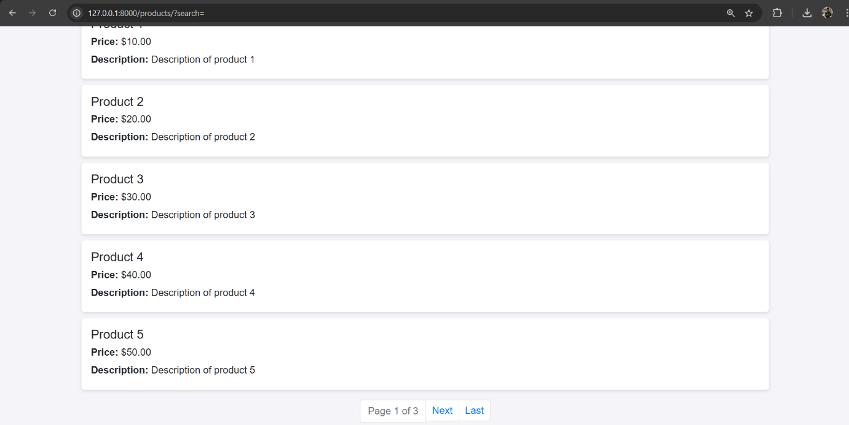

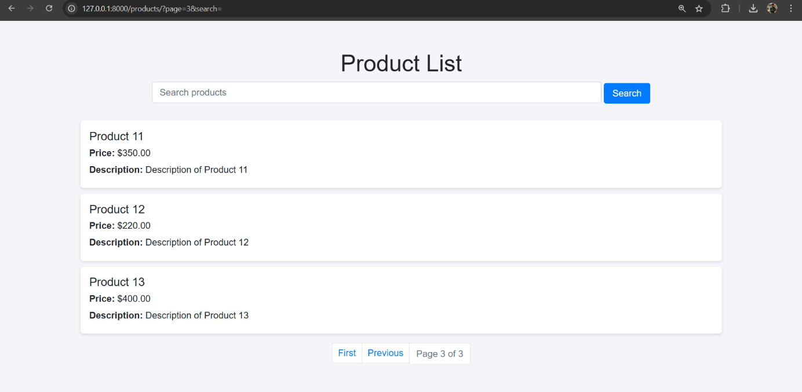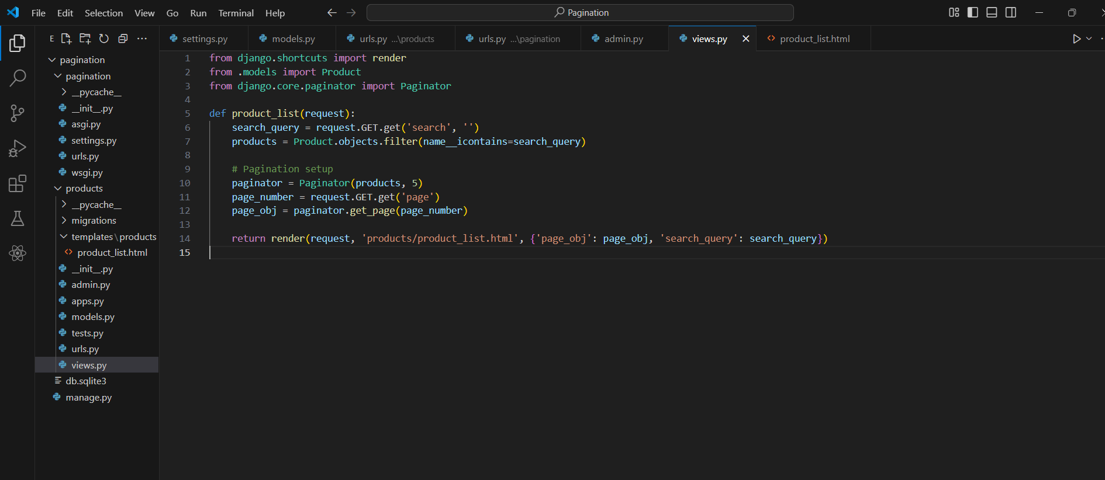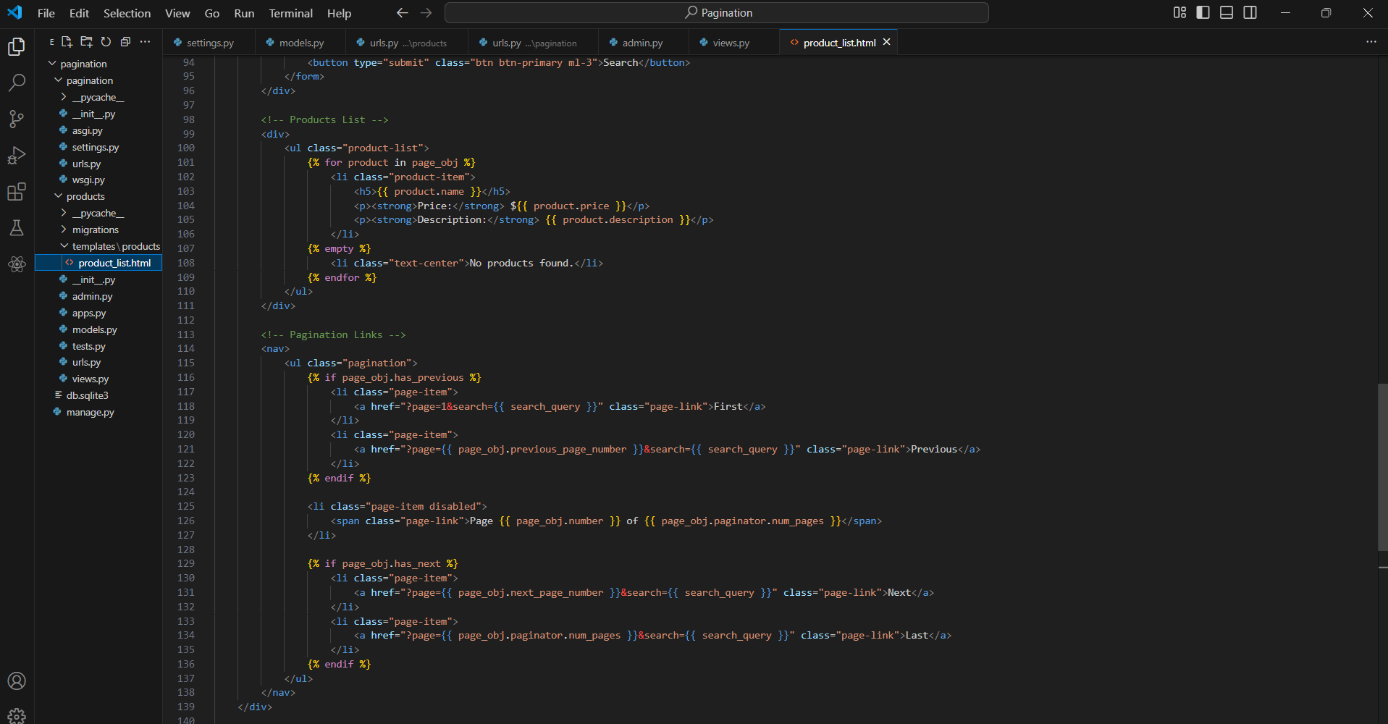

1. **How it is created:**

* **Implemented Search**: A search form allows filtering products based on their name.
* **Django Pagination**: The product list is divided into multiple pages, showing a limited number of products per page.
* **Navigation Links**: Pagination controls (Next, Previous, First, Last) enable easy navigation through product pages.