**Range Filter:**

1. **Task Description:**

Build a django app which can segment the products w.r.t their price and size, No. Of segment must be dynamic using range filter.(create atleast 30 products in db).

1. **Task Output Screenshot**

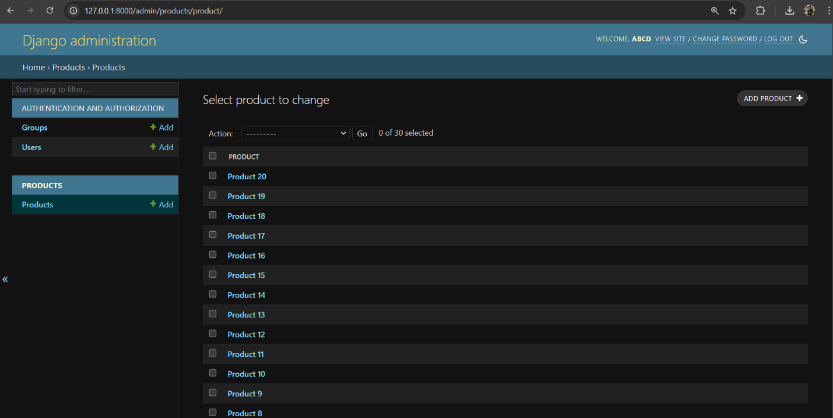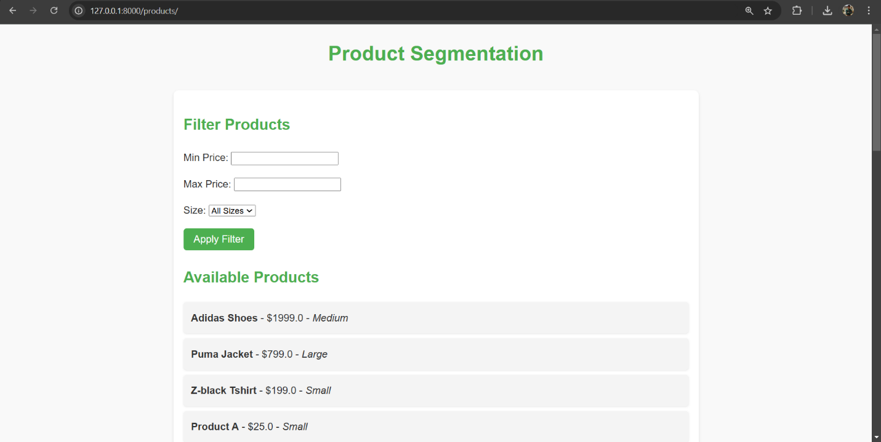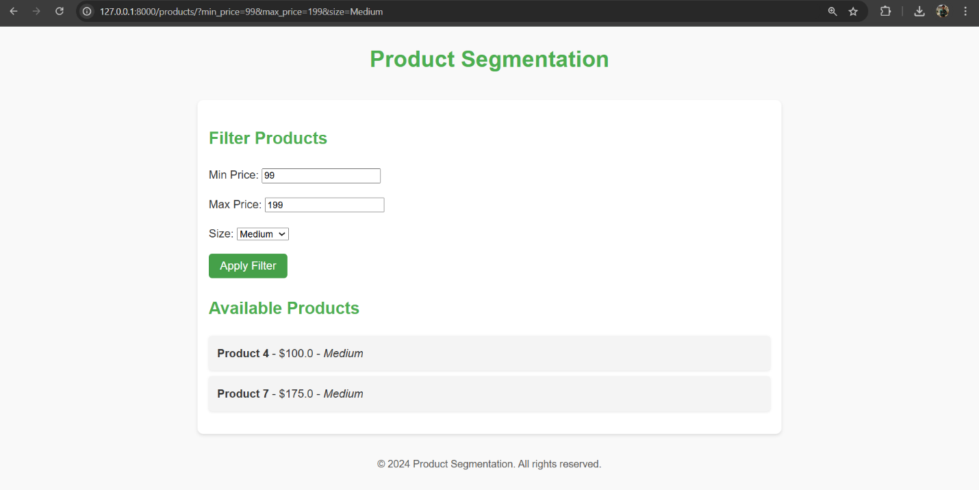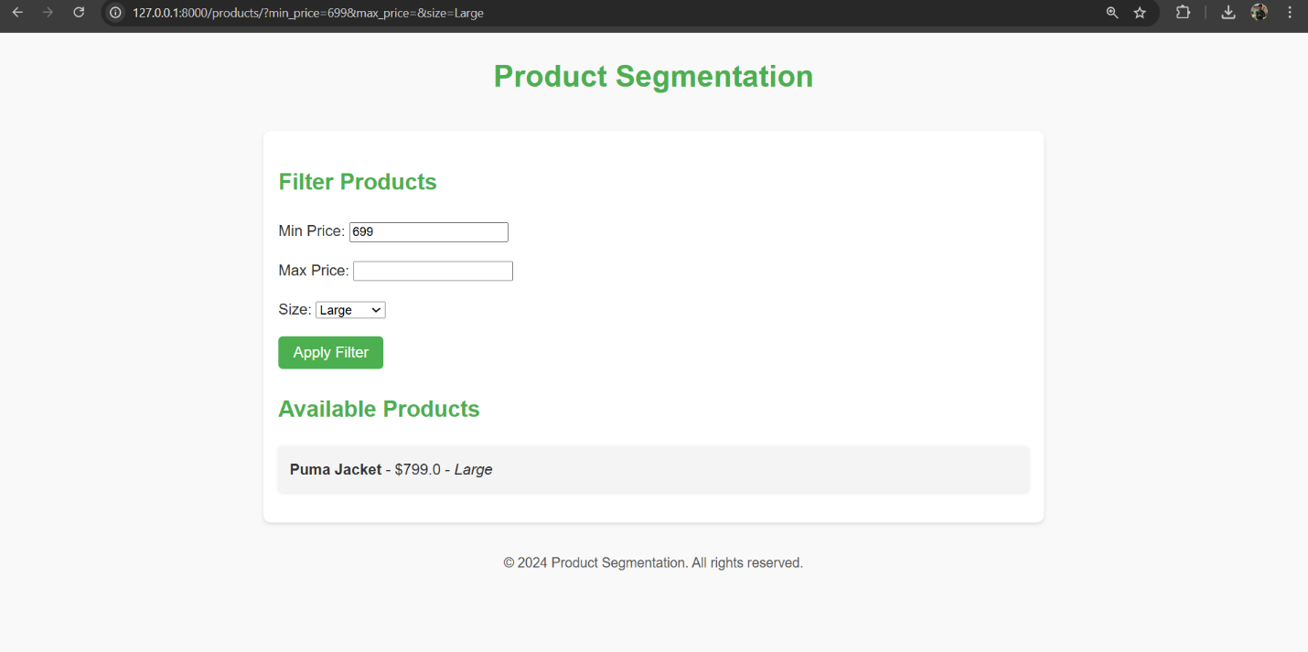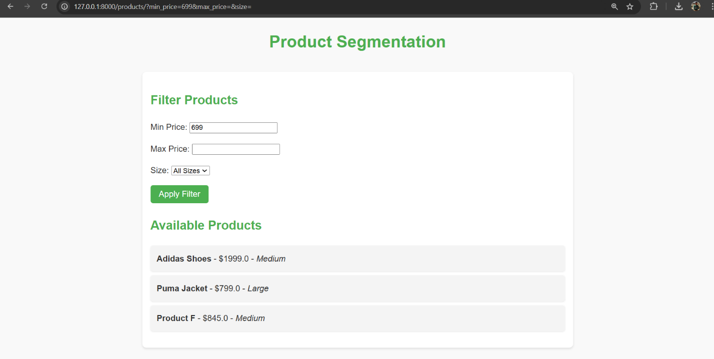

1. **Widget/Algorithm Used In Task**

* CSS used for better visualization in the form.
* By clicking on Apply Button user can see available product on basis of their search.
* Min Price and Max Price are Float Field Input.
* Size is Choice Field Input.