SYNOPSIS
On
"Home Energy Optimizer"
Diploma In
Computer Engineering
Submitted by:
[Farhan Baig] (B003)
[Rudra Shetye] (B059)
[Arif Chaudhary] (B065)
Under the Guidance of: [Sharyu Kadam]
Computer Engineering Department (2024-2027)
This is to certify that
Mr./Ms. ______________________________
has satisfactorily presented and submitted the Synopsis of
Home Energy Optimizer
Guide HOD
( Sharyu Kadam) (Janardhan Kulkarni)

Vision
"Create a sustainable academic environment to produce highly competent computer professionals of the future."

Mission
M1: To expose students to latest tools and technologies in computing
M2: To foster the professional development of students by providing excellence in education
M3: To adapt rapid advancements in computing by engaging students in lifelong learning
M4: To inculcate sound ethical, moral and social values amongst students for the benefit of society

Program Education Objectives (PEOs)
The program educational objectives (PEOs) are to produce Computer professionals.
PEO1: Able to identify, frame and solve computing problems by applying their knowledge in Computer Engineering.
PEO2: Promote lifelong learning by integrating academic knowledge and practical applications.
PEO3: Depict effective teamwork and practical skills for holistic development.

Program Specific Outcomes (PSOs)
PSO1: Demonstrate fundamental knowledge in Operating Systems, Web Technology, Microprocessor-based systems and IoT by applying programming skills and developing applications.
PSO2: Administer and manage Open Source, Networking, Security and Database domains to enhance student growth.

Course Outcome
Program: Computer Engineering Course: Project
Semester: VI Course Code: PRO190816
CO No. | Course Outcome
CO1 | Identify problem definitions that can be addressed by applying the acquired knowledge and skills
CO2 | Plan the activities with a timeline chart, work in groups/teams, and co-ordinate the work
CO3 | Select design methodologies and their implementation
CO4 | Write the Project Report

Table of Contents
Sr. No. | Contents | Page No.
1 | Abstract
2 | Introduction
3 | Problem Statement
4 | Solution
5 | Hardware Requirements
6 | Software Requirements
7 | Project Planning
8 | Development Modules
9 | Flowchart
10 | Scope of the Project
11 | Limitations
12 | Conclusion
13 | References

Abstract
The Home Energy Optimizer is an IoT-based smart monitoring and control system developed to help households track, predict, and reduce their electricity consumption. Most consumers only discover their monthly electricity bill after it is generated, leaving no opportunity to adjust usage in time. This project addresses that gap by continuously monitoring the power consumption of individual appliances using PZEM-004T energy sensors interfaced with an ESP32 microcontroller.
The system calculates daily energy usage and predicts the monthly bill in advance using tariff-slab-based calculations, presenting this information through a web dashboard. Appliances can be switched on or off remotely from the same dashboard through relay-based control. To help users reduce consumption, the system integrates the Gemini API, which analyzes usage patterns and generates personalized, AI-based energy-saving suggestions.
For demonstration purposes, the prototype monitors and controls two bulbs, each fitted with its own PZEM-004T sensor and relay channel, representing how the system can be scaled to a full household with multiple appliances.

Introduction
Household electricity consumption is rising steadily with the growing number of connected appliances, yet most consumers have very limited visibility into how their usage translates into cost. Electricity billing is typically done on a monthly cycle, which means a household only learns the financial impact of its consumption habits after the billing period has already ended, by which point no corrective action can be taken.
Existing energy meters, whether traditional or smart, generally report only the combined household load and do not break this down by individual appliance, making it difficult for users to identify which devices are responsible for high consumption. The Home Energy Optimizer project addresses this by placing sensors at the appliance level, allowing consumption to be tracked and understood on a per-device basis, in real time, well before the bill arrives.
The system is built around the ESP32 microcontroller and PZEM-004T energy sensors, which continuously measure voltage, current, power, and cumulative energy. This data is transmitted over WiFi to a backend server, which stores it, computes daily consumption trends, and projects the expected monthly bill using tariff-slab calculations. The same data is analyzed by the Gemini API to generate practical, personalized suggestions for reducing consumption, and a web dashboard ties everything together, also allowing users to remotely control appliances via relay switching.

Problem Statement
Consumers today have almost no insight into their electricity consumption until they receive their bill at the end of the month, by which point it is too late to make any adjustments to reduce cost. Standard electricity meters report only a single combined value for the entire household, giving no indication of which specific appliances are consuming the most power.
Without appliance-level data, users cannot identify inefficient devices, cannot anticipate an unusually high bill in advance, and have no way to receive timely, actionable guidance on how to reduce their usage. Manually tracking and estimating consumption is impractical and error-prone for most households.
There is therefore a need for a system that continuously monitors appliance-level power usage, predicts the electricity bill in advance using realistic tariff calculations, provides intelligent suggestions for reducing consumption, and allows users to control their appliances remotely — all through a single, accessible interface.

Solution
The proposed solution, Home Energy Optimizer, uses PZEM-004T AC energy monitoring sensors connected to an ESP32 microcontroller to measure voltage, current, power, and energy consumption of individual appliances in real time. Each monitored appliance is fitted with its own PZEM-004T sensor and a relay channel, allowing both independent measurement and independent control.
The ESP32 reads sensor data over UART using the Modbus RTU protocol and transmits it over WiFi (via MQTT) to a backend server, where it is stored in a time-series database. The backend computes daily energy consumption per appliance and projects the expected monthly bill using slab-wise electricity tariff calculations, rather than a simple flat-rate estimate.
This usage data is also sent to the Gemini API, which analyzes consumption patterns and generates personalized, easy-to-understand suggestions for reducing electricity usage — for example, flagging appliances with unusually high runtime or projecting when the household is about to cross into a higher tariff slab.
All of this information — live power usage, appliance-wise breakdown, predicted bill, and AI-generated suggestions — is presented on a web dashboard. The same dashboard allows users to remotely switch appliances on or off, with commands routed from the dashboard through the backend and MQTT to the ESP32, which drives the relay modules. For the prototype, two bulbs are used as sample appliance loads to demonstrate the complete monitoring-and-control pipeline.

Hardware Requirements
Component | Specification
Microcontroller | ESP32 development board (WiFi + Bluetooth, dual-core)
Energy Sensor | PZEM-004T v3.0 (x2) — AC voltage/current/power/energy sensor, 10A, TTL/Modbus RTU interface
Relay Module | 2-Channel relay module, 5V, opto-isolated
Load (demo appliances) | 2 x Bulbs (LED/incandescent) with holders
Power Supply | 5V DC, 2A+ USB adapter
Wiring accessories | Connecting wires, screw terminal blocks, common ground rail
Enclosure | Enclosure box for safe housing of mains-side wiring

Software Requirements
Component | Specification
Firmware Development | Arduino IDE, C++ (PZEM004Tv30, PubSubClient libraries)
Communication Protocol | MQTT (application layer), Modbus RTU (PZEM ↔ ESP32)
Backend | Node.js with Express
Database | MongoDB / PostgreSQL (time-series appliance readings)
AI Suggestions Engine | Google Gemini API (analyzes usage data, generates energy-saving suggestions)
Frontend | React.js, Recharts / Chart.js for data visualization
Version Control | Git / GitHub

Project Planning
(Timeline to be filled in as the project progresses)
Task / Module | JULY |  |  |  | AUGUST |  |  |  | SEPTEMBER
Task / Module | W1 | W2 | W3 | W4 | W5 | W6 | W7 | W8 | W9 | W10 | W11 | W12
Requirement Analysis & Planning
System Design (Architecture, Hardware Selection)
Web Dashboard Development
Hardware Setup & Sensor
ESP32 Firmware Development
Backend & Database Development
Bill Prediction Algorithm
Gemini API Integration
Relay Control Integration
Testing & Bug Fixing
Documentation & Deployment

Development Modules
Week | Module | Description
Week 1 | Requirement Analysis & System Design | Finalize requirements, hardware/software stack, system architecture, and tariff-slab configuration.
Weeks 2-3 | Web Dashboard Development | Build live monitoring dashboard, historical charts, bill prediction display, and appliance control UI.
Weeks 4-5 | Hardware Setup & Sensor Interfacing | Wire PZEM-004T sensors and relay module to ESP32; verify sensor readings on serial monitor.
Weeks 5-7 | ESP32 Firmware Development | Implement dual-sensor reading, WiFi connectivity, MQTT publishing, and relay control logic.
Week 7-8 | Backend & Database Development | Set up MQTT broker, backend API, and time-series database for storing appliance readings.
Week 8 | Bill Prediction Module | Implement daily consumption tracking and slab-wise monthly bill projection algorithm.
Week 9 | Gemini API Integration | Connect usage data to the Gemini API and generate personalized energy-saving suggestions.
Week 9-10 | Integration & Testing | Integrate all modules and test the end-to-end flow from sensor reading to dashboard control.
Week 11 | Documentation & Deployment | Final testing, bug fixing, and preparation of project documentation.

Flowchart
The following flowchart illustrates the complete working of the Home Energy Optimizer, from sensor-level data acquisition through to bill prediction, AI-based suggestions, and remote appliance control.
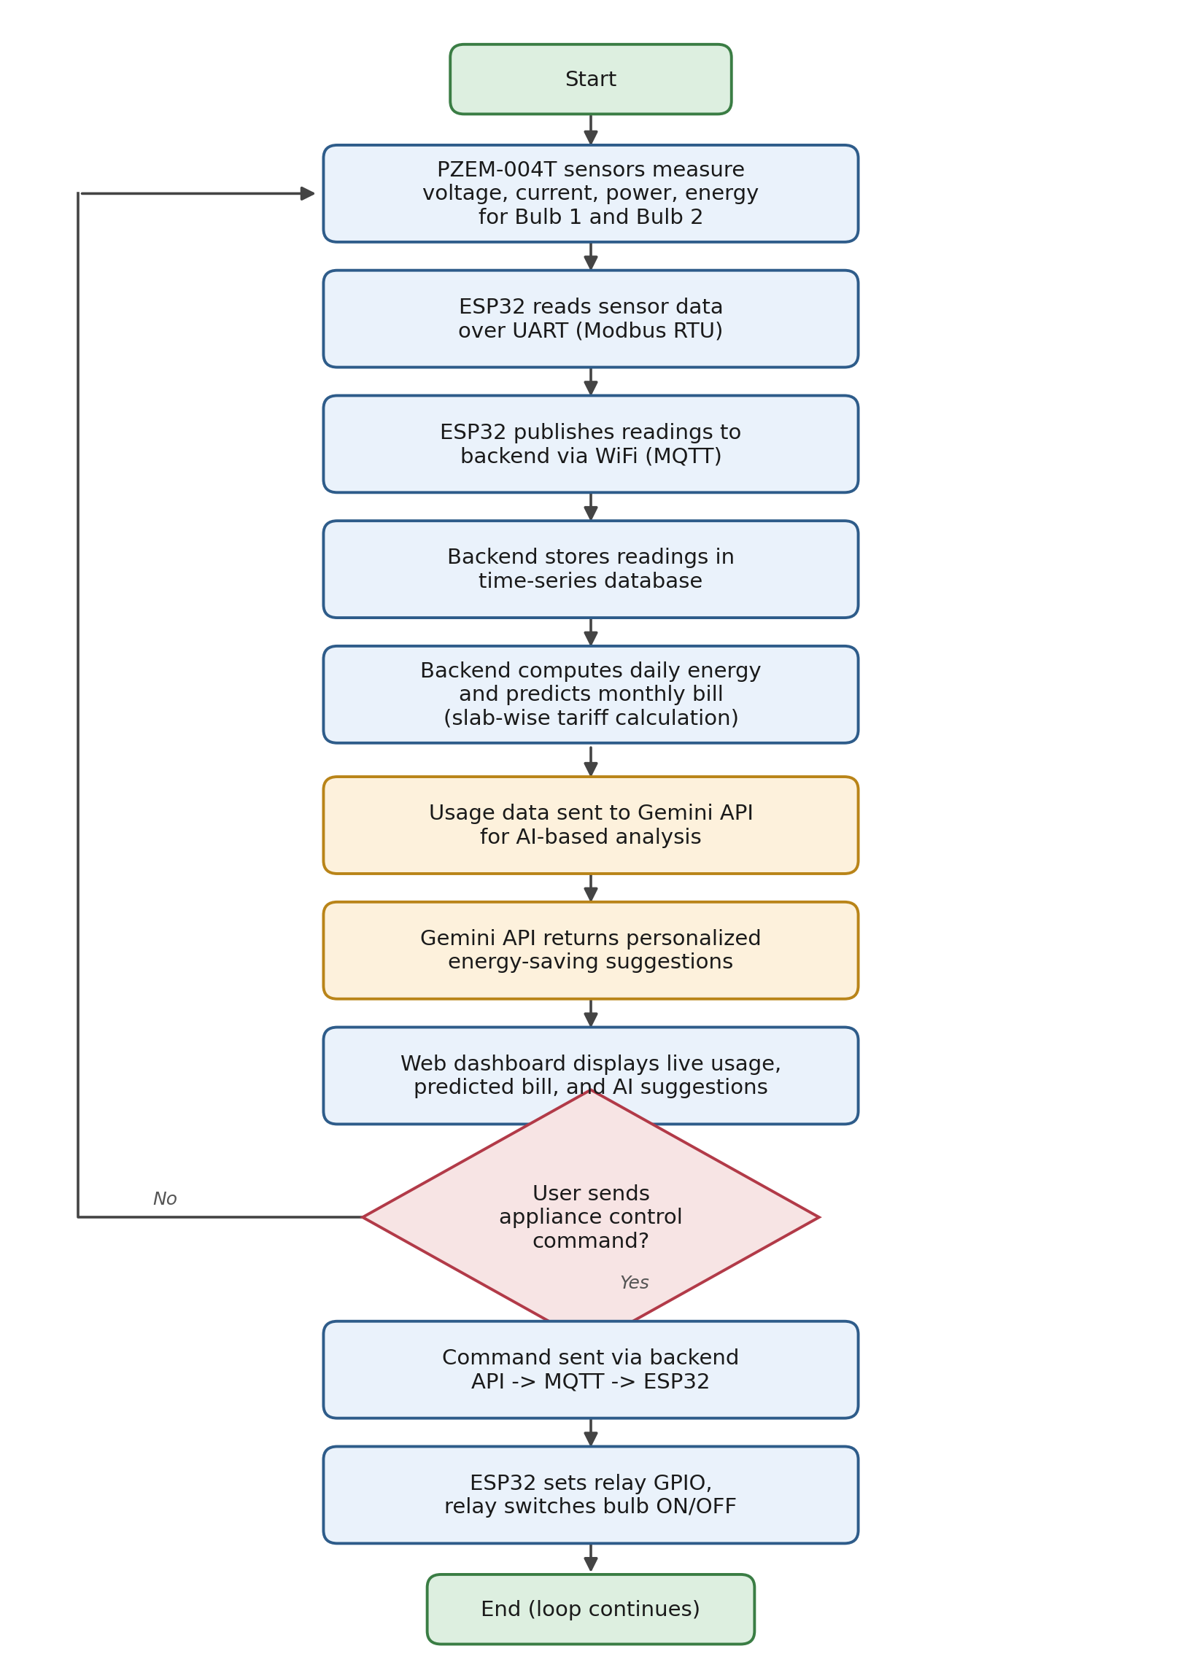

Scope of the Project
The Home Energy Optimizer is designed to provide real-time, appliance-level electricity monitoring and predictive billing for households. The prototype demonstrates the system using two bulbs, but the underlying architecture — one PZEM-004T sensor and one relay channel per appliance, all coordinated by a single ESP32 — is directly scalable to a full household with multiple appliances.
The project focuses on improving consumer awareness of electricity usage, enabling proactive rather than reactive cost management, providing AI-driven suggestions for reducing consumption via the Gemini API, and allowing remote control of appliances through a web dashboard.

Limitations
- The prototype currently demonstrates monitoring and control for two bulbs; scaling to a full household requires additional PZEM-004T sensors and relay channels.
- Bill prediction accuracy depends on the correctness of the user-configured electricity tariff slabs.
- The system requires a stable WiFi connection for real-time data transmission and remote appliance control.
- AI-based suggestions generated via the Gemini API depend on internet connectivity and API availability.
- The current prototype is designed for single-phase AC loads and does not support three-phase power monitoring.

Conclusion
In conclusion, the Home Energy Optimizer addresses a common yet significant problem — the lack of real-time visibility into electricity consumption — by combining IoT sensing, predictive billing, and AI-based suggestions within a single accessible system. By integrating PZEM-004T sensors, an ESP32 microcontroller, and the Gemini API within a web dashboard, the project enables users to monitor, predict, and reduce their electricity costs proactively rather than reactively.
The prototype demonstrates this concept using two bulbs, each independently monitored and controlled, laying the foundation for a fully scalable smart home energy management system.

References
[1] PZEM-004T V3.0 Datasheet / User Manual, hosted via the pzem-edl open-source library repository. https://github.com/vortigont/pzem-edl
[2] Components101, "PZEM-004T Datasheet: Pinout, Schematic & Specs Guide." https://components101.com/modules/pzem-004t-energy-meter-module-pinout-datasheet
[3] Espressif Systems, "ESP32 Series Datasheet." https://www.espressif.com/sites/default/files/documentation/esp32_datasheet_en.pdf
[4] Espressif Systems, "Arduino Core for ESP32 Documentation." https://docs.espressif.com/projects/arduino-esp32/
[5] Google AI for Developers, "Gemini API Documentation." https://ai.google.dev/gemini-api/docs
[6] "IoT-Based Electrical Power Consumption Monitoring System in Households Using ESP32 and PZEM-004T," Brilliance: Research of Artificial Intelligence, 2025. https://jurnal.itscience.org/index.php/brilliance/article/view/6368
[7] "A smart energy monitoring system using ESP32 microcontroller," ScienceDirect, 2024. https://www.sciencedirect.com/science/article/pii/S2772671124002468
[8] MQTT.org, "MQTT: The Standard for IoT Messaging." https://mqtt.org

