

A Project On

INTELLIGENT API RATE LIMITER USING PURE DATA STRUCTURES

Course Code: MSC40050
Course Name: Algorithm Design Strategies
FYM.Sc. Sem II
By
Rudra Khatri (1272250136)
Tushar Patel (1272250176)

Under the guidance of
Dr. Anuradha Kanade
2025-26
.

Department of Computer Science and Applications
Dr. Vishwanath MIT World Peace University

Pune, Maharashtra,
India, 411038

CERTIFICATE

This is to certify that the project entitled “Intelligent API Rate Limiter Using Pure Data Structures” being submitted by Rudra Khatri and Tushar Patel in partial fulfilment of the requirements for the award of the degree of the Master of Computer Science to MIT World Peace University is a record of bonafide work carried out by them under my guidance and supervision from January 2026 to April 2026.
The results presented in this project have been verified and found to be satisfactory. The results embodied in this project report have not been submitted to any other University for the award of any other degree or diploma.

Dr. Anuradha Kanade
Course Teacher

Table of Contents

Sr. No. | Particulars | Page No.
Chapter 1 | INTRODUCTION
Chapter 1 | 1.1 Existing System
Chapter 1 | 1.2 Problem Definition- Need of Computerization
Chapter 2 | PROPOSED SYSTEM
Chapter 2 | 2.1 Proposed System
Chapter 2 | 2.2 Objectives of System
Chapter 2 | 2.3 User Requirements
Chapter 2 | 2.4 Operating Environment – Hardware and Software
Chapter 3 | ANALYSIS AND DESIGN
Chapter 3 | Module List
Chapter 3 | 3.1 ERD, UML Diagram (Class Diagram, Use case diagram, sequence diagram, Activity diagram, component diagram, deployment diagram etc. as per your project requirement) if applicable
Chapter 3 | 3.2 Table Design (if applicable)
Chapter 3 | 3.3 Data Dictionary (if applicable)
Chapter 3 | 3.4 Screenshots (Input and Output)
Chapter 3 | 3.5 Reports (if applicable)
Chapter 3 | 3.6 Test Procedures and Implementation (if applicable)
Chapter 4 | CONCLUSIONS
Chapter 4 | 4.1 Limitations & Drawbacks
Chapter 4 | 4.2 Future Enhancement
Chapter 4 | 4.3 Conclusions
Chapter 4 | 4.4 References & Bibliography

Chapter 1: INTRODUCTION
  - Existing System In modern web architecture, API endpoints are vulnerable to Resource Exhaustion and Distributed Denial of Service (DDoS) attacks. Existing rate-limiting systems typically rely on external databases or third-party caching tools like Redis. While effective, these external dependencies introduce Network Latency and abstract the underlying algorithms, making them less suitable for demonstrating optimal Space and Time Complexity in a purely academic context.

  - Problem Definition - Need of Computerization There is a need for a lightweight, highly optimized Middleware Component that can manage high volumes of web traffic using core computer science principles. The system must natively implement a Trie (Prefix Tree) for O(L) string matching and a Sliding Window Log Algorithm utilizing a Hash Map and Queue to track user requests in memory with O(1) lookup times.

Chapter 2: PROPOSED SYSTEM
2.1 Proposed System The proposed system is an Intelligent API Rate Limiter built from scratch. It acts as a dual-layer security gateway:
- Network Layer Defense: Uses a custom Trie Data Structure to block malicious IP subnets dynamically.
- Application Layer Defense: Uses a Hash Map paired with Queues to track incoming request timestamps. It automatically Dequeues expired timestamps to enforce rolling time-window limits.
2.2 Objectives of System
- To implement complex data structures (Trees, Hash Maps, Queues) in a real-world backend environment.
- To achieve O(L) Time Complexity for IP blacklisting.
- To provide real-time traffic visualization and administrative controls via an interactive Full-Stack Dashboard.
2.3 User Requirements
- Administrator: Requires an interface to visually monitor active IP addresses, adjust API Tier limits dynamically, and manually block malicious IPs.
- Client/User: Requires seamless access to the API unless the predefined request threshold is breached, at which point an HTTP 429 Too Many Requests error should be returned.
2.4 Operating Environment – Hardware and Software
- Backend: Node.js, Express.js (Middleware)
- Database (Logging): MongoDB (Mongoose for Schema Definition)
- Frontend: HTML5, CSS3, Vanilla JavaScript (Polling mechanism via Fetch API)
- Testing: Postman API Platform, Chrome/Safari Web Browsers.

Chapter 3: ANALYSIS AND DESIGN
Module List
- Trie Blacklist Module: Handles dynamic insertion and character-by-character search of IPv4 and IPv6 addresses.
- Sliding Window Limiter Module: Manages the Hash Map and executes the Enqueue/Dequeue logic based on temporal parameters.
- Tier Authentication Module: Evaluates API keys via headers or query parameters to dynamically expand Queue Capacity.
- Admin Dashboard Module: Handles asynchronous data polling and renders real-time traffic statistics.
3.1 ERD & UML Diagrams
- ERD Diagram:
- UML Diagrams
  - Class Diagram:

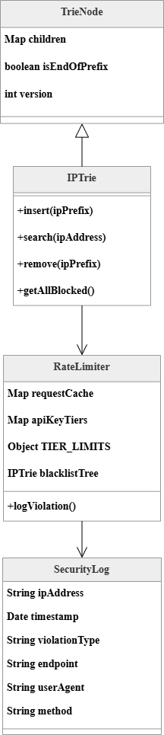

  - Use Case Diagram:

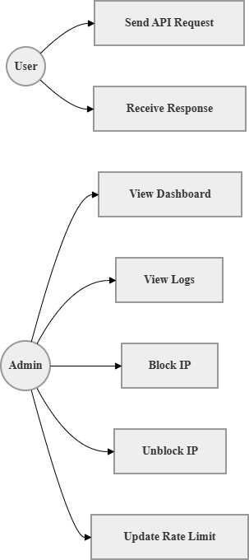

  - Sequence Diagram:

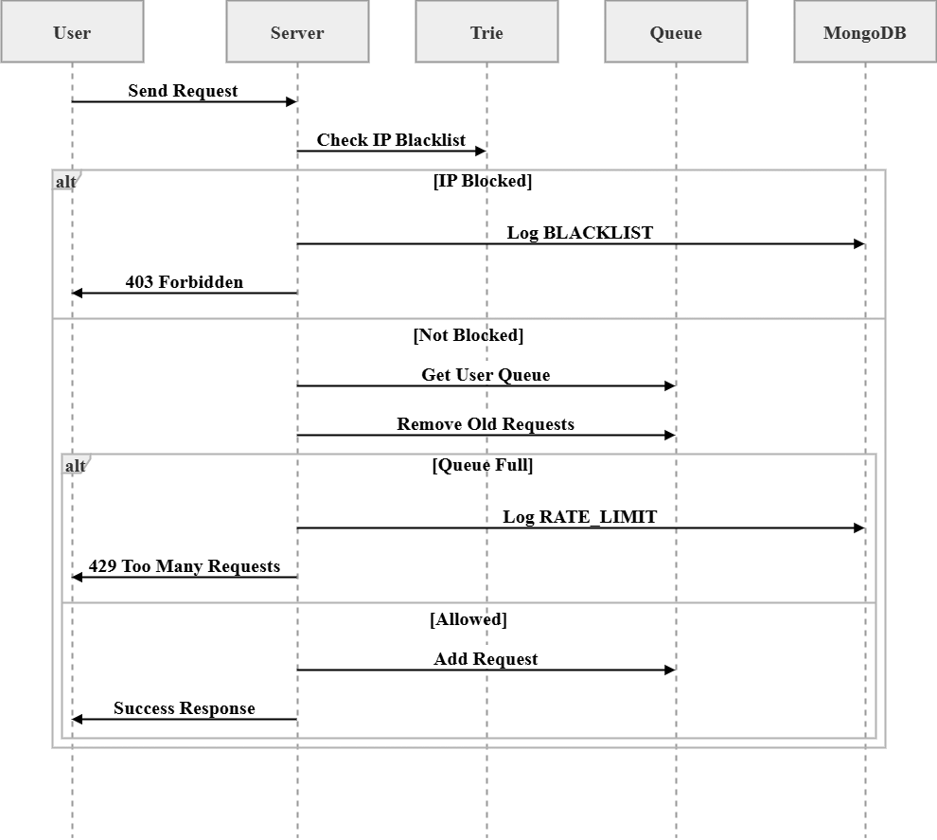

  - Activity Diagram:

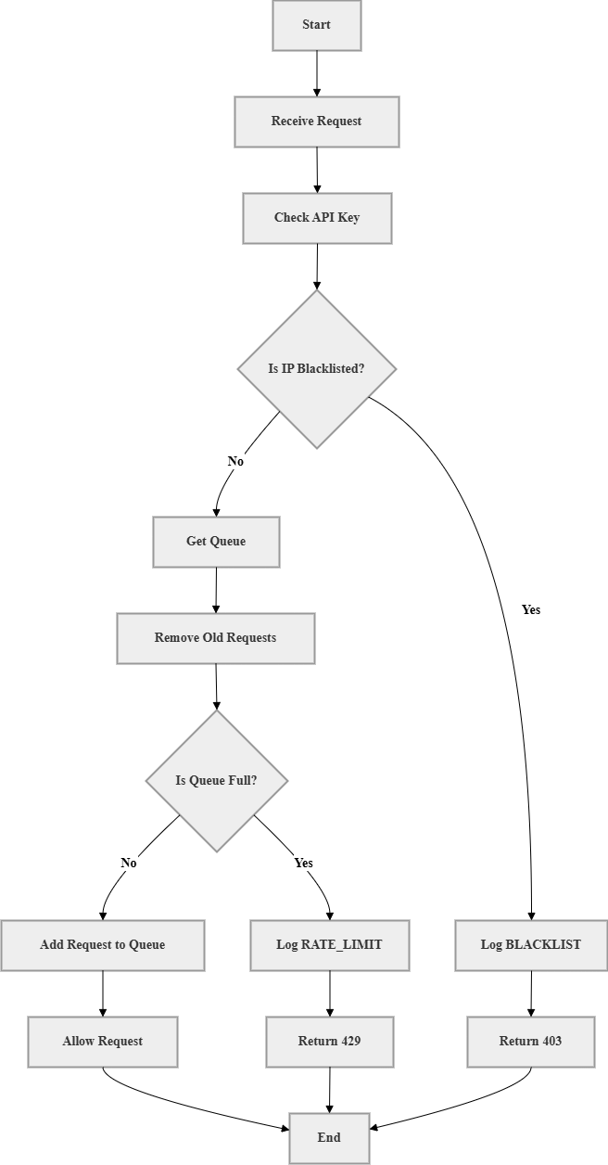
  - ER Diagram:

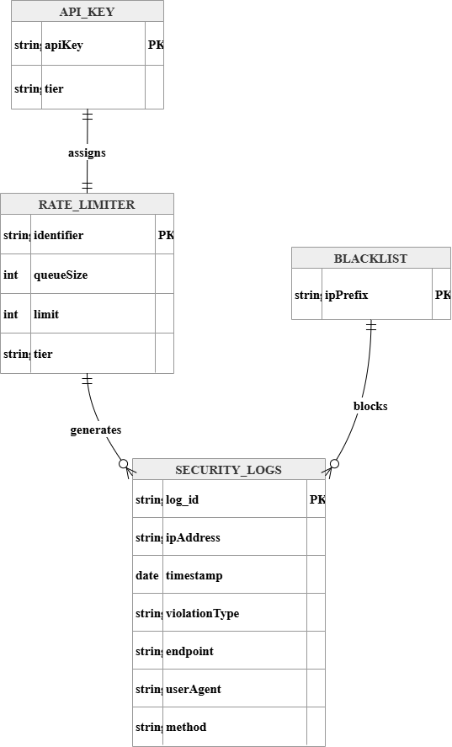

  - System Architecture Diagram:

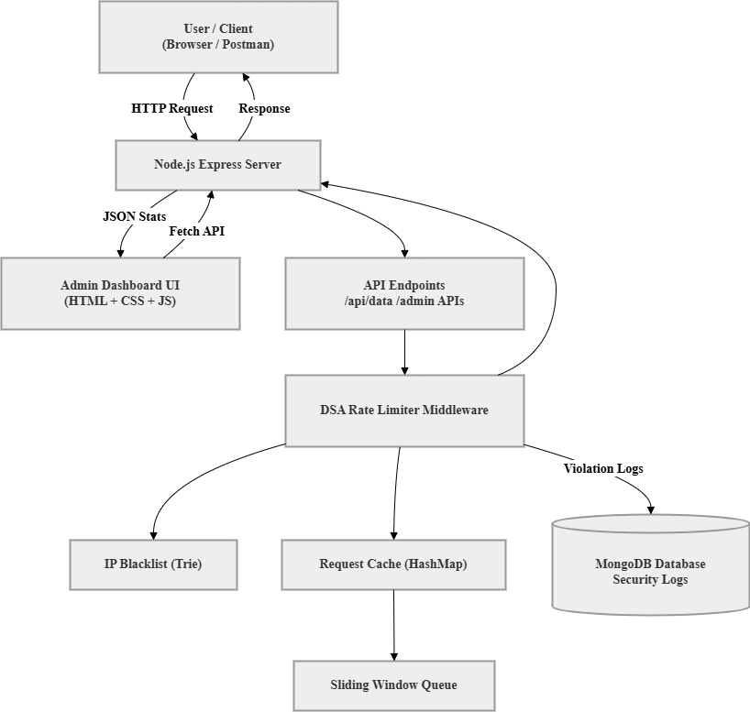

  - Data Flow Diagram (DFD Level 0):

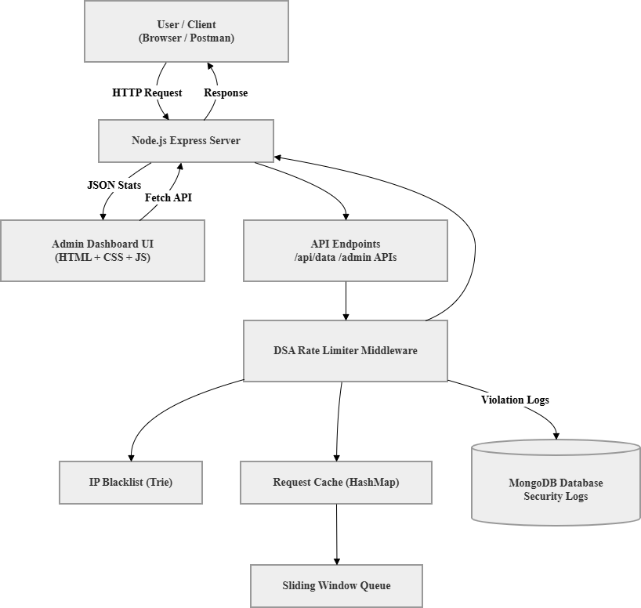

  - Data Flow Diagram (DFD Level 1):

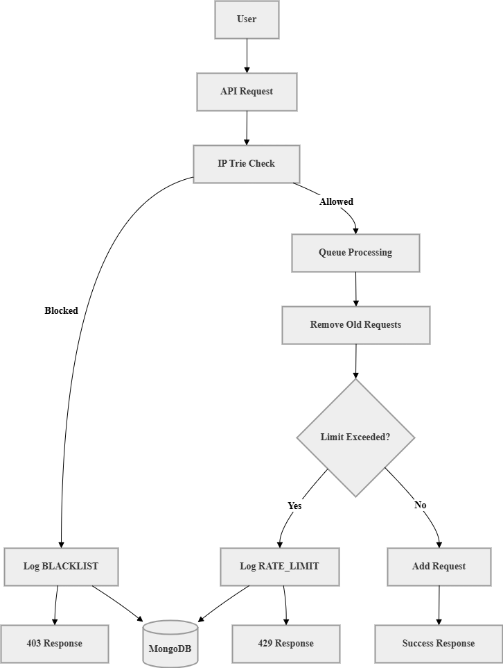

3.2 Table Design (MongoDB Schema)

Collection Name: SecurityLogs
Field Name | Data Type | Description & Constraints
_id | ObjectId | Primary Key. Auto-generated unique identifier for the log document.
ipAddress | String | The user identifier (IPv4 or IPv6 address) that triggered the violation.
violationType | String | The specific security breach. Strictly accepts Enum values: 'RATE_LIMIT' or 'BLACKLIST'.
endpoint | String | The specific API route the user attempted to access (e.g., /api/data).
timestamp | Date | The exact server time the violation was recorded. Default constraint is Date.now().

3.4 Screenshots (Input and Output) (Note to student: Insert your screenshots here!)
- Screenshot of Postman returning a 200 OK success message.
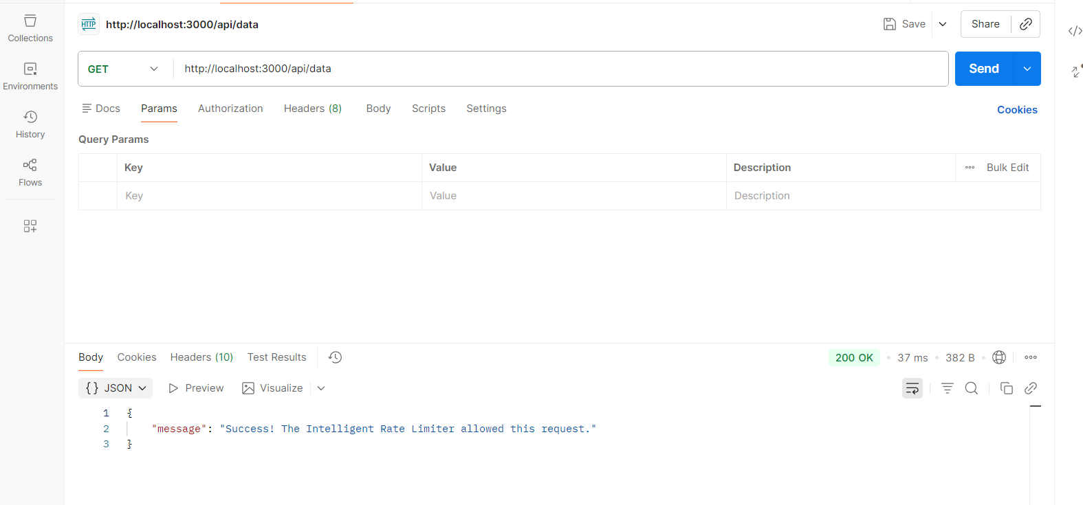
- Screenshot of Postman returning a 429 Error.
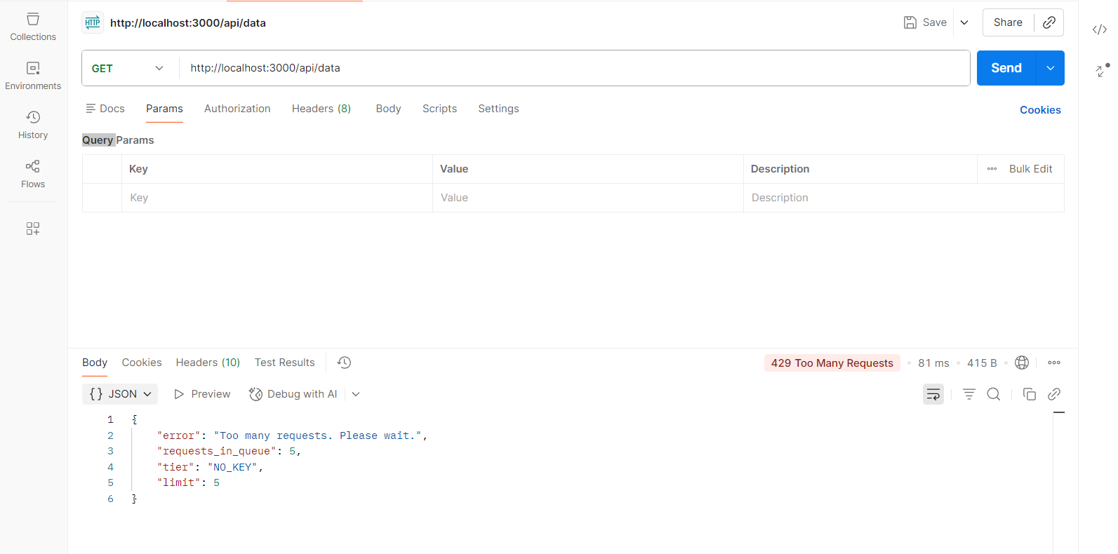
- Screenshot of blacklisted ip address
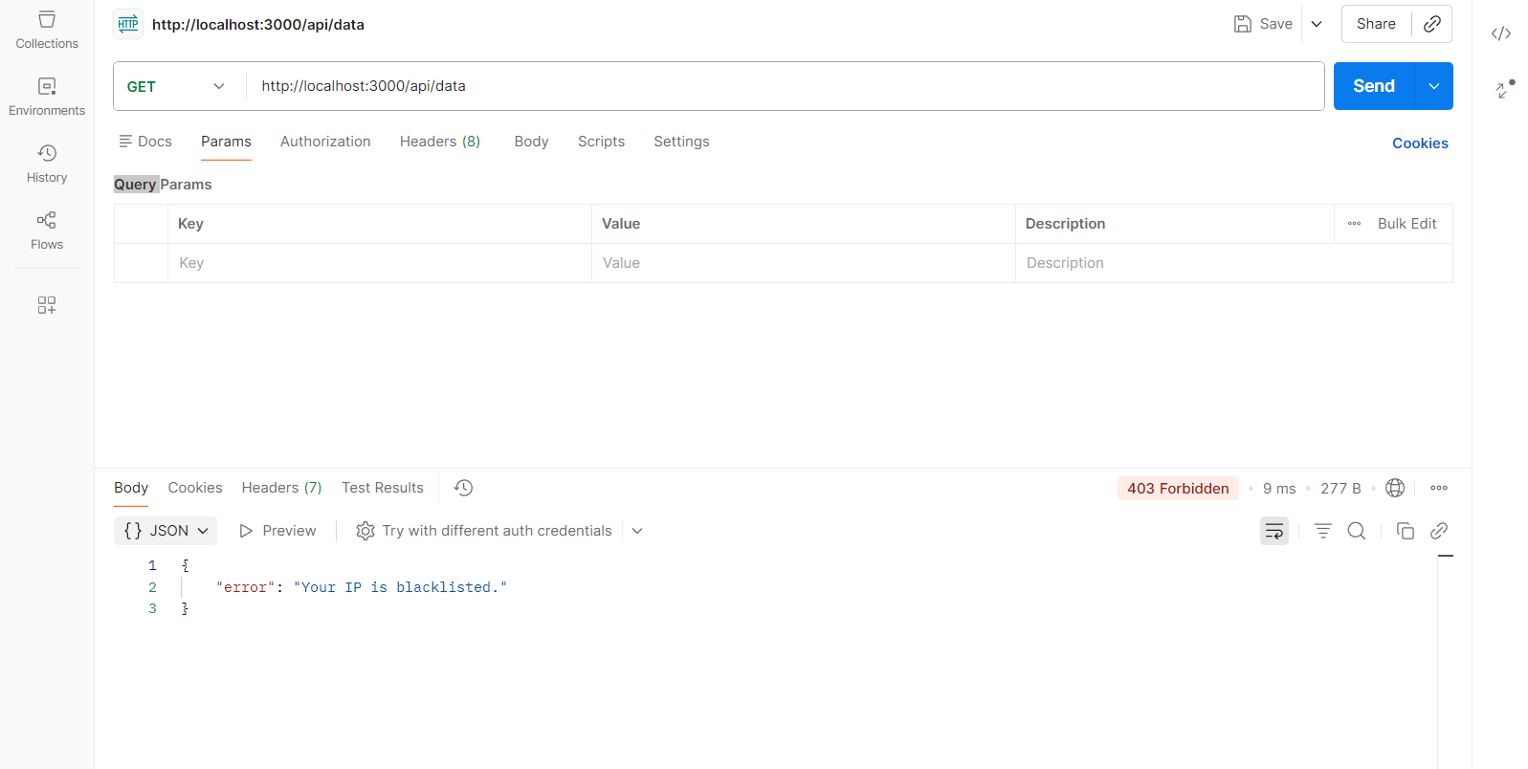
- Screenshot of the Real-Time Admin Dashboard populated with fake traffic data.
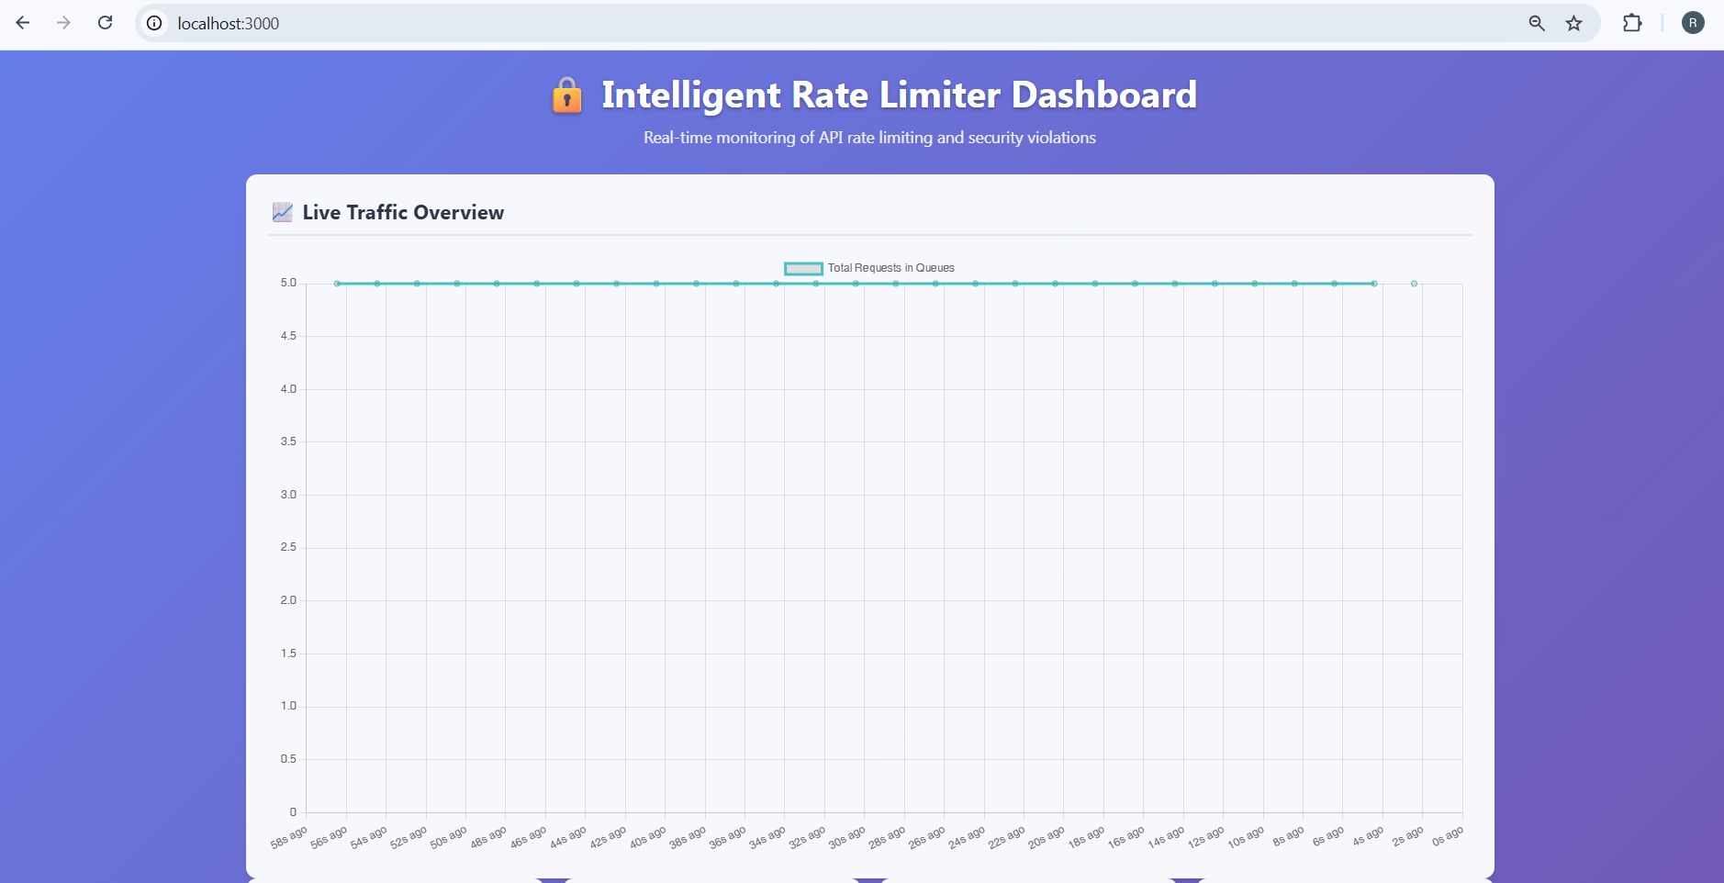
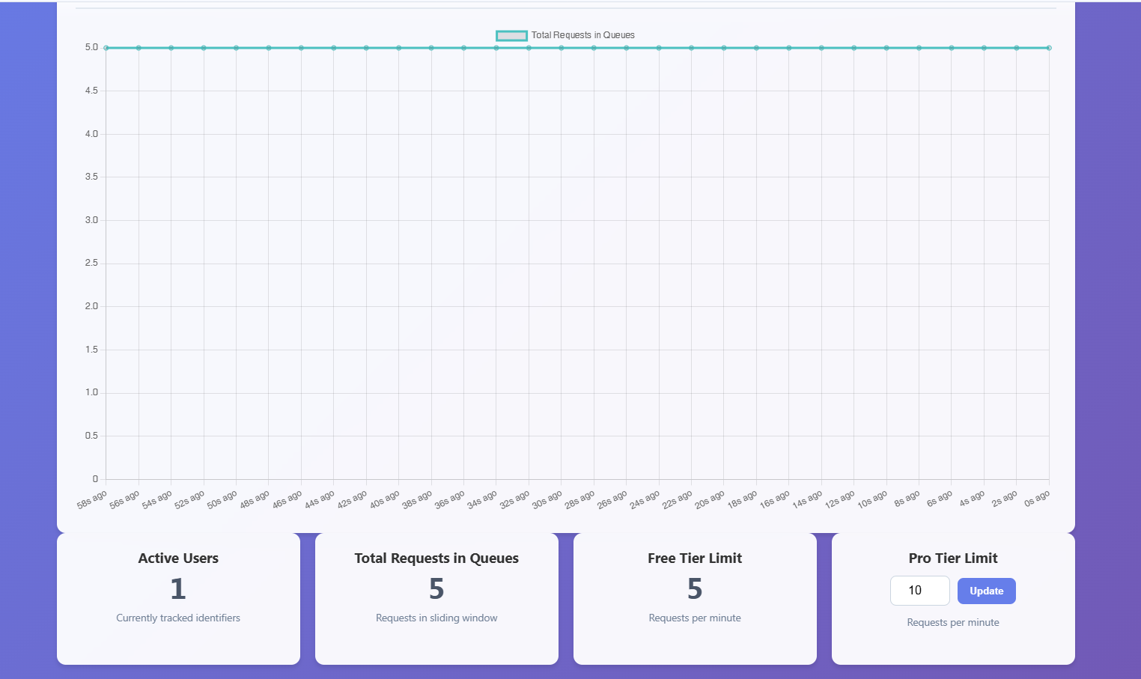
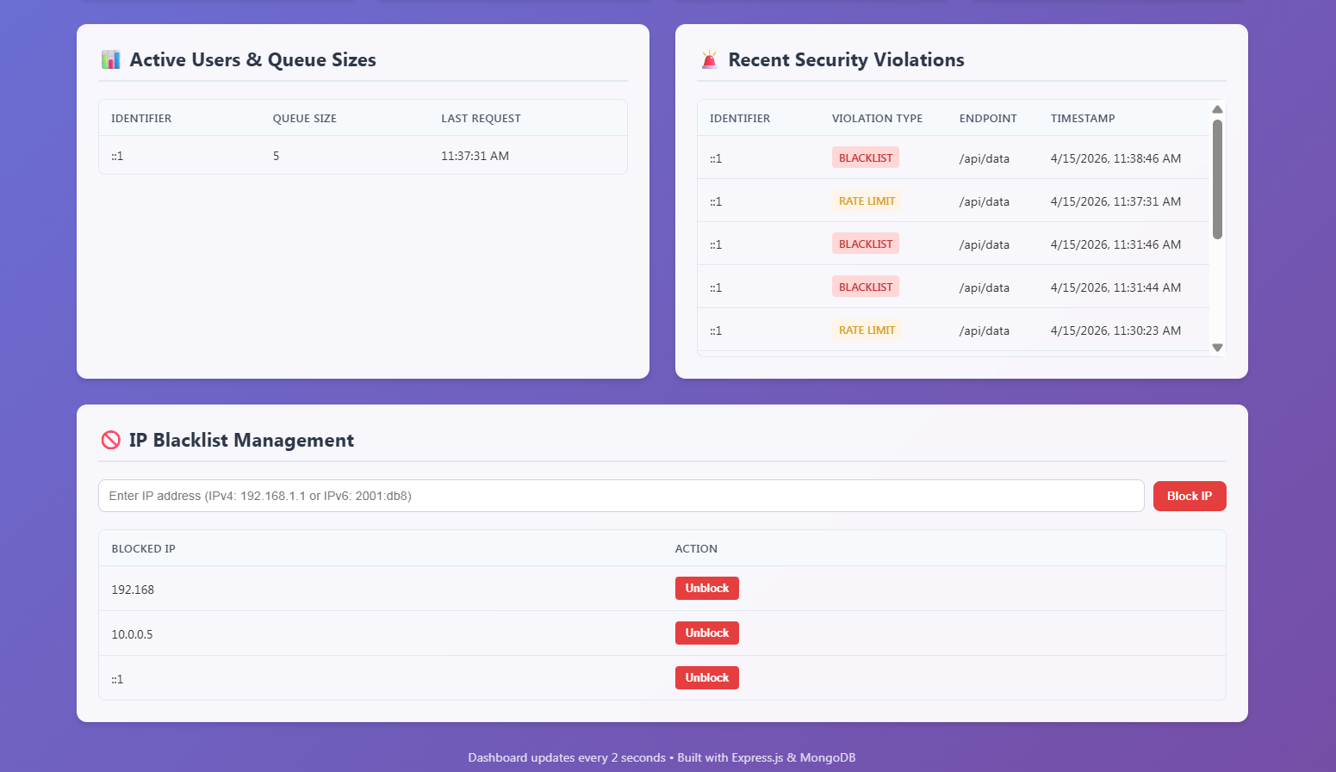
3.6 Test Procedures and Implementation Testing was conducted using Postman to send concurrent HTTP requests to the target endpoint. A Mock Traffic Generator was implemented to simulate a DDoS attack, injecting random IP addresses into the Hash Map to verify the system's stability under high load.

Chapter 4: CONCLUSIONS
4.1 Limitations & Drawbacks Because the core algorithms execute entirely in local server memory (RAM), the current state of the Hash Map and Trie will be lost if the Node.js server experiences a crash or restart.
4.2 Future Enhancement Future iterations could implement a distributed system architecture. We could synchronize the local Data Structures across multiple server instances using a Pub/Sub mechanism, allowing the rate limiter to function effectively behind a Load Balancer.
4.3 Conclusions This project successfully demonstrates the immense value of fundamental Computer Science Algorithms. By implementing a Trie and the Sliding Window Log Algorithm from scratch, the system successfully controls web traffic and mitigates malicious activity without relying on heavy database queries. It proves that proper Data Structure selection drastically optimizes application performance and network security.
4.4 References & Bibliography
- Node.js Official Documentation (v18.x)
- Express.js Middleware Implementation Guide
- Introduction to Algorithms (Cormen, Leiserson, Rivest, Stein) - Reference for Trie and Queue data structures.

