**CHAPTER I**

**INTRODUCTION**

India is mainly an agricultural country. Agriculture is the most important occupation for the most of the Indian families. It plays vital role in the development of agricultural country. In India, agriculture contributes about 16% of total GDP and 10% of total exports. (Naik *et al.* 2016)

For continuously increasing demand of food necessities, it’s important to rapid improvement in production of food technology. Agriculture is only source to provide this need. This is the important factor in human societies to growing and dynamic demand in food production. Agriculture plays an important role in economy and development. Due to lack of water and scarcity of land water result the decreasing volume of water on earth, the farmer use irrigation. Irrigation may be defined as the science of artificial application of water to the land or soil that means depending on the soil type, plant are to be provided with water. (Rane *et al.* 2014)

A good agricultural practice is still an art. Environmental parameters such as soil moisture, temperature, humidity, pH, solar radiations *etc*. plays an important role in overall development of the plant. Temperature affects many of plant activities such as pollination, germination *etc*. It is observed that, at higher temperature, respiration rate increases that results in reduction of sugar content of fruits and vegetables. At lower temperatures photosynthesis activity is slowed down. Humidity is responsible for moisture loss and temperature management of plant. (Yogesh G. Gawali,2016)

Irrigation in agriculture is one of the main tasks. It is very much important to water the crops as per their need. Very less watering or too much watering can damages the crops. In present irrigation system, farmer cannot check the moisture level of soil. Hence sometimes it may happen that watering is more than the need of the crop and sometimes water doesn’t reach up to the roots of the plants. This will waste the water and efforts. If water doesn’t reach up to the plant roots then it will directly affect the plant growth and profit. (Apparao C, 2014)

In today's era the traditional methods that are used for irrigation, such as overhead sprinkler and flood type, is not that much efficient. They results in a lot of wastage of water and can also promote diseases such as fungus formation due to over moisture in soil. (Yogesh G. Gawali,2016)

Traditional irrigation system requires manpower. Hence, it becomes necessary to do something so that the irrigation will become more convenient. Automatic irrigation system is a project which is developed to automatic the traditional irrigation system. Automated irrigation system is essential for conservation of water and indirectly viability of the farm since it is an important commodity. About 85% of total available water resources across the world are exclusively used for the irrigation purpose. In upcoming years this demand is likely to increase because of increasing population. To meet this demand we must adopt new techniques which will conserve need of water for irrigation process. In automation system water availability to crop is monitored through sensors and as per need watering is done through the controlled irrigation. (Yogesh G. Gawali,2016)

Therefore, in this regard to save water and time we have proposed project titled Impact study on arduino based irrigation system. In this proposed system, we were using various sensors like temperature, humidity, soil moisture sensors that sense the various parameters of the soil and atmosphere. In addition, based on soil moisture value land is automatically irrigated by ON/OFF of the motor. These sensed parameters and motor status will be displayed on LCD.

**1.1 Justification**

The proposed system has been designed to overcome the unnecessary water flow into the agricultural lands. For effective growth of crop and for reducing excess water used in irrigation and also save the time of farmers which consume during irrigation process it necessary to design irrigation system which saves the time of irrigation and also saves the water.

Keeping this points in view, objectives were made, which are as follows

1. To develop arduino model for irrigation scheduling.
2. To study parameters such as soil moisture, temperature and humidity by using sensors.

**CHAPTER II**

**REVIEW OF LITERATURE**

Rajpal *et al.* (2011) studied that, the combination of hardware and software provides a irrigation controller that can be implemented at relatively low cost and which is extremely user friendly because it requires only eight keys in all to carry out a myriad of operations and the operator is, at all times, apprised by the display of just what needs.

Nandurkar (2012) concluded that the current work’s aims to develop a smart irrigation system using soil moisture and temperature sensors. Automation helps in utilization of water for irrigation as per requirement of crop result in better yield of crop compared to normal practices carried out by farmers. The system is particularly useful for agriculture applications in sparsely populated semiarid area since human involvement and intervention is not needed for irrigation purposes. Further works are going on to increase the efficiency of the moisture sensors so as to minimize the effects of fertilizers on the value of soil moisture.

Singh and Sharma (2012) conclude that Conventional Flood-type methods consumes a large amount of water, but the area between crop rows remains dry and receives moisture only from the incidental rainfall whereas the drip irrigation technique slowly applies a small amount of water to the plants root zone. So by using the fuzzy based algorithm in wireless sensor drip irrigation technique, we can control the wastage of water and secondly by using wireless sensor, there is no need of labours.

Galande and Agrawal (2013) concluded that the developed system in which temperature will be measured and displayed for information for further action taken in consideration, also measure the soil moisture and display the moisture condition for the future action taken. This system helps the farmers to save the water as well as reduce efforts of farmers of water control action for the irrigation. The microcontroller based atomized drip irrigation system using wireless technique proves to be a real time feedback control system which monitors a controls all the activities of drip irrigation system efficiently. The present proposal is a model to modernize the agriculture industries at a mass scale with optimum expenditure. Using this system, one can save manpower, water to improve production and ultimately profit. The developed irrigation automation system can be proposed to be used in several commercial agricultural productions since it was obtained in low cost and in reliable operation. This application of sensor-based site-specific irrigation has some advantages such as preventing moisture stress of trees, diminishing of excessive water usage, ensuring of rapid growing weeds and derogating satisfaction. If different kinds of sensors (i.e. temperature, humidity, and etc.) are involved in such irrigation in future works.

Sanjukumar, R. K. (2013) concluded that the soil moisture content based irrigation system was developed and successfully implemented along with flow sensor. Salient features of the system are: Closed loop automatic irrigation system, temperature and water usage monitoring. User can easily preset the levels of the moisture and is regularly updated about current value of all parameters on LCD display.

Naga and Gunturi (2013) concluded that the system provides with several benefits and can operate with less manpower. This system supplies water only when the humidity in the soil goes below the reference. Due to the direct transfer of water to the root water conservation takes place and also helps to maintain the moisture to soil ratio at the root zone constant to some extent. Thus the system is efficient and compatible to changing environment.

Shobila and Mood (2014) concluded that the an Automated Irrigation System was developed to optimize water use for agricultural crops and also to verify water scarcity in the field. The system has distributed wireless network of soil moisture and temperature sensor and conductive sensors that are placed in the root zone of the plant. The automated irrigation system developed proved that the use of water can be diminished for a given amount of biomass production. Besides the monetary savings in water use, the importance of the preservation of this natural resources justify the use of this kind of irrigation systems.

Nagaraja Pandian *et al.* (2015) studied the project for farmers and gardeners who do not have enough time to water their crops and plants. It also covers those farmers who are wasteful of water during irrigation. The project can be extended to green houses where manual supervision is far and few in between. The principle can be extended to create fully automated gardens and farm lands. Combined with the principle of rain water harvesting, it could lead to huge water savings if applied in the right manner .In agricultural lands with severe shortage of rainfall, this model can be successfully applied to achieve great results with most type of soils.

Naik *et al.* (2017) proposed work includes an embedded system for automatic control of irrigation. This project has wireless sensor network for real-time sensing of an irrigation system. This system provides uniform and required level of water for the agricultural farm and it avoids water wastage. When the moisture level in the soil reaches below threshold value then system automatically switch ON the motor. When the water level reaches normal level the motor automatically switch OFF. The sensed parameters and current status of the motor will be displayed on user’s android application.

Mediawan *et al.* (2018) concluded that results were influenced by the level of moisture or water content contained in the soil, the soil moist so the smaller the value of discrete ADC readings on the sensor, and vice versa. Testing the temperature sensor, the comparison between the results obtained a DHT22 sensor with temperature gauges contained in the anemometer showed no difference.

**CHAPTER III**

**MATERIALS AND METHOD**

This chapter deals with methodology used for the study of fenugreek response to moisture content for point application of arduino based drip irrigation system.

* 1. **Location**

# The project work is carried out at Dr. D Y Patil CAET, Talsande. (16°52'38.1"N 74°15'39.4"E)

**3.2. Arduino setup**

Setup consists of various components which were described as follows.

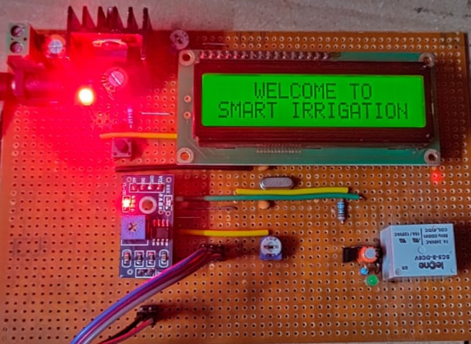

**Fig 3.3 Arduino setup**

**3.3 Experimental setup**

Testing was carried out on model field of about total 1392 cm2 area. The fenugreek crop variety of Methi No- 47 was selected for the experiment and it was planted in tray. For this study of drip irrigation, separate experimental setup was made in model tray. The objective of such study was to provide water as per plant-water requirement. Experimental setup consists of tray with covering material, main line, laterals, pump, arduino setup and water source. The length of tray is 43.5 cm, width is 32 cm and the depth of tray is 7.5 cm. The height of model greenhouse is about 40 cm.

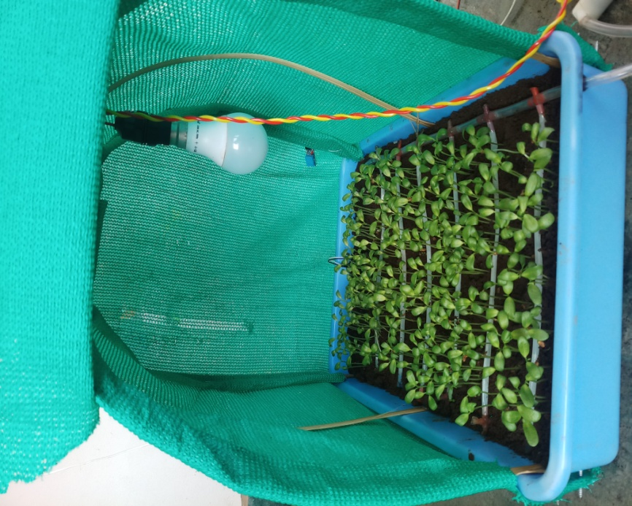

**Fig 3.1 Experimental setup**

**3.3.1 Water source**

The bucket having 25 liters storage capacity was used to supply water for operating system.

**3.3.2 Pump**

A submersible pump of 6 volt with electric supply was use for pumping water from bucket. The outside diameter of pump outlet is 7.5 mm and inside diameter is 5 mm. Theoretical flow rate of pump is varies between 80 lph to 120 lph. The actual flow rate of system is 90 lph.

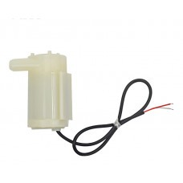

**Fig 3.2 Submersible water pump**

**3.3.3 Main line**

Irrigation water was diverted from the tank to the tray through plastic pipe of 5.9 mm inner diameter and outer diameter 7.5 mm. The length of main line is 43.5 cm. The discharge of main line is 90 lph.

**3.3.4 Lateral**

5 mm inner and 5.6 mm outer diameter laterals were connected to mainline. The length of laterals was 30 cm. Perforations of diameter 0.7 mm were made on the laterals at spacing 3 cm. The average discharge of lateral was 12.86 lph.

**3.3.54.1 Microcontroller ATMEGA328P (Arduino)**

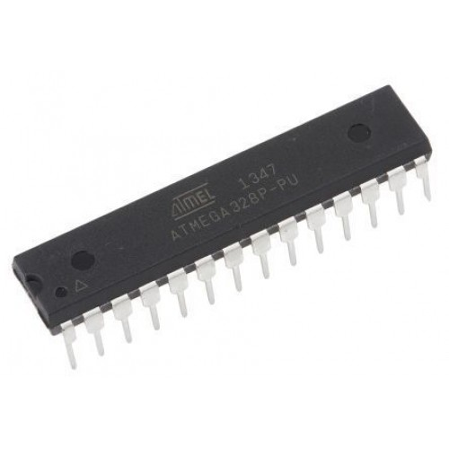  
**Fig 3.4 Microcontroller ATMEGA328P**

The ATMEGA328P-PU is a low-power CMOS 8-bit microcontroller based on the AVR enhanced RISC architecture. By executing powerful instructions in a single clock cycle, the ATmega328P-PU achieve throughput approaching 1 MIPS per MHz allowing the system designed to optimize power consumption verses processing speed.

The AVR core combines a rich instruction set with 32 general purpose working registers. All the 32 registers were directly connected to the Arithmetic Logic Unit (ALU), allowing two independent registers to be accessed in one single instruction executed in one clock cycle. The resulting architecture was more code efficient while achieving throughputs up to ten times faster than conventional CISC microcontrollers.

                        The ATmega328P-PU AVR was supported with a full suite of program and system development tools including: C Compilers, Macro Assemblers, Program Debugger/Simulators, In-Circuit Emulators, and Evaluation kits.

**ATMEGA328P Pinout**

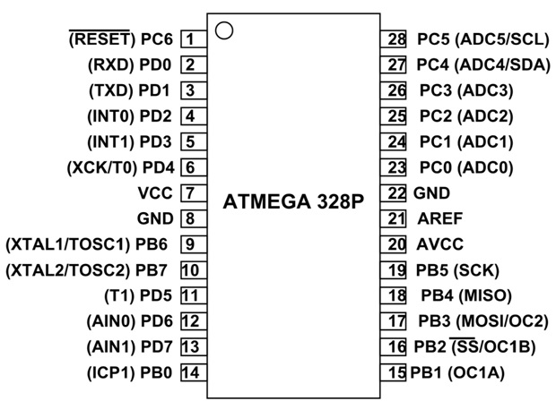

**Fig 3.5 Pin Diagram**

**Table 3.1 Specifications of ATMEGA328P**

|  |  |
| --- | --- |
| **ATMEGA328P – Simplified Features** | |
| CPU | 8-bit AVR |
| Number of Pins | 28 |
| Operating Voltage (V) | +1.8 V TO +5.5V |
| Number of programmable  I/O lines | 23 |
| Communication Interface | Master/Slave SPI Serial Interface(17,18,19 PINS) [Can be used for programming this controller]  Programmable Serial USART(2,3 PINS) [Can be used for programming this controller]  Two-wire Serial Interface(27,28  PINS)[Can be used to connect peripheral devices like Servos, sensors and memory devices] |
| JTAG Interface | Not available |
| ADC Module | 6channels, 10-bit resolution ADC |
| Timer Module | Two 8-bit counters with Separate Prescaler and compare mode, One 16-bit counter with Separate Prescaler, compare mode and capture mode. |
| Analog Comparators | 1(12,13 PINS) |
| DAC Module | Nil |
| PWM channels | 6 |
| External Oscillator | 0-4MHz @ 1.8V to 5.5V  0-10MHz @ 2.7V to 5.5V  0-20MHz @ 4.5V to 5.5V |
| Internal Oscillator | 8MHz  Calibrated Internal Oscillator |
| Program Memory Type | Flash |
| Program Memory or Flash memory | 32Kbytes[10000 write/erase cycles] |
| CPU Speed | 1MIPS for 1MHz |
| RAM | 2Kbytes Internal SRAM |
| EEPROM | 1Kbytes EEPROM |
| Watchdog Timer | Programmable Watchdog Timer with Separate On-chipOscillator |
| Program Lock | Yes |
| Power Save Modes | Six Modes[Idle, ADC Noise Reduction, Power-save, Power-down, Standby and Extended Standby] |
| Operating Temperature | -40°C to +105°C(+105 being absolute maximum, -40 being absolute minimum) |

**3.3.4.2 Soil Moisture Sensor**

Soil moisture sensors measure the dielectric constant of the soil in order to find its volumetric water content. It obtains volumetric water content by measuring the dielectric constant of the media through the utilization of frequency domain technology. Since the dielectric constant of the soil is sensitive measure of volumetric water content.

The sensor has a low power requirement and very high resolution. This gives the ability to make many measurements (i.e. hourly) over a long period of time with minimal battery usage. In addition, the sensors incorporate a high frequency oscillation, which allows the sensor to accurate measure soil moisture in any soil with minimal salinity and textural effects.

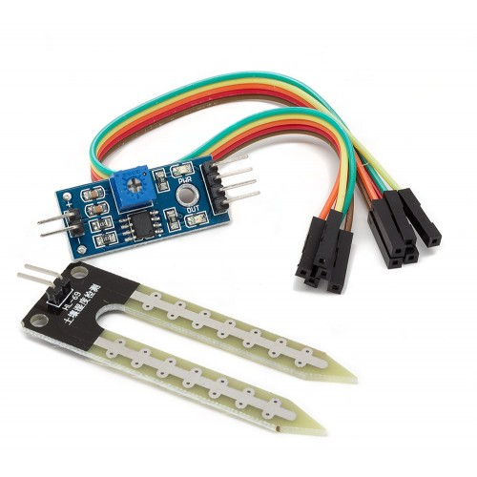

**Fig 3.6 Soil moisture sensor**

**3.3.4.3 Humidity and temperature sensor (DTH11)**

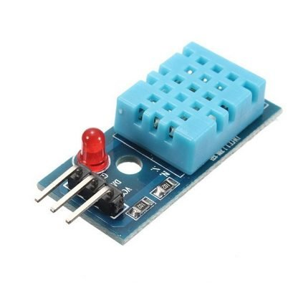

**Fig 3.7 DHT11 Humidity and temperature sensor**

The DHT sensors are made of two parts, a capacitive humidity sensor and a thermostat. There is also a very basic chip inside that does some analog to digital conversion and spits out a digital signal with the temperature and humidity. The digital signal is fairly easy to read using any microcontroller. The DHT11 and DHT22 sensors are used to measure temperature and relative humidity. These are very popular among makers and electronics hobbyists. These sensors contain a chip that does analog to digital conversion and spit out a digital signal with the temperature and humidity. The DHT11 is a basic, ultra low-cost digital temperature and humidity sensor. It uses a capacitive humidity sensor and a thermostat to measure the surrounding air, and spits out a digital signal on the data pin (no analog input pins needed). It’s fairly simple to use, but requires careful timing to grab data.

The DHT11 is a commonly used Temperature and humidity sensor. The sensor comes with a dedicated NTC to measure temperature and an 8-bit microcontroller to output the values of temperature and humidity as serial data. The sensor is also factory calibrated and hence easy to interface with other microcontrollers.

The DHT11 calculates relative humidity by measuring the electrical resistance between two electrodes. The humidity sensing component of the DHT11 is a moisture holding substrate with the electrodes applied to the surface. This module integrates DHT11 sensor and other required components on a small PCB. The DHT11 sensor includes a resistive-type humidity measurement component, an NTC temperature measurement component and a high-performance 8-bit microcontroller inside, and provides calibrated digital signal output.

**3.3.4.4 16×2 LCD**

LCD indicates different mode settings and set point adjustment. Also 16 characters are divided to indicate speed output. The LCD display used here is 16 characters by 2 lines display.

The 16 characters in both lines are equally divided to indicate commands and speed.



**Fig 3.8 162 LCD**

**The interfacing is given in detail which is as follows**

In this equipment the LCD was used which is 16×2 types i.e. 16 characters per row and two rows. The function of LCD was to display the status of events performed by the respective circuit or to display those resulting parameters which have to be displayed on screen as per requirement. It could display 16 characters per line and there are 2 such lines.

In this LCD each character was displayed in 5×7pixel matrix. This LCD has two registers, namely Command and Data. The command register stores the command instructions given to the LCD. A command is an instruction given to LCD to do a predefined task like initializing it, clearing its screen, setting the cursor position, controlling display etc. The data register stores the data to be displayed on the LCD.

**3.3.4.5 Software used for study**

**Arduino IDE**

Arduino consists of both a physical programmable circuit board (often referred to as a microcontroller) and a piece of software, or IDE (Integrated Development Environment) that runs on your computer, used to write and upload computer code to the physical board. The Arduino integrated development environment (IDE) is a cross-platform application (for Windows, macOS, Linux) that is written in the programming language Java.

Arduino consists of both a physical programmable circuit board (often referred to as a microcontroller) and a piece of software, or IDE (Integrated Development Environment) that runs on your computer, used to write and upload computer code to the physical board.

The Arduino compiler/IDE accepts C and C++ as-is. In fact many of the libraries are written in C++. Much of the underlying system is not object oriented, but it could be. Thus, "The arduino language" is C++ or C.

The programming code is written in embedded C fig 3.9 shows the compilation of the code in which we gave a condition as when moisture content of soil is below 40% then motor gets ON and when moisture content of soil is reach at 75% then motor gets turn OFF.

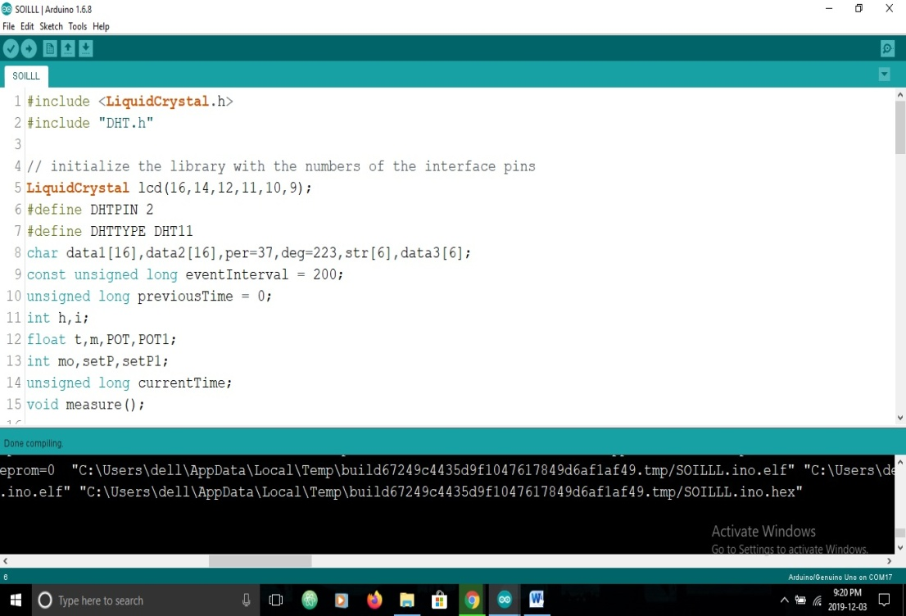

**Fig 3.9 Compilation code**

* **Program used for software “Arduino IDE” :**

#include <LiquidCrystal.h>

#include "DHT.h"

// initialize the library with the numbers of the interface pins

LiquidCrystallcd(16,14,12,11,10,9);

#define DHTPIN 2

#define DHTTYPE DHT11

char data1[16],data2[16],per=37,deg=223,str[6],data3[6];

const unsigned long eventInterval = 200;

unsigned long previousTime = 0;

inth,i;

float t,m,POT,POT1;

int mo,setP,setP1;

unsigned long currentTime;

void measure();

DHT dht(DHTPIN,DHTTYPE);

void setup() {

Serial.begin(9600);

dht.begin ();

lcd.begin(16, 2);

pinMode(3,OUTPUT);

lcd.setCursor(3,0);

lcd.print("WELCOME TO");

lcd.setCursor(0,1);

lcd.print("SMART IRRIGATION");

delay(3000);

lcd.clear();

}

void loop() {

currentTime = millis();

measure();

if(mo<setP&&mo<75)

{

i=1;

while(i){

measure();

if(mo>75){

i=0;

}

digitalWrite(3,HIGH);

}

}

else{

digitalWrite(3,LOW);

}

if (currentTime - previousTime>= eventInterval) {

lcd.clear();

previousTime = currentTime;

}

}

void measure()

{

h = dht.readHumidity();

t = dht.readTemperature();

if (isnan(h) || isnan(t)) {

Serial.println(F("Failed to read from DHT sensor!"));

while(isnan(h) || isnan(t)){

lcd.setCursor(0,0);

lcd.print("DHT Disconnec..!");

}

return;

}

m = analogRead(A4);

mo=map(m,0,1023,100,0);

POT = analogRead(A5);

setP=map(POT,0,1023,90,0);

dtostrf(t, 4, 1, str);

sprintf(data1,"H:%d%c T:%s%cC",h,per,str,deg);

sprintf(data2,"M:%d%c S:%d%c",mo,per,setP,per);

lcd.setCursor(0,0);

lcd.print(data1);

lcd.setCursor(0,1);

lcd.print(data2);

}

The result of compilation is shown in below fig 3.10

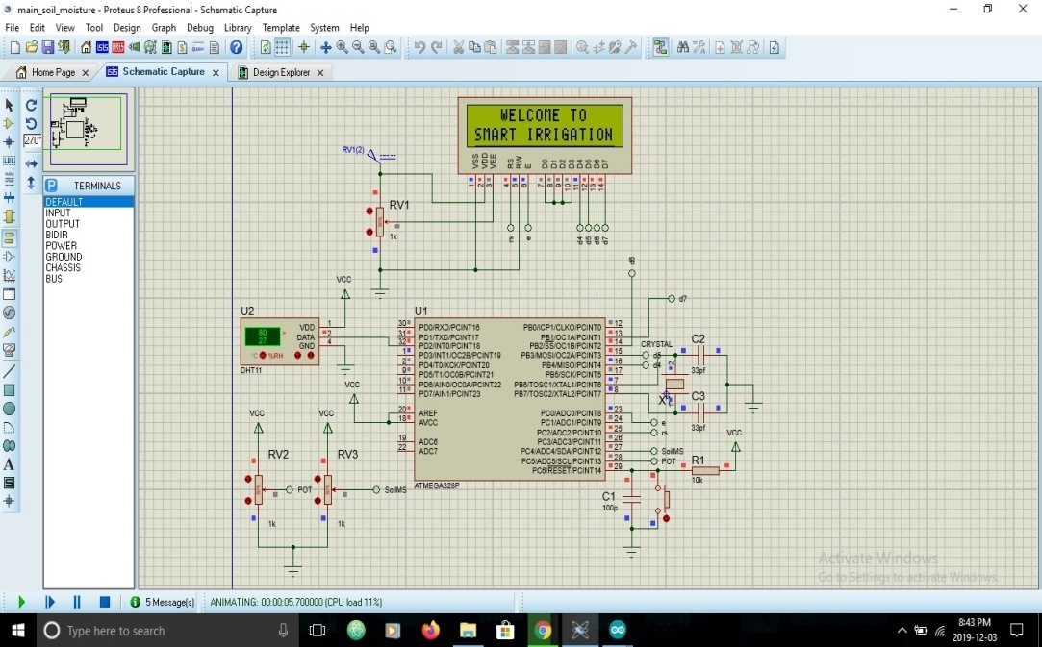

**Fig 3.10 Compilation code**

**Principle of working :**

Arduino based irrigation system checks the condition of soil, when soil moisture content fall below 40% then the motor will automatically supply water to the field and cuts the irrigation when soil moisture content reaches at 75% with the help of soil moisture sensor. The status of soil was displayed on LCD through microcontroller and switch on or off the pumping through relay. The pumping motor will pump the water into the field by using drip system until the field is wet which is monitored by microcontroller.

A

R

D

U

I

N

O

Power

Supply

LCD

H

ADC

MOTOR

T

M

**Fig 3.11 Block diagram for Working Principal**

**CHAPTER IV**

**RESULT AND DISCUSSION**

The project entitled “Arduino based irrigation system” was carried out in department of Irrigation and Drainage Engineering. This chapter deals with results of study parameters such as soil moisture, temperature and humidity taken with the help of developed arduino model.

**4.1 Irrigation scheduling and soil moisture sensor**

The fig 4.1 shows that soil moisture content by using soil moisture sensor which changes with time. When soil moisture falls below 40% then it automatically starts the motor and irrigation will be done. After watering soil moisture gets increased than first soil moisture. Readings were shown in Appendix I.

**Fig 4.1 Graph for Soil moisture content**

**4.2 Temperature**

The fig 4.2 shows that air temperature changes with time and watering. The minimum environmental temperature is 19.4oc and maximum atmospheric temperature is 35.2oc. Readings were shown in Appendix I.

**Fig 4.2 Graph for Temperature variations**

**4.3 Humidity**

The fig 4.3 shows the variations in atmospheric humidity. In winter season due to climatic conditions the percentage of humidity gets higher. The value of humidity ranges between 65% to 95%. Readings were shown in Appendix I.

**Fig 4.3 Graph for percentage Humidity**

**CHAPTER V**

**SUMMERY AND CONCLUSION**

Agricultural uses 85% of available fresh water resources worldwide, and this percentage will continue to be dominant in water consumption because of population growth and increased food demand. There is an urgent need to create strategies based on science and technology for sustainable use of water. In this irrigation system water availability to crop is monitored through sensors and as per need watering is done through the controlled irrigation.

In India, human power in agriculture sector widely used. An arduino based irrigation system is designed based on environmental parameters such as soil moisture, temperature and humidity to decrease human interference and make certain appropriate irrigation.

Arduino based irrigation system was designed on the basis of soil moisture content. With the objectives and need of automation, the system was used to irrigate the crop according to water requirement. As system consist of power supply, pumping unit and arduino kit.

The environmental parameter which affects the plant growth was determined such as soil moisture, temperature and humidity. The temperature and humidity has variations in greenhouse and on open field.

**Future Scope**

The readings which were taken manually that could be done automatically by modified circuit.

**CHAPTER VI**

**BIBILOGRAPHY**

Apparao, C. (2014). *Field Evaluation Of Automated Drip Irrigation System* (Doctoral Dissertation, Acharya Ng Ranga Agricultural University, Guntur).

Devika, S. V., Khamuruddeen, S., Khamurunnisa, S., Thota, J., & Shaik, K. (2014). Arduino based automatic plant watering system. *International Journal of Advanced Research in Computer Science and Software Engineering*, *4*(10), 449-456.

Galande, S. G., & Agrawal, G. H. (2013). Embedded controlled drip irrigation system. *International Journal of Emerging Trends & Technology in Computer Science (IJETTCS)*, *2*(5).

Gawali, Y. G., Chaudhari, D. S., & Chaudhari, H. C. (2016). Automated irrigation system using wireless sensor network. *Int. J. Adv. Res. Electron. Commun. Eng.(IJARECE)*, *5*(6).

Gunturi, V. N. R. (2013). Micro controller based automatic plant irrigation system. *International Journal of Advancements in Research & Technology*, *2*(4), 194-198.

Jonarv Hultgren, S., & Tennevall, P. (2019). Saving resources through smart farming: An IoT experiment study.

Kansara, K., Zaveri, V., Shah, S., Delwadkar, S., & Jani, K. (2015). Sensor based automated irrigation system with IOT: a technical review. *International Journal of Computer Science and Information Technologies*, *6*(6), 5331-5333.

Kumar, B. D., Srivastava, P., Agrawal, R., & Tiwari, V. (2017). Microcontroller based automatic plant Irrigation system. *International Research Journal of Engineering and Technology (IRJET)*, *4*(5), 1436-1439.

Mediawan, M., Yusro, M., & Bintoro, J. (2018, November). Automatic Watering System in Plant House-Using Arduino. In *IOP Conference Series: Materials Science and Engineering* (Vol. 434, No. 1, p. 012220). IOP Publishing.

Nagarajapandian, M., Ram Prasanth, U., Selva Kumar, G., & Tamil Selvan, S. (2015). Automatic irrigation system on sensing soil moisture content. *International Journal of Innovative Research in Electrical, Electronics, Instrumentation and Control Engineering*, *3*(1), 96-98.

Naik, P., Kumbi, A., Vishwanath Hiregoudar, C. N., Pavitra, H., Sushma, B., Sushmita, J., & Kuntanahal, P. (2017). Arduino Based Automatic Irrigation System Using IoT. *International Journal of Scientific Research in Computer Science, Engineering and Information Technology (IJSRCSEIT)*, *2*(3), 881-886.

Naik, P., Kumbi, A., Katti, K., & Telkar, N. AUTOMATION OF IRRIGATION SYSTEM USING IoT.

Naik, P., Kumbi, A., Vishwanath Hiregoudar, C. N., Pavitra, H., Sushma, B., Sushmita, J., & Kuntanahal, P. (2017). Arduino Based Automatic Irrigation System Using IoT. *International Journal of Scientific Research in Computer Science, Engineering and Information Technology (IJSRCSEIT)*, *2*(3), 881-886.

Nandurkar, S. R., & Thool, V. R. (2012). Design of a soil moisture sensing unit for smart irrigation application. In *International Conference on Emerging Technology Trends on Advanced Engineering Research (ICETT 2012), Proceedings published by International Journal of Computer Applications (IJCA)* (pp. 1-4).

Rajpal, A., Jain, S., Khare, N., & Shukla, A. K. (2011). Microcontroller-based automatic irrigation system with moisture sensors. In *Proceedings of the International Conference on Science and Engineering* (pp. 94-96).

Sanjukumar, R. K. (2013). Advance technique for soil moisture content based automatic motor pumping for agriculture land purpose. *International Journal of VLSI and Embedded Systems*, *4*, 599-603.

Singh, S., & Sharma, N. (2012). Research paper on drip irrigation management using wireless sensors. *International Journal of Computer Networks and Wireless Communications*, *2*(4), 461-464.

Shifa, T. K. (2018). Moisture Sensing Automatic Plant Watering System Using Arduino Uno. In *AJER*.

Shobila, P., & Mood, V. Automated Irrigation System Using Robotics and Sensors.

Vagulabranan, R., Karthikeyan, M., & Sasikala, V. (2016). Automatic irrigation system on sensing soil moisture content. *International Research Journal of Engineering and Technology (IRJET)*, *3*(03), 206-208.