GUJARAT TECHNOLOGICAL UNIVERSITY

Academic year

(2022-2023)

**Gandhinagar Institute of Technology**

INTERNSHIP REPORT UNDER SUBJECT OF

## SUMMER INTERNSHIP (3170001)

B.E. SEMESTER-**VII**

BRANCH – Information and Technology

Submitted by :- **Vraj M Patel**

BrainyBeam Technologies Pvt. Ltd.

Prof. Shweta Rajput Type the Name of Ext. guid

(Internal Guide) (External Guide)

**Company Profile**



**Company Name:** BrainyBeam Technologies Pvt Ltd

**Address:** 118, Sukan Mall , Science city road, Ahmedabad

**Contact No:** +91 9033237336

**Email Id :** [sagar@brainybeam.com](mailto:sagar@brainybeam.com)

**Website:** [www.brainybeam.com](http://www.brainybeam.com/)

**About Us**

At BrainyBeam, we see Innovation as a clear differentiator. Innovation, along with focus on deep, long-lasting client relationships and strong domain expertise, drives every facet of our day-to-day operations.

BrainyBeam Technologies was founded with a vision to address growing businesses' needs of reducing the time to market and cost effectiveness required to develop and maintain unique and customized web and mobile solutions. We are uniquely and strategically positioned to partner with startups and leading brands to help them expand their business and offer the most effective and cost-efficient solutions that provide revenues and value to their business needs.

**Vision**

To become the most trusted and preferred offshore IT solutions partner for Startups, SMBs and Enterprises through innovation and technology leadership. Understanding your ambitious vision, honing in on its essence, creating a design strategy, and knowing how to technically execute it is what we do best. Our promise? The integrity of your vision will be maintained and we'll enhance it to best reach your target customers. With our primary focus on creating amazing user experiences, we'll help you understand the tradeoffs, prioritize features, and distill valuable functionality. It's an art form we care about getting right.

**Joining Letter**

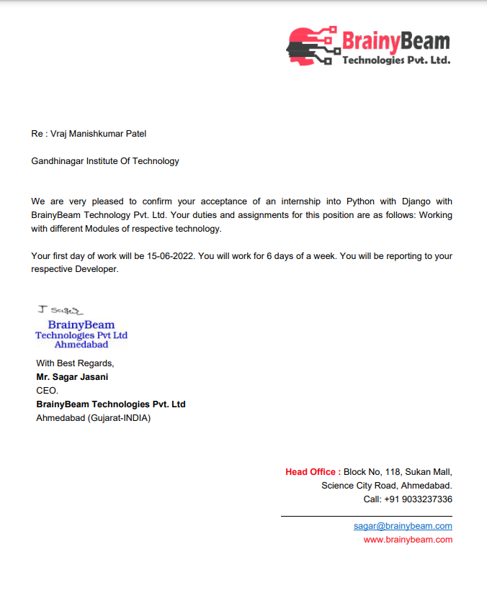

**Completion Certificate**

# ACKNOWLEDGEMENT

# Abstract

Task: - 1 ( Date:-15-06-2022)

Question :

1. **List Out Python Keywords and Operators** .

:- Python has a set of keywords that are reserved words that cannot be used as variable names, function names, or any other identifiers:

Keywords in python are :- false , await , else , if , elseif , from , return

Operators in python are :-

* Arithmetic operators
* Assignment operators
* Comparison operators
* Logical operators
* Identity operators
* Membership operators
* Bitwise operators

1. **Explain Structured , unstructured , semi structured data with example.**

Structured Data :- Structured data is data whose elements are addressable for effective analysis. It has been organized into a formatted repository that is typically a database.

Semi structured Data :- Semi-structured data is information that does not reside in a relational database but that has some organizational properties that make it easier to analyze.

Unstructured Data :- Unstructured data is a data which is not organized in a predefined manner or does not have a predefined data model, thus it is not a good fit for a mainstream relational database.

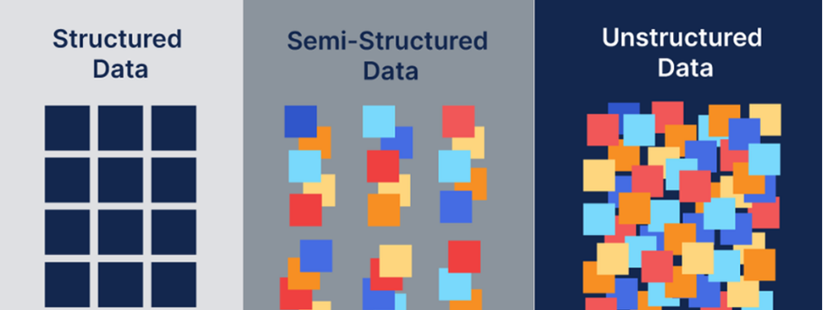

1. **Build a GST calculation program with multiple categories having different percentages.**

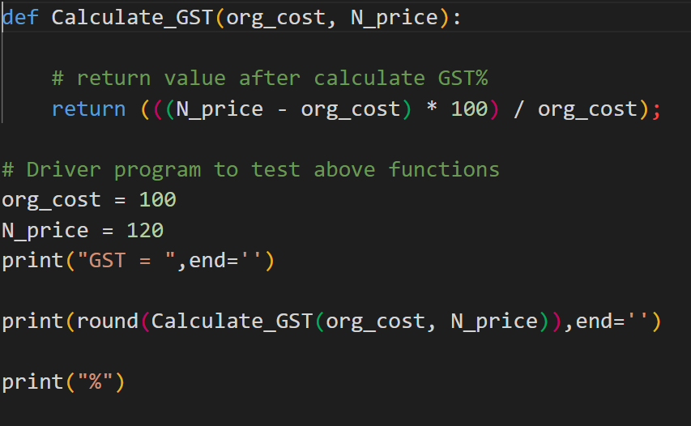

Output :-

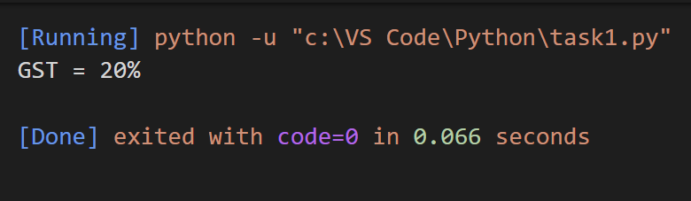

1. **Calculate the total price of items entered by the users**

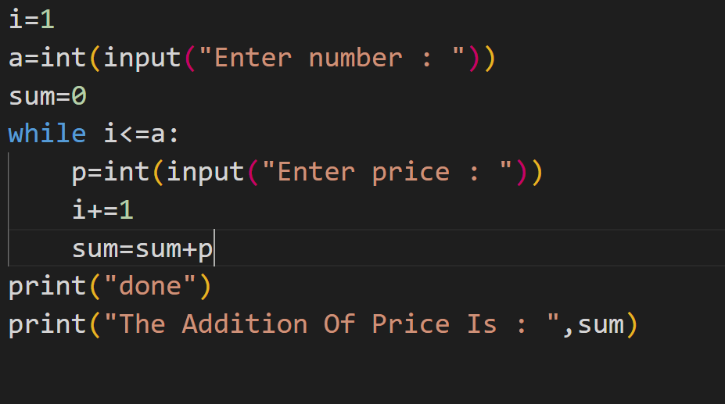

Output :

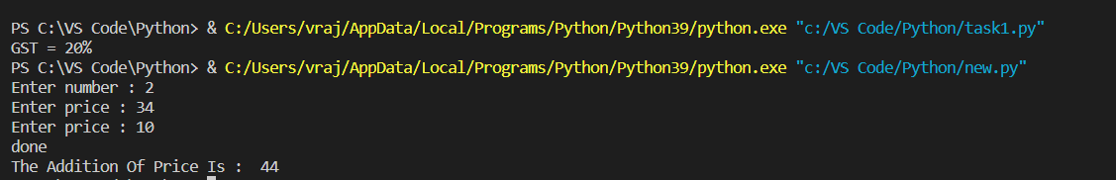

Task: - 2 ( Date:-16-06-2022)

Question :

* 1. **List out 5 methods of list , set and dictionary , explain them with example**

A Set in Python is a collection of unique elements which are unordered and mutable. Python provides various functions to work with Set

5 methods of set are :-

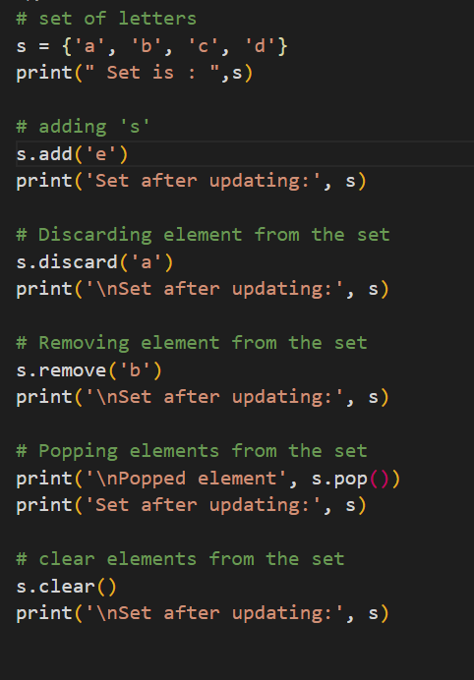

Output: -

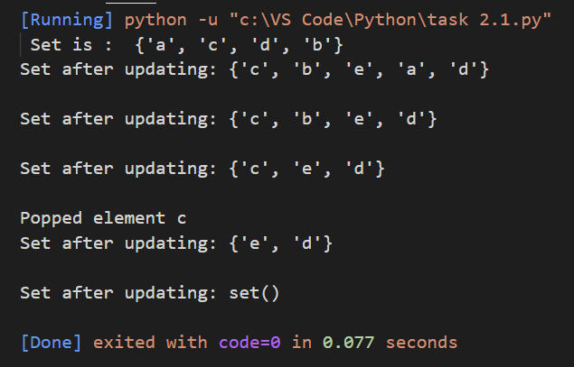

Python has a lot of list methods that allow us to work with lists.

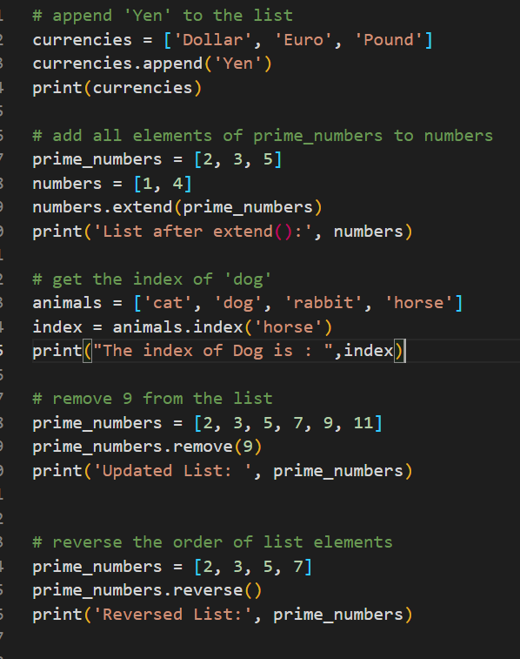

Output :-

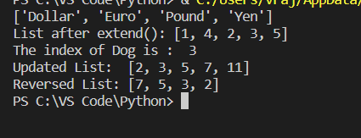

Python Dictionary is like a map that is used to store data in the form of a key: value pair. Python provides various in-built functions to deal with dictionaries.

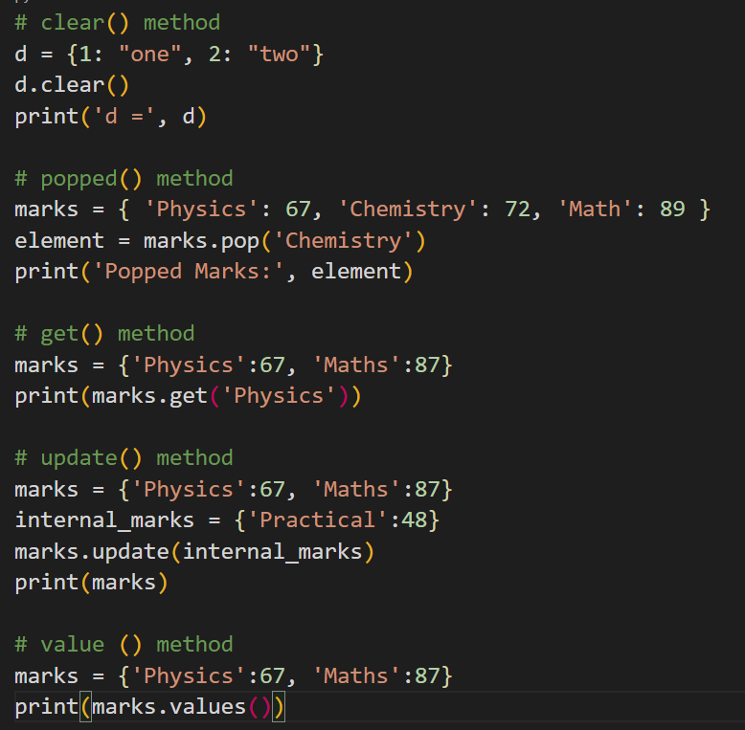

Output :-

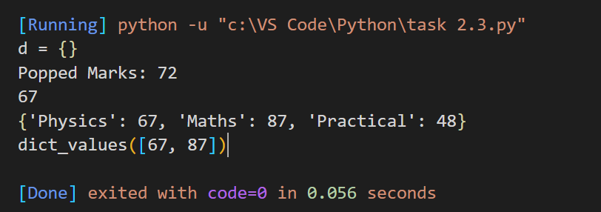

* 1. **Build a student report card program which can take subject, marks as input and return of marks students using function.**

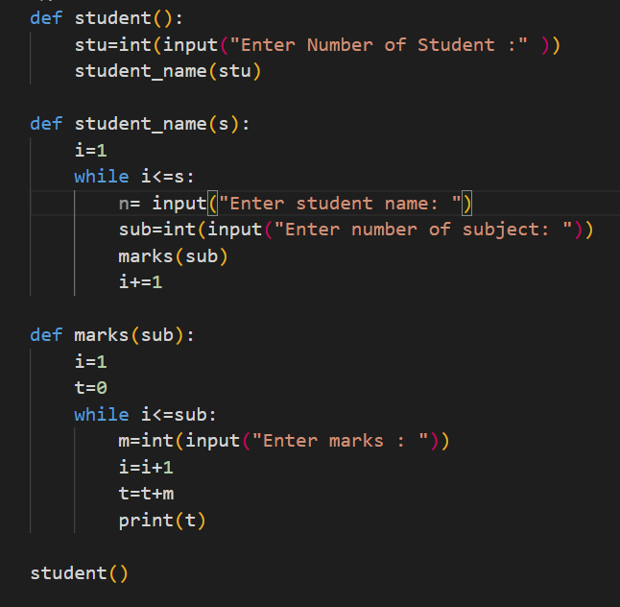

Output :-

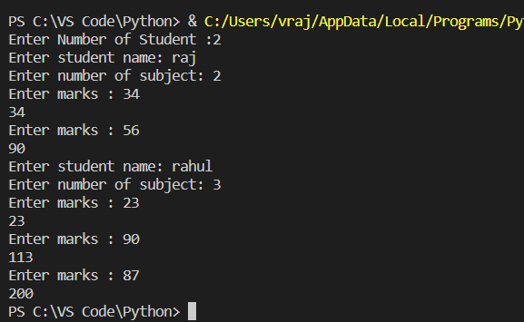

* 1. **Build a program to find factorial , prime, odd , even from user input in python**

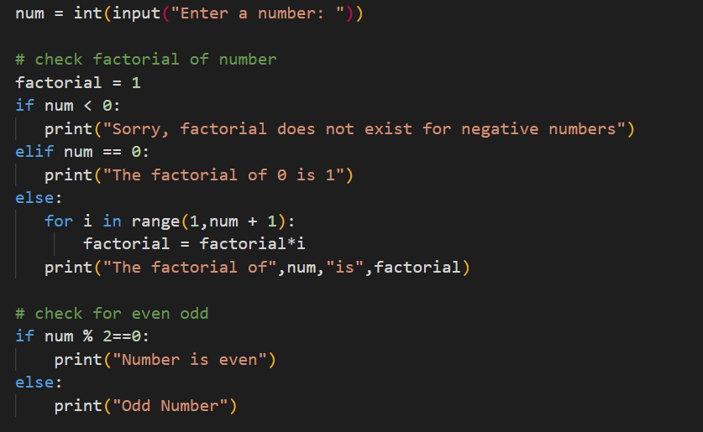

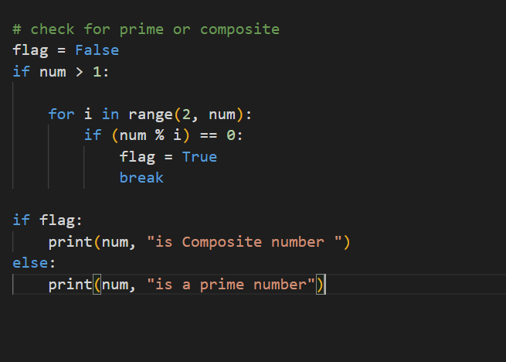

Output :-

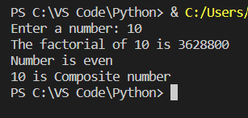

Task: - 3 ( Date:-17-06-2022)

Question :

1. **Build a ATM program containing deposit and withdraw functions with validations and loop using class**

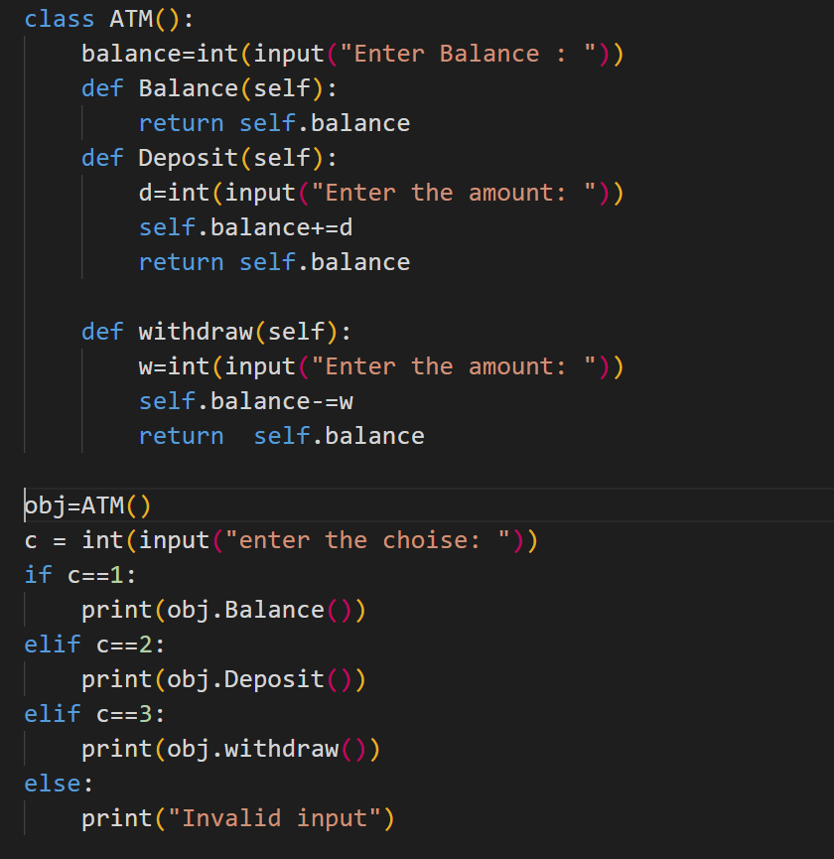

Output **:-**

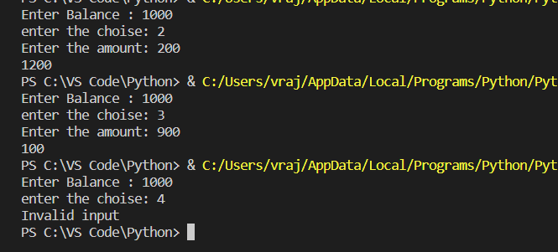

1. **List out 5 inbuilt libraries of python and use their 3 methods with examples.**

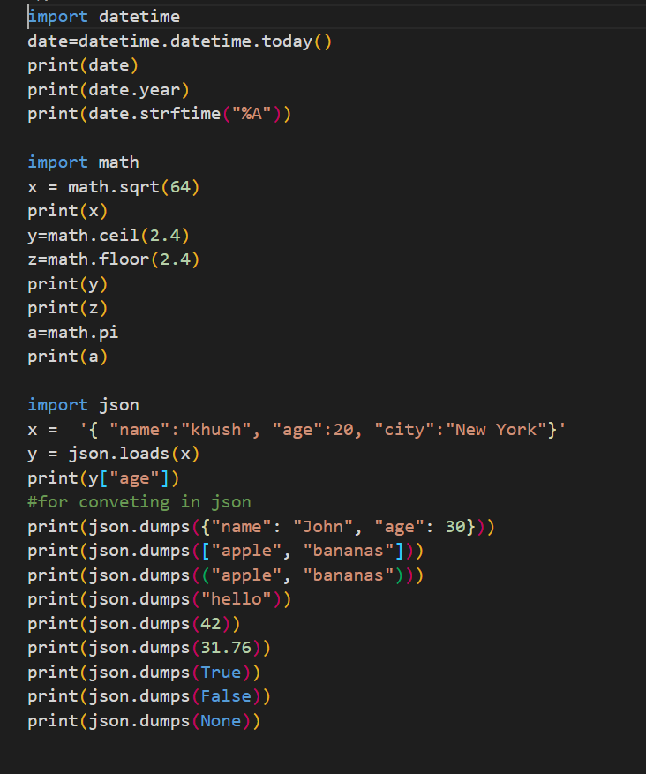

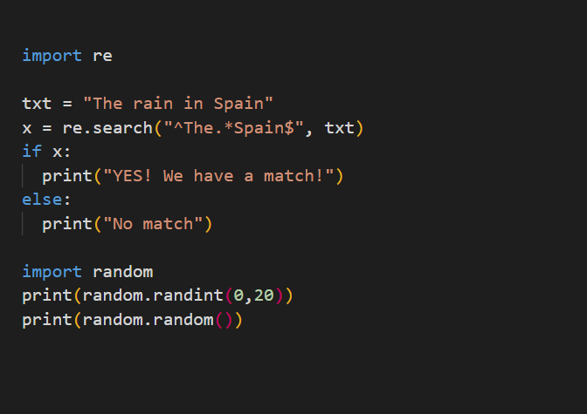

Output: -

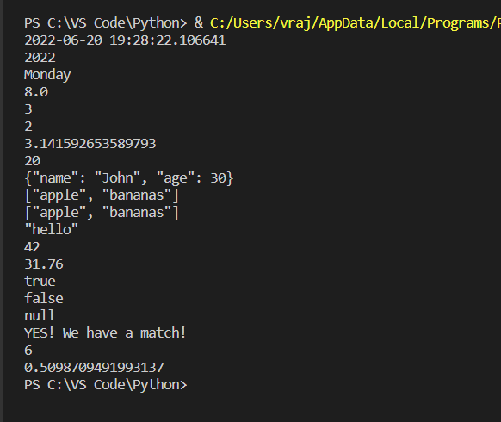

1. **List out at least 10 meta characters and use them in pattern for email and phone number validation.**

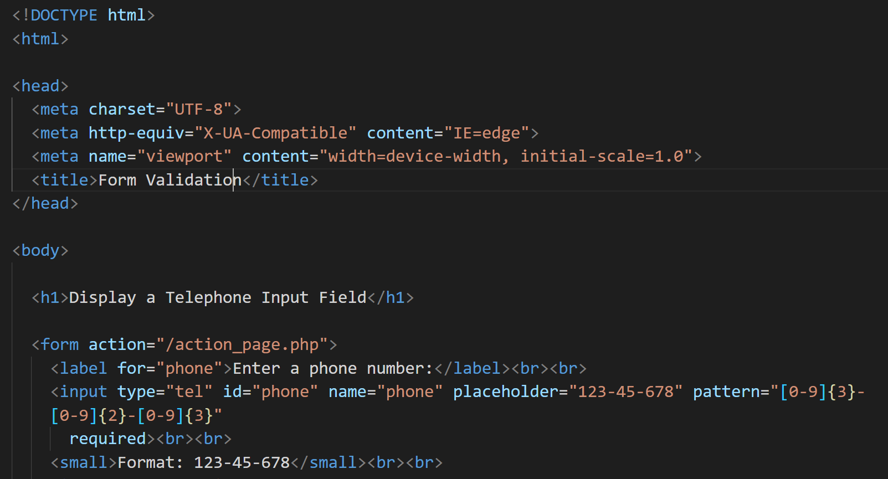

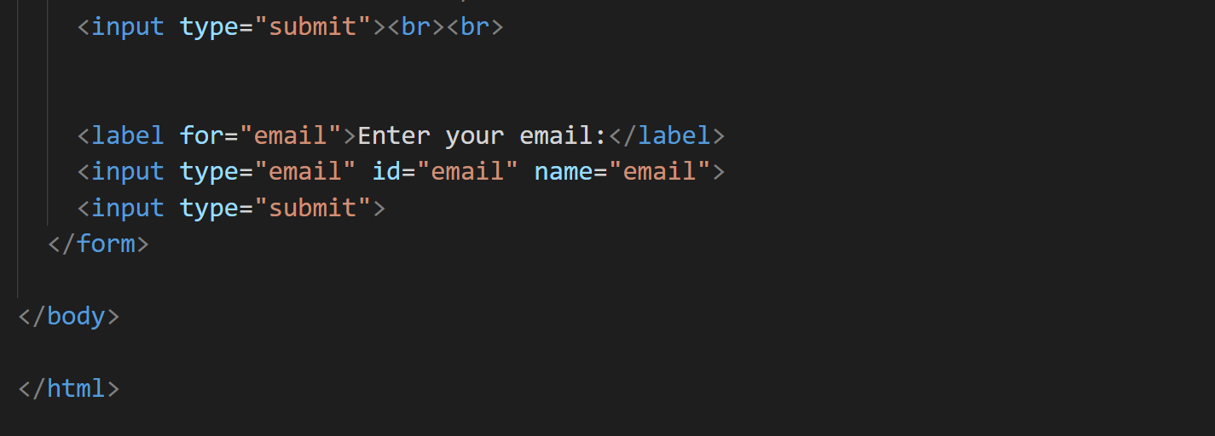

**Output**

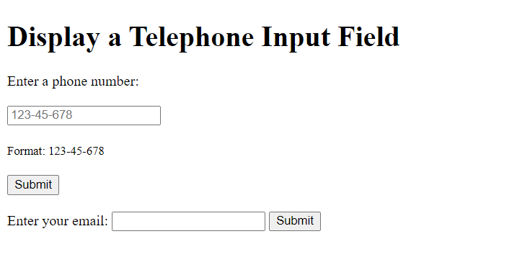

Task: - 4 ( Date:-20-06-2022)

Question: -

1. **Use any external library and inbuilt library in one python program with user input.**