Assignment 1 - Web Development Basics

Q1. Difference between frontend, backend, and full-stack development
Frontend development is the part of the website that we can see and use directly, like buttons, colors, text, images and menus. It runs in the browser. For example, when we open Instagram and see the feed, like button, and stories, that is the frontend.
Backend development is the part that works behind the scenes on the server. It handles things like login, storing data, and sending the correct information to the frontend. For example, when we login to Instagram, the backend checks our username and password and gives access.
Full-stack development means the developer can work on both frontend and backend. A full-stack developer can build the whole website from design to database. For example, a small startup may hire one full-stack developer to build their entire website alone.

Q2. Diagram of the client-server model
Below is a simple diagram showing how client and server communicate:
CLIENT (Browser) | → request → | SERVER
 | ← response ←
The client (browser) sends a request to the server asking for a webpage, and the server sends back a response with the webpage data.

Q3. How a browser requests and displays a web page
When we type a website address (URL) in the browser and press enter, the browser sends a request to the web server asking for that page.
The server receives the request, finds the correct files (HTML, CSS, JS) and sends them back to the browser as a response.
The browser then reads the HTML file and shows the text and structure, reads the CSS file to add colors and styling, and runs the JavaScript file to make the page interactive. Finally the page is displayed on our screen.

Q4. Tools required to set up a web development environment
- Text Editor / IDE (like VS Code) - used to write and edit our HTML, CSS, JS code.
- Web Browser (like Chrome) - used to open and test our webpage, and also check errors using inspect tool.
- Version Control (like Git) - used to save different versions of our code and track changes.
- GitHub account - used to store our code online and share it with others.
- Node.js - used to run JavaScript outside the browser and install packages.
- Web server / Live Server extension - used to run our website locally and see live changes.

Q5. What is a web server? Examples
A web server is a computer or a software that stores website files and sends them to the browser whenever someone requests a webpage. It basically 'serves' the webpage to the user.
Examples of commonly used web servers:
- Apache HTTP Server
- Nginx
- Microsoft IIS (Internet Information Services)
- Node.js server (using Express)

Q6. Roles of frontend developer, backend developer, and database administrator
Frontend Developer:
Designs and builds the part of the website the user sees. Works with HTML, CSS, JavaScript and frameworks like React.
Backend Developer:
Builds the logic that runs on the server, handles user requests, connects to the database, and makes sure everything works correctly behind the scenes.
Database Administrator (DBA):
Takes care of the database. Makes sure data is stored safely, organized properly, and can be accessed quickly without any loss.

Q7. Installing and configuring VS Code for HTML, CSS, JavaScript

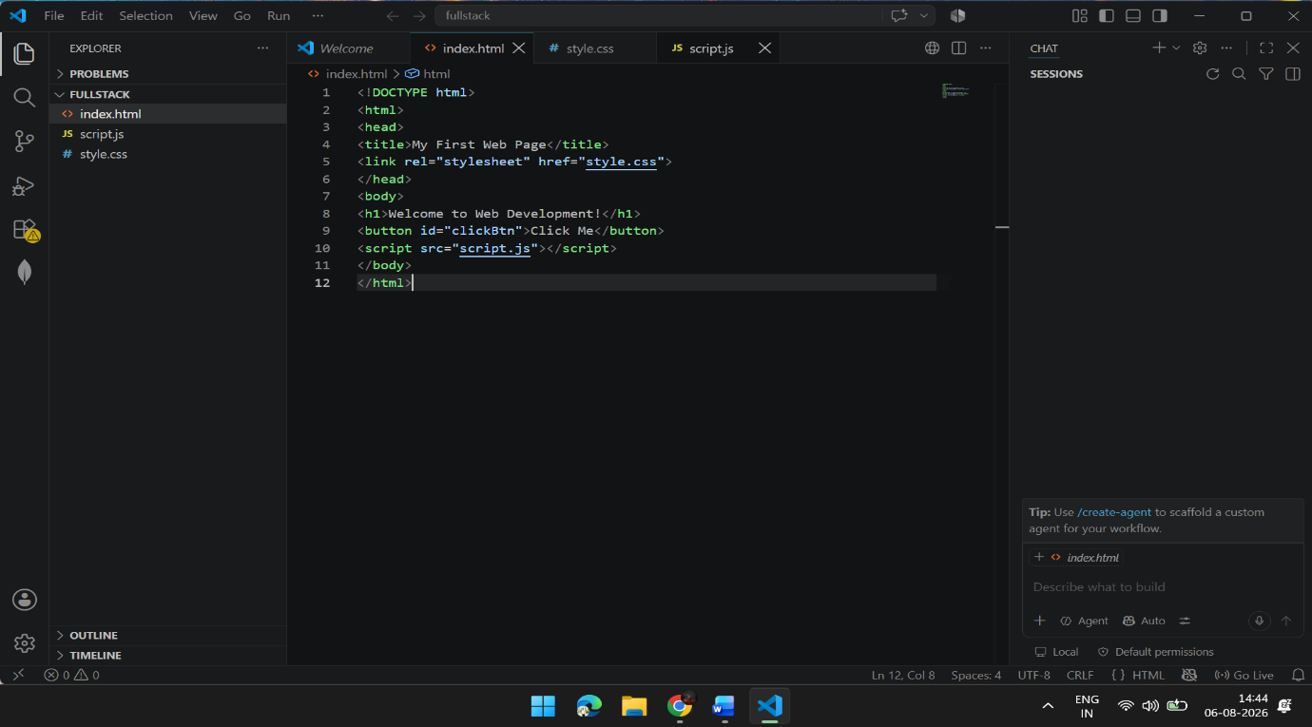

Q8. Difference between static and dynamic websites
A static website has fixed content. The content does not change unless a developer manually edits the code. Example: a simple portfolio website showing information about a person.
A dynamic website has content that can change automatically based on user actions or data from a database. Example: Amazon website, where product prices, stock, and recommendations change for every user.

Q9. Five web browsers and their rendering engines
- Google Chrome - uses Blink rendering engine.
- Mozilla Firefox - uses Gecko rendering engine.
- Safari - uses WebKit rendering engine.
- Microsoft Edge - uses Blink rendering engine (same as Chrome, since Edge switched to Chromium).
- Opera - uses Blink rendering engine.
Rendering engines are different because they are built by different companies, so sometimes the same website can look or behave a little differently in different browsers. This is why developers test their websites on multiple browsers.

Q10. Diagram of basic web architecture flow
Below is a simple diagram showing how client, server, database and APIs are connected:
CLIENT (Browser) | SERVER | API | DATABASE
The client sends a request to the server. The server uses an API to talk to the database, fetches the needed data, and sends the response back to the client, which is then displayed to the user.

