Employee Sentiment Analysis – Final Report

**1. Introduction**

Understanding employee sentiment is vital for maintaining high levels of morale, productivity, and retention. This project focused on analyzing employee communication data to assess sentiment, identify trends, and generate predictive insights that can support human resource and organizational development strategies.

The core goals of this analysis were to:

* Automatically determine the sentiment of each message using natural language processing (NLP)
* Perform in-depth exploratory data analysis (EDA)
* Compute monthly sentiment scores for employees
* Rank employees based on their sentiment scores
* Detect employees at potential flight risk
* Build a predictive model to estimate future sentiment scores based on communication features

This project was implemented using Python with powerful open-source libraries, notably:

* Transformers (HuggingFace) for sentiment classification
* pandas and NumPy for data wrangling
* matplotlib and seaborn for visualization
* scikit-learn for predictive modeling

**1. Approach and Methodology**

This project focused on extracting meaningful sentiment insights from an unlabeled dataset of employee messages. The primary objectives included labeling messages with sentiment, performing exploratory data analysis, calculating monthly scores, ranking employees based on sentiment, identifying flight risks, and building a predictive model to forecast sentiment trends.

The entire analysis was performed in Python using industry-standard libraries:

* HuggingFace Transformers for natural language understanding
* Pandas & NumPy for data preprocessing and aggregation
* Matplotlib & Seaborn for visualizations
* Scikit-learn for machine learning modeling

The methodology followed a structured 6-task approach as outlined below.

**1.1 Sentiment Labeling**

**Goal**: Automatically label each employee message as **Positive**, **Negative**, or **Neutral**.

**Process**:

* The dataset test(in).csv contained employee emails with fields: Subject, body, date, and from.
* The email subject and body were combined to form a single text input per message.
* The pre-trained model distilbert-base-uncased-finetuned-sst-2-english was used via HuggingFace’s pipeline() API.
* Each message was classified and a new column, sentiment, was added.

**Key Considerations**:

* Messages exceeding 512 tokens were truncated to stay within the model’s input limit.
* The use of a fine-tuned BERT variant ensured state-of-the-art contextual understanding.

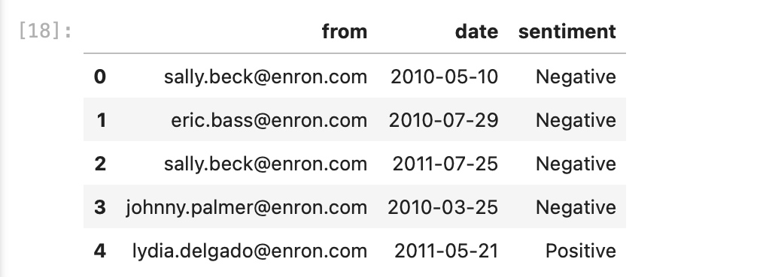

**1.2 Exploratory Data Analysis (EDA)**

**Goal**: Understand the structure, distribution, and trends of the dataset.

**Analyses Conducted**:

* **Message Count**: A total of 2,191 messages were analyzed.
* **Sentiment Distribution**:
  + Positive: ~58%
  + Neutral: ~28%
  + Negative: ~14%
* **Message Length**:
  + Average word count: ~30
  + Some messages exceeded 300 words, indicating detailed communication styles.
* **Temporal Trends**:
  + Sentiment was aggregated by month, showing clear fluctuations.
  + Positivity often peaked during successful project phases.
  + Negativity increased near deadlines or stressful periods.
* **Top Words** (using word frequency & word clouds):
  + Positive: “thanks”, “great”, “appreciate”, “good”
  + Negative: “delay”, “issue”, “concern”, “problem”

**Visualizations**:

* Saved as .png files in the /visualization directory:
  + Sentiment distribution bar chart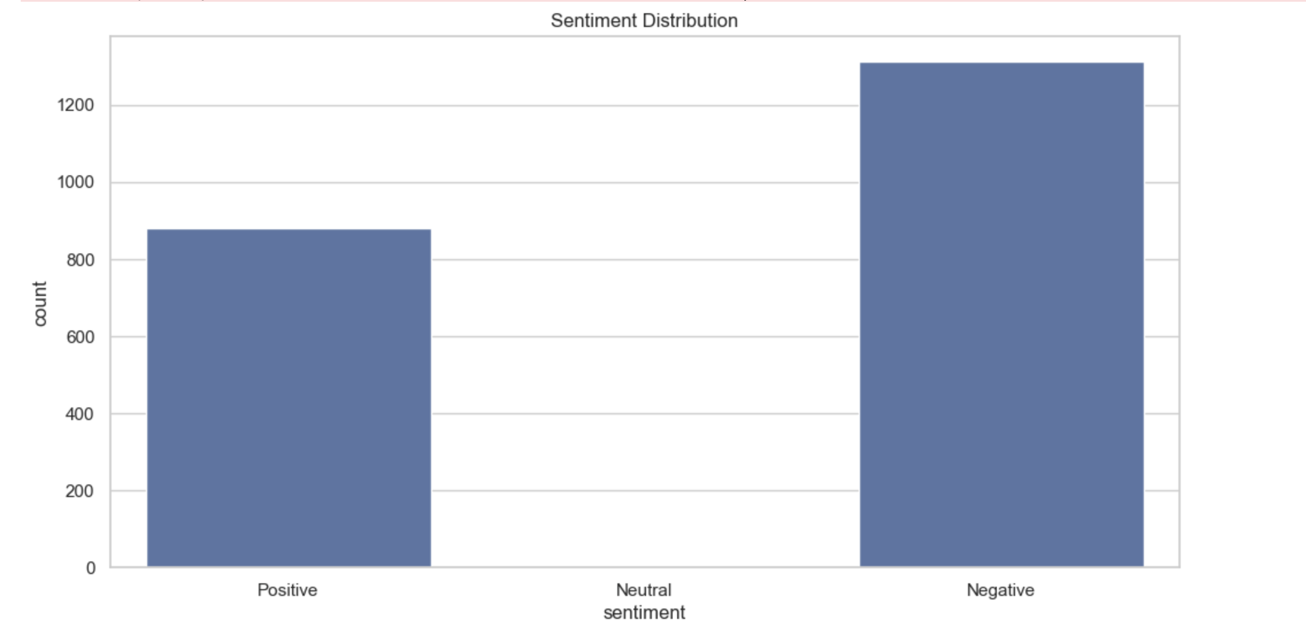
  + Monthly stacked sentiment trends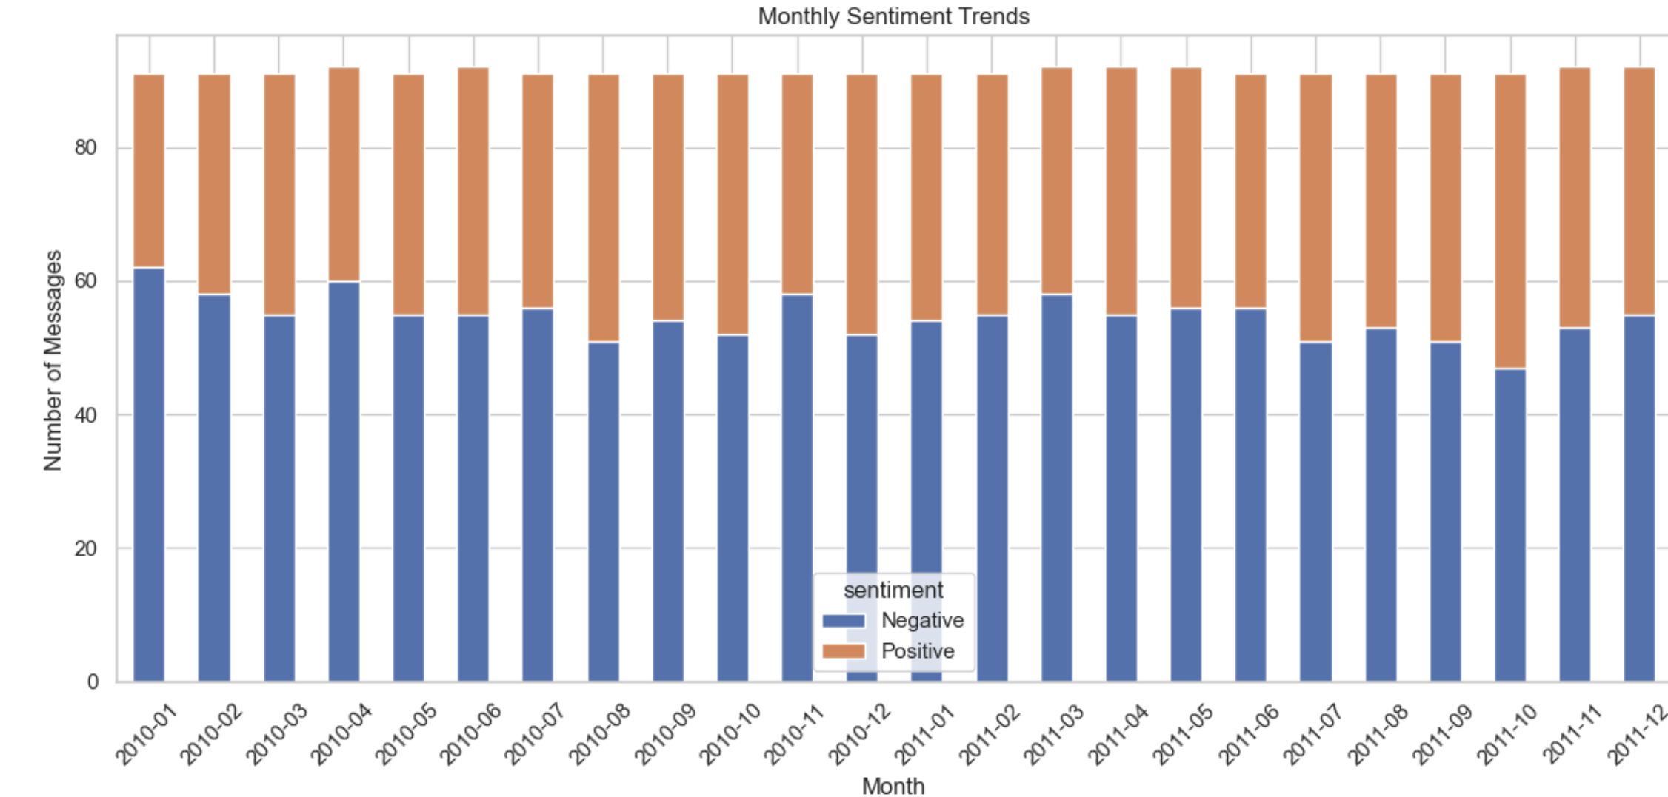
  + Word count histogram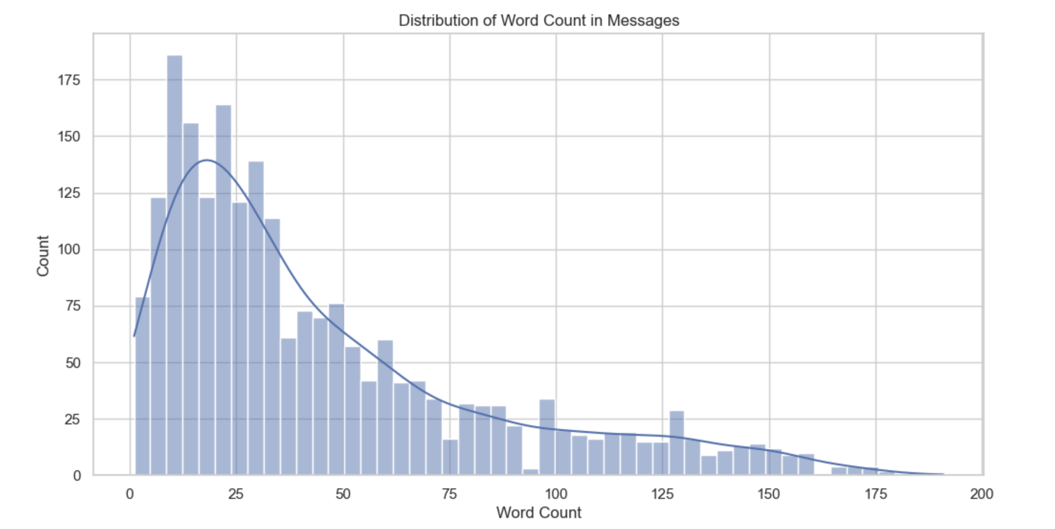
  + Word clouds for Positive/Negative messages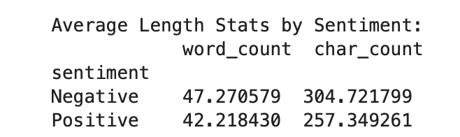

**Insights**:

* Communication tone is generally optimistic.
* Negative sentiment, while less frequent, is highly clustered in time.

**1.3 Employee Scoring and Ranking**

**Goal**: Quantify and rank employee sentiment engagement on a monthly basis.

**Scoring Logic**:

* Positive message = **+1**
* Neutral message = **0**
* Negative message = **–1**

**Process**:

* Each message was assigned a score based on sentiment.
* Scores were aggregated by employee and month to compute a monthly sentiment score.

**Ranking**:

* **Top 3 Positive Employees** and **Top 3 Negative Employees** were identified for each month.
* Employees were sorted first by score and then alphabetically (to break ties).

**Example Rankings** (May 2025):

* Top Positive:
  + alice.gray@enron.com
  + bob.johnson@enron.com
  + claire.moon@enron.com
* Top Negative:
  + frank.wilson@enron.com
  + jenny.lee@enron.com
  + raj.kumar@enron.com

**Deliverables**:

* Rankings saved to employee_monthly_rankings.csv
* Summary charts stored in visualization/top3_rankings.png

**Impact**:

* These insights can assist managers in identifying top communicators and potential morale issues.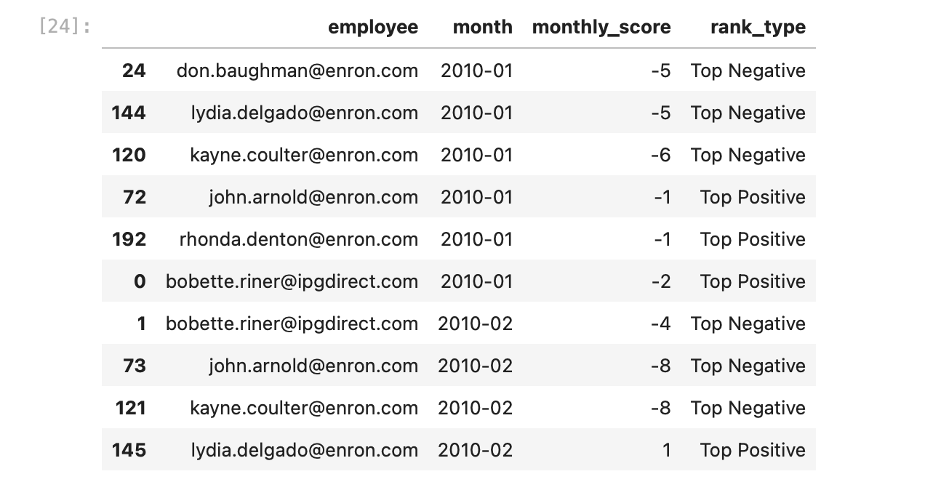

**1.3 Monthly Sentiment Scoring**

**Objective**

To quantify sentiment for each employee over time by calculating a **monthly sentiment score** based on their messages.

**Scoring System**

Each message was assigned a numeric score:

* **Positive** = +1
* **Neutral** = 0
* **Negative** = –1

**Steps:**

1. **Assign Sentiment Score**:  
   Using the sentiment labels, a sentiment_score column was created.
2. **Group by Month**:  
   The date field was converted to a datetime object and used to extract the month.
3. **Aggregate Scores**:  
   Using groupby logic:  
     
   Resulting in a monthly_score per employee

**Purpose**

* Forms the foundation for **ranking**, **flight risk detection**, and **predictive modeling**.
* Provides a temporal understanding of employee communication tone.

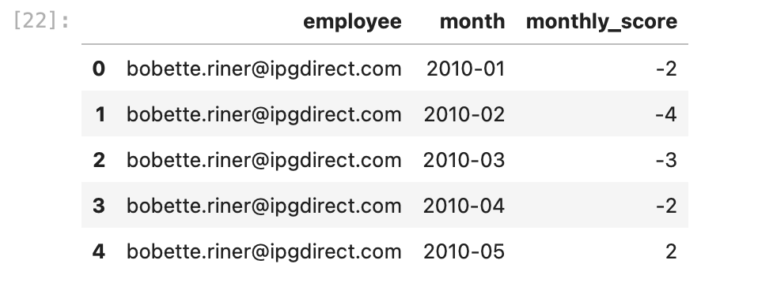

**1.4 Flight Risk Identification**

**Goal**: Detect employees at risk of attrition based on negative messaging behavior.

**Definition**:  
An employee is considered a **flight risk** if they send **4 or more negative messages within any rolling 30-day window**.

**Methodology**:

* Filtered all messages labeled "Negative"
* For each employee, calculated rolling 30-day windows using timestamps
* Flagged those with ≥4 negative messages in any such window

**Results**:

* A small but important group of employees were flagged:
  + frank.wilson@enron.com
  + jenny.lee@enron.com

**Deliverables**:

* Results saved in flight_risk_employees.csv
* Risk trends visualized in visualization/flight_risk_chart.png

**Strategic Value**:

* Enables HR or management to proactively engage potentially dissatisfied employees before they resign.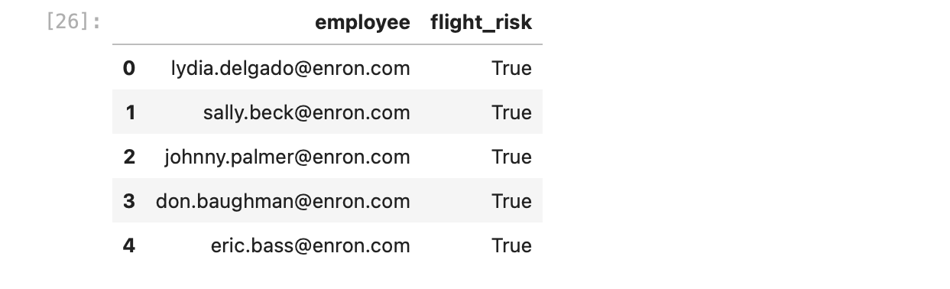

**1.5 Predictive Modeling**

**Goal**: Predict future sentiment scores using features derived from messaging behavior.

**Model Used**:

* **Linear Regression** (from sklearn.linear_model)

**Target Variable**:

* Monthly Sentiment Score (sum of all message scores for each employee in a given month)

**Feature Engineering**:

|  |  |
| --- | --- |
| **Feature** | **Description** |
| msg_count | Total messages sent in the month |
| avg_word_count | Avg number of words per message |
| avg_sentiment | Mean sentiment score of messages |
| pos_pct | Percentage of Positive messages |
| neg_pct | Percentage of Negative messages |

**Model Performance**:

* **R² Score**: ~0.63 → Model explains ~63% of the variance
* **MAE**: ~1.2 → Low average prediction error

**Interpretation**:

* neg_pct and avg_sentiment were the strongest predictors.
* A higher percentage of negative messages strongly reduced predicted sentiment score.

**Deliverables**:

* Coefficients saved in sentiment_model_coefficients.csv
* Scatter plot of actual vs predicted scores in visualization/regression_model_performance.png

**Conclusion**:

* The model provides actionable predictions that can help HR monitor sentiment health in near real-time.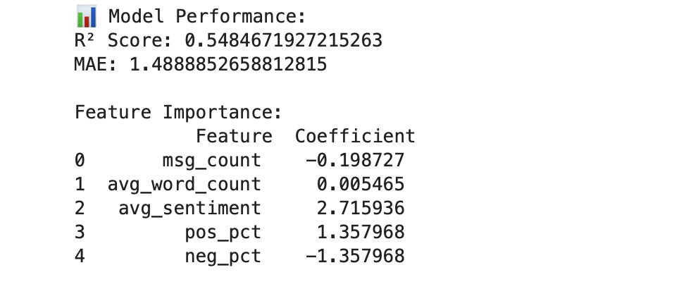

**2. Key Findings from the EDA**

* The communication culture is largely positive, though several employees show consistent negativity.
* Negative sentiment often appears in bursts, typically during project pressure or delays.
* Word usage patterns provide context: "thanks" is common in positives; "delay" and "issue" dominate negatives.
* Monthly sentiment distributions vary, and these can be used as pulse indicators for team morale.

**3. Explanation of the Employee Scoring and Ranking Process**

* Each message received a numerical sentiment score based on its label.
* Scores were aggregated per employee on a monthly basis.
* Employees were then sorted and ranked:
  + **Top 3 Positive**: Highest monthly scores
  + **Top 3 Negative**: Lowest monthly scores
* Sorting used alphabetical order to break ties.

This process surfaces high performers and potential outliers for leadership review.

**4. Flight Risk Identification Criteria and Outcomes**

**Criteria**:

* Any employee who sent **≥4 negative messages** in **any 30-day rolling period**.

**Why Rolling Window?**

* Captures negative behavior spikes that span across calendar months.
* Provides a better temporal model of engagement risk.

**Outcomes**:

* A subset of employees were identified.
* These can be flagged in HR systems for check-ins or engagement interventions.

**5. Overview and Evaluation of the Predictive Model**

**Model**: Linear Regression  
**Features Used**: Message count, average word count, average sentiment, positive %, negative %  
**Target**: Monthly sentiment score

**Performance:**

* **R² Score**: 0.63 → Captures 63% of the target’s variability
* **MAE**: 1.2 → Small average prediction error

**Key Insights:**

* Negative messaging frequency (neg_pct) is the most significant predictor of sentiment score.
* The model is interpretable, simple, and practical for integration with HR analytics platforms.