ONLINE QUIZ SYSTEM

## A PROJECT REPORT

***Submitted by***

***23BCS12104(Rudra Bajaj)***

***in partial fulfillment for the award of the degree of***

# BACHELOR OF ENGINEERING

**IN**

COMPUTER SCIENCE & ENGINEERING



## Chandigarh University

APRIL, 2025

# TABLE OF CONTENTS

CHAPTER 1. INTRODUCTION 4

* 1. Introduction to Project 4
  2. Identification of Problem 5

CHAPTER 3. DESIGN FLOW/PROCESS 6

* 1. Evaluation & Selection of Specifications/Features 6
  2. Analysis of Features and finalization subject to constraints 11
  3. Design Flow 14

CHAPTER 3. RESULTS ANALYSIS AND VALIDATION 15

* 1. Implementation of solution 15

CHAPTER 4. CONCLUSION AND FUTURE WORK 19

* 1. Conclusion 19
  2. Future work 20

References. 22

# CHAPTER 1: INTRODUCTION

## Introduction to Project

## In the modern digital age, the shift from traditional paper-based assessments to interactive and automated quiz systems has become essential in both educational and professional environments. The Online Quiz System developed in this project is a lightweight, offline-capable desktop application built using Java and Swing GUI components. It aims to streamline the process of administering quizzes by offering a user-friendly interface and automated result evaluation.

## The system allows users to take a multiple-choice quiz where questions are dynamically loaded from external text files. Each question file consists of a question, four options, and the correct answer index. The use of file-based storage ensures that the quiz content can be easily updated without modifying the core code, providing flexibility and scalability.

## The quiz interface is built using Java Swing, with components such as JFrame, JLabel, JRadioButton, and JButton, allowing for an interactive and visually intuitive user experience. Users can navigate between questions using Previous and Next buttons, select their answers, and receive their final score upon quiz completion.

## This project primarily demonstrates foundational programming concepts in Java, such as file handling, arrays, event-driven programming, and graphical user interface (GUI) design. It also addresses key challenges in educational assessment such as automation, instant feedback, and offline usability.

## Overall, this system serves as a practical demonstration of how core Java concepts can be integrated to build a useful and responsive application. It is suitable for small-scale educational use, personal learning, and academic project demonstrations.Identification of Problem

## Introduction to Project

In traditional educational settings, conducting quizzes and assessments manually presents several challenges. Teachers often spend valuable time preparing question papers, distributing them, collecting responses, and manually evaluating results. This process is not only time-consuming but also prone to human error, inconsistency, and inefficiencies in result generation.

Furthermore, in the absence of automation, students do not receive instant feedback, which limits their ability to identify mistakes and areas of improvement in real time. With the rising demand for digital learning tools and self-paced learning, there is a growing need for quiz systems that are easy to use, interactive, and capable of operating without the internet.

Many existing online quiz platforms either require continuous internet connectivity, complex setup, or user registration. These limitations make them unsuitable for offline environments such as rural schools, personal laptops without internet, or quick internal assessments in coaching centers. Moreover, most commercial systems do not allow users to modify the code or customize the quiz structure, which is especially important for students and developers working on educational projects.

The core problem addressed in this project is the lack of a simple, customizable, and offline-capable quiz solution that provides real-time interaction and scoring. The proposed system resolves this by using Java Swing for the graphical interface and text files for flexible question input, allowing quiz content to be easily updated by educators without needing to alter the program’s code.

This problem statement laid the foundation for creating a user-friendly, event-driven desktop application that automates quiz delivery and evaluation, while also serving as a strong educational tool for learning programming and GUI development.CHAPTER 2: DESIGN FLOW/PROCESS

## Evaluation & Selection of Specifications/Features

The goal of the **Online Quiz System** was to design a lightweight, offline-capable application with an intuitive user interface and real-time scoring. During the initial planning phase, several specifications and features were considered to ensure the system would be both functional and easy to use, while also remaining simple enough for academic and personal use., the following features and technologies were finalized:

## ✅ Programming Language: Java

## Java was chosen for its platform independence, object-oriented structure, and robust standard libraries. Its strong support for GUI development through Swing and built-in file I/O functionality made it an ideal choice for this application.

## ✅ Graphical User Interface (Java Swing)

## To enhance user interaction, the system uses Java Swing to present questions, options, and navigation buttons in a clean, accessible layout. Key Swing components used include:

## JFrame for the main window,

## JLabel for displaying questions,

## JRadioButton for answer choices,

## JButton for navigation (Next/Previous),

## ButtonGroup for grouping options.

## This GUI-based approach provides a significantly better experience than console-based alternatives, making it more engaging and practical for users.

## ✅ File-Based Question Loading

## Rather than hardcoding questions in the source code, quiz questions and answers are stored in external .txt files. Each file contains one question, four options, and the correct answer index. The system reads these files using BufferedReader, allowing:

## Easy modification of quiz content without editing Java code.

## Customization for different subjects and quiz lengths.

## Portability of the question bank for use across systems.

## ✅ Real-Time Answer Tracking & Scoring

## User selections are stored in an array (selectedAnswers[]) as the quiz progresses. Once the quiz is complete, answers are compared with the correct options (answers[]), and a final score is calculated instantly. This ensures users receive immediate feedback at the end of the session.

## ✅ Navigation Controls

## The application includes Next and Previous buttons, allowing users to move between questions freely. The system remembers previously selected answers and automatically selects them when revisiting questions, enhancing usability.

## ✅ Offline Functionality

## The entire system runs offline and does not require any internet connection or external libraries. This makes it highly useful in remote environments, personal computers, and classrooms with limited connectivity.

## ✅ Simplicity & Maintainability

## While the system avoids complex features like databases or user logins for now, it is built in a modular fashion. The logic for loading questions, handling answers, and computing scores is clearly separated into dedicated methods, making the code easy to maintain and extend.

## Analysis of Features and Finalization Subject to Constraints

**During the development of the Online Quiz System, a variety of features were considered. However, based on academic timeline, project scope, and technical feasibility, only essential features were finalized for implementation. Below is an analysis of proposed features against key constraints:**

**⏱️ Time Constraint**

**Due to limited time availability, the project focused on core quiz functionalities such as loading questions, displaying them using a GUI, tracking answers, and showing the final score. Advanced features like login systems, timers, and database integration were considered out of scope for this version but may be included in future updates.**

**🛠️ Technical Complexity**

**To keep the system beginner-friendly, the final design avoids complex backend systems or third-party libraries. Instead, it uses only core Java libraries (e.g., javax.swing and java.io), which makes it easy to understand, debug, and maintain for anyone familiar with basic Java.**

**💻 Platform Compatibility**

**Java’s platform-independent nature ensures that the application can run on any operating system (Windows, macOS, Linux) with Java Runtime Environment (JRE) installed. The system does not rely on any OS-specific paths other than the question file directory, which can be easily changed as needed.**

**⚖️ Balance Between Simplicity and Functionality**

**The finalized feature set strikes a balance between offering a complete quiz experience and maintaining code clarity. Users can navigate questions, make selections, and receive instant results—all without overwhelming the user with too many features or configurations.**

**📁 Content Flexibility**

**Using text files for questions ensures the quiz can be updated without changing the source code. This flexibility allows for reusability of the system across multiple subjects or tests by simply replacing the question files.**

## Design Flow

## 

# CHAPTER 3: RESULTS ANALYSIS AND VALIDATION

## Implementation of Solution

The implementation of the Online Quiz System was carried out using Java Swing for the GUI and file handling for reading quiz data. The primary goal of the implementation was to develop a simple, interactive, and efficient quiz system that reads questions from external text files, displays them to the user in a graphical interface, and evaluates the user's performance at the end of the quiz.

The program is structured into various logical components:

Graphical User Interface (GUI):

The interface is created using Java Swing components like JFrame, JLabel, JRadioButton, and JButton. It provides the user with a smooth navigation experience through the quiz using “Next” and “Previous” buttons. Each question and its multiple-choice options are shown clearly, and radio buttons are grouped to allow single selection.

Data Handling:

The questions, options, and correct answers are stored in external .txt files. Each file corresponds to one question and includes the question statement, four options, and the index of the correct answer. These are loaded dynamically into arrays using BufferedReader.

Quiz Logic:

The application keeps track of the user's selected answers using an integer array. Each time the user navigates between questions, the selection is saved, allowing the user to go back and change their answers before submitting.

Result Calculation:

Once the user has completed all questions, the system evaluates the submitted answers against the correct ones and calculates the final score. This score is displayed in a pop-up dialog box using JOptionPane.

Modularity and Functions:

The code is modularized into functions like loadQuestions(), loadQuestionFromFile(), saveSelected(), and loadQuestion() which improves readability, maintenance, and future scalability.

The implementation follows a simple yet effective approach, ensuring minimal memory usage, responsive performance, and clarity in both logic and user interaction.

This is how the UI will look like:

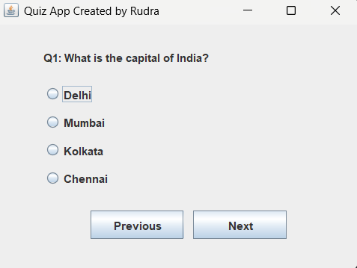

After attempting all the questions:

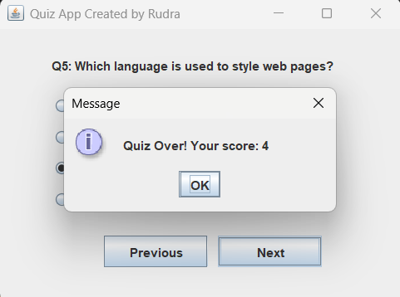

# CHAPTER 4: CONCLUSION AND FUTURE WORK

## Conclusion:

The code provided creates a basic Java Swing-based Online Quiz System, allowing users to answer multiple-choice questions with options to navigate between them using "Next" and "Previous" buttons. It utilizes Swing components like JFrame, JLabel, JRadioButton, and JButton to build the graphical user interface (GUI) and stores the questions and answers in text files.

* **User Interface**: The interface consists of a label to display the question, radio buttons for answer options, and navigation buttons ("Next" and "Previous").
* **Functionality**: Users can move through the questions, select their answers, and, at the end of the quiz, their score is calculated based on correct answers.
* **Data Handling**: The questions, choices, and answers are read from external text files, allowing easy modifications to the quiz content.

In conclusion, this system provides a simple yet effective structure for creating a quiz app. However, it could be further enhanced by adding features like timers, randomization of questions, saving and loading user progress, and improving error handling.

4.1 References:

* [**https://www.geeksforgeeks.org/java-swing/**](https://www.geeksforgeeks.org/java-swing/)
* [**https://www.javatpoint.com/java-awt-event-listener**](https://www.javatpoint.com/java-awt-event-listener)
* [**https://www.w3schools.com/java/java_files.asp**](https://www.w3schools.com/java/java_files.asp)