Expense Manager

Project Description
The Expense Manager System is designed to help companies record, manage, and analyse all employee-related business expenses and reimbursements in a systematic and transparent way. It provides employees with an easy way to enter expenses and helps HR manage monthly transfers efficiently, while also offering useful income–expense insights and reports.

Screens List
1. Authentication & Dashboard
- Login Page: Role-based authentication (Admin / Normal User)
- Dashboard:
  - Summary of Normal User Related Expenses, Incomes.
  - Summary of All Users Related Expenses, Incomes for Admin.
- Project & People/User Management
- Expense/Income Category/Subcategory Management
- Expense/Income Management
  - Date: The actual date of the expense/income.
  - Category: Type of expense/income (e.g., Travel, Food, Stay, Purchase, etc.).
  - Subcategory: A more specific classification (e.g., under Travel – Taxi, Train, Bus, etc.).
  - Project: The project or department the expense/income belongs to.
  - Amount: The total money spent.
  - Attachment (Bill/Receipt): The user uploads a copy or photo of the bill.
  - Remarks: Optional notes related to the expense/income
- Reports & Analytics
- Total Income and Total Expense
- Month-wise or Year-wise Statistics
- Category-wise Expense Distribution (e.g., charts or graphs)
- Project-wise Income Expense Summary
- Export to Excel / PDF

Database

Table Name: peoples
COLUMN_NAME | IS_NULLABLE | DATA_TYPE | CHARACTER_MAXIMUM_LENGTH
PeopleID | NO | int | PK
PeopleCode | YES | varchar | 50
Password | No | varchar | 50
PeopleName | NO | varchar | 250
Email | No | varchar | 150
MobileNo | No | varchar | 50
Description | YES | varchar | 500
UserID | NO | int
Created | NO | datetime
Modified | NO | datetime
IsActive | YES | bit

Table Name: categories
COLUMN_NAME | IS_NULLABLE | DATA_TYPE | CHARACTER_MAXIMUM_LENGTH
CategoryID | NO | int | PK
CategoryName | NO | varchar | 250
LogoPath | YES | varchar | 250
IsExpense | NO | bit
IsIncome | NO | bit
IsActive | NO | bit
Description | YES | varchar | 500
UserID | NO | int
Created | NO | datetime
Modified | NO | datetime
Sequence | YES | decimal

Table Name: projects
COLUMN_NAME | IS_NULLABLE | DATA_TYPE | CHARACTER_MAXIMUM_LENGTH
ProjectID | NO | int | PK
ProjectName | NO | varchar | 250
ProjectLogo | YES | varchar | 250
ProjectStartDate | YES | datetime
ProjectEndDate | YES | datetime
ProjectDetail | YES | varchar | 500
Description | YES | varchar | 500
UserID | NO | int
Created | NO | datetime
Modified | NO | datetime
IsActive | YES | bit

Table Name: expenses
COLUMN_NAME | IS_NULLABLE | DATA_TYPE | CHARACTER_MAXIMUM_LENGTH
ExpenseID | NO | int | PK
ExpenseDate | NO | datetime
CategoryID | YES | int
SubCategoryID | YES | int
PeopleID | NO | int
ProjectID | YES | int
Amount | NO | decimal
ExpenseDetail | YES | varchar | 500
AttachmentPath | YES | varchar | 250
Description | YES | varchar | 500
UserID | NO | int
Created | NO | datetime
Modified | NO | datetime

Table Name: sub_categories
COLUMN_NAME | IS_NULLABLE | DATA_TYPE | CHARACTER_MAXIMUM_LENGTH
SubCategoryID | NO | int | PK
CategoryID | NO | int
SubCategoryName | NO | varchar | 250
LogoPath | YES | varchar | 250
IsExpense | NO | bit
IsIncome | NO | bit
IsActive | NO | bit
Description | YES | varchar | 500
UserID | NO | int
Created | NO | datetime
Modified | NO | datetime
Sequence | YES | decimal

Table Name: incomes
COLUMN_NAME | IS_NULLABLE | DATA_TYPE | CHARACTER_MAXIMUM_LENGTH
IncomeID | NO | int | PK
IncomeDate | NO | datetime
CategoryID | YES | int
SubCategoryID | YES | int
PeopleID | NO | int
ProjectID | YES | int
Amount | NO | decimal
IncomeDetail | YES | varchar | 500
AttachmentPath | YES | varchar | 250
Description | YES | varchar | 500
UserID | NO | int
Created | NO | datetime
Modified | NO | datetime

Table Name: users
COLUMN_NAME | IS_NULLABLE | DATA_TYPE | CHARACTER_MAXIMUM_LENGTH
UserID | NO | int | PK
UserName | NO | varchar | 250
EmailAddress | No | varchar | 500
Password | No | varchar | 50
MobileNo | NO | varchar | 50
ProfileImage | Yes | varchar | 500
Created | NO | datetime
Modified | NO | datetime

ER Diagram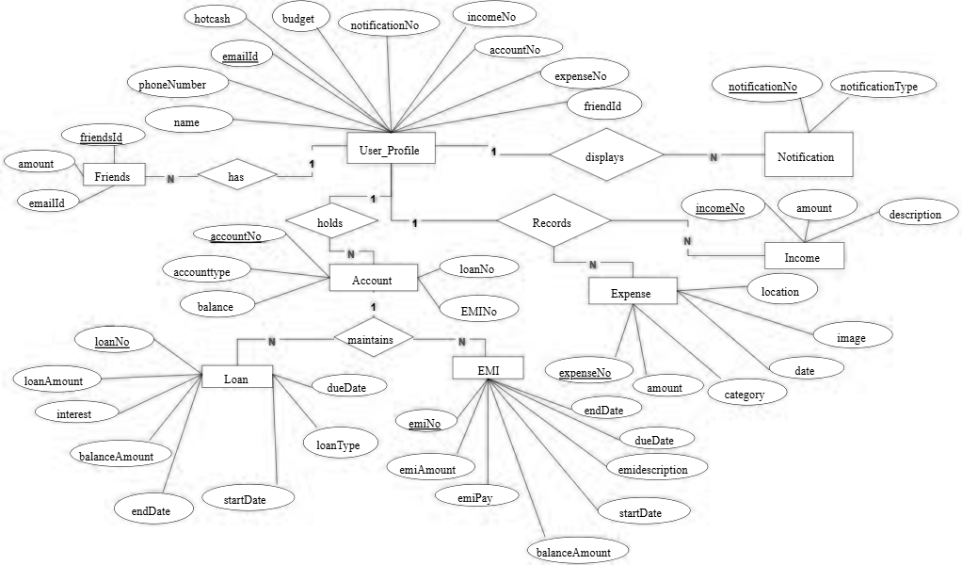

End-points
Users (Admin side)
GET /api/users
GET /api/users/{userId}
POST /api/users
PUT /api/users/{userId}
DELETE /api/users/{userId}

Peoples (Employees)
GET /api/peoples
GET /api/peoples/{peopleId}
POST /api/peoples
PUT /api/peoples/{peopleId}
DELETE /api/peoples/{peopleId}

