**Lab 2 Report: Kubernetes Cluster on AWS with Terraform and DaemonSet**

Name: Rudra Dave

Course: CSCL1050 Advanced CloudOps Tools and Techniques - Full-Time Winter 2025

Date: 24/05/2025

**1) k8s-master-Public-URL and k8s-node-Public-URL values from the end of the Terraform apply output-**

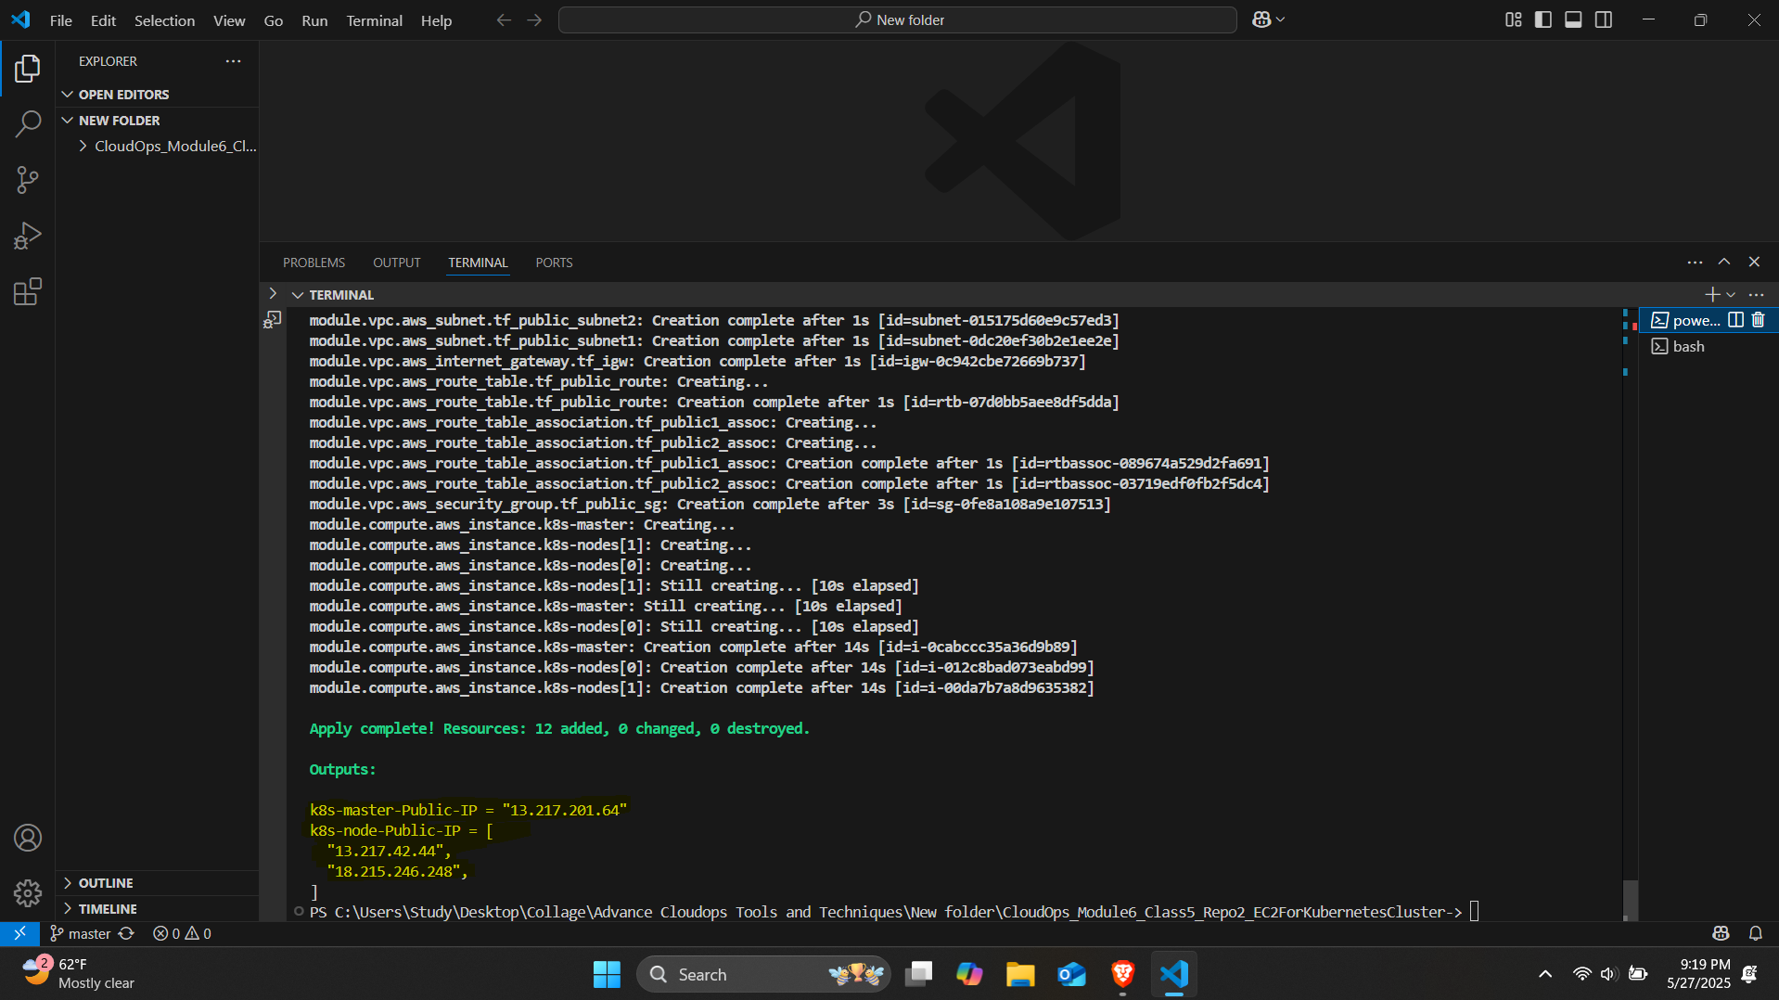

**2) Output from the “**sudo kubeadm init --config kube-config.yml --ignore-preflight-errors=all” **command on control plane**

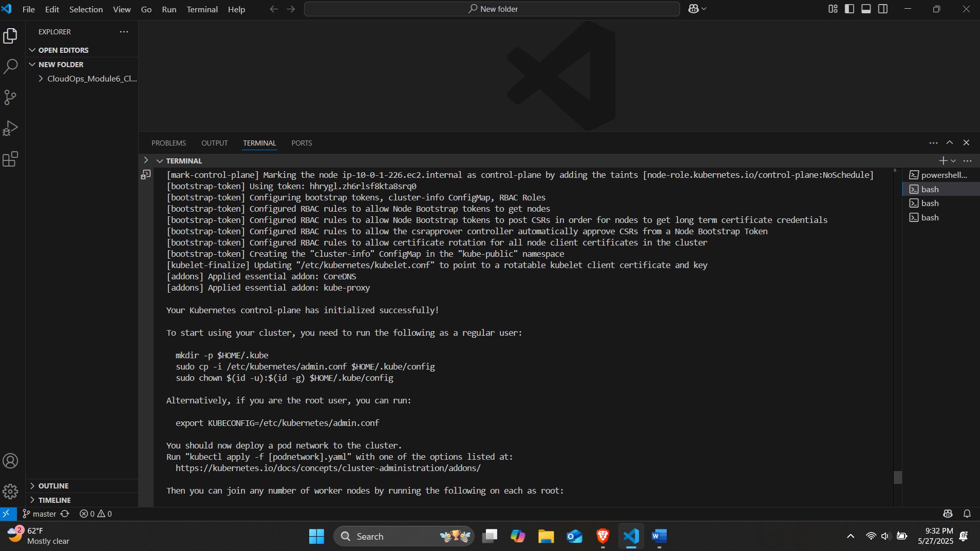

**3) Output from the “**kubectl get nodes” **command on the Master Node**

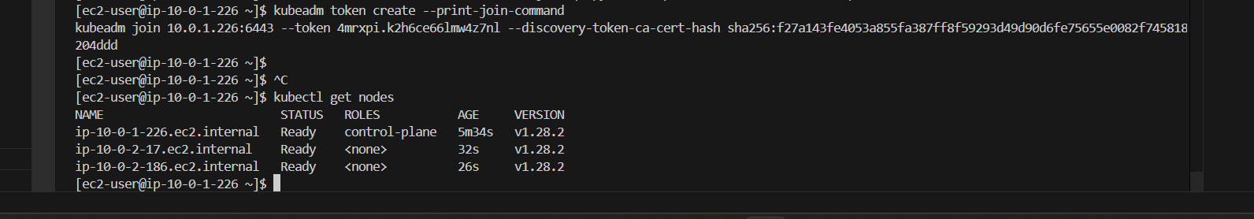

**4) Output from the “**kubectl get services” **command on the Master Node**

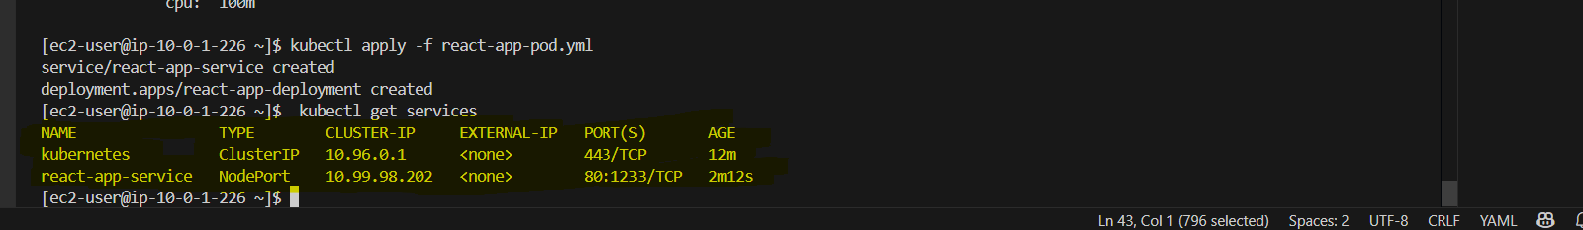

**5) Web browser showing address bar with port 1233 loaded for both Master and Worker public Ips**

*Master Node: k8s-master-Public-IP = "13.217.201.64"*

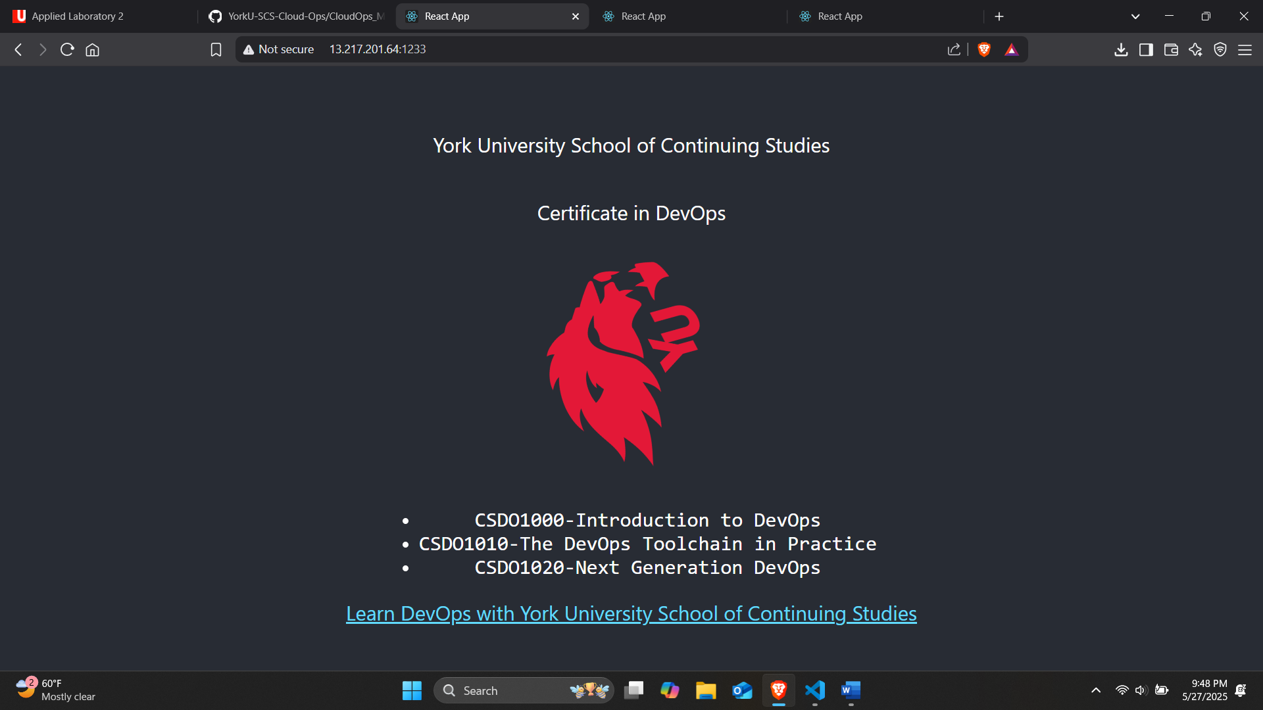

*Worker Nodes:*

*k8s-node-Public-IP = [*

***"13.217.42.44",***

***"18.215.246.248",***

*]*

*Worker Node 1*

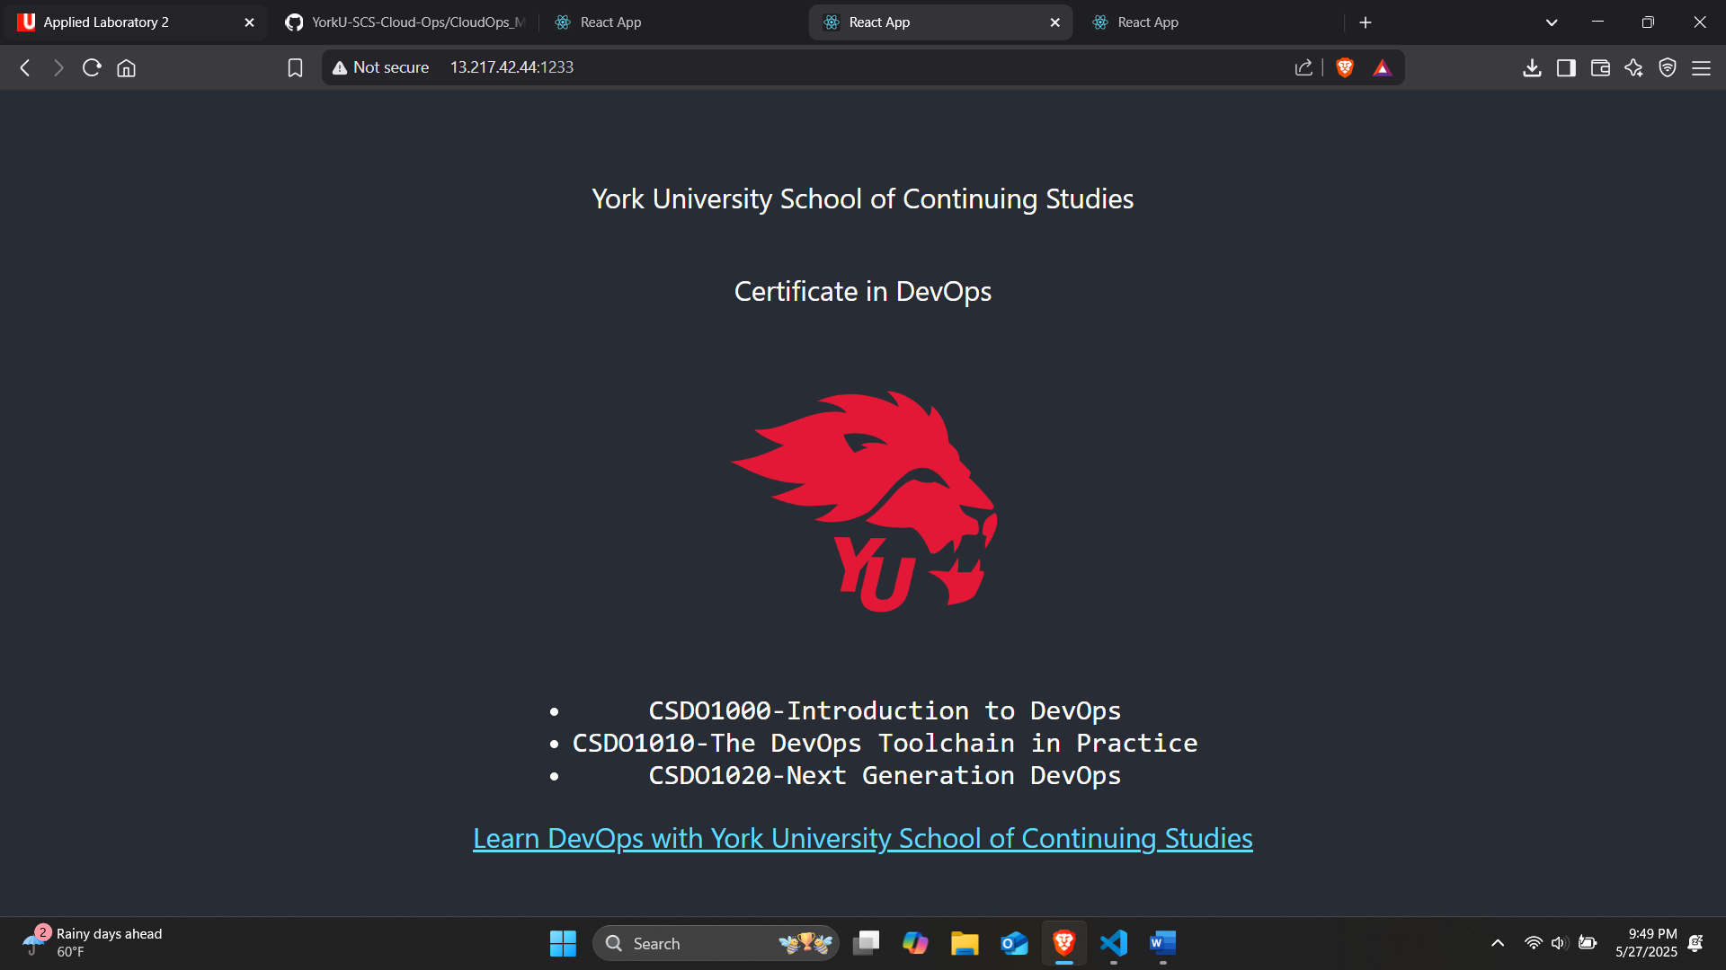

*Worker Node 2*

