**MICRO PROJECT REPORT**

***DESIGN AND ANALYSIS OF ALOGORITHM***

***SINGLE OBJECTIVE ANT COLONY OPTIMIZATION***

*SUB CODE* – CS591

*SUBMITTED TO*

HARINANDAN TUNGA

*SUBMITTED BY*

RAHUL RAJ , CSE2017/054

SUBHADIP NANDI , CSE2017/055

ABHISHEK AGRAHARI, CSE2017/059

RUDRAPRATAP GHOSH, CSE2017/033

**ABSTARCT**

Ant [Colony Optimization](https://www.omicsonline.org/open-access/efficient-ant-colony-optimization-eaco-algorithm-for-deterministicoptimization-2090-4908-1000131.php?aid=69378) is a new technique used for solving different combinatorial optimization problems. ACO is based on the behaviours of ant colony and this method has strong robustness as well as good distributed calculative mechanism. ACO has very good search capability for optimization problems.

Travelling salesman problem is one of the most famous combinatorial optimization problems. In this paper we applied the ant colony optimization technique for [symmetric](https://www.omicsonline.org/open-access/conformal-cartesian-grids-for-symmetric-bodies-a-novel-boundary-fitted-grid-method-2168-9679-1000234.php?aid=57804) travelling salesperson problem. Analysis are shown that the ant select the rich pheromone distribution edge for finding out the best path.

***MATHEMATICAL MODEL & METHODS***

In the ant colony optimization algorithms, an artificial ant is a simple computational agent that searches for good solutions to a given optimization problem. To apply an ant colony algorithm, the optimization problem needs to be converted into the problem of finding the shortest path on a weighted graph. In the first step of each iteration, each ant stochastically constructs a solution, i.e. the order in which the edges in the graph should be followed. In the second step, the paths found by the different ants are compared. The last step consists of updating the pheromone levels on each edge.

**EDGE SELECTION –**  Each ant needs to construct a solution to move through the graph. To select the next edge in its tour, an ant will consider the length of each edge available from its current position, as well as the corresponding pheromone level.

At each step of the algorithm, each ant moves from a state x to state y, corresponding to a more complete intermediate solution. Thus, each ant k computes a set Ak(x) of feasible expansions to its current state in each iteration, and moves to one of these in probability.

For ant k , the probability $P_{xy}^{k}$ of moving from state x to state y depends on the combination of two values, the attractiveness ηxy of the move, as computed by some heuristic indicating the a priori desirability of that move and the trail level τxy of the move, indicating how proficient it has been in the past to make that particular move. The trail level represents a posteriori indication of the desirability of that move. In general, the kth ant moves from state x to state y with probability

Where τxy is the amount of pheromone deposited for transition from state x to y , 0≤α is a parameter to control the influence of τxy, ηxy is the desirability of state transition xy (a priori knowledge, typically 𝟏/𝒅𝒙𝒚 , where dxy is the distance) and β≥ 1 is a parameter to control the influence of ηxy. τxz and ηxz represent the trail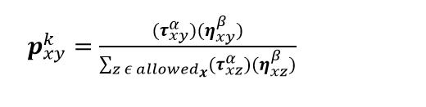 level and attractiveness for the other possible state transitions.

**PHEROMON UPDATE** **-**  Trails are usually updated when all ants have completed their solution, increasing or decreasing the level of trails corresponding to moves that were part of "good" or "bad" solutions, respectively. An example of a global pheromone updating rule is

$τ_{xy}⃪\left(1-ρ\right)τ_{xy}+\sum{∆τ_{xy}^{k}}$

where τxy is the amount of pheromone deposited for a state transition , ρ is the pheromone evaporation coefficient and ∆𝝉𝑥𝑦 𝑘 is the amount of pheromone deposited by kth ant, typically given for a TSP problem (with moves corresponding to arcs of the graph) by

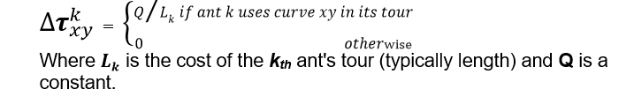

**EXAMPLE ILLUSTRATION**

Suppose that at time t = 0 there are 30 ants at point B (and 30 at point D). And at this moment there is no pheromone trail on any segments. So the ants randomly choose their path with equal probability. Therefore, on the average 15 ants from each node will go toward H and 15 toward C (Fig.1(b)). At t = 1 the 30 new ants that come to B from A find a trail of intensity, 15 on the path that leads to H, laid by the 15 ants that went that way from B, and a trail of intensity 30 on the path to C, obtained as the sum of the trail laid by the 15 ants that went that way from B and by the 15 ants that reached B coming from D via C (Fig.1(c)). The probability of choosing a path is therefore biased, so that the expected number of ants going toward C will be double of those going toward H: 20 versus 10, respectively. The same is true for the new 30 ants in D which come from E. This process continues until all of the ants will eventually choose the shortest path.

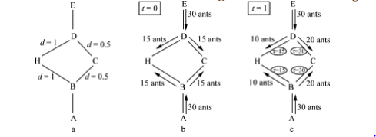

***ALGORITHM***

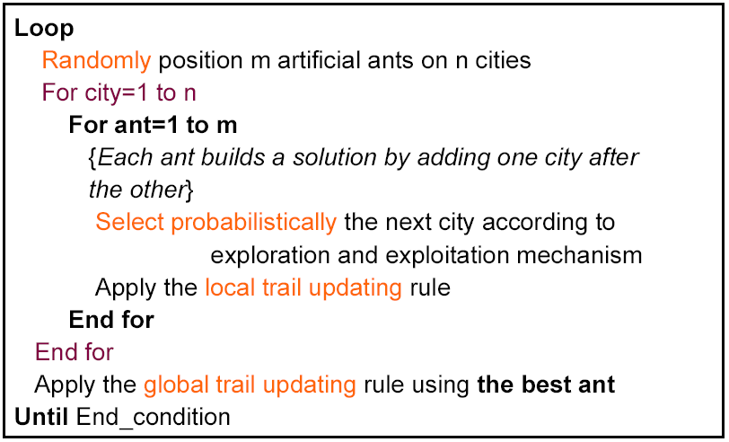

***RESULTS DESCRIPTION***

Enter number of cities

5

Enter the cost matrix

0 3 6 2 3

3 0 5 2 3

6 5 0 6 4

2 2 6 0 6

3 3 4 6 0

***Iteration 1***

Pheromon distribution

0.000000 1.000000 1.000000 1.000000 1.000000

1.000000 0.000000 1.000000 1.000000 1.000000

1.000000 1.000000 0.000000 1.000000 1.000000

1.000000 1.000000 1.000000 0.000000 1.000000

1.000000 1.000000 1.000000 1.000000 0.000000

The path for the Ant 1 :

1->4->2->5->3->1

Path length for Ant 1 = 17.000000

The path for the Ant 2 :

2->4->1->5->3->2

Path length for Ant 2 = 16.000000

The path for the Ant 3 :

3->5->1->4->2->3

Path length for Ant 3 = 16.000000

The path for the Ant 4 :

4->1->2->5->3->4

Path length for Ant 4 = 18.000000

The path for the Ant 5 :

5->1->4->2->3->5

Path length for Ant 5 = 16.000000

**Iteration 2**

Pheromon distribution

0.000000 0.200000 0.200000 0.325000 0.262500

0.200000 0.000000 0.325000 0.262500 0.200000

0.200000 0.262500 0.000000 0.200000 0.325000

0.262500 0.325000 0.200000 0.000000 0.200000

0.325000 0.200000 0.262500 0.200000 0.000000

The path for the Ant 1 :

1->4->2->5->3->1

Path length for Ant 1 = 17.000000

The path for the Ant 2 :

2->4->1->5->3->2

Path length for Ant 2 = 16.000000

The path for the Ant 3 :

3->5->1->4->2->3

Path length for Ant 3 = 16.000000

The path for the Ant 4 :

4->2->1->5->3->4

Path length for Ant 4 = 18.000000

The path for the Ant 5 :

5->1->4->2->3->5

Path length for Ant 5 = 16.000000

Ant colony optimization methodology is presented for symmetric cities of travelling salesmen problem in this paper. A detailed procedure for city selection for respective ant is presented for iteration 1 to 5. The selection of next city is based on the maximum probability within the set of possible selection of the cities for next move. This is marked as ‘*’ in the respective iteration. It gives the minimum distance with the initially assumed pheromone which is one for each edge. The minimum distance remain same for the ant 2, 3 and 5 for iteration 2, however the pheromone (τ) distribution is different because of updating the pheromone in the iteration 2 for each edge based on the updating rule. In the iteration 4, the ant 1, 2, 3 and 5 are selected the best path with minimum distance. However in the iteration 5, all the ants are converged to the minimum distance. The pheromone (τ) distribution for iteration, 2, 3, 4 and 5 are updated for each iteration.

***Conclusion***

It is shown that all the ants converge to the best path which gives minimum distance. The pheromone distribution for iteration and the next city selection based on maximum probability is determined in the iteration. It is evident from the analysis that the rich [**pheromone edge**](https://www.omicsonline.org/searchresult.php?keyword=Pheromone%20Edge) is converges the best path for the travelling [**salesmen problems**](https://www.omicsonline.org/searchresult.php?keyword=Salesmen%20Problems).

***REFERENCE***

https://en.wikipedia.org/wiki/Ant_colony_optimization_algorithms

https://en.wikipedia.org/wiki/Travelling_salesman_problem

https://www.sciencedirect.com/science/article/pii/S1002007108002736