**Lab Exercise 18- Scanning IaC Templates for Vulnerabilities**

**Objective**

* Learn how to scan Infrastructure as Code (IaC) templates for security vulnerabilities.
* Use open-source IaC security tools to detect misconfigurations.
* Understand common risks such as public access, unencrypted resources, and insecure network rules.

**Prerequisites**

* A Linux/Windows/Mac machine with:
  + Terraform installed (for sample IaC)
  + **Checkov** (pip install checkov) or **tfsec** (brew install tfsec or binary download)

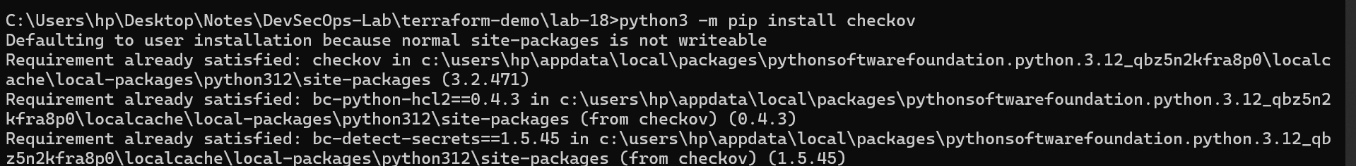

* Git installed (optional, for version control of IaC templates)

**Step 1: Create an Insecure IaC Template**

Create a file named main.tf with the following Terraform code:

provider "aws" {

region = "us-east-1"

}

resource "aws_s3_bucket" "insecure_bucket" {

bucket = "my-insecure-bucket-lab"

acl = "public-read"

}

resource "aws_security_group" "insecure_sg" {

name = "insecure-sg"

description = "Allow all inbound traffic"

ingress {

from_port = 0

to_port = 65535

protocol = "tcp"

cidr_blocks = ["0.0.0.0/0"]

}

}

**Step 2: Scan the Template with Checkov**

Run Checkov on the current directory:

checkov -d .

**Expected Findings:**

* Public S3 bucket access (public-read)
* Security group open to all inbound traffic

**Expected Findings:**

* Warns about S3 bucket without encryption
* Flags open Security Group rules

**Step 4: Review the Report**

Example output (Checkov):

Check: CKV_AWS_20: "S3 Bucket allows public read access"

FAILED for resource: aws_s3_bucket.insecure_bucket

Check: CKV_AWS_260: "Security group allows ingress from 0.0.0.0/0"

FAILED for resource: aws_security_group.insecure_sg

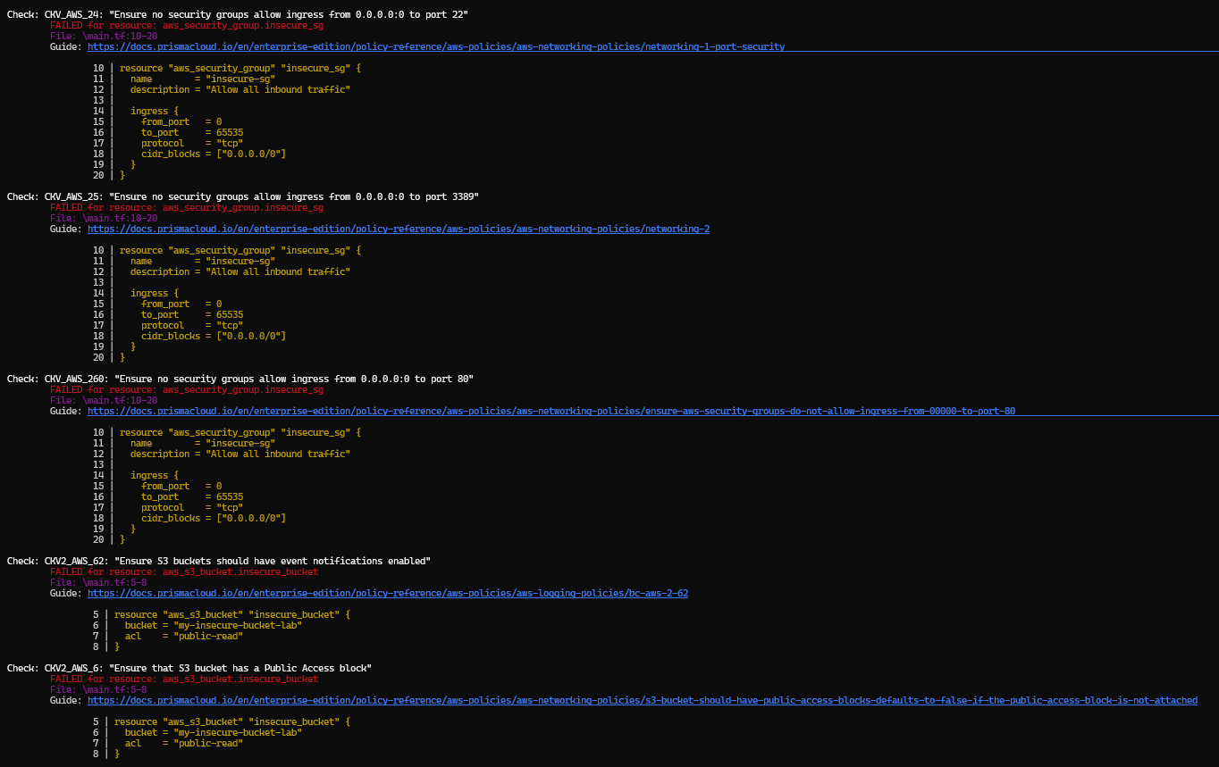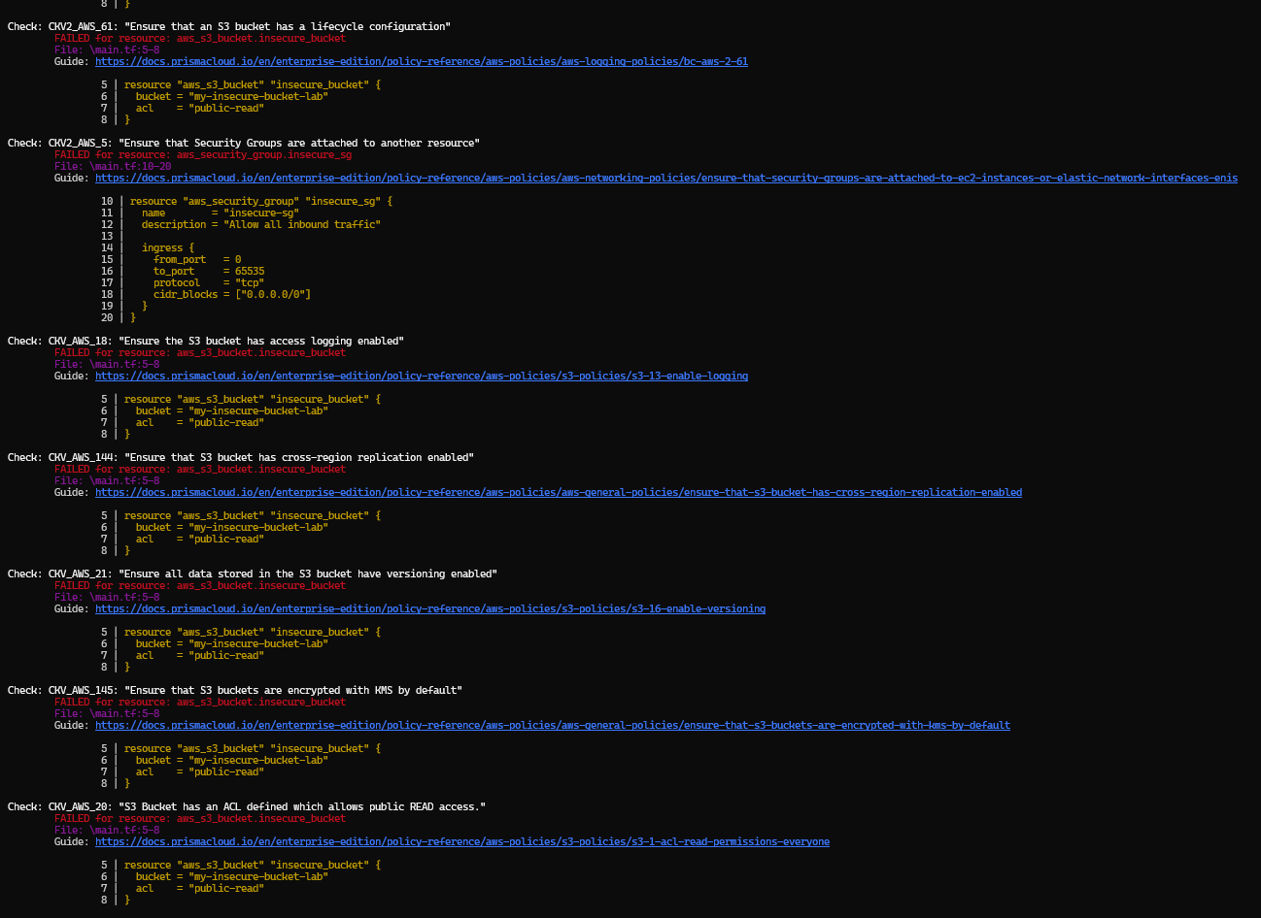

**Step 5: Apply Fixes (Optional)**

Modify the IaC template to:

* Set S3 bucket ACL to private
* Enable encryption (AES256)
* Restrict Security Group to specific IP ranges

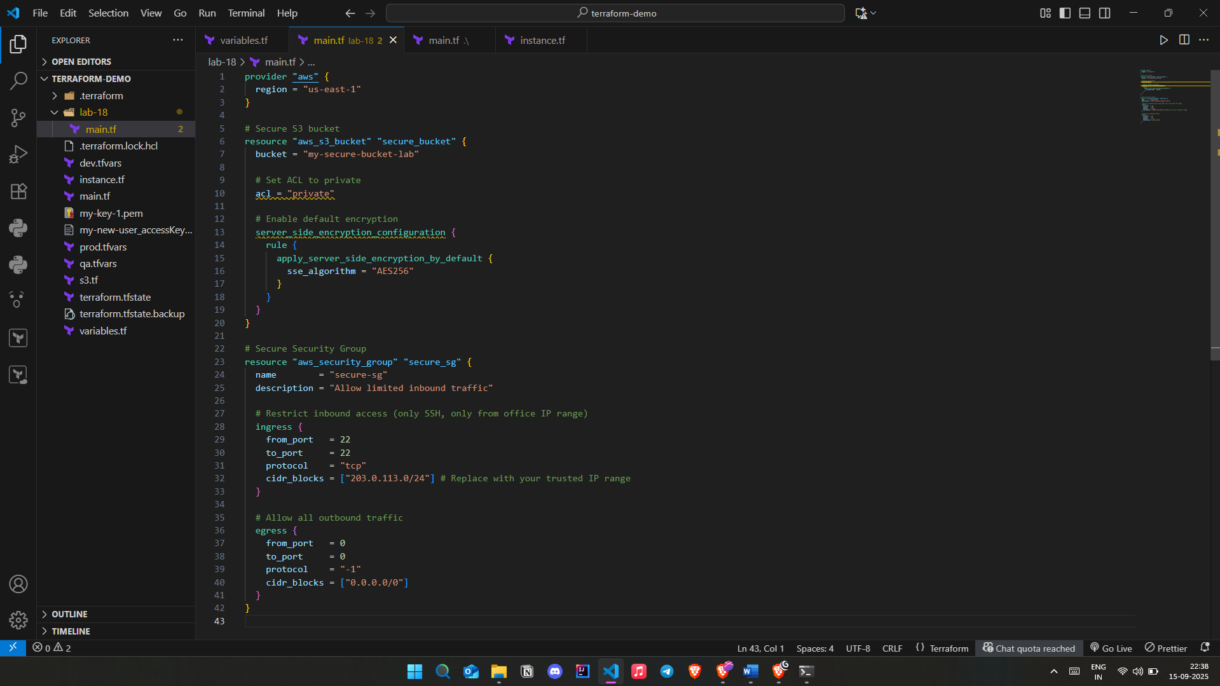

**Step 6: Rescan the Template**

Run the scan again:

checkov -d .

Now the findings should be **resolved or reduced**.

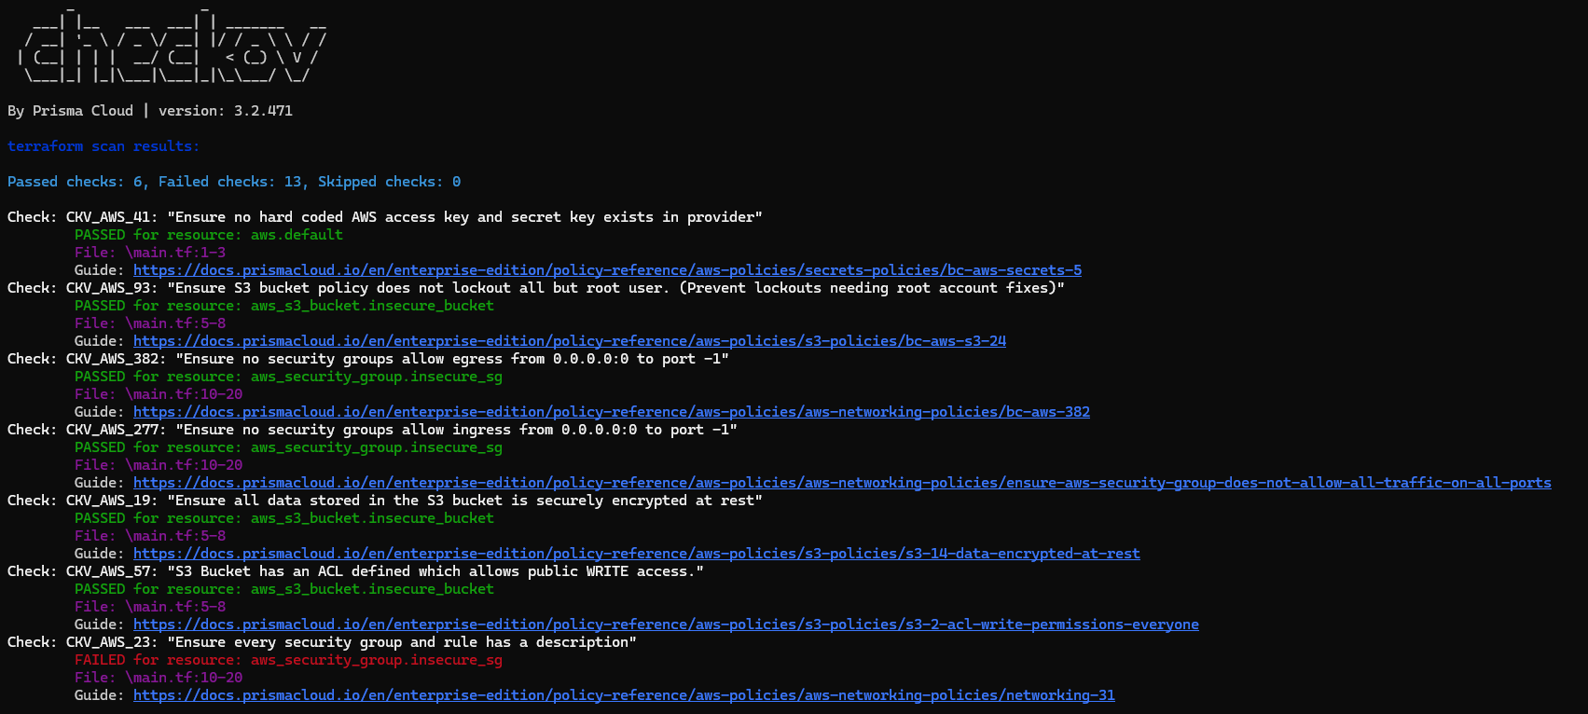

**Step 7: Document Findings**

Findings Log:

**Fixed Vulnerabilities:**

|  |  |  |  |  |
| --- | --- | --- | --- | --- |
| **ID** | **Resource** | **Issue Detected** | **Risk** | **Fix Applied** |
| **1** | aws_s3_bucket.secure_bucket | S3 bucket ACL was public-read | Public exposure of data | Changed ACL to **private** |
| **2** | aws_s3_bucket.secure_bucket | No encryption configured | Data at rest not protected | Enabled **AES256 server-side encryption** |
| **3** | aws_security_group.secure_sg | Ingress allowed 0.0.0.0/0 on all TCP ports | Full internet exposure (critical risk) | Restricted ingress to specific CIDR (203.0.113.0/24) and limited to **port 22 (SSH)** |

**Remaining Issues:**

|  |  |  |  |  |
| --- | --- | --- | --- | --- |
| Check ID | Description | | Status | Notes |
| CKV_AWS_23 | | **Missing SG rule descriptions** | **❌ Failed** | **Add descriptions to each rule** |
| CKV_AWS_382 | | **SG allows egress 0.0.0.0/0 on all ports** | **❌ Failed** | **Restrict egress to only required destinations** |
| CKV2_AWS_5 | | **SG not attached to a resource** | **❌ Failed** | **Attach SG to EC2 or relevant resource** |
| CKV_AWS_18 | | **S3 bucket logging not enabled** | **❌ Failed** | **Enable server access logging** |
| CKV_AWS_21 | | **S3 bucket versioning not enabled** | **❌ Failed** | **Enable versioning for recovery** |
| CKV2_AWS_6 | | **No public access block on S3 bucket** | **❌ Failed** | **Add aws_s3_bucket_public_access_block resource** |
| CKV2_AWS_61 | | **No lifecycle configuration on S3 bucket** | **❌ Failed** | **Add lifecycle rules for storage classes** |
| CKV_AWS_145 | | **S3 not using KMS encryption** | **❌ Failed** | **Switch from AES256 to KMS CMK** |
| CKV_AWS_144 | | **No cross-region replication configured** | **❌ Failed** | **Configure replication if needed** |
| CKV2_AWS_62 | | **No event notifications configured** | **❌ Failed** | **Add event notification configuration** |