Practical 4
Aim: Find the Maximum Temperature Recorded for Each Year of NCDC Data using MapReduce

Problem definition:
A meteorological research organization maintains historical weather records collected from
various weather stations worldwide. The organization uses Hadoop to analyze large climate
datasets and study long-term temperature trends. As a Data Analytics Engineer, you are
required to process the National Climatic Data Center (NCDC) dataset and identify the
maximum temperature recorded for each year using MapReduce.

Task 1: Upload the NCDC weather dataset to HDFS and examine the structure of the weather
records.
Task 2: Develop and implement the Mapper program to extract the year and
temperature values from each record and generate intermediate key-value pairs.
Task 3:Develop and implement the Reducer program to determine the maximum temperature
recorded for each year.
Task 4: Execute the MapReduce job on Hadoop and store the results
in HDFS. Verify the correctness of the output generated.
Task 5: Analyze the yearly maximum
temperature trends and identify the hottest year in the dataset. Discuss the advantages of
using MapReduce for large-scale climate data analysis.

Objectives:

- Configure the Hadoop environment and HDFS.
- Create and upload a text dataset to HDFS.
- Implement a Mapper to generate (word, 1) key-value pairs.
- Implement a Reducer to calculate word frequencies.
- Execute the MapReduce job on Hadoop.
- Store the output in HDFS.
- Find the top 10 most frequently occurring words.
- Analyze the performance for different dataset sizes.

Observation / Output

Task 1:

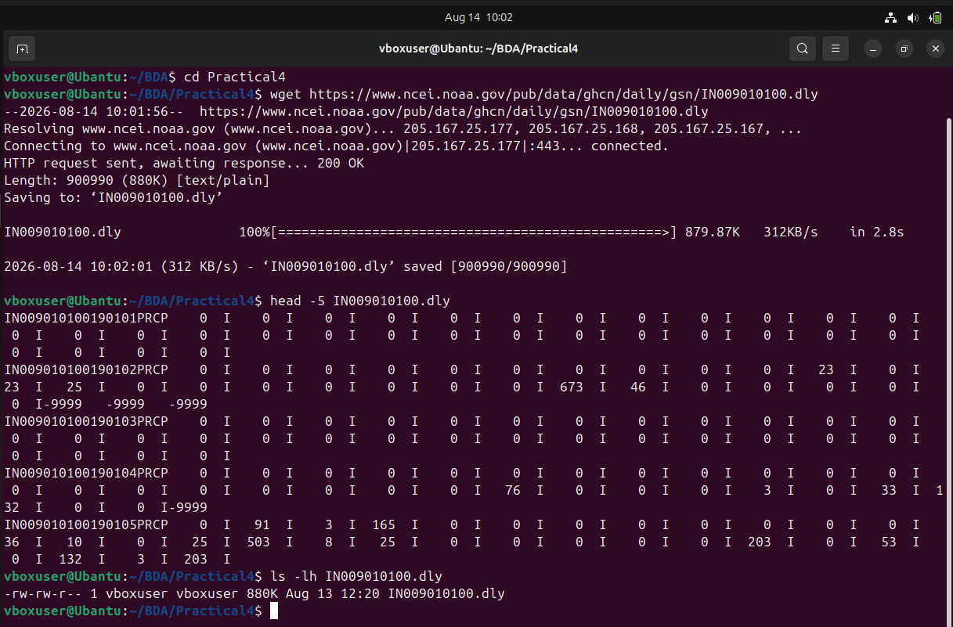

Into HDFC Directory:



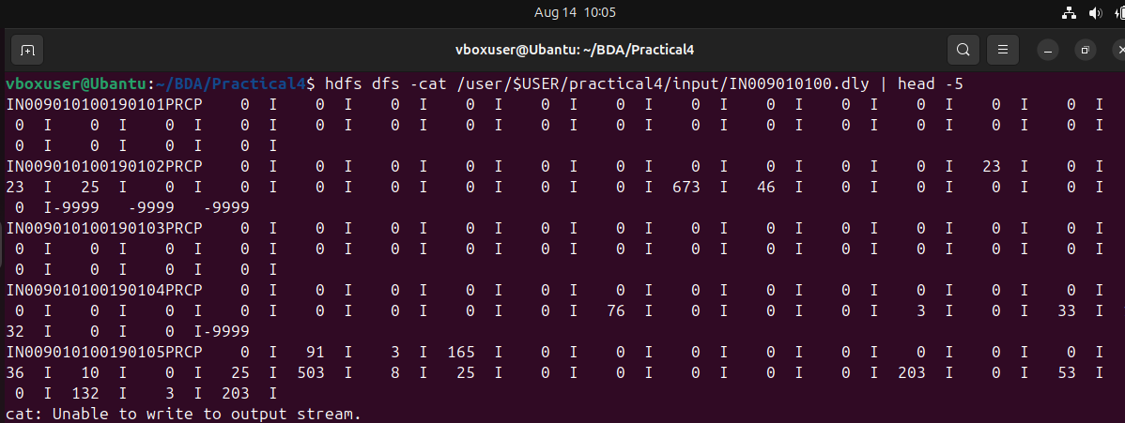

Task 2:

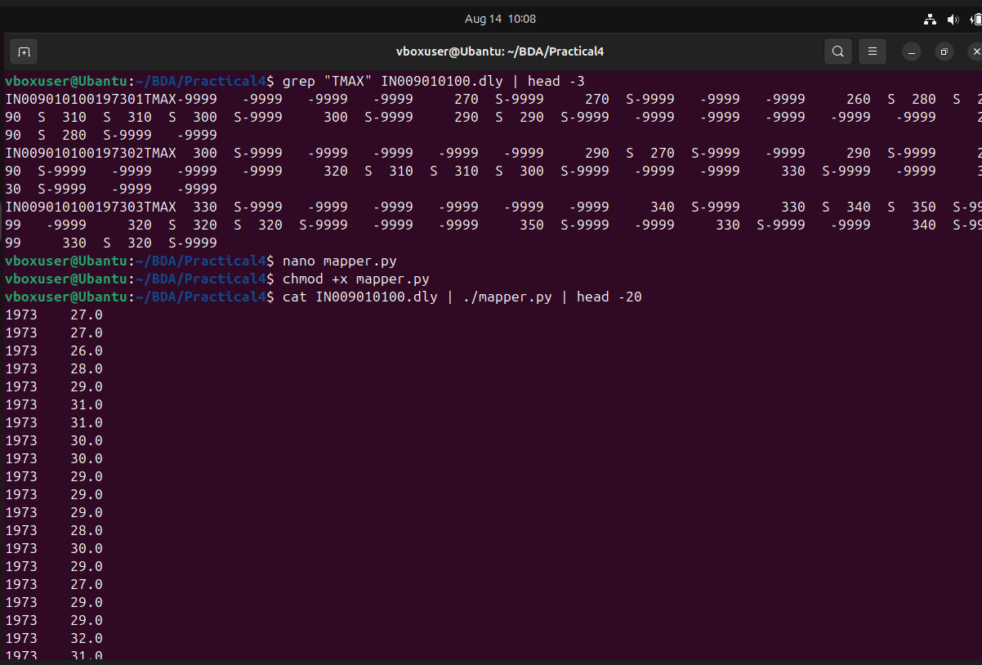



Task 3:

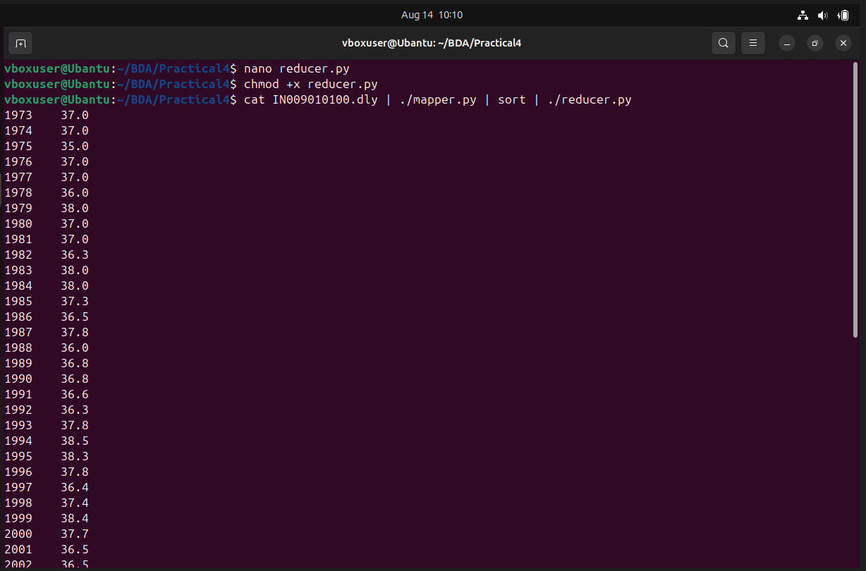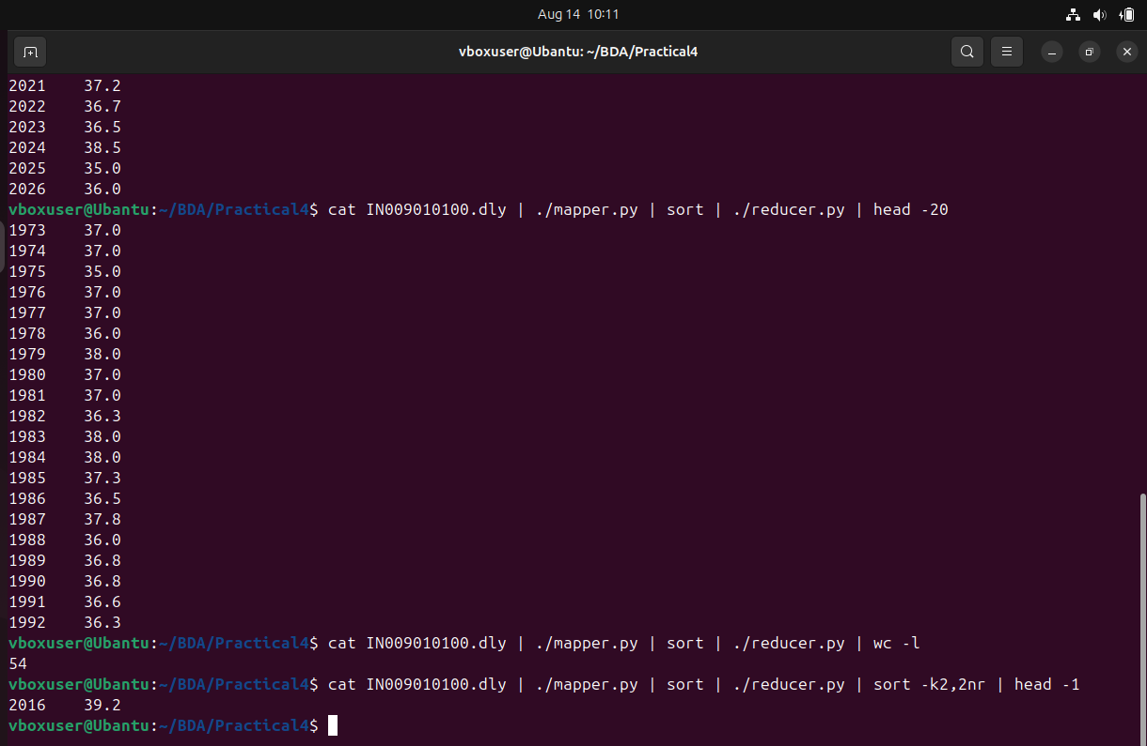

Task 4:

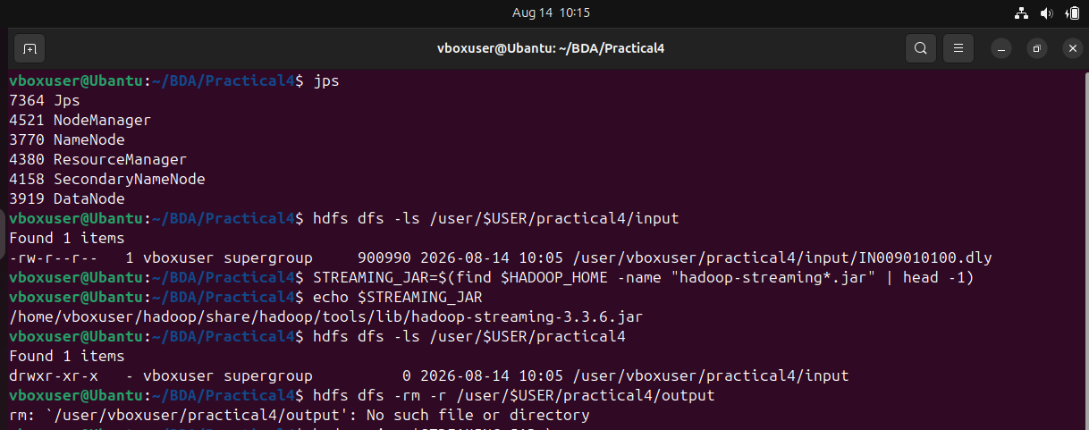

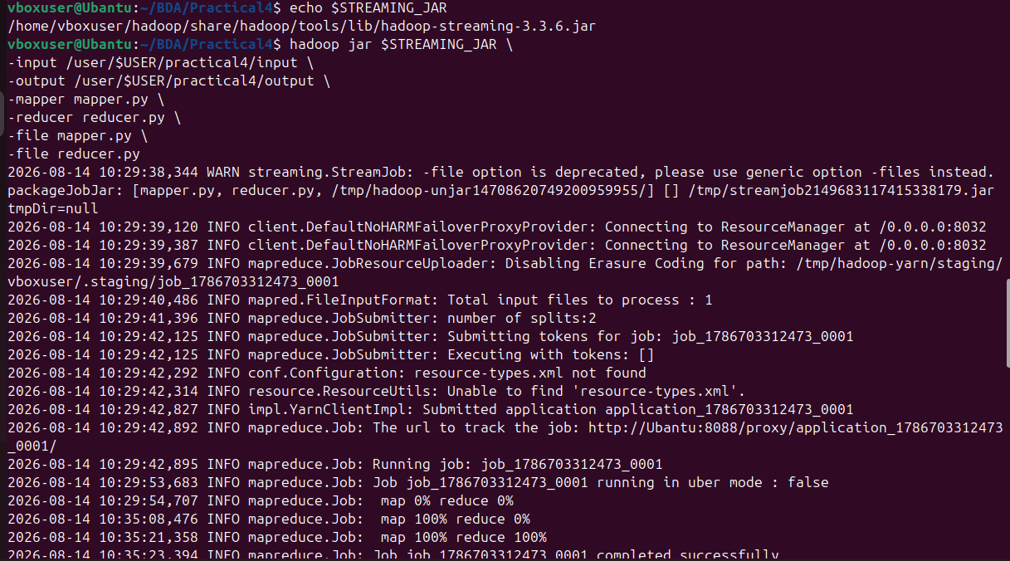

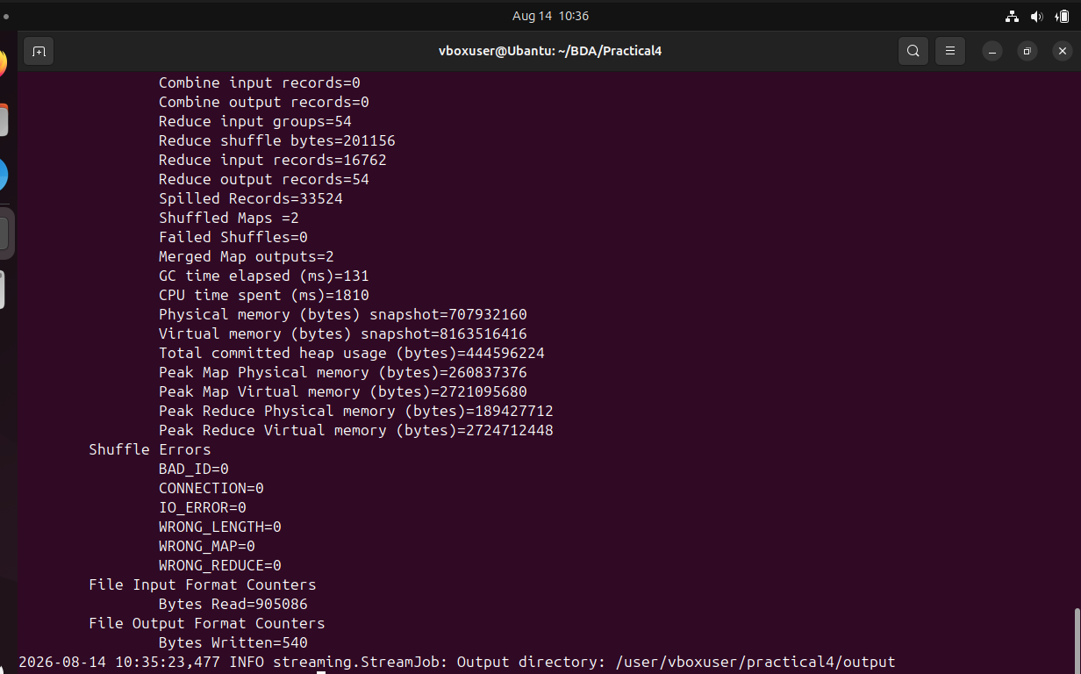

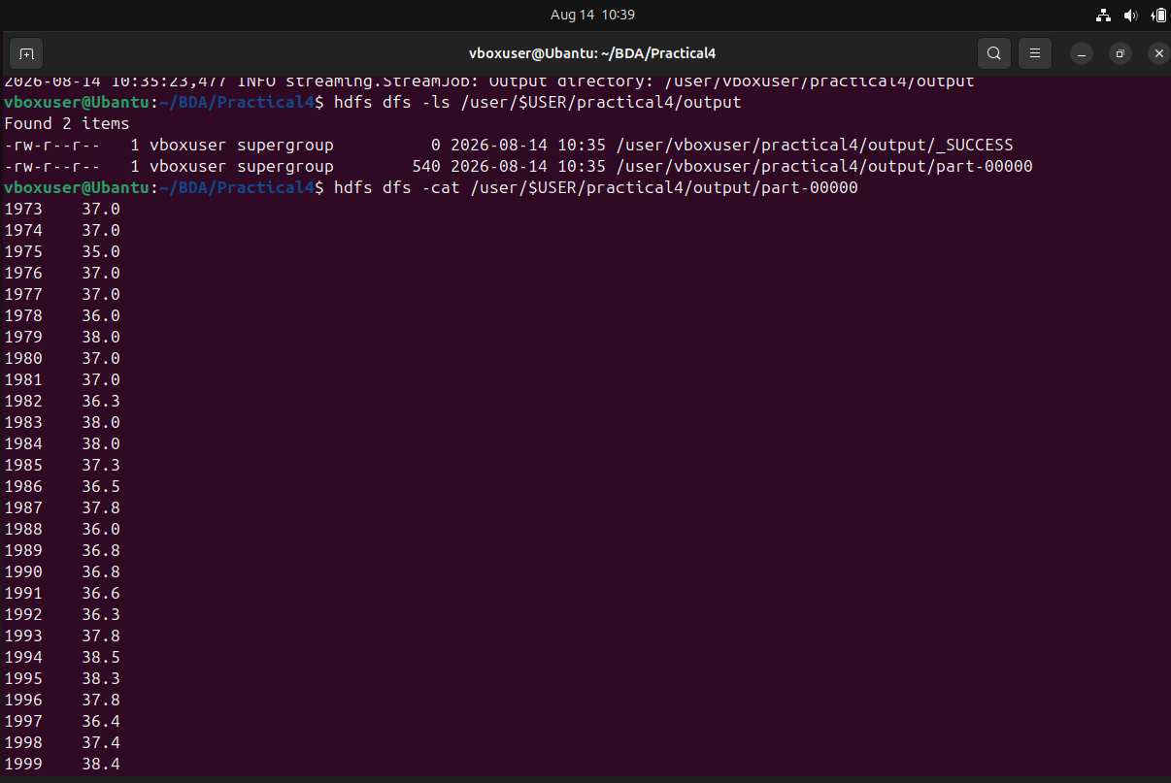

Task 5:

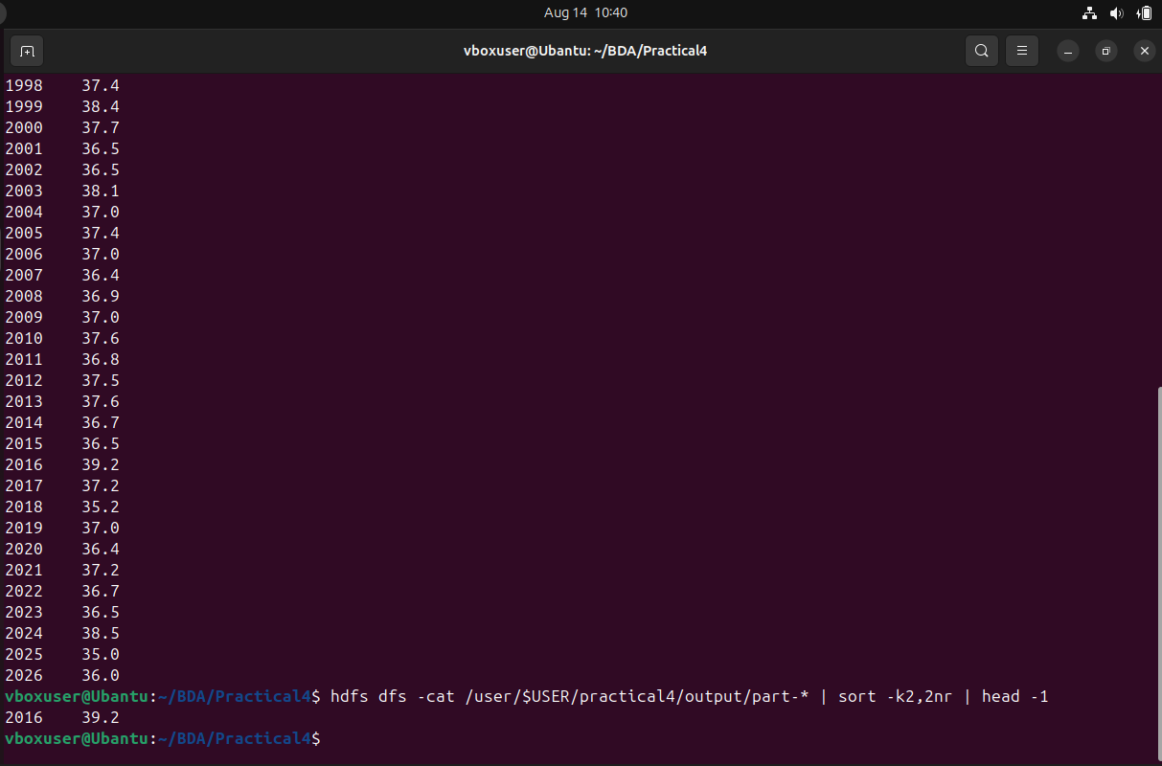

12.3 Key Questions / Analysis

Q1. How is weather data parsed and processed using MapReduce?

Ans:Weather data is stored in a file, usually in CSV or text format. The Mapper reads each record, parses the required fields such as the year and temperature, and generates key-value pairs. Hadoop then groups the data by year and sends all values for the same year to the Reducer. The Reducer processes these values to find the maximum temperature for each year.

Q2. What key-value pairs are generated by the Mapper?
Ans: The Mapper generates the year as the key and the temperature as the value.

For example, if the weather record contains:

2015,35

2015,39

2016,37

2016,42

The Mapper produces:

2015 35

2015 39

2016 37

2016 42

So the format is:

Key → Year

Value → Temperature

Q3. How does the reducer identify the maximum temperature for a given year?

Ans:

The Reducer receives all temperatures associated with the same year. It compares the temperature values and selects the highest value.

For example:

2015 → 35, 39, 37, 41

The Reducer compares these values and produces:

2015 41

Thus, the maximum temperature is calculated independently for each year.

Q4. What challenges arise when processing large climate datasets?

Ans:

Some common challenges are:

Huge data volume: Climate datasets can contain millions or billions of records.

Missing or incorrect data: Some weather records may contain missing or invalid temperature values.

Different data formats: Data may come from different weather stations and use different formats or units.

Processing time: Large datasets require significant computing resources.

Data distribution: Data must be efficiently distributed across multiple machines.

Fault tolerance: Hardware or software failures can occur while processing large datasets.

Q5. How does Hadoop improve scalability and performance for weather data analytics?

Ans:

Hadoop improves weather-data processing by using distributed storage and parallel processing. Large datasets are divided into smaller blocks and stored across multiple machines in HDFS. MapReduce processes these blocks simultaneously across different nodes.

This provides:

Scalability – more machines can be added as the dataset grows.

Faster processing – multiple nodes process data in parallel.

Fault tolerance – Hadoop can recover from node failures using replicated data.

Efficient storage – HDFS distributes large datasets across the cluster.

Parallel analysis – large amounts of weather data can be analyzed much faster than on a single machine.

Conclusion:

The NCDC weather dataset was successfully processed using the Hadoop MapReduce framework to determine the maximum temperature recorded for each year. The dataset was first uploaded to HDFS, where the Mapper extracted the year and temperature from each weather record and generated intermediate key-value pairs. The Reducer then grouped the temperature values by year and identified the maximum temperature for each year.

The MapReduce job was executed successfully, and the final results were stored in HDFS and verified. This practical demonstrates how Hadoop can efficiently process large-scale climate datasets using distributed storage, parallel processing, and fault tolerance. By analyzing the yearly maximum temperatures, the hottest year in the NCDC dataset can also be identified.

Overall, MapReduce provides a scalable and efficient approach for analyzing large meteorological datasets and studying long-term temperature trends.

