Round 1 — Quiz Round
C Programming — Multiple Choice Questions

Question 1
Which statement causes a runtime crash (Segmentation Fault)?
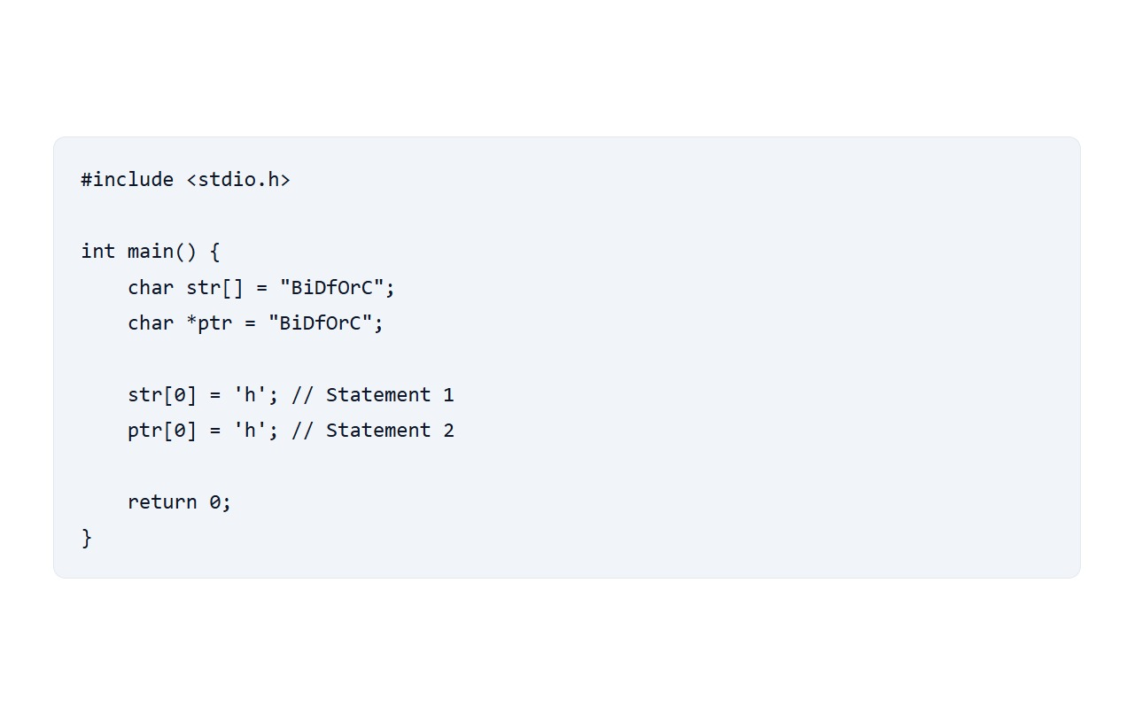
A) Statement 1 only
B) Both Statement 1 and 2
C) Statement 2 only ✓ Correct Answer
D) Neither

Question 2
What is the result of this code?
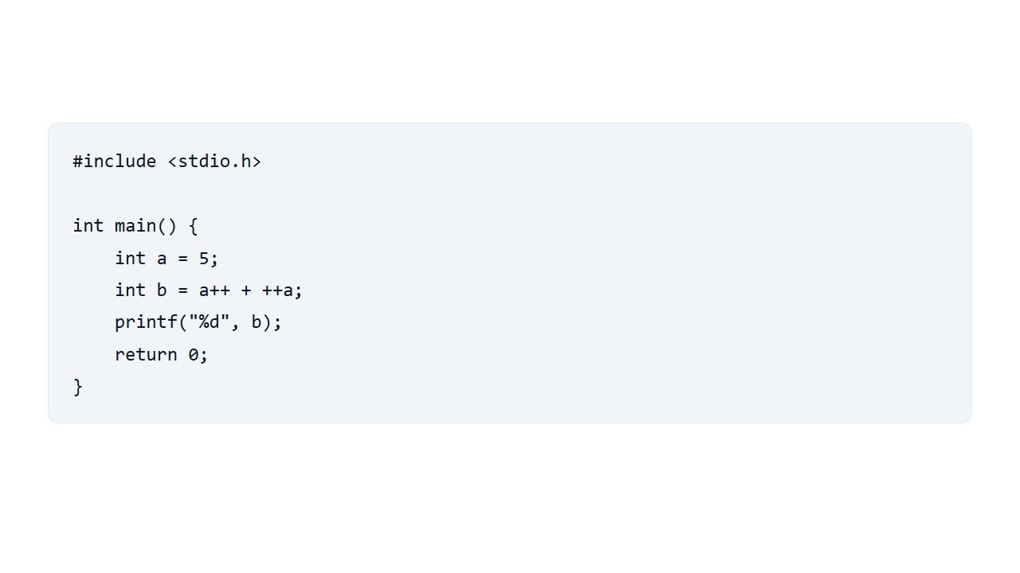
A) 11
B) 12 ✓ Correct Answer
C) 13
D) Undefined Behavior

Question 3
What is the output?
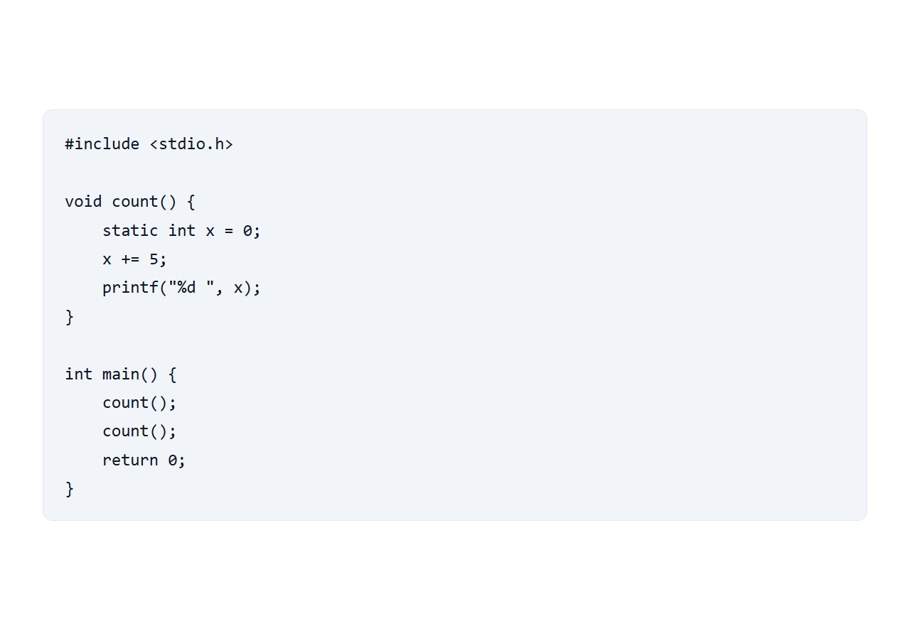
A) 5 10 ✓ Correct Answer
B) 5 5
C) 0 5
D) Compiler error: static variables cannot be updated

Question 4
What is the output of this C code snippet?
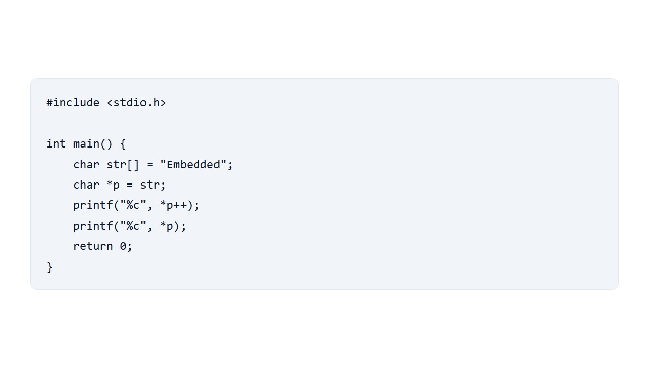
A) mm
B) EE
C) Em ✓ Correct Answer
D) mE

Question 5
What issue exists in the following function?
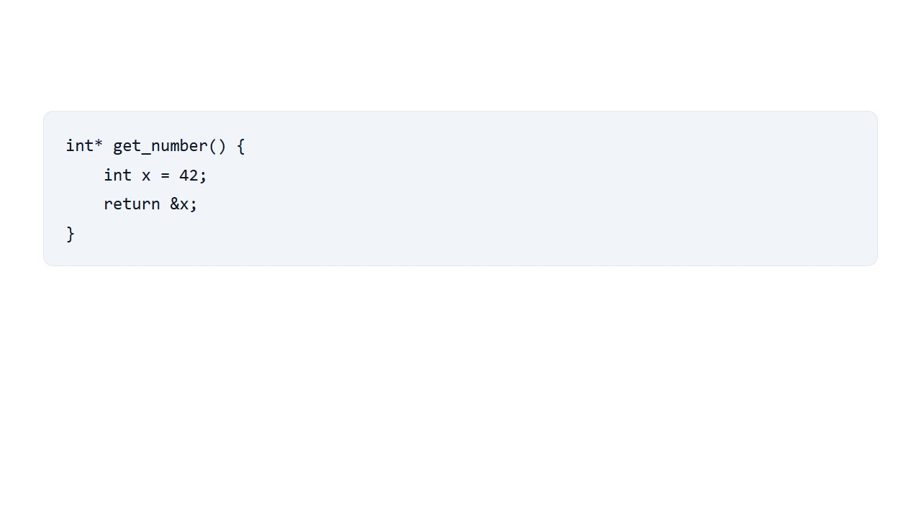
A) Syntax error returning an address
B) Returning a pointer to a local stack variable ✓ Correct Answer
C) Memory leak because x is not freed
D) Cannot assign an integer value to a pointer

Question 6
What is the output of the following code?
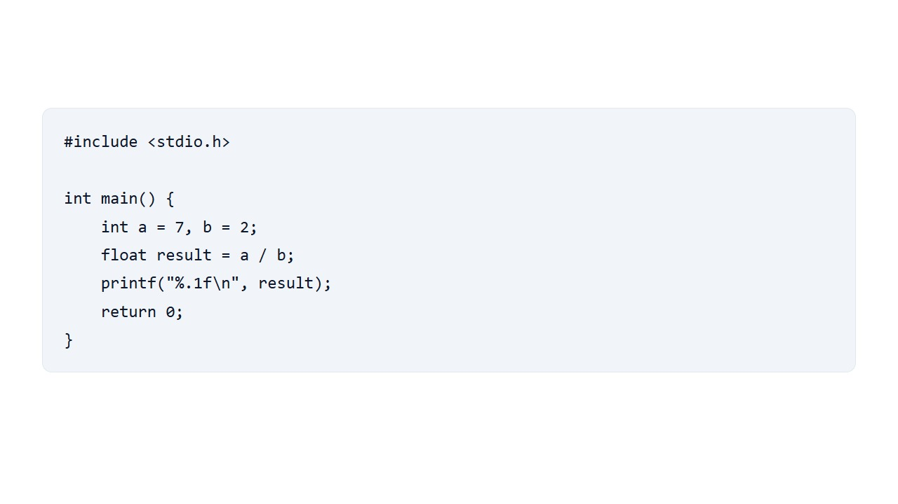
A) 3.5
B) Compilation error
C) 3.50
D) 3.0 ✓ Correct Answer

Question 7
How many times will the body of this for loop execute?
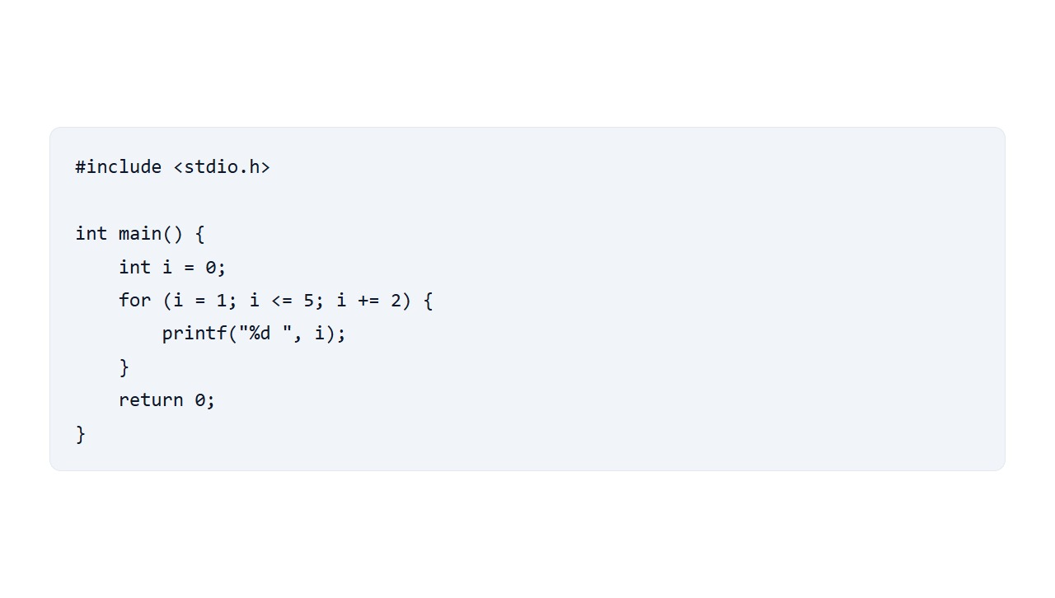
A) 5 times
B) 10 times
C) 2 times
D) 3 times ✓ Correct Answer

Question 8
Which of the following is a valid identifier name in C?
A) 2nd_value
B) default
C) _total_amount ✓ Correct Answer
D) user-name

Question 9
What type of file is generated by a C compiler directly from a source .c file before the linking stage takes place?
A) Object file (.o or .obj) ✓ Correct Answer
B) Executable file (.exe)
C) Header file (.h)
D) Library file (.dll or .so)

Question 10
What type of programming language is C?
A) Object-Oriented Programming Language
B) Procedural Programming Language ✓ Correct Answer
C) Functional Programming Language
D) Pure Visual Scripting Language

Question 11
For int a[5]; what is the last valid index?
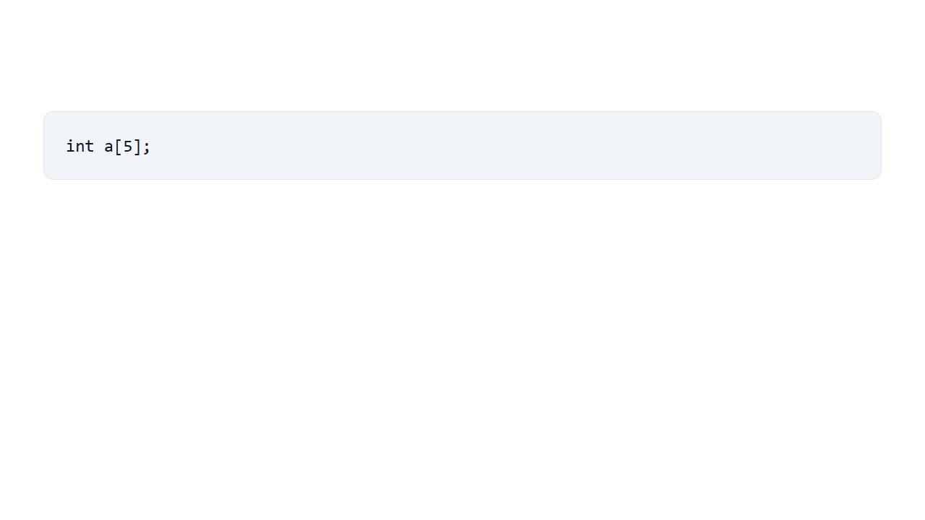
A) 3
B) 4 ✓ Correct Answer
C) 5
D) 6

Question 12
Compile and run. Select the exact output.
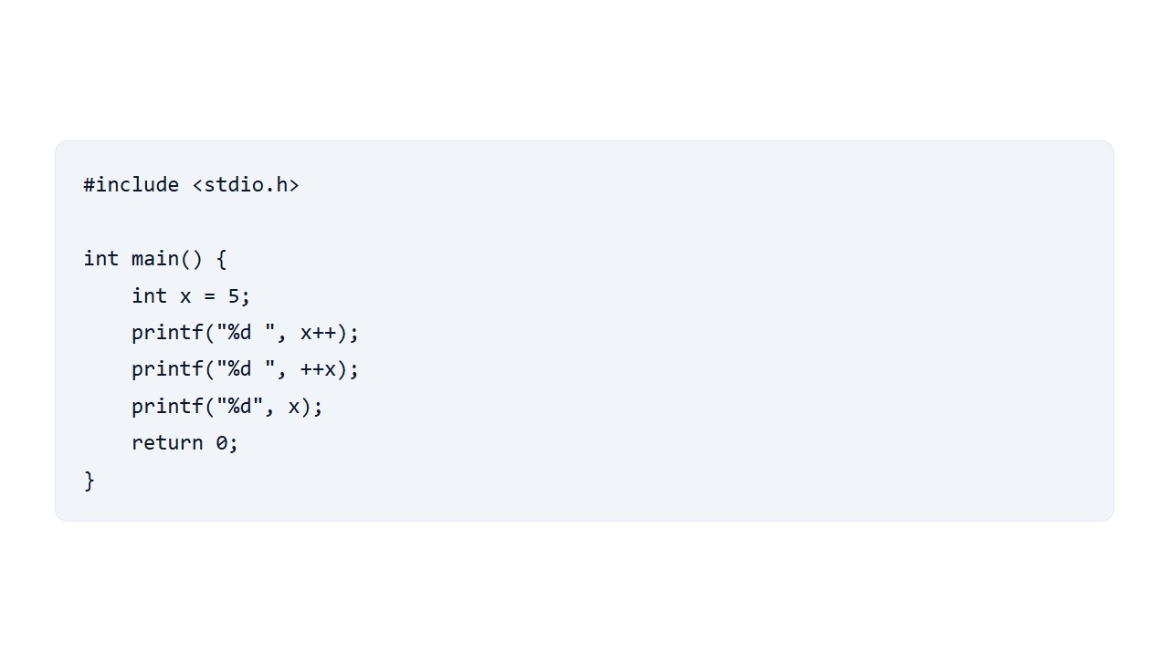
A) 5 6 7
B) 5 7 7 ✓ Correct Answer
C) 6 7 7
D) 5 6 6

