
PRESIDENCY COLLEGE’S
COLLEGE OF BUSINESS ADMINISTRATION, BERHAMPUR, ODISHA
A PROJECT REPORT ON
“E -TICKET TRACKING SYSTEM”
Submitted to

Berhampur University, Bhanja Bihar, Berhampur
Towards The Partial Fulfilment of the requirement for the award of
“Bachelor of Computer Application”
Submitted by:
ASUTOSH MISHRA
Roll. No : 23PBCA0419
Regd. No.: 23375/2023

Under The Guidance of
Asst. Prof. Khirabdhi Tanya Devi
College Of Business Administration

DECLARATION

I Asutosh Mishra a student of Bachelor of Business Administration, bearing Roll no. 23PBCA0419 declare that facts and findings presented in this report entitled "E -TICKET TRACKING" are true to the best of my knowledge and belief which is being submitted to the Berhampur University through "College of Business Administration, Berhampur" for the partial fulfilment of the award of Bachelor Degree of Computer Application.
I further declare that this is my own original work which has not been submitted to any other institution or university and also not published anywhere else earlier.

Date: Asutosh Mishra
Place: Roll no: 23PBCA0419

ACKNOWLEDGEMENT

The satisfaction and euphoria of the company the successful completion of any work would be incomplete without saluting the person who are responsible for the successful for the completion of the project.
I take this opportunity to express my sincere gratitude to Almighty God for His grace and blessings, which enabled me to successfully complete this work.
I would like to extend my heartfelt thanks to my esteemed guide, Asst. Prof. Khirabdhi Tanya Devi for her valuable guidance, constant support, and insightful suggestions at every stage of this project. Her encouragement and direction have been instrumental in the successful completion of this work.
I also express my sincere thanks to all the faculty members for their cooperation and for providing the necessary facilities to carry out this project.
Last but not least, I would like to thank my friends and family for their continuous support, encouragement, and motivation throughout the course of this work.

Date: Asutosh Mishra
Place: 3rd Year BCA
Roll no: 23PBCA0419

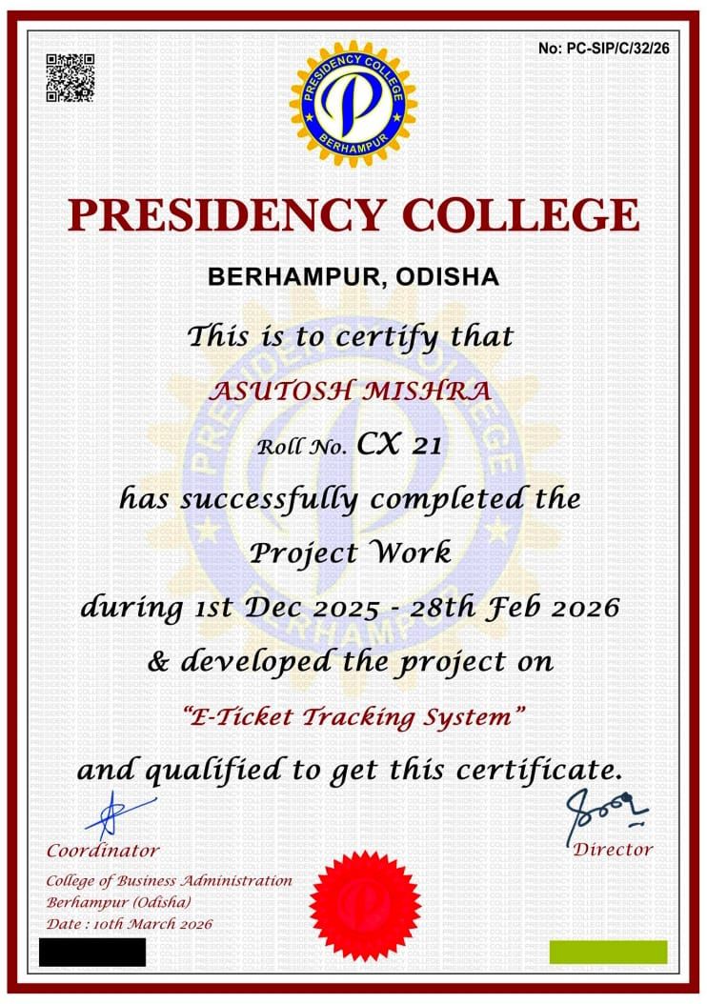

Guide certificate

This is to certify that the Asutosh Mishra, bearing Roll no. 23PBCA0419 & Regd No: 23375/2023. student of Bachelor of Computer Application under the Berhampur University has successfully completed his/her project work entitled “E -TICKET TRACKING SYSTEM” under my guidance and supervision.

Asst. Prof. Khirabdhi Tanya Devi
PROJECT GUIDE

INDEX
Sl No. | Contents |  | Page No:
1 | Introduction |  | 1
 | OBJECTIVES OF A PROPOSED SYSTEM: |  | 2
 | PROJECT CATEGORY |  | 3
2 | System Analysis |  | 5
 | 2.1 | Identification of need | 5
 | 2.2 | Preliminary Investigation | 5
 | 2.3 | Feasibility Study | 6
 | 2.4 | Project Planning | 6
 | 2.5 | Project Scheduling | 6
 | 2.6 | Software & Hardware requirement Specification | 7
 | 2.7 | Software Engineering Paradigm Applied | 7
 | 2.8 | Use case Diagram | 7
 | 2.9 | Link Flow Diagram | 8
 | 2.10 | Data Model | 8
 | 2.11 | Data Flow Diagram | 9
 | 2.12 | Data Dictionary | 10
 | 2.13 | ER Diagram | 10
3 | System Design |  | 11
 | 3.1 | Modularization Details | 12
 | 3.2 | Database Design | 13
 | 3.3 | User Interface Design | 14-15
 | 3.4 | Screenshots | 16-17
4 | Code Implementation |  | 18-47
5 | Testing |  | 47
6 | System Security Measures |  | 51
 | 6.1 | Database Security | 54
7 | Future scope & Further Enhancement of the Project |  | 59
8 | Glossary |  | 59
9 | Conclusion |  | 61
10 | Bibliography |  | 62

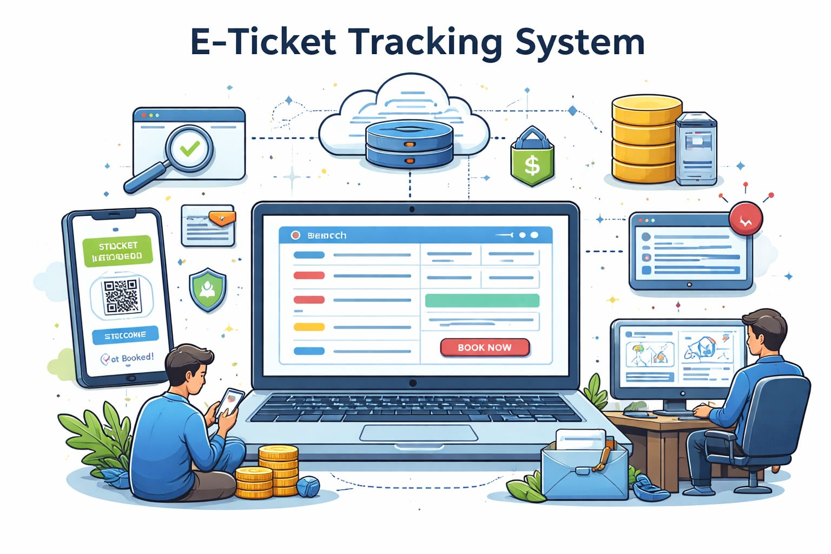
1. Introduction:
In today’s digital era, technology has become an essential part of our daily lives. Almost every activity, from communication to business transactions, is now performed using digital systems. One of the major areas where technology has made a significant impact is in ticket booking and management systems. Traditional ticket booking methods, which involve manual processes, long queues, and paperwork, are no longer efficient in meeting the growing demands of users. This has led to the development of modern online systems such as the E-Ticket Tracking System.
The E-Ticket Tracking System is a web-based application designed to simplify and automate the process of ticket booking and tracking. It allows users to book tickets, check their booking status, and manage their reservations through an online platform. This system eliminates the need for physical presence at booking counters and provides users with a convenient and efficient way to access services anytime and anywhere.
In the traditional system, users often face several challenges such as long waiting times, lack of proper information, and chances of human error. Manual handling of data can lead to inaccuracies, duplication, and difficulty in maintaining records. Moreover, tracking the status of tickets in a manual system is time-consuming and inefficient. The E-Ticket Tracking System overcomes these limitations by providing a fully automated solution that ensures accuracy, speed, and reliability.
The proposed system is developed using modern web technologies. The frontend is designed using HTML, CSS, and JavaScript, which provide an interactive and user-friendly interface. The backend is developed using Spring Boot, which handles the business logic and processes user requests efficiently. The system uses a MySQL database to store and manage data securely. This combination of technologies ensures that the system is robust, scalable, and easy to maintain.
The system provides multiple functionalities such as user registration, login authentication, ticket booking, payment processing, and ticket tracking. Users can create their accounts, log into the system, and perform various operations easily. The system also provides an admin panel that allows administrators to manage users, monitor bookings, and maintain the system effectively.
One of the key features of the E-Ticket Tracking System is its ability to provide real-time updates. Users can track the status of their tickets instantly without any delay. This improves transparency and enhances user satisfaction. The system also ensures data security by implementing various security measures such as authentication, encryption, and access control.
The E-Ticket Tracking System not only improves efficiency but also reduces the workload on staff. It minimizes human errors and ensures accurate data handling. The system promotes a paperless environment by storing all data digitally, which is beneficial for both users and organizations.
Another important aspect of the system is its scalability. The system can be enhanced in the future by adding new features such as mobile application support, online payment gateways, AI-based recommendations, and multi-language support. This makes the system adaptable to future technological advancements.
- OBJECTIVES OF THE PROPOSED SYSTEM:
The main objective of the proposed E-Ticket Tracking System is to provide an efficient, reliable, and user-friendly platform for online ticket booking and tracking. The system is designed to overcome the limitations of traditional manual systems and to improve overall performance and user experience.
The detailed objectives of the system are as follows:
1. To Provide an Easy and Convenient Booking System
The system aims to offer a simple and convenient method for users to book tickets online. Users can access the system from anywhere at any time using the internet. This eliminates the need to visit physical booking counters and reduces effort.

2. To Reduce Manual Work
The proposed system automates the entire ticket booking and tracking process. This reduces the dependency on manual work, minimizes paperwork, and improves overall efficiency.

3. To Minimize Human Errors
Manual systems are prone to errors such as incorrect data entry and record mismanagement. The automated system ensures accurate data handling and reduces the chances of mistakes.

4. To Provide Real-Time Tracking
The system allows users to track their ticket status in real time. Users can easily check booking confirmation, availability, cancellation status, and updates without any delay.

5. To Improve Speed and Efficiency
The system is designed to perform operations quickly and efficiently. Tasks such as booking, updating, and retrieving data are completed in a short time, improving user satisfaction.

6. To Ensure Data Security
One of the important objectives is to protect user data. The system uses authentication and password protection to ensure that only authorized users can access the system.

7. To Provide Better Management for Admin
The system allows administrators to manage users, bookings, and system operations effectively. It helps in monitoring activities and maintaining proper records.

8. To Provide User-Friendly Interface
The system is designed with a simple and easy-to-use interface. Even users with basic computer knowledge can easily operate the system without any difficulty.

9. To Reduce Waiting Time
By providing online services, the system eliminates the need for users to stand in long queues. This saves time and improves convenience.

10. To Support Paperless Environment
The system reduces the use of paper by storing all data electronically. This promotes an eco-friendly approach and makes data retrieval easier.
- PROJECT CATEGORY:
The E-Ticket Tracking System belongs to the category of Web-Based Application Systems. It is designed to operate over the internet and allows users to access its services through a web browser. This project is also classified as an Information Management System, as it deals with storing, processing, and retrieving large amounts of data related to users, tickets, and payments.
In today’s digital world, web-based systems are widely used because they provide easy accessibility, flexibility, and real-time interaction. The E-Ticket Tracking System fits perfectly into this category as it allows users to perform operations such as booking tickets, tracking status, and managing data from any location.

TYPE OF PROJECT
The project can be categorized into multiple types based on its functionality and technology:

1. Web-Based Application
The system is developed as a web application.
Features:
- Accessible through web browser
- No need for installation
- Can be used from any device

2. Database-Driven Application
The system uses a database to store and manage data.
Features:
- Stores user details
- Stores ticket and payment records
- Ensures data consistency

3. Client-Server Application
The system follows a client-server architecture.
Explanation:
- Client: User interface (browser)
- Server: Backend (Spring Boot)
- Database: MySQL

4. Online Transaction Processing System (OLTP)
The system processes transactions in real time.
Examples:
- Ticket booking
- Payment processing
- Status updates

5. Information Management System
The system manages and organizes information efficiently.
Features:
- Data storage
- Data retrieval
- Data processing

TECHNOLOGY CATEGORY
The project is also categorized based on technology used:
Category | Technology
Frontend | HTML, CSS, JavaScript
Backend | Spring Boot
Database | MySQL
Platform | Web Browser

CHARACTERISTICS OF THE PROJECT CATEGORY
- Online and internet-based system
- Interactive user interface
- Real-time data processing
- Secure data management
- Scalable and flexible

ADVANTAGES OF THIS CATEGORY
- Easy access from anywhere
- No installation required
- Fast processing
- Centralized data management
- High scalability

LIMITATIONS
- Requires internet connection
- Dependent on server performance
- Security risks if not properly handled
2. SYSTEM ANALYSIS:
System Analysis is the process of studying the existing system, identifying problems, and defining the requirements for a new system. It helps in understanding what the system should do and how it should perform.

2.1 IDENTIFICATION OF NEED
The need for the E-Ticket Tracking System arises due to the limitations of the existing manual system.
Problems in existing system:
- Time-consuming process
Users have to stand in long queues for booking tickets.
- Manual errors
Human mistakes may occur while recording or processing data.
- Lack of transparency
Users cannot easily track the status of their tickets.
- Limited accessibility
Booking is restricted to specific locations and timings.
- Poor data management
Records are not stored properly, leading to data loss.
Solution:
The proposed system provides an online platform for easy booking and tracking of tickets.

2.2 PRELIMINARY INVESTIGATION
Preliminary investigation is carried out to study the current system and identify its weaknesses. The existing system is manual and requires physical presence for booking tickets. It involves paperwork, which makes data management difficult. There is no proper system to track ticket status, and users often face confusion.
The proposed system introduces automation in the process. It allows users to perform all operations online, such as registration, login, booking, and tracking. It improves speed, accuracy, and reliability.
Existing System:
- Manual ticket booking
- Paper-based records
- Slow processing
Proposed System:
- Online ticket booking
- Automated data handling
- Fast and efficient

2.3 FEASIBILITY STUDY
Feasibility study checks whether the system is practical or not.

1. Technical Feasibility
- The system can be developed using HTML, CSS, JavaScript
- Database like MySQL can be used
- No advanced hardware required

2. Economic Feasibility
- Development cost is low
- Maintenance cost is minimal
- Saves time and money

3. Operational Feasibility
- Easy to use system
- Requires basic computer knowledge
- Suitable for all users

2.4 PROJECT PLANNING
Project planning includes all steps required to develop the system.
Steps involved:
- Requirement gathering
- System design
- Coding
- Testing
- Implementation

2.5 PROJECT SCHEDULING
Phase | Duration
Planning | 1 week
Design | 2 week
Coding | 5 week
Testing | 4 weeks

2.6 SOFTWARE & HARDWARE REQUIREMENTS

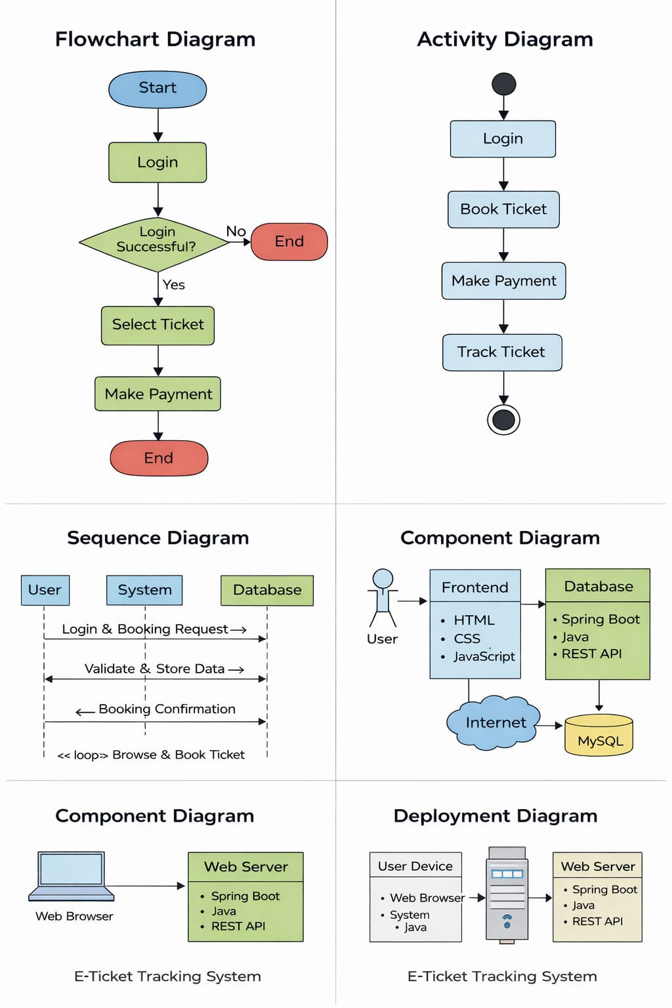
Software Requirements:
- HTML, CSS, JavaScript
- Backend (Java / Python / PHP)
- Database (MySQL)
- Web browser

Hardware Requirements:
- Computer or Laptop
- Minimum 4GB RAM
- Internet connection

2.7 SOFTWARE ENGINEERING PARADIGM APPLIED
The system follows the Waterfall Model.
Phases:
- Requirement Analysis
- System Design
- Implementation
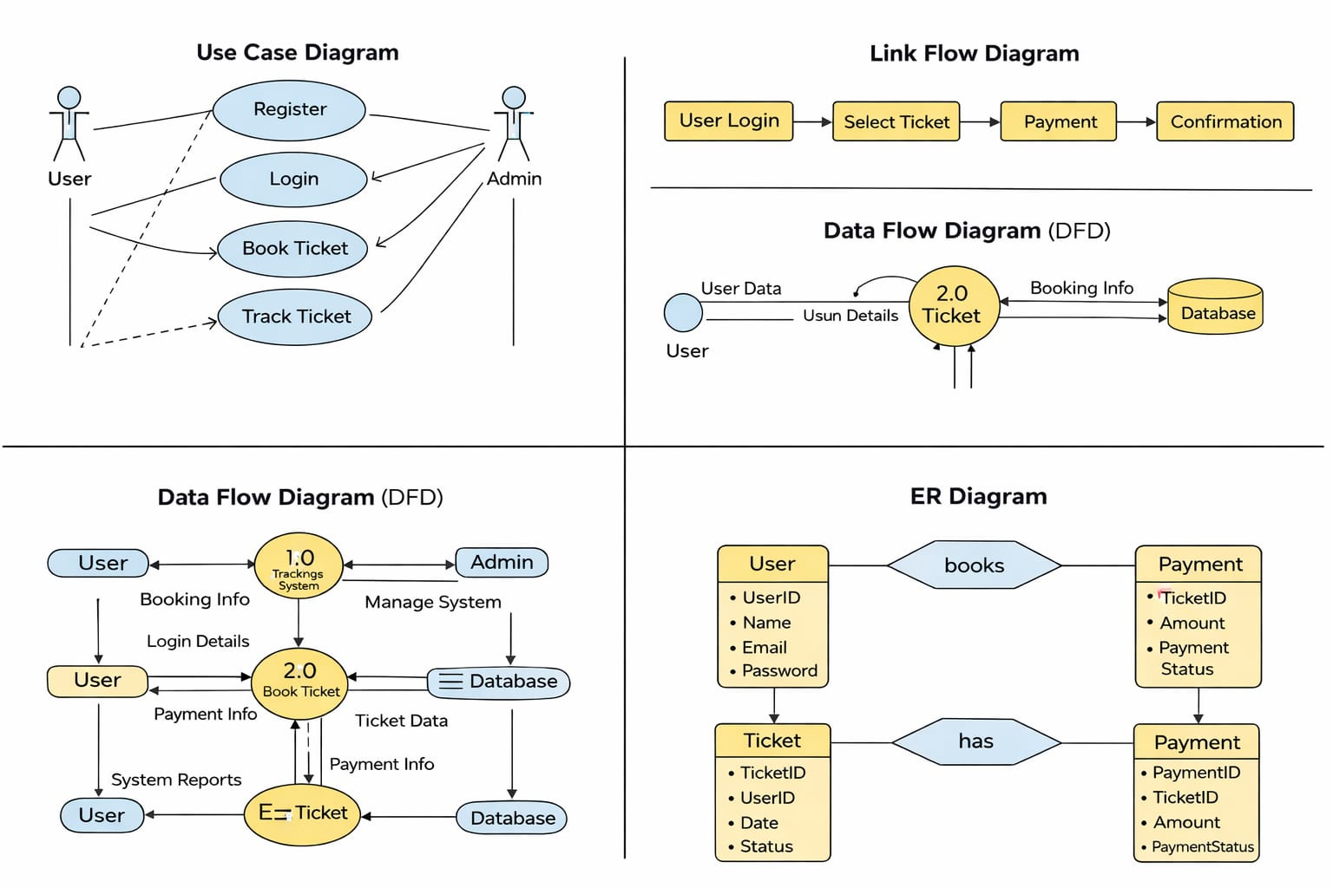
- Testing
- Deployment

2.8 USE CASE DIAGRAM
The Use Case Diagram represents the interaction between the users and the system. It shows how different types of users (actors) interact with the system to perform various operations. This diagram helps in understanding the functional requirements of the system clearly.
In the E-Ticket Tracking System, there are mainly two actors: User and Admin. The user performs operations such as registration, login, booking tickets, and tracking ticket status. The admin is responsible for managing users, monitoring bookings, and maintaining the system.

Main Use Cases:
- User Registration
- User Login
- Book Ticket
- Track Ticket
- Manage System (Admin)

Table: Use Case Description
Use Case | Actor | Description
Register | User | User creates a new account
Login | User/Admin | User enters credentials
Book Ticket | User | User books a ticket
Track Ticket | User | User checks ticket status
Manage System | Admin | Admin controls system

2.9 LINK FLOW DIAGRAM

The Link Flow Diagram shows the flow of activities in the system step by step. It represents how the user interacts with the system and how data flows from one step to another.
This diagram helps in understanding the sequence of operations involved in ticket booking and tracking.

Process Flow:
- User opens the system
- User logs into the system
- User selects ticket details
- User makes payment
- System confirms booking
- User tracks ticket

Table: Flow Steps
Step No. | Process | Description
1 | Login | User enters credentials
2 | Select Ticket | Choose ticket details
3 | Payment | Complete payment
4 | Confirmation | Ticket generated
5 | Tracking | Check ticket status

2.10 DATA MODEL
The Data Model defines how data is structured, stored, and related in the system. It shows the logical structure of the database and how different entities are connected.
The E-Ticket Tracking System uses a relational database model where data is stored in tables.

Main Entities:
- User
- Ticket
- Payment

Table: Data Model Structure
Entity | Attributes
User | UserID, Name, Email, Password
Ticket | TicketID, UserID, Date, Status
Payment | PaymentID, TicketID, Amount, Status

Explanation:
- Each user can book multiple tickets
- Each ticket has one payment
- Relationships are maintained using keys


2.11 DATA FLOW DIAGRAM (DFD)
Data Flow refers to the movement of data within the system from one process to another. It shows how data is collected from users, processed by the system, stored in the database, and finally returned as output. In the E-Ticket Tracking System, data flows through different stages such as input, processing, storage, and output.
The main purpose of data flow is to ensure that the right data reaches the right place at the right time. It helps in understanding how the system works internally and how different components interact with each other.
HOW DATA FLOWS IN THE SYSTEM:
The data flow in the E-Ticket Tracking System follows a structured process:
- User Input
The process starts when the user enters data such as login details, ticket information, and payment details.
- Data Processing
The system processes the input data using backend logic (Spring Boot). It validates user information and checks ticket availability.
- Data Storage
After processing, the data is stored in the database (MySQL). This includes user details, booking records, and payment information.
- Data Retrieval
When needed, the system retrieves data from the database to display ticket status or booking details.
- Output to User
The final result is shown to the user in the form of confirmation messages, ticket details, or tracking status.

2.12 DATA DICTIONARY
The Data Dictionary provides detailed information about the data used in the system. It defines each data element, its type, and its purpose.
This helps in maintaining consistency and clarity in database design.

Table: Data Dictionary
Field Name | Type | Description
UserID | INT | Unique user ID
Name | VARCHAR | User name
Email | VARCHAR | User email
Password | VARCHAR | User password
TicketID | INT | Unique ticket ID
Date | DATE | Booking date
Status | VARCHAR | Ticket status
PaymentID | INT | Payment ID
Amount | FLOAT | Payment amount


2.13 ER DIAGRAM
The Entity Relationship (ER) Diagram is a graphical representation of the database structure. It shows the entities, their attributes, and the relationships between them. The ER Diagram helps in understanding how data is organized and how different data elements are connected in the system.
In the E-Ticket Tracking System, the ER Diagram is used to design the database in a structured way. It ensures that data is stored efficiently and relationships between different entities are maintained properly.

COMPONENTS OF ER DIAGRAM
The ER Diagram consists of the following main components:
- Entity
An entity represents a real-world object or concept.
Example: User, Ticket, Payment
- Attribute
Attributes are the properties of an entity.
Example: Name, Email, TicketID
- Relationship
Relationship defines how entities are connected.
Example: User books Ticket

MAIN ENTITIES IN THE SYSTEM

1. User Entity
Represents the person who uses the system.
Attributes:
- UserID (Primary Key)
- Name
- Email
- Password

2. Ticket Entity:

Represents the ticket booked by the user.
Attributes:
- TicketID (Primary Key)
- UserID (Foreign Key)
- Date
- Status

3. Payment Entity:

Represents the payment details of the ticket.
Attributes:
- PaymentID (Primary Key)
- TicketID (Foreign Key)
- Amount
- Payment Status

RELATIONSHIPS IN ER DIAGRAM
- User → Ticket (1 : Many)
One user can book multiple tickets, but each ticket belongs to one user.
- Ticket → Payment (1 : 1)
Each ticket has one payment, and each payment is linked to one ticket.

3. SYSTEM DESIGN
System Design is the process of defining the architecture, components, modules, interfaces, and data for the system. It describes how the system will work and how different parts of the system interact with each other.

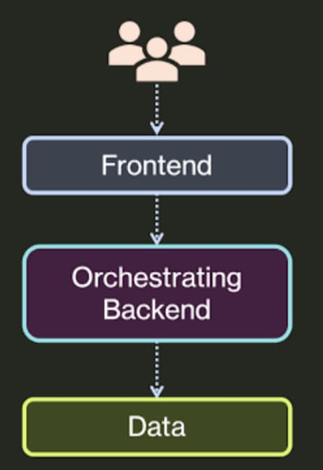
3.1 SYSTEM ARCHITECTURE
The E-Ticket Tracking System follows a Three-Tier Architecture, which divides the system into three layers:
- Presentation Layer (Frontend)
  - This is the user interface of the system
  - Users interact with the system through web pages
  - Technologies used: HTML, CSS, JavaScript
- Application Layer (Backend)
  - Handles logic and processing of user requests
  - Performs operations like booking, validation, and tracking
  - Technologies: Java / Python / PHP
- Data Layer (Database)
  - Stores all system data
  - Includes user details, ticket records, and payment data
  - Database used: MySQL

3.2 MODULARIZATION DETAILS
The system is divided into different modules for better organization.
- User Module
  - Registration and login
  - Profile management
- Booking Module
  - Ticket selection
  - Booking process
- Tracking Module
  - Check ticket status
  - View booking details
- Payment Module
  - Payment processing
  - Transaction handling
- Admin Module
  - Manage users
  - Manage tickets
  - Monitor system

3.3 DATABASE DESIGN
Database Design is the process of organizing data in a structured way so that it can be easily stored, managed, and retrieved. It plays a very important role in the E-Ticket Tracking System because all the information related to users, tickets, and payments is stored in the database.
A well-designed database ensures data accuracy, consistency, and security. It also improves system performance and reduces redundancy. In this project, a relational database (MySQL) is used to store and manage data efficiently.

OBJECTIVES OF DATABASE DESIGN
- To store data in an organized manner
- To ensure data accuracy and consistency
- To avoid duplication of data
- To provide fast data retrieval
- To maintain data security

TYPES OF DATABASE USED
The system uses a Relational Database Management System (RDBMS).
Features:
- Data stored in tables
- Tables are related using keys
- Easy to manage and update data

DATABASE TABLES
The E-Ticket Tracking System consists of three main tables:

1. USER TABLE
This table stores information about users.
Field Name | Type | Description
UserID | INT (PK) | Unique ID of user
Name | VARCHAR | Name of user
Email | VARCHAR | Email address
Password | VARCHAR | User password

2. TICKET TABLE
This table stores ticket booking details.
Field Name | Type | Description
TicketID | INT (PK) | Unique ticket ID
UserID | INT (FK) | Links to User table
Date | DATE | Booking date
Status | VARCHAR | Ticket status

3. PAYMENT TABLE
This table stores payment details.
Field Name | Type | Description
PaymentID | INT (PK) | Unique payment ID
TicketID | INT (FK) | Links to Ticket table
Amount | FLOAT | Payment amount
Status | VARCHAR | Payment status

RELATIONSHIP BETWEEN TABLES
The tables are connected using relationships:
- One User can book multiple Tickets (1:N relationship)
- One Ticket has one Payment (1:1 relationship)
These relationships are maintained using Primary Keys and Foreign Keys.

3.6 USER INTERFACE DESIGN
User Interface (UI) Design is one of the most important aspects of the E-Ticket Tracking System. It defines how users interact with the system and how information is presented on the screen. A well-designed user interface ensures that the system is easy to use, visually appealing, and efficient in performing tasks.
In this project, the user interface is designed using modern web technologies such as HTML, CSS, and JavaScript. The main goal of UI design is to provide a smooth and user-friendly experience so that users can easily navigate through the system without confusion. The design focuses on simplicity, clarity, consistency, and responsiveness.

OBJECTIVES OF USER INTERFACE DESIGN
The main objectives of designing the user interface are:
- To provide an easy and simple interaction between user and system
- To ensure smooth navigation between different pages
- To reduce user errors by providing clear instructions
- To enhance user satisfaction and experience
Main Screens:
- Home Page
- Login Page
- Booking Page
- Tracking Page

3.4 SCREENSHOTS
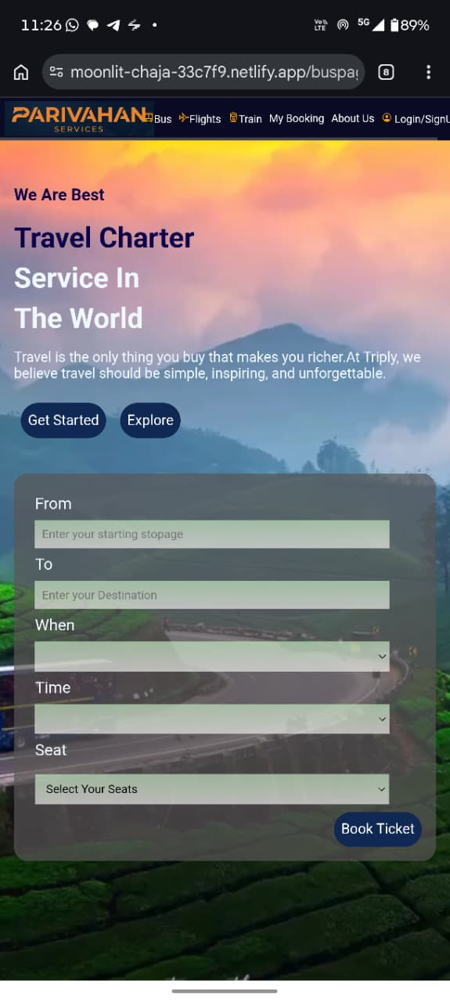 | 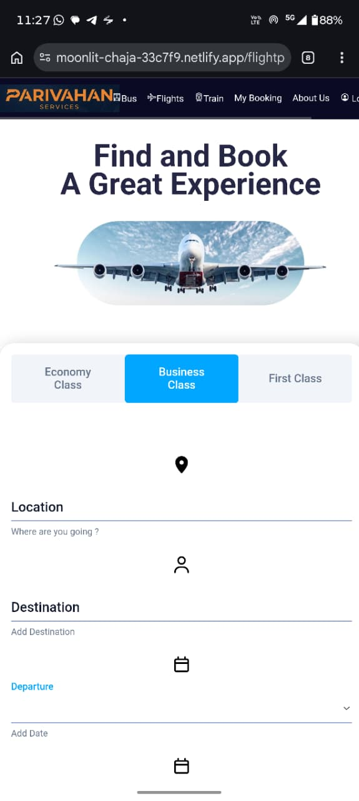 | 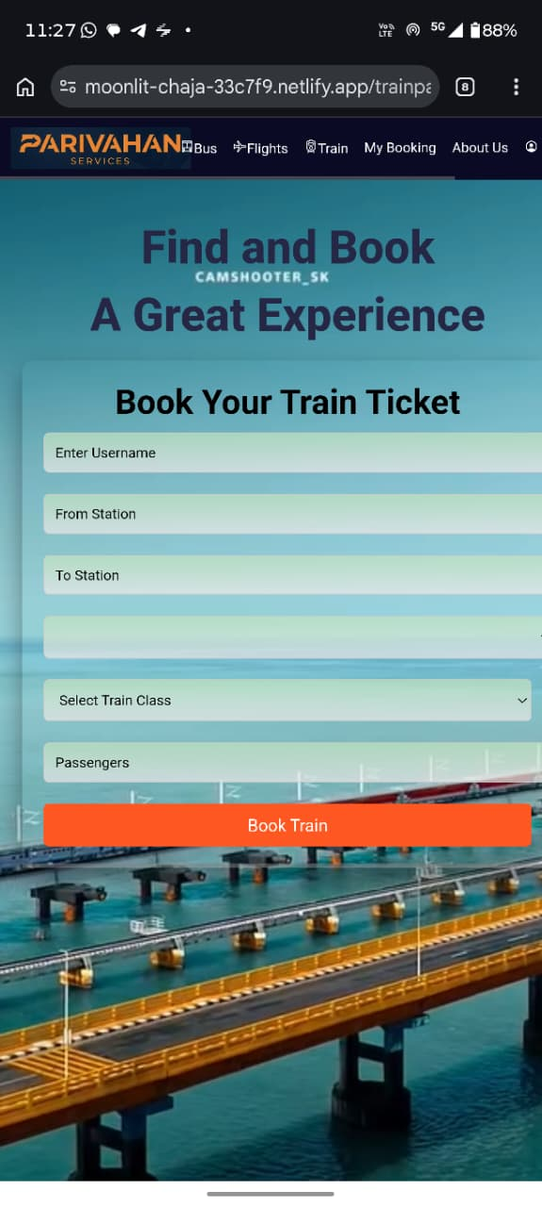
User Interface /  Bus Booking | Flight Booking | Train Booking
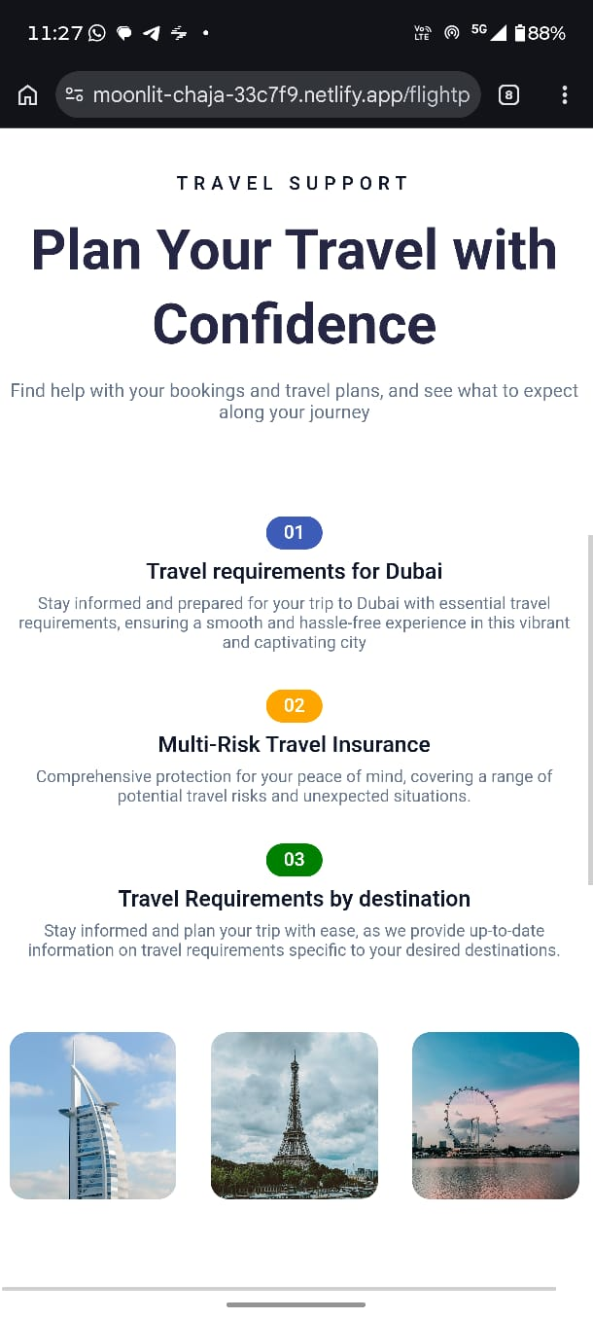 | 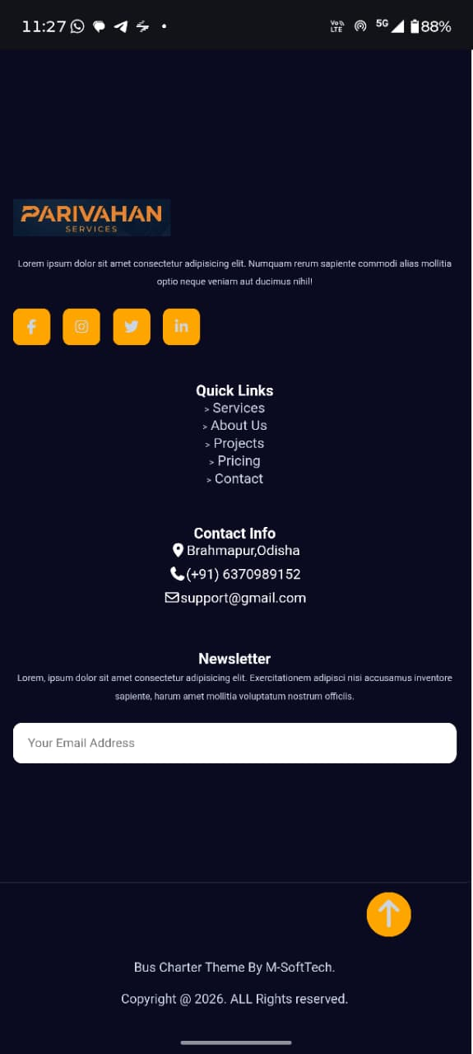
About Us
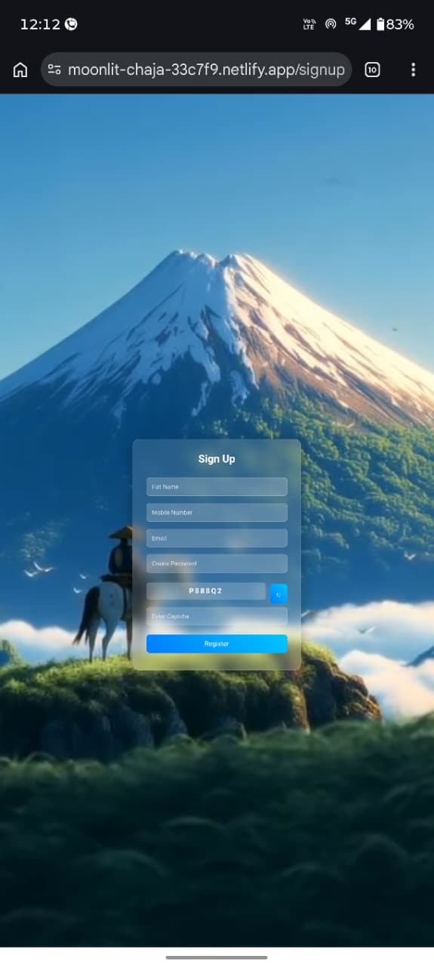
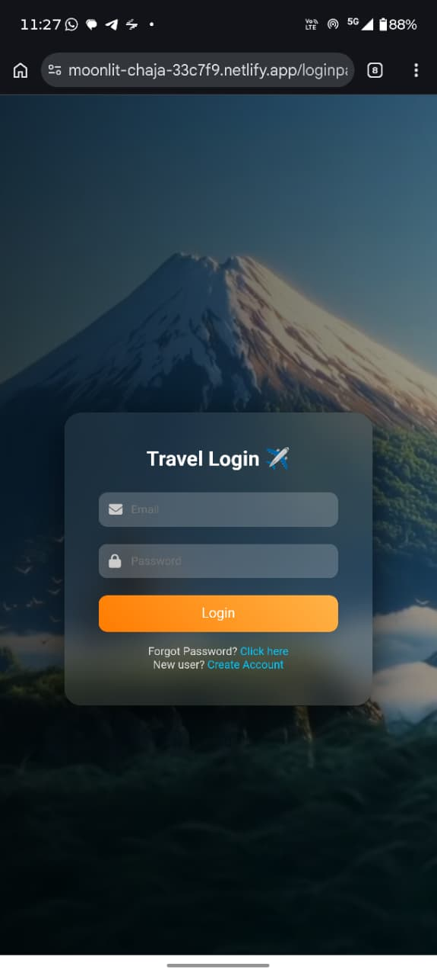
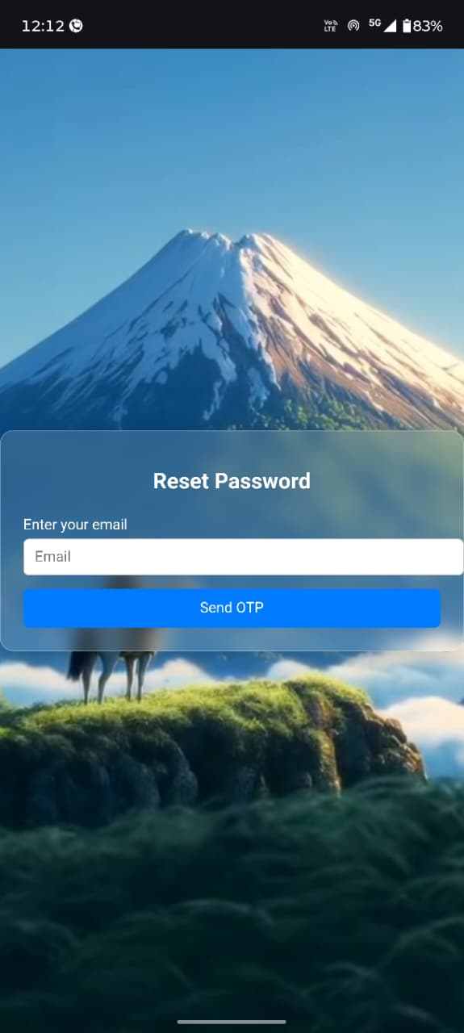
Login Page | SignUp Page | Reset Password
4. Code Implémentation:
4.1. Front end
- Admin Panel:
Index.html
<!DOCTYPE html>
<html>
<head>
<title>Admin Dashboard</title>
<link rel="stylesheet" href="style.css">
</head>
<body>

<div class="sidebar">
<h2>Admin Panel</h2>
<ul>
<li onclick="loadTickets()">All Tickets</li>
<li onclick="loadStats()">Dashboard</li>
</ul>
</div>

<div class="main">

<h1>Dashboard</h1>

<!-- Stats -->
<div class="cards">
<div class="card">
<h3>Total Tickets</h3>
<p id="totalTickets">0</p>
</div>

<div class="card">
<h3>Total Revenue</h3>
<p id="totalRevenue">0</p>
</div>

<div class="card">
<h3>Total Users</h3>
<p id="totalUsers">0</p>
</div>
</div>

<!-- Filter -->
<div class="filter">
<select id="typeFilter" onchange="filterTickets()">
<option value="ALL">All</option>
<option value="BUS">Bus</option>
<option value="TRAIN">Train</option>
<option value="FLIGHT">Flight</option>
</select>
</div>

<!-- Table -->
<table>
<thead>
<tr>
<th>ID</th>
<th>User</th>
<th>Type</th>
<th>Price</th>
<th>Status</th>
</tr>
</thead>
<tbody id="ticketTable"></tbody>
</table>
</div>

<script src="script.js"></script>
<script src="/BusPage/navscript.js"></script>
</body>
</html>
Style.css:
body { margin:0; font-family: Arial; display:flex; }
.sidebar { width:200px; background:#2c3e50; color:white; height:100vh; padding:20px; }
.sidebar ul { list-style:none; padding:0; }
.sidebar li { padding:10px; cursor:pointer; }
.sidebar li:hover { background:#34495e; }
.main { flex:1; padding:20px; }
.cards { display:flex; gap:20px; margin-bottom:20px; }
.card { background:#3498db; color:white; padding:20px; border-radius:8px; width:150px; text-align:center; }
table { width:100%; border-collapse:collapse; margin-top:20px; }
th, td { border:1px solid #ddd; padding:10px; text-align:center; }
.filter { margin-top:20px; }

Script.js:
document.addEventListener("DOMContentLoaded", function() {
const adminLink = document.getElementById("adminLink");
const userId = localStorage.getItem("userId");
const role = localStorage.getItem("role");

// Role-based navbar
if (role === "ADMIN") {
adminLink.style.display = "inline-block";
} else {
adminLink.style.display = "none";
// If a non-admin tries to open admin page
if (window.location.pathname.includes("/Adminpanel/")) {
alert("🚫 Access denied! Admins only.");
window.location.href = "/Frontend/loginpage/login.html";
}
}

// Default view on page load
showSection('dashboard'); // show dashboard first
});

// Global tickets array
let allTickets = [];

// Toggle sections
function showSection(section) {
const dashboard = document.getElementById("dashboardSection");
const tickets = document.getElementById("ticketsSection");

if (section === "dashboard") {
dashboard.style.display = "block";
tickets.style.display = "none";
loadStats(); // load dashboard stats
} else if (section === "tickets") {
dashboard.style.display = "none";
tickets.style.display = "block";
loadTickets(); // load ticket table
}
}

// Load all tickets for table (admin only)
function loadTickets() {
fetch("http://localhost:8080/tickets/admin")
.then(res => res.json())
.then(data => {
allTickets = data;
displayTickets(data);
});
}

// Display tickets in table
function displayTickets(tickets) {
const table = document.getElementById("ticketTable");
table.innerHTML = "";
tickets.forEach(t => {
const row = `
<tr>
<td>${t.id}</td>
<td>${t.userName || t.user?.name || "User"}</td>
<td>${t.type}</td>
<td>${t.price}</td>
<td>${t.status}</td>
</tr>
`;
table.innerHTML += row;
});
}
// Filter tickets by type
function filterTickets() {
const selectedType = document.getElementById("typeFilter").value;
let filteredTickets = allTickets;

if (selectedType !== "ALL") {
filteredTickets = allTickets.filter(t => t.type.toUpperCase() === selectedType);
}

displayTickets(filteredTickets);
updateStats(filteredTickets);
}

// Update stats for given tickets array
function updateStats(tickets) {
document.getElementById("totalTickets").innerText = tickets.length;

const revenue = tickets
.filter(t => t.status !== "CANCELLED")
.reduce((sum, t) => sum + t.price, 0);

document.getElementById("totalRevenue").innerText = revenue;

// Total Users = unique users in filtered tickets
const userIds = [...new Set(tickets.map(t => t.userId))];
document.getElementById("totalUsers").innerText = userIds.length;
}

// Load dashboard stats
function loadStats() {
fetch("http://localhost:8080/tickets/admin")
.then(res => res.json())
.then(tickets => {
const totalTickets = tickets.length;
const revenue = tickets
.filter(t => t.status !== "CANCELLED")
.reduce((sum, t) => sum + t.price, 0);

document.getElementById("totalTickets").innerText = totalTickets;
document.getElementById("totalRevenue").innerText = revenue;
});

fetch("http://localhost:8080/users")
.then(res => res.json())
.then(users => {
document.getElementById("totalUsers").innerText = users.length;
});
}
document.addEventListener("DOMContentLoaded", function() {
const adminLink = document.getElementById("adminLink");
const role = localStorage.getItem("role"); // must be set on login

// Show admin link only for ADMIN role
if (role === "ADMIN") {
adminLink.style.display = "inline-block";
} else {
adminLink.style.display = "none";
}
});
Bus Page:
<!DOCTYPE html>
<html lang="en">

<head>
<meta charset="UTF-8">
<meta name="viewport" content="width=device-width, initial-scale=1.0">
<title>Parivahan</title>
<script type="module" src="https://unpkg.com/ionicons@7.1.0/dist/ionicons/ionicons.esm.js"></script>
<script nomodule src="https://unpkg.com/ionicons@7.1.0/dist/ionicons/ionicons.js"></script>
<link rel="stylesheet" href="https://cdnjs.cloudflare.com/ajax/libs/font-awesome/7.0.1/css/all.min.css">
<link rel="stylesheet" href="mainstyle.css">

</head>

<body>
<header id="site-header">
<video autoplay muted loop id="bg-video">
<source src="background-video.mp4" type="video/mp4">
</video>
<nav>
<div class="navbar">
<div class="nav-logo">
<div class="logo"></div>
</div>
<div class="nav-items">
<a href="#"><ion-icon name="bus-outline"></ion-icon>Bus</a>
<a href="/FlightPage/index.html"><ion-icon name="airplane-outline"></ion-icon>Flights</a>
<a href="/TrainPage/index.html"><ion-icon name="train-outline"></ion-icon>Train</a>
<a href="/DashbordUi/index.html">My Booking</a>
<a href="#">About Us</a>
<a href="/AdminPanel/index.html" id="adminLink">Admin Panel</a>
<a href="/loginpage/login.html" id="userNav">
<ion-icon name="person-circle-outline"></ion-icon>
<span id="navText">Login/SignUp</span>
</a>
</div>
<button id="topbtn">Contact Us</button>
</div>
</nav>
<div class="container">
<div class="left-cont">
<h3>We Are Best</h3>
<h1 id="hed">Travel Charter</h1>
<h1>Service In </h1>
<h1>The World</h1>
<p>Travel is the only thing you buy that makes you richer.At Triply, we believe travel should be
simple,
inspiring, and unforgettable.</p>
<button>Get Started</button>
<button class="fun"><a href="#serv">Explore</a></button>
</div>
<div class="right-cont">
<form action="" id="busBookingForm" class="booking-from">
<label for="from">From</label>
<input type="text" id="from" placeholder="Enter your starting stopage">
<label for="to">To</label>
<input type="text" id="to" placeholder="Enter your Destination">
<label for="date">When</label>
<input type="date" id="date">
<label for="time">Time</label>
<input type="time" id="time">
<label for="seat">Seat</label>
<select name="seat" id="seat" required>
<option value="0">Select Your Seats</option>
<!-- Generate options from 1 to 45 -->
<script>
for(let i=1; i<=45; i++){
document.write(`<option value="${i}">${i}</option>`);
}
</script>
</select>
<button type="button" id="bookTicketBtn">Book Ticket</button>
</form>
</div>
</div>
</header>
<main>
<section class="hero-section">
<div class="hero-left">
<p>About Shuttle</p>
<h1>More Than 25 Years We Provide </h1>
<h1 id="buschar">Bus Charater </h1>
<h1>Service For You</h1>
<p id="des">This is very trusted bus service agency.Which started from last 25 years, it's very popular
in this area.
You can chose this bus for you'r safe journey.
</p>
<div class="features">
<ul>
<li><ion-icon name="checkmark-circle-outline"></ion-icon>Brilient Client Service</li>
<li><ion-icon name="checkmark-circle-outline"></ion-icon>24/7 Support</li>
<li><ion-icon name="checkmark-circle-outline"></ion-icon>Free Consultations</li>
</ul>
<ul>
<li><ion-icon name="checkmark-circle-outline"></ion-icon>User Experience</li>
<li><ion-icon name="checkmark-circle-outline"></ion-icon>Big Data & Analytics</li>
<li><ion-icon name="checkmark-circle-outline"></ion-icon>Quick Tips and Advice</li>
</ul>
</div>
<button class="fun"><a href="#fid">More About Us</a></button>
</div>
<div class="hero-right">
<div class="main-img">
<img src="mainn.jpeg" alt="airway">
</div>
<div class="card">
<img src="main.jpeg" alt="child image">
</div>
<div class="exp">
<h1>25+</h1>
<h1>Years Experience</h1>
</div>
</div>
</section>
<section class="bestsection">
<div class="left-about">
<div class="imge">
<img src="expimg.jpeg" alt="">
</div>
<div class="para">
<h1>We Provide Best Bus For You</h1>
<p>You can get more about us by this page. This is best bus service ever.</p>
</div>
</div>
<div class="right-about">
<p id="wcu">Why Choose Us</p>
<h1>We Are Experts In Bus Character Service Company.</h1>
<p>Odisha Bus Service provides complete timetable information for all 30 districts of Odisha. You can
get every detail like bus Routes, Arrival and Departure timings, Bus inquiries, New bus routes, Bus
tracking, Ticket Booking, Number of
buses </p>
<div class="about">
<ul>
<li><ion-icon name="bus-outline"></ion-icon>25+
<p>Busses Ready</p>
</li>
<li><ion-icon name="ribbon-outline"></ion-icon>
2,836+
<p>Booking Done</p>
</li>
</ul>
<ul>
<li>
<ion-icon name="repeat-outline"></ion-icon>
2,640+
<p>Satisfied Customers</p>
</li>
<li>
<ion-icon name="people-sharp"></ion-icon>
75+
<p>Professional Team</p>
</li>
</ul>
</div>
</div>
</section>
<section class="service" id="serv">
<div class="info">
<p id="serv">Our Services</p>
<h1>We Provide Best Service For You</h1>
<p>It is the India’s largest online bus booking platform serving thousands of customers across all the districts of Odisha.</p>
</div>
<div class="service-div">
<div class="safty">
<ion-icon name="shield-checkmark-outline"></ion-icon>
<h3>Safety Guarantee</h3>
<p>This bus will take you to you'r place safely.
It will our responsible to take you to you'r destination safely.
</p>
</div>
<div class="disc">
<ion-icon name="card-outline" id="discount"></ion-icon>
<h3>Discount & Promo</h3>
<p>You can also apply discount card to get offers.
It will provide best discount for travalling.
</p>
</div>
<div class="staff">
<ion-icon name="person-outline"></ion-icon>
<h3>Professional Staff</h3>
<p>We provide best staff and well trained driver to drive.
Each staff have many year of experience.
</p>
</div>
<div class="schedule">
<ion-icon name="alarm-outline"></ion-icon>
<h3>Schedule On Time</h3>
<p>We reach our stopage on the Scheduled time.
We value you'r Time.
</p>
</div>
<div class="book">
<ion-icon name="id-card-outline"></ion-icon>
<h3>Online Booking</h3>
<p>YOu can book you'r ticket online from your home.
It's a best feature we provide for first time.
</p>
</div>
<div class="support">
<ion-icon name="headset-outline"></ion-icon>
<h3>23/7Support</h3>
<p>We provide 24/7 support.
If any soubt occour in your mind than you will contact us by
this number <b>7854999268</b>
</p>
</div>
</div>
</section>
<section class="collection">
<div class="col-div">
<div class="desc">
<p>Our Bus</p>
<h1>Our Bus Collection</h1>
</div>
<div class="note">
<p>We have total 45 bus which include 28 volvo and 17 push back seater bus.
which are in their best condition.These all are brand new and confortable for long journey.
</p>
</div>
<div class="btn">
<button>All Vehicle</button>
</div>
<div class="bus1">
<img src="bus1.jpeg" alt="">
<div class="detl">
<h3>Hi-Tech Buses</h3>
<h3>$250<small>/day</small></h3>
<p><ion-icon name="person-outline"></ion-icon>45 seat</p>
<p><ion-icon name="people-outline"></ion-icon>2 Driver staff</p>
<p><ion-icon name="apps-outline"></ion-icon>Manual</p>
<p><ion-icon name="shield-checkmark-outline"></ion-icon>Fully insured</p>
<button class="butn">Book Now</button>
</div>
</div>
<div class="bus1">
<img src="bus2.jpeg" alt="">
<div class="detl">
<h3>Vikrant</h3>
<h3>$180<small>/day</small></h3>
<p><ion-icon name="person-outline"></ion-icon>45 seat</p>
<p><ion-icon name="people-outline"></ion-icon>2 Driver staff</p>
<p><ion-icon name="apps-outline"></ion-icon>Manual</p>
<p><ion-icon name="shield-checkmark-outline"></ion-icon>Fully insured</p>
<button class="butn">Book Now</button>
</div>
</div>
<div class="bus1">
<img src="bus3.jpeg" alt="">
<div class="detl">
<h3>Volvo Buses</h3>
<h3>$320<small>/day</small></h3>
<p><ion-icon name="person-outline"></ion-icon>45 seat</p>
<p><ion-icon name="people-outline"></ion-icon>2 Driver staff</p>
<p><ion-icon name="apps-outline"></ion-icon>Manual</p>
<p><ion-icon name="shield-checkmark-outline"></ion-icon>Fully insured</p>
<button class="butn">Book Now</button>
</div>
</div>
</div>
</section>
<section class="feedback" id="fid">
<div class="setp1">
<p>Our Testimonial</p>
<h1>What Our Clients Say</h1>
<p>Let's know the feedback from our clients who completed their journey in
safely .
</p>
</div>
<div class="feedback-div">
<div class="ctm1">
<p>The customer service was very prompt, and the representative, Rudra, was particularly polite and addressed all my queries regarding the cancellation of tickets. As he mentioned, I will receive the refund within 7 working days.
</p>
<p><ion-icon name="star"></ion-icon>
<ion-icon name="star"></ion-icon>
<ion-icon name="star"></ion-icon>
<ion-icon name="star"></ion-icon></p>
<div class="imgesec">
<img src="cus1.jpeg" alt="cust1" id="cus">
<h1>Rahul Kumar</h1>
<p>Marketing Staff</p>
</div>
</div>
<div class="ctm1">
<p>Felt very good, just booked the ticket from the app and the osrtc conductor gave very good suggestions but due to the absence of bus number in the ticket, I had to inquire a little, if the bus number was there in the ticket, it would have been very good and easy. Thank you for the app.
</p>
<p><ion-icon name="star"></ion-icon>
<ion-icon name="star"></ion-icon>
<ion-icon name="star"></ion-icon>
<ion-icon name="star"></ion-icon></p>
<div class="imgesec">
<img src="cus2.jpeg" alt="cust2" id="cus">
<h1>Rajesh Gupta</h1>
<p>Marketing Staff</p>
</div>
</div>
<div class="ctm1">
<p>It was a great trip from Berhampur to Jajpur, genuinely the conductor was too good. He cares a lot for the passengers, very active in every work that is responsible for him and yes but not the list. The Driver also drove theBus so well he used to carry each and every speed so well. Yes it was a very much great journey.❤️❤️❤️❤️❤️
</p>
<p><ion-icon name="star"></ion-icon>
<ion-icon name="star"></ion-icon>
<ion-icon name="star"></ion-icon>
<ion-icon name="star"></ion-icon></p>
<div class="imgesec">
<img src="cus3.jpeg" alt="cust3" id="cus">
<h1>Anjali Das</h1>
<p>Marketing Staff</p>
</div>
</div>
</div>
</section>
</main>
<footer class="site-footer">
<div class="container footer-grid">
<div class="footer-col">
<div class="brand">
<div class="logo">S</div><h3>Shuttle</h3>
</div>
<br>
<p>Lorem ipsum dolor sit amet consectetur adipisicing elit. Numquam rerum sapiente commodi alias mollitia optio neque veniam aut ducimus nihil!</p>
<div class="socials">
<a href="#"><i class="fa-brands fa-facebook-f"></i></a>
<a href="#"><i class="fa-brands fa-instagram"></i></a>
<a href="#"><i class="fa-brands fa-twitter"></i></a>
<a href="#"><i class="fa-brands fa-linkedin-in"></i></a>
</div>
</div>
<div class="footer-col">
<h4>Quick Links</h4>
<ul>
<li><a href="#"><p>></p> Services</a></li>
<li><a href="#"><p>></p> About Us</a></li>
<li><a href="#"><p>></p> Projects</a></li>
<li><a href="#"><p>></p> Pricing</a></li>
<li><a href="#"><p>></p> Contact</a></li>
</ul>
</div>
<div class="footer-col">
<h4>Contact Info</h4>
<ul class="contact-info">
<li>
<i class="fa-solid fa-location-dot"></i>Brahmapur,Odisha
</li>
<li>
<i class="fa-solid fa-phone"></i>(+91) 6370989152
</li>
<li>
<i class="fa-regular fa-envelope"></i>support@gmail.com
</li>
</ul>
</div>
<div class="footer-col">
<h4>Newsletter</h4>
<p>Lorem, ipsum dolor sit amet consectetur adipisicing elit. Exercitationem adipisci nisi accusamus inventore sapiente, harum amet mollitia voluptatum nostrum officiis.</p>
<div class="newsletter">
<input type="email" placeholder="Your Email Address">
<button><i class="fa-regular fa-envelope"></i></button>
</div>
</div>
</div>
<div class="footer-bottom">
<div class="container bottom-flex">
<p>Bus Charter Theme By M-SoftTech.</p>
<p>Copyright @ 2026. ALL Rights reserved.</p>
</div>
<div class="scroll-top">
<a href="#top">
<i class="fa-solid fa-arrow-up"></i>
</a>
</div>
</div>
</footer>
<script src="script.js"></script>
<script src="navscript.js"></script>
<script src="/AdminPanel/script.js"></script>
<!-- <script src="booking.js"></script> -->
</body>

</html>

4.2. Backend:
- Controller:
invoiceController.java:
package com.ticket.backend.controller;

import org.springframework.beans.factory.annotation.Autowired;
import org.springframework.web.bind.annotation.*;

import com.ticket.backend.model.Invoice;
import com.ticket.backend.service.InvoiceService;

import java.util.List;

@RestController
@RequestMapping("/invoices")
@CrossOrigin
public class InvoiceController {

@Autowired
private InvoiceService invoiceService;

@PostMapping
public Invoice saveInvoice(@RequestBody Invoice invoice) {
return invoiceService.saveInvoice(invoice);
}

@GetMapping
public List<Invoice> getAllInvoices() {
return invoiceService.getAllInvoices();
}
}

TicketController.java:
package com.ticket.backend.controller;

import com.ticket.backend.model.Ticket;
import com.ticket.backend.service.TicketService;
import org.springframework.beans.factory.annotation.Autowired;
import org.springframework.web.bind.annotation.*;

import java.util.List;

@RestController
@RequestMapping("/tickets")
@CrossOrigin(origins = "*")
public class TicketController {

@Autowired
private TicketService ticketService;

// CREATE
@PostMapping
public Ticket createTicket(@RequestParam Long userId, @RequestBody Ticket ticket) {
if (ticket.getType() == null || ticket.getType().isEmpty()) {
ticket.setType("Unknown");
}
return ticketService.createTicket(userId, ticket);
}
@GetMapping(path = "")
public List<Ticket> getAllTickets() {
return ticketService.getAllTickets();
}

// GET ALL USER TICKETS
@GetMapping("/user/{userId}")
public List<Ticket> getUserTickets(@PathVariable Long userId) {
return ticketService.getUserTickets(userId);
}

// GET BY ID (PDF FIX)
@GetMapping("/{id}")
public Ticket getTicketById(@PathVariable Long id) {
return ticketService.getTicketById(id);
}

@GetMapping("/admin")
public List<com.ticket.backend.dto.TicketDTO> getAllTicketsForAdmin() {
return ticketService.getAllTicketsDTO();
}
// UPDATE
@PutMapping("/{id}")
public Ticket updateTicket(@PathVariable Long id, @RequestBody Ticket ticket) {
if (ticket.getType() == null || ticket.getType().isEmpty()) {
ticket.setType("Unknown");
}
return ticketService.updateTicket(id, ticket);
}

// UPDATE STATUS
@PutMapping("/{id}/status")
public Ticket updateStatus(@PathVariable Long id, @RequestParam String status) {
return ticketService.updateStatus(id, status);
}

// DELETE
@DeleteMapping("/{id}")
public void deleteTicket(@PathVariable Long id) {
ticketService.deleteTicket(id);
}
}
UserController.java:
package com.ticket.backend.controller;

import com.ticket.backend.model.Otp;
import com.ticket.backend.model.User;
import com.ticket.backend.repository.UserRepository;
import com.ticket.backend.repository.OtpRepository;
import com.ticket.backend.service.OtpService;
import org.springframework.beans.factory.annotation.Autowired;
import org.springframework.http.HttpStatus;
import org.springframework.http.ResponseEntity;
import org.springframework.web.bind.annotation.*;
import java.util.Optional;

import java.time.LocalDateTime;
import java.util.Map;

@RestController
@RequestMapping("/users")
@CrossOrigin
public class UserController {

@Autowired
private UserRepository userRepository;

@Autowired
private OtpService otpService;

@Autowired
private OtpRepository otpRepository;

// Login endpoint

@PostMapping("/login")
public ResponseEntity<?> login(@RequestBody User loginUser) {
User dbUser = userRepository.findByEmail(loginUser.getEmail())
.orElseThrow(() -> new RuntimeException("User not found ❌"));

if (!dbUser.getPassword().equals(loginUser.getPassword())) {
return ResponseEntity.status(HttpStatus.UNAUTHORIZED)
.body("Invalid Credentials ❌");
}

dbUser.setPassword(null); // hide password
return ResponseEntity.ok(dbUser);
}
// Get all users

@GetMapping
public ResponseEntity<?> getAllUsers() {
var users = userRepository.findAll();
users.forEach(u -> u.setPassword(null)); // hide passwords
return ResponseEntity.ok(users);
}

// Get user by ID

@GetMapping("/{id}")
public ResponseEntity<?> getUserById(@PathVariable Long id) {
User user = userRepository.findById(id)
.orElseThrow(() -> new RuntimeException("User not found ❌"));
user.setPassword(null); // hide password
return ResponseEntity.ok(user);
}

//Create user
@PostMapping
public ResponseEntity<?> createUser(@RequestBody User user) {
User newUser = userRepository.save(user);
newUser.setPassword(null); // hide password
return ResponseEntity.status(HttpStatus.CREATED).body(newUser);
}
// Send OTP via email
@PostMapping("/send-otp")
public ResponseEntity<String> sendOtp(@RequestParam String email) {
try {
userRepository.findByEmail(email)
.orElseThrow(() -> new RuntimeException("User not found ❌"));

otpService.sendOtp(email); // Send OTP using OtpService

System.out.println("OTP sent to: " + email);
return ResponseEntity.ok("OTP sent successfully ✅");
} catch (Exception e) {
e.printStackTrace();
return ResponseEntity.status(HttpStatus.INTERNAL_SERVER_ERROR)
.body("Failed to send OTP: " + e.getMessage());
}
}

// Verify OTP and reset password
// Verify OTP without changing password
@PostMapping("/verify-otp")
public ResponseEntity<String> verifyOtp(@RequestParam String email,
@RequestParam String code) {
if (otpService.verifyOtp(email, code)) {
return ResponseEntity.ok("OTP verified ✅");
} else {
return ResponseEntity.status(HttpStatus.BAD_REQUEST)
.body("Invalid or expired OTP ❌");
}
}

// Reset Password using verified OTP
@PutMapping("/reset-password")
public ResponseEntity<String> resetPassword(@RequestBody Map<String, String> payload) {
String email = payload.get("email");
String otpCode = payload.get("otp");
String newPassword = payload.get("newPassword");

Optional<Otp> otpOpt = otpRepository.findByEmailAndCode(email, otpCode);
if (otpOpt.isEmpty() || otpOpt.get().getExpiryTime().isBefore(LocalDateTime.now())) {
return ResponseEntity.status(HttpStatus.BAD_REQUEST)
.body("Invalid or expired OTP ❌");
}

User user = userRepository.findByEmail(email)
.orElseThrow(() -> new RuntimeException("User not found ❌"));
user.setPassword(newPassword); // ideally encrypt
userRepository.save(user);

// OTP delete after successful reset
otpRepository.delete(otpOpt.get());

return ResponseEntity.ok("Password reset successful ✅");
}
}
- Model:
Invoice.java:
package com.ticket.backend.model;

import jakarta.persistence.*;

@Entity
@Table(name = "invoices")
public class Invoice {

@Id
@GeneratedValue(strategy = GenerationType.IDENTITY)
private Long id;

private String invoiceNumber;
private Double amount;

// getters & setters
public Long getId() { return id; }

public String getInvoiceNumber() { return invoiceNumber; }
public void setInvoiceNumber(String invoiceNumber) { this.invoiceNumber = invoiceNumber; }

public Double getAmount() { return amount; }
public void setAmount(Double amount) { this.amount = amount; }
}
TicketStatus.java:
package com.ticket.backend.model;

import com.fasterxml.jackson.annotation.JsonIgnoreProperties;
import jakarta.persistence.*;

@Entity
@Table(name = "tickets")
public class Ticket {

@Id
@GeneratedValue(strategy = GenerationType.IDENTITY)
private Long id;

private String source;
private String destination;
private String date;
private Double price;

@Enumerated(EnumType.STRING)
private TicketStatus status = TicketStatus.OPEN;

@ManyToOne
@JoinColumn(name = "user_id")
@JsonIgnoreProperties({"tickets"})
private User user;

@Column(name = "ticket_type")
private String type;

// ===== GETTERS & SETTERS =====

public Long getId() { return id; }

public String getSource() { return source; }
public void setSource(String source) { this.source = source; }

public String getDestination() { return destination; }
public void setDestination(String destination) { this.destination = destination; }

public String getDate() { return date; }
public void setDate(String date) { this.date = date; }

public Double getPrice() { return price; }
public void setPrice(Double price) { this.price = price; }

public TicketStatus getStatus() { return status; }
public void setStatus(TicketStatus status) { this.status = status; }

public User getUser() { return user; }
public void setUser(User user) { this.user = user; }

public String getType() { return type; }
public void setType(String type) { this.type = type; }
}
Otp.java:
package com.ticket.backend.model;

import jakarta.persistence.*;
import java.time.LocalDateTime;

@Entity
public class Otp {

@Id
@GeneratedValue(strategy = GenerationType.IDENTITY)
private Long id;

private String email;
private String code;
private LocalDateTime expiryTime;

// Getters & Setters
public Long getId() { return id; }
public void setId(Long id) { this.id = id; }

public String getEmail() { return email; }
public void setEmail(String email) { this.email = email; }

public String getCode() { return code; }
public void setCode(String code) { this.code = code; }

public LocalDateTime getExpiryTime() { return expiryTime; }
public void setExpiryTime(LocalDateTime expiryTime) { this.expiryTime = expiryTime; }
}
- Repository:
TicketRepository.java:
package com.ticket.backend.repository;

import com.ticket.backend.model.Ticket;
import org.springframework.data.jpa.repository.JpaRepository;
import org.springframework.data.jpa.repository.Query;
import org.springframework.data.repository.query.Param;
import java.util.List;

public interface TicketRepository extends JpaRepository<Ticket, Long> {

// GET ALL TICKETS FOR A USER

@Query("SELECT t FROM Ticket t WHERE t.user.id = :userId")
List<Ticket> findByUserId(@Param("userId") Long userId);
}
5. Testing:
System Testing is one of the most important phases in the development of the E-Ticket Tracking System. It ensures that the system is working correctly, efficiently, and according to the requirements. Testing is performed to identify errors, bugs, and issues before the system is delivered to users.
The main purpose of testing is to verify that all modules such as registration, login, booking, payment, and tracking are functioning properly. It also ensures that the system provides accurate results and handles user data securely. Testing improves system reliability, performance, and user satisfaction.
In this project, different types of testing are performed at various stages of development to ensure smooth functioning of the system.

OBJECTIVES OF TESTING
The main objectives of system testing are:
- To ensure that the system works without errors
- To verify all functionalities of the system
- To check accuracy of input and output
- To detect and fix bugs
- To improve system performance
- To ensure security of user data
- To provide a reliable system to users

TESTING STRATEGY
Testing is carried out in a systematic manner. The strategy includes testing each module individually and then testing the entire system.

Steps in Testing Strategy:
- Requirement analysis
- Test planning
- Test case design
- Test execution
- Result analysis
- Bug fixing
- Re-testing

TYPES OF TESTING

1. Unit Testing
Unit Testing is performed to test individual modules separately.
Example:
- Testing login functionality
- Testing registration form
Purpose:
- Ensure each module works correctly

2. Integration Testing
Integration Testing checks the interaction between different modules.
Example:
- Login + Booking module
- Booking + Payment module
Purpose:
- Ensure modules work together properly

3. System Testing
System Testing is done on the complete system.
Example:
- Full process from login to ticket tracking
Purpose:
- Verify complete system functionality

4. User Acceptance Testing (UAT)
Testing is done by actual users.
Purpose:
- Ensure system meets user requirements

5. Performance Testing
Checks system speed and response time.
Purpose:
- Ensure system works efficiently under load

🔸 6. Security Testing
Checks system security features.
Purpose:
- Protect user data
- Prevent unauthorized access

TEST CASE DESIGN
Test cases are designed to verify each function of the system.

Table: Test Cases
Test Case ID | Module | Input | Expected Output | Result
TC01 | Login | Valid data | Login success | Pass
TC02 | Login | Invalid data | Error message | Pass
TC03 | Register | Valid data | Account created | Pass
TC04 | Booking | Ticket details | Ticket booked | Pass
TC05 | Payment | Valid payment | Payment success | Pass
TC06 | Tracking | Ticket ID | Show status | Pass

TEST DATA
Test data is used to verify system behavior.

Types of Test Data:
- Valid data → correct inputs
- Invalid data → wrong inputs
- Boundary data → edge cases

ERROR DETECTION AND HANDLING
During testing, errors are identified and corrected.

Common Errors:
- Invalid login credentials
- Incorrect input data
- System crashes

Solutions:
- Input validation
- Error messages
- Debugging

PERFORMANCE TESTING DETAILS
Performance testing ensures system efficiency.

Parameters:
- Response time
- Load handling
- Speed

SECURITY TESTING DETAILS
Security testing ensures protection of data.

Measures:
- Authentication
- Authorization
- Data protection

TESTING TOOLS
- Browser testing
- Manual testing methods

RESULT OF TESTING
After performing all testing activities, the system was found to be working correctly. All modules function properly and meet the requirements. The system is reliable, secure, and ready for implementation.

6. SYSTEM SECURITY MEASURES
System Security Measures are the techniques and methods used to protect the system from unauthorized access, data loss, and cyber threats. In the E-Ticket Tracking System, security is very important because the system stores sensitive information such as user details, ticket data, and payment information.
The main goal of system security is to ensure confidentiality, integrity, and availability of data. Confidentiality means data is accessed only by authorized users, integrity ensures that data is accurate and not modified incorrectly, and availability ensures that the system is accessible whenever needed.
To achieve these goals, various security measures are implemented at different levels of the system.

OBJECTIVES OF SYSTEM SECURITY
- To protect user data from unauthorized access
- To ensure data accuracy and consistency
- To prevent data loss or damage
- To maintain system reliability
- To protect the system from cyber attacks

TYPES OF SECURITY MEASURES
The security measures in the system are divided into different categories:

1. AUTHENTICATION
Authentication is the process of verifying the identity of users before allowing access to the system.

Features:
- Login using username and password
- Only registered users can access the system
- Prevents unauthorized access

2. AUTHORIZATION
Authorization determines what actions a user can perform after logging in.

Features:
- Different roles (User, Admin)
- Limited access for normal users
- Full control for admin

3. DATA ENCRYPTION
Encryption is used to protect sensitive data by converting it into a secure format.

Features:
- Protects passwords and user data
- Prevents data misuse
- Ensures data confidentiality

4. INPUT VALIDATION
Input validation checks the data entered by users before processing.

Features:
- Prevents invalid data entry
- Protects against SQL Injection
- Ensures system stability

5. DATABASE SECURITY
Database security protects stored data from unauthorized access.

Measures:
- Secure database access
- Use of primary and foreign keys
- Data backup and recovery

6. SESSION MANAGEMENT
Session management ensures secure user sessions.

Features:
- Automatic logout after inactivity
- Session tracking
- Prevents session hijacking

7. FIREWALL PROTECTION
Firewalls protect the system from external threats.

Features:
- Blocks unauthorized access
- Monitors incoming and outgoing traffic

8. BACKUP AND RECOVERY
Regular backups are taken to prevent data loss.

Features:
- Data can be restored in case of failure
- Ensures system continuity

9. AUDIT AND LOGGING
The system keeps records of user activities.

Features:
- Tracks user actions
- Helps in identifying suspicious activities

TABLE: SECURITY MEASURES
Security Measure | Purpose
Authentication | Verify user identity
Authorization | Control access
Encryption | Protect data
Validation | Prevent errors
Backup | Prevent data loss

IMPORTANCE OF SYSTEM SECURITY
- Protects sensitive information
- Prevents cyber attacks
- Improves system reliability
- Builds user trust
- Ensures safe operation

6.1. DATABASE SECURITY
Database Security is one of the most critical components of the E-Ticket Tracking System. Since the system stores sensitive information such as user credentials, personal details, ticket booking records, and payment information, it is essential to ensure that the database is protected against unauthorized access, data breaches, and cyber attacks.
In modern web-based systems, especially those developed using backend frameworks like Spring Boot, database security plays a vital role in maintaining system integrity and reliability. A secure database ensures that only authorized users can access the data, prevents data manipulation, and guarantees that the system remains functional even in adverse conditions.
The primary goal of database security is to ensure the three fundamental principles known as the CIA Triad: Confidentiality, Integrity, and Availability.

1. SECURITY PRINCIPLES (CIA TRIAD)

Confidentiality
Confidentiality ensures that sensitive data is accessible only to authorized users. In the E-Ticket Tracking System, user information such as passwords and booking details must remain private.
Methods Used:
- Login authentication
- Encryption of passwords
- Role-based access

Integrity
Integrity ensures that the data stored in the database is accurate and consistent.
Methods Used:
- Data validation
- Database constraints
- Controlled updates

Availability
Availability ensures that the system and data are accessible whenever required.
Methods Used:
- Regular backups
- Reliable servers
- Recovery mechanisms

2. TYPES OF DATABASE THREATS
The database is exposed to various security threats:

External Threats
- Hacking attempts
- SQL Injection attacks
- Malware attacks

Internal Threats
- Unauthorized access by employees
- Data misuse
- Accidental data deletion

Environmental Threats
- System crashes
- Hardware failure
- Power failure

3. DATABASE SECURITY ARCHITECTURE
The security architecture consists of multiple layers:
- Application Layer (Spring Boot)
Handles authentication and validation
- Database Layer (MySQL)
Stores and manages data
- Network Layer
Secures communication

4. AUTHENTICATION MECHANISM
Authentication verifies the identity of users.

Features:
- Username & password login
- Secure authentication logic
- Prevention of unauthorized access

In Spring Boot:
- Use of authentication APIs
- Password hashing using BCrypt

5. AUTHORIZATION (ROLE-BASED ACCESS CONTROL)
Authorization defines what actions a user can perform.

Roles:
Role | Access
User | Book, Track tickets
Admin | Full system control

Benefits:
- Prevents misuse of data
- Limits user permissions

6. DATA ENCRYPTION
Encryption converts data into a secure format.

Types:
- Password hashing
- Data encryption

Example:
Passwords are stored in encrypted form so they cannot be read directly.

7. INPUT VALIDATION & SQL INJECTION PREVENTION
Input validation ensures safe data entry.

Techniques:
- Use of prepared statements
- Input sanitization
- Validation checks

Example:
Reject invalid or harmful inputs before storing them.

8. DATABASE BACKUP AND RECOVERY
Backup ensures data safety.

Types:
Backup Type | Description
Full Backup | Entire database
Incremental | Only changes
Differential | Since last backup

Recovery:
Data can be restored after failure.

9. DATABASE MONITORING & LOGGING
Monitoring tracks system activities.

Features:
- Log user actions
- Detect unusual behavior
- Maintain audit trails

10. FIREWALL & NETWORK SECURITY
Protects system from external threats.

Features:
- Blocks unauthorized access
- Filters traffic
- Protects server

11. DATA INTEGRITY CONTROL
Ensures data accuracy.

Methods:
- Primary Key
- Foreign Key
- Constraints

12. SECURE DATABASE CONNECTION (SPRING BOOT)
Ensures safe communication.

Features:
- Use of secure JDBC connections
- Encrypted data transfer

13. SESSION MANAGEMENT
Manages user sessions securely.

Features:
- Session timeout
- Auto logout
- Prevents session hijacking

14. ACCESS CONTROL LIST (ACL)
Defines permissions for users.

Features:
- Controls data access
- Restricts unauthorized actions

15. ADVANCED SECURITY TECHNIQUES
- Two-Factor Authentication (OTP)
- Token-based authentication (JWT)
- HTTPS protocol

16. TABLE: SECURITY MEASURES SUMMARY
Security Measure | Purpose
Authentication | Verify identity
Authorization | Control access
Encryption | Protect data
Validation | Prevent attacks
Backup | Data safety
Monitoring | Track activity

17. ADVANTAGES OF DATABASE SECURITY
- Protects sensitive data
- Prevents cyber attacks
- Ensures system reliability
- Improves performance
- Builds user trust

18. LIMITATIONS
- Requires maintenance
- Increases system complexity
- Needs regular updates
7. FUTURE SCOPE& FURTHER ENHANCEMENTS:
The E-Ticket Tracking System has been successfully developed to provide basic ticket booking and tracking features. However, there are many improvements and enhancements that can be made in the future to increase its functionality, efficiency, and user experience.

FUTURE SCOPE
- Mobile Application Development
The system can be converted into a mobile application so that users can access it easily on smartphones anytime and anywhere.
- Online Payment Integration
Advanced payment gateways like UPI, debit card, and credit card can be integrated for secure and fast transactions.
- Real-Time Notifications
The system can provide notifications through SMS or email for booking confirmation, cancellation, and updates.
- Multi-Language Support
The system can support multiple languages to make it user-friendly for people from different regions.
- Integration with Other Services
It can be connected with services like railway, bus, airlines, and event booking systems.
- Cloud-Based System
The system can be hosted on cloud platforms to improve scalability, storage, and performance.
- AI-Based Recommendations
Artificial Intelligence can be used to suggest tickets based on user preferences and previous bookings.

FURTHER ENHANCEMENTS
- Improved User Interface (UI)
The interface can be made more attractive and interactive to enhance user experience.
- Advanced Security Features
Additional security like OTP verification, biometric login, and data encryption can be added.
- Fast Search and Filter Options
Users can search tickets quickly using filters like date, price, and availability.
- Cancellation and Refund System
A proper system for ticket cancellation and automatic refund can be implemented.
- Admin Dashboard Enhancement
Advanced admin panel with reports, analytics, and monitoring tools can be developed.
- Chatbot Support
A chatbot can be added to help users with queries and provide instant assistance.
- Performance Optimization
System speed and response time can be improved for better performance.

8. GLOSSARY

The following terms are used in the project:
- E-Ticket
An electronic ticket generated online instead of a paper ticket.
- Tracking
The process of checking the status of a ticket.
- User
A person who uses the system to book or track tickets.
- Admin
The person who manages and controls the system.
- Database
A structured collection of data stored electronically.
- DBMS (Database Management System)
Software used to create, manage, and maintain databases.
- Frontend
The part of the system that users interact with (UI).
- Backend
The part of the system that processes data and logic.
- User Interface (UI)
The design through which users interact with the system.
- Authentication
The process of verifying user identity using login details.
- Authorization
Granting access rights to users based on roles.
- Encryption
Converting data into a secure format to prevent unauthorized access.
- Ticket ID
A unique number assigned to each ticket.
- Server
A system that provides services and data to other systems.
- Client
A user or device that accesses the system.
- HTML (HyperText Markup Language)
Used to design the structure of web pages.
- CSS (Cascading Style Sheets)
Used to style and design web pages.
- JavaScript
A programming language used to add interactivity to web pages.
- MySQL
A database system used to store and manage data.
- Login
The process of entering credentials to access the system.
- Registration
The process of creating a new user account.
- Booking
The process of reserving a ticket.
- Cloud Computing
Storing and accessing data over the internet instead of local storage.
- Bug
An error or flaw in the system.

9. CONCLUSION:
The E-Ticket Tracking System is a modern and efficient solution for managing ticket booking and tracking processes. It successfully replaces the traditional manual system by providing a fast, reliable, and user-friendly online platform. The system allows users to book tickets, check their status, and manage their bookings easily from anywhere.
This project helps in reducing manual work, minimizing human errors, and saving time for both users and administrators. It ensures accurate data handling and provides real-time updates, which improves transparency and user satisfaction. The use of a database system makes data storage secure and organized.
The system is designed with a simple and easy-to-use interface, making it accessible even for users with basic computer knowledge. It also provides administrative control, allowing efficient management of users and ticket records.
Although the system meets all the basic requirements, it also has great potential for future improvements such as mobile application support, advanced security features, and online payment integration.
In conclusion, the E-Ticket Tracking System is a reliable, efficient, and scalable solution that enhances the overall ticket booking experience. It plays an important role in digital transformation by making processes faster, easier, and more convenient.

10. BIBLIOGRAPHY:
The following sources were referred to during the development of this project:
- Books
  - “Computer Fundamentals” – Pradeep K. Sinha
  - “Database Management System” – Korth
  - “Web Technologies” – HTML, CSS & JavaScript basics
- Websites
  - www.google.com
  - www.w3schools.com
  - www.tutorialspoint.com
  - www.geeksforgeeks.org
- Online Tutorials & Videos
  - YouTube tutorials on web development
  - Online learning platforms for HTML, CSS, JavaScript
- Software Tools Used
  - Visual Studio Code
  - Postman
  - Web Browser (Google Chrome)
  - MySQL Database

