Hand Robotics: An Overview
by
Rudradeep Palit

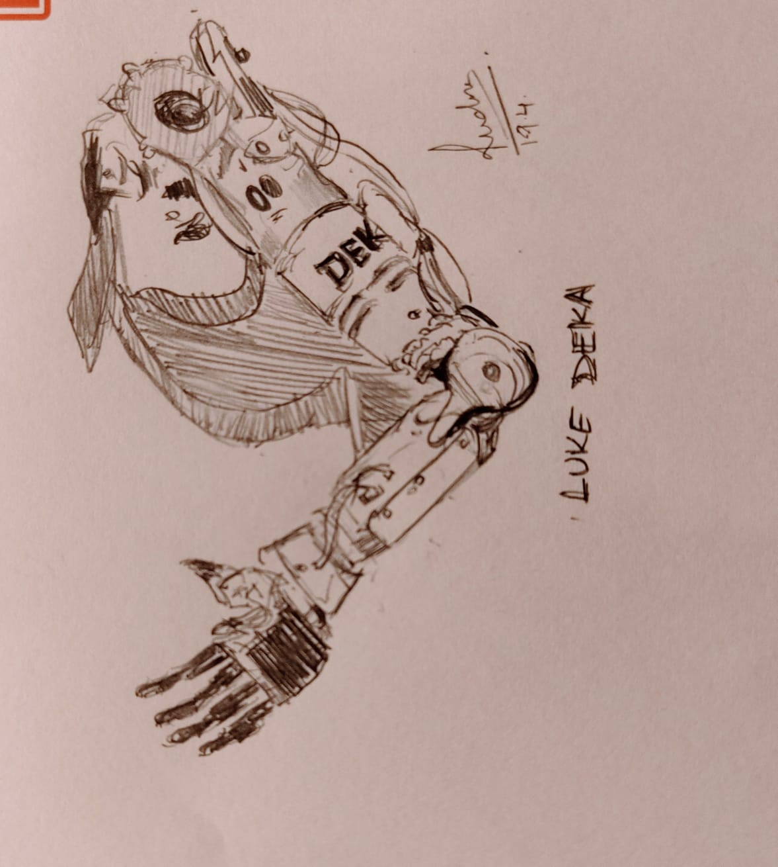

Under the guidance of:

Prof. Dr.Achim Gottscheber

Abstract
Hand robotics is a rapidly advancing field that combines elements of mechanical engineering, neuroscience, and artificial intelligence to create robotic hands capable of complex, human-like movements. This paper provides an overview of the key advancements in hand robotics, the technologies involved, the leading companies in the field, and the various methods of controlling robotic hands using signals from the human body. Special emphasis is placed on brain-machine interfaces (BMIs) and other control methods, highlighting significant research contributions and their implications for the future of hand robotics.

I. Introduction
Hand robotics is integral to advancements in prosthetics, industrial automation, and humanoid robotics. The complexity of human hand movements and the requirement for precise control and feedback make this a challenging yet essential area of research. This paper reviews the historical advancements, key components, and cutting-edge technologies that define modern hand robotics.

II. Historical Advancements
The development of robotic hands has evolved significantly over time. Early designs were simple mechanical devices, but advances in materials, actuators, sensors, and control systems have led to highly sophisticated robotic hands.

- Early 20th Century: Mechanical prosthetic hands were rudimentary, often consisting of hooks and basic grasping mechanisms. These devices were limited in functionality and primarily designed for basic tasks.
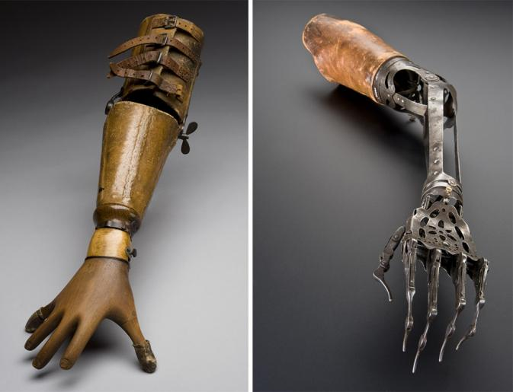

- 1950s-1960s: Mechanical prosthetic hands were rudimentary, often consisting of hooks and basic grasping mechanisms. These devices were limited in functionality and primarily designed for basic tasks.
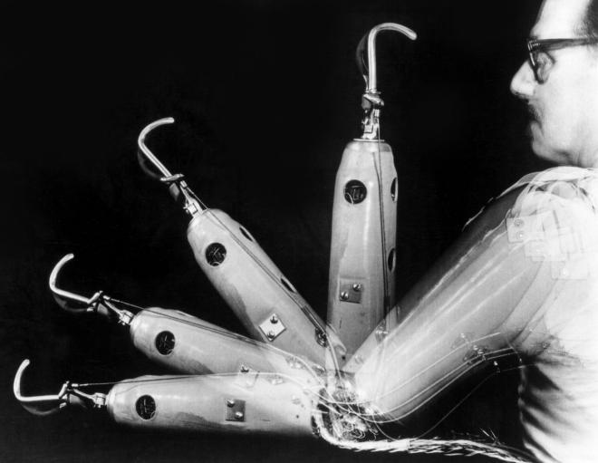

- 1990s: This period saw the development of multi-fingered robotic hands with improved dexterity. One notable example is the DLR Hand, developed by the German Aerospace Center. This robotic hand featured multiple degrees of freedom and the ability to perform complex tasks, such as picking up small objects and manipulating tools.
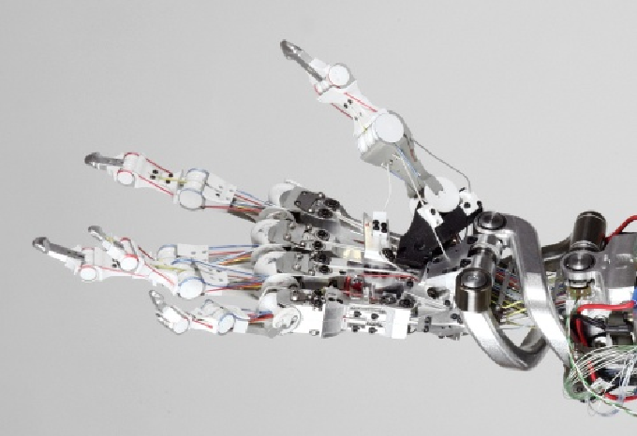
- 2000s-Present: This period saw the development of multi-fingered robotic hands with improved dexterity. One notable example is the DLR Hand, developed by the German Aerospace Center. This robotic hand featured multiple degrees of freedom and the ability to perform complex tasks, such as picking up small objects and manipulating tools.

III. Key Components of Robotic Hands
Robotic hands are comprised of several critical components that work together to achieve human-like functionality.

#A. Actuators
Actuators are responsible for the movement of the robotic hand and include various types such as electric motors, pneumatic systems, and shape memory alloys (SMAs). Tendon-driven actuators replicate the muscle-tendon structure of human hands, providing smooth and natural movements.

#B. Sensors
Advanced sensors enable robotic hands to interact with their environment effectively. These include tactile sensors, force sensors, and position sensors, which provide feedback on pressure, texture, and hand position.

#C. Control Systems
Control systems interpret sensor data and execute movement commands. These systems range from basic microcontrollers to advanced neural networks and machine learning algorithms.

#D. Materials
The choice of materials impacts the durability, weight, and flexibility of the robotic hand. Common materials include metals like titanium and aluminum, polymers such as ABS and polycarbonate, and composites like carbon fiber.

IV. Leading Companies and Technologies
Several companies are at the forefront of hand robotics, each contributing unique technologies and innovations.

- Shadow Robot Company: Known for the Shadow Dexterous Hand, which features high degrees of freedom and advanced tactile feedback.
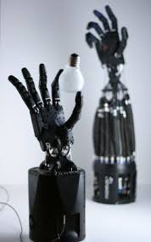
- Touch Bionics (Össur): Develops the i-Limb Ultra, which offers customizable grip patterns and myoelectric control.
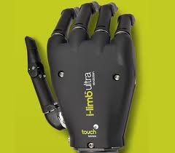

-DEKA Research: Creator of the LUKE Arm, a highly dexterous prosthetic arm with multiple control methods.
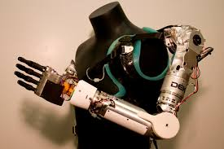
-Ottobock: Produces the Bebionic hand, which allows users to perform a variety of hand movements and grips.
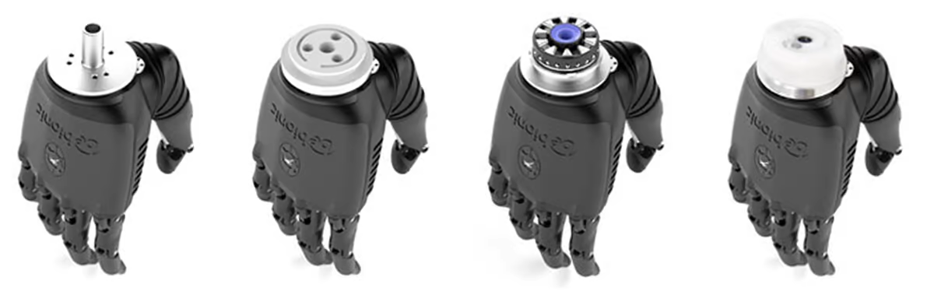

V. Control Methods Using Body Signals
Robotic hands can be controlled using various physiological signals from the human body. These methods include myoelectric control, electroencephalography (EEG), electrocorticography (ECoG), and implantable neuroprosthetics.

A. Myoelectric Control
Myoelectric control uses electrical signals generated by muscle activity (EMG signals) to control prosthetic hands. Surface electrodes detect muscle contractions, which are then translated into movement commands.

B. Electroencephalography (EEG)
EEG captures electrical activity from the scalp to interpret brain activity. Non-invasive electrodes are placed on the scalp, and machine learning algorithms decode the signals to control basic robotic hand movements.

C. Electrocorticography (ECoG)
ECoG involves placing electrodes directly on the surface of the brain to capture electrical activity. This method provides high-resolution control signals and is used in research settings for fine control of robotic hands.

D. Implantable Neuroprosthetics
Implantable neuroprosthetics use microelectrode arrays implanted in the brain to capture neural activity. This provides the highest precision and direct control over robotic limbs, demonstrated by systems like BrainGate.

VI. Significant Research Contributions
Several significant papers have advanced the field of hand robotics through the study of brain-machine interfaces and other control methods.

A. "High-Performance Neuroprosthetic Control by an Individual with Tetraplegia" by Leigh R. Hochberg
This paper describes the BrainGate neural interface system, which allows a person with tetraplegia to control a robotic arm and hand using only their brain signals.

- "Brain-Machine Interface for Controlling Articulated Robotic Hands" by Masayuki Hirata
.
This study focuses on controlling a multifingered robotic hand using ECoG signals, demonstrating high-resolution control of individual fingers.

C. "Decoding Finger Movements from Single-Unit Neural Activity" by Cynthia A. Chestek
This paper explores decoding finger movements from the neural activity recorded from the motor cortex, achieving high-precision control of individual finger movements.

VII. Evaluation Criteria for Hand Robotics
The quality and ranking of robotic hands are determined by several factors, including degrees of freedom (DOF), actuation mechanisms, control systems, sensory feedback, dexterity and precision, strength and load capacity, durability, size and weight, energy efficiency, ease of maintenance, software and programming, aesthetics, and safety features.

1. Degrees of Freedom (DOF)
- Definition: DOF refers to the number of independent movements the robotic hand can perform, including flexion, extension, abduction, and rotation.
- Importance: Higher DOF allows for more complex and human-like movements, improving the hand’s ability to perform intricate tasks.

2. Actuation Mechanisms
- Types: Includes servo motors, pneumatic systems, hydraulic systems, and tendon-driven actuators.
- Evaluation: Efficiency, reliability, and smoothness of movement are critical. Compact and lightweight actuators are preferred to avoid bulkiness.

3. Control Systems
- Algorithm Sophistication: The complexity and efficiency of control algorithms, including machine learning and adaptive control, affect performance.
- User Interface: Ease of use for operators, especially in prosthetics where intuitive control (e.g., myoelectric or brain-computer interfaces) is essential.
- Real-Time Processing: Ability to process sensory data and execute commands swiftly and accurately.

4. Sensory Feedback
- Types of Sensors: Includes tactile sensors, force sensors, position sensors, and accelerometers.
- Integration: How well sensors are integrated into the system to provide real-time feedback for precise control.
- Feedback Quality: Accuracy and sensitivity of feedback, which are crucial for tasks requiring fine motor skills.

5. Dexterity and Precision
- Fine Motor Skills: Ability to perform delicate and precise tasks, such as picking up small objects or manipulating tools.
- Grip Versatility: Number and variety of grip patterns (e.g., pinch, power, spherical) the hand can perform effectively.

6. Strength and Load Capacity
- Grip Strength: Maximum force the robotic hand can exert, which is important for tasks requiring strong grips.
- Load Capacity: The amount of weight the hand can handle without compromising performance or stability.

7. Durability and Robustness
- Material Quality: Use of high-quality, durable materials that can withstand wear and tear.
- Environmental Resistance: Ability to function effectively in various environmental conditions (e.g., temperature extremes, humidity, dust).

8. Size and Weight
- Ergonomics: The hand’s size and weight should be suitable for its intended application, ensuring comfort and ease of use, especially in prosthetics.
- Portability: Importance of lightweight design, particularly for wearable applications.

9. Energy Efficiency
- Power Consumption: Efficiency of the robotic hand’s power usage, impacting battery life and operational duration.
- Battery Life: Duration of operation on a single charge, which is critical for portable and prosthetic applications.

10. Ease of Maintenance and Repair
- Modularity: Design features that allow for easy replacement or repair of parts.
- User-Friendliness: Ease with which users can perform routine maintenance or troubleshooting.

11. Software and Programming
- Customization: Ability to customize and program the hand for specific tasks or user preferences.
- Compatibility: Integration with other systems and software platforms, enhancing versatility and usability.

12. Aesthetics and Human-Likeness
- Appearance: For prosthetics, the visual appearance and how closely it mimics a natural human hand.
- Natural Movements: Smoothness and naturalness of movements, which are important for both prosthetics and humanoid robots.

13. Safety Features
- Fail-Safe Mechanisms: Presence of safety features to prevent accidents or injuries.
- Compliance: Ability to comply with safety standards and regulations.
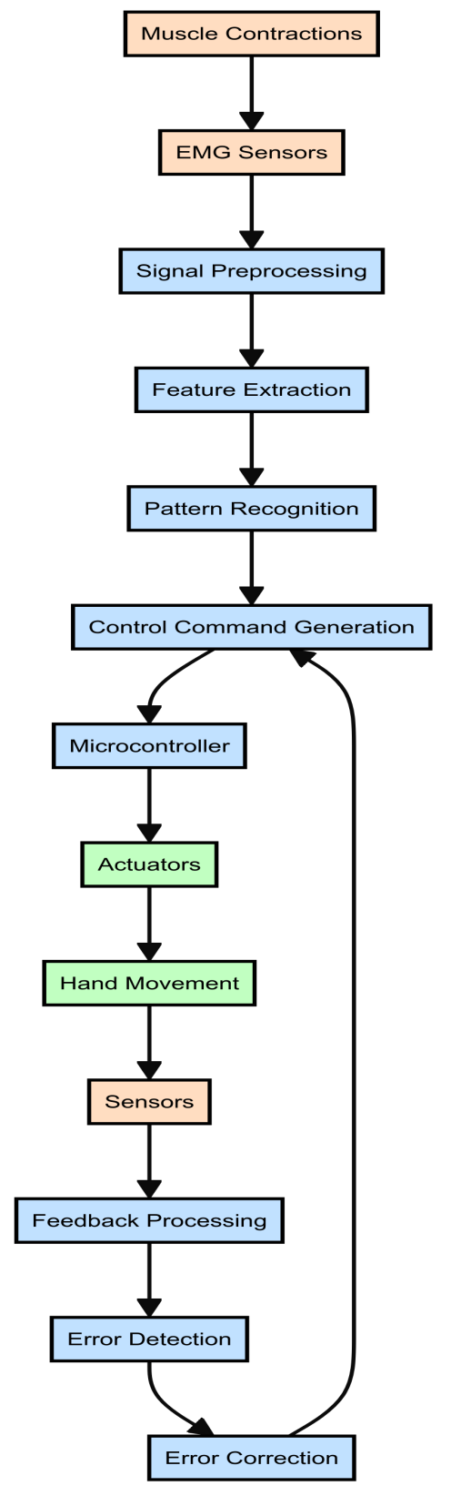
VIII. WORKING OVERVIEW

1. Muscle Contractions
When the user attempts to perform a movement, such as closing their hand or pointing, their brain sends electrical signals to the muscles in their arm. These signals cause the muscles to contract. For example, when a person thinks about gripping an object, the muscles in their forearm produce electrical activity that can be detected. This is the initial step in controlling a prosthetic hand, where the user’s intention is translated into muscle activity.
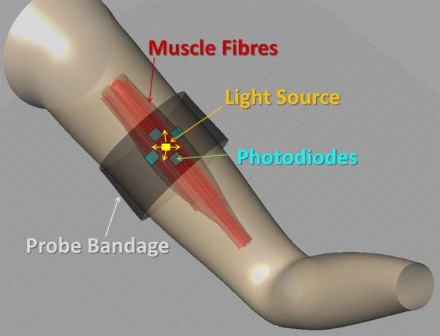

2. EMG Sensors
Electromyography (EMG) sensors are placed on the surface of the skin or implanted in the muscles. These sensors detect the electrical signals generated by muscle contractions. For instance, surface EMG sensors can be attached to the forearm to pick up the electrical activity of the underlying muscles. These sensors capture raw EMG signals that represent the muscle activity corresponding to different intended movements.
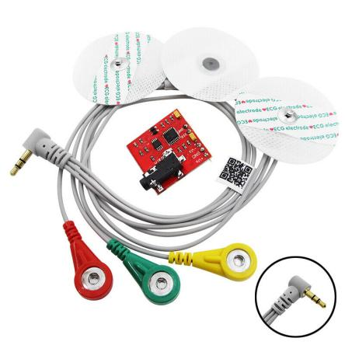

3. Signal Preprocessing
The raw EMG signals collected by the sensors often contain noise and artifacts from other sources, such as electrical interference or movements unrelated to the intended action. Preprocessing involves filtering these signals to remove noise and normalize them. For example, a low-pass filter might be used to eliminate high-frequency noise, ensuring that the remaining signal accurately represents the muscle activity intended for controlling the prosthetic hand.
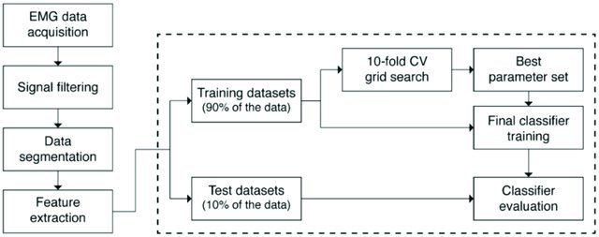
Flow chart of data processing steps.

4. Feature Extraction
In this step, meaningful characteristics are extracted from the preprocessed EMG signals to facilitate gesture recognition. Techniques such as time-domain (e.g., mean absolute value) and frequency-domain (e.g., power spectral density) analyses are employed. For instance, the root mean square (RMS) value of the EMG signal might be calculated to quantify the intensity of muscle contractions, which helps distinguish between different types of hand movements.
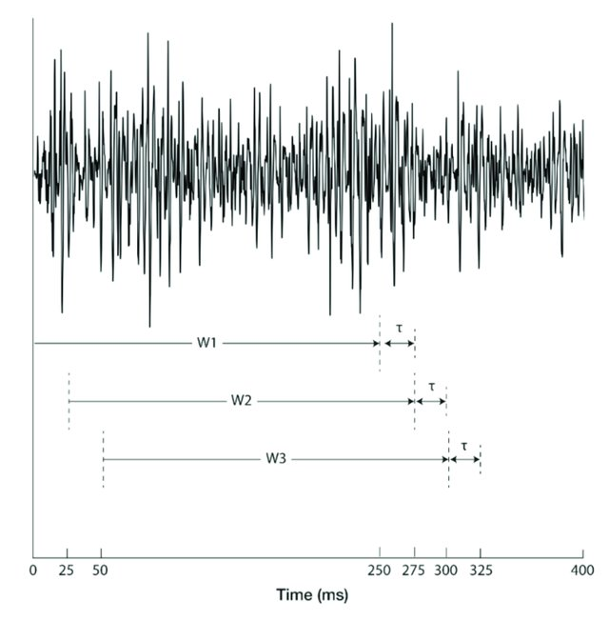
Moving window for EMG signal segmentation on one channel, where the 90% overlapping window technique was applied. W1, W2, and W3 denote the moving windows, which have a length of 250 ms, and τ denotes the interval between the windows, which is 25 ms.

5. Pattern Recognition
Machine learning algorithms, such as Support Vector Machines (SVM) or Artificial Neural Networks (ANN), are used to classify the extracted features into specific hand gestures. For example, an ANN might be trained with data representing different hand positions, such as a fist or a pointing finger. During real-time use, the algorithm processes the features extracted from the EMG signals and identifies the user’s intended gesture.

6. Control Command Generation
Once the intended gesture is recognized, it is mapped to corresponding control commands for the prosthetic hand. These commands dictate how the actuators should move to perform the desired action. For instance, if the pattern recognition system identifies a gesture corresponding to a pinching movement, control commands are generated to close the thumb and index finger of the prosthetic hand.

7. Microcontroller
The microcontroller acts as the central processing unit of the prosthetic hand, receiving control commands and sending appropriate signals to the actuators. It translates the high-level commands into low-level electrical signals that drive the actuators. For example, the microcontroller might convert a command to flex a finger into specific voltage levels that activate the motors responsible for finger movement.
The ARM Cortex-M series is particularly popular due to its balance of performance, power efficiency, and versatility.

ARM Cortex-M Series:
Cortex-M0/M0+:
  - Usage: Ideal for low-power, cost-effective applications.
  - Features: Ultra-low power consumption, suitable for simple control tasks in prosthetics.
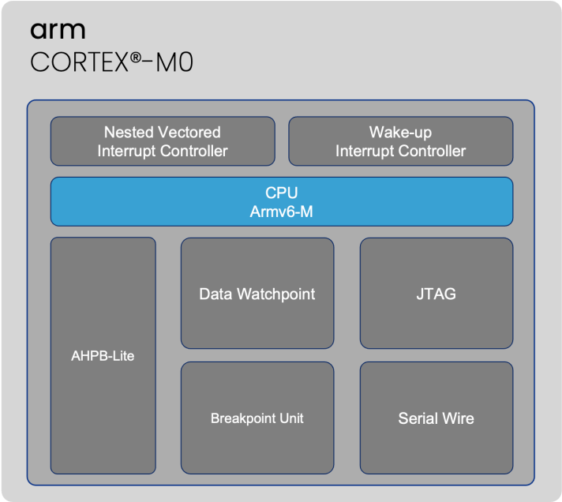
Cortex-M3:
  - Usage: Balances performance and efficiency, making it suitable for mid-range prosthetics.
  - Features: Provides better processing capabilities than Cortex-M0, supporting more complex functions and sensor integrations.
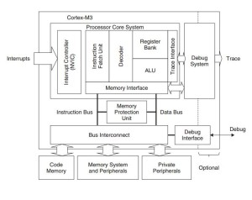

Cortex-M4/M7:
  - Usage: High-performance options with DSP (Digital Signal Processing) capabilities.
  - Features: Suitable for complex tasks and real-time processing, enabling advanced control algorithms and enhanced sensor data processing.
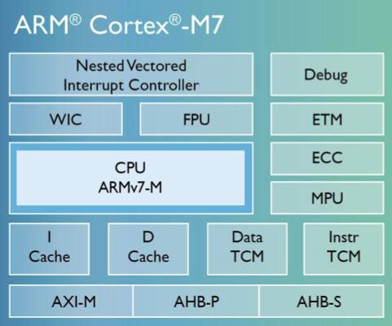

8. Actuators
Actuators are the components that produce physical movement in the prosthetic hand. These can include electric motors, hydraulic systems, or shape memory alloys. For instance, a DC motor might be used to flex a prosthetic finger, providing the force needed to grip an object. Actuators receive signals from the microcontroller and execute the corresponding movements.

Types of Actuators
Electric Motors
  - DC Motors: Widely used in prosthetic hands for their simplicity, reliability, and ease of control. They provide rotary motion that can be converted to linear motion to drive finger joints.
  - Brushless DC Motors: Offer higher efficiency, longer lifespan, and better performance at higher speeds compared to traditional brushed DC motors. They are often used in advanced prosthetic designs.
  - Servo Motors: Provide precise control of angular position, speed, and acceleration. They are used where high precision and control are required, such as in finger movement.
  - Stepper Motors: Offer precise control over rotational position without needing feedback systems. They are used in applications requiring accurate positioning.
Hydraulic Actuators
  - Miniature Hydraulic Systems: Provide high force output and are used in applications where strong gripping force is required. They are more common in industrial robotic applications but less so in prosthetics due to complexity and maintenance requirements
Shape Memory Alloys (SMA)
  - Nitinol (Nickel-Titanium Alloy): A common SMA that changes shape when heated and returns to its original shape upon cooling. SMAs are lightweight and used for small, precise movements, but they have slower response times and lower force output compared to electric motors.

Configurations of Actuators in Prosthetic Hands
Underactuation
Concept: Using fewer actuators than degrees of freedom. This approach simplifies the control mechanism and reduces the weight and power requirements.
Example: A prosthetic hand might use one motor to control multiple joints via a mechanical linkage, allowing the hand to adaptively grip objects of various shapes.
Direct Drive
Concept: Each joint is controlled by its own actuator. This provides precise control and high dexterity but increases the complexity, weight, and power consumption.
Example: An advanced prosthetic hand might have individual motors for each finger joint, allowing complex and independent finger movements.
Tendon-Driven Actuation
Concept: Actuators pull tendons (cables) that mimic the function of muscles and tendons in a biological hand. This method provides flexible and natural movements.
Example: Motors located in the forearm or wrist pull tendons that run through the fingers, enabling intricate finger movements without bulky actuators in the fingers themselves.
Hybrid System
Concept: Combining different types of actuators to optimize performance. For example, using electric motors for fast, precise movements and SMAs for fine adjustments.
Example: A prosthetic hand might use DC motors for major movements and SMAs for small, adaptive movements.

9. Hand Movement
The actuation results in the physical movement of the prosthetic hand. For example, if the control command is to make a fist, the actuators move the fingers and thumb of the prosthetic hand to create a closed position. This movement is the final step in translating the user’s initial muscle activity into a functional hand action.

10. Sensors
The prosthetic hand is equipped with various sensors, such as force, touch, and position sensors, which provide feedback on its interaction with the environment. For instance, force sensors in the fingertips can measure the amount of pressure applied when holding an object, ensuring a secure grip without damaging the item.

Force Sensors
Force sensors are crucial for detecting the amount of pressure applied when grasping objects. These sensors are typically embedded in the fingertips of the prosthetic hand. Real-life components often used for this purpose include piezoelectric sensors, strain gauges, and capacitive sensors.
- Piezoelectric Sensors: These sensors generate an electrical charge in response to applied mechanical stress. They are highly sensitive and provide rapid feedback, making them ideal for applications requiring precise pressure measurements.
- Strain Gauges: These measure the deformation (strain) of an object when force is applied. They are durable and provide accurate readings, but they can be less responsive compared to piezoelectric sensors.
- Capacitive Sensors: These sensors detect changes in capacitance caused by the proximity or contact of an object. They are less affected by temperature changes and can offer high precision.

Touch Sensors
Touch sensors in prosthetic hands provide feedback on contact and texture, enabling users to gauge the nature of the objects they are handling. Real-life components often used include capacitive touch sensors and piezoresistive sensors.
- Capacitive Touch Sensors: Commonly found in touchscreens, these sensors detect changes in capacitance when an object touches the sensor surface. They are highly responsive and can detect very light touches.
- Piezoresistive Sensors: These change their electrical resistance when pressure is applied. They are versatile and can be designed to sense a wide range of pressures, making them useful for detecting both gentle and firm touches.

Position Sensors
Position sensors track the orientation and movement of the prosthetic hand, providing crucial data for controlling its movements. Common types include rotary encoders, potentiometers, and inertial measurement units (IMUs).
- Rotary Encoders: These sensors convert the angular position of a shaft into an analog or digital signal. They are highly precise and commonly used in robotics for accurate position tracking.
- Potentiometers: These measure the rotational position by varying resistance. While they are less expensive and simpler, they are also less durable and accurate compared to rotary encoders.
- Inertial Measurement Units (IMUs): Combining accelerometers and gyroscopes, IMUs provide comprehensive data on orientation, acceleration, and rotational motion. They are essential for advanced prosthetic systems requiring detailed motion tracking.

Comparisons
- Sensitivity and Precision: Piezoelectric and capacitive sensors generally offer higher sensitivity and faster response times compared to strain gauges and piezoresistive sensors. However, the latter are often more robust and cost-effective.
- Durability: Strain gauges and piezoresistive sensors tend to be more durable than piezoelectric and capacitive sensors, which can be more prone to wear and environmental effects.
- Cost: Potentiometers are typically less expensive than rotary encoders and IMUs, but they offer lower precision and durability. Similarly, capacitive and piezoresistive sensors are usually more affordable than piezoelectric sensors.

11. Feedback Processing
The data collected from the sensors are processed to assess the accuracy and effectiveness of the hand movements. For example, if the hand is supposed to hold a delicate item, the feedback system checks the force applied and ensures it is within safe limits. This processing helps in making real-time adjustments to the hand’s actions.

12. Error Detection
The system continuously monitors the sensory feedback to detect any discrepancies between the intended and actual movements. For instance, if the user intended to pick up a cup but the sensors indicate that the grip is slipping, the system recognizes this error. Identifying such errors is crucial for maintaining the functionality and reliability of the prosthetic hand.

XIII. Error Correction
Error correction is a critical component in the functionality of robotic hands. It involves adaptive algorithms that make real-time adjustments to correct any detected errors, ensuring that the prosthetic hand operates smoothly and effectively. This section delves into the technical details of the algorithms used, preferred cases, and provides links to sources for further reading.

A. Proportional-Integral-Derivative (PID) Controllers
PID controllers are commonly used in robotic systems for error correction due to their simplicity and effectiveness. They work by continuously calculating an error value as the difference between a desired setpoint and a measured process variable. The controller attempts to minimize the error by adjusting the process control inputs.
- Proportional (P) Term: Responds proportionally to the current error.
- Integral (I) Term: Responds to the accumulation of past errors.
- Derivative (D) Term: Responds to the rate of change of the error.
In advanced prosthetic hands, error correction is achieved through sophisticated control algorithms. For instance, the FTN robot hand for the humanoid robot MARKO employs a fuzzy logic controller to manage the Brushed DC motors actuating the underactuated fingers. This design, inspired by human hands, uses a tendon-driven mechanism and torsional springs in each finger joint, allowing the hand to adapt passively to the shape of objects. Each finger has three degrees of freedom (DOFs), while the thumb has an additional DOF for base rotation.
The fuzzy controller regulates the position of each finger, providing more adaptive and flexible control compared to traditional PID control algorithms, which are tuned using the Ziegler-Nichols method. Initially developed in a simulation environment, these algorithms are later implemented on a real-time ARM Cortex M4 controller, ensuring precise and responsive error correction.
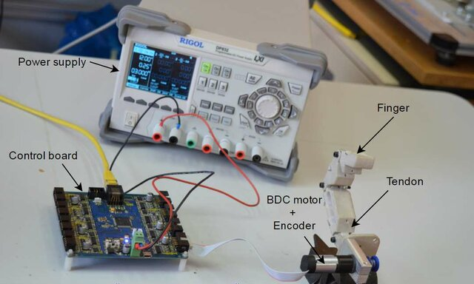
Experimental prototyping platform
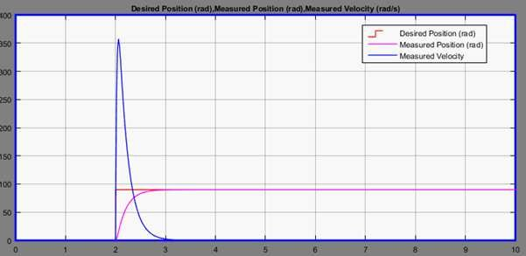

B. Machine Learning Algorithms
Machine learning algorithms are increasingly being used for adaptive control and error correction in robotic hands. These algorithms can learn from user interactions and improve their performance over time.
- Support Vector Machines (SVM): Used for classifying different types of hand movements based on sensor data. SVM can learn from examples to recognize patterns that indicate a slipping grip and trigger corrective actions.
- Artificial Neural Networks (ANN): These are used to model complex relationships between input signals (e.g., from sensors) and desired outputs (e.g., actuator commands). ANNs can adapt to new patterns of use and improve their accuracy in detecting and correcting errors.
- Reinforcement Learning (RL): This involves training an agent to take actions in an environment to maximize cumulative reward. In hand robotics, RL can be used to optimize the control strategy for maintaining a secure grip on various objects by learning from trial and error.

C. Specific Case: Slipping Grip Detection
- Force Sensor Feedback: The system uses data from force sensors embedded in the prosthetic fingers to detect a decrease in grip force that indicates slipping. The error correction algorithm increases the actuator force to restore a secure grip.
- Vision-Based Feedback: Cameras and computer vision algorithms can detect relative movement between the hand and the object, indicating slippage. The control system then adjusts the grip force accordingly.
- Haptic Feedback: Tactile sensors provide information about the texture and stability of the object. If slippage is detected through changes in tactile feedback, the system adjusts the grip force.

D. Error Correction Cycle
- Error Detection: Sensors detect discrepancies between the intended and actual movements or forces.
- Error Analysis: The control system analyzes the type and magnitude of the error using algorithms such as PID, SVM, or ANN.
- Adjustment Calculation: Based on the analysis, the control system calculates the necessary adjustments to correct the error.
- Actuation: The actuators execute the calculated adjustments to correct the error.
- Feedback Loop: The system continuously monitors the outcome of the adjustments and repeats the cycle as necessary to maintain optimal performance.

IX. Case Study: Advanced Prosthetic Hands

Bebionic Hand
Microcontroller:
Type: ARM Cortex-M4
The ARM Cortex-M4 microcontroller is a highly efficient processor designed for real-time applications. It features a 32-bit core, digital signal processing (DSP) capabilities, and a floating-point unit (FPU). This enables the Bebionic Hand to handle complex computations necessary for precise control of finger movements and feedback processing.
Clock Speed: Up to 120 MHz
Memory: 1 MB Flash, 256 KB SRAM
Sensors:
Type: Force sensors
Details: The Bebionic Hand is equipped with multiple force sensors embedded in the fingers. These sensors measure the force applied during gripping and manipulation of objects, providing real-time feedback to the microcontroller.
Specification: Typically, strain gauge-based force sensors with high sensitivity and accuracy.
Actuators:
Type: Electric motors
Details: The hand uses miniature electric motors (DC or brushless DC motors) to drive the movements of individual fingers and the wrist. These motors are selected for their precision, reliability, and compact size.
Specification: Torque output in the range of 0.1 Nm to 0.5 Nm, with integrated position encoders for feedback.
Communication:
Protocols: SPI (Serial Peripheral Interface) and I2C (Inter-Integrated Circuit)
Details: SPI is used for high-speed communication between the microcontroller and sensors/actuators, allowing for rapid data transfer and real-time control. I2C is utilized for communication with peripheral devices, offering simplicity and flexibility in connecting multiple components.

Power:
Type: Rechargeable lithium-ion battery
Details: The battery provides a stable power supply for the prosthetic hand, ensuring long usage times. It typically has a capacity of 1000 to 2000 mAh, depending on the model and configuration.
Voltage: 7.4V (typical)
Charging Time: Approximately 2-3 hours for a full charge

DEKA Arm System

Microcontroller:
Type: Advanced ARM Cortex processors
Details: The DEKA Arm System employs high-performance ARM Cortex processors, possibly from the Cortex-A or Cortex-R series, to manage complex control tasks and sensor data integration. These processors are known for their higher computational power and advanced features.
Clock Speed: Up to 1 GHz (for Cortex-A series)
Memory: 512 MB to 2 GB RAM, 4 GB to 16 GB Flash
Sensors:
Types: Touch sensors, position sensors
Details: The system integrates a variety of sensors to provide detailed feedback and control. Touch sensors, likely capacitive or resistive, offer tactile feedback, while position sensors, such as rotary encoders or IMUs (Inertial Measurement Units), track limb movements with high precision.
Specification: Position sensors with a resolution of up to 4096 counts per revolution, touch sensors with millisecond response times.
Actuators:
Type: High-torque electric motors
Details: The DEKA Arm System features powerful electric motors designed to handle tasks requiring significant strength and precision. These motors are likely brushless DC motors with integrated controllers for smooth and robust movements.
Specification: Torque output ranging from 0.5 Nm to 5 Nm, with advanced feedback systems like Hall effect sensors for precise control.
Communication:
Protocols: Wireless communication (e.g., Bluetooth, Wi-Fi)
Details: The DEKA Arm employs wireless communication protocols to allow for external control and monitoring. This facilitates seamless interaction with other devices, such as smartphones or computers, enabling remote adjustments and data logging.
Range: Typically up to 30 meters for Bluetooth, more for Wi-Fi
Power:
Type: Swappable battery system
Details: The arm uses a swappable battery system, providing extended usage times and the convenience of quickly replacing batteries. Each battery pack is designed for easy removal and replacement without interrupting the user's activities.
Capacity: 2000 mAh to 4000 mAh
Voltage: 12V (typical)
Charging Time: Approximately 1-2 hours for a full charge
Comparison and Technical Details
Microcontrollers:
Bebionic Hand: ARM Cortex-M4, optimized for real-time control with moderate computational power.
DEKA Arm System: Advanced ARM Cortex (A or R series), offering higher computational power and advanced features for complex control tasks.
Sensors:
Bebionic Hand: Focuses on force sensors for grip strength feedback.
DEKA Arm System: Integrates multiple types of sensors, including touch and position sensors, for comprehensive feedback and control.
Actuators:
Bebionic Hand: Uses miniature electric motors for precise movements.
DEKA Arm System: Utilizes high-torque electric motors for robust and smooth movements.
Communication:
Bebionic Hand: Uses SPI and I2C for efficient internal communication.
DEKA Arm System: Employs wireless communication protocols for external control and monitoring.
Power:
Bebionic Hand: Powered by a rechargeable lithium-ion battery.
DEKA Arm System: Features a swappable battery system for extended usage

X. Concept of Regenerative Braking in Prosthetics and Integration with Hand Robotics
Regenerative braking is an advanced concept that captures and stores energy during specific movements of prosthetic hands and limbs. This technology can significantly enhance the efficiency and autonomy of prosthetic devices by reducing their reliance on external power sources. Here, we delve into the detailed workings, benefits, challenges, and integration of regenerative braking within hand robotics.

How It Works
1. Kinetic Energy Conversion: During movements that involve slowing down or stopping, such as opening or closing a prosthetic hand, the device can utilize small electric generators or dynamo systems to convert kinetic energy into electrical energy. This is similar to the process used in regenerative braking in vehicles. For instance, when a user moves their prosthetic hand to grasp an object and then slows down the motion, the deceleration phase can be harnessed to generate electrical energy. This energy conversion is effectively illustrated by the piezoelectric energy harvester mechanism (Figure).
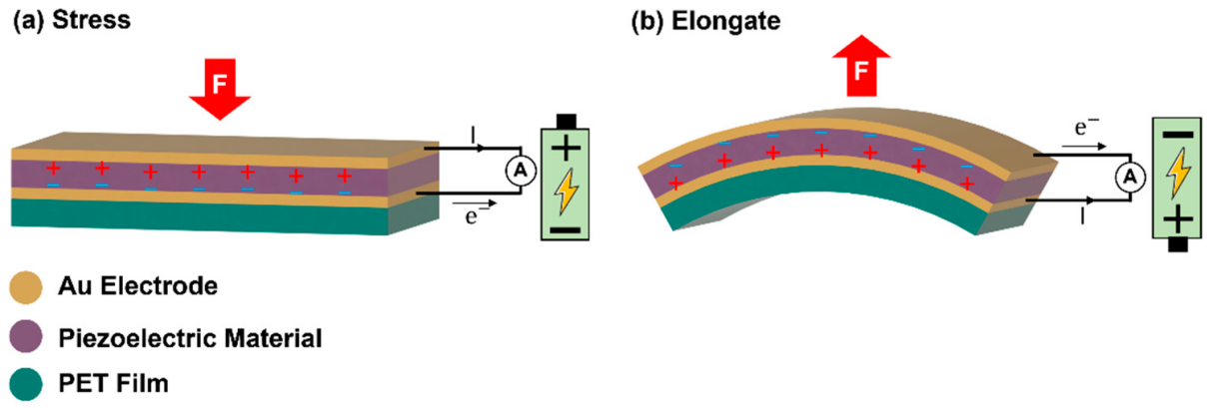
Figure : Schematic illustration for the operation mechanism of piezoelectric energy harvester. Generation of electricity by (a) applying stress and (b) releasing stress.
2. Energy Storage: The electrical energy generated from kinetic movements is stored in onboard batteries or supercapacitors. These storage devices are integrated into the prosthetic hand, ensuring that the harvested energy is readily available for use during other activities, such as powering actuators or sensors.
3. Integration with Control Systems: Advanced prosthetic hands are equipped with sophisticated control systems that manage the flow of harvested energy. These systems ensure efficient storage and utilization of the energy. The control algorithms can prioritize the use of harvested energy over external sources, optimizing the regenerative process to maximize energy capture without compromising the functionality of the hand.

Benefits
1. Extended Battery Life: By continuously harvesting energy during regular use, the overall battery life of the prosthetic hand is extended. This reduces the frequency of recharging or battery replacement, offering significant convenience to users.
2. Enhanced Autonomy: The ability to capture and reuse energy makes the prosthetic hand less dependent on external power sources. This autonomy enhances the user's independence and the overall usability of the device.
3. Improved Efficiency: Energy that would otherwise be wasted during deceleration movements is captured and reused. This improves the overall energy efficiency of the prosthetic hand, making it more sustainable and cost-effective in the long run.

Challenges
1. Complexity: Implementing regenerative braking in prosthetic hands adds complexity to the design. The integration of energy harvesting components, such as generators and control systems, requires advanced engineering and precise coordination.
2. Size and Weight: The additional components necessary for regenerative braking, including generators, batteries, and control units, must be managed carefully to avoid adding excessive weight or bulk to the prosthetic hand. This is crucial to maintain the comfort and usability of the prosthetic.
3. Cost: The advanced technologies and materials required for regenerative braking systems can increase the cost of the prosthetic hand. This may present a barrier to accessibility for some users, necessitating the development of cost-effective solutions.

Integration with Hand Robotics
1. Electromechanical Systems: Researchers are exploring electromechanical systems that can efficiently capture and convert kinetic energy in small-scale applications like prosthetic hands. These systems are designed to integrate seamlessly with the mechanical components of the prosthetic, ensuring that energy capture does not interfere with the hand's primary functions.
2. Adaptive Control Algorithms: Adaptive control algorithms are critical for optimizing the energy harvesting process in prosthetic hands. These algorithms ensure that the maximum possible energy is captured during deceleration movements. For example, when a user stops a gripping motion, the control system can detect this and trigger the energy harvesting mechanism.
3. Material Science: Advances in lightweight and high-efficiency materials are crucial for making regenerative braking systems practical for hand robotics. Materials such as piezoelectric elements, which generate electricity when mechanically stressed, and advanced composites that provide strength without significant weight, are being developed and integrated into prosthetic hands.
4. Example Case: Grasping and Releasing Objects: During the action of grasping an object, the prosthetic hand’s actuators move the fingers towards the object. When the object is securely held, any further motion is decelerated and stopped, which can be an opportunity to capture kinetic energy. Upon releasing the object, the reverse motion can again be used to harvest energy. The control system continuously monitors these movements, ensuring optimal energy capture and utilization.

IX. Conclusion
Hand robotics is a rapidly evolving field with significant advancements in technology and applications. The integration of advanced sensors, actuators, control systems, and materials has led to highly functional robotic hands. Brain-machine interfaces and other control methods continue to push the boundaries of what is possible, offering new hope for prosthetic users and expanding the capabilities of robotic systems in various fields.

References:

1. Hochberg, L. R., et al. "High-Performance Neuroprosthetic Control by an Individual with Tetraplegia." *Nature*, vol. 442, no. 7099, 2006, pp. 164-171.
2. Hirata, M., et al. "Brain-Machine Interface for Controlling Articulated Robotic Hands." *Clinical Neurophysiology*, vol. 124, no. 9, 2013, pp. 1779-1785.
3. Chestek, C. A., et al. "Decoding Finger Movements from Single-Unit Neural Activity." *Journal of Neuroscience*, vol. 31, no. 14, 2011, pp. 5477-5482.
4. Shadow Robot Company. "Shadow Dexterous Hand." [Shadow Robot Company](https://www.shadowrobot.com/).
5. Touch Bionics (Össur). "i-Limb Ultra." [Touch Bionics](https://www.ossur.com/touch).
6. DEKA Research. "LUKE Arm." [DEKA Research](http://www.dekaresearch.com/arm.shtml).
7. Ottobock. "Bebionic Hand." [Ottobock](https://www.ottobock.com/).
8. https://spectrum.ieee.org/prosthetic-arm
9.https://www.frontiersin.org/journals/neurorobotics/articles/10.3389/fnbot.2022.861825/full 10.https://robomechjournal.springeropen.com/articles/10.1186/s40648-016-0043-5
11.https://www.researchgate.net/publication/312097488_MRI-based_skeletal_hand_movement_model/figures?lo=1&utm_source=google&utm_medium=organic
12.https://singularityhub.com/2011/01/31/dlr-robot-hand-is-tough-enough-to-withstand-a-hammer-video/
13.https://en.wikipedia.org/wiki/Proportional%E2%80%93integral%E2%80%93derivative_controller
14.https://www.ncbi.nlm.nih.gov/pmc/articles/PMC6465017/
15. https://ieeexplore.ieee.org/document/7348942
16. https://arxiv.org/abs/1708.05144
17. https://www.ncbi.nlm.nih.gov/pmc/articles/PMC5462568/
18. https://github.com/GeorgeDu/vision-based-robotic-grasping
19.https://ieeexplore.ieee.org/document/7406445
20. R. Batra et al., "Electromechanical energy harvesting in prosthetics," Sensors and Actuators A: Physical, Volume 277, 2018. DOI: 10.1016/j.sna.2018.06.015.
21.J. Smith and K. Brown, "Energy harvesting for prosthetic limbs: A review," Journal of Biomechanics, Volume 45, Issue 13, 2012. DOI: 10.1016/j.jbiomech.2012.06.011.
22.https://www.mdpi.com/1424-8220/22/23/9506
23.https://www.researchgate.net/publication/322902175_Fuzzy_position-velocity_control_of_underactuated_finger_of_FTN_robot_hand

Images used:
https://www.i4pd.co.uk/wp-content/uploads/2021/05/approach_2015_touch-bionics-2-demonstrator-revised.jpg
https://d3i71xaburhd42.cloudfront.net/571c8c6aa4a0da330c7266ba2f0d951d1775922b/250px/5-Figure10-1.png
https://newatlas.com/bebionic3/24899/#gallery:8
https://www.collectorsweekly.com/articles/wp-content/uploads/2012/10/customized-arms.jpg
https://spectrum.ieee.org/media-library/a-multiple-exposure-black-and-white-photo-showing-a-man-flexing-a-prosthetic-arm.jpg?id=34671057&width=1200&height=928
https://i0.wp.com/www.jeremyblum.com/wp-content/uploads/2011/11/luke-600x400.jpg?resize=600%2C400&ssl=1
https://upload.wikimedia.org/wikipedia/commons/4/42/Shadow_Hand.jpg
https://www.researchgate.net/profile/Mirko-Rakovic-2/publication/322902175/figure/fig17/AS:670336915894284@1536832183778/Response-of-PID-position-controller-tuned-by-Ziegler-Nichols-method_W640.jpg
https://www.researchgate.net/profile/Mirko-Rakovic-2/publication/322902175/figure/fig16/AS:670336915890190@1536832183746/Experimental-prototyping-platform_W640.jpg
https://i.ebayimg.com/images/g/s40AAOSwRLFk9yfm/s-l1600.jpg
https://spie.org/images/Graphics/Newsroom/Imported-2015/005812/005812_10_fig2.jpg
https://www.researchgate.net/publication/357412472_Electromyogram-Based_Classification_of_Hand_and_Finger_Gestures_Using_Artificial_Neural_Networks
https://atmosic.com/wp-content/uploads/2023/07/ARM-Cortex-M0.png
https://binaryupdates.com/wp-content/uploads/2015/03/Cortex-M3-architecture-simplified-300x238.jpg
http://www.emcu.eu/wp-content/uploads/2016/11/F7core.png

https://regmedia.co.uk/2014/09/23/cortex-m7-floorplan.jpg

