Calendar-ProductType recommendation app (Jonathan SGP <> AiGENThix) – Phase 2

Required Files for project
Core Application & Logic
- .env – Environment variables
- app.py – Main application entry point
- data_cleaner.py – Data preprocessing logic
- rules.py – Business rules and logic
- llm_parser.py – Logic for parsing LLM responses
- client_plan_llm.py – LLM-driven client planning logic
- agent_controller.py – Orchestration of various agents
- llm_router.py – Routing requests to appropriate LLM completion logic
Tools & Modules
- calendar_tools.py – Calendar integration utilities
- client_tools.py – Client-specific data operations
- data_manager.py – Management of data flow within the app
- email_sender.py – Email notification module
- whatsapp_sender.py – WhatsApp Business API integration
- scheduling_tools.py – Task and appointment scheduling logic
- preview_engine.py – Engines for previewing outputs
Data & Documentation
- JonathanProj.ipynb – Main project notebook
- data.xlsx – Primary input data
- cleaned_data.xlsx – Preprocessed output data
- reminders.xlsx – Stored reminder data
- recommendationOutput.xlsx – Generated recommendations
- jonathan-writing-profile.txt – Writing style configuration
- marketoutlook-temporary.txt – Temporary market research data
- writing-style-prompt.txt – Base prompt for writing consistency
Configuration & Dependencies
- requirements.txt – Python package dependencies
- .env_example – Template for environment variables

Project Dependencies
- VS Code
- VS Code Jupyter extensions
- Python 3.10 or any version after 3.10
- All libraries inside requirements.txt

Setup Operations (One time only):

How to Setup Virtual Environment
- How to open the project folder in VS code
- Open VS code
- Click on File option in the top bar

- Select Open Folder
- Go to the folder in which you have setup the files
- Click on Select folder

- How to Setup Virtual Environment
- To open VS code terminal, use the shortcut CTRL + J
- In the terminal, type the following command to initialize a python environment
python -m venv venv

2. How to Activate Virtual Environment
- NOTE: You do not always have to create a virtual environment as long as a folder named ‘venv’ exists in your project folder. But, everytime you run the code, you need to always activate the virtual environment.
- In the VS code Terminal, input the following command
venv/Scripts/activate

3. How to install dependencies
- NOTE: You do not always have to install dependencies, as long as you have done it once in your venv its fine.
- Activate Virtual Environment (venv/Scripts/activate)
- In the terminal, use the following command to install required libraries (might take some time)
pip install -r requirements.txt

4. Setup .env file
- Open the .env file in VS code
- It should look something like this:
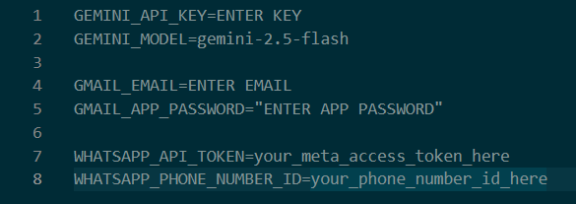
- In line 1, after the ‘=’, paste your Gemini API key
- In line 4, enter your Email address from which you want the mails to be sent.
- In line 5, you must enter your Gmail app password, this is different from the actual password for your gmail account. This can only be gotten after activating 2 Step verification on your gmail Id.
  - First activate 2 step verification on your gmail account
  - Then, go to app passwords page:
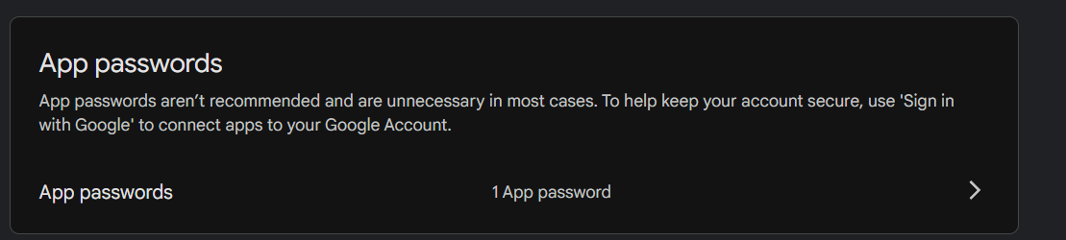
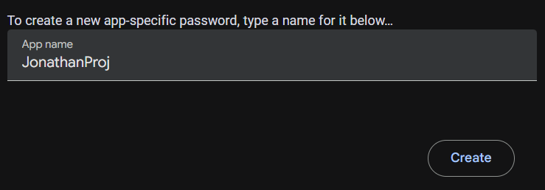
  - Add a new app password name
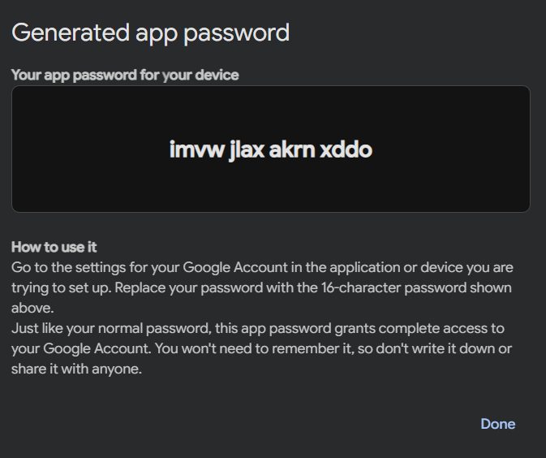
  - Click on create, it will show you an OTP, copy that, and paste the OTP in line 5 after “=”
- In lines 7 and 8, enter your whatsapp Business API credentials
- Save the file (ctrl + S)

- Your Setup is completed, Now, you don’t need to do anything except step (2) every time you want to run the code
- The Indicator for an Active Virtual Environment is (venv) in your command terminal

Running the code and application

1. How to clean data
- First, make sure that ‘’data.xlsx” is the name of the file in which you have the raw data
- Paste that file inside the project folder
- Activate Virtual Environment if you haven’t (venv/Scripts/activate)
- In the terminal, type the following command
python data_cleaner.py
- This will output a new file called: ‘cleaned_data.xlsx’

2. How to run analytics and Machine Learning Models
- First, make sure that “cleaned_data.xlsx” is present in your project folder
- Open the file ‘JonathanProj.ipynb’
- This is a Jupyter notebook, now, select your venv as the kernal.
- First click on ‘Select Kernal’. If it already shows ‘venv’ then you may skip step 4, 5 and 6.
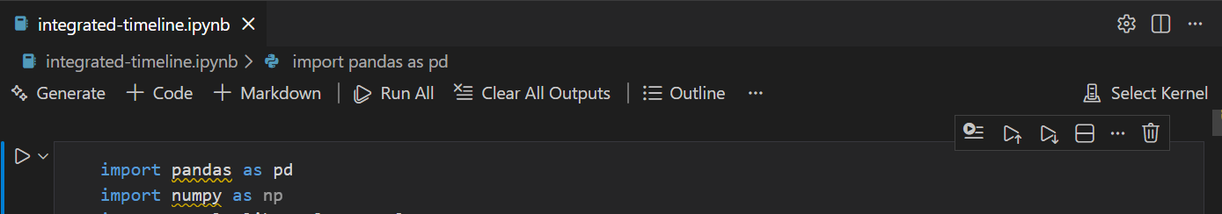
- Click on ‘Python Environements’
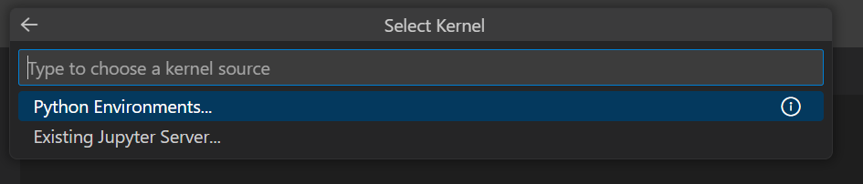
- Click on ‘venv’

- Click on the ‘Run all’ button
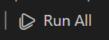
- This will output a new file called: ‘recommendationOuput.xlsx’

3. How to run Calendar application (Streamlit application)
- First activate Virtual Environment if you haven’t (venv/Scripts/activate)
- In the terminal, type the following command
streamlit run app.py
- If you didn’t directly get redirected, then go to your preferred browser and search for:
http://localhost:8501

