Experiment: Gradient Descent Implementation for Linear Regression

OUTPUT:

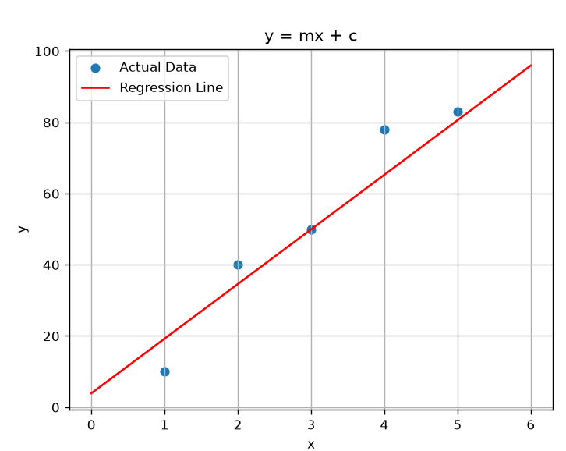

Code:
