SUPPLY CHAIN
ANALYTICS
Delivery Performance & Late Delivery Prediction
Executive Business Analysis

180,518  ORDERS ANALYZED | 57.3%  DELAY RATE | 1 day  MEDIAN DEVIATION | Decision Tree  BEST MODEL
Prepared from the DataCo Supply Chain dataset

Contents
────────────────────────────────────────────────────────
01 Executive Summary
02 Business Context & Objectives
03 Performance Snapshot
04 Delivery Performance
05 Factors Associated with Delay
06 Financial Performance
07 Time-Based Patterns
08 Predictive Model Results
09 Recommendations
10 Conclusion
Appendix Methodology

01 Executive Summary
────────────────────────────────────────────────────────
The analysis covers 180,518 cleaned orders from the DataCo Supply Chain dataset. The main business question is straightforward: where are delivery delays concentrated, what patterns are associated with them, and can late-delivery risk be predicted from information available at order level?
Delivery performance is the main concern. 103,399 orders, or 57.3% of the dataset, exceeded their scheduled shipping time. The median schedule deviation is 1 day and the 90th percentile is 2 days.
The clearest operational difference is by shipping mode. First Class has a 100.0% delay rate and Second Class 79.7%, compared with 39.8% for Standard Class. Regional, departmental, and customer-segment differences are narrower.
Financial measures also differ by delivery status. Average Benefit per Order is $21.58 for delayed orders versus $22.50 for on-time orders. These figures show association, not a proven causal loss.
For predictive analysis, three baseline models were compared. The Decision Tree produced the highest F1 score at 0.763. This provides a useful analytical baseline for identifying orders with higher late-delivery risk.
MANAGEMENT FOCUS Review shipping-mode performance first, then investigate the highest-delay regions and departments. Use the predictive model as a supporting prioritization tool.

02 Business Context & Objectives
────────────────────────────────────────────────────────
The dataset represents an e-commerce supply chain with order, customer, product, regional, shipping, timing, and financial information. Delivery performance is assessed by comparing actual shipping days with scheduled shipping days.

Business question
The analysis is designed to understand the current delivery-performance position, identify business dimensions associated with higher delay rates, and evaluate whether order-level information can support early identification of late-delivery risk.

Objectives
- Establish a delivery-performance baseline.
- Compare delays across shipping mode, region, customer segment, department, order type, and order status.
- Identify recurring time-based patterns.
- Compare selected financial measures for delayed and on-time orders.
- Build and compare baseline classification models.
- Translate the findings into practical areas for management review.

03 Performance Snapshot
────────────────────────────────────────────────────────
180,518  TOTAL ORDERS | 103,399  DELAYED ORDERS | 57.3%  DELAY RATE | 42.7%  ON-TIME RATE

1 day  MEDIAN DEVIATION | 2 days  90TH PERCENTILE | $183.11  AVG SALES / CUSTOMER | $21.97  AVG BENEFIT / ORDER

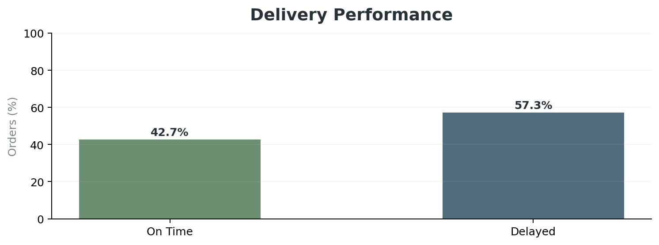
PERFORMANCE READING The delivery problem is frequent rather than isolated. More than half of all orders exceed their scheduled shipping time.

04 Delivery Performance
────────────────────────────────────────────────────────

Shipping mode is the clearest differentiator
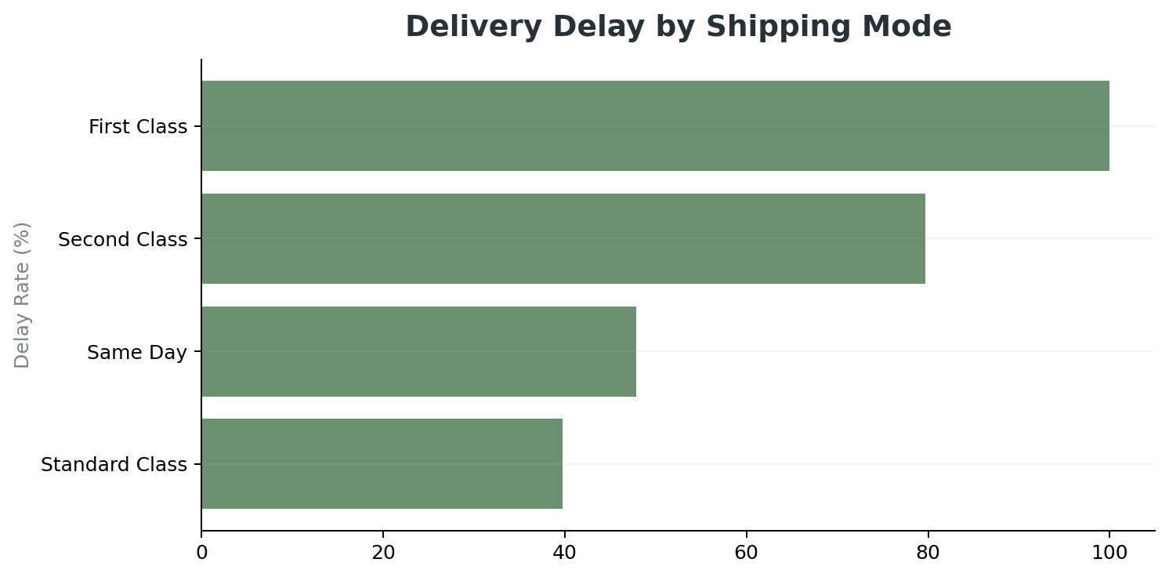
First Class has the highest observed delay rate at 100.0%, followed by Second Class at 79.7%. Standard Class is lower at 39.8%. Same Day is also elevated at 47.8%.
MANAGEMENT IMPLICATION Premium service promises should be reviewed against actual delivery performance, carrier allocation, and routing.

Regional performance
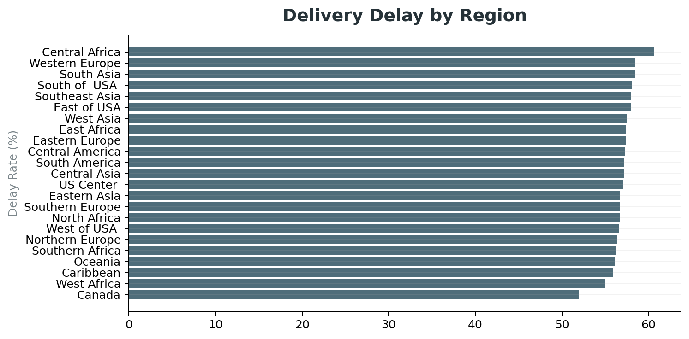
Central Africa records the highest regional delay rate at 60.7%. Most other regions sit within a relatively narrow range, so the regional pattern is important but less pronounced than the shipping-mode pattern.

05 Factors Associated with Delay
────────────────────────────────────────────────────────

Customer segment
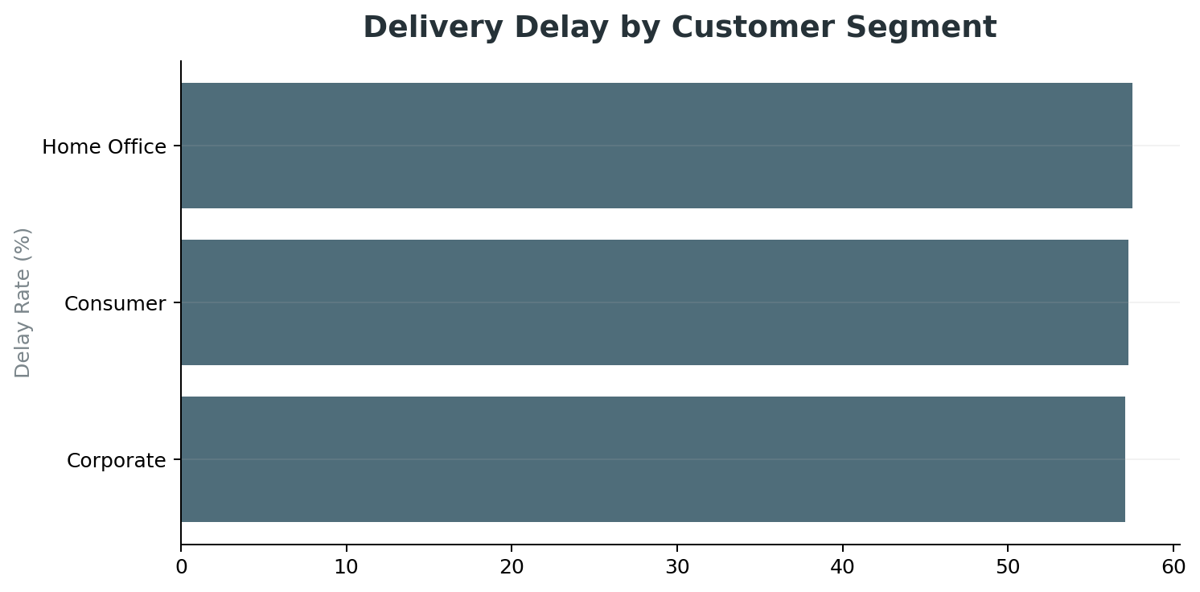
Customer-segment differences are limited. Home Office has the highest observed rate at 57.5%, followed by Consumer at 57.3% and Corporate at 57.1%.

Department
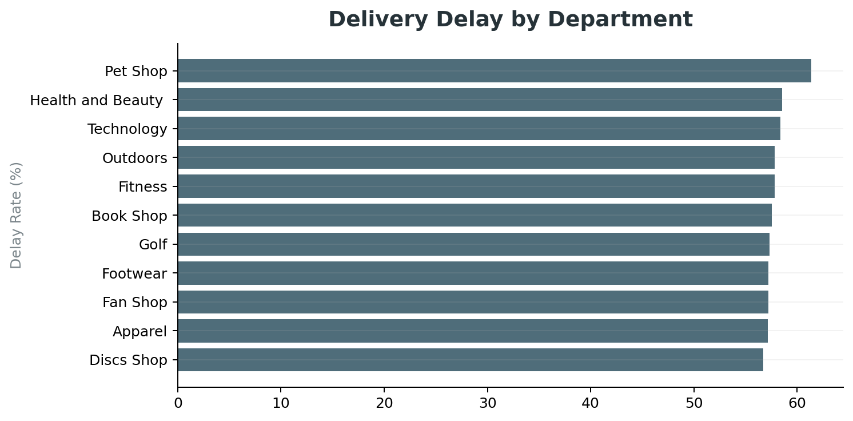
Pet Shop has the highest department delay rate at 61.4%. The next highest departments are Health and Beauty (58.6%) and Technology (58.4%).

Order type and status
Order type and order status show smaller differences than shipping mode. Their observed ranges are 56.6%-57.5% and 55.6%-57.9%, respectively.
INTERPRETATION These dimensions identify patterns for operational review. They should not be described as proven root causes without additional causal analysis.

06 Financial Performance
────────────────────────────────────────────────────────
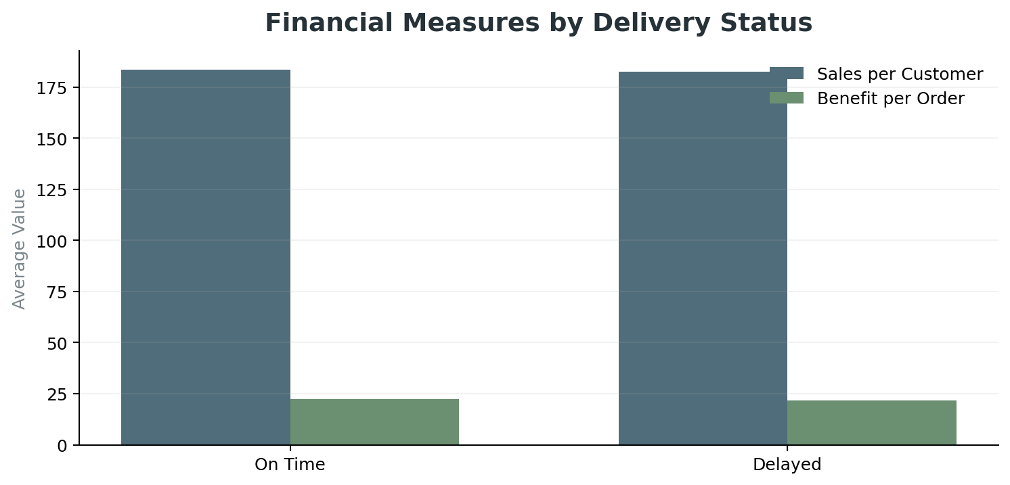
Average Benefit per Order is $21.58 for delayed orders and $22.50 for on-time orders. Average Sales per Customer is $182.69 for delayed orders and $183.67 for on-time orders.
The differences are relatively small at the average order level. The current dataset analysis therefore supports an association between delivery status and selected financial measures, but it does not quantify a causal financial loss.
NEXT ANALYTICAL STEP A richer profitability analysis should combine revenue, profit, discount, shipping cost, and customer-impact measures at order level.

07 Time-Based Patterns
────────────────────────────────────────────────────────

Monthly pattern
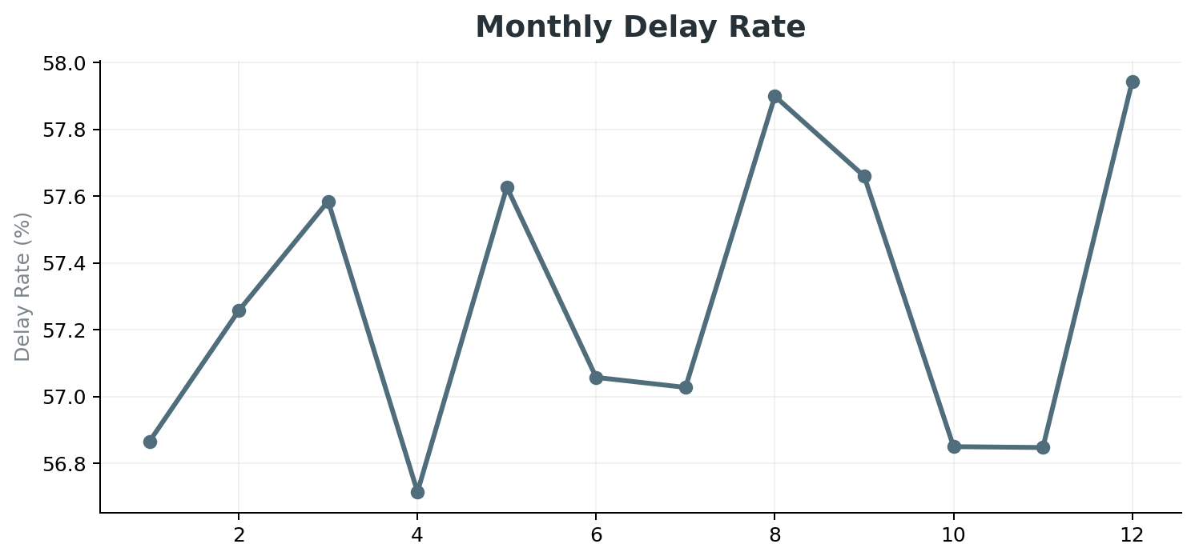
Month 12 has the highest observed delay rate at 57.9%, while month 4 is the lowest at 56.7%. The overall spread is modest.

Day of week
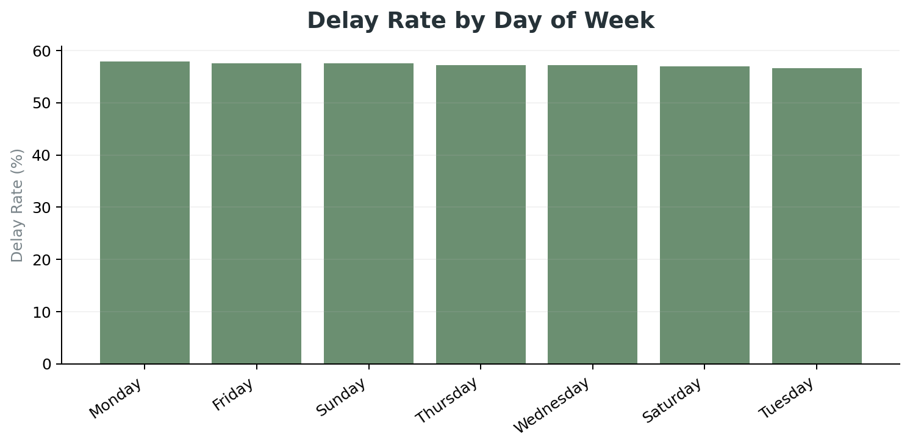
Monday has the highest day-of-week rate at 57.9%, while Tuesday has the lowest at 56.6%. The small spread suggests day of week is not a major management lever.

Hour of day
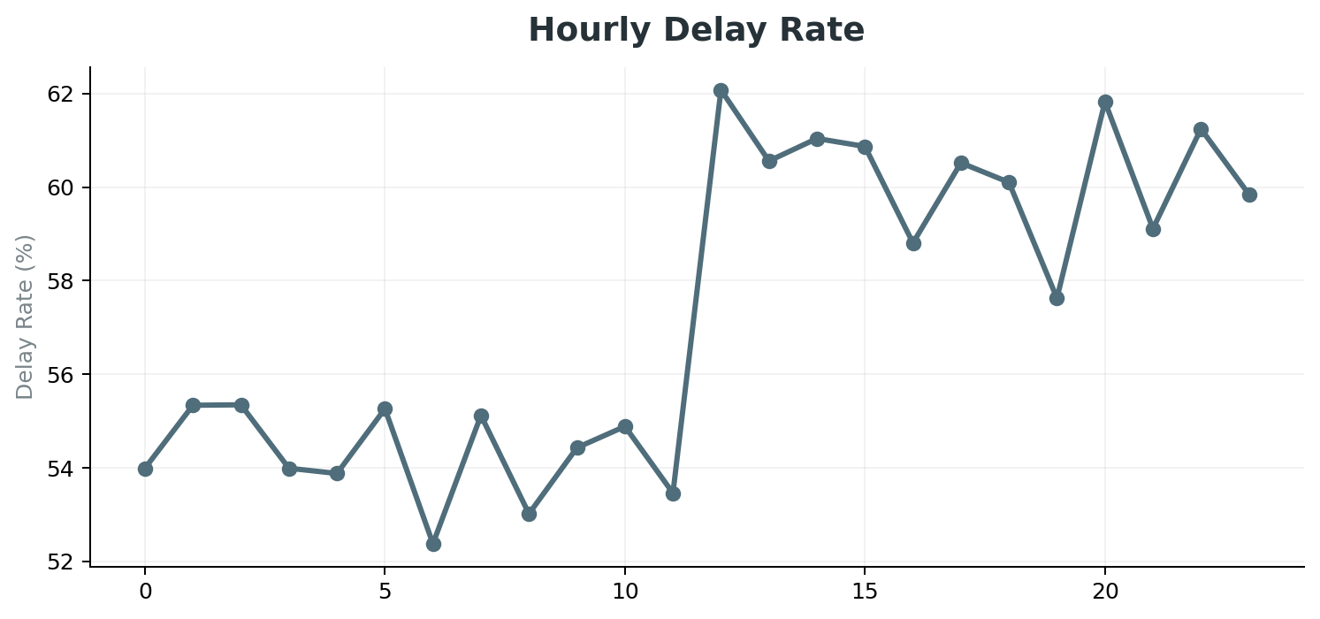
The three highest observed order hours are 12:00 (62.1%), 20:00 (61.8%), 22:00 (61.2%). These periods can be reviewed alongside workload, cutoff times, and processing capacity.

08 Predictive Model Results
────────────────────────────────────────────────────────
The machine-learning task predicts the dataset's Late_delivery_risk target. The model uses order type, scheduled shipping days, category, customer segment, department, region, shipping mode, order month, and order hour. Actual shipping days and the engineered delay flag are not used as predictors.
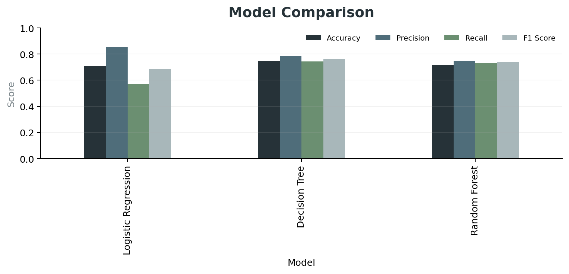
Model | Accuracy | Precision | Recall | F1
Logistic Regression | 0.710 | 0.854 | 0.569 | 0.683
Decision Tree | 0.746 | 0.783 | 0.743 | 0.763
Random Forest | 0.718 | 0.748 | 0.731 | 0.740
The Decision Tree is the strongest baseline under the selected F1 criterion, with an F1 score of 0.763 and accuracy of 0.746.

Selected model performance
For late-risk class 1, precision is 0.78, recall is 0.74, and F1 is 0.76. The model should be treated as a decision-support baseline rather than a production system.

09 Recommendations
────────────────────────────────────────────────────────
01 Review shipping-mode performance
First Class and Second Class show delay rates of 100.0% and 79.7%. Validate carrier allocation, routing, and promised service levels.
02 Investigate regional constraints
Central Africa has the highest regional delay rate at 60.7%. Review carrier coverage, processing time, and regional service assumptions.
03 Review high-delay departments
Pet Shop has the highest department rate at 61.4%. Compare inventory availability, fulfillment time, and carrier assignment.
04 Use time patterns for capacity planning
Review month 12 and the highest hourly periods against workload and processing capacity.
05 Use predictive risk as a prioritization tool
The Decision Tree provides an F1 score of 0.763. Use risk scoring to prioritize operational review while further validating the model.
06 Expand the financial view
Add order-level revenue, profit, discount, shipping cost, and customer-impact measures to quantify the business cost of delivery performance.

Priority
The first management review should focus on shipping-mode performance and the operating processes behind the highest-delay regions. Predictive scoring can then be used to support order-level prioritization.

10 Conclusion
────────────────────────────────────────────────────────
The analysis shows a delivery operation with a 57.3% observed delay rate across 180,518 cleaned orders. Shipping mode provides the clearest separation in delivery performance, while customer segment and day-of-week differences are comparatively small.
Regional and department patterns provide additional areas for operational review. The financial comparison shows modest differences in selected average measures between delayed and on-time orders, but the current analysis does not establish causal financial impact.
The predictive analysis provides a useful baseline. The Decision Tree achieved the highest F1 score among the three tested models. Further improvement would require additional operational features, validation, and model tuning.
MANAGEMENT TAKEAWAY The delivery issue is broad enough to require process-level attention, not only case-by-case intervention. The analysis provides a practical starting point for prioritizing that review.

Appendix Methodology
────────────────────────────────────────────────────────
Step | Approach
Dataset | DataCo Supply Chain dataset
Selection | 14 relevant delivery, business, financial, and date fields
Cleaning | 1 duplicate row removed; dates converted to datetime
Delay measure | Actual shipping days minus scheduled shipping days
Delayed flag | Delay greater than zero
Time features | Month, day of week, and hour
Encoding | One-hot encoding for categorical ML features
Split | 80% train / 20% test, stratified
Models | Logistic Regression, Decision Tree, Random Forest
Selection criterion | Highest F1 score

