1. Write a Complete chapter on Abstract class and interface in java which includes Definition, importance, uses. For each you have to write a program which completely explains the concept.

Write a program to create a class named Vehicle with attributes price, mileage and fuel and a parameterized constructor to initialize all the instance variables. Vehicle class must have a method int getFuel() which returns the fuel and an abstract method public void addFuel(int f) to add the fuel. Create a subclass of Vehicle named Car with attribute car_name. Implement the addFuel method. Also override the getFuel method in Car class to display the name of the Car and return the available fuel.

1. Write a Complete chapter on Generics in java which includes Definition, importance and uses. You have to write a program which completely explains the concept of Generics.

Create a generic class that contains a method sameAvg() that determines if two Stats objects contain arrays that yield the same average, no matter what type of numeric data each object holds. Call this method in another class and show details.

1. Write a Complete chapter on Nested Classes in java which includes Definition, importance, uses and its types. For each type you have to write a program which completely explains that type.

Write a java program having a public static method that read from two different file namely

(a1.txt and a2.txt) and store in (copy.txt) alternative manner.

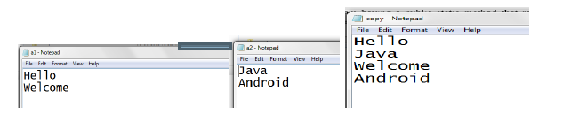

1. Write a Complete chapter on File Handling in java which includes Definition, importance, uses and different classes of File Handling. You have to write a program which completely explains the concept of file handling.

Write a java program that creates an object of Loan class and stores it in a file named output, read the Loan object from the file output and display total loan amount.

1. Write a Complete chapter on Exception Handling in java which includes Definition, importance, uses and different keywords. You have to write a program which completely explains the concept.

Write a java program with an exception handler that deals with negative radius exception. Your program should display a message that informs the user of the wrong input before exiting, and user can re-enter the correct input.

1. Write a Complete chapter on Collections in java which includes Definition, importance and uses.

Write a program to create two array lists containing “apple”, “orange”, “grapes”, “banana”, “strawberry”, “avocados” and “apple”, “apricots”, “orange”, “banana”, “mango”, “lemon” respectively and find their union, difference, and intersection using appropriate methods of Array List class.

1. Write a complete chapter on Inheritance in java which includes Definition of inheritance, importance, uses and its types. For each type you have to write a program which completely explains that type. Use inheritance with classes and interfaces.

Write a program to create a class Account (having attributes account_nos and balance) which inherits from Bank class (which contains two methods deposit and withdraw). Override the deposit method for cash and cheque. Create a class App which provides you a menu for deposit, withdraw, Account information and Exit. Perform all the above operations on the Account Number entered by the user.