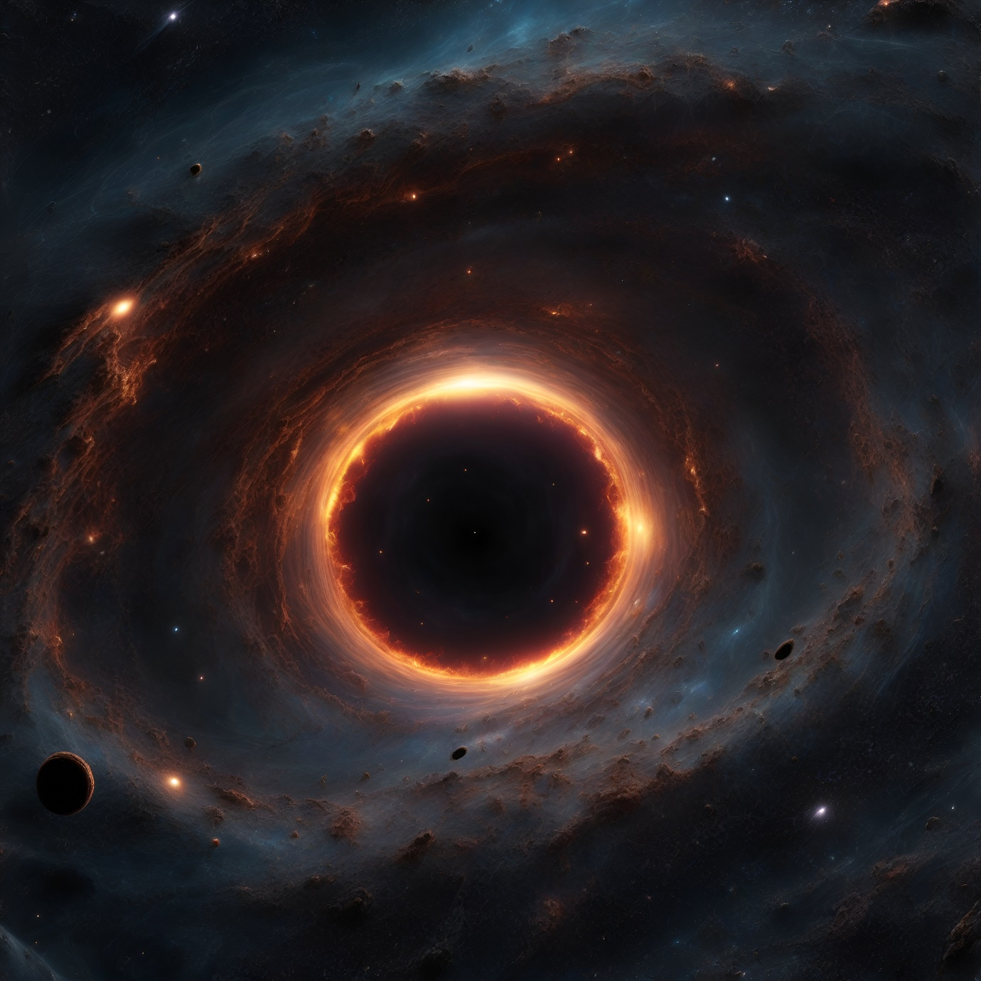

Prompt- A blackhole lost in the depths of space waiting to devour the planets, galaxies and travellers who have lost their paths. The gigantic black hole is scary and beautiful at the same time. It is an ethereal graveyard of galaxies.

Image Generation by Leonardo.ai