AgriSat AI Drip Irrigation System
Comprehensive Technical Report
CAET Campus, Dediapada • 21.628°N, 73.592°E • Navsari Agricultural University
System Type | Coverage | Cycle | Status
AI Satellite Drip | 3 Campus Zones | Every 3 Days | Autonomous

1. System Overview
AgriSat is an end-to-end, AI-driven precision irrigation platform specifically designed for the CAET campus at Dediapada. The system autonomously fuses satellite imagery, real-time weather intelligence, and soil physics to determine when and how much water to apply to each field zone — with zero manual intervention.

The system operates on a 3-day autonomous cron cycle. During each cycle, it:
- Acquires the latest cloud-free Sentinel-2 satellite scene over Dediapada
- Computes per-zone NDVI (Normalized Difference Vegetation Index)
- Fetches live weather data including ET₀, rainfall forecast, and VPD
- Applies a multi-layer decision logic to assign an irrigation status to each zone
- Issues valve commands and calculates the precise irrigation volume required
- Logs all decisions to CSV and Google Sheets for traceability
- Uploads NDVI maps and zone JSON reports to Google Drive

2. System Architecture — Three Layers

Layer 1: Satellite NDVI Engine (ndvi_harvester.py)
Queries Microsoft Planetary Computer for the latest cloud-free Sentinel-2 L2A scene over Dediapada. Key operations:
- Computes NDVI = (Band8_NIR − Band4_Red) / (Band8_NIR + Band4_Red)
- Generates a colourised JPEG map (red = bare/stressed, green = healthy vegetation)
- Clips NDVI to 3 named campus zones using saved GeoJSON boundaries (Shapely + Rasterio)
- Runs on a 3-day automatic cron cycle
- Uploads outputs to Google Drive via Selenium (incognito Chrome)

Layer 2: Weather Intelligence (get_weather_context + Open-Meteo)
Pulls live meteorological data from the Open-Meteo API (free, no API key required):

Parameter | Source | Purpose
ET₀ (mm/day) | Open-Meteo | Evapotranspiration rate — crop water loss
3-day Rain Forecast (mm) | Open-Meteo | Prevents unnecessary irrigation before rain
VPD (kPa) | Open-Meteo | Vapour Pressure Deficit — crop stress indicator

Weather Override Rules:

Condition | Override Action
STRESSED + Rain ≥ 15 mm forecast | → HOLD (skip irrigation)
HEALTHY/THRIVING + ET₀ > 8 mm/d | → MODERATE (irrigate sooner)
MODERATE + VPD > 3.0 kPa | → STRESSED (irrigate immediately)

Layer 3: Drip Decision Dashboard (app.py — Streamlit)
- Monitors 3 field zones (A, B, C) with live soil VWC (Volumetric Water Content)
- Calculates crop water demand using FAO Penman-Monteith ET₀ × Kc (crop coefficient)
- Drip system specs: 3 mm/hr application rate at 90% efficiency
- Fetches EOS-04 SAR data from ISRO Bhoonidhi API for radar-derived soil moisture
- Logs every irrigation decision to Google Sheets via service account

3. Soil Water Balance Model
The system uses a Soil Water Balance approach to determine crop water status and refill requirements.

Parameter | Value | Significance
Field Capacity (FC) | 32% | Maximum water soil can hold
Wilting Point (WP) | 14% | Minimum water before crop wilts
Total Available Water (TAW) | 18% | FC − WP = water available to crop
Refill Trigger (VWC) | 23% | WP + 50% × TAW — irrigation starts here

4. Key Equations

NDVI | NDVI = (Band8_NIR − Band4_Red) / (Band8_NIR + Band4_Red)

Soil Water Balance | Net VWC = Previous VWC + Rain − ET₀ × Kc − Drainage

Irrigation Volume | Vol (L) = (FC − VWC) × root_depth_m × area_m² ÷ drip_efficiency

Reference ET₀ | ET₀ = f(solar radiation, temperature, humidity, wind speed) [FAO Penman-Monteith]

5. NDVI Decision Thresholds

NDVI Range | Status | Action | Timeframe
< 0.25 | STRESSED | Irrigate | Within 24 hours
0.25 – 0.35 | MODERATE | Irrigate | In 2–3 days
0.35 – 0.50 | HEALTHY | Hold | Normal schedule
> 0.50 | THRIVING | No action | Skip cycle

6. Technologies & Components

Component | Technology | Notes
Satellite Imagery | Microsoft Planetary Computer | Sentinel-2 L2A — free, cloud API
Radar Soil Moisture | ISRO Bhoonidhi API | EOS-04 SAR C-band radar
Weather Data | Open-Meteo API | Free, no API key required
Dashboard | Python + Streamlit | Live zone monitoring
Zone Geometry | GeoJSON + Shapely + Rasterio | Campus boundary clipping
Drive Upload | Selenium (Chrome incognito) | Automated NDVI map upload
Data Logging | Google Sheets API | Service account, remote access
Map Display | Folium | Interactive zone maps

7. Output Files Per Cycle

File / Output | Contents
NDVI_Dediapada_scene-[date]_downloaded-[date].jpeg | Colourised NDVI satellite map of campus
NDVI_ZoneReport_scene-[date]_downloaded-[date].json | Per-zone NDVI, status, action, weather context
telemetry_log.csv | All irrigation decisions: timestamp, VWC, ET₀, valve state
Google Sheets (live) | Same telemetry, remotely accessible, auto-updated

8. System Decision Flowchart
The flowchart below illustrates the complete autonomous decision pipeline — from satellite data acquisition through valve command and logging, repeating every 3 days.

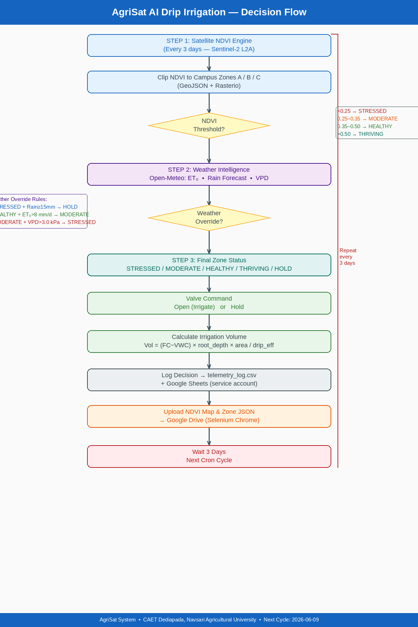

9. Decision Logic — Per Zone
Each zone (A, B, C) processes independently through the following sequential decision pipeline:

- Step 1 — NDVI Threshold: Raw satellite NDVI value is compared against 4 thresholds to assign a base status (STRESSED / MODERATE / HEALTHY / THRIVING)
- Step 2 — Weather Override: Live weather data (ET₀, rain forecast, VPD) is checked and may upgrade or downgrade the base status
- Step 3 — Final Status: Resolved zone status: STRESSED / MODERATE / HEALTHY / THRIVING / HOLD
- Step 4 — Valve Command: STRESSED or MODERATE → Open (irrigate); HEALTHY / THRIVING / HOLD → Keep closed
- Step 5 — Volume Calculation: Vol (L) = (FC − current VWC) × root_depth_m × area_m² / drip_efficiency
- Step 6 — Logging: Decision written to telemetry_log.csv and Google Sheets with timestamp

10. Operational Status

Field | Value
Location | CAET Campus, Dediapada — 21.628°N, 73.592°E
Institution | College of Agricultural Engineering & Technology, Navsari Agricultural University
Report Prepared | June 2026
Next Autonomous Cycle | 2026-06-09
System Mode | Fully Autonomous — 3-day cron
Zones Active | A, B, C (3 campus field zones)
Data Sources | Sentinel-2 L2A + ISRO EOS-04 SAR + Open-Meteo

This report was auto-generated from the AgriSat system design specification. All equations, thresholds, and logic are derived directly from FAO-56 Penman-Monteith guidelines and standard remote-sensing agronomic practice.

