Game Design Document

Fill up the Following document

1. Write the title of your project.

Quiz World

1. What is the goal of the game?

To enhance the knowledge of the Contestant

1. Write a brief story of your game?

**This is a simple quiz game. This is a simple quiz game**

**. Keep giving correct answers and keep scoring.(Hints are not available).**

**After every correct and wrong answer you will be given a information or a message describing the options.**

1. Which are the playing characters of this game?

* Playing characters are the ones which respond to the user based on the input from the user
* Cars, monkeys, dinos, wizards etc, are the playing characters in the game.

|  |  |  |
| --- | --- | --- |
| Number | Character Name | What can this character do? |
| 1 | Contestant | Playing the game |
| 2 |  |  |
| 3 |  |  |
| 4 |  |  |
| 5 |  |  |
| 6 |  |  |
| 7 |  |  |
| 8 |  |  |

1. Which are the Non Playing Characters of this game?

* Non Playing characters are the ones which don't have an action or a behaviour when the user interacts with the game.
* Hurdles, stones, bananas, coins, etc are non playing characters in the game.

|  |  |  |
| --- | --- | --- |
| Number | Character Name | What can this character do? |
| 1 | Question | Can be read |
| 2 | Options | Can be chosen |
| 3 | Expressions | Describers |
| 4 | Information | Can give knowledge |
| 5 |  |  |
| 6 |  |  |
| 7 |  |  |
| 8 |  |  |

Draw your imagination of this game. What does this game look like?

* Draw the game either on your computer or on paper,
* Add images of scenes of the game to show each of the playing and non-playing characters at least once.



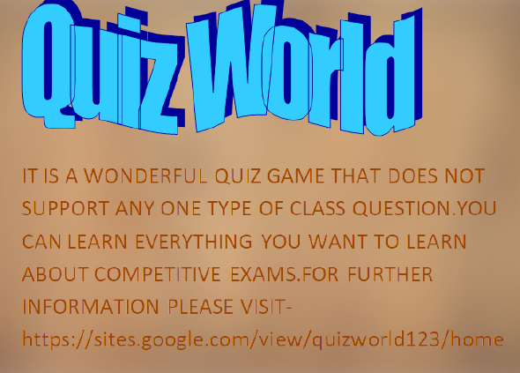

How do you plan to make your game engaging?

There are question and answers related to every class and every subject.