Week-4
Sequence and Activity Diagram
Software Engineering Lab

Sequence Diagram
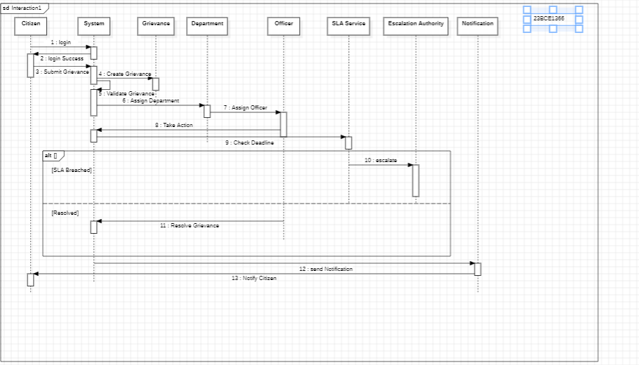

Activity Diagram

