WEEK -3
Software Engineering Lab

CLASS DIAGRAM

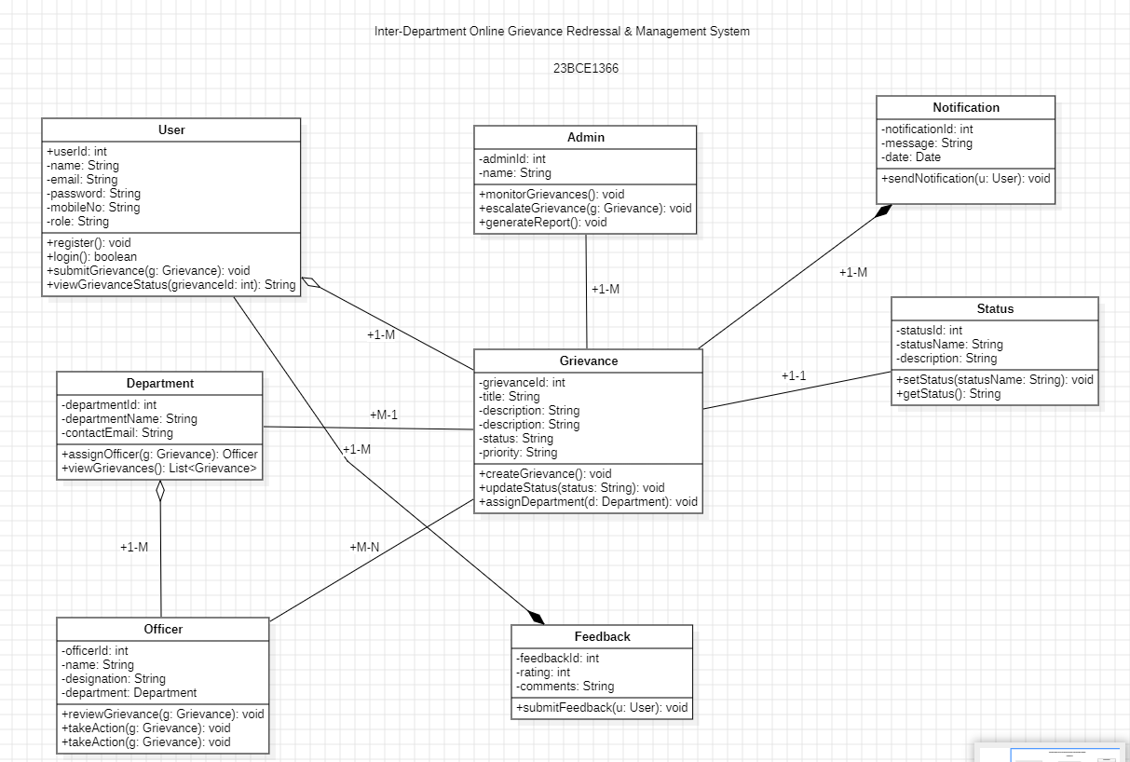

USE-CASE DIAGRAM

