4-Hour Theoretical Tutorial
Deep Learning Fundamentals
Neural Networks | Gradient Descent | Activation Functions | ANN Parameters | ANN Use Case | LSTM
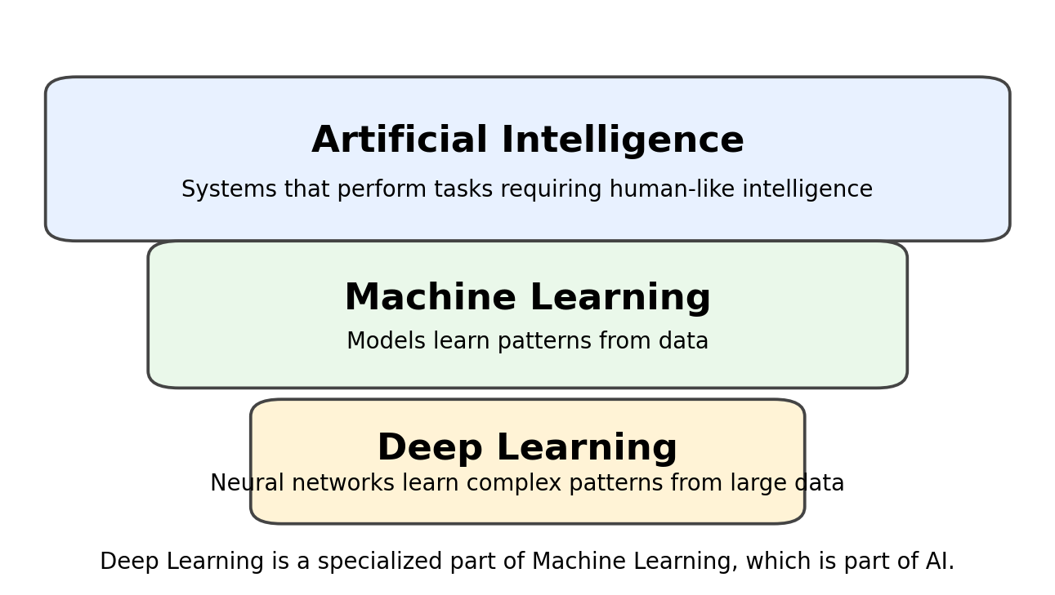
Figure 1: Deep Learning in the AI and Machine Learning family
Audience
Beginners who already understand basic machine learning concepts and want a clear theoretical introduction to deep learning.

Learning Outcome
Learners will be able to explain how neural networks learn, how gradient descent reduces error, why activation functions are needed, what ANN parameters mean, how ANN can solve a churn prediction use case, and why LSTM is used for sequence data.

Table of Contents
1. Tutorial Overview and 4-Hour Flow
2. Module 1: What is Deep Learning?
3. Module 2: Neural Network Fundamentals
4. Module 3: Gradient Descent Algorithm
5. Module 4: Activation Functions
6. Module 5: Parameters in Artificial Neural Networks
7. Module 6: Use Case - Customer Churn Prediction using ANN
8. Module 7: LSTM for Sequence and Time-Series Data
9. Recap, Quiz, and Teaching Notes

Tutorial Overview and 4-Hour Flow
This document is designed as a 4-hour instructor-led theoretical tutorial. It avoids heavy mathematics and explains each concept using business examples, diagrams, and simple language.
Time | Module | Topic | Focus
0:00 - 0:25 | Module 1 | Introduction to Deep Learning | What deep learning is and where it is used
0:25 - 0:55 | Module 2 | Neural Network Basics | Neurons, layers, forward pass, and simple intuition
0:55 - 1:25 | Module 3 | Gradient Descent | How neural networks reduce error step by step
1:25 - 1:55 | Module 4 | Activation Functions | ReLU, Sigmoid, Tanh, Softmax and non-linearity
1:55 - 2:25 | Module 5 | ANN Parameters | Weights, bias, epochs, batch size, learning rate, loss, optimizer
2:25 - 3:15 | Module 6 | ANN Use Case | Customer churn prediction using Artificial Neural Network
3:15 - 3:50 | Module 7 | LSTM | Why memory is needed for sequence and time-series data
3:50 - 4:00 | Module 8 | Recap and Q&A | Summary, quiz, and discussion points

Teaching Style
For every module: first explain the concept in layman terms, then show the diagram, then connect it to a real business example.

Module 1: What is Deep Learning?
Deep learning is a subfield of machine learning where we use artificial neural networks to learn patterns from data. The word "deep" comes from the use of multiple hidden layers in a neural network.
In traditional machine learning, we often manually design features. In deep learning, the network can learn useful representations automatically when enough data and computing power are available.
Problem Type | Deep Learning Example
Image classification | Detect cat vs dog, defective vs non-defective product
Text classification | Spam detection, sentiment analysis
Voice processing | Speech-to-text and voice assistants
Medical imaging | Disease detection from X-rays, MRI, CT images
Time-series forecasting | Sales forecasting, demand prediction, sensor anomaly detection

Layman Explanation
Deep learning is like a student who learns from many examples. The more examples the student sees, the better the student becomes at recognizing patterns.

Deep learning is powerful when data has complex relationships, such as images, sound, text, or time-based patterns. For small tabular datasets, classical machine learning can still work very well, so deep learning should be used when the problem complexity justifies it.

Module 2: Neural Network Fundamentals

What is a Neural Network?
A neural network is a model inspired by the human brain. It is made of small calculation units called neurons. Neurons are arranged in layers. Each layer receives information, transforms it, and passes it to the next layer.
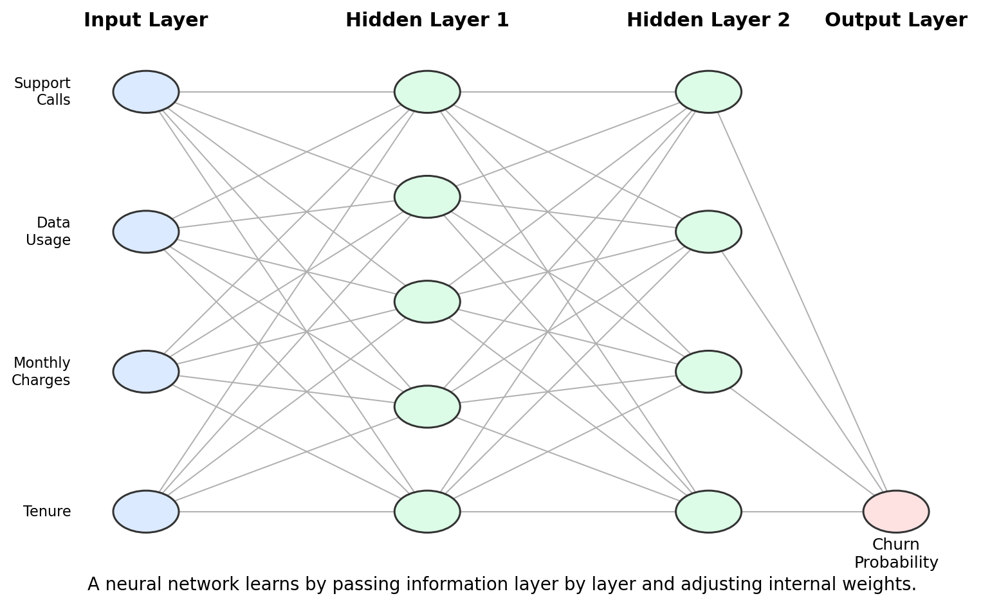
Figure 2: Basic neural network architecture
Layer | Role | Example in Churn Prediction
Input layer | Receives raw features | Tenure, monthly charges, data usage
Hidden layer | Learns intermediate patterns | High bill risk, low loyalty, service dissatisfaction
Output layer | Produces final answer | Churn probability

How a Single Neuron Works
A neuron receives multiple inputs. Each input is multiplied by a weight. A bias is added. Then an activation function decides the final output of the neuron.
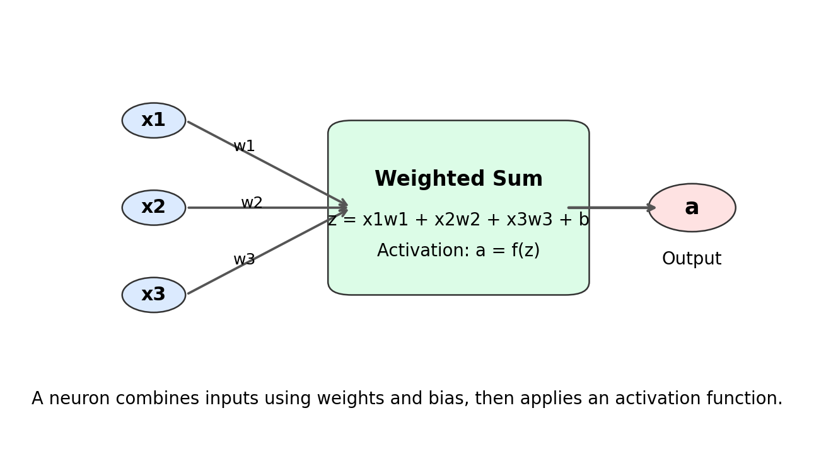
Figure 3: Single neuron calculation
Simple Formula
Neuron output = Activation(weighted sum of inputs + bias). The network learns by changing the weights and bias to reduce prediction error.

Module 3: Gradient Descent Algorithm

What is Gradient Descent?
Gradient descent is the learning process of a neural network. It helps the model reduce mistakes step by step. The model starts with random weights, makes predictions, calculates error, and then adjusts weights in the direction that reduces error.
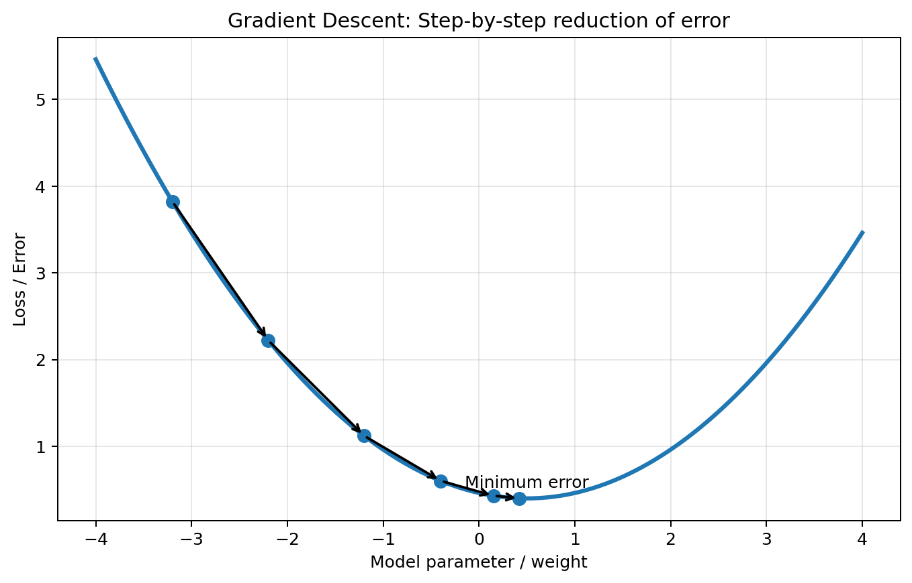
Figure 4: Gradient descent moving toward minimum error
Step | What Happens | Layman Meaning
1 | Model makes prediction | Student gives an answer
2 | Loss function calculates error | Teacher checks how wrong the answer is
3 | Gradient gives direction of improvement | Teacher tells how to improve
4 | Weights are updated | Student corrects the method
5 | Process repeats for many epochs | Practice continues until mistakes reduce

Learning Rate
The learning rate controls how big each update step is. If the learning rate is too small, training is slow. If it is too large, the model may jump around and fail to reach a good solution.
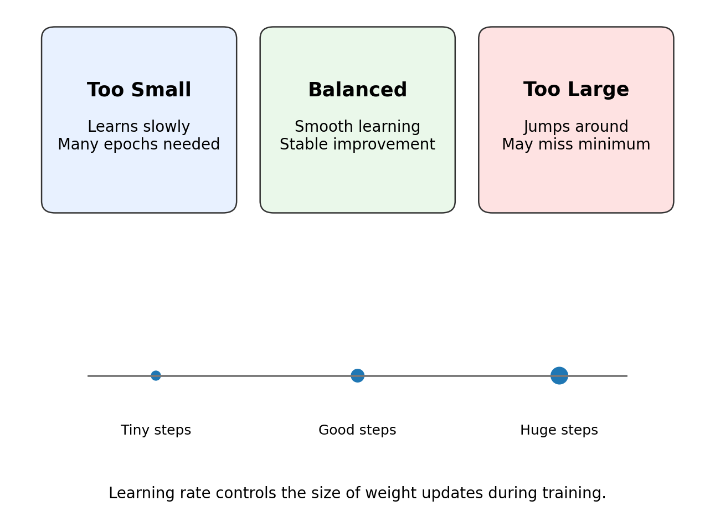
Figure 5: Learning rate controls the size of the learning step
Instructor Note
Use the hill example: the model is trying to walk downhill toward the lowest error. The learning rate controls the step size.

Module 4: Activation Functions
An activation function decides how much signal a neuron should pass forward. Without activation functions, multiple neural network layers would behave like a simple linear model. Activation functions add non-linearity, allowing neural networks to learn complex real-world relationships.
Activation Function | Output Range | Common Use
ReLU | 0 to infinity | Most common hidden-layer activation
Sigmoid | 0 to 1 | Binary classification output layer
Tanh | -1 to 1 | Sequence models and some hidden layers
Softmax | Class probabilities summing to 1 | Multi-class classification output layer

ReLU Activation
ReLU keeps positive values and converts negative values to zero. It is simple, fast, and widely used in hidden layers.
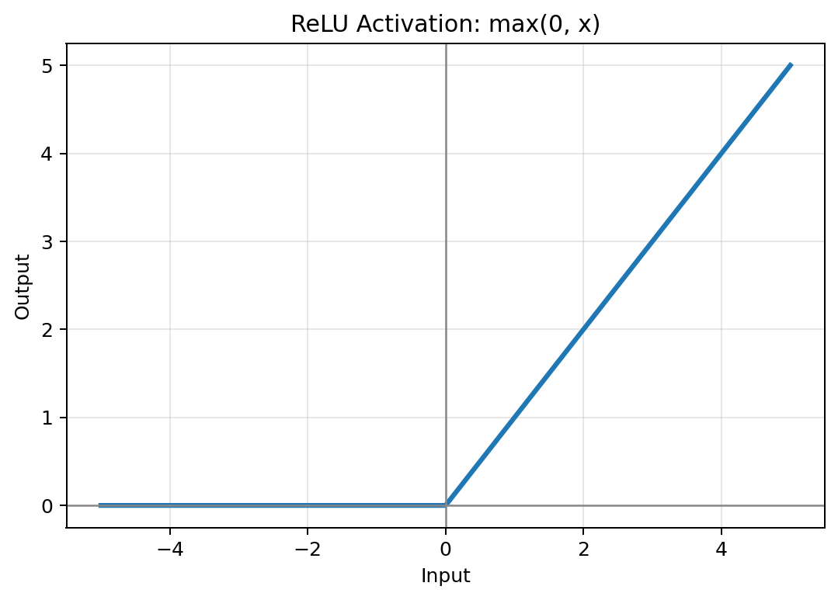
Figure 6: ReLU activation function

Sigmoid Activation
Sigmoid converts any input into a value between 0 and 1. This makes it useful when the final output is a probability, such as churn probability.
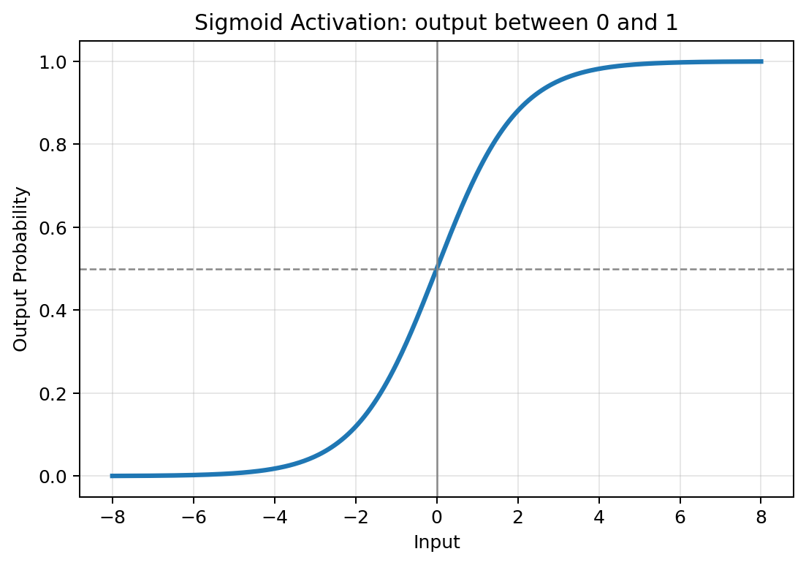
Figure 7: Sigmoid activation function

Tanh Activation
Tanh produces values between -1 and 1. It is centered around zero and is often discussed in recurrent neural networks and LSTM internals.
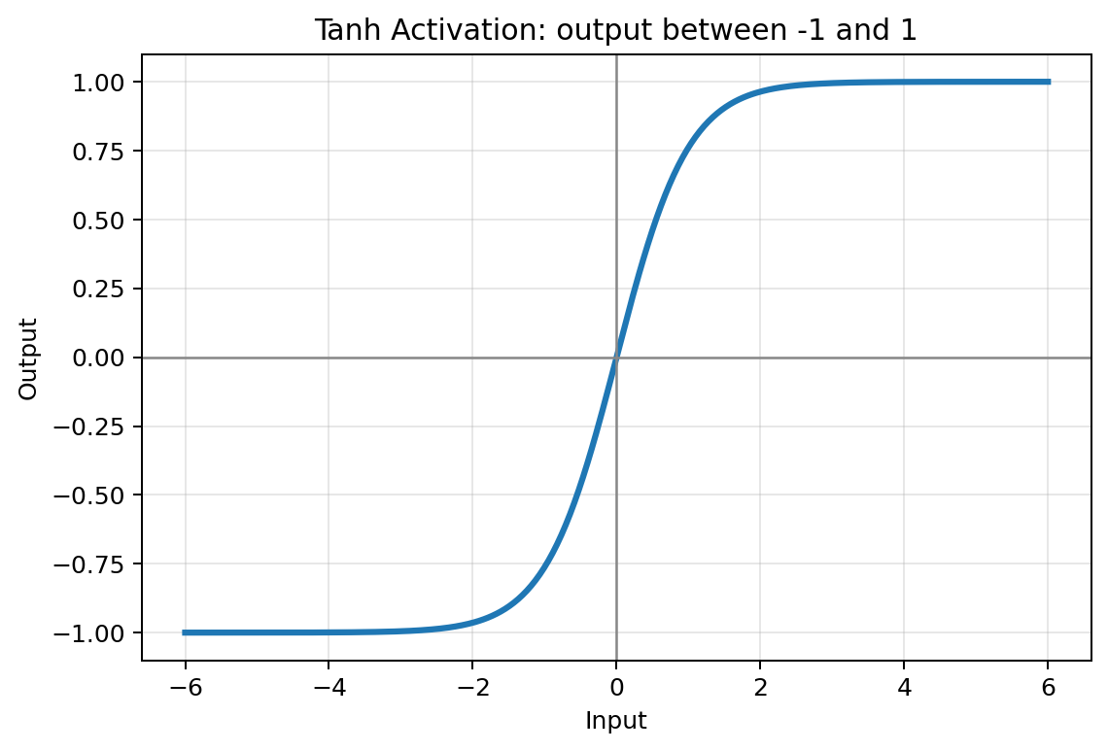
Figure 8: Tanh activation function

Module 5: Parameters in Artificial Neural Networks
An Artificial Neural Network has many values and settings that control how it learns. Some are learned from data, such as weights and bias. Others are chosen by the developer before training, such as epochs, batch size, and learning rate.
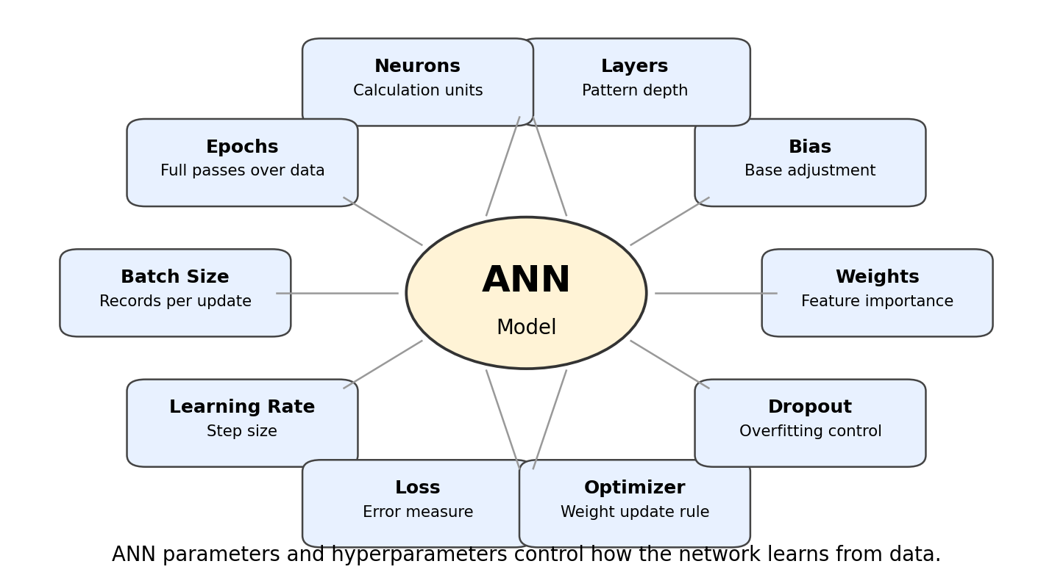
Figure 9: Important ANN parameters and hyperparameters
Term | Meaning | Layman Explanation
Weight | Importance given to an input | Higher weight means the feature has stronger influence
Bias | Extra adjustment value | Base adjustment before final decision
Neuron | Small calculation unit | Like one mini decision-maker
Layer | Group of neurons | Different stages of learning
Epoch | One full pass over training data | One full revision of all examples
Batch size | Records processed before weight update | How many examples the model studies at once
Learning rate | Size of each weight update | How big a correction step the model takes
Loss function | Measures prediction error | Teacher scoring the model mistake
Optimizer | Updates weights to reduce loss | Strategy used to improve the model
Dropout | Randomly switches off neurons during training | Prevents over-dependence on a few neurons

Parameter vs Hyperparameter
Parameters are learned by the model, such as weights and bias. Hyperparameters are chosen by us before training, such as learning rate, epochs, batch size, and number of neurons.

Module 6: Use Case - Customer Churn Prediction using ANN

Business Problem
A telecom company wants to predict whether a customer will leave the company. If the company can identify high-risk customers early, it can offer support, discounts, or retention plans.
Input Feature | Example Meaning
Tenure | How long the customer has stayed
Monthly charges | How much the customer pays every month
Data usage | How much internet data the customer uses
Contract type | Monthly, yearly, prepaid, etc.
Payment method | Auto debit, UPI, card, cash
Support calls | Number of complaints/support contacts
Internet service type | Fiber, DSL, 5G, broadband

ANN Architecture for Churn Prediction
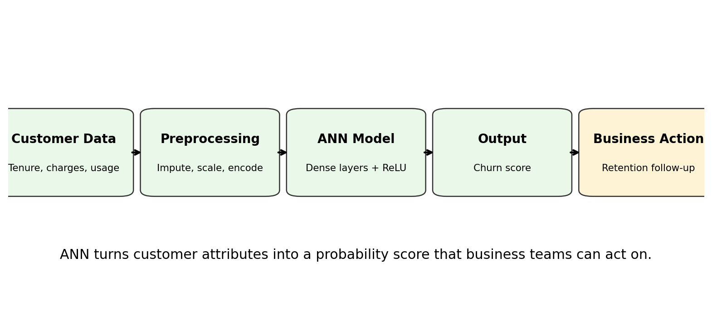
Figure 10: ANN-based churn prediction flow
A simple ANN for churn prediction may use dense hidden layers with ReLU activation and an output layer with sigmoid activation. The output is a probability between 0 and 1.
ANN Component | Suggested Choice | Why
Input layer | One input per processed feature | The model receives all customer attributes
Hidden layer 1 | 64 neurons with ReLU | Learns broad customer behavior patterns
Hidden layer 2 | 32 neurons with ReLU | Learns refined churn-related patterns
Dropout | 0.2 to 0.3 | Reduces overfitting
Output layer | 1 neuron with Sigmoid | Outputs churn probability
Loss function | Binary crossentropy | Best suited for yes/no classification
Optimizer | Adam | Popular optimizer

Business Interpretation
If the ANN outputs 0.82 for a customer, it means the model estimates an 82 percent chance of churn. The business can then decide what action to take based on risk category.
Churn Probability | Risk Level | Possible Action
0.00 - 0.30 | Low risk | No urgent action
0.31 - 0.70 | Medium risk | Send engagement message or service check
0.71 - 1.00 | High risk | Offer retention plan or priority support

Module 7: LSTM for Sequence and Time-Series Data

What is LSTM?
LSTM stands for Long Short-Term Memory. It is a special type of neural network designed for sequence data. Sequence data is data where order matters. Examples include sales over months, stock prices over days, text sentences, and sensor readings over time.
Data Type | Why Sequence Matters
Sales data | This month may depend on previous months
Stock prices | Today may depend on earlier trend and volatility
Text | Meaning of a word depends on previous words
Weather | Future weather depends on past patterns
Sensor readings | Current anomaly may depend on earlier readings

Why Normal ANN is Not Enough
A normal ANN usually treats input rows independently. But in sequence problems, previous observations carry useful memory. LSTM is designed to remember important past information and forget less useful information.
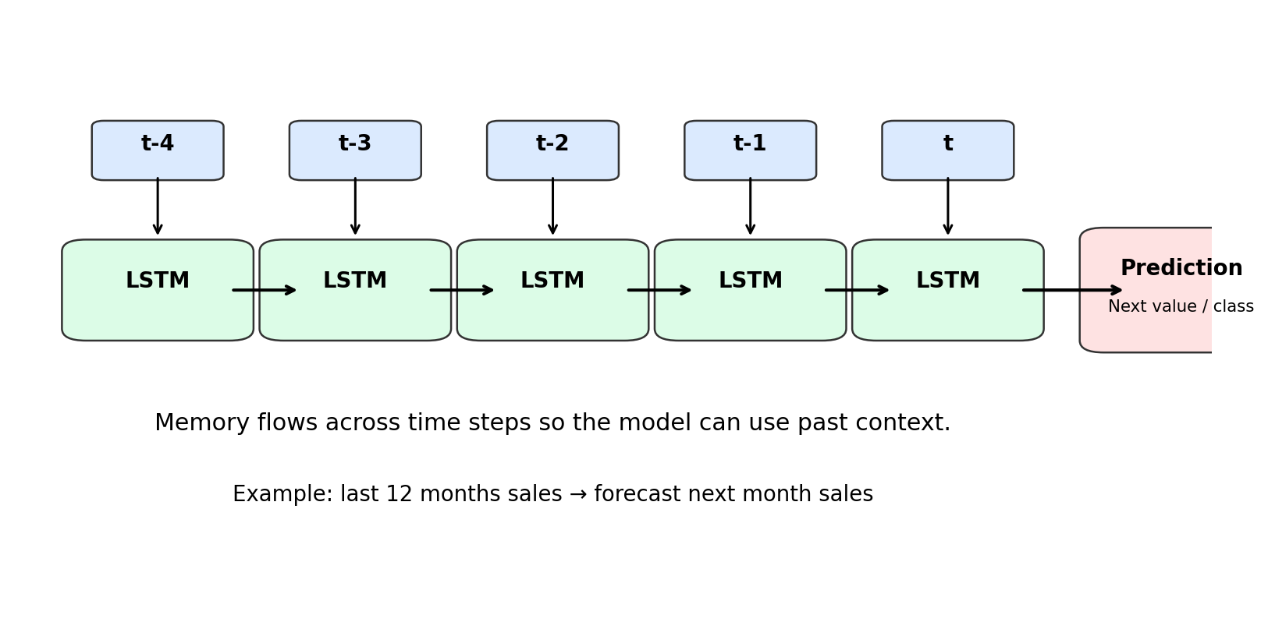
Figure 11: LSTM processes ordered time steps with memory

LSTM Gates in Simple Language
LSTM uses gates to control memory. You can explain gates as filters that decide what to forget, what to add, and what to output.
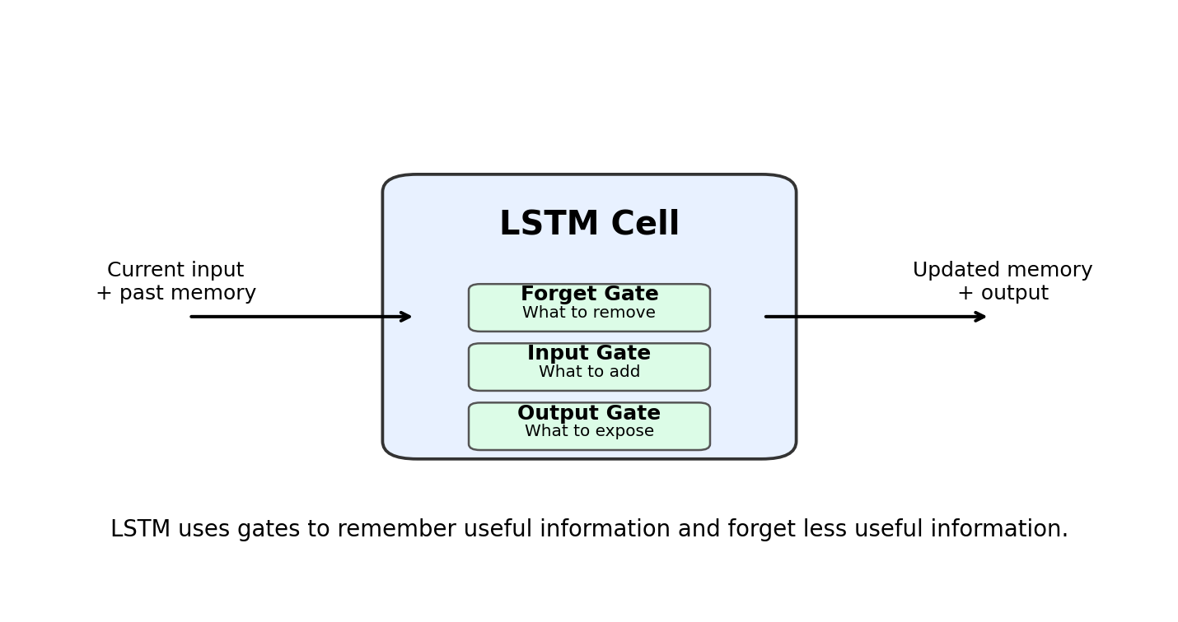
Figure 12: LSTM gates help manage memory
Gate | Simple Meaning | Example
Forget gate | Decides what old information to remove | Ignore old sales spike caused by one festival
Input gate | Decides what new information to store | Store recent increasing sales trend
Output gate | Decides what information to pass forward | Use current memory for next-month forecast

Layman Analogy
LSTM is like watching a movie. To understand the current scene, you remember important previous scenes and forget unnecessary details.

Recap and Teaching Notes
Concept | One-Line Explanation
Neural Network | A model made of layers and neurons that learns patterns from examples
Gradient Descent | The process of reducing model error step by step
Activation Function | Adds non-linearity so the model can learn complex patterns
ANN Parameters | Values and settings that control how a neural network learns
ANN Use Case | Customer churn prediction using tabular customer data
LSTM | A neural network designed for ordered sequence and time-series data

Final Beginner Explanation
A neural network is like a student learning from examples. Gradient descent is how the student reduces mistakes. Activation functions help the student understand complex patterns. ANN works well for tabular business problems like churn prediction. LSTM works when memory and sequence matter, such as sales forecasting.

Quick Quiz for Students
1. Why do neural networks need hidden layers?
2. What happens if the learning rate is too high?
3. Why is ReLU commonly used in hidden layers?
4. Why is Sigmoid useful for binary classification?
5. What is the difference between weights and bias?
6. Why is dropout used?
7. Why is LSTM better than normal ANN for time-series data?
8. Give one business use case where ANN can be used.
9. Give one business use case where LSTM can be used.
10. Explain deep learning to a non-technical manager in two sentences.

Suggested Closing Script
Today we learned that deep learning is not magic. It is a structured way of learning patterns using layers of neurons. The model learns by reducing error through gradient descent. Activation functions allow it to learn complex relationships. ANN is useful for business classification problems like churn prediction, while LSTM is useful when past sequence matters, such as sales forecasting or sensor prediction.

