LANGGRAPH 101
Building Production-Ready Agentic AI Systems
A complete hands-on tutorial inspired by the Deep Research Agent architecture
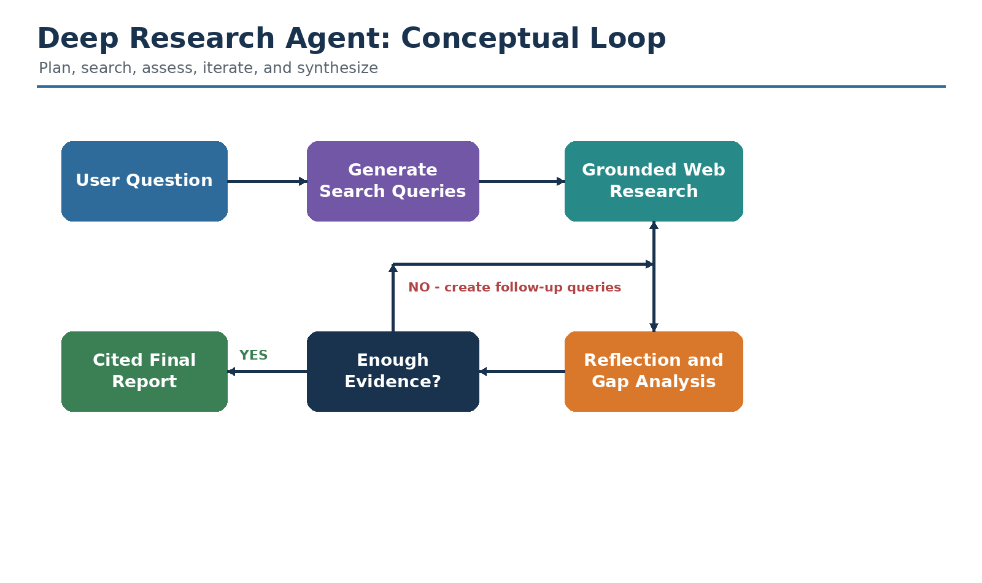
Concepts | Logical diagrams | Annotated code | Production architecture | SAP mapping
Prepared as an original educational synthesis

Preface
This manual is an original tutorial built from the concepts in Shuai Guo's Towards Data Science article "LangGraph 101: Let's Build a Deep Research Agent" and from current official LangGraph, Gemini, LangSmith, and SAP learning resources. It does not reproduce the article verbatim. Instead, it reorganizes the ideas into a self-contained learning path, modernizes selected implementation patterns, adds a complete reference project, and expands the production, evaluation, governance, deployment, and SAP Business AI sections.
Version note: Agent frameworks and model SDKs evolve quickly. The implementation uses the LangGraph v1-style runtime-context pattern and the Google Gen AI SDK's current Google Search grounding interface as of July 2026. Always validate package compatibility in a fresh virtual environment before production use.

What this Word guide contains
- Conceptual foundations: agentic AI, workflows, agents, deep research, graphs, state, nodes, and edges.
- Fourteen original logical diagrams explaining the complete architecture.
- A modular Python implementation using LangGraph, Gemini structured output, and grounded Google Search.
- Detailed explanations of query generation, state reducers, citation handling, reflection, routing, parallel Send tasks, and final synthesis.
- Production topics: retry, timeout, persistence, checkpoints, human approval, streaming, MCP, observability, evaluation, security, cost, and deployment.
- An SAP Business AI mapping using SAP BTP, SAP AI Core, Generative AI Hub, SAP HANA Cloud vector capabilities, SAP Integration Suite, and SAP application data.
- Interview questions, practical exercises, implementation checklists, and a troubleshooting guide.

Learning outcomes
1. Explain why graph-based orchestration is useful for nonlinear, stateful AI workflows.
2. Define a LangGraph state schema and choose appropriate reducers.
3. Build modular nodes with clear input and output contracts.
4. Force reliable LLM responses with Pydantic structured output.
5. Connect an agent to current web information and preserve source metadata.
6. Create bounded research loops using reflection and conditional routing.
7. Run multiple searches concurrently with the Send API and merge the results safely.
8. Configure, trace, test, secure, deploy, and evaluate an enterprise research agent.
9. Map the architecture to an SAP Business AI implementation.

Table of contents
- 1. Agentic AI and the Deep Research Pattern
- 2. Modeling the Workflow with Graphs, Nodes, and Edges
- 3. State Management: The Agent's Working Memory
- 4. Designing Modular Node Operations
- 5. Structured Output with Pydantic
- 6. Prompt Engineering for Research Agents
- 7. Tool Calling and Grounded Web Research
- 8. Citations and Source Provenance
- 9. Reflection and Knowledge-Gap Analysis
- 10. Conditional Routing and Loop Control
- 11. Parallel Processing with Send
- 12. Runtime Configuration and Dependency Injection
- 13. Complete Project Setup
- 14. End-to-End Reference Implementation
- 15. Running, Debugging, and Testing the Agent
- 16. Reliability: Retry, Caching, Checkpoints, Streaming, HITL, and MCP
- 17. Observability and Evaluation
- 18. Security, Governance, and Responsible AI
- 19. Cost and Latency Optimization
- 20. SAP Business AI Mapping
- 21. Deployment Architecture
- 22. Interview Questions and Answers
- 23. Hands-on Exercises and Extensions
- 24. Production Checklist and Common Failure Modes
- 25. References

1. Agentic AI and the Deep Research Pattern
Concept: Agentic AI is a goal-directed system in which a model can plan or choose actions, call tools, observe results, update its working state, and continue until a completion condition is met. A deep research agent is a bounded agentic workflow that iteratively searches, evaluates evidence, fills knowledge gaps, and writes a cited report.

Figure 1. A bounded deep-research loop: plan, search, reflect, and synthesize.

1.1 Chatbot, workflow, agent, and RAG
Pattern | Decision logic | External tools | Iteration | Typical use
Chatbot | Mostly one model response | Optional | Usually no | Conversation and drafting
Deterministic workflow | Predetermined by code | Common | Only predefined loops | Stable business process
Agent | Partly decided at runtime | Core capability | Yes, until stop condition | Open-ended tasks
RAG | Retrieve then generate | Retriever or vector search | Often single pass | Knowledge-grounded answers
Agentic RAG / research | Dynamic retrieval and evaluation | Several tools | Yes | Complex research and diagnosis

The deep research pattern sits between a completely free autonomous agent and a rigid workflow. The graph limits the agent to approved steps, tools, and maximum loops, but the model still makes useful runtime decisions such as which search queries to generate and whether the collected evidence is sufficient.

1.2 Why ordinary LLM calls are not enough
- A model's internal knowledge may be outdated or incomplete.
- A single answer does not expose how the system gathered evidence.
- The model may confidently fill missing facts with plausible but unsupported text.
- Broad questions often contain several subtopics that require separate searches.
- One search pass can miss contradictions, recency requirements, or specialist sources.
- Without state, every step works in isolation and cannot reliably build on previous results.

1.3 Example use cases
- Market and competitor research with source citations.
- Technical investigation across product documentation, release notes, and issue trackers.
- Enterprise policy analysis across HR, security, procurement, and legal sources.
- SAP incident research combining SAP Notes, internal runbooks, system logs, and configuration data.
- Vendor due diligence with human approval before high-impact conclusions.
- Medical or legal literature reviews where the agent assists but does not replace qualified professional judgment.
Design principle: Autonomy should be bounded. Specify the allowed tools, maximum iterations, stopping rules, data-access boundaries, and human-approval points before increasing model freedom.

2. Modeling the Workflow with Graphs, Nodes, and Edges
Concept: LangGraph represents a workflow as a graph. State contains the current data snapshot, nodes perform work, and edges determine the next step. This representation naturally expresses sequential steps, branches, loops, parallel paths, and termination.
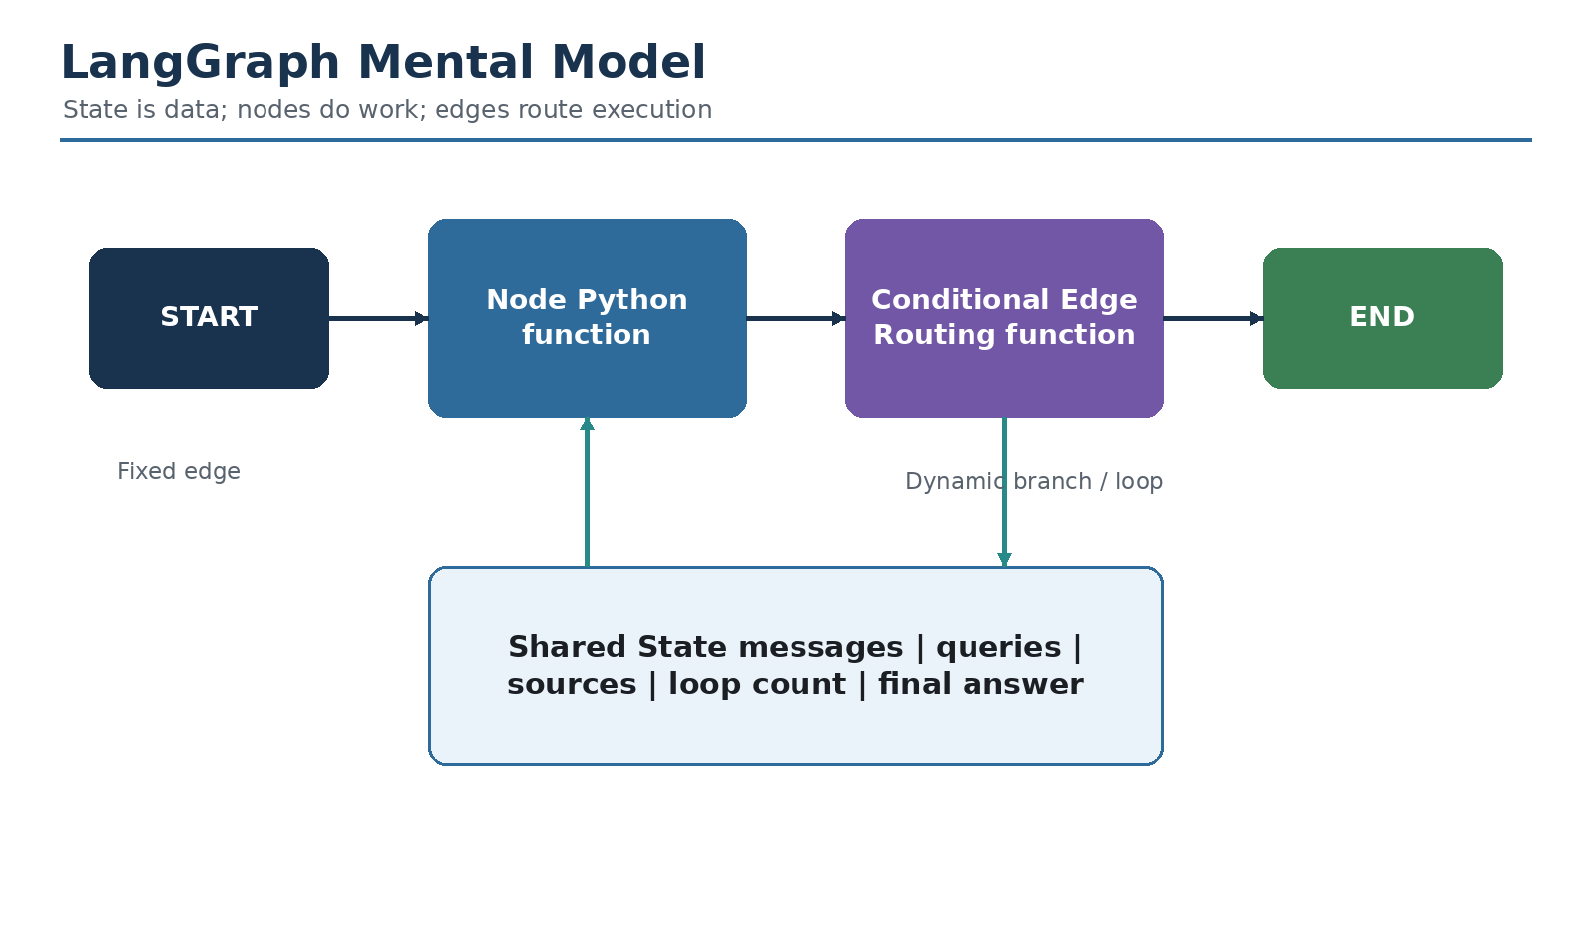
Figure 2. The graph mental model: nodes work, edges route, and state connects the entire run.

2.1 StateGraph
StateGraph is the builder used to assemble a stateful graph. The constructor receives the state schema. Modern LangGraph can also receive a context schema for immutable per-run configuration and dependencies.
Code 2.1 - Creating the graph container
from langgraph.graph import StateGraph
from state import OverallState
from context import AgentContext
builder = StateGraph(
OverallState,
context_schema=AgentContext,
)

2.2 Nodes
A node is normally a Python function. It receives the state and optionally runtime information. It performs one cohesive responsibility and returns a partial state update. A node may call an LLM, execute a tool, validate data, or transform evidence.
Code 2.2 - Minimal node pattern
def generate_query(state: OverallState, runtime: Runtime[AgentContext]):
# Read the user's question from state.
# Read model and limit settings from runtime.context.
# Return only the query_list update.
return {"query_list": ["query one", "query two"]}

2.3 Static edges
Use a static edge when the destination is always the same. After web research completes, for example, the workflow always moves to reflection.
Code 2.3 - Fixed transition
builder.add_edge("web_research", "reflection")

2.4 Conditional edges
A conditional edge calls a routing function after a node completes. The routing result identifies the destination node or returns Send instructions for dynamically created parallel branches.
Code 2.4 - Dynamic routing
builder.add_conditional_edges(
"reflection",
route_after_reflection,
["web_research", "finalize_answer"],
)

2.5 START and END
Code 2.5 - Entry and termination
from langgraph.graph import START, END
builder.add_edge(START, "generate_query")
builder.add_edge("finalize_answer", END)

2.6 Compile and invoke
Code 2.6 - Compile and execute
graph = builder.compile()
result = graph.invoke(
{"messages": [{"role": "user", "content": "Research agentic AI governance"}]},
context={"number_of_initial_queries": 3, "max_research_loops": 2},
)
Why graphs shine: Named nodes and edges improve visualization, traceability, unit testing, reuse, failure isolation, and parallelism. The graph is explicit enough for engineering control but flexible enough for model-driven decisions.

3. State Management: The Agent's Working Memory
Concept: State is the mutable, run-scoped memory of the workflow. Every node reads the current snapshot and returns only the keys it wants to update. Reducers define whether a new value replaces the old one or is accumulated.
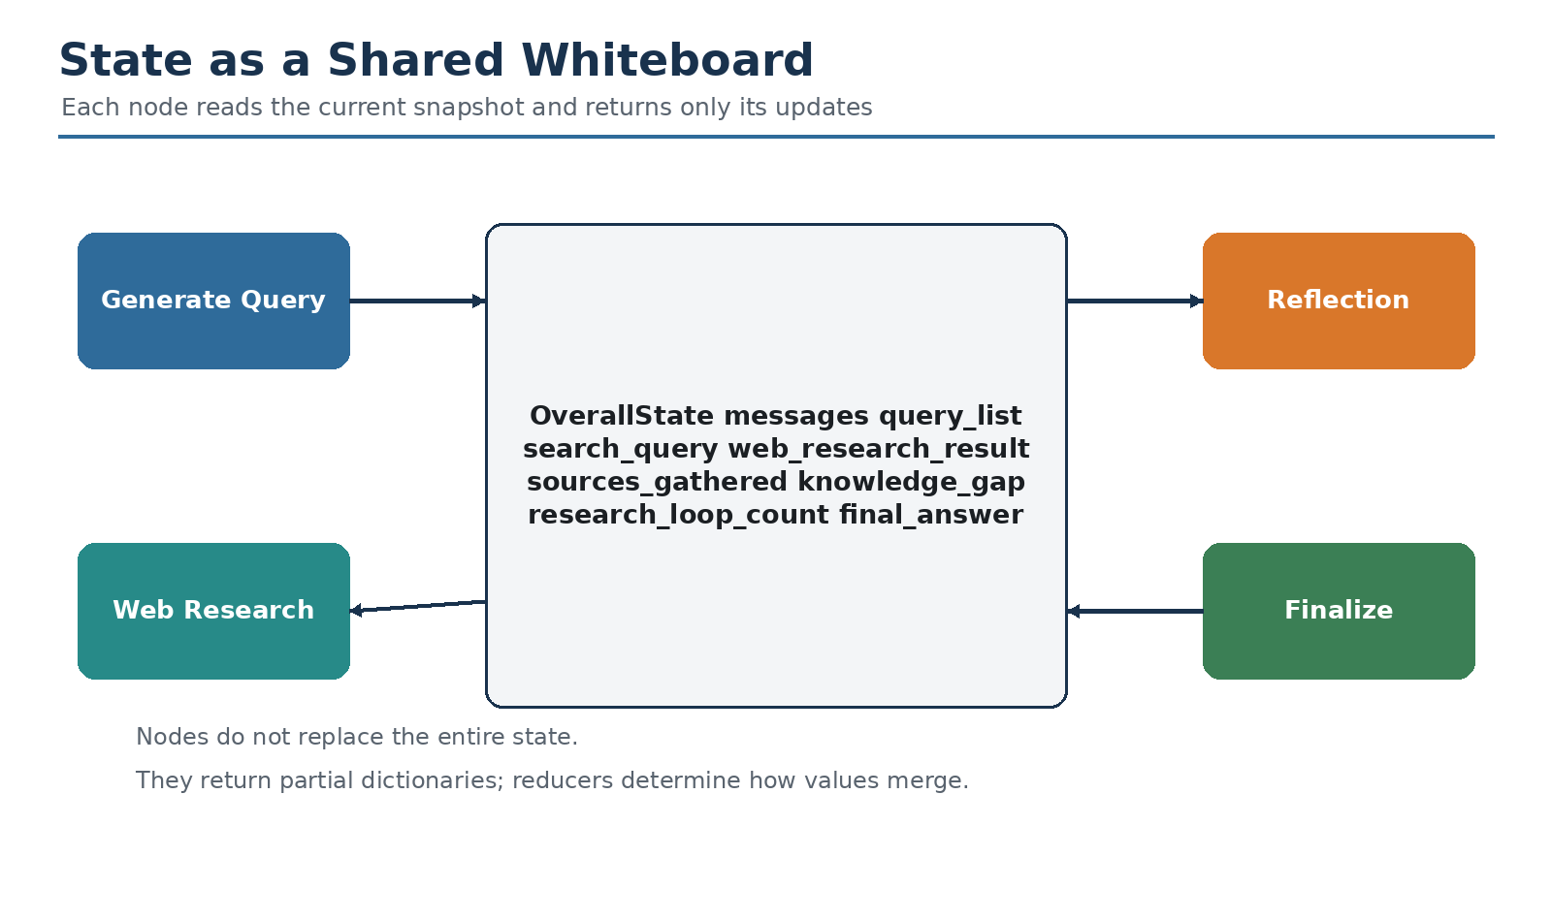
Figure 3. Nodes collaborate through one shared state snapshot.

3.1 OverallState
Code 3.1 - Global graph state
from typing import Annotated, Any
from typing_extensions import TypedDict
import operator
from langchain.messages import AnyMessage
from langgraph.graph.message import add_messages
class OverallState(TypedDict, total=False):
messages: Annotated[list[AnyMessage], add_messages]
query_list: list[str]
search_query: Annotated[list[str], operator.add]
web_research_result: Annotated[list[str], operator.add]
sources_gathered: Annotated[list[dict[str, Any]], operator.add]
is_sufficient: bool
knowledge_gap: str
follow_up_queries: list[str]
research_loop_count: int
final_answer: str

3.2 Reducers
Declaration | Merge behavior | Use case
field: str | Replace previous value | Latest decision or final answer
Annotated[list, operator.add] | Concatenate lists | Parallel search results and sources
Annotated[list, add_messages] | Message-aware merge | Conversation history
Custom reducer | Developer-defined | Deduplication, maximum score, map merge

Reducers become especially important when parallel nodes write to the same state key. Without a reducer, competing updates can conflict. For search results, list concatenation is a natural fan-in strategy; deduplication can occur later in the finalization node.

3.3 Node-specific state views
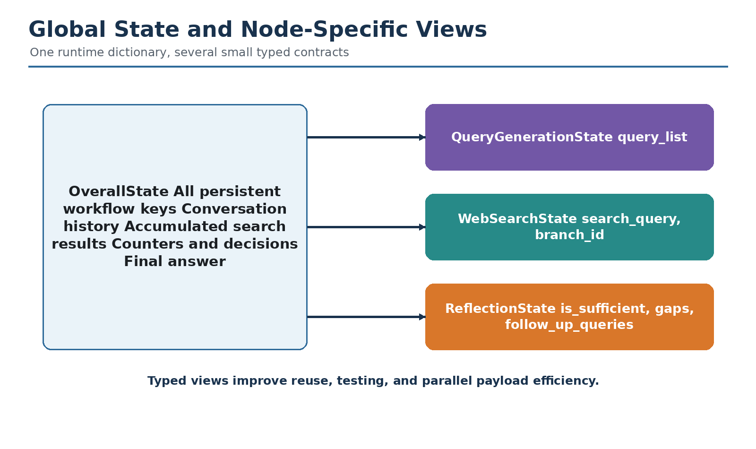
Figure 4. Small typed contracts are views over the single global runtime state.
Code 3.2 - Focused node contracts
class QueryGenerationState(TypedDict):
query_list: list[str]
class WebSearchState(TypedDict):
search_query: str
branch_id: int
class ReflectionState(TypedDict):
is_sufficient: bool
knowledge_gap: str
follow_up_queries: list[str]
research_loop_count: int

3.4 Practical state rules
- Persist a key in OverallState when several nodes need to read it later.
- Return minimal updates rather than rebuilding the whole state.
- Use reducers for keys that can receive parallel or repeated updates.
- Keep large raw objects out of state when a compact identifier is sufficient.
- Do not store API keys, passwords, or secrets in graph state.
- Use runtime context for immutable dependencies and state for mutable progress.
- Add explicit counters and stop conditions for loops.
Mental model: There is one runtime state. Node-specific TypedDicts improve typing and documentation; they are not separate databases.

4. Designing Modular Node Operations
Concept: A strong node has one responsibility, explicit inputs, validated outputs, predictable side effects, and testable behavior. The research agent uses separate nodes for query generation, search, reflection, routing, and finalization.
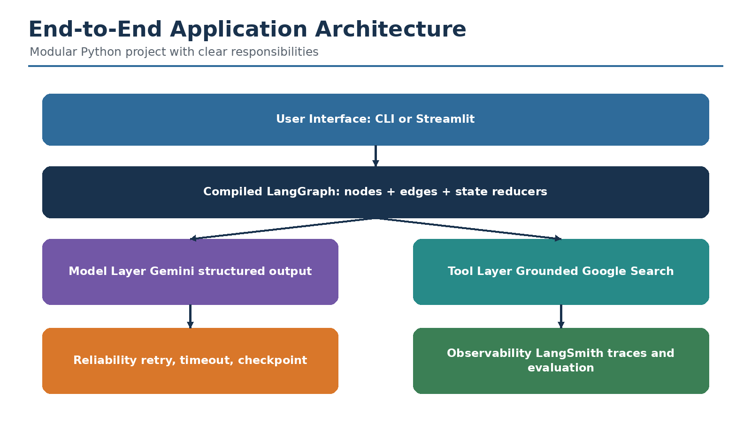
Figure 5. Application layers separate orchestration, model calls, tools, reliability, and observability.

4.1 Node responsibility matrix
Node | Primary input | Primary output | Why separate it
generate_query | User question and query limit | query_list | Planning can be tested without web access
web_research | One search query | Evidence and source metadata | Tool failures are isolated per branch
reflection | All evidence collected so far | Sufficiency and gaps | Evaluation uses a different prompt and model role
route_after_reflection | Reflection decision and counters | Next node or Send tasks | Routing remains deterministic code
finalize_answer | Evidence and sources | Cited final report | Synthesis is separated from retrieval

4.2 Node design template
Code 4.1 - Reusable node template
def node_name(state: InputState, runtime: Runtime[AgentContext]) -> dict:
# 1. Validate required state values.
# 2. Read immutable dependencies from runtime.context.
# 3. Perform one cohesive operation.
# 4. Handle known exceptions or allow retry policy to act.
# 5. Return the smallest valid state update.
return {"some_key": computed_value}

4.3 Separation of concerns
Query generation determines what to search. The dispatcher decides how many workers to create. The search node performs the tool call. Reflection assesses evidence. Routing applies explicit limits. Finalization writes the report. This separation makes failures observable and components reusable.

5. Structured Output with Pydantic
Concept: Agent workflows cannot depend on loosely formatted prose for routing. Structured output constrains the model to a schema and converts the result into a validated Python object.
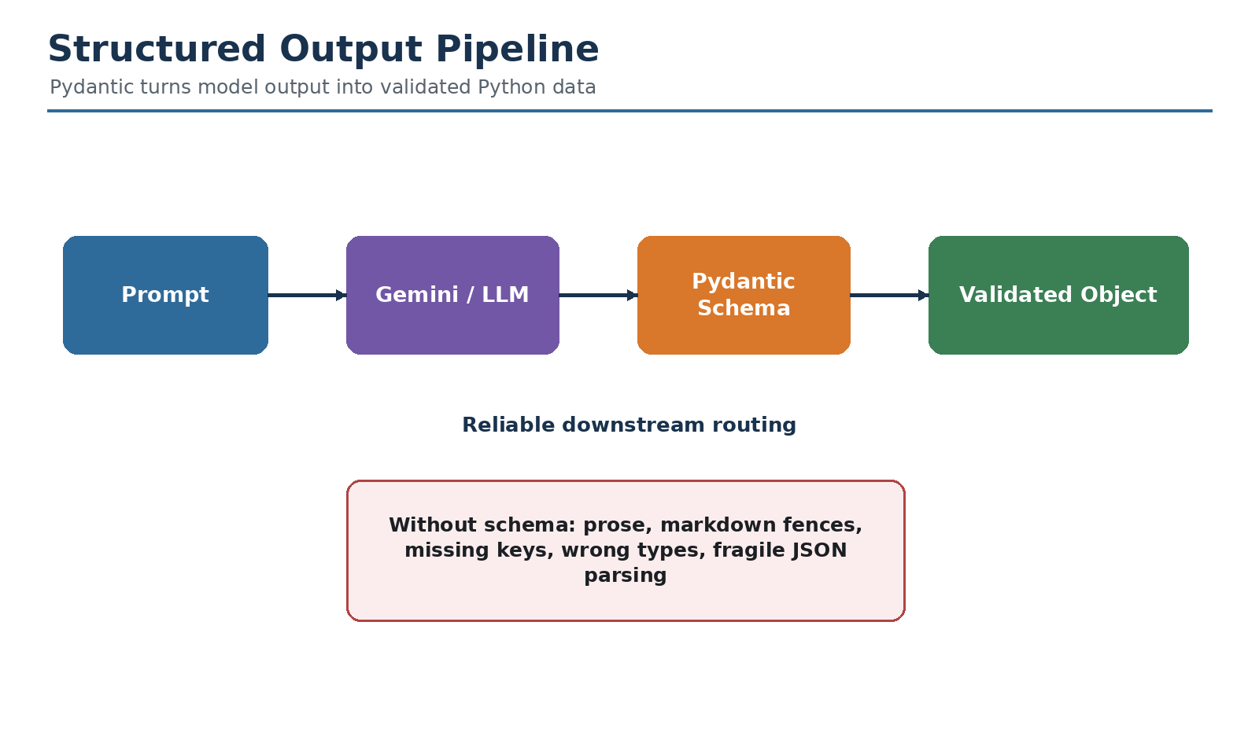
Figure 6. Structured output converts a probabilistic model response into a reliable software contract.

5.1 Query schema
Code 5.1 - Pydantic model for search planning
from pydantic import BaseModel, Field
class SearchQueryList(BaseModel):
rationale: str = Field(
description="Why the proposed queries cover the research question."
)
query: list[str] = Field(
description="Distinct, focused web search queries."
)

5.2 Reflection schema
Code 5.2 - Pydantic model for research evaluation
class ReflectionResult(BaseModel):
is_sufficient: bool
knowledge_gap: str = ""
follow_up_queries: list[str] = Field(default_factory=list)

5.3 Binding the schema to Gemini
Code 5.3 - Validated model response
from langchain_google_genai import ChatGoogleGenerativeAI
llm = ChatGoogleGenerativeAI(
model=runtime.context.query_model,
temperature=0.2,
max_retries=2,
)
structured_llm = llm.with_structured_output(SearchQueryList)
result = structured_llm.invoke(formatted_prompt)
queries = result.query

5.4 Validation and fallback
Code 5.4 - Defensive structured-output handling
from pydantic import ValidationError
try:
result = structured_llm.invoke(prompt)
except ValidationError as exc:
# Log the schema mismatch and retry with a stricter prompt,
# or return a safe deterministic fallback query.
result = SearchQueryList(
rationale="Fallback to the original user question.",
query=[user_question],
)
Best practice: Use temperature near zero for classification, routing, validation, and extraction. Use higher creativity only when the task benefits from diverse wording or query exploration.

6. Prompt Engineering for Research Agents
Concept: Prompts define the role, objective, constraints, available evidence, expected schema, and stopping behavior for each node. Separate prompts are preferable to one oversized agent prompt because each node has a specific responsibility.

6.1 Query-writer prompt
Code 6.1 - Query planning prompt
QUERY_WRITER_PROMPT = '''
You are the planning component of a research agent.
Current date: {current_date}
Research topic: {research_topic}
Maximum queries: {number_queries}
Generate distinct, focused search queries.
Prefer one query when one query is sufficient.
Use multiple queries only when the topic has separate aspects.
Include recency terms when the question depends on current information.
Do not create near-duplicate queries.
Return data that matches the SearchQueryList schema.
'''

6.2 Research prompt
Code 6.2 - Grounded research prompt
WEB_RESEARCH_PROMPT = '''
Research the following query using Google Search:
{search_query}
Requirements:
- Prefer authoritative and primary sources.
- Separate confirmed facts from interpretation.
- Capture relevant dates and definitions.
- Do not invent facts that are absent from the search evidence.
- Produce a concise evidence summary that can be combined with other branches.
'''

6.3 Reflection prompt
Code 6.3 - Evidence assessment prompt
REFLECTION_PROMPT = '''
Research topic:
{research_topic}
Evidence collected:
{evidence}
Assess whether the evidence is sufficient for a complete, accurate, cited answer.
Identify contradictions, missing subtopics, stale evidence, or weak sources.
If evidence is insufficient, propose focused follow-up queries.
Return data matching the ReflectionResult schema.
'''

6.4 Final synthesis prompt
Code 6.4 - Cited synthesis prompt
FINAL_ANSWER_PROMPT = '''
Write a well-structured research report answering:
{research_topic}
Use only the supplied evidence.
Preserve citation markers.
Distinguish fact, uncertainty, and inference.
Do not add unsupported claims.
Use descriptive headings and a concise conclusion.
Evidence:
{evidence}
'''

6.5 Prompt-quality checklist
- State the model's role and one primary objective.
- Provide the current date for time-sensitive research.
- Define source-quality expectations.
- Specify what the model must not do.
- Provide the exact structured-output schema through the model wrapper.
- Keep evidence clearly separated from instructions to reduce prompt injection risk.
- Test prompts against ambiguous, adversarial, empty-result, and conflicting-source cases.

7. Tool Calling and Grounded Web Research
Concept: The research node connects the model to current information. Gemini's Google Search grounding can return an answer together with grounding metadata that identifies supporting sources and text segments.
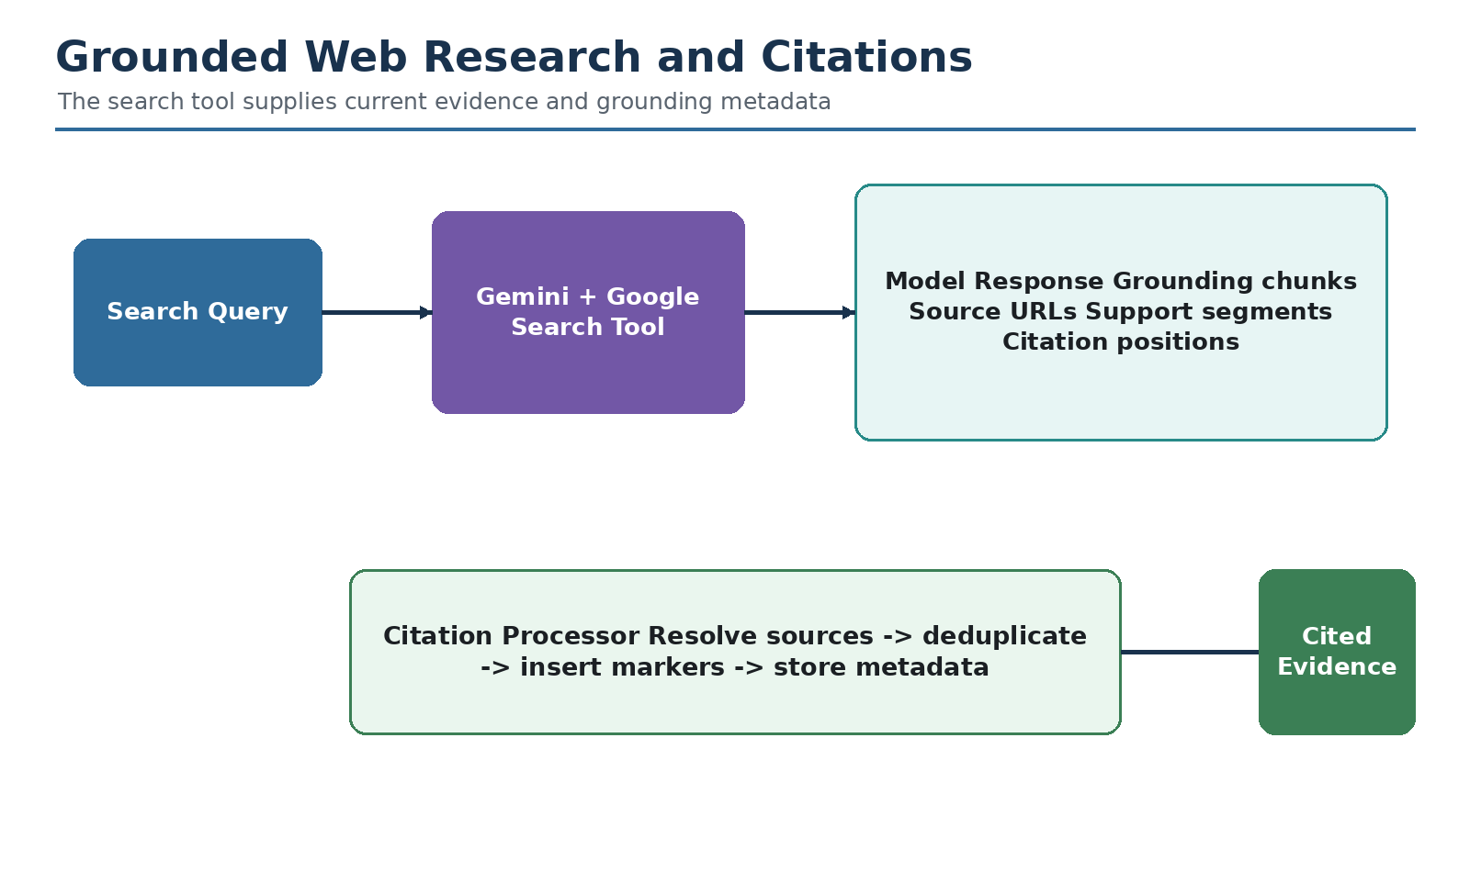
Figure 7. Grounding links generated evidence to source metadata that can be preserved by the agent.

7.1 Current Google Gen AI SDK pattern
Code 7.1 - Gemini grounded search
from google import genai
from google.genai import types
client = genai.Client(api_key=os.environ["GEMINI_API_KEY"])
response = client.models.generate_content(
model="gemini-2.5-flash",
contents=formatted_prompt,
config=types.GenerateContentConfig(
tools=[types.Tool(google_search=types.GoogleSearch())],
temperature=0,
),
)

7.2 What grounding metadata provides
- Grounding chunks that reference pages used by the model.
- Web source titles and URLs when available.
- Text segments associated with one or more source chunks.
- Positions that can be used to insert citation markers into generated text.
- Search-related metadata that improves auditability.

7.3 Search-node implementation pattern
Code 7.2 - Tool node with compact branch state
def web_research(
state: WebSearchState,
runtime: Runtime[AgentContext],
) -> dict:
prompt = WEB_RESEARCH_PROMPT.format(
search_query=state["search_query"]
)
response = runtime.context.genai_client.models.generate_content(
model=runtime.context.search_model,
contents=prompt,
config=types.GenerateContentConfig(
tools=[types.Tool(google_search=types.GoogleSearch())],
temperature=0,
),
)
evidence, sources = extract_grounded_evidence(
response=response,
branch_id=state["branch_id"],
)
return {
"search_query": [state["search_query"]],
"web_research_result": [evidence],
"sources_gathered": sources,
}

7.4 Tool safety
- Use an allowlist of tools rather than arbitrary tool discovery in sensitive environments.
- Set timeouts, retries, rate limits, and maximum result sizes.
- Validate tool arguments before execution.
- Treat tool output as untrusted data; never allow retrieved text to silently replace system instructions.
- Store source and request metadata for audit and debugging.
- Require human approval for tools that write, send, delete, purchase, or change enterprise data.

8. Citations and Source Provenance
Concept: A research agent is valuable only when readers can verify its claims. The workflow should preserve source identity, map evidence segments to citations, deduplicate sources, and expose uncertainty when support is weak.

8.1 Source record
Code 8.1 - Source metadata contract
class SourceRecord(TypedDict):
source_id: str
title: str
url: str
branch_id: int
query: str
supporting_text: str

8.2 Citation extraction
Code 8.2 - Defensive grounding-metadata extraction
def extract_grounded_evidence(response, branch_id: int) -> tuple[str, list[dict]]:
text = response.text or ""
candidate = response.candidates[0]
metadata = getattr(candidate, "grounding_metadata", None)
if metadata is None:
return text, []
sources = []
chunks = getattr(metadata, "grounding_chunks", []) or []
for index, chunk in enumerate(chunks, start=1):
web = getattr(chunk, "web", None)
if not web:
continue
sources.append({
"source_id": f"B{branch_id}-S{index}",
"title": getattr(web, "title", "") or "Untitled source",
"url": getattr(web, "uri", "") or "",
"branch_id": branch_id,
"query": "",
"supporting_text": "",
})
return text, sources

8.3 Citation-quality rules
- Cite the evidence that directly supports a claim, not merely a related page.
- Prefer official documentation, primary research, government data, and original company disclosures.
- Do not cite a search-result snippet as if the full source were inspected.
- Mark inference as inference.
- Preserve publication and event dates for current-information questions.
- Deduplicate tracking URLs and canonicalize sources before final output.
- Do not allow a polished citation format to hide weak evidence.

9. Reflection and Knowledge-Gap Analysis
Concept: Reflection is a separate evaluation step in which the model assesses the evidence rather than answering the user. It identifies missing subtopics, stale information, contradictions, source-quality weaknesses, and follow-up queries.
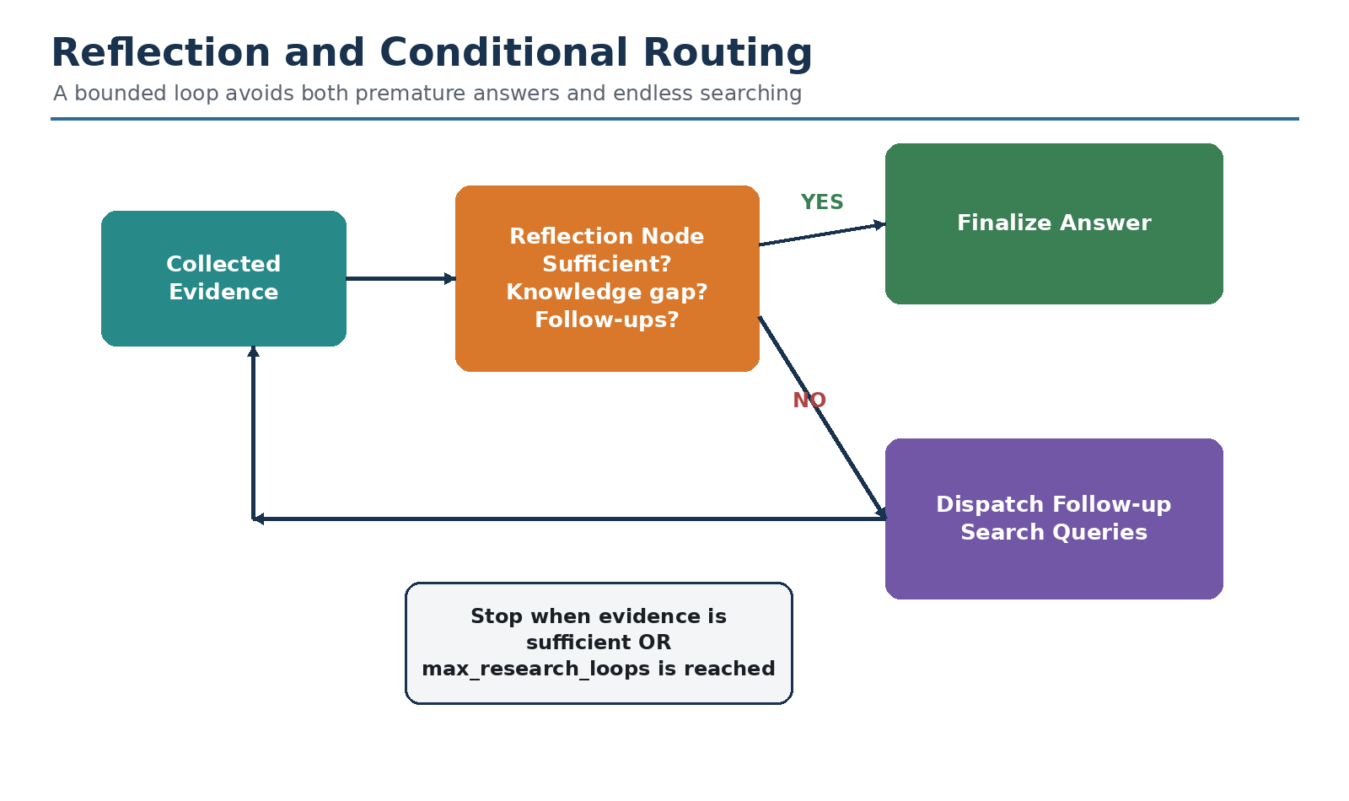
Figure 8. Reflection decides whether the workflow should finalize or perform another bounded search wave.

9.1 Reflection node
Code 9.1 - Evidence-reflection node
def reflection(
state: OverallState,
runtime: Runtime[AgentContext],
) -> dict:
loop_count = state.get("research_loop_count", 0) + 1
evidence = "\n\n---\n\n".join(
state.get("web_research_result", [])
)
prompt = REFLECTION_PROMPT.format(
research_topic=get_user_question(state["messages"]),
evidence=evidence,
)
llm = ChatGoogleGenerativeAI(
model=runtime.context.reflection_model,
temperature=0,
max_retries=2,
)
result = llm.with_structured_output(ReflectionResult).invoke(prompt)
return {
"is_sufficient": result.is_sufficient,
"knowledge_gap": result.knowledge_gap,
"follow_up_queries": result.follow_up_queries,
"research_loop_count": loop_count,
}

9.2 What should reflection inspect?
Dimension | Question
Coverage | Are all parts of the user's question addressed?
Factual support | Does each important claim have supporting evidence?
Recency | Is the evidence current enough for the question?
Authority | Are primary or authoritative sources represented?
Consistency | Do sources contradict one another?
Specificity | Are dates, versions, measurements, and definitions precise?
Safety | Does the answer require professional review or a human approval step?

Important: Reflection is not proof of correctness. The same model can repeat its own mistakes. Combine model reflection with deterministic checks, source validation, evaluation datasets, and human review for high-stakes use cases.

10. Conditional Routing and Loop Control
Concept: Routing should combine the model's structured decision with deterministic guardrails. The model proposes whether more research is needed; code enforces maximum loops, maximum queries, and safe destinations.

10.1 Routing function
Code 10.1 - Bounded conditional routing
from langgraph.types import Send
def route_after_reflection(
state: OverallState,
runtime: Runtime[AgentContext],
):
loop_count = state.get("research_loop_count", 0)
if state.get("is_sufficient", False):
return "finalize_answer"
if loop_count >= runtime.context.max_research_loops:
return "finalize_answer"
follow_ups = state.get("follow_up_queries", [])
follow_ups = follow_ups[: runtime.context.max_follow_up_queries]
if not follow_ups:
return "finalize_answer"
already_ran = len(state.get("search_query", []))
return [
Send(
"web_research",
{"search_query": query, "branch_id": already_ran + index},
)
for index, query in enumerate(follow_ups)
]

10.2 Stop conditions
- Evidence is judged sufficient.
- Maximum research loops are reached.
- No useful follow-up query is generated.
- Tool budget, token budget, or time budget is exhausted.
- A policy or safety rule requires human review.
- The user cancels the operation.
- A repeated-query detector finds that the agent is cycling.

10.3 Preventing endless loops
Code 10.2 - Duplicate-query guard
def normalize_query(query: str) -> str:
return " ".join(query.lower().split())
def remove_duplicate_queries(
proposed: list[str],
previous: list[str],
) -> list[str]:
seen = {normalize_query(q) for q in previous}
unique = []
for query in proposed:
key = normalize_query(query)
if key not in seen:
seen.add(key)
unique.append(query)
return unique

11. Parallel Processing with Send
Concept: The Send API dynamically creates one worker execution per query. Each worker receives only the state required for that search, and reducer-enabled state keys combine the outputs when the branches join.
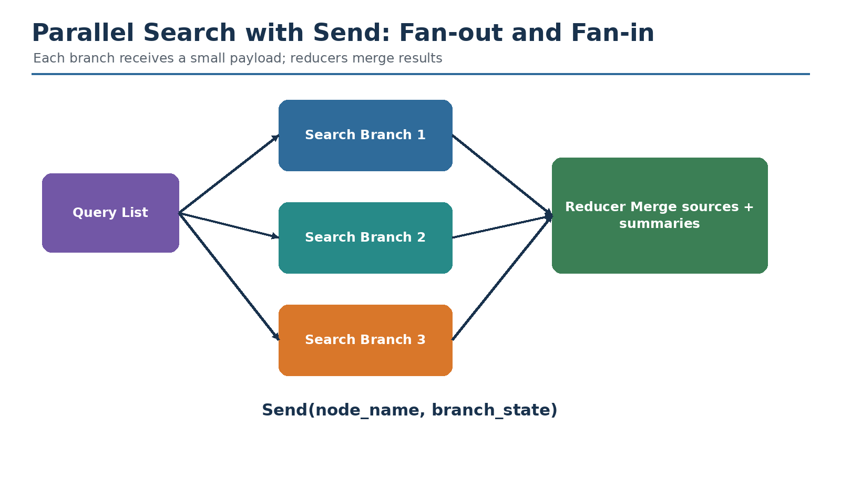
Figure 9. Send supports dynamic map-reduce: fan out search tasks and fan results back into shared state.

11.1 Initial dispatcher
Code 11.1 - Dynamic worker creation
from langgraph.types import Send
def dispatch_initial_queries(state: OverallState):
return [
Send(
"web_research",
{"search_query": query, "branch_id": index},
)
for index, query in enumerate(state.get("query_list", []))
]

11.2 Graph connection
Code 11.2 - Fan-out followed by fan-in
builder.add_conditional_edges(
"generate_query",
dispatch_initial_queries,
["web_research"],
)
builder.add_edge("web_research", "reflection")

11.3 Concurrency control
Code 11.3 - Limit concurrent tasks and graph steps
result = graph.invoke(
initial_state,
context=context,
config={
"max_concurrency": 4,
"recursion_limit": 20,
"configurable": {"thread_id": "research-001"},
},
)

11.4 Failure behavior
Parallel branches share a graph super-step. A failure can fail the step, although successful branch results may be recoverable through checkpointing depending on configuration. Use retry policies for transient failures, catch expected exceptions inside the tool node, and return an explicit error record when partial completion is acceptable.
Code 11.4 - Node retry policy
from langgraph.types import RetryPolicy
builder.add_node(
"web_research",
web_research,
retry_policy=RetryPolicy(
max_attempts=3,
initial_interval=1.0,
backoff_factor=2.0,
),
)

12. Runtime Configuration and Dependency Injection
Concept: Model names, limits, API clients, tenant identifiers, and other immutable per-run dependencies should be passed through runtime context. Mutable progress belongs in graph state.
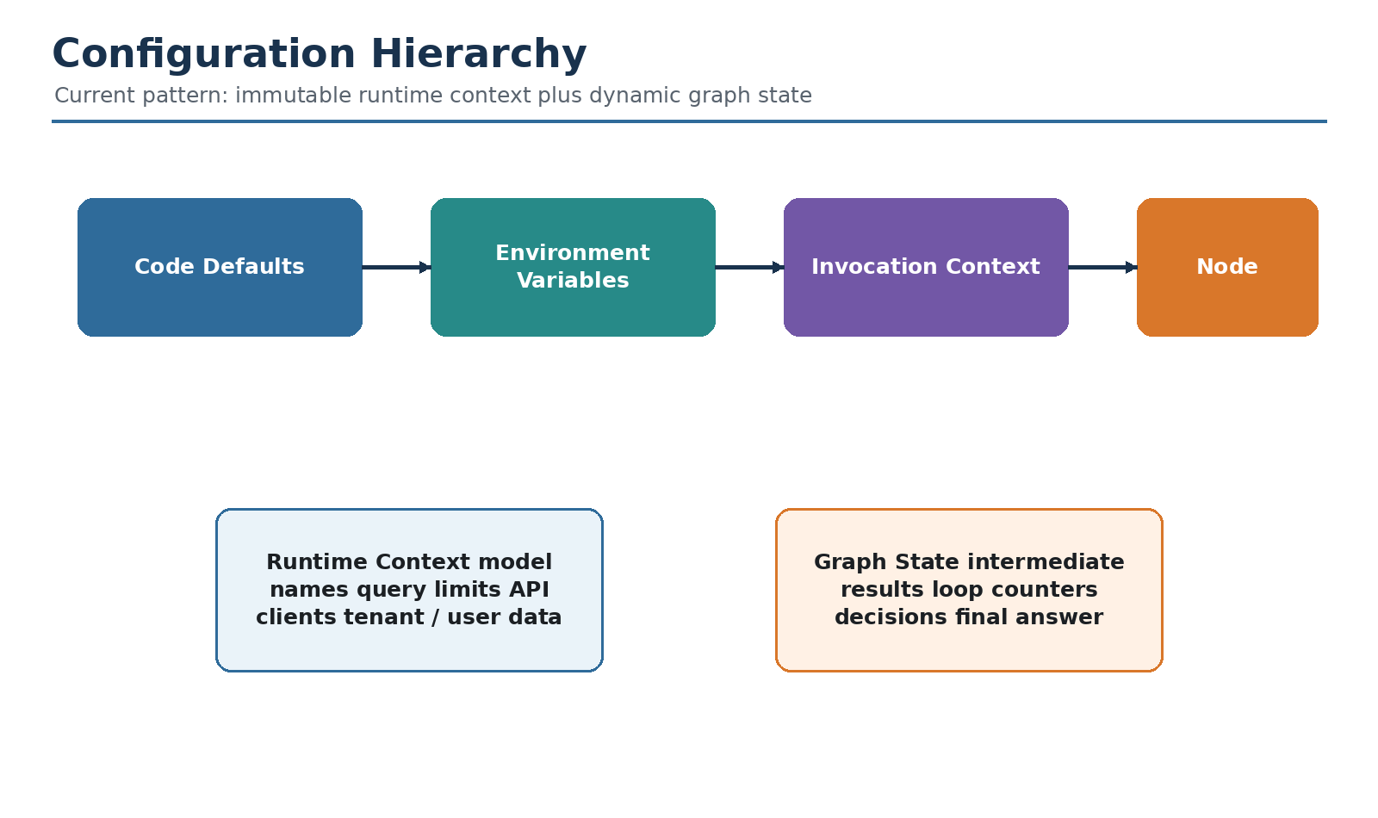
Figure 10. Separate immutable runtime context from mutable graph state.

12.1 Context schema
Code 12.1 - Immutable runtime context
from dataclasses import dataclass
from google import genai
@dataclass
class AgentContext:
query_model: str = "gemini-2.5-flash"
search_model: str = "gemini-2.5-flash"
reflection_model: str = "gemini-2.5-flash"
answer_model: str = "gemini-2.5-pro"
number_of_initial_queries: int = 3
max_research_loops: int = 2
max_follow_up_queries: int = 3
genai_client: genai.Client | None = None

12.2 Runtime access inside a node
Code 12.2 - Dependency injection
from langgraph.runtime import Runtime
def generate_query(
state: OverallState,
runtime: Runtime[AgentContext],
) -> dict:
query_limit = runtime.context.number_of_initial_queries
model_name = runtime.context.query_model
...

12.3 Invocation-time override
Code 12.3 - Per-run settings
context = AgentContext(
number_of_initial_queries=4,
max_research_loops=3,
genai_client=genai.Client(
api_key=os.environ["GEMINI_API_KEY"]
),
)
result = graph.invoke(initial_state, context=context)

12.4 Article pattern versus current pattern
Area | Older/common pattern | Current recommended pattern
Graph constructor | config_schema=Configuration | context_schema=AgentContext
Node configuration | RunnableConfig configurable dictionary | Runtime[AgentContext].context
Mutable progress | Sometimes mixed into config | Keep in graph state
Dependencies | Globals or environment lookup in each node | Inject client or identifiers via context
Tracing config | RunnableConfig | RunnableConfig still used for thread ID, tags, recursion, tracing

13. Complete Project Setup
Concept: The reference implementation is organized as a small, testable Python project. Each file has a clear responsibility, which makes it easier to teach, debug, extend, and deploy.

13.1 Project structure
Code 13.1 - Recommended source tree
deep_research_agent/
├── .env.example
├── requirements.txt
├── app.py
├── cli.py
├── agent/
│ ├── __init__.py
│ ├── context.py
│ ├── state.py
│ ├── schemas.py
│ ├── prompts.py
│ ├── citations.py
│ ├── nodes.py
│ └── graph.py
└── tests/
├── test_routing.py
├── test_state_reducers.py
└── test_citations.py

13.2 Requirements
Code 13.2 - requirements.txt
langgraph
langchain-core
langchain-google-genai
google-genai
pydantic
python-dotenv
streamlit
pytest

13.3 Environment variables
Code 13.3 - .env.example
GEMINI_API_KEY=replace_with_your_key
# Optional LangSmith tracing
LANGSMITH_TRACING=true
LANGSMITH_API_KEY=replace_with_your_key
LANGSMITH_PROJECT=deep-research-agent

13.4 Installation
Code 13.4 - Local environment
python -m venv .venv
# Windows PowerShell
.venv\Scripts\Activate.ps1
# macOS or Linux
source .venv/bin/activate
python -m pip install --upgrade pip
pip install -r requirements.txt
Security: Never place a real API key in source code, screenshots, notebooks committed to Git, or a Cloud Foundry manifest. Use environment variables or a managed secret/service binding.

14. End-to-End Reference Implementation
Concept: This chapter provides a complete modular implementation. It is intentionally explicit so every concept from the architecture can be inspected and modified.

14.1 schemas.py
Code 14.1 - Structured model contracts
from pydantic import BaseModel, Field
class SearchQueryList(BaseModel):
rationale: str = Field(
description="Why these queries cover the research topic."
)
query: list[str] = Field(
min_length=1,
description="Distinct and focused web search queries."
)
class ReflectionResult(BaseModel):
is_sufficient: bool = Field(
description="Whether the evidence is sufficient for the final report."
)
knowledge_gap: str = Field(
default="",
description="The most important missing or weakly supported information."
)
follow_up_queries: list[str] = Field(
default_factory=list,
description="Focused searches that would close the knowledge gap."
)
SearchQueryList prevents query planning from returning an unparseable prose list. ReflectionResult converts the evaluation into a Boolean decision, a written diagnosis, and a list of actionable follow-up searches.

14.2 state.py
Code 14.2 - Working state and reducers
from typing import Annotated, Any
from typing_extensions import TypedDict
import operator
from langchain.messages import AnyMessage
from langgraph.graph.message import add_messages
class SourceRecord(TypedDict, total=False):
source_id: str
title: str
url: str
query: str
branch_id: int
supporting_text: str
class OverallState(TypedDict, total=False):
messages: Annotated[list[AnyMessage], add_messages]
query_list: list[str]
search_query: Annotated[list[str], operator.add]
web_research_result: Annotated[list[str], operator.add]
sources_gathered: Annotated[list[SourceRecord], operator.add]
is_sufficient: bool
knowledge_gap: str
follow_up_queries: list[str]
research_loop_count: int
final_answer: str
class WebSearchState(TypedDict):
search_query: str
branch_id: int
The three accumulated list fields use operator.add so parallel search branches can contribute results. Decision fields replace their previous values after each reflection cycle.

14.3 context.py
Code 14.3 - Runtime dependencies and tunable limits
from dataclasses import dataclass
from google import genai
@dataclass
class AgentContext:
query_model: str = "gemini-2.5-flash"
search_model: str = "gemini-2.5-flash"
reflection_model: str = "gemini-2.5-flash"
answer_model: str = "gemini-2.5-pro"
number_of_initial_queries: int = 3
max_research_loops: int = 2
max_follow_up_queries: int = 3
genai_client: genai.Client | None = None

14.4 prompts.py
Code 14.4 - Node-specific instructions
QUERY_WRITER_PROMPT = '''
You are the query-planning component of a research agent.
Current date: {current_date}
User question: {research_topic}
Maximum queries: {number_queries}
Generate distinct, focused web search queries.
Use one query when one is enough.
Cover separate aspects with separate queries.
Use recency wording when current information matters.
Avoid near duplicates.
Return the SearchQueryList schema.
'''
WEB_RESEARCH_PROMPT = '''
Use Google Search to research:
{search_query}
Prefer primary and authoritative sources.
Capture relevant dates, versions, measurements, and definitions.
Separate confirmed facts from inference.
Return a concise evidence summary.
'''
REFLECTION_PROMPT = '''
Question:
{research_topic}
Evidence:
{evidence}
Decide whether the evidence is sufficient for a complete cited answer.
Identify missing aspects, weak sources, contradictions, or stale information.
Generate focused follow-up queries only when needed.
Return the ReflectionResult schema.
'''
FINAL_ANSWER_PROMPT = '''
Answer the user's question as a structured research report.
Question:
{research_topic}
Evidence:
{evidence}
Rules:
- Use only the supplied evidence.
- Preserve source references.
- Mark uncertainty and inference.
- Do not invent missing facts.
- Use descriptive headings and a concise conclusion.
'''

14.5 citations.py
Code 14.5 - Source extraction and deduplication
from typing import Any
def extract_grounded_evidence(
response: Any,
branch_id: int,
query: str,
) -> tuple[str, list[dict]]:
text = getattr(response, "text", "") or ""
candidates = getattr(response, "candidates", None) or []
if not candidates:
return text, []
metadata = getattr(candidates[0], "grounding_metadata", None)
if metadata is None:
return text, []
chunks = getattr(metadata, "grounding_chunks", None) or []
sources: list[dict] = []
for index, chunk in enumerate(chunks, start=1):
web = getattr(chunk, "web", None)
if web is None:
continue
sources.append({
"source_id": f"B{branch_id}-S{index}",
"title": getattr(web, "title", "") or "Untitled source",
"url": getattr(web, "uri", "") or "",
"query": query,
"branch_id": branch_id,
"supporting_text": "",
})
return text, sources
def deduplicate_sources(sources: list[dict]) -> list[dict]:
unique: dict[str, dict] = {}
for source in sources:
key = source.get("url") or source.get("source_id")
if key and key not in unique:
unique[key] = source
return list(unique.values())

14.6 nodes.py - utilities and query generation
Code 14.6 - Extract the question and plan searches
from __future__ import annotations
from datetime import date
from langchain.messages import AIMessage
from langchain_google_genai import ChatGoogleGenerativeAI
from langgraph.runtime import Runtime
from google.genai import types
from .context import AgentContext
from .state import OverallState, WebSearchState
from .schemas import SearchQueryList, ReflectionResult
from .prompts import (
QUERY_WRITER_PROMPT,
WEB_RESEARCH_PROMPT,
REFLECTION_PROMPT,
FINAL_ANSWER_PROMPT,
)
from .citations import extract_grounded_evidence, deduplicate_sources
def get_user_question(messages) -> str:
for message in reversed(messages):
message_type = getattr(message, "type", "")
if message_type in {"human", "user"}:
return str(getattr(message, "content", ""))
if isinstance(message, dict) and message.get("role") == "user":
return str(message.get("content", ""))
raise ValueError("No user question was found in state['messages'].")
def generate_query(
state: OverallState,
runtime: Runtime[AgentContext],
) -> dict:
question = get_user_question(state["messages"])
llm = ChatGoogleGenerativeAI(
model=runtime.context.query_model,
temperature=0.2,
max_retries=2,
)
planner = llm.with_structured_output(SearchQueryList)
prompt = QUERY_WRITER_PROMPT.format(
current_date=date.today().isoformat(),
research_topic=question,
number_queries=runtime.context.number_of_initial_queries,
)
result = planner.invoke(prompt)
queries = result.query[
: runtime.context.number_of_initial_queries
]
return {"query_list": queries}
The node reads the latest human message, creates a low-temperature structured-output model, formats the query-writing prompt, limits the result to the configured maximum, and returns only query_list.

14.7 nodes.py - web research
Code 14.7 - Execute one grounded search branch
def web_research(
state: WebSearchState,
runtime: Runtime[AgentContext],
) -> dict:
if runtime.context.genai_client is None:
raise RuntimeError("AgentContext.genai_client is required.")
query = state["search_query"]
branch_id = state["branch_id"]
prompt = WEB_RESEARCH_PROMPT.format(search_query=query)
response = runtime.context.genai_client.models.generate_content(
model=runtime.context.search_model,
contents=prompt,
config=types.GenerateContentConfig(
tools=[types.Tool(google_search=types.GoogleSearch())],
temperature=0,
),
)
evidence, sources = extract_grounded_evidence(
response=response,
branch_id=branch_id,
query=query,
)
return {
"search_query": [query],
"web_research_result": [evidence],
"sources_gathered": sources,
}
Each Send task calls this node with a small WebSearchState. The result is returned as one-element lists because the global reducers concatenate contributions from every branch.

14.8 nodes.py - reflection
Code 14.8 - Evaluate the accumulated evidence
def reflection(
state: OverallState,
runtime: Runtime[AgentContext],
) -> dict:
question = get_user_question(state["messages"])
evidence = "\n\n---\n\n".join(
state.get("web_research_result", [])
)
loop_count = state.get("research_loop_count", 0) + 1
llm = ChatGoogleGenerativeAI(
model=runtime.context.reflection_model,
temperature=0,
max_retries=2,
)
evaluator = llm.with_structured_output(ReflectionResult)
result = evaluator.invoke(
REFLECTION_PROMPT.format(
research_topic=question,
evidence=evidence,
)
)
return {
"is_sufficient": result.is_sufficient,
"knowledge_gap": result.knowledge_gap,
"follow_up_queries": result.follow_up_queries,
"research_loop_count": loop_count,
}

14.9 nodes.py - finalization
Code 14.9 - Synthesize and attach a deduplicated source list
def finalize_answer(
state: OverallState,
runtime: Runtime[AgentContext],
) -> dict:
question = get_user_question(state["messages"])
evidence = "\n\n---\n\n".join(
state.get("web_research_result", [])
)
llm = ChatGoogleGenerativeAI(
model=runtime.context.answer_model,
temperature=0.1,
max_retries=2,
)
answer = llm.invoke(
FINAL_ANSWER_PROMPT.format(
research_topic=question,
evidence=evidence,
)
).content
unique_sources = deduplicate_sources(
state.get("sources_gathered", [])
)
if unique_sources:
source_lines = [
f"[{index}] {item.get('title', 'Source')} - "
f"{item.get('url', '')}"
for index, item in enumerate(unique_sources, start=1)
]
answer = answer + "\n\nSources\n" + "\n".join(source_lines)
return {
"final_answer": answer,
"messages": [AIMessage(content=answer)],
"sources_gathered": unique_sources,
}

14.10 graph.py
Code 14.10 - Complete graph topology
from langgraph.graph import StateGraph, START, END
from langgraph.runtime import Runtime
from langgraph.types import Send, RetryPolicy
from .context import AgentContext
from .state import OverallState
from .nodes import (
generate_query,
web_research,
reflection,
finalize_answer,
)
def dispatch_initial_queries(state: OverallState):
return [
Send(
"web_research",
{"search_query": query, "branch_id": index},
)
for index, query in enumerate(state.get("query_list", []))
]
def route_after_reflection(
state: OverallState,
runtime: Runtime[AgentContext],
):
if state.get("is_sufficient", False):
return "finalize_answer"
if state.get("research_loop_count", 0) >= runtime.context.max_research_loops:
return "finalize_answer"
previous = {
" ".join(q.lower().split())
for q in state.get("search_query", [])
}
follow_ups = []
for query in state.get("follow_up_queries", []):
normalized = " ".join(query.lower().split())
if normalized not in previous:
previous.add(normalized)
follow_ups.append(query)
follow_ups = follow_ups[: runtime.context.max_follow_up_queries]
if not follow_ups:
return "finalize_answer"
offset = len(state.get("search_query", []))
return [
Send(
"web_research",
{"search_query": query, "branch_id": offset + index},
)
for index, query in enumerate(follow_ups)
]
builder = StateGraph(
OverallState,
context_schema=AgentContext,
)
builder.add_node("generate_query", generate_query)
builder.add_node(
"web_research",
web_research,
retry_policy=RetryPolicy(
max_attempts=3,
initial_interval=1.0,
backoff_factor=2.0,
),
)
builder.add_node("reflection", reflection)
builder.add_node("finalize_answer", finalize_answer)
builder.add_edge(START, "generate_query")
builder.add_conditional_edges(
"generate_query",
dispatch_initial_queries,
["web_research"],
)
builder.add_edge("web_research", "reflection")
builder.add_conditional_edges(
"reflection",
route_after_reflection,
["web_research", "finalize_answer"],
)
builder.add_edge("finalize_answer", END)
graph = builder.compile(name="deep-research-agent")

14.11 cli.py
Code 14.11 - Command-line application
import os
from dotenv import load_dotenv
from google import genai
from langchain.messages import HumanMessage
from agent.context import AgentContext
from agent.graph import graph
load_dotenv()
def main():
question = input("Research question: ").strip()
if not question:
raise SystemExit("A question is required.")
context = AgentContext(
genai_client=genai.Client(
api_key=os.environ["GEMINI_API_KEY"]
)
)
result = graph.invoke(
{
"messages": [HumanMessage(content=question)],
"research_loop_count": 0,
},
context=context,
config={
"max_concurrency": 4,
"recursion_limit": 20,
"configurable": {
"thread_id": "local-research-session"
},
},
)
print("\n" + result["final_answer"])
if __name__ == "__main__":
main()

14.12 app.py - Streamlit interface
Code 14.12 - Simple teaching interface
import os
import streamlit as st
from dotenv import load_dotenv
from google import genai
from langchain.messages import HumanMessage
from agent.context import AgentContext
from agent.graph import graph
load_dotenv()
st.set_page_config(
page_title="Deep Research Agent",
page_icon="🔎",
layout="wide",
)
st.title("Deep Research Agent")
st.caption("LangGraph + Gemini + grounded Google Search")
question = st.text_area(
"Research question",
height=120,
placeholder="Example: Compare enterprise agent observability approaches.",
)
query_count = st.slider("Initial search queries", 1, 6, 3)
max_loops = st.slider("Maximum research loops", 1, 4, 2)
if st.button("Run research", type="primary"):
if not question.strip():
st.warning("Enter a research question.")
st.stop()
context = AgentContext(
number_of_initial_queries=query_count,
max_research_loops=max_loops,
genai_client=genai.Client(
api_key=os.environ["GEMINI_API_KEY"]
),
)
with st.status("Researching...", expanded=True) as status:
final_state = None
for update in graph.stream(
{
"messages": [HumanMessage(content=question)],
"research_loop_count": 0,
},
context=context,
config={
"max_concurrency": 4,
"recursion_limit": 20,
"configurable": {
"thread_id": "streamlit-session"
},
},
stream_mode="updates",
):
final_state = update
st.write(update)
status.update(label="Research complete", state="complete")
# For production, retain the final accumulated graph state through
# graph.invoke or appropriate stream accumulation.
st.info(
"This teaching UI displays node updates. "
"Adapt it to render the final accumulated state cleanly."
)
Implementation note: SDK response structures can differ slightly between model versions. Keep citation extraction defensive, add tests against recorded response fixtures, and verify the selected Gemini model supports Google Search grounding.

15. Running, Debugging, and Testing the Agent
Concept: Agent debugging requires visibility into intermediate state and routing decisions. Test deterministic functions without model calls, record tool fixtures, and inspect traces for full workflow behavior.

15.1 Run commands
Code 15.1 - Run the project
python cli.py
streamlit run app.py
pytest -q

15.2 Unit-test the routing function
Code 15.2 - Deterministic routing tests
from agent.context import AgentContext
from agent.graph import route_after_reflection
class FakeRuntime:
context = AgentContext(
max_research_loops=2,
max_follow_up_queries=2,
)
def test_routes_to_finalize_when_sufficient():
state = {
"is_sufficient": True,
"research_loop_count": 1,
}
assert route_after_reflection(
state,
FakeRuntime(),
) == "finalize_answer"
def test_routes_to_finalize_at_limit():
state = {
"is_sufficient": False,
"research_loop_count": 2,
"follow_up_queries": ["another query"],
}
assert route_after_reflection(
state,
FakeRuntime(),
) == "finalize_answer"

15.3 Test reducers
Code 15.3 - Reducer expectation
def test_parallel_results_are_additive():
first = {"web_research_result": ["evidence A"]}
second = {"web_research_result": ["evidence B"]}
# The LangGraph reducer is operator.add for this key.
merged = first["web_research_result"] + second["web_research_result"]
assert merged == ["evidence A", "evidence B"]

15.4 Debugging checklist
- Print or trace the query_list produced by planning.
- Verify each parallel branch receives a unique branch_id.
- Inspect raw grounding metadata before writing citation logic.
- Confirm reducers are declared for every parallel output key.
- Log reflection decisions and loop counts.
- Track repeated follow-up queries.
- Test empty search results and a grounding response without metadata.
- Use a low maximum loop count during development to control cost.

16. Reliability: Retry, Caching, Checkpoints, Streaming, HITL, and MCP
Concept: A production agent must survive transient failures, avoid repeating expensive work, resume long-running processes, show progress, pause for approval, and connect to governed tools.
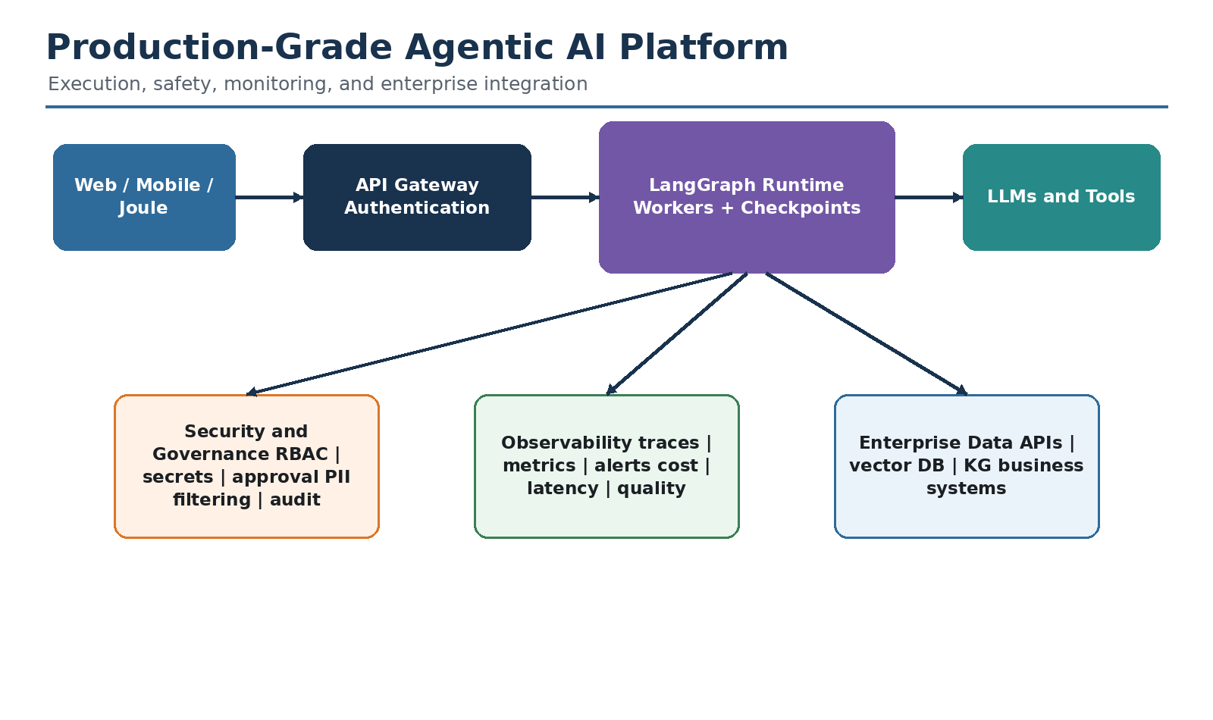
Figure 11. Production architecture combines orchestration with safety, observability, and enterprise integration.

16.1 Retry and fallback
- Retry only transient failures such as timeouts, rate limits, and temporary service errors.
- Use exponential backoff and a maximum attempt count.
- Do not retry validation or authorization failures without changing the input.
- Provide a fallback model only when output quality and compliance are acceptable.
- Record every retry in traces to expose hidden latency and cost.

16.2 Timeouts and budgets
Code 16.1 - Explicit timeout wrapper
import asyncio
async def call_with_timeout(coro, seconds: float):
return await asyncio.wait_for(coro, timeout=seconds)
A global research budget may include elapsed time, model tokens, number of search queries, total sources, and maximum graph super-steps. Budget exhaustion should route to a partial but honest answer rather than an infinite loop.

16.3 Caching
- Cache normalized search queries and their evidence for a short time-to-live.
- Include model name, prompt version, locale, and relevant date in cache keys.
- Do not cache tenant-specific or sensitive results in a shared namespace.
- Invalidate caches when source freshness is critical.

16.4 Checkpointing and persistence
Code 16.2 - Development checkpointer
from langgraph.checkpoint.memory import InMemorySaver
checkpointer = InMemorySaver()
graph = builder.compile(checkpointer=checkpointer)
config = {
"configurable": {
"thread_id": "research-thread-123"
}
}
Use an in-memory saver only for local development. Production systems should use a durable, supported checkpoint backend and a stable thread identifier. Checkpoints support recovery, human interruption, and inspection of previous state.

16.5 Human-in-the-loop
- Approve the generated research plan before costly searches.
- Review sensitive sources before synthesis.
- Require approval before external actions or enterprise writes.
- Allow a reviewer to edit state, remove a source, or add a required query.
- Record the reviewer identity, decision, and timestamp for audit.

16.6 Streaming
Code 16.3 - Stream node updates
for event in graph.stream(
initial_state,
context=context,
config=config,
stream_mode="updates",
):
render_progress(event)
Streaming should reveal meaningful progress such as query generation, searches completed, and reflection outcome. Do not expose private chain-of-thought. Show concise status information and source-backed intermediate results instead.

16.7 MCP integration
Model Context Protocol can standardize access to tools and resources. In an enterprise implementation, MCP servers should still be governed through authentication, tool allowlists, argument validation, network policy, and audit logs. Automatic discovery should not mean automatic permission.

17. Observability and Evaluation
Concept: Observability explains what the agent did; evaluation measures whether it did the right thing. Combine traces, operational metrics, automated quality checks, human feedback, and regression datasets.
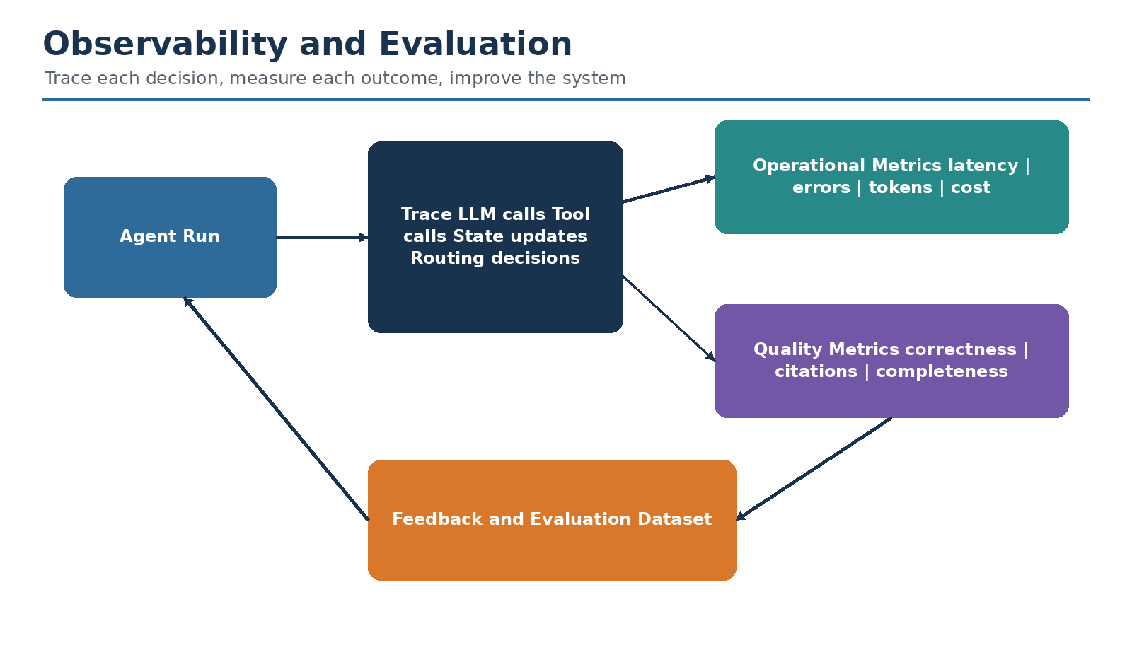
Figure 12. Traces and evaluation create the feedback loop required to improve an agent.

17.1 LangSmith tracing
Code 17.1 - Enable tracing
# Environment variables
LANGSMITH_TRACING=true
LANGSMITH_API_KEY=...
LANGSMITH_PROJECT=deep-research-agent
A trace should show the complete request: query planning, parallel web searches, prompts, model responses, reflection decisions, loop iterations, and final synthesis. Add tags and metadata such as application version, environment, tenant, model configuration, and evaluation set.

17.2 Operational metrics
Metric | Why it matters
End-to-end latency | Measures user experience and workflow complexity
Latency per node | Identifies slow search or model steps
Tool error rate | Exposes unreliable dependencies
Retry count | Shows hidden instability and cost
Input/output tokens | Supports cost and context optimization
Research loops | Detects premature stopping or excessive iteration
Queries and sources per run | Measures search breadth
Cancellation rate | Signals poor progress visibility or excessive latency

17.3 Quality evaluation
Metric | Evaluation question
Answer correctness | Are the important claims factually correct?
Citation correctness | Does each citation support the attached claim?
Citation completeness | Are important verifiable claims cited?
Coverage | Are all user-requested aspects answered?
Source quality | Are primary and authoritative sources preferred?
Freshness | Is the evidence current enough?
Faithfulness | Does the report stay within retrieved evidence?
Helpfulness | Is the final report usable, clear, and appropriately detailed?

17.4 Evaluation dataset
- Representative questions from real users.
- Expected required subtopics rather than only one reference answer.
- Known authoritative sources or source-quality criteria.
- Adversarial questions containing misleading assumptions.
- Queries requiring current information and date awareness.
- Queries with no reliable answer, where abstention is expected.
- Regression cases from previous production failures.

17.5 Example evaluator
Code 17.2 - Evaluation contract
class EvaluationResult(BaseModel):
correctness: float
citation_support: float
coverage: float
source_quality: float
comments: str
def evaluate_run(question, answer, sources):
# Use deterministic checks where possible.
# Use a separate judge model for rubric-based scoring.
# Periodically calibrate automated scores against human reviewers.
...

18. Security, Governance, and Responsible AI
Concept: Research agents handle external content, enterprise data, model outputs, and potentially high-impact decisions. Security and governance must be designed into the graph rather than added after deployment.

18.1 Threats and controls
Threat | Control
Prompt injection in retrieved pages | Treat content as data; separate instructions; filter and validate
Unauthorized data access | Identity propagation, RBAC, tenant filters, least privilege
Secret leakage | Managed secrets, redaction, no secrets in state or prompts
Unsafe tool execution | Allowlist tools, validate arguments, require approval for writes
Hallucinated citations | Grounding metadata, citation verification, source-quality checks
Cross-tenant leakage | Tenant-specific storage, retrieval filters, isolated caches and traces
Sensitive trace data | Redact PII, configure retention, restrict trace access
Unbounded cost | Query, loop, token, and time budgets
Unsupported high-stakes conclusion | Abstention, professional review, clear limitations

18.2 Governance artifacts
- Documented purpose, scope, and prohibited uses.
- Approved model and tool inventory.
- Data classification and retention policy.
- Prompt, schema, and graph version history.
- Evaluation results and release thresholds.
- Human-review and escalation procedures.
- Incident response and rollback plan.
- Audit trail linking user request, tool actions, sources, and final answer.
Responsible AI: The agent should be able to say that evidence is insufficient. Abstention is a capability, not a failure.

19. Cost and Latency Optimization
Concept: Deep research can become expensive because it performs several model and search calls. Optimize only after tracing real workloads, and preserve answer quality while reducing unnecessary work.

19.1 Optimization levers
Lever | Effect | Risk
Fewer initial queries | Lower cost and latency | Reduced coverage
Parallel search | Lower elapsed time | Higher burst rate and concurrency
Smaller planning model | Cheaper query and reflection calls | Lower reasoning quality
Stronger final model only | Concentrates cost on synthesis | May not repair poor retrieval
Short evidence summaries | Lower context tokens | Can remove important nuance
Caching | Avoids repeated work | Stale or cross-tenant data risk
Early stopping | Reduces loops | Premature conclusions
Source limits | Controls context size | May omit conflicting evidence

19.2 Budget-aware routing
Code 19.1 - Explicit execution budget
class Budget(TypedDict):
searches_remaining: int
tokens_remaining: int
seconds_remaining: float
def may_continue(state: OverallState) -> bool:
budget = state.get("budget", {})
return (
budget.get("searches_remaining", 0) > 0
and budget.get("tokens_remaining", 0) > 0
and budget.get("seconds_remaining", 0) > 0
)

20. SAP Business AI Mapping
Concept: The same agent pattern can be implemented within an SAP landscape. The exact architecture depends on licensing, security requirements, target SAP applications, and whether orchestration uses a custom LangGraph service, Joule Agents, SAP Build Process Automation, or a combination.
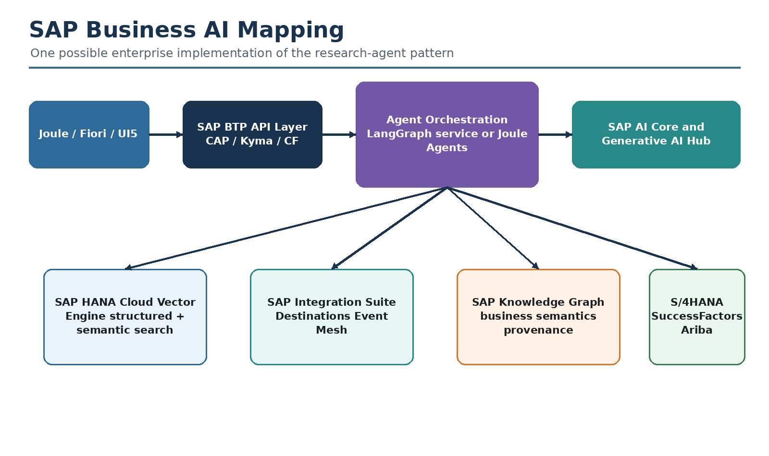
Figure 13. Illustrative mapping of the deep-research pattern to SAP Business AI and SAP BTP services.

20.1 Concept mapping
Research-agent component | Possible SAP implementation
User experience | Joule, SAP Fiori/UI5, SAP Build Work Zone, or custom UI
API and application layer | CAP service on Cloud Foundry or Kyma
Agent orchestration | Custom LangGraph service and/or Joule Agent capabilities
Foundation models | SAP AI Core through Generative AI Hub
Enterprise retrieval | SAP HANA Cloud vector capabilities plus relational filtering
Business semantics | SAP Knowledge Graph and governed metadata
External and SAP integration | SAP Integration Suite and Destination service
Event-driven triggers | SAP Event Mesh
Process automation and approval | SAP Build Process Automation
Observability | Application logging, Cloud ALM where applicable, custom metrics, and LLM tracing

20.2 SAP support-research use case
A support agent receives an incident such as a failed purchase-order process. It generates investigation queries, retrieves relevant internal runbooks and SAP documentation, checks S/4HANA configuration or logs through approved APIs, reflects on missing evidence, and creates a cited diagnosis. Before a corrective action is executed, SAP Build Process Automation requests approval from the responsible support lead.

20.3 SAP logical flow
1. Joule or a Fiori application captures the user's issue and identity.
2. A CAP service validates authorization and creates a research thread.
3. The orchestration service generates investigation queries.
4. SAP HANA Cloud retrieves internal knowledge using semantic and metadata filters.
5. SAP Integration Suite calls approved enterprise or external APIs.
6. The reflection node identifies missing evidence and may launch another bounded retrieval wave.
7. Generative AI Hub provides the model used for analysis and synthesis.
8. The final answer includes source provenance and confidence limitations.
9. A high-impact recommendation is routed to SAP Build Process Automation for human approval.

20.4 SAP-specific governance considerations
- Propagate authenticated user and tenant context to every retrieval and tool call.
- Use Destination service rather than hard-coded credentials.
- Apply row-level or document-level authorization before vector similarity search.
- Keep operational data residency and model-provider policies explicit.
- Log the business object identifiers and source versions used in the answer.
- Separate advisory agents from action agents; require approval for business writes.

21. Deployment Architecture
Concept: Deployment should separate the user-facing application, agent workers, persistent checkpoints, secrets, model APIs, and observability. A stateless front end can scale independently from long-running research jobs.
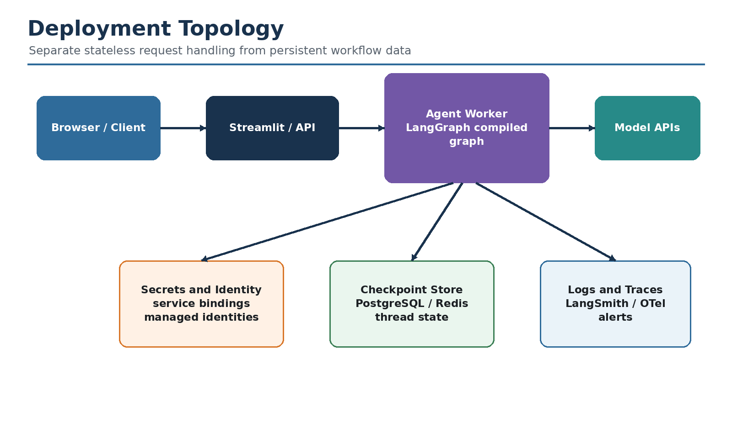
Figure 14. A deployment topology for local, cloud, or SAP BTP environments.

21.1 Local deployment
- Python virtual environment.
- Streamlit or command-line interface.
- Environment variables loaded from a local .env file.
- In-memory checkpointing for experimentation.
- LangSmith tracing for development visibility.

21.2 Container deployment
Code 21.1 - Minimal Streamlit container
FROM python:3.11-slim
WORKDIR /app
COPY requirements.txt .
RUN pip install --no-cache-dir -r requirements.txt
COPY . .
EXPOSE 8501
CMD ["streamlit", "run", "app.py",
"--server.address=0.0.0.0",
"--server.port=8501"]

21.3 SAP BTP Cloud Foundry example
Code 21.2 - Example manifest.yml
applications:
- name: deep-research-agent
memory: 1G
disk_quota: 1G
random-route: true
buildpacks:
- python_buildpack
command: >
streamlit run app.py
--server.address=0.0.0.0
--server.port=$PORT
env:
PYTHONUNBUFFERED: "true"
Do not place real API keys in manifest.yml. Bind managed services, use user-provided services only when appropriate, or inject secrets through the platform's approved mechanism. Add authentication before exposing the application.

21.4 Production deployment decisions
- Synchronous request versus background job and progress polling.
- Checkpoint database and thread-retention policy.
- Maximum worker concurrency and provider rate limits.
- Authentication, authorization, and tenant isolation.
- Private network connectivity to enterprise APIs.
- Trace redaction and observability retention.
- Model fallback and regional availability.
- Disaster recovery, retry semantics, and idempotency.

22. Interview Questions and Answers
Concept: These questions focus on explaining the architecture clearly, identifying trade-offs, and translating technical choices into enterprise value.

22.1 What is LangGraph?
LangGraph is a low-level orchestration framework and runtime for stateful, long-running workflows and agents. It represents execution through state, nodes, and edges and supports branching, loops, parallelism, persistence, streaming, and human intervention.

22.2 Why use a graph for an AI agent?
Real agent workflows are nonlinear. They branch based on model decisions, loop when evidence is incomplete, run independent work in parallel, and need explicit termination. A graph makes this control flow inspectable and testable.

22.3 What is the difference between state and runtime context?
State is mutable progress that changes during a run, such as evidence and loop counters. Runtime context is immutable per-run configuration or dependencies, such as model names, API clients, tenant identifiers, and limits.

22.4 Why use reducers?
Reducers define how new node updates combine with existing state. They are essential when repeated or parallel nodes write to the same key. For example, operator.add concatenates search results from parallel branches.

22.5 Why define node-specific TypedDicts?
They document the small input or output contract of a node, improve type checking and reuse, and avoid passing unnecessarily large payloads to parallel branches.

22.6 What problem does structured output solve?
It replaces fragile parsing of free-text JSON with a validated schema. Downstream code receives typed fields such as is_sufficient and follow_up_queries rather than unpredictable prose.

22.7 How does Send support parallelism?
A routing function returns one Send object per dynamic task. Each Send identifies a destination node and a branch-specific state payload. LangGraph schedules the workers and merges reducer-enabled outputs.

22.8 How do you stop an agent loop?
Combine a structured model decision with deterministic limits: sufficient evidence, maximum loops, duplicate-query detection, time and token budgets, no follow-up queries, cancellation, or human escalation.

22.9 Why separate reflection from final generation?
Reflection evaluates evidence quality and gaps, while final generation communicates the answer. Separate prompts and responsibilities improve testing, observability, and control.

22.10 What is grounding?
Grounding connects the model response to external evidence. Google Search grounding can supply current web information and metadata that associates generated text with supporting sources.

22.11 How would you reduce hallucinations?
Use authoritative retrieval, structured prompts, source metadata, faithfulness rules, citation verification, bounded autonomy, deterministic checks, evaluation datasets, and human review for high-impact cases.

22.12 How would you observe the agent?
Trace every node, model call, tool call, routing decision, state update, and retry. Monitor latency, errors, tokens, cost, loops, sources, user feedback, and evaluation scores.

22.13 How do you secure tools?
Use least privilege, allowlists, validated arguments, authenticated context, timeouts, audit logs, network controls, and human approval for write or irreversible actions.

22.14 How does this map to SAP Business AI?
Use Joule or Fiori for interaction, CAP/Kyma/Cloud Foundry for the service layer, SAP AI Core and Generative AI Hub for models, SAP HANA Cloud for retrieval, Integration Suite for APIs, and Build Process Automation for approvals.

22.15 What is the most important production lesson?
Do not treat the model as the control plane. Keep permissions, budgets, destinations, and irreversible actions under deterministic software and human governance.

23. Hands-on Exercises and Extensions
Concept: The best way to learn the architecture is to replace one component at a time and observe how state, routing, quality, latency, and cost change.

Exercise 1 - Minimal research workflow
Build generate_query -> web_research -> finalize_answer without reflection. Record latency, source count, and quality. Then add reflection and compare.

Exercise 2 - Query-planning evaluation
Create 20 research questions and manually label required subtopics. Measure whether the generated query list covers those subtopics without unnecessary duplicates.

Exercise 3 - Source-quality filter
Add a function that scores or filters sources by domain and source type. Prefer official documentation and primary sources.

Exercise 4 - Human approval
Pause after query generation, display the planned searches, and allow a reviewer to add, edit, or remove queries.

Exercise 5 - Agentic RAG
Replace web search with a retriever tool over internal documents. Let reflection decide whether to retrieve from another collection or escalate.

Exercise 6 - Multi-agent extension
Create a planner, research workers, a fact checker, and a synthesizer. Keep shared state explicit and restrict each agent's tools.

Exercise 7 - SAP incident agent
Use a mock S/4HANA incident dataset, internal knowledge base, and approval workflow. Produce a diagnosis and proposed next action without executing the action automatically.

Exercise 8 - Evaluation dashboard
Capture run metrics and quality scores in a table. Compare prompt and model versions across a fixed regression dataset.

23.9 Suggested capstone
Capstone project: Build a governed enterprise research agent that accepts a business question, plans searches across public and internal sources, runs retrieval in parallel, reflects on evidence, requests approval when necessary, produces a cited report, and logs traces and evaluation metrics.
- Deliverables: architecture diagram, state schema, graph code, test suite, deployment file, evaluation dataset, and governance checklist.
- Acceptance criteria: no uncited major claims, bounded loops, duplicate-query protection, source authorization, and traceable decisions.

24. Production Checklist and Common Failure Modes
Concept: Use this chapter as a release gate. Production readiness depends on correctness, reliability, security, observability, and maintainability rather than a successful demo alone.

24.1 Release checklist
- ☐ State schema documents every persistent key and reducer.
- ☐ Every node has one clear responsibility and unit tests where practical.
- ☐ Structured output is used for routing and extraction.
- ☐ Loops have deterministic maximums and duplicate-work protection.
- ☐ Tools are allowlisted, authenticated, validated, rate-limited, and timed out.
- ☐ Parallel writes use reducers and concurrency is capped.
- ☐ Source metadata is preserved and citations are verifiable.
- ☐ The final prompt forbids unsupported claims and exposes uncertainty.
- ☐ Tracing captures prompts, tools, routing, retries, cost, and latency with sensitive-data controls.
- ☐ A regression evaluation dataset runs before deployment.
- ☐ Human approval is required for high-impact or write actions.
- ☐ Secrets are stored outside code and graph state.
- ☐ Tenant and document authorization is enforced before retrieval.
- ☐ Checkpoint and retention policies are documented.
- ☐ Rollback and incident-response procedures are tested.

24.2 Common failure modes
Failure | Likely cause | Correction
Irrelevant searches | Weak query prompt or broad question | Decompose aspects and evaluate query coverage
Infinite or repeated loops | No hard limit or duplicate detection | Add loop, budget, and query-history guards
Lost parallel results | Missing reducer | Use Annotated reducer for shared output keys
Hallucinated citation | Source list added after generation without mapping | Preserve grounding metadata and verify support
High latency | Sequential searches or excessive loops | Use Send, concurrency limits, smaller planning models
High cost | Large evidence context and repeated queries | Summarize, cache, limit queries, budget tokens
Cross-tenant leakage | Shared cache or missing filters | Tenant namespaces and authorization-aware retrieval
Tool call fails silently | Exception swallowed without status | Return error record, trace branch, apply retry policy
Good demo, poor production quality | No evaluation dataset | Build representative regression and online monitoring
Unsafe action | Model controls execution directly | Deterministic policy and human approval

24.3 Final design principles
1. Use the model for language and judgment; use deterministic code for permissions, budgets, and safety limits.
2. Make intermediate state and routing visible.
3. Keep nodes small and reusable.
4. Ground claims in evidence and preserve provenance.
5. Bound every loop and external resource.
6. Evaluate on representative tasks, not only happy-path demos.
7. Design human oversight before enabling consequential actions.
8. Treat observability, security, and cost as architecture, not afterthoughts.

25. References
The following resources informed this original tutorial. Product behavior and APIs may change; consult the latest official documentation when implementing the project.
1. Shuai Guo, “LangGraph 101: Let’s Build a Deep Research Agent,” Towards Data Science, 14 August 2025. Open resource
2. LangChain documentation, “LangGraph overview.” Open resource
3. LangChain documentation, “Graph API overview.” Open resource
4. LangChain documentation, “Use the graph API.” Open resource
5. LangChain documentation, “Workflows and agents.” Open resource
6. LangChain documentation, “Persistence.” Open resource
7. LangChain documentation, “LangSmith observability.” Open resource
8. Google AI for Developers, “Grounding with Google Search.” Open resource
9. SAP Developers, “Retrieval Augmented Generation using generative-ai-hub-sdk and HANA vector search.” Open resource

Closing note
The central insight of the deep research architecture is not simply that an LLM can search the web. The important engineering achievement is a controlled feedback loop: explicit state, modular nodes, grounded tools, structured decisions, parallel execution, bounded iteration, traceability, and responsible final synthesis. These principles generalize beyond research to enterprise support, analytics, workflow automation, RAG, and multi-agent systems.
End of tutorial. This document is an original educational synthesis and implementation guide.

