Respected Sir/Ma’am,

We are ecstatic to announce the 20th Edition of AARUUSH'26, the National Level Techno- Management Fest of SRMIST, Chennai.

We will be highly obliged to have OYELA to our fest as our Official Sponsor.

Deliverables from AARUUSH'26 Team:
Special Benefits in collaboration with AARUUSH'26:
- Targeted Crowd: SRM IST is one of the most renowned universities in the country which has more than 60,000+ students pursuing their respective degrees, OYELA gets the most centered and targeted audience in SRM IST campus, also during 4 days of AARUUSH'26 we experience the footfall of 35,000+ participants from 200 different colleges from all over the country. Inaugurated by the late President Dr. APJ Abdul Kalam, AARUUSH has been going on for the past 15 years and we have built a strong reach within the budding student community.

- AARUUSH'26 Nites: Our Pro-Shows have hosted multiple artists and celebrities over the past couple of editions. We will be displaying OYELA banners, standees, and backdrop during the Pro shows which are properly visible to each attendee of the event.
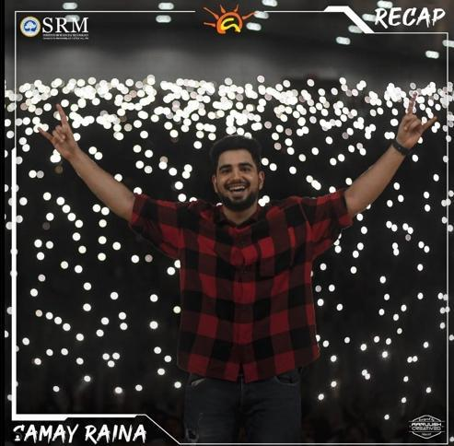

- National Level Publicity: AARUUSH External Publicity team goes to over 150 colleges around the country where it will be publicized as AARUUSH'26 sponsor.

- Product/Service Launch: OYELA can launch any of its new products/ services inside the Auditorium and Instagram Live in front of a 25000+ during the fest days.

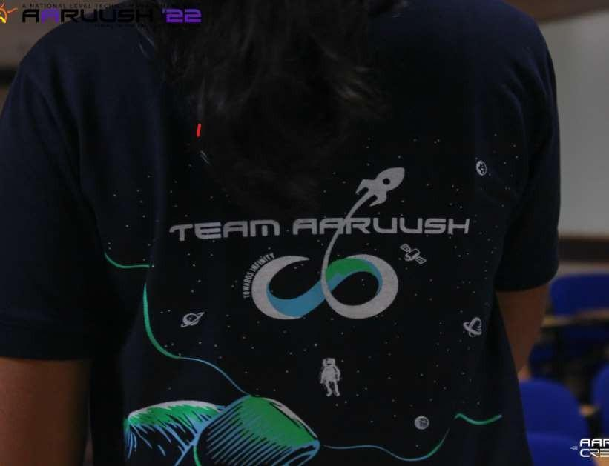
- Merchandise: All official Merchandise of AARUUSH'26 will contain the logo of OYELA.

- CSR Activities: Collaborative CSR activities by OYELA during the main days, with active involvement and assistance from AARUUSH'26 in their execution.
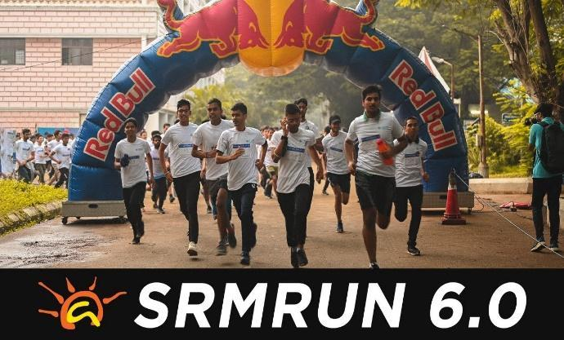

- Hack Summit: A unique opportunity to students all over India to showcase their skills in the fields of problem-solving abilities, mental endurance, and creativity in a 36-hour long hackathon competition, on a national stage to some of the biggest companies in the world.

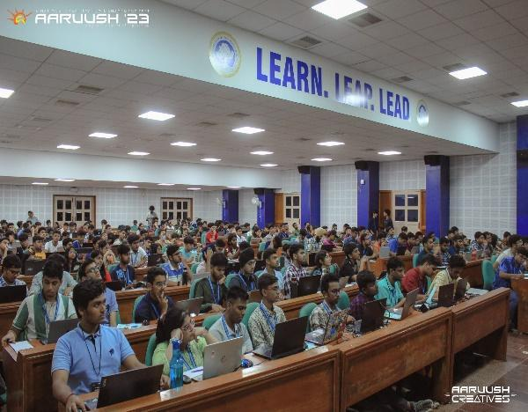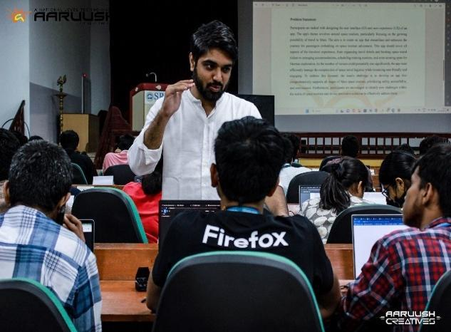
- Tech Rally: an adrenaline-fueled spectacle that pushes the boundaries of stunt riding, where fearless stunt riders take center stage, dazzling the crowd with gravity defying stunts and awe inspiring drifts. TECH RALLY is an event which promises to be a crowd pleaser and an unforgettable experience for all.
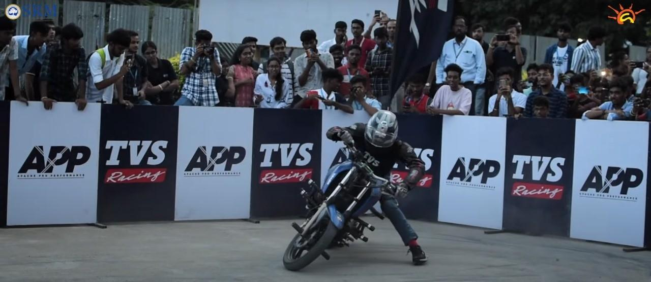
- Stalls and Promotion Booths: AARUUSH'26 will provide OYELA with stalls and promotion booths at the hotspots of the campus to promote their products and services.

- Product Placement: During the aforementioned highlight events, OYELA can display their official merchandise (such as mugs, etc.) on the podium or tables.

- Publicity through Reels: AARUUSH'26 will make tailored reels capturing OYELA essence and values.

- Domain Events: OYELA will be promoted in all 16 domains of AARUUSH'26. AARUUSH'26 has 16 domains under its umbrella which represent both aspects of both Engineering and Technology and Management. Various hackathons, competitions like:
    - X-play (Game Development Challenge)
    - Hack Summit (36 hour Hackathon)
    - ESP 32 Microcontroller Challenge
    - PCB Design Challenge, and many more

- Highlights Events: OYELA will be promoted as a sponsor in all the highlights events. For such occasions, High profile dignitaries from all work profiles visit the campus and enlighten the young minds. The events are:

- Industrial Conclave
It is a platform that aims to bridge the gap between industrialists, entrepreneurs, and students. It is a forum revolving around a central agenda. The aim of IC is to obtain a broad perspective on the challenges and risks faced by aspiring industrialists

- UnConference

Unconference is an annual event hosted by AARUUSH'26 which offers a platform to put forward visionary ideas and discussions between embellished individuals from different fields.
- Guest Lectures
Imparting the knowledge and enlightening the youth, high-profile dignitaries come with an array of topics from various fields.
- Exclusive Workshops and Sessions: OYELA experts could conduct workshops or sessions for the attendees. This would add educational value to the fest and align with OYELA expertise.

- Contests and Competitions: AARUUSH'26 can help OYELA to conduct specific contests related encouraging participation and engagement from students during main days.

- Records:

- Guinness World Record: On the 7th of September, 2019, Team Aaruush set a Guinness World Record for the Largest Software Lesson in Adobe Lighroom, as 900 eager learners gathered to participate in this historic event, making its mark in the prestigious book.

- Limca Book of Records: Aaruush spearheaded an ecorun on the morning of
India’s 71st Independence Day, and with a resounding success, this 5km run rallied 1181 enthusiastic participants, fostering awareness about the imperative of environmental conservation

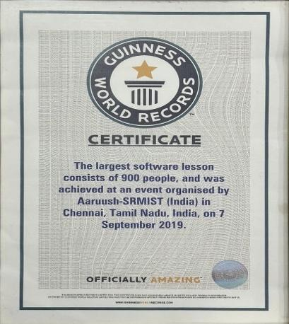
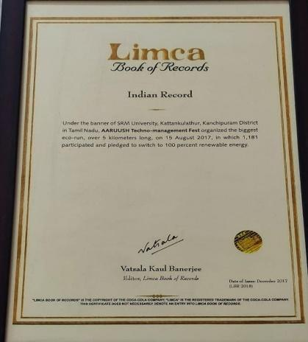

Marketing Tiers & Publicity:
- Title Sponsor [Pricing: 20 Lakhs]
- Helium Balloon will be place on Hotspot area of campus
- Stickers and QR codes of the company, redirecting to the website, will be placed on the auditorium's backseats.
- Aaruush will conduct Lucky Draw of 10 tickets on Instagram of Aaruush and OYELA.
- OYELA will be mentioned in ATOM (Aaruush Magazine) as our sponsor.
- Badges of the company will be given with every Common Registration kits.
- Aaruush would put fifty tree hangings which would display the logo of the company in and around the main hotspots of the campus.
- Company standees will be strategically placed in hotspot areas of the campus during the main days.
- Present captivating memes and product photography appealing to a broad audience, featuring the company's logo for brand recognition.
- Incorporate the company's logo on microphones used during key event moments for a subtle yet impactful visual association.
- Elevate visibility through flags displaying AARUUSH'26 and Title Sponsor logos along Mahatma Gandhi Road.
- Captivate attendees with a 5-6 minute audio-visual segment before each event, showcasing sponsor recognition.
- Host dedicated events for product launches, generating significant attention among attendees.
- Enhance brand outreach through radio station advertising, reaching a diverse and expansive audience.
- Utilize branded filters on platforms like Instagram and Facebook, creating a unified online presence.
- The Common Registration tickets for the AARUUSH'26 will contain the logo of the company.
- All deliverables are mentioned under tiers B ,C and D.

- Associate Sponsor [Pricing: 12 Lakhs]
- Prior to all events, a 3-4 minute audio-visual will be showcased.
- Company videos featuring new products or commercials will be featured during roadshows.
- Highlight the company's social and environmental initiatives as part of their corporate social responsibility across campus.

- Drive participation with company-themed quizzes and games on social media, deepening brand interaction.
- All deliverables are mentioned under tiers C and D.
- Co-Sponsor [Pricing: 6 Lakhs]
- Implement product placement through brand images across all events.
- Precede specific events with a concise 1-2 minute audio-visual presentation.
- Reach SRMIST students via email communication while external participants will be featured in brand-related posts.
- Distribute company flyers at all AARUUSH'26 desks for extensive visibility.
- Company-planned activity to guide participant registration with brand-specific details.
- All deliverables are mentioned under tiers D.
- Power Sponsor [ Pricing 3 Lakhs]
- Incorporate the logo prominently into all marketing materials, encompassing brochures and websites.
- Collaborating partners will feature event materials inclusive of the power sponsor's logo.
- Adorn key campus locations with decorative papers showcasing company logos, enhancing visual impact.
- Ensure verbal recognition both prior to and after each event.
- Feature the logo in the AARUUSH'26 film during student orientation.
- Include the logo on certificates for all AARUUSH'26 events.
- Extend branding to encompass all social media and media partner posts

Special creative marketing ideas will be exclusively tailored for OYELA by team AARUUSH'26.

*The sponsor tiers are subject to upgrade as per the deliverables from both parties *

Deliverables from OYELA:
  - OYELA is expected to provide the monetary funds on or before the discussed dates.
  - OYELA is expected to provide their official goodies and merchandise for their promotion.
  - OYELA is expected to provide its logo for all branding and marketing purposes.

“PROPER UNDERSTANDING OF LEGAL INFORMATION IS SPECIFIED OVER IN THE SPONSORSHIP & MARKETING BROCHURE.”

Looking forward to having a positive reply from your end and hope to have OYELA at AARUUSH'26.

Thanks and Regards,

HarSiddharth Agarwal | Vansh Gupta | Yas Devansh Gupta
+91 +91 87450 72181 | +91 84480 67969 | +91 95205 34441

Sponsorship and Marketing Heads
sponsorship@aaruush.org
SRM Institute of Science and Technology, Chennai.
https://www.aaruush.org/

