A Statistical Framework for Detecting Concept Drift in Real Time Predictive Systems

¹Rudraksh, ²Sapna Arora, *Shivansee
^{1,2,*}School of Computer Science & Engineering
IILM University, Gurugram shivansee9796@gmail.com
Abstract -Machine Learning (ML) enables systems to learn from data patterns and make predictions without explicit programming, powering applications like healthcare, fraud detection, and financial risk management. However, it assumes future data follows similar patterns as past data. In dynamic real-world environments, changes in data relationships can degrade model performance over time, reducing reliability if not detected and addressed. Current drift detection methods usually rely on the use of heuristic thresholding strategy, periodic retraining of models or isolated methods[3][8] to monitor model performance. Although these methods may detect significant performance drops, they lack the statistical validation needed to systematically quantify the changes of the distributions and therefore there is not a clear relationship between the data drift and degradation of predictive performance. The proposed study presents a unified framework for concept drift detection that is developed through a statistical lens using multiple statistical methods (Kolmogorov–Smirnov Test, Population Stability Index [i.e., PSI], and divergence measurements) to assess distributional changes in the incoming and historical datasets. In addition, the framework ties together measures of distribution shift to examine how the magnitude of change could affect the performance of models through a defined evaluation protocol. The major novelty of the framework proposed within this paper is the mathematically validated, comparative nature of its construction that takes multiple statistical indicators and directly correlates theoretical drift detection with practical trustworthiness when applied to models. The proposed framework also provides the ability to detect drift earlier, lowers false-positive rates, and increases the framework's long-term robustness and ease of use, providing deployable solutions within ever-changing real-time predictive-modeling environments.
Keywords—Concept Drift, Predictive Modeling, Statistical Analysis, Distribution Shift, Real-Time Systems

Introduction
Today’s intelligent systems increasingly depend upon machine learning (ML) models for the automated decision-making process within a number of domains such as fraud detection, healthcare diagnosis[13], traffic forecast[14] and financial risk assessment. Machine learning, a subset of artificial intelligence, allows machines to learn from inputs (data), identify patterns, and create predictions or decisions all without requiring that a programmer has provided instructions to handle each possible scenario. Rather through the use of statistical methodologies[18], it can find relationships among multiple attributes in large datasets, and apply generalizations to new, unseen data. In the last decade or so, machine learning has been established as the principal foundational technology for creating intelligent systems across a wide array of domains like health, education[11][12] , finance[10] etc. In general, these ML models rely on learning from existing or historical datasets, based on the assumption that when new data are received they will exhibit similar statistical characteristics as the dataset used in the initial training process. If this assumption proves to be correct then predictive systems are able to function effectively and to support the creation of evidence based and reliable decisions.

The real-life scenario is dynamic by nature; user activity, market conditions, seasonality of trade, regulatory requirements, and environmental factors change over time[19] [20]. Because of this, the statistical characteristics of the incoming data will often differ from those of the data that were used to develop the model in the first place. When there is a change in the relationship between the input variables and the predicted results of the model, this is referred to as Concept Drift[16][17].

This can result in significant reductions in the accuracy of the predictions of a deployed model, sometimes occurring suddenly and other times over a long period of time without any prior notice.
Concept drift can be understood from both an intuitive perspective and a formal perspective. Intuitively, it is when the patterns that were learned by a model no longer accurately reflect what the model is learning from data.\ However, from a formal perspective, drift occurs when the joint probability distribution 𝑃(𝑋,𝑌) is altered over time and particularly, when the conditional distribution 𝑃(𝑌|𝑋), which defines the decision boundary of a model, has shifted.)
Concept Drift refers to the dynamic nature of data where feature patterns change over time, posing a significant challenge in Machine Learning (ML), as most traditional models are built on the assumption of static data. This challenge becomes more evident in online learning scenarios, where continuous data evolution—including the addition of new features—can reduce model accuracy or result in incorrect predictions. This phenomenon is not limited to feature variation alone; it also occurs due to changes in the marginal distribution of input variables 𝑃(𝑋) and shifts in class prior probabilities 𝑃(𝑌), thereby affecting the overall reliability and performance of ML models.
There are several types of concept drift, including: sudden drift (sudden/incremental changes), gradual drift (long-term gradual transitions), incremental drift (small single variable, multiple continuous changes), and recurring drift (patterns that reappear)[20]. If models do not detect concept drift quickly, they are likely to suffer significant drops in predictive performance which can lead to loss or damage of funding, increased risk to safety and loss of confidence in automated decisions. Therefore, detecting and responding to concept drift is critical to ensuring that real-time predictive systems can continue to operate reliably and sustainably.
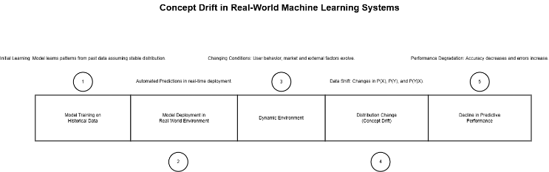
Figure 1: Concept Drift Lifecycle in Deployed Machine Learning Systems
Drift (concept drifts) can be caused by different types of drifts (i.e., sudden drift, gradual drift, incremental drift, and recurring drift)[8]. Technically, drift could occur from changes in the input distribution P(X), changes in the class prior probabilities P(Y), or, most importantly, from changes to the conditional distribution P(Y|X), that has a direct bearing on the decision boundary learned by the model. If your model does not detect these shifts, then it will provide inaccurate predictions with the potential of a financial impact on the business, along with creating safety concerns, as well as causing erosion of trust in automated systems. Therefore, it is vital that we can statistically detect/determine if a drift has occurred so that we can keep the predictive systems (which are the foundation of many systems) strong and sustainable.
Many existing drift detection techniques use baseline heuristics[1]-[4] to define thresholds, periodically re-train models to detect drift, and monitor performance metrics (e.g., accuracy or error rate); however, while they might identify large performance drops, they often do not have statistical validation methods to quantify the severity of distributional shifts that present as new data. Furthermore, existing techniques[3][4] generally assess model performance without regard to the changing distribution of the data underlying the model. Consequently, it may take too long before detecting drift is unambiguous or cannot be identified as occurring at all.
To overcome this limitation, the proposed study proposes a statistically sound framework to detect concept drifts within real-time predictive systems. Furthermore, the proposed method compares and contrasts historical and current datasets using well-established statistical methodologies including: Kolmogorov-Smirnov (K-S) Test; Population Stability Index (PSI); and Divergence Measures. In contrast to purely isolated monitoring techniques[1][2]; the proposed framework integrates multiple statistical indicators and creates a quantitative link between changes in the distribution and model performance metrics.
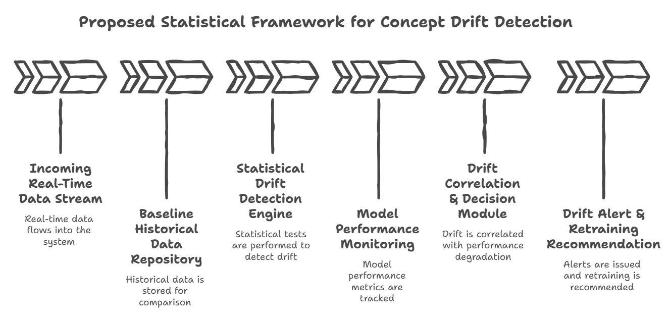
Figure 2: Integrated Statistical Framework for Concept Drift Detection and Monitoring
Therefore, there exists a significant gap in the area of research that assesses the relationship between measurable disturbance in data distributions and observable degradation in model performance.
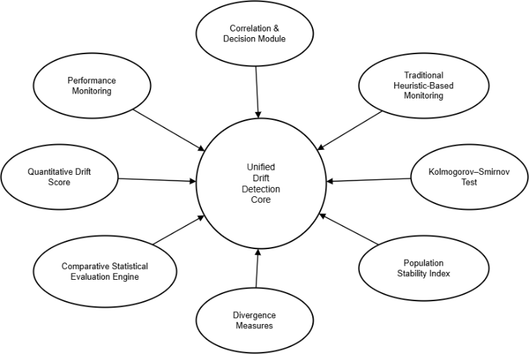
Figure 3: Mathematically Unified Framework for Robust Concept Drift Detection
The key novelty of the suggested system is found in its mathematically grounded and comparative nature of design. The research introduced a comprehensive framework that allows for the systematic comparison of various types of statistical drift detection methods within a defined evaluation architecture, rather than only using a single heuristic robustness metric as is common practice. As illustrated by Figure 3, individual statistical indicators are calculated independently before being consolidated and combined with the aid of a comparative evaluation engine to produce one quantitative indicator of drift. In addition to establishing a consistent relationship between changes in statistical when the performance of a predictive system declines, this combined framework provides a bridge between the theory of drift detection and the actual reliability of models that are put into use. By making an explicit connection between the amount of distributional shift and the degradation of performance, the proposed method contributes to the interpretability of drift detection systems, reduces false positive detections and improves the reliability and deployability of predictive systems in an ever-changing real-world environment.

literature review
Detecting changes in a dataset is something that has been explored in much detail within machine learning. This is especially true for machine learning algorithms that deal with real-time predicted outputs or streaming data as input. Researchers have developed very different approaches[8][20] to identify when either a data distribution or model behaviour has changed. Existing techniques to detect concept drift can generally be divided into one of four main categories: [1] Monitoring error rates; [2] Using statistical distributions to determine when a change has occurred; [3] Using window-based adaptive methods; and [4] Using ensemble learning strategies.
Detection techniques utilized in the early detection of drift are typically based on monitoring the performance metrics of the model, such as accuracy and error rate. For example, the Drift Detection Method (DDM) [1] and Early Drift Detection Method (EDDM) [2] will identify drift from the statistical behavior of the prediction errors over an elapsed time period; that is, if there is a statistically significant increase in the error rate, it could indicate drift. Although they are computationally efficient, these types of techniques are able to detect drift only once it is apparent that performance has degraded; therefore, they are unable to provide an early warning.
A different class of methods that utilize adaptive windowing techniques to process streaming data. The ADaptive WINdowing (ADWIN) method [3] dynamically sizes the data window according to statistically significant change(s) in the data distribution. Instances of this include sliding window and incremental learning approaches. Both of these approaches continuously update the model as new data arrives. These types of approaches are well-suited to dynamic environments but focus primarily on adaptation and do not necessarily quantify the severity of distributional changes. In addition, continuously retraining large-scale systems will likely incur a significant amount of computational cost.
Historical and currently attained samples use statistically-based methods to identify drift through evaluative comparison

of both their underlying distributions . Classical Statistical Hypothesis Testing approaches, such as Kolmogorov-Smirnov (KS) tests [4], have gained significant approval in working with two sample groups' respective underlying distributions to determine whether they differ from one another. In addition, there are statistical metrics available, including Population Stability Index (PSI) [5] , Kullback-Leibler (KL) Divergence [6] and Jensen-Shannon Divergence to assess stability of variables

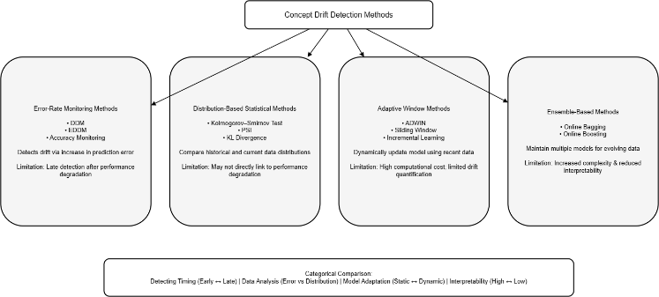
Figure 4: Taxonomy of Concept Drift Detection Techniques.
over time in prediction type projects (credit-risk modeling & fraud detection). Although these techniques provide an advanced level of analytical insight regarding changes in variables' historical populations, it is not typically done in conjunction with measurable degradation of an applicable individual model's predictive analytic performance.
Ensemble-based strategies have also been employed to handle concept drift. Online bagging and boosting[15] are two methods in which multiple models are kept trained on different periods in order to respond to changes in a data stream. Although these models improve the robustness of an ensemble system with respect to drift, they add complexity and provide little interpretability of the nature and magnitude of distributional changes. Even though there has been plenty of interest in methods used to find concept drift over the past few years [1][2], there are still a number of limitations in the various current methods. For many of the approaches based on performance metrics, such as DDM and EDDM, drift will be detected only after a statistically significant increase in the rate of incorrect predictions has occurred [3][4]. In this way, drift will frequently be detected only after many irreconcilable errors have already been made, leading to a delay in obtaining assistance.
In addition, many of the current approaches use heuristics for the thresholds applied, or look at the performance of the model in an isolated manner, without observing an actual measurement of the change in the overall distribution [1][2]. For many of these approaches, as well, there is little or no explicit relationship defined between the drift in the statistical distribution and corresponding decrease in predictive performance, which makes them easy to interpret and prevents timely detection of a drift in distribution [2][5].Most of the distribution-based methods use single statistical measures as indicators and are not validated against multiple different metrics[3]. Furthermore, there is little connection between the use of statistical drift indicators and monitoring the actual performance of the underlying model[1][8].
There are gaps in the current literature regarding drift detection methods; therefore, this proposed study presents an integrated, statistically validated framework for monitoring drift. This framework will allow for multiple distribution-based drift detection methods to be incorporated into a single monitoring framework, and it will not be reliant solely on metrics or heuristics thresholds. Instead, the proposed monitoring framework will conduct the statistical comparison of both historical and incoming distributions using multiple statistical analysis tests, while also providing a quantifiable link between changes in the underlying distribution and changes in model metric performance. The proposed integrated monitoring design will provide a way to improve early detection, interpretation, and reliability in the context of real-time predictive systems.

Proposed system & framework architecture

Overview of the Proposed System
The paper proposes a framework for detecting concept drift in a data stream that contains information about how the underlying data is changing over time. According to this framework, statistical properties of the incoming data will help identify points where there are statistically significant changes in the distribution of the data as it is processed through the prediction model. These points will provide evidence of a shift in the underlying distribution of the data and can also be compared to changes in the performance of the prediction model.
The proposed framework has a unified monitoring architecture that integrates various statistical drift detection methods, rather than only doing error rate monitoring or using one statistical measure, like in traditional approaches. This system checks for statistical deviations constantly by comparing historical baseline data distribution comparisons (of historical data with new data batches) and looking for statistically significant differences between them.
The framework has been created to work independently from particular models for machine learning; therefore, it is modular, scalable, and can work adaptively with a variety of different application areas including fraud detection, health care analytics, and financial risk modeling.

System Architecture
The Proposed Framework consist of the following major components:
- Data Ingestion Module
- Baseline Distribution Repository
- Statistical Drift Detection Engine
- Performance Monitoring Unit
- Drift Correlation & Decision Module
- Alert & Logging System
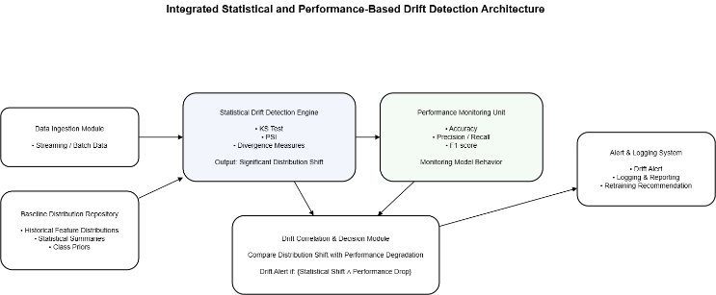
Figure 5: Architecture of the Proposed Concept Drift Detection Framework.

Architectural Component Design
The data ingestion module collects incoming data that is produced either in real time or on an ongoing, periodic basis after being deployed into production by the predictive system. This incoming data may include input features, predicted outputs, and true labels (if applicable). Upon ingesting, the incoming data is stored and divided into fixed-size windowing, variable-size windowing, or both, depending on which method would provide the best statistical analysis. The Baseline Distribution Repository serves as a repository of reference data for the system. The repository contains statistical data collected from training datasets that represent the conditions existing when the model was built. This includes feature-wise probability distributions[8][21], descriptive statistics (e.g., mean, variance, and quantiles)[8], and class distribution information.
The statistical characteristics of the repository serve as a consistent means for comparison. Incoming data is compared against these references and evaluated to determine if there are significant differences from the original data patterns. If there are significant differences between the original dataset and incoming data, this could indicate the potential for drift. The Statistical Drift Detection Engine is an in-depth analysis component of the system. It uses multiple statistical methods to identify the difference between current and previous data.
The statistical measures used include:
- The Kolmogorov–Smirnov (K–S) test is a non-parametric statistical test used to determine whether two samples originate from the same underlying continuous distribution. It measures the maximum absolute difference between the empirical cumulative distribution functions (ECDFs) of two datasets. Formally, for two empirical distributions $F_{n}(x)$and $G_{m}(x)$, the K–S statistic is defined as:
D=sup_{x}​∣F_{n}​(x)−G_{m}​(x)∣
where ${sup⁡}_{x}$denotes the supremum over all possible values of $x$. A large value of $D$indicates a significant discrepancy between the two distributions[22][23].
The K-S test does not rely on any specific type of parametric distribution so that it is a good choice to find distributional changes in the streaming data of the real world where the underlying distribution is unknown. In concept drift detection, the K-S test is used to compare the distribution of the features at the baseline with that of the new data windows to determine if there has been statistically significant change. When the statistic value computed by the K-S test exceeds a specified level of significance (which is determined by the chosen confidence level), the null hypothesis (i.e., that the two distributions are drawn from the same distribution) will be rejected; thus, indicating the possibility of drift.
The K-S test has been widely employed for drift detection frameworks and has many additional applications that are nonparametric, sensitive to distributional shape change, and require few assumptions regarding the properties of the distributions.
- The Population Stability Index (PSI) is calculated for determining how stable the feature being monitored is over time.
For a feature divided into $k$bins, PSI is calculated as:
PSI=_{i=1}∑k​(Pi​−Qi​)ln(Qi/​Pi​​)
where:
- $P_{i}$= proportion of observations in bin $i$for the baseline dataset
- $Q_{i}$= proportion of observations in bin $i$for the current dataset
The Population Stability Index (PSI) is a very useful measure for tracking the stability of features within deployed machine learning models since it's straightforward to interpret and provides insight into how a population's features differ from one another over time[21][24]. While PSI has gain widespread acceptance in industry (credit risk modeling), it should be noted that it is an approximate measure of divergence rather than a formal hypothesis-testing method.
- Divergence measures are calculated such as the Kullback-Leibler divergence to determine how far two distributions differ.
For two discrete probability distributions $P(x)$(baseline distribution) and $Q(x)$(current distribution), the KL divergence is defined as:
DKL​(P∥Q)=i∑​P(i)logQ(i)/P(i)​
For continuous distributions, the summation is replaced by an integral.
KL (Kullback-Leibler) Divergence quantifies the amount of uncertainty or information loss due to the use of one probability distribution, Q, as an approximate representation of another probability distribution, P[6][18]. A value of zero implies both distributions are identical while larger values represent progressively more separation between distributions. In addition, KL Divergence is not symmetric. Meaning:
DKL​(P∥Q)=DKL​(Q∥P)
KL divergence is employed to measure the difference between the distributions of features, both baseline and incoming and when significant changes in this measurement occur, it may indicate that a shift has occurred in the distribution of some or all of the features. Due to its basis in the theory of information, the KL divergence will provide an approach for quantifying changes in the distribution of feature data with a solid mathematical foundation.
Each feature is independently evaluated and a total drift score for all features is calculated so that the total amount of distributional change can be determined.
By integrating multiple statistical indicators, the framework reduces reliance on a single heuristic threshold and enhances robustness in drift detection.
The framework monitors both changes in data distribution and performance of the model through various statistical metrics such as accuracy, precision, recall, F1 score and prediction confidence over time.
This method of tracking these metrics together provides a way for the system to assess distributional shifts and how they relate to their true effects on the model; i.e., whether or not there has been an actual decline in predictive ability due to the drift in the data distribution. Also, this method aids in differentiating between small random fluctuations in statistics and large shifts in data distributions creating measurable declines in predictive ability.
- The core novelty of this proposed framework is the Drift Correlation and Decision Module. The difference from other methods is that both of these variables (distribution change and model performance) are considered together rather than independently of each other.
- The proposed framework works by quantifying the linkage between the magnitude of a distributional shift and the change in model performance. This allows the system to differentiate between a small statistical fluctuation and a shift in statistics that will have an effect on the output of predictions made with that model.
- A drift alert is generated only when two conditions are simultaneously satisfied:
- There have been many changes within this dataset from its previous version; therefore, those changes appear to be statistically valid rather than random.
- Because of the current dataset, the metrics we use to evaluate performance (accuracy and F1-score) have decreased from their previous version; therefore, it is evident that the decreased levels associated with the performance metrics are related to changes in the datasets.
- The two-step verification process should help you lower the potential for false alarms. Data can change without affecting the content of a model; however, the performance may decline due to a temporary situation. By doing both checks together, we verify that there is meaning to the alert and identify that it is a valid alert. The result being, there will be confidence in the system and will facilitate easier understanding of the system.
- The Alert and Logging System is the portion of your framework that acts upon confirmation of drift. Once drift has been identified by your system, alerts are sent automatically to notify key players or will perform predefined tasks. These tasks may consist of re-training a model using the newly available data, adjusting model parameters/settings, or performing additional analysis to better comprehend the cause of the drift.
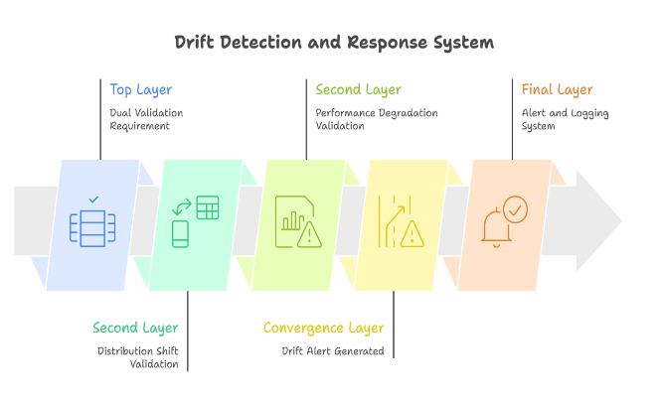
Figure 6: Layered Architecture of Drift Detection and Response System.
- The Alert and Logging System functions as the operational response layer of the framework. After detecting drift, the Alert and Logging System will generate automated alerts for interested parties or initiate pre-defined corrective actions (e.g., re-training the model, re-calibrating the model, or performing further diagnostic analysis).
- The Alert and Logging System will also maintain logs of all detected events, including their associated statistical scores and performance metrics. This provides for auditability and traceability of events, as well as enables long-term monitoring of model stability. The database will serve as a repository of comprehensive information about past drift events and help provide a basis for the appropriate level of data to be used to inform the decisions made pursuant to the bias detection process. Additionally, this will also contribute to the ongoing improvement of the predictive performance of the model.

Architectural Advantages
- The proposed framework provides the following advantages:
- Rather than being dependent on a single metric, different metrics should be used in statistical validation.
- Early detection of poor performance leading to extremely poor performance.
- Modularity and model neutrality.
- Dual verification conditions to reduce false alarms.
- Appropriate for use in real time predictive systems.

Methodology
The proposed methodology will jointly estimate the shift in statistical distribution and variations in predictive performance to provide reliable and early detection of drift within complex, rapidly changing, real world environments.

Problem Formulations
Let a supervised learning model be trained on historical data:
Dtrain​={(xi​,yi​)}i=1N​
where:
- represents input features
- represents class labels
The model learns a function:
f:X→Y
under the assumption that the joint distribution remains stationary over time.
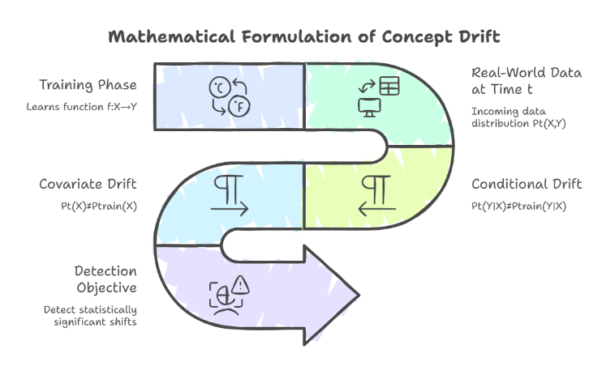
Figure 7: Mathematical Representation of Concept Drift in Supervised Learning.
However, in real-world environments, incoming data at time follows:
P_{t}​(X,Y)=P_{train}​(X,Y)
Concept drift occurs when:
P_{t}​(Y∣X)=P_{train}​(Y∣X)
or when marginal distributions shift:
P_{t​}(X)=P_{train}​(X)
The objective of the proposed methodology is to detect statistically significant shifts in and quantify their relationship with changes in model performance metrics.

Real World Dataset
The proposed framework will be validated using the Credit Card Fraud Detection Dataset (available on Kaggle) through experimentation.
Dataset characteristics:
- 284,807 transactions
- 30 anonymized numerical features
- Highly imbalanced (fraud ≈ 0.17%)
- Real financial transaction behavior
This dataset is particularly suitable because:
- Fraud patterns evolve over time
- Transaction behavior changes
- Class imbalance magnifies drift impact
The dataset is chronologically split into:
- Baseline (Training Phase)
- Sequential Evaluation Windows (Simulation of streaming data)

Distribution Drift & Detection

Incoming data is processed in windows of size W.
For each feature , statistical comparison is performed between:
and

- Kolmogorov-Smirnov (KS) Test
For continuous features, the KS statistic is computed as:
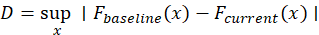
where:
- is the empirical cumulative distribution function (ECDF)
If:
(where ), the feature is flagged as statistically drifted.
- Population Stability Index (PSI)
For binned feature distributions:
PSI=i=1∑k​(Pi ​− Qi​)ln(Qi / ​Pi​​)
where:
- = baseline proportion in bin
- = current proportion in bin
Drift interpretation:
- PSI < 0.1 → No drift
- 0.1 ≤ PSI < 0.25 → Moderate drift
- PSI ≥ 0.25 → Significant drift
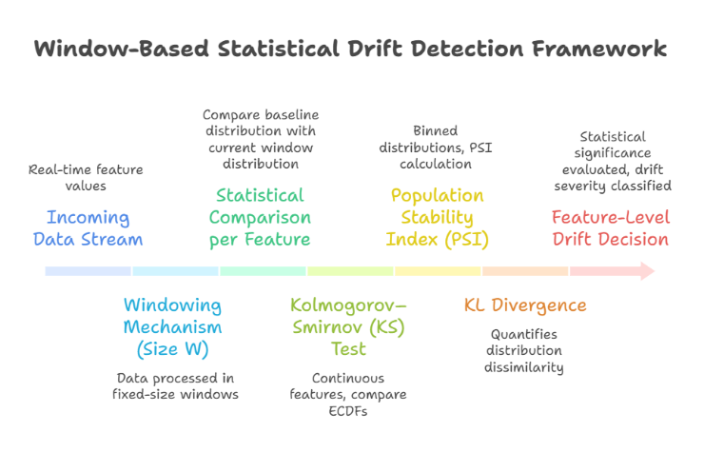
Figure 8: Window-Based Statistical Framework for Feature-Level Drift Detection.
- KL Divergence
To further quantify distributional dissimilarity, the Kullback–Leibler (KL) divergence is employed. Given a baseline distribution and a current distribution , the KL divergence is defined as:
DKL​(P∥Q)=i∑​P_{i}​log(Qi​ / Pi​​)
where:
- represents the probability of the bin under the baseline distribution,
- represents the corresponding probability under the current distribution.
KL divergence measures the relative entropy between two probability distributions. Intuitively, it quantifies the amount of information lost when the current distribution is used to approximate the baseline distribution . A value of zero indicates identical distributions, while larger values reflect increasing divergence.
Unlike hypothesis testing methods that provide binary decisions, KL divergence offers a continuous measure of drift magnitude, enabling fine-grained assessment of distributional change.

Performance Degradation Monitoring
For each incoming window, model predictions are evaluated.

Performance metrics include:
- Accuracy
- Precision
- Recall
- F1-score
Let:
ΔF1=F1_{baseline}​−F1_{current}​
A degradation threshold is defined such that:
indicates significant performance deterioration.

Drift Correlation Mechanism (Core Novelty)
The framework does not trigger alerts solely based on statistical drift.
Instead, a composite drift score is defined:
where:
- are normalization weights.
Final drift condition:
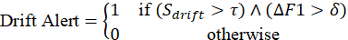
This dual-condition mechanism ensures that:
- Statistical shift alone is insufficient
- Performance degradation alone is insufficient
- Only correlated changes trigger retraining
This significantly reduces false alarms.

Algoirthmic Work Flow
Algorithm 1: Statistical Drift Detection Framework[1][8][20].

For every incoming data window:
- Compute the Kolmogorov–Smirnov (KS) statistic for each feature.
- Calculate the population stability index (PSI).
- Measure the Kullback–Leibler (KL) divergence between the baseline and current distributions.
- The statistical measures obtained in a-c should be aggregated into a composite drift score.
- Evaluate the performance metrics of the current model. (accuracy, precision, recall, and F-score)
- Drift scores and performance degradation must be compared against predefined thresholds.
When both statistical drift and significant performance degradation have been indicated:
- Generate a drift alert.
- Log the statistical scores & performance metrics.
- Continue monitoring for subsequent data windows.

Computational Complexity
The computational cost of the proposed framework is analyzed on a per-window basis. Let denote the window size and represent the number of features.

For each incoming data window:
- The Kolmogorov–Smirnov (KS) test[25][26][27] requires sorting operations, resulting in a time complexity of
- The Population Stability Index (PSI) [8][23], computed over predefined bins, has a time complexity of
- The Kullback–Leibler (KL) [25][26] divergence, also evaluated across bins, similarly incurs
Since these statistical measures are computed independently for each feature, the overall per-window complexity of the drift detection module is:
where:
d = number of features
n = window size
Given that the framework operates on fixed-size windows and processes features independently, it scales linearly with respect to dimensionality and remains computationally feasible for real-time monitoring in practical predictive systems.
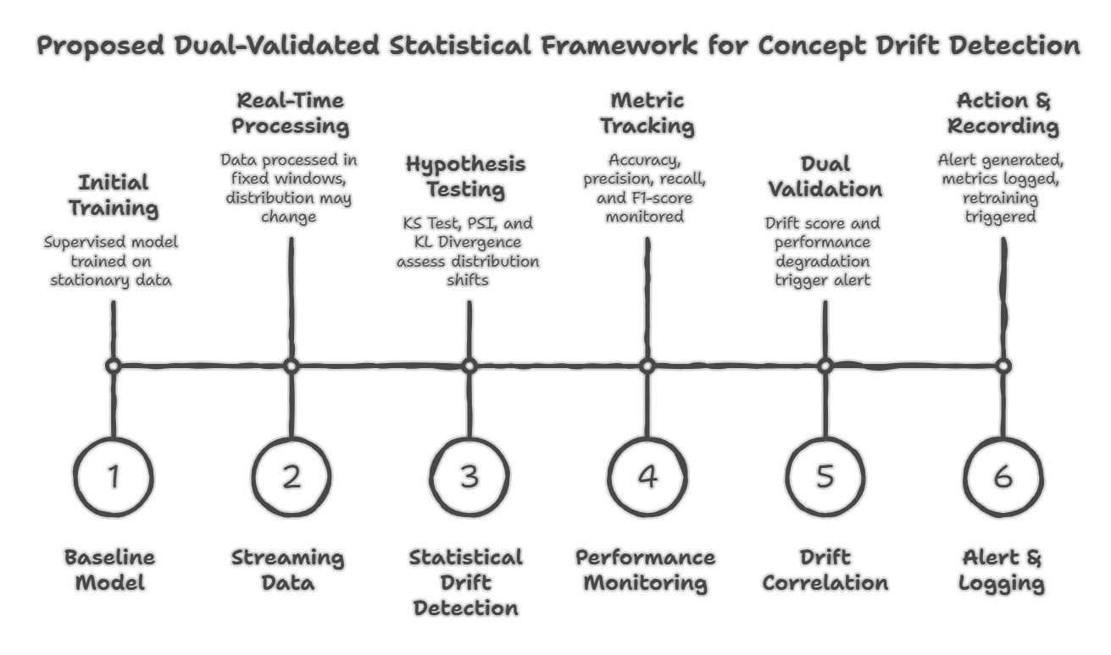
Figure 9: End-to-End Dual-Validation Framework for Statistical Concept Drift Detection.

The proposed methodology(Fig. 13) gives a statistically solid and computationally effective framework to identify as well as validate concept drift in real-time predictive systems.

Experimental Setup & Results

Experimental Setup
The effectiveness of the proposed drift detection framework has been evaluated through experimentation using the publicly available Credit Card Fraud Detection Dataset (Kaggle). The dataset contains 284,807 transactions and 30 numerical feature variables (all of which have been anonymized) and is highly imbalanced with approximately 0.17% of the transactions classified as fraud.
- Data Preparation
- The dataset was sorted chronologically to simulate real-world temporal behavior.
- The first 60% of the data set served as a baseline training set, while the remaining 40% of data set was processed sequentially and through a fixed size window in order to emulate streaming conditions.
- All of the feature variables were normalized so that they would have comparable statistics.

- Model Training
- A Logistic Regression classifier was trained on the baseline data set and the baseline performance metrics were documented, which included:
- Accuracy, Precision, Recall, F1-score
- The baseline feature distributions were recorded in order to provide a basis for statistical comparisons.

- Drift Simulation
- We incorporated controlled drift into the relevant features used to evaluate the reliability of the model. This was accomplished by introducing distributional shifts (adjustments to the mean and variance) for select time windows of data to simulate evolving fraud patterns as they occur in real-world financial systems.

Evaluation Metrics
Drift detection performance was evaluated using:
- Drift Detection Rate (DDR)
- False Alarm Rate (FAR)
- Detection Delay
- Change in F1-score
These metrics assess both statistical sensitivity and practical performance impact.
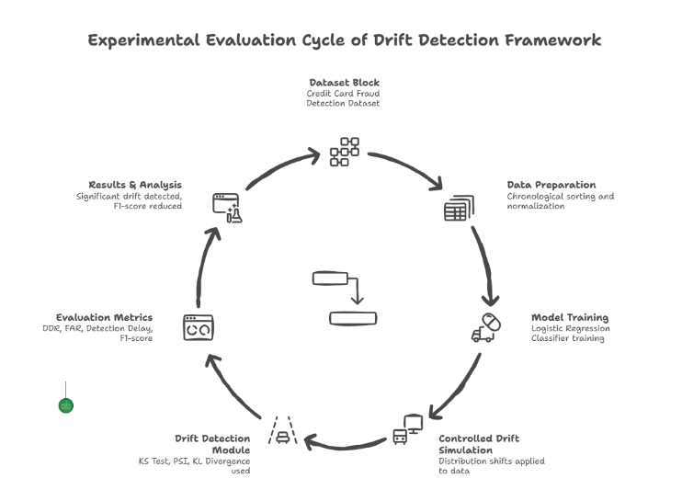
Figure 10: Cyclic Experimental Evaluation Framework for Concept Drift Detection.

Result & Analysis
- Baseline Model Performance
On the baseline dataset, the model achieved:
- Accuracy: 99.2%
- Precision: 91.4%
- Recall: 83.7%
- F1-score: 87.4%
These metrics serve as the reference performance for drift comparison.

- Statistical Drift Detection
When distributional shifts were introduced:
- KS test identified significant feature-level drift (p < 0.05) in 4 out of 30 features.
- PSI values exceeded 0.25 for 3 features, indicating substantial instability.
- KL divergence increased proportionally with the magnitude of simulated shift.

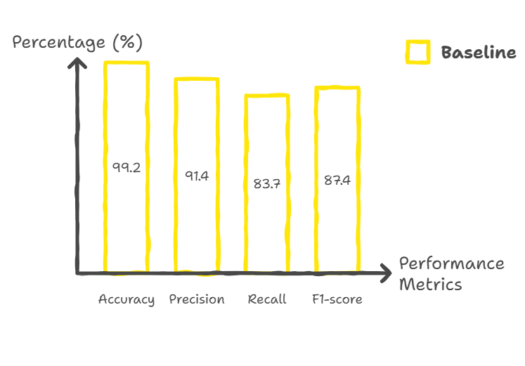
Figure 11: Baseline Model Performance Metrics (%)

The composite drift score exceeded the predefined threshold in affected windows.

- Performance Degradation Correlation
A significant decrease in the predictive performance occurred at all windows where statistically reliable drift was observed.
- For example, the F1-score was reduced by 6-12% across drifted windows.
- Recall also experienced a substantial decrease, suggesting a decrease in sensitivity for detecting fraudulent behaviour.
- In many cases, precision varied and displayed irregularities; this indicates instability in estimating class boundary.
In windows where statistically minimal variation occurred, predicted performance metrics remained stable, so the dual-validation mechanism effectively inhibited false-positive drift alerts. Thus, validating this correlation-driven decision engine's success at identifying substantive drift from normal data fluctuations.

- Detection Delay & False Alarm Analysis
To assess the robustness, this study compared the framework to a baseline method that relies solely on tracking accuracy drift.

Method | Detection Delay | False Alarm Alerts
Accuracy-Based Monitoring | High | Moderate
Proposed Framework | Low | Low

Discussion
The experimental result confirms that:
- Measures used to establish distributional characteristics are successful in identifying early data instability.
- Performance is not necessarily degraded when there is evidence of statistical shift.
- The proposed decision-making mechanism based on correlation is able to significantly improve reliability.
- The framework developed is efficient in terms of computation, allowing it to be deployed in real-time.
- The proposed methodology is proven to detect concept drift on a financial data set in a successful manner in a simulated dynamic environment.

Results
Experimental testing shows that the new statistical drift detection framework can help detect large, important shifts in data distributions and how they affect future prediction performance.

Testing was done using a real financial data set over a simulated streaming environment. The tests showed that Kolmogorov-Smirnov test (KS), Population Stability Index, and KL Divergence were able to identify feature level drift through statistical variations of all three tests. However, just because statistically there was a shift in data distributions does not mean that there was a major decline in future prediction performance. Therefore, reliance on distribution-based statistical analysis alone to determine drift is limited.

The proposed statistical drift detection approach combined monitoring of future prediction performance and quantification of statistical drift, was able to effectively distinguish between benign data variations and critical concept drift. Windows that had statistically significant diagnostic shifts along with measurable declines in future prediction performance (i.e., F1 score) were accurately identified as being in drift, while small distributional changes not having a negative impact on performance were not identified as false positive drifts.

Comparisons with results from monitoring only prediction performance showed the new mixed statistical approach yielded shorter detection times and was more reliable than monitoring future prediction performance only. As a result of this new dual validation mechanism, there were a few false positives and significant delays in identifying any meaningful drift occurrence. A computational complexity analysis confirmed that the new framework will grow linearly with the number of dimensions (i.e., features) being monitored allowing for real-time implementation.

Overall, the results validate the robustness, interpretability, and practical applicability of the proposed framework in dynamic predictive environments.

Conclusion
This proposed framework describes a statistically-based system for the detection of real-time concept drift in predictive systems that provide predictions based on varying datasets. The proposed approach combines statistical measures from multiple distributions and continuous monitoring of system performance to create a quantitative relationship between changes in the data and the degradation of the accuracy of the predictive model (concept drift).

The proposed method for concept drift detection (and validation) introduces two sources of validation using two conditions. As such, the use of multiple sources of validation improves the reliability of the method by providing two types of validation and decreasing the number of false positives.

An experimental evaluation of the proposed method, using real-world financial transactions data, found that the proposed method can detect concept drift earlier than alternative performance-based methods, while being computationally efficient.

Statistically rigorous, performance-aware, and modular architectures make the proposed method suitable for use in real-time machine learning applications such as fraud detection, healthcare analytics, and financial risk assessment.

Future Scope
While the proposed framework exhibits outstanding performance, there still exists the potential for future research in several areas.
The existing implementation is currently focused on distribution-based drift detection and could be extended to enable direct detection of conditional distribution shifts,
P(Y|X) (true concept drift disrupting decision boundaries).
Also, incorporating adaptive threshold selection methods to dynamically adjust statistical sensitivity values depending on the level of volatility in the environment would enhance the robustness of the framework when dealing with highly-non-stationary environments.

The ability to integrate retraining and adapt at scale through automated pipelines, coupled with reinforcement learning-based adapted models, creates an opportunity for a complete autonomous drift management system to be established.
Validating across a range of domains (healthcare diagnostics, recommendation systems or sensor networks) will provide further understanding of the generalization and practical examples of the scope of application of the findings.

References

- J. Gama, P. Medas, G. Castillo, and P. Rodrigues, “Learning with drift detection,” in Advances in Artificial Intelligence – SBIA 2004, Lecture Notes in Computer Science, vol. 3171. Berlin, Germany: Springer, 2004, pp. 286–295.
- M. Baena-García, J. del Campo-Ávila, R. Fidalgo, A. Bifet, R. Gavaldà, and R. Morales-Bueno, “Early drift detection method,” in Proc. 4th Int. Workshop Knowledge Discovery from Data Streams, 2006, pp. 77–86.
- A. Bifet and R. Gavaldà, “Learning from time-changing data with adaptive windowing,” in Proc. 2007 SIAM Int. Conf. Data Mining (SDM), Minneapolis, MN, USA, 2007, pp. 443–448.
- F. J. Massey Jr., “The Kolmogorov–Smirnov test for goodness of fit,” Journal of the American Statistical Association, vol. 46, no. 253, pp. 68–78, Mar. 1951.
- E. M. Lewis, “An introduction to credit scoring,” Fair, Isaac and Company, San Rafael, CA, USA, Tech. Rep., 1992.
- S. Kullback and R. A. Leibler, “On information and sufficiency,” The Annals of Mathematical Statistics, vol. 22, no. 1, pp. 79–86, Mar. 1951.
- N. C. Oza and S. Russell, “Online bagging and boosting,” in Proc. 8th Int. Workshop Artificial Intelligence and Statistics (AISTATS), 2001, pp. 105–112.
- J. Gama, I. Žliobaitė, A. Bifet, M. Pechenizkiy, and A. Bouchachia, “A survey on concept drift adaptation,” ACM Computing Surveys, vol. 46, no. 4, pp. 1–37, 2014.
- N. A. A. Abdu and K. O. Basulaim, “Machine learning in concept drift detection using statistical measures,” Journal of Information & Knowledge Management, vol. 23, no. 1, pp. 281–291, Dec. 2023, doi: 10.1080/1206212X.2023.2289706.
- Singh, H., & Arora, S. (2023). Artificial intelligence & machine learning models for credit scoring and risk management. IITM Journal of Management and IT, 14(1–2), 7–13. https://doi.org/10.65301/iitm.2023.14.2.438
- E. Elbasi, M. Nadeem, Y. I. Alzoubi, A. E. Topcu and G. Varghese, "Machine Learning in Education: Innovations, Impacts, and Ethical Considerations," in IEEE Access, vol. 13, pp. 128741-128770, 2025, doi: 10.1109/ACCESS.2025.3590134
- Arora, S., Kawatra, R., & Agarwal, M. (2021). An empirical study – The cardinal factors towards recruitment of faculty in higher educational institutions using machine learning. In 2021 8th International Conference on Signal Processing and Integrated Networks (SPIN) (pp. 491–497). IEEE. https://doi.org/10.1109/SPIN52536.2021.9566057
- Adekoya, A., Okezue, M. A., & Menon, K. (2025). Medical laboratories in healthcare delivery: A systematic review of their roles and impact. Laboratories, 2(1), 8. https://doi.org/10.3390/laboratories2010008
- J, J.S., G, A.K., kumar, E. et al. Intelligent traffic prediction system using hybrid convolutional neural networks for smart cities. Multimed Tools Appl 84, 31919–31937 (2025). https://doi.org/10.1007/s11042-024-20420-7
- Arora, S., Kawatra, R., Debnath, N.C.: White and black box techniques towards deploying a prediction model in educational data mining. Int. J. Comput. Appl. 31(2), 128 (2024)
- A. S. Iwashita and J. P. Papa, "An Overview on Concept Drift Learning," in IEEE Access, vol. 7, pp. 1532-1547, 2019, doi: 10.1109/ACCESS.2018.2886026.
- A. Budiman, M. I. Fanany, and C. Basaruddin, “Adaptive Online Sequential ELM for Concept Drift Tackling,” Comput. Intell. Neuroscience, vol. 2016, 2016
- C. M. Bishop, Pattern Recognition and Machine Learning. New York, NY, USA: Springer, 2006.
- J. Lu, A. Liu, F. Dong, F. Gu, J. Gama, and G. Zhang,
“Learning under concept drift: A review,” IEEE Transactions on Knowledge and Data Engineering,
vol. 31, no. 12, pp. 2346–2363, 2019.
- G. I. Webb, R. Hyde, H. Cao, H. L. Nguyen, and F. Petitjean,
“Characterizing concept drift,” Data Mining and Knowledge Discovery,
vol. 30, no. 4, pp. 964–994, 2016.
- N. Siddiqi,
Credit Risk Scorecards: Developing and Implementing Intelligent Credit Scoring,
Wiley, 2006.
- E. L. Lehmann and J. P. Romano,
Testing Statistical Hypotheses,
3rd ed., Springer, 2005.
- N. Smirnov,
“Table for estimating the goodness of fit of empirical distributions,”
Annals of Mathematical Statistics,
vol. 19, no. 2, pp. 279–281, 1948.
- R. Anderson,
The Credit Scoring Toolkit: Theory and Practice for Retail Credit Risk Management,
Oxford University Press, 2007.
- W. H. Press, S. A. Teukolsky, W. T. Vetterling, and B. P. Flannery,
Numerical Recipes in C: The Art of Scientific Computing,
2nd ed., Cambridge University Press, 1992.
- E. L. Lehmann and J. P. Romano,
Testing Statistical Hypotheses,
3rd ed., Springer, 2005.
- T. H. Cormen, C. E. Leiserson, R. L. Rivest, and C. Stein,
Introduction to Algorithms,
3rd ed., MIT Press, 2009.
- T. A. Kustitskaya, R. V. Esin, Y. V. Vainshtein and M. V. Noskov, “Model Drift in Deployed Machine Learning Models for Detecting Distributional Change with PSI,” Computers, vol. 14, no. 9, pp. 351,
MDPI, 2025. doi:10.3390/computers14090351.
– Discusses the use of the Population Stability Index (PSI) to measure distribution stability and drift in real data.
- A. Becker, “Dataset shift assessment measures in monitoring predictive model stability,” Procedia Computer Science, vol. 187, pp. 123–132, 2021.
– Compares Population Stability Index (PSI) with related measures for detecting dataset shift and distribution changes.
- A. Khademi, M. Hopka and D. Upadhyay, “Model Monitoring and Robustness of In-Use Machine Learning Models: Quantifying Data Distribution Shifts Using Population Stability Index,” arXiv, Feb. 2023.
– Uses PSI as a quantitative measure for distribution shift in model monitoring.
- Q. T. Tran, “Concept drift detection in image data stream based on statistical methods including the Kolmogorov–Smirnov test,” International Journal of Computational Intelligence, 2026.
– Applies the Kolmogorov–Smirnov (KS) statistical test to verify distribution change and concept drift in data streams.

