THREADLY
Week 2: UI/UX Design and Wireframe Development
Apparel and Textiles E-commerce Website

1. Introduction
This report presents the Week 2 UI/UX design and wireframe development plan for THREADLY, an apparel and textiles e-commerce website. The purpose of this stage is to convert the strategic blueprint prepared in Week 1 into clear, practical, and user-friendly interface concepts. The existing wireframes are retained as the visual basis of the report; the following design details make the proposed interface more specific through measurable layout rules, interaction states, accessibility considerations, and responsive behavior. The wireframes focus on four important areas of the shopping experience: the home page, product listing page, product detail page, and checkout flow.
The design is based on THREADLY’s goal of providing a convenient one-stop shopping platform for women’s wear, men’s wear, kids’ clothing, ethnic wear, fabrics, sportswear, loungewear, and home textiles. The interface should be simple enough for first-time visitors while also supporting repeat shoppers who want to save sizes, addresses, wish-list items, and cart information. A key Week 1 persona is Neha Sharma, age 38, a teacher from Chandigarh and a family shopper. Her example journey supports cross-category navigation, a persistent cart, saved addresses and sizes, clear discounts, and easy order tracking.

2. Design Goals
- Create a clean and organized shopping experience with clear navigation, consistent 4–48 px spacing tokens, and predictable placement of global actions.
- Make product discovery easy through categories, search, filters, and sorting, with visible result counts and clear empty states.
- Present product information in a readable and trustworthy manner, keeping price, size, fabric, delivery, returns, and care information easy to locate.
- Support family shopping across multiple categories in one persistent cart, including saved addresses and saved sizes for repeat shoppers.
- Make the checkout process short, understandable, and secure, with visible steps, inline validation, editable order details, and a final review.
- Use consistent branding, spacing, typography, buttons, and visual hierarchy across the four wireframed areas.
- Follow usability and accessibility principles through keyboard focus, descriptive labels, meaningful alternative text, non-color-only feedback, and mobile-friendly touch targets.

3. Upgraded Visual Direction
- The wireframes presented are mid-to-high fidelity, providing a realistic sense of structure, typography, and UI component behavior before final brand photography is fully integrated.
- Color & Typography: A neutral base (white/off-white and soft grey) with dark, legible sans-serif text and one consistent brand accent is proposed. A practical starting palette is off-white #FAF9F6, charcoal #222222, secondary grey #666666, light border #D9D9D9, and a restrained accent such as deep green #285943. These are proposed design values, not tested brand specifications. Body text is proposed at 16 px desktop/mobile, H1 at 36 px desktop and 28 px mobile, H2 at 24 px desktop and 20 px mobile, captions at 12–13 px, and buttons at 14–16 px with medium/semi-bold weight.
- Layout & Tone: The responsive grid uses a maximum content width of about 1200 px on desktop, 24 px page padding on tablet, and 16 px on mobile. A base spacing scale of 4, 8, 12, 16, 24, 32 and 48 px is proposed so that cards, headings, filters and forms use consistent gaps. The tone remains modern and practical rather than decorative, which suits family shoppers comparing several products.
- Micro-interactions: Includes hover effects on product cards, skeleton loaders during data fetches, inline validation during input, visible focus states, selected/unselected filter states, wishlist feedback, and cart confirmation. Interactive controls should generally provide a touch target of at least 44 × 44 px on mobile. These are proposed interaction specifications for the design and are not claims of implementation or user testing.

4. Home Page Wireframe
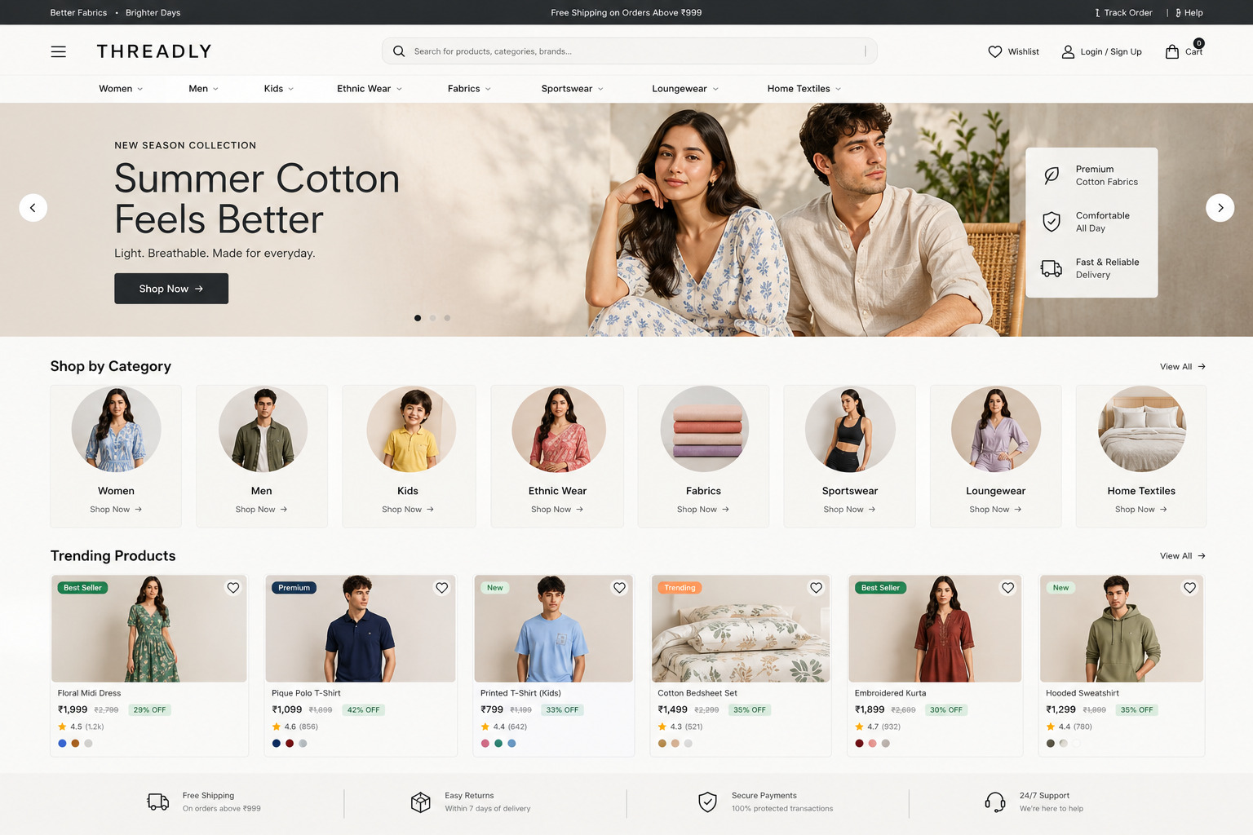
Figure 1: High-fidelity wireframe of the THREADLY home page.

Layout explanation
The home page begins with a compact header containing the menu, THREADLY logo, search, wishlist, account and cart. A proposed desktop header height is 72 px, with a 44 px minimum interactive target for icons. This header remains consistent across the website so users always know where to access essential functions. The hero banner promotes the current campaign, such as Summer Cotton, and contains a clear call-to-action button that leads to relevant products. The main content can use a maximum width of about 1200 px with 24–32 px section spacing.
Below the hero section, the Shop by Category area provides direct entry points to Women, Men, Kids, Ethnic, and Fabrics. Each category card can use a consistent image ratio such as 4:5 and a minimum 16 px text-to-image spacing. This supports both focused shopping and family shoppers who need to move between categories. The Trending Products section highlights selected items and encourages exploration without forcing users to search manually. A desktop row can show 4 product cards, while the mobile layout can show 2 cards per row with approximately 12 px card gaps.

Design decisions
- The header is placed at the top because search, wishlist, account and cart are high-priority actions. The proposed 72 px desktop header and compact mobile header keep these functions available without taking excessive vertical space. The search field should remain visually prominent because users may enter terms such as ‘cotton kurta’ or ‘bedsheets’.
- The hero banner creates a strong first impression and communicates the current campaign immediately. A proposed desktop hero height is approximately 420–480 px, while mobile should use a shorter stacked banner to avoid pushing category choices too far below the fold. The primary CTA should use a clear action label such as ‘Shop Summer Cotton’ and a proposed height of 44–48 px.
- Category cards reduce the number of steps needed to reach a product group. The category area should maintain consistent card dimensions, 16–24 px internal spacing and descriptive labels so that users can scan the options quickly. For a family shopper, this reduces the need to return to the main menu when moving from Women to Kids or Home Textiles.
- Product cards should show image, product name, price, discount where relevant, rating, and wishlist control. A proposed product image ratio is 4:5, with the product name limited to about two lines before truncation. Price information should remain visually closer to the product name than secondary metadata, while discounts should never rely only on color.
- The layout should collapse into a vertical mobile structure with a compact menu and easily reachable cart. On mobile, content can use 16 px horizontal padding, 12 px card gaps and a minimum 44 × 44 px touch target. The navigation drawer should contain the same main categories as desktop so the information architecture remains consistent.

Expected user interaction
- Users can open the menu to view all major categories. The menu should open without moving the underlying page unexpectedly, and focus should move into the drawer for keyboard and screen-reader users.
- Users can search for a product using keywords such as ‘cotton kurta’ or ‘bedsheets’. The search control should provide a clear label, support an explicit submit action, and return a useful empty state such as ‘No products found. Try cotton kurta or clear filters.’
- Users can select a category card to reach the product listing page. The selected category should be reflected in the page title and breadcrumb so users understand where they are.
- Users can open a trending product, save it to wishlist, or add it to the cart. After a successful add-to-cart action, the interface should provide visible confirmation and update the cart count rather than requiring the user to guess whether the action worked.
- Hovering over any product card immediately reveals an interactive 'Add to Wishlist' icon. On touch devices, the same action must remain available without relying on hover; the wishlist control should have a visible label or accessible name and a 44 × 44 px target.

5. Product Listing Page Wireframe
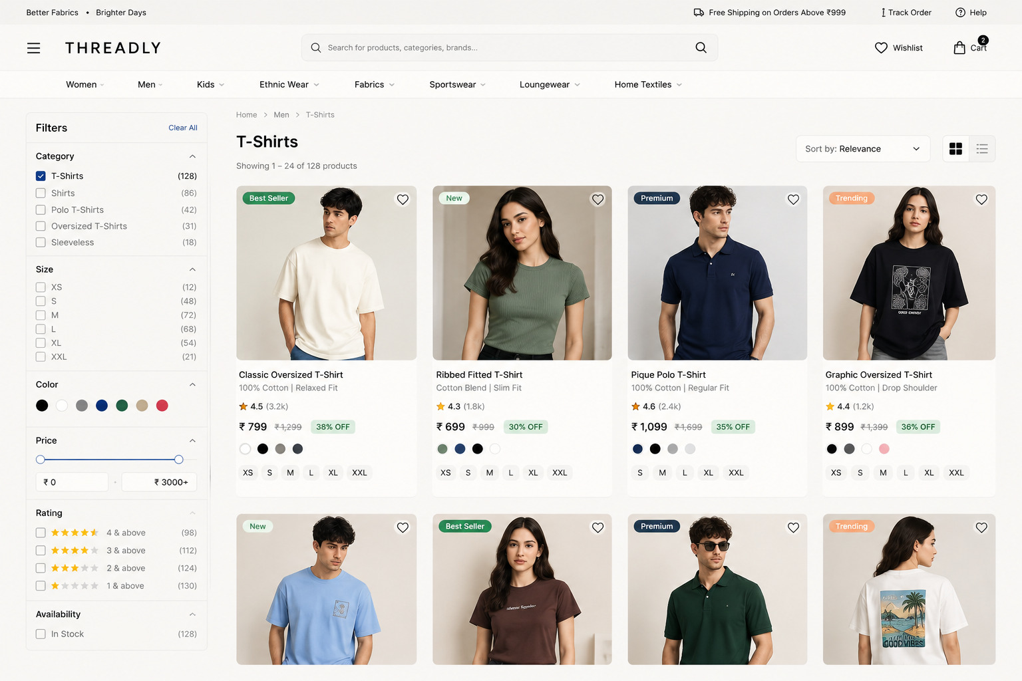
Figure 2: High-fidelity wireframe of the product listing page.

Layout explanation
The product listing page is divided into two main areas. The left panel contains filters, while the larger right area contains the product grid. A proposed desktop sidebar width is 240–280 px, leaving the remaining width for products inside the 1200 px content area. Filters include category, size, color, price, rating, fabric/material, and availability. A sorting control is placed above the grid so users can arrange products by relevance, newest items, price, or rating. The proposed desktop grid is 3–4 columns depending on viewport width, with approximately 16–24 px gaps.
Each product card should have a consistent structure. The image should be the most visually prominent element, followed by the product name, price, discount information, rating, available sizes, and wishlist icon. The page should also display the number of results and provide feedback when no products match the selected filters. For example, a listing can display ‘128 results’ above the grid. Product cards should maintain equal image ratios so users can compare products without uneven card heights.

Design decisions
- Filters are grouped in one area to reduce visual clutter. Each filter group should have a clear heading and expandable state. A 44 px minimum filter control height is proposed for comfortable interaction, especially when the page is used on a touchscreen laptop or tablet.
- The product grid uses consistent card dimensions to support easy comparison. A 4-column desktop layout may be used on wider screens, reducing to 3 columns on narrower desktop/tablet widths and 2 columns on mobile. Card gaps can use the 12–24 px spacing scale rather than arbitrary values.
- The result count helps users understand the size of the current selection. It should update when filters are applied, for example changing from ‘128 results’ to ‘14 results’. This gives immediate system feedback without requiring another page load.
- Sorting is separated from filtering because they serve different purposes. Filtering changes which products are included, while sorting changes their order. The sort control should remain visible above the product grid and use an explicit label such as ‘Sort by’.
- On mobile, filters can open in a drawer or expandable panel instead of occupying permanent screen space. The filter control should show the number of active filters, for example ‘Filters (3)’, and the drawer should provide both ‘Apply’ and ‘Clear all’ actions.

Expected user interaction
- Users can apply multiple filters together, such as Men + Shirts + Size M. Each active filter should appear as a removable chip so the current selection is visible.
- Users can clear individual filters or reset all filters. Removing one chip should update the product count and grid while keeping the other selected filters active.
- Users can sort products without losing their selected filters. For example, selecting ‘Price: Low to High’ should preserve Men + Shirts + Size M rather than resetting the listing.
- Users can open a product card to view full product details. The card should have a clear clickable area and accessible name, while secondary actions such as wishlist should remain separately actionable.
- Users can add an item to wishlist or cart directly from the listing page when size information is available. If a required size is missing, the interface should explain the next action instead of silently failing.
- An empty state design is included for when applied filters (e.g., Men + Shirts + Size M) yield no results, offering a highly visible 'Clear All Filters' one-click button to reset the view. A useful secondary suggestion can be ‘Try removing Size M or Color Black’ rather than showing a blank grid.

6. Product Detail Page Wireframe
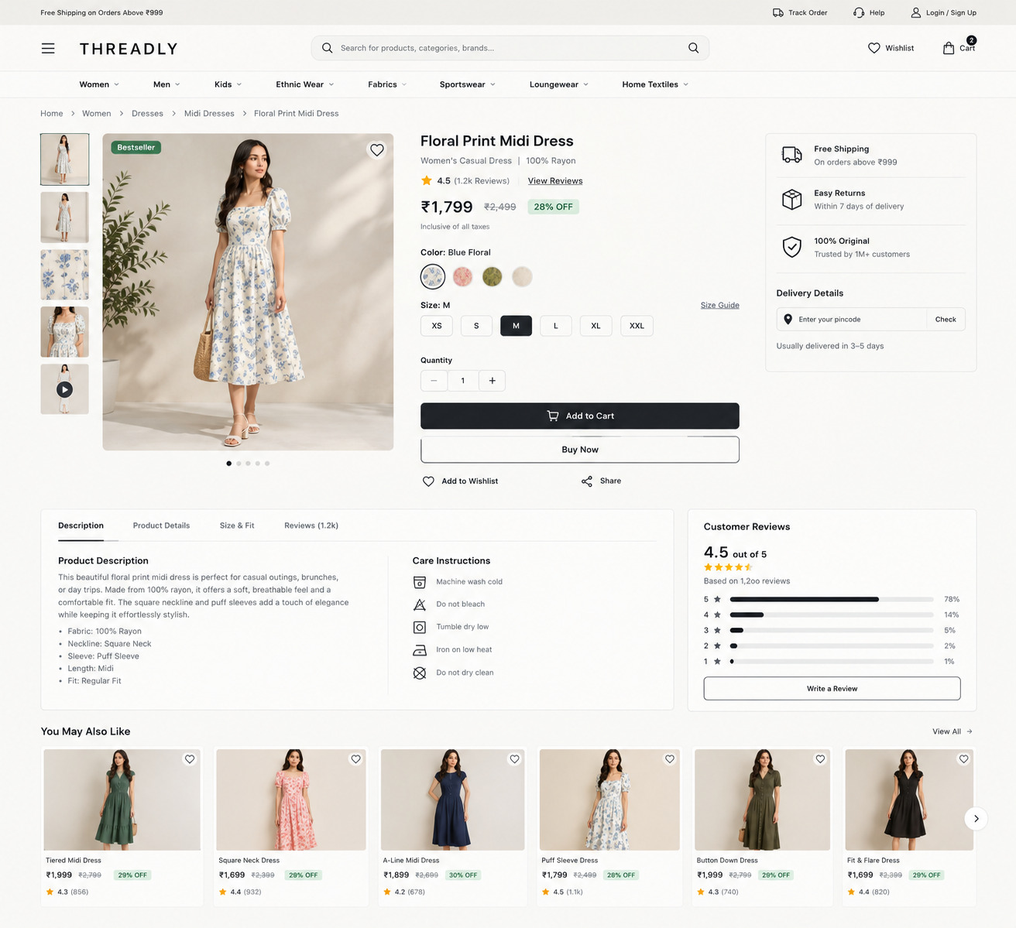
Figure 3: High-fidelity wireframe of the product detail page.

Layout explanation
The product detail page uses a two-column layout on desktop. The left side displays the main product image and supporting thumbnails, while the right side contains the product name, ratings, price, size selector, color choice, delivery information, and the main Add to Cart button. A proposed desktop split is approximately 55% visual area and 45% information area within the content width. On mobile, these columns stack vertically.
Important information such as fabric type, fit, care instructions, delivery details, return policy, and size guide should be placed in expandable sections below the main purchase area. This keeps the first screen focused while still making detailed information available to users who need it. The size guide should be positioned immediately beside or below the size selector so a shopper does not need to search for it.

Design decisions
- The product image is large because apparel decisions depend heavily on visual information. A proposed main image ratio is 4:5, with thumbnails large enough to be selected comfortably. The selected thumbnail should have a visible non-color-only state such as a border or focus outline.
- The price and primary action are placed close together to support quick purchase decisions. A proposed primary button height is 48 px, with 16 px spacing between price information and the size selector and approximately 16–24 px before the main CTA.
- Size and color controls are explicit rather than hidden inside long paragraphs. Size options can use approximately 44 × 44 px buttons with clear selected, unavailable and focus states. Out-of-stock sizes should remain visible but disabled with text such as ‘M — Out of stock’.
- The size guide should be accessible near the size selector, especially for family shoppers. It can include garment measurements and body-measurement guidance, with an example such as ‘Chest: 40 in | Length: 28 in’ clearly labelled as an illustrative value.
- The Add to Cart button should have strong contrast and a clear action label. The selected size and color should be checked before the action is accepted, and a clear inline message should appear if required information is missing.

Expected user interaction
- Users can view product images and zoom in when needed. On desktop, the proposed image zoom can be triggered by hover or an explicit zoom control; on mobile, an explicit tap-to-zoom interaction should be available because hover is unavailable.
- Users can select size and color before adding the product to the cart. The selected state should be visually distinct and should also be available to assistive technology through an appropriate accessible state.
- Users can open the size guide and compare measurements. Closing the guide should return the user to the same product and preserve the selected options.
- Users can read reviews, delivery information, and return conditions. Illustrative review values, if displayed in the wireframe, should be treated as sample content rather than research evidence.
- Users can save the item to wishlist or continue shopping after adding it to the cart. The cart count should update immediately after a successful add action and the user should receive a concise confirmation message.
- Hovering over the main product image triggers a localized zoom micro-interaction, allowing users to inspect fabric textures closely. Because hover is not available on mobile, the mobile equivalent should be an explicit image-tap or zoom control.

7. Checkout Flow Wireframe
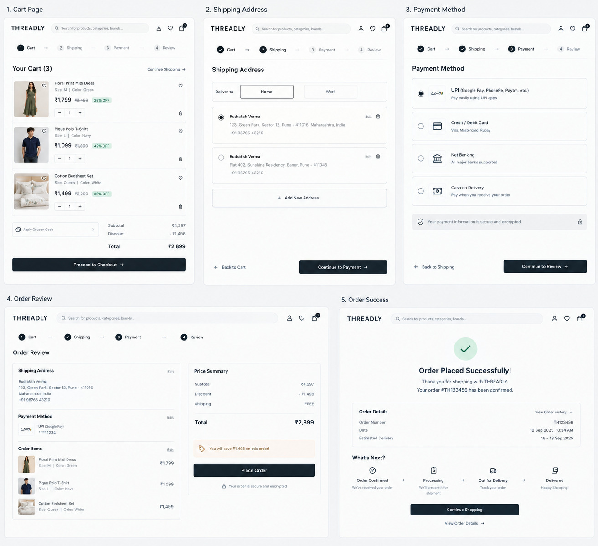
Figure 4: High-fidelity wireframe of the checkout flow.

Checkout stages
- Cart review: Users check selected products, sizes, quantities, discounts, and subtotal.
- Address: Users select a saved address or enter a new delivery address.
- Payment: Users choose an available payment method and review the final amount.
- Confirmation: Users receive an order summary, order number, and expected delivery information.

Layout explanation
The checkout page uses a clear step indicator so users understand where they are in the process. The main form appears on the left, while the order summary remains visible on the right. A proposed desktop arrangement is approximately 65% form area and 35% order summary within the content width. On mobile, the summary can move below the active form step while remaining easy to expand. This reduces uncertainty and helps users confirm the final amount before payment.
For Neha Sharma, the Family Shopper persona from Week 1, saved addresses and saved sizes are especially useful. The system should allow her to select an existing address, review several family members’ items, and see discounts before placing one combined order. For example, a cart could contain a women’s kurta, a men’s shirt and a bedsheet while still presenting one consolidated order summary.

Design decisions
- The number of checkout steps is limited to reduce unnecessary navigation. The proposed sequence is Cart Review → Address → Delivery → Payment → Review → Confirmation, with the step indicator showing the current stage.
- The order summary remains visible so users do not need to go back to the cart. As an illustrative example only, the summary could show Item subtotal ₹2,400, Discount −₹300, Delivery ₹0, Tax ₹378, Final total ₹2,478. These are sample values, not live pricing or tax data.
- Form labels are placed above fields and are not replaced only by placeholder text. Input fields should have clear labels for name, phone number, address, city, state and PIN code, with consistent spacing and an approximately 44–48 px field height.
- Errors should appear beside the relevant field with a clear correction message. For example, instead of only showing a red border, display ‘Enter a valid PIN code’ below the PIN field. The message should remain understandable without depending on color alone.
- The payment area should communicate security without making unsupported claims. Payment methods should be clearly labelled, and a failed transaction should explain what happened and what the user can do next without exposing unnecessary technical information.

Expected user interaction
- Users can edit quantities or remove products before payment. Quantity controls should provide visible plus and minus actions, preserve the selected size, and update the subtotal immediately.
- Users can select a saved address or add a new address. A saved address card should show enough information to distinguish addresses, such as ‘Home — Chandigarh’, without exposing unnecessary personal data in the interface.
- Users can apply or review discount codes where available. The coupon result should clearly state whether the code was applied, invalid, expired, or not applicable to the current cart.
- Users can choose a payment method and confirm the total. The final payable amount should remain visually prominent, and the primary action should use a specific label such as ‘Place Order’ rather than an ambiguous label such as ‘Continue’.
- After successful payment, users can view confirmation and track the order. The confirmation should include a clear success message, order reference, summary, expected delivery information and an entry point to Order Tracking.
- Inline validation provides immediate visual feedback (e.g., a green checkmark for a correctly formatted PIN code) rather than making the user wait for a form submission error. Validation should also use text or an icon with an accessible label so color is not the only signal. Skeleton loaders may appear momentarily in the summary panel while final taxes and shipping are calculated.

8. Navigation Flow
The proposed primary navigation flow is:
- Home Page → Category or Search
- Category/Search → Product Listing Page
- Product Listing Page → Product Detail Page
- Product Detail Page → Add to Cart
- Cart → Address → Payment → Confirmation
- Confirmation → Order Tracking / Account
Users should be able to return to previous stages without losing entered information. The cart should remain persistent across pages and, where the user is signed in, across sessions. The overall path is Home → Category/Search → Product Listing → Product Detail → Cart → Address → Delivery → Payment → Review → Confirmation → Order Tracking/Account. Decision points include required size selection, valid delivery information, coupon eligibility and payment success.

9. Usability and Accessibility Considerations
- Use readable text sizes, sufficient line spacing, and clear heading hierarchy. A proposed body size is 16 px with approximately 1.5 line height, while headings should follow a consistent hierarchy.
- Maintain strong contrast between text and backgrounds. The chosen palette should be checked against an appropriate contrast tool before implementation; this report treats the listed values as proposed design tokens rather than a completed accessibility audit.
- Do not rely on color alone to communicate errors, discounts, availability, or selected states. Combine color with text, borders, icons, labels or patterns where necessary.
- Provide visible keyboard focus indicators for interactive controls. Focus should be clearly visible on menus, search, filter controls, product cards, size buttons, form fields, accordions and checkout actions.
- Use descriptive labels for search, filters, size selectors, buttons, and form fields. Labels should communicate the action or purpose without requiring the user to infer meaning from icons alone.
- Provide alternative text for meaningful product images. Decorative images should be treated differently so screen readers are not forced to read unnecessary descriptions.
- Make buttons and touch targets large enough for comfortable mobile use. A proposed minimum is 44 × 44 px for touch targets, with larger 48 px primary buttons where space permits.
- Ensure menus, filter panels, accordions, and checkout steps work with keyboard and screen readers. Expand/collapse controls should expose their current state and preserve a logical focus order.
- Show clear validation messages, such as ‘Enter a valid PIN code,’ near the relevant field. Messages should explain the correction needed instead of only saying ‘Invalid input’.
- Keep navigation and button placement consistent across pages. For example, the cart icon remains in the global header and the primary purchase action remains visually distinct on the product detail and checkout screens.
- Allow users to review their order before final confirmation. The review stage should show product names, sizes, quantities, discounts, delivery charge and final payable amount.
- Avoid unnecessary pop-ups and distractions during checkout. Important confirmation and error messages should appear in context and should not unexpectedly move the user to another page.
- Ensure a logical keyboard navigation tab order (left-to-right, top-to-bottom) through the checkout form and expandable filter panels. This is a design requirement to be checked during later prototype evaluation, not a claim that such testing has already been completed.
- Implement clear screen-reader announcements for dynamic page changes, such as when a product is successfully added to the persistent cart. These announcements should communicate the result without requiring the user to visually inspect the cart icon.

10. Responsive Design Plan
THREADLY should be designed for desktop, tablet, and mobile screens. Proposed breakpoints are mobile 0–767 px, tablet 768–1023 px, and desktop 1024 px and above. On desktop, the interface can use a multi-column layout with a permanent filter panel and a two-column product detail page. On smaller screens, the layout should become single-column. The menu can become a drawer, filters can become an expandable panel, and the product detail content can stack image, product information, size selection, and purchase actions vertically.
- Desktop: 1024 px and above. Use wide navigation, a sidebar filter area of about 240–280 px, a 3–4 column product grid, and a two-column product detail layout. The main content can be limited to about 1200 px for readability.
- Tablet: 768–1023 px. Reduce the product grid to approximately 2–3 columns, collapse filters into a drawer or expandable panel, reduce side padding where necessary, and keep primary buttons at approximately 44–48 px height.
- Mobile: 0–767 px. Use a compact header, stacked sections, 2-column product grid where appropriate, 16 px horizontal padding, large tap targets, and a simplified checkout. The order summary should remain available without forcing users to repeatedly navigate back.

11. Conclusion
The Week 2 wireframes provide a practical foundation for THREADLY’s visual interface and shopping experience. The home page supports discovery, the product listing page supports comparison, the product detail page supports informed decisions, and the checkout flow supports a clear path to purchase. The added specifications make the proposal more actionable by defining concrete spacing, sizing, responsive behavior, interaction states, sample checkout values, and accessibility rules. Together, these screens reflect the Week 1 strategy by emphasizing convenience, family shopping, persistent cart behavior, saved information, and simple navigation. The next stage will involve converting these designs into fully clickable and interactive prototypes for evaluation; no user-testing results are claimed in this report.

