CS 487 Software engineering Reliability Handout
Problem 1 Reliability
Reliability analysis helps to understand the system failure and helps identifying mitigation. These mitigations could be a design activity that become a reliability requirement. For this problem use the sequence diagram for the engine start, below:
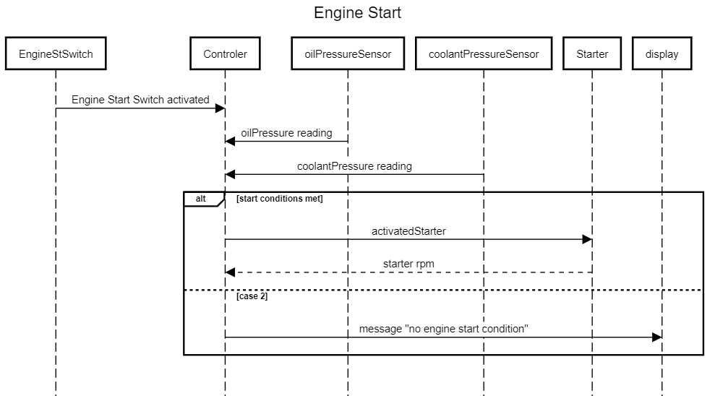
a- (0.7 pt) Failure mode effect analysis (FMEA) is conducted as part of the reliability analysis. Severity, probability and detectability are a number from 1-10. Severity is given 10 for the highest severity, high probability of failure occurrence is also given high number and a high detection rank reflects low detection capability of the failure. The risk priority number (RPN) is the product of all three measure. It is important to reduce the RPN especially high RPN by adding mitigations.

Item | Failure modes | Causes | Effects | Severity | Probability | Detectability | RPN | Mitigation
EngineStSwitch | Switch fail open | -Wiring  -Switch failure  -Incorrect sizing of switch | Failure to start engine | 7 | 6 | 4 | 168 | - Wiring shall be tested, and proper wiring category shall be used  - Use proper switch sizing
EngineStSwitch | Switch fails closed | -Debri  -Wiring short  - Incorrect sizing of switch | Failure to stop engine using key switch | 2 | 3 | 4 | 24 | - Wiring shall be tested, and proper wiring category shall be used  - Use proper switch sizing  - Switch enclosing
Controller | Engine start condition incorrectly processed | - Fail to process input  - incorrect algorithm  - Wiring | Engine fails to start | 7 | 6 | 4 | 168 | - Exception handling for checking out of bound condition  - Redundant algorithm  - Testing algorithm logic
Controller | Engine start condition incorrectly processed | - Fail to process input  - incorrect algorithm  -Shortage to battery (output high) | Engine start when conditions aren’t met | 8 | 6 | 55 | 240 | - Exception handling for checking out of bound condition  - Redundant algorithm  - Add check logic  - Testing algorithm logic
oilPressure Sensor | Read low | Sensor faulty  Wiring | Engine fails to start | 7 | 6 | 4 | 168 | - Exception handling for checking out of bound condition  - Sensor self-test  - Add logic check  - Sensor lifetime acceleration test
coolantPressureSensor | Read higher | Sensor faulty  Wiring | Engine start when conditions aren’t met | 8 | 6 | 55 | 240 | - Exception handling for checking out of bound condition  - Self-test  - Sensor life time acceleration test
Starter | Starter fail to turn | Started stuck  Started motor stator failure | Fail |  |  |  |  | - Allow 3 start attempt  - Quality manufacturing check
List 5 failure modes is sufficient
b-(0.3 pt) Write the reliability requirement associated with each mitigation and appropriate tests case to verify these requirements.
Req1 Wiring shall be tested, and proper wiring category shall be used
Req2 Use proper switch sizing
Req3 Switch sizing shall be proper to meet circuit
Req4 Switch shall be enclosing in housing
Req5 Exception handling shall check out of bound condition for input
Req6 Redundant algorithm to check engine start condition
Req7 Engine start algorithm shall be testing
Req8 Sensor shall self check is sensor fails fall back to engine condition met
Req 9 Sensor shall be calibrated to +/- 5% of the range
Req10 Sensor lifetime acceleration test
Req11 Engine shall be given 3 attempts to start
Req12 Quality manufacturing procedures shall be followed for starter building
List 6 requirments are sufficient
c-(0.3 pt) List application or industries that requires the following attributes and appropriate metric:
High reliability
banking, stock exchange, Nuclear, military, medical equipment
High reliability on demand: Overspeed, protection system
High availability : ATM,
Problem 2 Safety
In this exercise we will use the safety analysis to come up with the system safety requirement. The automatic train allow door to open for passenger to exit it will open and close automatic.
A (0.75 pt)- Create a preliminary analysis for the automatic door on a locomotive, use the risk matrix provided in the class note (chapter 12)
Hazard | Causes | Consequence | Severity | Probability | Risk | Mitigation
Train unauthorized movement | Incorrect door state reading | Controller reads door closed when it is open. Power applied, when passenger still getting in the train | Severe | Occasional | Medium | Multiple input shall be used to determine door status
Train unauthorized movement | Failure to detect door open | Controller failure to seize power when door is open. Train moves while passenger trying to get in | Severe | Occasional | Medium | Algorithm shall be test  Use of recommend coding practice  Diverse and redundant algorithm to control the traction based on the door closure
Train unauthorized movement | Failure to respond to traction request | Failure to communicate or respond to no traction request | Severe | Occasional | Medium | Reliable traction cut off mechanism in place
Door open while train | Incorrect signal to door to open, or door failure | Door open while train moved could cause risk of passenger fall | Severe | Improbable | Low | Reliable door locking mechanism
Door Locks | Incorrect door state and response | Controller reads door open when it is closed. Failure to open door in emergency | Sever | Improbable | Low | Manual door opening mechanism shall be available

List 3 hazard are sufficient

b-(0.75 pt) Choose one hazard, create a fault tree analysis (FTA) and drill down to a detailed failure causes that contribute to the hazard.
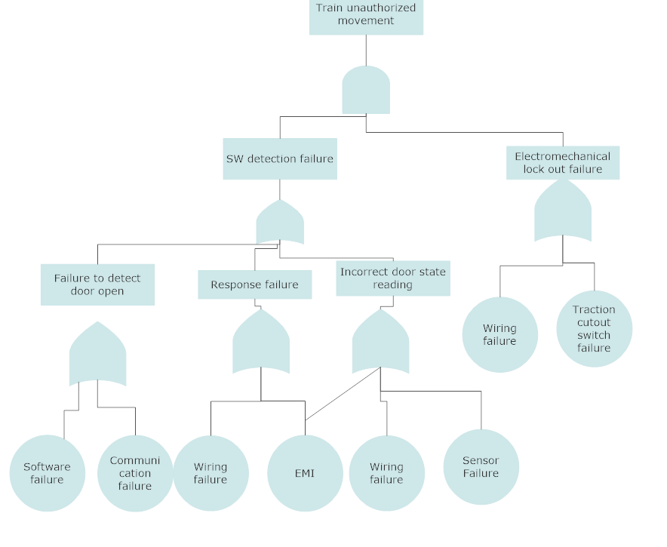
Taking one line of the hazard log to create the Fault tree is sufficient
c- (0.6 pt) Use the following system requirements and the FTA to get a system hazard analysis.
The door shall only open when the train at full stop and throttle in idle (no traction)
The open door shall prevent loading traction and hence prevent movement of the train
The door shall automatically open when conditions are met
The door shall close after 30 second and when no passenger is detected
The door shall be able to close manually

Hazard | Causes | Consequence | Severity | Probability | Risk | Mitigation
Train unauthorized movement | Sensor failure | Controller reads door closed when it is open. Power applied, when passenger still getting in the train | Severe | Occasional | Medium | Multiple sensor to provide door reading  Add electromechanical switch to cut traction
Train unauthorized movement | Wiring failure | Controller reads door closed when it is open. Power applied, when passenger still getting in the train | Severe | Occasional | Medium | Apply traction shall be require voltage to ensure that loss voltage does command traction  Add electromechanical switch to cut traction
Train unauthorized movement | EMI | EMI influences sensor reading  EMI influences stop traction command | Severe | Occasional | Medium | Use of shield and proper wiring guideline to reduce EMI
Train unauthorized movement | Communication failure | Loose wire  Communication failure | Severe | Occasional | Medium | Use CAN network and include signal integrity check.  Voltage drop should result in traction seize
Train unauthorized movement | SW error  Logical error | Controller failure to seize power when door is open. Train moves while passenger trying to get in | Severe | Occasional | Medium | Algorithm shall be test  Use of recommend coding practice  Diverse and redundant algorithm to control the traction based on the door closure
Train unauthorized movement | Cutout switch failure | Failure to communicate or respond to no traction request | Severe | Occasional | Medium | Cut out switch failure rate shall be better or equal to 10⁻² failure/hour.  Cut out switch shall me normally closed
List 4 hazard are sufficient
d- (0.15 pt) Use the hazard analysis to get the safety requirements. List 3 req are sufficient
Multiple sensor shall be used to provide door reading, along with a voting mechanism.
Different technology sensor or sensor from different manufacturing should be use avoid single
Electromechanical switch shall be added to cut traction
Shielded wire and proper wiring guideline to reduce EMI
CAN network that include signal integrity check shall be used
Voltage drop shall result in traction seize
Controller algorithm shall be test
Standard coding practice shall be followed
Diverse and redundant algorithm shall be used to control the traction based on the door closure
(0.25 pt) List the content of a automatic door safety case
The safety case includes all the supporting documentation that system will operate and meets the safety target. The safety case includes a description of system, the safety organization, procedure or plan followed (including quality assurance, configuration and change management, team competence) and evidence of following the plan, hazard analysis been conducted and safety requirement been identified to reduce risk. Also evidence of sufficient testing been done and result have passed.
Problem 1 Security
- Create a miss use case for a banking application
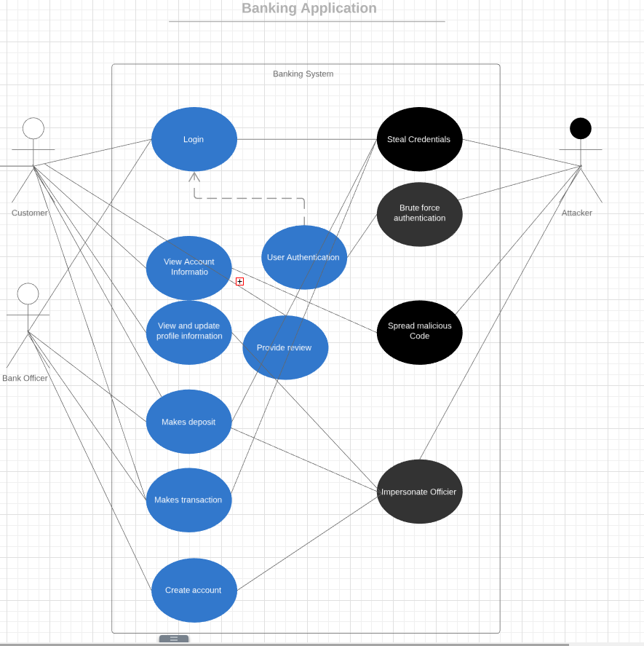
- Create a design risk assessment for a bank application that uses layered architecture.
Asset | Causal | Threat | Exposure/Consequence | Security measure
The customer’s database | Use of virus or code to hack the system or impersonate officer. | Unauthorized user gains access to the system and gets confidential information. | High financial loss due to reputation impact and customer leaving the financial institute. | Add firewall.
The customer’s database | Weak officer’s password.  Unattended officier’s computer.  Phishing scam.  Use of code to brute force authentication. | Unauthorized user gains access to the system and gets confidential information. | High financial loss due to reputation impact and customer leaving the financial institute. | Inforce strong password requirement to access database. Inforce password periodic change.  Requires 2 level of authentication.  Session timeout.  Sensitive data shall be encrypted.
Individual customer information | Weak password.  Unattended computer.  Unattended computer.  Phishing scam. | Access to individual information . | Low financial loss due to access to one customer information. | Inforce strong password requirement to access database.  Requires 2 level of control to access database.  Session timeout.
Application | Use of a code to brute force authentication of officer. | Make fraud transfer and deposit | High financial loss. | Use of firewall.  Use safe communication.  Use of good programing principal ( no buffer overflow).
User interface | Use of virus of code. | Impacts system usability. | Medium or low loss. | Use of antivirus.

- Come up with the security requirements needed for this application
Security requirements:
SR1: Firewall shall be used to block traffic from suspicious sources.
SR2: Customer’s password shall be at least 10 character with a least one special character.
SR3: Officer’s password shall be at least 12 character with a least one special character and one number.
SR4: Officer password shall be update every 4 months, new password shall not be the same as the last 5 passwords.
SR5: Session shall timeout after 10 minutes of inactivity.
SR6: Data shall be encrypted.
SR7: Communication between the client and server shall use the Secure Socket Layer.
SR8: Communication between client and server shall be encrypted.
SR9: 2 level of authentication shall be required to access system, including a verification code sent to customer’s private email or phone and password authentication.
SR10: Application shall use good programing principals to prevent buffer overflow.
SR11: System shall be protected against virus.

Problem 2 Resilience

- Create a vulnerability analysis for the banking application
Attack/ Event Vulnerability | Recognition | Resistance | Recovery and reinstatement
Corrupt database. | Compare data to existing backup database.  Record all activity in a log.  Use of checksum. | Limit access to database and set privileges. | Use backup database and activity log.
Malware infection | Malware check | Disable USB port and untrusted for client computer. | Clear up system when malware is detected.
Unauthorized Access to database | Monitoring user activities patterns and identify unusual activities | Policy for officers.  Manager approval for large transactions.  Temporary lock affected accounts. | Remove locks and notify user.
Unauthorized Access to a customer account | Monitoring customer activities patterns and identify unusual activities | Security recommendation tips for customers when they sign in.  Limit daily transfer amount.  Requires safe transfer for amount greater than 800. | Test message customer for all account activities.
Server Unavailability / Denial of user access | Use timer and watchdog. | Use a backup server.

- Deduce the resilience requirements for the system:
VR1: Data shall be compared to backup database.
VR2: Privileges shall be set to limit access to the data.
VR3: Database image shall be recovered using backup base and activity log.
VR4: Software shall be installed to check malware.
VR5: Untrusted web pages shall be blocked on client computer.
VR6: USB ports shall be disable on officer’s computer.
VR7: Officer and customer activities patterns shall be monitored and unusual activities shall be flagged.
VR8: Temporary lock shall be added to accounts with flagged unusual activities.
VR9: Lock shall be removed by authorized admin after contacting users.
VR10: Customer daily transaction shall be limited to $10000.
VR11: Safe transfer shall be done for amount larger than $800.
VR12: Text customer for all activity greater than $100.
VR13: Security tips shall be shared with customers upon login.

Problem3 Security
Problem 1 Security
- Create a miss use case for a banking application

- Create a design risk assessment for a bank application that uses layered architecture.
Asset | Causal | Threat | Exposure/Consequence | Security measure
The customer’s database | Use of virus or code to hack the system or impersonate officer. | Unauthorized user gains access to the system and gets confidential information. | High financial loss due to reputation impact and customer leaving the financial institute. | Add firewall.
The customer’s database | Weak officer’s password.  Unattended officier’s computer.  Phishing scam.  Use of code to brute force authentication. | Unauthorized user gains access to the system and gets confidential information. | High financial loss due to reputation impact and customer leaving the financial institute. | Inforce strong password requirement to access database. Inforce password periodic change.  Requires 2 level of authentication.  Session timeout.  Sensitive data shall be encrypted.
Individual customer information | Weak password.  Unattended computer.  Unattended computer.  Phishing scam. | Access to individual information . | Low financial loss due to access to one customer information. | Inforce strong password requirement to access database.  Requires 2 level of control to access database.  Session timeout.
Application | Use of a code to brute force authentication of officer. | Make fraud transfer and deposit | High financial loss. | Use of firewall.  Use safe communication.  Use of good programing principal ( no buffer overflow).
User interface | Use of virus of code. | Impacts system usability. | Medium or low loss. | Use of antivirus.

- Come up with the security requirements needed for this application
Security requirements:
SR1: Firewall shall be used to block traffic from suspicious sources.
SR2: Customer’s password shall be at least 10 character with a least one special character.
SR3: Officer’s password shall be at least 12 character with a least one special character and one number.
SR4: Officer password shall be update every 4 months, new password shall not be the same as the last 5 passwords.
SR5: Session shall timeout after 10 minutes of inactivity.
SR6: Data shall be encrypted.
SR7: Communication between the client and server shall use the Secure Socket Layer.
SR8: Communication between client and server shall be encrypted.
SR9: 2 level of authentication shall be required to access system, including a verification code sent to customer’s private email or phone and password authentication.
SR10: Application shall use good programing principals to prevent buffer overflow.
SR11: System shall be protected against virus.

Problem 2 Resilience

- Create a vulnerability analysis for the banking application
Attack/ Event Vulnerability | Recognition | Resistance | Recovery and reinstatement
Corrupt database. | Compare data to existing backup database.  Record all activity in a log.  Use of checksum. | Limit access to database and set privileges. | Use backup database and activity log.
Malware infection | Malware check | Disable USB port and untrusted for client computer. | Clear up system when malware is detected.
Unauthorized Access to database | Monitoring user activities patterns and identify unusual activities | Policy for officers.  Manager approval for large transactions.  Temporary lock affected accounts. | Remove locks and notify user.
Unauthorized Access to a customer account | Monitoring customer activities patterns and identify unusual activities | Security recommendation tips for customers when they sign in.  Limit daily transfer amount.  Requires safe transfer for amount greater than 800. | Test message customer for all account activities.
Server Unavailability / Denial of user access | Use timer and watchdog. | Use a backup server.

- Deduce the resilience requirements for the system:
VR1: Data shall be compared to backup database.
VR2: Privileges shall be set to limit access to the data.
VR3: Database image shall be recovered using backup base and activity log.
VR4: Software shall be installed to check malware.
VR5: Untrusted web pages shall be blocked on client computer.
VR6: USB ports shall be disable on officer’s computer.
VR7: Officer and customer activities patterns shall be monitored and unusual activities shall be flagged.
VR8: Temporary lock shall be added to accounts with flagged unusual activities.
VR9: Lock shall be removed by authorized admin after contacting users.
VR10: Customer daily transaction shall be limited to $10000.
VR11: Safe transfer shall be done for amount larger than $800.
VR12: Text customer for all activity greater than $100.
VR13: Security tips shall be shared with customers upon login.

