A PROJECT REPORT

On

Weather Detector

Submitted by

SUBHAM MUKHERJEE (Roll No.: 10800219030)
RUDRANATH KABIRAJ (Roll No.: 10800219092)
UDAYAN DEY(Roll No.: 10800219003)
SUBRATA GORAI(Roll No.: 10800219016)

Under the Guidance of

Mr.VICTOR DAS
Assistant Professor



Information Technology

Asansol Engineering College
Asansol

Affiliated to

MAULANA ABUL KALAM AZAD UNIVERSITY OF TECHNOLOGY

05/2022



CERTIFICATE

Certified that this project report on “Weather Detector” is the bonafide work of “Subham Mukherjee (10800219030), Rudranath Kabiraj (10800219092), Udayan Dey (10800219003), Subrata Gorai (10800219016)” who carried out the project work under my supervision.

__________________________________ _________________________________
Mr.Victor Das Dr. Anup Kumar Mukhopadhyay

(Assistant Professor of Asansol Engineering College (HOD, Information Technology)

Information Technology
Asansol Engineering College
Asansol

ACKNOWLEDGEMENT

It is our great privilege to express my profound and sincere gratitude to our Project Supervisor <Name of Project Guide>, <Designation> for providing me with very cooperative and precious guidance at every stage of the present project work being carried out under his/her supervision. His valuable advice and instructions in carrying out the present study have been a very rewarding and pleasurable experience that has greatly benefitted us throughout our work.

We would also like to pay our heartiest thanks and gratitude to <Name of HoD>, HoD, and all the faculty members of the <Name of the Department>, Asansol Engineering College for various suggestions being provided in attaining success in our work.

We would like to express our earnest thanks to our colleagues along with all technical staff of the <Name of the Department>, Asansol Engineering College for their valuable assistance being provided during our project work.

Finally, we would like to express our deep sense of gratitude to our parents for their constant motivation and support throughout our work.

……………………………………………
SUBHAM MUKHERJEE(Roll No.: 10800219030)

……………………………………………
RUDRANATH KABIRAJ(Roll No.: 108200219092)

……………………………………………
UADYAN DEY(Roll No.: 10800219003)

……………………………………………
SUBRATA GORAI(Roll No.: 10800219016)

Date: <27/05/2022 > 3rd Year
Place: Asansol Information Technology

CONTENT

Certificate ……………………………………………………………………………… ii

Acknowledgement ……………………………………………………………………... iii

Content …………………………………………………………………………………. iv

List of Figures/Tables ………………………………………………………………….. v

Project Synopsis ………………………………………………………………………... 1 - 2

- Introduction …………………………………………………………………….. 3 - 4

- Project Details …………………………………………………………………... 5 – 13

- Screenshots ……………………………………………………………………… 14 - 17

- Conclusion and Recommendations ……………………………………………. 18 - 19

- Reference ………………………………………………………………………… 20

Project Synopsis:

Title: Weather Detector - A Real-Time Weather Website
Objectives:
- To create a weather website that provides real-time weather updates and forecasts to users.
- To provide a user-friendly interface that allows users to easily access weather information for their location or a location of their choice.
- To leverage APIs and other technologies to provide accurate and up-to-date weather information to users.
Scope:
- The website will provide real-time weather updates, including temperature, humidity, wind speed, and precipitation, for locations around the world.
- The website will allow users to search for weather information for a specific location or use geolocation to automatically provide weather information for their current location.
- The website will include interactive maps, radar images, and weather-related news articles to provide a comprehensive weather experience.
Approach:
- The website will be built using HTML, CSS, and JavaScript, with APIs used to provide weather data and other functionality.
- The website will be designed with a user-friendly interface that is responsive and accessible across different devices.
- The website will be hosted on a cloud server to ensure scalability and high availability.

Expected Outcomes:
- A fully functional weather website that provides real-time weather updates and forecasts to users.
- Increased user engagement and traffic to the website through its user-friendly interface and comprehensive weather data.
- Improved user experience through the use of interactive maps, radar images, and weather-related news articles.

Introduction:

Welcome to our comprehensive weather website, your one-stop destination for up-to-date and accurate weather information from around the world. Our website is designed to provide you with the latest weather forecasts, warnings, and observations, as well as expert analysis and insights from our team of experienced meteorologists.
We understand that weather plays a critical role in our daily lives, affecting everything from what we wear and how we plan our day, to our travel arrangements and even our safety. With this in mind, our website is dedicated to delivering the most reliable and detailed weather information possible, so you can make informed decisions and stay prepared for whatever Mother Nature has in store.
Our website features a user-friendly interface that is easy to navigate, making it simple for you to access the information you need quickly and easily. Whether you're looking for current conditions, short-term forecasts, or long-range outlooks, our site has you covered. We also provide in-depth analysis of severe weather events, such as hurricanes, tornadoes, and severe thunderstorms, so you can stay informed and take appropriate action to protect yourself and your property.
In addition to our comprehensive weather data, our website also features a range of interactive tools and resources to help you plan your day, week, or even month. From radar and satellite imagery to detailed maps and charts, our site has everything you need to stay on top of the weather no matter where you are.

At our weather website, we are committed to providing you with the most accurate and reliable weather information available. So whether you're a professional meteorologist, an outdoor enthusiast, or simply someone who wants to stay informed about the weather, we invite you to explore our site and discover all that we have to offer.

Project Details:

Technologies that we have used:
- HTML
- CSS
- JAVASCRIPT
- API

- HTML/CSS - HTML and CSS are the foundational technologies used in web development. HTML is used to create the structure of the webpage, while CSS is used to style and layout the webpage. Weather websites typically use these technologies to create a visually appealing and easy-to-navigate user interface.
- JavaScript - JavaScript is used to add interactivity and functionality to weather websites. It can be used to display live weather updates, create weather-related animations, and provide user interactions.
- APIs - Weather websites often rely on external data sources, such as weather APIs, to provide real-time weather data. These APIs can be accessed using languages such as JavaScript, PHP, or Python.

HTML:

Welcome to our weather website, where we use HTML (Hypertext Markup Language) to create the structure and content of our web pages. HTML is a fundamental technology used in web development, and it plays an essential role in the creation of our weather website.
At its core, HTML is a markup language that allows developers to create structured content that can be displayed in a web browser. This content can include headings, paragraphs, lists, tables, images, and other elements that are essential to the design of a website. By using HTML, we can create web pages that are well-organized, easy to navigate, and visually appealing.
In the context of a weather website, HTML is used to structure the content that we present to our users. For example, we use HTML to create headings that indicate the location of the weather forecast, as well as to create tables that display temperature, wind speed, and other relevant information. We also use HTML to embed images and videos that help to illustrate the weather conditions in a particular location.

HTML is a versatile language that can be combined with other technologies to create dynamic and interactive web pages. For example, we use CSS (Cascading Style Sheets) to control the presentation of our HTML content, ensuring that our weather website has a consistent and visually appealing look and feel. We also use JavaScript to add interactivity to our web pages, such as allowing users to switch between different weather locations or to zoom in on a map.
In conclusion, HTML is an essential technology used in the creation of our weather website. It allows us to structure our content in a way that is easy to navigate and visually appealing, and it forms the foundation upon which we build our website. By combining HTML with other technologies such as CSS and JavaScript, we can create a website that is both informative and engaging for our users.

CSS:

Welcome to our weather website, where we use CSS (Cascading Style Sheets) to control the visual presentation of our HTML content. CSS is an essential technology used in web development, and it plays a critical role in the design and layout of our weather website.
CSS allows developers to control the style and layout of web pages, separating the presentation of content from its underlying structure. By using CSS, we can create a visually appealing and consistent design across our weather website, ensuring that our users have a positive and engaging experience.
In the context of our weather website, CSS is used to control the visual presentation of our HTML content. For example, we use CSS to set the font size, color, and style of our headings and paragraphs, ensuring that they are easy to read and visually appealing. We also use CSS to control the layout of our web pages, such as the placement of images and the spacing between elements.

One of the key advantages of CSS is its flexibility. CSS can be used to create a wide range of designs and layouts, from simple and minimalistic to complex and visually rich. By using CSS, we can create a weather website that is both informative and engaging, allowing our users to quickly and easily access the information they need about the weather in their area.
CSS is also essential for creating responsive designs that adapt to different screen sizes and devices. With CSS, we can create a website that looks great on desktop computers, tablets, and smartphones, ensuring that our users have a positive experience regardless of the device they are using.
In conclusion, CSS is an essential technology used in the design and layout of our weather website. By using CSS to control the visual presentation of our HTML content, we can create a visually appealing and engaging website that provides our users with the information they need about the weather in their area. Whether you are a beginner or an experienced developer, learning CSS is essential for creating modern and effective websites

JAVASCRIPT:

Welcome to our weather website, where we use JavaScript (JS) to add interactivity and dynamic functionality to our web pages. JS is a powerful programming language that allows developers to create engaging and interactive websites that provide a superior user experience.
In the context of our weather website, JS is used to add interactivity to our web pages, such as allowing users to switch between different weather locations or to zoom in on a map. JS is also used to fetch data from weather APIs, process and manipulate that data, and display it to the user in an easy-to-understand format.
One of the key advantages of JS is its versatility. JS can be used to create a wide range of interactive features, from simple animations to complex data visualizations. By using JS, we can create a weather website that provides our users with an immersive and engaging experience, allowing them to explore the weather conditions in their area in a way that is both informative and enjoyable.
JS is also essential for creating responsive designs that adapt to different screen sizes and devices. With JS, we can create a website that is optimized for desktop computers, tablets, and smartphones, ensuring that our users have a positive experience regardless of the device they are using.

In addition, JS is essential for creating efficient and scalable web applications. By using modern JS frameworks and libraries, such as React, Vue, and Angular, we can create complex web applications that are easy to maintain and update, ensuring that our weather website remains up-to-date and relevant for our users.
In conclusion, JavaScript is an essential technology used in the development of our weather website. By using JS to add interactivity and dynamic functionality to our web pages, we can create a website that provides our users with an engaging and informative experience. Whether you are a beginner or an experienced developer, learning JS is essential for creating modern and effective web applications.

API:

Welcome to our weather website, where we use API calling to gather real-time weather data and provide our users with accurate and up-to-date information about weather conditions in their area. API calling is an essential technology used in web development that enables applications to communicate with external data sources and retrieve data in a structured and organized format.
In the context of our weather website, we use API calling to fetch weather data from various weather data providers, such as OpenWeatherMap and Weather Underground. The API returns weather data in a structured format, such as JSON or XML, which we can then process and display on our website.
One of the key advantages of API calling is that it allows us to provide our users with real-time weather data. By fetching data from weather APIs, we can provide our users with the most up-to-date information about weather conditions in their area, including temperature, precipitation, wind speed, and humidity.
API calling also enables us to provide our users with a wide range of weather-related features, such as radar maps, satellite images, and weather forecasts. By integrating with weather APIs, we can provide our users with a comprehensive set of weather-related information that is both informative and engaging.

In addition, API calling enables us to create scalable and efficient web applications. By fetching data from external data sources, we can reduce the load on our server and improve the performance of our website. This is particularly important for weather websites, which can receive a large volume of traffic during extreme weather conditions.
In conclusion, API calling is an essential technology used in the development of our weather website. By fetching weather data from external data sources, we can provide our users with accurate and up-to-date information about weather conditions in their area. Whether you are a beginner or an experienced developer, learning how to fetch data from APIs is essential for creating modern and effective web applications.

SCREENSHOTS:

HTML:

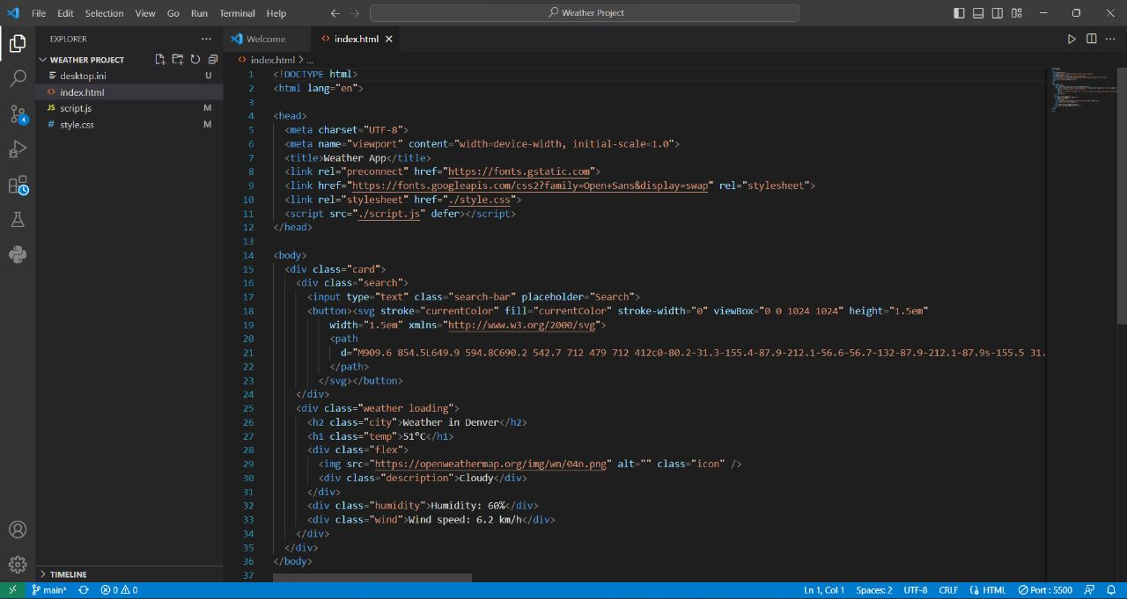

CSS:

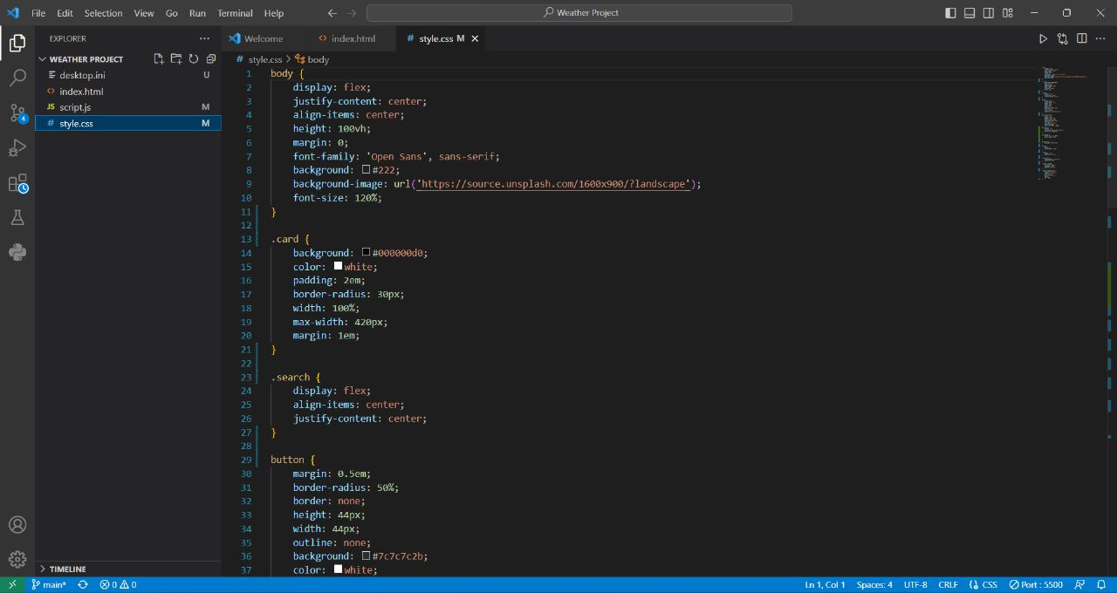
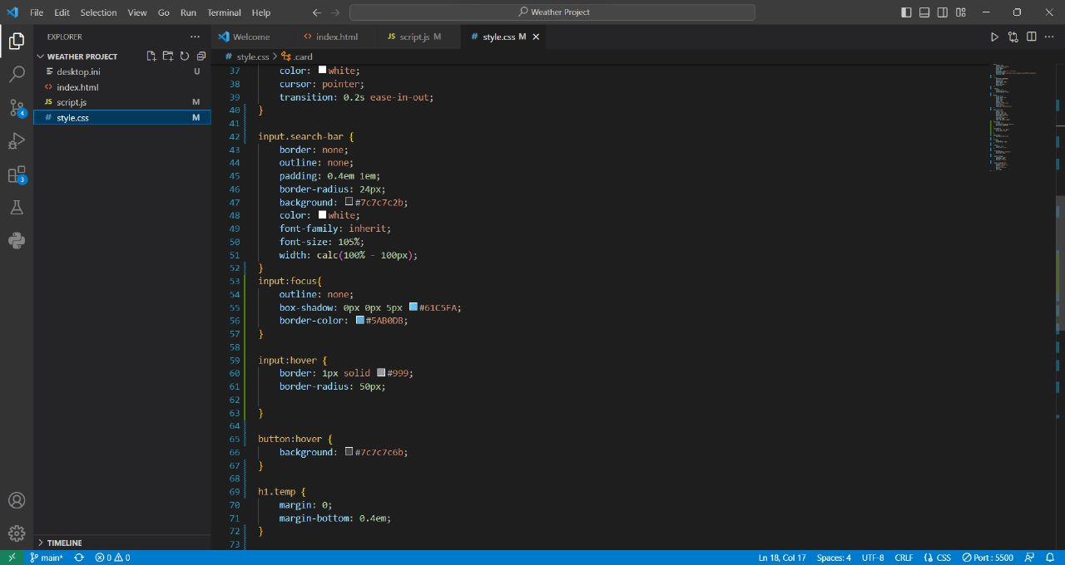
JAVASCRIPT:

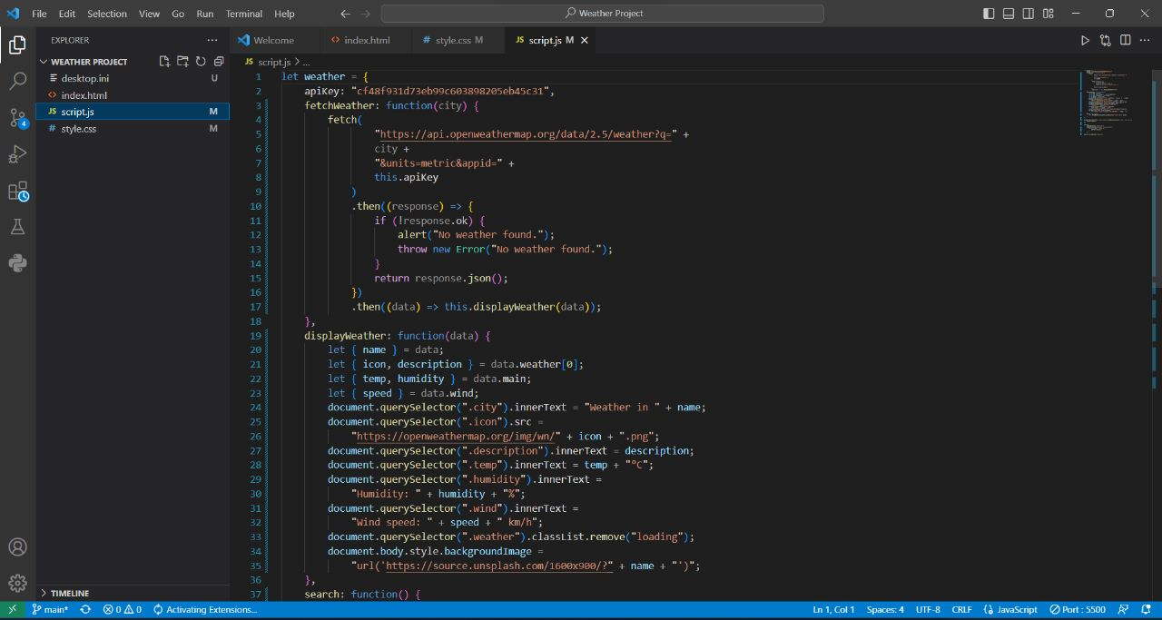

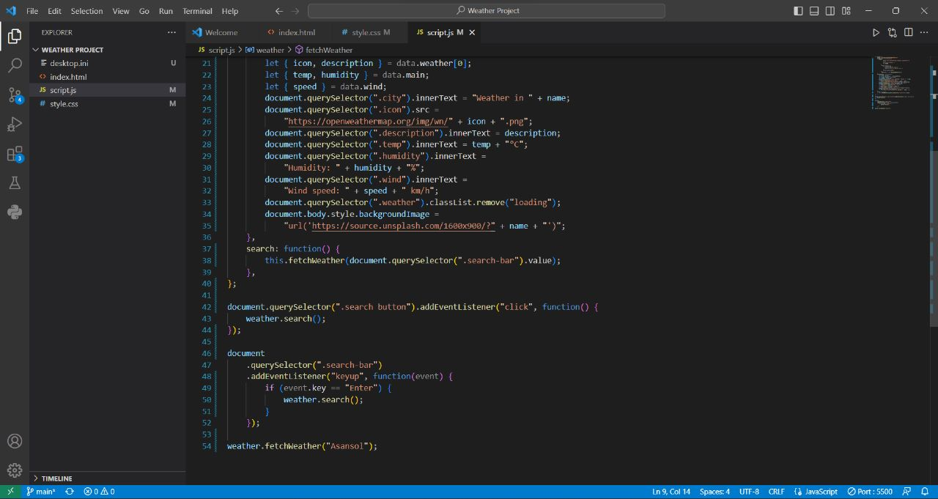

Webpages Screenshots:
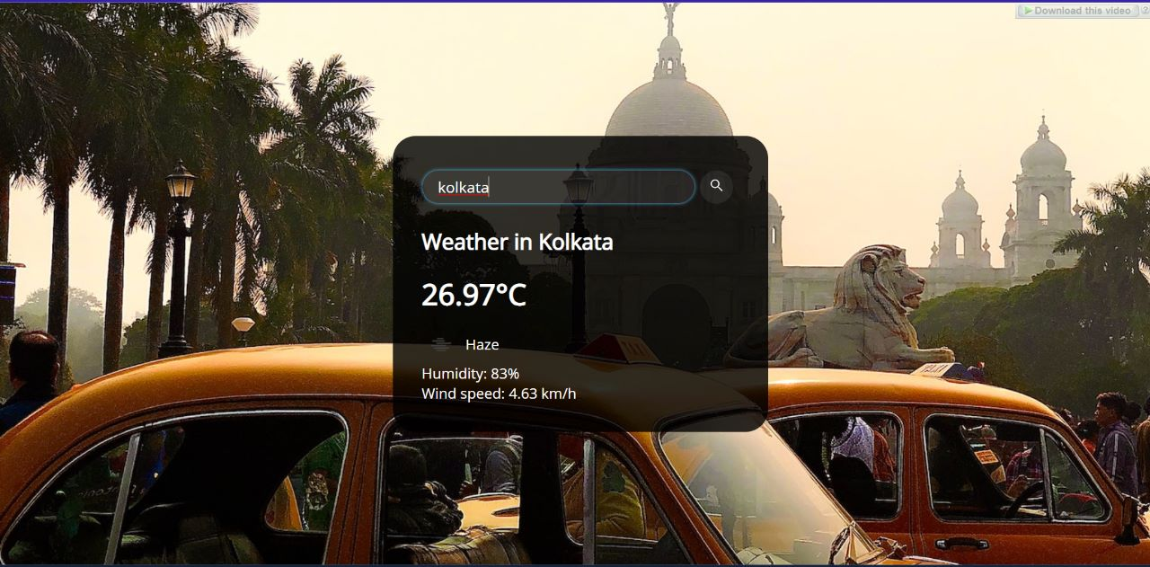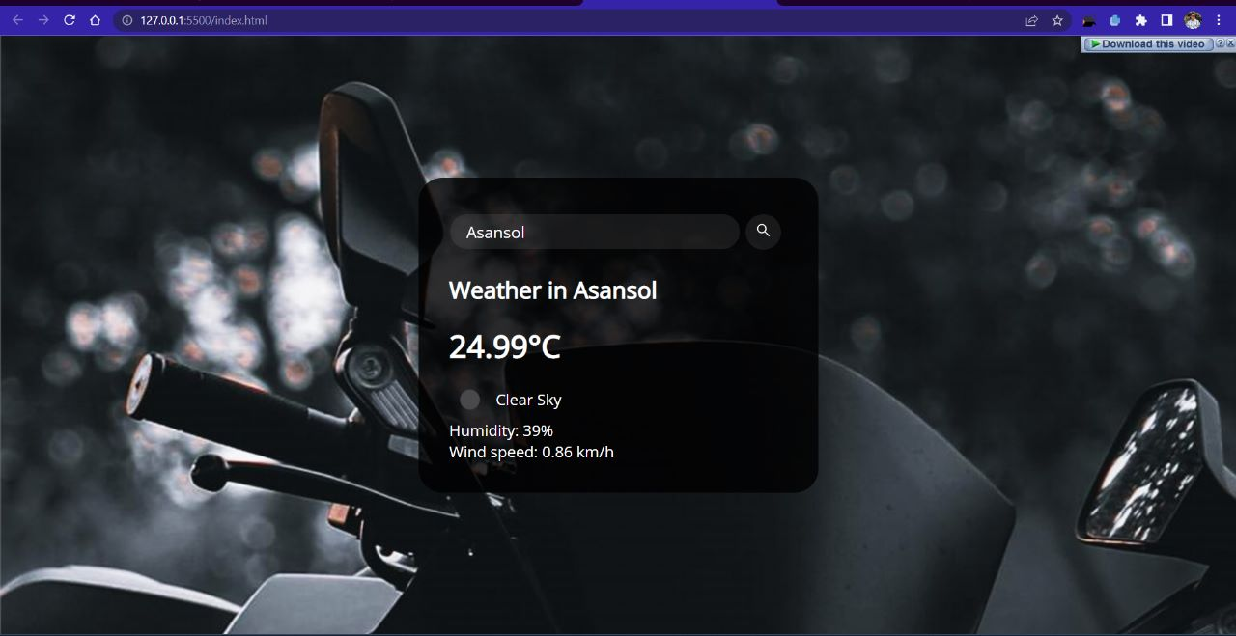
Conclusion and Recommendations:

In conclusion, a weather website can be an excellent resource for users seeking real-time weather updates and forecasts. The project synopsis provided a detailed overview of the objectives, scope, approach, and expected outcomes of creating such a website. The use of HTML, CSS, JavaScript, and APIs were discussed as the primary technologies required to build the website.
The recommendations provided highlighted the importance of conducting thorough research, incorporating user feedback, implementing analytics tools, partnering with other weather-related websites, and updating the website regularly to maintain user engagement and interest.
Ultimately, the success of a weather website will depend on its ability to provide accurate and up-to-date weather information in a user-friendly and accessible format. With careful planning, design, and development, a weather website can be a valuable resource for weather enthusiasts and casual users alike.

In terms of recommendations, the following suggestions could be considered:
- Conduct thorough research on weather APIs and other technologies to ensure that the website provides the most accurate and up-to-date weather information possible.
- Consider incorporating user feedback into the website design and development process to ensure that the website is user-friendly and meets user needs.
- Implement analytics tools to track user engagement and traffic to the website, as well as to identify areas for improvement.
- Consider partnering with other weather-related websites or organizations to increase the visibility and reach of the Weather Now website.
- Regularly update the website with new features, weather-related news, and other content to maintain user engagement and interest.

Reference:

- W3Schools - W3Schools is a comprehensive online learning platform for web development. It offers tutorials, references, and interactive exercises on HTML, CSS, JavaScript, and other web development technologies.
- MDN Web Docs - MDN Web Docs is a collaborative learning platform for web developers. It offers documentation, tutorials, and reference materials on web development technologies, including HTML, CSS, JavaScript, and APIs.
- Stack Overflow - Stack Overflow is a popular online community of web developers. It allows users to ask and answer questions related to web development and programming, making it a great resource for troubleshooting and problem-solving.
- Codecademy - Codecademy is an interactive learning platform for web development. It offers courses on HTML, CSS, JavaScript, and other web development technologies, with interactive exercises and quizzes to reinforce learning.
- Udemy - Udemy is an online learning platform that offers courses on a wide range of topics, including web development. It offers courses on HTML, CSS, JavaScript, and other web development technologies, with video tutorials and quizzes to reinforce learning.
- GitHub - GitHub is a web-based platform for version control and collaboration on software development projects. It can be used to host and manage code repositories for web development projects, as well as collaborate with other developers.

