- Mongodb_Connection

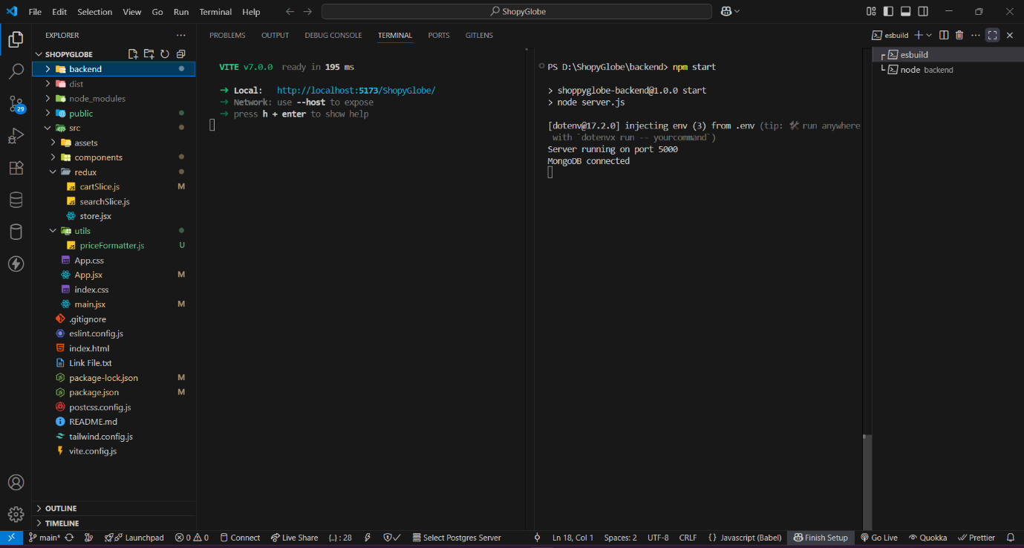

2.ThunderClientUser_Registed_SUCCESFULL
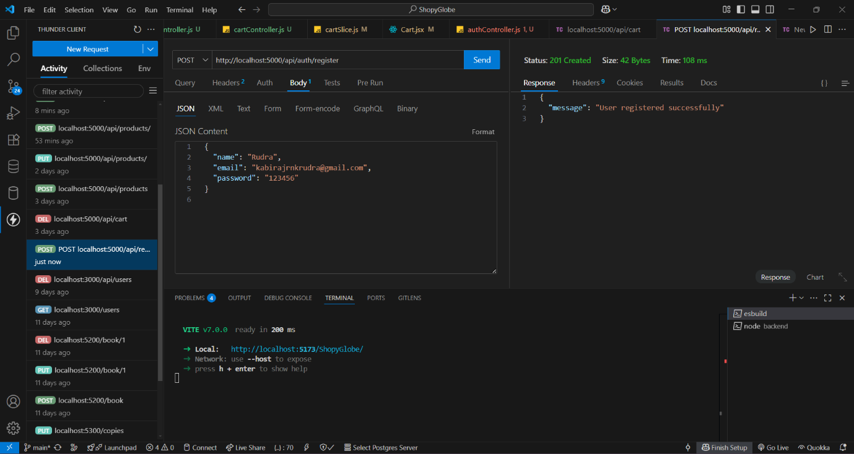

3.ThunderClient_Loged_In
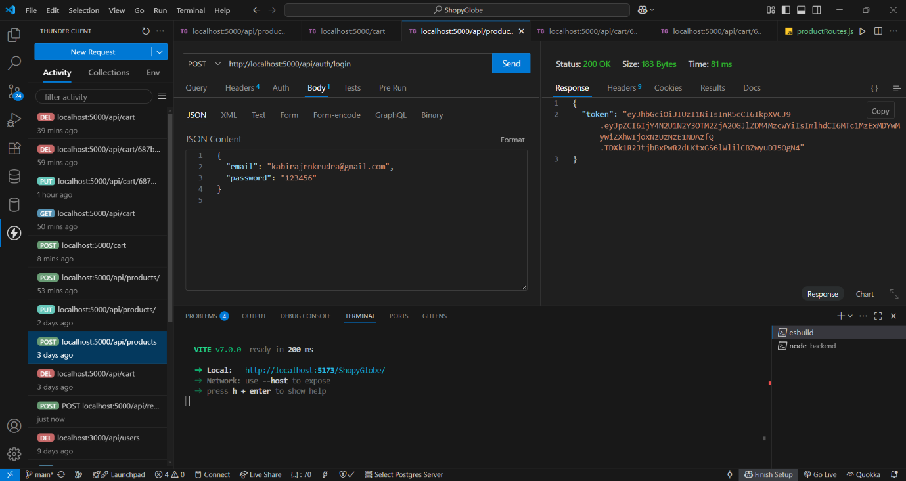

- ThunderClient_Get_products
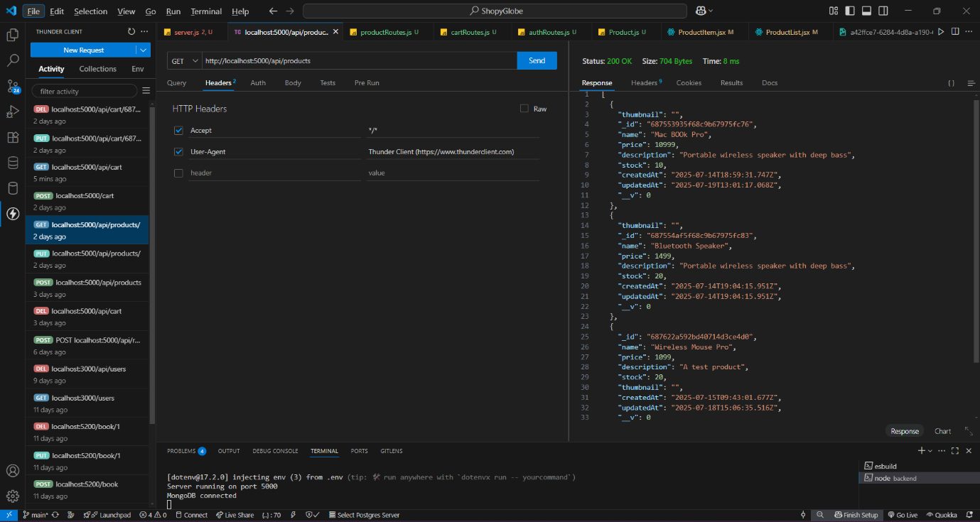

- ThunderClient_Get_By_id products
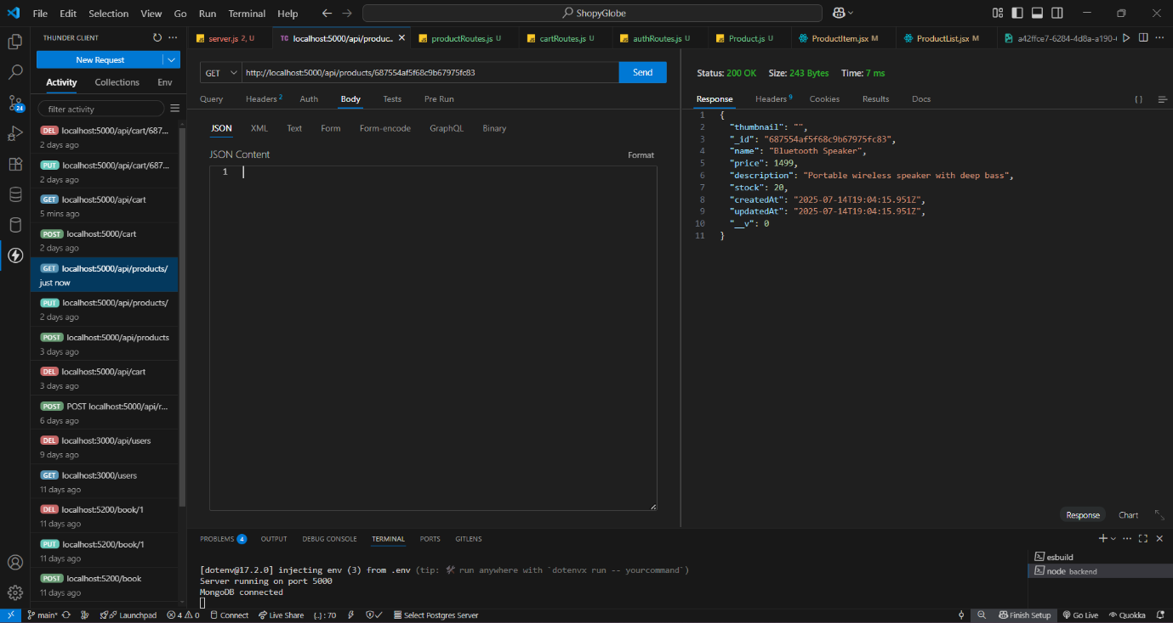

- ThunderClient_Invalid_ProductId
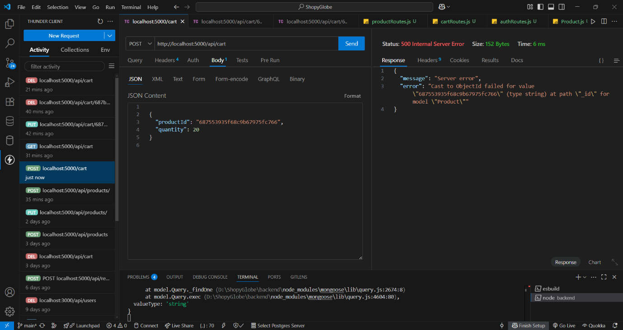

- ThunderClient_POST_New_Product
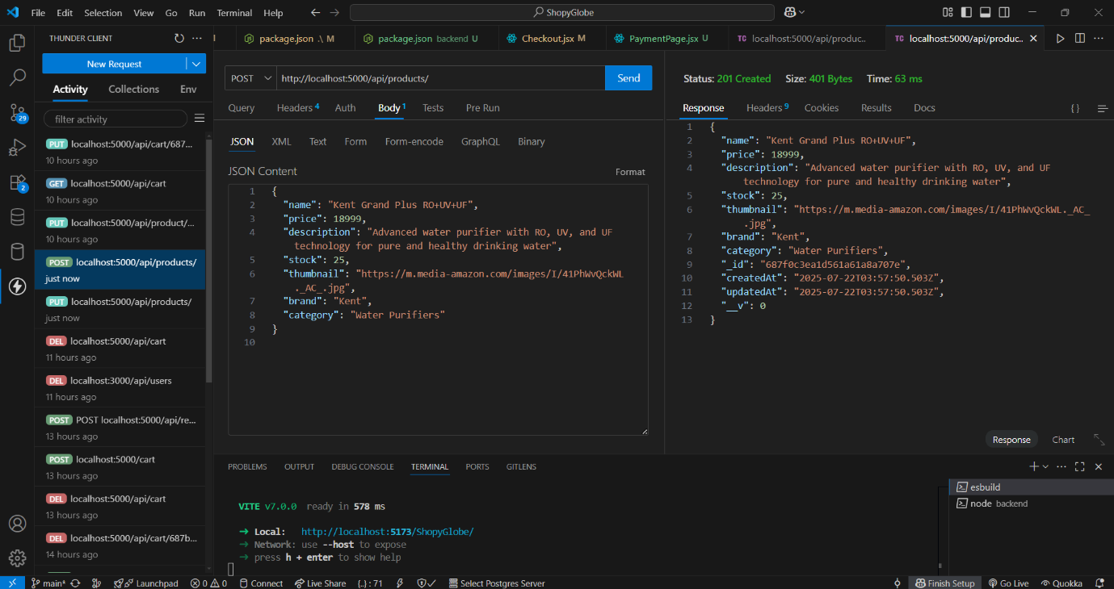

- ThunderClient_Put_Products
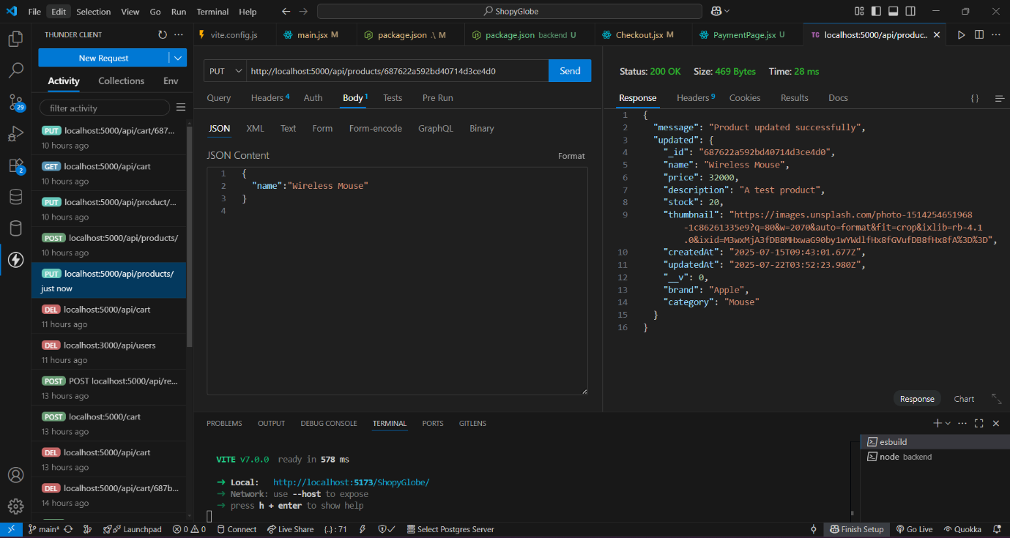

- ThunderClient_DELETE_productByid
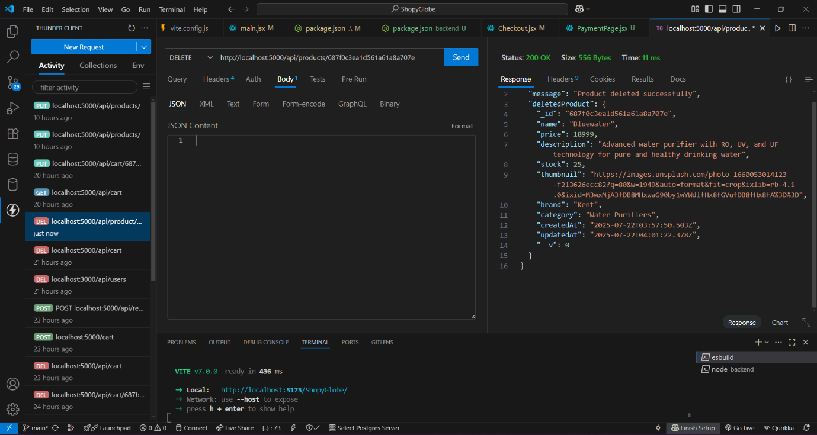

- Home_page_before_delete
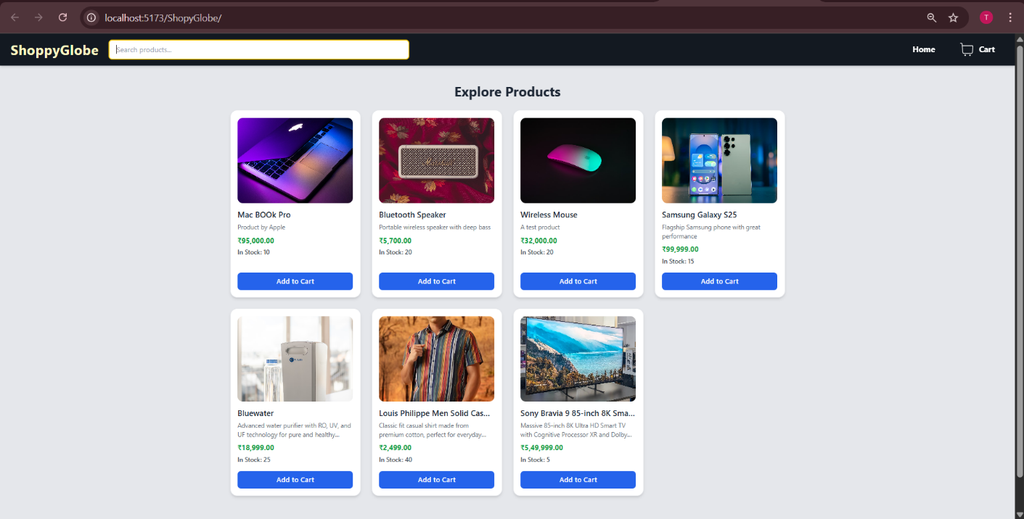

- Home_page_after_delete

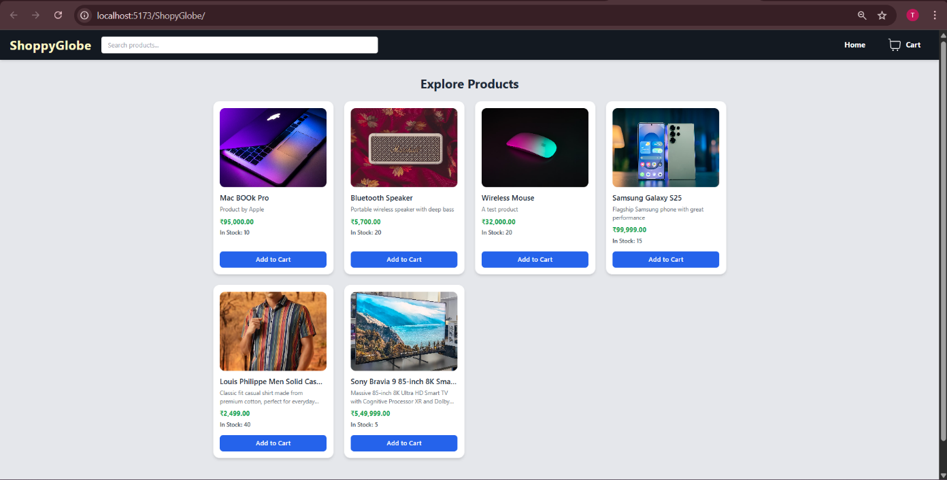

- Mongodb_products_page1
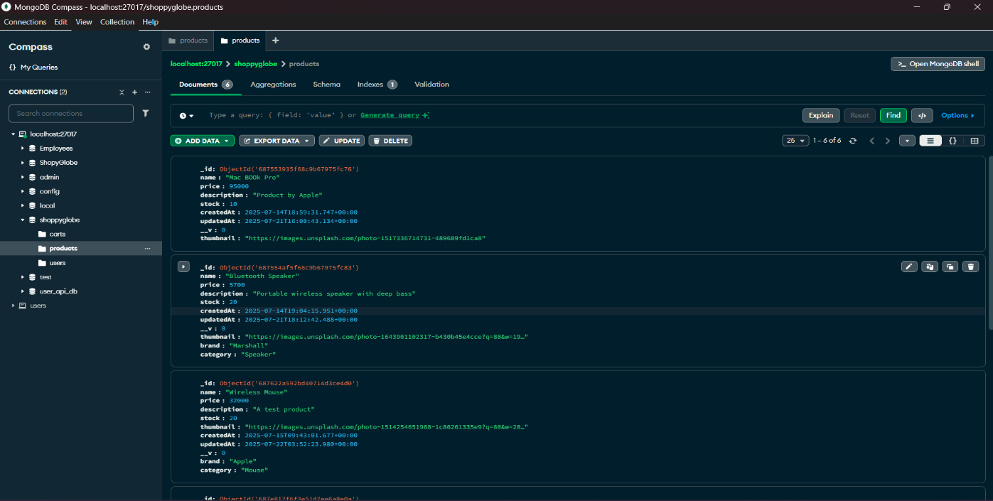
- Mongodb_products_page2
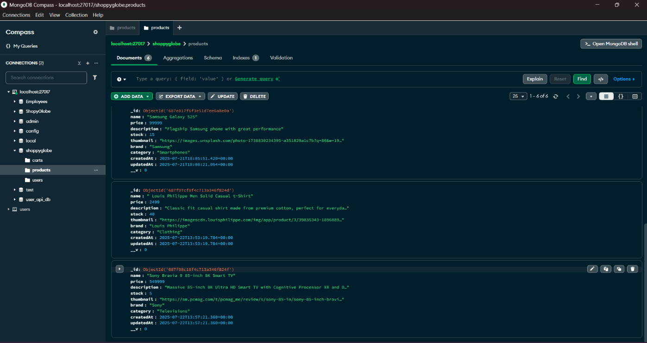

- ThunderClient_GET_Cart

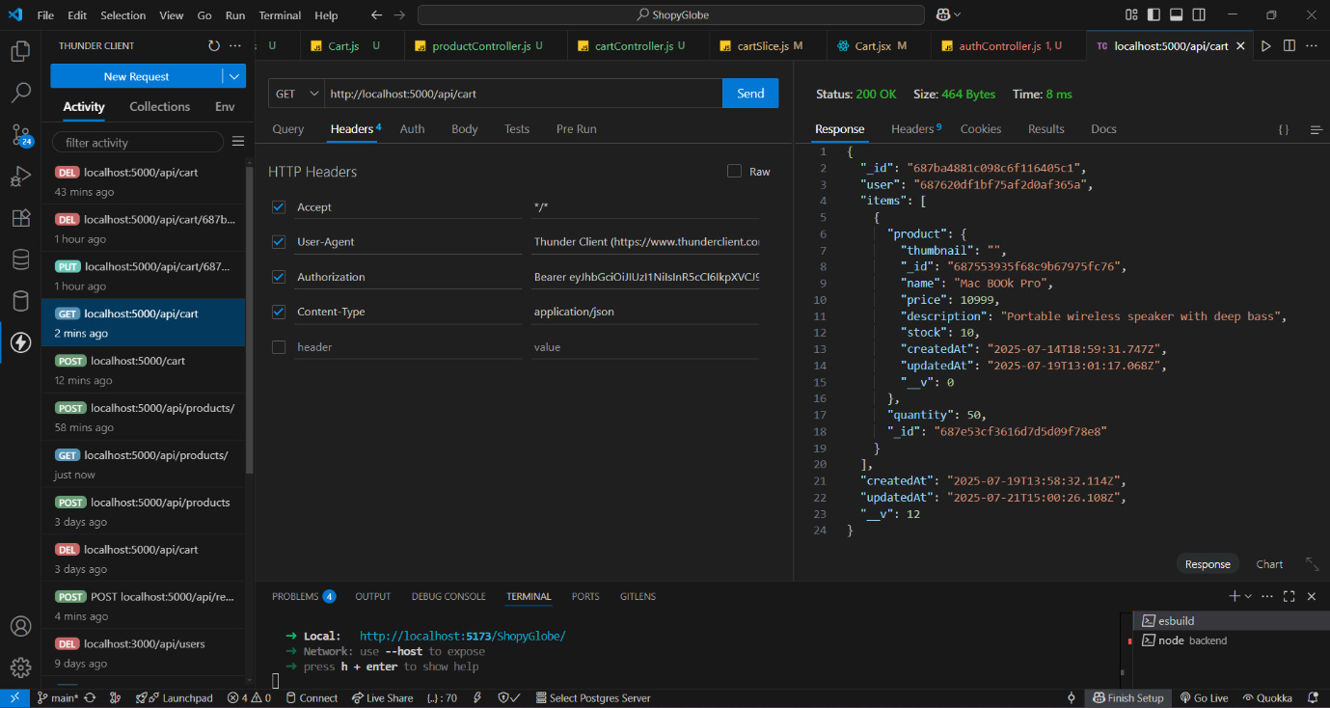

- ThunderClient_POST_Cart
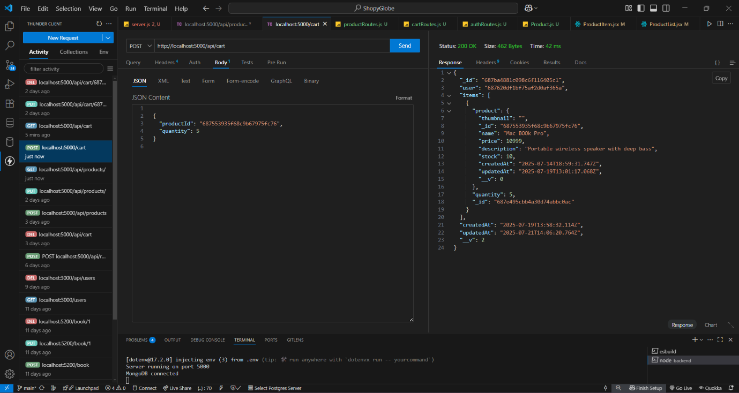

- ThunderClient_Put_CartQuantity
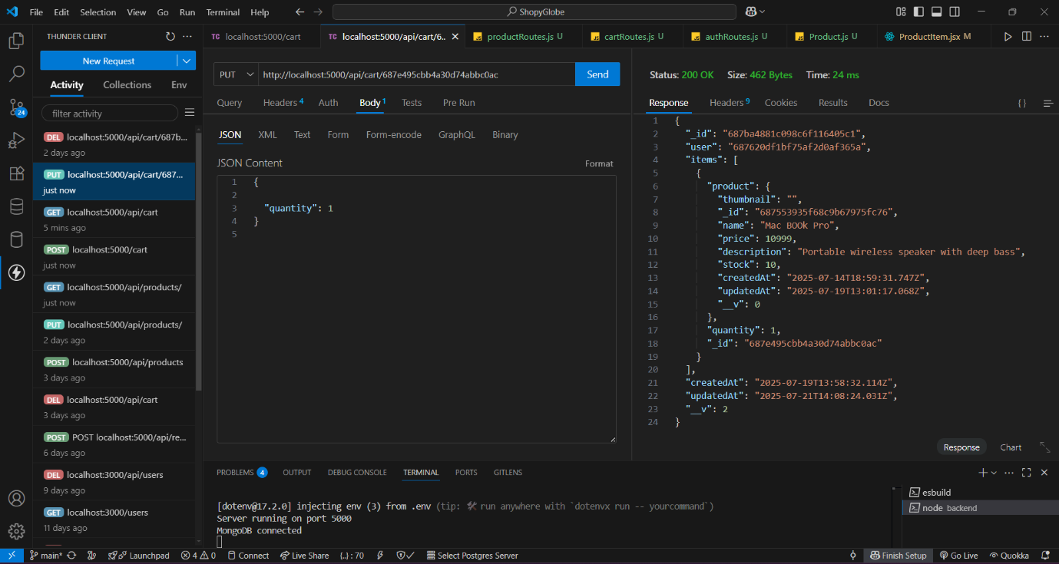

- No_Product_Id
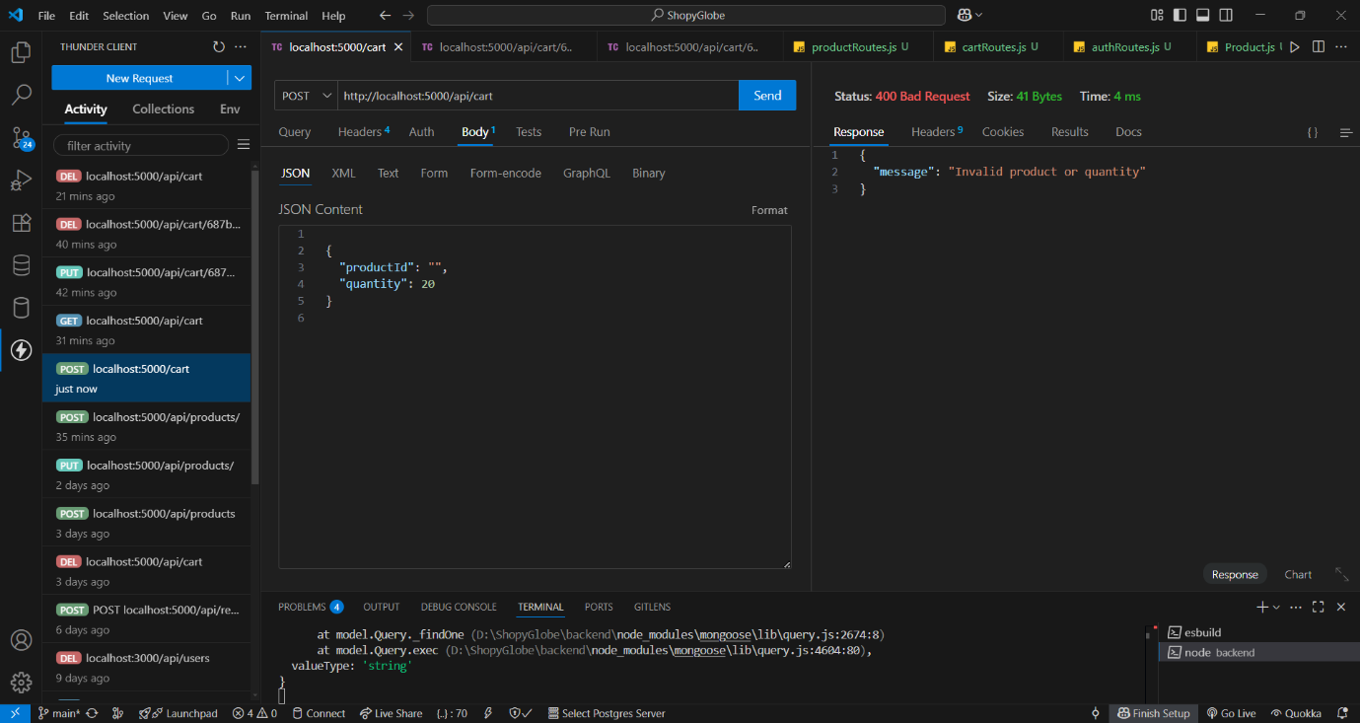

- ThunderClient_CART With Token

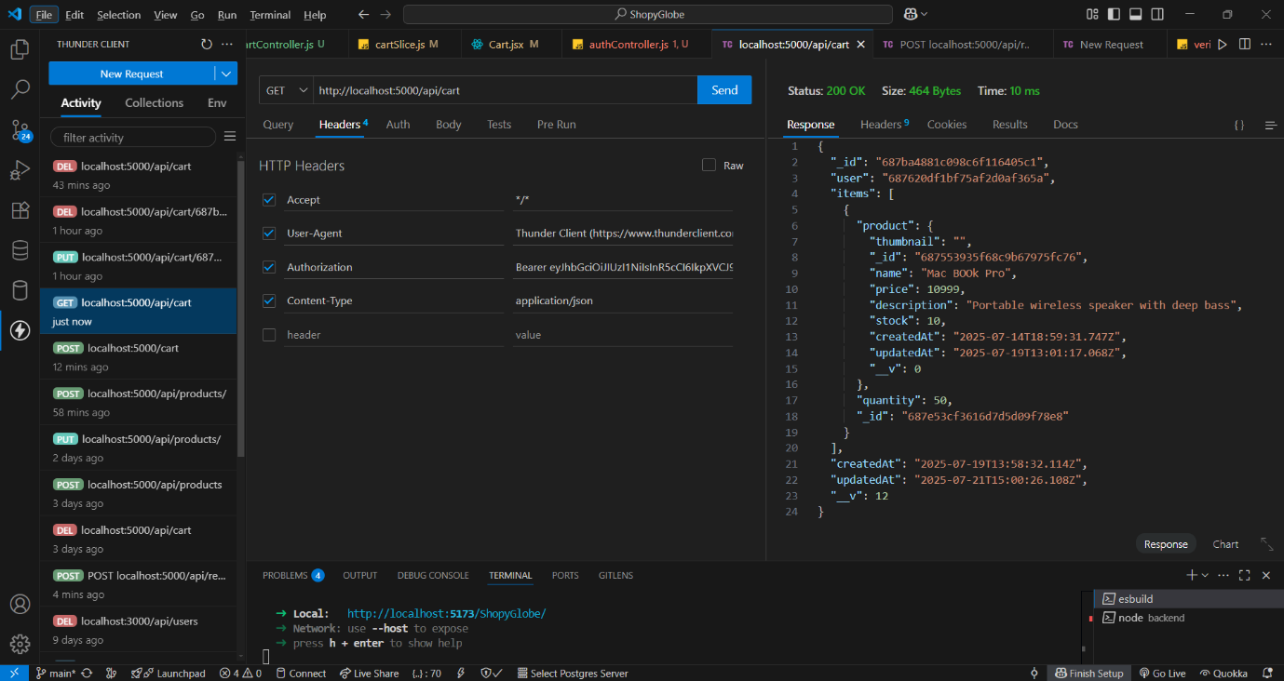

- ThunderClient_CART Without Token
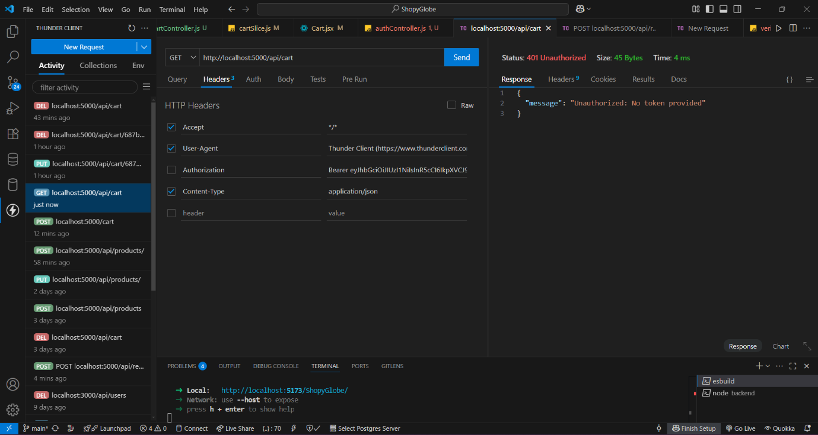

- ThunderClient_DELETE_cart_id
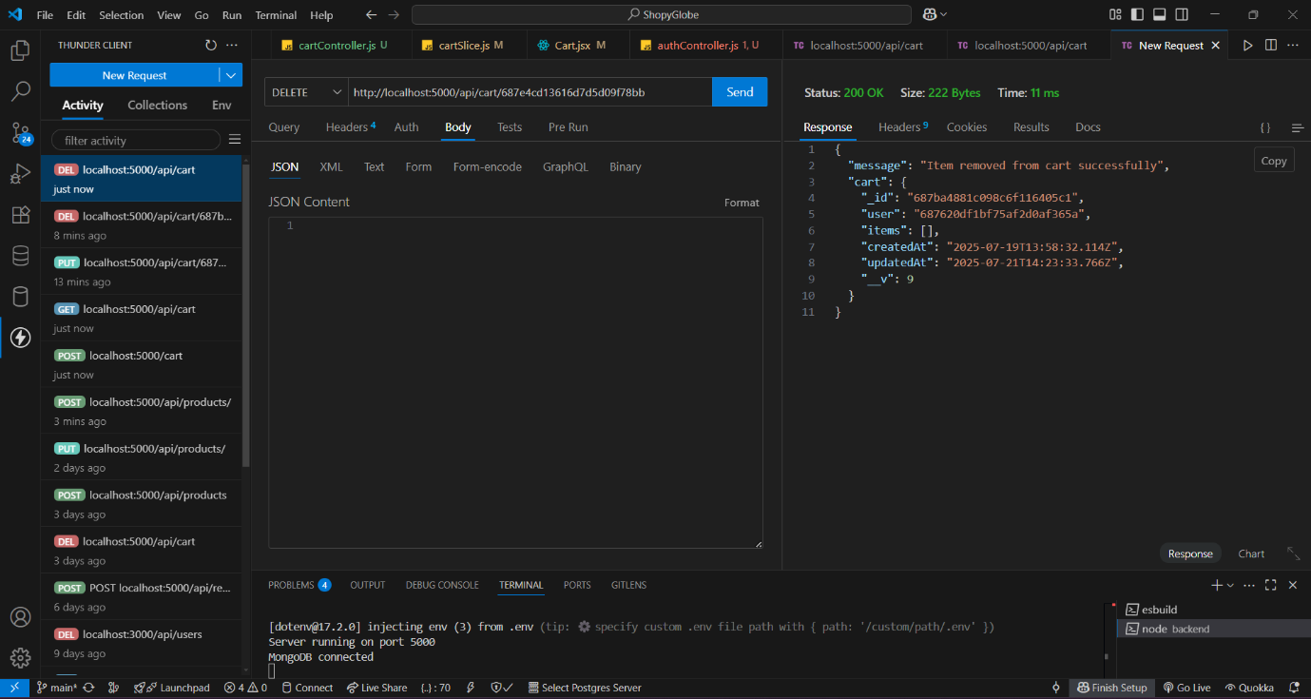

- Mongodb_CART_Items
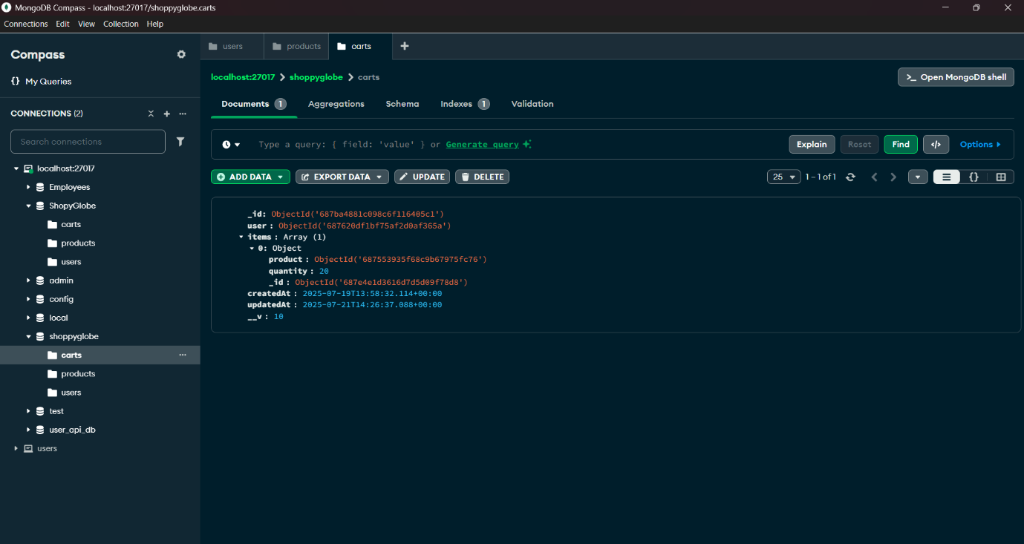

- Mongodb_CART_after delete
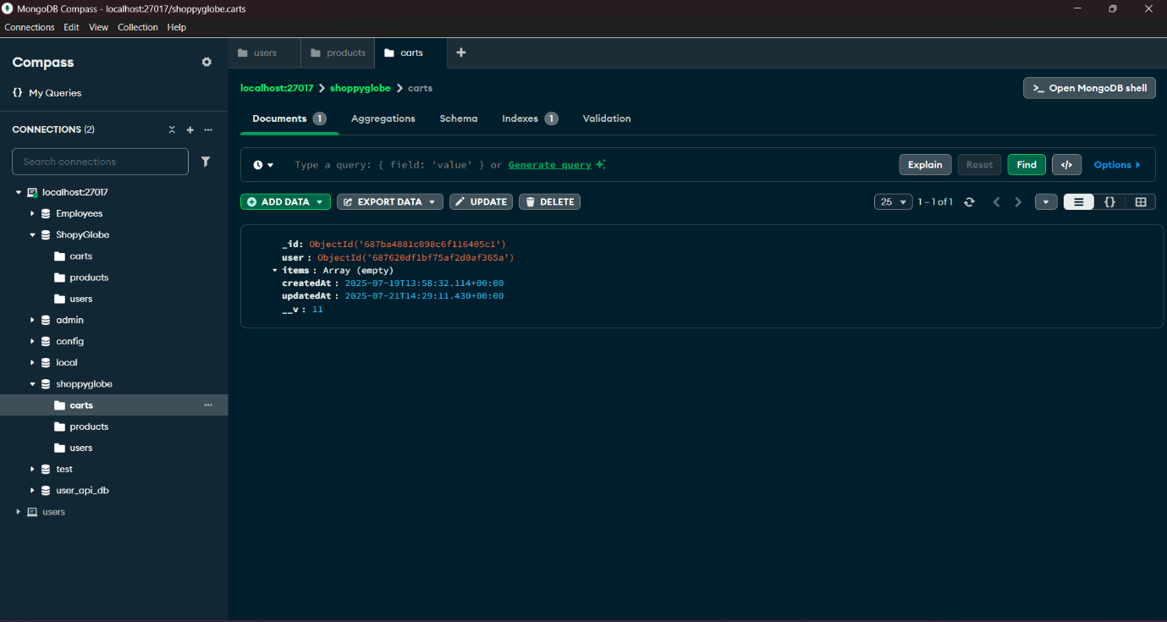

- VSCODE_Add_to_cart
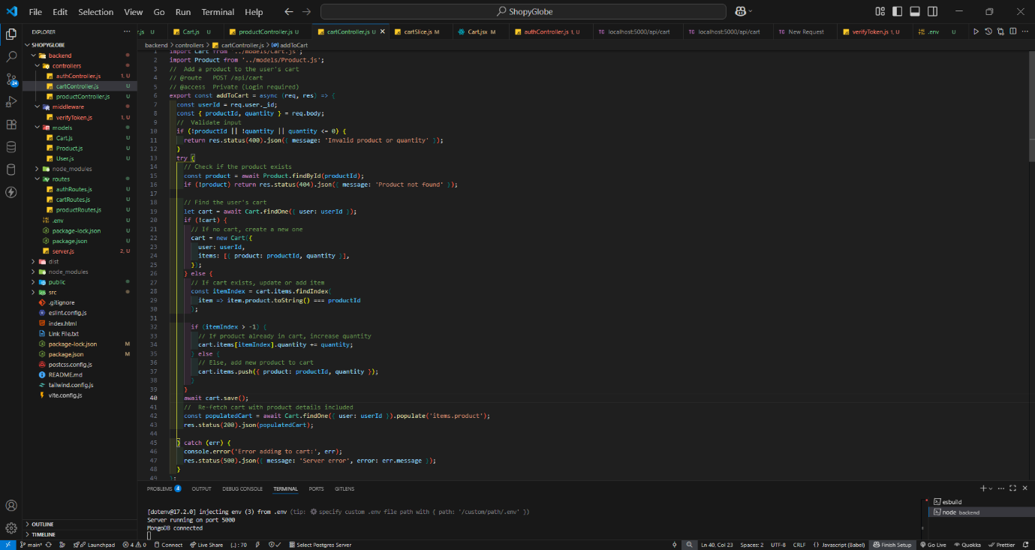

- VSCODE_Get_allItemsInCart
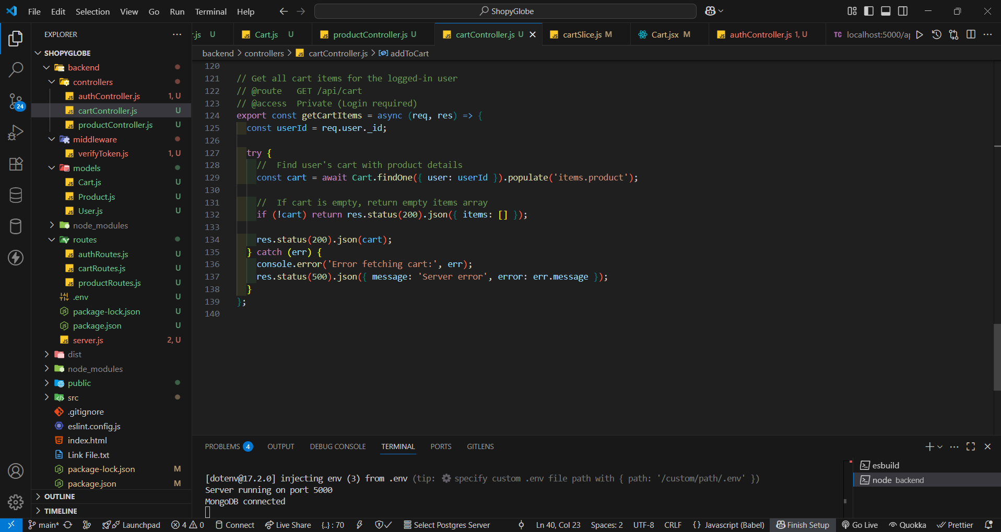

- VSCODE_Update_cart
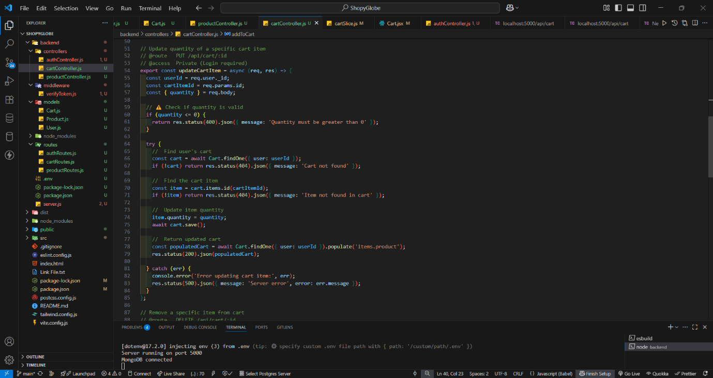

- VSCODE_Delete_from_cart
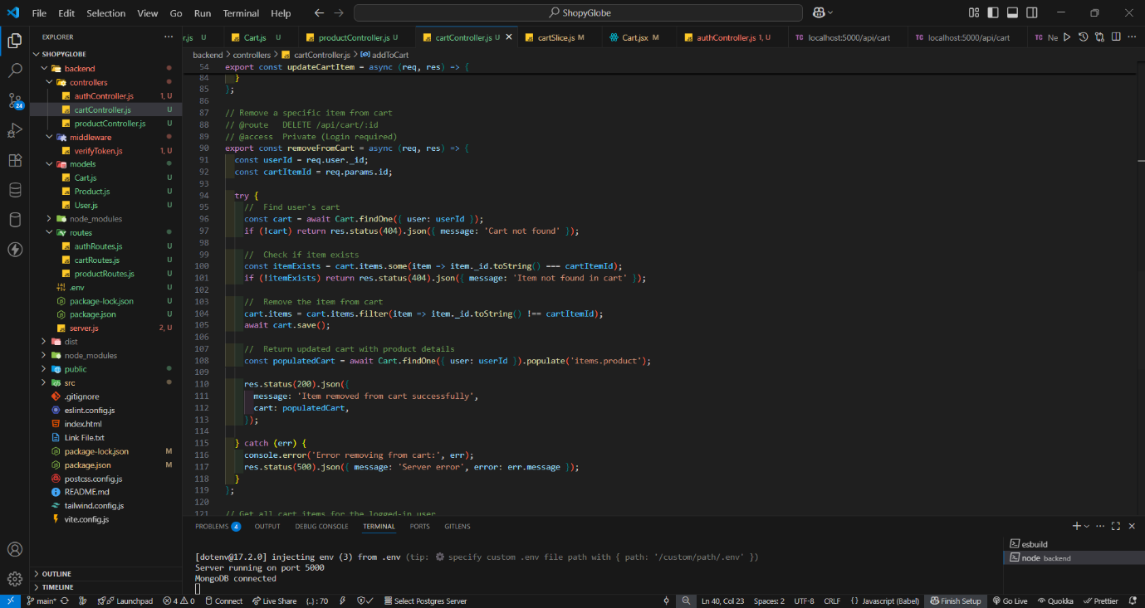

- VSCODE_cartController-validation-errorHandling
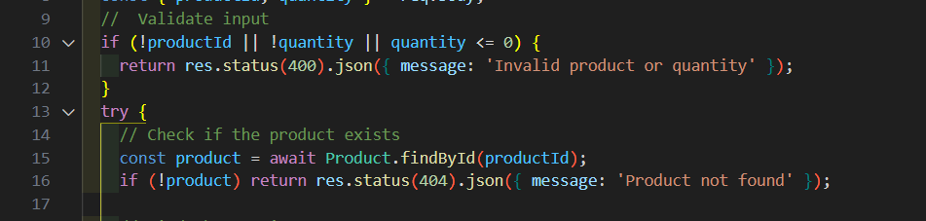

- VSCODE_Code for Register_User
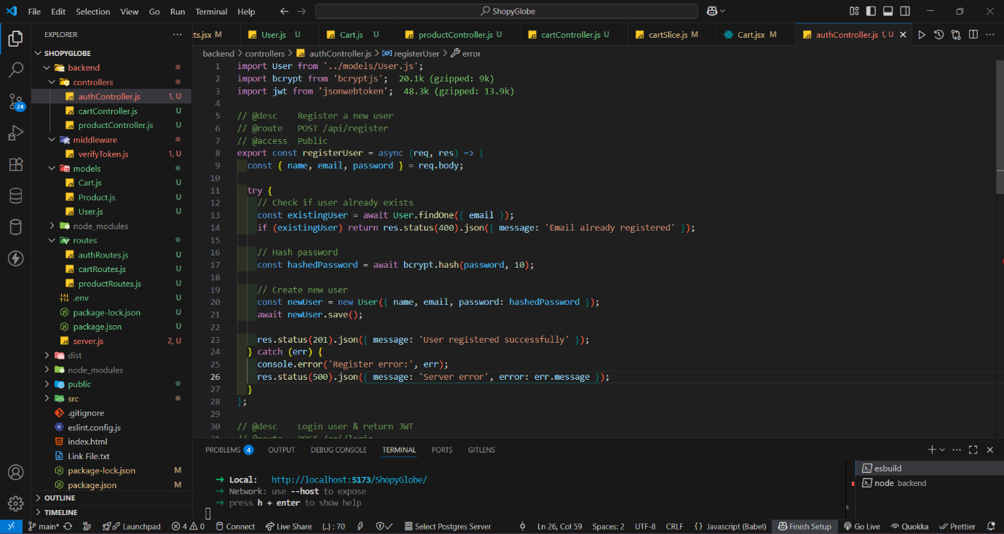

- VSCODE_Code_For_Login_User
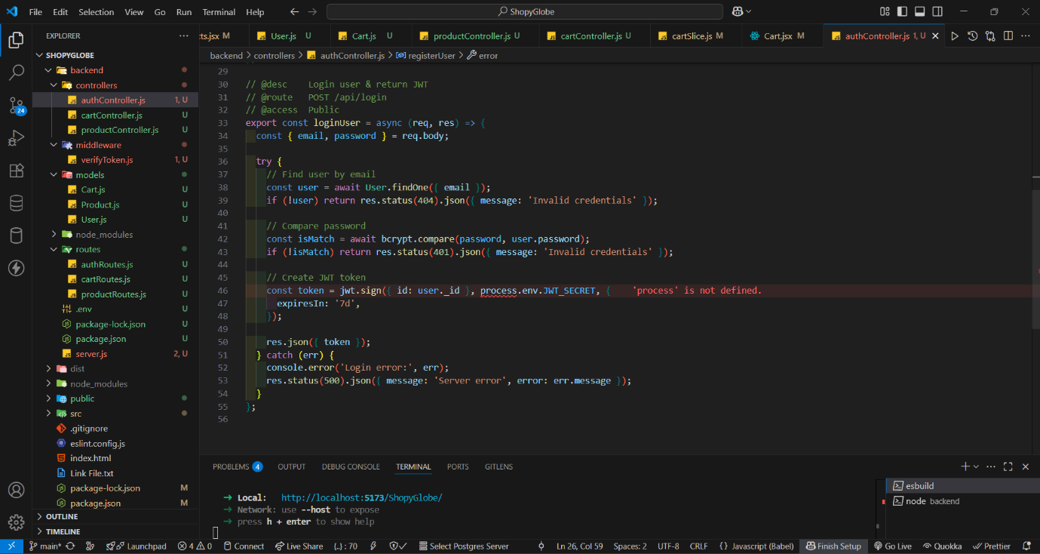

- VSCODE_get_allProducts and get_productsById
