DS6306_CaseStudy02

Rudranil Mitra

8/14/2020

## R Markdown

library(ggplot2)  
library(dplyr)

##   
## Attaching package: 'dplyr'

## The following objects are masked from 'package:stats':  
##   
## filter, lag

## The following objects are masked from 'package:base':  
##   
## intersect, setdiff, setequal, union

library(tidyverse)

## -- Attaching packages ------------------------------------------------------------------------------------------------------ tidyverse 1.3.0 --

## v tibble 3.0.3 v purrr 0.3.4  
## v tidyr 1.1.1 v stringr 1.4.0  
## v readr 1.3.1 v forcats 0.5.0

## -- Conflicts --------------------------------------------------------------------------------------------------------- tidyverse_conflicts() --  
## x dplyr::filter() masks stats::filter()  
## x dplyr::lag() masks stats::lag()

library(caret)

## Loading required package: lattice

##   
## Attaching package: 'caret'

## The following object is masked from 'package:purrr':  
##   
## lift

library(class)  
library(dplyr)  
library(e1071)  
library(FNN)

##   
## Attaching package: 'FNN'

## The following objects are masked from 'package:class':  
##   
## knn, knn.cv

library(gmodels)   
library(psych)

##   
## Attaching package: 'psych'

## The following objects are masked from 'package:ggplot2':  
##   
## %+%, alpha

library(epiR)

## Loading required package: survival

##   
## Attaching package: 'survival'

## The following object is masked from 'package:caret':  
##   
## cluster

## Package epiR 1.0-15 is loaded

## Type help(epi.about) for summary information

## Type browseVignettes(package = 'epiR') to learn how to use epiR for applied epidemiological analyses

##

library(DMwR)

## Loading required package: grid

## Registered S3 method overwritten by 'quantmod':  
## method from  
## as.zoo.data.frame zoo

##   
## Attaching package: 'DMwR'

## The following object is masked from 'package:psych':  
##   
## crossValidation

# Load attrition dataset with labels  
attrition_dataset = read.csv('D:\\SMU_MSDS\\MSDS_6306_Doing-Data-Science\\Unit 14 and 15 Case Study 2\\CaseStudy2-data.csv')  
# Load attrition dataset without labels   
attrition_dataset_wl = read.csv('D:\\SMU_MSDS\\MSDS_6306_Doing-Data-Science\\Unit 14 and 15 Case Study 2\\CaseStudy2CompSet No Attrition.csv')  
#   
attrition_dataset_lm = attrition_dataset

### Does mean age differ significantly among Attrition Groups

# Execute the t-test between two groups, we are assuming that the variances are not equal  
fit = t.test(  
 attrition_dataset[attrition_dataset['Attrition']=='No',]$Age,  
 attrition_dataset[attrition_dataset['Attrition']=='Yes',]$Age,  
 var.equal = FALSE)  
# P-value is less than the significance level(0.05), so we can reject the null hypothesis and say that mean age is different between two groups  
fit$p.value

## [1] 5.049764e-05

# Looking at the confidence intervals we can suggest that individuals who are not leaving the company have higher mean age than the individuals who leave the company  
fit$conf.int

## [1] 1.902905 5.350324  
## attr(,"conf.level")  
## [1] 0.95

attrition_dataset %>% ggplot(mapping=aes(x=Age,y=Attrition,fill=Attrition)) +   
 geom_boxplot() +   
 annotate("text",x=40,y=2.5,label=paste0('P-value=',round(fit$p.value,4))) +   
 ggtitle('Distribution of Age between two Attrition Groups')

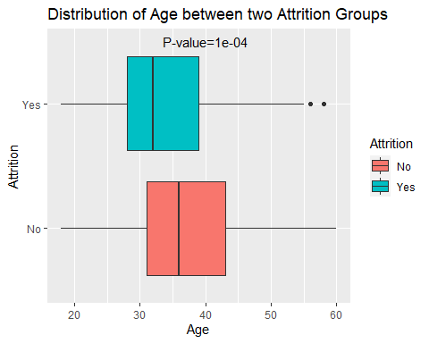 ### Does median monthly income differ significantly among Attrition Groups

# Execute the t-test between two groups, we are assuming that the variances are not equal  
fit = t.test(  
 log(attrition_dataset[attrition_dataset['Attrition']=='No',]$MonthlyIncome),  
 log(attrition_dataset[attrition_dataset['Attrition']=='Yes',]$MonthlyIncome),  
 var.equal = FALSE)  
# P-value is less than the significance level(0.05), so we can reject the null hypothesis and say that median monthly income is different between two groups  
fit$p.value

## [1] 1.159977e-08

# Looking at the confidence intervals(confidence intervals are in the log scale) we can suggest that individuals who are not leaving the company have higher median monthly income than the individuals who leave the company. So monthly income is a significant reason for leaving the company  
# The lower bound of the increase between two groups is 27%   
round(exp(fit$conf.int[1])-1,2)

## [1] 0.27

# The upper bound of the increase between two groups is 60%  
round(exp(fit$conf.int[2])-1,2)

## [1] 0.61

attrition_dataset %>% ggplot(mapping=aes(x=MonthlyIncome,y=Attrition,fill=Attrition)) +   
 geom_boxplot() +   
 annotate("text",x=15000,y=2.5,label=paste0('P-value=',round(fit$p.value,4))) +   
 ggtitle('Distribution of Monthly Income between two Attrition Groups')

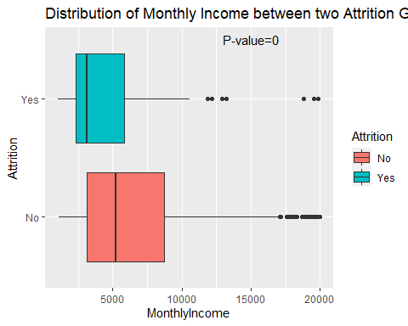

### Does mean distance from home differ significantly among Attrition Groups

# Execute the t-test between two groups, we are assuming that the variances are not equal  
fit = t.test(  
 attrition_dataset[attrition_dataset['Attrition']=='No',]$DistanceFromHome,  
 attrition_dataset[attrition_dataset['Attrition']=='Yes',]$DistanceFromHome,  
 var.equal = FALSE)  
# P-value is less than the significance level(0.05), so we can reject the null hypothesis and say that mean distance from home is different between two groups  
fit$p.value

## [1] 0.01640519

# Looking at the confidence intervals we can suggest that individuals who are not leaving the company are staying close to home than the individuals who are leaving the company  
fit$conf.int

## [1] -3.4992554 -0.3574961  
## attr(,"conf.level")  
## [1] 0.95

attrition_dataset %>% ggplot(mapping=aes(x=DistanceFromHome,y=Attrition,fill=Attrition)) +   
 geom_boxplot() +   
 annotate("text",x=10,y=2.5,label=paste0('P-value=',round(fit$p.value,4))) +   
 ggtitle('Distribution of Distance From Home between two Attrition Groups')

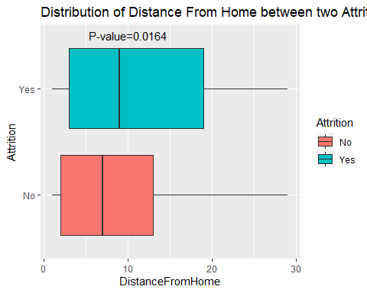 ## Does mean total working years differ significantly among Attrition Groups

# Execute the t-test between two groups, we are assuming that the variances are not equal  
fit = t.test(  
 attrition_dataset[attrition_dataset['Attrition']=='No',]$TotalWorkingYears,  
 attrition_dataset[attrition_dataset['Attrition']=='Yes',]$TotalWorkingYears,  
 var.equal = FALSE)  
# P-value is less than the significance level(0.05), so we can reject the null hypothesis and say that mean total working years is different between two groups  
fit$p.value

## [1] 6.595682e-07

attrition_dataset %>% ggplot(mapping=aes(x=DistanceFromHome,y=Attrition,fill=Attrition)) +   
 geom_boxplot() +   
 annotate("text",x=20,y=2.5,label=paste0('P-value=',round(fit$p.value,4))) +   
 ggtitle('Distribution of Total Working Years between two Attrition Groups')

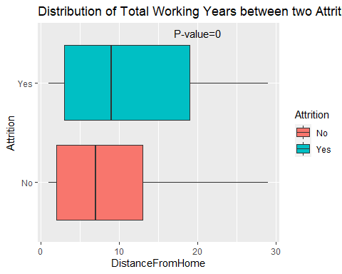

## Does mean total years working at the company different significantly among Attrition Groups

# Execute the t-test between two groups, we are assuming that the variances are not equal  
fit = t.test(  
 attrition_dataset[attrition_dataset['Attrition']=='No',]$YearsAtCompany,  
 attrition_dataset[attrition_dataset['Attrition']=='Yes',]$YearsAtCompany,  
 var.equal = FALSE)  
# P-value is less than the significance level(0.05), so we can reject the null hypothesis and say that mean years at current company is different between two groups  
fit$p.value

## [1] 0.0002563021

attrition_dataset %>% ggplot(mapping=aes(x=DistanceFromHome,y=Attrition,fill=Attrition)) +   
 geom_boxplot() +   
 annotate("text",x=20,y=2.5,label=paste0('P-value=',round(fit$p.value,4))) +   
 ggtitle('Distribution of Years at Current company between two Attrition Groups')

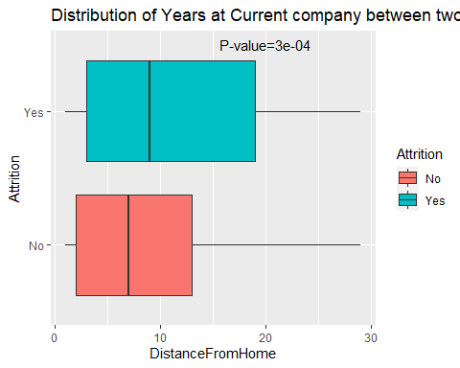 ## Run categorical tests to check whether those variables are associated with attrition

fit=chisq.test(table(attrition_dataset$BusinessTravel,attrition_dataset$Attrition))  
barplot(table(attrition_dataset$Attrition,attrition_dataset$BusinessTravel),  
 col = c("green","red"),  
 main=paste0('Attrition by Business Travel, p-value=',round(fit$p.value,4)),  
 xlab='Business Travel Class')   
legend("topleft",c("Attrition - Yes","Attrition - No"),fill = c("red","green"))

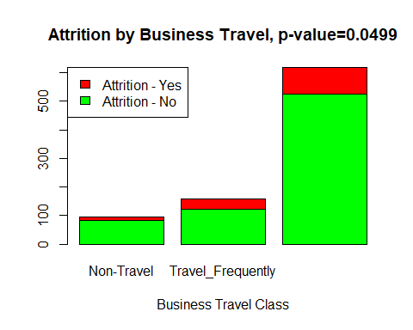

fit=chisq.test(table(attrition_dataset$Department,attrition_dataset$Attrition))  
barplot(table(attrition_dataset$Attrition,attrition_dataset$Department),  
 col = c("green","red"),  
 main=paste0('Attrition by Department, p-value=',round(fit$p.value,4)),  
 xlab='Department')   
legend("topleft",c("Attrition - Yes","Attrition - No"),fill = c("red","green"))

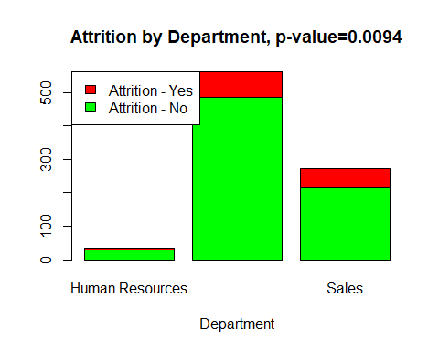

fit=chisq.test(table(attrition_dataset$EducationField,attrition_dataset$Attrition))

## Warning in chisq.test(table(attrition_dataset$EducationField,  
## attrition_dataset$Attrition)): Chi-squared approximation may be incorrect

barplot(table(attrition_dataset$Attrition,attrition_dataset$EducationField),  
 col = c("green","red"),  
 main=paste0('Attrition by Education Field, p-value=',round(fit$p.value,4)),  
 xlab='Education Field')   
legend("topleft",c("Attrition - Yes","Attrition - No"),fill = c("red","green"))

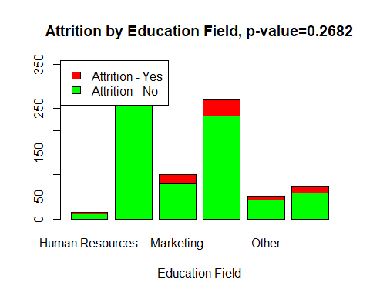

fit=chisq.test(table(attrition_dataset$Gender,attrition_dataset$Attrition))  
barplot(table(attrition_dataset$Attrition,attrition_dataset$Gender),  
 col = c("green","red"),  
 main=paste0('Attrition by Gender, p-value=',round(fit$p.value,4)),  
 xlab='Gender')   
legend("topleft",c("Attrition - Yes","Attrition - No"),fill = c("red","green"))

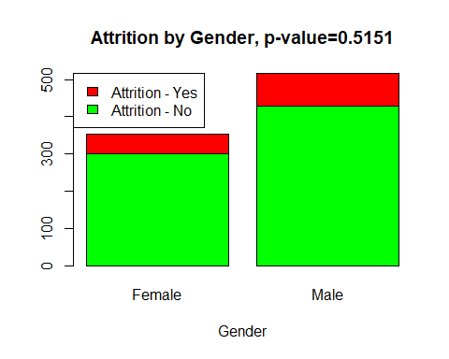

fit=chisq.test(table(attrition_dataset$JobRole,attrition_dataset$Attrition))

## Warning in chisq.test(table(attrition_dataset$JobRole,  
## attrition_dataset$Attrition)): Chi-squared approximation may be incorrect

barplot(table(attrition_dataset$Attrition,attrition_dataset$JobRole),  
 col = c("green","red"),  
 main=paste0('Attrition by JobRole, p-value=',round(fit$p.value,4)),  
 xlab='Job Role')   
legend("topleft",c("Attrition - Yes","Attrition - No"),fill = c("red","green"))

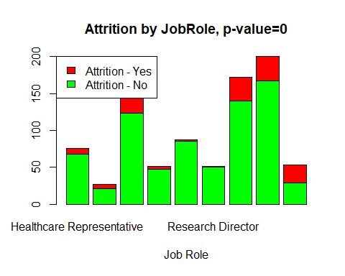

fit=chisq.test(table(attrition_dataset$MaritalStatus,attrition_dataset$Attrition))  
barplot(table(attrition_dataset$Attrition,attrition_dataset$MaritalStatus),  
 col = c("green","red"),  
 main=paste0('Attrition by Marital Status, p-value=',round(fit$p.value,4)),  
 xlab='Marital Status')   
legend("topleft",c("Attrition - Yes","Attrition - No"),fill = c("red","green"))

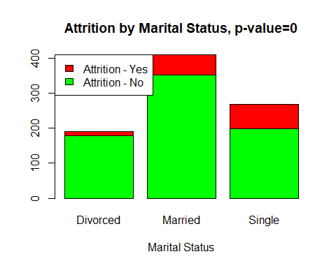

## Convert categorical variables by using dummy encoding

clean_wrangle_dataset = function(df,test){  
 ##  
 input_dataset = df  
 ##  
 if(test==0){  
 input_dataset$Attrition = as.factor(input_dataset$Attrition)   
 }  
 ##  
 input_dataset$BusinessTravel = as.factor(input_dataset$BusinessTravel)  
 input_dataset$Department = as.factor(input_dataset$Department)  
 input_dataset$EducationField = as.factor(input_dataset$EducationField)  
 input_dataset$Gender = as.factor(input_dataset$Gender)  
 input_dataset$JobRole = as.factor(input_dataset$JobRole)  
 input_dataset$MaritalStatus = as.factor(input_dataset$MaritalStatus)  
 input_dataset$Over18 = as.factor(input_dataset$Over18)  
 input_dataset$OverTime = as.factor(input_dataset$OverTime)  
   
 # Shorten Department Names by replacing the values   
   
 input_dataset$Department = str_replace(input_dataset$Department, "Research & Development", "RnD")  
 input_dataset$Department = str_replace(input_dataset$Department, "Human Resources", "HR")  
   
   
 # Change variables with 2 levels to 1 and 0   
 input_dataset$Gender <- ifelse(input_dataset$Gender == "Female", 1, 0)  
 input_dataset$OverTime <- ifelse(input_dataset$OverTime == "Yes", 1, 0)  
   
 # Remove Variables not needed in the model  
 input_dataset = input_dataset %>% select(-Over18)  
 input_dataset = input_dataset %>% select(-EmployeeCount)  
 input_dataset = input_dataset %>% select(-EmployeeNumber)  
 input_dataset = input_dataset %>% select(-ID)  
 input_dataset = input_dataset %>% select(-StandardHours)  
 input_dataset = input_dataset %>% select(-DailyRate)  
 input_dataset = input_dataset %>% select(-HourlyRate)  
 input_dataset = input_dataset %>% select(-MonthlyRate)  
   
   
   
 # Scale numeric variables   
 input_dataset[, c("Age","DistanceFromHome","Education","EnvironmentSatisfaction","JobInvolvement","JobLevel","JobSatisfaction","MonthlyIncome","NumCompaniesWorked","PercentSalaryHike","PerformanceRating","RelationshipSatisfaction","StockOptionLevel","TotalWorkingYears","TrainingTimesLastYear","WorkLifeBalance","YearsAtCompany","YearsInCurrentRole","YearsSinceLastPromotion","YearsWithCurrManager")] = scale(input_dataset[, c("Age","DistanceFromHome","Education","EnvironmentSatisfaction","JobInvolvement","JobLevel","JobSatisfaction","MonthlyIncome","NumCompaniesWorked","PercentSalaryHike","PerformanceRating","RelationshipSatisfaction","StockOptionLevel","TotalWorkingYears","TrainingTimesLastYear","WorkLifeBalance","YearsAtCompany","YearsInCurrentRole","YearsSinceLastPromotion","YearsWithCurrManager")])  
   
   
 # Add feature names and replace spaces  
   
 input_dataset$BusinessTravel = paste("BT_",str_replace(input_dataset$BusinessTravel," ","_"),sep="")  
 input_dataset$Department = paste("DP_",str_replace(input_dataset$Department," ","_"),sep="")  
 input_dataset$EducationField = paste("EF_",str_replace(input_dataset$EducationField," ","_"),sep="")  
 input_dataset$JobRole = paste("JR_",str_replace(input_dataset$JobRole," ","_"),sep="")  
 input_dataset$MaritalStatus = paste("MS_",str_replace(input_dataset$MaritalStatus," ","_"),sep="")  
   
   
 # Dummy code categorical variables having 3 or more levels  
 BusinessTravel = as.data.frame(dummy.code(input_dataset$BusinessTravel))  
 Department = as.data.frame(dummy.code(input_dataset$Department))   
 EducationField = as.data.frame(dummy.code(input_dataset$EducationField))  
 JobRole = as.data.frame(dummy.code(input_dataset$JobRole))  
 MaritalStatus = as.data.frame(dummy.code(input_dataset$MaritalStatus))  
   
   
 # Add the dummy codes to the dataset  
 input_dataset = cbind(input_dataset,BusinessTravel,Department,EducationField,JobRole,MaritalStatus)  
   
 # Remove the original categorical variables   
 input_dataset = input_dataset %>% select(-one_of(c("BusinessTravel", "Department", "EducationField","JobRole","MaritalStatus")))  
   
 # Return the dataset  
 return(input_dataset)  
}

## Clean and make the datasets ready for KNN algorithm

attrition_dataset = clean_wrangle_dataset(attrition_dataset,0)  
#Move outcome to the last column  
attrition_dataset$Outcome = attrition_dataset$Attrition  
attrition_dataset = attrition_dataset %>% select(-Attrition)  
  
attrition_dataset_wl = clean_wrangle_dataset(attrition_dataset_wl,1)

## Run KNN on training set to check specificity and sensitivity of the model

#set.seed(1243) # set the seed to make the partition reproducible  
  
# 80% of the sample size  
smp_size <- floor(0.8 * nrow(attrition_dataset))  
train_ind <- sample(seq_len(nrow(attrition_dataset)), size = smp_size)  
  
train_df <- attrition_dataset[train_ind, ]  
test_df <- attrition_dataset[-train_ind, ]  
# Use SMOTE to oversample the Attrition = Yes Observations  
  
train_df = SMOTE(Outcome~.,train_df,perc.over = 600,perc.under=100,k=10)  
prop.table(table(train_df$Outcome))

##   
## No Yes   
## 0.4615385 0.5384615

classifications = knn(train_df[,c(1:46)], test_df[,c(1:46)], train_df$Outcome,prob = T,k=10)  
confusionMatrix(table(test_df$Outcome,classifications,dnn=c('Predicted','Actual')))

## Confusion Matrix and Statistics  
##   
## Actual  
## Predicted No Yes  
## No 70 73  
## Yes 12 19  
##   
## Accuracy : 0.5115   
## 95% CI : (0.4347, 0.5879)  
## No Information Rate : 0.5287   
## P-Value [Acc > NIR] : 0.7028   
##   
## Kappa : 0.0578   
##   
## Mcnemar's Test P-Value : 7.62e-11   
##   
## Sensitivity : 0.8537   
## Specificity : 0.2065   
## Pos Pred Value : 0.4895   
## Neg Pred Value : 0.6129   
## Prevalence : 0.4713   
## Detection Rate : 0.4023   
## Detection Prevalence : 0.8218   
## Balanced Accuracy : 0.5301   
##   
## 'Positive' Class : No   
##

## Predict classifications on the test data set

# attrition_dataset_train = SMOTE(Outcome~.,attrition_dataset,perc.over = 600,perc.under=100,k=10)  
# classifications = knn(attrition_dataset_train[,c(1:46)], attrition_dataset_wl[,c(1:46)], attrition_dataset_train$Outcome,prob = F,k=5)  
# write.csv(x=classifications, file='D:\\SMU_MSDS\\MSDS_6306_Doing-Data-Science\\Unit 14 and 15 Case Study 2\\attrition_results.csv',row.names = F)

## Run linear regression

attrition_dataset_lm$BusinessTravel = as.factor(attrition_dataset_lm$BusinessTravel)  
attrition_dataset_lm$Department =as.factor(attrition_dataset_lm$Department)  
attrition_dataset_lm$Gender = as.factor(attrition_dataset_lm$Gender)  
attrition_dataset_lm$JobRole = as.factor(attrition_dataset_lm$JobRole)  
attrition_dataset_lm$OverTime = as.factor(attrition_dataset_lm$OverTime)  
   
model.full = lm(MonthlyIncome~Age+  
 BusinessTravel+  
 Department+  
 Education+  
 EducationField+  
 EnvironmentSatisfaction+  
 Gender+  
 JobInvolvement+  
 JobLevel+  
 JobRole+  
 JobSatisfaction+  
 NumCompaniesWorked+  
 OverTime+  
 PercentSalaryHike+  
 PerformanceRating+  
 RelationshipSatisfaction+  
 StockOptionLevel+  
 TotalWorkingYears+  
 TrainingTimesLastYear+  
 WorkLifeBalance+  
 YearsAtCompany+  
 YearsInCurrentRole+  
 YearsSinceLastPromotion+  
 YearsWithCurrManager,data=attrition_dataset_lm)  
   
model.aic.backward <- step(model.full, direction = "backward", trace = 1)

## Start: AIC=12155.21  
## MonthlyIncome ~ Age + BusinessTravel + Department + Education +   
## EducationField + EnvironmentSatisfaction + Gender + JobInvolvement +   
## JobLevel + JobRole + JobSatisfaction + NumCompaniesWorked +   
## OverTime + PercentSalaryHike + PerformanceRating + RelationshipSatisfaction +   
## StockOptionLevel + TotalWorkingYears + TrainingTimesLastYear +   
## WorkLifeBalance + YearsAtCompany + YearsInCurrentRole + YearsSinceLastPromotion +   
## YearsWithCurrManager  
##   
## Df Sum of Sq RSS AIC  
## - EducationField 5 2188361 934002638 12147  
## - StockOptionLevel 1 3063 931817340 12153  
## - OverTime 1 5013 931819290 12153  
## - YearsAtCompany 1 25354 931839631 12153  
## - YearsInCurrentRole 1 84141 931898418 12153  
## - EnvironmentSatisfaction 1 104984 931919261 12153  
## - Age 1 127371 931941648 12153  
## - JobInvolvement 1 127908 931942184 12153  
## - RelationshipSatisfaction 1 173320 931987597 12153  
## - NumCompaniesWorked 1 458909 932273186 12154  
## - JobSatisfaction 1 573107 932387383 12154  
## - TrainingTimesLastYear 1 693826 932508103 12154  
## - WorkLifeBalance 1 738527 932552804 12154  
## - Education 1 1079327 932893604 12154  
## - Department 2 3464790 935279067 12154  
## <none> 931814277 12155  
## - Gender 1 2629318 934443595 12156  
## - YearsWithCurrManager 1 2723629 934537906 12156  
## - PercentSalaryHike 1 3093401 934907678 12156  
## - YearsSinceLastPromotion 1 4468805 936283081 12157  
## - PerformanceRating 1 4994816 936809093 12158  
## - BusinessTravel 2 14309251 946123528 12164  
## - TotalWorkingYears 1 23152293 954966570 12175  
## - JobRole 8 639534354 1571348630 12594  
## - JobLevel 1 1254725478 2186539755 12895  
##   
## Step: AIC=12147.25  
## MonthlyIncome ~ Age + BusinessTravel + Department + Education +   
## EnvironmentSatisfaction + Gender + JobInvolvement + JobLevel +   
## JobRole + JobSatisfaction + NumCompaniesWorked + OverTime +   
## PercentSalaryHike + PerformanceRating + RelationshipSatisfaction +   
## StockOptionLevel + TotalWorkingYears + TrainingTimesLastYear +   
## WorkLifeBalance + YearsAtCompany + YearsInCurrentRole + YearsSinceLastPromotion +   
## YearsWithCurrManager  
##   
## Df Sum of Sq RSS AIC  
## - StockOptionLevel 1 1475 934004112 12145  
## - OverTime 1 11571 934014208 12145  
## - YearsAtCompany 1 44460 934047098 12145  
## - Age 1 66006 934068644 12145  
## - EnvironmentSatisfaction 1 93279 934095917 12145  
## - RelationshipSatisfaction 1 94114 934096752 12145  
## - YearsInCurrentRole 1 108600 934111237 12145  
## - JobInvolvement 1 141435 934144073 12145  
## - NumCompaniesWorked 1 455968 934458606 12146  
## - TrainingTimesLastYear 1 474340 934476978 12146  
## - JobSatisfaction 1 584562 934587200 12146  
## - WorkLifeBalance 1 741738 934744376 12146  
## - Education 1 1025519 935028157 12146  
## - Department 2 3219440 937222078 12146  
## <none> 934002638 12147  
## - YearsWithCurrManager 1 2637717 936640355 12148  
## - Gender 1 2684309 936686946 12148  
## - PercentSalaryHike 1 2834550 936837188 12148  
## - YearsSinceLastPromotion 1 4384582 938387219 12149  
## - PerformanceRating 1 4665021 938667659 12150  
## - BusinessTravel 2 15020987 949023625 12157  
## - TotalWorkingYears 1 22511231 956513869 12166  
## - JobRole 8 638539302 1572541940 12584  
## - JobLevel 1 1263905298 2197907936 12890  
##   
## Step: AIC=12145.25  
## MonthlyIncome ~ Age + BusinessTravel + Department + Education +   
## EnvironmentSatisfaction + Gender + JobInvolvement + JobLevel +   
## JobRole + JobSatisfaction + NumCompaniesWorked + OverTime +   
## PercentSalaryHike + PerformanceRating + RelationshipSatisfaction +   
## TotalWorkingYears + TrainingTimesLastYear + WorkLifeBalance +   
## YearsAtCompany + YearsInCurrentRole + YearsSinceLastPromotion +   
## YearsWithCurrManager  
##   
## Df Sum of Sq RSS AIC  
## - OverTime 1 11562 934015674 12143  
## - YearsAtCompany 1 44894 934049006 12143  
## - Age 1 65574 934069686 12143  
## - EnvironmentSatisfaction 1 92788 934096900 12143  
## - RelationshipSatisfaction 1 93397 934097509 12143  
## - YearsInCurrentRole 1 111499 934115611 12143  
## - JobInvolvement 1 143909 934148021 12143  
## - NumCompaniesWorked 1 457120 934461233 12144  
## - TrainingTimesLastYear 1 476007 934480120 12144  
## - JobSatisfaction 1 584445 934588558 12144  
## - WorkLifeBalance 1 740271 934744383 12144  
## - Education 1 1024752 935028865 12144  
## - Department 2 3218145 937222258 12144  
## <none> 934004112 12145  
## - YearsWithCurrManager 1 2639133 936643245 12146  
## - Gender 1 2689316 936693429 12146  
## - PercentSalaryHike 1 2835993 936840105 12146  
## - YearsSinceLastPromotion 1 4383213 938387326 12147  
## - PerformanceRating 1 4670853 938674965 12148  
## - BusinessTravel 2 15021284 949025396 12155  
## - TotalWorkingYears 1 22511103 956515215 12164  
## - JobRole 8 638565271 1572569384 12582  
## - JobLevel 1 1264319112 2198323224 12888  
##   
## Step: AIC=12143.26  
## MonthlyIncome ~ Age + BusinessTravel + Department + Education +   
## EnvironmentSatisfaction + Gender + JobInvolvement + JobLevel +   
## JobRole + JobSatisfaction + NumCompaniesWorked + PercentSalaryHike +   
## PerformanceRating + RelationshipSatisfaction + TotalWorkingYears +   
## TrainingTimesLastYear + WorkLifeBalance + YearsAtCompany +   
## YearsInCurrentRole + YearsSinceLastPromotion + YearsWithCurrManager  
##   
## Df Sum of Sq RSS AIC  
## - YearsAtCompany 1 46383 934062057 12141  
## - Age 1 67583 934083257 12141  
## - RelationshipSatisfaction 1 91890 934107564 12141  
## - EnvironmentSatisfaction 1 97656 934113330 12141  
## - YearsInCurrentRole 1 112579 934128253 12141  
## - JobInvolvement 1 148008 934163682 12141  
## - NumCompaniesWorked 1 456652 934472326 12142  
## - TrainingTimesLastYear 1 484940 934500614 12142  
## - JobSatisfaction 1 581620 934597294 12142  
## - WorkLifeBalance 1 740094 934755768 12142  
## - Education 1 1018293 935033967 12142  
## - Department 2 3212824 937228498 12142  
## <none> 934015674 12143  
## - YearsWithCurrManager 1 2630980 936646653 12144  
## - Gender 1 2689018 936704692 12144  
## - PercentSalaryHike 1 2831337 936847011 12144  
## - YearsSinceLastPromotion 1 4384873 938400547 12145  
## - PerformanceRating 1 4663175 938678849 12146  
## - BusinessTravel 2 15013172 949028846 12153  
## - TotalWorkingYears 1 22560376 956576050 12162  
## - JobRole 8 638556143 1572571817 12580  
## - JobLevel 1 1264447159 2198462833 12886  
##   
## Step: AIC=12141.31  
## MonthlyIncome ~ Age + BusinessTravel + Department + Education +   
## EnvironmentSatisfaction + Gender + JobInvolvement + JobLevel +   
## JobRole + JobSatisfaction + NumCompaniesWorked + PercentSalaryHike +   
## PerformanceRating + RelationshipSatisfaction + TotalWorkingYears +   
## TrainingTimesLastYear + WorkLifeBalance + YearsInCurrentRole +   
## YearsSinceLastPromotion + YearsWithCurrManager  
##   
## Df Sum of Sq RSS AIC  
## - Age 1 60206 934122263 12139  
## - YearsInCurrentRole 1 73558 934135615 12139  
## - RelationshipSatisfaction 1 86548 934148605 12139  
## - EnvironmentSatisfaction 1 95411 934157468 12139  
## - JobInvolvement 1 162641 934224698 12140  
## - TrainingTimesLastYear 1 464219 934526276 12140  
## - JobSatisfaction 1 559113 934621170 12140  
## - NumCompaniesWorked 1 563109 934625166 12140  
## - WorkLifeBalance 1 732744 934794801 12140  
## - Education 1 1008788 935070846 12140  
## - Department 2 3238870 937300927 12140  
## <none> 934062057 12141  
## - Gender 1 2689800 936751857 12142  
## - PercentSalaryHike 1 2821084 936883141 12142  
## - YearsWithCurrManager 1 3542462 937604519 12143  
## - YearsSinceLastPromotion 1 4507553 938569610 12144  
## - PerformanceRating 1 4641401 938703458 12144  
## - BusinessTravel 2 15016362 949078419 12151  
## - TotalWorkingYears 1 23873634 957935692 12161  
## - JobRole 8 639224009 1573286066 12579  
## - JobLevel 1 1273330299 2207392356 12888  
##   
## Step: AIC=12139.36  
## MonthlyIncome ~ BusinessTravel + Department + Education + EnvironmentSatisfaction +   
## Gender + JobInvolvement + JobLevel + JobRole + JobSatisfaction +   
## NumCompaniesWorked + PercentSalaryHike + PerformanceRating +   
## RelationshipSatisfaction + TotalWorkingYears + TrainingTimesLastYear +   
## WorkLifeBalance + YearsInCurrentRole + YearsSinceLastPromotion +   
## YearsWithCurrManager  
##   
## Df Sum of Sq RSS AIC  
## - YearsInCurrentRole 1 80707 934202970 12137  
## - RelationshipSatisfaction 1 85611 934207874 12137  
## - EnvironmentSatisfaction 1 97018 934219282 12138  
## - JobInvolvement 1 156026 934278289 12138  
## - TrainingTimesLastYear 1 464773 934587037 12138  
## - NumCompaniesWorked 1 535391 934657654 12138  
## - JobSatisfaction 1 551692 934673956 12138  
## - WorkLifeBalance 1 721655 934843919 12138  
## - Department 2 3204811 937327075 12138  
## - Education 1 1113579 935235843 12138  
## <none> 934122263 12139  
## - Gender 1 2700660 936822924 12140  
## - PercentSalaryHike 1 2797788 936920051 12140  
## - YearsWithCurrManager 1 3490081 937612344 12141  
## - YearsSinceLastPromotion 1 4536647 938658910 12142  
## - PerformanceRating 1 4608768 938731031 12142  
## - BusinessTravel 2 15107121 949229385 12149  
## - TotalWorkingYears 1 29571597 963693860 12164  
## - JobRole 8 639614967 1573737230 12577  
## - JobLevel 1 1279471476 2213593740 12888  
##   
## Step: AIC=12137.44  
## MonthlyIncome ~ BusinessTravel + Department + Education + EnvironmentSatisfaction +   
## Gender + JobInvolvement + JobLevel + JobRole + JobSatisfaction +   
## NumCompaniesWorked + PercentSalaryHike + PerformanceRating +   
## RelationshipSatisfaction + TotalWorkingYears + TrainingTimesLastYear +   
## WorkLifeBalance + YearsSinceLastPromotion + YearsWithCurrManager  
##   
## Df Sum of Sq RSS AIC  
## - RelationshipSatisfaction 1 87624 934290595 12136  
## - EnvironmentSatisfaction 1 89384 934292354 12136  
## - JobInvolvement 1 162881 934365851 12136  
## - TrainingTimesLastYear 1 461468 934664439 12136  
## - NumCompaniesWorked 1 498728 934701699 12136  
## - JobSatisfaction 1 555540 934758511 12136  
## - WorkLifeBalance 1 684204 934887174 12136  
## - Department 2 3197456 937400427 12136  
## - Education 1 1127285 935330256 12136  
## <none> 934202970 12137  
## - Gender 1 2667998 936870968 12138  
## - PercentSalaryHike 1 2813352 937016323 12138  
## - YearsWithCurrManager 1 4053911 938256882 12139  
## - PerformanceRating 1 4596343 938799314 12140  
## - YearsSinceLastPromotion 1 5185810 939388781 12140  
## - BusinessTravel 2 15257474 949460445 12148  
## - TotalWorkingYears 1 30708719 964911689 12164  
## - JobRole 8 640216778 1574419748 12576  
## - JobLevel 1 1280125017 2214327987 12886  
##   
## Step: AIC=12135.52  
## MonthlyIncome ~ BusinessTravel + Department + Education + EnvironmentSatisfaction +   
## Gender + JobInvolvement + JobLevel + JobRole + JobSatisfaction +   
## NumCompaniesWorked + PercentSalaryHike + PerformanceRating +   
## TotalWorkingYears + TrainingTimesLastYear + WorkLifeBalance +   
## YearsSinceLastPromotion + YearsWithCurrManager  
##   
## Df Sum of Sq RSS AIC  
## - EnvironmentSatisfaction 1 90448 934381043 12134  
## - JobInvolvement 1 167861 934458455 12134  
## - TrainingTimesLastYear 1 468392 934758987 12134  
## - NumCompaniesWorked 1 524253 934814848 12134  
## - JobSatisfaction 1 542238 934832833 12134  
## - WorkLifeBalance 1 669703 934960298 12134  
## - Department 2 3186222 937476817 12134  
## - Education 1 1143383 935433977 12135  
## <none> 934290595 12136  
## - Gender 1 2683039 936973634 12136  
## - PercentSalaryHike 1 2788558 937079152 12136  
## - YearsWithCurrManager 1 4074126 938364720 12137  
## - PerformanceRating 1 4597944 938888539 12138  
## - YearsSinceLastPromotion 1 5271089 939561683 12138  
## - BusinessTravel 2 15183961 949474556 12146  
## - TotalWorkingYears 1 30622610 964913204 12162  
## - JobRole 8 640255663 1574546257 12574  
## - JobLevel 1 1280577371 2214867966 12884  
##   
## Step: AIC=12133.6  
## MonthlyIncome ~ BusinessTravel + Department + Education + Gender +   
## JobInvolvement + JobLevel + JobRole + JobSatisfaction + NumCompaniesWorked +   
## PercentSalaryHike + PerformanceRating + TotalWorkingYears +   
## TrainingTimesLastYear + WorkLifeBalance + YearsSinceLastPromotion +   
## YearsWithCurrManager  
##   
## Df Sum of Sq RSS AIC  
## - JobInvolvement 1 166174 934547216 12132  
## - TrainingTimesLastYear 1 475544 934856586 12132  
## - NumCompaniesWorked 1 513481 934894523 12132  
## - JobSatisfaction 1 550060 934931103 12132  
## - WorkLifeBalance 1 714729 935095772 12132  
## - Department 2 3135929 937516972 12132  
## - Education 1 1125593 935506636 12133  
## <none> 934381043 12134  
## - Gender 1 2663265 937044307 12134  
## - PercentSalaryHike 1 2775796 937156838 12134  
## - YearsWithCurrManager 1 4049332 938430375 12135  
## - PerformanceRating 1 4576288 938957331 12136  
## - YearsSinceLastPromotion 1 5239083 939620125 12136  
## - BusinessTravel 2 15176270 949557313 12144  
## - TotalWorkingYears 1 30772196 965153239 12160  
## - JobRole 8 646149738 1580530780 12575  
## - JobLevel 1 1282553207 2216934250 12883  
##   
## Step: AIC=12131.76  
## MonthlyIncome ~ BusinessTravel + Department + Education + Gender +   
## JobLevel + JobRole + JobSatisfaction + NumCompaniesWorked +   
## PercentSalaryHike + PerformanceRating + TotalWorkingYears +   
## TrainingTimesLastYear + WorkLifeBalance + YearsSinceLastPromotion +   
## YearsWithCurrManager  
##   
## Df Sum of Sq RSS AIC  
## - TrainingTimesLastYear 1 462929 935010145 12130  
## - NumCompaniesWorked 1 508433 935055649 12130  
## - JobSatisfaction 1 515180 935062396 12130  
## - WorkLifeBalance 1 705094 935252310 12130  
## - Department 2 3157508 937704724 12131  
## - Education 1 1107352 935654568 12131  
## <none> 934547216 12132  
## - Gender 1 2699867 937247083 12132  
## - PercentSalaryHike 1 2779368 937326584 12132  
## - YearsWithCurrManager 1 3991098 938538315 12134  
## - PerformanceRating 1 4572419 939119635 12134  
## - YearsSinceLastPromotion 1 5182906 939730122 12135  
## - BusinessTravel 2 15346441 949893658 12142  
## - TotalWorkingYears 1 30732900 965280116 12158  
## - JobRole 8 649418679 1583965896 12575  
## - JobLevel 1 1284903930 2219451146 12882  
##   
## Step: AIC=12130.19  
## MonthlyIncome ~ BusinessTravel + Department + Education + Gender +   
## JobLevel + JobRole + JobSatisfaction + NumCompaniesWorked +   
## PercentSalaryHike + PerformanceRating + TotalWorkingYears +   
## WorkLifeBalance + YearsSinceLastPromotion + YearsWithCurrManager  
##   
## Df Sum of Sq RSS AIC  
## - NumCompaniesWorked 1 455369 935465514 12129  
## - JobSatisfaction 1 481044 935491189 12129  
## - WorkLifeBalance 1 679194 935689339 12129  
## - Department 2 3192432 938202577 12129  
## - Education 1 1175777 936185922 12129  
## <none> 935010145 12130  
## - Gender 1 2693652 937703797 12131  
## - PercentSalaryHike 1 2838961 937849106 12131  
## - YearsWithCurrManager 1 3917100 938927245 12132  
## - PerformanceRating 1 4660379 939670524 12132  
## - YearsSinceLastPromotion 1 5044764 940054909 12133  
## - BusinessTravel 2 15390450 950400596 12140  
## - TotalWorkingYears 1 30861379 965871524 12156  
## - JobRole 8 650046383 1585056528 12573  
## - JobLevel 1 1284675894 2219686039 12880  
##   
## Step: AIC=12128.61  
## MonthlyIncome ~ BusinessTravel + Department + Education + Gender +   
## JobLevel + JobRole + JobSatisfaction + PercentSalaryHike +   
## PerformanceRating + TotalWorkingYears + WorkLifeBalance +   
## YearsSinceLastPromotion + YearsWithCurrManager  
##   
## Df Sum of Sq RSS AIC  
## - JobSatisfaction 1 421477 935886991 12127  
## - WorkLifeBalance 1 648770 936114284 12127  
## - Department 2 3135967 938601481 12128  
## - Education 1 1003975 936469489 12128  
## <none> 935465514 12129  
## - Gender 1 2660866 938126380 12129  
## - PercentSalaryHike 1 2814843 938280356 12129  
## - PerformanceRating 1 4670907 940136420 12131  
## - YearsSinceLastPromotion 1 4741665 940207179 12131  
## - YearsWithCurrManager 1 4854286 940319800 12131  
## - BusinessTravel 2 15137039 950602553 12139  
## - TotalWorkingYears 1 37423188 972888702 12161  
## - JobRole 8 649602115 1585067629 12571  
## - JobLevel 1 1287418605 2222884119 12880  
##   
## Step: AIC=12127.01  
## MonthlyIncome ~ BusinessTravel + Department + Education + Gender +   
## JobLevel + JobRole + PercentSalaryHike + PerformanceRating +   
## TotalWorkingYears + WorkLifeBalance + YearsSinceLastPromotion +   
## YearsWithCurrManager  
##   
## Df Sum of Sq RSS AIC  
## - WorkLifeBalance 1 671894 936558885 12126  
## - Department 2 3108168 938995159 12126  
## - Education 1 981158 936868149 12126  
## <none> 935886991 12127  
## - Gender 1 2710035 938597027 12128  
## - PercentSalaryHike 1 2866513 938753504 12128  
## - YearsSinceLastPromotion 1 4682723 940569714 12129  
## - PerformanceRating 1 4741301 940628293 12129  
## - YearsWithCurrManager 1 4760429 940647420 12129  
## - BusinessTravel 2 14984008 950870999 12137  
## - TotalWorkingYears 1 37261608 973148599 12159  
## - JobRole 8 649219309 1585106300 12569  
## - JobLevel 1 1287190977 2223077969 12878  
##   
## Step: AIC=12125.63  
## MonthlyIncome ~ BusinessTravel + Department + Education + Gender +   
## JobLevel + JobRole + PercentSalaryHike + PerformanceRating +   
## TotalWorkingYears + YearsSinceLastPromotion + YearsWithCurrManager  
##   
## Df Sum of Sq RSS AIC  
## - Department 2 3044302 939603187 12124  
## - Education 1 997785 937556671 12125  
## <none> 936558885 12126  
## - Gender 1 2768792 939327677 12126  
## - PercentSalaryHike 1 2873679 939432564 12126  
## - YearsSinceLastPromotion 1 4549174 941108059 12128  
## - YearsWithCurrManager 1 4723230 941282115 12128  
## - PerformanceRating 1 4794127 941353012 12128  
## - BusinessTravel 2 15152301 951711186 12136  
## - TotalWorkingYears 1 37286211 973845096 12158  
## - JobRole 8 649097073 1585655959 12568  
## - JobLevel 1 1286772821 2223331707 12876  
##   
## Step: AIC=12124.45  
## MonthlyIncome ~ BusinessTravel + Education + Gender + JobLevel +   
## JobRole + PercentSalaryHike + PerformanceRating + TotalWorkingYears +   
## YearsSinceLastPromotion + YearsWithCurrManager  
##   
## Df Sum of Sq RSS AIC  
## - Education 1 964753 940567941 12123  
## <none> 939603187 12124  
## - PercentSalaryHike 1 2811590 942414777 12125  
## - Gender 1 2873416 942476604 12125  
## - PerformanceRating 1 4624294 944227482 12127  
## - YearsSinceLastPromotion 1 4795892 944399079 12127  
## - YearsWithCurrManager 1 4901852 944505039 12127  
## - BusinessTravel 2 14577582 954180769 12134  
## - TotalWorkingYears 1 36362628 975965815 12156  
## - JobRole 8 678333126 1617936314 12581  
## - JobLevel 1 1297921805 2237524993 12877  
##   
## Step: AIC=12123.35  
## MonthlyIncome ~ BusinessTravel + Gender + JobLevel + JobRole +   
## PercentSalaryHike + PerformanceRating + TotalWorkingYears +   
## YearsSinceLastPromotion + YearsWithCurrManager  
##   
## Df Sum of Sq RSS AIC  
## <none> 940567941 12123  
## - PercentSalaryHike 1 2694685 943262626 12124  
## - Gender 1 2883603 943451543 12124  
## - PerformanceRating 1 4452833 945020774 12126  
## - YearsSinceLastPromotion 1 4775586 945343526 12126  
## - YearsWithCurrManager 1 4975294 945543234 12126  
## - BusinessTravel 2 14477895 955045836 12133  
## - TotalWorkingYears 1 35742372 976310313 12154  
## - JobRole 8 677398331 1617966271 12579  
## - JobLevel 1 1300663927 2241231868 12877

fit=lm(MonthlyIncome ~ BusinessTravel + Gender + JobLevel + JobRole +   
 PercentSalaryHike + PerformanceRating + TotalWorkingYears +   
 YearsSinceLastPromotion + YearsWithCurrManager,data=attrition_dataset_lm)  
summary(fit)

##   
## Call:  
## lm(formula = MonthlyIncome ~ BusinessTravel + Gender + JobLevel +   
## JobRole + PercentSalaryHike + PerformanceRating + TotalWorkingYears +   
## YearsSinceLastPromotion + YearsWithCurrManager, data = attrition_dataset_lm)  
##   
## Residuals:  
## Min 1Q Median 3Q Max   
## -3728.8 -636.5 -11.9 627.8 4121.8   
##   
## Coefficients:  
## Estimate Std. Error t value Pr(>|t|)   
## (Intercept) 209.57 424.91 0.493 0.621986   
## BusinessTravelTravel_Frequently 226.20 138.64 1.632 0.103153   
## BusinessTravelTravel_Rarely 396.70 117.09 3.388 0.000736 ***  
## GenderMale 118.50 73.32 1.616 0.106423   
## JobLevel 2785.86 81.16 34.325 < 2e-16 ***  
## JobRoleHuman Resources -367.63 249.43 -1.474 0.140882   
## JobRoleLaboratory Technician -606.90 167.79 -3.617 0.000315 ***  
## JobRoleManager 4016.47 228.33 17.591 < 2e-16 ***  
## JobRoleManufacturing Director 157.44 166.13 0.948 0.343562   
## JobRoleResearch Director 4007.65 214.07 18.721 < 2e-16 ***  
## JobRoleResearch Scientist -356.06 167.77 -2.122 0.034101 *   
## JobRoleSales Executive -47.75 143.02 -0.334 0.738557   
## JobRoleSales Representative -450.59 211.05 -2.135 0.033044 *   
## PercentSalaryHike 24.28 15.54 1.562 0.118577   
## PerformanceRating -319.71 159.19 -2.008 0.044920 *   
## TotalWorkingYears 48.25 8.48 5.690 1.75e-08 ***  
## YearsSinceLastPromotion 28.53 13.71 2.080 0.037835 *   
## YearsWithCurrManager -26.27 12.38 -2.123 0.034048 *   
## ---  
## Signif. codes: 0 '***' 0.001 '**' 0.01 '*' 0.05 '.' 0.1 ' ' 1  
##   
## Residual standard error: 1051 on 852 degrees of freedom  
## Multiple R-squared: 0.9488, Adjusted R-squared: 0.9478   
## F-statistic: 928.7 on 17 and 852 DF, p-value: < 2.2e-16

par(mfrow=c(2,2))  
plot(fit)

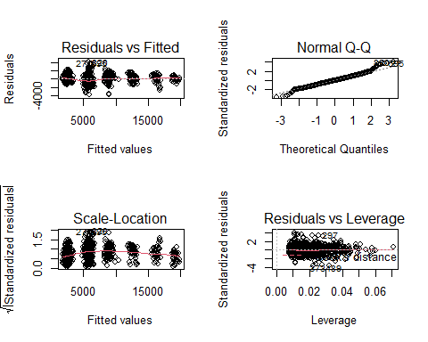

Note that the echo = FALSE parameter was added to the code chunk to prevent printing of the R code that generated the plot.