03 | Data Flow Diagrams
  - Context-level and functional decomposition of system data movement
Version 1.0 | 29 October 2026 | Status: Proposed / Pre-development

Notation and scope
Rounded process boxes represent transformation steps; cylinders represent data stores; external systems are shown separately. These are logical DFDs: a data-flow arrow does not imply direct database access by the browser.

DFD Level 0 — Context diagram
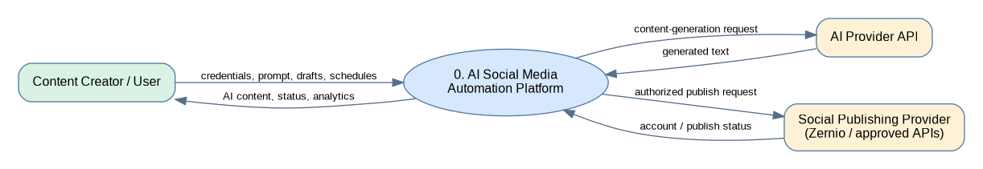
The user supplies credentials, content prompts, edits and scheduled times; the platform returns drafts, confirmations and delivery results. AI and publishing services are external trusted-boundary integrations.

DFD Level 1 — Process decomposition
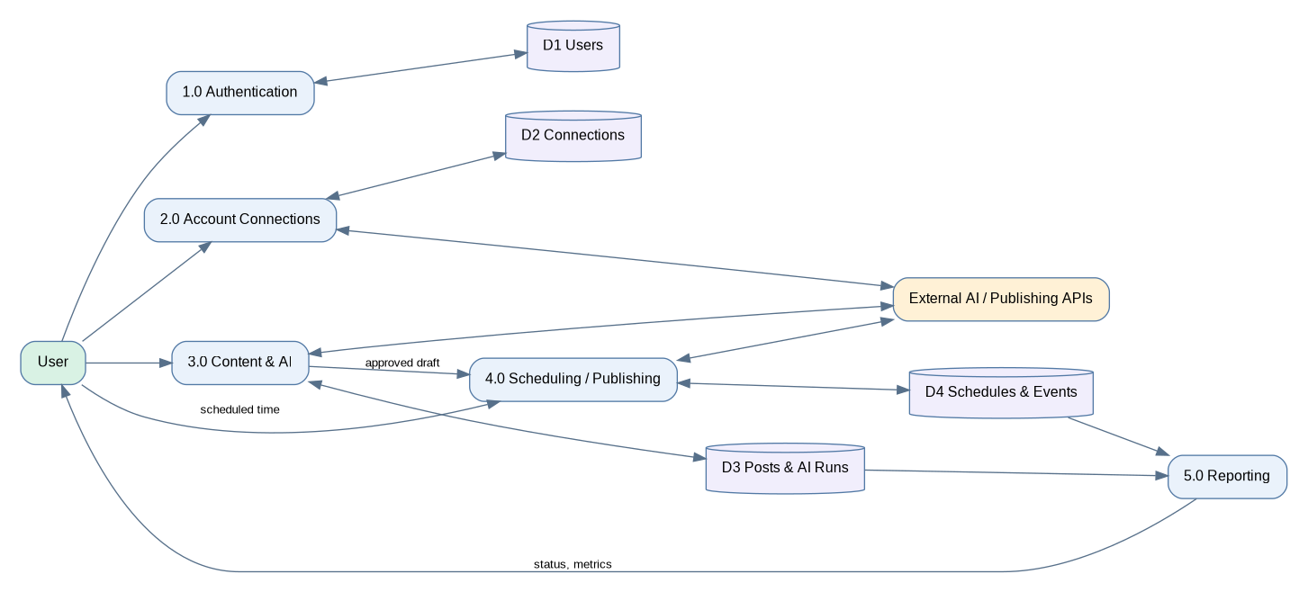
Process | Inputs | Outputs / store
1.0 Authentication | Registration and login | JWT/session result; D1 Users
2.0 Connections | User-authorized account linking | D2 SocialAccounts and connection status
3.0 Content & AI | Prompt, tone, draft edits | D3 Posts and AIGenerations
4.0 Scheduling | Approved post, targets and timestamp | D4 ScheduleJobs; provider delivery response
5.0 Reporting | Posts, job events, metrics | Dashboard totals and audit trail

Detailed workflow — AI post and scheduling
- User submits prompt and tone over authenticated HTTPS.
- Backend validates ownership/limits and forwards a minimal request to the AI provider.
- AI response is shown as an editable suggestion and saved only when the user chooses to save.
- User chooses one or more authorized social targets and a future date/time.
- Backend creates a scheduled post target and persisted job; worker selects due jobs.
- Worker invokes supported publishing provider using server-stored credentials, records provider ID or failure and updates user-visible status.
- Dashboard reads current post/job state; analytics snapshots are populated only when the provider exposes such data.

Trust boundaries and exception flows
Client input is untrusted. The API validates identity, data, time and ownership before storage; secrets never enter DFD responses. AI timeouts, rejected provider tokens, duplicate jobs and rate limits are explicit failure paths, with visible error states and bounded retry.

Reference
Reference: GreatStack, “Build an AI Powered Social Media Automation Platform Using MERN Stack | AI Project Tutorial,” published 28 May 2026, https://www.youtube.com/watch?v=L3OmeClSiQ0&t=348s. The public description was used; this package does not claim frame-by-frame verification or reproduce the video source code.

