04 | System Architecture
  - Components, deployment design, APIs and security boundaries
Version 1.0 | 29 October 2026 | Status: Proposed / Pre-development

Architecture style
A three-tier, service-oriented MERN application: a React SPA communicates via HTTPS to an Express REST API; services use MongoDB and third-party integrations. Scheduled publishing uses a separate background execution path rather than relying on a browser tab being open.

Component diagram
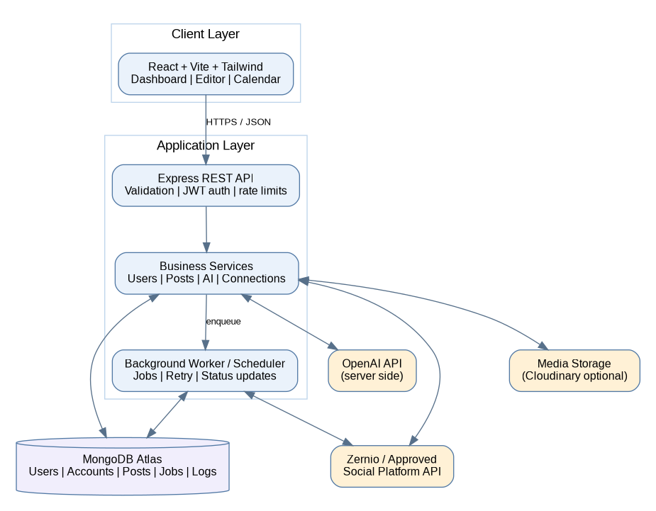

Core components
Component | Responsibility | Interface
React SPA | Login, dashboard, editor, calendar, analytics | REST JSON to API
Express API | Validation, authentication, authorization, orchestration | /api/v1/*
Auth service | Hash and verify passwords; issue/verify tokens | Users collection
Content service | Draft CRUD and status transitions | Posts and targets
AI service | Prompt templates, model invocation, error handling | External AI over HTTPS
Connection service | OAuth/provider account lifecycle, encrypted credentials | Provider / SocialAccounts
Scheduler + worker | Persist tasks, execute due targets, retry safely | Jobs, provider API
Reporting service | Aggregate post/job status, available metrics | Posts, jobs, snapshots
MongoDB Atlas | Authoritative application data | Mongoose models

Suggested API contract
Method | Endpoint | Purpose
POST | /api/v1/auth/register | Create user
POST | /api/v1/auth/login | Issue authenticated session
GET | /api/v1/auth/me | Current profile
POST | /api/v1/ai/generate | Generate suggestions
GET/POST | /api/v1/posts | List / create posts
GET/PATCH/DELETE | /api/v1/posts/:id | Read / edit / delete owned post
POST | /api/v1/posts/:id/schedule | Schedule approved targets
GET | /api/v1/jobs | Review scheduling and publish status
GET | /api/v1/connections | List authorized accounts
POST | /api/v1/connections/start | Begin provider authorization flow
GET | /api/v1/dashboard | Counts and activity summary

Post and job lifecycle
Post: draft → ready → scheduled → partially_published / published / failed / cancelled. Each post target has its own status so one platform failure does not mask another. Job: queued → running → succeeded / retry_wait / failed / cancelled. A post is published only when all required targets succeed.

Security and operational safeguards
- JWT identity checks plus object-level ownership authorization on every resource. Prefer secure HttpOnly cookies for sessions when implementing web login; protect state-changing requests against CSRF as appropriate.
- bcrypt password hashes, minimal data retention, sanitization/validation, rate limiting, CORS allowlist and request size limits.
- Store provider tokens encrypted at rest; never return access tokens to the frontend or store them in source control.
- UTC timestamps, idempotency key per target attempt, transactional-like state transitions and bounded exponential backoff.
- Environment separation, health checks, logs without secrets, monitoring and backups.

Deployment topology
Frontend: static hosting. API: Node hosting. Worker: always-on background process. Database: MongoDB Atlas. Queue option: managed Redis/BullMQ; if not available for the minor-project deployment, use a database-backed polling worker with atomic claim/lease semantics. A simple in-process node-cron timer alone is not durable across server restarts.

Integration decision
GreatStack mentions Zernio as a publishing abstraction. Evaluate the provider documentation, supported networks, OAuth capabilities, free tier, webhooks and terms before implementation. Keep an adapter interface so simulated publishing can be swapped for an approved real API.

Reference
Reference: GreatStack, “Build an AI Powered Social Media Automation Platform Using MERN Stack | AI Project Tutorial,” published 28 May 2026, https://www.youtube.com/watch?v=L3OmeClSiQ0&t=348s. The public description was used; this package does not claim frame-by-frame verification or reproduce the video source code.

