PROJECT DESCRIPTION

Goal: Enhance revenue and sales of an offline retail store using the concept of Market Basket Analysis.

Abstract: We are a team of Business Analysts who have been tasked with analyzing data to identify associations between items. Our goal is to help businesses introduce pricing and selling strategies that are better aligned with customer purchasing habits. Each transaction has a unique set of items purchased by different customers. Our task is to dive into these transactions and help businesses identify frequently bought items and which items are bought together in the same transactions, which have the highest association among them. As Business Analysts, our primary objective is to use machine learning algorithms (Apriori & FP Growth) to identify associated products and help businesses formulate effective pricing and selling strategies that can boost revenue and sales.

Background/Practical Motivation: Currently, around 45% of online shoppers tend to buy multiple products at once, and this percentage is gradually increasing. Similarly, when customers visit an offline grocery store with a single item on their list, they often come across additional products placed nearby, leading to further purchases. These occurrences are not random but rather a strategic planning technique known as Market Basket Analysis.

Market Basket Analysis is a data mining technique that enables retailers to increase their sales by gaining a deeper understanding of customer buying habits. This method analyzes large datasets such as past purchases to identify natural product connections and frequently purchased items. By analyzing co-purchasing patterns, retailers can make informed decisions on inventory management, targeted marketing, cross-selling, and store layout to enhance customer interaction.

How does Market Basket Analysis work?

Market Basket Analysis is a process that follows a series of steps to identify patterns in customer purchasing behavior:

1. Collect transactional data from customers, which includes details like the items bought, the date and time of the transaction, and other relevant information.

2. Clean and prepare the data by removing non-relevant details, addressing missing values, and transforming the data into a format that is ready for analysis.

3. Apply algorithms, such as Apriori or FP-Growth, to mine association rules and detect frequent item sets. Frequent item sets refer to groups of items that commonly occur together in transactions.

4. After identifying the frequent item sets, metrics such as support, confidence, and lift are calculated for each set. These metrics quantify how often items are bought together and the probability of purchasing a particular item when another item is bought.
5. Develop association rules based on the frequent item sets and their support and confidence metrics. These rules can be used to predict the likelihood of buying certain items together.

6. Once the association rules are developed, the outcomes of the market basket analysis are analyzed to identify commonly purchased items, evaluate the strength of item associations, and discover additional insights into consumer behavior and preferences.

7. Finally, the insights gained through market basket analysis can be used to guide business strategies, including optimized product placement, store layout, and targeted marketing initiatives.

PROJECT OBJECTIVES

Our project aims to fulfill the following objectives:

1. Optimize Product Placement: By identifying products that are frequently purchased together, we can help the retail store strategically arrange their placement within the physical store layout. Placing these items nearby encourages customers to consider purchasing both items simultaneously while browsing in-store. This optimization can increase the likelihood of cross-selling and maximize revenue.

2. Optimize Pricing Strategies: By analyzing association rules and transactional data, we aim to determine optimal pricing strategies for bundled or related products. This will help maximize revenue generation while maintaining competitive pricing.

3. Enhance User Experience: Implementing market basket analysis will help us improve the overall user experience of shoppers. By providing customers with relevant product suggestions and bundles, the retail store can streamline the shopping process, making it more convenient and enjoyable for users.

In summary, this holistic approach will empower businesses to make data-driven decisions that can significantly impact sales, customer satisfaction, and overall business success.

Importance of Market Basket Analysis to different industries:

1. E-commerce: Enhance customer shopping experience by suggesting complementary products.

2. Retail: Create promotions or cross-selling strategies by identifying products frequently purchased together.

3. Telecommunications: Create bundle service packages by understanding products and services purchased together, with the aim of increasing revenue and improving overall customer shopping experience.

4. Banking/Finance: Create targeted marketing initiatives by understanding customer behavior and preferences, leading to better revenue generation.

5. Healthcare: Create medications bundle that are often prescribed together by identifying patterns in patient behavior or treatment outcomes
6. Hospitality: Creating meal packages or menu recommendations by identifying menu items which are often ordered together

The Importance of MBA in Retail:

1. Customer Behavior Understanding: Retailers can effectively tailor their offerings and marketing strategies to meet customer needs by identifying which products are frequently bought together.
2. Cross-selling Opportunities: Retailers can strategically place related items together or offer bundled discounts to increase their average transaction value and overall revenue by identifying strong associations between the products.

3. Inventory Management: Retailers can minimize the issue of stockouts or overstock situations by identifying which items are often purchased together.

4. Personalized Marketing: Retailers can create targeted promotions to enhance their overall shopping experience by understanding the customer purchasing habits.

5. Store Layout Optimization: Retailers can strategically place related items in close proximity to create impulsive behavior in customers by understanding product associations.

6. Competitive Advantage: Retailers can improve the overall satisfaction of the customers and ultimately gain market share by showing them relevant products through better understanding of customer behavior.

7. Revenue Maximization: Market Basket Analysis will ultimately help retailers increase their revenues by enhancing customer experience, store layout optimization, and personalized and targeted marketing.
DATASET USED AND DATA DICTIONARY
For this Analytics project, the dataset was obtained from Kaggle. The dataset contains information on the various products purchased at a retail store. This dataset can be obtained here.
Number of records- 38765
Member_number – Unique Transaction ID
Date – Date of the Transaction occurred
itemDescription – Item bought
DATA CLEANING AND PREPROCESSING
Snapshot of the dataset
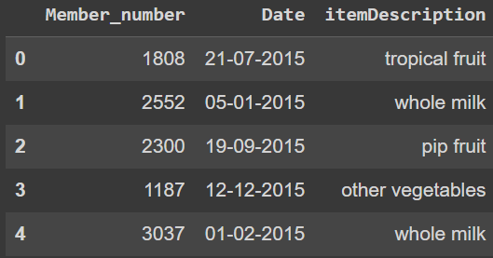

- Created New Columns: We have extracted the Day, Month, Year, and Day_of_week from the “Date” column and stored it in new columns. Below is the snapshot:
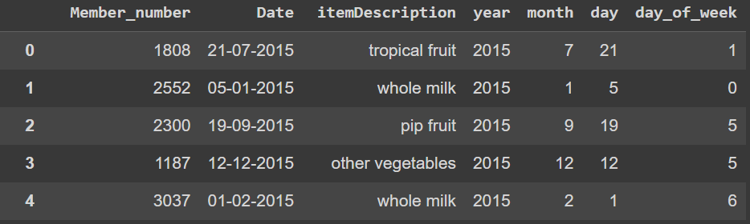
2. Checked for every feature datatype and found out that the Date column has an object datatype. Therefore, converted the Date’s datatype as “object” to “datetime64”.
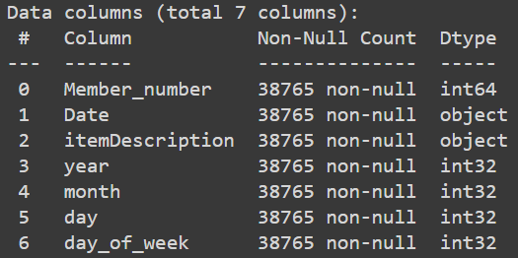
3. There are no missing values in the dataset
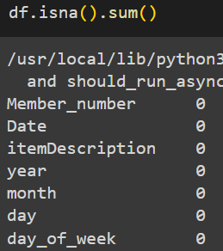
4. There were around 759 duplicate values and we have dropped them from our dataset.
5. Since the Month column has values stored in Integer from 1 to 12, We replaced them with the Month names. For Example, 1 is “January”, 2 is “February”, 12 is “December” and so on for simplicity.
6. Similarly, the Day column has values stored in Integer from 0 to 6. Therefore, we replaced them with the Day names. For Example, 0 is “Monday”, 1 is “Tuesday”, 6 is “Sunday” and so on. Below is the snapshot:
7. We also created a new column as “itemcategory”. For example, items “Milk”, “Yogurt” and “Processed Cheese” are stored under the category – “Dairy Products”.
8. Below is the dataset ready for analysis after creating new columns and transforming the values into their correct format: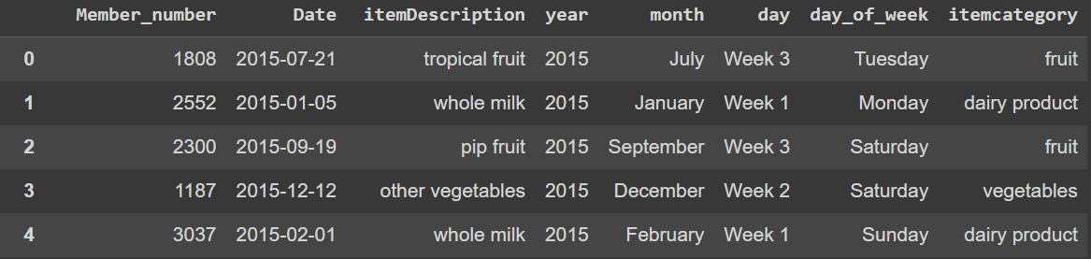
DATA EXPLORATION AND VISUALIZATION
1. There are a total of 17 unique categories of items being sold in the retail store's dataset. Below is a snapshot of the categories:
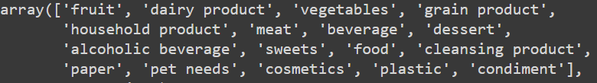
2. We then looked at how frequently customers shop and how many transactions occur on a monthly, weekly, and daily basis. Below are some snapshots:
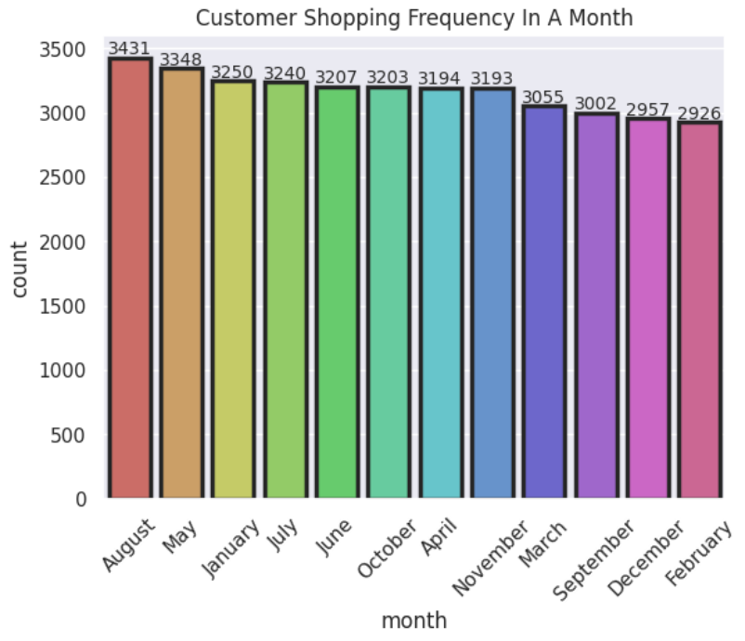
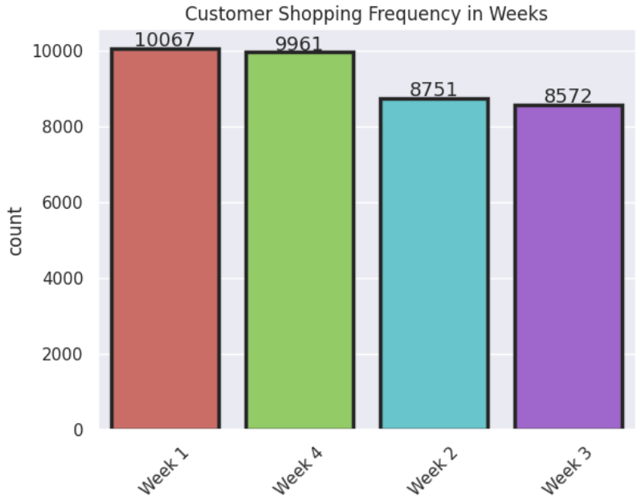
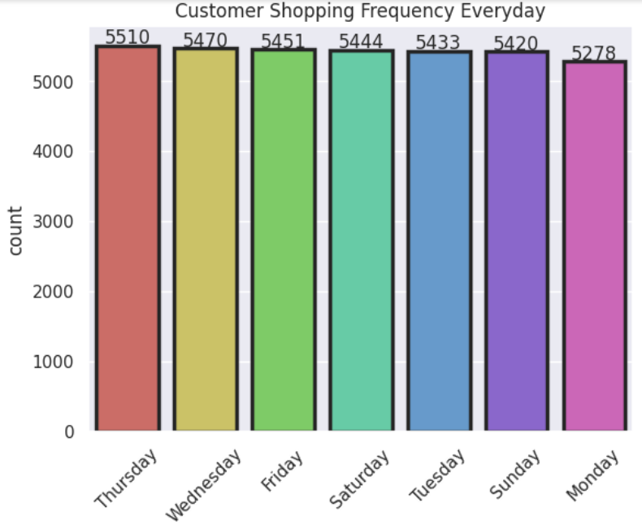
3. Next, we checked the top 10 selling items in the retail store and found that "Whole Milk" is the most frequently purchased item.
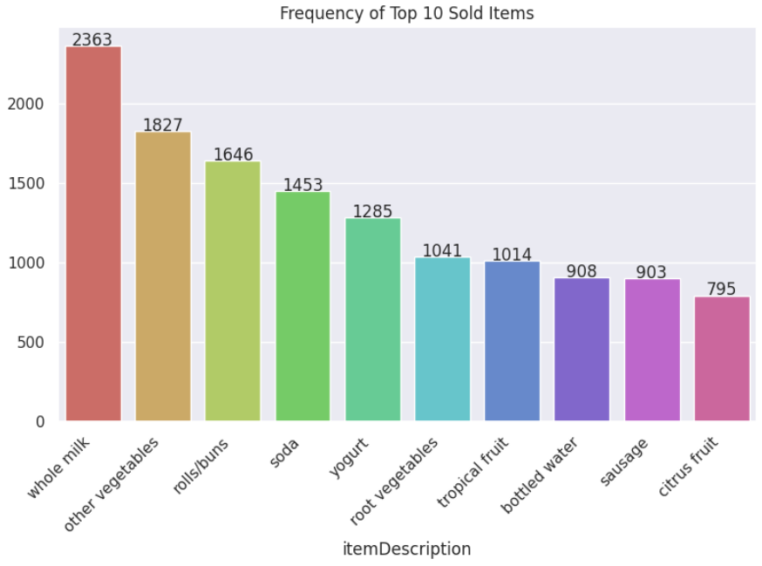
4. Finally, we checked for the top-selling item category and discovered that "Dairy Products" is the most popular category. Here's a snapshot:
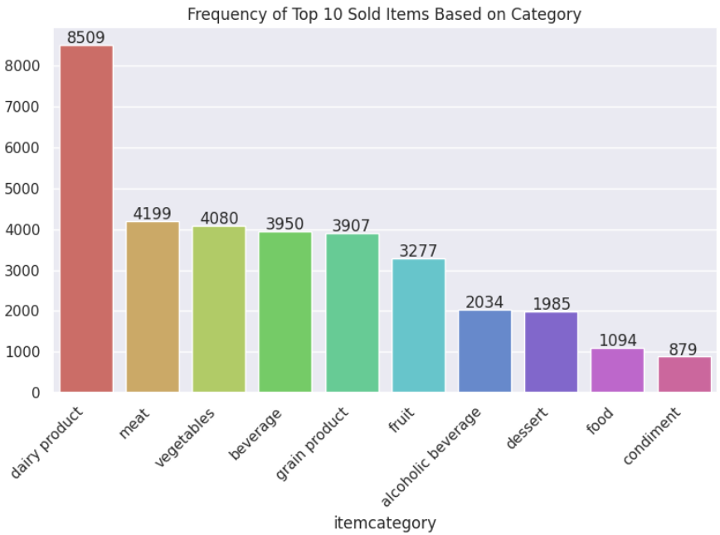

5. Number of Items sold by month. Below is the snapshot:
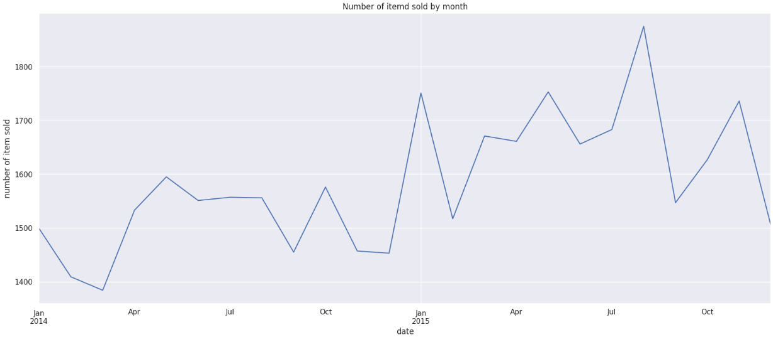

DATA SCIENCE ALGORITHMS USED
We have used two unsupervised machine learning algorithms to create association rules based on the insights we gained from our dataset. Before diving into the two main algorithms which are Apriori and FP Growth, we need to understand the meaning of Association rule mining and its three key metrics.
Association Rule Mining: It is a data mining technique that is used to identify interesting relationships, associations, or patterns within large datasets. The primary goal of this technique is to discover the relationship between items in a dataset, typically transactional data like retail transactions.
Association Rule Mining can also be thought of as an IF-ELSE relationship. IF is an antecedent which can be think of as an item or group of items which customer is purchasing frequently and ELSE is a consequent which is the item which a customer is buying with the frequently purchased item.
Association rule uses three measures such as Support, Confidence and Lift to obtain product and association product sets.
Now, let’s take an example of a small retail store. There is total 8 transactions and, in each transaction, different products are purchased.
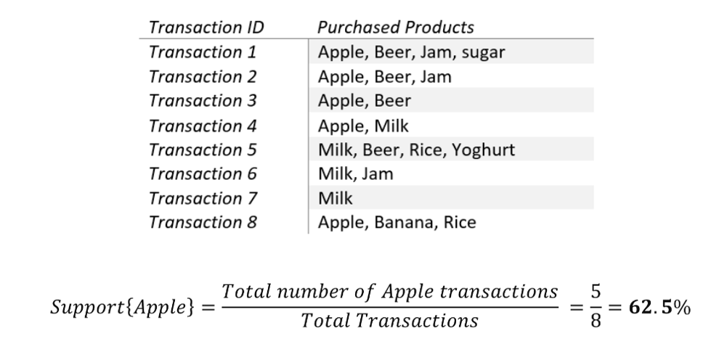
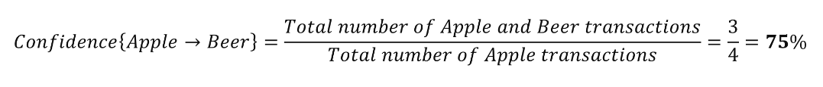
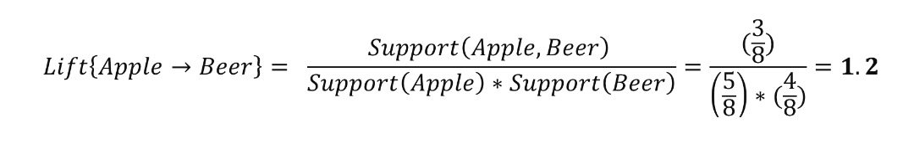
- Support refers to the frequency of a particular product, which can be calculated as a percentage of the total transactions. For example, if Apple has occurred in 5 out of 8 transactions, its support value is 62.5%.
- Confidence, on the other hand, measures the strength of the association between two products based on the probability of buying one product given the purchase of another. For instance, if a customer buys an apple, and the probability of them buying beer is 75%, then we can say that we have 75% confidence that they will buy beer.
- Finally, lift is used to determine how strong the association between two products is. If the lift value is greater than 1, then it is considered to be a strong association rule.
In order to maximize sales and revenue, it is crucial to identify strong association rules. However, this can be challenging when dealing with large datasets containing thousands of products and millions of transactions.

To overcome this challenge, we have used association rule mining algorithms such as Apriori and FP Growth.
Apriori Algorithm Implementation
Here, our goal is to maximize the revenue and sales for the retail store by using Apriori algorithm. So that, the store can use the insights and come up with some recommendations, marketing, and price strategies.
We are creating rules by giving some threshold values to the support, confidence, and lift metrics.
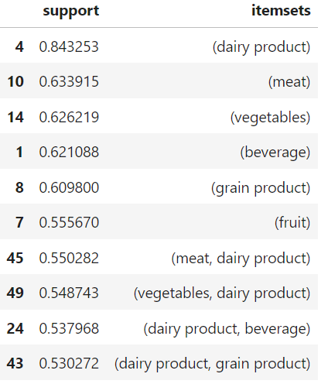
Apriori algorithm is used to find the most frequently purchased products (best selling products) using the support value. In this case we define best-selling products as products that have been sold at 10% of the total transactions, meaning we will provide a support value of 0.1.
Based on this output, there are 268 transactions that are considered as best-selling products. It can be seen in the dataframe that dairy product is the best-selling product with a support value of 0.843253, followed by meat and vegetables with respective support values ​​of 0.633915 and 0.626219. In terms of bundling, dairy product and meat are the most frequently purchased bundle transactions with a support value of 0.550282. This means that these items are most often purchased together of the whole.
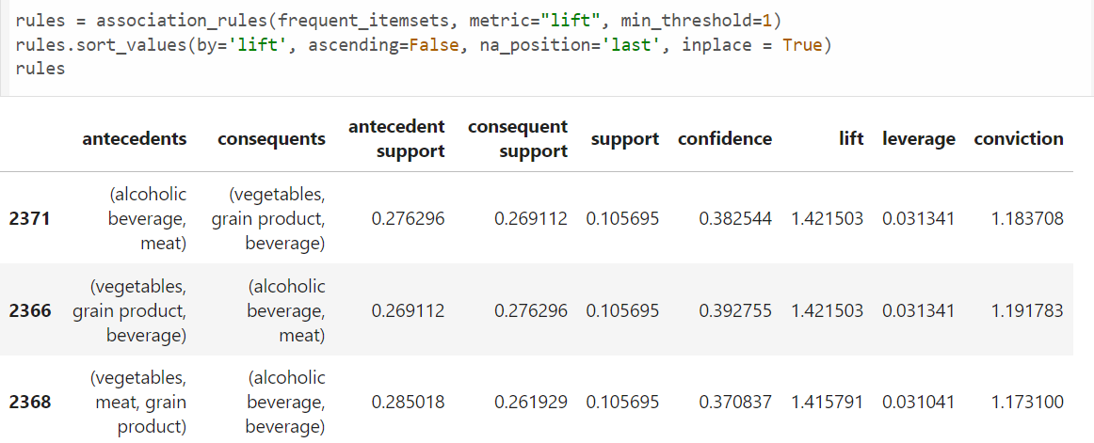

From the results of the association_rule we can see that grain product, beverage, and vegetables are most often purchased with meat and alcoholic beverage with a lift of 1.421503, these items have the highest association because they have a high lift value.

RECOMMENDATION
- The marketing strategy that can be carried out is to offer member loyalty to customers, that is, every customer who purchases will get points. The more products customer buys, the more points they will get. Points earned by customers can then be used for discounts on subsequent purchases or they can redeem those points for gifts.
- Based on the results of EDA, it is known that the month with the fewest customers to shop is September. To increase the frequency with which customers shop, various campaigns can be implemented, one example is Food Safety Month. Supermarkets can give fruit or vegetable gifts to customers who shop in September with a certain minimum purchase. It is also known that the day with the fewest customers to shop is Monday. Therefore, marketing strategies can be implemented such as special discounts every Monday for certain products. Products that are given a discount can be products that are purchased a little by customers. With the application of discounts on products, it is hoped that customers will be interested in shopping on Monday and at the same time buy products that are given a discount.
- The confidence value of the first rule is 0.728739 (it can be said to be large), that is, every purchase of dairy product and meat also purchased fruit, grain product, beverage, and vegetables can be applied to the distance positioning marketing strategy, which is keeping dairy products and meat away from fruit, grain product, beverage, and vegetables which aims to allow customers to browse other products. By implementing this strategy, it is expected that sales of other products can increase.
- Create bundling packages between products that are purchased a lot with products that are purchased a little. Some bundling package recommendations are:
- Dairy product with sweets
- Vegetables or fruits with cleansing product such as fruit and vegetable cleaner

