**P**

|  |  |
| --- | --- |
|  | **Sri Sivasubramaniya Nadar College of Engineering, Kalavakkam – 603 110**  **(An Autonomous Institution, Affiliated to Anna University, Chennai)**  Department of CSE  **Team Project Topics**  **Regulations – R2021** |

|  |  |  |  |  |  |  |  |
| --- | --- | --- | --- | --- | --- | --- | --- |
| **Degree & Branch** | BE CSE | | | | **Semester** | | V |
| **Subject Code & Name** | **UCS 2501 Computer Networks** | | | | | | |
| **Academic Year** | 2023-2024  ODD | **Batch** | 2021-2025 | **Due Date** | | **11.10.2023** | |

Implement the following problems which is allocated to your team using the knowledge you gained from CO3, CO4 & CO5 of the course. Prepare documentation for the same. You can use Network Simulator, Cisco Packet Tracer, Java, Python , C and Wireshark tool as demanded by the project requiremenet.

Marking Scheme:

|  |  |
| --- | --- |
|  | Marks |
| Implementation | 25 |
| Upload in your Github page | 05 |
| Documentation with ReadMe file and Github link | 10 |
| Viva | 10 |
| Total | 50 |

Submission Due Date: 13/11/2023 (upload in LMS) Documentation Format: (Minimum 15 pages)

Title

Team members regno,nam Index

Contents – Problem Definition, Protocol/ Method explanation, Topology, Code, Output, Learning Outcomes

Readme file amd github link

Useful Link : <https://routersimulator.certexams.com/router-labs/index.html>

**PROBLEM STATEMENT:**

Build the following network and implement DHCP.

<https://routersimulator.certexams.com/router-labs/configuring-two-dhcp-clientsand-verification-commands.html>

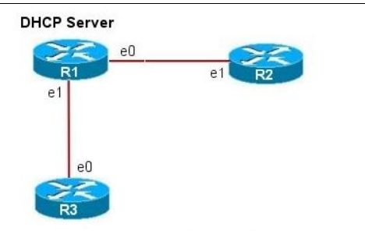

**TEAM:**

**SB RUDRASHREE 3122215001088**

P SASI REKA 3122215001096

HP. PRITHIKA PRIYADHARSHINI 3122215001070

M.PRIYA 3122215001071

**TABLE OF CONTENTS:**

|  |  |  |
| --- | --- | --- |
| **SNO** | **CONTENTS** | **PAGE** |
| 1 | Description | 4 |
| 2 | Networks | 4 |
| 3 | Implementation | 5 |
| 4 | stimulation | 12 |
| 5 | Result | 14 |

**Description:**This lab exercise demonstrates DHCP server configuration and DHCP client configuration on two routers and also shows the verification commands both on the server and the client.

**Software used:**

CISCO packet tracer

**NETWORKS:**

**NETWORK 0 – 192.168.4.0**

**NETWORK 1 - 192.168.5.0**

**NETWORK 2 - 192.168.6.0**

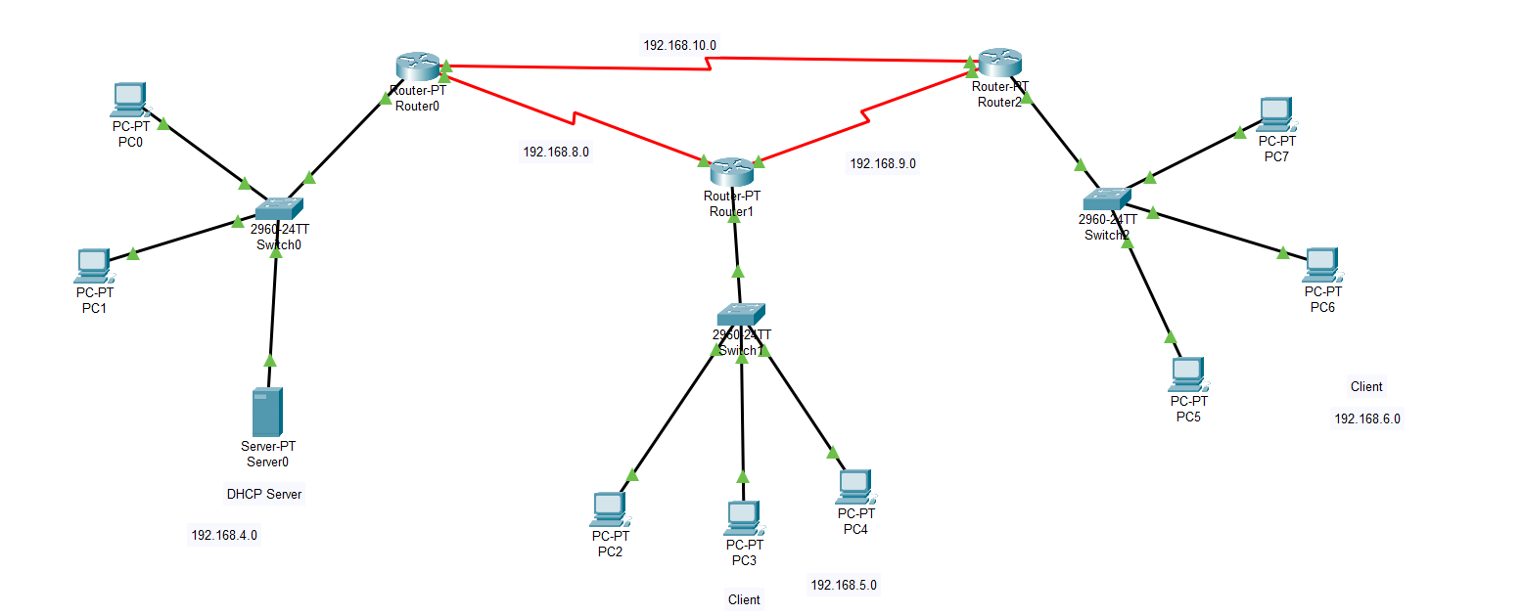

N0 R0-192.168.4.5 N1 R1 – 192.168.5.5 N2 R2 – 192.168.6.5

Let us connect the DHCP server to the switch of the network 0 where we have set up 2 PCs. Make the other two clients out of PCs and switches and routers appropriately.

Set the default Gateway to 192.168.4.5 and the DNS SERVER as 192.168.4.2 as per the given requirement in the problem statement, in the server0

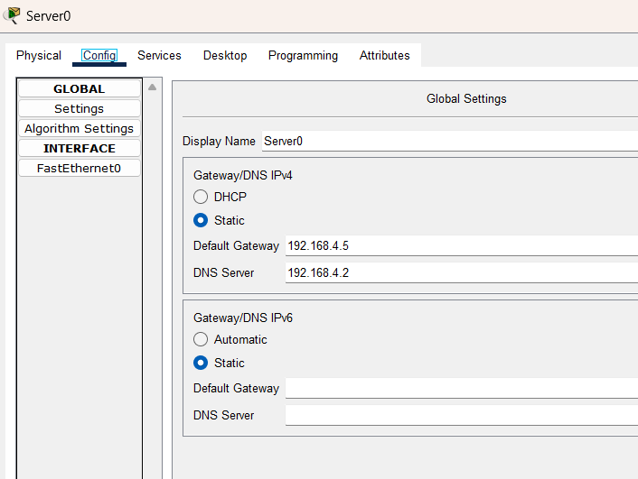

In the Fastethernet 0, set port status ON, and set the unique IPv4 address and subnet mask, where the IPv4 address here, is used for the DHCP client server communication.

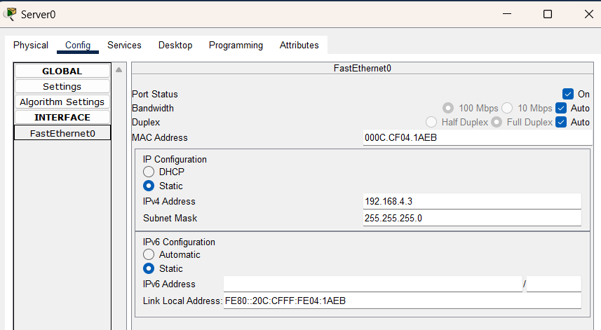

In the services of server, in the DHCP service, set the server pools and IPv4 address for all three networks(client) in the server.

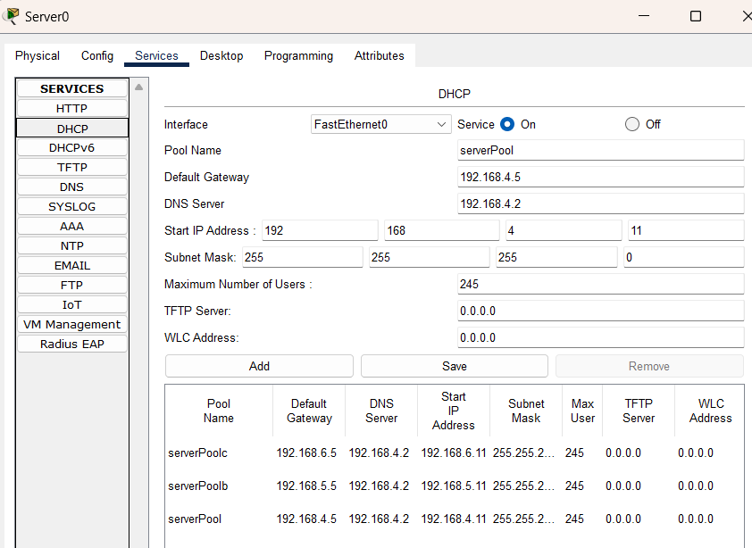

Set the default gateway as usual in the PC 0.

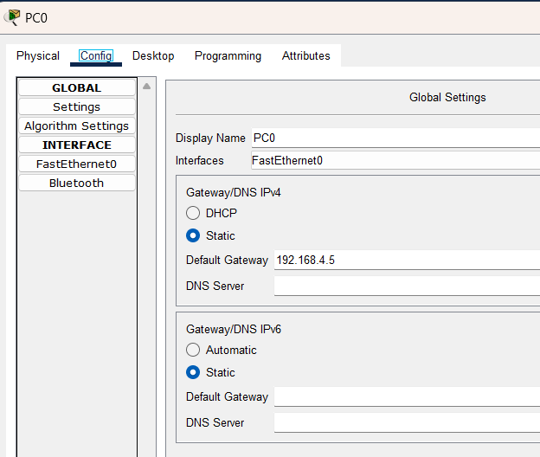

In the fastEthernet0 , Set the port status ON. Give the IPv4 address as a unique address of class C i.e, 192.168.4.6 and set the subnet mask appropriately as per the IPv4 address.

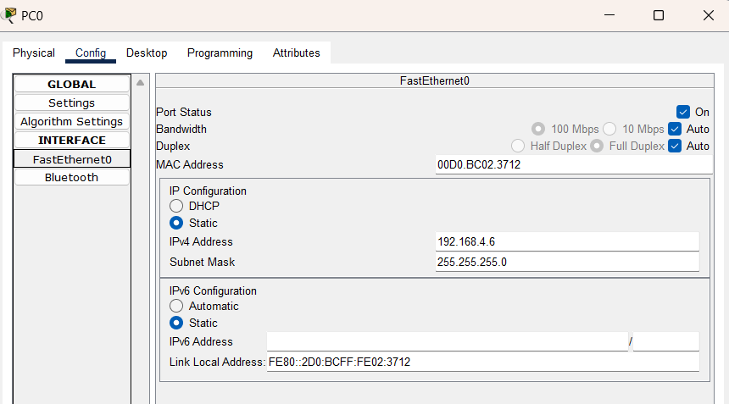

Similarly do the above steps for all the PCs connected in the other two networks of the client.

In the router 0, Set the port status and in the fastethernet0 set the default gateway to be the IPv4 address and the appropriate mask also. Similarly for all the other routers. For router 1 the IPv4 address is said to be , 192.168.5.5 and for router 2 it is 192.168.6.5.

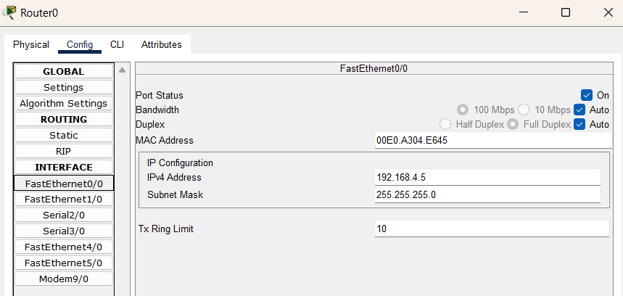

Dynamic Routing is then made for the establishment of connection between the routers and the switches.

Now to connect the routers to each other, let us give serial connections.

R0 – R1 -> Se2/0

R1- R2 ->Se 2/0

R1 - R2 ->Se 3/0

R2- R1 -> Se 3/0

R0 – R2 ->Se 3/0

R2 – R0 – Se 2/0

For instance, in router0, in the serial connection 2 set the unique IPv4 address of 192.168.8.5 and the corresponding mask.

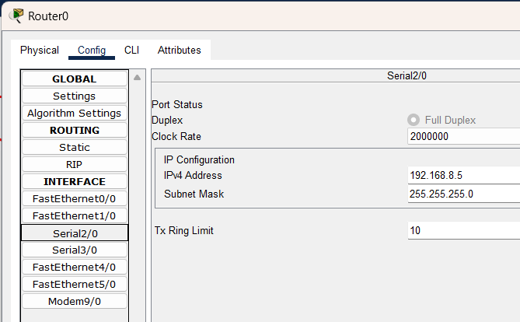

For the connection between router R0 and R2,

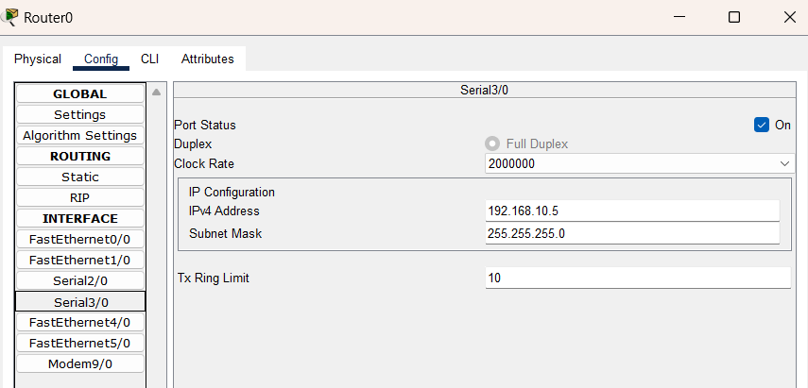

Similarly, set the unique ipv4 addresses for all the connections ,mentioned in the serial connections.

In the Router0, in the Routing information protocol(RIP), add the IPV4 addresses for all the connected devices’s network’s IP.

Here R0 is connected to two additional paths except the 192.168.4.0, which are the paths from R0 – R1 and R0-R2. Add the ip addresses in the RIP.

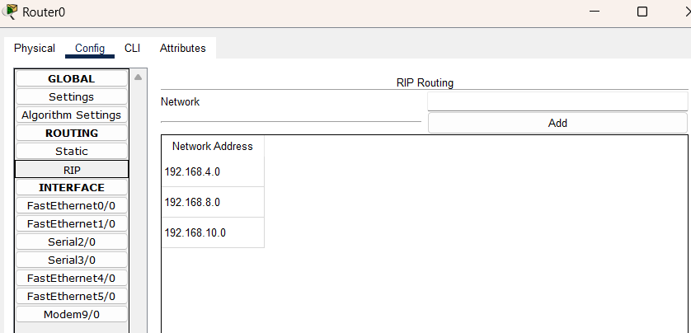

Similarly add the connected paths to the other routers namely R1, R2.

To send messages from client to server and receive message from the client for DHCP connection.

In the CLI of R0

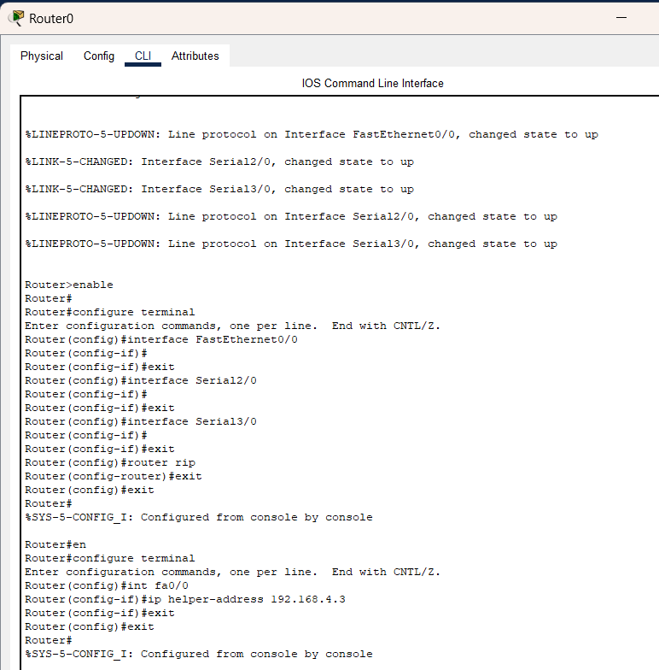

In router R1 of CLI

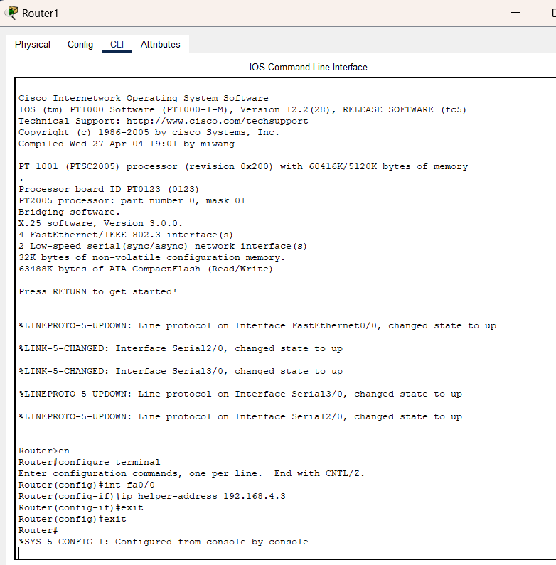

In the router 2 of CLI,

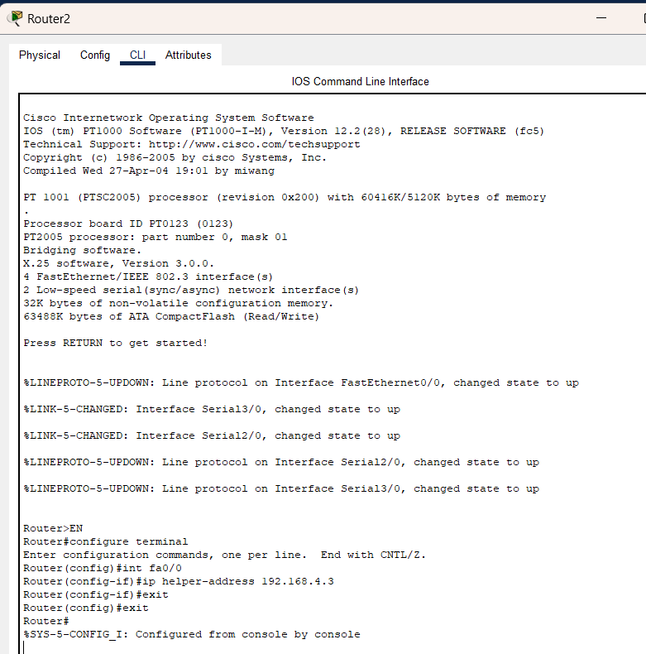

To send Message from client to server in DHCP, let us choose a client PC = PC7.

Set it to DHCP mode, it now requests for DHCP ip address and the request gets successful later.

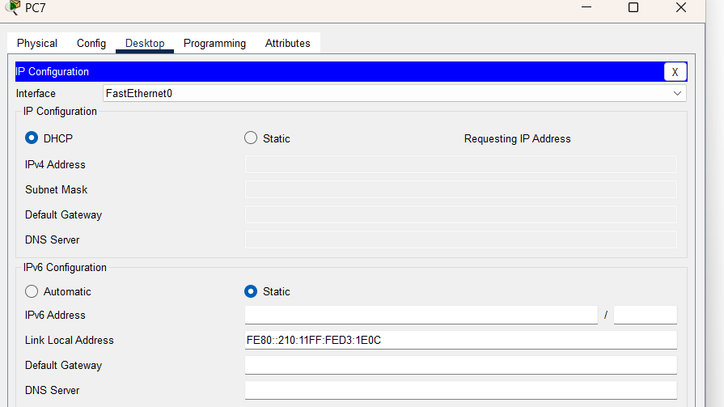

**Now let us run the simulation.**

Message from PC7 is sent to Switch2 from where it is broadcasted to pc6 , pc5 and router2.

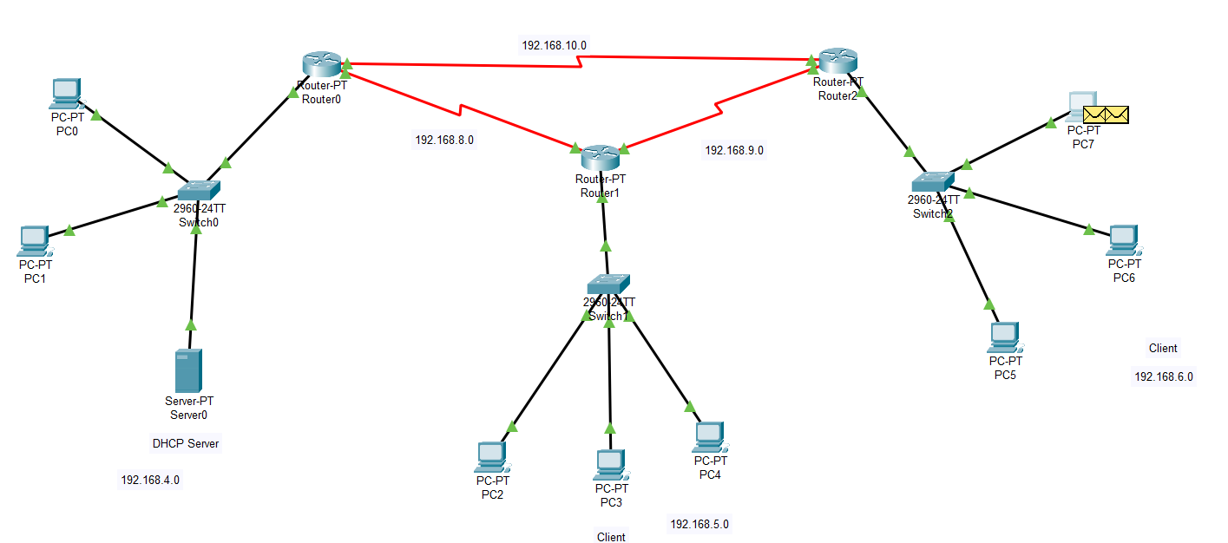

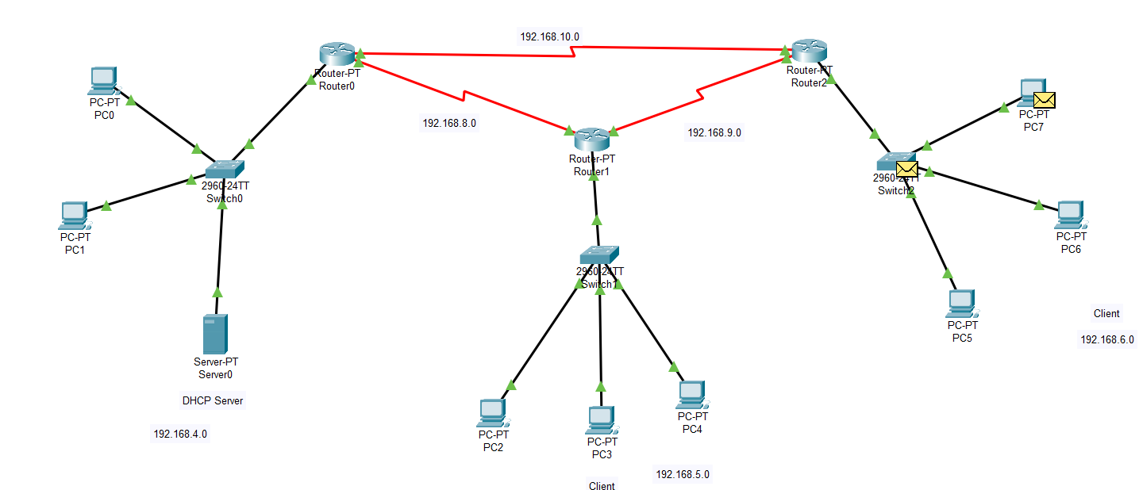

Router2 receives the message and sends it broadcast, for where router1 is chosen from where it goes to the switch of the network 0 where the server is.

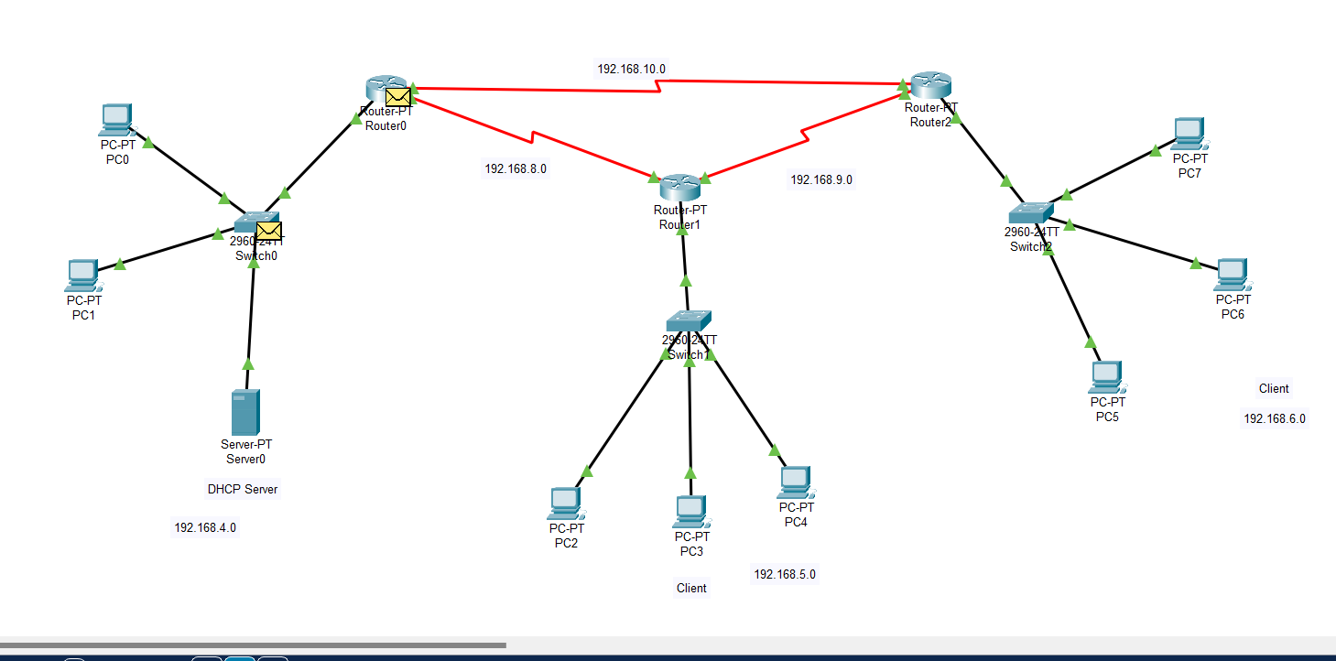

Here message is received at the server successfully.

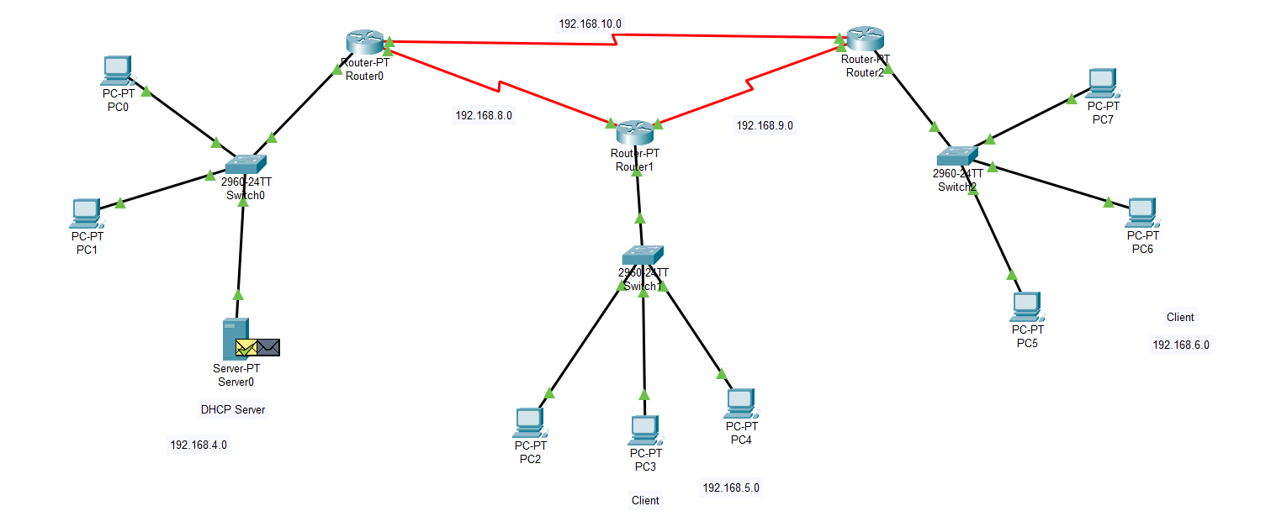

The verification is done and acknowledgement is sent back.

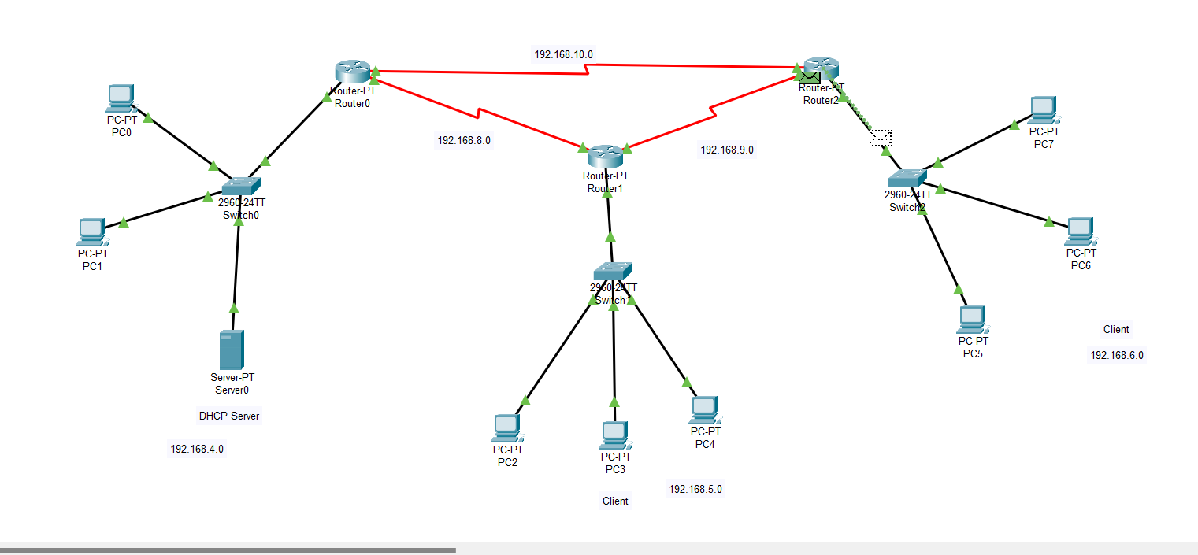

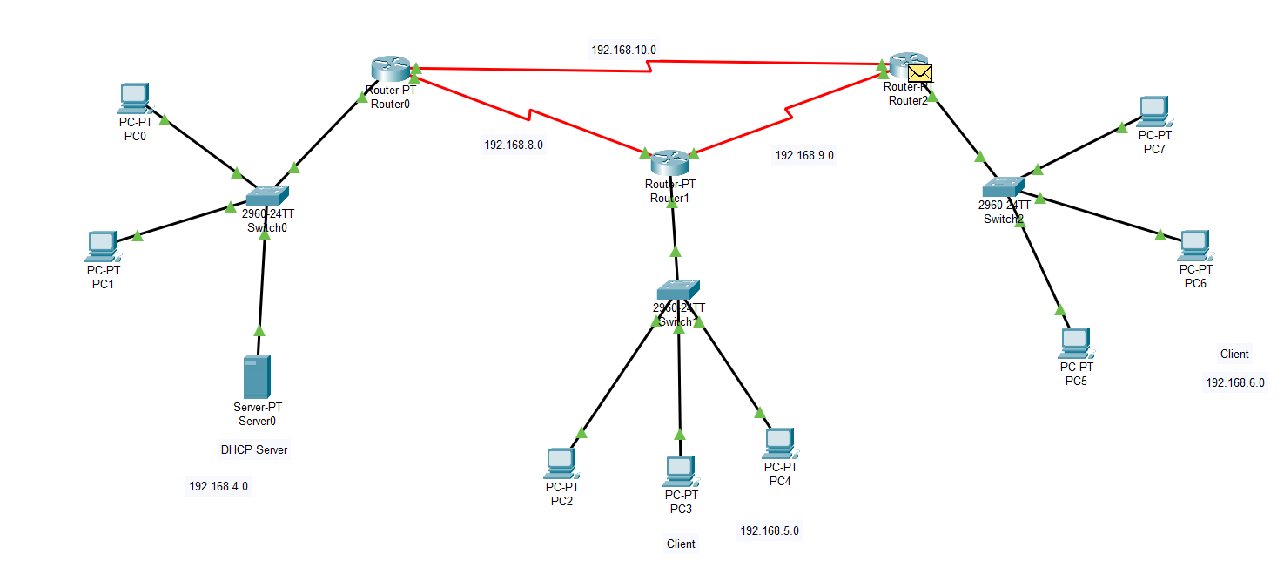

Message goes to PC7 now starting from the server of the network 0.

Message acknowledged successfully and verification is done in the server-client interface in DHCP.

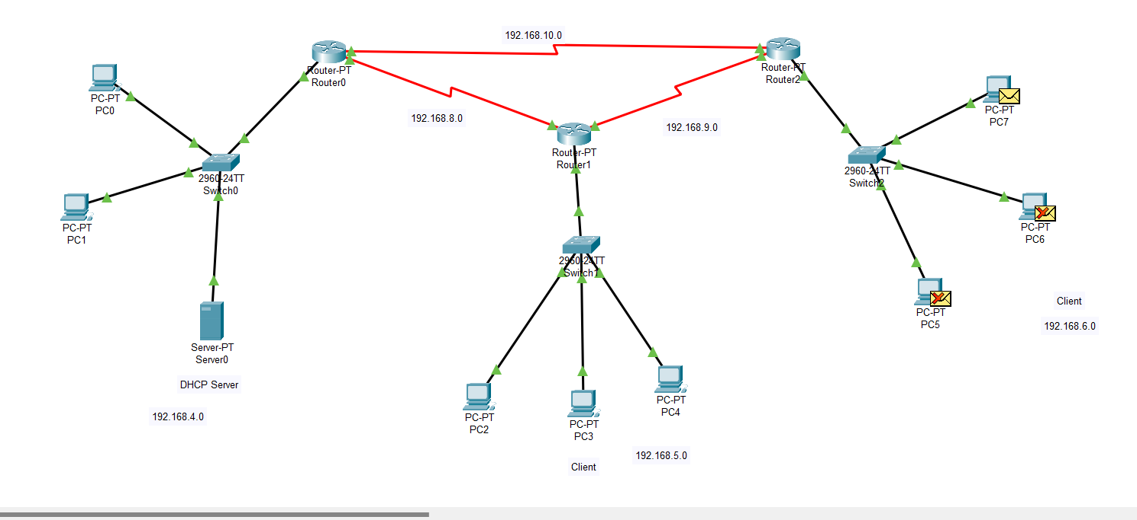

**Result:**

The DHCP server configuration and DHCP client configuration on two routers is successfully completed and also the verification commands both on the server and the client are shown successfully.

Project link:

<https://drive.google.com/file/d/120Rv3Gw4iG30Sa6IM7Ale20uA5Ujw8Ha/view?usp=sharing>

Readme link:

<https://drive.google.com/file/d/1evKvH9Cpq09Vj08QL4LF3kXve-j8QgBy/view?usp=sharing>