AWS Cloud Networking
AWS VPC Peering Project
Private connectivity between two VPCs, bastion access, and a controlled ICMP failure-and-recovery test
Field | Detail
Student | Rudra Sanjay Rakshe
Course | AWS Cloud Networking
AWS Region | Asia Pacific (Sydney), ap-southeast-2
Evidence captured | 28 October 2026 (from screenshot timestamps; no separate completion date was supplied)
Repository | https://github.com/pawaraditya0903/AWS-VPC-Peering-Project
Report file | RudraRakshe_EWB_VPC_Peering.pdf

Table of Contents
1. Executive summary 2
2. Objectives and requirements 2
3. Architecture 2
3.1 Key concepts 3
4. Resource inventory 4
5. Routing configuration 4
5.1 Forward and return path 5
5.2 Internet access to the bastion 5
6. Security configuration 5
7. Test results and evidence 6
7.1 Test 1: Baseline failure (before peering) 6
7.2 Test 2: Forward path (App-A to App-B) 6
7.3 Test 3: Reverse path (App-B to App-A) 7
7.4 Test 4: Private SSH through the bastion 7
7.5 Test 5: Isolation (no public IPv4) 8
8. Controlled ICMP failure and recovery 9
8.1 Observed results 10
8.2 Limits of this evidence 11
8.3 What this demonstrates 11
9. Troubleshooting and lessons learned 11
Lessons learned 11
10. Cleanup evidence and cost considerations 12
11. Conclusion 14
12. Appendix 14
Appendix A: Missing evidence and checklist 14
Appendix B: Supplementary file test1.png 14
Appendix C: Evidence file map 15

1. Executive summary
This project connects two Amazon VPCs in the Sydney region (ap-southeast-2) with a VPC peering connection, and proves private communication between one EC2 instance in each VPC. A public bastion host in VPC A is the only internet-facing entry point; the two application instances (App-A and App-B) have no public IPv4 address and are reached by SSH through the bastion using their private addresses.
The screenshots supplied support the following verified outcomes. Where evidence is missing or limited, the table says so rather than claiming a pass.
Test | Status | What the evidence shows
Test 1: Baseline failure (before peering) | Not verified. Evidence not provided | No capture of a failed ping before peering was supplied. The file test1.png shows a successful ping with peering already active, so it cannot serve as a baseline (see section 8.1).
Test 2: Forward path (App-A to App-B) | Passed | Figure 2: 4 packets transmitted, 4 received, 0% loss (two consecutive runs).
Test 3: Reverse path (App-B to App-A) | Passed | Figure 3: 4 packets transmitted, 4 received, 0% loss.
Test 4: Private SSH through the bastion | Passed | Figure 4: SSH to 10.20.1.10 via the bastion; hostname and IP confirmed. The command header in Figure 2 shows the same method for App-A (10.10.2.10).
Test 5: Isolation (no public IPv4) | Passed | Figure 5 and Figure 6: Public IPv4 address and Public DNS are blank for App-B and App-A.
Controlled ICMP failure and recovery | Partial. Ping results shown; rule edits not captured | Figure 7: 100% packet loss. Figure 8: 0% loss after recovery. No console screenshot of the security-group rule removal or restoration was supplied.
Cleanup | Partial | Instances terminated (Figure 9), no EBS volumes remaining (Figure 10), peering connection deleted (Figure 11). Other resources are not evidenced (section 10).

2. Objectives and requirements
The objectives below come from the project brief as summarised in the report request. The original project instructions PDF was not available when this report was prepared, so test names and numbers follow the summary supplied, and the PDF's submission checklist could not be checked directly.
- Connect two VPCs with non-overlapping CIDR ranges through an active VPC peering connection.
- Run one public bastion EC2 instance in VPC A and one private EC2 instance in each VPC.
- Reach the private instances from a Windows laptop by SSH through the bastion.
- Demonstrate private communication in both directions with ping (Tests 2 and 3), private SSH (Test 4) and isolation from the internet (Test 5).
- Show that security-group rules control traffic by removing and restoring an ICMP rule.
- Clean up billable resources and record the evidence.

3. Architecture
VPC A (ewb-vpc-a, 10.10.0.0/16) holds a public subnet (ewb-a-public, 10.10.1.0/24) with the bastion host and a private subnet (ewb-a-private, 10.10.2.0/24) with App-A. An internet gateway (ewb-igw-a) is attached to VPC A. VPC B (ewb-vpc-b, 10.20.0.0/16) holds one private subnet (ewb-b-private, 10.20.1.0/24) with App-B. The two VPCs are joined by the peering connection pcx-04950eee78a68adf1.
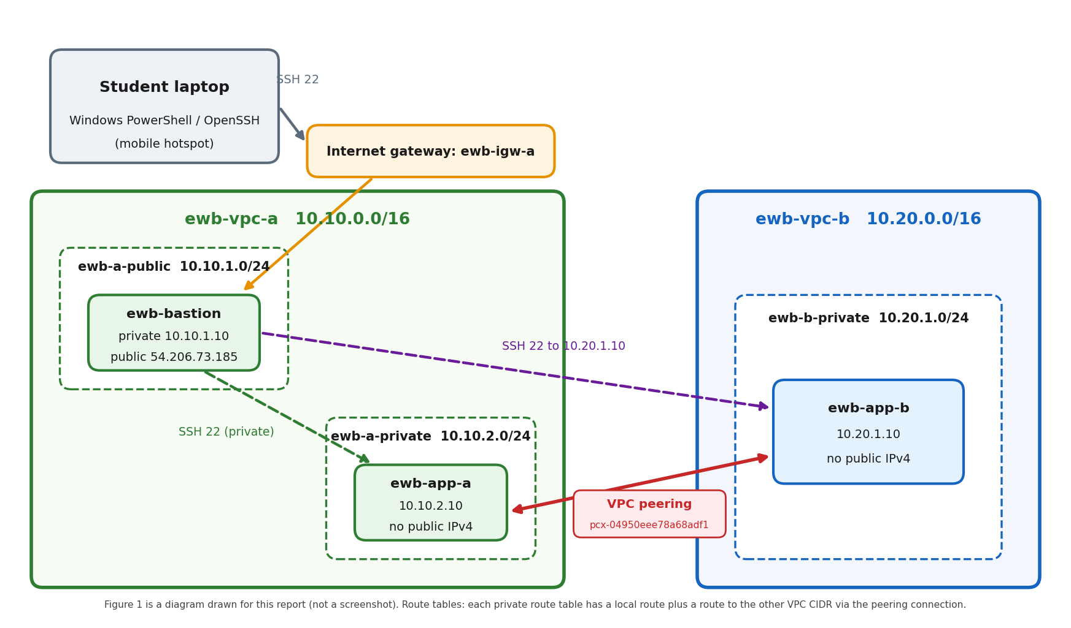
Figure 1: Architecture of the project with the actual CIDR ranges and private IPs (diagram drawn for this report).

3.1 Key concepts
Concept | Explanation
Non-overlapping CIDRs | A route table chooses a destination by matching an address range. If both VPCs used the same range, a packet for 10.10.2.10 could not be told apart from a local address, so AWS refuses to peer VPCs with overlapping CIDRs. Here 10.10.0.0/16 and 10.20.0.0/16 are distinct.
Peering alone is not enough | A peering connection only creates a possible path. Traffic does not flow until each side has a route that sends the other VPC's CIDR to the peering connection, and security groups and network ACLs allow the traffic.
Routes on both sides | A ping needs a request path and a reply path. Each private route table sends the other VPC's CIDR to the peering connection; if one side lacked its route, requests would arrive but replies would be lost.
Security groups | Stateful, instance-level filters. Rules are matched on traffic initiated toward the instance; replies to connections the instance started are allowed automatically. This explains why removing an inbound ICMP rule affects only pings started by the other side.
Network ACLs | Stateless, subnet-level filters. The default ACLs in this project allow all inbound traffic (rule 100, 0.0.0.0/0), so they do not block any test.
Private IPs for App-A and App-B | The application servers need no inbound internet access. Giving them private addresses only removes them from the public internet and shrinks the attack surface.
Bastion host | A hardened, internet-reachable instance that administrators SSH into first and then use as a stepping stone. The private instances accept SSH only from the bastion's private IP 10.10.1.10/32.

4. Resource inventory
The last column states where each value is supported. "Screenshot" means it appears in a supplied screenshot. "Supplied text" means the student provided it in the project description but no screenshot of it was supplied. IDs that were not supplied are not listed.
Resource | Name | ID / value | Support
VPC A | ewb-vpc-a | 10.10.0.0/16 (VPC ID not supplied) | Supplied text
VPC B | ewb-vpc-b | 10.20.0.0/16 (VPC ID not supplied) | Supplied text
Peering VPC IDs | Names truncated in console | Requester vpc-05d428ad6f23309a6; accepter vpc-08ee2f62ef6ca0958 (the report does not assign these to A or B) | Screenshot
Public subnet (A) | ewb-a-public | 10.10.1.0/24, subnet-0f2d077ab0f838d40 | Supplied text
Private subnet (A) | ewb-a-private | 10.10.2.0/24 | Supplied text
Private subnet (B) | ewb-b-private | 10.20.1.0/24 | Supplied text
Internet gateway | ewb-igw-a | igw-0c9d444d4bf46e346, attached to VPC A | Supplied text
Peering connection | ewb-vpc-a-to-vpc-b | pcx-04950eee78a68adf1; Active during testing, shown as Deleted after cleanup | Screenshot (deleted state); Supplied text (Active)
Route tables | ewb-rt-public, ewb-rt-a-private, ewb-rt-b-private | IDs not supplied | Supplied text
Security groups | ewb-sg-bastion, ewb-sg-app-a, ewb-sg-app-b | ewb-sg-app-b = sg-005b2092a76af1dd5; others not supplied | Supplied text
Bastion (final) | ewb-bastion | i-044f460b5fb67b887, private 10.10.1.10, public 54.206.73.185 | Screenshot (Figure 9, command lines)
Bastion (original) | ewb-bastion | i-0275c2cb17ef82f49, terminated and replaced during troubleshooting | Screenshot (instance list)
App-A | ewb-app-a | i-02d7cd88e7647e009, private 10.10.2.10, no public IPv4 | Screenshot (Figure 6)
App-B | ewb-app-b | i-01b723cce810423fd, private 10.20.1.10, no public IPv4 | Screenshot (Figure 5)
Instance details | All three | t3.micro, Availability Zone ap-southeast-2a, Amazon Linux 2023 (login banner), key pair ewb-key | Screenshot

5. Routing configuration
The route tables below are taken from the supplied project description; no route-table console screenshots were provided. Functional evidence that both peering routes exist is that pings succeeded in both directions (Tests 2 and 3).
Route table | Routes | Associated subnet
ewb-rt-public (VPC A) | 10.10.0.0/16 to local  0.0.0.0/0 to igw-0c9d444d4bf46e346  10.20.0.0/16 to pcx-04950eee78a68adf1 | ewb-a-public
ewb-rt-a-private (VPC A) | 10.10.0.0/16 to local  10.20.0.0/16 to the peering connection | ewb-a-private
ewb-rt-b-private (VPC B) | 10.20.0.0/16 to local  10.10.0.0/16 to the peering connection | ewb-b-private

5.1 Forward and return path
- Forward (App-A to App-B): App-A (10.10.2.10) sends an echo request to 10.20.1.10. ewb-rt-a-private matches 10.20.0.0/16 and forwards it to the peering connection, which delivers it into VPC B and on to App-B.
- Return (App-B to App-A): App-B replies to 10.10.2.10. ewb-rt-b-private matches 10.10.0.0/16 and forwards the reply over the same peering connection back to App-A.
Both routes are needed: with only the forward route, App-B would receive the request but could not send a reply. The same logic applies in the reverse direction (Test 3).

5.2 Internet access to the bastion
ewb-rt-public sends 0.0.0.0/0 to the internet gateway and is associated with the public subnet, which gives the bastion a path to and from the internet through its public IPv4 address. The private subnets have no default route to the internet, which is why App-A and App-B are not internet-reachable.

6. Security configuration
Rules are documented from the supplied project description. No security-group console screenshots were supplied.
Security group | Inbound | Outbound / notes
ewb-sg-bastion (VPC A) | SSH, TCP 22, from the laptop's public IPv4 /32 (intended configuration) | All traffic allowed. See the note below about the temporary 0.0.0.0/0 source.
ewb-sg-app-a (VPC A) | SSH, TCP 22, from 10.10.1.10/32 (bastion)  ICMP Echo Request from 10.20.1.10/32 (App-B) | Default allow-all
ewb-sg-app-b (VPC B) sg-005b2092a76af1dd5 | SSH, TCP 22, from 10.10.1.10/32 (bastion)  ICMP Echo Request from 10.10.2.10/32 (App-A) | Allow all to 0.0.0.0/0. This group was the only one attached to App-B.

Purpose of the bastion. Only the bastion has a public IPv4 address and an inbound SSH rule from the internet. The private instances accept SSH solely from the bastion's private IP, so administrators must pass through one controlled entry point.
Temporary exposure to disclose. The student worked from a mobile hotspot whose public IPv4 address changed between connections, so a /32 rule repeatedly stopped matching. To finish testing, the bastion's SSH source was temporarily set to 0.0.0.0/0 (open to the internet). This is insecure for anything but a short test. The best practice is to set the source back to the current /32 straight after connecting. No screenshot of the final state of this rule is included; the bastion was later terminated (Figure 9).

7. Test results and evidence
Terminal screenshots were cropped only to remove blank terminal space; the Windows taskbar clock was kept. The terminal output and console values are unaltered. Taskbar times are the time each screenshot was taken, in India Standard Time (UTC+5:30), while the shell's Last login and date lines are in UTC.

7.1 Test 1: Baseline failure (before peering)
Item | Detail
Objective | Show that App-A cannot reach App-B before the peering connection and routes exist.
Method | ping -c 4 10.20.1.10 from App-A before peering was set up.
Expected | 100% packet loss.
Observed | Evidence not provided. The only file supplied for this test, test1.png, shows a successful ping (4 of 4 received) with peering already active. It is reproduced in Appendix B for transparency.
Conclusion | Not verified. This report does not claim a pre-peering baseline. Test 2 shows connectivity with peering in place, but cannot by itself show it was absent beforehand.

7.2 Test 2: Forward path (App-A to App-B)
Item | Detail
Objective | Show App-A reaches App-B privately over the peering connection.
Method | SSH to App-A through the bastion, then run ping -c 4 10.20.1.10.
Expected | 4 replies, 0% packet loss.
Observed | Figure 2 shows two consecutive runs, each with 4 transmitted, 4 received, 0% packet loss, round-trip about 0.16 to 0.28 ms and ttl=127.
Conclusion | Passed. The forward route, the return route, and the App-B inbound ICMP rule (source 10.10.2.10/32) all worked together.
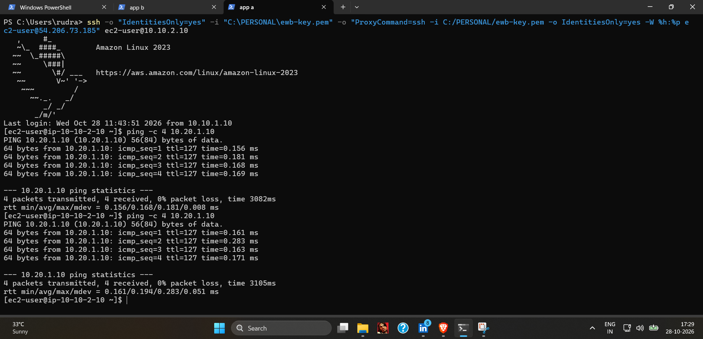
Figure 2: Test 2: App-A to App-B ping, 4 packets received, 0% packet loss (two runs). The command line also shows SSH to App-A (10.10.2.10) through the bastion at 54.206.73.185.

7.3 Test 3: Reverse path (App-B to App-A)
Item | Detail
Objective | Show App-B reaches App-A privately.
Method | SSH to App-B through the bastion, then run ping -c 4 10.10.2.10.
Expected | 4 replies, 0% packet loss.
Observed | Figure 3: 4 transmitted, 4 received, 0% packet loss, round-trip about 0.17 ms.
Conclusion | Passed. App-B can reach App-A across the peering connection.
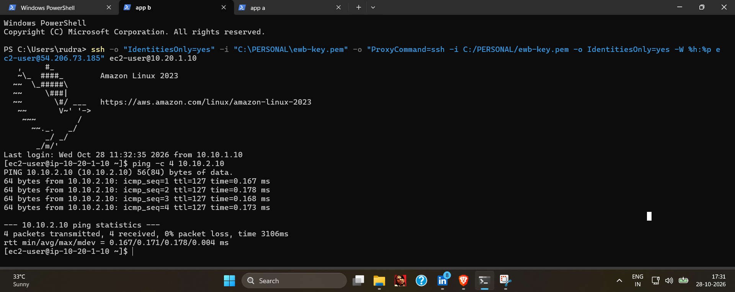
Figure 3: Test 3: App-B (ip-10-20-1-10) to App-A ping, 4 packets received, 0% packet loss.

7.4 Test 4: Private SSH through the bastion
Item | Detail
Objective | Show a private instance in the other VPC can be administered through the bastion using its private IP.
Method | From the laptop, SSH to ec2-user@10.20.1.10 with a ProxyCommand that hops through ec2-user@54.206.73.185; then run hostname and hostname -I.
Expected | A shell on App-B reporting its private address 10.20.1.10.
Observed | Figure 4: hostname ip-10-20-1-10.ap-southeast-2.compute.internal and address 10.20.1.10. The login banner shows Amazon Linux 2023 and a last login from 10.10.1.10 (the bastion).
Conclusion | Passed. App-B is reachable only through the bastion over private addressing. (The key file path appears in the command line; no key contents are shown.)
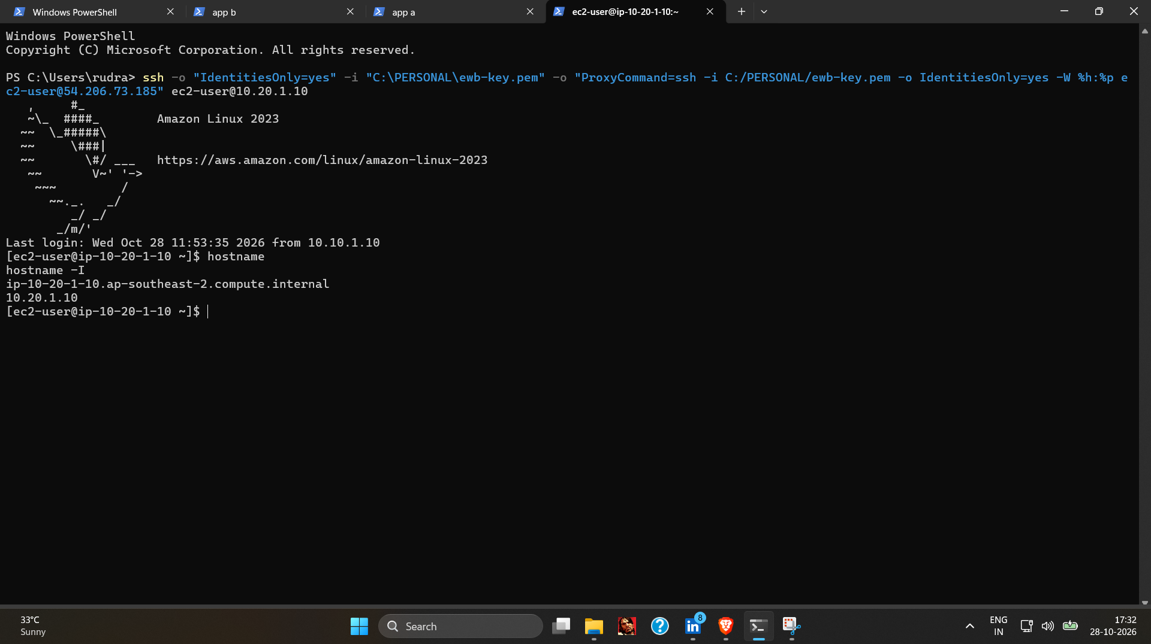
Figure 4: Test 4: SSH to App-B (10.20.1.10) through the bastion; hostname and hostname -I confirm 10.20.1.10.

7.5 Test 5: Isolation (no public IPv4)
Item | Detail
Objective | Verify App-A and App-B have no public IPv4 address.
Method | EC2 console, Instances, Details tab for each instance.
Expected | Public IPv4 address and Public DNS blank for both.
Observed | Figure 5 (App-B): Public IPv4 address "–", Public DNS "–", private IPv4 10.20.1.10. Figure 6 (App-A): the same, with private IPv4 10.10.2.10. Both are Running with 3/3 checks passed.
Conclusion | Passed. Neither private instance has a public IPv4 address. (The "Elastic IP" field is below the visible area in these screenshots, so it is not claimed.)
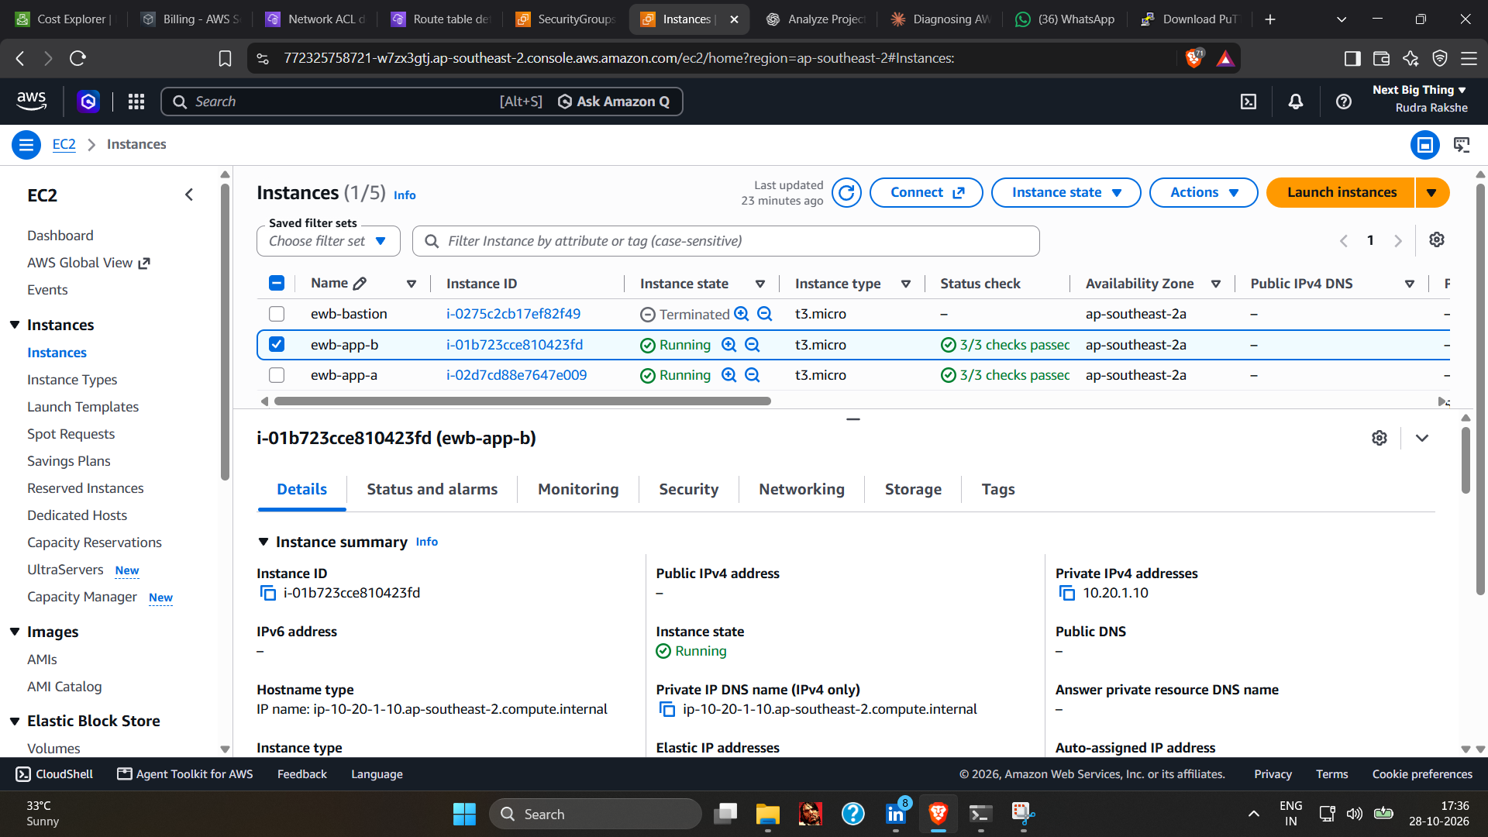
Figure 5: Test 5: ewb-app-b (i-01b723cce810423fd) shows no Public IPv4 address and private IPv4 10.20.1.10.
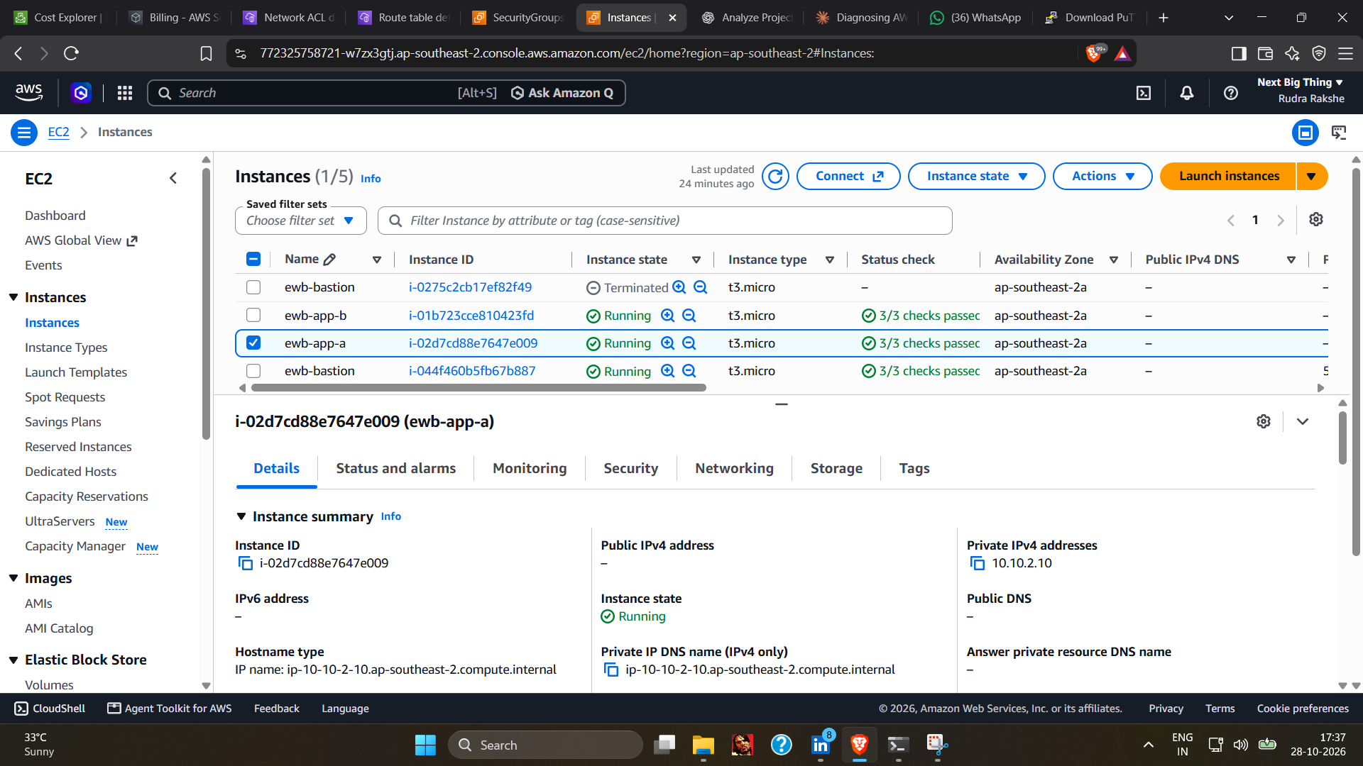
Figure 6: Test 5: ewb-app-a (i-02d7cd88e7647e009) shows no Public IPv4 address and private IPv4 10.10.2.10.

8. Controlled ICMP failure and recovery
This test shows that a security-group rule, not just routing, decides whether App-A's ping reaches App-B.
Step | Detail
Normal state | App-A pings App-B successfully (Test 2).
Failure | Remove the inbound rule on ewb-sg-app-b that allows ICMP Echo Request from 10.10.2.10/32, then ping from App-A. Expected: 100% packet loss.
Recovery | Re-add the rule (Custom ICMP, Echo Request, source 10.10.2.10/32), then ping again from App-A. Expected: 0% packet loss.

8.1 Observed results
Failure. Figure 7 shows a successful run (4 of 4 received) followed by two runs with 4 packets transmitted, 0 received, 100% packet loss. The terminal then reports a dropped connection (client_loop: send disconnect: Connection reset).
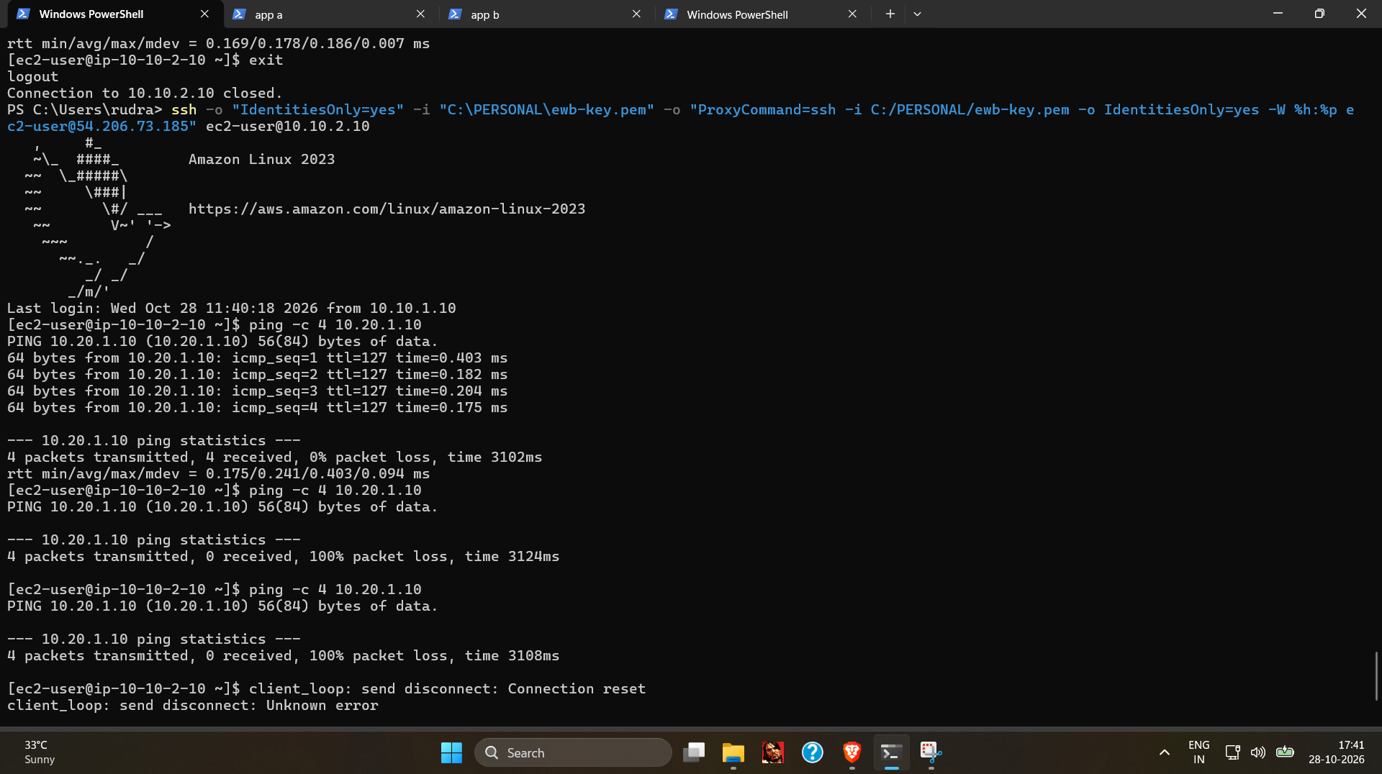
Figure 7: Controlled failure: App-A (10.10.2.10) ping to App-B (10.20.1.10) shows 100% packet loss (two runs), after an earlier successful run in the same terminal.
Recovery. Figure 8 shows a new session on App-A with 4 transmitted, 4 received, 0% packet loss.
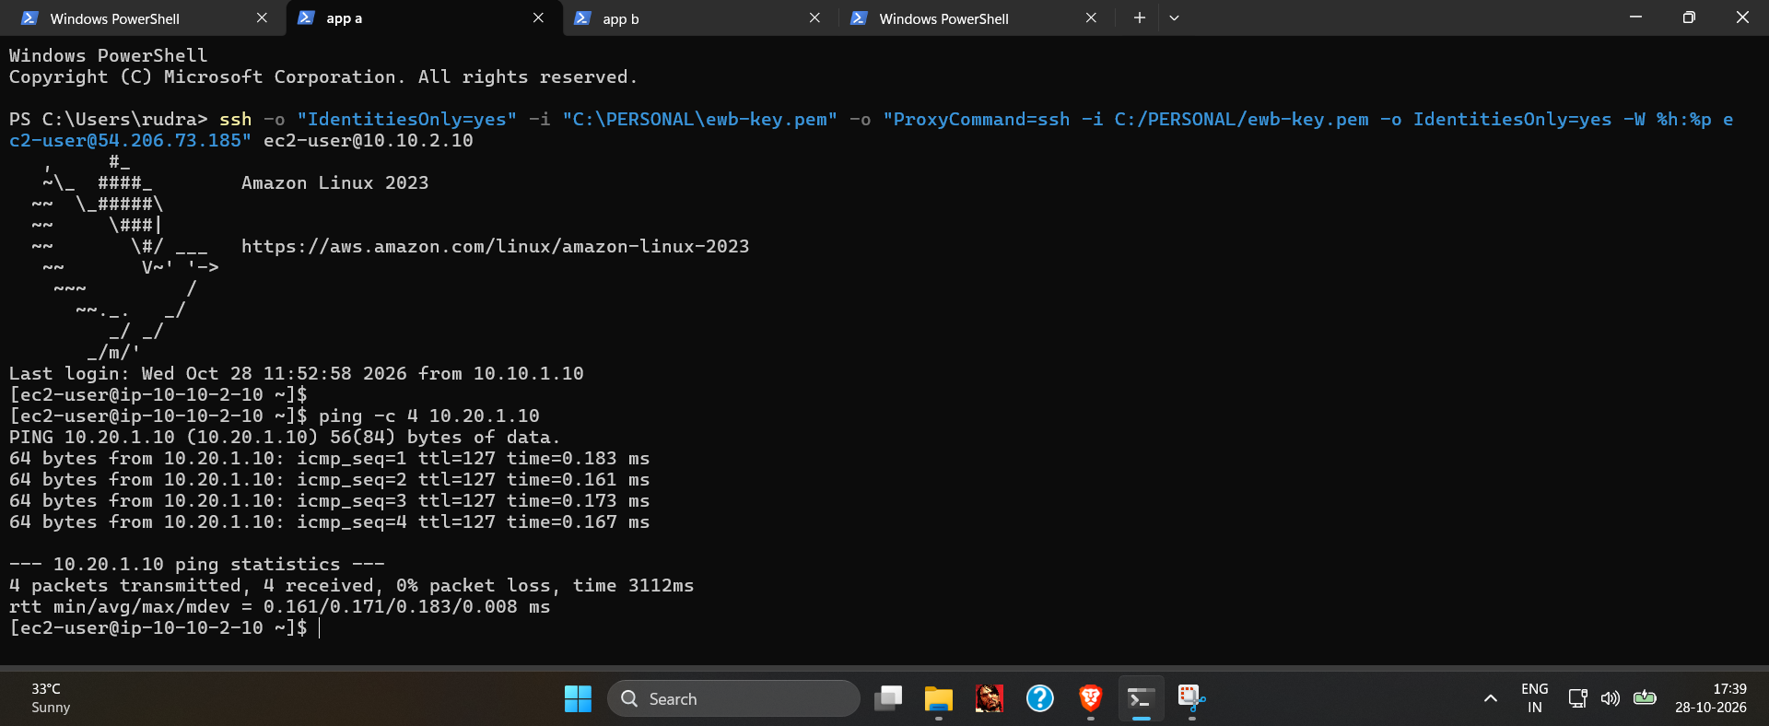
Figure 8: Recovery: App-A ping to App-B again shows 4 packets received, 0% packet loss.

8.2 Limits of this evidence
- Rule changes are not captured. No screenshot shows the ICMP rule deleted or re-added in the console, so the link between the rule and the result rests on the student's account rather than on a screenshot.
- Order is not time-stamped. The failure screenshot was taken at 17:41 and the recovery screenshot at 17:39 (taskbar time). The failure terminal is a scrollback of an older session, so the ping runs happened earlier than the screenshot. The ping runs themselves carry no timestamps.
- An earlier anomaly. After the rule appeared to be removed, pings from App-A to App-B kept succeeding for a time. Pings from App-B to App-A are expected to succeed, because App-B starts that connection and its outbound rules allow it; the deleted rule only governs traffic initiated by App-A. The supplied screenshots do not record what was changed before the failure in Figure 7 appeared, so this report does not name a cause.

8.3 What this demonstrates
Because routes, peering and network ACLs were unchanged, the loss of replies after the rule was removed, and their return afterwards, is consistent with the inbound ICMP rule on ewb-sg-app-b being what permits App-A's pings. Stating it as proven would need the missing console screenshots listed in Appendix A.

9. Troubleshooting and lessons learned
Problem | What was found | Resolution / lesson
SSH to the bastion refused or timing out | The original bastion (i-0275c2cb17ef82f49) was unusable and was replaced. The replacement received a new public IP (54.206.73.185); testing the old IP (3.106.134.175) gave "Connection refused" because the address no longer belonged to the project. After that, the bastion's security group did not match the laptop's public IP (mobile hotspot). | Always re-read the instance's current public IPv4. With a changing hotspot IP, a temporary open rule confirmed the diagnosis (reported by the student). Narrow the rule back to a /32 afterwards.
"Connection refused" vs timeout | A security group or ACL block normally causes a timeout (packets dropped). A refusal means something answered with a reset, such as a closed port or an address that belongs to someone else. | Distinguish the two before changing rules.
ssh -J rejected at the bastion | -J did not pass the key to the jump host. | A ProxyCommand with -i on both hops worked (visible in Figures 2 to 4).
ping -c failed in PowerShell | The command was run on the Windows laptop, where -c is not a valid ping option. | Run Linux ping inside the EC2 shell (prompt [ec2-user@ip-10-10-2-10 ~]$).
Ping kept working after an ICMP rule was removed | B-to-A pings are not governed by the deleted rule (stateful behaviour). The A-to-B anomaly is described in section 8.2. | Test in the correct direction, start a new ping after each change, and screenshot the rule before and after.

Lessons learned
- Security groups are stateful: an inbound rule matters only for connections started toward that instance.
- Document each rule change with a console screenshot and a timestamped terminal run, so the failure and recovery sequence can be proven.
- A public IPv4 address that is not an Elastic IP changes when an instance is replaced or stopped and started.
- Do not leave SSH open to 0.0.0.0/0.

10. Cleanup evidence and cost considerations
Resource | Evidence | Status
EC2 instances (App-B, App-A, bastion) | Figure 9: all three shown as Terminated (17:51). The original bastion was already terminated earlier (visible in Figure 5 and Figure 6 instance lists). | Verified
EBS volumes | Figure 10: "No matching volumes found" in ap-southeast-2 (17:52). | Verified
VPC peering connection | Figure 11: "successfully deleted peering connection pcx-04950eee78a68adf1", status Deleted (17:56). | Verified
Elastic IPs | None known to have been allocated; no screenshot supplied. | Pending: not evidenced
Route tables, subnets, internet gateway, VPCs, security groups | No screenshots supplied. Route entries that pointed at the deleted peering connection show as "blackhole" if their route tables still exist. | Pending: not evidenced
Bastion SSH rule (0.0.0.0/0) | Final state not shown; the bastion is terminated. | Pending: not evidenced

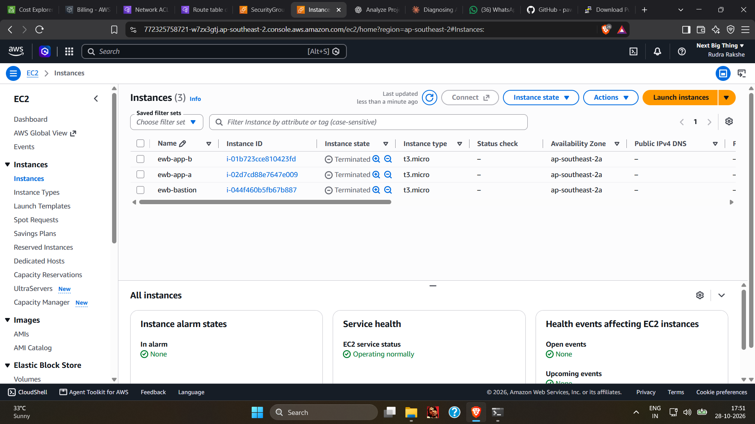
Figure 9: Cleanup: ewb-app-b, ewb-app-a and ewb-bastion (i-044f460b5fb67b887) all show Terminated.
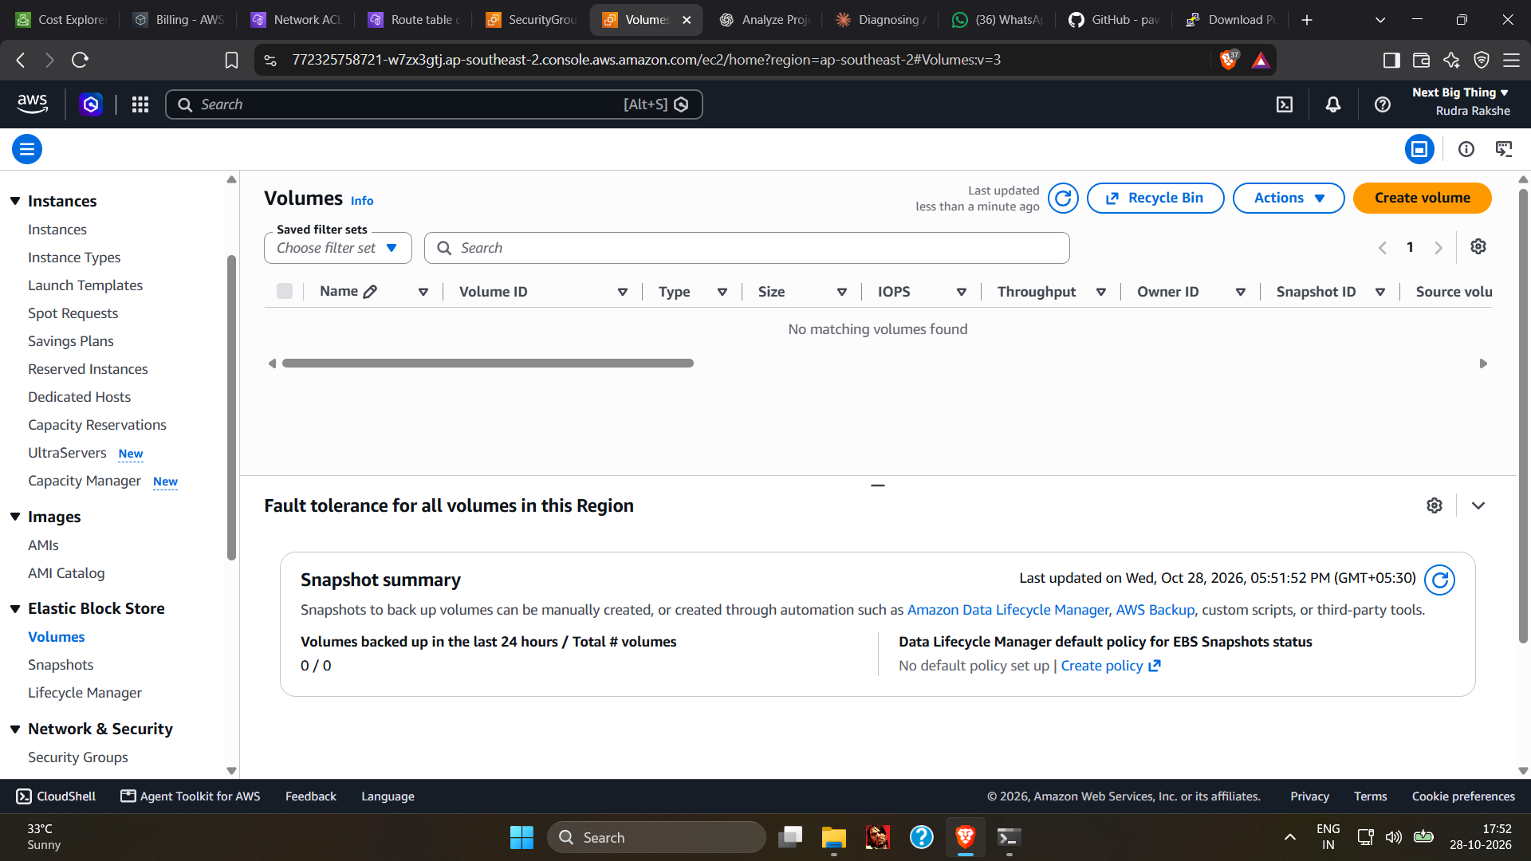
Figure 10: Cleanup: Volumes page in ap-southeast-2 shows "No matching volumes found".
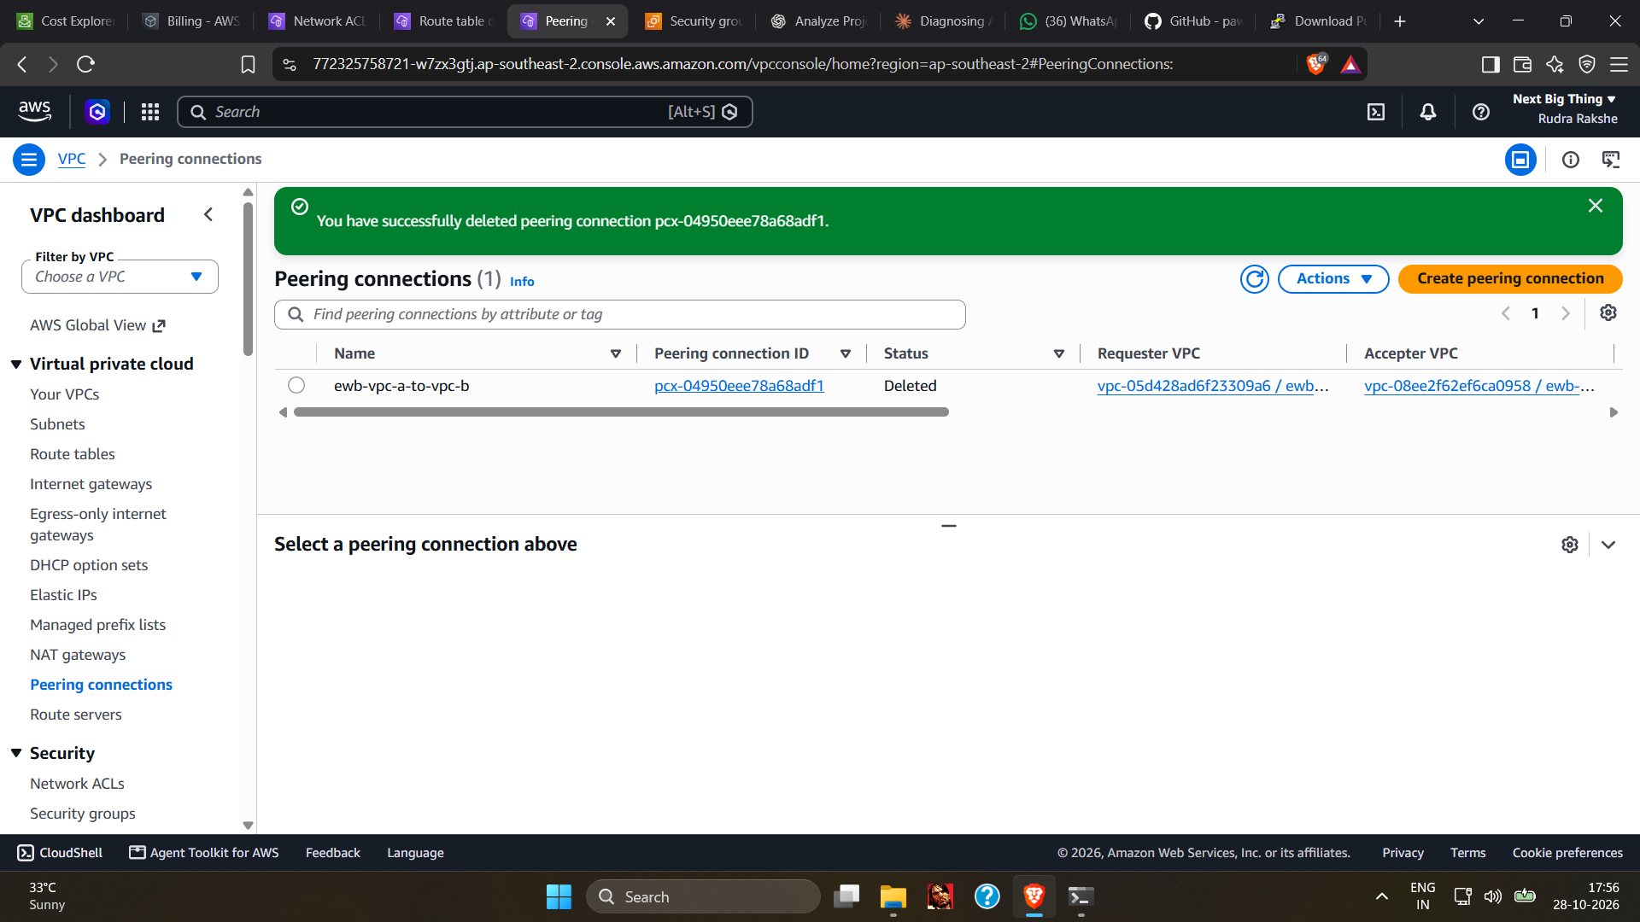
Figure 11: Cleanup: peering connection pcx-04950eee78a68adf1 (ewb-vpc-a-to-vpc-b) deleted.
Cost considerations. EC2 instances, attached EBS volumes and public IPv4 addresses can incur charges, including Elastic IPs that are allocated but not in use. Charges stop when instances are terminated and their volumes deleted. Re-check Instances, Volumes and Elastic IPs in ap-southeast-2 (Sydney), since resources in another region are not shown. VPCs, subnets, route tables and internet gateways have no hourly charge, but delete them if the project is finished. No NAT Gateway was used.

11. Conclusion
The two VPCs, connected by pcx-04950eee78a68adf1, communicated privately in both directions (Tests 2 and 3), the private instances were reached only through the bastion (Test 4), and neither had a public IPv4 address (Test 5). A removed ICMP rule coincided with 100% packet loss and its restoration with recovery, although the rule edits themselves were not captured. Test 1 could not be verified, and cleanup is evidenced for instances, volumes and the peering connection only.
The main technical lessons are the difference between a refusal and a timeout, the role of stateful security groups, and the cost of an unstable public IP when restricting SSH.

12. Appendix

Appendix A: Missing evidence and checklist
Item | Status / what would close the gap
Test 1 baseline failure | Evidence not provided. Would need a ping with 100% loss before peering and routes existed.
Security-group rule removal and restoration | Not captured. Add console screenshots of ewb-sg-app-b inbound rules without and with the ICMP rule.
Time-ordered failure then recovery | Not shown. Re-run both with date; ping -c 4 -W 2 10.20.1.10 if the resources still existed.
VPC, subnet, route-table, internet-gateway and security-group screenshots | Not provided. Resource details come from supplied text.
Cleanup of VPCs, subnets, route tables, IGW, security groups, Elastic IPs | Not evidenced.
Project PDF submission checklist | Could not be checked; the PDF was not available.

Appendix B: Supplementary file test1.png
This is the file supplied for Test 1. It shows a successful ping with peering active, so it is not a baseline failure.
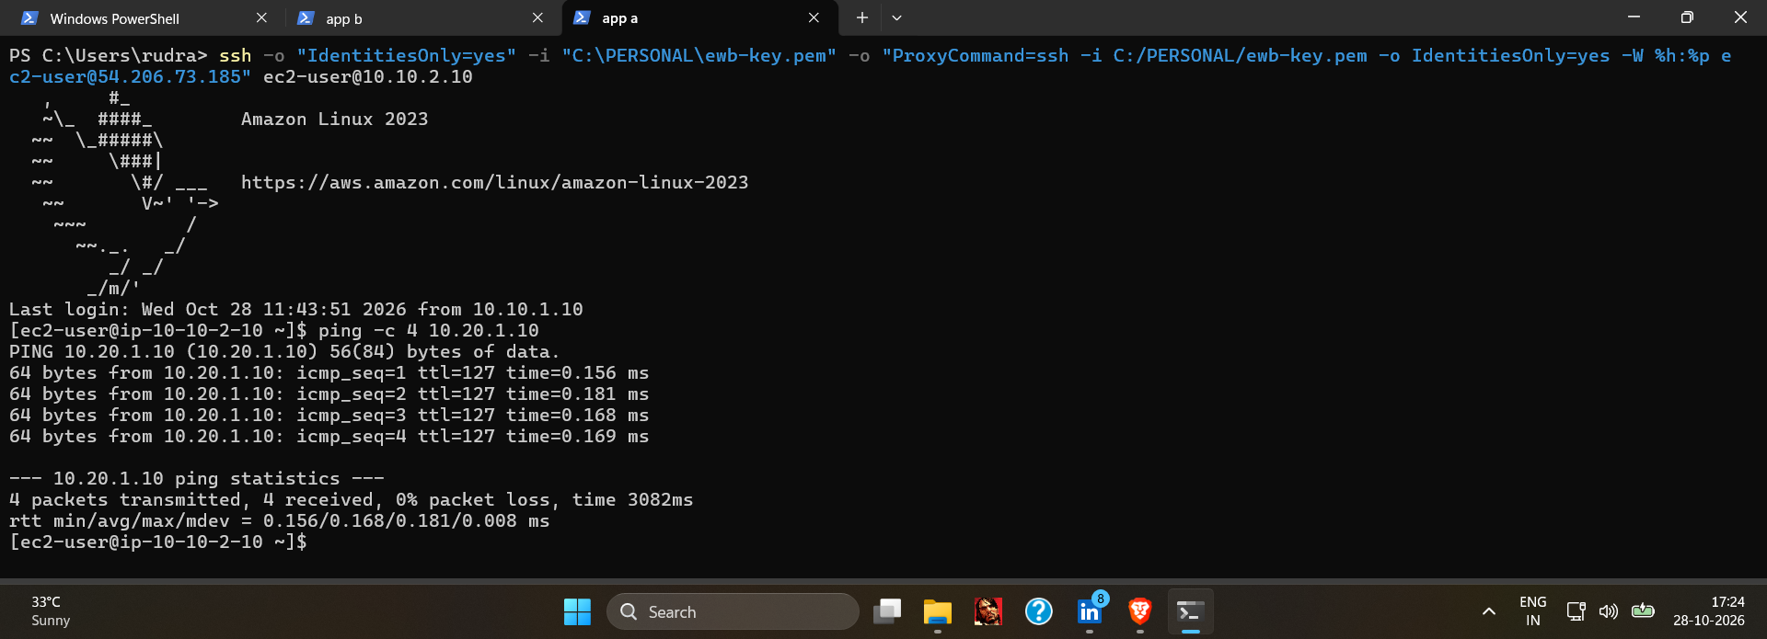
Figure B1: Supplementary: first App-A to App-B ping, 4 packets received, 0% packet loss (peering active, not a baseline).

Appendix C: Evidence file map
Supplied file | Used as
test1.png | Figure B1 (supplementary)
test2-forwardping.png | Figure 2
test3-reverping.png | Figure 3
test4-privatessh_test.png | Figure 4
test5p1_isolation.png | Figure 5
test5p2.png | Figure 6
test6_failure.png | Figure 7
test6_p2_recovery.png | Figure 8
cleanupinstances.png (same image as Screenshot_2026-10-28_175128.png) | Figure 9
volume_cleanup.png (same image as Screenshot_2026-10-28_175214.png) | Figure 10
Screenshot_2026-10-28_175625.png | Figure 11

